University of Bergen
Postboks 7803
NO-5020 Bergen
Norway

7th January 2019

To whom it may concern,

This statement is to confirm that the manuscript entitled “Characterizing user-defined objects from outcrop and modern system interpretations for stochastic object-based reservoir modelling” is a non-peer reviewed preprint uploaded to EarthArXiv as an open-access contribution. The authors and affiliations of the manuscript are:

Björn Nyberg
Department of Earth Sciences, University of Bergen, P.O. Box 7803, 5020 Bergen, Norway.
bjorn.nyberg@uib.no

John A. Howell
Department of Geology and Petroleum Geology, University of Aberdeen, Meston Building, Old Aberdeen, AB24 3UE UK2
john.howell@abdn.ac.uk

Simon J. Buckley
Uni Research CIPR, P.O. Box 7810, 5020 Bergen Norway.
simon.buckley@uib.no

Christian Haug Eide
Department of Earth Sciences, University of Bergen, P.O. Box 7803, 5020 Bergen, Norway.
christian.eide@uib.no

Sincerely,
Björn Nyberg

Characterizing user-defined objects from outcrop and modern system interpretations for stochastic object-based reservoir modelling
Björn Nyberg^{1*}, John A. Howell², Simon J. Buckley^{3,1}, Christian Haug Eide¹
Department of Earth Sciences, University of Bergen, P.O. Box 7803, 5020 Bergen, Norway.¹
Department of Geology and Petroleum Geology, University of Aberdeen, Meston Building, Old Aberdeen, AB24 3UE UK²
Uni Research CIPR, P.O. Box 7810, 5020 Bergen Norway.³

*Corresponding Author: bjorn.nyberg@uib.no
Abstract
Outcrops and modern depositional environments are important analogues for subsurface hydrocarbon-, water- or CO₂-sequestration reservoirs, as they supplement limited well- and seismic- data and provide information on connectivity of sandbodies observed in subsurface datasets. Object based modelling is one of a series of methods that is widely used for modelling subsurface facies architecture. A common criticism of object based modelling is the simplistic shapes in the models and the limited dimensional data typically used to describe those objects. Advances in virtual outcrop mapping and availability of remotely sensed data have the potential to generate quantitative geometrical information of sandbody geometries from large volumes of geospatially-constrained sources; however, there are no systematic ways to describe and incorporate bodies from outcrop or satellite imagery for reservoir modelling. Here we present an objective approach to derive geometric attribute and shape information from outcrop and modern elements, by measuring multiple width and centreline deviation parameters in relation to an object’s centreline and integrating those objects directly into existing object-based reservoir modelling packages. We demonstrate the technique on a fluvial outcrop model from the Beckwith Plateau in Utah and an equivalent modern environment from the Mitchell Delta in Australia to produce an object-based reservoir model.

Introduction
Stochastic-based reservoir modelling algorithms are routinely used to simulate the spatial distribution of facies which control the petrophysical properties in subsurface reservoirs and aquifers (Bryant and Flint 1993; Deutsch 2002; Howell et al. 2014). Stochastic models form the basis for probabilistic suites of models that may be used to predict ranges of reservoir behaviour (Larue and Legarre 2004) and also form an integral part of facies modelling within individual models in more scenario-based approaches (Ringrose and Bentley 2014). Stochastic models are critical for capturing and mitigating the significant uncertainty that is associated with the low volumes of data typically available in subsurface reservoirs (Howell et al. 2014). Inputs for stochastic facies models commonly come from outcrop and/or modern depositional environments and there have been significant advances in the methods for the acquisition of these data in recent times. However, workflows for transferring and integrating outcrop and modern data for 3-dimensional stochastic modelling are limited. This paper outlines a method for defining geometric data from mapped outcrop and modern architectural elements to objectively define its shape for use in stochastic object-based reservoir models.
A variety of stochastic reservoir modelling methods exist. These are broadly subdivided into pixel based- and object-based approaches. There are a variety of algorithms within these two groups, each of which have benefits and disadvantages depending on the application (see Howell et al. 2014 for a review). Pixel-based algorithms include sequential indicator simulations (SIS), truncated Gaussian simulations (TGS) and multi-point statistics (MPS). SIS is the most commonly used algorithm, based on variograms comparing the probability of given facies occurring between two points. The sill of the variogram defines the distance at which there is no correlation between two points. The main limiting factor of this approach is that pixel-based methods tend to produce “patchy distributions” that are typically poor at generating geologically-realistic bodies with sharp, discrete boundaries. A second issue is that deriving variograms for body shapes from outcrop data is not normally a part of the outcrop data collection workflow, although notable exceptions exist (Colombera et al. 2012; Rarity et al. 2014).
MPS methods are based on using a neural network pattern recognition algorithm to calculate the probability of change from a centroid cell to its neighbour within a given window (Guardiano and Srivastava 1993; Caers 2001; Strebelle 2002). These pattern recognitions are gathered from training images that represent the stationary, repetitive distribution of a 3D spatial pattern of facies (Caers and Zhang 2004). MPS can generate models with multiple facies which include discrete bodies and complex geometries. The key challenge is the generation of suitable stationary training images though significant advances have been made to incorporate geological trends into these models (Hu and Chugunova, 2008; Hu et al., 2014; Strebelle and Levy, 2008).
Object-based modelling places objects with a predefined shape in a background facies (Holden et al. 1998). This approach produces discrete bodies which replicate the geometries, shape and relationship of facies as observed in outcrop and modern analogues. While these stochastic models are typically limited by the number of facies that can be modelled and are also difficult to condition to datasets with large number of wells (Howell et al. 2014), they produce the most realistic representation of discrete sandbody geometries (e.g., Deutsch and Tran, 2002). Early versions of the object based modelling algorithms were also criticized for the simplistic nature of the available object shapes, however recent advances in the software have produced a variety of tools that allow user defined shapes to be modelled (e.g., Deutsch and Tran, 2002; Maharaja 2008). The availability of information on geobody shape remains a challenge, which is addressed in the current study. The spatial variability and connectivity of discrete sandbody geometries is important to understand the fluid-flow behaviour of a subsurface reservoir (Bryant and Flint 1993; Deutsch 2002; Howell et al. 2014) and can be used to generate improved training images for MPS (e.g., Maharaja 2008; Pyrcz et al. 2008; Hashemi et al. 2014). While solutions exist for the integration of geobody interpretations from outcrop and modern depositional environments for pixel-based stochastic reservoir modelling methods (Colombera et al. 2012; Rarity et al. 2014), object-based reservoir modelling is the focus of the remainder of the article.
Geological outcrops have long been used as analogues to improve understanding of subsurface reservoirs (e.g. Alexander 1993; Bryant and Flint 1993; Grammer et al. 2004). The collection of geometric data for populating reservoir models dates back to the pioneering work of Zeito (1965) and became more commonplace with the advent of computer-based reservoir modelling in the early 1990s (e.g., Miall and Tyler 1991; Bryant and Flint 1993; Dreyer et al. 1993). Early data collection was based on field mapping and scaled photo panel measurements (e.g., Arnot et al. 1997; Howell et al. 2008). The advent of LiDAR (Bellian et al. 2005; Pringle et al. 2006; Buckley et al. 2008a; Buckley et al. 2008b) and advances in photogrammetry have led to a new generation of “virtual outcrop” datasets, from which it is possible to extract large volumes of spatially constrained geometric data that can be used to populate reservoir models (Hodgetts et al. 2004, Enge et al. 2010; Labourdette 2011; Rittersbacher et al 2014; Eide et al., 2014). Such data are commonly stored in analogue databases which describe the dimensions of the objects (Fielding and Crane 1987; Reynolds 1999; Eschard et al. 2002) and more recently provide statistics that summarize their spatial relationships (Colombera et al. 2012). While there have been previous efforts for automated fracture mapping from virtual outcrop data (Monsen et al. 2007; Colombera et al. 2010; Viseur 2010) and sequential orthogonal 2D broadcasting of outcrop sandbody interpretations to 3D training images (e.g., Pickel el al. 2015), to date, no method exists to objectively define geometry and shape of geobodies as required to characterize user-defined objects for object-based reservoir modelling.
Modern depositional environments are likewise important to constrain shape, heterogeneity and connectivity of subsurface geometry in the planform perspective where reservoir information is spatially limited (Howell et al., 2008; Massey et al., 2013; Nanson et al., 2012). Modern analogues provide both the spatial and temporal trends on the lateral distribution of sandbody architecture along dip and strike of a similar subsurface field and have been an instrumental part in providing models of facies trends within depositional environments (e.g., Boyd et al. 1992; Dalrymple et al. 1992; Nichols and Fisher 2007; Ainsworth et al. 2011, Nanson et al., 2012, Massey et al. 2013, Vakarelov and Ainsworth 2013). Geobody interpretations of reservoir vs non-reservoir elements from modern depositional environments (Nanson et al. 2012) have been used to provide direct object-based analogues for subsurface reservoir behaviour (Massey et al. 2013). Stochastically, object based classifications of satellite imagery have been used to create training images of modern depositional environments for MPS modelling (Hashemi et al., 2014), however, there is often a lack of appropriate training images to use for reservoir models or are otherwise based on conceptualized shapes such as ellipsoids, lobes, sinusoids or cuboids (e.g., Maharaja 2008; Pyrcz et al. 2008) that do not capture the complexity of geobodies found in outcrop or modern systems. While most object-based reservoir modelling packages and training image generators allow for more detailed user-defined objects (e.g., Deutsch and Tran 2002 and Maharaja 2008), a significant limitation remains the geometric representation of outcrop and modern geobody shape interpretations as required to describe user-defined objects.
Nyberg et al. (2015) proposed a method for the automated and quantitative spatial characterization of architectural elements from satellite or aerial images of modern systems by measuring multiple width and centreline deviation values along an object’s centreline to describe shape and geometric attributes. The current contribution extends this method to define the shape and geometric attributes from modern and geological outcrop interpretations to describe a 3-dimensional user-defined shape for input to object-based modelling approaches and object-based training image generators. The aims of this paper are three-fold; 1) to demonstrate the workflow to characterize shape and geometric attributes from outcrop and modern analogue interpretations, 2) the creation of user-defined objects from analogue data for object-based reservoir modelling and 3) its application to a case study of a distributive fluvial outcrop system in the Cretaceous Blackhawk Formation, Utah and an equivalent modern system from the Mitchell Delta in Australia.
Method
Mapping architectural elements in virtual outcrops
When considering geobodies and outcrops it is common to refer to 2D, 2.5D and 3D data. In reservoir models, the 3D geometry and architecture of the geobodies are represented. However, for analogues, true volumetric 3D data are rarely available, because the accessible surfaces are cliff sections or aerial photos of modern systems that do not cover the subsurface. A single planar slice through a body gives a 2D cross section, from which it difficult to reconstruct 3D geometry in any detail. The term 2.5D is often used when an irregular topographic expression provides several cuts through a geobody which allow its shape to be at least partially reconstructed. Virtual outcrop models (VOMs) from complex outcrops such as quarries, or irregular cliffs with buttresses, gullies and canyons provide sources of 2.5D data (Jones et al. 2008), which may be extrapolated to 3D in geocellular modelling (e.g. Enge and Howell 2010).
Geobody interpretations from VOMs are represented as polylines in 3D space (x,y,z) that are mapped on the 2.5D outcrop surface. Dimensions from these interpretations are then calculated by manually performing measurements at locations that appear to represent the maximum width and thickness along depositional strike and dip of a representative 2D profile, or by correcting the measured length relative to estimated palaeocurrent direction (Rittersbacher et al 2014). The geometric data provides valuable information to constrain geobodies in a reservoir model (see Howell et al. 2014 for review). Interpretations representing stratigraphic boundaries can also be incorporated from VOMs by importing them as surfaces in the reservoir modelling software to define zones. A comprehensive discussion on the current state of workflows integrating virtual outcrops in reservoir models are provided by Enge et al. (2007) and Rarity et al. (2014).
The main challenge that remains is to integrate objects and their variable geometric dimensions along dip and strike as interpreted from outcrop and modern systems for use as 3D objects in stochastic objected-based reservoir modelling software (e.g., Deutsch and Tran 2002) or as geometric input to training image generators for MPS (e.g., Maharaja 2008). At present, VOM workflows map architectural elements and manually measure the maximum length and thickness for each interpreted object and assign a simplified subjective shape (e.g., ellipsoid, lobe, sinusoid or cuboid) to those dimensions to be modelled by a stochastic object-based reservoir modelling approach (e.g., Eide et al., 2014). This method is prone to human error and fails to capture the spatial variability of the objects dimensions along strike and dip as mapped in the original outcrop or modern system interpretation.
Geometric description of an object
A number of methods have been proposed for the characterization of 2D profiles and geometric attributes, for a number of applications (e.g., van der Werff and van der Meer 2008; Blaschke 2010; Tafesse et al. 2012; Kröner and Doménech Carbó 2013). These have ranged from simple (minimum bounding box) approaches (e.g., Nanson et al. 2012) to more complex and detailed analysis of geometric structure and form (e.g., Gardoll et al. 2000, van der Werff and van der Meer 2008). Most recently, Nyberg et al. (2015) presented an automated method for characterizing geometric attributes and profiles of mapped 2D polygons, addressing limitations in standard automated Geographical Information System (GIS) tools. This technique characterizes the centreline of the object and calculates multiple width and centreline deviation parameters from the mapped centreline for each individual shape. A set of parameters are gathered and analysed to automatically define the shape’s geometric profile, length, width and centreline deviation. These parameters are objectively-derived and based on extensive automated measurements which are considered to be robust and repeatable. The application of this method to virtual outcrop data is described below.
VOM interpretations to 2D planar geometries
To utilize the centreline algorithms of Nyberg et al., 2015 for descriptive characterization of outcrop data, the polylines interpreted and mapped from the VOMs need to be converted into spatial 2D polygons. To this end, a reference point (xyz) is selected at the start of the outcrop model for both the dip and strike directions (Fig 1). Subsequently the start vertex of each newly-generated 2D polygon is registered as the vertex with distance closest to the reference point. This ensures that the start of each polygon is relative to the distance from the reference point and demonstrates that all features are oriented in the same direction. Once the start vertex of each polygon has been determined, the cumulative distance between each point of the mapped polygon and the start point is calculated to form the x axis. The original z value of each vertex is then used as the y axis, resulting in a 2D planimetric representation that can be used within a GIS environment.
Using 3D distance calculation between the start vertex and other polygon vertices prevents erroneous overlap of vertices that may otherwise occur if a geometry is simply projected on a 2D plane. For instance, for polygons that bend around local topography, it is important to capture the full geometry of a geobody, although extending this curved object into a planar surface can cause a longer profile in 2D space. When dealing with cliff sections that are relatively vertical, with negligible cross-cutting gullies, the error may be minimal in the overall scale of the feature. Within the scope of this paper, obtaining the absolute length, width and shape of the object is most important to calibrate the user defined objects that are used to define the 3D shape.
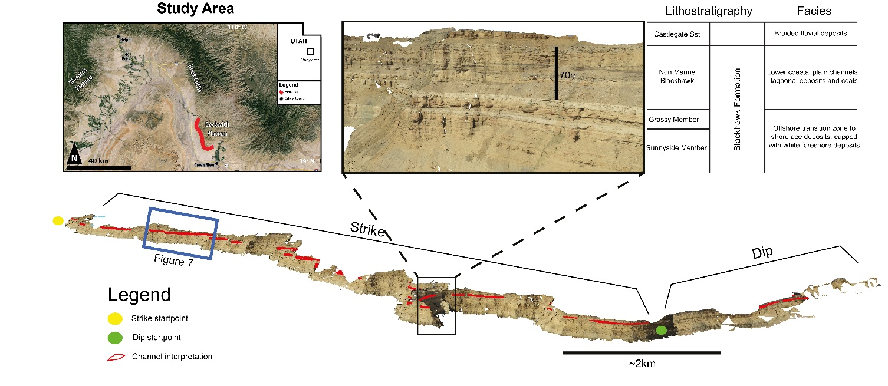
Fig. 1. An overview of the Heli-LiDAR-derived Beckwith Plateau virtual outcrop model in Utah, USA, showing strike and dip sections and mapped channels belts. The black inset box shows the lithostratigraphy and facies of the Blackhawk formation. Reference points derived in the 3D environment are used to map the relative starting vertex of each 2D converted polygon. Study area map modified after Eide et al. (2015). Imagery © Google 2013.
Attribute Characterization
Once a polygon has been acquired, centreline measurements along dip, strike and planar view of an object (Fig. 2A) are used to calculate width and centreline deviation along the feature (Fig. 2B). Centreline deviation is defined as the distance between the centreline and the shortest path, measuring not only the apparent sinuosity, but also the amplitude with distance. This method is an input into most object-based modelling algorithms to define more complex objects (Deutsch and Tran 2002). Width is subsequently calculated as the perpendicular distance from the centreline at an equal interval. These parameters can be used to define sinuous, crescentic or ellipsoidal shapes and whether those features are linear, symmetrical or asymmetrical geometrical distances (Fig 2C). More complex individualized shapes can be defined based on this methodology and its shape stored geometrically (e.g., Fig. 3) rather than categorically as is standard practise in subjectively describing modern or outcrop shape interpretations.
Once centreline deviation and width are calculated along the distance of an object, taking half the width above and below any given centreline deviation will spatially model the geometry of a feature around its centreline as a deviated width value. The purpose of these attributes is to describe each individual geobodies geometry and dimensions, as well as to group similar shapes into classes so that their geometric geostatistics can be collated to simplify object-based stochastic simulations.
User-Defined Objects for Reservoir Modelling
The descriptive geometric parameters of objects are a required input into numerous object-based reservoir modelling packages and training image generators (e.g., Deutsch and Tran 2002; Maharaja 2008). RMS, an industry-standard reservoir modelling software from Roxar, is used to
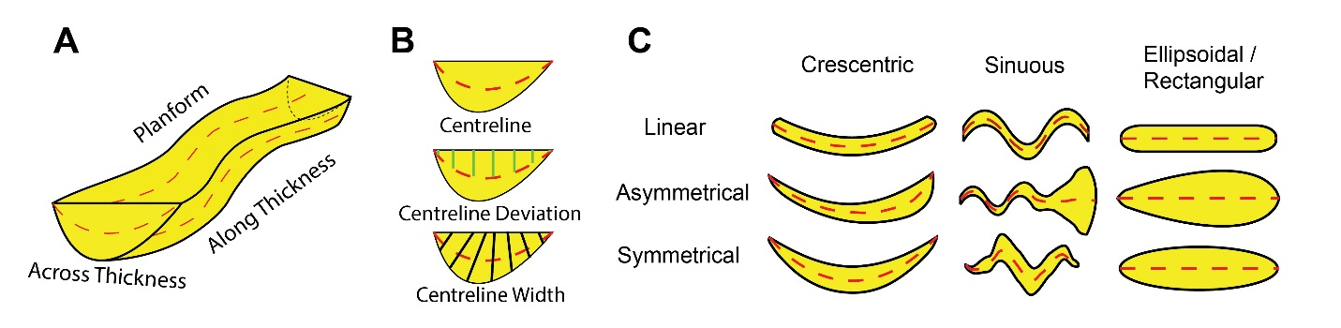
Fig. 2. A, demonstration of the planform, along thickness (dip) and across thickness (strike) perspectives that characterize a 3 dimensional user-defined object for reservoir modelling packages (e.g., Fig. 13). The proposed method, B, will automatically measure these geometries from modern or outcrop interpretations by equally spaced width and centreline deviation values along a centreline. The quantitative geometric information may be used to objectively define nine categories of shapes that are common in object-based reservoir modelling packages, C. The shapes include crescentic, sinuous or ellipsoidal with a linear, asymmetrical or symmetrical aspect (after Nyberg et al. 2015).

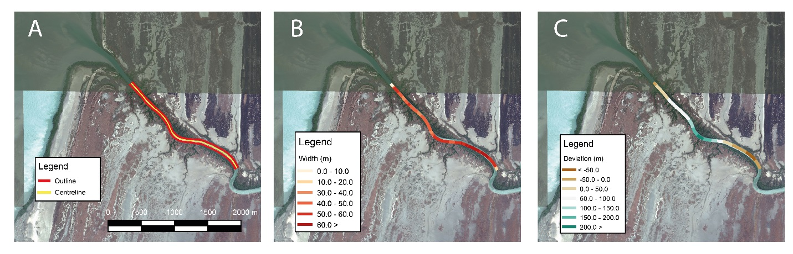
Fig. 3. A, satellite image with a manual interpretation of the lower part of the distributive fluvial system of the Mitchell Delta, Gulf of Carpentaria, Northern Queensland and its calculated centreline. B, calculated width measurements along the centreline. C, calculated centreline deviation along the centreline. The geometric attributes may then be used to define shape (Fig. 2C) and describe user-defined objects for reservoir modelling suites (e.g., Fig. 10). Image from ©Google 2015.
demonstrate the integration of the parameters to characterize user-defined objects over each given axis (e.g., strike, dip and planform profile) for object-based reservoir modelling. A 3D user-defined object requires at least two parameters of planform geometry and thickness along the axis. Thickness across axis can be modelled to provide the third dimension of an object; otherwise a rectangular grid will be modelled if not explicitly specified.
Two options are presented here to characterize user-defined objects of the planform geometry; i) relative width and relative centreline and ii) deviated width and deviated centreline objects. Relative width and relative centreline refers to a shape that is defined solely based on its relative width as it changes with distance (Fig. 4A). Subsequent stochastic modelling may introduce sinuosity if desired. Deviated width and deviated centreline refers to a user-defined object with an element of amplitude (i.e. sinuosity) incorporated into the shape (Fig. 4B). Choice of each option depends on the complexity of the geometry and the user needs which needs to be determined on a case by case basis.
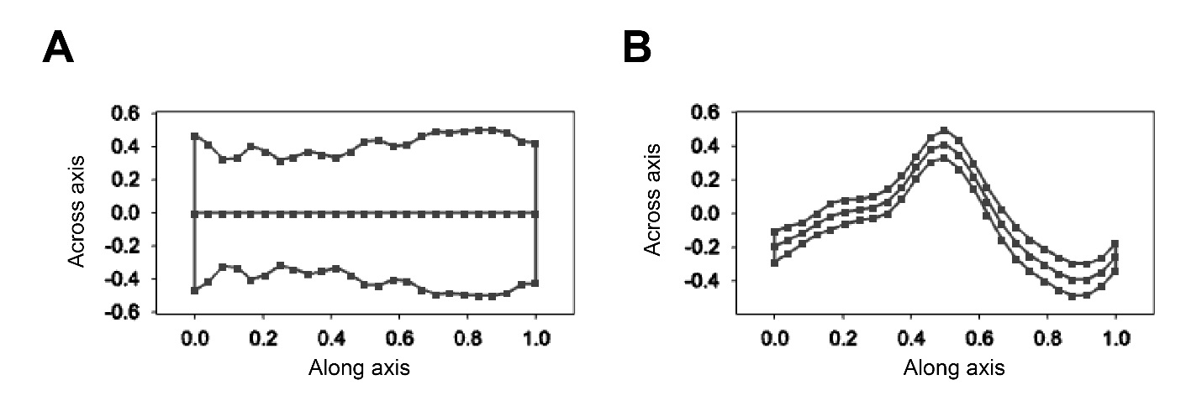
Fig. 4. User-defined objects of the planform perspective within Roxar RMS described from the channel shape in Fig. 4 based on 25 sample points. A shows a description of shape by relative width while B shows a description of shape by deviated width versus distance.
User-defined objects are modelled by dimensionless parameters of relative width and centreline distance (or deviated width and deviated centreline), which are normalized from -0.5 to 0.5 and from 0 to 1 along an axis, respectively. Relative width is normalized to its maximum width by Equation (1) where RW is its relative width value. Distance is normalized from 0 to 1 by Equation (2), where D is distance.
$\frac{RW}{max\left(RW\right)}$ Equation (1)
$\frac{D−min\left(D\right)}{max\left(D\right)−min\left(D\right)}$ Equation (2)
$\left(\frac{X−min\left(bW\right)}{max\left(aW\right)−m⁡\left(bW\right)}\right)−0.5$ Equation (3)
The normalization of deviated centreline (c) and deviated width above (aW) and below (bW) the deviated centreline is shown in Equation (3), where X represents the individual measurements of aW, bW and c. Thickness profiles (along and across) are normalized between 0 and 0.5 above and below the central axis, which can be calculated by dividing the relative width by half in Equation (1).
User-defined objects are defined in reservoir modelling packages along an axial distance (or shortest path) of equally spaced distances (e.g. 0, 0.25, 0.5, 0.75, 1) with corresponding width measurements (e.g. Roxar 2014). This may differ from the spacing of measurements taken along the centreline (or shortest path). As such, a higher-order polynomial representation, (i.e. $\sum_{i=0}^{n}{a_{i}}x^{i}y=ax^{2}+ax+a$ of both the maximum width and centreline (or deviated width and deviated centreline) are modelled to define the normalized distance vs normalized width function (see Fig. 6).
Once a polynomial function has been established, values of y (i.e. width and centreline) can be solved at equal grid intervals (as above). This function then allows the user to define sample spacing in order to describe any complex shape (up to 200 samples in RMS), which would otherwise be manual, inefficient and time-consuming. The planform geometry and thickness along axis require the same sampling, whereas the thickness across axis can be separately sampled. The geometric shape described by the user-defined objects can subsequently be used in reservoir modelling by applying the absolute geometric attributes defining the shape (e.g. length, width and sinuosity). These shapes are stored as text files and imported directly into RMS as a user-defined object.
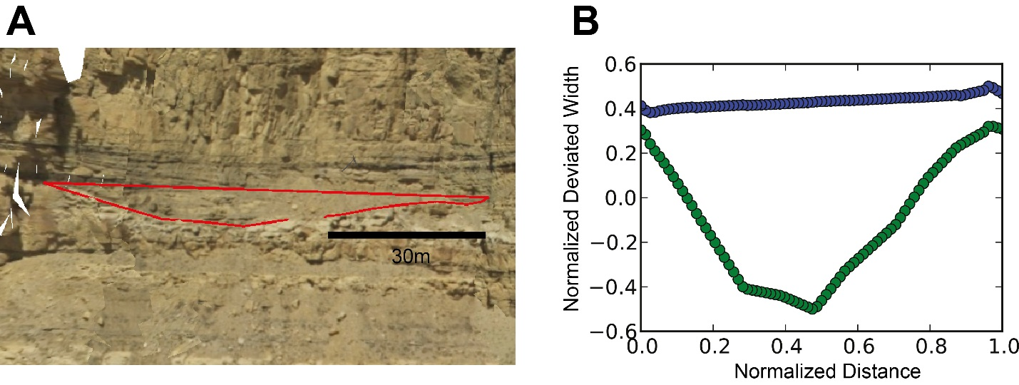
Fig. 5. A shows an interpretation of a single channel belt along depositional strike from the Beckwith Plateau VOM, with its corresponding automated calculation in B. This geometry can be used as input to user-defined objects, as shown in Fig. 14. Alternatively, the average geometry and variability of multiple realizations can be used to define its shape, as demonstrated in Fig. 6.
Conditioning a reservoir model to multiple geometries
Theoretically, each feature within the mapped VOM extents can be given a user-defined shape and modelled within a reservoir model. More useful for stochastic modelling is to group similar geometric shapes into populations and then use the distribution within the populations to build stochastic models. The geomorphological shapes previously defined as crescentic, ellipsoidal or sinuous with symmetrical, asymmetrical or linear profiles are automatically categorized (Fig. 2), and therefore similar shapes can be represented by one user-defined object and stochastically modelled by its variability. In this way, any single geometric profile within the categories can represent the whole (e.g., Fig 5) or an averaged geometric profile (e.g., Fig. 6.) which represents the population from either strike, dip or planar perspectives, capturing the range of variability within each shape class.
An averaged geometric profile implies the same procedure used to characterize any user-defined object, though the normalized geometries from all the features are used to define an average. Considering that both distance and width are normalized, this defines the object by shape, irrespective of absolute values. If the direction of asymmetry is valid, i.e. centreline has been spatially corrected along depositional system direction (Fig. 1), these geometries can further be split based on the same criteria. Otherwise, to compare asymmetric shapes, the asymmetry is always normalized with a positive slope (e.g. Fig. 6A) to ensure multiple features do not contain different profiles that might be averaged when a polynomial function is used to describe shape.
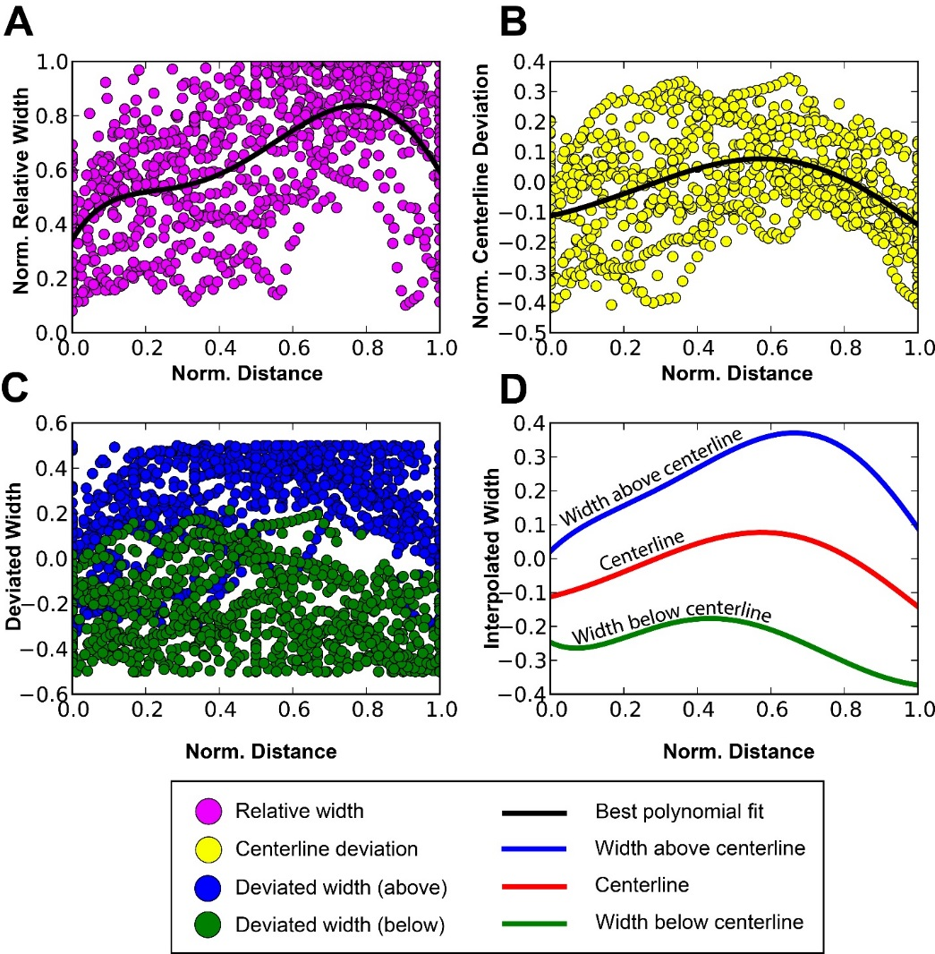
Fig. 6. Multiple individual shapes (e.g. Fig. 5) can be combined to generate an averaged profile shape. The plots in the figure show an automated profile report of 23 ellipsoidal asymmetrical shapes to characterize its relative width in A, centreline deviation in B, deviated width in C to generate shape in D. A 5th order polynomial function is used to describe the mean geometric shape. The variability between each realization of relative width in A and centreline deviation in B can be measured to define variability in shape of the resulting geometry (D). That variability may be incorporated directly as variability in user-defined objects for object-based reservoir modeling. The geometry that a profile report generates in D may be used to define the shape of a user-defined object.

Similarly, normalization of the centreline deviation is oriented so that the direction of deviation with the greatest measurement is always positive, as shown in Fig. 6B. An advantage to modelling the average shape from multiple features is that in addition to geometric attribute variability, shape can be acquired as the standard deviation of the centreline deviation and width and modelled by a user-defined object.
Geometric Attributes
The normalized user-defined objects applied in object-based modelling are representations of shape rather than an absolute size with specific dimensions. As such each group of similar shapes is paired with its mean maximum length, width, centreline deviation and sinuosity statistics as important parameters that standard reservoir modelling software may utilize to simulate such objects based on their dimensional variability (see Table 1). For example, the planar view description of channels can be described in typical reservoir modelling packages, not only by the change of width along distance, but also by amplitude (centreline deviation) or sinuosity (e.g., Deutsch and Tran 2002). It is important to note that the geometric dimensions applied to a user-defined object relate to the entire grid unit rather than the maximum normalized width of an object.
Case Study
The method for extracting geometric data and building object-based models is demonstrated using a case study from the non-marine portion of the Cretaceous Blackhawk Formation, which crops out in the Book Cliffs of eastern Utah. Polygons were mapped using a 25 km-long virtual outcrop section, which was collected using oblique helicopter-based LiDAR (see Buckley et al. 2008b for data collection and processing procedure, and Eide et al. 2015 for a detailed description of this specific dataset). The processed VOM provides both dip- and strike-orientated cross sections through a 50-70 m-thick succession of coal-bearing coastal plain deposits with abundant, well-defined channel sandbodies. This dataset is thus ideally suited for evaluating the described method.
Geological description
The study interval is north of the town of Green River in eastern Utah (Fig. 1). The Book Cliffs and their westerly extension, the Wasatch Plateau, provide a 300 km-long, near continuous outcrop through the Mesaverde Group clastic wedge (Howell and Flint 2004; Hampson et al. 2012), which prograded from the uplifted Sevier orogenic belt in the east, into the Cretaceous Western Interior Basin. The Blackhawk Formation includes a series of marine shorefaces which are overlain by an easterly thinning wedge of coastal plain and alluvial deposits. These deposits, informally termed the non-marine Blackhawk Formation, thin from 300 m in the Wasatch Plateau to 50 m in the study area. Deposits within the non-marine Blackhawk include lagoonal deposits, overbank heteroliths and mudstones, coals, fluvial channels and tidally-influenced channels (Hampson et al. 2012; Rittersbacher et al. 2014b; Fig. 1).
Detailed analysis of the spatial and vertical changes in channel dimensions based on two heli-LiDAR datasets from the Wasatch Plateau (Rittersbacher et al. 2014a; Rittersbacher et al. 2014b) indicated the presence of a large prograding, distributive fluvial system, similar in scale to the modern day Mitchell Delta system in the Gulf of Carpentaria, northern Australia (Nanson
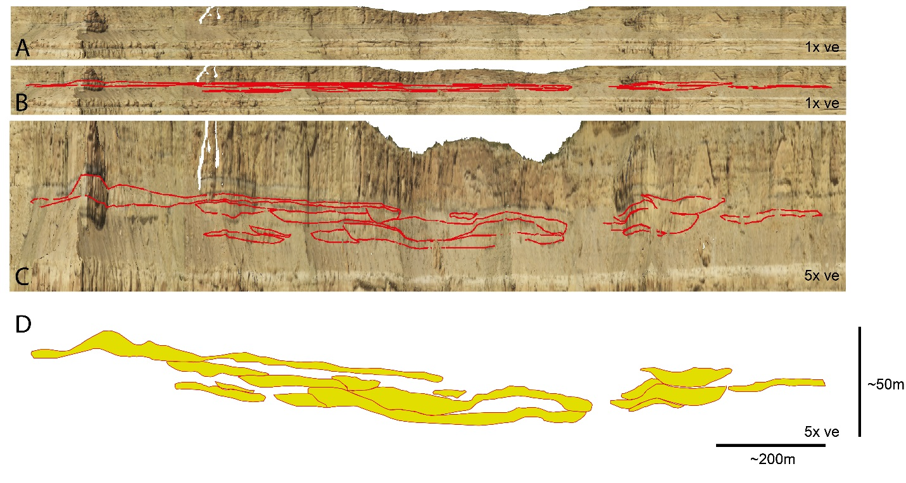
Fig. 7. A ~1.7 km long by ~50 m thick succession of channel belts interpretations along the strike section of the virtual outcrop representing the inset in Fig. 1 as well as the extent of the reservoir model in Fig. 11. A shows an un-interpreted section of the virtual outcrop model with no exaggeration. B shows the interpreted channel belt model with no exaggeration. C shows a 5x vertical exaggeration of channel belt interpretations. The resulting 2D GIS classification of those channel belt interpretations are shown in D, exaggerated vertically by 5x. ve = vertical exaggeration.
et al., 2012). The area is steep and difficult to access, though several sedimentary logs were obtained from side canyons. These were used to calibrate the interpretation of the VOM. Sixty nine channel bodies were manually mapped using in-house software for virtual outcrop visualization and manipulation, LIME.
Of the sixty nine individual channel belts mapped within the study interval, 61 provide cross sections of the channels, parallel to depositional strike (e.g., Fig. 7.) and 8 provide oblique depositional dip orientated sections. Channel belt width along strike measures 221 m (+/- 170m) and channel belt thickness measures 5.6 m (+/- 2.8 m) as shown in Table 1.
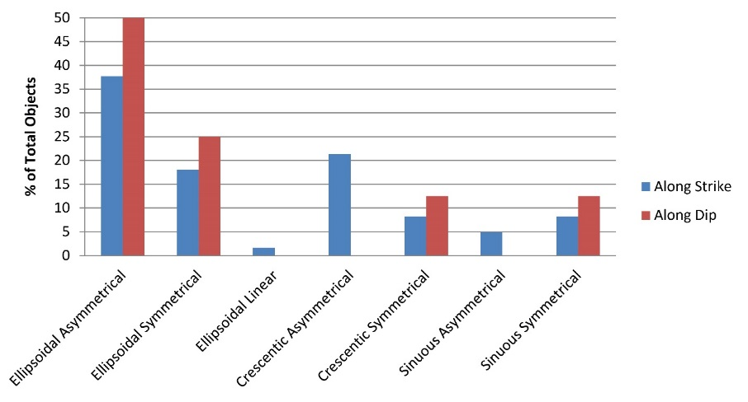
Fig. 8. Geometric shapes of the outcrop model along dip (red) and strike (blue). Along dip and strike, the most common shape outcropping at the surface are of ellipsoidal channel belts. Strike-sections show a higher degree of variability due to the large variety of irregular cuts along the bodies, while dip-oriented cuts are more faithful to the actual shape of the body.
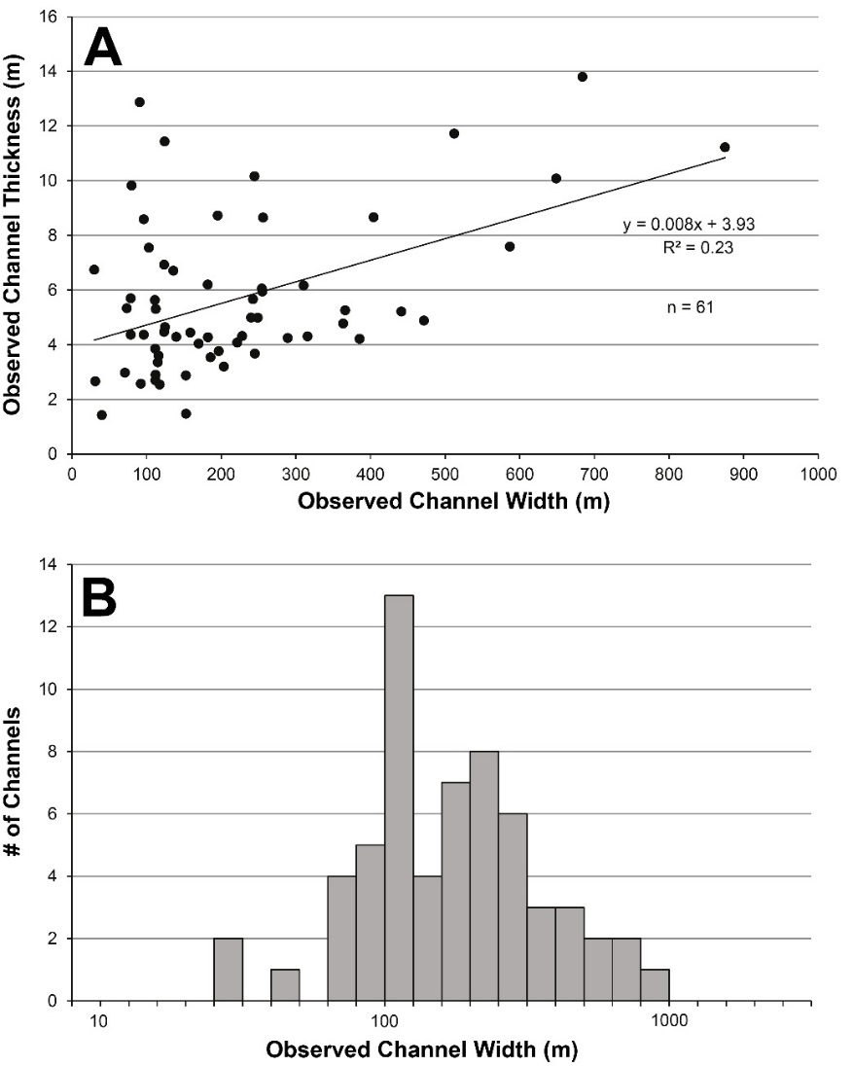
Fig. 9. Typical plots that may be acquired in the analysis and interpretation of continental channel deposits from outcrop. A shows a plot of observed channel thickness by observed channel width to show a general increase by a linear regression line. B shows the same dataset binned by observed channel width distribution and frequency.
The range of channel belt width values ranges from 30 m to 875m while channel belt thickness ranges from 1.3 m to 13.8 m. Along dip, channel belts outcrop with a width and thickness of 169m (+/- 166m) and 5.4m (+/- 2.4m), respectively (Table 2). The range of values for channel belt width is 65m to 474m and channel belt thickness ranges from 1.6m to 9.2m.
The outcropped shape of channel objects along dip and strike is summarized in Fig. 8. Given the low sinuosity in both Table 1 and 2, most of the features are described by an ellipsoidal character (Fig. 8A, B). In addition, the majority of those shapes tend to have an asymmetrical profile. Along strike, however, a higher degree of variability is witnessed (Fig. 8B), in particular, crescentic features represent nearly a third (29%). This is likely due to the large variety of along-body intersections possible for sinuous channel belts.
The individual channel belt geometric values forming the results in Tables 1 and 2 can be analysed in further detail. For example, Fig. 9 shows maximum values along strike for channel width and thickness. Fig. 9A plots a general increase in channel thickness with channel belt width at a y = 0.008x + 3.93 linear relationship with an r² of 0.23 where x is channel width and y is the channel thickness. A binned log 10 channel width distribution plotted in Fig. 9B shows a normal log distribution with a peak centred at approximately 100m.
Reservoir Model
Observations made from outcrops have been represented in commercially available reservoir modelling packages (RMS, Roxar 2014) to improve characterization of reservoir sandbodies. A user defined-object is characterized (Fig. 10) based on the strike geometry in Fig. 5, an ellipsoidal asymmetrical shape along dip (Fig. 6 & 8A) from the Beckwith Plateau outcrop and a planform geometry (Fig 3) from the Mitchell Delta to demonstrate the approach. A reservoir volume measuring 2000 x 2000 x 50 m modelled by 20 x 13.33 x 0.5m regular grid increments created a 100 x 150 x 50 grid of 750,000 cells (Fig. 11).
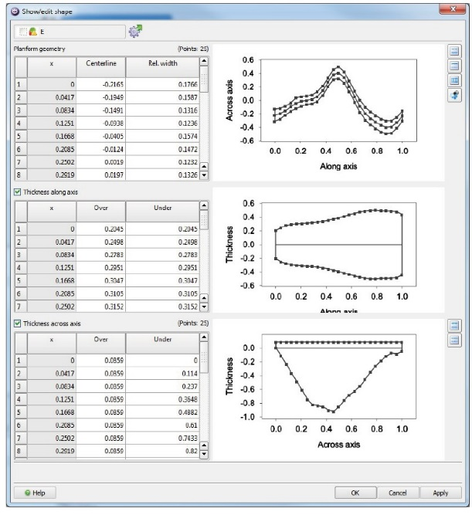
Fig. 10. Creation of user-defined object within Roxar RMS defining the planform geometry (Fig. 3), thickness across axis (Fig.5) and thickness along axis (Fig. 6). This defines the input for user defined object-based modelling in Fig. 11.

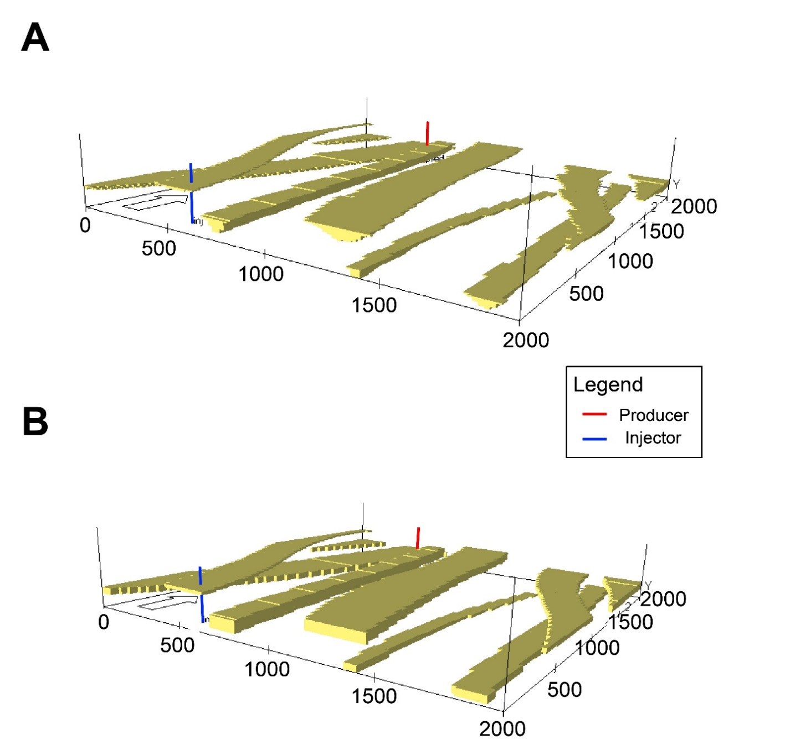
Fig. 11. A shows a stochastic object-based model of 10 channel bodies based on the user-defined object in figure 10. B shows a stochastic object-based model of 10 channel bodies utilizing the same seed and planform geometry whilst a rectangular geometry across the geobody.
The mean and standard deviation of width and thickness of the channel body were modelled using the geometric attributes defined in Table 1. The length of the planform geometry was taken as the length of the reservoir model given that the planform geometry from the modern analogue is representative of shape rather than absolute length found in the outcrop. The resulting object-based model comprises two categories – channel and background – that stochastically simulate 10 individual channel sandbodies (Fig. 11A) honouring the shape shown in Fig. 10. A control model was built using the same seeded stochastic object-based model with 10 channel objects with the same planform geometry but built with a box geometry along and across axis (Fig. 11B). The box geometry represents a conventional object-based model for channels within reservoir modelling packages based on typical outcrop measurements that only highlight maximum length and thickness. This control model used inputs from the same dataset described in Tables 1 and 2 for channel body width and thickness.
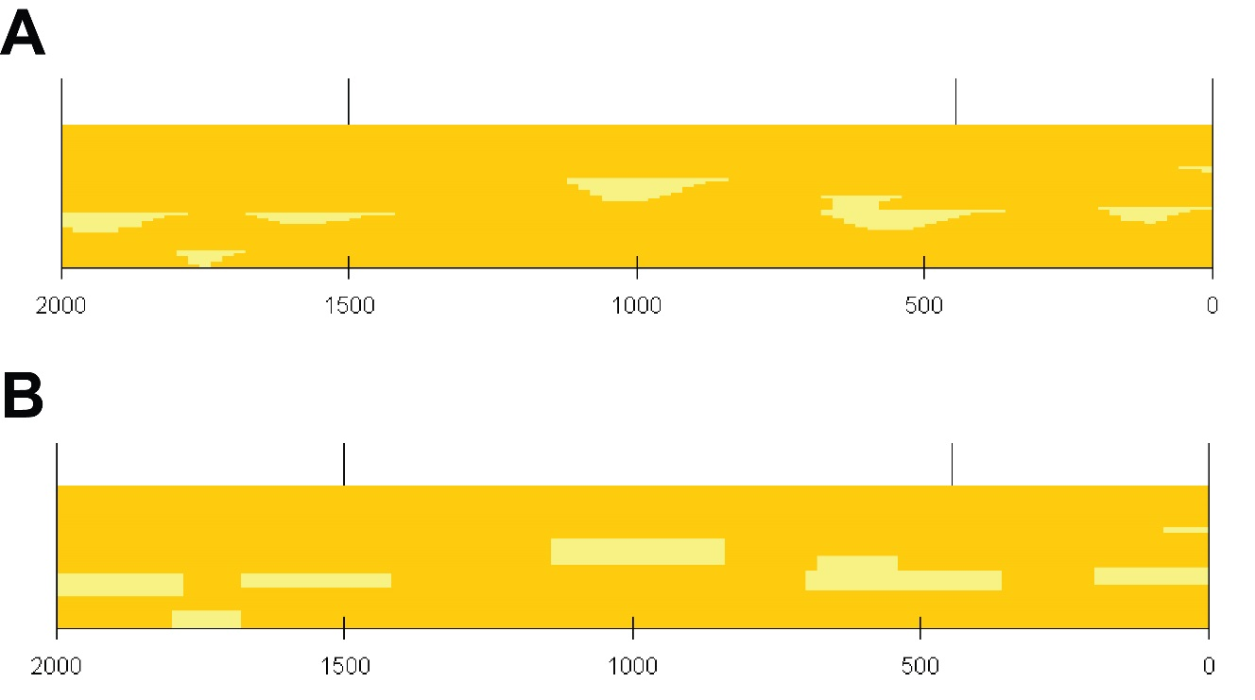
Fig. 12. A comparison along strike of the reservoir model for the user defined object (A) versus a traditional object-based channel in standard reservoir modelling suites (B).
The modelling suggests that geometric change along and across the axis of a user-defined object that defines a geo-realistic shape is important as it significantly reduces the volume of net reservoir compared to a traditional box-geometry channel object (Fig. 11 & 12). In this example, the object-based model (Fig. 11A & 12A) from the user-defined shape in Figure 10 create channels that are 45% less in volume in comparison to that of the box channel geometry (Fig. 11B & 12B). A simple two-phase (oil and water) simulation was run over a 10 year period on the two models with the same reservoir pressure of 150bar, one injector with a bottom hole pressure at 175bar and one producer with a bottom hole pressure at 125bar (Fig. 11 & 13). Permeability and porosity of channel-filled deposits from the similar deposits in the nearby Ferron Sandstone were taken from Deveugle et al. (2014) at 28% and 1793k_{h} mD, respectively. The non-reservoir background was defined by a porosity of 10% with a k_{h} of 5k_{h} mD and a k_{h}/k_{v} ratio of 0.1 was used across the model.
Figure 13 shows a two-phase production comparison between the user-defined object-based model (A) and the channel box model (B) at a 4 year production stage to demonstrate the early water breakthrough in the latter example. Oil and water production by time (Fig 14A & 14B) illustrates the longer oil production and delayed onset of water production of a user-defined object-based model in comparison to a traditional object-based channel model. The results shows a lower cumulative water production (Fig. 14C) while an increased cumulative oil production (Fig. 14D) on the user-defined object-based model over the lifespan of the simulation run.
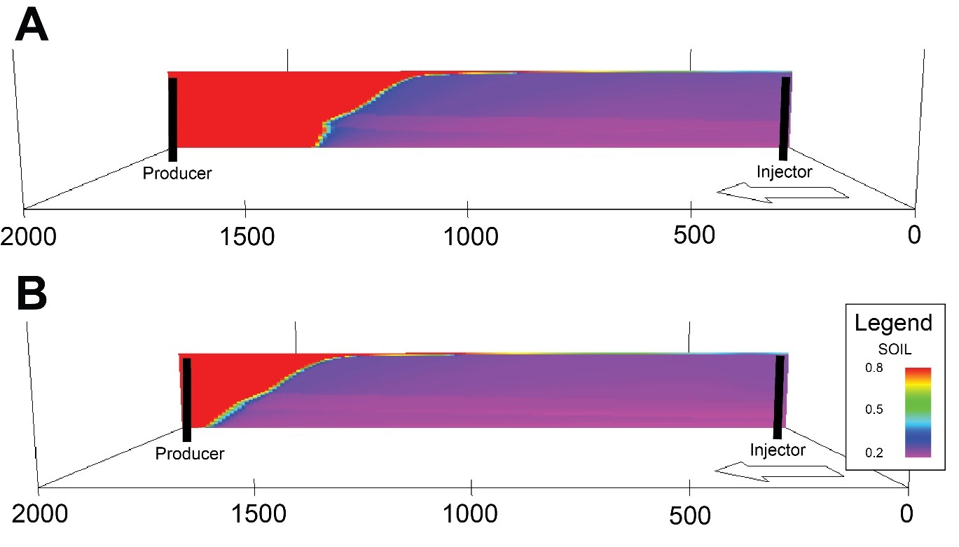
Fig. 13. Shows one slice along dip of a reservoir simulation from injector to producer after 1460 days displaying the percentage of oil in place between the user-defined object based model (A) and a standard channel box object-based model (B).
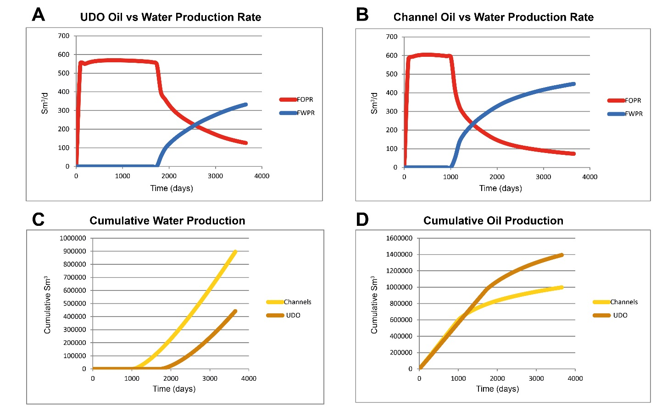
Fig. 14. Shows a comparison of a reservoir simulation between one water injector and one oil producer on the proposed user-defined object (UDO) based method and an objected based channel model over a 10 year period. A and B display results of field oil production rate (FOPR) and field water production rate (FWPR) at the surface in m³/day for the user-defined object based model and object based channel model, respectively. C compares the cumulative water production of a UDO vs an object based channel model. D compares the cumulative oil production of a UDO vs an object based channel model. Note the relatively early water breakthrough and lower cumulative oil production that is produced with an object based channel model.

Discussion & Conclusion
A quantitative geometric attribute characterization of a geobody can provide a substantial amount of information beyond manual virtual outcrop measurements that typically rely on maximum width and length to describe dimensions of objects. The main benefit of this is that it allows geobodies to be described as shapes in a way that is directly applicable in standard reservoir modelling software, and to be stochastically modelled using conventional object-based techniques (Fig. 10).
The application of the presented methodology to the channels belts of the Blackhawk Formation in the Beckwith Plateau demonstrates that detailed user-defined shapes can be characterized based on data from outcrop and modern systems for object based-modelling. Although it is recognized that other methods are available for fluvial facies (Deutsch and Tran 2002), the advantage of the present method is that it can be used across a range of depositional elements and shapes and based on actual measurements from outcrop and modern systems or conceptualized sketches. Furthermore, the automated method to analyse geometric data of outcrop or modern system interpretations can be used as input to describe the parameters of objects (e.g., thickness along strike) as required in object-based modelling or training image generator software (e.g., Deutsch and Tran 2002, Maharaja 2008). Previously, manual alternatives to measure geometries of an outcrop or modern geobody interpretation have been limited by feasibility and efficiently, typically only recording the maximum length and maximum thickness, which cannot be used to replicate the original objects shape geometrically (e.g., Eide et al., 2014).
Sedimentological databases that store repositories of geometric data for improved reservoir modelling (e.g., Dreyer et al. 1993, Colombera et al. 2012, Vakarelov & Ainsworth 2014) typically generate a suite of geometric parameters that are derived from tedious manual effort to plot specific relationships (Howell et al. 2014). Those relationships can be automatically generated and analysed from virtual outcrop as shown in the present study (e.g., Table 1, 2 and Fig. 9) in order to efficiently populate those databases. An opportunity for sedimentological databases offered by the current methodology is to describe interpretations geometrically in terms of shape that can subsequently be used directly by the reservoir modeller for object-based reservoir modelling workflows (e.g., Figs. 10 - 14) or object-based training image generators (e.g., Maharaja 2008).
Furthermore, accurately defined object-based models will improve training images for MPS modelling. This approach can produce the repetitive stationary shapes that are required in most MPS algorithms (Caers and Zhang 2004). The creation of more detailed training images proposed in this study expands on that of previous authors (Maharaja 2008; Pyrcz et al. 2008) to describe more realistic geological shapes. In addition, it provides a more objective methodology to describe geometric attributes from outcrop that otherwise is important in interpreting ancient depositional systems and building reservoir models (Alexander 1993; Bryant and Flint 1993; Grammer et al. 2004). As algorithms are improved by incorporating more realistic geological training images which contain non-stationary trends found within depositional systems (Hu and Chugunova 2008; Mariethoz et al. 2010), MPS will become an increasingly viable option for stochastic simulations over traditional object-based modelling. This in turn will increase the need for better, deterministic outcrop-based training images that represent the geological trends of depositional environments.
This paper has narrowed the discrepancy in efficiency for gathering geological outcrop geobody interpretations from VOMs and describing geobody interpretations geometrically for stochastic based reservoir modelling. The methodology presented, defines objects geometrically in an automated and objective approach as objects for stochastic object-based reservoir modelling. Geo-realistic reservoir models are important as volumetrically identical but topologically different sandbody reservoir geometries have different fluid flow characteristics. The continued integration of outcrop and modern analogue data into reservoir modelling suites as realistic geobody shapes is important in improving the topological relationship of sandbody representations and in developing training images for MPS modelling. It is foreseen that this contribution will encourage further discussion on improving the objective and automated geometric attribute and shape characterization of geobody interpretations from VOM and modern systems for stochastic based reservoir modelling.

Acknowledgements
The authors thank the FORCE consortium of oil companies (Bayern Gas, ConocoPhillips, Dana Petroleum, Dong Energy, Eni Norge, GDF Suez, Idemitsu, Lundin, Noreco, OMV, Repsol; Rocksource, RWE, Statoil, Suncor, Total, PDO and VNG) and the Norwegian Petroleum Directorate (NPD) for funding this research through the SAFARI Phase II project. Roxar AS and Riegl GmbH are acknowledged for providing academic software licenses.
References
Alexander, J. 1993. A discussion on the use of analogues for reservoir geology. Geological Society, London, Special Publications, 69, 175-194, doi: 10.1144/gsl.sp.1993.069.01.08.
Arnot, M.J., Good, T.R. & Lewis, J.J.M. 1997. Photogeological and image-analysis techniques for collection of large-scale outcrop data. Journal of Sedimentary Research, 67, 984-987.
Bellian, J.A., Kerans, C. & Jennette, D.C. 2005. Digital Outcrop Models: Applications of Terrestrial Scanning LiDAR Technology in Stratigraphic Modeling. Journal of Sedimentary Research, 75, 166-176.
Blaschke, T. 2010. Object based image analysis for remote sensing. ISPRS Journal of Photogrammetry and Remote Sensing, 65, 2-16, doi: http://dx.doi.org/10.1016/j.isprsjprs.2009.06.004.
Bryant, I.D. & Flint, S.S. 1993. Quantitative Clastic Reservoir Geological Modelling: Problems and Perspectives. The Geological Modelling of Hydrocarbon Reservoirs and Outcrop Analogues. Blackwell Publishing Ltd., 1-20.
Buckley, S.J., Howell, J.A., Enge, H.D. & Kurz, T.H. 2008a. Terrestrial laser scanning in geology: data acquisition, processing and accuracy considerations. Journal of Geological Society, 165, 625-638.
Buckley, S.J., Vallet, J., Braathen, A. & Wheeler, W. 2008b. Oblique helicopter-based laser scanning for digital terrain modelling and visualisation of geological outcrops. International Archives of the Photogrammetry, Remote Sensing and Spatial Information Sciences, 37, 493-498.
Caers, J. 2001. Geostatistical reservoir modelling using statistical pattern recognition. Journal of Petroleum Science and Engineering, 29, 177-188, doi: http://dx.doi.org/10.1016/S0920-4105(01)00088-2.
Caers, J. & Zhang, T. 2004. Multiple-point Geostatistics: A Quantitative Vehicle for Integrating Geologic Analogs into Multiple Reservoir Models. Integration of outcrop and modern analogs in reservoir modeling: AAPG Memoir, 80, 383-394.
Casciello, E., Thurmond, J.B., Fernandez, N., Saura, E., Romaire, I., Vergés, J. & Hunt, D.W. 2010. Geological Mapping and Structural Interpretation Using a Virtual Outcrop Digitiser, Examples from the Zagros (Iran): A New Spring for Geoscience. 72nd EAGE Conference and Exhibition incorporating SPE EUROPEC 2010 2639-2643.
Colombera, L., Felletti, F., Mountney, N. & McCaffrey, W. 2012. A Database Approach for Constraining Stochastic Simulations of the Sedimentary Heterogeneity of Fluvial Reservoirs. AAPG Bulletin, 96, 2143-2166, doi: DOI:10.1306/04211211179.
Deutsch, C.V. 2002. Geostatistical Reservoir Modeling. Oxford University Press, New York, New York.
Deutsch, C.V. & Tran, T.T. 2002. FLUVSIM: a program for object-based stochastic modeling of fluvial depositional systems. Computers & Geosciences, 28, 525-535, doi: http://dx.doi.org/10.1016/S0098-3004(01)00075-9.Deveugle, P.E.K., Jackson, M.D., Hampson, G.J., Stewart, J., Clough, M.D., Ehighebolo, T., Farrell, M.E., Calvert, C.S., Miller, J.K., 2014. A comparative study of reservoir modeling techniques and their impact on predicted performance of fluvial-dominated deltaic reservoirs. AAPG Bulletin 98, 729-763.
Dreyer, T., Fält, L.M., Høy, T., Knarud, R., Steel§, R. & Cuevas, J.L. 1993. Sedimentary Architecture of Field Analogues for Reservoir Information (SAFARI): A Case Study of the Fluvial Escanilla Formation, Spanish Pyrenees. The Geological Modelling of Hydrocarbon Reservoirs and Outcrop Analogues. Blackwell Publishing Ltd., 57-80.
Eide, C.H., Howell, J. & Buckley, S. 2014. Distribution of discontinuous mudstone beds within wave-dominated shallow-marine deposits: Star Point Sandstone and Blackhawk Formation, Eastern Utah. The American Association of Petroleum Geologists Bulletin, 98, 1401-1429.
Eide, C.H., Howell, J.A. & Buckley, S.J. 2015. Sedimentology and reservoir properties of tabular and erosive offshore transition deposits in wave-dominated, shallow-marine strata: Book Cliffs, USA. Petroleum Geoscience, doi: doi:10.1144/petgeo2014-015.
Enge, H.D., Buckley, S., Rotevatn, A. & Howell, J.A. 2007. From outcrop to reservoir simulation model: Workflow and procedures. Geosphere, 3, 469-490.
Enge, H.D. & Howell, J.A. 2010. Impact of deltaic clinothems on reservoir performance: dynamic studies of reservoir analogs from the Ferron Sandstone Member and Panther Tongue, Utah. AAPG Bulletin, 94, 139-161.
Enge, H.D., Howell, J.A. & Buckley, S.J. 2010. Quantifying clinothem geometry in a forced-regressive river-dominated delta, Panther Tongue Member, Utah, USA. Sedimentology, 57, 1750-1770, doi: 10.1111/j.1365-3091.2010.01164.x.
Eschard, R., Doligez, B. & Beucher, H. 2002. Using Quantitative Outcrop Databases as a Guide for Geological Reservoir Modelling. In: Armstrong, M., Bettini, C., Champigny, N., Galli, A. & Remacre, A. (eds.) Geostatistics Rio 2000. Springer Netherlands, Quantitative Geology and Geostatistics, 7-17.
Fielding, C.R. & Crane, R.C. 1987. An Application of Statistical Modelling to the prediction of Hydrocarbon Recovery Factors in Fluvial Reservoir Sequences In: Ethridge, F. G., Flores, R. M. & Harvey, M. D. (eds) Recent Developments in Fluvial Sedimentology. Society of Economic Paleontologists and Mineralogists Special Publication, 39, 321-327.
Grammer, G.M., Harris, P.M. & Eberli, G.P. 2004. Integration of outcrop and modern analogs in reservoir modeling: Overview with examples from the bahamas. In: Grammer, G.M., Harris, P.M. & Eberli, G.P. (eds) Integration of outcrop and modern analogs in reservoir modeling. American Association of Petroleum Geologists, AAPG Memoir, 80, 1 - 22.
Guardiano, F. & Srivastava, R.M. 1993. Multivariate Geostatistics: Beyond Bivariate Moments. In: Soares, A. (ed.) Geostatistics Tróia ’92. Springer Netherlands, Quantitative Geology and Geostatistics, 133-144.
Hampson, G.J., Royhan Gani, M., Sahoo, H., Rittersbacher, A., Irfan, N., Ranson, A., Jewell, T.O., Gani, N.D.S., Howell, J.A., Buckley, S.J. & Bracken, B. 2012. Controls on large-scale patterns of fluvial sandbody distribution in alluvial to coastal plain strata: Upper Cretaceous Blackhawk Formation, Wasatch Plateau, Central Utah, USA. Sedimentology, 59, 2226-2258, doi: 10.1111/j.1365-3091.2012.01342.x.
Hashemi, S., Javaherian, A., Ataee-pour, M., Tahmasebi, P., Khoshdel, H., 2014. Channel characterization using multiple-point geostatistics, neural network, and modern analogy: A case study from a carbonate reservoir, southwest Iran. Journal of Applied Geophysics 111, 47-58.
Hodgetts, D., Drinkwater, N.J., Hodgson, J., Kavanagh, J., Flint, S.S., Keogh, K.J., Howell, J.A., 2004. Three-dimensional geological models from outcrop data using digital data collection techniques: an example from the Tanqua Karoo depocentre, South Africa. Geological Society, London, Special Publications 239, 57-75.
Holden, L., Hauge, R., Skare, Ø., Skorstad, A., 1998. Modeling of Fluvial Reservoirs with Object Models. Mathematical Geology 30, 473-496.
Howell, J., Skorstad, A., MacDonald, A., Fordham, A., Flint, S., Fjellvoll, B. & Manzocchi, T. 2008. Sedimentological parameterization of shallow-marine reservoirs. Petroleum Geoscience, 14.
Howell, J.A. & Flint, S.S. 2004. Sequence stratigraphical evolution of the Book Cliffs succession. In: Coe, A.L. (ed.) The Sedimentary Record of Sea-Level Change. Cambridge University Press, Cambridge, UK.
Howell, J.A., Martinius, A.W. & Good, T.R. 2014. The application of outcrop analogues in geological modelling: a review, present status and future outlook. Sediment-Body Geometry and Heterogeneity: Analogue Studies for Modelling the Subsurface. Geological Society, London, Special Publications, 387.
Hu, L.Y. & Chugunova, T. 2008. Multiple-point geostatistics for modeling subsurface heterogeneity: A comprehensive review. Water Resources Research, 44, W11413, doi: 10.1029/2008WR006993.
Hu, L.Y., Liu, Y., Scheepens, C., Shultz, A.W., Thompson, R.D., 2014. Multiple-Point Simulation with an Existing Reservoir Model as Training Image. Mathematical Geosciences 46, 227-240.
Jones, R.R., Wawrzyniec, T.F., Holliman, N.S., McCaffrey, K.J.W., Imber, J. & Holdsworth, R.E. 2008. Describing the dimensionality of geospatial data in the earth sciences—Recommendations for nomenclature. Geosphere, 4, 354-359, doi: 10.1130/ges00158.1.
Kröner, S. & Doménech Carbó, M.T. 2013. Determination of minimum pixel resolution for shape analysis: Proposal of a new data validation method for computerized images. Powder Technology, 245, 297-313, doi: http://dx.doi.org/10.1016/j.powtec.2013.04.048.
Labourdette, R. 2011. The application of outcrop analogues in geological modelling: a review, present status and future outlook. AAPG Bulletin, 95, 585-617.
Larue, D.K. & Legarre, H. 2004. Flow units, connectivity, and reservoir characterization in a wave-dominated deltaic reservoir: Meren reservoir, Nigeria. AAPG Bulletin, 88, 303-324, doi: doi: 10.1306/10100303043.
Maharaja, A. 2008. TiGenerator: Object-based training image generator. Computers & Geosciences, 34, 1753-1761, doi: http://dx.doi.org/10.1016/j.cageo.2007.08.012.
Mariethoz, G., Renard, P. & Straubhaar, J. 2010. The Direct Sampling method to perform multiple-point geostatistical simulations. Water Resources Research, 46, W11536, doi: 10.1029/2008WR007621.
Massey, T.A., Fernie, A.J., Ainsworth, R., Nanson, R.A., Vakarelov, B.K., 2013. Detailed mapping, three-dimensional modelling and upscaling of a mixed-influence delta system, Mitchell River delta, Gulf of Carpentaria, Australia. In: Sediment Body Geometry and Heterogeneity: Analogue Studies for Modelling the Subsurface. Geological Society of London Special Publications 387.
Miall, A.D. & Tyler, N. 1991. The Three-Dimensional Facies Architecture of Terrigenous Clastic Sediments and Its Implications for Hydrocarbon Discovery and Recovery : Concepts in Sedimentology and Paleontology 3. SPEM.
Monsen, E., Savary-Sismondini, B., Bounaim, A., Brenna, T., Pedersen, S.I., Tjostheim, B., Sonneland, L., Hunt, D., Gillespie, P. & Thurmond, J. 2007. Automated 3D interpretation of fractures from photorealistic outcrop models. 69th European Association of Geoscientists and Engineers Conference and Exhibition 2007: Securing The Future. Incorporating SPE EUROPEC.
Nanson, R., Ainsworth, R., Vakarelov, B., Fernie, J. & Massey, A. 2012. Geometric attributes of reservoir elements in a modern, low accommodation, tide-dominated delta. APPEA Journal, 483-492.
Nyberg, B., Buckley, S.J., Howell, J.A., Nanson, R.A., (2015). Geometric attribute and shape characterization of modern depositional elements: A quantitative GIS method for empirical analysis, Computers & Geosciences, Vo. 82, 2015, p. 191-204.
Pickel, A., Frechette, J.D., Comunian, A., Weissmann, G.S., (2015). Building a training image with Digital Outcrop Models, Journal of Hydrology, Volume 531, Part 1, December 2015, Pages 53-61, ISSN 0022-1694, http://dx.doi.org/10.1016/j.jhydrol.2015.08.049.
Pringle, J.K., Howell, J.A., Hodgetts, D., Westerman, A.R. & Hodgson, D.M. 2006. Virtual outcrop models of petroleum reservoir analogues: a review of the current state-of-the-art. First Break, 24, 33-42, doi: DOI: 10.3997/1365-2397.2006005
Pyrcz, M.J., Boisvert, J.B. & Deutsch, C.V. 2008. A library of training images for fluvial and deepwater reservoirs and associated code. Computers & Geosciences, 34, 542-560, doi: http://dx.doi.org/10.1016/j.cageo.2007.05.015.
Rarity, F., van Lanen, X.M.T., Hodgetts, D., Gawthorpe, R.L., Wilson, P., Fabuel-Perez, I. & Redfern, J. 2014. LiDAR-based digital outcrops for sedimentological analysis: workflows and techniques. Geological Society, London, Special Publications, 387, doi: 10.1144/sp387.5.
Reynolds, A.D. 1999. Dimensions of Paralic Sandstone Bodies. AAPG Bulletin, 83, 221-229.
Ringrose, P. & Bentley, M. 2014. Reservoir Model Design: A Practitioner's Guide. Springer, London, UK.
Rittersbacher, A., Buckley, S., Howell, J., Hampson, G. & Vallet, J. 2014a. Helicopter-based laser scanning: a method for quantitative analysis of large-scale sedimentary architecture. in Sediment-body geometry and heterogeneity; analogue studies for modelling the subsurface Special Publication - Geological Society of London, 387.
Rittersbacher, A., Howell, J.A. & Buckley, S.J. 2014b. Analysis Of Fluvial Architecture In the Blackhawk Formation, Wasatch Plateau, Utah, U.S.A., Using Large 3D Photorealistic Models. Journal of Sedimentary Research, 84, 72-87, doi: 10.2110/jsr.2014.12.
Strebelle, S. 2002. Conditional Simulation of Complex Geological Structures Using Multiple-Point Statistics. Mathematical Geology, 34, 1-21, doi: 10.1023/A:1014009426274.
Strebelle, S., Levy, M., 2008. Using multiple-point statistics to build geologically realistic reservoir models: the MPS/FDM workflow. Geological Society, London, Special Publications 309, 67-74.
Tafesse, S., Fernlund, J.M.R. & Bergholm, F. 2012. Digital sieving-Matlab based 3-D image analysis. Engineering Geology, 137–138, 74-84, doi: http://dx.doi.org/10.1016/j.enggeo.2012.04.001.
Vakarelov, B. & Ainsworth, R. 2013. A hierarchical approach to architectural classification in marginal-marine systems: Bridging the gap between sedimentology and sequence stratigraphy. AAPG Bulletin, 97, 1121-1161, doi: DOI:10.1306/11011212024.
van der Werff, H.M.A. & van der Meer, F.D. 2008. Shape-based classification of spectrally identical objects. ISPRS Journal of Photogrammetry and Remote Sensing, 63, 251-258, doi: http://dx.doi.org/10.1016/j.isprsjprs.2007.09.007.
Viseur, S. 2010. Automated Methods for Fully Exploring and Interpreting LIDAR Data Points. 72nd European Association of Geoscientists and Engineers Conference and Exhibition Incorporating SPE EUROPEC 384-388.
Zeito, G.A. 1965. Interbedding of shale breaks and reservoir heterogeneities. Journal of Petroleum Technology, 17, 1223 - 1228.

