Wood Jam Dynamics Database and Assessment Model (WooDDAM): A Monitoring Protocol for an Evolving, Public Database and Predictive Model
Running Title: Wood Jam Dynamics Database and Assessment Model (WooDDAM)

Daniel N. Scott^{1*}, Ellen Wohl², Steven E. Yochum³

¹ University of Washington, Department of Each and Space Sciences, Seattle, WA, USA
² Colorado State University, Department of Geosciences, Fort Collins, CO, USA
³ U.S. Forest Service, National Stream and Aquatic Ecology Center, Fort Collins, CO, USA
* Corresponding author: Daniel N. Scott, scott93@uw.edu

This manuscript is currently under review in River Research and Applications. This version of the manuscript represents a non-peer reviewed initial submission. Subsequent versions of the manuscript may have different content. If accepted, the final version of this manuscript will be available via the “Peer-reviewed Publication DOI” link on this webpage. Please feel free to contact the corresponding author with suggestions to help improve this manuscript.

Acknowledgements
We received funding for this project from the U.S. Forest Service National Stream Aquatic Ecology Center and the Colorado Water Institute. We thank Natalie Kramer and Ellen Daugherty for thoughtful discussions that helped shape the ideas and methods presented here. Additionally, we thank Ellen Daugherty for extensive assistance in the field and Mike Vogler, Shannon Weld, Michaela Snow, and Breanna Van for field assistance in refining the measurement protocol. Data supporting this manuscript can be found on the website that hosts WooDDAM (sites.warnercnr.colostate.edu/woodjam) and the USFS website for this tool (https://www.fs.fed.us/biology/nsaec/products-tools.html#tools-woodjamdynamics).

Abstract
Wood jams in rivers and on floodplains play an essential role in shaping valley bottoms, and their dynamics regulate the ecology and morphology of river systems. We present the Wood Jam Dynamics Database and Assessment Model (WooDDAM) to improve understanding and management of natural and anthropogenic wood jams in rivers. WooDDAM is comprised of a field data collection protocol, an open database of wood jam characteristics and dynamics, machine learning statistical models for predicting wood jam dynamics during high flows, and an online user interface to facilitate collaborative data collection and use. Here, we provide the background and guidance necessary to utilize WooDDAM to make predictions of and contribute to the database describing wood jam dynamics. We present tests of interoperator variability to justify database variable selection. To refine model predictions and improve predictive power, we encourage users to follow simple resurvey procedures and submit observations of wood jam dynamics. WooDDAM provides a management and monitoring tool for the retention or reintroduction of wood jams in rivers and facilitates further research into the interactions between wood jam dynamics and fluvial or ecological processes.

Keywords
Wood jam; machine learning; dynamics; prediction; management

1. Introduction
Wood jams (3 or more wood pieces larger than 10 cm diameter and 1 m length) support habitat for diverse organisms (e.g., Coe et al., 2009; Francis et al., 2008; Klaar et al., 2011; Wohl, 2015) and drive overbank flow, forcing water, sediment, and nutrients onto floodplains (Jeffries et al., 2003; Sear et al., 2010; Wohl, 2013). Stable wood jams can alter erosion and deposition on the stream bed and banks and drive avulsion and island creation (Abbe & Montgomery, 2003; Bertoldi et al., 2009; Collins et al., 2012; Gurnell et al., 2005; Sear et al., 2010). Dynamic wood jams can generate spatial and temporal morphologic heterogeneity and regulate organic matter retention (Daniels, 2006; Sear et al., 2010). By interacting with bed sediment, banks, and living wood, wood jams shape channels and regulate fluvial processes (Brooks et al., 2003; Nakamura & Swanson, 1993; Scott et al., 2014).
Historic wood removal (Comiti, 2012; Sedell & Froggatt, 1984; Wohl, 2014) has motivated the reintroduction and active retention of wood in rivers as a mechanism of ecological restoration. However, wood can be hazardous to infrastructure and people (De Cicco et al., 2018; Mazzorana et al., 2009; Wohl et al., 2015). Balancing the positive ecological effects of wood jams with their potential hazards depends on building or retaining wood jams that will exhibit dynamics (change through time) that are desirable for given management goals (e.g., minimizing wood transport downstream while maximizing heterogeneity in a given reach). Recent wood reintroduction and retention efforts have shown that the use of more dynamic wood structures that work with river processes can be effective in stream restoration (Roni et al., 2015; Thompson et al., 2018). Such structures are typically not securely anchored in place, can be cheaper than stabilized structures, and can allow for restoration of process as well as form over long stream segments. An inability to predict wood jam dynamics hampers our ability to use engineered wood structures or naturally deposited jams cost-effectively and sustainably.
Although the National Large Wood Manual suggests a force and moment analysis of large wood structures (USBR & ERDC, 2016), this analysis does not account for rearrangement of the jam during high flow, jams that are not secured (i.e., those in which wood pieces can act independently of one another), complex interactions between jams and relatively immobile objects on the bed and banks, and jams with high porosity. Such an analysis is insufficient to predict natural and natural-analog wood jam dynamics.
Here, we present the Wood Jam Dynamics Database and Assessment Model (WooDDAM), including a field data collection protocol, an evolving wood jam characteristics and dynamics database, supervised machine learning models of wood jam dynamics, and online user interface. This tool accomplishes three primary objectives:
- Provide a reproducible survey protocol to survey wood jam characteristics and, via repeat surveys, wood jam dynamics in varied environments. By ensuring that measurements are reproducible, research, management, and practitioner teams can contribute to the database and help improve the machine learning models without introducing excessive unknown bias.
- Create a well-organized database that is regularly archived, open to the public, and facilitates ancillary research.
- Provide contextualizable, interpretable, and accurate predictions of wood jam dynamics via supervised machine learning models. As the database of wood jam dynamics grows, it can provide more training data for these machine learning models, thus improving model predictions and applicability. For more informed management, the statistical models and associated user-interface allow users to understand how the model developed its prediction (i.e., which wood jam characteristics are most important) and whether the newly predicted data are similar to data used to train the model.
WooDDAM represents a hypothesis: that a collaborative approach to observing wood jams can generate a database sufficient to drive working machine learning models of wood jam dynamics. We describe WooDDAM’s approach to encourage others to consider using it for management and research. Community use of this tool will help test this hypothesis and benefit users of the tool via access to the public database and, once the models are sufficiently reliable, access to robust predictions of wood jam dynamics.

2. WooDDAM Component Descriptions
WooDDAM is primarily accessed via a web interface, hosted at https://sites.warnercnr.colostate.edu/woodjam (permalink also available at: https://www.fs.fed.us/biology/nsaec/products-tools.html#tools-woodjamdynamics). This web interface provides tools to facilitate data collection (the survey protocol), enables viewing and downloading of the database, and facilitates use of the predictive models of wood jam dynamics.

2.1 Reproducible Field Survey Protocol to Measure Wood Jam Characteristics and Dynamics
The WooDDAM field survey protocol facilitates the collection of wood jam characteristics and associated hydrologic regime and valley bottom characteristics (Table 1), as well as the observation of wood jam dynamics via repeat surveys. While an initial survey of wood jam characteristics is all that is necessary to make predictions of wood jam dynamics (e.g., for management purposes), resurveys of wood jam dynamics after high flows are necessary to contribute to the database and improve the predictive models.
To describe the survey protocol and variables used to describe wood jams, we define a key piece as any large wood (approximately greater than 1 m in length and 0.10 m in diameter) that retains or supports other large wood in the jam, rather than the most stabilizing or largest pieces.

2.1.1 Variables Used to Characterize Wood Jam Characteristics and Dynamics
We group the variables used in WooDDAM into those that describe hydrologic regime, channel geometry, reach-scale valley bottom characteristics, relative location and geometry of the wood jam, physical characteristics of the wood jam, and how the wood jam has changed during a high flow. Table 1 provides descriptions of each variable, as well as justifications relating each variable to wood jam dynamics. We describe wood jam characteristics and dynamics using primarily binary or categorical variables, which enhance reproducibility between multiple operators collecting data (see section 3.1). Figure 1 provides an example of how we use binary variables to describe wood jam geometry and interactions with valley bottom morphology.

Figure 1: Illustration depicting wood jam geometry and location measurements, and how they each determine either where a wood jam is located within a channel cross-section or the relative dimensions of the jam. Blue depicts explicit location metrics. Green depicts channel boundary location metrics. Brown depicts wood jam geometry and orientation metrics. See Table 1 for descriptions of each measurement. These measurements, when taken together, provide a comprehensive description of the location, size, and orientation of a wood jam relative to the geometry of the channel.

2.1.2 Field Survey Protocol
The field survey protocol consists of initial surveys to describe wood jam characteristics, followed by optional repeat surveys of jam dynamics after high flows. The prescribed measurements can be rapidly, reproducibly, and cheaply collected by a team of two in all fluvial conditions using only basic survey equipment (e.g., laser rangefinders; Scott et al., 2016), a field notebook or mobile device, a GPS enabled device, and a camera. The survey procedure generally takes between 5 and 15 minutes per wood jam for a 1-2 person team. After field data collection, wood jam observations are submitted to the database via the WooDDAM website and are manually reviewed for compatibility and completeness.
Resurveys consist of determining what change the wood jam experienced after a high flow (i.e., whether the jam mobilized, accumulated wood, lost wood, contracted, and/or expanded). To facilitate continued monitoring of jam dynamics, it is necessary to determine whether any of the initially measured characteristics changed following the initial survey and, if needed, to resurvey those characteristics. Repeat photography is necessary to document jam change through time: we strongly recommend taking photographs of the jam from the left, right, upstream, and downstream sides of the jam during each survey for comparison. We also recommend noting a descriptive location for each jam relative to local landmarks to assist with relocating the jam.

2.2 Wood Jam Characteristics and Dynamics Database
The wood jam monitoring database is designed to serve two purposes: 1) compile data to train the supervised machine learning models of jam dynamics; and 2) store repeat monitoring data of jam characteristics and the channel and watershed context in which they reside, serving as a resource for further research into relationships between jam dynamics, geomorphic change, human activities, and other environmental variables. The database is manually monitored for completeness.

2.3 Supervised Machine Learning Models to Predict Wood Jam Dynamics
Flow magnitude alone poorly predicts wood transport rates (Iroumé et al., 2015; Kramer & Wohl, 2014; Macvicar & Piégay, 2012). Instead, channel conditions surrounding wood jams are likely better predictors of wood jam longevity and dynamics (Roni et al., 2015). As such, the predictive models of jam dynamics are based on the hypothesis that the variables described above will be sufficient to predict jam dynamics for flow conditions below, near, or above bankfull stage.
These models utilize multiple logistic regression to predict the occurrence probability of binary jam change variables (mobilization, accumulation, losing wood, contraction, and expansion; Table 1). Statistical analyses are performed using the R statistical package (R Core Team, 2017). Logistic regression enables model interpretation: summary statistics describe the change in the odds of a given jam change for a unit increase in each predictor, holding other predictors constant (see section 3.2 below for examples). Supplemental Text 1 describes model fitting procedures.
Importantly, model predictions are not intended to be the only line of evidence for evaluating a specific jam. Because the model is interpretable, users can augment predictions by understanding why the model may have made a prediction and evaluating whether that prediction is valid given site-specific conditions (e.g., although a jam may be likely to accumulate wood, it cannot do so if there is no wood supply from upstream). In addition, comparing predicted data against the data from the WooDDAM database (summarized on the website), can give users some idea of the confidence expected from the model prediction: if newly submitted data are far out of the range of data used to train the model, users should be careful in applying the model prediction.
The online user interface and model interaction is implemented using the R package shiny (Chang et al., 2017). This package allows users with little to no experience in statistical modeling or coding to utilize the predictive model and database in an online user interface.

2.4 Measuring Reproducibility of Field Measurements
We performed two field tests to evaluate the best types of variables to include in WooDDAM to maximize interoperator reproducibility (necessary to create a reliable database). We hypothesized that: 1) measurements that required precise identification of wood jam boundaries (i.e., length, width, height) would be more difficult to reproduce between operators, 2) in describing porosity, an obstruction index would be more reproducible than a visual estimate of porosity as a percentage, and 3) simpler binary variables (i.e., variables that delineated whether key pieces touched certain parts of the channel) would be more reproducible than descriptive binary variables (i.e., variables that ask whether the jam met a certain description, such as being ramped on a bank or bridging the channel). See Supplemental Text 2 for methodological details.

3. Results and Discussion
As of February 2019, the wood jam dynamics database consisted of 399 unique jams, including 351 repeat surveys of jam dynamics, from 16 rivers ranging in bankfull width from 4 to 228 m and slope from 0.01 to 27.7%. Of the 351 jam dynamics observations, 35 jams (10%) mobilized, 98 (28%) accumulated wood, 55 (16%) lost wood, 8 (2%) contracted, none expanded, and 183 (52%) did not change. We resurveyed 202 jams after a flow of bankfull stage or greater, of which 35 (17%) mobilized and 76 (38%) did not change. Although the database does not include many repeat surveys after exceptionally high flows, the current data suggest that natural wood jams generally exhibit low rates of mobility, even under bankfull or greater flows. Bankfull stage appears to act as a mobility threshold: flows below bankfull tend not to mobilize jams, while mobilization is more likely but not guaranteed above bankfull flows; this is in agreement with the synthesis of Kramer and Wohl (2016).

3.1 Interoperator Variability Testing
Field tests indicated that measurements of wood jam width, length, and height were significantly more variable between operators than binary observations of relative jam geometry. Similarly, we found that binary descriptions of jam interactions with the valley bottom were more reproducible than categorical descriptions, and a categorical obstruction index was more reproducible than a visual estimate of porosity. See Supplemental Text 3 for details.

3.2 Example Model: Predicting Wood Jam Mobilization
From the data currently available, we built a preliminary multiple logistic regression model to predict jam mobilization given channel conditions, jam characteristics, and flow magnitude. We present this model with uncertainty shown by 95% confidence intervals to demonstrate the potential for WooDDAM predictive models if more data are submitted to the database, and with the disclaimer that this information should not be used for decision-making. This model indicates that jams are ${5.3}_{−4.1}^{+44.7}$ times less likely to mobilize with in situ key pieces, ${4.03}_{−2.9}^{+11.28}$ times more likely to mobilize when in a straight planform (compared to anastomosing), and ${3.63}_{−2.6}^{+9.5}$ times more likely to mobilize when in a meandering planform (compared to anastomosing). Jams are also ${22.6}_{−15.4}^{+70.3}$ more likely to mobilize during flows that are greater than bankfull, compared to those that are near bankfull. It is important to note that in the current database, no jams that resided in side channels or that experienced a flow less than bankfull stage mobilized. As such, this model currently predicts mobility likelihood for jams not in side channels and under flows greater than or equal to bankfull stage.
From 100 repeats of 10-fold cross validation, this model has a mean kappa statistic (a measure ranging from -1 to 1, with more positive values indicating better performance relative to random chance) of 0.25 ± 0.02, a mean true positive rate (rate at which true mobilizations are predicted correctly) of 0.25 ± 0.01, and a mean true negative rate (rate at which true non-mobilizations are predicted correctly) of 0.96 ± 0.002. While this model performs significantly better than random chance, its low rate of true positives indicate that it would currently be unwise to use this model for decision-making. However, the moderate success of this model even with the imbalanced and sparse data currently available indicates the potential of the WooDDAM machine learning framework to eventually be able to provide useful predictions of jam dynamics with the addition of more data.

4. Conclusions
We present a field data collection protocol, database, statistical model, and online user interface that facilitates collaborative data collection to describe wood jam dynamics in a variety of stream environments. We have provided justification for our choice of variables, tests of reproducibility, and our observations of jam dynamics. This paper essentially poses a hypothesis: that an adaptive, evolving database and model paired with a reproducible data collection protocol will prove to be an effective tool for furthering understanding and prediction of jam dynamics. Even while its predictions will not always be accurate, its interpretability will facilitate the integration of model predictions with other lines of evidence, leading to more effective management and understanding of wood jams in rivers.
Moving forward, we encourage investigators and practitioners to utilize this proposed data collection framework and submit easy-to-collect monitoring data to the database. In doing so, the database will continue to grow and support an increasingly more effective predictive model. At the same time, this database will likely prove a useful resource in quantifying factors such as wood jam longevity and expected natural characteristics of jams. We hope this will aid both investigators and policy-makers by both informing future research into the interactions between wood and fluvial geomorphology and policy that seeks to sustainably manage wood in rivers.

References
Abbe, T., & Montgomery, D. (2003). Patterns and processes of wood debris accumulation in the Queets river basin, Washington. Geomorphology, 51(1–3), 81–107. https://doi.org/10.1016/S0169-555X(02)00326-4
Bertoldi, W., Gurnell, A., Surian, N., Tockner, K., Zanoni, L., Ziliani, L., & Zolezzi, G. (2009). Understanding reference processes: Linkages between river flows, sediment dynamics and vegetated landforms along the Tagliamento River, Italy. River Research and Applications, 25(5), 501–516. https://doi.org/10.1002/rra.1233
Bilby, R. E. (1984). Removal of Woody Debris May Affect Stream Channel Stability. Journal of Forestry, (October), 609–613.
Boivin, M., Buffin-Bélanger, T., & Piégay, H. (2017). Interannual kinetics (2010–2013) of large wood in a river corridor exposed to a 50-year flood event and fluvial ice dynamics. Geomorphology, 279, 59–73. https://doi.org/10.1016/j.geomorph.2016.07.010
Braudrick, C. A., Grant, G. E., Ishikawa, Y., & Ikeda, H. (1997). Dynamics of Wood Transport in Streams: A Flume Experiment. Earth Surface Processes and Landforms, 22, 669–683.
Brooks, A. P., Brierley, G. J., & Millar, R. G. (2003). The long-term control of vegetation and woody debris on channel and flood-plain evolution: Insights from a paired catchment study in southeastern Australia. Geomorphology, 51(1–3), 7–29. https://doi.org/10.1016/S0169-555X(02)00323-9
Chang, W., Cheng, J., Allaire, J., Xie, Y., & McPherson, J. (2017). shiny: Web Application Framework for R.
De Cicco, P. N., Paris, E., Ruiz-Villanueva, V., Solari, L., & Stoffel, M. (2018). In-channel wood-related hazards at bridges: A review. River Research and Applications, 34(7), 617–628. https://doi.org/10.1002/rra.3300
Coe, H. J., Kiffney, P. M., Pess, G. R., Kloehn, K. K., & McHenry, M. L. (2009). Periphyton and Invertebrate Response to Wood Placement in Large Pacific Coastal Rivers. River Research and Applications, 25, 1025–1035.
Collins, B. D., Montgomery, D. R., Fetherston, K. L., & Abbe, T. B. (2012). The floodplain large-wood cycle hypothesis: A mechanism for the physical and biotic structuring of temperate forested alluvial valleys in the North Pacific coastal ecoregion. Geomorphology, 139–140, 460–470. https://doi.org/10.1016/j.geomorph.2011.11.011
Comiti, F. (2012). How natural are Alpine mountain rivers? Evidence from the Italian Alps. Earth Surface Processes and Landforms, 37(7), 693–707. https://doi.org/10.1002/esp.2267
Daniels, M. D. (2006). Distribution and dynamics of large woody debris and organic matter in a low-energy meandering stream. Geomorphology, 77(3–4), 286–298. https://doi.org/10.1016/j.geomorph.2006.01.011
Davidson, S. L., MacKenzie, L. G., & Eaton, B. C. (2015). Large wood transport and jam formation in a series of flume experiments. Water Resources Research, 51, 10065–10077. https://doi.org/10.1002/ 2015WR017446
Dunkerley, D. (2014). Nature and hydro-geomorphic roles of trees and woody debris in a dryland ephemeral stream: Fowlers Creek, arid western New South Wales, Australia. Journal of Arid Environments, 102, 40–49. https://doi.org/10.1016/j.jaridenv.2013.10.017
Francis, R. A., Tibaldeschi, P., & McDougall, L. (2008). Fluvially-deposited large wood and riparian plant diversity. Wetlands Ecology and Management, 16(5), 371–382. https://doi.org/10.1007/s11273-007-9074-2
Gurnell, A. M., Tockner, K., Edwards, P., & Petts, G. (2005). Effects of deposited wood on biocomplexity of river corridors. Frontiers in Ecology and the Environment, 3(7), 377–382.
Harmon, M. E., Woodall, C. W., & Sexton, J. (2011). Standing and Downed Dead Tree Wood Density Reduction Factors : A Comparison Across Decay Classes and Tree Species. Research Paper NRS-15.
Iroumé, A., Mao, L., Andreoli, A., Ulloa, H., & Ardiles, M. P. (2015). Large wood mobility processes in low-order Chilean river channels. Geomorphology, 228, 681–693. https://doi.org/10.1016/j.geomorph.2014.10.025
Jeffries, R., Darby, S. E., & Sear, D. A. (2003). The influence of vegetation and organic debris on flood-plain sediment dynamics: Case study of a low-order stream in the New Forest, England. Geomorphology, 51(1–3), 61–80. https://doi.org/10.1016/S0169-555X(02)00325-2
Klaar, M. J., Hill, D. F., Maddock, I., & Milner, A. M. (2011). Interactions between instream wood and hydrogeomorphic development within recently deglaciated streams in Glacier Bay National Park, Alaska. Geomorphology, 130(3–4), 208–220. https://doi.org/10.1016/j.geomorph.2011.03.017
Kramer, N., & Wohl, E. (2014). Estimating fluvial wood discharge using time-lapse photography with varying sampling intervals. Earth Surface Processes and Landforms, 852(March), 844–852. https://doi.org/10.1002/esp.3540
Kramer, N., & Wohl, E. (2016). Rules of the road: A qualitative and quantitative synthesis of large wood transport through drainage networks. Geomorphology, 279, 74–97. https://doi.org/10.1016/j.geomorph.2016.08.026
Macvicar, B., & Piégay, H. (2012). Implementation and validation of video monitoring for wood budgeting in a wandering piedmont river, the Ain River (France). Earth Surface Processes and Landforms, 37(12), 1272–1289. https://doi.org/10.1002/esp.3240
Mazzorana, B., Zischg, A., Largiader, A., & Hübl, J. (2009). Hazard index maps for woody material recruitment and transport in alpine catchments. Natural Hazards and Earth System Science, 9, 197–209. https://doi.org/10.5194/nhess-9-197-2009
Merten, E., Finlay, J., Johnson, L., Newman, R., Stefan, H., & Vondracek, B. (2010). Factors influencing wood mobilization in streams. Water Resources Research, 46, 1–13. https://doi.org/10.1029/2009WR008772
Merten, E. C., Vaz, P. G., Decker-Fritz, J. A., Finlay, J. C., & Stefan, H. G. (2013). Relative importance of breakage and decay as processes depleting large wood from streams. Geomorphology, 190, 40–47. https://doi.org/10.1016/j.geomorph.2013.02.006
Montgomery, D. R., & Buffington, J. M. (1997). Channel-reach morphology in mountain drainage basins. Bulletin of the Geological Society of America, 109(5), 596–611.
Nakamura, F., & Swanson, F. J. (1993). Effects of Coarse Woody Debris on Morphology and Sediment Storage of a Mountain Stream System in Western Oregon. Earth Surface Processes and Landforms, 18, 43–61.
Opperman, J. J., & Merenlender, A. M. (2007). Living trees provide stable large wood in streams. Earth Surface Processes and Landforms, 32, 1229–1238. https://doi.org/10.1002/esp
Opperman, J. J., Meleason, M., Francis, R. a., & Davies-Colley, R. (2008). “Livewood”: Geomorphic and Ecological Functions of Living Trees in River Channels. BioScience, 58(11), 1069. https://doi.org/10.1641/B581110
Prowse, T., & Culp, J. (2003). Ice breakup: a neglected factor in river ecology. Canadian Journal of Civil Engineering, 30, 128–144. https://doi.org/10.1080/09540250600667892
R Core Team. (2017). R: A Language and Environment for Statistical Computing. Vienna, Austria: R Foundation for Statistical Computing.
Roni, P., Beechie, T., Pess, G., Hanson, K., & Jonsson, B. (2015). Wood placement in river restoration: fact, fiction, and future direction. Canadian Journal of Fisheries and Aquatic Sciences, 72(3), 466–478. https://doi.org/10.1139/cjfas-2014-0344
Rood, S. B., Goater, L. A., Mahoney, J. M., Pearce, C. M., & Smith, D. G. (2007). Floods, fire, and ice: disturbance ecology of riparian cottonwoods. Canadian Journal of Botany, 85(11), 1019–1032. https://doi.org/10.1139/B07-073
Scott, D. N., Montgomery, D. R., & Wohl, E. (2014). Log step and clast interactions in mountain streams in the central Cascade Range of Washington State, USA. Geomorphology, 216, 180–186. https://doi.org/10.1016/j.geomorph.2014.04.004
Scott, D. N., Brogan, D. J., Lininger, K. B., Schook, D. M., Daugherty, E. E., Sparacino, M. S., & Patton, A. I. (2016). Evaluating survey instruments and methods in a steep channel. Geomorphology, 273, 236–243. https://doi.org/10.1016/j.geomorph.2016.08.020
Sear, D. A., Millington, C. E., Kitts, D. R., & Jeffries, R. (2010). Logjam controls on channel:floodplain interactions in wooded catchments and their role in the formation of multi-channel patterns. Geomorphology, 116(3–4), 305–319. https://doi.org/10.1016/j.geomorph.2009.11.022
Sedell, J. R., & Froggatt, J. L. (1984). Importance of streamside forests to large rivers: the isolation of the Willamette River, Oregon, U.S.A., from its floodplain by snagging and streamside forest removal. Verhandlungen Der Internationale Vereinigung Fur Theoretische Und Angewandte Limnologie, 22, 1828–1834.
Thompson, M. S. A., Brooks, S. J., Sayer, C. D., Woodward, G., Axmacher, J. C., Perkins, D. M., & Gray, C. (2018). Large woody debris “rewilding” rapidly restores biodiversity in riverine food webs. Journal of Applied Ecology, 55(2), 895–904. https://doi.org/10.1111/1365-2664.13013
USBR, & ERDC. (2016). National Large Wood Manual: Assessment, Planning, Design, and Maintenance of Large Wood in Fluvial Ecosystems: Restoring Process, Function, and Structure.
Wohl, E. (2011). Threshold-induced complex behavior of wood in mountain streams. Geology, 39(6), 587–590. https://doi.org/10.1130/G32105.1
Wohl, E. (2013). Floodplains and wood. Earth-Science Reviews, 123, 194–212. https://doi.org/10.1016/j.earscirev.2013.04.009
Wohl, E. (2014). A legacy of absence: Wood removal in US rivers. Progress in Physical Geography, 38(5), 637–663. https://doi.org/10.1177/0309133314548091
Wohl, E. (2015). Bridging the gaps: An overview of wood across time and space in diverse rivers. Geomorphology. https://doi.org/10.1016/j.geomorph.2016.04.014
Wohl, E., & Goode, J. R. (2008). Wood dynamics in headwater streams of the Colorado Rocky Mountains. Water Resources Research, 44(9), 1–14. https://doi.org/10.1029/2007WR006522
Wohl, E., Bledsoe, B. P., Fausch, K. D., Kramer, N., Bestgen, K. R., & Gooseff, M. N. (2015). Management of Large Wood in Streams: An Overview and Proposed Framework for Hazard Evaluation. American Water Resources Association, 52(2), 315–335. https://doi.org/10.1017/CBO9781107415324.004

Tables
Table 1: All variables included in the wood jam dynamics database that describe wood jam characteristics and dynamics. Key piece refers to any wood piece that retains or supports any other wood in the jam. Channel geometry measurements describe only the channel the wood jam resides in, even if there are multiple channels across the valley bottom. We categorize measurements by whether they describe hydrologic regime (blue), channel geometry (brown), reach-scale valley bottom characteristics (red), the location and geometry of the jam (purple), and the physical characteristics of a jam (green).

Measurement | Database Variable ID | Unit | Description | Justification
river | river |  | Full name of river
jam number | jam_num |  | One unique number per jam in a stream.
survey number | survey_num |  | Denotes whether an observation represents an initial survey (survey_num = 1) or a repeat survey (survey_num > 1)
descriptive location | loc_descriptive |  | Location relative to noticeable landmarks and position in channel (e.g., left or right bank)
latitude | lat |  | Decimal degrees, e.g., “+/- ###.#########”
longitude | lon |  | Decimal degrees, e.g., “+/- ###.#########”
perennial? | perennial | y, n | yes if the stream experiences surface flow year-round on an average water year | Indicates whether live woody vegetation may establish in channel and potentially stabilize wood jams (Dunkerley, 2014; Opperman & Merenlender, 2007; Opperman et al., 2008)
flashy? | flashy | y, n | yes if high flow events involve rapid increases in flow stage (e.g., low flow to bankfull in less than 24 hours) | Wood jam structure may behave differently under rapid versus slowly rising high flows, altering porosity and resulting drag force on jam. Flashy streams may be more likely to mobilize wood than non-flashy streams (Braudrick et al., 1997; Kramer & Wohl, 2016).
sustained peaks? | sustained_peaks | y, n | yes if high flow events are characterized by durations over approximately one week | Sustained high flow may result in greater rearrangement of jam structure, influencing porosity and resulting drag force (Kramer & Wohl, 2016)
ice jams? | ice_jams | y, n | yes if in a typical water year, the river transports enough large ice pieces to cause ice jams in the reach surrounding the wood jam | Ice jam breakup floods can be more erosive than non-ice floods (Prowse & Culp, 2003; Rood et al., 2007) and can transport large amounts of wood, even at low flows (Boivin et al., 2017).
melt-driven? | melt_driven | y, n | yes if in a typical water year, high flows are driven by the melt of snow or glacial ice | Diurnal flow fluctuations from melt flows can lead to substantial packing of jam material, reducing porosity.
bankfull depth | bfd | meters | bankfull depth that best characterizes the reach around the jam (see solid vertical line in confinement diagram below) | Provides information on hydraulic forces exerted on jam by high flow
bankfull width | bfw | meters | bankfull width that best characterizes the reach around the jam (see solid horizontal line in confinement diagram below)
local slope | s_percent | % | from above to below sediment wedge behind wood jam, or the slope that best characterizes the reach around the jam
visual clast size | clast_size | s, g, c, b, br | Visual estimate of dominant clast size on bed in reach surrounding jam: Sand [s] (<2mm), Gravel [g] (2-64mm), Cobbles [c] (64-256mm), Boulders [b] (>256mm), Bedrock [br] | Indicates channel roughness and relative energy level
bedform | bedform | sb, pr, pb, sp, c | from Montgomery and Buffington (1997): sand bed [sb], pool-riffle [pr], plane-bed [pb], step-pool [sp], cascade [c] | Indicates channel roughness and relative energy level
planform | planform | s, m, a, b | Straight if one channel and sinuosity < 1.5 [S], meandering if one channel and sinuosity >1.5 and evidence of migration (point bars, cut banks) [m], anastomosing if multiple channels and vegetated islands [a], braided if multiple channels and non/sparsely vegetated islands [b]. | Indicates channel roughness and relative energy level
isolated? | isolated | y, n | yes if no wood surrounding jam within sight or 5 channel widths upstream/downstream, whichever is shorter | Wood load can relate to wood transport capacity (Kramer & Wohl, 2016); isolated wood jams may be less stable.
in side channel? | side_channel | y, n | yes if bulk of wood resides in a channel with approximately less than half the cross-sectional area at bankfull flow of the main channel | Indicates relative channel transport capacity
floodplain present? | fp_present | y, n | yes if floodplain surface exists within valley near jam | Indicates rate of change in transport capacity as flow increases above bankfull (Wohl, 2011)
confined? | confined | y, n | 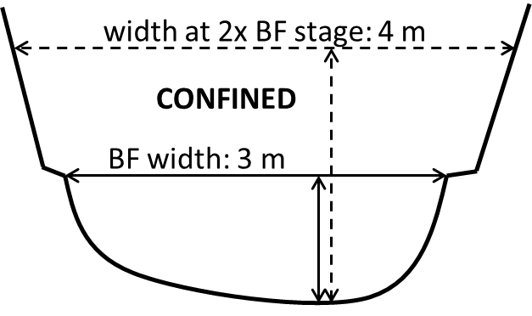  yes if the wetted width at 2x the bankfull stage is less than 1.5x the bankfull width  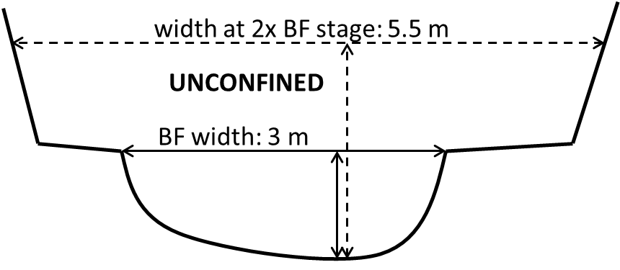
touches bed? | touch_bed | y, n | yes if any key pieces touch channel bed | Describes jam geometry (Figure 1) and key piece interactions with valley bottom morphology that can influence stability (Davidson et al., 2015)
touches banks? | touch_bank | y, n | yes if any key pieces touch channel bank
touches floodplain surface? | touch_fp | y, n | yes if any key pieces of the jam contact floodplain surface (including woody vegetated bar tops in anastamosing channels)
touches valley wall? | touch_valley_wall | y, n | yes if any key pieces of the jam contact valley wall surface (including terraces and objects fixed to valley wall like trees, stumps, infrastructure, etc.)
touches outer bend? | touch_outer | y, n | yes if any key pieces of the jam contact the outer bend of the channel. If no outer bend exists (e.g., straight channel) this must be no.
touches inner bend? | touch_inner | y, n | yes if any key pieces of the jam contact the inner bend of the channel. If no inner bend exists, this must be no.
occupies thalweg? | occ_thal | y, n | yes if any key pieces are in or above the thalweg.
channel spanning? | chan_span | y, n | yes if any key pieces or a combination of multiple key pieces together touch both channel banks
parallel orientation? | parallel_to_flow | y, n | yes if the bulk of the jam is longer (parallel to flow) than it is wide (perpendicular to flow)
key pieces >15 degrees? | key_over_15_deg | y, n | yes if any key pieces are at an angle over ~15 degrees relative to horizontal | Provides a threshold estimate of the rate of key pieces submergence (and buoying) during high flows
obstruction index (1-3) | obstruct_index | 1-3 | 3: Can't see light coming through most of the jam. Creates backwater and flow through jam is heavily obstructed. Estimated porosity <25%. 2: Can see light coming through the jam, but you may not be able to see through the jam in all spots. Flow likely interacts with wood but still flows through. Noticeable change in water surface elevation from upstream to downstream side of jam. Estimated porosity 25-75%. 1: Can see through most parts of the jam. Water flows freely (or would flow freely at high flow) through jam. Large voids. Estimated porosity >75%.  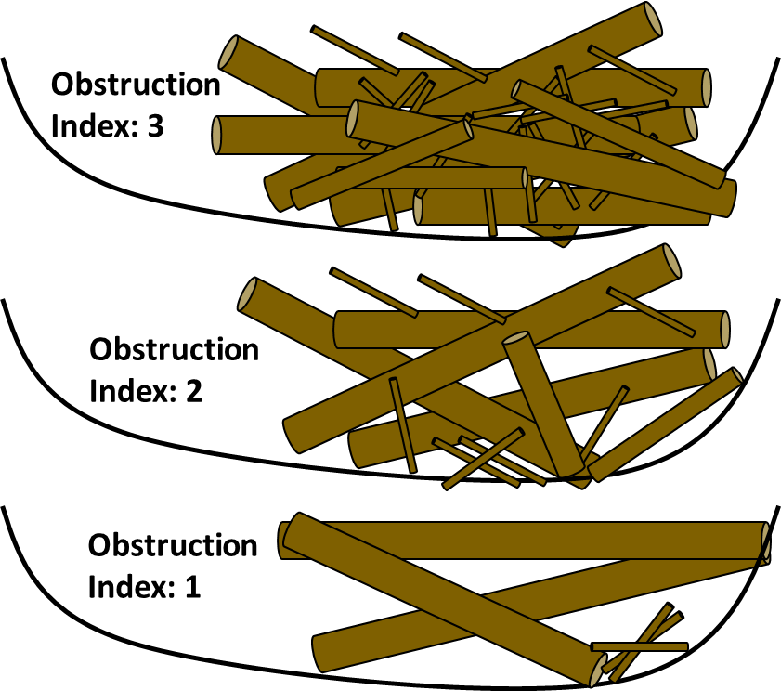 | As an alternative to visual estimates of porosity (see section 3.1), describes porosity and drag force experienced by jam during high flow
morphologically impactful? | morph_impact | y, n | yes if jam significantly impacted morphology around it (e.g., scour pools, bank erosion, deposited bars, sediment wedges) | Indicates sufficient stability to influence bed material sediment dynamics
buried? | buried | y, n | yes if any key pieces are at least partially buried by sediment | Buried key pieces are likely more stable than those resting on the bed (Bilby, 1984; Merten et al., 2010)
key pieces above bankfull? | key_above_bf | y, n | yes if any key pieces extend above bankfull depth. If jam touches floodplain surface, this must be yes. | If above bankfull depth, key pieces are less likely to float at bankfull flow.
fines? | fines | y, n | yes if there are fine pieces of wood or sediment visible on/in the jam | Indicates jam has withstood flows of stage at least as high as highest fine material deposited atop jam
pinned? | pinned | y, n | yes if any key pieces are pinned on a relatively immobile object (e.g., large boulders, live and non-sapling trees, mid-channel bars that have been stabilized by vegetation, bridge piers, etc.)  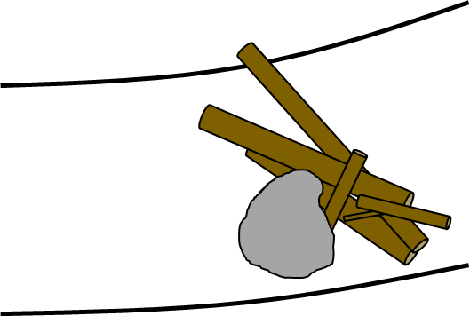 | Pinning (or anchoring, bracing) stabilizes key pieces during high flows (Merten et al., 2010), especially if key pieces cannot float over pinning object at bankfull flow.
pinning object above bankfull? | pin_obj_above_bf | y, n | yes if the object the jam is pinned on extends above bankfull depth. If jam is not pinned, this must be no.
decay class | decay_class | 1-5 | Scale paraphrased from Harmon et al. (2011) to describe key pieces. Most jams in rivers will be category 1-3, although some floodplain jams could be more decayed.  1: Sound, freshly fallen, intact logs with no rot, fine twigs attached with tight bark. 2: Sound log sapwood partly soft but can’t be pulled apart by hand, many fine twigs are gone and remaining fine twigs have peeling bark. 3: Heartwood is still sound with piece supporting its own weight, sapwood can be pulled apart by hand or is missing, wood color is reddish-brown or original color, only branch stubs are remaining which cannot be pulled out of log. 4: Heartwood is rotten with piece unable to support own weight, a metal pin can be pushed into heartwood, branch stubs can be pulled out. 5: There is no remaining structural integrity to the piece with a lack of circular shape as rot spreads out across ground, rotten texture is soft and can become powder when dry, wood color is red-brown to dark brown | Indicates key piece resistance to breakage and density, which may impact stability (Macvicar & Piégay, 2012; Merten et al., 2013; Wohl & Goode, 2008)
in situ? | in_situ | y, n | yes if any of the key pieces of the jam are sourced from the banks directly adjacent to the jam | In situ key pieces may be anchored to bank material, increasing resistance to mobilization
rootwads? | rootwads | y, n | yes if any rootwads are attached to any pieces in the jam | Indicates potentially higher complexity (Braudrick et al., 1997; Davidson et al., 2015; Merten et al., 2010) and potential interaction with relatively stable living vegetation (Dunkerley, 2014), both of which can increase stability
live wood? | live_wood | y, n | yes if live woody vegetation is growing on or proximal to the jam.
multi-trunk? | multi_trunk | y, n | yes if any key pieces have multiple trunks
survey picture time | pic_time_survey | HH:MM | used to reference photographs taken of jam for use in detecting change during resurveys
date of survey | date_survey | YYYY/MM  /DD | used to put resurvey data in temporal context, if resurvey data is provided
survey notes | notes_survey |  | used to provide additional context for jam characteristics
recharacterization needed | recharacterization_needed | y, n | yes if any of the above variables (including channel dimensions) have changed since the initial survey
resurvey picture time | pic_time_resurvey | HH:MM | used to reference photographs taken of jam for use in detecting change during resurveys
date of resurvey | date_resurvey | YYYY/MM  /DD | used to put resurvey data in context, if resurvey data is provided
resurvey notes | notes_resurvey |  | used to record change while in the field and provide contextual details (e.g., which logs were lost, how channel morphology may have changed, etc.)
qualitative magnitude of high flow | qual_mag_high_flow | below, near, or above bankfull | estimate of the qualitative magnitude of high flow using geomorphic and vegetation markers of recent peak flows (or gage data if available) | Predictions are given for each category of this variable, as bankfull flow acts as a mobility threshold (section 3.2; Kramer & Wohl, 2016)
quantitative magnitude of high flow | quant_mag_high_flow | cms | optional: the quantitative magnitude of high flow can be estimated from nearby flow gage data during the period between surveys
mobilized? | mobilized | y, n | yes if upon resurvey, wood jam is found to be either no longer a jam (lost enough pieces to be less than 3 pieces touching) or completely gone from its initial position | Describes potential changes a wood jam can experience during a high flow
lost wood? | lost_wood | y, n | yes if large wood pieces observed in the initial survey are unable to be located in the resurvey
accumulated wood? | accumulated | y, n | yes if new large wood pieces are observed in the resurvey that were not present during the initial survey
contracted? | contracted | y, n | yes if the volume of the jam decreased apart from any loss of wood
expanded? | expanded | y, n | yes if the volume of the jam increased apart from any accumulation of wood

