Wood Jam Dynamics Database and Assessment Model (WooDDAM): A Monitoring Protocol for an Evolving, Public Database and Predictive Model
Running Title: Wood Jam Dynamics Database and Assessment Model (WooDDAM)

Daniel N. Scott^{1*}, Ellen Wohl², Steven E. Yochum³

¹ University of Washington, Department of Each and Space Sciences, Seattle, WA, USA
² Colorado State University, Department of Geosciences, Fort Collins, CO, USA
³ U.S. Forest Service, National Stream and Aquatic Ecology Center, Fort Collins, CO, USA
* Corresponding author: Daniel N. Scott, scott93@uw.edu

This manuscript is currently in preparation for submission to River Research and Applications. This version of the manuscript represents a non-peer reviewed initial submission. Subsequent versions of the manuscript may have different content. If accepted, the final version of this manuscript will be available via the “Peer-reviewed Publication DOI” link on this webpage. Please feel free to contact the corresponding author with suggestions to help improve this manuscript.

Acknowledgements
We received funding for this project from the U.S. Forest Service National Stream Aquatic Ecology Center and the Colorado Water Institute. We thank Natalie Kramer and Ellen Daugherty for thoughtful discussions that helped shape the ideas and methods presented here. Additionally, we thank Ellen Daugherty for extensive assistance in the field and Mike Vogler, Shannon Weld, Michaela Snow, and Breanna Van for field assistance in refining the measurement protocol. Data supporting this manuscript can be found on the website that hosts WooDDAM (sites.warnercnr.colostate.edu/woodjam).

Abstract
Wood jams in rivers and on floodplains play an essential role in shaping valley bottoms. Jams are inherently complex and difficult to measure and collecting data on wood jam dynamics during high flows is complicated by the recurrence interval between flows that measurably change or mobilize a jam. We present the Wood Jam Dynamics Database and Assessment Model (WooDDAM) to improve understanding and management of both natural and anthropogenic wood jams in rivers. WooDDAM provides a platform for building a wood jam dynamics database as well as an evolving, machine-learning statistical model for predicting wood jam dynamics during high flows. The tool includes a field data collection protocol, wood jam dynamics database, predictive statistical model, and an online user interface to facilitate collaborative data collection. This article provides the background and guidance necessary to utilize WooDDAM to make predictions of and contribute to the database describing wood jam dynamics. We present tests of interoperator variability to justify database variable selection. To refine the model predictions and improve the predictive power, users are encouraged to follow simple resurvey procedures and submit new data. This statistical model provides a management tool for the retention or reintroduction of wood jams in rivers and facilitates further research into the interactions between wood jam dynamics and fluvial or ecological processes.

Keywords
Wood jam; machine learning; dynamics; prediction

1. Introduction
Wood is a fundamental component of riverine ecologic and geomorphic systems. Accumulations of wood, or wood jams (defined as 3 or more wood pieces larger than 10 cm diameter and 1 m length) can support habitat for diverse organisms (e.g., Coe et al., 2009; Francis et al., 2008; Klaar et al., 2011; Wohl, 2015) and drive overbank flow, forcing water, sediment, and nutrients onto floodplains (Jeffries et al., 2003; Sear et al., 2010; Wohl, 2013). Relatively stable wood jams can strongly alter erosion and deposition on the stream bed and banks and drive avulsion and island creation (Abbe & Montgomery, 2003; Bertoldi et al., 2009; Collins et al., 2012; Gurnell et al., 2005; Sear et al., 2010). Dynamic wood jams can generate spatial and temporal morphologic heterogeneity and regulate organic matter retention (Daniels, 2006; Sear et al., 2010). By interacting with bed sediment, banks, and living wood, wood jams shape channels and regulate fluvial processes (Brooks et al., 2003; Gurnell, 2013; Le Lay et al., 2013; Nakamura & Swanson, 1993; Scott et al., 2014).
Rivers have historically experienced widespread wood removal (Comiti, 2012; Sedell & Froggatt, 1984; Wohl, 2014). These activities have reduced channel roughness (e.g., Ruffing et al., 2015) and led to continually low wood loads and resulting negative impacts on aquatic habitat (Fausch & Northcote, 1992; Gerhard & Reich, 2000; Johnson et al., 2003; Wohl, 2014). This motivates the reintroduction and active retention of wood in rivers as a mechanism of ecological restoration. However, wood can be hazardous to infrastructure and people (Lucía et al., 2015; Mazzorana et al., 2009; Ruiz-Villanueva et al., 2013; Wohl et al., 2015). Wood can cause avulsions and drive overbank flows that threaten riparian infrastructure and can pose a risk to recreational river users.
Wood is commonly a high priority for management (Roni et al., 2015) due to its ecological and physical function as well as its potential to create hazards. Balancing the positive ecological effects of wood jams with their potential hazards depends primarily on building or retaining wood jams that will exhibit dynamics (change through time) that are desirable for a given management goals (e.g., minimizing wood transport downstream while maximizing heterogeneity in a given reach). The focus of wood reintroduction and retention efforts is shifting towards the use of more natural wood structures (Roni et al., 2015). Such structures are typically not anchored in place, can be cheaper than stabilized structures, and can allow for restoration of process as well as form over long stream segments. Unfortunately, our lack of knowledge of how wood jams change through time (i.e., wood jam dynamics) severely limits our ability to predict the impact of restoring or retaining wood in and around rivers, hampering our ability to cost-effectively and sustainably use natural-analog wood structures or retained natural wood jams in river restoration.
Wood jams can accumulate wood, lose wood, contract, expand, mobilize (i.e., lose most or all of the wood in the jam), or remain entirely unchanged during a given high flow. Together, these possible modes of change define how a wood jam will regulate nutrient, water, and sediment dynamics, pose hazards to people and riverine and riparian infrastructure, and provide habitat for organisms.
While wood piece mobility can be estimated using a force and moment balance approach (Merten et al., 2010; Rafferty, 2013; Rafferty, 2017; Wohl et al., 2015), such an approach is generally not applicable to wood jams, for which exact dimensions and shape are difficult to quantify. Although the National Large Wood Manual suggests a force and moment analysis of large wood structures (USBR & ERDC, 2016), this analysis does not account for: rearrangement of the jam during high flow; jams that are not secured (i.e., those in which wood pieces can act independently of one another); complex interactions between jams and relatively immobile objects on the bed and banks; and jams with high porosity. Due to these deficiencies, such a force and moment analysis is insufficient to predict natural and natural-analog wood jam dynamics.
Here, we present the Wood Jam Dynamics Database and Assessment Model (WooDDAM), including a field data collection protocol, an evolving wood jam characteristics and dynamics database, supervised machine learning models of wood jam dynamics, and online user interface. This tool is designed to accomplish three primary objectives:
- Provide a reproducible survey protocol to survey wood jam characteristics and, via repeat surveys, wood jam dynamics in varied environments. Because wood jams change on timescales ranging from seconds to hundreds of years (Collins et al., 2012; Kramer & Wohl, 2016), it is difficult to generate a statistically viable sample of wood jam dynamics in a reasonable amount of time without involving multiple investigators. By ensuring that measurements are reproducible, various research, management, and practitioner teams can contribute to the database and help improve the machine learning models without introducing excessive unknown bias.
- Create a well-organized database that is both regularly archived and open to the public. This allows users of the predictive models to investigate the data used to train the models and facilitates ancillary research that can benefit from a long-term, extensive database of wood jam characteristics and dynamics.
- Provide contextualizable, interpretable, and accurate predictions of wood jam dynamics via supervised machine learning models. These machine learning models can be repeatedly trained on the database of wood jam dynamics as it is continually updated with new data, thus improving model predictions and applicability to various scenarios as the database grows. However, a single probabilistic prediction of how a wood jam may change under a particular high flow will never be fully sufficient to be a sole source of guidance for wood jam management. Thus, the statistical models and associated user-interface are designed to allow users to understand how the model developed its prediction (i.e., which wood jam characteristics are most important) and whether the newly predicted data are similar to data used to train the model (which would indicate a higher likelihood of a correct prediction). This interpretability allows the probabilistic prediction provided by WooDDAM to be seamlessly integrated into other lines of evidence to guide decision-making.
WooDDAM represents a hypothesis: that a collaborative approach to observing wood jams can generate a database sufficient to drive working machine learning models of wood jam dynamics. Here, we describe WooDDAM’s approach to encourage others to consider using it for management and research. Community use of this tool will help us test this hypothesis as well as likely benefit users of the tool via access to the public database and, provided the models are eventually reliable enough, access to robust predictions of wood jam dynamics.

2. WooDDAM Component Descriptions
WooDDAM is primarily accessed via a web interface, hosted at https://sites.warnercnr.colostate.edu/woodjam. This web interface provides tools to facilitate data collection (the survey protocol), enables viewing and downloading of the database, and facilitates use of the predictive models of wood jam dynamics.

2.1 Reproducible Field Survey Protocol to Measure Wood Jam Characteristics and Dynamics
The WooDDAM field survey protocol facilitates the collection of wood jam characteristics (and associated hydrologic regime and valley bottom characteristics; Table 1), as well as the collection of wood jam dynamics (how a wood jam has changed between surveys) via repeat surveys. While an initial survey of wood jam characteristics is all that is necessary to utilize the predictive models (e.g., for management purposes), resurveys of wood jam dynamics performed after high flows are necessary to contribute to the database and help improve the predictive models. The general procedure for surveying a wood jam, submitting data to the database, and obtaining model predictions is outlined in Figure S1.
For the purpose of describing the survey protocol and variables used to describe wood jams, we define a key piece as any piece that retains or holds up other large wood (greater than 1 m in length and 0.10 m in diameter) in the jam, rather than just the most stabilizing or largest pieces.

2.1.1 Variables Used to Characterize Wood Jam Characteristics and Dynamics
The variables used in WooDDAM to describe wood jam characteristics can be grouped into those that describe hydrologic regime, channel geometry, reach-scale valley bottom characteristics, relative location and geometry of the wood jam, physical characteristics of the wood jam, and how the wood jam has changed during a high flow (Table 1). We describe wood jam characteristics and dynamics using primarily binary or categorical variables, which enhance reproducibility between multiple operators collecting data (see section 3.1).
Hydrologic regime is described by 5 binary variables: whether flow in the channel is perennial, the flow regime is flashy, high flow peaks are sustained, ice jams regularly occur, and whether high flows are driven by snow- or glacier-melt. Defining the stream as perennial versus ephemeral indicates whether live woody vegetation may be able to establish in the channel or on bars, potentially stabilizing wood jams (Dunkerley, 2014; Opperman & Merenlender, 2007; Opperman et al., 2008). High flows that rise quickly (flashy flow regime) may not allow for readjustment of pieces as flow rises (see section 4 below), meaning that the jam may not change during the rising limb of a high flow. In contrast, slowly rising and/or sustained flows can facilitate wood accumulation, contraction and rearrangement of jam pieces, and deposition of fine sediment and organic matter on the upstream face of the jam that may alter the interaction between hydraulic forces and the jam structure. Flashy streams can also be more likely to mobilize wood than non-flashy streams (Braudrick et al., 1997; Kramer & Wohl, 2016). Sustained peaks, especially those that are melt-driven, frequently exhibit diurnal flow fluctuation, resulting in substantial rearrangement of wood jam structure during high flows (see section 3.2), which may influence hydraulics around wood jams and their resulting dynamics (Kramer & Wohl, 2016). Additionally, ice jam breakup floods can be more erosive than non-ice floods (Prowse & Culp, 2003; Rood et al., 2007) and can transport large amounts of wood, even at low flows (Boivin et al., 2017).
Channel geometry is described by bankfull width, bankfull depth, and channel slope, which together provide information on the likely hydraulic forces exerted on a wood jam. Reach-scale valley bottom characteristics include planform, bedform, categorical clast size, valley confinement, whether the channel is a main or side channel, a floodplain is present, and whether there are other wood jams in the reach. Planform indicates the morphological roughness of the channel (e.g., a braided channel is expected to contain more bars than a straight channel). Similarly, bedform, described by the classification of Montgomery and Buffington (1997), denotes the presence or absence of pools or other bed roughness elements. Because these data are designed to be rapidly collected, simple categorical bed clast size is used, which provides an approximate characterization of the hydraulic energy level in the reach. The presence of a floodplain or an unconfined valley indicates a lower rate of change in transport capacity as flow increases above bankfull compared to a confined channel or one lacking a floodplain (Wohl, 2011). Differentiating channels into main versus side channels provides an indication of relative transport capacity (with side channels expected to have a lower capacity for a given stream). Although there is no direct mechanistic link between the presence of other pieces of wood in a reach and the dynamics of a given wood jam, there is some indication that wood load can relate to wood transport capacity (Kramer & Wohl, 2016), such that wood jams that are isolated within a reach may be less stable.
Latitude and longitude describe the absolute location of wood jams. The relative position and geometry of jams are described by whether the jam touches the bed, banks, the outer and/or inner banks where bends are present, floodplain surface, valley wall, and whether the jam occupies the thalweg, spans the channel, is oriented dominantly parallel or perpendicular to flow, has key pieces extending above bankfull depth, and has key pieces that are oriented at an angle of 15 degrees from horizontal or greater. The variables describing the orientation and the valley bottom surfaces touched or occupied by the jam provide a comprehensive picture of the jam geometry relative to the channel boundaries and floodplain (Figure 1). The location of key pieces of a jam within the channel or floodplain can influence its stability (Davidson et al., 2015). The angle of key pieces relative to the horizontal provides a threshold estimate of the rate of submersion during high flows – key pieces that are closer to horizontal will be submerged quickly as flow rises, while those at an angle to the horizontal will be submerged more slowly and could be more stable during rapid stage increases.

Figure 1: Illustration depicting wood jam geometry and location measurements, and how they each determine either where a wood jam is located within a channel cross-section or the relative dimensions of the jam. Blue depicts explicit location metrics. Green depicts channel boundary location metrics. Brown depicts wood jam geometry and orientation metrics. See Table 1 for descriptions of each measurement. These measurements, when taken together, provide a comprehensive description of the location, size, and orientation of a wood jam relative to the geometry of the channel.
The physical characteristics of a wood jam are described by the degree to which the jam obstructs flow, whether the jam has morphologically impacted the channel via scour or deposition, key pieces are buried in sediment, fine wood or sediment rest atop key pieces, the jam is pinned on a relatively immobile object, and whether that object extends above bankfull depth. Additional physical characteristics include the average decay class of the wood comprising the jam (Harmon et al., 2011), whether any key pieces forming the jam were sourced in situ from the bank immediately surrounding the jam, rootwads are present in the jam, wood comprising or growing off the jam is living, and whether key pieces have multiple trunks. Flow obstruction is measured by a 3-category index as an alternative to estimates of porosity, which is difficult to reproducibly estimate (see section 3.1). High obstruction index values indicate a lower porosity and likely higher drag forces during high flows. Morphologic impact is an indicator of sufficient stability to influence bed material sediment dynamics during flows of sufficient discharge to move bed material. Buried key pieces are likely more stable than those resting on the bed (Bilby, 1984; Merten et al., 2010). Fine wood or sediment deposition atop key pieces indicates that the jam has experienced submersion without mobilization. Pinning on a relatively immobile object (also described as anchoring or bracing) is likely to stabilize a wood jam during high flows (Merten et al., 2010), especially if the wood cannot be easily transported over the pinning object because that object extends above bankfull depth. Decay class provides an indication of both the density and durability of wood pieces, both of which may impact the stability and dynamics of the jam during high flows (Macvicar & Piégay, 2012; Merten et al., 2013; Wohl & Goode, 2008). In situ key pieces commonly remain anchored to bank material, possibly increasing stability. Rootwads and multi-trunk pieces both increase the complexity of key pieces, likely increasing the degree to which such pieces can entangle themselves with other objects in the channel and increase stability (Braudrick et al., 1997; Davidson et al., 2015; Merten et al., 2010). Finally, living wood can both indicate long-term stability, if growing atop a jam, and stabilize a jam through root growth into pieces in the jam and surrounding banks (Dunkerley, 2014).
Wood jam dynamics can be classified into 5 binary variables that describe the possible changes a wood jam may experience during high flow. These include whether a jam accumulated wood, lost wood, contracted, expanded, mobilized. It is important to note that aside from mobilization, these modes of change are non-exclusive, in that a wood jam can change in more than one way during a high flow (e.g., contract and accumulate wood).

2.1.2 Field Survey Protocol
The field survey protocol consists of initial surveys to describe wood jam characteristics, followed by optional repeat surveys of wood jam dynamics conducted after some period during which high flows might be expected to occur (e.g., spring for a snowmelt-dominated watershed). Resurveys are not necessary for obtaining wood jam dynamics predictions but are necessary for contributing to the database or continued monitoring.
The prescribed measurements are designed to be rapidly, reproducibly, and cheaply collected by a team of two in all fluvial conditions using minimal equipment. Because channel geometry measurements are only needed to give a general idea of channel geometry, efficient but less accurate survey equipment, such as handheld laser rangefinders, are suitable for collecting these data (Scott et al., 2016). All other measurements can be collected by examining the jam visually. Using a handheld laser rangefinder, this procedure generally takes between five and 15 minutes per wood jam for a 1-2 person team. The initial wood jam characteristics survey, ideally completed when jams are visible and accessible at low flow, can be submitted to the database in a spreadsheet format. The spreadsheet can be downloaded from the website (https://sites.warnercnr.colostate.edu/woodjam/) and the relevant columns for field data collection can easily be copied into a field notebook or be filled out on a mobile device in the field.
Wood jam observations submitted to the database via the data collection spreadsheet are identified by the river the wood jam is on, a number assigned by the operator, and a unique identifier code assigned to the observation as it is submitted to the database. All database submissions are manually reviewed by the database administrator (Scott) to ensure compatibility. Dates are recorded for each observation to facilitate temporal analyses. Each row in the database corresponds to a particular wood jam and (if data are collected and submitted) a single resurvey of that wood jam, showing how that wood jam changed over the time between surveys. Each time a jam is resurveyed, a new row is created and either populated with data from the initial survey (if no change occurred) or populated with updated data from the resurvey (if change to the jam or the surrounding channel occurred). New rows for a given jam (resurveys) are denoted by the appension of a number after the jam ID, which, in conjunction with the absolute location of each jam, can facilitate tracking of jam dynamics through time. We note that jam characteristics may not change enough to alter any measured variables, even if the wood jam experiences some form of change.
Resurveys consist of determining what change the wood jam experienced after a high flow (i.e., whether the jam mobilized, accumulated wood, lost wood, contracted, and/or expanded). Supporting data collected during resurveys includes repeat photographs and estimates of the peak flow magnitude between surveys. The website facilitates resurveys by allowing users to download only the portion of the database that needs resurveying in a spreadsheet format compatible with viewing and filling out on a mobile device in the field (or being filled out after fieldwork).
The database can accommodate a qualitative and quantitative (peak discharge, if an appropriate gage exists) description of peak flow magnitude between resurveys. The qualitative description of peak flow between resurveys describes whether peak flows were below, near, or above bankfull stage.
To facilitate continued monitoring of wood jam dynamics, it is necessary to determine whether any of the initially measured characteristics changed during the high flow following the initial survey and to resurvey those characteristics if so. Commonly, change can be best noticed through the analysis of repeat photography; we strongly recommend taking photographs of the jam from the left, right, upstream, and downstream sides of the jam during each survey for comparison. We also recommend noting a descriptive location for each jam to assist with relocating the jam.
It is important to note that if a high flow is missed (e.g., if two flows at or above bankfull occur before resurveys are completed), the cause of the change can only be attributed to a flow of the peak magnitude between surveys or lower. Higher temporal resolution resurveys (e.g., after every storm during the rainy season) increases knowledge of how both low and high flows affect wood jam dynamics, while lower temporal resolution resurveys restrict information to only the highest flows that occur between surveys. If flow magnitude cannot be estimated, those data will not contribute to our understanding of how flow magnitude influences wood jam dynamics, but the provided data can still help relate jam and channel conditions to measured change.

2.2 Wood Jam Characteristics and Dynamics Database
The wood jam monitoring database is designed to serve two purposes: 1) compile data used to train the supervised machine learning models of wood jam dynamics; and 2) store repeat monitoring data of wood jam characteristics and the channel and watershed context in which they reside, serving as a resource for further research into relationships between wood jam dynamics, geomorphic change, human activities, and other environmental variables.
While the database is manually monitored, it also accommodates missing data, which may result from incomplete surveys or difficult survey conditions. Although wood jams with missing data cannot be used to train the predictive model, they can still be included in the database to facilitate ancillary research. WooDDAM as a whole represents a hypothesis: that predictive models based on the particular variables presented here can adequately predict wood jam dynamics. As time goes on and more data are submitted to the database, we will continually evaluate that hypothesis. It is unfortunately unfeasible to add new variables to the survey protocol without either collecting or imputing data to describe those new variables for previously measured jams (e.g., via analysis of survey photographs) or effectively starting the predictive model training over from scratch. However, we propose that collecting the data suggested here and testing the predictive models described below is an essential first step given the current lack of knowledge regarding controls on wood jam dynamics. While the database will be actively maintained in the short term, it will also be archived regularly on the CSU Digital Archive.

2.3 Supervised Machine Learning Models to Predict Wood Jam Dynamics
Flow magnitude alone is a poor predictor of wood transport rates (Iroumé et al., 2015; Kramer & Wohl, 2014; Macvicar & Piégay, 2012). Instead, it has been proposed that channel conditions surrounding wood jams are likely a better predictor of their longevity and how they may change over time (Roni et al., 2015). As such, the predictive models of wood jam dynamics are based on the hypothesis that the wood jam variables described above, which relate to wood jam and surrounding valley bottom characteristics, will be sufficient to predict wood jam dynamics.
These models utilize multiple logistic regression to predict a series of binary variables describing potential change a wood jam can experience during high flow. The output describes the probability of a wood jam experiencing change during a high flow (e.g., a given wood jam may be predicted to have a 76% probability of accumulating wood). All statistical analyses are performed using the R statistical package (R Core Team, 2017). Logistic regression allows relatively easy model interpretation. For each model, summary statistics can be output to describe the change in odds of the outcome for a unit change in each predictor holding other predictors constant (e.g., if a given variable is true, a jam might be x ± a times more likely to accumulate wood during a bankfull flow).
To avoid overfitting, we use multiple model selection techniques to select only relevant variables from the database to train the model. We first examine univariate relationships between all potential mechanistic predictors and the response to filter variables with extremely insignificant relationships to the response. We use the remaining variables to perform multiple logistic regression. We judge variable importance via a combination of effect size and confidence interval on the effect, and compare models using an Akaike Information Criterion (Wagenmakers & Farrell, 2004). We use bivariate analysis and a variable inflation factor to ensure that no two variables in the final model strongly correlate with one another, which could impair interpretation. Finally, to evaluate predictive accuracy, we perform repeat k-fold cross-validation appropriate to the sample size and computational power. We use the accuracy relative to the no-information rate (the likelihood of correct prediction from guessing based on only the past occurrence of the predicted event), kappa statistic, and, when appropriate, the true positive rate (defined as predicted true positives divided by the sum of true positives and false negatives) and true negative rate (defined as predicted true negatives divided by the sum of true negatives and false positives) to evaluate the predictive performance of the model across all cross-validations. To determine whether model selection significantly increases predictive performance, we also compare the filtered full model to the reduced model.
Because the statistical model must be adaptive to new data as users submit data to the database, the model must be periodically retrained using the procedure outlined above. Although the procedure will likely work as the dataset grows, we will periodically reevaluate the type of model we use and the model selection and testing procedure to ensure that it is appropriate given the nature of the database and developments in both statistical software and techniques.
Importantly, model predictions are not intended to be the only line of evidence for making a decision about a particular wood jam. Because the model is interpretable, users can utilize their knowledge to augment model predictions by understanding why the model may have made a prediction. In addition to this contextual knowledge, the model also reports summary statistics for pertinent predictor variables to show the similarity between data used to train the model and new data submitted to the model for prediction. This gives users some idea of the confidence expected from the model prediction. For instance, if newly submitted data are far out of the range of data used to train the model, users should be careful in applying the model prediction.
The online user interface and model interaction is implemented using the R package shiny (Chang et al., 2017). This package allows users with little to no experience in statistical modeling or coding to utilize the predictive model and database in an online user interface.

2.4 Methods: Measuring Reproducibility of Field Measurements
We performed two field tests to compare variability within different measurement categories among various operators to evaluate field measurement reproducibility. We hypothesized that: 1) measurements that required precise identification of wood jam boundaries (i.e., length, width, height) would be more difficult to reproduce between operators, 2) in describing porosity, an obstruction index would be more reproducible than a visual estimate of porosity as a percentage, and 3) simpler binary variables (i.e., variables that delineated whether key pieces touched certain parts of the channel) would be more reproducible than descriptive binary variables (i.e., variables that ask whether the jam met a certain description, such as being ramped on a bank or bridging the channel).
Our first field test included three professional geomorphologists and engineers (Master’s level or above with specific field experience in measuring wood in rivers). Our second field test included one professional geomorphologist as well as four undergraduate geology students, none of whom had experience collecting field data in a fluvial setting. For both tests, a handheld laser rangefinder (TruPulse 360) was used to measure distances and slopes (see Scott et al., 2016 for more details). All laser rangefinders were calibrated using factory recommendations before each test. All operators were given identical instructions for data collection both verbally and via an instruction sheet to which they could refer throughout the field work but were told not to discuss measurements in the field. All operators collected data on the same wood jams at the same time.
We measured interoperator variability using a coefficient of variation (defined as the variance normalized by the mean) for continuous numerical variables and a coefficient of unalikeability for binary or categorical variables. The coefficient of unalikeability is a measure of how often observations differ from one another (Kader and Perry, 2007; similar to coefficient of variation). We compared these coefficients using Wilcoxon rank-sum tests (Wilcoxon, 1945), visual examination, and examination of appropriate confidence intervals.

3. Results and Discussion

3.1 Interoperator Variability Testing
The field tests (n = 25 wood jams) indicate that width, length, and height measurements for wood jams were significantly more variable (p < 0.0001, 95% confidence interval on median coefficient of variation between 0.28 and 0.36) between operators than binary measurements meant to act as proxies for those geometric measurements (95% confidence interval on median coefficient of unalikeability between 0.00 and 0.00). Binary variables include whether the jam is channel spanning, touches the bank or bed, has key pieces that extend above bankfull depth, occupies the thalweg, and whether the jam is dominantly oriented parallel to flow (Figure 2). From this, we concluded that binary proxies for measurements of wood jam dimensions would be preferable in terms of maximizing reproducibility.

Figure 2: Boxplot showing coefficient of variation (for numerical variables: width, length, and heights) and coefficient of unalikeability (for binary variables). Bar represents median, top and bottom of box represent 3rd and 1st quartiles, respectively, and ends of dashed lines represent range of data, excluding outliers (which are represented as circles).
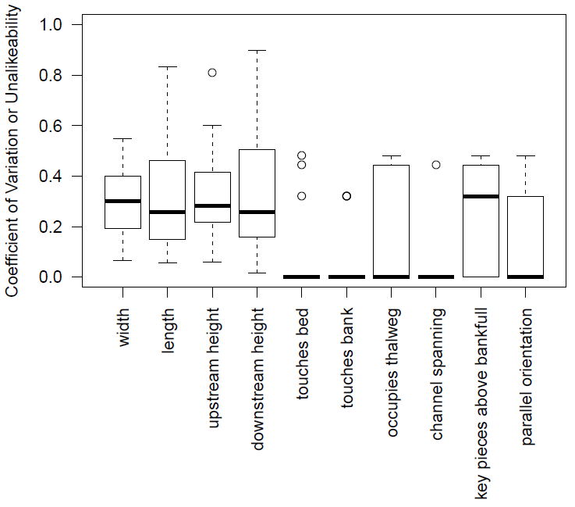

Using data on 8 jams with experienced operators (only this test included the porosity variable), porosity (95% confidence interval on median coefficient of variation between 0.43 and 0.58) was marginally more variable (p = 0.07) than obstruction index (95% confidence interval on median coefficient of unalikeability between 0.00 and 0.44). Thus, we concluded that obstruction index was likely a more reproducible way of measuring porosity than a visual estimate of porosity as a percentage. Using this same dataset, descriptive variables (whether the jam was bridging the channel or ramped on a bank) exhibited a higher unalikeability coefficient (95% confidence interval on median between 0.44 and 0.44) than binary variables that simply asked whether key pieces were touching a particular surface (touches bank, touches bed, 95% confidence interval on median between 0.00 and 0.00). This indicated that simpler binary variables were likely more reproducible than those that utilized descriptive terms commonly found in the literature (e.g., Wohl et al., 2010).

3.2 Database Summary and Limitations
As of November 2018, the wood jam dynamics database consists of 393 unique wood jams, including 345 repeat surveys of wood jam dynamics, from 15 rivers ranging in bankfull width from 4 to 228 m and slope from 0.01 to 27.7%. Of the 345 wood jam dynamics observations, 31 jams (9%) mobilized, 98 (28%) accumulated wood, 55 (16%) lost wood, 8 (2%) contracted, none expanded, and 183 (53%) did not change. 191 jams were resurveyed after a flow of bankfull stage or greater, of which 31 (16%) mobilized and 87 (46%) did not change. Although the database does not include repeat surveys after exceptionally high flows, the current data suggest that natural wood jams generally exhibit low rates of mobility, even under bankfull or greater flows. Bankfull stage appears to act as a mobility threshold, where flows below bankfull tend not to mobilize jams, but mobilization is certainly not guaranteed above bankfull flows, in agreement with the synthesis of Kramer and Wohl (2016).

3.3 Example Model: Predicting Wood Jam Mobilization
From the data currently available, we built a preliminary multiple logistic regression model to predict wood jam mobilization given channel conditions, wood jam characteristics, and flow magnitude. While this model is very limited by having only 31 observations of mobilization (of the 329 complete observations used to train the model), it indicates that burial (which makes jams ${4.0}_{−2.4}^{+6.8}$ times more likely to not mobilize), pinning against a relatively immobile object (which makes jams ${4.6}_{−3.2}^{+13.6}$ times more likely to not mobilize), and having in situ key pieces (which makes jams ${7.6}_{−6.3}^{+135.3}$ times more likely not to mobilize) all reduce the likelihood of jam mobilization. In addition, jams are more likely to mobilize during flows that are above bankfull, compared to those that are near or below bankfull. After performing 10-fold cross-validation 100 times, this model has a mean kappa statistic (a measure ranging from -1 to 1, with more positive values indicating better performance relative to random chance) of 0.40 ± 0.3 , a mean accuracy of 0.91 ± 0.005 , a mean true positive rate (rate at which true mobilizations are predicted correctly) of 0.42 ± 0.03 , and a mean true negative rate (rate at which true non-mobilizations are predicted correctly) of 0.96 ± 0.004 . While this model performs better than random chance, its low rate of true positives and accuracy that is indistinguishable from the no-information rate (91%) indicates that it would likely be unwise to put significant stock into wood jam dynamics predictions made by this model. However, the moderate success of this model even with the imbalanced and sparse data currently available indicates the potential of the WooDDAM machine learning framework to eventually be able to provide useful predictions of wood jam dynamics.

4. Conclusions
We present a field data collection protocol, database, statistical model, and online user interface that facilitates collaborative data collection to describe wood jam dynamics in a variety of stream environments. Although we have provided justification for our choice of variables to include in the database, either from previous results, tests of reproducibility, or our observations of wood jam dynamics from time-lapse monitoring, this paper essentially poses hypotheses. Specifically, we hypothesize that an adaptive, evolving database and model paired with a reproducible data collection protocol will prove to be an effective tool for furthering understanding and prediction of wood jam dynamics. Even while its predictions will not always be accurate, its interpretability will facilitate the integration of model predictions with user expertise, leading to more effective management and understanding of wood jams in rivers.
Moving forward, we encourage both investigators and practitioners to utilize this proposed data collection framework and submit easy-to-collect monitoring data to the database. In doing so, the database will continue to grow and support an increasingly more effective predictive model. At the same time, this database will likely prove a useful resource in quantifying factors such as wood jam longevity and expected natural characteristics of wood jams. We hope this will aid both investigators and policy-makers by both informing future research into the interactions between wood and fluvial geomorphology and policy that seeks to sustainably manage wood in rivers.

Tables
Table 1: All variables included in the wood jam dynamics database that describe wood jam characteristics and dynamics. These variables should be collected to run the wood jam dynamics model, and resurvey data should be collected to submit data to the database. Key piece refers to any wood piece that retains or holds up any other wood in the jam, not just the most stabilizing pieces. Measurements regarding channels relate solely to the channel the wood jam resides in, even if there are multiple channels across the valley bottom. We categorize measurements by whether they describe hydrologic regime (blue), channel geometry (brown), reach-scale valley bottom characteristics (red), the location and geometry of the jam (purple), and the physical characteristics of a jam (green).

Measurement | Possible Values | Description
river |  | Full name of river
jam # |  | One number per jam in a stream. Do not repeat numbers used for mobilized jams.
descriptive location |  | Location relative to noticeable landmarks and position in channel (e.g., left or right bank)
latitude |  | Decimal degrees, e.g., “+/- ###.#########”
longitude |  | Decimal degrees, e.g., “+/- ###.#########”
perennial? | y, n | yes if the stream experience surface flow year-round on an average water year
flashy? | y, n | yes if high flow events characterized by rapid increases in flow such that the bankfull channel can go from a low or moderate flow stage to a high flow stage in less than 24 hours
sustained peaks? | y, n | yes if high flow events are characterized by durations over approximately one week
ice jams? | y, n | yes if in a typical water year, the river transports enough large ice pieces to cause ice jams in the reach surrounding the wood jam
melt-driven? | y, n | yes if in a typical water year, high flows are driven by the melt of snow or glacial ice
bankfull depth | meters | bankfull depth that best characterizes the reach around the jam (see solid vertical line in confinement diagram below)
bankfull width | meters | bankfull width that best characterizes the reach around the jam
local slope | % | from above to below sediment wedge behind wood jam, or the slope that best characterizes the reach around the jam
visual clast size | S, G, C, B, BR | Visual estimate of dominant clast size on bed in reach surrounding jam: Sand [S] (<2mm), Gravel [G] (2-64mm), Cobbles [C] (64-256mm), Boulders [B] (>256mm), Bedrock [BR]
bedform | SB, PR, PB, SP, C | from Montgomery and Buffington (1997): sand bed [SB], pool-riffle [PR], plane-bed [PB], step-pool [SP], cascade [C]
planform | S, M, A, B | Straight if one channel and sinuosity < 1.5 [S], meandering if one channel and sinuosity >1.5 and evidence of migration (point bars, cut banks) [M], anastomosing if multiple channels and vegetated islands [A], braided if multiple channels and non/sparsely vegetated islands [B].
isolated? | y, n | yes if no wood surrounding jam within sight or 5 channel widths upstream/downstream, whichever is shorter
in side channel? | y, n | yes if bulk of wood resides in a channel with approximately less than half the cross-sectional area at bankfull flow of the main channel)?
floodplain present? | y, n | yes if floodplain surface exists within valley near jam, no if no floodplain exists
confined? | y, n | 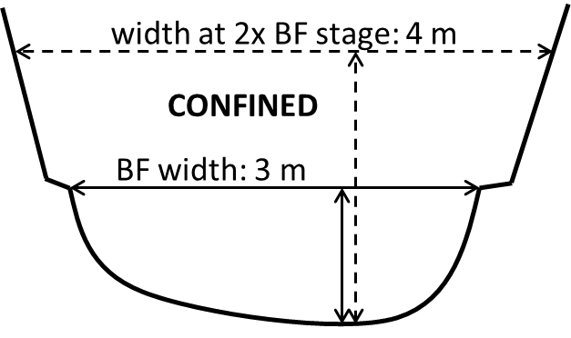  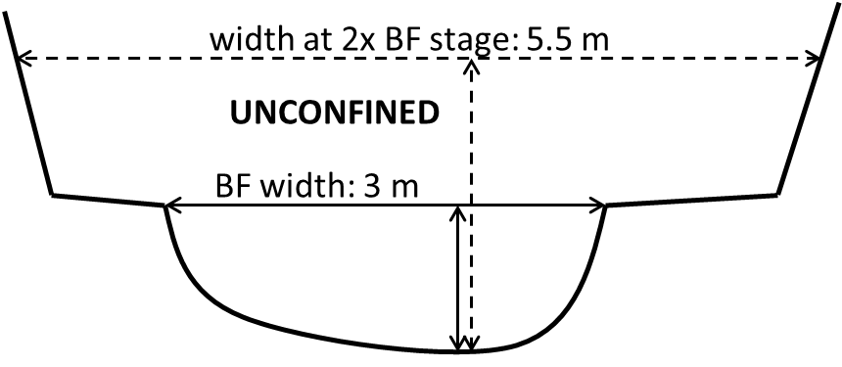  yes if the wetted width at 2x the bankfull stage is less than 1.5x the bankfull width, otherwise no:
touches bed? | y, n | yes if any key pieces of jam touch the channel bed
touches banks? | y, n | yes if any key pieces touch channel bank
touches floodplain surface? | y, n | yes if any key pieces of the jam contact floodplain surface (including woody vegetated bar tops in anastamosing channels)
touches valley wall? | y, n | yes if any key pieces of the jam contact valley wall surface (including terraces and objects fixed to valley wall like trees, stumps, infrastructure, etc.)
touches outer bend? | y, n | yes if any key pieces of the jam contact the outer bend of the channel. If no outer bend exists (e.g., straight channel) this must be no.
touches inner bend? | y, n | yes if any key pieces of the jam contact the inner bend of the channel. If no inner bend exists (e.g., straight channel) this must be no.
occupies thalweg? | y, n | yes if any key pieces are in or above the thalweg.
channel spanning? | y, n | yes if any key pieces or a combination of multiple key pieces together touch both channel banks
key pieces >15 degrees? | y, n | yes if any key pieces are at an angle over ~15 degrees relative to horizontal
parallel orientation? | y, n | yes if the bulk of the jam longer (parallel to flow) than it is wide (perpendicular to flow)
obstruction index (1-3) | 1-3 | 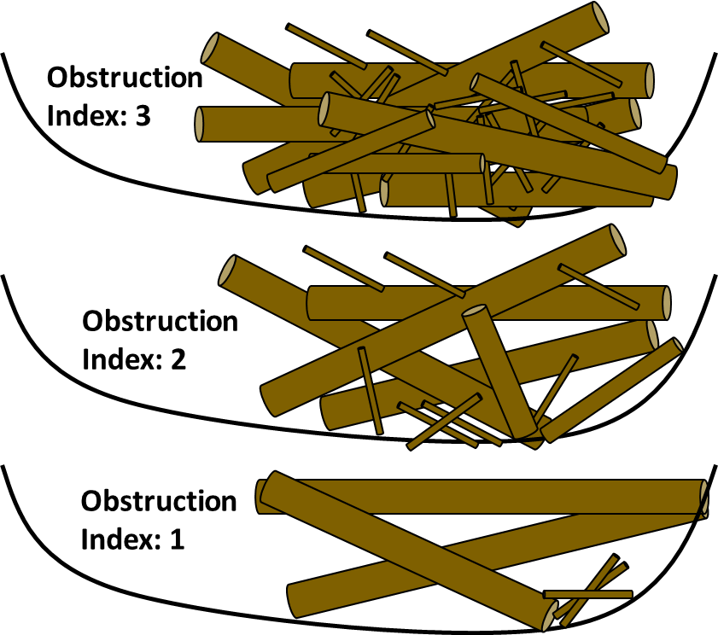  3: Can't see light coming through most of the jam. Creates backwater and flow through jam is heavily obstructed. Estimated porosity <25%. 2: Can see light coming through the jam, but you may not be able to see through the jam in all spots. Flow likely interacts with wood but still flows through. Noticeable change in water surface elevation from upstream to downstream side of jam. Estimated porosity 25-75%. 1: Can see through most parts of the jam. Water flows freely (or would flow freely at high flow) through jam. Large voids. Estimated porosity >75%.
morphologically impactful? | y, n | yes if jam significantly impacted morphology around it (e.g., scour pools, bank erosion, deposited bars, sediment wedges)
buried? | y, n | yes if any key pieces at least partially buried by sediment
key pieces above bankfull? | y, n | yes if any key pieces of the jam extend above bankfull depth. If jam touches floodplain surface, this must be yes.
fines? | y, n | yes if there are fine pieces of wood or sediment visible on/in the jam
pinned? | y, n | 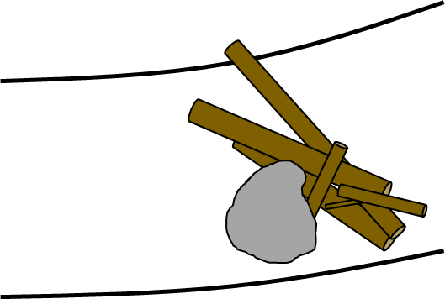  yes if any key pieces of jam are pinned on a relatively immobile object (e.g., large boulders, live and non-sapling trees, mid-channel bars that have been stabilized by vegetation, bridge piers, etc.)
pinning object above bankfull? | y, n | yes if the object the jam is pinned on extends above bankfull depth. If jam is not pinned, this must be no.
decay class | 1-5 | Scale paraphrased from Harmon et al. (2011). Most jams in rivers will be category 1-3, although some floodplain jams could be more decayed.  1: Sound, freshly fallen, intact logs with no rot, fine twigs attached with tight bark. 2: Sound log sapwood partly soft but can’t be pulled apart by hand, many fine twigs are gone and remaining fine twigs have peeling bark. 3: Heartwood is still sound with piece supporting its own weight, sapwood can be pulled apart by hand or is missing, wood color is reddish-brown or original color, only branch stubs are remaining which cannot be pulled out of log. 4: Heartwood is rotten with piece unable to support own weight, a metal pin can be pushed into heartwood, branch stubs can be pulled out. 5: There is no remaining structural integrity to the piece with a lack of circular shape as rot spreads out across ground, rotten texture is soft and can become powder when dry, wood color is red-brown to dark brown
in situ? | y, n | yes if any of the key pieces of the jam are sourced from the banks directly adjacent to the jam
rootwads? | y, n | yes if any rootwads are attached to any pieces in the jam
live wood? | y, n | yes if live woody vegetation is growing on or touching the jam, including any woody vegetation that is utilizing the jam as substrate to grow, growing through the jam, or growing proximal to the jam and touching it (e.g., if the jam is pinned on or bordered by live wood).
multi-trunk? | y, n | yes if any key pieces of jam have multiple trunks (common in species such as cottonwood, maple, etc.)
survey picture time | 24 hour format | Used to reference photographs taken of jam for use in detecting change during resurveys
date of survey | YYYY/MM  /DD | Used to put resurvey data in context, if resurvey data is provided
survey notes |  | Use to provide added context to observations. Helpful notes might include whether the jam was engineered or not, instructions for accessing the jam if access is difficult, how pictures were taken, etc.
recharacterization needed | y, n | yes if any of the above variables have changed since the initial survey (including channel dimensions). This enables data to simply be copied to the next observation for this jam if no change occurred.
resurvey picture time | 24 hour format | Used to reference photographs taken of jam for use in detecting change during resurveys
date of resurvey | YYYY/MM  /DD | Used to put resurvey data in context, if resurvey data is provided
resurvey notes
qualitative magnitude of high flow | below, near, or above bankfull | optional, but extremely helpful: the qualitative magnitude of high flow can be estimated during a resurvey using geomorphic and vegetation markers of recent peak flows
quantitative magnitude of high flow | cms | optional: the quantitative magnitude of high flow can be estimated from nearby flow gage data during the period between surveys
mobilized? | y, n | yes if upon resurvey, wood jam is found to be either no longer a jam (lost enough pieces to be less than 3 pieces touching) or completely gone from its initial position
lost wood? | y, n | yes if large wood pieces observed in the initial survey are unable to be located in the resurvey
accumulated wood? | y, n | yes if new large wood pieces are observed in the resurvey that were not present in the jam in the initial survey
contracted? | y, n | yes if the volume of the jam decreased noticeably apart from any loss of wood
expanded? | y, n | yes if the volume of the jam increased noticeably apart from any accumulation of wood

References
Abbe, T., & Montgomery, D. (2003). Patterns and processes of wood debris accumulation in the Queets river basin, Washington. Geomorphology, 51(1–3), 81–107. https://doi.org/10.1016/S0169-555X(02)00326-4
Bertoldi, W., Gurnell, A., Surian, N., Tockner, K., Zanoni, L., Ziliani, L., & Zolezzi, G. (2009). Understanding reference processes: Linkages between river flows, sediment dynamics and vegetated landforms along the Tagliamento River, Italy. River Research and Applications, 25(5), 501–516. https://doi.org/10.1002/rra.1233
Bilby, R. E. (1984). Removal of Woody Debris May Affect Stream Channel Stability. Journal of Forestry, (October), 609–613.
Boivin, M., Buffin-Bélanger, T., & Piégay, H. (2017). Interannual kinetics (2010–2013) of large wood in a river corridor exposed to a 50-year flood event and fluvial ice dynamics. Geomorphology, 279, 59–73. https://doi.org/10.1016/j.geomorph.2016.07.010
Braudrick, C. A., Grant, G. E., Ishikawa, Y., & Ikeda, H. (1997). Dynamics of Wood Transport in Streams: A Flume Experiment. Earth Surface Processes and Landforms, 22, 669–683.
Brooks, A. P., Brierley, G. J., & Millar, R. G. (2003). The long-term control of vegetation and woody debris on channel and flood-plain evolution: Insights from a paired catchment study in southeastern Australia. Geomorphology, 51(1–3), 7–29. https://doi.org/10.1016/S0169-555X(02)00323-9
Chang, W., Cheng, J., Allaire, J., Xie, Y., & McPherson, J. (2017). shiny: Web Application Framework for R.
Coe, H. J., Kiffney, P. M., Pess, G. R., Kloehn, K. K., & McHenry, M. L. (2009). Periphyton and Invertebrate Response to Wood Placement in Large Pacific Coastal Rivers. River Research and Applications, 25, 1025–1035.
Collins, B. D., Montgomery, D. R., Fetherston, K. L., & Abbe, T. B. (2012). The floodplain large-wood cycle hypothesis: A mechanism for the physical and biotic structuring of temperate forested alluvial valleys in the North Pacific coastal ecoregion. Geomorphology, 139–140, 460–470. https://doi.org/10.1016/j.geomorph.2011.11.011
Comiti, F. (2012). How natural are Alpine mountain rivers? Evidence from the Italian Alps. Earth Surface Processes and Landforms, 37(7), 693–707. https://doi.org/10.1002/esp.2267
Daniels, M. D. (2006). Distribution and dynamics of large woody debris and organic matter in a low-energy meandering stream. Geomorphology, 77(3–4), 286–298. https://doi.org/10.1016/j.geomorph.2006.01.011
Davidson, S. L., MacKenzie, L. G., & Eaton, B. C. (2015). Large wood transport and jam formation in a series of flume experiments. Water Resources Research, 51, 10065–10077. https://doi.org/10.1002/ 2015WR017446
Dunkerley, D. (2014). Nature and hydro-geomorphic roles of trees and woody debris in a dryland ephemeral stream: Fowlers Creek, arid western New South Wales, Australia. Journal of Arid Environments, 102, 40–49. https://doi.org/10.1016/j.jaridenv.2013.10.017
Fausch, K. D., & Northcote, T. G. (1992). Large Woody Debris and Salmonid Habitat in a Small Coastal British Columbia Stream. Canadian Journal of Fisheries and Aquatic Sciences, 49(4), 682–693. https://doi.org/10.1139/f92-077
Francis, R. A., Tibaldeschi, P., & McDougall, L. (2008). Fluvially-deposited large wood and riparian plant diversity. Wetlands Ecology and Management, 16(5), 371–382. https://doi.org/10.1007/s11273-007-9074-2
Gerhard, M., & Reich, M. (2000). Restoration of streams with large wood: Effects of accumulated and built-in wood on channel morphology, habitat diversity and aquatic fauna. International Review of Hydrobiology, 85(1), 123–137.
Gurnell, A., Tockner, K., Edwards, P., & Petts, G. (2005). Effects of deposited wood on biocomplexity of river corridors. Frontiers in Ecology and the Environment, 3(7), 377–382.
Gurnell, A. M. (2013). Wood in Fluvial Systems. In J. Schroder & E. Wohl (Eds.), Treatise on Geomorphology (Vol. 9, pp. 163–188). San Diego, CA: Elsevier Ltd. https://doi.org/10.1016/B978-0-12-374739-6.00236-0
Iroumé, A., Mao, L., Andreoli, A., Ulloa, H., & Ardiles, M. P. (2015). Large wood mobility processes in low-order Chilean river channels. Geomorphology, 228, 681–693. https://doi.org/10.1016/j.geomorph.2014.10.025
Jeffries, R., Darby, S. E., & Sear, D. A. (2003). The influence of vegetation and organic debris on flood-plain sediment dynamics: Case study of a low-order stream in the New Forest, England. Geomorphology, 51(1–3), 61–80. https://doi.org/10.1016/S0169-555X(02)00325-2
Johnson, L. B., Breneman, D. H., & Richards, C. (2003). Macroinvertebrate community structure and function associated with large wood in low gradient streams. River Research and Applications, 19(3), 199–218. https://doi.org/10.1002/rra.712
Kader, G. D., & Perry, M. (2007). Variability for Categorical Variables. Journal of Statistics Education, 15(2), 1–17.
Klaar, M. J., Hill, D. F., Maddock, I., & Milner, A. M. (2011). Interactions between instream wood and hydrogeomorphic development within recently deglaciated streams in Glacier Bay National Park, Alaska. Geomorphology, 130(3–4), 208–220. https://doi.org/10.1016/j.geomorph.2011.03.017
Kramer, N., & Wohl, E. (2014). Estimating fluvial wood discharge using time-lapse photography with varying sampling intervals. Earth Surface Processes and Landforms, 852(March), 844–852. https://doi.org/10.1002/esp.3540
Kramer, N., & Wohl, E. (2016). Rules of the road: A qualitative and quantitative synthesis of large wood transport through drainage networks. Geomorphology, 279, 74–97. https://doi.org/10.1016/j.geomorph.2016.08.026
Le Lay, Y. F., Piégay, H., & Moulin, B. (2013). Wood Entrance, Deposition, Transfer and Effects on Fluvial Forms and Processes: Problem Statements and Challenging Issues. Treatise on Geomorphology, 12, 20–36. https://doi.org/10.1016/B978-0-12-374739-6.00320-1
Lucía, A., Comiti, F., Borga, M., Cavalli, M., & Marchi, L. (2015). Dynamics of large wood during a flash flood in two mountain catchments. Natural Hazards and Earth System Sciences, 15(8), 1741–1755. https://doi.org/10.5194/nhess-15-1741-2015
Macvicar, B., & Piégay, H. (2012). Implementation and validation of video monitoring for wood budgeting in a wandering piedmont river, the Ain River (France). Earth Surface Processes and Landforms, 37(12), 1272–1289. https://doi.org/10.1002/esp.3240
Mazzorana, B., Zischg, A., Largiader, A., & Hübl, J. (2009). Hazard index maps for woody material recruitment and transport in alpine catchments. Natural Hazards and Earth System Science, 9, 197–209. https://doi.org/10.5194/nhess-9-197-2009
Merten, E., Finlay, J., Johnson, L., Newman, R., Stefan, H., & Vondracek, B. (2010). Factors influencing wood mobilization in streams. Water Resources Research, 46, 1–13. https://doi.org/10.1029/2009WR008772
Merten, E. C., Vaz, P. G., Decker-Fritz, J. A., Finlay, J. C., & Stefan, H. G. (2013). Relative importance of breakage and decay as processes depleting large wood from streams. Geomorphology, 190, 40–47. https://doi.org/10.1016/j.geomorph.2013.02.006
Montgomery, D. R., & Buffington, J. M. (1997). Channel-reach morphology in mountain drainage basins. Bulletin of the Geological Society of America, 109(5), 596–611.
Nakamura, F., & Swanson, F. J. (1993). Effects of Coarse Woody Debris on Morphology and Sediment Storage of a Mountain Stream System in Western Oregon. Earth Surface Processes and Landforms, 18, 43–61.
Opperman, J. J., & Merenlender, A. M. (2007). Living trees provide stable large wood in streams. Earth Surface Processes and Landforms, 32, 1229–1238. https://doi.org/10.1002/esp
Opperman, J. J., Meleason, M., Francis, R. a., & Davies-Colley, R. (2008). “Livewood”: Geomorphic and Ecological Functions of Living Trees in River Channels. BioScience, 58(11), 1069. https://doi.org/10.1641/B581110
Prowse, T., & Culp, J. (2003). Ice breakup: a neglected factor in river ecology. Canadian Journal of Civil Engineering, 30, 128–144. https://doi.org/10.1080/09540250600667892
R Core Team. (2017). R: A Language and Environment for Statistical Computing. Vienna, Austria: R Foundation for Statistical Computing.
Rafferty, M. (2013). Development of a computational design tool for evaluating the stability of large wood structures proposed for stream enhancement. Colorado State University.
Rafferty, M. (2017). Computational Design Tool for Evaluating the Stability of Large Wood Structures. Technical Note TN-103.2. Fort Collins, CO.
Roni, P., Beechie, T., Pess, G., Hanson, K., & Jonsson, B. (2015). Wood placement in river restoration: fact, fiction, and future direction. Canadian Journal of Fisheries and Aquatic Sciences, 72(3), 466–478. https://doi.org/10.1139/cjfas-2014-0344
Rood, S. B., Goater, L. A., Mahoney, J. M., Pearce, C. M., & Smith, D. G. (2007). Floods, fire, and ice: disturbance ecology of riparian cottonwoods. Canadian Journal of Botany, 85(11), 1019–1032. https://doi.org/10.1139/B07-073
Ruffing, C. M., Daniels, M. D., & Dwire, K. A. (2015). Disturbance legacies of historic tie-drives persistently alter geomorphology and large wood characteristics in headwater streams, southeast Wyoming. Geomorphology, 231(February), 1–14. https://doi.org/10.1016/j.geomorph.2014.10.029
Ruiz-Villanueva, V., Bodoque, J. M., Díez-Herrero, A., Eguibar, M. A., & Pardo-Igúzquiza, E. (2013). Reconstruction of a flash flood with large wood transport and its influence on hazard patterns in an ungauged mountain basin. Hydrological Processes, 27(24), 3424–3437. https://doi.org/10.1002/hyp.9433
Scott, D. N., Montgomery, D. R., & Wohl, E. (2014). Log step and clast interactions in mountain streams in the central Cascade Range of Washington State, USA. Geomorphology, 216, 180–186. https://doi.org/10.1016/j.geomorph.2014.04.004
Scott, D. N., Brogan, D. J., Lininger, K. B., Schook, D. M., Daugherty, E. E., Sparacino, M. S., & Patton, A. I. (2016). Evaluating survey instruments and methods in a steep channel. Geomorphology, 273, 236–243. https://doi.org/10.1016/j.geomorph.2016.08.020
Sear, D. A., Millington, C. E., Kitts, D. R., & Jeffries, R. (2010). Logjam controls on channel:floodplain interactions in wooded catchments and their role in the formation of multi-channel patterns. Geomorphology, 116(3–4), 305–319. https://doi.org/10.1016/j.geomorph.2009.11.022
Sedell, J. R., & Froggatt, J. L. (1984). Importance of streamside forests to large rivers: the isolation of the Willamette River, Oregon, U.S.A., from its floodplain by snagging and streamside forest removal. Verhandlungen Der Internationale Vereinigung Fur Theoretische Und Angewandte Limnologie, 22, 1828–1834.
USBR, & ERDC. (2016). National Large Wood Manual: Assessment, Planning, Design, and Maintenance of Large Wood in Fluvial Ecosystems: Restoring Process, Function, and Structure.
Wagenmakers, E.-J., & Farrell, S. (2004). AIC model selection using Akaike weights. Psychonomic Bulletin & Review, 11(1), 192–196. https://doi.org/10.3758/BF03206482
Wilcoxon, F. (1945). Individual Comparisons by Ranking Methods. Biometrics Bulletin, 1(6), 80–83. https://doi.org/10.2307/3001946
Wohl, E. (2011). Threshold-induced complex behavior of wood in mountain streams. Geology, 39(6), 587–590. https://doi.org/10.1130/G32105.1
Wohl, E. (2013). Floodplains and wood. Earth-Science Reviews, 123, 194–212. https://doi.org/10.1016/j.earscirev.2013.04.009
Wohl, E. (2014). A legacy of absence: Wood removal in US rivers. Progress in Physical Geography, 38(5), 637–663. https://doi.org/10.1177/0309133314548091
Wohl, E. (2015). Bridging the gaps: An overview of wood across time and space in diverse rivers. Geomorphology. https://doi.org/10.1016/j.geomorph.2016.04.014
Wohl, E., & Cadol, D. (2011). Neighborhood matters: Patterns and controls on wood distribution in old-growth forest streams of the Colorado Front Range, {USA}. Geomorphology, 125(1), 132–146. https://doi.org/10.1016/j.geomorph.2010.09.008
Wohl, E., & Goode, J. R. (2008). Wood dynamics in headwater streams of the Colorado Rocky Mountains. Water Resources Research, 44(9), 1–14. https://doi.org/10.1029/2007WR006522
Wohl, E., Cenderelli, D. A., Dwire, K. A., Ryan-Burkett, S. E., Young, M. K., & Fausch, K. D. (2010). Large in-stream wood studies: A call for common metrics. Earth Surface Processes and Landforms, 35(5), 618–625. https://doi.org/10.1002/esp.1966
Wohl, E., Bledsoe, B. P., Fausch, K. D., Kramer, N., Bestgen, K. R., & Gooseff, M. N. (2015). Management of Large Wood in Streams: An Overview and Proposed Framework for Hazard Evaluation. American Water Resources Association, 52(2), 315–335. https://doi.org/10.1017/CBO9781107415324.004

