A climatology of rain-on-snow events for Norway

Pardeep Pall, Lena M. Tallaksen, and Frode Stordal

Department of Geosciences, University of Oslo

Corresponding author email: pardeep.pall@geo.uio.no

This article is a non-peer reviewed preprint published at EarthArXiv

This work has been submitted for publication. Copyright in this work may be transferred without further notice, and this version may no longer be accessible.

Abstract

Rain-on-snow (ROS) events are complex multivariate hydrometeorological phenomena requiring a combination of rain and snowpack. Impacts include floods and landslides, and rain may freeze within the snowpack or on bare ground, potentially affecting vegetation, wildlife, and permafrost. ROS events occur mainly in high-latitude and mountainous areas, where sparse observational networks hinder accurate quantification – as does a scale mismatch between coarse (50-100 km) resolution re-analysis products and localised events. Variability in the rain-snow temperature threshold, and temperature sensitivity of snowmelt, adds additional uncertainty. Here the high-resolution (1 km) seNorge hydrometeorological dataset, capturing complex topography and drainage networks, is utilized to produce the first climatology of ROS events for mainland Norway. For daily data spanning 1957-2016, suitable rain and snowpack thresholds for defining ROS events are applied to construct ROS climatologies for 1961-1990 and 1981-2010, and investigate trends. Differing ROS characteristics are found, reflecting Norway’s diverse climates. Compared to 1961-1990, events in the 1981-2010 period decrease most in the southwest in winter, southeast in spring, and north in summer (consistent with less snow cover in a warming climate), and increase most in the southwest, central mountains, and north in winter-spring (consistent with increased precipitation and/or more snow falling as rain in a warming climate). Events also broadly correlate with the North Atlantic and Arctic Oscillations, with the latter dominating slightly. Finally, the extreme May 2013 ROS event in central Oppland county, causing devastating flooding, is examined to better understand the interplay between rain, snow, and temperature, with a view to future studies.

1. Introduction

While numerous studies exist on extreme rain events (Hartmann et al. 2013), studies of rain-on-snow (ROS) events are less commonplace – in part because they occur mainly in high latitude and mountainous areas (e.g. Ye et al. 2008; Hansen et al. 2014; McCabe et al. 2007; Beniston and Stoffel 2016). However, ROS events can also be extreme, if somewhat more complex, hydrometeorlogical phenomena requiring a sufficient combination of rain, snowpack, and snow cover to generate high impact events. Furthermore, each of these components need not necessarily be extreme in themselves to generate an impact, nor do they have to form simultaneously – such as when spring rain falls on winter snow still on the ground. Thus surface temperature and elevation is also a modulating factor (e.g. Wurzer et al. 2016), all adding to the complexity.

The impacts of ROS events are also complex, with most immediate impacts including floods, landslides, and snow avalanches, which result from a combination of rain and snowmelt (e.g. Marks et al. 1998; Harr 1981; Stimbers and Rubin 2011). However, there can also be longer term impacts, such as when fallen rain subsequently percolates and freezes within the snowpack, forming ice layers that can affect vegetation growth or produce ‘locked pastures’ that inhibit animals from foraging; with surface temperature being an important factor (Putkonen et al. 2009; Hansen et al. 2014). Furthermore, the latent heat released upon freezing of rain can ripen the snowpack, making it susceptible to future rain; deep-percolating rain and any subsequent ground ice formation can also affect the thermal budget of permafrost (Putkonen and Roe 2003; Westerman et al. 2011). Thus it is of value to understand the climatology of ROS events and how it might be affected by climate change.

This complexity of ROS events and associated impacts, however, has led to varying definitions for their quantification. Most studies require, at the very least, minimum daily thresholds for both rain and snowpack (typically characterized by its snow water equivalent (SWE), or snow depth) to be exceeded for a ROS event (on a daily timescale) to occur, but this can be augmented to include a snowmelt component if flooding is the focus (see e.g., Freudiger et al. 2014, and references therein). Furthermore, the thresholds can be region and impact specific – for example rain thresholds are typically higher for Alpine regions, reflecting the overall larger snowpacks in the region and thus larger amount of rain needed for flooding to occur (Beniston and Stoffel 2016; Wurzer et al. 2016). Other more general studies make more flexible definitions dictated by multiple impacts; e.g. Rennert et al. (2009) chose a low and high threshold for the rain component, reflecting the smaller scale impact on foraging ungulates and the larger scale impact on permafrost in the Arctic, respectively. In regions, such as the high Arctic, with continuous winter-spring snow cover, all rain events may be considered ROS events (Hansen et al. 2014), and this point may also apply in high-altitude regions. Additionally, the data product used to measure ROS components can itself dictate the definition. For example, if precipitation observations do not distinguish between rain and snowfall, then an additional criteria for a ROS event can be that SWE must decrease on successive days (Jeong and Sushama 2018); a simple temperature-based criterion may also be used to distinguish between rain and snow (Beniston and Stoffel 2016), although the same temperature threshold may not be applicable across all regions (Jennings et al. 2018).

Field investigations (e.g. Singh et al. 1997; Floyd and Weiler 2008; Garvelmann, et al. 2014; Trubilowicz and Moore 2017) and case studies (Marks et al. 1998; Sui and Koehler 2001; Pomeroy et al. 2016; Pradhanang et al. 2013; Hansen et al. 2014; Morán-Tejeda et al. 2016; Corripio and López-Moreno 2017) can offer good insight into the interplay between components of a ROS event, and serve as a bell weather for future changes. However, comprehensive large-scale studies are hindered by typically sparse observation networks in high latitude and mountainous regions, and studies based on global re-analysis suffer from a mismatch between the coarse resolution of the products (~50-100 km) and the fine scale of actual events. Accordingly, only general conclusions can be drawn, with more focus on the driving atmospheric circulation patterns (Rennert et al. 2009; Cohen et al. 2015). Thus, few good-resolution large-scale ROS studies exist to date (e.g. McCabe et al. 2007; Freudiger et al. 2014; Jeong and Sushama 2018).

In this study we construct a large-scale ROS climatology over all of mainland Norway for recent decades by taking advantage of an observationally-derived high-resolution (1 km, daily) gridded hydrometeorological data set: seNorge (Tveito et al. 2005). This data set was utilized recently by Rizzi et al. (2017), hereafter referred to as R17, to explore the effect of rising temperatures over recent decades on snow cover. They found that snow cover generally decreased, notably in spring and early summer, but with interesting regional variations, reflecting the varied hydroclimatology of Norway – ranging from northern arctic, to central alpine, to southern maritime. In this sense, Norway provides an interesting ‘laboratory’ for examining potential changes in regional characteristics of ROS events over recent decades, and our study thus also provides valuable insight transferable to similar climates in other parts of the world.

This is the first time, to our knowledge, that a ROS climatology has been constructed for mainland Norway. However, studies showing recent changes in heavy precipitation (Dyrrdal et al. 2012) and winter warming episodes (Vikhamar-Schuler et al. 2016) for some Norwegian regions, along with broader increases in precipitation and temperature (Hanssen-Bauer et al. 2017), do at least indicate that the risk of ROS events could have increased in some regions and seasons – and they are certainly a known major trigger of floods and other impacts (e.g. landslides and slush flows) in the country (Roald 2013; Hansen et al. 2014; Hanssen-Bauer et al. 2017). We also examine the relationship to large-scale circulation indices, to provide a broader context. Finally, we present a case study of the devastating ROS event occurring in May 2013 in southern Norway, in order to gain an initial understanding of the interplay between the hydrometeorological variables for this event – with a view to more detailed hydrological modeling in a future study.

2. Data & Methods

2.1 The seNorge dataset

seNorge is a high-resolution gridded hydrometeorological data set covering mainland Norway. It is produced by taking observations of temperature and precipitation from the Norwegian Meteorological Office observation network and optimally interpolating to a 1km grid; this subsequently drives an operational hydrological model from the Norwegian Water and Energy Directorate (NVE), which generates snow variables such as SWE, snow depth, and snow cover area (SCA), on the same grid. An overview of seNorge is found in Dyrrdal et al. (2012) and R17, including discussion of the limitations of the data set – related mainly to interpolation of variables over complex topography, lack of data homogeneity due to sparser observation networks at higher elevations, precipitation under catch, and change in the number of observing stations over time. We also note that an updated version (version 2) of the dataset is currently under development, particularly in terms of improving mountainous precipitation issues, but a new release is not planned until later in 2018 (Cristian Lussana, NVE, pers. comm.). For this reason we chose to use version 1 of the dataset, as also used in R17. Specifically, we use version 1.1 (Mohr 2009) for the meteorological variables of temperature and precipitation, where the latter was apportioned into rain and snowfall using a temperature threshold of 0.5°C (Saloranta 2012). Likewise we use version 1.1.1 of the snow model (Saloranta 2014) for the snow variables of SWE and SCA, where this model has improved routines for snow melt, accumulation, and distribution, compared to that of the original model (Saloranta 2012). Data is available from September 1957 to present, at daily resolution, and here we consider data up to November 2016.

2.2 ROS definition

Following conventional approaches, we define a ROS event based on daily rain and SWE thresholds both being exceeded. Specifically, a ROS event occurs in each grid square of our dataset on a day where there is at least 3mm of SWE, and at least 5 mm of rain. This choice is based mainly on the broad analysis of Rennert et al. (2009), and constitutes values generally applicable across a range of hydroclimates. In particular, we chose 5 mm as an intermediate threshold for rain, possibly most adapted to flood impacts, as the value lies in-between the values affecting foraging animals (3 mm), and permafrost (10 mm), according to Rennert et al. (2009). Specifically, we reason that, on a daily timescale and across a range of hydroclimates (as found in Norway), flood-inducing ROS events would generally involve rain heavier than 3 mm, but not necessarily heavier than 10 mm. We additionally require at least 25% daily SCA per grid square to mask out relatively small events. Choosing harsher criteria (SWE = 5 mm, rain = 10 mm, SCA = 50%), as found partly in some studies (e.g. Cohen et al. 2015), did not qualitatively affect our results (see Appendix), and some large-scale studies have even used more lax criteria (e.g. Jeong and Sushama 2018).

2.3 Study regions

Following R17, we conduct our analysis over four ‘macro regions’ for mainland Norway (see Figure 1, top left panel). These regions are derived from smaller climatic regions in Norway (Dyrrdal et al. 2012). Each macro region has its own aggregate climate characteristics, described as follows:

1) A south central ‘Mountain’ region (above 1000 m a.s.l.), with an alpine climate partially influenced by westerly Atlantic flows. This region is dominated by a complex mountain range that together with an extended, but less prominent, range continuing further northward, spans several latitudes (see R17 figure 1, or Dyrrdal et al. (2012) figure3c, for an elevation map). This topographic feature to a large part influences Norwegian weather on both the western coastline and eastern inland (see the other region descriptions below), and the region itself receives large amounts of precipitation from incoming low-pressure systems (Dyrrdal et al. 2012). The precipitation often falls as snow in higher elevation areas (on average, approximately 30% of the annual precipitation falls as snow (Saloranta 2014), and its distribution is complex reflecting the sharp gradients in topography (Dyrrdal et al. 2013), meaning that snow can persist for large parts of the year in some locations (snow cover above 800 m in southern Norway is present for at least 200 days of the year during the period 1971-2000, according to Hanssen-Bauer et al. 2017). This also means high discharge during spring and early summer due to snowmelt (and even glacier melt in late summer) (Vormoor et al. 2016).

2) A ‘Southwest’ region, with a mild wet maritime climate dominated by southwesterly Atlantic flows. Most precipitation in this region originates from moist flows from the Atlantic Ocean that collide with the steep central mountain range, resulting in heavy orographically-driven events, and an annual mean of more than 3500 mm in some parts (Dyrrdal et al. 2012; Vormoor et al. 2016). The year-to-year variability in Atlantic storminess is also reflected in the annual precipitation, which deviates up to ±30%, from the 1971-2000 baseline (Hanssen-Bauer et al. 2017). The highest precipitation occurs during fall and winter, as also reflected in discharge – with rain rather than snowmelt being the main runoff generating process in this milder southern climate (Vormoor et al. 2016). In fact, with mean annual temperatures of more than 6 ºC, compared to less than -3 ºC in the high-elevation areas of the Mountain region (Vormoor et al. 2016), the southern coast has the lowest climatological (1961-1990) annual SWE values (< 100 mm) in Norway, although these values rise toward the foothills (R17).

3) A ‘Southeast’ region, also with a maritime climate, but somewhat sheltered from westerly flows by the Mountain region. Accordingly, the inner parts of the Southeast region are characterized by a drier and colder continental climate (Dyrrdal et al. 2013). These inland regions receive the largest precipitation during summer (Vormoor et al. 2016). This can include convective precipitation that extends to the southern coast (Dyrrdal et al. 2018), which still experiences a somewhat maritime coastal climate associated with more southerly, and to a lesser extent easterly, moist continental flows (Roald et al., 2008).

4) A ‘North’ region, with a predominantly Arctic climate. However, there is some influence of warmer westerly flows at the coasts, particularly further south, akin to the Southwest region (Dyrrdal et al. 2013). Higher elevation areas along the spine of the North region share some of the snow and runoff characteristics with the southern central Mountain region (Vormoor et al., 2016). These high elevation areas also shelter the far northeast part of the region that, akin to inland areas of the Southeast region, experiences a dry and cold continental winter climate, where mean annual precipitation is as low as 300 mm (Vormoor et al. 2016).

2.4 Analysis methods

We primarily analyze ROS characteristics by constructing two long-term climatologies. Firstly, we construct a 30-year-average monthly climatology of daily ROS events for 1961-1990, which serves as our baseline (presented in Section 3.1). Secondly, we construct a corresponding 30-year climatology for 1981-2010, which we compare to our baseline to investigate ROS changes (presented in Section 3.2). These results are presented on nationwide maps (mainland only), and also as averages over the four study regions.

Furthermore, we investigate the timeseries of ROS events over the whole data period (September 1957-November 2016), and for each region (presented in Section 3.2). A trend is fitted to these time series using the Theil-Sen estimator (Theil 1950; Sen 1968), which is a nonparametric method for trend detection that is widely applied to hydrometeorological time series. Trend significance is estimated (at the 5% level) using the non-parametric Mann-Kendal test, suited to hydrometeorological data that are typically non-normally distributed and so would otherwise adversely affect probability of rejecting the null hypothesis of no trend (Yue and Pilon 2004).

To gain a broader perspective of ROS characteristics and their relation to the large-scale atmospheric circulation, we correlate our nationwide ROS counts against two established indices representing dominant modes of atmospheric variability known to influence northern European weather (presented in Section 3.3). Firstly, we correlate against the North Atlantic Oscillation index (NAOi), for which a positive index is associated with wetter winter weather funneled into northern Europe by pressure centers in the Atlantic, accompanied by drier weather in southern Europe (Hurrell et al. 2003). The opposite is true for a negative index. Secondly, we correlate against the Arctic Oscillation index (AOi), which is akin to the NAOi in its characteristics, but represents circulation more hemispherically zonal in nature, and is dictated by pressure centers more symmetric about the Arctic, given that it is a lower atmospheric manifestation of the polar vortex (Thompson and Wallace 1998). The Pearson correlation coefficient (Pearson 1931) was used throughout, and areas of correlation significant at the 1% level identified. Values of monthly NAOi and AOi were downloaded from the U. S. National Centers for Environmental Information webpages (www.ncdc.noaa.gov/teleconnections/nao/ & www.ncdc.noaa.gov/teleconnections/ao/, respectively) and averaged to seasonal values.

Finally, in order to gain a first-order insight into the types of ROS events that lead to floods, and the interplay between hydrometeorological variables, we look at the case study of the devastating May 2013 flooding in southeastern Norway (Sund 2014; Roald 2015). Specifically, we focus on hydrological catchments in the county of Oppland, and construct time series of ROS events, and corresponding rain, SWE, SCA, and surface temperature (presented in Section 3.4). This is all with a view to performing follow up studies addressing the hydrological modeling of such events.

3. Results

3.1 Baseline ROS climatology (1961-1990)

Our baseline 1961-1990 ROS climatology is displayed in Figure 1. Throughout winter-spring (November-May), and especially in the early winter months (December-January), ROS events occur most frequently in the Southwest region. This region very much dominates in terms of ROS activity during these months compared to the other regions, as summarized in Figure 3a. In particular, ROS events occur at higher elevation areas of the Southwest region, which form the foothills of the more mountainous central Norway (see Section 2.3). In fact, there is some continuation of the high frequency of ROS events into the western flank of the Mountain region during winter. A similar pattern is found for the western flank of high-elevation areas in the North region. Related to this, a rain shadow-type pattern is apparent in the Southeastern region on the eastern side of the Mountain region. ROS activity occurs here later into the spring (particularly in April/May, as illustrated by the peak in Figure 3a).

From late spring to early summer (May-July), ROS events dominate the Mountain region, and high-elevation areas of the North region. This is most clearly seen in Figure 3a, where ROS counts for these two regions are at a peak during this period compared to the rest of the year. After June/July, little ROS activity is found in all four regions (all curves are at a minimum in Figure 3a) until the snow season begins again in October/November – following the main mountain areas in Norway.

3.2 Change relative to baseline ROS climatology (1981-2010 versus 1961-1990)

Our 1981-2010 ROS climatology is compared to our baseline 1961-1990 climatology in Figure 2. For winter-spring the Southwest region exhibits mixed changes, with decreases in ROS events in coastal areas (peaking in December/January and April/May), and increases in the higher elevation foothill areas (particularly in January-February). These increases dominate the regional-average change, as seen in Figure 3b. These increases also continue into the western flank of the Mountain region, as well as the western flank of higher elevation areas in the North region, with a strong signal in January-March, moving further north in May. Minor changes are seen in late summer and fall in all regions.

In late spring, and particularly in May, notable ROS decreases are found in the Southeast region. This behavior is similar to the winter-spring decrease in the Southwest region (compare the May minima in Figure 3b). Summer (particularly June) exhibits ROS declines in the North region, along with small pockets of ROS increase in the highest-elevation areas of the Mountain region. After this point, very little ROS change occurs in all regions, reflecting the low frequency of ROS events in the baseline climate until the start of the following snow season.

The above changes also manifest somewhat in annual, seasonally totalled time series constructed over the whole data period, with ROS counts averaged over each region (Figure 4). Again we see that large ROS counts dominate in the Southwest region in winter, reflecting the patterns seen in Figure 2 (particularly for January and February). However, despite an exhibiting increasing trend, it is not statistically significant due to the large variability in counts. This likely reflects the large inter-annual variability of rain in western Norway (see Section 2.3), as well as the fact that these regionally-averaged values also contain large areas of ROS decreases toward the coasts. Conversely, the increasing trend in the Mountain region is statistically significant for winter and spring, reflecting a more spatially coherent pattern, and likely also a lower annual variability; likewise for the spring increase and summer decrease in the North region. Figure 4 also illustrates the contrast in ROS activity within and outside of the snow season.

3.3 ROS correlation with large-scale atmospheric circulation

The correlations of our ROS events against the NAOi and AOi are performed for the most active ROS seasons of winter and spring, as identified in Figure 4, and over the entire data period (daily ROS counts are first totaled for each season). Figure 5 shows maps of the correlations.

With respect to the NAOi, strong areas of positive correlation are found in winter in the Southwest region and western flank of the Mountain region (Figure 5a), with other notable regions along the high-elevation spine of the North region and some areas of the Southeast region. This geographical pattern also corresponds well to the signature of winter ROS events in our baseline climatology (Figure 1).

For spring (Figure 5b) we see a similar, but rather diminished pattern – likely reflecting the fact that less ROS events occur in this season for the Southwest region (Figure 1). However, there is an appreciable increase in areas of correlation for the far north, perhaps reflecting snow-on-snow events now becoming ROS events in these warmer months (particularly May).

With respect to the AOi, we see similar correlation characteristics (Figures 5c and d) as for the NAOi, which is not surprising given the affinity between the two indices (Thompson and Wallace 1998; Hurrel et al. 2003). However, correlations are now generally somewhat stronger and more widespread, suggesting a slightly more dominant role of this circulation.

3.4 Case study: the May 2013 ROS flood

The May 2013 flood affected a large part of southeastern Norway, particularly in upland areas. However, the flood was not dictated by the typical predominantly wet westerly weather systems, but rather by warm moist southeasterly flow from southern Europe, which then collided with the cooler Atlantic westerlies in a border zone over southeastern Norway, producing several episodes of heavy rain during May (Tiranti et al. 2017, their Figure 1). This type of meteorological pattern is associated with a strong instance of the so-called ‘Vb’ atmospheric circulation (classified according to a German weather system developed at end of 19th century; Mesmmer et al. 2015), and although relatively rare, it is historically the cause of the most devastating floods in Norway, as well as in central Europe (Roald 2013). The flood peaked during mid-to-late May, causing significant damage to properties and infrastructure, estimated at around NOK 1.5 billion (Tirnati et al. 2017).

The antecedent winter of 2012/13 was cold and dry, with cool northerly winds in southeastern Norway, and precipitation deficits in many areas resulting in lower than usual snow depths. However, snow persisted into mid-May in mountainous areas (above 700 m a.s.l.), with above normal snow depth toward the west in the more central mountainous areas (Sund 2014, their Figure 6) – feeding meltwater into downstream catchments to east. Approaching the time of the floods, temperature was an important factor: rising in early May, and particularly rapidly on 18-19th May due to hot air behind a rain front, causing rapid snowmelt (Roald 2015). Thus, when 200-500% above average May rain occurred across southern Norway, at first towards the very south, but then more towards the mountainous western central parts, this induced ROS events and quickly led to high groundwater levels and saturation downstream towards the east (Sund 2014, their Figures 9 & 11). Most notably, the largest deluge of rain between 22-23rd May induced high return-level floods in the central county of Oppland (Tirenti 2017, their Figure 10), especially within the Gudbrandsdalen – the county’s main valley – which received 50-93 mm of rain and also experienced the most landslides (Sund 2014). Here the village of Kvam became a ‘poster child’ for the flood (e.g. https://kommunal-rapport.no/annonse/aldri-mer-100-arsflom), having also been affected by similar events in June 2011, with over 200 residents evacuated in this latest episode (Roald 2015).

Thus, we focus our attention on the Gudbrandsdalen in a ‘first look’ for the signal of ROS events, as defined in our study (Section 2.2). Firstly, Figure 6a shows ROS counts for southern Norway, computed as the May 2013 anomalies relative to 1961-1990. The map depicts a strong signal over the central mountainous region. Breaking down this signal into the constituent variables, Figures 6b-d show a large rain anomaly over the southeast, particularly in upstream areas, and anomalous SWE and SCA at higher elevation, including in Oppland county. This is consistent with the above description of the May 2013 flood, being caused by heavy precipitation combined with antecedent snow persisting in the upstream mountainous areas.

For the Gudbrandsdalen specifically, we target a section along the Gudbrandsdalslågen (the main river) from the town of Lillehammer upstream to the town of Otta. Rain during May 2013 upstream of Otta was appreciably less than downstream (Roald 2015). The Gudbrandsdalslågen drains into a large lake at Lillehamer (lake Mjøsa), which is why we deem these suitable upper and lower boundary points, respectively, for our target area (the area also includes the village of Kvam). All the hydrological sub-catchments directly influencing this section of the river are outlined in red in Figure 6 (and are themselves part of the larger Vorma-Lågen sub-catchment in the county of Oppland). The catchments’ boundaries were generated using the NEVINA tool from the NVE (http://nevina.nve.no). Figure 7 shows the May 2013 time series of ROS counts, along with key hydrometeorological variables (rain, SWE, snow cover, and temperature), averaged over our target area (i.e. the drainage area of the river section defined above).

Consistent with the description of May 2013 event given at the beginning of this sub-section, we see a steady warming (Figure 7e) and particularly large temperature signal on 18-19th May, with corresponding decrease in SCA and SWE (Figures 7d-c), following a rain front hitting the region around 16th May (Figure 7b). We also clearly see the strongest rain deluge on 22-23rd May. This is reflected in the ROS signals (Figure 7a), which exhibit the highest frequency of events on 9th May following the first rain after the start of the warmer period (after 6th May). The ROS signals grow steadily weaker in time – presumably because of the steady reduction in snow. However, it is not possible to judge, from this analysis alone, the different role each ROS signal has in contributing to the flood (see Discussion).

4. Discussion

Our results suggest various meteorological factors shape ROS climatology, and its change, across the Norwegian mainland. These factors operate and interplay in different ways, depending on the region and season. Here we discuss the most notable features.

4.1 Baseline climatology (1961-1990) and relationship with large-scale atmospheric circulation

It is clear from our baseline climatology (Section 3.1; Figures 1 & 3a) that the majority of ROS events occur in winter-spring – especially in high-elevation areas of the Southwest region, extending higher into the western flank of the Mountain region (likewise for high-elevation areas of the North region). This behavior is consistent with western Norway’s weather being dominated by Atlantic frontal storm systems for most of year (Dyrrdal et al. 2012; Hanssen-Bauer et al. 2017), bringing rain on winter snow. However, the straddling of the ROS signal across the Southwest and Mountain regions also suggests that some redefinition of these regions – which were originally created with mainly rain alone in mind (Dyrrdal et al. 2012) – may be beneficial in future ROS studies. Such a redefinition could be based on binning of ROS counts by elevation (e.g. McCabe et al. 2007), to see at which elevation a significant signal appears in the climatology, and then using this elevation as boundary.

The pattern of western winter-spring ROS activity also correlates well with the large-scale NOAi (Figures 5a & b), and is perhaps not surprising given the aforementioned dominance of western Norwegian precipitation by Atlantic storminess, which is reflected by this index. This correspondence may also partly account for the large variability in our winter ROS time series (Figure 4a), given the large year-to-year and decadal variability of the NAOi (Hurrel et al. 2003). Our findings are also consistent with previous studies correlating the NAOi with Norwegian precipitation (Uvo 2003) and wind climate (Iversen and Burningham 2015). In particular, Uvo (2003) found highest precipitation correlations for meteorological stations clustered along the western Norwegian coast. Complementary to this, Iversen and Burningham (2015) used reanalysis to indicate that a positive NAOi is strongly correlated with increased southwesterly winds over Norway up to about 68ºN, which would account for why our ROS correlations diminish rapidly above this latitude.

We see similar correlation characteristics with respect to the AOi, but generally slightly stronger and more widespread (Figures 5c & d) – presumably because of the more Arctic weather it brings, which is more conducive to ROS events. In particular, significant correlations for winter and spring now reach into the furthest northern county of Finnmark, where Atlantic weather has less influence. The analysis of Cohen et al. (2015) also indicates that winter AOi has a more widespread correlation with northern European ROS events than the NAOi (for the period 1979-2013). They also find high correlations on the western Norwegian coast, and into the north – albeit the coarse resolution of the re-analysis they use hampers more detailed conclusions (and their ROS definition is also a little different).

Accompanying this dominant western ROS activity described thus far, a rain shadow-type pattern is apparent in the drier Southeast region, on the leeward side of the Mountain region. This Southeast region experiences a colder, more continental, climate and suggests that the ROS activity that occurs here mainly later into the spring and towards the coast (particularly in April/May, as illustrated by the, albeit relatively weak, peak in Figure 3a), is associated with more southerly, and to a lesser extent easterly, moist continental flows (see Section 2.3). Indeed, the NAOi and AOi usually diminish in spring, as reflected in the lower correlations in Figures 5b & d, and Uvo (2003) also found much lower NAOi-precipitation correlations on the leeward side of the Scandinavian mountain chain, suggesting a sheltering of these regions from Atlantic winds (and any rain here perhaps more influenced continental moisture sources; from the Baltic sea in some cases).

Furthermore, the lessening of ROS activity in the Southwest and Southeast region towards the end of spring and into summer is consistent with the winter snowpack gradually declining as local temperatures warm, and additional warm winds bringing fluxes of latent and sensible heat that can leave snow susceptible to melt (e.g. Marks et al. 1998; Corripio et al. 2017). Also, preceding ROS events in the season that do not immediately generate snowmelt can instead add to the liquid water content of the snowpack, leaving it ripe for subsequent ROS events (e.g. Singh et al. 1997; Kroczynski 2004).

Another notable ROS signal in our baseline climatology is in late spring-early summer (May-July), where events dominate the Mountain region and high-elevation areas of the North region. This is consistent with the snow cover persisting longer in these areas, and with a tendency for snow-on-snow events to become rain-on-snow events in the warmer months (including convective rain particularly toward the south, in addition to westerly moist flows (Dyrrdal et al. 2018)). This elevation-dependent behavior reflects that in other ROS-affected parts of the world (e.g. McCabe et al. 2007; Pradhanang et al. 2013; Morán-Tejeda et al. 2016; Jeong et al., 2017), and individual summer ROS events can be quite distinct from winter ones (Pomeroy et al. 2016).

However, one factor to bear in mind is the quality of the data set at high elevations, where the underlying station network is relatively sparse. For example, the model for vertical precipitation gradient applied in the data set may be overestimating high-elevation values in some southern areas; furthermore, we may in part be seeing a higher rain signal in warmer months because under catch is less of an issue than for lighter-weight mixed rain/snowfall in colder months (Dyrrdal et al. 2012). This issue of high-elevation data quality also applies to the underlying temperature data that determines whether precipitation is treated as rain or snowfall, and dictates when snowmelt occurs on the ground (See Section 2.1).

4.2 Change relative to baseline climatology (1981-2010 versus 1961-1990)

Similar to the pattern of ROS activity for the baseline climatology, the change in ROS activity is dominated by a winter-spring signal (Section 3.2; Figures 2 & 3b), especially in the Southwest region – with a mixed signal of coastal decreases, and higher-elevation increases continuing into the western flank of the Mountain region (likewise for high-elevation areas of the North region). Again the increases straddle the Southwest and Mountain regions – reinforcing the notion that a redefinition of these regions could be considered with respect to ROS.

These ROS decreases in coastal areas are consistent with less snow cover in a warming climate. Indeed, R17 show that temperature has increased in all regions throughout winter-spring – particularly the Southwest region – and that this is significantly correlated with snow cover decrease (see their Figures 5 & 6). Conversely, the ROS increases in high elevation areas are consistent with a persistence of snow cover in these cooler areas (where temperature stays below the freezing temperature despite a warmer climate), along with more precipitation in a warmer climate with increased atmospheric moisture holding capacity (Trenberth et al. 1999). However these ROS increases depend to some extent on whether any increased precipitation is indeed mainly in the form of more rain: if it’s instead mainly more snow, as expected in the highest elevation foothills and into the Mountain region, then this could instead potentially provide a base for increased ROS events in the later spring months (as seen most clearly in Figure 3b). For example, R17 show that snow cover changes little from January-March in the Mountain region, despite warmer temperatures, and that precipitation increases suggesting increased ROS; but SWE also increases somewhat, suggesting that snowfall rather than rain is occurring at the highest elevations further up from the foothills of the western flank. This overall winter-spring behavior in ROS activity is also in line with the findings for recent decades of Dyrrdal et al. (2012), and Dyrrdal et al. (2013), whereby snow depth decreases are dominated by higher temperature in the warmer (coastal) Norwegian climates, and increases are dominated by higher precipitation in cooler (mountain) climates.

In late-spring, and notably in May, the decreases in the Southeast region may be for similar reasons as for the winter-spring decrease in the Southwest region (see Figure 3b). Specifically, the Southeast decreases are also in coastal and low-elevation areas, and for this region precipitation changes very little compared to the baseline, whereas temperature increases in all preceding months and is highly correlated with decreases in SWE and snow cover (R17, their figures 5 & 6), suggesting temperature is the driver of the ROS decline. In particular, R17 found statistically significant warming in April (their Figure 1) with accompanying decreases in snow cover, and suggested that a positive snow-albedo feedback plays a role in earlier snow melt and shortening of the snow season, which would account for our ROS declines in May.

A similar argument could be made for the summer (particularly June) ROS declines in the North region, where again R17 found widespread warming across this region, and decreases in snow cover in similar locations to our ROS declines. Furthermore, in this North region case, the co-located ROS increases in preceding months may also have contributed to less snowpack remaining for any activity to occur in summer. Additionally, those ROS increases may themselves be due to climatic warming resulting in rain rather than snowfall – i.e. an earlier start of the snow free period. Indeed, R17 (their figure 5) show that North region snow cover and SWE decreases for months preceding June, while temperature and precipitation generally increases, implying increased rain.

Also in summer, small pockets of ROS increase are present in the highest-elevation areas of the Mountain region, suggesting locations where snow has persisted, only to be affected by increased summer rain – akin to the aforementioned pattern for lower-elevation areas in winter-spring in the Southwest region.

4.3 Case study: the May 2013 ROS flood

While our climatological analysis and the relationship to atmospheric circulation provide a useful nationwide perspective for ROS events, our case study for the May 2013 flood showed that fully understanding ROS events, in terms of the complex interplay between variables that ultimately leads to flood occurrence, requires further modeling. Specifically, although our ROS algorithm can detect individual signals (Figure 7a), it is not possible to judge, from this analysis alone, the different role each signal has in contributing to the flood: i.e. does that signal itself lead to flood, or contribute substantially to the ripening of the snow pack for subsequent ROS signals to cause flood? To make that assessment would require some hydrological modeling, as has been done to varying degrees in several other studies (e.g. Pradhanang et al. 2013; Surfleet and Tullos 2013; Rössler et al. 2014; Wayand et al. 2015; Corripio and López-Moreno 2017). Such a model would need to account for routing of water (surface water and well as channel routing) due to the rain and snowmelt. In addition, the rain versus snowmelt contribution to the flow can be important in dictating the flood generation processes in different parts of Norway (Vormoor et al. 2016). These issues are planned to be the subject of follow-up studies. Nevertheless, we feel this ‘first-look’ exercise is useful in drawing attention to the complex interplay that needs to be considered in understanding the key driving processes behind ROS flood events, and these can be challenging to model fully (e.g. Rössler et al. 2014). As mentioned in Section 4.1, one particularly sensitive aspect is the correct modeling of the threshold temperature determining whether precipitation falls as rain or snow, and it is important to get a good estimate of the temperature gradient with elevation (Saloranta 2012; Saloranta 2014).

5. Conclusions

ROS events are complex, multivariate, hydrometeorological phenomena, with a range of impacts. However, the quantification of ROS events, and detection of any changes, can be difficult because events generally occur at high latitudes and/or in mountainous areas, which typically have sparse observation networks (and instruments may not always distinguish directly between rain and snowfall, with air temperature instead employed to estimate the separation). Likewise, re-analysis products are typically too coarse to resolve what are often quite localized events, particularly when topographic gradients in temperature, rain, and snow, are important.

In this study we have taken advantage of the high-resolution (1km) seNorge hydrometeorological data set for mainland Norway, capable of resolving rugged topography and complex drainage networks. Given the diverse range of Norwegian climates, we followed previous studies (Dyrrdal et al. 2012; R17) and split our analysis across four macro regions: a south central Mountain region, a predominantly Arctic North region, and maritime Southwest region, and a somewhat more continental Southeast region. We also use the findings of R17 for these regions regarding temperature, precipitation, and snow, to underpin our conclusions regarding ROS.

We formulated an ROS definition for daily events based on the literature, and applied it to the seNorge dataset to construct a baseline (1961-1990) climatology, as well as examine changes relative to a 1981-2010 climatology. We also examined correlations of our ROS events with the NAOi and AOi to provide a larger-scale context for our findings. The main conclusions were as follows, and showcase the complexity of these events (as explored further in the Discussion):

Baseline climatology:
- Winter-spring ROS events in the Southwest region (and to a lesser extent in western areas of the North region) dominate the climatology, particularly in winter and in higher-elevation foothill areas. Some continuation of this signal occurs into the western flank of the Mountain region – suggesting a redefinition of the macro regions may be appropriate with respect to ROS in future studies.
- The winter-spring ROS activity is consistent with western Norway’s weather being dominated by Atlantic frontal storm systems, bringing rain on winter snow. Moreover, it correlates well with the NOAi, which also may partly account for the large year-to-year variability we find in ROS activity. Slightly stronger and more widespread correlations are found with the AOi, particularly toward the northernmost parts of the mainland, presumably because Arctic weather is more conducive to ROS events.
- The dominant winter-spring western ROS activity is accompanied by less active rain shadow-type pattern in Southeast region, leeward of the central Mountain region. Only a relatively small peak in activity occurs in late spring, consistent with weak NAOi and AOi correlations and instead an influence of a more continental climate.
- The ROS domination lessens in the Southwest and Southeast in late spring into early summer. This is consistent with local warming, and probably warmer winds bringing fluxes of latent and sensible heat, as well as ROS events in preceding months melting the snow, or possibly leaving it ripe for melt upon subsequent ROS events.
- In early spring-late summer ROS events dominate the Mountain region and high-elevation areas of the North region. This is consistent with the persistence of snow cover in these high areas, and with a tendency for snow-on-snow events to become rain-on-snow events in the warmer months. However data quality at high-elevations with steep topographic gradients is always a factor to bear in mind.

Changes to baseline:
- ROS changes are dominant in winter-spring and the Southwest region. Here there is a mixed signal of coastal decreases consistent with less snow cover in a warming climate, and foothill area increases (also continuing into the western flank of the Mountain region) consistent with more precipitation in a warming climate.
- The increased winter-spring precipitation may be snowfall rather than rain at higher elevations, potentially forming a base for the increased ROS activity seen later in spring in the Mountain region, in combination with snow-on-snow events transitioning to rain-on-snow events in the warmer months of the year.
- Notable declines in ROS activity occur in spring in the Southeast (and to a lesser extent Southwest) region – predominantly temperature driven (i.e. earlier snowmelt).
- Likewise summer ROS activity declines in the North region – albeit, in this case, probably additionally influenced by increased ROS activity for antecedent months (itself influenced by climatic warming that implies rain rather than snowfall – i.e. an earlier start of the snow free period) , resulting in less snow remaining in the summer.

To better understand actual localized ROS events, we also applied our methodology to the case study of the May 2013 ROS events, which lead to devastating flood (and landslides) in southern Norway. Specifically, we focused on a severely affected flood area in the southern central Oppland county. We found ROS signals during the main periods of the actual reported flood event and, equally importantly, the correct interplay between the underlying variables – reinforcing our choice of threshold values for these variables when defining our ROS events (Section 2.2). However, we cannot presently assess the causality of any flood occurrence resulting from our ROS events unless we include some form of hydrological modeling. In particular, we need to account for routing of runoff produced in each gridsquare of our data (to and along the river network). These issues will explored in future studies.

In this sense, we feel our first attempt at a nationwide ROS climatology provides a useful high-resolution overview that could not be gained from conventional resolution re-analysis- or climate model-based studies, and that this will serve a base for more detailed studies focusing on regions where ROS events have the largest impacts.

Acknowledgements

This work forms a contribution to LATICE (www.mn.uio.no/latice), which is a Strategic Research Initiative funded by the Faculty of Mathematics and Natural Sciences at the University of Oslo. We thank Jonanthan Rizzi, now at the Norwegian Institute of Bioeconomy Research, for directing us to the seNorge data and for various technical advice; Frans-Jan Parmentier at the University of Oslo for helpful discussions; Kolbjørn England at NVE for advice with analyzing the May 2013 flood and supplying related shapefiles.

Appendix

In this appendix we re-present results from the first stages of analysis in the main text, but now using harsher criteria (i.e. higher threshold values in the underlying variables) for the definition of a daily ROS event. Namely, we now require: SWE = 5 mm, rain = 10 mm, and SCA = 50%. Thus, Figures 1-3 of the main text correspond to Figures A1-3 here using the harsher criteria. In general, results remain qualitatively the same, in terms of spatial pattern and timing of ROS events, but signals are now weaker (i.e. less events detected), as might be expected for the more punitive thresholds chosen.

References

Beniston, M., and M. Stoffel, 2016: Rain-on-snow events, floods and climate change in the Alps: Events may increase with warming up to 4 °C and decrease thereafter. Science of the Total Environment, 571, 228-236, http://dx.doi.org/10.1016/j.scitotenv.2016.07.146.

Cohen, J., Y. Hengchun, J. Justin. Trends and variability in rain-on-snow events. Geophys. Res. Lett., 42, 7115-7122, http://dx.doi.org/10.1002/2015GL065320.

Corripio, J., and J. I. López-Moreno, 2017: Analysis and Predictability of the Hydrological Response of Mountain Catchments to Heavy Rain on Snow Events: A Case Study in the Spanish Pyrenees, Hydrology, 4, 1-21.

Dyrrdal, A. V., K. Isaksen, H. O. Hygen, and N. K. Meyer, 2012: Changes in meteorological variables that can trigger natural hazards in Norway. Clim. Res., 55, 153-165, doi:10.3354/cr01125

Dyrrdal, A. V., T. Saloranta, T. Skaugen, and H. B. Stranden, 2013: Changes in snow depth in Norway during the period 1961-2010. Hydrology Res., 44, 169-179. doi:10.2166/nh.

2012.064.

Dyrrdal, A.V., F. Stordal, F., and C. Lussanaa, 2018: Evaluation of summer precipitation from EURO-CORDEX fine-scale RCM simulations over Norway. Int. J. Climatol., 38, 1661-1677, doi:10.1002/joc.5287.

Floyd, W., and M. Weiler, 2008: Measuring snow accumulation and ablation dynamics during rain-on-snow events: innovative measurement techniques. Hydrol. Process., 22, 4805-4812.

Freudiger, D., I. Kohn, K. Stahl, and M. Weiler, 2014: Large-scale analysis of changing frequencies of rain-on-snow events with flood-generation potential. Hydrol. Earth Syst. Sci., 18, 2695-2709, doi:10.5194/hess-18-2695-2014.

Garvelmann, J., S. Pohl, and M. Weiler, 2014: Variability of Observed Energy Fluxes during Rain-on-Snow and Clear Sky Snowmelt in a Midlatitude Mountain Environment. J. Hydromet., 15, 1220-1237, https://doi.org/10.1175/JHM-D-13-0187.1.

Hansen, B. B, and Coauthors, 2014: Warmer and wetter winters: characteristics and implications of an extreme weather event in the High Arctic. Environ. Res. Lett., 9, 114021, doi:10.1088/1748-9326/9/11/114021.

Hanssen-Bauer, I., and Coauthors, 2015: Klima i Norge 2100. NCCS Report no. 2/2015. Norwegian Centre for Climate Services, Oslo, Norway, 204 pp.

Harr, R. D., 1981: Some consequences and characteristics of snowmelt during rainfall in western Oregon. J. Hydrol., 53, 77-304.

Hartmann, D. L., and Coauthors, 2013: Observations: Atmosphere and Surface. Climate Change 2013: The Physical Science Basis. Contribution of Working Group I to the Fifth Assessment Report of the Intergovernmental Panel on Climate Change, T. F. Stocker, and Coauthors, Eds., Cambridge Univ. Press, 159-254.

Hurrell, J. W., Y. Kushnir, and G. Ottersen, 2003: An overview of the North Atlantic oscillation. The North Atlantic Oscillation: Climatic Significance and Environmental Impact, J.W. Hurrell, Y. Kushnir, G. Ottersen, M. Visbeck, and M.H. Visbeck, Eds., Geophysical Monograph Series, American Geophysical Union, Washington, 1-35 doi:10.1029/134GM01.

Iversen, E. C., and H. Burningham, 2015: Relationship between NAO and wind climate over
Norway. Clim. Res., 63, 115–134, doi:10.3354/cr01277.

Jennings, K. S., T. S. Winchell, B. Livneh, and N. P. Molotch, 2018: Spatial variation of the rain–snow temperature threshold across the Northern Hemisphere. Nat. Commun., 1148, doi:10.1038/s41467-018-03629-7.

Jeong, D. I., and L. Sushama, 2018: Rain-on-snow events over North America based on two Canadian regional climate models. Clim. Dyn., 50, 303-316, doi:10.1007/s00382-017-3609-x.

Kroczynski, S., 2004: A Comparison Of Two Rain-On-Snow Events And The Subsequent Hydrologic Responses In Three Small River Basins In Central Pennsylvania. NOAA Eastern Region Technical Attachment, No. 2004-04, 21 pp, https://repository.library.noaa.gov/view/noaa/6656.

Marks, D., J. Kimball, D. Tingey, and T. Link, 1998: The sensitivity of snowmelt processes to climate conditions and forest cover during rain-on-snow: a case study of the 1996 Pacific Northwest flood. Hydrol. Process., 12, 1569-1587.

McCabe, G. J., L. E. Hay, and M. P. Clark, 2007: Rain-on-snow events in the western United States. Bull. Amer. Meteo. Soc., 88, 319-328.

Messmer, M., J. J. Gómez-Navarro, and C. C. Raible, 2015: Climatology of Vb cyclones, physical mechanisms and their impact on extreme precipitation over Central Europe. Earth Syst. Dynam., 6, 541–553, doi:10.5194/esd-6-541-2015, 2015.

Mohr, M., 2009: Comparison of Version 1.1 and 1.0 of gridded temperature and precipitation data for Norway. met.no Note 19/2009. Norwegian Meteorological Institute, Oslo. 44 pp.

Morán-Tejeda, E., J. López-Moreno, M. Stoffel, and M. Beniston, 2016: Rain-on-snow events in Switzerland: Recent observations and projections for the 21st century. Clim. Res. 71, 111-125.

Pearson, E. S., 1931: The test of significance for the correlation coefficient. Journal of the American Statistical Association, 26, 128–134.

Pomeroy, J. W., X. Fang, and D. G. Marks, 2016: The cold rain-on-snow event of June 2013 in the Canadian Rockies — characteristics and diagnosis. Hydrol. Process., 30, 2899-2914.

Pradhanang, S. M., A. Frei, M. Zion, E. M. Schneiderman, T. S. Steenhuis, and D. Pierson, 2013: Rain-on-snow events in New York, Hydrol. Process., 27, 3035–3049.

Putkonen J., and Roe G, 2003: Rain-on-snow events impact soil temperatures and affect ungulate survival. Geophys. Res. Lett., 30, doi:10.1029/2002GL016326.

Putkonen, J., T. C. Grenfell, K. Rennert, C. Bitz, P. Jacobson, and D. Russell, 2009: Rain on snow: little understood killer in the north. Eos Trans. Am. Geophys. Union, 90, 221-222.

Rennert, K. J., G. Roe, J. Putkonen, C. M. and Bitz, 2009: Soil thermal and ecological impacts of rain on snow events in the circumpolar Arctic. J. Clim., 22, 2302-2315.

Rizzi, J., Nilsen, I. B., Stagge, J. H., Gisnås K., and L. M. Tallaksen, 2017: Five decades of warming: impacts on snow cover in Norway. Hydrology Research, 49, doi:10.2166/nh.2017.051.

Roald, L. A., 2008: Rainfall Floods and Weather Patterns. NVE report 14-2008. Norwegian Water Resources and Energy Directorate, Oslo, Norway, 45 pp, http://publikasjoner.nve.no/oppdragsrapportA/2008/oppdragsrapportA2008_14.pdf

Roald, L. A., 2013: Flom i Norge. Tom & Tom, 184 pp.

Roald, L. A., 2015: Flommen på Østlandet i mai 2013. NVE report 21-2015. Norwegian Water Resources and Energy Directorate, Oslo, Norway, 65 pp, http://publikasjoner.nve.no/rapport/2015/rapport2015_21.pdf.

Rössler, O., P. Froidevaux, U. Börst, R. Rickli, O. Martius, and R. Weingartner, R., 2014: Retrospective analysis of a nonforecasted rain-on-snow flood in the Alps – a matter of model limitations or unpredictable nature?, Hydrol. Earth Syst. Sci., 18, 2265-2285, doi:10.5194/hess-18-2265-2014.

Saloranta, T. M., 2012: Simulating snow maps for Norway: description and statistical evaluation of the SeNorge snow model. Cryosphere, 6, 1323–1337, doi:10.5194/tc-6-1323-2012.

Saloranta, T., 2014: New Version (v.1.1.1) of the seNorge SnowModel and Snow Maps for Norway. Report 6-2014. The Norwegian Water Resources and Energy Directorate, Oslo, Norway. 34 pp.

Sen, P. K., 1968: Estimates of the regression coefficient based on Kendall’s tau. Journal of the American Statistical Association, 63, 1379–1389.

Singh, P., G. Spitzbart, H. Hübl, and H. W. Weinmeinster, 1997: Hydrological response of snowpack under rain-on-snow events: a field study. J. Hydrol., 202, 1-20.

Stimbers, J., and C. M. Rubin, 2011: Glide avalanche response to an extreme rain-on-snow event, Snoqualmie Pass, Washington, USA. J. Glaciol., 57, 468-474.

Sui, J., and G. Koehler, 2001: Rain-on-snow induced flood events in Southern Germany. J. Hydrol., 252, 205-220.

Sund, M., 2014: Jord- og sørpeskred i Sør Norge, mai 2013. NVE report 52-2014. Norwegian Water Resources and Energy Directorate, Oslo, Norway, 35 pp, http://publikasjoner.nve.no/rapport/2014/rapport2014_52.pdf.

Surfleet, C. G., and D. Tullos, 2013: Variability in effect of climate change on rain-on-snow peak flow events in temperate climate, J. Hydrol., 479, 24–34.

Theil, H., 1950: A rank-invariant method of linear and polynomial regression analysis. Indagationes Mathematicae, 12, 85–91.

Thompson, D. W. J., and J. M. Wallace, 1998: The Arctic oscillation signature in wintertime geopotential height and temperature fields. Geophys. Res. Lett., 25, 1297–1300.

Tiranti, D., G. Devoli, R. Cremonini, M. Sund, and S. Bo, 2017: Regional landslide forecasting in Piemonte (Italy) and in Norway: experiences from 2013 late spring. Nat. Hazards Earth Syst. Sci. Discuss., https://doi.org/10.5194/nhess-2017-411.

Trenberth, K. E, 1999: Conceptual framework for changes of extremes of the hydrological cycle with climate change. Clim. Change, 42, 327-339.

Trubilowicz, J. W., and R. D. Moore, 2017: Quantifying the role of the snowpack in generating water available for run-off during rain-on-snow events from snow pillow records. Hydrol. Process., 31, 4136–4150. https://doi.org/10.1002/hyp.11310.

Tveito, O. E., I. Bjørdal, A. O. Skjelvåg, and B. Aune, 2005: A GIS based agro-ecological decision system based on gridded climatology. Meteorological Applications, 12, 57-68.

Uvo, C. B., 2003: Analysis and regionalization of northern European winter precipitation based on its relationship with the North Atlantic Oscillation. Int. J. Climatol., 23, 1185−1194.

Vikhamar-Schuler, D., K. Isaksen, and J. E. Haugen, 2016: Changes in Winter Warming Events in the Nordic Arctic Region. J. Clim., 29, 6223-6244, doi:10.1175/JCLI-D-15-0763.1.

Vormoor, K., D. Lawrence, L. Schlichting, D. Wilson, and W. K. Wong, 2016: Evidence for changes in the magnitude and frequency of observed rainfall vs. snowmelt driven floods in Norway. J. Hydrol., 538, 33–48, http://dx.doi.org/10.1016/j.jhydrol.2016.03.066.

Wayand, N. E., J. D. Lundquist, and M. P. Clark, 2015: Modeling the influence of hypsometry, vegetation, and storm energy on snowmelt contributions to basins during rain-on-snow floods. Water Resources Res., 51, 8551-8569, https://doi.org/10.1002/2014WR016576.

Westermann, S., J. Boike, M. Langer, T. V. Schuler, and B. Etzelmüller, 2011: Modelling the impact of wintertime rain events on the thermal regime of permafrost. The Cryosphere, 5, 945-59.

Würzer, S., T. Jonas, N. Wever, and M. Lehning, 2016: Influence of Initial Snowpack Properties on Runoff Formation during Rain-on-Snow Events. J. Hydrometeor., 17, 1801-1815, doi:10.1175/JHM-D-15-0181.1.

Ye, H., D. Yang, and D. Robinson, 2008: Winter rain on snow and its association with air temperature in northern Eurasia. Hydrol. Process., 22, 2728-2736, doi:10.1002/hyp.7094.

Yue, S., and P. Pilon, 2004: A comparison of the power of the t test, Mann-Kendall and bootstrap tests for trend detection. Hydrol. Sci. J., 49, 21-37.

Figures

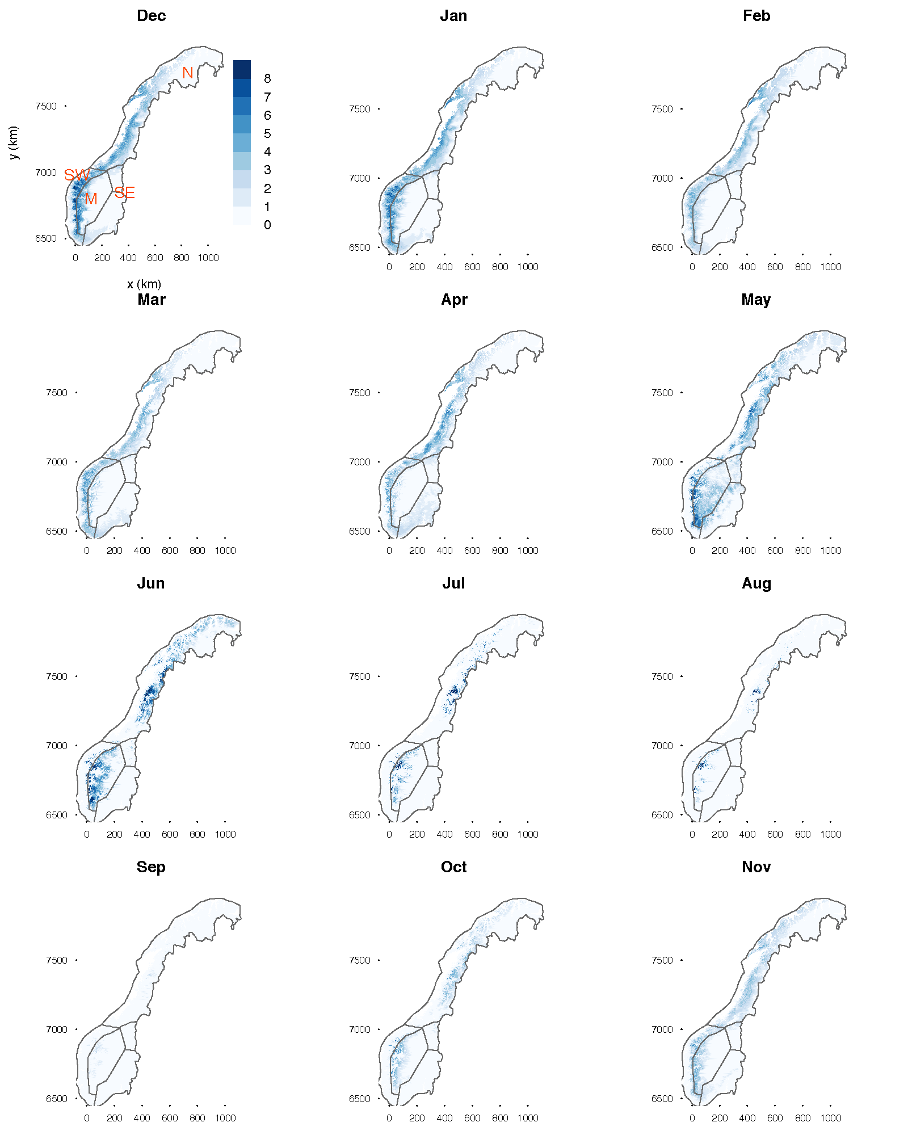

Figure 1. Average monthly counts of daily ROS events for the period 1961-1990. Counts are for mainland Norway, on the Universal Transverse Mercator Zone 33N projection. The four macro regions considered in this study are demarcated by the grey borders, and labelled by the red symbols in the top left panel as follows: M = Mountain, N = North, SW= Southwest, and SE = Southeast. Note that the SE macro region actually comprises two sub-regions, as a legacy of their original definition (see Rizzi et al. 2017), which are considered as one throughout this study.

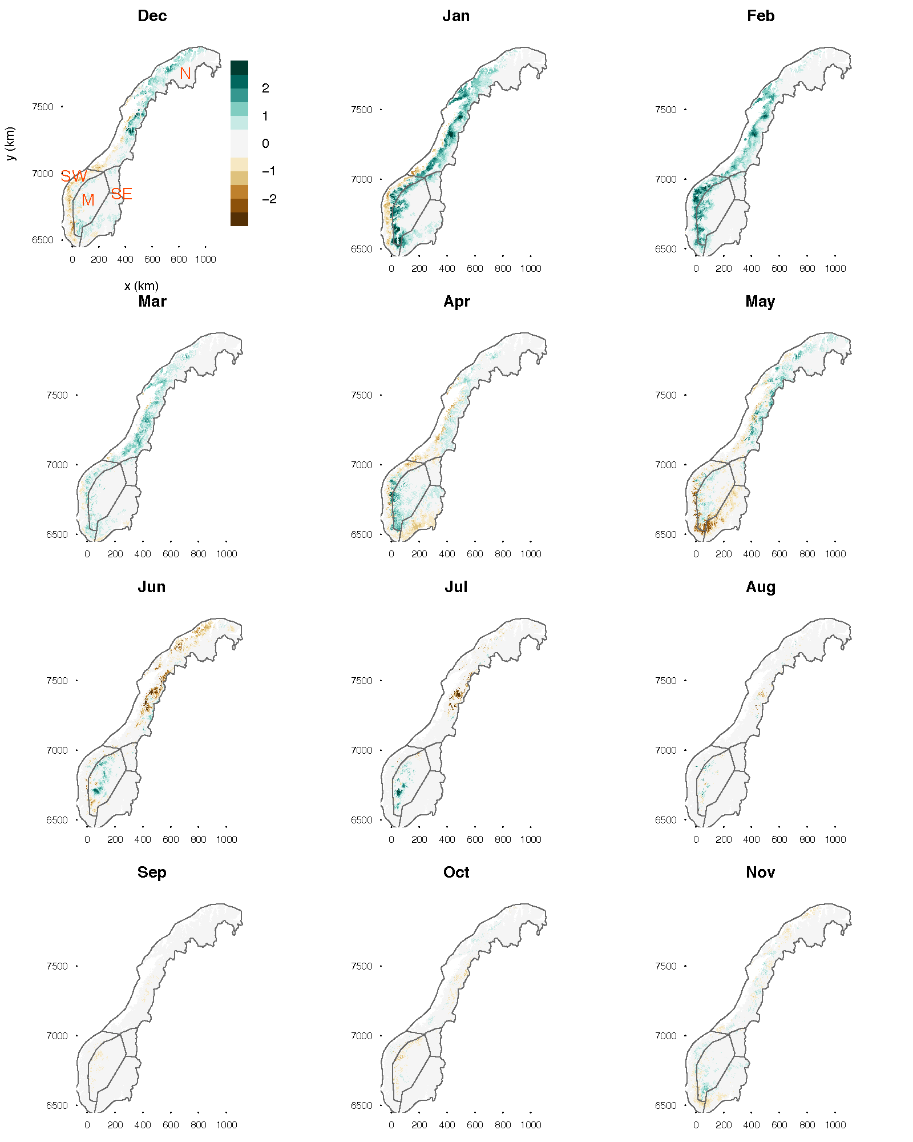

Figure 2. As for Figure 1, but now for the change in count going from the 1961-1990 to the 1981-2010 period.

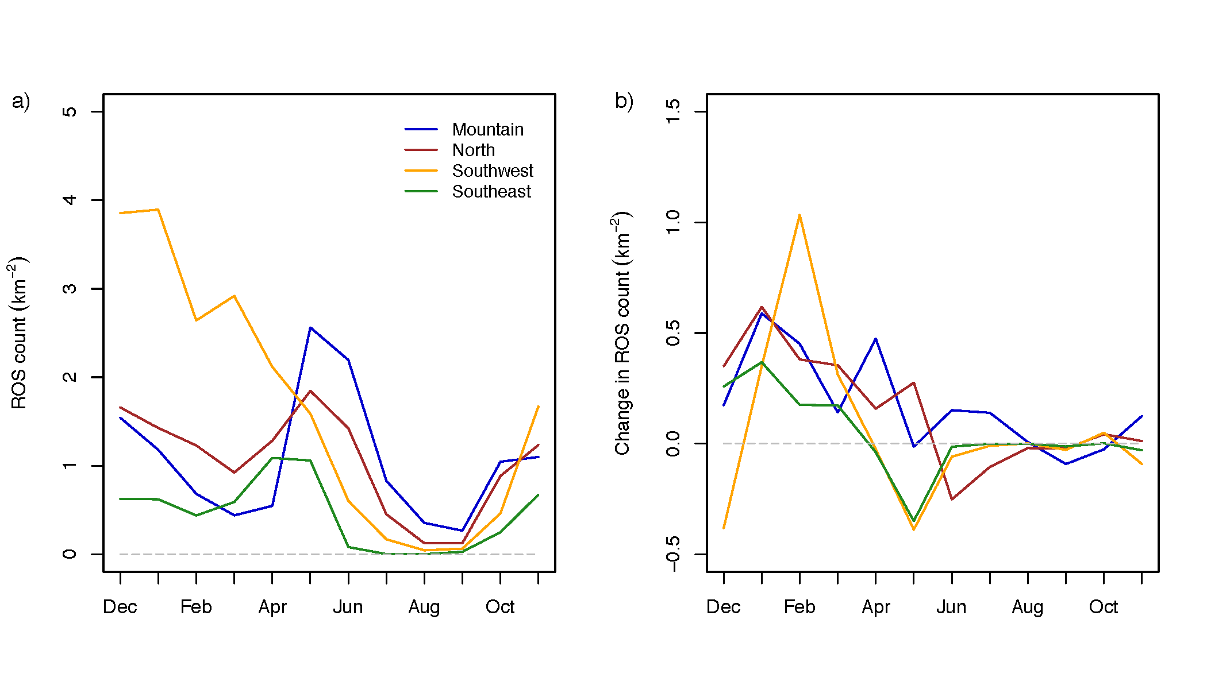

Figure 3. As for a) Figure 1, and b) Figure 2, but now for area averages over each macro region (average over all 1km grid squares).

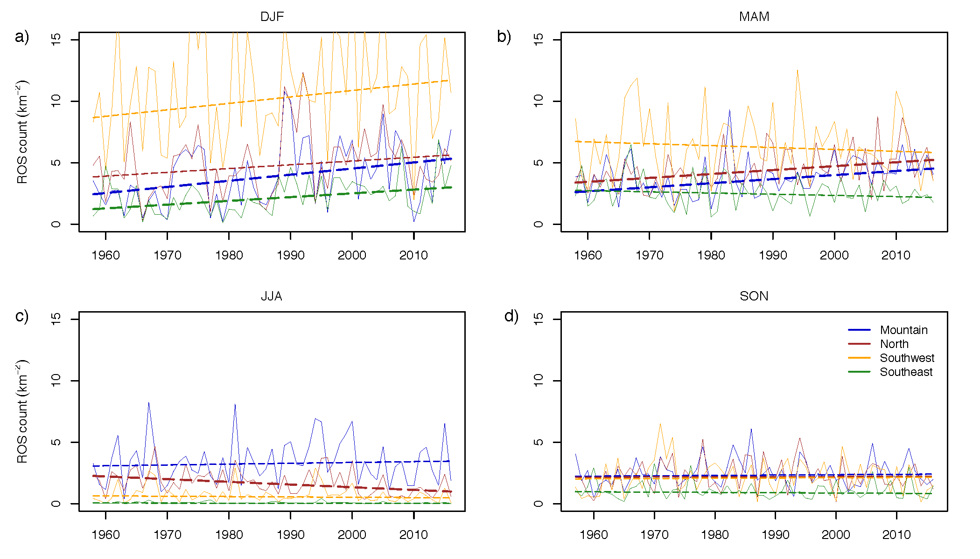

Figure 4. Seasonal time series (September 1957 to November 2016) of ROS counts, averaged over each macro region (average over all 1km grid squares within a region), for a) Winter (December-February), b) Spring (March-May), c) Summer (June-August), and d) Fall (September-October). Lines show fitted trends, with thicker lines distinguishing significant (5% level) trends.

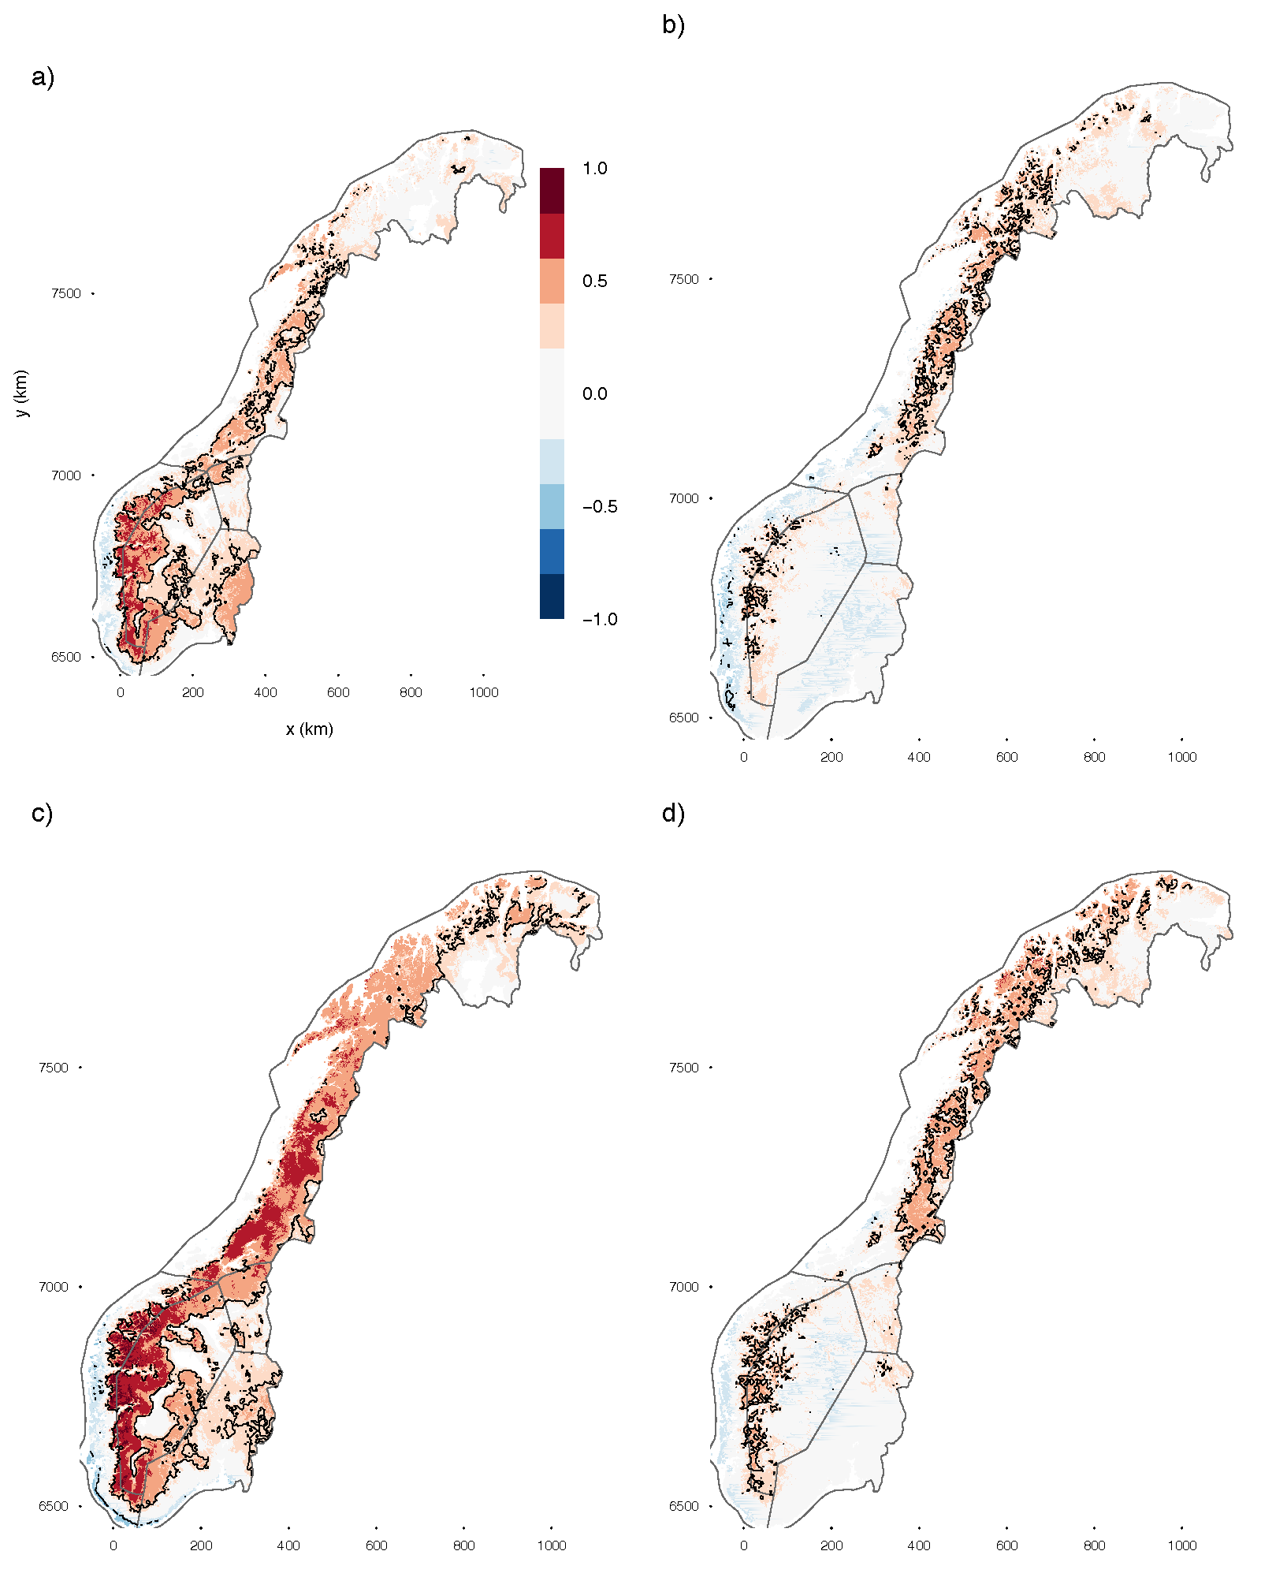

Figure 5. Correlation (Pearson’s coefficient) between ROS count and NAOi for a) winter and b) spring; likewise for correlation between ROS count and AOi, c-d). Data period, and winter and spring seasons, are as stated in caption for Figure 4. Areas of significant (1% level) correlation are demarcated by black contours.

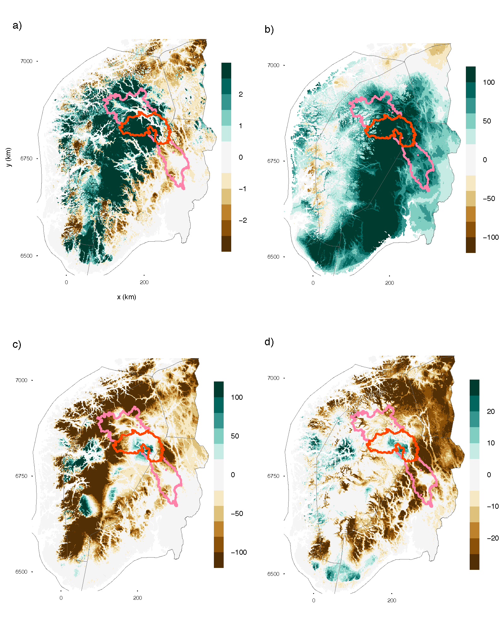

Figure 6. May 2013 anomaly, relative to 1961-1990 climatology, for southern Norway a) ROS events (counts), b) rain (mm), c) SWE (mm), d) SCA (%). The Vorma-Lågen sub-catchment in Oppland county is outlined in pink. Within this catchment, our target area is outlined in red (see text). Grey regional borders are as for Figure 1.

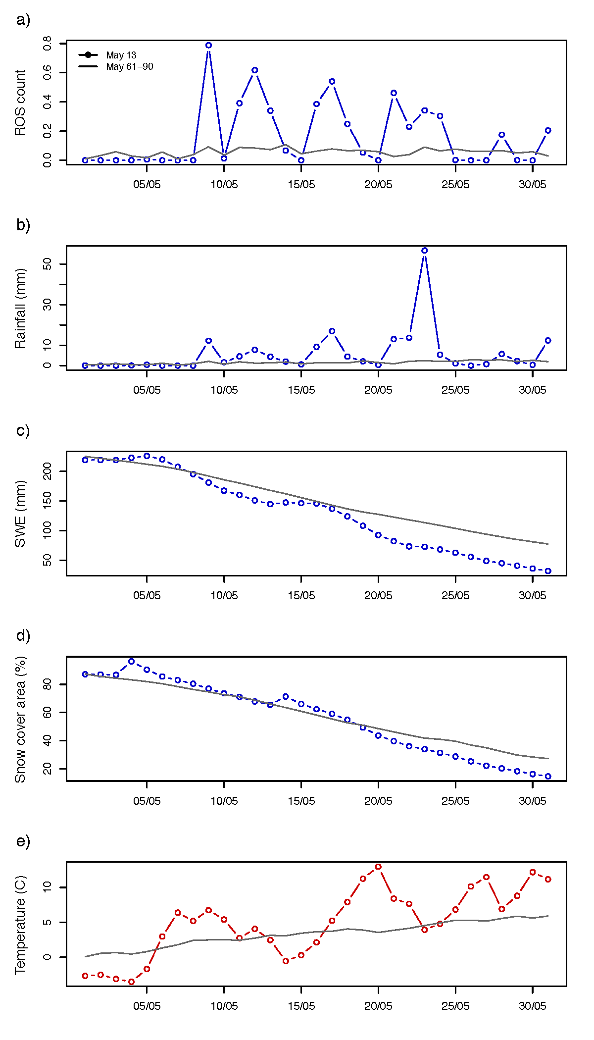

Figure 7. May 2013 time series of a) ROS events and, b-e) underlying hydrometeorological variables. Corresponding 1961-1990 climatological series are plotted as solid lines. All values are area-averages over the red target area outlined in Figure 6.

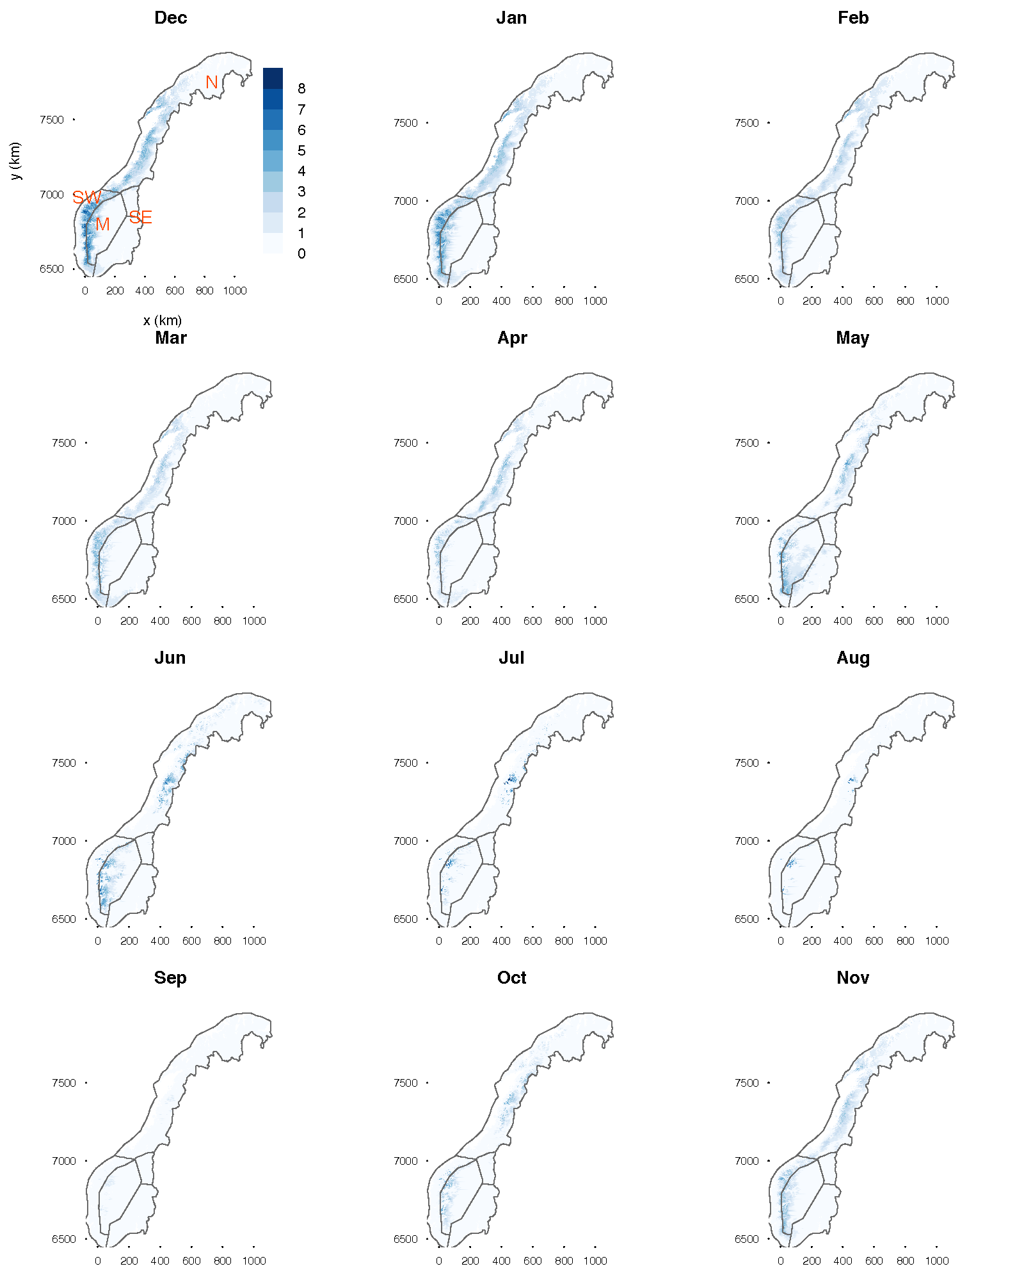

Figure A1. As for Figure 1, but now using harsher criteria in the definition of a daily ROS event (see text in Appendix).

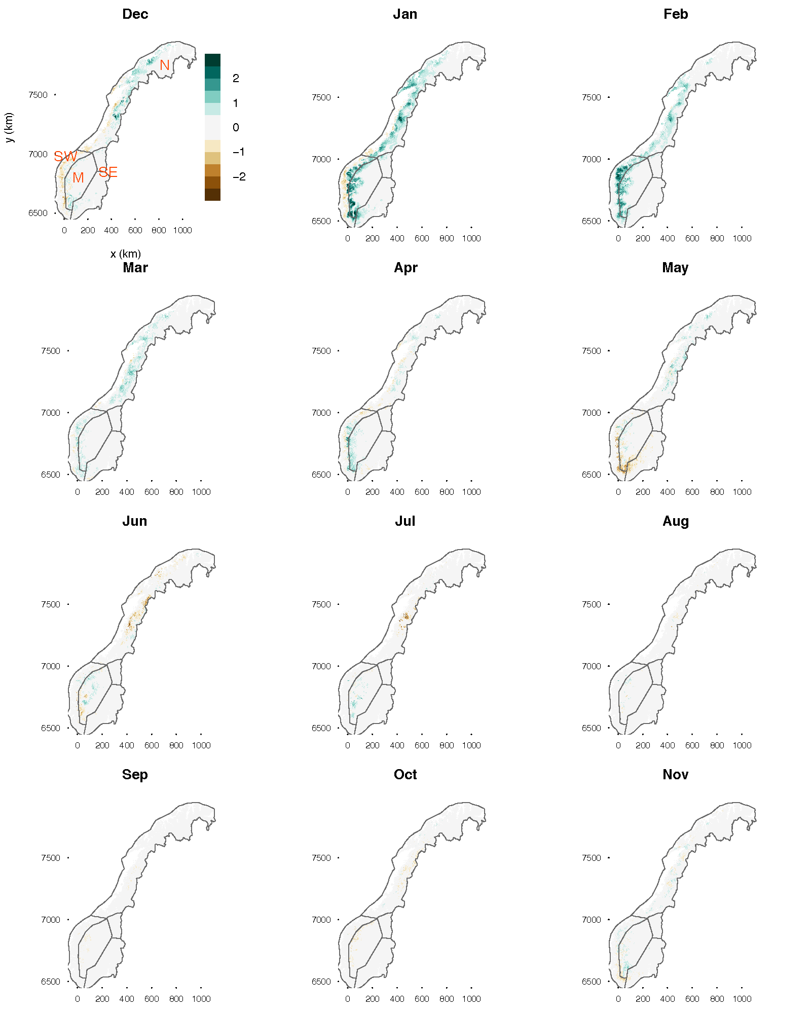

Figure A2. As for Figure 2, but now using harsher criteria in the definition of a daily ROS event (see text in Appendix).

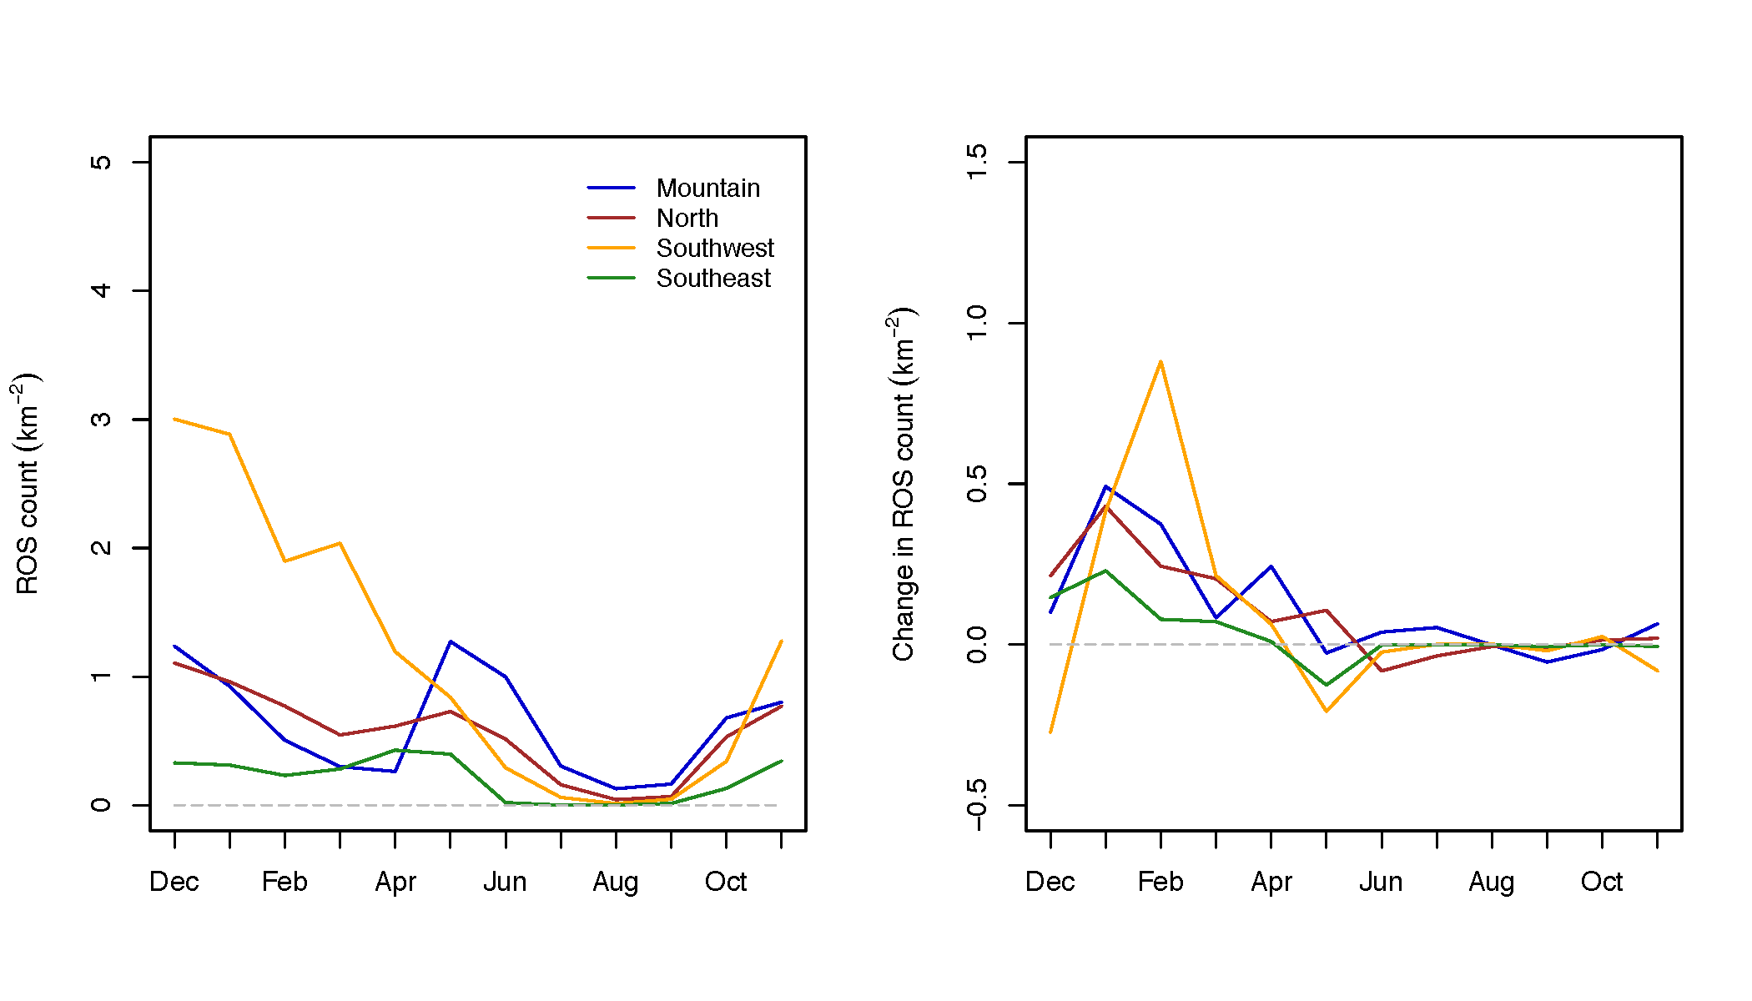

Figure A3. As for Figure 3, but now using harsher criteria in the definition of a daily ROS event (see text in Appendix).

