Preparing for the Utilization of Data Science / Data Analytics in Earth Science Research
Steve Kempler¹, Lindsay Barbieri^{2,} Tiffany Trapasso³
¹ NASA Goddard Space Flight Center, ² The University of Vermont, ³ NASA Langley Research Center
¹ sjkempler@gmail.com, ² lkbar@uvm.edu, ³ tiffany.trapsso@nasa.gov
Preparing for the Utilization of Data Science / Data Analytics in Earth Science Research
Abstract
Data analytics is the process of examining large amounts of varying data types to uncover hidden patterns, unknown correlations and other useful information. The Earth Science Information Partners (ESIP) Earth Science Data Analytics (ESDA) Cluster was created to facilitate the co-analysis of Earth science data and information. In addition to pioneering the definition of ESDA, the cluster has analyzed and compared data science/data analytics (DS/DA) university curricula with DS/DA techniques and skills necessary to fill the growing demand for DS/DA professionals. Here we identify the techniques utilized and skills needed to perform Earth science DS/DA, and survey University level DS/DA curricula currently available to prepare students for careers in Earth science DS/DA. Earth science DS/DA techniques and skills were identified through community discussions and presentations (including ESIP ESDA Cluster, literature search, discussions with scientists, and perspectives from students). The curricula of 267 DS/DA degree programs from 167 universities were analyzed to determine the DS/DA courses most often taught. Once compiled, this information was then used to identify, analyze, and report on gaps between the professional needs and the academic offerings. This study provides guidelines for both prospective students of Earth science DS/DA in pursuit of their professional career and teachers of Earth science DS/DA. It also serves as a starting point to examine this rapidly changing academic landscape and extrapolate from for future studies. Ultimately, we hope that the results of this study will enable a more holistic consideration of the development of Earth science data science and analytics curricula.
Keywords: data science, analytics, education, information, knowledge, information technology, Earth science, mathematics, statistics, computer science
Preparing for the Utilization of Data Science / Data Analytics in Earth Science Research

The increase of earth science data coupled with a continuum of ever-evolving data management systems affords great opportunities to enhance the knowledge and facilitation of Earth science research. To take advantage of these opportunities, it is essential to develop, understand and employ techniques that enable the examination of data relationships, and the analysis of information (Hey, Tansley & Tolle, 2009). The amount of heterogeneous Earth science data and value-added information is rapidly growing (EOSDIS Cloud Evolution, 2017), and holistically leveraging this information is new and challenging. It is new in that information technology is being developed and improved to provide tools for advancing the management and analysis of datasets, thus providing novel opportunities to discover scientific relationships. It is challenging in that it takes individuals, or teams of individuals, with the right combination of techniques and skills to produce salient and credible knowledge from these increasing and complex streams of data and information.
The application for data manipulation techniques and skills to facilitate the advancement of Earth science research is increasingly needed, but the supply of qualified data scientists and data analytics practitioners has not kept up (McKinsey, 2011). This imbalance, in combination with the advent and subsequent burgeoning of data science as its own academic field, motivates our study. These data manipulation techniques and skills can be considered in two steps: Data management techniques (e.g., subsetting, data transformation, format conversion, etc.) extract information from data, while data analytics techniques improve the ability to glean knowledge from information (Figure 1; Kempler, 2014). In this study we focus on the latter. As data analytics techniques and skills are developed and improved upon, it is essential to ensure that early career professionals are properly trained and able to gain experience in the application of Earth science data analytic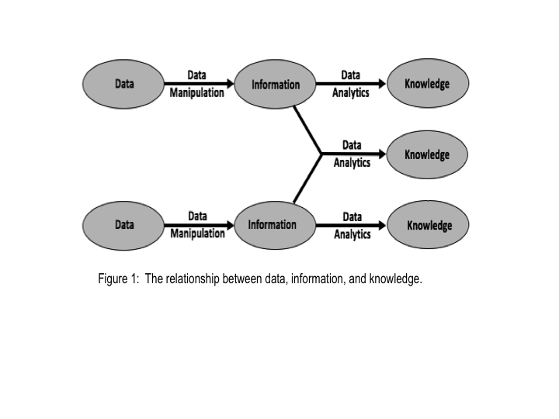
Defining Data Science and Data Analytics
As a concept, data analytics has been used in the business world for a century (Mortenson et al., 2015), but was only recently formally examined and defined in the Earth Science community, by the Earth Science Data Analytics (ESDA) Cluster (Kempler & Mathews, 2017), an active working group of the Earth Science Information Partners (ESIP), with over 150 members. They define Earth science data analytics as the process of examining, preparing, reducing, and analyzing large amounts of spatial (multi-dimensional), temporal, or spectral data, encompassing varieties of data types. This definition provides a reference for the analytics that enable the uncovering of knowledge, to better understand our Earth. Earth science data analytics is categorized by the goals of the analytics performed (Table 1) and includes three main actions:
- Data Preparation – Preparing heterogeneous data so that they can be jointly analyzed.
- Data Reduction – Correcting, ordering, and simplifying data in support of analytic objectives.
- Data Analysis – Applying techniques to derive results.
Table 1: Earth science data analytics goals.
To calibrate data
To validate data (note it does not have to be via data intercomparison)
To assess data quality
To perform coarse data preparation (e.g. subsetting data, mining data, transforming data, recovering data)
To intercompare datasets (i.e. any data intercomparison; Could be used to better define validation/quality)
To tease out information from data
To glean knowledge from data and information
To forecast/predict/model phenomena (i.e. Special kind of conclusion)
To derive conclusions (i.e. that do not easily fall into another type)
To derive new analytics tools

Contributing to the development of this definition, many sources and definitions were considered, including: The National Institute of Standards and Technology (NIST, 2015); The Data Science Association (DSA, 2016), and; Thompson (2016). Each offered nuanced definitions and detailed descriptions for data science, the data scientist, other data related roles, and the analytics process. Extracts from these sources include:
- Data science is the extraction of actionable knowledge directly from data through a process of discovery, or hypothesis formulation and hypothesis testing (NIST, 2015).
- A data scientist is a practitioner who has sufficient knowledge in the overlapping regimes of business needs, domain knowledge, analytical skills, and software and systems engineering to manage the end-to-end data processes in the data life cycle (NIST, 2015).
- The analytics process is the synthesis of knowledge from information (NIST, 2015).
- Data science means the scientific study of the creation, validation and transformation of data to create meaning (DSA, 2016).
- Data scientists primarily build data products, simulations, and applications for analysis along with responsibilities for scientific data management (Thompson 2016).
In summary, data analytics is the process of examining data, typically of a variety of types, to discover, interpret, and communicate meaningful patterns in data. Data scientists study and develop techniques and acquire skills for analyzing, storing, and presenting data. When data scientists utilize these techniques and skills for exploring or solving specific problems, they are performing data analytics. Thus, knowledge of both the techniques and skills of applying the techniques required for the data scientist, and data analytics practitioners, are similar. Once techniques and skills are acquired, it is up to the individual to determine how best to use them based on the scope of the research question or project, and their interest and aptitude. This study examines DS/DA techniques that make up the skill sets of these practitioners, and considers them within the broader Earth science domains, but leaves the specific application to the creativity of the individual.

Method
Scope
This study first identifies techniques and skills utilized by data scientists, and the use of data analytics, pertaining to Earth science data and information. We then compare these necessary techniques and skills to the educational preparation students are currently offered. To do so, we examined the curricula of each of the United States university degree level programs found in the list of ‘Master’s in Data Science, Complete Directory of Data Science Graduate Degrees’ (2016). Programs were excluded if their website was not accessible, their program offered certificates (not degrees), or their program was not addressing either data science or data analytics.
Methodology
We determined how well universities prepare future Earth Scientists in the area of Earth science DS/DA, and identified how universities can strengthen their curricula in these areas, through the following three steps:
- Determining the practiced DS/DA techniques and skills needed that apply to Earth science research.
- Identifying the DS/DA techniques and skills most often being taught in US universities pertaining to Earth science.
- Performing a gap analysis to determine where universities can improve their DS/DA curricula to better meet the needs of Earth science research.
1. Practiced DS/DA techniques and skills. Information from three sources is utilized to determine the most significant Earth science DS/DA techniques and skills practiced in the field: literature, practitioners, and an early career scientist perspective.
As described in the literature. With the growing need to utilize information from various sources to better understand our environment, it is evident that developing and using new ways to analyze heterogeneous information relationships is critical. Insights like: “Researchers in science must work with colleagues in computer science and informatics to develop field-specific requirements” (Hey, Tansley & Tolle, 2009: 151) and “The process of combining information from existing scientific knowledge … including the specific methodologies that were followed to produce conclusions, should be automatic and implicitly supported” (Hey, Tansley & Tolle, 2009: 170-171), are the foundations for melding the expanding manipulation of information and associated technologies, with Earth science research. The literature is surveyed and techniques and skills that facilitate Earth science DS/DA are noted and summarized.
As described by the practitioners. Information regarding needed Earth science DS/DA techniques and skills expertise are also found in presentations given at Earth science informatics forums such as the American Geophysical Union Earth and Space Science Informatics (AGU ESSI), and ESIP. Some of the more significant presentations are provided in the Appendix. The authors of this paper also took the opportunity, at AGU, to visit science poster presentations to better understand research techniques, and specifically analytics utilized. Research that involved analysis of multiple datasets were sought out by asking presenters of Atmospheric Research and Hydrologic Research presentations:
- Do you perform analysis of heterogeneous data in your research?
- What techniques do you utilize to analyze heterogeneous data?
- What specific tools do you employ in your analysis of heterogeneous data?
As described by an Early Career Scientist. Climate change, food and water security, and changing land use and land cover, are all significant global problems that draw from multiple Earth science and other natural and social science disciplines. To tackle these complex environmental problems, this early career scientist works with multiple research teams to draw from a variety of heterogeneous, often interdisciplinary, Earth science data, and also attended two graduate courses in data science within their course of study. Insights, lessons learned, and academic perspectives of Earth science DS/DA education is synthesized and shared.
2. DS/DA techniques and skills most often being taught. The following methodology is used to determine the focus of university level DS/DA programs and curricula:
Survey the curricula of US universities offering DS/DA degree programs. Several websites exist that list universities providing DS/DA degree programs. The most comprehensive list is the ‘Master’s in Data Science, Complete Directory of Data Science Graduate Degrees’ (2016). From this list the curricula of 167 universities offering 267 data science or data analytics degree programs were examined. This includes all the US programs, except those whose websites are inaccessible, who offer certificates (non-degree), or are not addressing data science nor data analytics. The complete listing of all 267 universities surveyed can be accessed on the ‘Master’s in Data Science, Complete Directory of Data Science Graduate Degrees’ website, provided in references.
From all curricula, determine DS/DA program focus areas and relevant course topics most often offered. The curricula of each of the 267 DS/DA programs are examined to determine the DS/DA focus area of the program, and relevant DS/DA course topics most often offered. Program focus areas are the main domain or topic that the program emphasizes, and can be data science or more specific focus areas such as computer science, business analysis, etc. Relevant course topics can be broad (e.g. statistics) or narrow (e.g. data mining). It is the overall breadth of course topics that are presented here. The most relevant course topics offered, for each program focus area, are identified. Categorizing DS/DA courses offered per program focus area, helps us to understand how program focus area curricula differ, and that not all courses are relevant to all program focus areas. We then categorize results by Degree Level (Bachelors, Masters, Doctoral).
Compare changes to 2013 survey. Although on a much smaller scale, a similar study to this one was performed in 2013 encompassing top DS/DA schools (Kempler, 2014). Even with the fewer number of programs offered in 2013, the trends in DS/DA education are still instructive. The findings of the 2013 survey are provided for comparison with the current findings.
3. Perform Gap Analysis. DS/DA curricula study results are compared to professionally used Earth science DS/DA techniques and skills. The professionally used DS/DA techniques and skills are compiled from the information gathered in the first methodology step, above. The DS/DA techniques and skills professionally utilized (and needed) are then compared to the course topics most often offered in each identified program focus areas. Most often taught DS/DA course determination and gap analysis methodology is summarized in Figure 2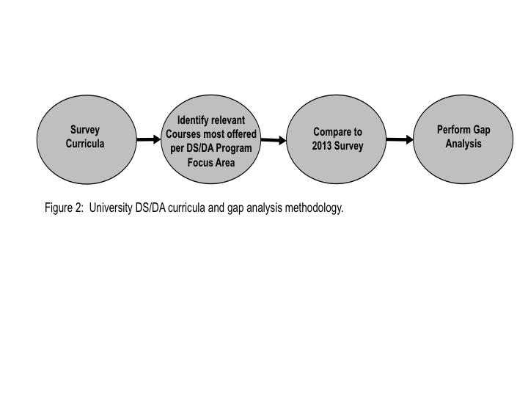Results
1. Earth Science DS/DA Practiced
Literature. Maximizing the use of information through technical evolution, developed techniques, and refined skills has become the purview of the data scientist performing data analytics. Earth science DS/DA techniques are considered to be computational methods that are employed by data analytics. Earth science DS/DA skills encompass the ability to apply techniques. Earth science DS/DA skills also encompass the ability to make data useful. Thus far, DS/DA has had a much wider usage in the business world, which is why most literature and developed tools reflect on business as the primary application. Unlike business analytics that typically address a fairly known solution set, Earth science data analytics explores the possibility of new solution sets, based on discipline specific expertise, creative use of resources within and outside the known problem area, and the use of techniques and skills applied to interdisciplinary relationships.
DS/DA techniques and skills have been generally specified in various ways by many sources. The article, ‘8 skills you need to be a Data Scientist’ (Udacity, 2014) defines essential DS/DA skills in Table 2. In addition, the ‘Master’s in Data Science, The Life of a Data Scientist’ (2016) summarizes the technical skills and techniques of a data scientist, to be those listed in Table 3. O’Neil and Schutt (2014) in their book, ‘Doing Data Science’, states that most data scientist job descriptions ask for expertise in computer science, statistics, communication, data visualization, and to have extensive domain expertise. Already, a consensus is forming around key techniques and skills.
Table 2: Skills of a Data Scientist (Udacity).
Basic Tools | Data Munging
Basic Statistics | Data Visualization & Communication
Machine Learning | Software Engineering
Multivariable Calculus and Linear Algebra | Thinking Like a Data Scientist

Table 3: Technical skills and techniques of a Data Scientist (Master’s in Data Science).
Math (e.g. linear algebra, calculus and probability)
Statistics (e.g. hypothesis testing and summary statistics)
Machine learning tools and techniques (e.g. k-nearest neighbors, random forests, ensemble methods, etc.)
Software engineering skills (e.g. distributed computing, algorithms and data structures)
Data mining
Data cleaning and munging
Data visualization (e.g. ggplot and d3.js) and reporting techniques
Unstructured data techniques
R and/or SAS languages
SQL databases and database querying languages
Python (most common), C/C++ Java, Perl
Big data platforms like Hadoop, Hive & Pig
Cloud tools like Amazon S3

In response to the rapid increase in the need for and creation of DS/DA programs, ‘EDISON Data Science Framework’ (Demchenko, 2016) provides a comprehensive study of the competencies and skills needed by data scientists. Demchenko identifies five data science competence groups (the first three also are consistent with NIST findings):
- Data analytics including statistical methods, Machine Learning and Business Analytics.
- Engineering: software and infrastructure.
- Subject/Scientific Domain competences and knowledge.
- Data Management, Curation, Preservation.
- Scientific or Research Methods.
Specific to the data analytics competence groups, Demchenko identifies techniques in Table 4 as being most relevant.
Table 4: Data analytics techniques of a Data Scientist (Demchenko).
Artificial intelligence, machine learning
Machine Learning and Statistical Modelling
Machine learning solutions and pattern recognition techniques
Supervised and unsupervised learning
Data mining
Markov Models, Conditional Random Fields
Logistic Regression, Support Vector Machines
Predictive analysis and statistics (including Kaggle platform)
(Artificial) Neural Networks
Statistics

The Belmont Forum published ‘e- Infrastructure Data Management Skills Gap Analysis’ (Lucas, 2017), which takes a broader look at the techniques needed for managing data for Global Change Research. This study also provides very comprehensive survey results, and technique skills catalog (Lucas, 2017). Lucas identifies the most necessary skills for global change research, as specified in Table 5.
Table 5: Data Management Techniques Needed for Global Change Research (Lucas).
Data processing and analysis
Programming (creating clear and robust code)
Data management
Visualization
Statistical methods
Data mining
Developing statistical or numerical models
Use of new facilities/techniques (e.g. cloud, ML)
Use of big data technologies (e.g. Hadoop)
Using statistical or numerical models
Use of High Performance Computing

As can be seen, many computational techniques were identified in performing Earth science DS/DA (Table 6). The usefulness of any particular technique is dependent on the specific application.
Table 6: Earth science data science/data analytics techniques (sampling).
DS/DA Techniques
Data Preparation | Data Reduction | Data Analysis
Aggregation | Aggregation | Anomaly Detection
Bias Correction | Anomaly Detection | Bayesian Techniques
Classification | Bias Detection | Bivariant Regression
Cluster Analysis | Classification | Constrained Variational Analysis
Coordinate Transformation | Cluster Analysis | Correlation/Regression Analysis
Data Engineering | Data Engineering | Decision Tree
Data Mining | Data Fusion | Factor Analysis
Data Munging | Data Mining | Fourier Analysis
Data Warehousing | Database Management | Graphics Analysis
Database Management | Factor Analysis | Imputation
Exponential Differentiation | Filtering | Linear/Non-linear Regression
Factor Analysis | Machine Learning | Machine Learning
Filtering | Neural Networks | Mathematics/Calculus
Format Conversion | Outlier Removal | Modeling
Imputation | Ratios | Monte Carlo Method
Map Reduce | Revised Averaging Scheme | Multi-variate Time Series
Normalization/Transformation | Rule Learning | Normalization
Outlier Removal | Time Series | Pattern Recognition
Ratios | Visualization | Principal Component Analysis
Rule Learning |  | Revised Averaging Scheme
Sensitivity Analysis |  | Rule Learning
Smoothing |  | Signal Processing
Spatial Interpolation |  | Spectral Analysis
Statistics (general) |  | Statistics (general)
Time Series |  | Temporal Trend Analysis
Visualization |  | Time Series
 |  | Visualization

Earth science DS/DA practitioners. After surveying hundreds of presentations for DS/DA techniques used at the 2015 AGU Winter Meeting, 31 atmospheric science (study of gases) and 12 hydrologic science (study of liquid) presentations provided specific research techniques, listed in Table 7. This sampling highlights the variety of data analytics techniques pertaining specifically to data analysis. Yet many of these same techniques are also involved in the data preparation and data reduction stages of research.
Table 7: Sampling of science research techniques used.
In Atmospheric Research |  | In Hydrology Research
Correlation Analysis; Bias Correlation | Spectral Analysis | Linear Regression
Regression Analysis; Bivariant Regression | Temporal Trending; Trend Analysis | Monte Carlo
Decision Tree | Spatial Interpolation | Darcy Equation
Machine Learning | Revised Averaging Scheme | Poisson Regression
Data Mining | Forward Modeling; Inverse Modeling | Multi-variate time series analysis
Data Fusion | Radiative Transfer Model | BUDYKO formula
Computational Tools | Baysian Synthesis Inversion | Smoothing (Gaussian)
Constrained Variational Analysis | Temporal Stability | Filtering (Destriping)
Model Simulations | Gaussian Distribution | MESH Model
Ratios | Exponential Differentiation
Time Series Analysis

Early Career Scientist. As an early career Earth scientist, it is recognized that there is a clear need to bridge the gaps between graduate programs DS/DA training, and additional techniques and skills needed by professional DS/DA. While tools and techniques to manage and analyze these data are improving with the advancement of DS/DA, in many natural science disciplines such as ecology, academic curricula are lagging behind (Touchon & Mccoy, 2016). Not only is it important to learn the Earth science DS/DA techniques and skills as compiled in this study, but especially to treat these techniques and skills with the same rigor as other scientific methods. Utilizing software development as a starting point for bridging Earth science research to the usage DS/DA techniques and skills, scientists in many Earth science and natural science disciplines typically develop their own software, or use domain-specific software for data preparation and analysis (Wilson et al., 2014), yet studies have shown that even though scientists spend 30% of time developing software, 90% are self-taught (Hannay et al., 2009; Prabhu et al., 2011). Furthermore, this scientific software is often not carefully validated or maintained, even though computing errors can have disproportionate impacts on process and outcomes (Wilson et al., 2014). Wilson et al. (2014) describes software practices that are easy to adopt and have proven effective in many research settings (Summarized in Table 8). When introduced and adhered to, these best practices could help to alleviate the disconnect that many domain scientists experience between being able to write software to accomplish necessary data preparation and analysis, and writing robust software that is credible and reproducible. An example of where this can become a research issue is in the utilization of statistics. Statistics training is important for Earth science research, and in particular the employment of DS/DA techniques. Basic statistics is a competency recommended or required for Earth science graduate students via formal courses. However, there needs to be a more holistic understanding of statistics, that includes scientific programming, that provides the researcher a path to apply statistics in order to further development and utilize needed DS/DA techniques and skills. While the summary of best practices might look simple or obvious to any professional, these basic software principles are rarely taught in any systematic way in Earth science graduate programs. These DS/DA principles and best practices are relatively straightforward, and if formally introduced, understood, and implemented, Earth science researchers, could go a long way toward in advancing their research.
Table 8: Summary of application software development best practices (Summarized from Wilson et al. 2014).

Summary of Software Development Best Practices
Write programs for people, not computers
Let the computer do the work
Make incremental changes
Don’t Repeat Yourself (or others)
Plan for mistakes
Optimize Software only after it works correctly
Document design and purpose, not mechanics
Collaborate

Another area needing more planning is connecting Earth science and DS/DA coursework. With the increased importance of DS/DA and data management, it is difficult for students to keep up with the rapid advancement of DS/DA without relevant coursework. And yet, there is not often an overlap between Earth science disciplinary programs and Computer Science or Mathematical / Statistics programs, where much of the DS/DA techniques and skills are being taught (Touchon & Mccoy, 2016). To address this gap, strengthening connections between Earth science and DS/DA programs are necessary and could be accomplished with formal, integrated Earth science DS/DA courses or training. The instruction of the principles and applications of Geographical Information System (GIS) is one example of an area whereby students of Earth science disciplines have largely benefited from integrating DS/DA techniques and skills e.g. the advancement of geostatistics techniques. For much Earth science research, basic familiarity with GIS is useful and encouraged, and GIS training is often offered as a part of a formal course of study. However, these techniques and skills are not always placed within the larger context of DS/DA. Aligning GIS courses within both Earth science and DS/DA programs can help facilitate the bridge between Earth science and DS/DA.
Summary. Resulting from the compilation of literature findings, relevant presentations, and early and later career experiences, a set of the most relevant techniques and skills are identified to successfully perform Earth science DS/DA, compiled in Table 9. To achieve the Earth science research objectives of today, these Earth science DS/DA techniques and skills professionally practiced, are guidelines for preparing students of Earth science DS/DA. Current professionals seeking DS/DA expertise to perform Earth science research, or Earth science data management activities that facilitate Earth science research, are indicating the need for people with good understanding of mathematics, numerical modeling, statistics, software engineering and the ability to integrate data across multiple domains. Also, there is a need for expertise in rule learning, classification, cluster analysis, data fusion, machine learning, neural networks, anomaly detection, modeling, time series analysis, and visualization. In addition, individuals performing Earth science DS/DA need knowledge in the particular science domain(s) where these data analytics advance understanding. This includes skills in working with data lifecycle, data structures, metadata, data integration, and data interpretation. The individual also needs to know what domain specific information is available, where to get it, how it is generated, statistical, mathematical, and computational techniques to manipulate it, and how to best manage it for future analysis or research.
Table 9: Earth science DS/DA techniques/skills practiced.
Earth Science DS/DA Techniques
Anomaly Detection
Artificial Intelligence
Classification
Cluster analysis
Data Compression
Data Engineering
Data Fusion
Data Mining
Data Munging
Data Warehousing
Database Management
Geographic Information Systems (GIS)
Machine Learning
Mathematical Modeling
Mathematics
Neural networks
Pattern Recognition
Rule learning
Signal Processing
Statistics
Bivariant Regression
Constrained Variational Analysis
Correlation/Regression Analysis… etc.
Trend Analysis
Time series
Visualization
Earth Science DS/DA Skills
Ability to integrate data across multiple domains
Support domain scientists with data & computational knowledge
Communicate across domains
Knowledge of data cycle
Software engineering
Software programming

2. Current Earth Science DS/DA Curricula
Survey curricula. Many universities offer multiple programs under the label of data science. Examining the courses offered in the 267 curricula reveals diversity in data science curricula definition, subject matter, and departmental emphasis. The curricula vary based on the college and department in which data science is being taught. For example, a College of Business emphasizes different data science curricula than that of a College of Arts and Sciences. Likewise, the data science curricula offered by a Statistics Department emphasizes different courses than that of a Computer Science Department.
Determine DS/DA program focus areas and relevant course topics offered. DS/DA curricula were most often associated with eight focus areas of study. These University program focus areas tell us what programs and/or applications are emphasized in the DS/DA curricula (Table 10). The number of programs per degree are charted by DS/DA program focus areas, and provided in Table 11. In addition, upon surveying all DS/DA program curricula, the most often offered courses relevant to Earth science DS/DA were determined, provided in Table 12, left column. Other relevant Earth science DS/DA courses, less often taught, are listed in Table 12, right column.
Table 10: Data science program focus areas.
Business Analytics
Data/Information Science
Data Analysis/Analytics
Quantitative Analysis/Applied Statistics
Information Technology/ Systems/Management
Computer Science
Health/Bio Analytics
Business Management

Table 11: Data science programs offered by program focus area, by degree.
Program Focus Areas | Bach | Master | PhD
Business Analytics | 5 | 63
Data/Information Science | 15 | 31 | 4
Data Analysis/Analytics | 5 | 46 | 1
Quantitative Analysis/Applied Statistics |  | 22 | 1
Information Technology/ Systems/Management |  | 23 | 5
Computer Science |  | 6
Health/Bio Analytics |  | 30 | 1
Business Management |  | 8

Table 12: For all DS/DA program curricula, the courses relevant to Earth science DS/DA that are offered most often, are provided in left column. Other relevant Earth science DS/DA courses are listed in right column (not exhaustive list).

Most Often Offered DS/DA Courses | Other Offered DS/DA Courses
Data Mining | Programming
Data Warehousing | Neural Networks
Text Mining | Data Analysis
Time Series Analysis | Artificial Intelligence
Mathematics | Clustering
Statistics | Pattern Recognition
Machine Learning | GIS
Data Visualization | Remote Sensing
Decision Support Modeling
Mathematical Modeling
Database Management/Analysis
Data Management Tools
Information Management/Quality
Knowledge Management /Discovery
Computational Health/Biology
Predictive Modeling

For each program focus area, the percentage of university curricula that includes the most relevant DS/DA courses (Table 12, left column), is provided in Figure 3. This shows the relative popularity of each course per program focus area. As can be seen, although these courses are relevant to DS/DA, not all program focus area curricula include these courses. In fact, some universities contain DS/DA program focus area curricula that have a fairly low percentage of relevant DS/DA courses. Note that the first block of courses is labeled ‘All Programs’, giving an overview of the percentage of all programs that include most offered DS/DA courses in their curricula.
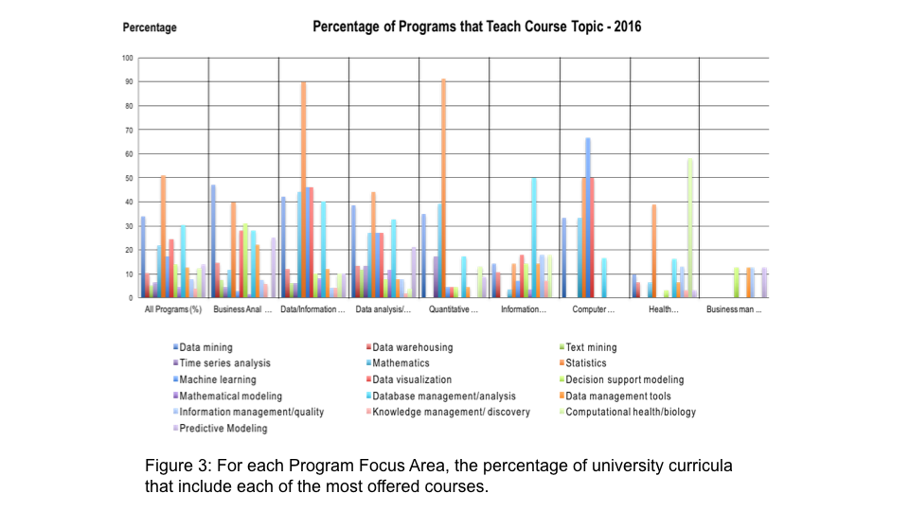
Compare to 2013 survey. In our latest survey, business analytics continues to be the primary focus of DS/DA overall, however the number of programs in other program focus areas is growing. This can be seen when comparing the results above with similar analysis in 2013, aggregated across all degrees, as illustrated in Figures 4 and 5. The number of programs has grown in every program focus area (Figure 4), however more revealing is how the percentage of all DS/DA programs have changed for each DS/DA program focus area. In Figure 5, we see that the program focus areas with the greatest percentage increase in number of programs (aggregated across all degrees) are: Data/Information Science, Data Analysis/Analytics, and Health/Bio Analytics. These 3 focus areas also have a larger percentage of all DS/DA Programs in 2016, than they did in 2013. This indicates that there is movement in DS/DA degrees being offered with a focus on, specifically, the discipline of data science and data analytics. Health/Bio Analytics also is becoming more relevant. Like Business Analytics, Health/Bio Analytics offers DS/DA courses, and a domain to apply it to, all in one curricula. Program focus areas such as Quantitative Analysis/Applied Statistics, Information Technology and Computer Science, extremely valuable on their own, do not generally provide focus on DS/DA applications, as seen by the courses most often offered. This is reflected in their lower percentage of degree programs from 2013 to 2016. In addition, since 2013, DS/DA programs focus areas are found to be enhancing their curricula by offering a wider variety of courses (Figure 6). As noted above, the 2013 study is only a guideline because the number of DS/DA programs were much fewer.
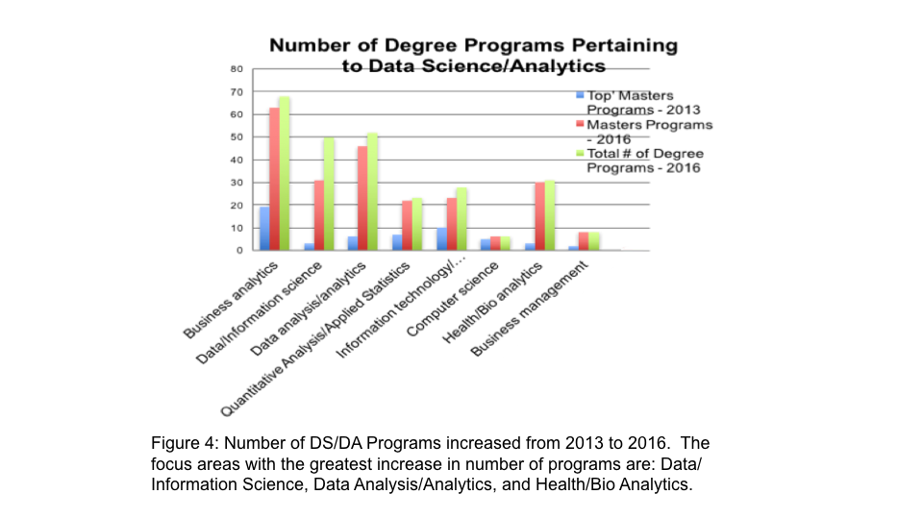
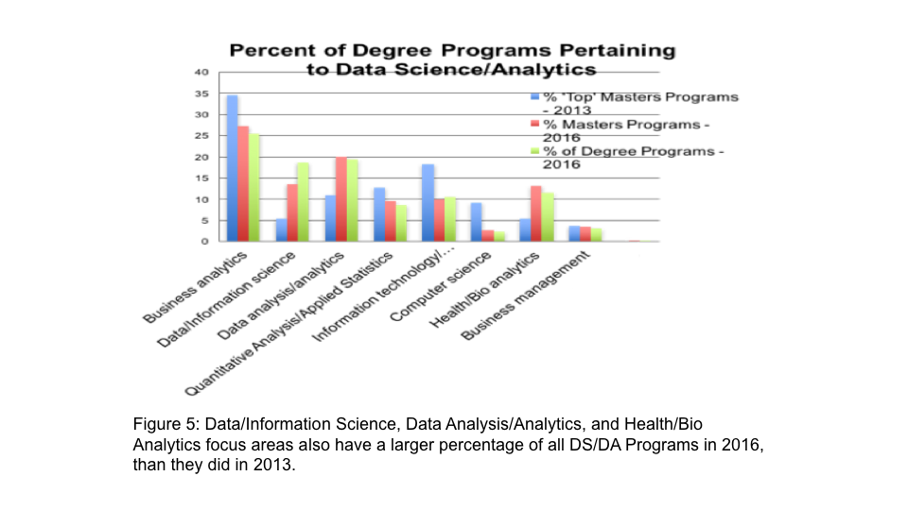
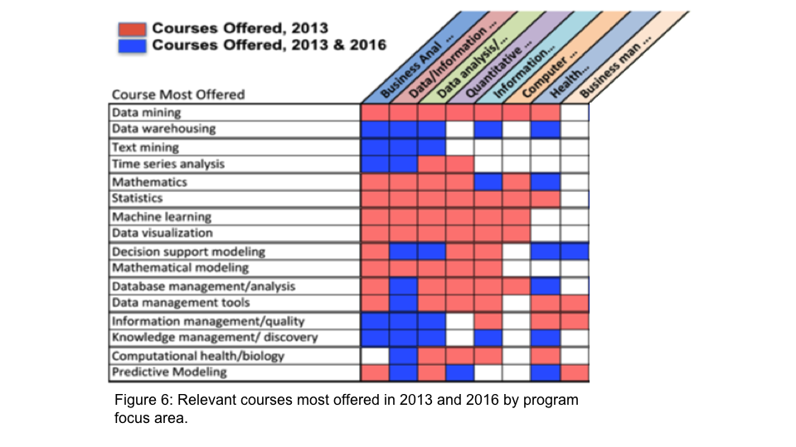
3. Gap analysis between courses offered and professional needs
Here we consider the DS/DA techniques/skills practiced, listed in Table 9, to perform the gap analysis. Figure 7 compares the responsiveness of university DS/DA curricula, by program focus area, to the predominant Earth science DS/DA techniques and skills courses being offered. Boxes checked indicate DS/DA courses (left vertical column) that are offered in a high percentage of All Programs and program focus areas (top horizontal row). These are dominant courses. This distinguishes courses that are being addressed adequately per program focus area from those that need more attention (not checked) in a program focus area. Boxes checked in the last column indicate DS/DA courses that are most applicable to solving professional DS/DA problems. Shaded boxes indicate Earth science DS/DA techniques practiced that are not dominant in university course offerings, in any of the program focus areas. 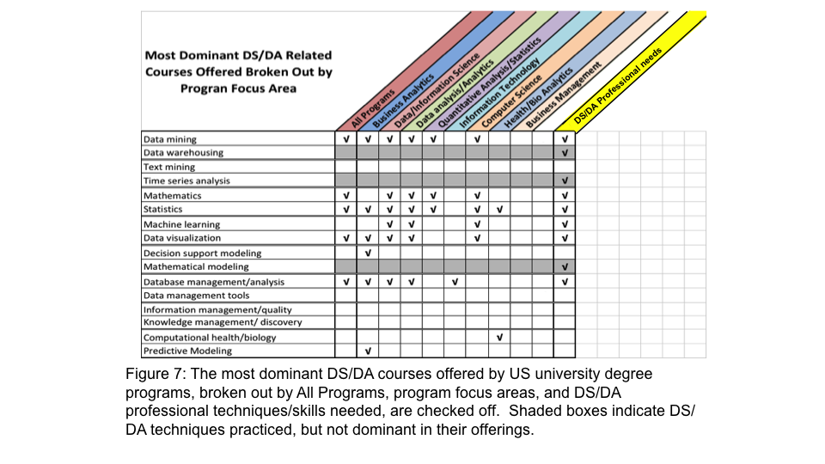
Figure 7 reveals the gaps between dominant DS/DA courses and the Earth science DS/DA techniques and skills practiced by the professional community. Students of Earth science DS/DA are indeed being offered many courses that will be very useful in their professional careers, in particular if the program focuses on data science, data analytics, and to a lesser degree, computer science. Three practiced techniques, data warehousing, time series analysis, and mathematical modeling can use additional attention in all curricula. Programs that focus on quantitative analysis and information technology, do not consistently offer courses relevant to Earth science DS/DA. Business analytics and health analytics are examples of DS/DA programs geared to specific applications, and offer appropriate courses for their respective application.
In addition to comparing most practiced Earth science DS/DA techniques/skills with courses offered that teach these techniques/skills, other practiced Earth science DS/DA techniques and skills that do not readily show up in curricula, need to be considered. Table 13 is a subset of Table 9, containing practiced techniques and skills not strongly evident in DS/DA curricula. Italicized Earth science DS/DA techniques and skills do show up in some curricula. Other techniques and skills listed in Table 13, are overall, rarely found in university DS/DA programs.
Table 13: Other Earth science DS/DA techniques/skills practiced but not a relevant part of DS/DA programs. Italicized Earth science DS/DA techniques and skills do show up in some curricula. Other techniques and skills are overall, rarely found in university DS/DA programs.

Earth Science DS/DA Techniques
Anomaly Detection
Artificial Intelligence
Classification
Cluster analysis
Data Compression
Data Engineering
Data Fusion
Data Munging
Geographic Information Systems (GIS)
Neural networks
Pattern Recognition
Rule learning
Signal Processing
Trend Analysis
Earth Science DS/DA Skills
Ability to integrate data across multiple domains
Support domain scientists with data & computational knowledge
Communicate across domains
Knowledge of data cycle
Software engineering
Software programming

DS/DA Programs provide courses to educate students in many of the Earth science DS/DA techniques and skills practiced, but gaps remain. In addition, and somewhat more noteworthy, except for the programs that focus on specific applications, the techniques and skills needed to perform Earth science DS/DA are not consistently evident. Techniques and skills described in Table 13 are sometimes addressed through interdisciplinary curricula such as partnerships with Earth science oriented programs; Or, occasionally, the DS/DA program will include courses that address principles of a science domain. In addition, courses about ‘the data’ (e.g. courses that provide insight into the data life cycle, data architecture, metadata, data formats and other data management) are not evident within DS/DA degree programs.

Discussion and Conclusions
The future is bright for Earth Science DS/DA university degree programs in preparing students for professional degrees in data science, and with specialization in data analytics. Just as the field of DS/DA is evolving, so are associated curricula, adding additional opportunities for universities to be engaged. University programs and relevant Earth science DS/DA courses are increasing.
Business and Health program focus areas still dominate DS/DA curricula. Historically, much more attention has been given to Business data analytics, which explains why data analytics discussions in the literature almost exclusively address business and economics. More recently, DS/DA has become more integrated into the Health/Bio curricula. The great majority of DS/DA degrees in these two program focus areas are given at the Master’s level, most likely because, this is the degree level offering for most Business and Health programs (e.g. Masters in Business Administration). Quantitative Analysis and Information Technology DS/DA program focus areas also have most of their degree offerings at the Masters level.
Data/Information science and data analytics program focus areas offer degrees at the Masters and Bachelors level, and a few offer Doctoral degrees. Many of these programs offer courses consistent with our understanding of what constitutes good undergraduate preparation for advanced studies and entry level professional positions. DS/DA programs that specialize in data/information science and data analytics include the most comprehensive curricula for preparing students in developing DS/DA techniques and skills for Earth science, at all degree levels.
Nevertheless, there is room for program improvement, specifically in adding courses addressing additional key DS/DA techniques and skills, integrating courses in the application of Earth science (or any domain of interest), and incorporating data engineering skills. These enhancements to DS/DA programs focused on data/information science and data analytics would be particularly significant.
Amongst the topics that need to be added to Earth science DS/DA programs, GIS techniques serve as a bridge between Earth science and DS/DA. Not typically included in DS/DA curricula, GIS courses are often hosted by Earth science departments.
Naturally, DS/DA curricula vary, however most teach several core DS/DA techniques. As mentioned, program focus areas that are associated with an application include well integrated DS/DA coursework. Unfortunately, that is not always the case in the program areas that focus specifically on DS/DA, and not an application. In addition to the need for teaching additional DS/DA techniques described above, the importance of teaching a DS/DA application, or for Earth science, a science domain, must be emphasized. Understanding the science domain sufficiently, as well as the data and data life cycle is essential to increasing one’s value in performing DS/DA relevantly and wisely in their professional career. DS/DA techniques and skills are often addressed through interdisciplinary curricula, DS/DA program containing courses that address principles of a science domain, and/or courses about ‘the data’ that provide insights into the data life cycle, data architecture, metadata, formats, etc. Looking at it another way, consideration should be given to include Earth science DS/DA courses as part of the science discipline degree program, as deemed relevant.

The strategies universities employ in offering DS/DA programs vary greatly. They include:
- Assigning DS/DA programs to a single department; Seldom cross disciplinary.
- Offering the DS/DA degrees that require just a minimal number of courses relevant to DS/DA.
- Integrating DS/DA programs in ‘specialized’ departments, most noteworthy, Business Analysis and Health Analytics. Integrating programs that offer specialization courses from another department, thus applying DS/DA to a subject of interest, is the best of both worlds. Unfortunately, not many university departments have done this.
- Adding a DS/DA course or two relevant to a department’s curricula, and calling it a degree in data science or data analytics.
- Adding a course called ‘Introduction to Data Science’, or a variation of that name, and calling it a degree program.
- Taking on multiple DS/DA programs, provided by different university academic departments. While potentially confusing to the prospective student this could lend itself to cross disciplinary curricula.

As a new and expanding realm of knowledge that can be applied to many domains, the structure of DS/DA programs vary widely across universities. This underscores the importance of understanding and characterizing the programs, and techniques and skills currently being offered, especially in considering employment within a specific application.
University level Earth science and DS/DA programs must enhance their programs to integrate Earth science DS/DA with coursework related to the domain expertise, and provide opportunities for students to understand and practice DS/DA. It is always good for prospective students to study the curricula of candidate Earth science DS/DA programs to match their personal subject matter interest, and ensure the courses offered are relevant to their field of interest. It is hoped that this study provides guidelines for considering the goals and outcomes of Earth science DS/DA programs, can be used as a starting point for characterizing the landscape of Earth science DS/DA programs and their application. We also offer a methodology to extrapolate from for future studies. Ultimately, it is hoped that this study will serve as a starting point to critically analyze programs that will prepare students for the growing and important profession of data science and data analytics.

Acknowledgements

The authors would like to thank the ESIP Federation and, in particular, the ESDA Cluster members for their support and insights, as well as Peter Fox, Karen Stocks, and Erin Robinson for their wisdom and encouragement. And Dr. James Bagrow for teaching a comprehensive data science course accessible to early career scientists, as well as students from all disciplines and programs (even natural resources).

References

The Booz/Allen/Hamilton (B/A/H) Report (2015). The Field Guide to DATA SCIENCE, second edition, Retrieved from https://www.boozallen.com/content/dam/boozallen_site/sig/pdf/publications/2015-field-guide-to-data-science.pdf
Chen, H., Chiang, R. H. L., & Storey, V. C. (2012). Business intelligence and analytics: From big data to big impact. Management Information Quarterly, 36, 1165-1188. Retrieved from http://citeseerx.ist.psu.edu/viewdoc/download?doi=10.1.1.362.1573&rep=rep1&type=pdf
Cleveland, W. S. (2001). Data Science: An Action Plan for Expanding the Technical Areas of the Field of Statistics. International Statistical Review, 69(1), 21-26
Datajobs, What is Data Science? (2016). Retrieved from https://datajobs.com/what-is-data-science
Demchenko, Y., Belloum, A., & Wiktorski, T. (2016). EDISON Data Science Framework: Part 1. Data Science Competence Framework (CF-DS) Release 1. Retrieved from http://edison-project.eu/sites/edison-project.eu/files/filefield_paths/edison_cf-ds-release1-v07.pdf
EOSDIS Cloud Evolution, NASA EOSIDS EARTHDATA (2017), Retrieved from https://earthdata.nasa.gov/about/eosdis-cloud-evolution
ESIP Earth Science Data Analytics (ESDA) – Earth Sciences Information Partners (ESIP). Retrieved from http://wiki.esipfed.org/index.php/Earth_Science_Data_Analytics
Gund Institute for Ecological Economics (2016). Available at: http://www.uvm.edu/giee/
Hannay, J., Langtangen, H., MacLeod, C., Pfahl, D., Singer, J., Wlson, G. (2009). How do scientists develop and use scientific software?. In Proceedings Second International Workshop on Software Engineering for Computational Science and Engineering. 1–8. doi: 10.1109/SECSE.2009.5069155
Hey, T., Tansley, S., & Tolle, K., (Eds.). (2009). The Fourth Paradigm: Data-Intensive Scientific Discovery, Microsoft Research
Kempler, S. 2014 How Do We Facilitate the Use of Large Amounts of Heterogeneous Data, In: NASA/GSFC Information Science and Technology Colloquium Series
Kempler, S., and Mathews, T. 2017 Earth Science Data Analytics: Definitions, Techniques and Skills. Data Science Journal 16(6)
Lucas, V. (2007). Belmont Forum, e- Infrastructure Data Management Skills Gap Analysis. Retrieved from http://www.bfe-inf.org/sites/default/files/doc-repository/BF-Skills-Gap_Analysis-2017_0.pdf
Master’s in Data Science, Complete Directory of Data Science Graduate Degrees (2016). Retrieved from http://www.mastersindatascience.org/schools/
Master’s in Data Science, The Life of a Data Scientist (2016). Retrieved from http://www.mastersindatascience.org/careers/data-scientist/
McKinsey Global Institute (2011). Big data: The next frontier for innovation, competition, and productivity. Retrieved from http://www.mckinsey.com/insights/business_technology/big_data_the_next_frontier_for_innovation
Mortenson, M., Doherty, N. F., & Robinson, S. (2015). Operational research from Taylorism to Terabytes: A research agenda for the analytics age. European Journal of Operational Research 241(3), 583-595.
National Research Council (2013). Frontiers in Massive Data Analysis, The National Academies Press, Washington, D.C.
NIST Big Data Interoperability, NIST Big Data Public Working Group Definitions and Taxonomies Subgroup (2015). Framework: Volume 1, Definitions, NIST Special Publication 1500-1. Retrieved from https://bigdatawg.nist.gov
O’Neill, C. & Schutt, R. (2014). Doing Data Science: Straight Talk from the Frontline, O'Reilly Media. ISBN:978-1-449-35865-5
Prabhu, P., et al. (2011). A survey of the practice of computational science. Proceedings of the 2011 International Conference on High Performance Computing, Networking, Storage and Analysis. doi: 10.1145/2063348.2063374.
Quora, What is the difference between Data Analytics, Data. Retrieved from https://www.quora.com/What-is-the-difference-between-Data-Analytics-Data-Analysis-Data-Mining-Data-Science-Machine-Learning-and-Big-Data-1
Rubenstein School of Environment and Natural Resources (2016). Retrieved from http://www.uvm.edu/rsenr/
Science Data Association (2016). Code of Conduct DATA SCIENCE CODE OF PROFESSIONAL CONDUCT. Available at http://www.datascienceassn.org/code-of-conduct.html
Thompson, C. (2016). Cultivating Data Expertise in Geoscience Research Centers. SciDataCon. Retrieved from http://www.scidatacon.org/2016/sessions/98/poster/33/
Touchon, J. & Mccoy, M. (2016). The mismatch between current statistical practice and doctoral training in ecology, Ecosphere. Retrieved from http://onlinelibrary.wiley.com/doi/10.1002/ecs2.1394/full
Udacity (2014). 8 skills you need to be a Data Scientist. Available at http://blog.udacity.com/2014/11/data-science-job-skills.html
Waller, M. & Fawcett, S. (2013), Data Science, Predictive Analytics, and Big Data: Revolution That Will Transform Supply Chain Design and Management. Journal of Business Logistics, 34(2), 77–84.
Wilson, G., et al. (2014). Best Practice for Scientific Computing. PLoS Biol. Retrieved from https://www.ncbi.nlm.nih.gov/pmc/articles/PMC3886731/#pbio.1001745-Merali1

Appendix

Presentations addressing Earth science data science/analytics techniques and skills needed.
David Lary | IN21D-06: ‘Using Multiple Big Datasets and Machine Learning to Produce a New Global Particulate Dataset | AGU 2013
Peter Fox | ED31E-3455: The Anatomy and Physiology of Data Science | AGU 2104
Robert W Carver | ED31E-3456: From Scientist to Data Scientist: What Students and Educators Need to Know | AGU 2104
S. George Djorgovski | ED31E-3457: Teaching the Methodology of Computational Science at Caltech | AGU 2104
Kim Kastens | ED31E-3458: Developing an occupational skills profile for the emerging profession of “big-data-enabled professional" | AGU 2104
Peter Fox | Data Scientists Are Freaks of Nurture but Products of Nature | ESIP 2015
Karen Stocks | Educating Data Scientists: a view from the trenches | ESIP 2015
Wade Bishop | Developing a Curricula for the Earth Science Data Scientist | ESIP 2015
Rebecca Fowler and Erin Robinson | IN24A-06: Strategies for Building a Reliable Diverse Pipeline of Earth Data Scientists | AGU 2015
Kerstin Lehnert | IN24A-07: Credentialing Data Scientists: A Domain Repository Perspective | AGU 2015
Emily Kara Read | IN33D-1817: Building a Data Science capability for USGS water research and communication | AGU 2015
Kevin Koy | IN33D-1819: Careers in Data Science: A Berkeley Perspective | AGU 2015
Micaela S Parker and Sarah Stone | IN33D-1820: University of Washington’s eScience Institute Promotes New Training and Career Pathways in Data Science | AGU 2015
Shelley Knuth | IN33D-1825: From Atmospheric Scientist to Data Scientist | AGU 2015
Karen Stocks | IN33D-1827: Data Science Careers: A Sampling of Successful Strategies Pitfalls and Persistent Challenges | AGU 2015

