Title: Do Geology Field Courses Improve Penetrative Thinking?

Author: Kimberly A. Hannula, Department of Geosciences, Fort Lewis College

Article type: Research

Corresponding author: Kimberly Hannula, Department of Geosciences, Fort Lewis College, 1000 Rim Drive, Durango, CO 81301, hannula_k@fortlewis.edu

Key Words: Field geology, penetrative thinking, spatial thinking, spatial perception, gender differences

Abstract
Spatial thinking skills are important for geoscientists, and field courses play an important role in using and developing those skills. This study examines the development of spatial perception and geoscience-specific penetrative thinking skills, as measured by paired pre- and post-tests using the water-level test and the Geologic Block Cross-sectioning Test, in a sophomore field mapping course. Students began the course with strong spatial perception skills, but developed their penetrative thinking skills significantly (p<0.0001) between the beginning and end of the course. Furthermore, the gender gap in penetrative thinking skills that existed at the beginning of the course became statistically insignificant by the end of the course. This work can be used as a baseline for comparison with results of non-field-based exercises that are designed to develop geologic penetrative thinking skills in other ways.

INTRODUCTION
Geoscientists consider spatial thinking to be an important part of their work (Hegarty et al., 2010; Mogk & Goodwin, 2012; Shipley et al., 2013; Kranz et al., 2016), and learning to solve 3D problems is an important component of a geoscience education (Mosher et al., 2014). Field courses, in particular, are thought to play a key role in developing 3D visualization skills (Mogk & Goodwin, 2012; Mosher et al., 2014). However, although spatial thinking skills have been shown to be trainable and malleable (e.g. Terlecki et al., 2008; Uttal & Cohen, 2012; Uttal et al., 2013; Cohen & Hegarty, 2014; Ormand et al., 2014a; Atit et al., 2015; Gagnier et al., 2016; Gagnier & Shipley, 2016), it is not clear whether students develop spatial thinking skills by taking geology courses (Titus & Horsman, 2009; Ormand et al., 2014a; Gold et al., 2018), or whether those skills serve as a gate-keeper early in STEM education in general (Uttal & Cohen, 2012). This study, originally designed to collect baseline data about the development of spatial thinking skills during geology courses, demonstrates that penetrative thinking skills significantly improved during a sophomore field mapping course. These results support arguments for the importance of bedrock mapping in developing the some of the spatial thinking skills of geoscientists, and can be used for comparison of virtual training environments with the benefits of field studies.
“Spatial thinking” refers to a complicated mix of skills that have been categorized in a number of different ways (e.g. Linn & Peterson, 1985; Voyer et al., 1995; Kastens & Ishikawa, 2006; Uttal et al., 2013; Newcombe & Shipley, 2015). One theoretical classification divides spatial thinking into four categories, based on whether objects are stationary (static) versus moving (dynamic), and whether they include relationships within single objects (intrinsic) versus relationships between objects or between an object and its surroundings (extrinsic) (Chatterjee, 2008; Shipley et al., 2013; Uttal et al., 2013). One of the most commonly studied spatial thinking skills, mental rotation (recognizing which of several 3D blocks is a rotated view of a reference block) is a type of intrinsic dynamic skill. Disembedding (seeing relevant objects within a complex scene) is an example of an intrinsic static skill. These skills do not necessarily correlate with one another (Hegarty et al., 2010; Ormand et al., 2014a).
Learning geologic field techniques could be expected to train a variety of spatial thinking skills (Liben & Titus, 2012). For example, measuring the strike and dip of a planar rock surface involves thinking about the relationship between the surface and a horizontal reference frame (extrinsic-static). Drawing and evaluating a cross-section involves imagining cutting through a block of rock (intrinsic-dynamic). Drawing stratigraphic contacts on a topographic base map from observations within a stream valley involves perspective-taking (extrinsic-dynamic). Do these spatial thinking skills develop with practice doing geology? Or are spatial skills necessary prerequisites to succeeding in geology courses?
This study focuses on two skills that seem especially relevant for geologists. The concept of horizontal, as measured by the water-level test (Fig. 1) (Piaget & Inhelder, 1967; Liben, 1990; Liben, 1991), is a type of extrinsic-static skill (also categorized as “spatial perception” (Linn & Peterson, 1985; Voyer et al., 1995)). Understanding the concept of horizontal is important for geology students measuring the strike and dip of bedding or other planar surfaces (Liben et al., 2011; Liben & Titus, 2012). It is also used while measuring the trend and plunge of a line, understanding gradient on a topographic map, and projecting dip angles underground while drawing a cross-section.
Penetrative thinking (or visual penetrative ability) is a type of intrinsic dynamic skill that involves imagining the interior shapes within objects based on external clues (Kali & Orion, 1996; Alles & Riggs, 2011). It is especially important for drawing structural cross-sections and for visualizing the internal 3D geometries of structures, but it is also involved in visualizing stratigraphic relations, groundwater flow, or underground engineered structures such as mine workings. This study uses the Geologic Block Cross-sectioning Test (Fig. 2) (Ormand et al., 2014a) as the instrument for evaluating penetrative thinking. The Geologic Block Cross-sectioning Test (GBCT) was developed as a geoscience-specific test, with distractors based on the kinds of mistakes made by high school students who were asked to draw cross-sections of geologic structures (Kali & Orion, 1996). The incorrect answers include block surfaces parallel and perpendicular to the "cut," as well as some surprising types of mistakes, such as "wrapping paper" - visualizing the box as a covered surface to be unwrapped (Ormand et al., 2014b). The most common of the mistakes is the "parallelogram" option - an image based on the exact shapes contained within the parallelogram-shaped box that represents the place where the block diagram should be cut (Fig. 2) (Ormand et al., 2014b). The parallelogram response is especially interesting because it suggests that participants who choose it are not picturing the problem in three dimensions.
Many studies have examined the variation of spatial thinking skills within the population. Spatial thinking skills correlate partly with general intelligence (Linn & Peterson, 1985; Uttal & Cohen, 2012; Gold et al., 2018), although they do not necessarily correlate with grades in individual courses (Ormand et al., 2014a). There are also gender differences in spatial thinking skills. Differences between male and female participants have been observed in spatial perception (including the water-level test) (Linn & Peterson, 1985; Voyer et al., 1995; Liben et al., 2011), and in intrinsic-dynamic skills such as mental rotation (Vandenberg & Kuse, 1978; Linn & Peterson, 1985; Voyer et al., 1995; Parsons et al., 2004; Terlecki et al., 2008; Hegarty et al., 2009; Uttal et al., 2013; Gold et al., 2018) and penetrative thinking (Kali & Orien, 1996; Piburn et al., 2005; Hegarty et al., 2009, Giorgis, 2015).
Intentionally designed exercises can improve students' scores on penetrative thinking tests. Some of these exercises are fundamentally 3-dimensional, such as the use of analog models (Murphy et al., 2011). Others may or may not include 3D objects, but specifically include predictions and sketching (Gagnier et al., 2016). Many training exercises use 3D models on computers (Cohen & Hegarty, 2014; Piburn et al., 2005; Giorgis, 2015; Murphy et al., 2011). Paper-and-pencil exercises (Murphy et al., 2011) and skill puzzles (Titus & Horsman, 2009) have also been developed to help students learn to think spatially. The observed improvements in penetrative thinking associated with training are consistent with studies that show that spatial thinking skills are moderately malleable and can be developed by many different activities (Baenninger & Newcombe, 1989; Terlecki et al., 2008; Uttal et al., 2013). Some training exercises reduce gender differences in spatial thinking (Piburn et al., 2005; Giorgis, 2015); in other cases, both male and female participants improve their spatial thinking after training (Baenninger & Newcombe, 1989; Uttal et al., 2013).
Although professional geoscientists think they are good at spatial thinking (Hegarty et al., 2010), it is not clear whether those skills develop during undergraduate geology courses, or whether the geosciences attract people who already have strong spatial abilities (Uttal & Cohen, 2012). Introductory geology, mineralogy, stratigraphy and sedimentology, structural geology, tectonics, and hydrogeology courses can, in some cases, improve a variety of spatial thinking skills (including mental rotation, disembedding, and penetrative thinking) (Titus & Horsman, 2009; Ormand et al., 2014a; Giorgis, 2015). However, the effect sizes of these improvements are typically small to moderate (Ormand et al., 2014a), and advanced geology students do not show statistically significant differences in spatial thinking skills from geology majors in introductory courses (Gold et al., 2018). Furthermore, many students entering capstone field camps do not feel confident in their 3D visualization skills and are not satisfied with their ability to draw cross-sections from field data (Jones et al., 2016).
Field experiences are thought to play an important role in developing 3D thinking skills (Mogk & Goodwin, 2012; Mosher et al., 2014), and geoscientists consider undergraduate field education to be important (Petcovic et al., 2014). Studies of field courses have focused on the skills and knowledge necessary to succeed in the course (e.g. D'Errico & Kimbrough, 2016; Dykas & Valentino, 2016) rather than on the skills gained during the course. Performance in field courses is predicted more by motivation and self-efficacy than by previous academic performance (Dykas & Valentino, 2016). On the other hand, novice mappers rely on their spatial thinking skills in order to make good maps (Hambrick et al., 2011), whereas experienced geologists do not. The focus of this study is different from these previous studies: it examines whether field courses are important for initially developing (as opposed to using) spatial thinking skills.

STUDY POPULATION AND SETTING
This study was conducted over a 4-year period (2014-2017) at a 4-year public college in the western US. The college is located on the geologic transition from the Colorado Plateau to the Rocky Mountains, in a town of approximately 17,000 people. Topographic relief in the local area is greater than 2000 meters, and the area is used for several traveling field courses taught by other institutions. The overall student population at the college is primarily undergraduate, with 24% first-generation college students, 34% Native American students, and 11% Hispanic students.
During the study period, there were approximately 90 to 120 undergraduate majors in geology (and no graduate students) each year. Out of those students, approximately one-third originated as transfer students, approximately 25% were underrepresented minorities (groups other than non-Hispanic whites), and approximately 33% were female.
The geology major at this institution (Table 1) consists of one introductory geology course (with lab), followed by Historical Geology, Field Methods I, Mineralogy, Petrology, Stratigraphy and Sedimentology, Structural Geology, Geomorphology, GIS, two additional upper-level elective courses, a 4-week summer field camp, and a multi-semester undergraduate research experience. This study focuses on the development of spatial thinking skills in Field Methods I ("Methods"), which is a prerequisite to Structural Geology, Stratigraphy/Sedimentology, Geomorphology, and Field Camp. Although Methods is typically taken during fall semester of a student's second year, its only prerequisites are an introductory geology course (with a lab) and college algebra, to allow students who switch majors to take the course with minimal delay. Transfer students take the course during either the summer preceding their fall semester or during their first fall semester at the institution.
Methods was taught in two formats in this study. Most participants (82%) took the course in the 15-week fall semester, as a 2-credit-hour course that meets one day per week for four hours each day. The remaining participants (18%) took the course during a three-week summer course, which met three days a week for 6 to 7 hours each day. Each class was taught by a single instructor, but during this study, ten distinct classes, taught by five different instructors, were taught. Both the summer and fall versions of the course were taught locally, at field sites within an hour's drive from campus. The field sites used during each class varied based on weather and on the instructor. Because the local area is used by other institutions for their traveling field camps, some of the mapping areas used by this class are commonly used by capstone field courses taught by other institutions.
The Methods course is focused on techniques, rather than on content knowledge. These techniques include measuring planes (strike and dip) and lines (trend and plunge) with a Brunton compass; using a Brunton compass to sight bearings, recognize points at the same elevation, and estimate heights of objects; using a handheld GPS (to find points given by the instructor or for determining location in the field); using topographic maps in the field (for location, navigation, and as base maps); creating geologic maps in the field (at least two different mapping projects); and drawing geologic cross-sections based on field data. Students in each section created two or three geologic maps and at least one cross-section. Most classes also measured a stratigraphic section, wrote a geologic report, took field notes, and wrote simple rock descriptions. Most of the course is spent in the field, with introductory explanations of techniques in a classroom setting at the beginning of each field project.
In this study, 63% of the participants were male, 79% were non-Hispanic white, and 81% were 19 to 23 years old.

METHODS

Research strategy
This study was originally designed to provide baseline data, to compare with results of future exercises developed to improve spatial thinking. None of the Methods classes incorporated direct practice with the GBCT or water-level test, and none of the classes used any exercises that have been developed to improve penetrative thinking (e.g. predictive sketching (Gagnier et al., 2016) or 3D animations (Piburn et al., 2005)). Therefore, based on the classification of training types by Baenninger & Newcombe (1989), this study can be considered a test of indirect training through a geology field course, rather than direct training. The study uses paired pre- and post-tests, which make it possible to statistically evaluate improvement by students, rather than only examining the change in mean scores. It does not use a control group to evaluate the improvements related only to re-taking the test.
Fifty-one of the participants took the pre-test an additional time, at the beginning of Structural Geology. Most of these students took Structural Geology the fall semester after completing Methods, giving a nine-month delay between taking the Methods post-test and the Structure pre-test. However, some of the students took Structural Geology immediately after completing Methods during August, and some of the students took Structural Geology a year later than normal (21 months after taking the post-test).

Data collection
The Geologic Block Cross-sectioning Test (GBCT; Ormand et al., 2014a) (Fig. 2) and the water-level test (Liben, 1991) (Fig. 1) were administered as pre- and post-tests to students who took Methods in Fall 2014, Fall 2015, Summer 2016, Fall 2016, Summer 2017, and Fall 2017 semesters. Pre-tests were administered on the first day of class; post-tests were administered within the last two weeks of the fall classes or on the last day of the summer classes. Out of 118 potential participants, 83 students completed all of the Methods pre- and post-tests (Table 2), and 51 students completed the Methods post-test and Structure pre-test. The remaining students either were not present in class at both times when the tests were administered or chose not to participate in the study.
During the pre-test administration, students filled out an informed consent form, then a demographic information form (age, gender, and ethnicity), and then completed the GBCT and water-level tests. Administration of the post-test was identical, except that students did not complete a demographic information form. The informed consent forms assured students that their names would only be used to connect pre- and post-test data, and would never be used to compare their course grades to the spatial thinking results. Each student was given a participant number at the time they took their first test, and those numbers were used to pair pre- and post-tests. The GBCT was given as a timed test, with students given eight minutes to complete the sixteen questions. The water-level test was not timed.
The GBCT (Ormand et al., 2014a) consists of different pre- and post-tests, each including 16 questions with four multiple-choice answers (Fig. 2). The incorrect answers were designed to match the kinds of errors that students make in open-ended cross-section drawing exercises (Kali & Orion, 1996), and are categorized based on the type of error. Each correct answer is worth one point, with no penalty for wrong answers. The number of correct answers and the number of incorrect answers in each category were calculated from .csv files using an R markdown script (available in supplemental files).
The water-level test was scored by measuring the angle between the student’s line and the correct line (parallel to the line at the base of each drawing, Fig. 1) using a protractor. The six angles were averaged to provide a single water-level score for each test.

Questions and Data Analysis
Standard statistical analyses (performed in R; markdown files available as supplementary data) were used to address the following questions:
1) Did students’ understanding of horizontality (as measured by the water-level test) change during the field course?
2) Did discipline-specific penetrative thinking (as measured by the GBCT) improve between the beginning and end of the field course?
3) Is the training effect durable?
4) Is there any relationship between water-level test scores and GBCT scores?
5) Did students reject the "parallelogram" misconception without switching to correct answers?
6) Are there gender differences between penetrative thinking skills, water level scores, or improvement in scores?
The following statistical analyses were used to address the questions.
- Median, mean, standard deviation, and skewness of the data sets (water-level test angle, correct GBCT responses, parallelogram GBCT responses, proportion of parallelogram responses out of total incorrect answers).
- p-values for pairs of scores (pre- and post-tests for Methods; post-test for Methods and pre-test for Structure), using a paired, 2-tailed t-test.
- Effect sizes (using Cohen’s d, which is useful for comparing studies with different population sizes).
- p-values for differences in median GBCT scores based on gender, using the Mann-Whitney U test (used to compare smaller data sets that are skewed and different in size).

RESULTS

Water level test
Most water level scores for both the pre- and post-tests were less than 6.5°, which is categorized as "high water-level ability" by Liben et al. (2011), and were positively skewed (Fig. 3, Table 3). The scores were categorized as "pass" (average angle ≤ 6.5°) or "fail" (average angle > 6.5°) for comparison with other studies that use a similar approach. Out of the 83 participants, 71 (86%) had “pass” scores on their pre-test (Table 3).
Water level scores were slightly worse on the post-test (median increase of 0.2°, p = 0.131, Cohen's d = 0.140). The change in water-level scores was not significant, even at the 90% confidence level. None of the students' scores changed pass/fail categories between the pre-test and the post-test.
On average, male students performed better on the water-level test than female students (male median pre-test = 2.9°, 89% pass; female median pre-test = 4.1°, 79% pass) (Table 3). However, the difference in median scores is not statistically significant (p = 0.1917).

GBCT scores
Median GBCT scores improved from a score of 6 (out of 16) on the pre-test to 9 on the post-test (p < 0.0001) (Fig. 4, Table 4). Students improved by a median of 2 points (Table 5), with a moderate effect size (Cohen’s d = 0.538), and most individual students improved during the course (Fig. 5, Table 5). The 51 students who took the GBCT a third time, at the beginning of Structure, did not change their GBCT scores significantly between Methods (median post-test 9) and Structure (median post-test 8) (Fig. 4b, Table 4).
Male students had higher GBCT scores than female students on both the Methods pre-test (male median 7; female median 5) and on the post-test (male median 10; female median 8) (Fig. 6, Table 4). Post-test scores for male students are more strongly skewed (-0.561) than female post-test scores (-0.239), although both groups showed long tails of low scores (Table 4, Fig. 6). Both male and female students improved significantly between the pre-test and the post-test (p < 0.0001) (Table 5), but the effect size was larger for female students (median improvement = 4; d = 0.832) than for male students (median improvement = 2; d = 0.538).
The number of parallelogram-type incorrect responses decreased between the pre-test (median 4) and the post-test (median 3) (Fig. 7, Table 6). Both pre- and post-test scores are negatively skewed with post-test scores more strongly skewed than pre-test scores. Between the pre- and post-test, parallelogram scores improved (decreased) by a median of 1 point (p = 0.0003), with an effect size of 0.331 (small) (Table 7).
In addition to selecting the parallelogram response, students could leave questions blank. Students left a range of 0 to 8 questions blank on both the pre-test and the post-test (pre-test mean 0.7, post-test mean 0.3).
Parallelogram responses made up 0 to 100% of the incorrect responses that students chose (Table 6, Fig. 8). On both the pre-test and the post-test, the median proportion of parallelogram responses was 50% (Table 6, Fig. 8). Female students chose parallelogram responses for 67% of their incorrect responses on the pre-test and 53% of their incorrect responses on the post-test. For male students, the parallelogram responses made up 44% of the incorrect responses on the pre-test and 50% of incorrect responses on the post-test.

Discussion

Pre-test scores
Geoscientists believe that they depend on spatial abilities in their work (Hegarty et al., 2010; Mogk & Goodwin, 2012; Shipley et al., 2013; Mosher et al., 2014; Kranz et al., 2016). However, it is not clear whether spatial thinking skills develop consistently as students take geology courses (Titus & Horsman, 2009; Ormand et al., 2014a; Gold et al., 2018); it is possible that spatial thinking skills serve as a gate-keeper early in many STEM disciplines, including the geosciences (Uttal & Cohen, 2012).
This study involves a group of students early in their geoscience careers: students who have taken at least one introductory geology course, but who have not taken intermediate-level courses such as Structural Geology or Stratigraphy. Therefore, the pre-test scores may indicate whether students with high spatial abilities self-select into a geology major.
The results are different for the water-level test (spatial perception, extrinsic static) versus the GBCT (penetrative thinking, intrinsic dynamic). In the water-level test, 86% of the students had scores better than 6.5° (Table 3). For comparison, in Liben et al. (2011)’s study of non-geology majors, only 52% of male students and 41% of female students in the potential participant pool had water-level scores better than 6.5°. The students in Methods already had strong spatial perception skills at the beginning of their sophomore-level geology courses.
On the other hand, at the beginning of Methods, students' mean GBCT scores (6 out of 16, or 38%) (Table 4) were only slightly higher than scores reported for test populations of introductory psychology students (Gagnier et al., 2016, 36%; Gagnier & Shipley, 2016, 28% to 35%; Atit et al., 2015, 26% to 30%), using shorter versions of the GBCT. Most of the students in this study had plenty of room to improve their penetrative thinking skills.

Improvements in GBCT scores
The most important result from this study is the confirmation that field courses do improve one kind of spatial thinking: penetrative thinking (as measured by the GBCT). Both male and female students improved significantly (p < 0.0001), with moderate to high effect sizes (Table 4). Improvements vary from 45% of a standard deviation (for male students) to 83% of a standard deviation (for female students). These effect sizes are similar to those found in meta-analyses of successful training that is specifically designed to improve spatial thinking skills, and higher than typical for indirect training (e.g. through engineering courses) (Baenninger & Newcombe, 1989). This result is consistent with findings that spatial skills are malleable, and can be improved by courses as well as by task-specific training (Uttal et al., 2013).
In comparison, previous studies have shown mixed results of other geology courses on penetrative thinking skills. Statistically significant improvements in general penetrative thinking (Planes of Reference Test) during Structural Geology were reported by Titus & Horsman (2009) and Ormand et al. (2014a), and by Giorgis (2015) after adding a Google Earth mapping exercise. On the other hand, no statistical improvement was observed on the GBCT during structural geology courses by Ormand et al. (2014a).
The improvement in GBCT scores in this study is consistently significant at the 99% confidence level and has a moderate to high effect size. This result supports the anecdotal beliefs amongst geologists that "3D thinking" (or penetrative thinking) improves by learning basic bedrock geologic mapping.

Durability of training versus re-testing effect
The durability of the improvement in penetrative thinking can be explored by looking at GBCT scores for students who took the test again nine months later, at the beginning of Structural Geology (Table 4). Previous work has shown that taking a test repeatedly can improve scores, and studies with a pre-test/post-test design, such as this study, tend to report higher effect sizes than studies that use a control group (Uttal et al., 2013). Although the GBCT has not shown a re-testing effect (Ormand et al., 2014a), data from the Structural Geology pre-test could include the effect of re-taking the test, as well as the effect of losing the skills gained in Methods. Students may also have improved their spatial thinking skills through other geology courses (e.g. Petrology for students who took the courses in the expected sequence, or Historical Geology or Stratigraphy and Sedimentology for students who took a less common path through the major).
In general, there was very little change between the post-test scores from Methods and the pre-test scores from Structural Geology (Fig. 4b; Table 5). None of the changes are significant at the 95% confidence level. One possible interpretation is that the GBCT does not have a strong re-testing effect (consistent with the results of Ormand et al., 2014a), and that the effect of the indirect spatial training through the Methods course was also durable. However, it is also possible that the loss of skills during the time after completing Methods was completely balanced by the improvement of scores resulting from re-taking the test.

Relationship between water level and GBCT scores
Students who did well on the water-level test (scores ≤ 6.5°) had a wide range of both pre-test and post-test scores on the GBCT (Fig. 9a, Fig. 9c, Table 8). This is consistent with previous work on the relationship between spatial thinking skills: the water level test (spatial perception, extrinsic static) is a different skill from penetrative thinking (spatial visualization, intrinsic dynamic) (e.g. Linn & Peterson, 1985; Baenninger & Newcombe, 1989; Voyer et al., 1995; Ormand et al., 2014a; Newcombe & Shipley, 2015). However, students with poorer scores on the water level test typically did not have high pre-test scores on the GBCT (Fig.9). Comparing the GBCT scores for students who passed versus failed the water-level test (score ≤ 6.5°) illuminates those differences (Fig. 9b, Fig. 9d, Table 8, Table 9). Students who passed the water level test had both higher pre-test GBCT scores (median 7) and post-test scores (median 10) than students who failed the water level test (pre-test 2.5, post-test 5.5) (Fig. 9, Table 8).
Both students who passed and failed the water-level test improved their penetrative thinking during Methods (Fig. 9, Table 9). The effect size was moderate for both groups: students who passed the water-level test improved by 55% of a standard deviation, and students who failed the water-level test improved by 72% of a standard deviation. The difference in improvement was not significant (p = 0.6903).
The small number of students who failed the water-level test (n = 12) makes it difficult to draw any statistically significant conclusions from these data, and makes it difficult to examine the interaction between low skill at the water-level test and other variables (particularly gender). Even with these low numbers, the improvement in GBCT scores by students who failed the water-level test was statistically significant at the 95% confidence level. This suggests that students who struggle with some types of spatial thinking can improve at other types with training.

GBCT improvement - correct versus parallelogram scores
The incorrect responses on the GBCT provide insight into the nature of students' confusion about penetrative thinking. One of the types of incorrect response, the parallelogram answer, is especially bizarre. These answers represent drawings of the exact image that is in the parallelogram-shaped "box" used to show participants where to "cut" the block diagram (Ormand et al., 2014b). The parallelogram responses tend to look like very bizarre structures, much stranger than other possible responses (such as the image on a visible face of a block) (Fig. 2). Selecting these responses could represent a fundamental misunderstanding of the activity. Do students need to understand that these types of responses are incorrect in order to start thinking penetratively? This question can be explored through two different approaches: examining the improvement in the total parallelogram score (a number between 0 and 16), and evaluating changes in the proportion of parallelogram answers out of the total number of incorrect answers. If a conceptual change (Rapp & Uttal, 2006) is necessary before spatial thinking improves, then one should expect the parallelogram responses to decrease more than the correct responses increase. One could also expect that the proportion of parallelogram responses (out of all incorrect answers) should decrease between the pre- and post-test, especially for the students with low scores.
Both the correct GBCT scores and the incorrect parallelogram scores improved between the pre- and post-tests. Correct scores increased by 2 points (Fig. 4a; Table 4), and incorrect parallelogram responses decreased (improved) by 1 point (Fig. 7; Table 7). Both changes were significant at the 99% confidence level (correct p < 0.0001; parallelogram p = 0.0003). The effect size for improvement in the correct scores was larger (0.538) than for the parallelogram scores (-0.331).
Typically, around half of the incorrect answers chosen by students were the parallelogram responses (Fig. 8, Table 6). That was true both on the pre- and the post-test. However, there is a large variation amongst the students. If students had to reject the parallelogram response, maybe students with low GBCT scores would have chosen a high proportion of parallelogram responses. On graphs comparing the proportion of parallelogram responses to GBCT scores (Fig. 10a), this appears to be the case for the pre-tests. Students with high GBCT scores tended to choose a smaller proportion of the parallelogram responses. This pattern disappears for the post-test (Fig. 10b): both low- and high-scoring students chose the full range of possible parallelogram responses.
If students need to reject the "parallelogram" misconception in order to reach the correct answer, the change in parallelogram scores should precede a change in correct scores. A graph of improvement in correct scores versus improvement in parallelogram scores (Fig. 11) can be used to explore whether students rejected parallelogram responses, switched directly from parallelogram to correct scores, or changed from other responses to correct responses. Improvement in both scores should appear in the upper left quadrant (positive correct change and negative parallelogram change). Most students improved in both scores. If students traded parallelogram responses for correct responses, the points should lie on a line with a slope of -1 (Fig. 11). Students who changed more parallelogram responses should plot below the line, and students who changed more responses to correct should plot above the line. Most points lie above the line, implying that more students changed to correct responses than rejected parallelogram responses.

Gender differences
Previous studies have recognized differences in spatial thinking skills between males and females (Linn & Peterson, 1985; Voyer et al., 1995; Uttal et al., 2013; Gold et al., 2018). These differences are especially prominent in mental rotation tests (Vandenberg & Kuse, 1978), which are not addressed in this study. However, gender differences have also been recognized in spatial perception (including the water-level test) (Linn & Peterson, 1985; Voyer et al., 1995) and in penetrative thinking skills (Kali & Orion, 1996; Piburn et al., 2005; Hegarty et al., 2009; Giorgis, 2015).
Gender differences exist in pre-test scores for both the water-level test and the GBCT. In the water-level test, the differences are most pronounced when the scores are categorized into "pass" (average angle ≤ 6.5°) or fail (> 6.5°): 89% of the male students passed, whereas 79% of the female students did (Table 3). No students changed pass/fail categories between the pre-test and post-test; the gender differences in water-level test scores remained at the end of the course.
On the GBCT, there are also gender differences in pre-test scores (Fig. 6a; Table 4) (female median 5; male median 7). These differences are significant at the 99% confidence level (p = 0.009). On the post-test (which is more negatively skewed than the pre-test scores), there is still a difference in median scores (female 8; male 10) (Fig. 6b, Table 4). However, the difference in post-test scores between male and female students is not statistically significant, even at the 90% confidence level (p = 0.151) (Table 4). The improvements in penetrative thinking during the sophomore field course lessened the gap in penetrative thinking skills between male and female students.
Both female and male students improved their GBCT scores between the beginning and end of the course. Female students improved more than male students (female median 4; male median 2), and the effect size of the improvement is larger for female students (0.832) than for male students (0.445). However, the differences in improvement are not statistically significant even at the 90% confidence level (p = 0.112).
Improvement in the parallelogram scores shows a somewhat different pattern by gender. The improvement in parallelogram scores for female students was larger than the improvement for male students. Female students improved by a median of 2 points (p = 0.0011, Cohen's d = 0.597) (Fig. 12; Table 7). This improvement is significant at the 99% confidence level, and represents an improvement of 60% of a standard deviation. Male students showed little change in their parallelogram scores (median improvement = 0, p = 0.053, Cohen's d = -0.197) (Table 7). Improvement in parallelogram scores for male students was not significant at the 95% confidence level. The difference in improvement between female and male students is statistically significant at the 95% confidence level (p = 0.017) (Table 7).
When students did not choose the correct answer, approximately half of their responses were parallelogram answers (Table 6). On the pre-test, female students chose parallelogram answers for 64% of their incorrect answers, whereas male students chose parallelogram answers 45% of the time. This difference is significant at the 99% confidence interval (p = 0.004). On the post-test, the gender difference in selecting the parallelogram response disappeared (p = 0.175) (Table 6). Female students are the one population for whom the conceptual change (rejecting the parallelogram option) seems to have been important in improving penetrative thinking.
Previous work has shown contradictory results about the effect of training on gender differences in spatial thinking skills. Although some types of training reduce the difference in penetrative thinking between male and female students (Reynolds et al., 2006; Giorgis, 2015), the differences in improvement tend to not be statistically significant (Baenninger & Newcombe, 1989; Uttal et al., 2013). Baenninger & Newcombe (1989) suggested that this discrepancy could be explained if males had not reached an asymptotic level of performance on a particular skill, and both males and females had room to improve their spatial skills. This explanation is consistent with the improvements in GBCT scores: the highest GBCT score recorded on the pre-test (14) was below the maximum possible score (16), and no student had a perfect score on the post-test. The parallelogram scores, which show greater differences in improvement between female and male students, are also closer to an asymptotic level of performance for male students: the minimum score is zero (students did not choose any of the parallelogram responses), and the post-test scores are strongly skewed, especially for male students.
On the other hand, if gender differences are reduced when participants already have strong spatial skills, this effect should also be seen in the water-level test scores. Performance on the water-level test should have been asymptotic, particularly for the male students (86% passed on the pre-test). Water level scores did not improve during the course, and no students who had failed the pre-test (score > 6.5°) passed the post-test. The gender gap between male and female students on the water-level test did not decrease. This is additional evidence that the indirect training involved in the course did not affect the spatial perception skills of the students in the same manner that it affected penetrative thinking skills.
Many studies have examined gender differences in spatial thinking and discussed their implications for the causes of those gender differences (Linn & Peterson, 1985; Baenninger & Newcombe, 1989; Voyer et al., 1995; Uttal et al., 2013; Gold et al., 2018). This study does not shed any light on the causes of gender differences in penetrative thinking. However, its results are consistent with models in which spatial thinking skills are at least partly shaped by differences in experiences. Gender differences in penetrative thinking can be reduced by the indirect training involved in collecting field data and using them to make geologic maps and cross-sections.

What activities could promote development of penetrative thinking skills?
This study does not address the causes of the improvement of penetrative thinking skills. However, understanding the activities in the sophomore mapping course can provide hypotheses for future study.
The course activities that are most similar to penetrative thinking tests involve making geologic maps in areas with sufficient relief and exposure to show cross-section relationships during field work. Approximately half of Methods is spent making geologic maps in the field and using those maps to draw geologic cross-sections. For each map, students spend eight to twelve hours of class time in the field (locating contacts, drawing contacts on a topographic base map, measuring strike and dip of bedding or other planar features), followed by additional class time drawing cross-sections. The geology in the map areas is structurally simple (dipping beds or dipping beds cut by 10-meter-offset faults). Most of the map areas include valleys eroded in the general dip direction, making the cross-section relationships visible on valley walls.
In addition to making maps, the course includes instruction and practice in sighting bearings and inclinations with a compass, measuring lines and planes with a compass, measuring distances and plotting them to scale on a map, measuring angles on a map, drawing topographic profiles (both from inclinations measured in the field and from topographic maps), and reading and plotting the typical symbols used on geologic maps. These activities seem less applicable to penetrative thinking, but may relate to other types of spatial thinking that were not addressed in this study.

Limitations
This study did not include any measure of general intelligence (e.g. SAT scores, admissions index scores, or course grades), which explained some of the variation in spatial thinking skills in previous studies (e.g. Gold et al., 2018). General intelligence may be responsible for the association between poorer scores on the water-level test and on the GBCT. In addition, considering the effect of general intelligence has been shown to make gender differences more pronounced (Gold et al., 2018). If this were true of the population in this study, it is possible that gender differences would still exist in the post-test scores.

Implications
Although geoscientists generally believe that field work is important (Petcovic et al., 2014), field mapping may be inaccessible for many students. Sophomore mapping courses are rare; more commonly, US geology majors spend the summer after their junior year traveling to appropriate field areas to learn to make geologic maps. The time and expense necessary for travel can be a burden for some populations of students (Petcovic et al., 2014; Hupp, 2017). Furthermore, many field areas are physically challenging to access for students with disabilities, and it is important to design field exercises to accommodate these students (Atchinson & Feig, 2011). Finally, traditional field camps that emphasize bedrock mapping can seem too specialized for today's wide range of geoscience careers; in Petcovic et al. (2014)'s survey of geoscientists, only 36.5% of respondents thought a bedrock mapping course should be required for a geoscience degree.
This study suggests that learning to make a geologic map is an effective way to learn penetrative thinking skills. If that is true, and penetrative thinking skills are valuable regardless of whether a geoscientist's career involves bedrock mapping, then geoscience programs need to ensure that field work is accessible to all students, or find alternative ways to effectively train penetrative thinking skills.
Computer-based exercises may be able train students in the kinds of penetrative thinking used by geologists (e.g. Google Earth exercise used by Giorgis (2015); fold analysis challenge (De Paor et al., 2016); block model activities on Visible Geology (http://app.visiblegeology.com/); Hidden Earth modules (Reynolds et al., 2006)). In addition, activities such as predictive sketching (Gagnier et al., 2016) and gesturing (Atit et al., 2015) provide similar improvements in penetrative thinking skills to the Methods course. The results of this study provide a baseline for comparison for these and future studies. If these activities provide similar benefits to field mapping, then they could be combined with accessible field trips that are focused on the other benefits of field work (such as affective experiences and induction into a community of practice (Mogk & Goodwin, 2012)) to achieve similar outcomes.

CONCLUSIONS
Learning to make a geologic map from one’s own field data improves penetrative thinking skills, as geologists have long suspected. In addition, bedrock mapping reduces the gender differences in penetrative thinking skills; after learning to map, the skills of male and female students are statistically indistinguishable. The magnitude of this improvement is similar to that observed after direct training of penetrative thinking skills, and the improvement seems to be durable. These results imply that access to field courses is important for developing the penetrative thinking skills of geoscientists.

REFERENCES CITED
Alles, M., & Riggs, E.M. (2011). Developing a process model for visual penetrative ability. In Feig, A.D., and Stokes, A., (Eds.), Qualitative inquiry in geoscience education research. Geological Society of America Special Paper 474 (pp. 63-80). Boulder, CO: Geological Society of America.
Atchison, C.L., & Feig, A.D. (2011). Theoretical perspectives on constructing experience through alternative field-based learning environments for students with mobility impairments. In Feig, A.D., and Stokes, A., (Eds.), Qualitative inquiry in geoscience education research. Geological Society of America Special Paper 474 (pp. 11-21). Boulder, CO: Geological Society of America.
Atit, K., Gagnier, K., & Shipley, T.F. (2015). Students’ gestures help their penetrative thinking skills. Journal of Geoscience Education, 63(1), 55-72.doi: 10.5408/14-008.1
Baenninger, M., & Newcombe, N. (1989). The role of experience in spatial test performance: A meta-analysis. Sex Roles, 20(5-6), 327-347.
Chatterjee, A. (2008). The neural organization of spatial thought and language. Seminars in Speech and Language, 29(3), 226–238.
Cohen, C.A., & Hegarty, M. (2014). Visualizing cross-sections: training spatial thinking using interactive animations and virtual objects. Learning and Individual Differences, 33, 63-71.
De Paor, D.B., Dordevic, M.M., Karabinos, P., Tewksbury, B.J., & Whitmeyer, S.J. (2016). The Fold Analysis Challenge: a virtual globe-based educational resource. Journal of Structural Geology, 85, 85-94.
D'Errico, M. E., & Kimbrough, D. (2016). Gauging how novice geologists process and learn in first field experiences. International Geological Congress, Abstracts = Congres Geologique International, Resumes, 35@Abstract2431.
Dykas, M. J., & Valentino, D. W. (2016). Predicting performance in an advanced undergraduate geological field camp experience. Journal Of Geoscience Education, 64(4), 314-322.
Gagnier, K. M., Atit, K., Ormand, C. J., & Shipley, T. F. (2017). Comprehending 3d diagrams: Sketching to support spatial reasoning. Topics In Cognitive Science, 9(4), 883-901. doi:10.1111/tops.12233
Gagnier, K., & Shipley, T. (2016). Visual completion from 2D cross-sections: Implications for visual theory and STEM education and practice. Cognitive Research: Principles & Implications, 1(1), 1-18. doi:10.1186/s41235-016-0010-y
Giorgis, S. (2015). Google Earth mapping exercises for structural geology students; a promising intervention for improving penetrative visualization ability. Journal Of Geoscience Education, 63(2), 140-146.
Gold, A. U., Pendergast, P. M., Ormand, C. J., Budd, D. A., Stempien, J. A., Mueller, K. J., & Kravitz, K. A. (2018). Spatial skills in undergraduate students; influence of gender, motivation, academic training, and childhood play. Geosphere [Boulder, CO], 14(2), 668-683. doi:10.1130/GES01494.1
Hambrick, D. Z., Libarkin, J. C., Petcovic, H. L., Baker, K. M., Elkins, J., Callahan, C. N., & ... Ladue, N. D. (2012). A test of the circumvention-of-limits hypothesis in scientific problem solving: the case of geological bedrock mapping. Journal Of Experimental Psychology. General, 141(3), 397-403. doi:10.1037/a0025927
Hegarty, M., Keehner, M., Khooshabeh, P., & Montello, D. R. (2009). How Spatial Abilities Enhance, and Are Enhanced by, Dental Education. Learning And Individual Differences, 19(1), 61-70.
Hegarty M., Crookes R.D., Dara-Abrams D., Shipley T.F. (2010). Do All Science Disciplines Rely on Spatial Abilities? Preliminary Evidence from Self-report Questionnaires. In Hölscher C., Shipley T.F., Olivetti Belardinelli M., Bateman J.A., & Newcombe N.S. (Eds.) Spatial Cognition VII. Spatial Cognition 2010. Lecture Notes in Computer Science, 6222 (pp. 85-94). Berlin: Springer.
Hupp, B. N. (2017). The unconventional minority; preparing single parents for success in the geosciences. Abstracts With Programs - Geological Society Of America, 49(2), @Abstract no. 32-3.
Jones, A. D., Burmeister, K. C., & Giorgis, S. D. (2016). 3D visualization skills; do students possess the training and confidence needed to succeed at capstone summer field courses?. Abstracts With Programs - Geological Society Of America, 48(7), @Abstractno.65-14.
Kali, Y., & Orion, N. (1996). Spatial abilities of high-school students in the perception of geologic structures. Journal Of Research In Science Teaching, 33369-391. doi:10.1002/(SICI)1098-2736(199604)33:4<369::AID-TEA2>3.0.CO;2-Q
Kastens, K. A., & Ishikawa, T. (2006). Spatial thinking in the geosciences and cognitive sciences; a cross-disciplinary look at the intersection of the two fields. Special Paper - Geological Society Of America, 41353-76. doi:10.1130/2006.2413(05)
Krantz, B., Ormand, C. J., & Freeman, B. (2016). Learning from the 2013 3-D interpretation Hedberg conference; how geoscientists see 3-D. AAPG Memoir, 1111-6. doi:10.1306/13561982M1113181
Liben, L. S. (1990). Six-item water-level task. Unpublished measure. The Pennsylvania State University, University Park, PA..
Liben, L. S. (1991). The Piagetian water-level task: Looking beneath the surface. In R. Vasta, R. Vasta (Eds.), Annals of child development, Vol. 8 (pp. 81-143). London, England: Jessica Kingsley Publishers.
Liben, L. S., Kastens, K. A., & Christensen, A. E. (2011). Spatial Foundations of Science Education: The Illustrative Case of Instruction on Introductory Geological Concepts. Cognition & Instruction, 29(1), 45-87. doi:10.1080/07370008.2010.533596
Liben, L. S., & Titus, S. J. (2012). The importance of spatial thinking for geoscience education; insights from the crossroads of geoscience and cognitive science. Special Paper - Geological Society Of America, 48651-70. doi:10.1130/2012.2486(10)
Linn, M. C., & Petersen, A. C. (1985). Emergence and characterization of sex differences in spatial ability: a meta-analysis. Child Development, 56(6), 1479-1498.
Mogk, D. W., & Goodwin, C. (2012). Learning in the field; synthesis of research on thinking and learning in the geosciences. Special Paper - Geological Society Of America, 486131-163. doi:10.1130/2012.2486(24)
Mosher, S., Bralower, T., Huntoon, J., Lea, P., McConnell, D., Miller, K., Ryan, J., Summa, L., Villalobos, J., and White, L. ( 2014). Summary Report for Summit on Future of Undergraduate Geoscience Education. Retrieved from http://www.jsg.utexas.edu/events/files/Future_Undergrad_Geoscience_Summit_report.pdf
Murphy, R., Ormand, C. J., Goodwin, L., Shipley, T. F., Manduca, C. A., & Tikoff, B. (2011). Improving students' visuo-penetrative thinking skills through brief, weekly practice. Abstracts With Programs - Geological Society Of America, 43(5), 184.
Newcombe , N.W., & Shipley, T.F. 2015. Thinking about spatial thinking: new typology, new assessments. In Gero, J.S. (Ed.), Studying Visual and Spatial Reasoning for Design Creativity (pp. 179-192). Netherlands, Springer.
Ormand, C. J., Manduca, C., Shipley, T. F., Tikoff, B., Harwood, C. L., Atit, K., & Boone, A. P. (2014). Evaluating Geoscience Students' Spatial Thinking Skills in a Multi-Institutional Classroom Study. Journal Of Geoscience Education, 62(1), 146-154.
Ormand, C. J., Shipley, T. F., Kiven, C., Davis, J. S., Klopfer, D., & Vrolijk, P. (2014). The geologic block cross-sectioning test; insights into the novice-expert spectrum in visual penetrative ability. Abstracts With Programs - Geological Society Of America, 46(6), 384.
Parsons, T. D., Larson, P., Kratz, K., Thiebaux, M., Bluestein, B., Buckwalter, J. G., & Rizzo, A. A. (2004). Sex differences in mental rotation and spatial rotation in a virtual environment. Neuropsychologia, 42(4), 555-562.
Petcovic, H. L., Stokes, A., & Caulkins, J. L. (2014). Geoscientists' perceptions of the value of undergraduate field education. GSA Today, 24(7), 4-10. doi:10.1130/GSATG196A.1
Piaget, J., & Inhelder, B. (1967). The Child's Conception of Space. New York, NY: Norton.
Piburn, M., Reynolds, S., McAuliffe, C., Leedy, D., Birk, J., & Johnson, J. (2005). The role of visualization in learning from computer‐based images. International Journal Of Science Education, 27(5), 513-527. doi:10.1080/09500690412331314478
Rapp, D. N., & Uttal, D. H. (2006). Understanding and enhancing visualizations; two models of collaboration between earth science and cognitive science. Special Paper - Geological Society Of America, 413121-127. doi:10.1130/2006.2413(09)
Reynolds, S. J., Piburn, M. D., Leedy, D. E., McAuliffe, C. M., Birk, J. P., & Johnson, J. K. (2006). The hidden Earth; interactive, computer-based modules for geoscience learning. Special Paper - Geological Society Of America, 413157-170. doi:10.1130/2006.2413(12)
Shipley, T. F., Tikoff, B., Ormand, C., & Manduca, C. (2013). Structural geology practice and learning, from the perspective of cognitive science. Journal Of Structural Geology, 5472-84. doi:10.1016/j.jsg.2013.07.005
Terlecki, M.S., Newcombe, N.S., and Little, M. (2008). Durable and generalized effects of spatial experience on mental rotation: gender differences in growth patterns. Applied Cognitive Psychology, 22(7), 996-1013. doi:10.1002/acp.1420
Titus, S., & Horsman, E. (2009). Characterizing and Improving Spatial Visualization Skills. Journal Of Geoscience Education, 57(4), 242-254.
Uttal, D. H., & Cohen, C. A. (2012). Spatial thinking and STEM education: When, why, and how?. In B. H. Ross, B. H. Ross (Eds.) , The psychology of learning and motivation (pp. 147-181). San Diego, CA, US: Elsevier Academic Press. doi:10.1016/B978-0-12-394293-7.00004-2
Uttal, D. H., Meadow, N. G., Tipton, E., Hand, L. L., Alden, A. R., Warren, C., & Newcombe, N. S. (2013). The malleability of spatial skills: A meta-analysis of training studies. Psychological Bulletin, 139(2), 352-402. doi:10.1037/a0028446
Vandenberg, S. G., & Kuse, A. R. (1978). Mental rotations, a group test of three-dimensional spatial visualization. Perceptual And Motor Skills, 47(2), 599-604.
Visible Geology. (2012). Retrieved from http://app.visiblegeology.com/
Voyer, D., Voyer, S., & Bryden, M. P. (1995). Magnitude of sex differences in spatial abilities: a meta-analysis and consideration of critical variables. Psychological Bulletin, 117(2), 250-270.

TABLES
Table 1. Expected sequence of courses in the geology major at the study institution. The course discussed in this paper, Field Methods I, has a prerequsite of an introductory geology course and College Algebra or above. It is a prerequisite for junior-level courses such as Structural Geology, Sedimentology and Stratigraphy, and Geomorphology.

Freshman | Sophomore | Junior | Senior
Intro Geology with lab | Field Methods I | Structural Geology | Field Camp
Historical Geology | Mineralogy | Stratigraphy/Sedimentology | Elective 1
 | Petrology | Geomorphology | Elective 2
 | GIS | Research Methods | Senior thesis

Table 2. Comparison of the number of potential participants (all students in the courses) with the numbers of students who took the pre-test, the post-test, and both. The study only includes the students who took both the pre- and post-tests.
Term | Potential participants | Pre-test | Post-test | Both
F14 | 37 | 32 | 23 | 23
F15 | 21 | 19 | 17 | 16
F16 | 25 | 23 | 18 | 18
F17 | 18 | 17 | 12 | 11
S16 | 9 | 8 | 8 | 8
S17 | 8 | 7 | 7 | 7
Total | 118 | 106 | 85 | 83

Table 3. Water-level task results. The standard deviation is given in parentheses after the mean. The number of female plus male students is less than that total number because some students did not report a gender. “Pass” is the number of students whose average water-level angle was ≤ 6.5°. The Mann-Whitney U test was used to calculate p for the gender difference.

Test |  | N | Mean (sd) | Median | Skewness | # Pass
Methods Pre-test | All | 83 | 3.3 (4.1) | 2 | 2.03 | 71 (86%)
Methods Pre-test | Female | 29 | 4.1 (4.0) | 3.5 | 0.89 | 23 (79%)
Methods Pre-test | Male | 53 | 2.9 (4.2) | 1.7 | 2.61 | 47 (89%)
Methods Post-test | All | 83 | 3.9 (4.7) | 3 | 4.68 | 71 (86%)
Methods Post-test | Female | 29 | 4.5 (3.2) | 3.7 | 1.15 | 23 (79%)
Methods Post-test | Male | 53 | 3.6 (5.4) | 2.5 | 4.85 | 47 (89%)

Table 4. GBCT scores. The second Methods post-test is the subset of students who also took the Structure pre-test. Score is out of a total of 16 possible points. Standard deviation is given in parentheses after the mean score.

Test |  | n | Mean | Percent correct | Median | Skewness | p (gender difference)
Methods Pre-test | All | 83 | 6.1 (3.7) | 38% | 6 | 0.124 | 0.009**
Methods Pre-test | Female | 29 | 4.7 (2.6) | 31% | 5 | 0.034 | 0.009**
Methods Pre-test | Male | 53 | 6.8 (3.9) | 44% | 7 | -0.126 | 0.009**
Methods Post-test | All | 83 | 8.3 (4.4) | 56% | 9 | -0.443 | 0.151
Methods Post-test | Female | 29 | 7.5 (4.0) | 50% | 8 | -0.239 | 0.151
Methods Post-test | Male | 53 | 8.7 (4.6) | 63% | 10 | -0.561 | 0.151
Methods Post-test | All | 51 | 7.8 (4.4) | 56% | 9 | -0.299 | 0.950
Methods Post-test | Female | 16 | 7.9 (4.5) | 53% | 8.5 | -0.266 | 0.950
Methods Post-test | Male | 34 | 7.8 (4.6) | 53% | 8.5 | -0.261 | 0.950
Structure Pre-test | All | 51 | 8.3 (3.7) | 50% | 8 | -0.202 | 0.348
Structure Pre-test | Female | 16 | 7.4 (3.8) | 44% | 7 | -0.156 | 0.348
Structure Pre-test | Male | 34 | 8.6 (3.6) | 53% | 8.5 | -0.143 | 0.348

Table 5. Changes in paired GBCT scores. Standard deviation for the change is given in parentheses after the mean. Two-tailed t-tests used to calculate mean change, confidence interval, standard deviation, and p-value; means and standard deviations of pre- and post-tests used to calculate Cohen’s d. Asterisks indicate changes that are significant at the 99% confidence level.
Tests | Change | n | Mean | Median | p | Cohen's d
Methods pre to Methods post | All | 83 | 2.2 (2.9) | 2 | <0.0001** | 0.538
Methods pre to Methods post | Female | 29 | 2.8 (3.2) | 4 | <0.0001** | 0.832
Methods pre to Methods post | Male | 53 | 1.9 (2.7) | 2 | <0.0001** | 0.445
Methods post to Structure pre | All | 51 | 0.43 (2.7) | 0 | 0.2632 | 0.106
Methods post to Structure pre | Female | 16 | -0.44 (2.7) | -1.5 | 0.5314 | -0.105
Methods post to Structure pre | Male | 34 | 0.79 (2.7) | 1.0 | 0.0951 | 0.193

Table 6. Number of parallelogram responses for students who took both the pre-test and post-test for Methods. Score is out of a total of 16 possible points. Standard deviation is given in parentheses after the mean score. “Mean prop” is the fraction of all incorrect answers that were parallelogram answers. The Mann-Whitney U test was used to test the significance of the gender difference in proportion of parallelogram responses compared to the total number of incorrect responses.
 |  | n | Mean | Median | Skew | Mean prop | Median prop | Skew | p (gender difference)
Methods pre | All | 83 | 5.2 (4.1) | 4 | 0.84 | 0.52 (0.28) | 0.50 | 0.016 | 0.004**
Methods pre | Female | 29 | 7.1 (4.2) | 6 | 0.47 | 0.64 (0.26) | 0.67 | -0.160 | 0.004**
Methods pre | Male | 53 | 4.3 (3.7) | 4 | 1.07 | 0.45 (0.27) | 0.44 | 0.137 | 0.004**
Methods post | All | 83 | 3.9 (3.6) | 3 | 1.29 | 0.48 (0.25) | 0.50 | -0.111 | 0.175
Methods post | Female | 29 | 4.7 (3.7) | 4 | 0.98 | 0.53 (0.23) | 0.53 | -0.513 | 0.175
Methods post | Male | 53 | 3.5 (3.6) | 2 | 1.46 | 0.46 (0.26) | 0.50 | -0.094 | 0.175

Table 7. Changes in paired parallelogram scores. Standard deviation for the change is given in parentheses after the mean. Two-tailed t-tests used to calculate mean change, confidence interval, standard deviation, and p-value; means and standard deviations of pre- and post-tests used to calculate Cohen’s d. Asterisks indicate changes that are significant at the 99% confidence level.
Tests | Change | n | Mean (sd) | Median | p | Cohen's d | p (gender difference)
Methods pre-Methods post | All | 83 | -1.3 (3.1) | -1 | 0.0003** | -0.331 | 0.017*
Methods pre-Methods post | Female | 29 | -2.4 (3.5) | -2 | 0.0011** | -0.597 | 0.017*
Methods pre-Methods post | Male | 53 | -0.7 (2.6) | 0 | 0.0534 | -0.197 | 0.017*

Table 8. GBCT scores for students who passed the water-level task (average water-level angle ≤ 6.5°) compared with students who failed the water-level task (average water-level angle > 6.5°). Score is out of a total of 16 possible points. Standard deviation is given in parentheses after the mean score.
 |  | n | mean | median | skewness
Pre-test | Water pass | 71 | 6.6 (3.7) | 7 | -0.08
Pre-test | Water fail | 12 | 3.3 (1.8) | 3.5 | -0.01
Post-test | Water pass | 71 | 8.8 (4.3) | 10 | -0.64
Post-test | Water fail | 12 | 5.3 (3.5) | 5.5 | 0.21

Table 9. Changes in paired GBCT scores for students who passed the water-level task versus students who failed the water-level task. One asterisk indicates change that is significant at the 5% confidence level; two asterisks represent change that is significant at the 99% confidence level.
Change | n | mean | median | p | Cohen's d | p (difference pass vs fail)
Water pass | 71 | 2.2 (2.9) | 2 | <0.0001** | 0.547 | 0.690
Water fail | 12 | 2.0 (3.1) | 1 | 0.049* | 0.718 | 0.690

FIGURE CAPTIONS
Figure 1. Example question from the water level task (Liben, 1990; retrieved from http://labs.la.psu.edu/libencsdlab/). Subjects are instructed to imagine that the bottle is half to ¾ full of water, and to draw a line showing the top of the water in the bottle.

Figure 2. Example GBCT question. Subjects are asked to identify the correct cross-section from the four possible answers. Answer “B” is an example of the parallelogram type of incorrect answer.

Figure 3. Histograms of water-level task scores on pre-tests for (A) the pre-test and (B) the post-test for Methods. Each score represents the average of angular difference between the student’s answer and the correct answer for six problems.

Figure 4. GBCT scores (out of 16) for (A) pre- and post-tests in the sophomore field methods course and (B) the post-test for Methods and the pre-test for Structural Geology. Each triangle represents an individual score. The black square represents the mean score for the group, and the thick line represents the median score. The box shows the middle half of the scores (between the 25th and 75th percentile). The vertical lines show the full range of data, from the maximum to the minimum scores. The data set for (A) includes all students who took both the Methods pre-test and post-test; the data set for (B) includes only the students who also took the Structure pre-test.

Figure 5. Comparison of pre-test versus post-test GBCT scores for the Methods. The line represents equal pre- and post-test scores. All points above the line show improvement between the beginning and end of the class. The darkness of the points indicates the number of pairs of data with those values; darker shades indicate a higher density of points. Scores of female participants are shown with a circle; scores of male participants are shown with a triangle.

Figure 6. Comparison of GBCT scores (out of 16) of female (F) and male (M) students for the Methods pre- and post-tests. Each triangle represents an individual score. The black square represents the mean score for the group, and the thick line represents the median score. The box shows the middle half of the scores (between the 25th and 75th percentile). The vertical lines show the full range of data, from the maximum to the minimum scores.

Figure 7. GBCT parallelogram scores (out of 16) for Methods pre- and post-tests. Each triangle represents an individual score. The black square represents the mean score for the group, and the line represents the median score. The box shows the middle half of the scores (between the 25th and 75th percentile). The vertical lines show the range of data, from the maximum to the minimum scores; statistical outliers (more than 1.5 times the interquartile range from the 3rd quartile) are shown as a dark grey circle.

Figure 8. Proportion of incorrect GBCT responses represented by the parallelogram response for the Methods pre- and post-tests. Each triangle represents the proportion for an individual student. The black square represents the mean proportion for the group, and the line represents the median proportion. The box shows the middle half of the proportion (between the 25th and 75th percentile). The vertical lines show the range of data, from the maximum to the minimum proportion.

Figure 9. Comparison of water-level test scores with GBCT scores. (A) and (B) Scatter plot of GBCT score versus water level test score for the pre-tests and post-tests. (C) and (D) Box-and-whiskers plots comparing GBCT scores for students who passed the water-level test (average angle ≤ 6.5°) with students who failed the water-level test (average angle > 6.5°). Each triangle represents an individual score. The black square represents the mean score for the group, and the line represents the median score. The box shows the middle half of the scores (between the 25th and 75th percentile). The vertical lines show the range of data, from the maximum to the minimum scores.

Figure 10. Scatter plot of the proportion of parallelogram scores versus the number of correct GBCT responses on the Methods pre-test (A) and Methods post-test (B). The maximum number of correct responses possible is 16.

Figure 11. Comparison of change (post-test – pre-test) in correct scores versus parallelogram scores. Negative values of “parallelogram improvement” represent better scores. Points within the upper left quadrant of the graph represent improvements in both scores. The line with a negative slope represents an equal increase in correct scores and decrease in parallelogram scores. Points that plot above the line show more improvement in correct scores; points that plot below the line show more improvement in parallelogram scores.

FIGURES
Fig. 1
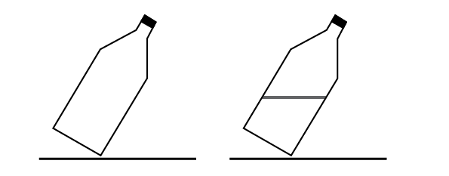

Fig. 2
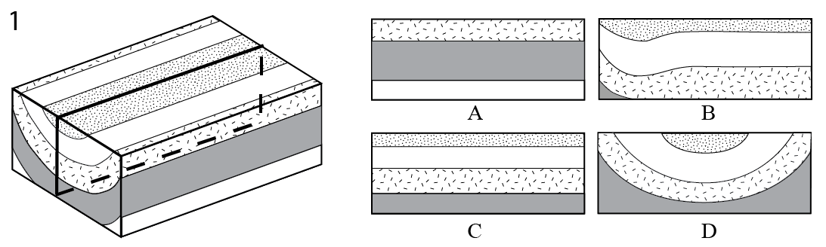

Fig. 3
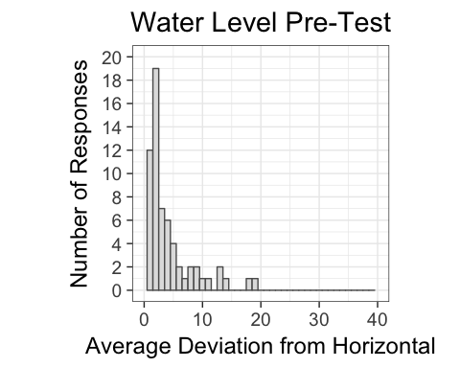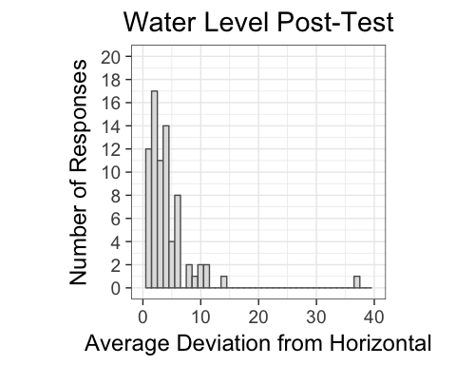

Fig. 4
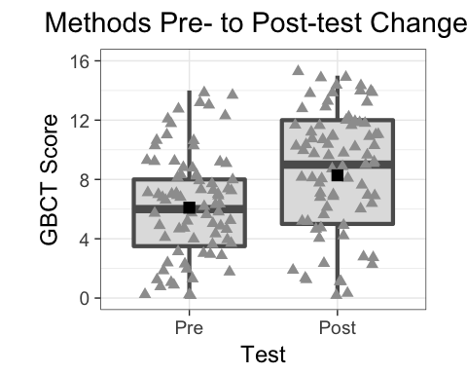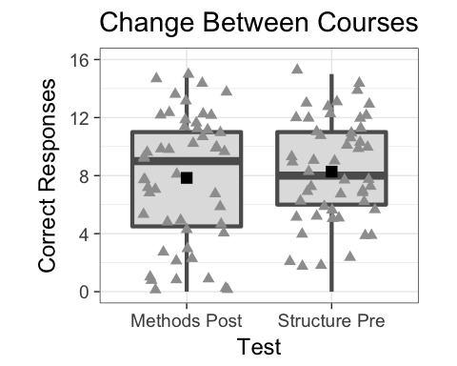

Fig. 5
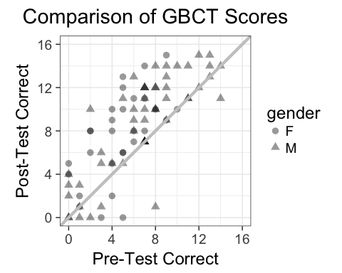
Fig. 6
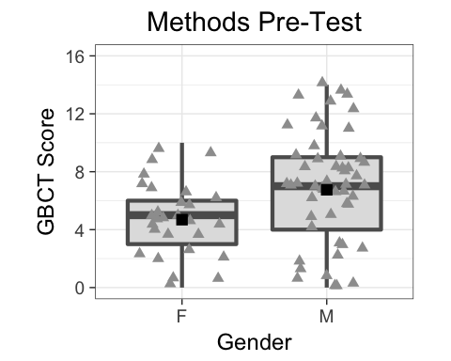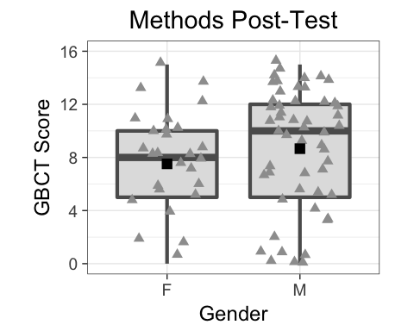

Fig. 7
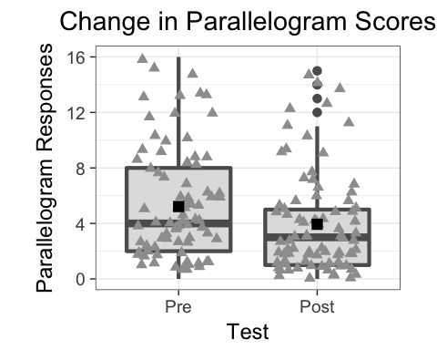
Fig. 8
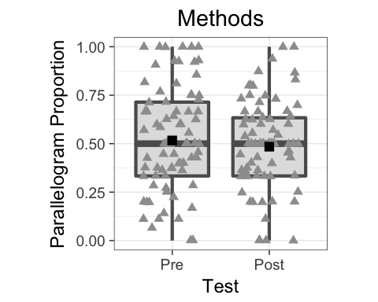

Fig. 9
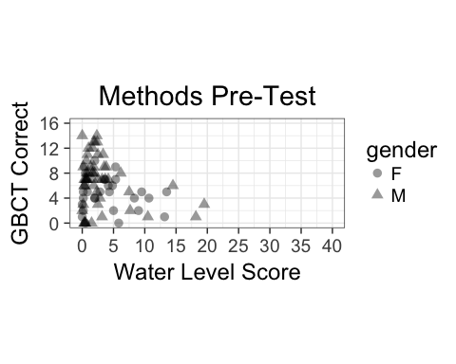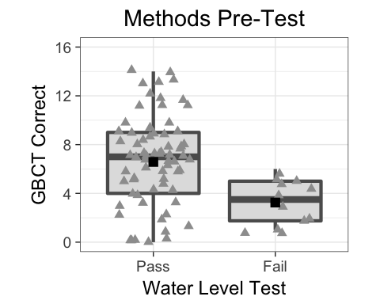
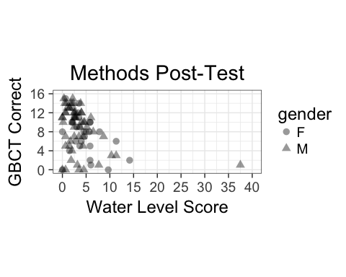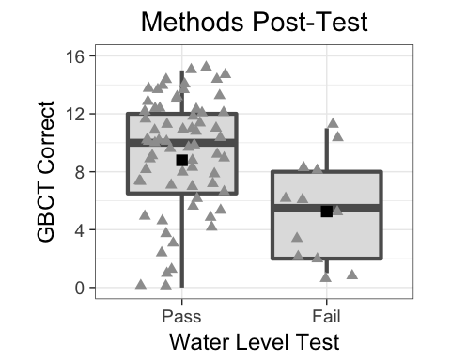

Fig. 10
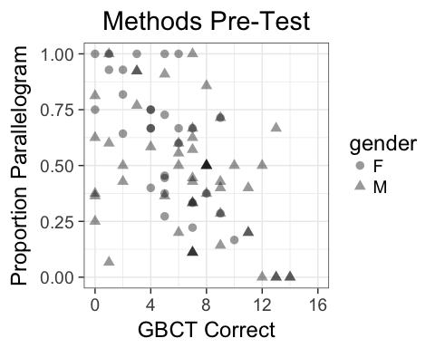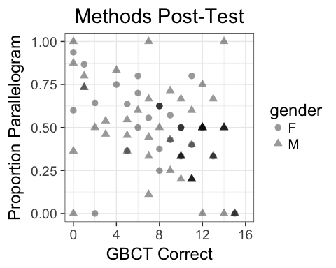

Fig. 11
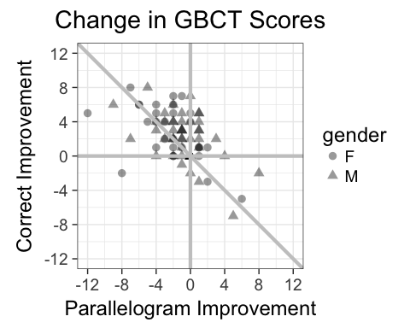

Fig. 12.
