Determination of the diffusion constants of dimethylsulfide and dimethylsulfoniopropionate by diffusion-ordered nuclear magnetic resonance spectroscopy

Christopher E. Spiese
Donald J Bettinger Department of Chemistry and Biochemistry, Ohio Northern University, 525 S Main St., Ada OH 45810
Email: c-spiese.1@onu.edu
Phone: +1-419-772-2365
Running Head: Diffusion of DMS and DMSP
Keywords: gas transfer, uptake, diffusion

Abstract
Diffusion of small molecules influences sea-to-air transfer in the oceans as well as export or uptake from the water column by microorganisms. Direct quantification of diffusion therefore can better constrain the rates of these processes. The diffusion coefficients (D) for both dimethylsulfide (DMSP) and dimethylsulfoniopropionate (DMSP) were determined using diffusion-ordered nuclear magnetic resonance spectroscopy (DOSY). Diffusion coefficients were measured across a temperature range (285 – 315 K, 12 – 42°C) and were corrected for changes in the diffusion coefficient of water. D_{DMSP} was determined in both artificial seawater (salinity 30.5) and in MilliQ water. Diffusion constants (0.929 – 2.22 × 10⁻⁵ cm² s⁻¹ for DMS and 0.504 – 1.22 × 10⁻⁵ cm² s⁻¹ for DMSP) were within the range predicted by various empirical models (0.72 – 2.12 × 10⁻⁵ cm² s⁻¹ for DMS and 0.34 – 1.12 × 10⁻⁵ cm² s⁻¹ for DMSP). D_{DMSP} was well-predicted by theoretical models such Evans (2013) and does not have a strong concentration, salinity, or pH dependence. Implications for diffusion of DMSP on cellular physiology are discussed.
Introduction
Sea-to-air dimethylsulfide (DMS)transfer DMS is a major source of reduced sulfur emissions to the atmosphere, comprising 16.0 – 28.1 Tg S y⁻¹ (Bates et al., 1987; Bates et al., 1992; Lana et al., 2011; Land et al., 2014). For trace gases like DMS, the transfer rate from the surface oceans to the lower atmosphere depends on wind speed, ambient concentration, and transfer resistance (Broecker and Peng, 1974; Wanninkhof, 1992), which itself is often parameterized using the Schmidt number, S_{C} (Johnson, 2010). S_{C} is the ratio of the kinematic viscosity to the diffusion constant, D (m² s⁻¹), and so accurate measurement of D_{DMS} is required to better constrain models of DMS production and emission as well as the global DMS budget. Transfer from the surface ocean to the atmosphere has been hypothesized to facilitate tritrophic interactions in order to relieve grazing pressure (Savoca and Nevitt, 2014). Apart from ocean-atmosphere interactions, diffusion away from phytoplankton cell surfaces controls intracellular DMS concentrations (Spiese et al., 2016) and potential physiological roles for this compound. DMS diffusion can also constrain bacterial use as a carbon source and signaling within the cellular boundary layer (Lavoie et al., 2018a). A large D_{DMS} facilitates a rapid diffusion rate through the external boundary layer of phytoplankton cells, preventing DMS from accumulating inside the cell (Spiese et al., 2016), decreasing its effectiveness as an antioxidant, as has been suggested (Sunda et al., 2002). However, faster diffusion may facilitate algal-bacterial mutualistic interactions, providing carbon, sulfur, and energy from algae to bacteria in the vicinity of phytoplankton (Green and Hatton, 2014; Hatton et al., 2012; Schäfer et al., 2010).
Marine DMS largely derives from the sulfonium compound dimethylsulfoniopropionate (DMSP) (Spielmeyer et al., 2011). Although there is no atmospheric component for DMSP cycling, the cellular and ecological roles it plays often depend strongly on its diffusion rate. While D_{DMS} has been determined before (Saltzman et al., 1993), D_{DMSP} has not. Previous studies estimated D_{DMSP} to be on the order of 10⁻⁵ cm² s⁻¹ (Wolfe, 2000), a value typical of aqueous solutes, but one that is highly imprecise. DMSP is known to react with reactive oxygen species (Spiese, 2010; Sunda et al., 2002), and like DMS, to supply carbon and sulfur for bacterial growth (Green and Hatton, 2014; Hatton et al., 2012; Schäfer et al., 2010). DMSP uptake has also been suggested in certain phytoplankton (Lavoie et al., 2018b; Vila-Costa et al., 2006), and like dissolved nutrients, uptake of DMSP is likely controlled by diffusion at low shear velocity (Hurd et al., 1996; Wolf-Gladrow and Riebesell, 1997).
Previously, D_{DMS} was determined in aqueous agar gels (Saltzman et al., 1993), which have the potential to alter diffusion rates and subsequently bias estimates of D_{DMS}. Other methods for determining diffusion coefficients rely on isotopic tracers (Wang, 1951), permeable membranes (Rebreanu et al., 2008), or electrochemical activity (Martin and Unwin, 1998). In the present study diffusion-ordered nuclear magnetic resonance spectroscopy (DOSY) was used to remove potential biases due to extraneous phases (e.g., membranes or gels). DOSY is a two-dimensional technique that directly measures D in situ (Evans et al., 2018; Evans et al., 2013; Johnson, 1999). DOSY operates by varying the magnetic field strength along the z-axis of the sample using a shaped gradient pulse and then determining the signal strength after a delay. The decay of the signal strength as the gradient pulse strength increases can be fit to an exponential function that depends on D (for review, see Johnson, 1999). DOSY has been used in other areas of environmental analysis to study molar mass and aggregation of dissolved organic matter (Simpson, 2002) and to differentiate phosphorus compounds from soil extracts (Wang et al., 2017), among other applications. DOSY can also be used to determine the molar mass of small molecules (Evans et al., 2018; Evans et al., 2013).
This study is the first to utilize DOSY for measuring D_{DMS} and D_{DMSP} in seawater. These results confirm previous measurements of D_{DMS} and are compared to theoretical and published values. D_{DMSP} is empirically determined for the first time. The implications for DMS(P) physiology in the unmixed layer surrounding algal cells are discussed.

Methods & Materials
Chemicals—Unless otherwise noted, chemicals were purchased from commercial sources (generally Sigma Aldrich) and were of the highest available purity. DMSP·HCl was synthesized from DMS and acrylic acid according to published procedures (Chambers et al., 1987) and recrystallized from ethanol before use. In order to tightly control salinity and to ensure non-interference by other compounds, artificial seawater was made according to the recipe of Parsons (1984) in 18.2 MΩ·cm water (Millipore). The original recipe of Parsons (1984) is made for 30.5 salinity, and no alterations were made to the recipe.

Diffusion-ordered NMR Spectroscopy—NMR spectra were collected using a Bruker Avance III 400 MHz NMR spectrometer. Samples (500 μL) were prepared in artificial seawater (Parsons, 1984) at pH 8.0 and placed in 5 mm i.d. Grade 4 NMR tubes. Neat DMS (2 drops, ~30 mg) was added directly to 0.5 mL aliquots of artificial seawater (final concentration approximately 1 M). DMSP·HCl (61 – 654 mM) was added to the seawater, and the pH decreased to 2.00. Unless otherwise noted, the pH in DMSP samples was not adjusted (vide infra). Concentrations were varied at constant temperature in order to determine whether D_{DMSP} exhibited a concentration dependence.
A coaxial insert (Wilmad® 3.3 mm o.d. × 2.34 mm i.d.) containing D₂O was placed in the tube to provide ²H signal for field locking and for in situ measurement of the self-diffusion coefficient for pure water (D_{w}). The coaxial insert reduced the annular radius of the tube from 2.54 mm to 0.85 mm and restricted the internal volume of the NMR tube to 500 μL with minimal headspace. The presence of the insert also restricts convection, which can bias DOSY measurements to higher values (Evans et al., 2018). NMR samples were allowed to equilibrate for > 30 min in order to assure constant temperature. Gradient pulse widths (500 – 900 μs) were optimized before collection of the DOSY spectrum. 2-D DOSY spectra were comprised of 25 spectra of 16 scans each and processed using Bruker TopSpin software. Nominal temperatures reported by the instrument’s internal thermocouple were calibrated using an external methanol sample (Raiford et al., 1979). In general, the instrumental and calibrated temperatures agreed to within 3°C. In all cases, temperatures reported are methanol-calibrated temperatures and have a precision of ±0.2°C.
Because DMSP is charged and has can engage in acid-base chemistry, two additional experiments were performed. In order to study the effects of salt on D_{DMSP}, one set of DOSY spectra were collected at 300 K in MilliQ water (0 salinity) with DMSP·HCl added (300 mM). In another experiment, 1.0 M DMSP·HCl was first reacted with solid Ag₂O in order to remove chloride (precipitated as AgCl) and to neutralize acidity. DMSP was vortexed with sufficient Ag₂O to bring the pH to 7.00, and then filtered to remove suspended particles. This solution was added to artificial seawater (30.5 salinity) to make a 300 mM solution for DOSY analysis.
D_{DMS} was determined from the center of the projection distribution for the DMS peak at δ 2.19 ppm (Figs. 1 and S1) and the standard deviation of the distribution along the F1 axis (log D axis) was determined from the full width at half maximum (FWHM = 2.355σ). For D_{DMSP}, the value was determined as the mean of D values based on all three peaks corresponding to DMSP (δ 2.87 (2H, triplet), 2.90 (6H, singlet), 3.46 (2H, triplet), Fig. 2), and error is estimated as the standard deviation of these peak centers.
The diffusion coefficient for water (as HDO) in D₂O (D_{w}) was used to assess the accuracy of the DOSY technique. The H₂O signal at δ 4.79 (corresponding to pure water) was observed to be a sharp peak on the shoulder of the much larger H₂O peak from seawater (δ 4.58). The DOSY signal for this peak was clearly separated from that of seawater H₂O, however (Fig. 2). The H₂O peak at δ 4.79 was used to determine D_{w} using the same procedure as for D_{DMS} described above.

Diffusion Models—Diffusion constant values were compared to two theoretical models. First, the Stokes-Einstein relation (Einstein, 1905) describes D in terms of the viscosity (η, cP), temperature (T, K), and the effective spherical radius of the solute (r, cm):
$D=\frac{RT}{6ηN_{A}πr}$ (1)
The viscosity of seawater (salinity 30.5) was determined according to El-Dousskly and Ettouney (2002) at each temperature from 285 – 315 K (12 – 42 °C) and 1 atm pressure (Table 1).
Evans et al. (2013) noted that the Stokes-Einstein model (Einstein, 1905) does not correlate well with empirical measurements of D by DOSY. This is thought to occur due to certain approximations made in the Stokes-Einstein model (Evans et al., 2018; Evans et al., 2013). As such, there is a tendency for Stokes-Einstein to underestimate D (Evans et al., 2018; Evans et al., 2013). To correct for this, Evans et al. (2013) developed a model based on molar mass of both solute and solvent (MW and MW_{S}, respectively, kg mol⁻¹) and the effective density, ρ_{eff} (619 kg m⁻³, Evans et al., 2013):
$D=\frac{k_{B}T\left(\frac{3α}{2}+\frac{1}{1+α}\right)}{6πη\sqrt[3]{\frac{3MW}{4πρ_{eff}N_{A}}}}$ (2)
$α=\sqrt[3]{\frac{{MW}_{S}}{MW}}$ (3)
where N_{A} is Avogadro’s number, k_{B} is Boltzman’s constant. This model aligns well with diffusion coefficients measured by DOSY and removes several assumptions inherent in the Stokes-Einstein model. Using the value for ρ_{eff} from Evans et al. (2018) did not improve the rms error for either D_{DMS} or D_{DMSP}. Because the Evans et al. (2018) model incorporates additional non-aqueous solvents in the estimation of ρ_{eff}, the original value (619 kg m⁻³) is used in this study.
For additional comparisons, the models of Wilke and Chang (1955, Eqn. 4) and Hayduck and Laudie (1974, Eqn. 5) were included for DMS. These models depend on the molar volume of the solute (V), temperature, and/or viscosity:
$D=\frac{7.4×{10}^{-8}{\left({2.6MW}_{S}\right)}^{1/2}T}{{ηV}^{0.6}}$ (4)
$D=\frac{13.26×{10}^{-5}}{η^{1.4}V^{0.589}}$ (5)

Statistical Analyses—Statistical analyses were performed using RStudio v. 1.0.105. Normality was assessed using the Shapiro-Wilk test (shapiro.test function), and linear regressions were determined using the lm function. Where appropriate, t-tests were conducted using Microsoft Excel 2016.

Results & Discussion
Diffusion of H₂O—D_{w} was determined for pure H₂O by DOSY. As the coaxial insert contained trace H₂O in D₂O, the water signal was present in all samples, allowing for assessment of accuracy across the entire sample set. D_{w} from the DOSY results ranged from 1.00 × 10⁻⁵ cm² s⁻¹ (at 279 K, 6°C) to 2.90 × 10⁻⁵ cm² s⁻¹ (at 318 K, 45°C). D_{w} values measured in this study, particularly at higher temperatures, were lower than literature values (Fig. 3,Wang, 1951; Wang, 1966). Therefore, a correction factor was applied to align D_{w} DOSY values to literature values. The literature values were fitted with a second-order polynomial equation (D = 1.087×10⁻⁸ T² – 5.792×10⁻⁶ T +7.846×10⁻⁴), and DOSY values were corrected to match this equation. Correction factors (f) were calculated as the ratio of the measured D_{w} to the predicted value, according to Equation 6:
$f=\frac{D_{w,measured}}{D_{w,predicted}}$ (6)
Correction factors ranged from 0.19 – 0.41, and were applied to the corresponding temperatures for both D_{DMS} and D_{DMSP} data (Table S1). This approach has been used before to correct for systematic bias in DOSY measurements (Neufeld and Stalke, 2015).
From the temperature dependence of D_{w}, the activation barrier (E, kJ mol⁻¹) and the limiting diffusion coefficient (i.e., D at infinite temperature, D₀, cm² s⁻¹) were determined according to the Arrhenius equation:
$D=D_{0}e^{-\frac{E}{RT}}$ (7)
where R is the universal gas constant (8.314 J mol⁻¹ K⁻¹). For D_{w} (uncorrected), this was found to be 19.0 ± 1.1 kJ mol⁻¹, which is comparable to literature estimates (20.3 ± 0.5 kJ mol⁻¹, Wang et al. 1966).

Diffusion of DMS—D_{DMS} was determined across the range of 285 – 315 K (12 – 42°C) in 30.5 salinity artificial seawater. D_{DMS} was found to increase exponentially with temperature from 9.29 × 10⁻⁶ cm² s⁻¹ to 2.22 × 10⁻⁵ cm² s⁻¹ (Fig. 4). DOSY values were similar to those reported by Saltzman et al. (1993), with the differences being within 5% on average. D_{DMS} by DOSY showed poor agreement with the Stokes-Einstein equation (Einstein, 1905), leading to ≥ 30 % higher values. However, good agreement was found between the other models and measured DOSY values, with these data sets agreeing to within ~15 % across the temperature range. The only exception to this was the model of Evans et al. (2013), which had a mean difference of 27 %.
From Equation 6, an activation barrier of 20.6 ± 2.4 kJ mol⁻¹ was determined for D_{DMS} by DOSY, which is not significantly different (p = 0.338) from that determined by Saltzman et al. (1993) (18.1 ± 1.2 kJ mol⁻¹, Fig. 5). The D₀ value for DMS was found to be 0.054 ± 0.022 cm² s⁻¹, which is slightly larger, but not significantly different from that found by Saltzman et al. (0.0200 ± 0.0002 cm² s⁻¹, p = 0.173), although the large uncertainty complicates comparisons. Fitting each of the theoretical models to the Arrhenius equation results in E and D₀ values smaller than those found by NMR (16.8 – 17.7 kJ mol⁻¹ and 0.004 – 0.013 cm² s⁻¹). These results suggest that while the theoretical models do not necessarily predict all parameters accurately, DOSY can determine D_{DMS} accurately, as there are no significant differences between the DOSY data and previous reports. It should be noted that the correction to D_{DMS} based on D_{w} is essential, as without this correction, D_{DMS} can be underestimated by as much as 16%.

Diffusion of DMSP—Similarly to DMS, D_{DMSP} was found to vary exponentially across the temperature range (5.04 – 12.2 × 10⁻⁶ cm² s⁻¹) (Fig. 6). Although no empirical data exist for D_{DMSP}, the theoretical models suggest that these values are on the same order of magnitude as other small molecules in water (Lide, 1996). The values predicted for D_{DMSP} from the models range from 3.36 ×10⁻⁶ cm² s⁻¹ at 285 K (12 °C) to 1.16 × 10⁻⁵ cm² s⁻¹ at 318 K (45°C), with the Evans (2013) model coming close to fitting the DOSY data (< 3% difference on average).
Because DMSP is a zwitterion at seawater pH and a cation at low pH, higher concentrations may affect D_{DMSP} as electrostatic effects restrict diffusion. The concentration of DMSP was varied from 61 – 654 mM in 30.5 salinity artificial seawater at constant temperature (300 K). D_{DMSP} varied little over this range, decreasing from 9.8 ± 0.2 × 10⁻⁶ cm² s⁻¹ at 61 mM to 9.6 ± 0.2 × 10⁻⁶ cm² s⁻¹ at 654 mM (Fig. 7). The concentration dependence was linear, with a change in D_{DMSP} of –(13 ± 9)×10⁻⁷ cm² s⁻¹ M⁻¹, although this slope was indistinguishable from zero (p = 0.208). Concentration effects do not significantly alter D_{DMSP} at 300 K, although caution is warranted as the concentrations used in this study are substantially higher than ambient concentrations, which are on the order of tens of nM (Kiene et al., 2007; Kiene and Slezak, 2006; Kinsey et al., 2016).
Salt concentration also could have an effect on D_{DMSP}. In a study of ion diffusion through Phaeocystis mucilage, Mg²⁺ and Ca²⁺ exhibited diffusion coefficients that were orders of magnitude lower than in bulk seawater (Smith et al., 2014). Likewise, high salt concentrations are known to alter the viscosity of water (Kaminsky, 1957), on which all of the empirical models for D rely. To assess the potential for electrostatic interactions between salt and DMSP, the DOSY experiment was conducted in MilliQ water (0 salinity). To control for possible pH effects, the same experiment was conducted after treating the DMSP solution with Ag₂O to remove HCl and adjust the pH to 7.00. In neither case was D_{DMSP} significantly different from DMSP in artificial seawater (30.5) at pH 2.00 (Table 2), indicating little effect from electrostatics (p = 0.134 for pH 2.00 versus pH 7.00, p = 0.816 for 0 salinity versus 30.5). While DMSP might be expected to show lower diffusivity in seawater versus MilliQ, diffusion constants for ions in seawater have been reported to be ≤ 8% different from those in pure water (Li and Gregory, 1974). It would appear that this is also the case for DMSP at pH 2.00 (singly charged) and at pH 7.00 (zwitterionic).
Fitting D_{DMSP} to the Arrhenius equation resulted in a D₀ value of 0.017 ± 0.011 cm² s⁻¹ and an activation barrier of 19.3 ± 1.8 kJ mol⁻¹ (Fig. 5). The activation barrier is similar to those reported for various amino acids (~19 kJ mol⁻¹ for glycine and alanine), which should exhibit similar charge states to DMSP between pH 2 – 7 (Longsworth, 1954). The Stokes-Einstein (Einstein, 1905) model predicted an activation barrier of 16.8 ± 0.1 kJ mol⁻¹, slightly lower than the DOSY data (p = 0.191). The modelled D₀ value is lower than the DOSY data (0.0064 ± 0.0007 cm² s⁻¹, p < 0.0001). The Evans (2013) model likewise predicted a smaller higher D₀ value (0.009 ± 0.001 cm² s⁻¹) but a similar activation barrier (17.7 ± 0.3 kJ mol⁻¹).
The diffusivity of DMSP has great implications for the chemical ecology and physiology of this compound. In the local cellular environment, diffusive loss from the phycosphere competes with microbial uptake for removal. Ledyard and Dacey (1996) report microbial turnover times in bulk seawater of several hours to 1.5 d. Likewise, Kiene and Linn (2000) reported turnover of DMSP in coastal waters a day or so. The characteristic diffusion time (t_{D}), which is the time required for a molecule to diffuse a given length (l), is related to D by Equation 8:
$t_{D}=\frac{l^{2}}{2D}$ (8)
Assuming that the phycosphere scales as the cell radius, then t_{D} for DMSP around a 5 μm radius cell would be on the order of 15 ms at 300 K (D_{DMSP} = 7.7 × 10⁻⁶ cm² s⁻¹), meaning that microbial uptake cannot effectively compete with diffusion for DMSP if consumption rates in the phycosphere resemble those in bulk seawater (~1.4 nM d⁻¹, t_{consumption} = 60500 s at 2 nM) (Galí and Simo, 2015). There is evidence that bacterial abundances can be higher in the phycosphere versus bulk water, which would increase the overall consumption rate. Phycosphere bacterial abundances are ~10¹¹ cells mL⁻¹ while bulk abundances are ~10⁶ cells mL⁻¹ (Cole, 1982). Scaling the uptake rate by this difference in abundance could mean phycosphere turnover times for DMSP of about 0.6 s, which is still 40-fold slower than diffusion. This is not to imply, however, that DMSP is unimportant as a source of either carbon or sulfur for phycosphere bacteria, only that microbial uptake may not necessarily be the most important loss pathway for DMSP in the phycosphere. Reactions between DMSP and various reactive oxygen species (e.g., hydroxyl radical, superoxide, etc.) are unlikely to contribute substantially to removal due to low concentrations ([OH] ~ 10⁻¹⁸ M) or low rate constants (k_{DMSP + O2-} = 8 M⁻¹ s⁻¹; C. Liu, personal communication). Thus, DMSP is likely removed from the phycosphere primarily by diffusion and is then metabolized by free bacteria.
Typically, the phycosphere thickness is estimated as the cell radius. However, a more appropriate estimate of the thickness of this layer is based on the diffusion speed of the compound of interest. Seymour et al. (2017), for example, define the phycosphere as the region where the compound is present at 150% of background concentration. For DMSP, assuming a continuous exudation rate of ~0.1 mmol [L cell volume]⁻¹ d⁻¹ (Laroche et al., 1999), a 5 μm diameter cell would have a DMSP-defined phycosphere some 29 μm in thickness for a background DMSP concentration of 3 nM (Dusenbery, 1992), or a full order of magnitude larger than predicted based on cell radius alone. This, of course, can change depending on the exudation rate and the presence of biological consumption within the phycosphere, but suggests that the sphere of influence for DMSP can be quite large.

Conclusions
The diffusion of DMS and DMSP were determined using DOSY NMR. While the values are close to those previously reported for DMS, raw DOSY values needed to be corrected, using D_{w} as a reference. This highlights the need for internal calibration of DOSY values in order to yield accurate results. D_{DMSP} was determined for the first time and diffusion is identified as a major removal pathway for DMSP in the phycosphere. Salt effects were examined, as differences between experimental results and model predictions suggested that ion pairing might alter model inputs such as effective molar mass when calculating D_{DMSP}.

Acknowledgements
This research did not receive any specific grant from funding agencies in the public, commercial, or not-for-profit sectors.

References
Bates, T.S., Cline, J.D., Gammon, R.H. and Kelly-Hansen, S.R., 1987. Regional and seasonal variations in the flux of oceanic dimethylsulfide to the atmosphere. J. Geophys. Res., 92(C3): 2930-2938.
Bates, T.S., Lamb, B.K., Guenther, A., Dignon, J. and Stoiber, R.E., 1992. Sulfur emissions to the atmosphere from natural sources. J. Atmos. Chem., 14: 315-337.
Broecker, W.S. and Peng, T.-H., 1974. Gas exchange rates between air and sea. Tellus, 26: 21-35.
Chambers, S.T., Kunin, C.M., Miller, D. and Hamada, A., 1987. Dimethylthetin can substitute for glycine betaine as an osmoprotectant for Escherichia coli. J. Bacteriol., 169: 4845-4847.
Cole, J.J., 1982. Interactions between bacteria and algae in aquatic ecosystems. Ann. Rev. Ecol. Syst., 13: 291-314.
Dusenbery, D.B., 1992. Sensory Ecology. Freeman and Company, New York.
Einstein, A., 1905. Über die von der molekularkinetischen Theorie der Wärme geforderte Bewegung von in ruhenden Flüssigkeiten suspendierten Teilchen. Ann. Phys. (Berlin, Ger.), 322: 549-560.
El-Dessouky, H.T. and Ettouney, H.M., 2002. Fundamentals of Salt Water Desalination. Elsevier Science, Amsterdam.
Evans, R., Dal Poggetto, G., Nilsson, M. and Morris, G.A., 2018. Improving the interpretation of small molecule diffusion coefficients. Anal. Chem., 90: 3987-3994.
Evans, R. et al., 2013. Quantitative interpretation of diffusion-ordered NMR spectra: Can we rationalize small molecule diffusion coefficients? Angew. Chem. Int. Ed., 52: 3199-3202.
Galí, M. and Simo, R., 2015. A meta‐analysis of oceanic DMS and DMSP cycling processes: disentangling the summer paradox. Global Biogeochem. Cycl., 29: 496-515.
Green, T.K. and Hatton, A.D., 2014. The CLAW hypothesis: a new perspective on the role of biogenic sulphur in the regulation of global climate. Oceanogr. Mar. Biol. Ann. Rev., 52: 315-336.
Hatton, A.D., Shenoy, D.M., Hart, M.C., Mogg, A. and Green, D.H., 2012. Metabolism of DMSP, DMS and DMSO by the cultivable bacterial community associated with the DMSP-producing dinoflagellate Scrippsiella trochoidea. Biogeochem., 110: 131-146.
Hayduck, W. and Laudie, H., 1974. Prediction of diffusion coefficients for nonelectrolytes in dilute aqeuous solutions. AIChE J., 20: 611-615.
Hurd, C.L., Harrison, P.J. and Druehl, L.D., 1996. Effect of seawater velocity on inorganic nitrogen uptake by morphologically distinct forms of Macrocystis integrifolia from wave-sheltered and exposed sites. Mar. Biol., 126: 205-214.
Johnson, C.S., 1999. Diffusion ordered nuclear magnetic resonance spectroscopy: principles and applications. Prog. Nucl. Mag. Res., 34: 203-256.
Johnson, M.T., 2010. A numerical scheme to calculate temperature and salinity dependent air-water transfer velocities for any gas. Ocean Sci., 6: 913-932.
Kaminsky, M., 1957. Ion-solvent interaction and the viscosity of strong-electrolyte solutions. Disc. Farad. Soc., 24: 171-179.
Kiene, R.P. et al., 2007. Distribution and cycling of dimethylsulfide, dimethylsulfoniopropionate, and dimethylsulfoxide during spring and early summer in the Southern Ocean south of New Zealand. Aquat. Sci., 69(3): 305-319.
Kiene, R.P. and Linn, L.J., 2000. The fate of dissolved dimethylsulfoniopropionate (DMSP) in seawater: Tracer studies using ³⁵S-DMSP. Geochim. Cosmochim. Acta, 64: 2797-2810.
Kiene, R.P. and Slezak, D., 2006. Low dissolved DMSP concentrations in seawater revealed by small-volume gravity filtration and dialysis sampling. Limnol. Oceanogr. Methods, 4: 80-95.
Kinsey, J.D., Kieber, D.J. and Neale, P.J., 2016. Effects of iron limitation and UV radiation on Phaeocystis antarctica growth and dimethylsulfoniopropionate, dimethylsulfoxide and acrylate concentrations. Environ. Chem., 13: 195-211.
Lana, A. et al., 2011. An updated climatology of surface dimethylsulfide concentrations and emission fluxes in the global ocean. Global Biogeochem. Cycl., 25: GB1004.
Land, P.E., Shutler, J.D., Bell, T.G. and Yang, M., 2014. Exploiting satellite earth observation to quantify current global oceanic DMS flux and its future climate sensitivity. J. Geophys. Res., 119: 7725-7740.
Laroche, D. et al., 1999. DMSP synthesis and exudation in phytoplankton: a modeling approach. Mar. Ecol. Progr. Ser., 180: 37-49.
Lavoie, M. et al., 2018a. Modeling dimethylsulfide diffusion in the algal external boundary layer: Implications for mutualistic and signaling roles. Environ. Microbiol., In press.
Lavoie, M., Waller, J.C., Kiene, R.P. and Levasseur, M., 2018b. Polar marine diatoms likely take up a small fraction of dissolved dimethylsulfoniopropionate relative to bacteria in oligotrophic environments. Aquat. Microb. Ecol., 81: 213-218.
Ledyard, K.M. and Dacey, J.W.H., 1996. Microbial cycling of DMSP and DMS in coastal and oligotrophic seawater. Limnol. Oceanogr., 41: 33-40.
Li, Y.-H. and Gregory, S., 1974. Diffusion of ions in sea water and in deep-sea sediments. Geochim. Cosmochim. Acta, 38: 703-714.
Lide, D.R., ed., 1996. CRC Handbook of chemistry and physics. CRC Press, Boca Raton, Florida.
Longsworth, L.G., 1954. Temperature dependence of diffusion in aqueous solutions. J. Phys. Chem., 58: 770-773.
Martin, R.D. and Unwin, P.R., 1998. Theory and experiment for the substrate generation/tip collection mode of the scanning electrochemical microscope: Application as an approach for measuring the diffusion coefficient ratio of a redox couple. Anal. Chem., 70: 276-284.
Neufeld, R. and Stalke, D., 2015. Accurate molecular weight determination of small molecules via DOSY-NMR by using external calibration curves with normalized diffusion coefficients. Chem. Sci., 6(3354-3364).
Parsons, T.R., 1984. A manual of chemical and biological methods for seawater analysis. Pergamon Press, New York.
Raiford, D.S., Fisk, C.L. and Becker, E.D., 1979. Calibration of methanol and ethylene glycol nuclear magnetic resonance thermometers. Anal. Chem., 51(12): 2050-2051.
Rebreanu, L., Vanderborght, J.-P. and Chou, L., 2008. The diffusion coefficient of dissolved silica revisited. Mar. Chem., 112: 230-233.
Saltzman, E.S., King, D.B., Holmen, K. and Leck, C., 1993. Experimental determination of the diffusion coefficient of dimethylsulfide in water. J. Geophy. Res., 98(C9): 16481-16486.
Savoca, M.S. and Nevitt, G.A., 2014. Evidence that dimethyl sulfide facilitates a tritrophic mutualism between marine primary producers and top predators. Proc. Nat. Acad. Sci., 111(11): 4157-5161.
Schäfer, H., Myronova, N. and Boden, R., 2010. Microbial degradation of dimethylsulphide and related C₁-sulphur compounds: organisms and pathways controlling fluxes of sulphur in the biosphere. J. Exp. Biol., 61: 315-334.
Seymour, J.R., Amin, S.A., Raina, J.-B. and Stocker, R., 2017. Zooming in on the phycosphere: the ecological interface for phytoplankton–bacteria relationships. Nat. Microbiol., 2: 17065.
Simpson, A.J., 2002. Determining the molecular weight, aggregation, structures and interactions of natural organic matter using diffusion ordered spectroscopy. Magnet. Res. Chem., 40: S72-S82.
Smith, W.O. et al., 2014. Giantism and its role in the harmful agal bloom species Phaeocystis globosa. Deep Sea Res. II, 101: 95-106.
Spielmeyer, A., Gebser, B. and Pohnert, G., 2011. Dimethylsulfide sources from microalgae: Improvement and application of a derivatization-based method for the determination of dimethylsulfoniopropionate and other zwitterionic osmolytes in phytoplankton. Mar. Chem., 124: 48-56.
Spiese, C.E., 2010. Cellular production and losses of dimethylsulfide in marine phytoplankton, State University of New York College of Environmental Science and Forestry, Syracuse NY, 178 pp.
Spiese, C.E., Le, T., Zimmer, R.L. and Kieber, D.J., 2016. Dimethylsulfide membrane permeability, cellular concentrations and implications for physiological functions in marine algae. J. Plank. Res., 38: 41-54.
Sunda, W., Kieber, D.J., Kiene, R.P. and Huntsman, S., 2002. An antioxidant function for DMSP and DMS in marine algae. Nature, 418: 317-320.
Vila-Costa, M. et al., 2006. Dimethylsulfoniopropionate uptake by marine phytoplankton. Science, 314(5799): 652-654.
Wang, J.H., 1951. Self-diffusion and structure of liquid water. I. Measurement of self-diffusion of liquid water with deuterium as tracer. J. Am. Chem. Soc., 73: 510-513.
Wang, J.H., 1966. Self-diffusion coefficients of water. J. Phys. Chem., 69: 4412.
Wang, L., Amelung, W. and Willbold, S., 2017. Diffusion-ordered nuclear magnetic resonance spectroscopy (DOSY-NMR): A novel tool for identification of phosphorus compounds in soil extracts. Environ. Sci. Tech., 51: 13256-64.
Wanninkhof, R., 1992. Relationship between wind speed and gas exchange over the ocean. J. Geophys. Res. Oceans, 97: 7373-7382.
Wilke, C.R. and Chang, P., 1955. Correlation of diffusion coefficients in dilute solutions. AIChE J., 1: 264-270.
Wolf-Gladrow, D. and Riebesell, U., 1997. Diffusion and reactions in the vicinity of phytoplankton: A refined model for inorganic carbon transport. Mar. Chem., 59: 17-34.
Wolfe, G.V., 2000. The chemical defense ecology of marine unicellular plankton: Constraints, mechanisms, and impacts. Biol. Bull., 198: 225-244.

Table 1. Dynamic viscosity of seawater in cP at various temperatures. Viscosity was determined according to the equations present in El-Dessouky and Ettouney (2002).
T (K) | T (°C) | η (cP)
279.0 | 5.8 | 1.535
284.6 | 11.4 | 1.317
290.1 | 17.0 | 1.143
295.7 | 22.6 | 1.001
301.3 | 28.2 | 0.885
306.8 | 33.6 | 0.792
312.4 | 39.2 | 0.711

Table 2. D_{DMSP} variation with salinity and pH. D_{DMSP} values are reported as mean ± standard deviation.
Salinity | pH | D_{DMSP} (10⁶ cm² s⁻¹)
30.5 | 7.00 | 10.8 ± 1.0
 | 2.00 | 8.4 ± 0.8
0 | 2.00 | 8.9 ± 1.5

Spiese Figure 1.
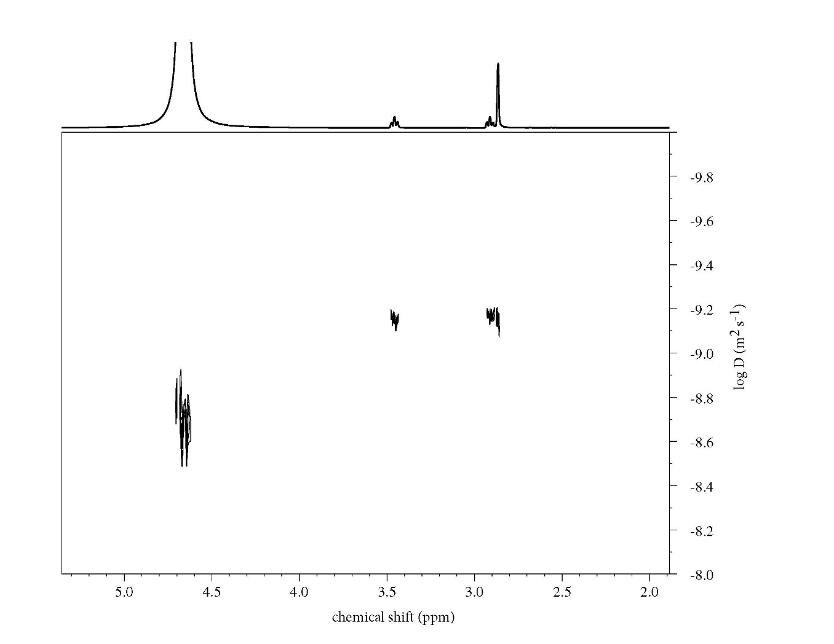

Figure 1. 2D DOSY spectrum of DMSP. The large peak at δ 4.7 ppm is H₂O from seawater, overlapping slightly with a signal from the coaxial insert. 1D ¹H NMR data with peak assignments is presented in Supplemental Information (Fig. S2).

Spiese Figure 2
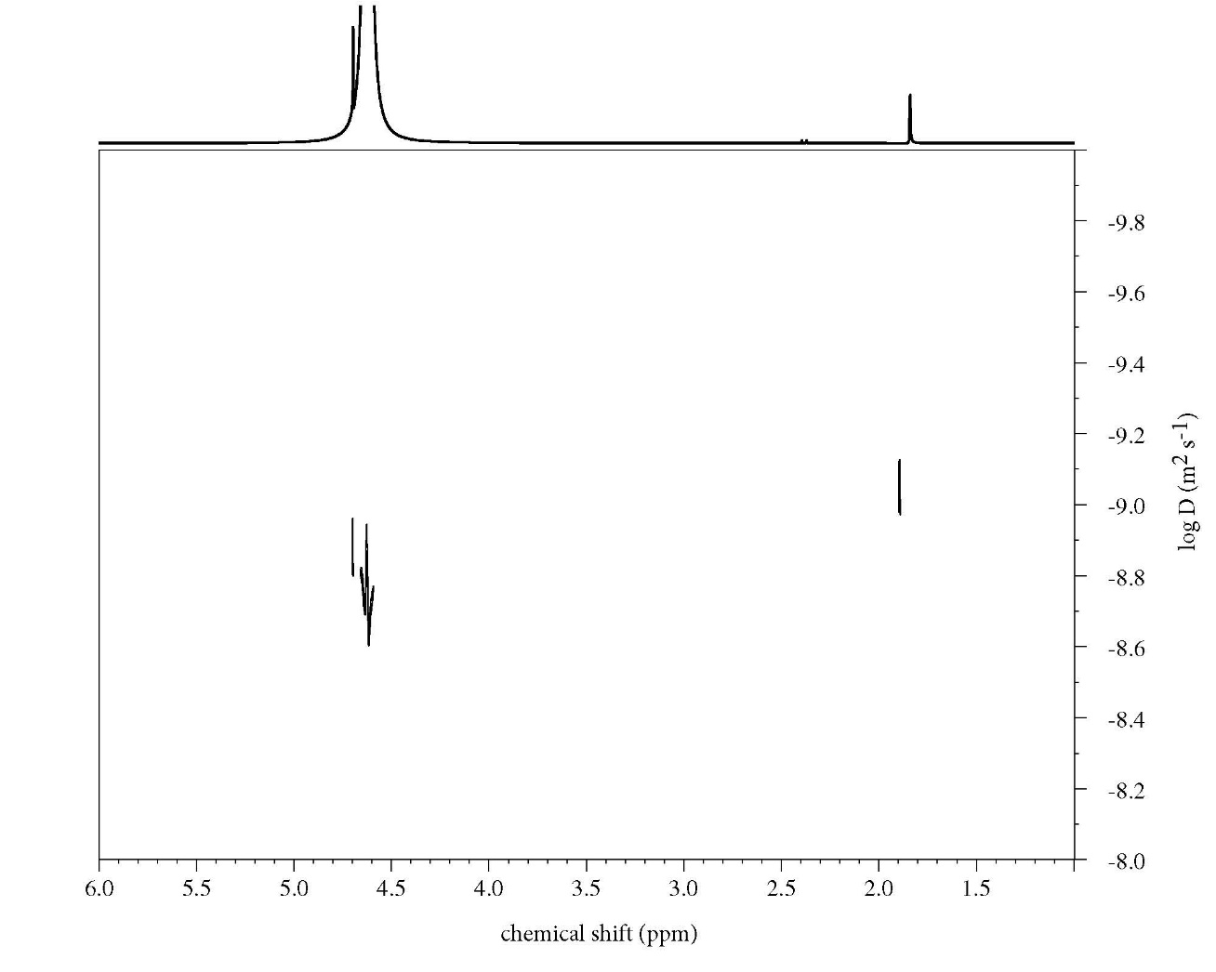
Figure 2. 2D DOSY spectrum of DMS. The large peak at δ 4.7 ppm is H₂O from seawater, overlapping slightly with a signal from the coaxial insert.

Spiese Figure 3.
Literature
Figure 3. Diffusion constant for H₂O by DOSY NMR (open squares), from literature sources (Wang, 1951; Wang, 1966, closed squares) and various diffusion models (lines). DOSY points represent the center of the peak (δ = 4.79 ppm), and error bars represent the standard deviation of the distribution of D_{w}. DOSY values are corrected as described in the Results & Discussion section (Eqn. 6). Model values are based on the dynamic viscosity of seawater at a given temperature and were calculated according to Eqns. 1-5 as appropriate.

Spiese Figure 4
Figure 4. Diffusion constant for DMS by DOSY NMR (points) and diffusion models (lines). Points represent the center of the peak (δ = 2.19 ppm), and error bars represent the standard deviation of the distribution of D_{DMS}. For comparison, D_{DMS} predicted by the Evans (solid line), Stokes-Einstein (Einstein, 1905) (dash line), Saltzman et al. (dotted line), Wilke and Chang (1955) (dash-dot line), and Hayduck and Laudie (1974) (long-short dash) models are included. Model values are based on the dynamic viscosity of seawater at a given temperature.
Spiese Figure 5
Figure 5. Arrhenius plots for D_{DMSP} (closed symbols) and D_{DMS} (open symbols). Lines denote the best fit: DMSP: intercept = -(4.1 ± 0.7); slope = - (2.3 ± 0.2) K⁻¹, r² = 0.960; DMS: intercept = -(2.9 ± 0.4); slope = - (2.5 ± 0.1) K⁻¹, r² = 0.988.

Spiese Figure 6
Figure 6. Diffusion constant for DMSP by DOSY NMR (points) and diffusion models (lines). Points represent the mean D for all DMSP peaks, and error bars represent the standard error in D_{DMSP}. For comparison, D_{DMS} predicted by the Evans (solid line), Stokes-Einstein (dash-dot-dot line), Wilke and Chang (1955) (dotted line), and Hayduck and Laudie (1974) (dashed line) models are included. Model values are based on the dynamic viscosity of seawater at a given temperature.
Spiese Figure 7
Figure 7. Variance of D_{DMSP} with DMSP concentration. Points represent the mean value of DOSY peaks and error bars represent one standard deviation. Linear regression: slope = -(1.3 ± 0.9) × 10⁻⁹ cm² s⁻¹ mM⁻¹, p = 0.218; intercept = 10.0 ± 0.4 × 10⁻⁶ cm² s⁻¹, p < 0.0001.

Determination of the diffusion constants of dimethylsulfide and dimethylsulfoniopropionate by diffusion-ordered nuclear magnetic resonance spectroscopy

Christopher E. Spiese
Donald J Bettinger Department of Chemistry and Biochemistry, Ohio Northern University, 525 S Main St., Ada OH 45810

SUPPLEMENTAL INFORMATION

Figure S1. Normal distribution fit to DOSY F1 spectrum for DMS.
Figure S2. ¹H NMR spectrum of DMSP in seawater.
Table S1. Correction factors for D_{w}

Spiese Figure S1.
Figure S1. DOSY distribution of D_{DMS} and normal distribution fit to DOSY F1 axis projection for DMS at 300 K. Points denote normalized intensity of the DOSY signal and the line represents the normal distribution fit to those points. Normal distribution was fitted to data by minimization of residuals using Microsoft Excel Solver add-in.
Spiese Figure S2
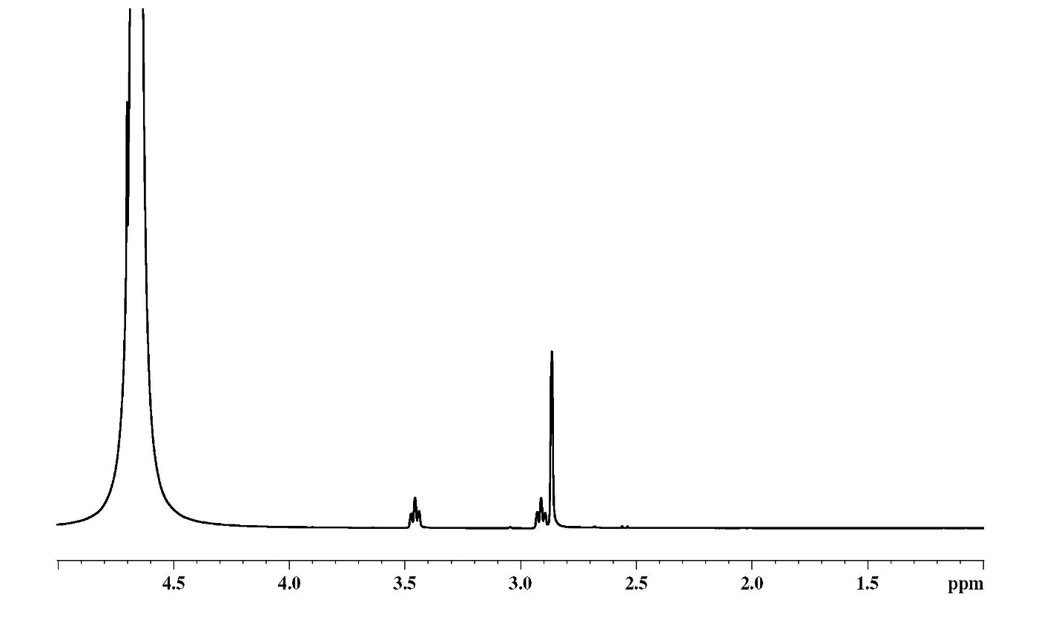
C
B
A
Figure S2. ¹H NMR spectrum of DMSP with structure shown (inset). DMSP peaks are assigned as A (δ 2.87 ppm, singlet), B (δ 2.90 ppm, triplet), and C (δ 3.46 ppm, triplet). The large peak at δ 4.7 ppm is H₂O from seawater.

Table S1. Correction factors for D_{w}. Factors are determined as described in the Results & Methods section (Eqn. 6).
Temperature (K) | Temperature (°C) | Raw D_{w}  (10⁻⁵ cm² s⁻¹) | Literature D_{w} (10⁻⁵ cm² s⁻¹) | Correction Factor | Corrected D_{w} (10⁻⁵ cm² s⁻¹)
279.0 | 5.9 | 1.000 | 1.317 | 0.399 | 1.399
284.6 | 11.4 | 1.323 | 1.678 | 0.195 | 1.581
290.1 | 17.0 | 1.500 | 1.770 | 0.221 | 1.831
295.7 | 22.5 | 1.809 | 2.150 | 0.188 | 2.149
301.3 | 28.1 | 1.828 | 2.354 | 0.386 | 2.533
306.8 | 33.7 | 2.300 | 2.500 | 0.298 | 2.985
312.4 | 39.2 | 2.534 | 3.130 | 0.383 | 3.504
318.0 | 44.8 | 2.904 | 4.100 | 0.408 | 4.090

