Exploring carbonate reef flat hydrodynamics and potential formation and growth mechanisms for motu

Alejandra C. Ortiz^{1,2,3*} and Andrew D. Ashton¹

¹ Department of Geology and Geophysics, Woods Hole Oceanographic Institution, Woods Hole, Massachusetts, USA.
² Department of Earth, Atmospheric, and Planetary Science, Massachusetts Institute of Technology, Cambridge, Massachusetts, USA.
³ Current Address: Department of Civil, Construction, and Environmental Engineering, North Carolina State University, Raleigh, North Carolina, USA.

*Corresponding author: aortiz4@ncsu.edu.
Abstract
Atolls, which develop as reef-building coral platforms extend to near sea level, typically consist of a shallow reef flat encircling a central lagoon. Often, sub-aerial islets, known as motu or reef islands, consisting of sand, gravel, and coral detritus, can be found perched on the reef flat. Here, we use hydrodynamic numerical modeling (XBeach) to better understand the role of waves and wave-driven currents on the reef flat and the processes driving motu formation and evolution. By differing representative reef-flat geometry (e.g. width and water depth), we investigate the effects of varying wave climate on hydrodynamics and resultant bed shear stresses across the reef flat. Model results suggest that as a reef flat shallows, bed shear increases, then, after passing a critical value, decreases again. Using these results, we hypothesize that reef flats should attain a critical water depth just at the threshold for sediment mobilization, resulting in a constant depth flat in both abrasional and depositional settings. As reef flats widen, prograding into the back-reef lagoon, shear stress decreases across the flat, with a minimum in shear stress arising approximately midway on the reef flat. Motu formation would be expected to initiate at this mid-flat nucleation site, either from a storm, when coarse sediment is mobilized and deposited, or gradually as the reef flat widens. A mid-flat deposit need not be subaerial to form a motu—sediment piled shallower than the critical depth would continue to accumulate. Once a motu is present, reef-flat shear stress directions reverse and the motu shoreline should prograde seawards until reaching a relatively narrow critical reef-flat width (~200 m). Together, these results suggest that reef flats and motu spatially self-organize through a series of morphodynamic feedbacks.

Keywords: Atoll, Reef Islands, XBeach, Sediment Transport

Highlights:
- Presents conceptual model of motu (reef island) formation on atolls from hydrodynamic models
- Critical reef-flat depth depends on offshore wave climate and reef flat width
- Widening of reef flat may lead to nucleation of motu in the middle of the reef flat
- Motu nucleation could be caused by storms or steady reef flat widening
- Emplacement of motu should result in seaward shoreline progradation

- Introduction
The sub-aerial islets found atop atoll carbonate reef platforms, known alternately as reef islands, islets, motu, and cays (here we use the Polynesian word “motu” throughout), often serve as the only home to terrestrial ecosystems and human infrastructure on remote island nations. Despite the essential role these islets serve, the morphologic processes and environmental forcings responsible for island formation and maintenance remain poorly understood. With predicted global sea-level rise by the end of this century of up to a meter or more (Horton et al., 2014; Kopp et al., 2014), understanding the processes shaping motu and the reef flats they reside atop will be vital for understanding the potentially dramatic changes that may be in store for island nations in the coming century and beyond (Barnett and Adger, 2003; Nunn, 1998).
Here, we conduct a series of hydrodynamic infragravity wave modeling (XBeach) studies of prototype reef flat and motu profile geometries to better understand the morphodynamic processes shaping these shallow-water systems. By investigating the impacts of varying offshore wave conditions and reef-flat profile geometry (depth and width; with and without motu blocking onshore flow), we develop a process-grounded conceptual model that can explain geologic observations, including reef flat shallowing to a fixed depth, lagoonwards reef flat growth, incipient motu formation, and subsequent oceanwards growth. These results help inform the past geologic evolution of reef flat environments and the future response of these islands to changing environmental forcings by providing a series of self-organizing steps in the evolution of reef flats and motu.
- Background
  - Geologic Evolution of Atolls
Reef flats and islands are the surficial expression of atolls, extensive (100m – km thick) carbonate deposits extending from the igneous seafloor or other basement rocks. Atolls typically are found in deep ocean basins between the tropics of Cancer and Capricorn, where, less than 1-2 km offshore, water depths may exceed 1,000 m. Atoll reef flats can be shallower than 1 m, encircling an inner lagoon (Jones, 2012) with depths ranging from 1-80 m (Toomey et al., 2016). This general geometric configuration remains consistent with Darwin’s (1842) conceptual model for atoll formation, based on subsidence of an extant volcanic island that accretes reefal limestone (calcium carbonate) to a fringing reef that then, over time, evolves into an atoll (Buigues, 1985; Ladd et al., 1970). More recent research emphasizes the importance of ~100 kyr Pleistocene sea level oscillations (Daly, 1925) and rates of carbonate accumulation for the development of barrier reefs, which are predecessors of atolls (Toomey et al., 2013). For modern atolls, because of subsidence and karstification during the previous glacial low-stand (Toomey et al., 2016), Holocene deglacial sea-level rise downed many preexisting atoll surfaces from the Pleistocene highstand, resulting in accretion of a Holocene ‘cap’ of reefal limestone to reach modern sea level (Gray and Hein, 2005; Kench et al., 2014b, 2014a).
Global sea levels stabilized around 6,000 years ago. In the Indo-Pacific region (home of most modern atolls) evidence suggests that a mid-Holocene highstand ~1 m above present occurred around 3-4 kybp (Dickinson, 2003; Nunn, 1998; Rashid et al., 2014), driven by equatorial ocean siphoning (Mitrovica and Milne, 2002; Peltier, 2001). Since then, sea level has primarily been falling for the Pacific atolls up until recent times.
Although often idealized as circular in plan form, atolls come in a variety of different shapes and sizes, including circular, elliptical, rectangular, and more complex plan-form shapes—the controls on atoll shape remains poorly understood, yet it could be assumed that modern atoll planforms are a palimpsest of their extensive geologic history. Some atolls are quite large with an inner lagoon longer than 100 km across, while others can be less than 5 km across (Figure 1a and 1b). Inner lagoons, where present, have depths ranging from 1 - 80 m; these depths appear to be controlled by atoll size and degree of karstification during subaerial exposure (Toomey et al., 2016). Surrounding the lagoon is a shallow carbonate reef flat often contains multiple motu (islets) around the reef edge. Shallow channels, or ‘hoa’, typically of similar depth as the reef flat, often segment motu. In most cases, one or more deep channels (10 m or deeper), or ‘ava’, connect an atoll’s lagoon with the ocean interrupting and cutting through the reef flat, as opposed to the hoa limited to shallow flows over the reef flat.
Starting from the ocean, atolls consist of four distinct geomorphic regions: fore reef, reef flat, subaerial landmass (motu), and inner lagoon (Figure 2) (McLean and Woodroffe, 1994). The primary near-surface component of atolls are reef flats (carbonate reef platforms), slightly submerged rims (typically with depths of 1-2 m below mean sea level) that can extend from the ocean edge to the inner lagoon with widths from 100’s of m to several km (Figure 2b). The reef flat typically contains “remarkably level surfaces and their low-tide elevation varies little for hundreds of meters” (Blanchon, 2011). The majority of active coral growth occurs on the oceanwards edge of the reef flat (fore reef) rather than on the reef flat itself. At low tide, for example, on Ebeye Motu, the reef-flat water depths are less than 0.5 m (Figure 3c and 3d). As opposed to the reef crest, which can consist of thickets of actively growing coral, the typically smoother reef flat tends to be comprised of growing head coral and hard, cemented coral and coralline algal detritus as well as, moving lagoonwards, unconsolidated sandy sediment. Interestingly, the reef flat generally maintains a constant depth across these environments, spanning active coral growth, cemented bed, and depositional sandy apron, suggesting that some process other than the subaerial exposure growth limit for carbonates controls reef flat morphology.
  - Formation and Evolution of Motu
‘Motu’, ‘cay’, and ‘reef island’ are different terms for the islets found atop reef flats; we specifically use the Polynesian term motu (Newell, 1961) to refer to the islands found in atolls throughout this paper. As the composition of islands in Polynesia range from mixed cobbles and sand-sized sediment (McLean, 2011) to entirely sand (Stoddart and Steers, 1977), we do not limit the term ‘motu’ to only islands composed of large-grained sediment as has been suggested by other authors (Brander et al., 2004; Kench et al., 2017; Woodroffe, 2008) especially as this distinction has been inconsistently applied (Richmond, 1992). Moreover, the use of the term motu coupled with the sediment composition of both gravel and sand has been linked to possible formation and evolution mechanisms of these islets to high-energy wave events (Bayliss-Smith, 1988). Since we do not want to infer a specific formation mechanism for these reef islands, we use the term motu throughout our paper to refer to our idealized subaerial landmass sitting atop a reef flat encircling an inner lagoon.
Mostly low-lying with a mean elevation of 1-2 m above sea level (Woodroffe, 2008), motu are typically composed of coral reef sediment, dead micro-organisms living on the reef (such as forams), and rubble from the surrounding coral reefs; larger islands may sustain vegetation. Grain sizes of sediment on motu can vary from very fine-grained sand to large boulder-sized pieces of coral detritus (Figure 3a & 3b)—this carbonate sediment is mostly produced on the surrounding reef from the skeletal remains of coral and organisms living on the reef. Cross-shore motu widths tend to be on the order of several hundred meters (Figure 1). Even on the same atoll, motu may be frequently dissected by shallow hoa channels (every 100s of m to several km) into individual islets or may be continuous and elongated for up to 10s of kilometers (Figure 1c and 1d).
Kench (2014) argues that formation and evolution of motu on atolls is dependent on the interaction of 5 factors: sea level change, substrate characteristics, accommodation space, sediment supply, and the wave energy. Our research aims to elucidate the importance of the wave climate on driving motu formation and evolution. Mixed-sediment motu often have seaward (ocean-side) shingle ridges and leeward (lagoon-side) sand deposits composed of fine-grained sand and large-grained coral rubble, respectively (Murphy, 2009). The coarse-grained rubble may be deposited on the reef rim during large storm events (e.g., tropical cyclones). The fair-weather wave climate, on the other hand, is expected to deposit sand and fine-grained sediment on the motu.
Tropical cyclones are thought to be extremely important in both the formation and the evolution of motu, particularly as large storms have been observed to dislodge reef framework and deposit piles of rubble debris on top of the reef flat (Bayliss-Smith, 1988; Harmelin-Vivien and Laboute, 1986; Kench et al., 2006a; Stoddart et al., 1971). For example, on Takapoto Atoll, Tropical Cyclone Orama contributed up to 62% of sediment for island accretion over the last 30 years (Duvat and Pillet, 2017). When no motu is present, high-energy events can also easily transport fine-grained sand inwards towards the lagoon (McLean and Woodroffe, 1994).
Mandlier and Kench (2012) simulate wave refraction in planform over varying reef-platform shapes, arguing that focal points or zones of wave convergence can lead to sub-aerial landmass formation on small reef flats (area ~1 km²) in the Maldives. There remains some question on what processes are necessary for the formation of these motu. On the other hand, some authors argue that motu initiation requires falling sea level from the mid-Holocene Indo-Pacific highstand (Dickinson, 2009, 2003; Yasukochi et al., 2014). However, modern observations demonstrate that motu formation can occur during rising sea level (Kench et al., 2005; Mandlier and Kench, 2012). For example, on Nadikdik Atoll in the Marshall Islands, a motu formed and stabilized over the past 61 years (Ford and Kench, 2014). The timing of motu formation on atolls varies greatly, some are decades old whereas others have persisted for millennia (Ford and Kench, 2014; Kench et al., 2014a; Woodroffe et al., 2007; Woodroffe and Morrison, 2001), with most motu forming 3,000 years ago (Brander et al., 2004).
Historically, motu have grown in size even as sea level has risen; for example, in French Polynesia, despite a sustained 2.9 mm/yr centennial rate of sea-level rise (Church et al., 2006), the majority of motu on Takapoto Atoll in French Polynesia have either increased in area or remained stable from 1969-2013 (Duvat and Pillet, 2017). A survey of four atolls (Funafuti, Pingelap, Mokil, and Tarawa Atoll) over the last 60 years using historical photographs and satellites found that 86% of the atolls surveyed either increased their land mass or their area stayed the same (Webb and Kench, 2010) concluding that atolls are geomorphically resilient landforms. Beetham and Kench (2014) found a rapid response (weeks) of motu shorelines to varying wave climate conditions in the Maldives using field measurements of wave data coupled with surveyed beach data.
  - Hydrodynamics and Morphodynamic Modeling
The shallow depth of the fore reef and reef flat (1-5 m) strongly controls transformation and transmission of waves approaching from the extremely deep offshore (Figure 2b). The majority of waves arriving from offshore break at the reef crest on the ocean side of the reef flat as well as dissipate from bottom friction (Monismith et al., 2015). For the remaining wave energy propagating towards the interior, field measurements on barrier reefs and reef-flats show waves attenuating across the reef flat (Kench and Brander, 2006; Monismith et al., 2013) where wave energy is dissipated due to continued breaking and bottom friction (Becker et al., 2014; Lugo-Fernández et al., 1998; Monismith et al., 2015; Péquignet et al., 2011; Rogers et al., 2016). Bottom friction factors across reefs have been found to be at least an order of magnitude greater than for sandy bottoms, but with significant variability for both fringing reefs (Lugo-Fernández et al., 1998) and atoll reef flats (Monismith et al., 2015; Quataert et al., 2015). Water depth locally controls wave energy (Kench and Brander, 2006; Péquignet et al., 2011) and increased water depth has been shown to decrease set-up on the reef due to decreased wave energy dissipation (Lugo-Fernández et al., 1998).
In terms of modeling reef hydrodynamics, most studies have focused on fringing reefs (backed by land) or barrier reefs (Buckley et al., 2014; Lugo-Fernández et al., 1998; Péquignet et al., 2011; Pomeroy et al., 2012; Van Dongeren et al., 2013) compared to atoll reef-flats (Quataert et al., 2015). Gelfenbaum et al. (2011) modeled varying geometries of incised channels and fringing reefs using Delft3D; model results suggest that landward-narrowing embayments increase wave inundation and that wider reef-flats increase dissipation.
Using XBeach, a two-dimensional numerical model of wave propagation, sediment transport, and morphology (Roelvink et al., 2009), Van Dongeren et al. (2013) modeled wave dynamics over a fringing coral reef, finding that infra-gravity (IG) waves were important in transporting energy over the reef flat. These IG waves, which are strongly modulated by depth variations because of frictional dissipation, contribute more than half of the total bottom shear stress. Buckely et al. (2014) compared 3 different numerical wave models including XBeach to a laboratory-created fringing reef and found that XBeach was capable of accurately predicting short wave height and IG wave height and spectral transformation. Moreover, they saw a strong sensitivity to the breaking wave parameter when ignoring the effect of wave-energy dissipation from bottom roughness.
Longer-tem modeling approaches address potential morphodynamic evolution of motu. Using the modified version of the morphokinematic profile Shoreface Translation Model (STM), Cowell and Kench (2001) simulate the response of motu to changes in sea level. Their model results suggest that sea-level rise should drive shoreline recession, thus widening of the reef-flat (Kench and Cowell, 2001), with a strong sensitivity of motu to sediment supply from the reef flat. Barry et al. (2008), using a non-linear box model, the Sediment Allocation Model (SAM), simulate a pattern of motu growth characterized by rapid lateral expansion and diminishing vertical accretion assuming constant sediment supply and static accommodation space.
  - Outline
This paper is motivated by observations that reef flats and reef islands are geologically young landforms, with formation timescales much shorter than the atolls that underlie them. Modern, active reef flats are shallow, consistently found within several meters of modern sea level, and extend for significant distances with little to no change in elevation. Many reef islands appear to have formed from a rubble core on top of pre-existing reef flats, subsequently prograding towards the ocean. Dating of reef islands suggests that most formed over the last several thousand years (Kayanne et al., 2011; Kench et al., 2005; Woodroffe et al., 1999; Woodroffe and Morrison, 2001), with reef island formation even observed in the instrumental record (Ford and Kench, 2014). Here, we conduct hydrodynamic experiments to develop a comprehensive model of reef flat growth and subsequent island formation and evolution.
To better understand the hydrodynamic processes affecting reef flats and motu, we use XBeach to simulate how different wave conditions affect the hydrodynamic conditions of reef flats both with and without motu present. Previous work has mostly focused on using XBeach to model IG wave transformation on fringing reefs (Van Dongeren et al., 2013); here we specifically model hydrodynamic transformation of IG waves on submerged reef flats backed by a deep, well-drained lagoon. The hydrodynamic results, and in particular the computed bed shear stresses, are interpreted to better understand reef flat evolution and how motu form and evolve. We explore a range of external forcing and underlying geometry for prototype reef flat systems.
In this paper, we first explain the underlying model framework. Then we detail results, first for reef flats, showing how varying offshore wave climate, water depth, and width affects local hydrodynamics. We then briefly discuss the implications of the hydrodynamic results in terms of controls on reef flat depth, widening, and the incipient formation of reef islands. We then return to the model, adding a subaerial landmass, representing a motu, on the reef flat and rerun the simulations to examine how the presence of land affects local hydrodynamics. These results are interpreted to develop a conceptual model reef flat development and motu formation and evolution.
- Methods
We developed a simplified profile geometry for the XBeach modeling based on characteristic shapes of atolls, reef flats, and motu (Figure 2c). XBeach was selected because it specifically models infragravity waves (Roelvink et al., 2009), which have been demonstrated in the field to be important in energy transfer and bottom shear stress across the reef flat (Pomeroy et al., 2012; Van Dongeren et al., 2013). For our simulations, we vary the external forcing (offshore wave height) and geometry of the atoll, specifically the reef-flat width, water depth, and presence of sub-aerial landmass. Our objective is not to simulate any exact atoll, but rather to investigate how underlying atoll geometry, and in particular the reef flat, affects wave transformation, hydrodynamics, and potential for sediment transport. Modeling simplified cross-shore profiles allows us to explore a wide range of potential reef flat and island morphologies while avoiding onerous simulation times.
XBeach is run in 1-D profile mode with a constant-depth reef flat, which may be topped by a motu (Figure 2b & 2c). Because most atolls, such as those in the Marshall Islands and French Polynesia, have a steep, almost vertical bathymetric profile (less than 2 km offshore of atoll the water depth can be over 1,000 m) the offshore ocean-side slope is steep (Blanchon, 2011) ascending to the constant-depth reef flat (h_{r}). The 2 km-wide ocean domain was important to avoid ocean-side boundary affects, particularly for the IG waves. The reef flat terminates in a backbarrier lagoon with a water depth of 40 m, extending past the reef flat for a distance of 500 m, to avoid lagoon-side boundary effects. We vary the profile geometry: the water depth over the reef flat (h_{r}) from 0.1 to 5 m, the width of the reef flat (w_{r}) from 0.1 to 1.5 km, and the motu height (h_{m}) from 0 (no motu present) to 2 m (fully subaerial motu). Horizontal spatial resolution varies from 100 to 2 m in areas of interest to optimize model run time. Our total domain varies from 2.6 km to 3.75 km wide depending on our total reef-flat width.
The offshore waves are generated using the XBeach built-in JONSWAP spectrum for a peak wave period (T) of 10 seconds and varying offshore wave heights (H₀) from 0.5 – 4 m, spanning background and storm conditions. The model is run in “surfbeat” or instationary mode, where the short wave variations on the wave group scale (short wave envelope) and the long waves associated with them are resolved (Holthuijsen et al., 1989; Roelvink et al., 2009). Each XBeach simulation is run for 6 hours of model time and variables are output every 10 seconds. Output data at each spatial location is averaged over all time steps to compute temporal means and standard deviation. We found that model spin-up is minimal, and temporally averaging over all time outputs versus a subset had less than 2% of impact on the mean values. We do not model tidally driven flows or locally generated waves, and, for all runs, the water level in the lagoon is held at a constant value, assuming that the lagoon is well-drained by ‘ava’ channels even during our large wave events.
Although XBeach has the capability to model morphodynamic evolution of sandy environments, reef flats are heterogeneous, containing corals, concreted bed material, and variable sediment distribution. Therefore, we run XBeach with no morphodynamics or sediment transport to focus on the hydrodynamic transformation across the reef flat. However, the effects of waves and currents on potential sediment transport can be investigated using XBeach-calculated bottom shear stress (τ_{b}) based on the near bottom orbital velocity (generated by the waves) and the mean Eulerian velocity (generated by any induced currents),
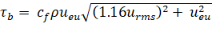 , (1)
where c_{f} is the bed friction coefficient associated with mean currents and IG waves (Feddersen et al., 2000), 0.1 (Van Dongeren et al., 2013), ρ is the density of saltwater, 1.027 g/cm³, u_{eu} is the mean Eulerian velocity (m/s), and u_{rms} is the near-bottom orbital velocity (m/s). To account for wave-induced mass flux and subsequent return flows, the mean Eulerian current is the short-wave averaged velocity (u_{eu}), and sets the direction of bottom shear stress (τ_{b}). Direction of modeled bottom shear stress (τ_{b}) indicates the potential net direction of transport of sediment (oceanwards for negative shear stress, τ_{b} < 0, and landwards or lagoonwards for positive shear stress, τ_{b} > 0,).
We estimate initiation of motion of sediment using a critical bottom shear stress criterion, τ_{cr} (Fredsøe et al., 1992; Miller et al., 1977), dependent on the density and grain size of the bed sediment. In atolls, sediment ranges from very fine-grained sand (1/16 mm) to large pieces of coral rubble, from gravel to boulder-sized pieces (15 – 300 mm or larger) (Perry et al., 2011). Coral clasts, limestone, and beach rock sediment are light and have variable density, ranging from 1.1 to 2.4 g/cm³, compared to a typical density of quartz sand of 2.65 g/cm³. Based upon these ranges of carbonate density, the critical shear stress to initiate movement of sediment found in reef flat environments ranges from 0.05 to 230 N/m² utilizing Shield’s method (Fredsøe et al., 1992; Madsen, 1991). In particular for coarse carbonate sands, critical shear stresses range from 0.05 to 1.1 N/m² compared to a τ_{cr} = 1.5 N/m² for coarse, quartz sands (2 mm diameter).
Our hydrodynamic model outputs bed shear stress (τ_{b}), which we relate to movement of sediment above a critical shear stress driving bed abrasion or deposition. These results drive our conceptual model of reef-flat aggradation, progradation, potential erosion, and eventual formation of a motu driven by the offshore wave climate. The concept of tools and cover for abrasion-driven erosion is borrowed from bedrock rivers (Anderson and Anderson, 2010; Sklar and Dietrich, 2001) and rocky coastlines (Blanco-Chao et al., 2007; Limber and Murray, 2011; Stephenson, 2014; Sunamura, 1992, 1977). Our suggestion is not that the waves on the reef-flat are directly driving erosion of the bed but rather wave-driven sediment transport (when the bed-shear stress exceeds critical shear stress to mobilize sediment) drives abrasion of the consolidated reefal material.
The XBeach model results were most sensitive to the length of the run, presence of the backbarrier lagoon, infragravity wave generation, and the friction coefficients (c_{f} and f_{w}) used in calculating bottom shear stress (τ_{b}). Model runs of 6 hours were required for convergence of mean model results. We found that if the model was run for less time (e.g. 2 hours), there were variations of about 10-20% in computed mean bottom shear stress between runs for the same initial inputs. For longer model runs (10 or 24 hours), the variation in mean bottom shear stress was significantly less (< 2%); simulations run for 6 hours enabled us to run multiple simulations and scenarios quickly. The generation and presence of infragravity waves contributed to almost 50% of bottom shear stress over the entire width of the reef flat (Figure S4).
There are two friction coefficients used by XBeach in the calculation of wave height (f_{w}) and bottom shear stress (c_{f}) that affect modeled wave transformation over the reef flat. XBeach was originally designed for a sandy bottom where friction is much less than a hard coral reef-flat bed, typically at least an order of magnitude smaller (Brander et al., 2004; Gelfenbaum et al., 2011; Kunkel et al., 2006; Lugo-Fernández et al., 1998). We used 0.6 instead of the default of 0 for the short-wave friction coefficient (f_{w}) following the model calibration of Van Dongeren et al. (2013) for a fringing coral reef. In addition, we also used the same bed friction coefficient of 0.1 (c_{f}) instead of the default value of 0.003 (equation 1). These default friction coefficients resulted in significantly less bottom shear stress over the entire reef flat (at least a 25% reduction).
- Reef-flat Hydrodynamic Modeling
  - Results: Changing Reef-flat depth
The shallow reef flat (h_{r}) filters the wave field as short-period waves break on the ocean edge of the reef flat (Figure 4). Wave height, water level, and near bottom orbital velocity decay moving lagoonwards. If only short waves were present, shallow-water waves would be expected to completely break at the reef interface for shallow reefs. However, water level oscillations associated with infragravity waves allow incident waves to penetrate into the reef flat. The infragravity waves then slowly decay as they propagate landwards over the reef flat (Figure S3a and S3d), accounting for 25% of the water set up (Supplemental Information, Figure S3) and 50% of the bottom shear stress across the reef flat (Figure S4).
Vigorous wave breaking at the fore-reef sets up the water elevation, driving an onshore-directed flow (Figure 4b and 4c). Cross-shore radiation stress gradients drive the water setup at the ocean-side reef-flat edge (Figure S2), which drives the mean Eulerian current (Figure 4c & Figure S3c). Similarly, Becker et al. (2014), measuring water level variations and waves over reef flats in the Marshall Islands and Mariana Islands, found that as ambient water levels over a reef flat increase, there is a corresponding decrease in the setup, as we see in the simulations (Figure 4b). If the reef flat is sufficiently shallow, the flow slightly accelerates towards the lagoon as water elevations (set-up) decrease (Figure 4c). Increasing the water depth over the reef flat increases both the wave heights (Figure 4a) and the near-bottom orbital velocities across the entire reef flat (Figure 4d). However, decreased wave breaking reduces the set-up (Figure 4b), thus decreasing the lagoonwards current (represented by the mean Eulerian velocity) (Figure 4c).
The magnitude and temporal variability of the bottom shear stress is similarly reduced for deeper reef flats (Figure 5). Except for the initial large local minima in offshore-directed bottom shear stress at the ocean edge of the reef flat, bottom shear stress stays positive (onshore-directed) across the entire reef flat. Just landwards of this large negative peak (offshore-directed) of bed shear stress at the reef-flat ocean edge, there is a corresponding local maximum in onshore shear stress. As wave height decays, bottom shear stress decreases over the width of the reef flat. However, for shallow depths (less than 1-2 m) a secondary peak of bottom shear stress arises at the reef-flat edge at the lagoon, caused by the subtle acceleration of the current, u_{eu} (Figure 4c).
Increasing the offshore wave height increases the bottom shear stress across the entire reef flat (Figure 6). For a given offshore wave height, the bottom shear stress increases with increasing water depth up to a maximum at 1-2 m depth and then decreases with increasing depth. For offshore wave heights of 1 m or less, bottom shear stress is below the critical shear stress for moving coarse sand (τ_{cr, sand} = 1.1 N/m²) for most reef-flat depths. For larger offshore wave height, the bed shear maximum occurs at a larger reef flat depth (Figure 6b, c).
  - Results: Changing Reef-flat Width
Increasing the total reef-flat width decreases the bottom shear stress across the reef flat (Figure 7), caused by decreases in the mean current, u_{eu}, as wave heights are unaffected by the wider flat (Figure S1). Interestingly, an almost parabolic pattern of bottom shear stress emerges for depths between approximately 1-2 m. The ocean-side decay in shear stress is from wave dissipation. Moving towards the lagoon, as the set-up level decreases, the flow accelerates as a result of mass conservation, increasing the bed shear stress due to the increased net current (Figure S1 and Figure 4). Between these two, a shear minimum occurs. This phenomenon is not observed for deeper reef flats (Figure 4) as reduced wave dissipation results in an increased importance of waves on bed shear and reduced set-up to drive the cross-flat flow. Furthermore, if the flow is deeper, the relative difference in flow depth is less and acceleration is minimal (Figure 4). Note that because bed shear is non-linear with flow velocity (see eq. 1); a subtle increase in velocity can lead to a pronounced increase in bed shear stress (Figure 7).
Combining simulation results, we interpolate the bottom shear stress for different reef flat depths for varying reef-flat widths (Figure 8). As expected, larger offshore wave heights generate a significantly larger bottom shear stress for all geometries and the deeper reef flats have reduced bottom shear stress. However, for shallower flats a saddle, or bow tie pattern in bed shear stress distribution arises, with higher bottom shear stress at either edge of the reef-flat (ocean-side and lagoon-side) that is connected by a narrow bridge in the mid part of the reef flat (most easily seen in Figure 8, row 2 column 3, w_{r} = 1.0 km, H₀ = 4 m). This saddle pattern emerges for reef flats with a width greater than half a kilometer, and the cross-shore location of the minimum in bottom shear stress varies with reef flat width, but tends to be near the middle of the reef flat.
  - Discussion: Reef-flat Geometry
At the oceanward side, coral growth and accumulation sets the elevation of the reef flat. In general, corals and coralline algae accumulate the reef to the intertidal region such that they remain submerged. Vigorous wave breaking on the fore reef does not generally limit coral growth—instead waves tend to break apart actively growing corals, creating a mix of mobile sediment, from sand to rubble (Perry et al., 2011). Coral growth continues behind the fore reef, where numerous processes, including bioerosion as well as Halimeda and Foraminifera growth may tend to generate sand-sized particles (Perry et al., 2015). Moving towards the lagoon, reef flats often steadily transition, typically with little to no elevation change, from a rocky, cemented bed into a sandy flat without significant elevation changes of the bed (Figure 2).
The model results for differing reef-flat depths provide a framework to explain the emergence of a near-constant elevation reef flat that extends for 100’s of meters and in some cases for kilometers. Where the bottom shear stress exceeds a critical shear stress (τ_{b} > τ_{cr}), sediment is mobilized and can be transported landwards by the wave-driven currents. There are two ways that sediment mobilization can set reef flat elevation. In the distal, sediment-rich portions of the reef flat, if bottom shear stress is below the critical shear stress (τ_{b} < τ_{cr}), sediment is deposited. However, in coral- and hard-bottom-dominated portions of the reef, if waves are able to move bed sediment on a regular basis, it will be difficult for the sediment to become cemented and moving sediment can abrade the reef framework (similar to tools and abrasion in bedrock rivers (Anderson and Anderson, 2010; Sklar and Dietrich, 2001)) and inhibit coral growth. Therefore, we hypothesize the bed will erode through abrasion if the mean wave conditions exceed the critical shear stress for a given sediment size.
As stated earlier, the variety of sediment sizes upon a reef flat results in a large range of potential critical bottom shear stress, although production of sand-sized sediment is common. For a given critical shear stress, there may be two depths where the critical shear stress equals the bottom shear stress (τ_{b} = τ_{cr}), corresponding to two equilibria points (Figure 6a). This results in a model for reef flat elevation control similar that of Fagherazzi et al. (2006) for tidal flat elevations controlled by locally generated waves.
First, if the reef flat is deeper than the unstable equilibrium depth but shallower than the stable equilibrium depth (where the bottom shear stress is greater than the critical shear stress, Figure 6a), then the reef flat will tend to erode and deepen through advective transport of sediment lagoonwards or abrasion of hard-bottom reef flat by agitation of sediment. Deepening will continue until the bottom shear stress equals the critical shear stress. If, however, the reef flat is deeper than the stable equilibrium depth, available sediment will tend to deposit, shallowing until the bottom shear stress equals the critical mobilizing shear stress at the stable equilibrium. In the distal reef flat, sediment may remain noncohesive; near the ocean, where nutrients are more available, large-grained sediment (rubble) may be bound by coralline algae, solidifying the bed. The second, shallower, equilibrium point is unstable. If the reef flat is shallower than this unstable equilibrium depth, sediment can continue to deposit and thus continue to shoal the reef flat up to sea level, potentially emerging sub-aerial land. Of course, the sediment size and the critical shear stress are paramount in controlling the behavior of the reef flat.
Because of the mid-reef stress minimum, on a shallow reef flat, for a given grain size and density, there may be a lagoonwards location on the reef flat that the bottom shear stress no longer exceeds the critical shear stress where sediment would likely be deposited. This onshore distance varies with water depth over the reef flat. For example, for a 5 m deep reef flat with a 2 m offshore wave height, sand would be predicted to be deposited around 0.8 km inland of the reef flat, but for shallower reef flats or larger offshore wave heights, sand would be transported across the flat, and deposited into the lagoon (Figure 6). For a sample critical shear stress, τ_{cr sand =} 1.1 N/m², approximating a 2.0 mm grain of high-density carbonate sand (ρ_{s} = 2.4 g/cm³), waves with H₀ = 2 m can mobilize sandy sediment across an entire 1 m deep reef flat (Figure 6). However, for a sample critical shear stress, τ_{cr boulder} = 12 N/m², representing a lightweight piece of coral rubble (ρ_{s} = 1.1 g/cm³ and d = 30 cm), the mean shear stress never exceeds this critical shear stress, meaning that coarse gravel and coral rubble will not be easily mobilized by 2 m offshore waves.
For narrow reef flats, high bottom shear stress should tend to move sediment across the reef flat, bypassing the flat itself and depositing in the lagoon, extending the flat lagoonwards. This lagoonwards growth agrees with observations that once an actively accreting reef community has reached a vertical growth limit, lateral lagoonwards accretion becomes the dominant mode of growth, with progradation rates of 15-300 mm/yr observed in Indo-Pacific Reefs (Montaggioni, 2005).
As the reef flat widens, the bottom shear stresses will decrease, and should eventually fall below the critical shear stress to mobilize sediment, most likely at the mid-flat where the bottom shear stress reaches a minimum. There may be some landward distance over the reef flat that the mean grain size of sediment can be transported (where τ_{b} > τ_{cr}). This location of minimum bottom shear stress may serve as a locus of deposition. For larger offshore waves (from a storm for example), sediment could be transported further onshore (or across the entire reef flat) by the larger bottom shear stress.
The location of the bottom shear stress minimum varies with depth and offshore wave height (Figure 9a). For example, for a wide reef flat (w_{r} = 1.0 km), as the flat gets deeper, the location of the minimum of bottom shear stress first moves oceanwards then steadily moves lagoonwards until, at the deepest reef-flat depths, the minimum in bottom shear stress is at the back edge of the reef flat (Figure 9a). For increasing offshore wave height, the location of the minimum of bottom shear stress moves oceanwards. For varying reef-flat widths, the location of the minimum of bottom shear stress over all depths tends to be slightly oceanwards of the middle of the flat (Figure 9b).
We suggest that these locations of minimum bottom shear stress might be the locations during a high-energy event (like a storm) where the bottom shear stress falls below the critical shear stress for mobilization of large sediment, resulting in deposition. These potential depocenters tend to be on the order of half to a third of the total reef-flat width (Figure 9b). Once the large sediment is deposited (a pile of coral rubble), the local depth will decrease, possibly becoming shallower than the unstable equilibrium depth for the mean wave climate (Figure 6), allowing even sand-size sediment to accrete during fair weather, eventually causing a sub-aerial landmass to emerge, a proto-motu.
  - Discussion: Reef-flat Evolution
Our model results suggest that, similar to tidal basins, reef flats depths may self-organize; there is a tendency for reef flats to develop towards constant depth based on the available sediment and the wave climate. If a hypothetical reef flat is deeper than the stable equilibrium for the predominant sediment and wave climate, the reef flat would be expected to accrete, either through sediment deposition or through carbonate reef accumulation (coral growth, bed cementation) because bed shear stresses are too low to agitate bed sediment and abrade a rocky bottom. On the other hand, reef flats shallower than the stable equilibrium (but deeper than the unstable equilibrium) will tend to deepen as sediment is continually mobilized by the high bottom shear stress (Figure 6b), abrading the bed or transporting loose sediment into the lagoon. If a reef flat is too shallow, waves do not frequently mobilize sediment, and the bed can accrete to sea level.
Any changes in local sea level, offshore wave climate, and sediment type would change this equilibrium depth (Figure 6b, c). If relative sea level increases, then the reef flat should accrete to maintain an equilibrium depth. However, an increase in mean wave climate or perhaps a shift in the frequency of storms should deepen the reef flat. Changes to the sediment supply from the reef edge, driven either by sea level and wave climate changes, or by other environmental stressors such as bleaching or acidification could also affect the reef flat.
Narrower reef flats have higher mean bottom shear stress (Figure 7) easily mobilizing sediment across the entire reef flat (Figure 8)—this should widen the reef flat as sediment is continually driven across the entire reef flat and deposited at the lagoon edge. This widening of the reef flat should continue until the reef-flat is sufficiently wide that the mid-reef minimum bottom shear stress falls below the critical bottom shear stress (Figure 9). Although a reduction of sea level should decrease bottom shear stress across the reef (Figure 8) and could increase the likelihood of mid-reef deposition, reef flat widening alone could initiate motu formation. As such, our model for motu formation does not require local sea-level fall, in accordance with observations by Kench et al. (2014). Furthermore, although mid-flat motu formation could be initiated by a storm event, proto-motu will be more likely to form as the reef flat widens and bed shear stresses decrease overall.
- Motu Evolution
The previous XBeach model simulations were applied to a submerged, constant-depth reef flat. Using these results, we hypothesized a mechanism whereby subaerial land may emerge upon a reef flat at a location onshore of the reef edge, preferentially towards the middle of the flat at the location of minimum bed shear stress. Here, to explore the influence of motu on reef flat hydrodynamics, we add a rigid subaerial landmass (a motu) atop the reef flat. As before, we explore how reef hydrodynamics and shear stresses are affected by different wave heights and changes to the depth and width of the reef flat (in this case the reef flat width in front of the motu). Because we are modeling 1-D profile mode, our model best represents a long continuous motu, similar to the motu shown on the NE side of the Rangiroa (Figure 1c) rather than the small disconnected motu seen on the SW side (Figure 1d).
  - Results: Motu Effect on Hydrodynamics
The presence of a subaerial landmass has minor effect on wave heights and the near-bottom orbital velocities over the reef flat (Figure 10a and 10d). However, the emergent land blocks flow and therefore has a strong effect on both water-level elevation and the subsequent currents generated over the reef flat (Figure 10b and 10c). The presence of a landmass creates an increased and sustained elevation of the water level compared to a case where there is no motu, similar to field data collected in front of Fatato Motu on Funafuti Atoll, Tuvalu (Beetham et al., 2016). Net currents generated over the reef flat with a motu are minimal.
The reduced mean Eulerian velocity translates to a significant reduction in the bottom shear stress across the entire flat (Figure 11a), including dampening the strong initial peak of bottom shear stress near the ocean edge of the reef flat. For almost all reef flat depths, the mean bottom shear stress is close to zero and rarely exceeds the critical shear stress for sand. Moreover, the bottom shear stress over the reef flat is no longer consistently positive (onshore-directed), fluctuating between on- and offshore-directed. For many water depths, the mean bottom shear stress is directed offshore on the outer reef flat, with a zero-crossing (bottom shear stress transitioning from negative to positive moving landward) somewhere on the reef flat. The location of the zero crossing moves landwards with increasing reef flat depth (Figure 11b & Figure S6). The presence of infragravity waves increases the variability of bed shear stress (Figure S5) significantly (4-5 times) but not the mean bed shear stress potentially driving increased sediment transport.
Again interpolating across many numerical experiments for varying reef depths and width, we first note the overall low magnitude of bottom shear stress across the entire reef flat (Figure 12) compared to simulations where there is no motu present (Figure 8). Wider (and shallower) reef flats tend to have more onshore-directed (positive) bottom shear stress. Increasing the offshore wave height slightly increases the magnitude of bottom shear stress and expands the region of positive (landwards) shear stress. At depths greater than 3.5 m, the bottom shear stress is negative (and oceanwards-directed) across the entire reef flat.
A straightforward deduction would be that positive (onshore-directed) shear stresses would tend to move sediment onshore, thus growing and prograding a motu shoreline. Similarly, negative (offshore-directed) stresses at the motu shoreline would suggest offshore sediment transport across the entire reef flat, which should result in motu erosion or at least a cessation of motu growth. Therefore, the location of the reversal of bed shear should be an important location suggestive of continued growth or contraction of the motu. This location, where shear stress changes from negative to positive, moves steadily landward (towards the motu) for deeper reef flats (Figure 13a).
Plotting the location of the zero crossing of bottom shear stress for all possible widths (Figure 13b), along the 1:1 line, zero shear stress coincides with the shoreline location. Above this line, bed transport on the reef flat offshore of the motu is positive and onshore-directed (purple shading); below the line, shear stress is negative across the entire flat, suggesting offshore-directed sediment transport (blue shading). This implies that if there were motu fronted by a reef flat that is narrower than this steady-state line (in the blue shaded area), sediment would be driven offshore, thus contracting the width of the motu and widening the reef flat. Conversely, for a reef flat wider than the steady-state line (purple shading), sediment would be driven onshore by the positive shear stress thus accreting or prograding the motu and narrowing the reef flat width.
The depth of the reef flat should affect motu extension, particularly for shallow flats (Figure 13b). For example, model results suggests that 1 m deep reef flat should extend to a maximum width of 200 m regardless of the offshore wave height. However, a deeper (2 m) reef flat could attain a critical width of almost 600 m. In this case, increasing the offshore wave height affects the critical width (400 m vs. 600 m for an offshore wave height of 2 m or 4 m respectively). This is because deeper reef flats allow penetration of larger waves (Figure 13), whereas shallow reef flats more effectively filter waves of all sizes.
  - Discussion: Motu Evolution
The presence of a motu on a reef flat significantly changes the hydrodynamics and sediment transport. Motu significantly decrease the magnitude of bottom shear stress and can drive negative bottom shear stress (suggesting offshore-directed sediment transport) over the reef flat (Figure 11a and Figure 13). The change in potential direction of sediment transport indicates a feedback that could develop once a motu is present. If, for example, the reef flat in front of a motu is wider than the critical width, the bottom shear stress is positive and sediment is onshore-directed (Figure 12), any sediment present would be expected to accrete on the motu shoreline, prograding and expanding the motu. This would narrow the reef flat until it reaches the critical width (read right to left on Figure 12 to envision this evolution from positive to negative shear stress). For example, if we start with an initially wide flat of 750 m (third column Figure 12) with a depth of 1.5 m, with a motu present, we have positive bed shear stress that would drive sediment onshore thus prograding the motu and narrowing the reef-flat, until the reef flat narrows to a width of 250 m (column 1 Figure 12). Then a change in bed shear stress to negative (offshore directed) would move sediment offshore and provide the negative feedback inhibiting motu growth driving self-regulation of the critical reef-flat width. This feedback suggests that motu, forming towards the middle of a wide reef flat, should prograde oceanwards up to a critical reef flat width. If, however, a reef-flat were narrower than the critical width, the negative bed shear stress would be expected to transport sediment offshore, removing it from the motu. This would tend to widen the reef flat fronting the motu. In both cases, feedbacks drive the reef flat to self-organize to the same critical width.
Ford and Kench (2014) observe motu evolution from an “embryonic deposit”, what we term a proto-motu, to a vegetated motu over the course of 61 years on Nadikdik Atoll. They also report a progression of motu evolution from landward migration, to accretion, to elongation (shoreline stops moving). All of these varying morphologic responses of motu could be easily placed in context of the equilibrium reef-flat width. Ford (2013) found that oceanside shorelines were primarily accretionary on Wotje Atoll over the last 67 years, during a period of rising sea level. This could also be explained by a simple response of the motu and reef flat to a critical width (Figure 13b). Similar to Woodroffe (2008) and McLean and Woodroffe (1994), reef flats with a motu are wider where there are no storms (or other high wave energy events). A similar trend can be seen in Figure 13b where the critical width for an offshore wave height of 2 m is larger than that for an offshore wave height of 4 m.
  - Discussion: Model Limitations
It is important to note that our model is run in cross-section with no flow or sediment transport accounted for around the motu. For a significantly elongated motu, the effects of flow around the motu would be minimal, as in the modeled profile. Elongated, thin motu are found on many atolls (Figure 1c). Moreover, we do not investigate the tidal control on non IG waves (swell) propagation and transmission across the reef, as investigated by Beetham et al. (2016) on Funafuti Atoll in Tuvalu. In addition, Rogers et al. (2016) find that tides can significantly modulate wave energy on Palmyra Atoll in the Pacific. Previous work has also stressed the importance of reef-flat morphology being primarily controlled by coral growth due to low-tide elevations on fringing and barrier reefs (Brander et al., 2004; Jago et al., 2007; Kench, 1998; Kench et al., 2006b), in particular with estimating a non-dimensional reef energy window index (Kench and Brander, 2006) based on tidal depth and reef-flat geometry. However, as we do not explicitly examine coral growth or tides, our model does not investigate these processes. Since we focus on conceptualizing how long-term wave energy and climate can drive sediment transport given certain boundary conditions (reef flat geometry, sea level, and offshore wave climate), we suggest that tides would merely modulate the depth-based trends we see on a higher frequency. Overall, tides probably play the largest role if the high tide coincides with a large storm event that would enable increased penetration of swell and IG wave energy over the reef flat width and either into the lagoon or onto the motu shoreline.
- Conceptual Model of Reef Flat and Motu Evolution
The modeling results allow us to present a cohesive, process-based model of reef flat and motu evolution (Figure 14). We make three assumptions about reef flats. First, primary carbonate production occurs at the ocean edge as a fringing reef approaches sea level, producing carbonate sediment ranging from fine sands to coarse gravel or boulders of coral detritus. Second, there is an inner shallower water body (lagoon) that is separated from the much deeper ocean by an existing reef-platform, i.e., the atoll is an “empty bucket” (Toomey et al., 2016). Third, waves are the primary driver of sediment transport, determining the long-term geomorphic evolution of the reef flat.
Given an initial simple reef platform growing towards sea level, the reef flat grows vertically to an equilibrium depth determined not just by coral growth limits but also by hydrodynamics (Figure 6 & Figure 14a), similar to models of tidal flat equilibrium evolution (Fagherazzi et al., 2006). Reef flat elevation can, therefore, be strongly influenced by local changes in sea level. Once the reef flat has reached a steady-state depth, lateral growth widens the reef flat lagoonwards (Figure 14b). Narrow reef flats have high mean bottom shear stresses (Figure 7) that can easily move the sediment off the reef flat and into the lagoon, thus building out the reef flat laterally.
During an extreme event (like a tropical cyclone), increased bottom shear stress can lead to mobilization of coarser-grained sediment that subsequently will be deposited on the reef flat due to the mid-flat shear minimum (Figure 9 & Figure 14c). After storm events, background wave conditions could lead to increased deposition of fine sediment over the coarse pile of sediment. Alternatively, once a reef flat has widened significantly that the mid-point minimum of bottom shear stress falls below critical shear stress, deposition of sediment could commence at this location.
Both cases would lead to the development of a “proto-motu,” an incipient subaerial landmass on the reef flat (Figure 14d). Continued deposition of sediment at the proto-motu, particularly if the mid-flat deposit is shallower than the unstable equilibrium depth, can lead to the formation of a sub-aerial landmass, a new motu (Figure 14e). Finally, once in place, the subaerial motu blocks onshore currents and the motu shoreline progrades laterally over the reef flat from continued onshore-driven sediment transport (Figure 11). This shoreline progradation ends once the reef flat reaches a critical width (Figure 13) whereby wave-driven currents become net offshore-directed (Figure 13b and Figure 14f).
Previous research focused on wave crest convergence zones on specific reef-platform shapes (Mandlier and Kench, 2012), the presence of extreme events (Harmelin-Vivien and Laboute, 1986), or falling sea level (Dickinson, 2009; Yasukochi et al., 2014) to form motu. Our conceptual model merges previous field measurements, proposed models of wave convergence, and hydrodynamic modeling to explain reef flat evolution and motu formation. Our conceptual model is simple and does not need a specific geometric shape to drive motu formation (Mandlier and Kench, 2012) or a complex sea-level history. Instead, we argue that the system self-organizes to the boundary wave climate conditions and sea level.
- Conclusions
Our prototype modeling of the hydrodynamics of reef flats and the interactions with motu emphasizes the self-organizing capability of atolls. Understanding the interplay between hydrodynamics and local geometry leads to insightful ideas of reef flat evolution and motu formation and underlines the importance of IG waves in sediment transport across a reef flat. Model results suggest that the potential for motu formation depends on offshore wave climate and sediment type available for transport and deposition. The higher-energy the offshore wave climate, the deeper the predicted reef-flat depth and wider the predicted reef-flat width. However, if motu are emplaced, reef flats fronting the motu would tend to be narrower for higher-wave energy systems, as increasing wave energy increases the onshore-directed bottom shear stress driving sediment towards the motu that should promote motu accretion. The larger the sediment (or denser it is), the shallower the stable equilibrium depth for the reef flat and the narrower the predicted width for the reef flat. Once there is a motu present on the reef flat, the motu interacts dynamically with the reef flat, widening to an equilibrium width. Thus, our conceptual model argues that the mean wave climate is the predominant driver of motu evolution and when coupled with future sea-level rise, can help predict future responses of motu to climate change. Moreover, our conceptual model of motu formation may predict increased formative events of motu with potential escalations in storm intensities in the coming decades.
- Acknowledgements
This material is based upon work supported by Strategic Environmental Research Development Program Project RC-2336, the Ocean Ventures Fellowship, and a Geological Society of America Research Grant. Any opinions, findings, and conclusions or recommendations expressed in this material are those of the authors and do not necessarily reflect the views of the funding institutions. We would like to thank Jorge Lorenzo Trueba and Jeff Donnelly for helpful conversations.
- References
Anderson, R.S., Anderson, S.P., 2010. Geomorphology: the mechanics and chemistry of landscapes. Cambridge University Press.
Barnett, J., Adger, W.N., 2003. Climate Dangers and Atoll Countries. Clim. Change 61, 321–337. https://doi.org/10.1023/B:CLIM.0000004559.08755.88
Barry, S.J., Cowell, P.J., Woodroffe, C.D., 2008. Growth-limiting size of atoll-islets: Morphodynamics in nature. Mar. Geol. 247, 159–177. https://doi.org/10.1016/j.margeo.2007.09.004
Bayliss-Smith, T.P., 1988. The Role of Hurricanes in the Development of Reef Islands, Ontong Java Atoll, Solomon Islands. Geogr. J. 154, 377–391. https://doi.org/10.2307/634610
Becker, J.M., Merrifield, M.A., Ford, M., 2014. Water level effects on breaking wave setup for Pacific Island fringing reefs. J. Geophys. Res. Ocean. 119, 914–932. https://doi.org/10.1002/2013JC009373
Beetham, E., Kench, P.S., O’Callaghan, J., Popinet, S., 2016. Wave transformation and shoreline water level on Funafuti Atoll, Tuvalu. J. Geophys. Res. Ocean. 121, 311–326. https://doi.org/10.1002/2015JC011246
Beetham, E.P., Kench, P.S., 2014. Wave energy gradients and shoreline change on Vabbinfaru platform, Maldives. Geomorphology 209, 98–110. https://doi.org/10.1016/j.geomorph.2013.11.029
Blanchon, P., 2011. Geomorphic Zonation, in: Hopley, D. (Ed.), Encyclopedia of Modern Coral Reefs: Structure, Form and Process. Springer Netherlands, Dordrecht, pp. 469–486. https://doi.org/10.1007/978-90-481-2639-2_33
Blanco-Chao, R., Pérez-Alberti, A., Trenhaile, A.S., Costa-Casais, M., Valcárcel-Díaz, M., 2007. Shore platform abrasion in a para-periglacial environment, Galicia, northwestern Spain. Geomorphology 83, 136–151. https://doi.org/10.1016/J.GEOMORPH.2006.06.028
Brander, R.W., Kench, P.S., Hart, D., 2004. Spatial and temporal variations in wave characteristics across a reef platform, Warraber Island, Torres Strait, Australia. Mar. Geol. 207, 169–184. https://doi.org/http://dx.doi.org/10.1016/j.margeo.2004.03.014
Buckley, M., Lowe, R., Hansen, J., 2014. Evaluation of nearshore wave models in steep reef environments. Ocean Dyn. 64, 847–862.
Buigues, D., 1985. Principal facies and their distribution at Mururoa atoll (French Polynesia), in: Proc. Fifth Int. Coral Reef Congr. Tahiti. pp. 249–255.
Church, J.A., White, N.J., Hunter, J.R., 2006. Sea-level rise at tropical Pacific and Indian Ocean islands. Glob. Planet. Change 53.
Daly, R.A., 1925. Pleistocene changes of level. Am. J. Sci. 281–313. https://doi.org/10.2475/ajs.s5-10.58.281
Darwin, C., 1842. On the Structure and Distribution of Coral Reefs: Being the First Part of the Geology of the Voyage of the Beagle Under the Command of Captain Fitzroy, RN During the Years 1832 to 1836. Smith, Elder.
Dickinson, W.R., 2009. Pacific atoll living: how long already and until when? GSA Today 19, 4–10. https://doi.org/10.1130/GSATG35A.1
Dickinson, W.R., 2003. Impact of Mid-Holocene Hydro-Isostatic Highstand in Regional Sea Level on Habitability of Islands in Pacific Oceania. J. Coast. Res. 19, 489–502.
Duvat, V.K.E., Pillet, V., 2017. Shoreline changes in reef islands of the Central Pacific: Takapoto Atoll, Northern Tuamotu, French Polynesia. Geomorphology. https://doi.org/https://doi.org/10.1016/j.geomorph.2017.01.002
Fagherazzi, S., Carniello, L., D’Alpaos, L., Defina, A., 2006. Critical bifurcation of shallow microtidal landforms in tidal flats and salt marshes. Proc. Natl. Acad. Sci. 103, 8337–8341. https://doi.org/10.1073/pnas.0508379103
Feddersen, F., Guza, R.T., Elgar, S., Herbers, T.H.C., 2000. Velocity moments in alongshore bottom stress parameterizations. J. Geophys. Res. Ocean. 105, 8673–8686.
Ford, M., 2013. Shoreline changes interpreted from multi-temporal aerial photographs and high resolution satellite images: Wotje Atoll, Marshall Islands. Remote Sens. Environ. 135, 130–140. https://doi.org/10.1016/j.rse.2013.03.027
Ford, M.R., Kench, P.S., 2014. Formation and adjustment of typhoon-impacted reef islands interpreted from remote imagery: Nadikdik Atoll, Marshall Islands. Geomorphology 214, 216–222. https://doi.org/10.1016/j.geomorph.2014.02.006
Fredsøe, J., Deigaard, R., Fredsoe, J., Deigaard, R., 1992. Mechanics of Coastal Sediment Transport, Advanced Series on Ocean Engineering, Advanced series on ocean engineering. World Scientific Publishing Co Pte Ltd.
Gelfenbaum, G., Apotsos, A., Stevens, A.W., Jaffe, B., 2011. Effects of fringing reefs on tsunami inundation: American Samoa. Earth-Science Rev. 107, 12–22.
Gray, S.C., Hein, J.R., 2005. Lagoonal reef accretion and Holocene sea-level history from three atolls in the Cook Islands, Central South Pacific. J. Coast. Res. 253–264.
Harmelin-Vivien, M.L., Laboute, P., 1986. Catastrophic impact of hurricanes on atoll outer reef slopes in the Tuamotu (French Polynesia). Coral Reefs 5.
Holthuijsen, L.H., Booij, N., Herbers, T.H.C., 1989. A prediction model for stationary, short-crested waves in shallow water with ambient currents. Coast. Eng. 13, 23–54.
Horton, B.P., Rahmstorf, S., Engelhart, S.E., Kemp, A.C., 2014. Expert assessment of sea-level rise by AD 2100 and AD 2300. Quat. Sci. Rev. 84, 1–6. https://doi.org/10.1016/j.quascirev.2013.11.002
Jago, O.K., Kench, P.S., Brander, R.W., 2007. Field observations of wave-driven water-level gradients across a coral reef flat. J. Geophys. Res. Ocean. 112. https://doi.org/10.1029/2006JC003740
Jones, O.A., 2012. Biology and Geology of Coral Reefs V4: Geology 2. Elsevier Science.
Kayanne, H., Yasukochi, T., Yamaguchi, T., Yamano, H., Yoneda, M., 2011. Rapid settlement of Majuro Atoll, central Pacific, following its emergence at 2000 years CalBP. Geophys. Res. Lett. 38.
Kench, P.S., 2014. Coral Reefs, in: Masselink, G., Gehrels, R. (Eds.), Coastal Environments and Global Change. John Wiley & Sons, Chichester, pp. 381–409.
Kench, P.S., 1998. Physical processes in an Indian Ocean atoll. Coral Reefs 17, 155–168. https://doi.org/10.1007/s003380050110
Kench, P.S., Beetham, E., Bosserelle, C., Kruger, J., Pohler, S.M.L.M.L., Coco, G., Ryan, E.J.J., 2017. Nearshore hydrodynamics, beachface cobble transport and morphodynamics on a Pacific atoll motu. Mar. Geol. 389, 17–31.
Kench, P.S., Brander, R.W., 2006. Wave Processes on Coral Reef Flats: Implications for Reef Geomorphology Using Australian Case Studies. J. Coast. Res. 22.
Kench, P.S., Brander, R.W., Parnell, K.E., McLean, R.F., 2006a. Wave energy gradients across a Maldivian atoll: Implications for island geomorphology. Geomorphology 81.
Kench, P.S., Brander, R.W., Parnell, K.E., McLean, R.F., 2006b. Wave energy gradients across a Maldivian atoll: Implications for island geomorphology. Geomorphology 81.
Kench, P.S., Chan, J., Owen, S.D., McLean, R.F., 2014a. The geomorphology, development and temporal dynamics of Tepuka Island, Funafuti atoll, Tuvalu. Geomorphology 222, 46–58. https://doi.org/10.1016/j.geomorph.2014.03.043
Kench, P.S., Chan, J., Owen, S.D., McLean, R.F., 2014. The geomorphology, development and temporal dynamics of Tepuka Island, Funafuti atoll, Tuvalu. Geomorphology 222, 46–58. https://doi.org/10.1016/j.geomorph.2014.03.043
Kench, P.S., Cowell, P.J., 2001. The Morphological Response of Atoll Islands to Sea-Level Rise. Part 2: Application of the Modified Shoreface Translation Model (STM). J. Coast. Res. 34.
Kench, P.S., McLean, R.F., Nichol, S.L., 2005. New model for reef-island evolution: Maldives, Indian Ocean. Geology 33.
Kench, P.S., Owen, S.D., Ford, M.R., 2014b. Evidence for coral island formation during rising sea level in the central Pacific Ocean. Geophys. Res. Lett. 41, 820–827. https://doi.org/10.1002/2013GL059000
Kopp, R.E., Horton, R.M., Little, C.M., Mitrovica, J.X., Oppenheimer, M., Rasmussen, D.J., Strauss, B.H., Tebaldi, C., 2014. Probabilistic 21st and 22nd century sea-level projections at a global network of tide-gauge sites. Earth’s Futur. 2, 383–406. https://doi.org/10.1002/2014EF000239
Kunkel, C.M., Hallberg, R.W., Oppenheimer, M., 2006. Coral reefs reduce tsunami impact in model simulations. Geophys. Res. Lett. 33.
Ladd, H.S., Tracey, J.I., Gross, M.G., 1970. Deep drilling on Midway atoll. US Government Printing Office.
Limber, P.W., Murray, A.B., 2011. Beach and sea-cliff dynamics as a driver of long-term rocky coastline evolution and stability. Geology 39, 1147–1150. https://doi.org/10.1130/G32315.1
Lugo-Fernández, A., Roberts, H.H., Suhayda, J.N., 1998. Wave transformations across a Caribbean fringing-barrier coral reef. Cont. Shelf Res. 18, 1099–1124.
Madsen, O.S., 1991. Mechanics of cohesionless sediment transport in coastal waters, in: Coastal Sediments. ASCE, pp. 15–27.
Mandlier, P.G., Kench, P.S., 2012. Analytical modelling of wave refraction and convergence on coral reef platforms: Implications for island formation and stability. Geomorphology 159, 84–92.
McLean, R., 2011. Atoll Islands (Motu), in: Encyclopedia of Modern Coral Reefs. Springer, pp. 47–51.
McLean, R., Kench, P., 2015. Destruction or persistence of coral atoll islands in the face of 20th and 21st century sea‐level rise? Wiley Interdiscip. Rev. Clim. Chang. 6, 445–463.
McLean, R.F., Woodroffe, C.D., 1994. Coral Atolls, in: Carter, R.W.G. (Ed.), Coastal Evolution: Late Quaternary Shoreline Morphodynamics. Cambridge University Press, Cambridge, pp. 267–302.
Miller, M.C., McCave, I.N., Komar, P.D., 1977. Threshold of sediment motion under unidirectional currents. Sedimentology 24, 507–527.
Mitrovica, J.X., Milne, G.A., 2002. On the origin of the late Holocene sea-level highstands within the equatorial basins. Quat. Sci. Rev. 21.
Monismith, S.G., Rogers, J.S., Koweek, D., Dunbar, R.B., 2015. Frictional wave dissipation on a remarkably rough reef. Geophys. Res. Lett. 42, 4063–4071.
Montaggioni, L.F., 2005. History of Indo-Pacific coral reef systems since the last glaciation: development patterns and controlling factors. Earth-Science Rev. 71, 1–75.
Murphy, F.J., 2009. Motu, in: Gillespie, R.G., Clague, D.A. (Eds.), Encyclopedia of Islands. University of California Press, Berkeley.
Newell, N.D., 1961. Recent terraces of tropical limestone shores. Z. Geomorphol 3, 87–106.
Nunn, P.D., 1998. Sea-Level Changes over the past 1,000 Years in the Pacific. J. Coast. Res. 14.
Peltier, W.R., 2001. Global glacial isostatic adjustment and modern instrumental records of relative sea level history. Int. Geophys. 75, 65–95.
Péquignet, A.-C.C., Becker, J.M., Merrifield, M. a., Boc, S.J., 2011. The dissipation of wind wave energy across a fringing reef at Ipan, Guam. Coral Reefs 30, 71–82. https://doi.org/10.1007/s00338-011-0719-5
Perry, C.T., Kench, P.S., Smithers, S.G., Riegl, B., Yamano, H., O’Leary, M.J., 2011. Implications of reef ecosystem change for the stability and maintenance of coral reef islands. Glob. Chang. Biol. 17, 3679–3696.
Pomeroy, A., Lowe, R., Symonds, G., Van Dongeren, A., Moore, C., 2012. The dynamics of infragravity wave transformation over a fringing reef. J. Geophys. Res. Ocean. 117, C11022. https://doi.org/10.1029/2012JC008310
Quataert, E., Storlazzi, C., van Rooijen, A., Cheriton, O., van Dongeren, A., 2015. The influence of coral reefs and climate change on wave-driven flooding of tropical coastlines. Geophys. Res. Lett. n/a-n/a. https://doi.org/10.1002/2015GL064861
Rashid, R., Eisenhauer, A., Stocchi, P., Liebetrau, V., Fietzke, J., Rüggeberg, A., Dullo, W.-C., 2014. Constraining mid to late Holocene relative sea level change in the southern equatorial Pacific Ocean relative to the Society Islands, French Polynesia. Geochemistry, Geophys. Geosystems 15, 2601–2615. https://doi.org/10.1002/2014GC005272
Richmond, B.M., 1992. Development of atoll islets in the central Pacific, in: Proceedings of the 7th International Coral Reef Congress. pp. 1185–1194.
Roelvink, D., Reniers, A., van Dongeren, A., van Thiel de Vries, J., McCall, R., Lescinski, J., 2009. Modelling storm impacts on beaches, dunes and barrier islands. Coast. Eng. 56, 1133–1152. https://doi.org/http://dx.doi.org/10.1016/j.coastaleng.2009.08.006
Rogers, J.S., Monismith, S.G., Koweek, D.A., Dunbar, R.B., 2016. Wave dynamics of a Pacific Atoll with high frictional effects. J. Geophys. Res. Ocean. 121, 350–367.
Sklar, L.S., Dietrich, W.E., 2001. Sediment and rock strength controls on river incision into bedrock. Geology 29, 1087–1090. https://doi.org/10.1130/0091-7613(2001)029<1087:sarsco>2.0.co;2
Stephenson, W., 2014. Rock coasts, in: Masselink, G., Gehrels, R. (Eds.), Coastal Environments and Global Change. Wiley Online Library, pp. 356–379.
Stoddart, D.R., Steers, J.A., 1977. The nature and origin of coral reef islands. Biol. Geol. coral reefs 4, 59–105.
Stoddart, D.R., Taylor, J.D., Fosberg, F.R., Farrow, G.E., 1971. Geomorphology of Aldabra Atoll. Philos. Trans. R. Soc. London.
Sunamura, T., 1992. Geomorphology of rocky coasts. Wiley Chichester.
Sunamura, T., 1977. A relationship between wave-induced cliff erosion and erosive force of waves. J. Geol. 85, 613–618.
Toomey, M., Ashton, A.D., Perron, J.T., 2013. Profiles of ocean island coral reefs controlled by sea-level history and carbonate accumulation rates. Geology.
Toomey, M.R., Ashton, A.D., Raymo, M.E., Perron, J.T., 2016. Late Cenozoic sea level and the rise of modern rimmed atolls. Palaeogeogr. Palaeoclimatol. Palaeoecol. 451, 73–83.
Van Dongeren, A., Lowe, R., Pomeroy, A., Trang, D.M., Roelvink, D., Symonds, G., Ranasinghe, R., 2013. Numerical modeling of low-frequency wave dynamics over a fringing coral reef. Coast. Eng. 73, 178–190. https://doi.org/http://dx.doi.org/10.1016/j.coastaleng.2012.11.004
Webb, A.P., Kench, P.S., 2010. The dynamic response of reef islands to sea-level rise: Evidence from multi-decadal analysis of island change in the Central Pacific. Glob. Planet. Change 72.
Woodroffe, C.D., 2008. Reef-island topography and vulnerability of atolls to sea-level rise. Glob. Planet. Change 62.
Woodroffe, C.D., McLean, R.F., 1994. Coral Atolls, in: Carter, R.W.G. (Ed.), Coastal Evolution: Late Quaternary Shoreline Morphodynamics. Cambridge University Press, Cambridge, pp. 267–302.
Woodroffe, C.D., McLean, R.F., Smithers, S.G., Lawson, E.M., 1999. Atoll reef-island formation and response to sea-level change: West Island, Cocos (Keeling) Islands. Mar. Geol. 160, 85–104.
Woodroffe, C.D., Morrison, R.J., 2001. Reef-island accretion and soil development on Makin, Kiribati, central Pacific. Catena 44.
Woodroffe, C.D., Samosorn, B., Hua, Q., Hart, D.E., 2007. Incremental accretion of a sandy reef island over the past 3000 years indicated by component-specific radiocarbon dating. Geophys. Res. Lett. 34, L03602. https://doi.org/10.1029/2006GL028875
Yasukochi, T., Kayanne, H., Yamaguchi, T., Yamano, H., 2014. Sedimentary facies and Holocene depositional processes of Laura Island, Majuro Atoll. Geomorphology 222, 59–67. https://doi.org/10.1016/j.geomorph.2014.04.017

- Figures
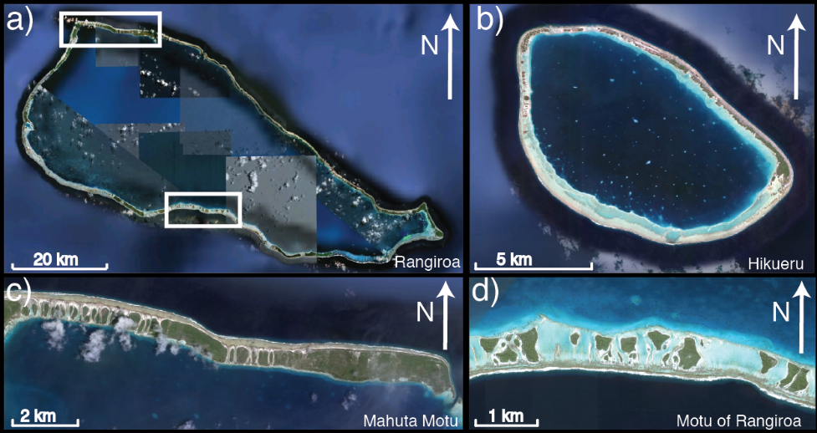
Figure 1. Aerial imagery of a) Rangiroa Atoll and b) Hikueru Atoll in French Polynesia. Varying motu morphology from Rangiroa atoll on the c) northwestern coast and the d) southern coast.

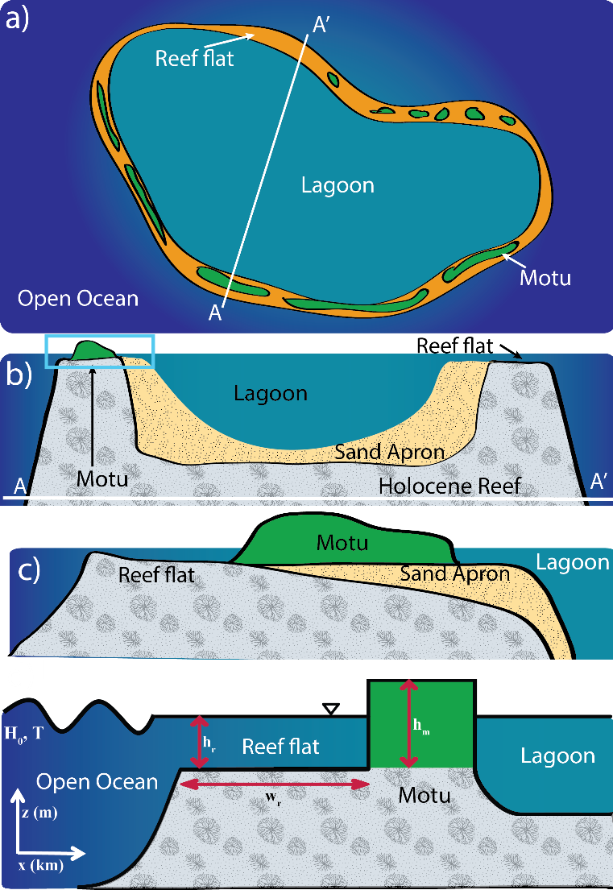
Figure 2. a) Idealized atoll, b) cross-section of idealized atoll, c) zoom in of the blue box– reef flat platform with motu. Both b) and c) adapted from McLean and Kench (2015), and d) diagram of model setup for XBeach simulations with varying offshore wave climate (H₀) and differing geometries of the reef flat and motu: reef-flat width (w_{r}), reef-flat depth (h_{r}), and motu height (h_{m}).
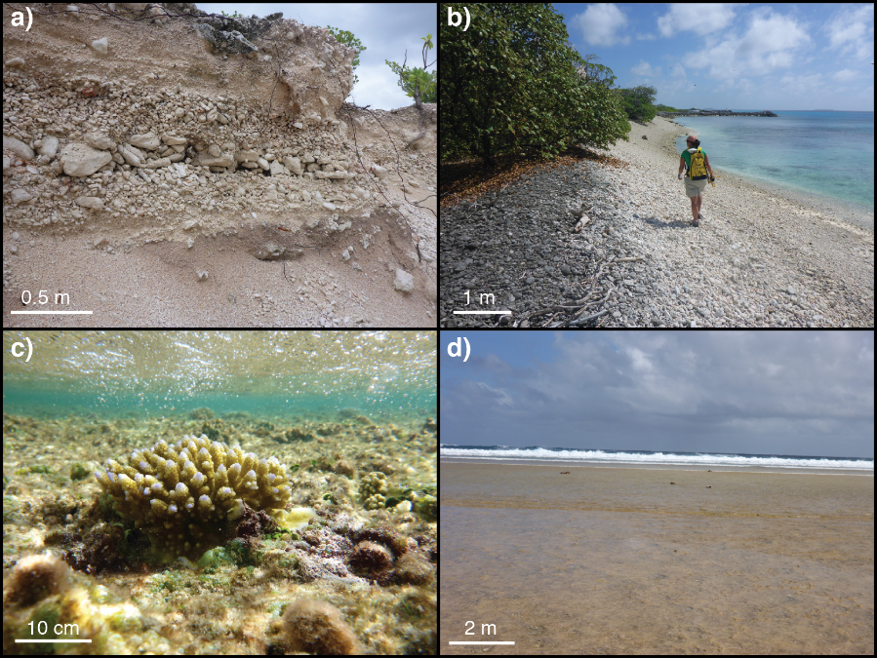
Figure 3. a) Exposed trench on Rotoava Motu, Fakarava Atoll, in French Polynesia showing large variation in grain sizes of sediment composing the motu. b) Beach of motu on ocean side of Kwajalein Atoll, c) small acropora coral on a reef flat at low tide on ocean side, and d) ocean-side reef flat at low tide on Ebeye Motu, Kwajalein Atoll, in the Marshall Islands.

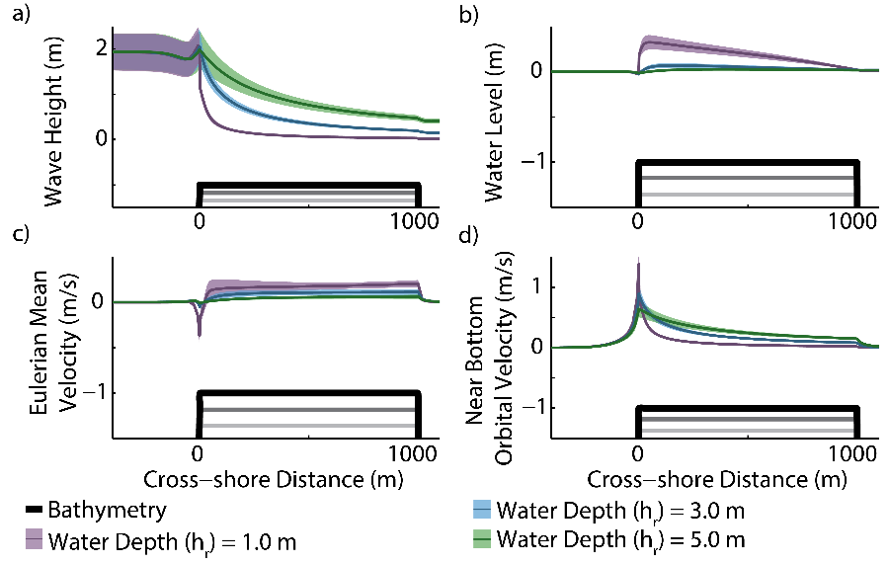
Figure 4. Effect of varying water depth over reef flat of 1 km width on a) wave height, b) water level, c) mean Eulerian velocity, and d) the near-bottom orbital velocity for an offshore wave height of 2 m and a wave period of 10 s and the varying reef-flat depths (gray solid lines).

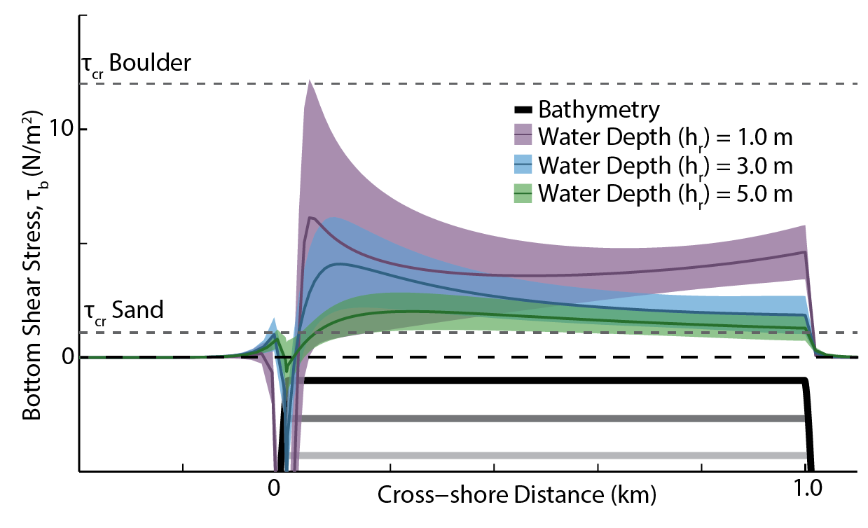
Figure 5. Effect of varying water depth over the reef flat of 1 km width on bottom shear stress with plotted critical shear stress for very coarse sand (2 mm diameter and 2.4 g/cm³ density) and a coral clast (30 cm diameter and 1.1 g/cm³ density) for an offshore wave height of 2 m with a zero-line plotted (dashed black line) and the varying reef-flat depths (gray solid lines).

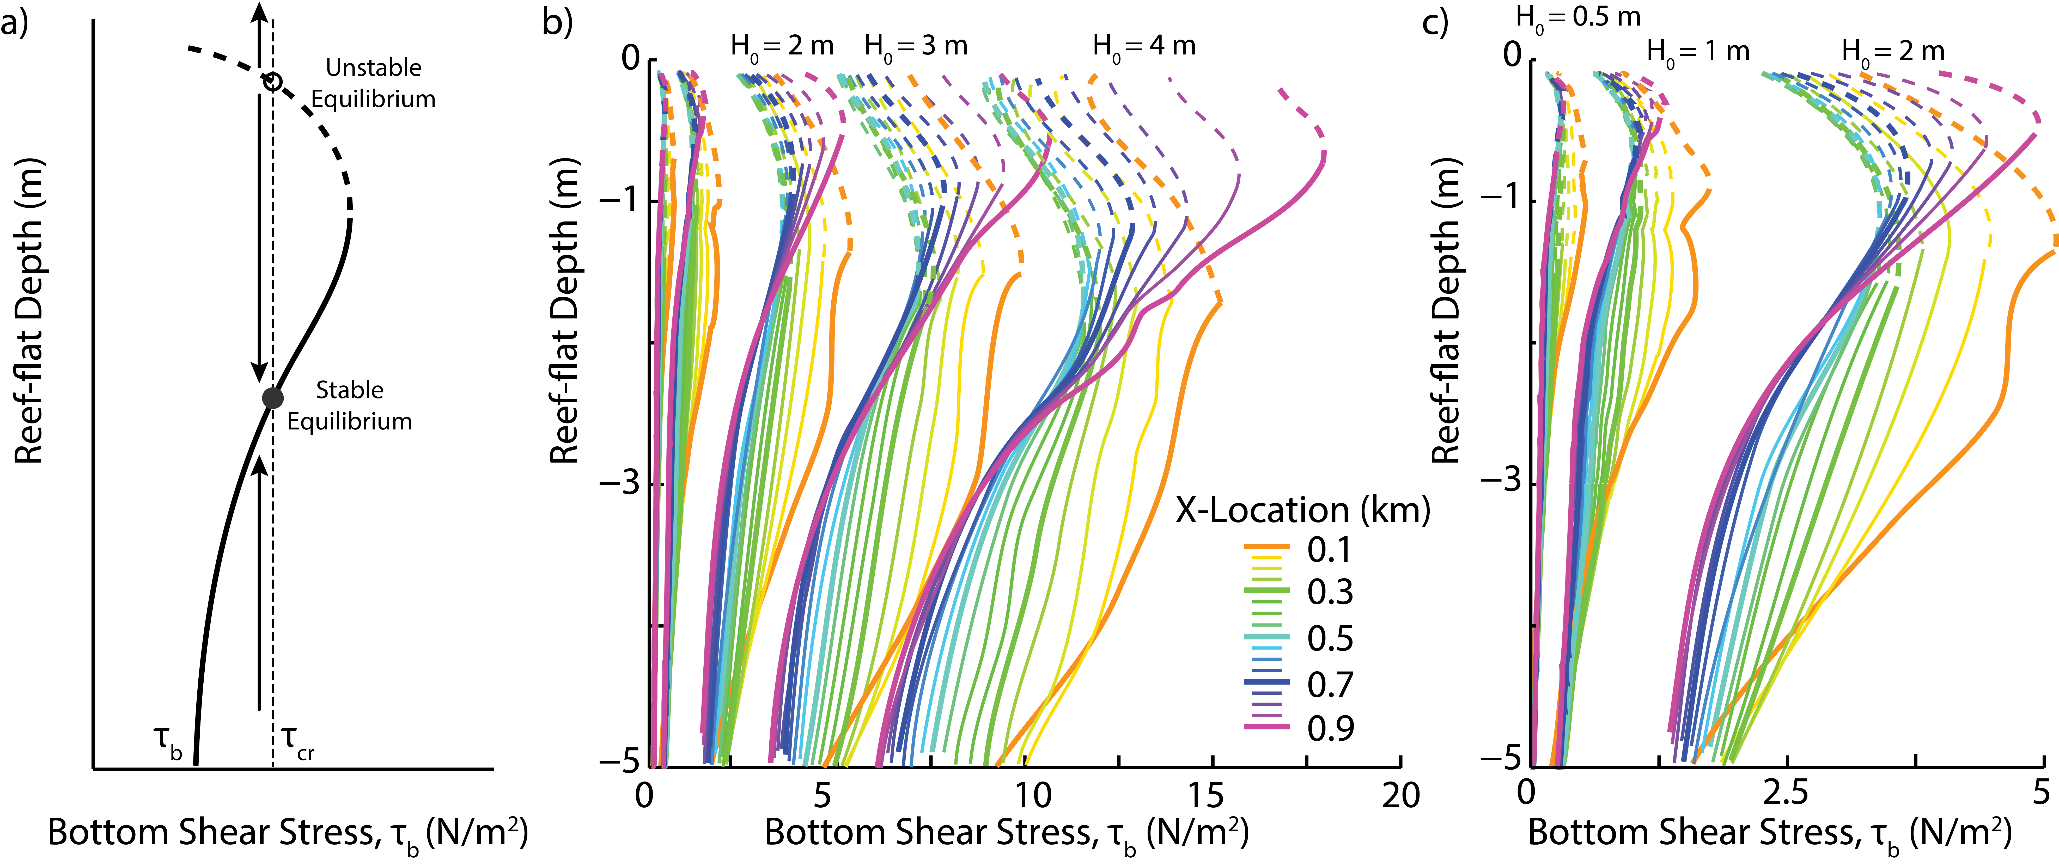
Figure 6. a) Example of bottom shear stress (τ_{b}) variation with reef-flat depth showing subsequent stable and unstable equilibria for a given critical bottom shear stress (τ_{cr}). b) Bottom shear stress variation with depth at locations every 50 m across a 1 km wide reef flat for different offshore wave heights (H₀ = 0.5, 1.0, 2.0, 3.0, and 4.0 m) where the solid line indicates potentially stable equilibria and the dashed lines indicate potentially unstable equilibria. c) Close-up of bottom shear stress variation with depth at locations every 50 m across a 1 km wide reef flat for the smaller offshore wave heights (H₀ = 0.5, 1.0, and 2.0 m).

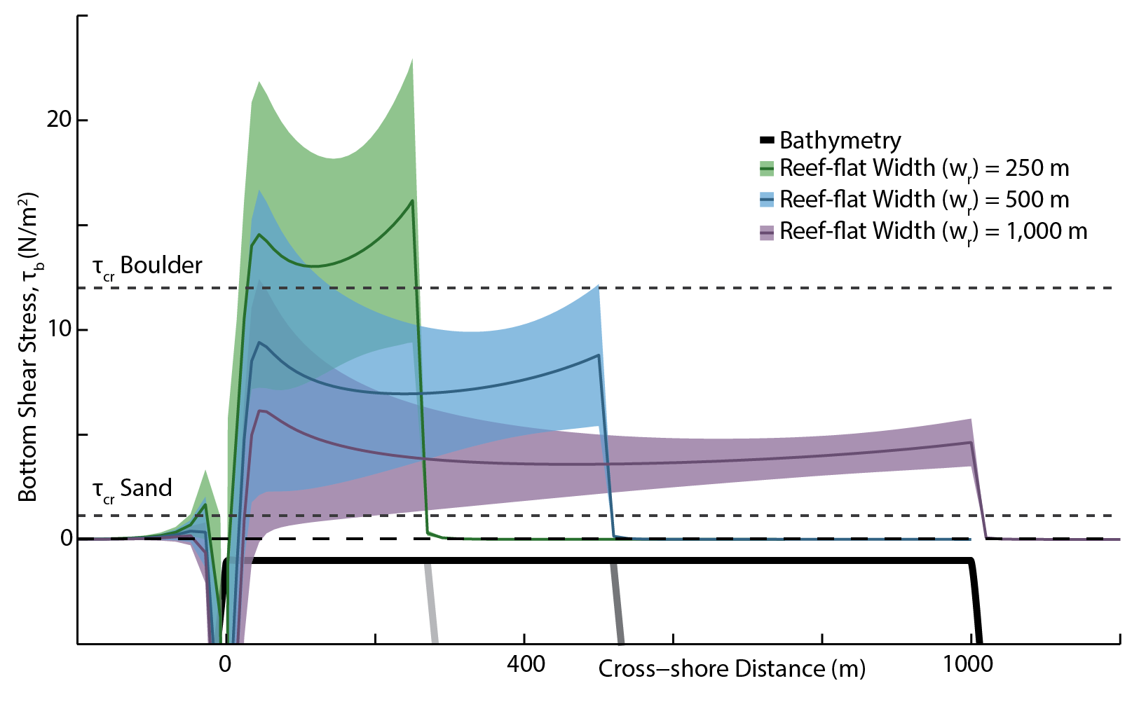
Figure 7. Effect of varying reef-flat width on bottom shear stress, τ_{b}, with plotted critical shear stress for very coarse sand (2 mm diameter and 2.4 g/cm³ density) and a coral clast (30 cm diameter and 1.1 g/cm³ density) with an offshore wave height of 2 m and a reef-flat water depth of 1 m.

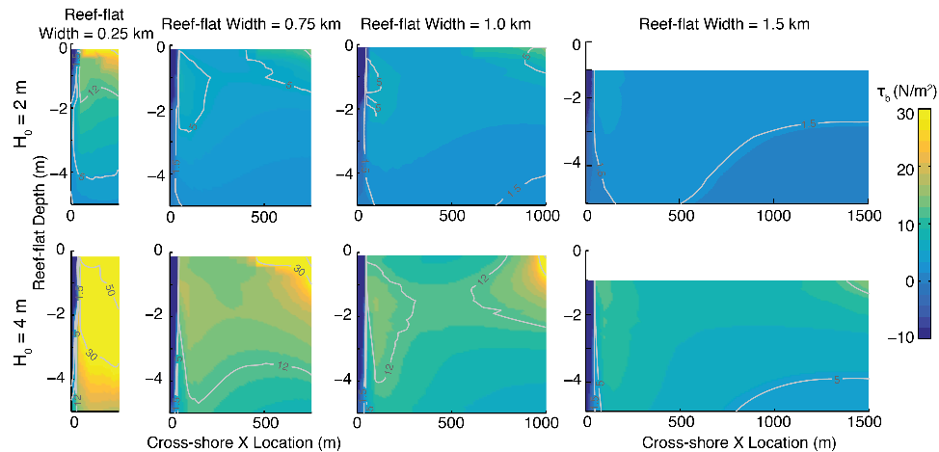
Figure 8. Phase space plot of bottom shear stress, τ_{b}, across the reef flat (x-axis) for varying reef-flat water depths (y-axis) for different total reef-flat widths under an offshore wave height of 2 m (top row) and 4 m (bottom row). For all cases, bed shear stresses are directed onshore (positive, τ_{b} > 0) across the reef flat except for at the reef edge (negative, τ_{b} < 0).

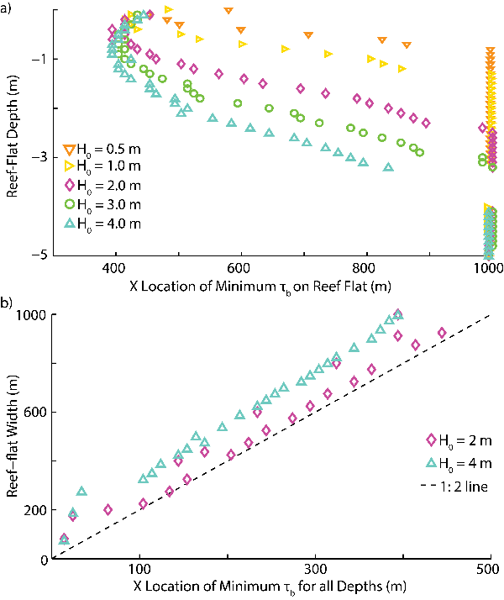
Figure 9. a) Cross-shore location on the reef flat of the minimum in bottom shear stress, τ_{b}, for different reef flat depths for five different offshore wave heights for a total reef-flat width of 1 km. b) Location of the minimum bottom shear stress, τ_{b}, for different reef flat widths with total reef-flat width for two different offshore wave heights.
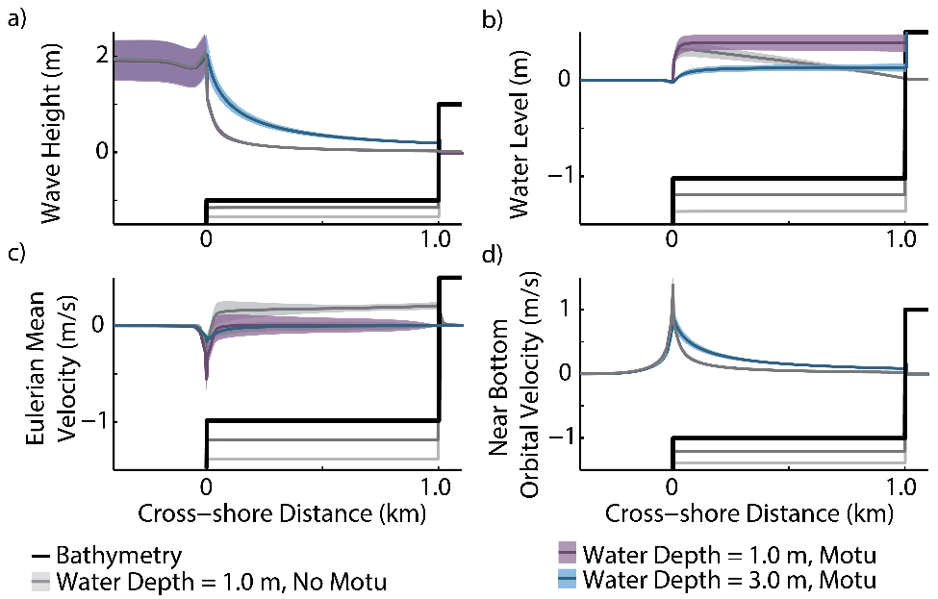
Figure 10. Effect of varying water depth over reef flat of 1 km width with a motu and no motu on a) wave height, b) water level, c) mean Eulerian velocity, and d) the near-bottom orbital velocity for an offshore wave height of 2 m and a wave period of 10 s.

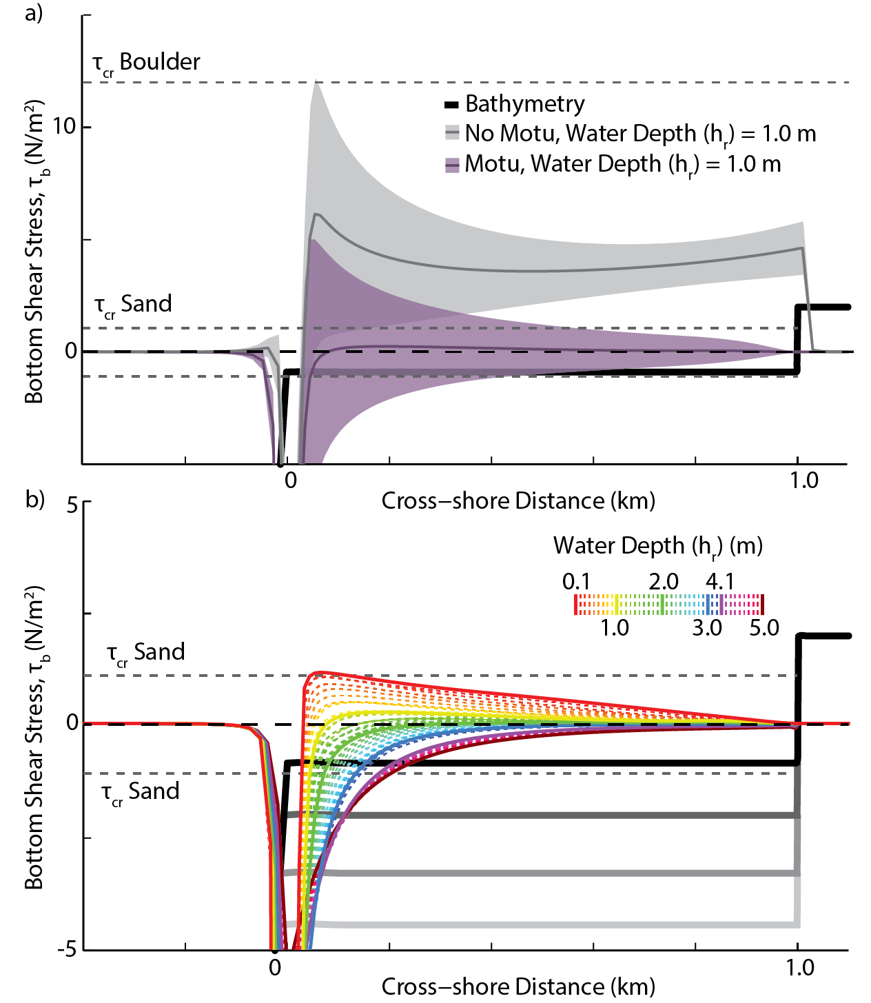
Figure 11. a) Bottom shear stress for 1 m deep reef flat with width of 1 km with a motu and no motu. b) Effect of varying water depth with a motu over reef flat 1 km wide at 0.1 m increments of bottom shear stress with critical shear stress for mobilizing coarse sand (2 mm diameter and 2.4 g/cm³ density) and a coral clast (30 cm diameter and 1.1 g/cm³ density) for an offshore wave height of 2 m.

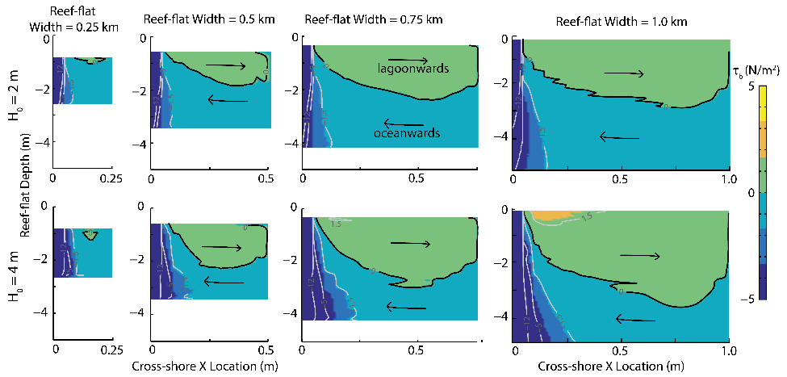
Figure 12. Colored and contoured parameter space of bottom shear stress, τ_{b}, for varying water depth (y-axis) and x-location over the reef flat (x-axis) with a motu for varying total reef-flat widths for an offshore wave height of 2 m (top row) and 4 m (bottom row), where the change from negative to positive shear stress is indicated by the black contour line. The black arrows indicate direction of sediment transport onshore or offshore.

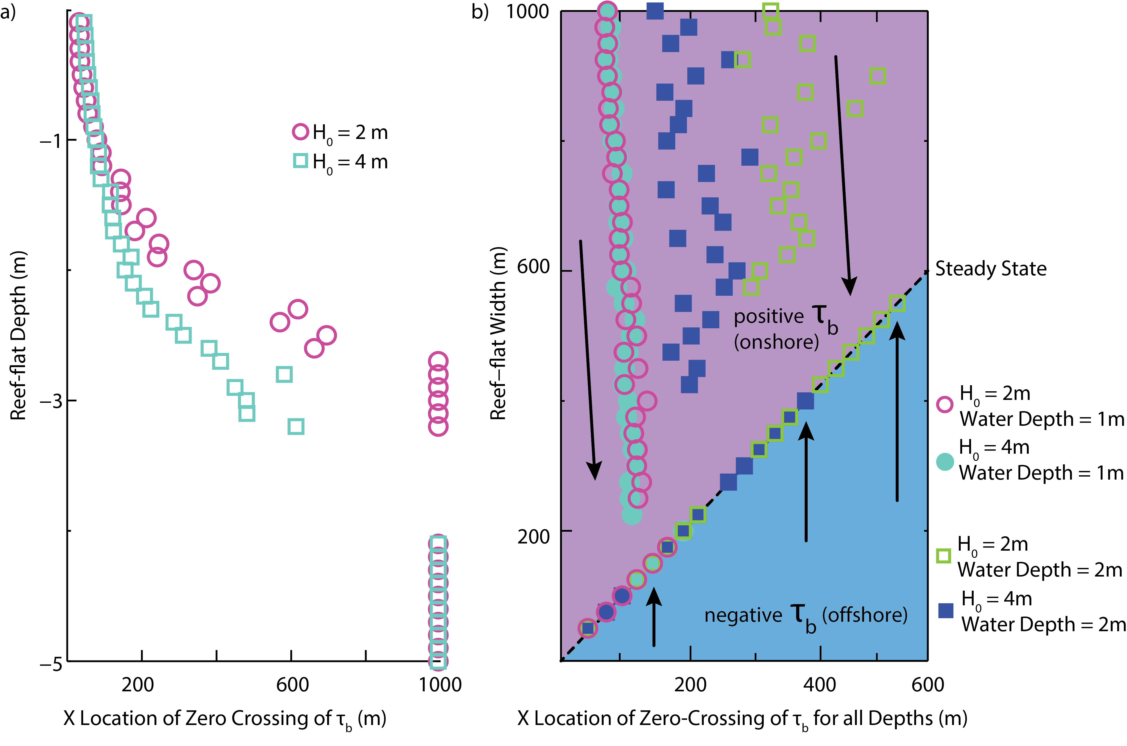
Figure 13. a) For a 1km wide reef flat with a motu, variation of the location of the zero crossing of bottom shear stress, τ_{b}, for different reef-flat depths and for two different offshore wave heights. b) Variation of the location of the zero crossing of bottom shear stress, τ_{b}, with total reef-flat width for two different offshore wave heights at two different reef-flat depths. The black arrows indicate direction of hypothesized self-organization of motu to a steady-state reef-flat width.

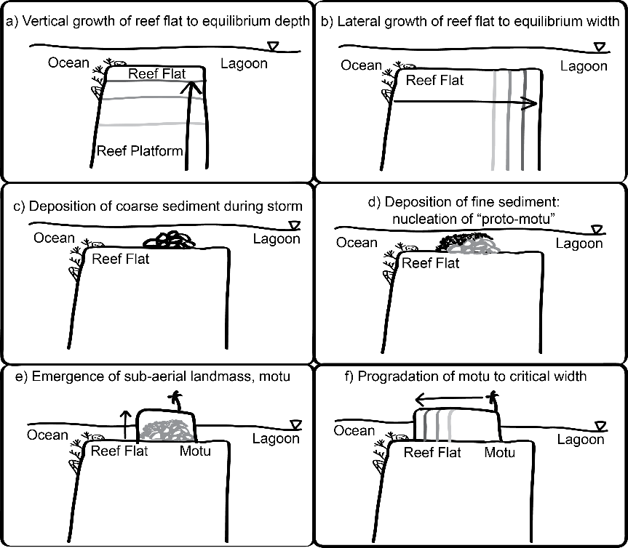
Figure 14. Conceptual diagram of possible motu formation and evolution on a reef flat. a) The reef flat accretes vertically until reaching an equilibrium depth, b) subsequent lateral growth as the reef flat depth is maintained. c) During an extreme event increased bottom shear stress leads to mobilization of coarser-grained sediment from the reef edge, which is subsequently deposited at the shear minimum approximately halfway across the reef flat. d) During subsequent fair-weather conditions, even if the coral rubble is below sea level, it may be shallow enough that increased deposition of fine sediment over the pile of coarse sediment could lead to the shoaling of a “proto-motu,” an incipient landmass on the reef flat. e) Continued deposition of sediment leads to the formation of a sub-aerial landmass, a motu, onshore of the reef edge. f) The motu progrades laterally over the reef flat until the reef flat reaches a critical width.

