Estimating geological CO₂ storage security to deliver on climate mitigation
Juan Alcalde¹*, Stephanie Flude²*, Mark Wilkinson², Gareth Johnson², Katriona Edlmann², Clare E. Bond¹, Vivian Scott², Stuart M. V. Gilfillan², Xènia Ogaya³ and R. Stuart Haszeldine².
¹Geology and Petroleum Geology, University of Aberdeen, School of Geosciences, Kings College, Aberdeen, AB24 3UE, UK.
²School of GeoSciences, University of Edinburgh, James Hutton Road, Edinburgh, EH9 3FE, UK.
³Institut GEOMODELS, Departament de Dinàmica de la Terra i de l’Oceà, Universitat de Barcelona, C/Martí i Franquès s/n, Barcelona 08028, Spain.
*These authors contributed equally to this work
Corresponding author: juan.alcalde@abdn.ac.uk

Abstract
Carbon Capture and Storage (CCS) can help nations meet their Paris CO₂ reduction commitments cost-effectively. However, lack of confidence in geologic CO₂ storage security remains a barrier to CCS implementation. Here we present a numerical program that calculates CO₂ storage security and leakage to the atmosphere over 10,000 years. This combines quantitative estimates of geological subsurface CO₂ retention, and of surface CO₂ leakage. We calculate that realistically well-regulated storage in regions with moderate well densities has a 50% probability that leakage remains below 0.0008% yr⁻¹, with over 98% of the injected CO₂ retained in the subsurface over 10,000 years. An unrealistic scenario, where CO₂ storage is inadequately regulated, estimates that more than 78% will be retained over 10,000 years. Our modelling results suggest that geological storage of CO₂ can be a secure climate change mitigation option, but we note that long-term behaviour of CO₂ in the subsurface remains a key uncertainty.

Introduction
Limiting global average temperature rise to well below 2°C of pre-industrial levels, in order to comply with the Paris 2015 Agreement, requires that fossil carbon use is curtailed, and/or large tonnages of CO₂ must be captured and securely stored underground^{1–3}. Despite worldwide interest and the successful implementation of several tens of CO₂ storage research, pilot and commercial projects^{4,5}, some scientists, publics and stakeholders remain concerned that leakage of CO₂ poses a threat to the viability of long duration CO₂ storage as an effective climate mitigation tool^{6–12}. Leak rates of 0.01% yr⁻¹, equivalent to 99% retention of the stored CO₂ after 100 years, are referred to by many stakeholders as adequate to ensure the effectiveness of CO₂ storage^{1,13–14}. We assert that secure storage must allow global average temperature rise, driven by excess CO₂, to remain well below 2°C; these timescales are typically modelled to be at least 10,000 years¹⁵.
However, there is a lack of quantitative predictions on long-term CO₂ storage security and the likelihood of this target being achieved, beyond the individual site scale, and across a global CO₂ storage industry. Many studies that assess the global industry-wide risk of subsurface gas leakage do not specifically assess subsurface CO₂ retention mechanisms^{16,17}, despite experimental measurements showing that residual trapping may effectively immobilise a significant proportion of the CO₂ almost immediately on injection into the subsurface¹⁸. The published studies that incorporate subsurface CO₂ retention into their risk assessments are for site-specific, real or hypothetical, hydrogeological models^{19,20}, rather than industry-wide, regional, or global scenarios. A recent tool developed by the National Risk Assessment Partnership (NRAP) applies a system-modelling approach and Monte Carlo analysis to detailed subsurface storage reservoir models²¹. This tool can provide long-term storage security predictions and uncertainties for individual sites, but to date, no comprehensive case studies have been published that facilitate an industry-wide assessment of CO₂ storage security.
In order to address this gap in knowledge and prediction assessment, we present a new numerical program – the Storage Security Calculator (SSC). The SSC has been designed to determine if global adoption of geological CO₂ storage will be secure enough, and secure for long enough, to effectively mitigate climate change. This program uses two routines: one using established and measured geological processes to assess retention in the geological reservoir; the second calculating surface leakage flux rates, which vary through time. The input parameters for these routines are derived from a data compilation, based on extensive literature review of empirically measured data and simulated data, encompassing CO₂ immobilisation, and surface leakage of CO₂ or appropriate analogues. A summary of this review is provided in Supplementary Notes 2-8.
Practical CO₂ storage is already undertaken in both onshore and offshore environments, with each exhibiting differing implementation and operational challenges. We thus apply the SSC to three different scenarios, that differ in their input parameters. For regional implementation of CO₂ storage in a realistically well-regulated industry, with a moderate density of legacy wells, our program calculates a 50% probability that more than 98% of the injected CO₂ will remain trapped in the subsurface over 10,000 years. Applying the SSC to a worst-case, unrealistic scenario of CO₂ storage being inadequately regulated and implemented in a region with a high risk of leakage along abandoned wells, calculates that at least 78% of the CO₂ will be trapped in the subsurface over 10,000 years. These results assume that our data compilation and subsequent input parameters are representative of the scenarios we modelled, and the SSC has thus been designed to accept new, improved, or case-specific input parameters, as appropriate. Key uncertainties remaining in the program include a lack of empirical data, and thus understanding, of CO₂ behaviour in the subsurface over the thousands of years timescale, long term behaviour of abandoned wells as fluid migration pathways, and long-term evolution of leakage rates.

Results
Storage Security Calculator Overview
The SSC is designed to quantify the immobilisation of CO₂ injected into the subsurface for geological storage and the total CO₂ leakage to the atmosphere. Once injected, the CO₂ will be subject both to immobilisation processes ([1] on Figure 1) and to potential leakage (migration out of the reservoir and subsequent leakage to the atmosphere- [2] on Figure 1). As this study focuses on assessing the effectiveness of CO₂ storage for climate mitigation, the SSC solely quantifies the leakage of CO₂ to the atmosphere, rather than migration of CO₂ into secondary subsurface environments. This numerical program, implemented in the programming language R, combines immobilisation and leakage models (Figure 1 and Figure 2). The amount of immobilised and leaked CO₂ are calculated over time and subtracted from the total injected CO₂ to yield the mobile (i.e. potentially leakable) CO₂ remaining in the reservoir. The integrated program runs until 10,000 years, with leakage ceasing once no mobile (leakable) CO₂ remains in the reservoir (See Methods).
The SSC is comprised of two core elements, a CO₂ immobilisation model (1), and a CO₂ leakage model (2). The CO₂ immobilisation model see [1] on Figure 1computes quantities and rates of residual saturation, solubility in subsurface brine, and reactions that precipitate solid minerals. All these processes result in permanent trapping of CO₂ in the subsurface. Two sub-models consider the impact of residual trapping (see [1a] on Figure 1), and of chemical trapping (here defined as a combination of solubility and mineral trapping – [1b] on Figure 1). Combining these two sub-models computes the proportion of CO₂ immobilised in the subsurface, and thus unavailable to leak. The leakage model (see [2] on Figure 1) calculates fluxes of CO₂ leaking to the surface from depth, and is independent of subsurface conditions. It combines three leakage sub-models that quantify leakage from active (injection) wells see [2a] on Figure 1, abandoned wells see [2b] on Figure 1, and natural pathways see [2c] on Figure 1. Parameters for each of these models are based on measured surface risk and fluxes of subsurface gases from analogues, which are used to calculate a conservative, initial surface leakage rate. Conservative values are adopted for each leakage input parameter to ensure that the SSC does not under-estimate leakage risk (see Supplementary Notes 3-5). Our adopted leakage fluxes are based on observed fluxes of CO₂, oil, and natural gas, with most of the data representing natural gas leakage (see Supplementary Notes 3-5). A recent study investigated how the Aliso Canyon blowout would have proceeded if it had been leaking CO₂ rather than natural gas, and concluded that leakage would have been lower due to a higher density of CO₂ compared to methane, and resulting differences in thermodynamic and flow properties²². Our estimates for leakage parameters do not yet account for this, due to uncertainties in quantifying the magnitude of the difference between CO₂ and methane blowouts. It is thus likely that real world leakage will be lower than calculated by the SSC.
The calculated leakage rate is an initial, maximum rate that reduces over time. The rate reduction is based on modelled and observed rates of leaking CO₂ and methane, as well as measured natural gas production rates (See Methods and Supplementary Note 6 for datasets used); it represents a real-world response to changes in subsurface conditions, such as reservoir pressure dissipation, and reduction in the buoyancy of the brine and CO₂ fluid as the column height and proportion of mobile CO₂ is reduced¹.
Residual trapping occurs on geologically instantaneous timescales, and can be measured in laboratory and field tests over experimental timescales^{18,23,24}. Hence, when free-phase CO₂ contacts the pore-space, a proportion of that CO₂ will become residually trapped, and thus unable to leak (immobilised). Leakage can also occur instantaneously, but it cannot remove CO₂ from the reservoir that has already been residually trapped CO₂. The chemical trapping model includes both dissolution and mineral trapping and is based on a published trapping model²⁵ that incorporates both dissolution and mineralisation in a time scale appropriate for CO₂ storage. Figure 2 shows a schematic representation of the steps used to calculate leakage and immobilisation by the SSC.
The SSC uses three different calculation techniques. The Base Case Scenario applies a single value for each input parameter determined as the most likely conservative value by the authors, based on currently available data (see Methods). A Monte Carlo analysis applies ranges of values for most parameters (normal, lognormal, uniform, and triangular distributions as appropriate for each dataset) and facilitates an assessment of the overall uncertainty of the model results. Finally, a sensitivity analysis is carried out where only one parameter is varied across multiple simulations, allowing an assessment of the influence and uncertainties of each parameter to the model. Further details on the program and parameters are provided in the Methods section and the R-code is available in Supplementary Data 1.

Overview of the Immobilisation Model [1a]
There are four trapping mechanisms that retain injected CO₂ in the reservoir: structural and stratigraphic, residual, solubility, and mineral trapping¹. The process of structural and stratigraphic trapping prevents injected CO₂ migrating to the surface due to impermeable layers of rock being present above the CO₂ reservoir. CO₂ remains in the permeable reservoir as a free-phase (gas or supercritical, depending on reservoir conditions) and could be contained indefinitely in this state in a secure trap²⁶. However, this mechanism does not immobilise the CO₂ in the subsurface permanently, and a failure in storage integrity, via caprock or well failure, could allow the CO₂ to migrate out of the reservoir. Structural and stratigraphic trapping are implicitly invoked in the SSC, so that all mobile CO₂ remaining in the reservoir is assumed to be structurally/stratigraphically trapped.
The three other trapping mechanisms - residual, solubility and mineral trapping - are more secure and would require deliberate engineering to reverse. For example, displacing residually trapped CO₂ would require injection of a fluid to re-mobilise the CO₂ in much the same way that tertiary oil production (i.e. EOR) is conducted. Solubility trapping may only be reversed by significant reservoir depressurisation, and even then, a subset of this would be irreversible in the form of ionic trapping, where aqueous CO₂ has dissociated and is now in bicarbonate or carbonate ion form²⁷. Reversing mineral trapping, where CO₂ precipitates as carbonate minerals, would require dissolution of these minerals and hence is the most secure form of trapping²⁷.
The SSC incorporates separate sub-models for residual trapping (1a), and for chemical trapping (1b - combined solubility and mineral trapping). The residual trapping sub-model (1a) draws on 44 residual trapping values compiled by Burnside and Naylor¹⁸, who calculated the proportion of residually trapped CO₂ from experimental residual CO₂ saturation values. These data indicate that residual trapping immobilises between 12.8% and 91.6% of the injected CO₂. Residual trapping values are also now available for a number of reservoir-scale experiments. The Otway 2B experiment (Paaratte Formation, Australia) used a range of techniques (pulsed neutron logging, noble gas tracers, and oxygen isotope fractionation) to calculate residual CO₂ pore space saturations of between ~7% and 42% over two separate experiments in 2011 and 2014^{23,28,29}. These values are comparable to the residual CO₂ saturation of 33%, determined by core flooding experiments on a sample of Paaratte Formation sandstone²⁴ (corresponding proportion of CO₂ that was residually trapped = 55.9%¹⁸), and indicate that laboratory-scale residual trapping experiments are representative of reservoir-scale conditions.
Solubility trapping via CO₂ dissolution occurs on timescales of hundreds of years. Whilst this is essentially instantaneous on geological timescales, it is a slower process than residual trapping and leakage. Mineral trapping is a much slower process that occurs over the thousand-year timescale. Hence, chemical trapping (1b) is computed in the SSC following residual trapping (1a) and leakage (2) calculations. Chemical trapping consumes both mobile and residually trapped CO₂, so the amount of residually trapped CO₂ decreases over time. The chemical trapping sub-model (1b) is based on the reactive transport equilibrium simulation carried out by Xu et al²⁵, which simulates the transfer of injected CO₂ between free-phase (gas), dissolved (aqueous) and mineralised (solid) phases, over 10,000 years. To the best of our knowledge, this²⁶ is the only model in the literature that quantifies both dissolution and mineral trapping rates over geological storage timescales specifically for CO₂ storage (see Methods and Supplementary Note 8). This means we cannot apply a sensitivity analysis to the chemical trapping model section of the SSC (1b) as uncertainty cannot be quantified for this part of the model.

Overview of the leakage model [2]
Our leakage model is based on assessments of volumes of subsurface fluids leaked from: active hydrocarbon industry wells (analogous to CO₂ injection – 2a); abandoned wells (i.e. legacy hydrocarbon industry wells – 2b); and natural examples of gases leaking from geological features (e.g., faults or poor caprock integrity – 2c). For a given storage reservoir, the degree of leakage along a fluid migration pathway will depend on a number of factors, including: the areal density and depth of the migration pathways, proximity of the migration pathway to the injection well, plume geometry, reservoir pressure, free-phase CO₂ column height, the relative permeability of all geological formations and migration pathways, capillary entry pressure, fluid pore pressure, hydrodynamic flow regime, and temperature^{30–35}. Precise modelling of potential leakage along migration pathways at a given storage site requires detailed constraints on all of these parameters, injection volume and pressure, and appropriate model-grid spacing and equations of state^{30–32}. Generalising these factors to estimate global or regional storage security is unrealistic, and so we base our estimates on a combination of directly measured surface fluxes of subsurface fluids leaking from depth (via wells and fault systems) and published numerical leakage models. This approach allows resolution of a globally averaged surface flux that is independent from the multiple complex factors of specific subsurface conditions (See Supplementary Notes 2-6 for further details).
To date, industrial experience related to CCS is limited to six commercial-scale dedicated CO₂ storage sites (Sleipner and Snøhvit, Norway; Aquistore and Quest, Canada, In Salah, Algeria, and the Illinois Industrial Carbon Capture and Storage (IICCS) project, USA). This is supplemented with experience from a number of large tests such as Lacq (France)³⁶ and Ketzin (Germany)³⁷ and multiple CO₂ EOR projects which have operated since the early 1970’s^{5,38}. No leakage has yet been detected from dedicated CO₂ storage projects so direct leakage data does not exist. We therefore base our active (2a) and abandoned (2b) well leakage estimates on data from the wider hydrocarbon industry, including UGS and EOR. Geological storage of CO₂ employs expertise, techniques and technology from the hydrocarbon industry, making this industry a suitable analogue of the CO₂ geological storage technology ^{39,40}. Input parameters for active and abandoned well leakage include the frequency of leakage events, (continuous leakage and discrete events/blowouts), and mass lost per leaking well during a leakage event. For each scenario, assumptions are made about the quality of the engineered well barriers (casing and plugging – see Supplementary Note 3 for a description of barrier features), and these are used to determine appropriate event frequencies. (Supplementary Notes 3 and 4). To estimate CO₂ leakage along natural pathways (2c) we utilise measured areal fluxes of CO₂ and natural gas from areas containing natural gas seeps at regional to global scale, to provide a mass per km² per year for natural leakage (Supplementary Note 5).
In any highly explored subsurface area with numerous wells, it can be difficult to identify all abandoned wells and to determine their integrity and associated leakage risk^{20,41,42}. Hence, abandoned wells are expected to be a significant hazard to CO₂ storage security⁴³ and thus receive considerable attention in our SSC tool, varying between the modelled scenarios. In regions with a long-lived hydrocarbon industry, there may be instances of wells not being recorded and being improperly abandoned. For example, a recent study of Pennsylvanian hydrocarbon industry wells revised estimates of legacy well numbers from 350,000 wells to up to 750,000⁴⁴. In this Pennsylvania example, an under-estimation factor of ~2.1 describes the difference between recorded and existing wells. In a well-regulated industry, CO₂ storage site operators will be required to identify all local wells. In well-regulated regions, we expect all abandoned wells to have been documented, so that the under-estimation factor will be 1. In regions with a poorly regulated hydrocarbon industry, undocumented abandoned wells may not be identified by site surveys. Therefore, we have built an under-estimation factor into the SSC that allows quantification of the impact of unidentified abandoned wells. For our Offshore, and Onshore Well-Regulated scenarios, the under-estimation factor is 1. For our Poorly-Regulated Onshore scenario, we adopt a base-case under-estimation factor of 1.55, with a minimum and maximum of 1.1 and 2.0, respectively (see Methods).
Collated data from well leakage simulations and from measurements of natural gas production rates and a long-lived blowout show that leakage rates decrease through time in an approximately exponential manner. This is due to the leakage itself depleting the available volume of free CO₂, combined with CO₂ immobilisation and pressure dissipation within the subsurface. To incorporate leakage decay into our model, we created two exponential decay curves (see Methods, Equation [3]) that form an envelope to the data. The longest data set is that of a Zahasky and Benson model (500 years)⁴⁵, while other models and measurements are for much shorter, decadal timescales. To avoid inaccuracies in extrapolating the leakage reduction curves forward in time beyond the range of data, our curves assume that leakage rate decreases to a point, and then remains constant over time. The exponential decay curves (Equation [3]) are a function of model parameters A and B, which were iteratively determined to produce curves that envelop the data. Parameter A represents the minimum long-term leakage rate as a percentage of the maximum. For the Monte Carlo analysis, a triangular distribution is assumed for Parameter A; this means that the value we judged most likely, and used in the base case simulation, is different from the mean and median of the distribution. Parameter B is the exponential function of the equation that defines the leakage reduction (see Methods and Supplementary Note 6).

Overview of modelled scenarios
The geological and engineering factors relating to leakage of subsurface gases are generally well understood. Hence, regional differences of leakage risk are well identified in historic subsurface industry activity and regulation. We therefore apply the SSC to three hypothetical scenarios that investigate implementation of CO₂ storage in a large global region: a Well-Regulated Offshore Scenario, a Well-Regulated Onshore Scenario, and a Poorly Regulated Onshore Scenario.
The Offshore Scenario can be considered to be analogous to CO₂ storage beneath the North Sea, which is the most likely store for CO₂ emissions captured in the EU. The Well-Regulated Onshore Scenario can be considered analogous to Texas, USA, which has a mature and well-regulated hydrocarbon industry in place. The Poorly-Regulated Onshore Scenario represents the highly unlikely event of CO₂ storage being implemented in regions or countries with long-duration, poorly regulated hydrocarbon industries leading to difficulties in identifying legacy abandoned wells, or enforcing applicable regulation. For each scenario we investigate the injection and storage of a large cumulative tonnage of CO₂ (12 Gt), comparable to the 2050 storage target of the European Union^{46,47}. Storage commences in 2020, finishes in 2050, and the SSC is run for 10,000 years into the future. CCS will very likely be required to continue well beyond the year 2050⁴⁷, but for simplicity we focus on modelling CO₂ storage security during the initial decades of CCS implementation. The three scenarios vary in their model parameter inputs: Onshore and Offshore Scenarios differ in the frequency of leaking injection wells, abandoned well areal density, and abandoned well integrity; the Onshore Well-Regulated and Poorly-Regulated scenarios differ in the proportion of unidentified abandoned wells, and the integrity status of abandoned wells.
The Offshore Scenario uses the North Sea as an exemplar of a CO₂ storage environment. The assigned abandoned well density (0.44 wells km⁻²) is based on recent well densities of the North Sea (4,400 wells per 10,000 km²)¹. Abandoned well integrity and frequency of leaking wells are based on data from offshore hydrocarbon fields. The Onshore Well-Regulated Scenario uses Texas as a CO₂ storage environment exemplar, with an abandoned well density of 2.5 wells km⁻², based on estimates of the number of hydrocarbon wells in Texas⁴¹, and well integrity and leakage risk based on data from onshore hydrocarbon fields. The Poorly-Regulated Onshore Scenario investigates CO₂ storage security if implemented in a region with inadequate regulations (either past or current) regarding drilling and abandonment of wells. For this scenario, we use Pennsylvania (USA) as an exemplar due to the high number of undocumented legacy wells (to give a well under-estimation factor) and the proportion of abandoned wells that are unplugged (See Supplementary Note 4 for further details).

Base Case Results
SSC modelled results are presented as the proportion of CO₂ leaked, relative to the amount injected, over time for the three scenarios in Table 1. These are cumulative results that sum the amount of CO₂ leaked per year. Base case results for immobilisation and retention of the CO₂ are shown graphically in Figure 3 along with base case and Monte Carlo results (90% confidence envelope) for leakage.
Base case cumulative leakage, as a percentage of the total injected, at 10,000 years are 0.53% for the Offshore Scenario, 2.10% for the Onshore Well-Regulated Scenario, and 11.25% for the Onshore Poorly-Regulated Scenario. These base case results equate to simplified time-averaged linear leak rates of 0.00005% yr⁻¹, 0.0002% yr⁻¹, and 0.001% yr⁻¹, respectively. Well Regulated Offshore sites perform best, due to leakage being limited by a low density of abandoned wells. Onshore sites perform equally well with geological immobilisation in the reservoir, but have higher leakage rates due to a greater density of abandoned wells; to ensure we do not under-estimate leakage, we have assumed that intact abandoned wells experience a very low long-term leak rate (0.004 t yr⁻¹; see Supplementary Note 4 for discussion). Cumulative leakage in the Well-Regulated Onshore Scenario is dominated by long-term leakage via abandoned wells. Conversely, cumulative leakage in the Poorly-Regulated Scenario is governed by blowouts in improperly abandoned wells during the injection period.

Monte Carlo Analysis Results
If the SSC model is now used in Monte Carlo mode to calculate outcomes, then retention and leakage calculations can be made by sampling the distributions of the full range of possibilities over 10,000 realisations of the model. The P50, P95 and P05 percentiles of the calculated leakage from the 10,000 model runs are reported in Table 1, which are the equivalent of the median (P50) and 90% confidence envelope (P95 to P05) of the computed results. These can also be portrayed as leakage exceedance values through time as shown in Figure 3. For each scenario, Base Case leakage results are lower than the P50 percentile of the Monte Carlo analysis; this is an inevitable statistical outcome due to applying a triangular distribution to the minimum long-term leakage rate (Parameter A) of the leakage reduction function.
Amounts of CO₂ leakage over the three Scenarios are shown in Figure 4, which also highlights the 5th, 50th and 95th percentiles for each Scenario. The Offshore Well-Regulated Scenario shows the least leakage, where 95% of values (P05) are less than 6.29% leakage of total CO₂ injected at 10,000 years, and 50% of simulations (P50) are less than 1.89% leakage.
The Onshore Well-Regulated Scenario shows that total cumulative leakage remains low at the 1,000 year scale (P50 at 1,000 years is 0.89% of the total injected CO₂), but leakage continues over the subsequent 9,000 years resulting in higher total cumulative leakage (P50 at 1,000 years is 8.18%). This results in 95% of leakage simulations leaking less than 25.71% over 10,000 years. This is despite a lower modelled frequency of leakage from injection wells, and a lower proportion of degraded abandoned wells in the Onshore Well-Regulated Scenario compared to the Offshore Well-Regulated Scenario. However, the Onshore scenarios have a much higher areal density of abandoned wells (2.5 wells km⁻² as opposed to 0.44 wells km⁻² for the Offshore Scenario); while leakage rates from individual abandoned wells remain low for the Well-Regulated Scenario, the cumulative leakage for such a high well density becomes significant.
For the Onshore Poorly-Regulated Scenario, 95% of leakage calculations do not exceed 32.62% of the total injected. Somewhat surprisingly, this is only ~7 % more than for the Well-Regulated Scenario, despite the Base Case simulation producing more than twice as much leakage. This is because the highest leakage rates simulated in the Monte Carlo analysis of the Poorly-Regulated Scenario result in all of the CO₂ in the reservoir being either immobilised or leaked before the simulation ends at 10,000 years. For the 95th percentile, leakage essentially stops after approximately 7000 years, as no mobile CO₂ remains in the reservoir. This is illustrated by the plateauing of the 95th percentile curve of the Poorly-Regulated Scenario in Figure 4. This demonstrates the failsafe nature of geological CO₂ storage: even a worst-case leakage scenario results in a most likely (base case) outcome that 89% of injected CO₂ is permanently stored (Fig 3). This scale of retention is confirmed by full Monte-Carlo modelling, where the P50 results shows 21.96% leakage - i.e. over 78% of the injected CO₂ is retained in the subsurface after 10,000 years (Figure 5).

Time Averaged Leak Rates
The SSC results can also be expressed as time-averaged leakage rates, by dividing the cumulative leakage percentages by the model run time. This produces a single number as a percentage rate of leakage per year. This is an artificial and simplistic linear rate of leakage calculation, which obscures the complexity of varying leak rates through time (Figure 4), but is nevertheless a useful tool for comparing our model results with leak rates deemed to be acceptable. These results, for the modelling years 1, 100, 1,000 and 10,000 after the start of injection are shown in Table 2.
Our results highlight that annual leakage rates reduce over time and range from 0.00005 to 0.003 % yr⁻¹ in the Offshore and Onshore Well-Regulated Scenarios, but reach up to 0.5% yr⁻¹ early in the worst-case Onshore Poorly-Regulated Scenario. These high CO₂ leakage simulation results can be seen in the Onshore Poorly-Regulated histogram in Fig 3b. Importantly, for both Well-Regulated Scenarios, time-averaged yearly leak rates are more than an order of magnitude less than 0.01% yr⁻¹, the yearly leakage rate considered by many stakeholders to be acceptable for CO₂ storage to remain effective as a climate mitigation tool^{13,14}. For the worst-case, Onshore Poorly Regulated Scenario, leakage is unacceptably high for the first hundred years, but will reduce to acceptable levels by 1,000 years in at least half of cases. This provides confidence that even in a very pessimistic deployment scenario CO₂ storage will provide a significant long-term climate benefit.

Input parameter sensitivity analysis
We apply Monte Carlo analysis and sensitivity tests using the range of SSC input parameters to constrain their influence and identify the greatest sources of uncertainty in the results. The sensitivity analysis was undertaken on the input parameters for which reliable estimates of parameter variation were available (17/26 parameters - see Methods). Of these, only nine influenced the results to cause a deviation of greater than 5% (relative) from the base case value in at least one of the scenarios. These nine parameters are the focus of our sensitivity analysis discussion and are presented in Figure 5; the parameters are detailed in the Methods section and rationale for the values chosen is provided in Supplementary Notes 2-7.

Residual saturation is a significant influence on total leakage results for scenarios that involve a high level of leakage. In the SSC, residual trapping (along with chemical trapping, inputs which were not varied in our sensitivity analysis due to using a single model – see Methods Section) only directly limits leakage by immobilising CO₂ and preventing it from leaving the reservoir. A lower level of residual trapping only causes a higher leakage result for scenarios where the simulation runs out of mobile CO₂. This does not occur for any of the base case scenarios, and so the maximum leakage results that derive from minimising residual saturation are the same as the base cases.
A parameter that exerts a strong influence on all scenarios is the plume areal extent (Figure 5). This is unsurprising as leakage via both abandoned wells and natural pathways are proportional to the plume area. However, our simplified model assumes that plume geometry will be controlled by well-defined traps, meaning migration and subsequent increased residual and solubility trapping will not take place. If storage was to be implemented in a horizontally-unconfined reservoir, as in the case of Sleipner⁴⁹, then CO₂ migration would be more pronounced, leading to higher levels of residual and solubility trapping^{50,51}. This would result in the amount of CO₂ available for leakage being lower and over time increased immobilisation due to plume spreading will outweigh the increased leakage risk posed by a larger plume area. These interactions between plume geometry, migration, and immobilisation are too complex to incorporate into our generalised model, but are likely to result in lower leakage than our model results.
The most influential parameters directly associated with CO₂ leakage are the minimum long-term leakage rate (parameter A in the leakage reduction function), the long term well-blowout frequency and mass lost per blowout, abandoned well density (frequency of wells per until of area), the abandoned well under-estimation factor, the proportion of degraded wells, and the natural leakage rate. Of these, the natural leakage rate is one of the least influential parameters, with leakage associated with abandoned wells having a stronger influence. Well density is solely responsible for the leakage increase between the Offshore and Onshore Well-Regulated Scenarios. For the Offshore Well-Regulated Scenario, which has a low abandoned well density, changing the well density produced the largest difference in leakage results, confirming that the SSC is highly sensitive to this parameter, likely due to the small amount of long-term leakage we assume for each well (see Supplementary Note 4). The minimum and maximum leakage results associated with varying the abandoned well density are similar for the Offshore, and Onshore Well-Regulated Scenarios, indicating that abandoned wells pose a significant leakage risk in both Well-Regulated scenarios, if the wells leak even a small amount due to cement corrosion over hundreds to thousands of years. In the Poorly-Regulated Scenario, the abandoned well under-estimation factor also imparts a noticeable influence on leakage results. Varying the under-estimation factor between 1.1 (where ~ 91% of abandoned wells are identified) and 2.0 (where only ~ 50% abandoned wells are identified) produces total leakage values of 3.76% and 18.74 % respectively.
The SSC considers leakage along abandoned wells in terms of continuous low-level leakage and discrete events (here called blowouts, irrespective of mass leaked). Varying the proportion of degraded wells, and thus the amount of continuous leakage imparts a minor influence on the SSC results and has the greatest impact in the poorly-regulated scenario where degraded abandoned wells may not be identified and remediated. Variation of the low-level leak-rate experienced by intact wells was not modelled due to a lack of available data, but reducing this is expected to significantly enhance storage security. Leakage during a blowout exerts a moderate influence on the results, and is based on conservative estimates of leakage that do not account for improvements in well remediation techniques and technologies that are likely to occur with time and experience⁵². In most cases, the long term blowout frequency imparts a greater influence on results than the amount leaked. The long term blowout frequency is based on observations from steam injection fields in California where different inactive well blowout frequencies were determined for short-term, initial-defect controlled blowouts, and for longer-term, aging-related defect controlled blowouts⁵³. However, no data yet exists for abandoned well blowouts from wells that are more than a few decades old. In the absence of more appropriate data we have extrapolated these long-term blowout frequencies for 10,000 years into the future, but acknowledge that these may not be wholly representative. While corrosion is considered to be a significant long-term risk to well integrity in CO₂-rich reservoirs, other processes acting on the well may decrease permeability. Corrosion may be associated with carbonation and precipitation of minerals, effectively plugging defects⁵⁴. Furthermore, stress regimes in many sedimentary basins promote closure of vertical pathways, with observations of reduction in annulus size and narrowing of steel casing in active wells over decades, suggesting that many abandoned well leakage pathways may become self-sealing over time^{55,56}.
We attempted to incorporate the effects of these leak-inhibiting processes into the SSC via the leakage reduction function. This calculates a reduction in the leakage rate over time due sealing of migration pathways, scavenging of leaked material into overlying reservoirs, and a loss of buoyancy as the plume stabilises and the amount of mobile CO₂ is reduced by either immobilisation or leakage. This function was introduced to counter the lack of coupling between our surface flux leakage model and subsurface immobilisation model, and is based on observed and simulated leak rate decays over time. A parameter that defines this function is the minimum long-term leakage rate - the percentage of the initial yearly leakage rate that leakage will reduce to over time. This parameter exerts a strong influence on the results due to high uncertainty (minimum = 3%, maximum = 53%) and thus a large range in values. Applying an optimistic leakage reduction function to the SSC significantly reduces leakage, with the worst-case poorly-regulated scenario leaking just 7.8% of the injected CO₂ (Figure 5). The leakage reduction function is based on up to 500 years of leakage data, a timespan that is two orders of magnitude lower than we modelled, and thus carries considerable uncertainty. The minimum long-term leakage rate was introduced as a parameter to ensure that the SSC does not under-estimate long-term leakage by extrapolating rate decay trends far beyond their timeframes. However, given the above discussion on long-term blowout frequency, this approach may be overly conservative and CO₂ leakage may be lower in reality than our model results suggest.

Discussion
The input parameters we have applied to the SSC in this work were selected to be both as realistic as possible, based on the currently available data, but also conservative enough to ensure that we do not over-estimate storage security. Input parameters influencing post-injection abandoned well leak rates (both continuous leakage and blowouts) were especially selected to be conservative as large uncertainties remain in our knowledge of cement behaviour on the thousands-of-years timescale. In our simulations, natural leakage is also likely over-estimated. Our natural leakage input parameters are based on measured surface fluxes and represent mature leakage systems presumed to have reached a steady state. They do not account for the possibility of a time-lag between initiation of leakage from the reservoir, and the leaked material reaching the surface, as would be expected if the leakage pathway was connected to the overlying reservoirs³¹. The magnitude of this time-lag is highly uncertain; if it takes hundreds of years for the leaked material to reach the surface, then our simulations significantly over-estimate natural leakage. Furthermore, in reality, many cases of CO₂ geological storage are expected to involve higher levels of immobilisation due to enhancement of residual trapping via migration^{50,51}, and of solubility trapping via convective mixing as dense, CO₂ saturated brine sinks⁵⁷. These factors have not been incorporated into the SSC due to uncertainties in quantifying their contribution to CO₂ immobilisation. Our model results are thus most-likely worst-case values for each scenario.
Even when applying these conservative input parameters, results from the SSC illustrate that CO₂ storage in regions with moderate abandoned well densities and that are regulated using current best practice will retain 98% of the injected CO₂ over 10,000 years in more than half of cases, and result in maximum leakage of 6.3% of the injected CO₂ in fewer than 5% of cases. As expected, we find that unregulated storage is less secure. Here, however, over 10,000 years, only 22% of injected CO₂ will leak in half of cases, with the possibility that up to 33% of the injected CO₂ could leak in 5% of cases. This leakage is primarily through undetected and poorly abandoned legacy wells, and could be reduced through identification and remediation of leakage if a comprehensive site screening and monitoring program is deployed. Importantly, natural subsurface trapping mechanisms mean that this leakage will not continue indefinitely. Consequently, even with mitigation actions restricted solely to repair of abandoned wells that blow out, regions with a legacy of poorly regulated subsurface operations can reliably and robustly store and retain 78% of injected CO₂. We find that regulators can most effectively improve CO₂ storage security by identifying and monitoring abandoned wells, and perform reactive remediation should they leak.
Overall our findings indicate that geological storage of CO₂ is a secure, resilient and feasible option for climate mitigation even when applying pessimistic values for input parameters and in poorly regulated storage scenarios. Hence, deployment of carbon capture and storage can be recommended to all governments as part of their actions to comply with the Paris 2015 target of keeping the global mean temperature well below 2°C.

Methods
SSC Program Development and Structure
Factors influencing retention and leakage of CO₂ in a subsurface reservoir were identified and a literature review carried out for each factor to determine the type of appropriate quantitative data available. The ‘Storage Security Calculator’ (SSC) structure was designed to make best use of the available data and resulted in the development of two separate models – a subsurface immobilisation and retention model, and a surface leakage model (Figure 6). Each model assumes a common injection target and calculates the amount of CO₂ leaked or immobilised for each year. The results of these models are summed for each year and subtracted from the total amount of CO₂ injected to calculate the mobile CO₂ remaining in the reservoir. If the amount of mobile CO₂ in the reservoir reaches zero the model run ends, otherwise it continues until 10,000 years.

CO₂ Injection
The model assumes a timeline with a 30-year injection period, during which the amount of CO₂ injected into the reservoir increases from 0 to 100% (12 Gt). The increase in injected CO₂ over the injection period is modelled as a linear increase.

Immobilisation model
The immobilisation model (see [1] on Figure 1) comprises two sub-models of residual [1a] and chemical trapping [1b], and are calculated based on the amount of CO₂ injected into the reservoir. The residual trapping and chemical trapping are calculated using separate models, but these models interact as residually trapped CO₂ is consumed by chemical trapping (solubility and mineral trapping). Computationally, this is achieved by calculating the amount of chemically trapped CO₂, subtracting this from the total injected CO₂ and calculating the amount of residually trapped CO₂ from the remaining free-phase CO₂.
The proportion of free-phase CO₂ that becomes chemically trapped is calculated over time via:
% Solubility Trapping (t) = 0.204 x t ^{0.0342} [eq. 1]
And
% Mineral Trapping (t) = (1.67 x 10⁻¹³ x t³) + (2.90 x 10⁻⁹ x t²) + (1.40 x 10⁻⁵ x t)
Where t = time in years. These equations are derived from the Xu et al²⁵ model, as described in Supplementary Note 8.
The proportions are applied to the CO₂ remaining in the reservoir (i.e. injected minus leaked) for a given year, to calculate the amount of CO₂ chemically trapped in that year. The amount of residually trapped CO₂ is derived by subtracting the amount of chemically trapped CO₂ for a given year from the total injected CO₂, and multiplying this by the fraction of CO₂ residually trapped (Supplementary Note 7).

Leakage Model
The leakage model (see [2] on Figure 1) combines three separate sub-models of active well leakage [2a], abandoned well leakage [2b], and natural pathways leakage [2c]. These models are combined to calculate maximum leakage rates for the injection and post-injection periods. The leakage model is mostly uncoupled from the amount of CO₂ in the reservoir and is based on measured surface fluxes. During the injection period, we apply a linear increase from 0 to 100% of the calculated leakage rate, to mirror the increase in injected CO₂.
Several elements in the leakage model require the number of injection wells, and the area of the injected CO₂ plume. The number of injection wells are calculated by dividing the annual injection target (i.e. 12 Gt / 30 years = 400 Mt yr⁻¹) by the well injectivity (base case for all scenarios = 0.75 Mt CO₂ well⁻¹ yr⁻¹). The areal extent of the CO₂ plume is calculated by multiplying the injection target by the Plume Area parameter, which is an empirically derived ratio of area: mass (see Supplementary Note 2).
Two types of leakage are defined for active (injection) wells [2a]. The first is continuous leakage, which is calculated by multiplying the frequency of leaking wells (% of wells that leak) by the amount of CO₂ leaked per year per leaking well (t CO₂ yr⁻¹). The second type of leakage is discrete events (blowouts) which are considered in terms of minor and major blowouts. Leakage from minor and major blowouts is calculated by multiplying the blowout frequency (events well⁻¹ yr⁻¹) by the mass leaked per blowout (t CO₂ event⁻¹). The amount of CO₂ leaked via continuous leakage, minor blowouts, and major blowouts are summed to give a maximum annual leakage from active wells. This leakage rate is only applied to the first 30 years – the injection period - of the model. More details are available in Supplementary Note 3.
Similar to active wells, leakage from abandoned wells [2b] is defined in terms of continuous leakage and blowouts. However, there are many more variables associated with abandoned wells, and thus calculating this leakage rate is more complex. A step-by step description of how abandoned well leakage is calculated is presented in Supplementary Note 9.
The number of abandoned wells are introduced into the model as areal densities (wells km⁻²), and leakage rates are initially calculated as leakage per km² and finally multiplied by the plume area to calculate absolute leakage.
The true abandoned well density is calculated by multiplying the known well density by the under-estimation factor (=1 for well-regulated scenarios); from this the areal density of known and unknown wells are calculated. The areal densities of unplugged, plugged but degraded, and plugged and intact wells are then calculated by multiplying the well densities by the proportion (frequency) of each well status. We then assume that all known abandoned wells will be investigated and that known unplugged wells will be remediated and converted to plugged and intact wells prior to injection.
During the injection period, continuous leakage is calculated by multiplying the areal well density for each well status (i.e. plugged / unplugged, degraded / intact) by its associated leakage rate. Leakage via abandoned well blowouts is calculated by multiplying the short-term blowout frequency by the number of plugged wells, and the mass lost per blowout. Additionally, all unplugged wells (only present in poorly-regulated scenarios where the well under-estimation factor >1) are assumed to blowout. Summing the masses lost per year gives the abandoned well leakage rate (t km⁻² yr⁻¹) AB1, applied for the injection period.
At the end of the injection period, all active wells are converted to plugged and intact wells. All unknown, unplugged wells experienced blowout and are assumed to have been identified and remediated to intact, plugged status. Other unknown, plugged wells that experienced blowout are assumed to have been degraded wells; these are thus identified, remediated, and converted to known and intact wells. We assume a comprehensive monitoring programme and that all known wells are monitored during the injection period, allowing identification and remediation of degraded wells and high continuous leak rates. Thus, at the end of the injection period, all known wells are converted to intact wells with a low leak rate.
Post injection, the continuous leak rate is again calculated by multiplying the areal well density for each well status by its corresponding leak rate. Leakage due to blowouts is calculated by multiplying the long-term blowout frequency (events well⁻¹ yr⁻¹) by the total well density and the mass leaked per blowout. Summing these masses lost per year gives an abandoned well leakage rate (t km⁻² yr⁻¹) AB2, which is applied to the post-injection period.
Abandoned well leakage rates are multiplied by the plume area to give mass lost per year. Definition of parameters are described in Supplementary Note 4.
The yearly amount of CO₂ leakage along natural pathways [2c] is calculated by multiplying the CO₂ plume area by the natural leakage rate parameter (in t km⁻²). The natural leakage rate parameter adopts gas flux data from regional and global scales. The minimum and maximum values are based onthe estimate of global fluxes of geological CO₂ (0.44 t km⁻² year ⁻¹), and the average areal flux from total petroleum systems (10 t km⁻² year⁻¹), respectively. The most likely natural leakage rate assumed, 2 t km⁻² year⁻¹, is based on the areal fluxes observed at the Ojai Valley natural seeps and data from the Rangely EOR field. More details are available in Supplementary Notes 2 and 5.
The Leakage model sums the leakage from natural pathways, active wells, and abandoned wells to give two leakage rates applied to the injection period and the post-injection period. These leakage rates are not calculated in a way that is coupled to the subsurface, but we expect changes in subsurface conditions, such as pressure and the amount of mobile CO₂, to influence the amount of CO₂ that can be leaked.
To address the increase in injected CO₂ over the injection period, we invoke a linear increase in leakage rate from 0 to 100%, mirroring the simplified total injection rate. For leakage reduction once injection has ceased, we invoke a leakage decay curve that is based on empirical data (see Supplementary Note 6). This has the form:
% of maximum leak rate at time t = A + (100 – A) x e^{-Bt} [eq. 3]
Where A and B are the iteratively derived input parameters for the leakage reduction function.
For a given year, the % of the maximum leak rate is calculated and multiplied by the post-injection total leak rate, to give the leak rate (t CO₂ yr⁻¹) for that year.

Sensitivity Analysis
In many cases, ranges of values are available for the model input parameters and we use these to carry out two types of sensitivity analysis: Monte Carlo analysis and input parameter tornado-diagrams.
To quantify the uncertainty on our model results derived from the uncertainty of the input parameters, we carry out a Monte Carlo analysis. For this analysis, we define ranges of values for each model parameter, using an appropriate probability distribution (normal, lognormal, triangular, or uniform – definitions of distributions are described in Table 3 and the Supplementary Notes 2-7). The SSC is run for 10,000 realisations, each selecting a random number for each model parameter from within the defined ranges. For selected years, we then compile the P05, P50 and P95 of the 10,000 realisations to obtain a range of leakage results that represent 90% confidence (i.e. range of results between P05 and P95).
To assess the sensitivity of our program to the different parameters, we define base-case, maximum, and minimum values, and run the program varying each parameter whilst holding the other parameters at their base case value (Figure 3). In most cases, we only carried out sensitivity analysis on parameters for which ranges are defined by the literature review presented in Supplementary Notes 2-7.
For parameters that are defined by normal or lognormal distributions in the Methods Section, we defined the minimum and maximum values as ± 2 standard deviations (note that this will produce a greater amount of variation than modelled in the Monte Carlo simulation, which varied some parameters using the standard error; as such, the sensitivity analysis is akin to applying the SSC to individual sites, rather than a global average). For other parameters we defined minimum and maximum values based on the range of data. Abandoned well areal density is defined as a single value for each Scenario, but we assessed the sensitivity of the models to this factor by varying between 0 and 5 wells km⁻². This also allows us to consider the leakage risk for implementation of CO₂ storage in regions without a legacy hydrocarbon industry. To investigate the impact of the well under-estimation factor in the sensitivity analysis we varied this between 1 (base case) and 1.1 for the well-regulated scenarios.
R Code
The R code is presented in a single file (SSC.R) which contains multiple sections and functions.
The base-case calculation is contained in the function SSCBase. This calls on a function called AbSetUp which calculates the AB1 and AB2 leakage rates (in t km⁻² yr⁻¹), based on the input parameters. The Monte Carlo analysis is carried out using the function SSCMC, which calls SSCBase and carries out n realisations (we choose 10,000) using randomly selected numbers from within the defined parameter ranges.
The code is organised as follows:
Section 1 includes functions that are not part of the base case or Monte Carlo calculations but are required to be loaded into the R environment to be called by SSCBase or SSCMC. Included here are the function AbSetUp (described above) and rtriangle⁵⁸, which allows production of a random number from a triangle distribution defined by (minimum, maximum, most likely) values.
Section 2 contains the code for the function SSCBase. It creates a 2-dimensional matrix output, which consists of 10,000 rows (1 per year of the model) and 10 columns (1 = time (yr); 2 = Injected CO₂; 3 = CO₂ leaked that year; 4 = Cumulatively leaked CO₂; 5 = Leakage reduction parameter A; 6 = Leakage reduction parameter B; 7 = Mineral-trapped CO₂; 8 = solubility trapped CO₂; 9 = residually trapped CO₂; 10 = remaining mobile CO₂).
Section 3 contains the code for function SSCMC, which creates a list output, based on 10,000 iterations of SSCBase. To make the large amount of data generated more manageable, this function runs SSCBase using randomly selected numbers from the defined ranges, and then extracts the results for years 1, 3, 10, 30, 100, 500, 1000, 2000, 3000, 4000, 5000, 6000, 7000, 8000, 9000, and 10,000, storing the results for each year in a separate matrix. This process is repeated 10,000 times to create a list of 16 matrices, each containing 10,000 rows. The data is then interrogated using the FigLoss function described below.
Section 4 contains functions for interrogating the SSCBase and SSCMC outputs. The Basic function returns the total cumulative leakage, as a percentage of the total injected, at the end of the model run (maximum 10,000 years). MinMaxSA is code that allows minimum and maximum values to be substituted for the base case in SSCBase. The desired values are entered for the appropriate Min_ / Max_ pair. For parameters where the minimum and maximum values are to be defined by standard deviations, the values can be entered as a mean plus or minus the standard deviation. Multiplying the standard deviation by SDN (standard deviation number) allows the minimum and maximum values to be quickly changed to check a different number of standard deviations. Code to plot the CO₂ partitioning over time calls the results from SSCBase and plots parameters of interest against time. The function FigLoss converts the SSCMC cumulative CO₂ leakage output to leakage as a percentage of the injection target and calculates the P5, P50, and P95 leakage percentiles for each year.

Data availability
All data used to determine input parameters are summarised in Supplementary Notes 2-8, Supplementary Tables 1-10, and Supplementary Figures 1-13.
Model availability
The R code for the Storage Security Calculator is available as a supplementary code file (Supplementary Data 1), using the Offshore Scenario as an example.

References
1. Metz, B., Davidson, O., de Coninck, H., Loos, M. & Meyer, L. (eds). Special Report on Carbon Dioxide Capture and Storage. (2005).
2. Scott, V., Gilfillan, S., Markusson, N., Chalmers, H. & Haszeldine, R. S. Last Chance for Carbon Capture and Storage. Nature Climate Change 3, 105–111 (2012).
3. Pachauri, R. K. & Meyer, L. (eds). Climate Change 2014: Synthesis Report. Contribution of Working Groups I, II and III to the Fifth Assessment Report of the Intergovernmental Panel on Climate Change. (2014).
4. Michael, K. et al. Geological storage of CO2 in saline aquifers—A review of the experience from existing storage operations. International Journal of Greenhouse Gas Control 4, 659–667 (2010).
5. Global CCS Institute. The Global Status of CCS Summary Report. 82 (Global CCS Institute, 2017).
6. Damen, K., Faaij, A. & Turkenburg, W. Health, Safety and Environmental Risks of Underground Co2 Storage – Overview of Mechanisms and Current Knowledge. Climatic Change 74, 289–318 (2006).
7. Mabon, L., Shackley, S. & Bower-Bir, N. Perceptions of sub-seabed carbon dioxide storage in Scotland and implications for policy: A qualitative study. Marine Policy 45, 9–15 (2014).
8. Monastersky, R. Seabed scars raise questions over carbon-storage plan. Nature 504, 339–340 (2013).
9. Scott, V. What can we expect from Europe’s carbon capture and storage demonstrations? Energy Policy 54, 66–71 (2013).
10. Shaffer, G. Long-term effectiveness and consequences of carbon dioxide sequestration. Nature Geoscience 3, 464–467 (2010).
11. Ashworth, P. et al. Public Preferences to CCS: How does it Change Across Countries? Energy Procedia 37, 7410–7418 (2013).
12. Scott, V., Haszeldine, R. S., Tett, S. F. B. & Oschlies, A. Fossil fuels in a trillion tonne world. Nature Climate Change 5, 419–423 (2015).
13. Hepple, R. P. & Benson, S. M. Geologic storage of carbon dioxide as a climate change mitigation strategy: Performance requirements and the implications of surface seepage. Environmental Geology 47, 576–585 (2005).
14. Chadwick, A. et al. Best practice for the storage of CO2 in saline aquifers - observations and guidelines from the SACS and CO2STORE projects. North Star 14, (2008).
15. Archer, D. Fate of fossil fuel CO₂ in geologic time. Journal of Geophysical Research 110, (2005).
16. Lewicki, J. L., Oldenburg, C. M., Dobeck, L. & Spangler, L. Surface CO ₂ leakage during two shallow subsurface CO ₂ releases. Geophysical Research Letters 34, (2007).
17. Koornneef, J., Ramírez, A., Turkenburg, W. & Faaij, A. The environmental impact and risk assessment of CO2 capture, transport and storage – An evaluation of the knowledge base. Progress in Energy and Combustion Science 38, 62–86 (2012).
18. Burnside, N. M. & Naylor, M. Review and implications of relative permeability of CO2/brine systems and residual trapping of CO2. International Journal of Greenhouse Gas Control 23, 1–11 (2014).
19. Würdemann, H. et al. CO2SINK—From site characterisation and risk assessment to monitoring and verification: One year of operational experience with the field laboratory for CO2 storage at Ketzin, Germany. International Journal of Greenhouse Gas Control 4, 938–951 (2010).
20. Celia, M. A., Nordbotten, J. M., Court, B., Dobossy, M. & Bachu, S. Field-scale application of a semi-analytical model for estimation of CO2 and brine leakage along old wells. International Journal of Greenhouse Gas Control 5, 257–269 (2011).
21. Pawar, R. J. et al. The National Risk Assessment Partnership’s integrated assessment model for carbon storage: A tool to support decision making amidst uncertainty. International Journal of Greenhouse Gas Control 52, 175–189 (2016).
22. Lindeberg, E., Bergmo, P., Torsæter, M. & Grimstad, A.-A. Aliso Canyon Leakage as an Analogue for Worst Case CO 2 Leakage and Quantification of Acceptable Storage Loss. Energy Procedia 114, 4279–4286 (2017).
23. Paterson, L. et al. Overview of the CO2CRC Otway Residual Saturation And Dissolution Test. Energy Procedia 37, 6140–6148 (2013).
24. Krevor, S. C. M., Pini, R., Zuo, L. & Benson, S. M. Relative permeability and trapping of CO ₂ and water in sandstone rocks at reservoir conditions: multiphase flow of co ₂ and water in sandstone rocks. Water Resources Research 48, (2012).
25. Xu, T., Apps, J. A. & Pruess, K. Reactive geochemical transport simulation to study mineral trapping for CO₂ disposal in deep arenaceous formations. Journal of Geophysical Research: Solid Earth 108, (2003).
26. Miocic, J. M. et al. Controls on CO₂ storage security in natural reservoirs and implications for CO₂ storage site selection. International Journal of Greenhouse Gas Control 51, 118–125 (2016).
27. Gunter, W. D., Bachu, S. & Benson, S. The role of hydrogeological and geochemical trapping in sedimentary basins for secure geological storage of carbon dioxide. Geological Society, London, Special Publications 233, 129–145 (2004).
28. Serno, S. et al. Using oxygen isotopes to quantitatively assess residual CO2 saturation during the CO2CRC Otway Stage 2B Extension residual saturation test. International Journal of Greenhouse Gas Control 52, 73–83 (2016).
29. LaForce, T., Ennis-King, J., Boreham, C. & Paterson, L. Residual CO2 saturation estimate using noble gas tracers in a single-well field test: The CO2CRC Otway project. International Journal of Greenhouse Gas Control 26, 9–21 (2014).
30. Celia, M., Bachu, S., Nordbotten, J., Gasda, S. & Dahle, H. Quantitative estimation of CO2 leakage from geological storageAnalytical models, numerical models, and data needs. in Greenhouse Gas Control Technologies 7 I, 663–671 (Elsevier, 2005).
31. Nordbotten, J. M., Celia, M. A. & Bachu, S. Analytical solutions for leakage rates through abandoned wells: ANALYTICAL SOLUTIONS FOR LEAKAGE RATES. Water Resources Research 40, n/a-n/a (2004).
32. Nordbotten, J. M., Celia, M. A. & Bachu, S. Injection and Storage of CO2 in Deep Saline Aquifers: Analytical Solution for CO2 Plume Evolution During Injection. Transport in Porous Media 58, 339–360 (2005).
33. Tao, Q., Checkai, D., Huerta, N. & Bryant, S. L. An improved model to forecast CO2 leakage rates along a wellbore. Energy Procedia 4, 5385–5391 (2011).
34. Edlmann, K., Bensabat, J., Niemi, A., Haszeldine, R. S. & McDermott, C. I. Lessons learned from using expert elicitation to identify, assess and rank the potential leakage scenarios at the Heletz pilot CO 2 injection site. International Journal of Greenhouse Gas Control 49, 473–487 (2016).
35. Heinemann, N., Stewart, R. J., Wilkinson, M., Pickup, G. E. & Haszeldine, R. S. Hydrodynamics in subsurface CO₂ storage: Tilted contacts and increased storage security. International Journal of Greenhouse Gas Control 54, 322–329 (2016).
36. Prinet, C., Thibeau, S., Lescanne, M. & Monne, J. Lacq-Rousse CO2 Capture and Storage Demonstration Pilot: Lessons Learnt From Two and a Half Years Monitoring. Energy Procedia 37, 3610–3620 (2013).
37. Martens, S. et al. Europe’s longest-operating on-shore CO2 storage site at Ketzin, Germany: a progress report after three years of injection. Environmental Earth Sciences 67, 323–334 (2012).
38. Manrique, E. J. et al. EOR: Current Status and Opportunities. in (Society of Petroleum Engineers, 2010). doi:10.2118/130113-MS
39. Ritter, K., Siveter, R., Lev-On, M., Shires, T. & Kheshgi, H. Harmonizing the quantification of CCS GHG emission reductions through oil and natural gas industry project guidelines. Energy Procedia 1, 4451–4458 (2009).
40. Sweatman, R. E., Parker, M. E. & Crookshank, S. L. Industry Experience With CO2-Enhanced Oil Recovery Technology. in (Society of Petroleum Engineers, 2009). doi:10.2118/126446-MS
41. Nicot, J. A survey of oil and gas wells in the Texas Gulf Coast, USA, and implications for geological sequestration of CO2. Environmental Geology 57, 1625–1638 (2009).
42. Davies, R. J. et al. Oil and gas wells and their integrity: Implications for shale and unconventional resource exploitation. Marine and Petroleum Geology 56, 239–254 (2014).
43. Duguid, A. et al. Baseline integrity property measurement of legacy oil and gas wells for carbon storage projects: Original Research Article: Baseline integrity property measurement of legacy oil and gas wells for carbon storage projects. Greenhouse Gases: Science and Technology 7, 866–890 (2017).
44. Kang, M. et al. Identification and characterization of high methane-emitting abandoned oil and gas wells. Proceedings of the National Academy of Sciences 201605913 (2016). doi:10.1073/pnas.1605913113
45. Zahasky, C. & Benson, S. M. Evaluation of hydraulic controls for leakage intervention in carbon storage reservoirs. International Journal of Greenhouse Gas Control 47, 86–100 (2016).
46. International Energy Agency. IEA Technology Roadmap: Carbon Capture and Storage. (2013).
47. IEA. World Energy Outlook 2017: Summary Report. 13 (2017).
48. European Climate Foundation. Roadmap 2050: a practical guide to a prosperous, low-carbon, Europe. 100 (2010).
49. Arts, R. et al. Monitoring of CO2 injected at Sleipner using time-lapse seismic data. Energy 29, 1383–1392 (2004).
50. Heinemann, N. et al. CO₂ sequestration with limited sealing capability: A new injection and storage strategy in the Pearl River Mouth Basin (China). International Journal of Greenhouse Gas Control 68, 230–235 (2018).
51. Heinemann, N., Haszeldine, R. S., Shu, Y. & Wilkinson, M. CO₂ Storage as Dispersed Trapping in Proximal Areas of the Pearl River Mouth Basin offshore Guangdong, China. Energy Procedia 114, 4436–4443 (2017).
52. Jordan, P. D. & Benson, S. M. Well blowout rates and consequences in California Oil and Gas District 4 from 1991 to 2005: implications for geological storage of carbon dioxide. Environmental Geology 57, 1103–1123 (2009).
53. Jordan, P. & Carey, J. W. Steam blowouts in California Oil and Gas District 4: Comparison of the roles of initial defects versus well aging and implications for well blowouts in geologic carbon storage projects. International Journal of Greenhouse Gas Control 51, 36–47 (2016).
54. Carey, J. W. et al. Analysis and performance of oil well cement with 30 years of CO₂ exposure from the SACROC Unit, West Texas, USA. International Journal of Greenhouse Gas Control 1, 75–85 (2007).
55. Carroll, S. et al. Review: Role of chemistry, mechanics, and transport on well integrity in CO₂ storage environments. International Journal of Greenhouse Gas Control 49, 149–160 (2016).
56. Loizzo, M., Lecampion, B. & Mogilevskaya, S. The Role of Geological Barriers in Achieving Robust Well Integrity. Energy Procedia 114, 5193–5205 (2017).
57. Emami-Meybodi, H., Hassanzadeh, H., Green, C. P. & Ennis-King, J. Convective dissolution of CO2 in saline aquifers: Progress in modeling and experiments. International Journal of Greenhouse Gas Control 40, 238–266 (2015).
58. Godfrey, A. R. The Triangular Distribution: ExtDist v0.6-3. (2015).

Author Contributions: JA, GJ, VS, KE and SF conceived the study. JA developed the calculation model with XO and SF. MW wrote the R code with SF. GJ and JA compiled trapping model data. SF compiled active and abandoned well leakage data. SMVG, SF and JA compiled natural pathway leakage data. SF, MW, RSH and JA contributed to the leakage reduction model. VS, CEB, MW and RSH provided manuscript text and context for interpreting the model results. SF wrote the manuscript and Supplementary Information with JA and with input from all co-authors.

Acknowledgements: JA and CEB were supported by NERC Grant NE/M007251/1 on interpretational uncertainty; SF and SMVG were supported by EPSRC Grant EP/K036033/1; RSH was supported by Scottish Funding Council, EPSRC Grants EP/P026214/1, EP/K000446/2 and NERC Grant NE/L008475/1; GJ was supported by EPSRC Grant EP/P026214/1; VS was supported by NERC GHGR programme Grant NE/P019749/1; KE was supported by H2020 Grant 636811. S.D. Hovorka is thanked for constructive feedback on an earlier version of this manuscript. A. Hewinson is thanked for assisting SF with the R code.

Competing interests
The Authors declare no Competing Financial or Non-Financial Interests.

Tables
Scenario § | Time (yr) | CO₂ leaked (%)†
Scenario § | Time (yr) | Base Case‡ | P95 ‡ | P50‡ | P05‡
Offshore Well-Regulated | 1 | 0.00075 | 0.00051 | 0.00078 | 0.0014
Offshore Well-Regulated | 100 | 0.029 | 0.025 | 0.045 | 0.089
Offshore Well-Regulated | 1,000 | 0.074 | 0.071 | 0.21 | 0.65
Offshore Well-Regulated | 10,000 | 0.53 | 0.48 | 1.89 | 6.29
Onshore Well-Regulated | 1 | 0.0021 | 0.0013 | 0.0022 | 0.0045
Onshore Well-Regulated | 100 | 0.086 | 0.074 | 0.16 | 0.36
Onshore Well-Regulated | 1,000 | 0.269 | 0.25 | 0.89 | 2.96
Onshore Well-Regulated | 10,000 | 2.1 | 1.81 | 8.18 | 25.71
Onshore Poorly-Regulated | 1 | 0.22 | 0.052 | 0.2 | 0.52
Onshore Poorly-Regulated | 100 | 6.71 | 1.7 | 6.41 | 16.51
Onshore Poorly-Regulated | 1,000 | 7.12 | 2.39 | 8.05 | 19.98
Onshore Poorly-Regulated | 10,000 | 11.25 | 6.91 | 21.96 | 32.62

Table 1. Storage Security Calculator outputs. The leakage values are expressed as a percentage of originally injected CO₂. Example times are presented at t=1, 100, 1000, and 10,000 years.
† The total leakage percentages are calculated by adding together all the yearly increments of leaked CO₂ calculated for each model run.
§ Three scenarios are represented, to illustrate regional storage security decreasing from well-regulated to poorly-regulated.
‡ Four probabilities of CO₂ leakage are chosen to be represented: a Base Case, where the model parameters are selected by expert judgement, and Monte Carlo results of sampling the whole probability range of each parameter in the Immobilisation and Leakage model datasets.P95 means that 95% of the calculated leakage values are greater than the percentage calculated (not a 90% probability of occurrence), P50 represents that 50% of values will be greater (the median), and P05 means that 5% of the calculated leakage values from the original total injected (not a 10% probability) are greater than the calculated percentage. Conventional reporting of statistics of subsurface hydrocarbon reserves and resources, or of the greatest possibility of an outcome, use P50 (the median) as the most probable outcome.

Scenario | Time (yr) | Time averaged leakage rate (% yr⁻¹) †
Scenario | Time (yr) | P95 | P50 | P05
Offshore Well-Regulated | 1 | 0.0005 | 0.0008 | 0.001
Offshore Well-Regulated | 100 | 0.0002 | 0.0004 | 0.0009
Offshore Well-Regulated | 1,000 | 0.0001 | 0.0002 | 0.0006
Offshore Well-Regulated | 10,000 | 0.00005 | 0.00019 | 0.00063
Onshore Well-Regulated | 1 | 0.001 | 0.002 | 0.005
Onshore Well-Regulated | 100 | 0.0007 | 0.002 | 0.004
Onshore Well-Regulated | 1,000 | 0.0002 | 0.0009 | 0.003
Onshore Well-Regulated | 10,000 | 0.0002 | 0.0008 | 0.003
Onshore Poorly-Regulated | 1 | 0.05§ | 0.2§ | 0.5§
Onshore Poorly-Regulated | 100 | 0.02§ | 0.06§ | 0.2§
Onshore Poorly-Regulated | 1,000 | 0.002 | 0.008 | 0.02§
Onshore Poorly-Regulated | 10,000 | 0.0007 | 0.002 | 0.003

Table 2. Time averaged leakage rates of the three scenarios. The leakage values are expressed as a percentage of originally injected CO₂. Example times are presented at t=1, 100, 1000, and 10,000 years.
† Time averaged leak rates are calculated by dividing the total cumulative leakage computed for the selected model time by the same number of model years. This results in an artificial linear rate of leakage which is constant from the start of injection to the selected time, and obscures the true variation in leakage rates over time (cf. Fig 4).
§ Results that do not meet the 0.01 % yr⁻¹ acceptability level^{13,15}. Notably, even on this simple metric, all well-regulated regions pass the simple acceptability test at all timescales. For the worst-case Poorly Regulated Onshore Scenario, time-averaged leak rates are unacceptable in the short term, but at least 95% of the realisations give acceptable time-averaged leak rates over long time scales (several thousand years).

Parameter | Offshore† | Onshore: WR† | Onshore: PR†
General Parameters
Injection target [CO2target] § | 12 Gt by 2050
Injection rate per well (t yr⁻¹) [injectperWell] | Normal Distribution: Mean= 0.75 × 10⁶ ± 0.083 × 10⁶  SE (400 wells) = 0.00415.
Injection Period [InjectionPeriod] | 30 Years
Area:Mass ratio of CO₂ plume [meanPlumeArea] | Lognormal Distribution: Mean of Ln= -0.7595 ± 0.8815  SE (25 data points) = 0.1763.
Active (Injection) Well Parameters
Fraction of injection wells that are leaking  [ActiveWellFreq] | Distribution: lognormal  Mean of Ln= -2.17 ± 0.6 | Distribution: lognormal  Mean of Ln= -2.89 ± 0.7
Mass of CO2 leaked per leaking well per year  [SlowLeakInjector] | Normal Distribution: Mean = 158.5 ± 18.83  SE (8 wells (1.3% of 400)) = 5.2
Frequency of minor blowouts [MinorBlowFreq] | 0.0693 events⁻¹ well¹ yr⁻¹
Mass of CO₂ lost per minor blowout (t)  [MinorBlowout ] | Distribution: log normal: Mean of Ln(Ln)= 1.27 ± 0.21  SE (28 wells (400*0.0693)) = 0.0397.
Frequency of major blowouts  (events⁻¹ well¹ yr⁻¹)  [MajorBlowFreq] | Distribution: Normal  Mean= 1.48 × 10⁻⁴  ± 3.33 × 10⁻⁵ | Distribution: Normal  Mean= 1.35 × 10⁻⁴ ± 4.4 × 10⁻⁵
Ma Mass of CO₂ lost per major blowout (t)  [CO2MajorBlowout] | Distribution: Lognormal: Mean of Ln(Ln)= 2.57 ± 0.045  SE (17 data points) = 0.011
Abandoned Well Leakage Parameters
Areal density of abandoned wells (wells km⁻²)  [KnownWellDensity] | 0.44 | 2.5
Abandoned well under-estimation factor  [wellUnderEst] | 1 | 1 | Uniform Distribution  1.1 to 2.0  Base Case = 1.55
Fraction of abandoned wells that are unplugged  [UnPlugWells] | 0% | 0% | 0.3  (30%)
Fraction of plugged wells that are degraded  [DegradWells] | Distribution: lognormal  Mean of Ln = -2.17 ± 0.6 | Distribution: lognormal  Mean of Ln = -2.89 ± 0.7
Fraction of intact plugged wells with the higher leak rate. [IntactHighRate] | 0.054  (5.4 %)
Plugged abandoned well blowout frequency for the first 30 years (events well⁻¹ 30yrs⁻¹)  [PlugBlowoutYear] | Distribution: Lognormal  Mean of Ln= -8.6125 ± 0.23  (1/2,000 to 1/9,000)
Long term blowout frequency (events well⁻¹ yr⁻¹)  [BlowoutWellYear] | Uniform Distribution: 1 × 10⁻⁵ to 1 × 10⁻⁴ ;  Base Case = 5 × 10⁻⁴ (1/50,000)
Mass CO₂ lost during an abandoned well blowout (t). [CO2largeBlowout] | Distribution: lognormal  Mean of Ln = 13.4 ± 0.35
Abandoned well continuous leak rates (t yr⁻¹) for:
Degraded wells [CO2degraded] | 300 t
Intact wells with high leak rate [CO2intactHigh] | 230 t
Intact wells with low leak rate [CO2intactLow] | 0.004 t
Other Parameters
Leak rate via natural pathways (t y⁻¹ km⁻²)  [NatLeakRate] | Distribution: Lognormal  Mean of Ln = 0.693 ± 0.37
% of CO₂ residually trapped  [res_sat] | Normal Distribution: Mean = 0.58 ± 0.1897  SE (44 data points) = 0.0286
Long-term leakage reduction: % of maximum leakage rate at time t = A+100 * e^{(-Bt)}
Parameter A. [A] | Triangle distribution: Min = 3, Max = 53, Most likely = 12
Parameter B. [B] | Uniform Distribution: 0.0143 to 0.5; Base Case = 0.257
Table 3. Input parameters for the model
§ Square brackets indicate the label assigned to the parameter in the R-code.
† Parameters are provided for three different scenarios (Offshore well-regulated, Onshore well-regulated, and Onshore poorly-regulated).

Figures and captions
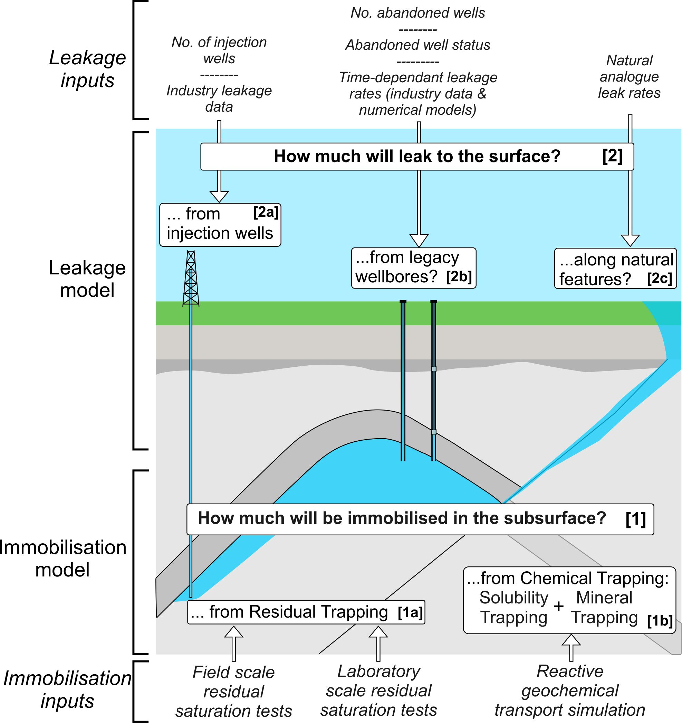
Figure 1. The Storage Security Calculator concept. The CO₂ immobilisation model [1] combines two sub-models: [1a] residual trapping, and [1b] chemical trapping (defined as a combination of solubility and mineral trapping). The CO₂ leakage model [2] combines three sub-models: [2a] leakage through active (injection) wells, [2b] abandoned wells, and [2c] leakage via natural pathways. The key input parameters for each sub-model are shown.

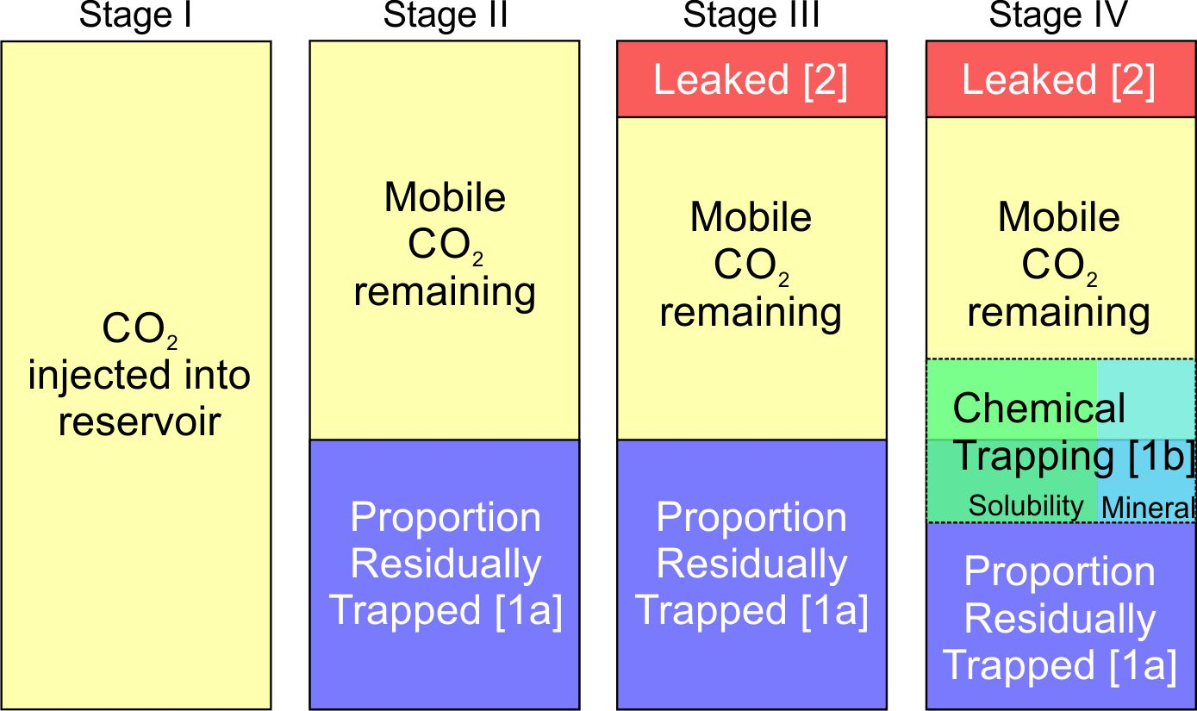
Figure 2. Modelling stages computed by the Storage Security Calculator. The immobilisation and leakage models described in Fig. 1 are integrated in the Storage Security Calculator to compute the proportion of remaining mobile CO₂ in the subsurface in four stages. I) The total amount of CO₂ injected into reservoir is computed (based on the storage target). II) The amount of CO₂ immobilised by residual trapping is calculated (residual trapping immobilisation model – [1a]). III). The amount of CO₂ leaked from the reservoir (and, for simplicity, assumed to reach the atmosphere) is calculated via the leakage model. IV) The amount of CO₂ immobilised by chemical trapping (chemical trapping immobilisation model) is calculated as a function of free-phase (i.e. both residual and mobile) CO₂ remaining in the reservoir. The calculations are carried out annually for each time-step of the model until there is no mobile CO₂ remaining, or until 10,000 years, whichever happens first.
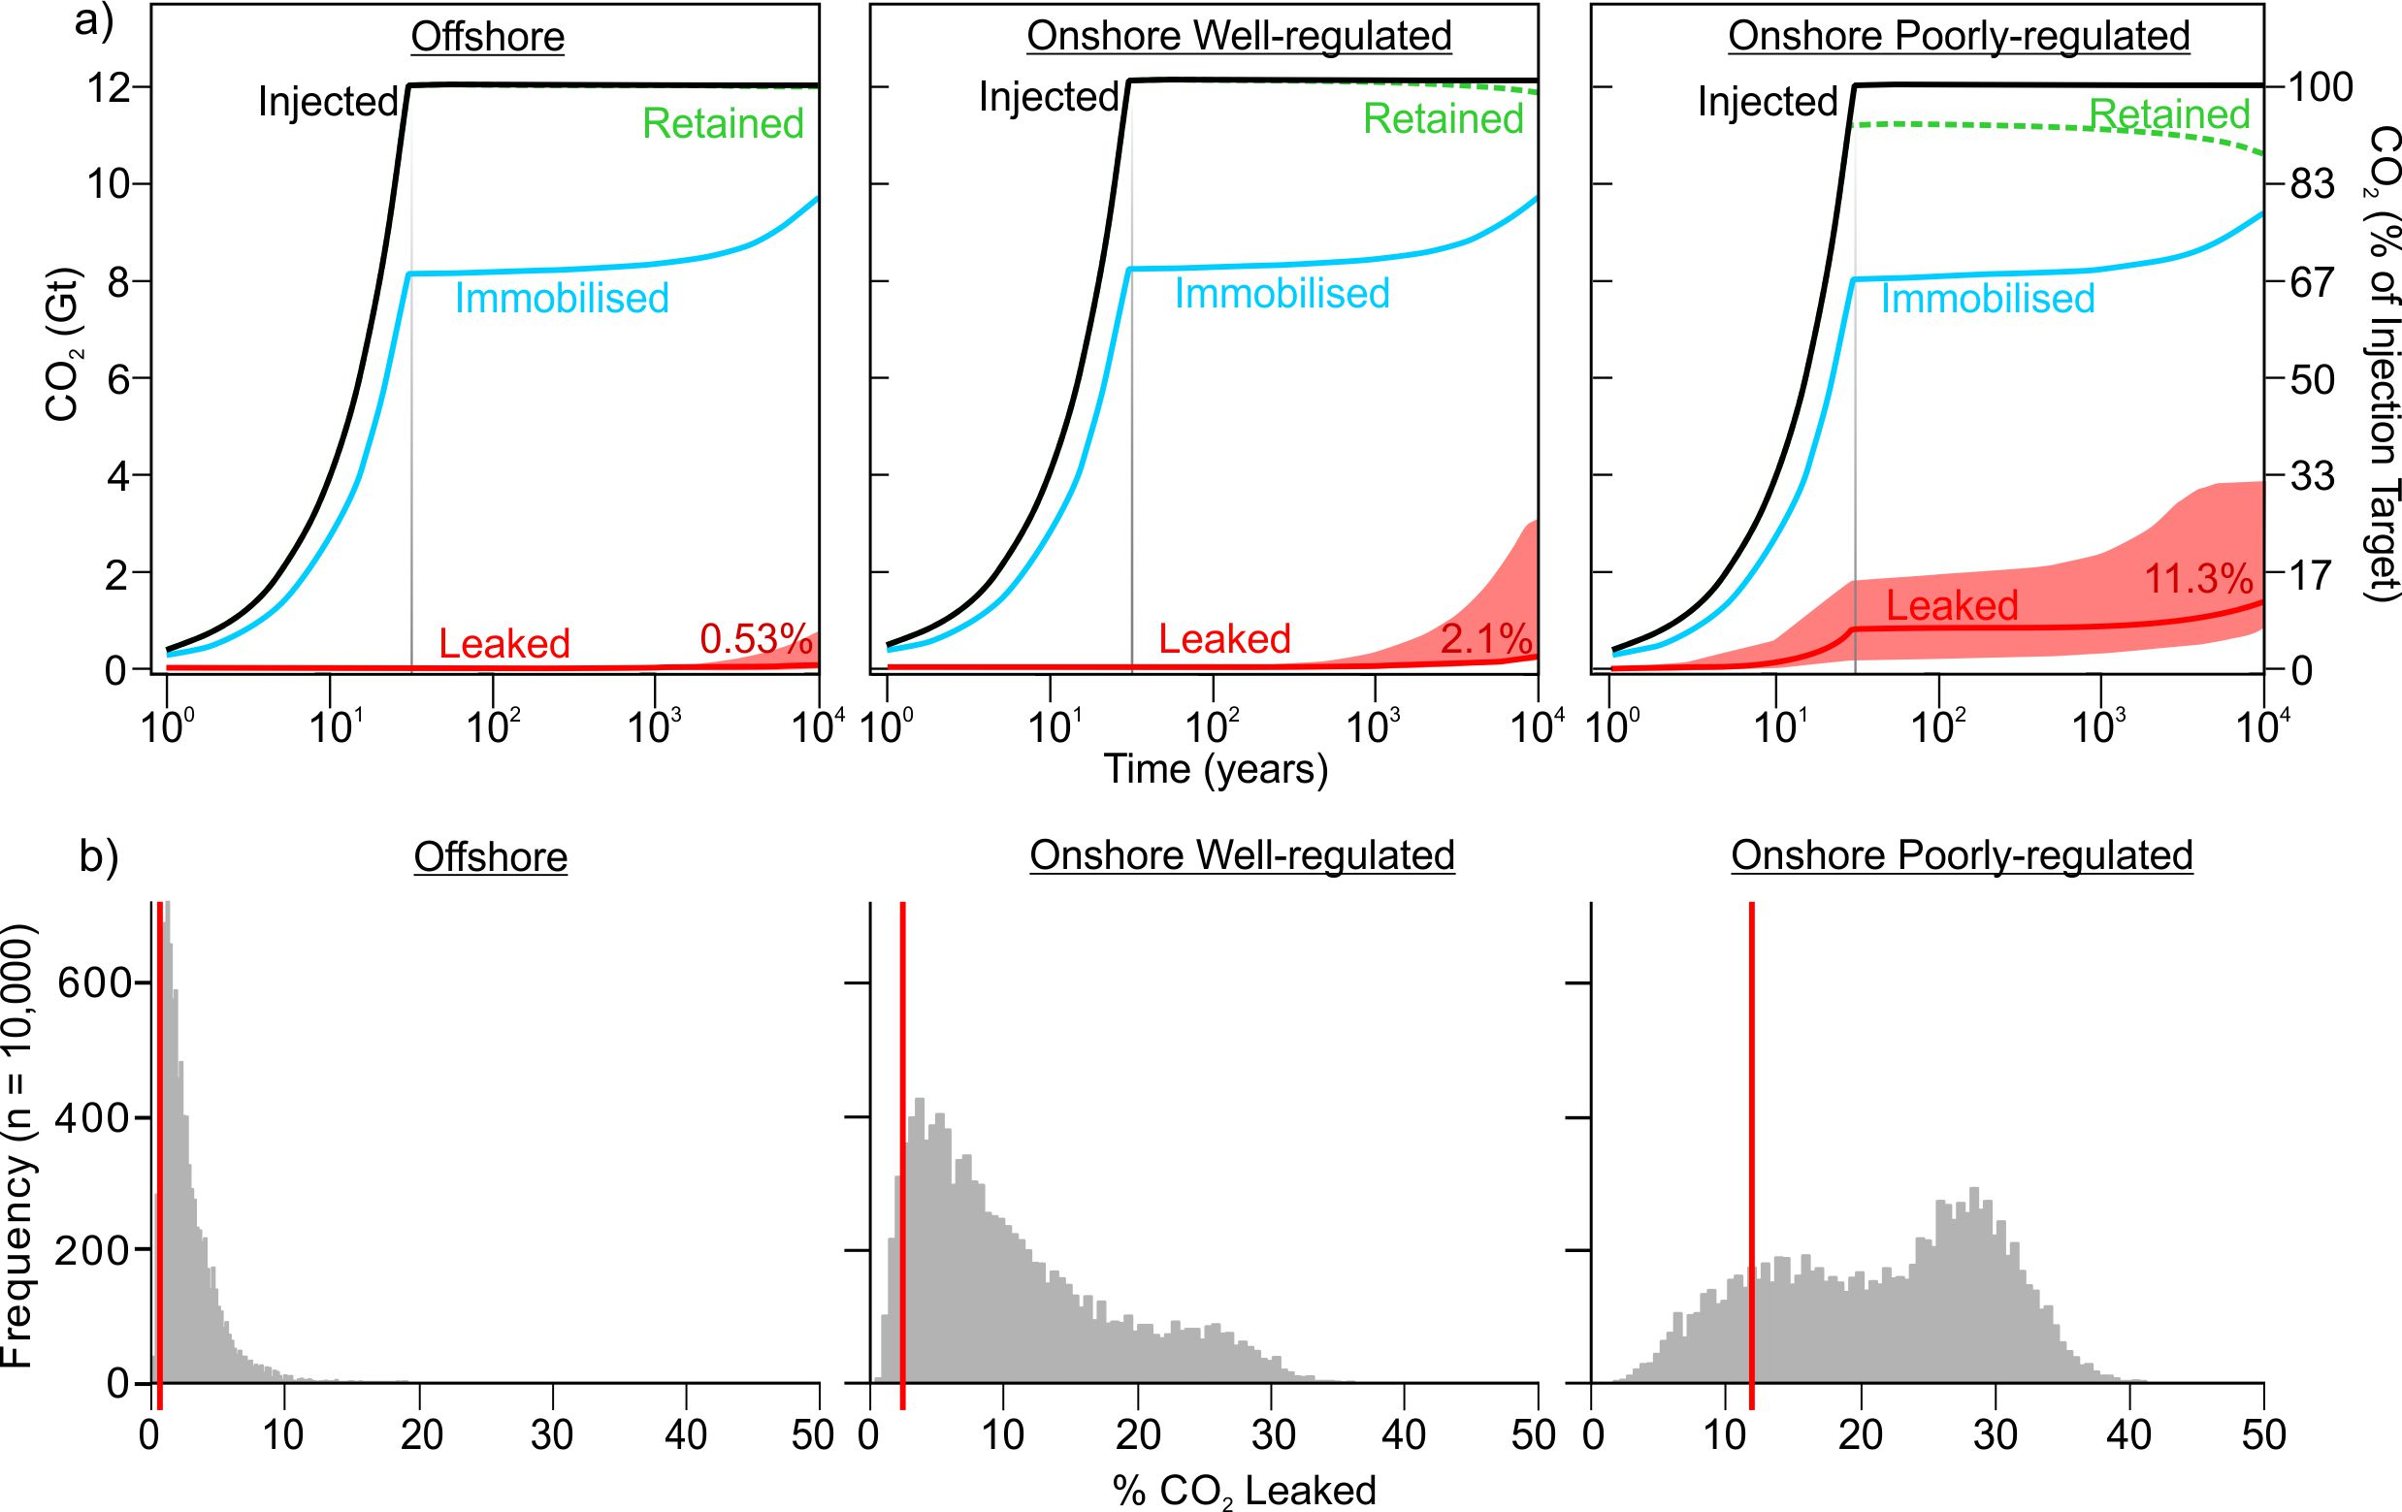
Figure 3. CO₂ storage modelling results for the three target scenarios. a) Evolution of CO₂ immobilisation and leakage over time, for the three base case scenarios. The black line shows the total CO₂ injected, between 2020 and 2050. The grey line shows when injection ceases. The blue line shows CO₂ retained by immobilisation due to rapid residual saturation and due to longer-timescale dissolution and mineralisation trapping. The green dashed line is the cumulative limit of CO₂ retention due to leakage of CO₂ out of the subsurface, for example through faults or leaking wells, and is the inverse of leakage (red line). Between the blue and green lines is CO₂ retained in the reservoir by structural / stratigraphic trapping. Most CO₂ is lost through leaking wells. Red line at base of graph shows the base case result of cumulative leakage through time, with shaded P5 to P95 distribution envelopes above and below as derived from Monte Carlo analysis. The red number is the base case percentage cumulative leakage at 10,000 years, cf Table 1. b) Histograms showing the distribution of results from Monte Carlo analysis (10,000 realisations) for each scenario; results are cumulative leakage as a percentage of the total CO₂ injected at model year 10,000 (x-axis). Red vertical lines show the base case scenario cumulative leakage result at 10,000 years (red numbers in graphs above, and Table 1).

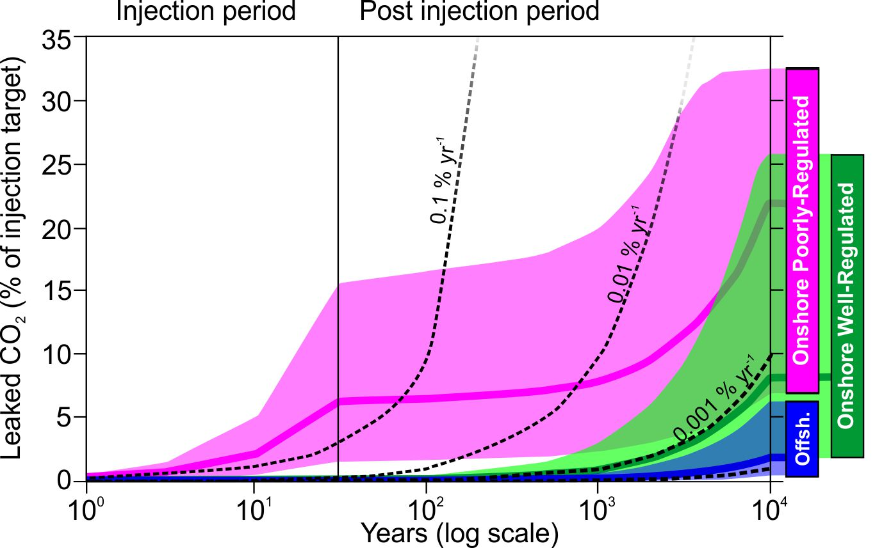
Figure 4. Monte Carlo runs of the three scenarios. The graphs show cumulative leakage of CO₂ as a percentage of the total injected. Each scenario shows the P50 output as a blue, green, or magenta line, with shading above showing the P05 limit, and below for the P95 limit, defining occurrence envelopes for the three scenarios. These are calculated on 12Gt CO₂ injected between 2020-2050, with subsequent storage and leakage over 10,000 years. Black dotted lines show comparisons based on time averaged yearly constant leak rates for 0.1 %, 0.01 %, 0.001 % and 0.0001 % per year (the latter represented by the unlabelled dotted line at the base of the diagram). Offshore Well-Regulated storage (blue) is found to be the most reliable Scenario. Onshore Well-Regulated storage (green) exhibits higher leakage due to a higher density of abandoned wells acting as potential leakage pathways. Poorly-Regulated Onshore storage (magenta) exhibits the highest leakage rates in the short term due to the prevalence of unidentified abandoned wells that are unplugged or degraded.

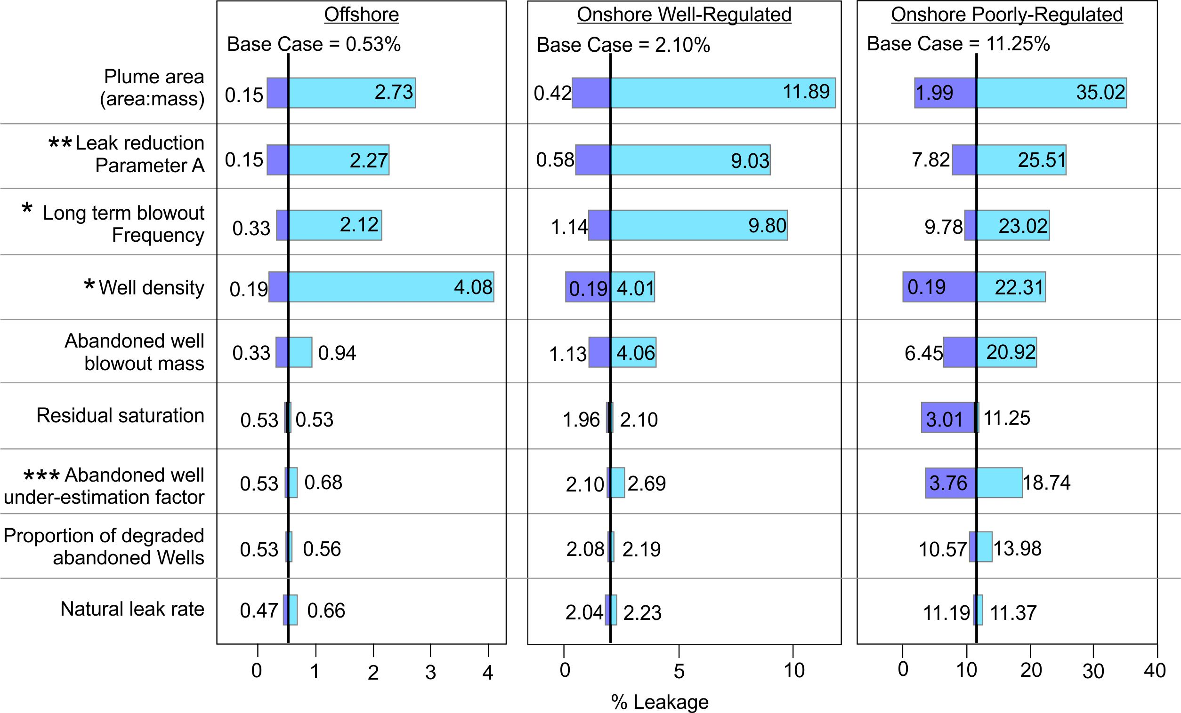
Figure 5. Sensitivity tests of the input parameters. The tornado diagrams for the three Scenarios show the impact on leakage of changing the parameters listed. The graphs show cumulative leakage of CO₂ as a percentage of the total injected. Each parameter was assessed in turn by varying it between its maximum and minimum values, with all the other parameters held at their base case values. The parameters shown are those that have a significant impact on the computed results (a relative difference of at least 5% between the base case and sensitivity test results). Values listed are % leakage results at 10,000 years. Maximum and minimum values were defined as either two standard deviations from the mean, or: *= used minimum and maximum values varying between 0 and 5 wells km⁻²; ** = minimum and maximum values as defined in the Methods Section ***Varied between 1 and 1.1 for the well-regulated scenarios and from 1.1 to 2.0 for the Poorly Regulated Scenario.

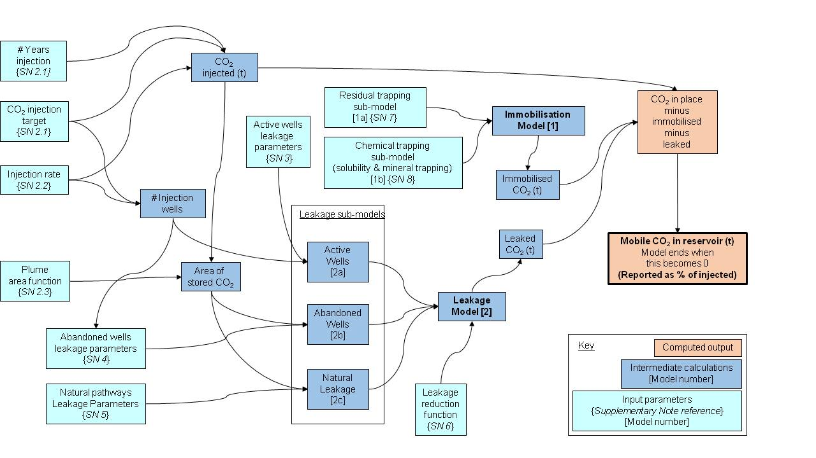
Figure 6. Schematic flow diagram of the Storage Security Calculator program. The program relies on 26 input parameters, each are called in at least one of the models. These parameters are listed in Table 3, along with the values applied. Discussion of how the values were derived is provided in the Supplementary Information Section 2.

