Scientific and risk-reduction benefits of involving citizens in monitoring volcanic activity
Jonathan Stone†**, Jenni Barclay , Peter Simmons†, Paul D.Cole, and Susan C.Loughlin

Abstract

Citizen science involves volunteers, regardless of scientific background, in conducting scientific investigations. Although the extent of citizen involvement varies, the reported benefits of such activities include: the generation of new knowledge; increased public understanding of and confidence in science, and ‘real-time’ insights into rapidly evolving events such as natural hazards. In volcanic environments, involving citizens at risk in participatory monitoring activities also has the potential to encourage and to inform risk-reducing actions. A global survey of volcano monitoring institutions (VMIs) found that around two-thirds of those that responded had engaged in citizen science initiatives. The majority of initiatives involved direct observation of eruptions or impacts. VMIs that had engaged in citizen science reported that it had improved participants’ scientific knowledge and enhanced the relationship between the VMI and local citizens. A few had involved citizens in further data gathering or in data analysis and reported additional risk reduction benefits.

Résumé

1 Introduction
Citizen science is a term used to refer to a broad range of activities in which members of the public engage in the process of scientific investigation, regardless of their previous scientific training. The degree to which they engage with all aspects of this process varies, but citizen science typically includes one or more elements of: asking questions, collecting data, and interpreting results (Bonney et al., 2016, Haklay et al., 2013, Conrad & Hilchey, 2011, Irwin, 1995). Motivations for conducting research projects or experiments involving citizen science also vary. Most commonly these are associated with the desire to expand or calibrate observations made by scientists themselves (Silvertown, 2009, Sullivan et al., 2014), including techniques where citizen scientists are passive sensors or collectors of large volume datasets (‘crowdsourcing’, Bonney et al., 2014). A second important objective is for participants to learn about the scientific problem under scrutiny; or about the scientific process itself (Haklay et al., 2013, Bonney et al., 2016, Stone et al., 2014). There has also been increasing attention to involving citizens in research projects whose results affect them, from the monitoring of air pollution in city streets to the stewardship of fragile species or ecosystems (Sullivan et al., 2014, Snyder et al., 2013, Dickinson et al., 2012). These projects can be shaped by citizens themselves to varying degrees, from their concerns feeding into and framing the study design to involvement in the collection and analysis of data to inform or influence local policy and decision-making^{2,10}. Some within the scientific community have questioned the reliability of the data generated (Bonney et al., 2014) or suggested that such projects will tend to attract ‘activists’ with a strong value-driven agenda, which could compromise the objectivity of the research (Conrad and Hilchey, 2011). There is considerable evidence, however, that this type of engagement both enhances public and scientific understanding (Woolley et al., 2010) and develops trust between the scientists and the volunteers with whom they are working (Stone et al., 2014, Danielsen et al., 2009).
Within environmental sciences this evolution towards more direct citizen participation has been considerably aided by recent developments in sensor and remote-sensing technology; it has become much cheaper to provide interested citizens with the relatively disposable equipment needed to systematically track, map and record biological subjects, long-term morphological change and responses to transient events such as flooding, wildfires, pollution spills or volcanic eruptions. Rapid technological developments, particularly smart phone technology also support the recording of observations through web-supported applications e.g. mappingforchange.org.uk; www.ispex-eu.org; terra.nasa.gov/citizen-science). Thus, there is considerable potential to deploy citizen science in and around volcanic regions both to improve scientific knowledge around their eruptions and to inform and encourage risk reducing actions.

1.1 Citizen science within the context of volcano monitoring
Globally there are more than 1500 volcanoes considered to be active (Simkin et al., 2013). 800 million people live within 100 km of these active volcanoe (Brown et al., 2015). Volcanic eruptions typically result in the generation of a range of hazardous phenomena. Volcano monitoring institutions (VMIs) have responsibility for the production and communication of knowledge relating to potential or actual volcanic activity, usually including long-term hazard or risk assessment as well as monitoring. This knowledge is then used to inform decision-making with the goal of reducing or managing risk. There is a wide range of processes and signals that can be observed to understand volcanic activity (Sparks et al., 2012); crust is displaced by magma on the way to the surface, and mixtures of gas and magma are released during eruption. Instrumentation focuses on recording and interpreting signals indicative of the subsurface activity or ongoing eruption (seismic energy, deformation and the detection of gas). Volcanologists also make systematic observations of the phenomena as they occur and detailed maps of new deposits. In almost all settings the mapping and interpretation of recent, historical and pre-historical deposits allow them to infer the potential future impacts of renewed eruption.
Although there are 74 VMIs across 37 countries, many of them monitoring more than one volcano, the majority of volcanoes are not monitored, with the most active or most recently active having priority (Jolly et al., 2015). For example, of the 314 volcanoes in Central America that have been active in the Holocene, 64% are currently not monitored on the ground (Ortiz Guerrero et al., 2015). Monitoring networks are difficult to finance and maintain and, as a consequence, there is considerable variance in instrumentation at different volcanoes, with some in developed countries having many tens of sensors, whereas many in developing countries are not monitored at all (Jolly et al., 2015). Furthermore, volcanic activity is highly variable in both space and time; eruptions can continue for months and even years. Monitoring is therefore not just about forecasting new eruptions but also anticipating and recording the changing impacts of various flows and ash fall.
Given the patchiness of monitoring cover and the needs of those responsible for volcanic monitoring and hazard assessment, considerable potential exists for data expansion by involving citizens in the process. This is particularly true during a volcanic crisis or eruption, when the impact on infrastructure, communication and the environment become important, as citizens living in affected areas are able to greatly increase visual observations. The wider goals of encouraging participation in order to improve citizen understanding of volcanic activity (risk communication) or to encourage improved societal risk management (or disaster risk reduction) give further impetus to involving citizens. It is clear therefore that an analysis of the role that citizen science plays in volcanic settings should not focus only on its contribution to the creation of new knowledge or on building trust, but should also consider the potential of an initiative to reduce volcanic risk.

1.2 Disaster risk reduction and citizen science
Disaster risk reduction (DRR) is a systematic process aimed at reducing the adverse effects of hazards for vulnerable people and reducing the vulnerability of people exposed to hazards. During volcanic emergencies DRR focuses on anticipating impacts and encouraging population movement in response to advancing hazards (lava flows, pyroclastic density currents and lahars) in the immediate vicinity. At such times VMIs would typically have responsibility for providing information to support decision-making by government agencies, communities or individuals (Newhall et al., 1999; IAVCEI Task Group, 2016). On longer timescales DRR should also involve strategies for limiting exposure to these hazards and for mitigating the impacts of prolonged ash fall, as well as improving preparedness for the onset of future activity. Thus, VMIs have a critical role to play in DRR, both in improving early warning of changes in volcanic activity and in improving anticipation of activity and its impacts.
In DRR scholars and practitioners (e.g. Wisner et al., 2004; Kelman et al., 2012, Mercer et al., 2012, Maskrey, 2011, Scolobig et al., 2015, UNISDR, 2015) advocate approaches that put those at risk at the centre of initiatives to reduce risk, referred to as ‘people-centred’ DRR. Such approaches are often focussed at the community scale and emphasise the empowerment of individuals within a community to ‘own their risk’ in the longer term and, where appropriate, act to reduce it. There are several examples where communities threatened by volcanic hazards have successfully mapped their risk environment (Cronin et al., 2004a, Cadag et al., 2017). The integration of people-centred local DRR with risk management plans and processes at other scales could lead to a ‘sustainable reduction in disaster risks over time’ (Maskrey, 2013). Collaboration between citizens at risk and those responsible for volcanic monitoring, to identify and integrate knowledge-gathering techniques that benefit both citizens and VMIs, could therefore encourage sustained involvement in community-based risk reduction projects.
There is also a growing body of evidence that suggests that community-based assessment, monitoring and management of some disaster risks can be very effective, including landslides (e.g. Holcombe et al., 2011), flooding and coastal hazards (e.g. Delica-Wilson et al., 2005) and volcanic hazards (e.g. Donovan, 2010). The involvement of citizens at the community level can also improve linkages in technical early warning or monitoring networks and embed warning mechanisms within communities that need to act during an emergency (e.g. Armijos et al., 2017, Karnawati et al., 2011; Figure 1). In the longer term, involving citizens in the assessment of risk (another identified goal of many VMIs) allows them to identify hazards and vulnerabilities, plan for their response and mitigate or eliminate risks. These provide further strong motivations both for VMIs to engage with citizen science and for citizens to engage in community-focussed initiatives that gather and analyse these types of data.

1.3 Our approach to the problem
Despite this, there has been very little attempt to date to characterise the involvement of citizens in the monitoring of volcanic activity and its impacts, or to understand the outcomes from these initiatives. Understanding citizen science in volcanic contexts, with their multiple or cascading impacts from hazardous events, will also provide insights applicable to other hazardous environments (Gill and Malamud, 2016). Positive outcomes may range from improved scientific understanding of volcanic processes to more effective risk management to empowerment of citizens to increase their resilience to volcanic activity. In this study, we address this knowledge gap and use evidence from these early initiatives and other, more established, uses of citizen science to consider how citizen involvement in gathering scientific data in volcanic settings may be developed.
We begin by presenting the results from a survey of volcano-monitoring institutions (VMI). The survey solicited both factual data and expert opinion. It was designed with two key aims: (i) to understand the extent to which citizen science initiatives were being used to gather and supplement data relevant to volcano monitoring; and (ii) to understand if there were perceived benefits to the communication and reduction of volcanic risk. We then consider how these initiatives compare with other reported participatory monitoring initiatives in volcanology that are more clearly aimed at citizen participation in disaster risk reduction. Using these data, we consider the extent to which VMI-driven initiatives can both empower citizens and encourage adaptation to local risk, and the evidence for the most important avenues for future developments in this field of science.

2 methods
The survey was designed with three objectives: (i) to understand the role and structure of the VMI; (ii) to understand the extent of citizen participation in the work of the VMI, and (iii) to investigate the anticipated and actual outcomes of participation as reported by the VMI-based respondents.
The online questionnaire (see Appendix 2) contained both factual questions and solicitations of opinion. Some questions required respondents to give short written responses; others required them to respond to a series of statements using a five-point Likert scale to indicate strength of agreement or disagreement. These scaled questions were used largely to assess attitudes towards and perceived benefits of citizen science initiatives. The questionnaire contained 39 questions, some of which could be skipped where a response was not applicable. Average completion time during trialling was 45 minutes. There were no incomplete questionnaires. Questions were posed in English but respondents were encouraged to respond in their native language if preferred. After an initial trial phase, a link to the questionnaire was emailed to the member list kept by the World Organisation of Volcano Observatories, to contacts made at international meetings and to others through the recommendations of and sharing by survey respondents.
In total 33 completed questionnaires were gathered from 23 separate VMIs (Table 1). Ordinal data from the scaled questions were plotted and analysed for trends. Written responses and supplementary interview data were analysed thematicall (Bernard and Ryan, 2009) with themes derived both deductively from the research literature and inductively from the data. The qualitative data are presented in tabulated/figure form; illustrative quotes taken from the data are presented verbatim in the text. Multiple responses from a single institution were counted individually in the ordinal data analysis but written answers from different respondents in the same VMI were analysed for coherence between response (Bryman and Burgess, 1994).
Our survey focusses on the views and opinions of citizen science from the perspective of the monitoring institutions, which inevitably are often more powerful than citizens at risk. We therefore undertook additional analysis, drawing on reports identified in the research literature, of initiatives that were not led by VMIs but which involved citizens living with volcanic risk in collecting data (Table 1 Appendix). This analysis used the same criteria, where the relevant information was available, that were applied to the survey data. These secondary data are summarised in Appendix 1. These other initiatives are often more concerned with disaster risk reduction or management and involve citizen participation in the characterisation of their own risk environment, using methods such as participatory rural appraisal and participatory mapping (Figure 2).

3 results

3.1 Structure and capacity of volcano monitoring institutions surveyed
Volcano monitoring arrangements have been established at different times in response to local or regional need; structure, capacity and remit consequently varies and there are no internationally agreed criteria for what constitutes a VMI (Table 1). The World Organisation of Volcano Observatories (WOVO) aims to represent VMIs and facilitate collaboration, learning and support. WOVO has 79 members which vary in the number of volcanoes for which they are responsible, their funding sources, and their territorial remit (Table 1). Our survey focussed on the 74 WOVO member organisations with direct responsibility for volcano monitoring, so excluded Volcanic Ash Advisory Centres (5). We received 33 individual responses, representing 23 separate organisations responsible for monitoring 296 potentially active volcanic centres across 24 countries with different levels of economic development. Nine of the multiple responses from within the same organisations represented groups with responsibility for differing volcanic systems. This represents an organisational response rate of 32%, which is about average for this type of research (Baruch and Holtom, 2008). Responding institutions display a range of ages, organisational forms and funding structures (Table 1). High income countries are disproportionately represented in our sample, although this reflects the overall correlation between intensity of monitoring and degree of economic development (Loughlin et al., 2015). Respondents identified 20 citizen science-type initiatives across 14 countries; two observatories reported activities that have been happening intermittently for well over 100 years. There is not a great difference in the adoption of citizen science initiatives between VMIs in our sample as classified by their country’s degree of economic development (Table 1): 60% of VMIs in High Income countries, 56% of VMIs in Upper Middle Income countries, and 75% of VMIs in Lower Middle Income countries are involved in citizen science initiatives.

Table 1: Summary of responses from volcano monitoring institutions to illustrate, degree of development, no. of volcanoes for which responsible, and source of funds for monitoring.

Citizen science projects? | Level of Development⁽¹⁾ | Organisation⁽²⁾ | Funding⁽³⁾ | Networked⁽⁴⁾
Yes | H | RF | GOV+RES | Yes
Yes | H | RI(V) | GOV | Yes
Yes | H(a) | RI(V) | GOV+RES | Yes
Yes | H(a) | RI(V) | GOV+RES | Yes
Yes | H(b) | RI(V) | GOV+RES+PRIV | Yes
Yes | H(b) | RI(V) | GOV+RES+PRIV | Yes
Yes | H(b) | RI(V) | GOV | Yes
Yes | H(c) | GS | GOV | Yes
Yes | H(c) | GS | GOV | Yes
Yes | H(c) | GS | GOV | Yes
Yes | H(d) | GS | GOV+RES+PRIV | Yes
Yes | H(d) | GS+RI(V) | GOV | No
Yes | UM | RF | GOV+NGO | Yes
Yes | UM(a) | RF | RES | Yes
Yes | UM(a) | RF | GOV | Yes
Yes | UM(a) | RF | GOV | Yes
Yes | UM | RI(V) | GOV | Yes
Yes | UM | RMI | GOV+RES+PRIV | Yes
Yes | UM | NMI | GOV | No
Yes | LM | GS | GOV+NGO | No
Yes | LM | NMI | GOV | Yes
Yes | LM | VMI | GOV | No
No | H | RF | GOV+RES | No
No | H | RF | GOV | No
No | H | RI(V) | GOV+RES | Yes
No | H | RI(V)+GS | GOV | Yes
No | H(a) | RI(V) | GOV+RES | Yes
No | H(a) | RI(V) | GOV+RES | Yes
No | H(c) | RF | GOV | No
No | H(c) | GS | GOV | Yes
No | UM | RI(V) | GOV | No
No | UM | RMI | GOV+RES | Yes
No | LM | RI(V) | GOV | No

Notes
- Classification of the domicile country or countries in terms of World Bank Degree of Economic Development (based on median income): H High income, UM Upper Middle income, LM Lower Middle income, L Low income. Where multiple respondents from the same country (but not necessarily the same VMI) responded, this is shown by lower-case letters, where respondents from the same country have the same letter code. Two VMIs from LI countries responded via email to indicate they did not have ‘citizen science’ initiatives but did not complete the questionnaire, so are not included in the survey.
- Type of monitoring organisation, GS Geological Survey with volcano monitoring department
NMI – Institution dedicated to the monitoring of a single or multiple volcanoes within a single country, RF – monitoring organisation within an institution mainly funded for research or higher education, RI(V) research-led or monitoring institution (multiple types of hazards) with a dedicated volcano monitoring department, RMI – institution dedicated to monitoring volcanoes in multiple countries across a region. ,
- Dominant sources of funding – GOV Government (Federal, local and regional), NGO funding from a non-governmental agency or overseas aid, PRI – private donors including insurance agencies, RES – grant-won research funding
- Indicator of whether organisation is within a national network of organisations also tasked with volcano monitoring (not including international agencies such as VAAC and NASA). An italicised ‘Yes’ indicates that networked organisations have different responsibilities for the same volcanic systems.

In the first instance, the VMIs themselves exist to provide early warning of volcanic hazards for the protection of society. Some institutions provide these warnings purely within a technical risk management network, and do not engage directly with citizens (see e.g. IAVCEI TaskGroup, 2016). Nonetheless more than 70% of respondents to our survey have some form of outreach or education program with a member of staff with dedicated responsibilities, and 64% indicated that there is some form of citizen participation in volcano monitoring. However, only 4 of the 22 respondents that reported citizen participation indicated that it is organised by the staff member responsible for outreach, suggesting that it is not viewed primarily as an outreach mechanism. It is also clear from the data that where an organisation has multiple VMIs in one country, citizen participation in one volcanic setting will not necessarily be replicated in another (Table 1).

3.2 Reported types of citizen science
Figure 1 summarises the main forms of participation reported by VMIs. The majority involve recording observations (written/photographed or measured) of eruptive activity or its impacts, which is consistent with the finding that 70% of citizen involvement is associated with periods of activity (Figure 1). Only a small number of VMIs state that they are involved in initiatives that continue over longer time periods or continuously, examples of which are given below.
We also surveyed the literature for initiatives associated with volcano monitoring where VMIs might have played a lesser role (summarised in Appendix 1 and captured in Figure 2b). Those identified most commonly involve mapping risk in anticipation of future activity. There is, however, one initiative in this group that involves volunteers from outside the country collecting longitudinal instrument data to monitor and understand long-term changes and environmental impacts resulting from a continuing long-lived eruption.
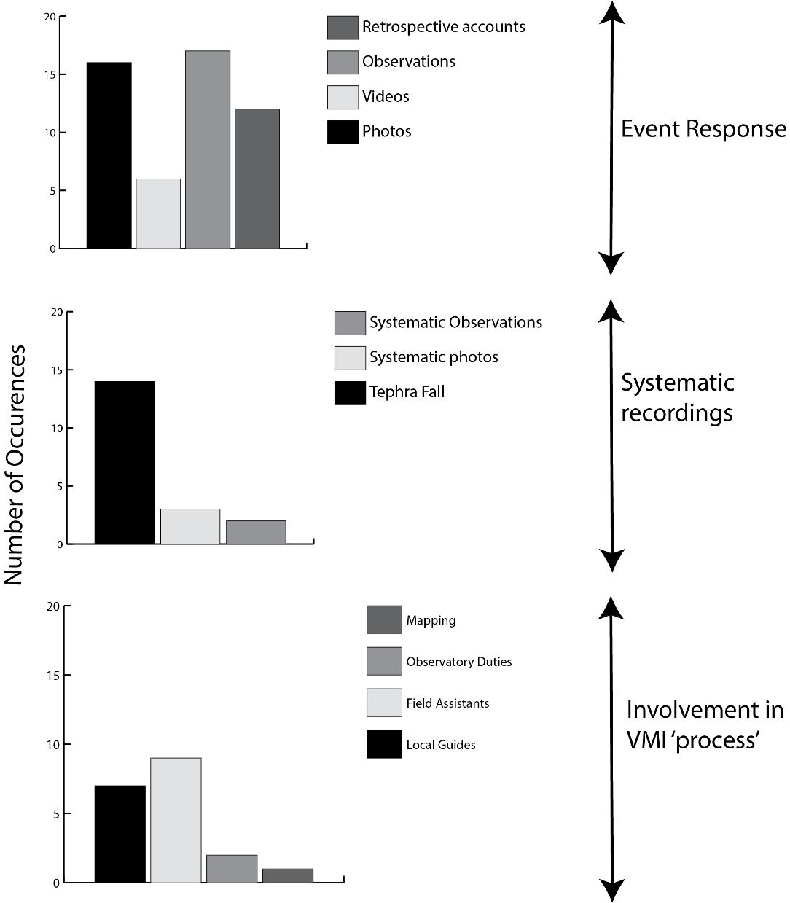
Figure 1. Summary of activities undertaken by those participating in citizen science projects. These are grouped as follows: those in which citizen involvement in making observations or measurements is reactive, prompted largely by the occurrence of volcanic activity; those where it is proactive, the result of anticipatory deliberation or decision-making; and those which involve citizens in VMI duties. These categories have been created by analysis of responses to the questions ‘When have they/are they involved’ and ‘What type of monitoring or observations have they been involved with?’ Answers were in closed, multiple response format with space for additional comment. Survey questions are in Appendix 2.

The extent to which the different initiatives map onto the goals of forecasting, early-warning and disaster risk reduction and involve the different organisations charged with these responsibilities is represented in Figure 2, using data from the survey and the Table in Appendix 1.
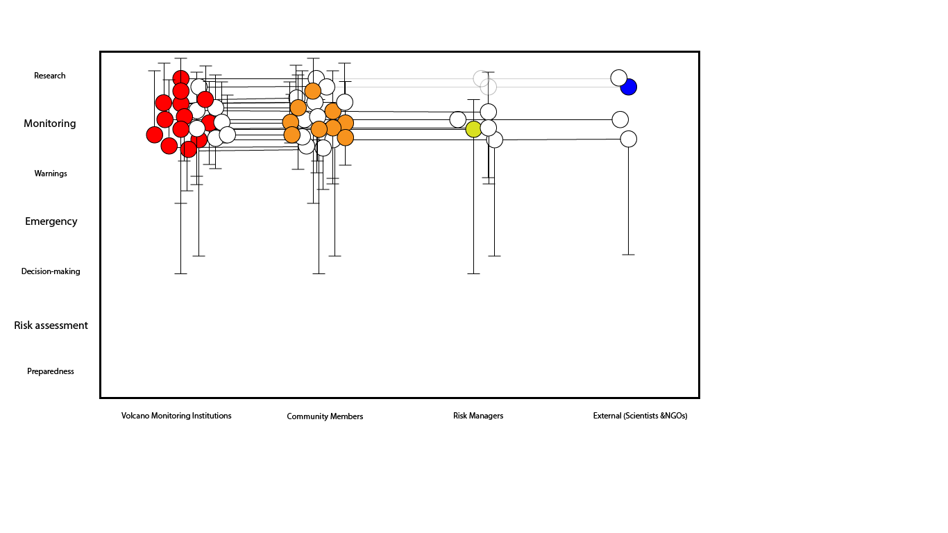
(a)
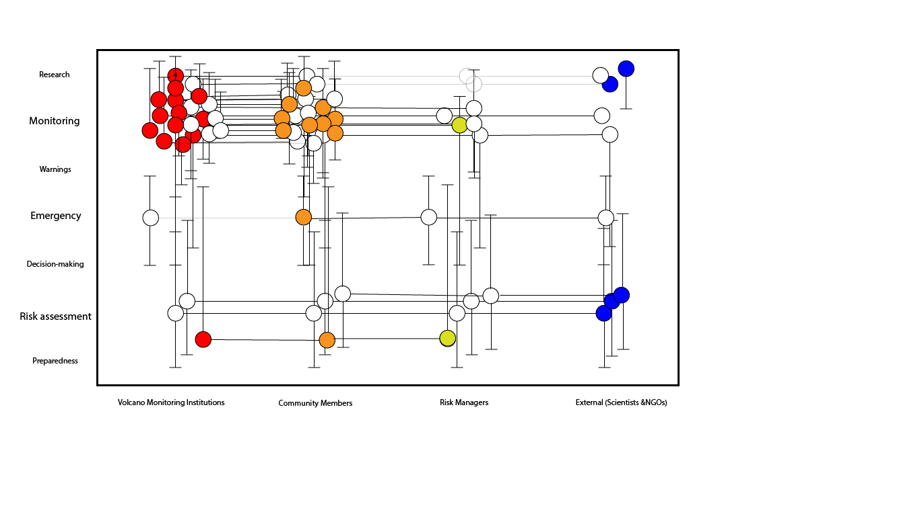
(b)
Figure 2. Mapping the applications of data from volcanological citizen science projects. The horizontal axis shows the different groupings that can be involved in gathering and sharing data and the vertical axis represents the range of uses of the data (broadly grouped around risk assessment, emergency management and monitoring). Each circle represents a project that contributes to that activity and most projects generally contribute to more than one: e.g. a project aimed at monitoring volcanic activity involving VMI and community members would have two circles, one in each participant column, joined by a horizontal tieline. Where the contribution of an initiative extends beyond the primary application, vertical tielines indicate the range of applications for the data. Solid colour indicates the initiating grouping: red are those in VMIs; orange, community members; yellow, risk managers; and blue, external groups such as research scientists or non-governmental organisations. The positions of the circle within the field are designed for both visibility and to represent the ordinal position of the project applications. (a) outcomes from the projects identified and described by our survey respondents. (b) outcomes from the survey plus those initiatives identified in Appendix 1.

3.3 Perceived benefits and limitations of citizen science
In the survey, few observatories set out with a deliberate plan for participatory monitoring without some initial catalyst for action, generally associated with an increase in volcanic activity. Most respondents state that participatory monitoring was at least initiated in an ad-hoc manner; some started because they needed to fill knowledge gaps, others because citizens volunteered information during discussions or casual encounters, and it was seen to be of value.
The predominant rationale for participatory monitoring initiatives is to fill data gaps, usually during an eruption when there are a lot of data to collect but limited resources to do so (Figure 3a-d). These data gaps take various forms and so, consequently, does the role of citizens in filling them; e.g. by reporting first sight of new surface activity, making more complete visual observations during eruptions, providing wider spatial recording of tephra fall. One respondent describes this: “They (citizens) are on the spot, so can make observations and collect ash quicker than we can.” Some initiatives are intended to provide early warning, or fulfil that role in cases where citizens are often the first to see new activity (Figure 3c). There were three examples of the incorporation of structured forms of participatory monitoring into early warning systems: all were in more economically developed countries (High or Upper Middle Income countries as defined in Table 1).
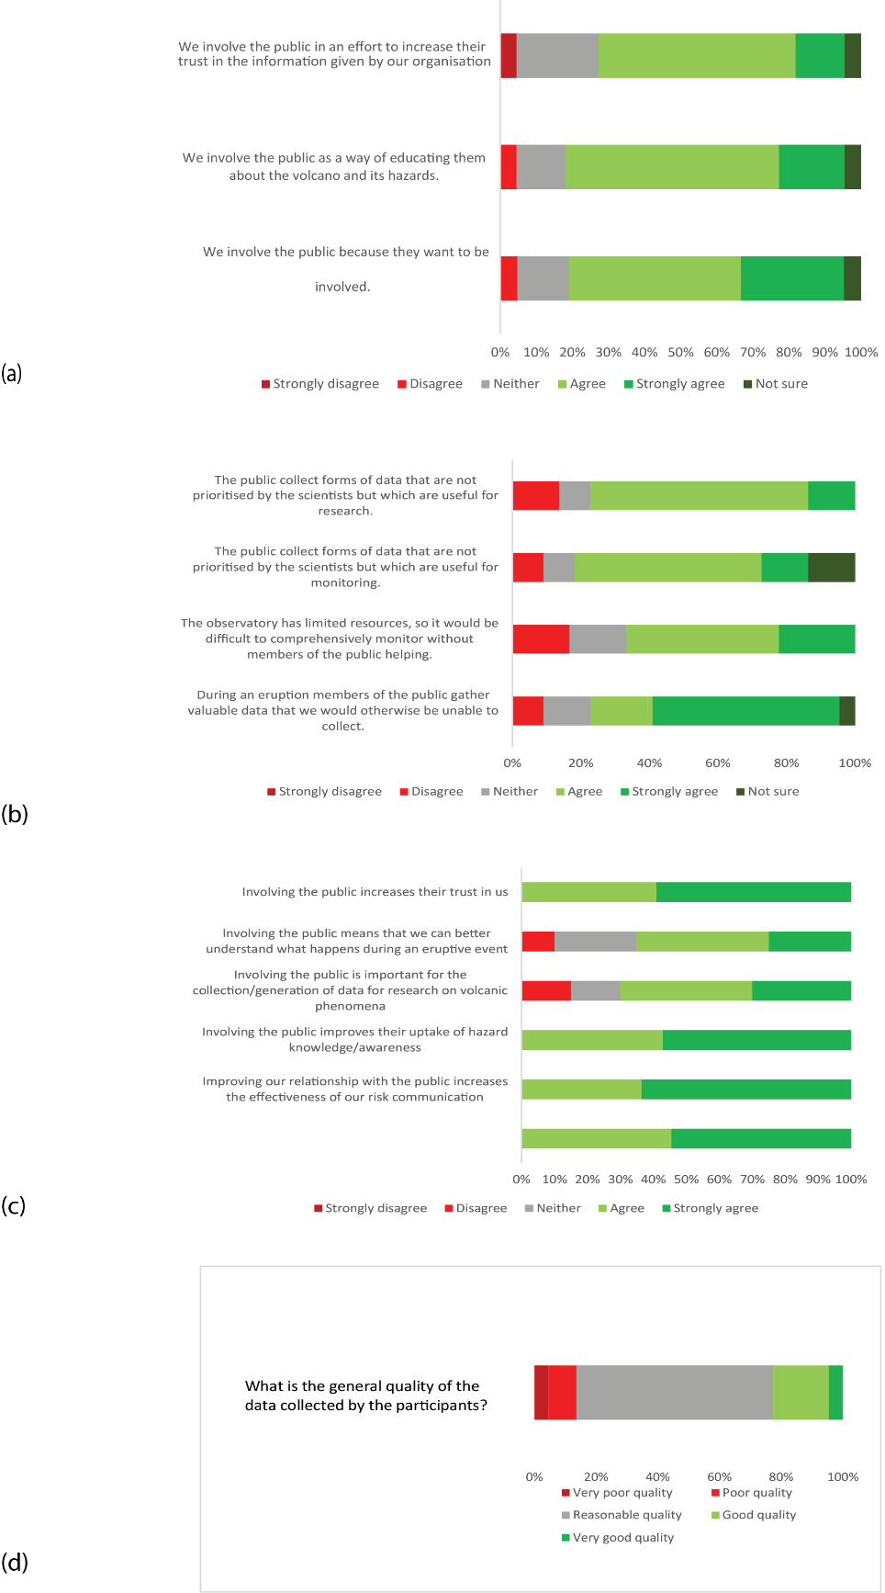
Figure 3. Likert responses to statements relating to the rationale, processes and outcomes of citizen science projects: (a) statements relating to the motivations behind the citizen science projects; (b) statements that describe the utility of the data collected to the VMI and (c) statements relating to the perceived outcomes of the projects; (d) describes perceived data quality in response to the question shown. Each question had n= 22 respondents.

However, participatory monitoring is also explicitly used by VMIs as a means of public engagement (Figure 3a), often in the form of school-based activities such as hosting simple seismometers at schools. In other fields of citizen science it has been shown that being involved in science as a process leads to greater scientific literacy and awareness (Bonney et al.,2016, Conrad & Hilchey, 2011, Dickinson et al., 2012, Tulloch et al.,2013).
Many respondents state that citizens want or ask to be involved in monitoring activities, but few agree that their institutions take part in participatory monitoring simply because citizens would like to be involved. However, all VMIs are aware, have experienced, or indeed expect that participatory monitoring may improve relationships with citizens (Figure 3 a and c), as illustrated in the following quotation:
“If they know us as people, they are more likely to trust our judgements when we have critical messages.”
Similarly they all agree or strongly agree that good relationships are important for the communication of risk and uptake of hazard information, and that participation acts to enhance trust in decisions made or advised by monitoring institutions, conclusions supported by findings from other fields of risk research (e.g. Fischhoff, 2013).
Nevertheless, one respondent suggested that there are concerns that involving citizens in monitoring could instead undermine trust in scientists:
“I get the feeling that our organisation is hesitant to involve the public in monitoring, as it might cause the public to think they can interpret the data themselves (false confidence), and therefore the scientists aren't needed or trusted as much”
In a similar way, some scientists in both groups are concerned that involving citizens at risk in monitoring could affect their own objectivity or increase the risk of competing messages (Figure 4).
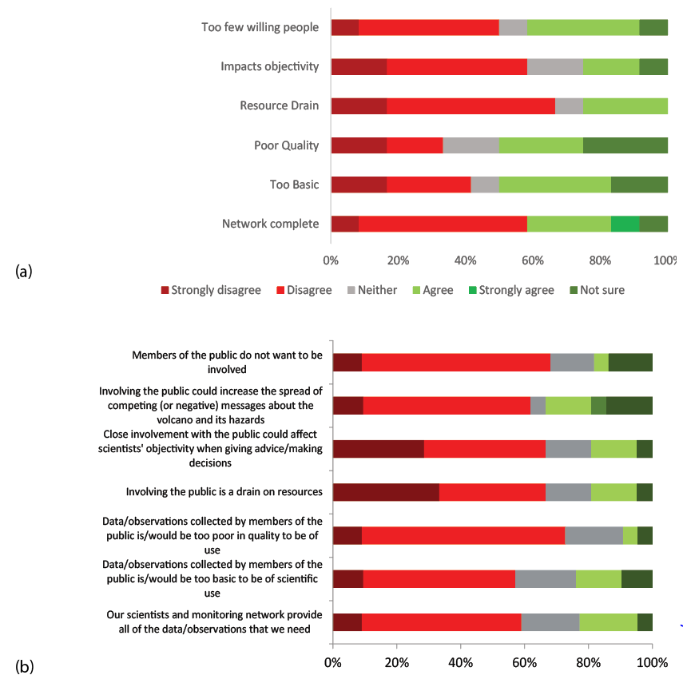
Figure 4 Likert responses to statements relating to: (a) challenges to implementing citizen science projects anticipated by the n = 11 respondents with no experience of these initiatives (involving a separate question in the survey). (b) challenges associated with citizen science projects by the n= 22 respondents with experience of these initiatives

The degree to which these initiatives have value beyond that associated with relationship building and risk communication varies between settings, something which our analysis of the qualitative survey data elucidates further. There is, certainly, a more equivocal view overall about the quality of data collected (Figure 3d) and less strong agreement about the need for gathering the data purely for its scientific benefits (Figure 3b). While most respondents think that the data are of reasonable or good quality (Figure 3d), others question the quality and therefore the value of the data:
“…(the data are) highly variable, this is pivotal, and a major reason that we do not strive to do more of it.”
Others agree with this but are also pragmatic, seeing citizen-generated data as useful when that is all there is:
“…(the data are) very poor compared to monitoring data. If there is no monitoring data, then public observations are better than nothing.”
In contrast, however, a VMI that has formalised systematic participatory monitoring reports that:
“(the participants are) stunningly detailed collectors - we give many options and many people pick the most complicated forms of collections which give us the most information”
This divergence of opinion and of experience is echoed in the n=11 responses from those who have never engaged in participatory monitoring activities (Figure 4a) and in the reservations of those who do (Figure 4b). However, even among those who do not engage, there is still not a majority that attributes this to a lack of confidence in the quality or volume of the data that would be produced. It is also noticeable that experience of citizen science increases the likelihood that respondents consider the data to be ‘useful’ (Figure 4). Those who do not engage are also more likely to consider their current monitoring network sufficient and perceive there to be insufficient public interest for an initiative to be successful. There were also suggestions in this group’s written responses that engaging with the public is outside of their institution’s remit; i.e. other national agencies communicate and interact with the public:
“No one organization has resources to do everything. Perhaps it works well for organizations to stand and support one and another, and for each organization to focus on what they do best and fits their funding mission.”
Some respondents state that citizen science is less necessary due to increasing automation of monitoring, along with more sophisticated and technological means of communication. Only one respondent gives lack of basic volcanological knowledge amongst citizens as a reason for not having used participatory monitoring, although they also cite this as a potential motivation for using it in the future if it were to lead to enhanced awareness.

4 Discussion
Although it is likely that VMIs which engage in citizen science activities are overrepresented in our sample, our survey provides insight into current perception and practice within the global community of VMIs and an indication of the potential wider benefits for volcanology and for disaster risk reduction.
Perhaps the clearest point of consensus to emerge is that citizen science is valued for its capacity to increase trust by building relationships with affected communities. This view is consistent with outcomes of public engagement with science more widely (e.g. Stilgoe et al., 2014) notwithstanding our lack of insight into whether this reflects a desire for a relationship of reciprocated trust or simply for citizens to place their trust in the established practices, structures and worldview of the VMIs.
The prevailing view among respondents that citizen science delivers benefits by improving knowledge of the scientific process that surrounds volcano monitoring is also consistent with recent surveys of citizen science projects which conclude that it enhances public understanding of science (Bonney et al., 2014).
When it comes to the means that are used, we found relatively few examples of volcano citizen science exploiting the potential of cheap or mass-produced sensors to enable remote participation or widen the engagement of citizens at risk. Notable exceptions here are the ‘Is Ash Falling?’ website developed by Alaska Volcano Observatory as an online version of a longer-term ashfall reporting initiative (Wallace et al,. 2015), and the myVolcano app developed by the British Geological Survey in association with the Global Volcanism Program of the Smithsonian Institution, which has the potential to source and tag images and data on observations, including ashfall. The development of accurate ashmeters made from cheap everyday materials has also significantly increased involvement in established citizen science networks in Ecuador (Bernard et al., 2013). No initiatives were reported that involved citizens in the identification or verification of online data (e.g. identification of post-eruption damage from satellite imagery or observation of online volcano cameras). There is therefore considerable untapped potential for exploiting developments in low-cost ground-based sensors and for creating mass online databases. The relatively slow adoption of remote crowd sourcing initiatives could reflect reservations about the veracity of data (Figure 3d), but is also undoubtedly a function of the lack of a large, high impact event that would attract the interest of volunteer specialists such as ‘Open Street Map’ on which these organisations had drawn. The cost in time and money of developing more sophisticated methods of data collection or analysis requires a clear benefit in the form of improved monitoring capacity or understanding, a large-scale would increase this benefit. Most of our respondents deemed the quality of data collected to date as ‘reasonable’ rather than good or very good (Figure 3d). The currently limited use of the data is also consistent with the metadata analysis of findings from the well-established citizen science field of ‘biodiversity research’ (e.g. Theobald et al., 2015). In that field, there is an under-representation of new research papers that exploit citizen science data, despite the proliferation of projects and the use of demonstrably adequate data quality measures in many of these. However, these projects more frequently influence environmental management or policy directly, often without being reported in the peer-reviewed scientific literature, particularly the regional-scale projects most analogous in scale to many volcano citizen science initiatives. Citizen science projects that are focussed on influencing decision-making in managing volcanic risk need not be framed solely around advancing scientific research or improving monitoring capacity for the VMI (Theobald et al., 2015, see also those summarised in Appendix 1). There is analogous potential for citizen science in the field of volcanology to be developed in ways that contribute to and increase the effectiveness of volcanic risk management, particularly if the framing of the data gathering is designed collaboratively.
There is little evidence, however, that VMIs’ citizen science projects or data are being used deliberately to empower those who do not have a voice in decision-making or to use collaborative science to inform decision-making in contentious areas such as the borders of high hazard zones or thresholds for warning or evacuation (sharing risk ownership). In contrast, the initiatives described in Appendix 1 and represented in Figure 2 are designed primarily to encourage citizen participation and risk ownership; however, these initiatives typically are exercises designed to produce an assessment of risk, or to encourage further planning by citizens in preparation for future eruptions, and are not sustained. Maintaining interest outside the immediacy of periods of activity was also identified as a significant barrier to continued participation in the observation based activities in our survey.
Nevertheless, our survey does include examples where citizens are involved in managing risk as well as data collection, like the participatory mapping initiatives identified in Appendix 1. This typically involves citizens monitoring a threat to themselves with help from scientists, such as tephra fall or lahar hazards (Figure 2; Stone et al., 2014 Mothes et al., 2015, Bernard et al., 2013). Several VMIs also reported instances where citizens had been the first to see volcanic activity and feel able to contact scientists to report that information.
Further, although deliberate strategies to empower participants were not articulated, there was very strong evidence for the value of the process of working together in building trust and improving the flow of relevant knowledge. As well as improving understanding of the volcanic system (Figure 2 and 3) some do encourage risk reducing adaptations (Armijos et al., 2017) and most lead to perceived benefits in terms of enhanced trust-based relationships with citizens (even with relatively limited levels of involvement) or lead to other forms of participation.
A few VMIs, in their written comments, express goals consistent with increasing knowledge to empower citizens to manage their own risk or incorporating local knowledge into their own understanding of impacts and risk. Those VMIs which share data from these initiatives with others responsible for managing risk (n = 9; Figure 2) show a stronger orientation than the rest of the sample towards disaster risk reduction benefits of citizen science. For example, ‘the relationship between the scientific team and the population is very important for risk management’ (translation). Many in this sub-group adopt a collaborative approach to the design of the initiative, with some evidence of iterative development that is indicative of a collective learning process, and all of them used the data for more than one purpose.
Although the goals of scientific monitoring of volcanic eruptions and disaster risk reduction intersect, not all citizen science initiatives involve VMIs directly (see Appendix 1). Participatory approaches to disaster risk reduction in volcanic settings typically focus more squarely on empowering citizens to foster longer-term preparedness and the development of mitigation strategies. This view aligns with the core goals of many VMIs even though they are not intended to be the primary beneficiaries.
These participatory initiatives usually take an integrated approach, and consider other sources of risk, but only rarely has the new understanding developed been tested during an eruption. Typically, there is some effort to involve the local VMI (Figure 3), with some documented success but where VMIs are not included conclusions and actions may not fully address the hazards and thus reduce risk⁴³. These projects are usually associated with the co-production of a discrete output (hazard or risk map, Alert Level Scheme) rather than the development of a sustained working relationship, via the types of initiative shown in Figure 1. Cadag et al. (2017) provides a notable exception to this.
When all of the initiatives are analysed in relation to the range of activities associated with the reduction of risk in a volcanic context (Figure 2b), citizens tend to occupy two discrete roles: either observing events or participating in planning for future activity. Only a small number of those observing events collected and measured data from scientific instruments.
From the critical perspective of DRR research, therefore, the citizen science initiatives identified in our survey might be viewed simply as ‘extractive’ forms of participation, designed to provide data for science, and therefore limited in their potential for achieving sustainable risk-reducing outcomes⁴⁴. We suggest, however, that there is considerable scope for embedding citizen science within a DRR-focused network that extends beyond VMIs. This would entail cultivating a richer, more multi-functional mode of citizen science, one that could contribute to the kind of horizontal and vertical integration between actions, institutions, individuals and roles (Figure 3) seen as essential for the effective reduction of risk (Maskrey, 2011, UNISDR, 2015). One of the principle benefits identified by our survey, in addition to increased awareness and understanding of hazards, is the development of improved relationships between different groups through involvement in the process of data collection. The evidence presented here therefore suggests that VMIs are well-placed to empower citizens by engaging them in the process of monitoring volcanoes and furthermore, consistent with findings from disaster vulnerability research (Chambers, 2006) , to do so without compromising the risk governance roles of authorities and institutions.
Not only do citizen science initiatives in volcanic contexts hold out the potential for improved relationships between scientists, citizens and decision-makers but, as already suggested, they also constitute spaces for social learning. Evidence from the survey, from Ecuador ( and Stone et al., 2014, Mothes et al., 2015, Armijos et al., 2017) USA (and Wallace et al., 2015), UK (and Stevenson et al., 2013), and New Zealand suggests that participation typically evolved in response to crises and shocks that were new experiences for most of the groups involved, including the VMIs. In these examples, VMIs learned reflexively how to improve participation, and developed relatively clear rationales for why and how they do it. This involved a gradual process of experimentation and adaptation, typically sustained by the persistence of volcanic activity within the region.
Creativity and entrepreneurship are also needed to overcome resource constraints: “This work is valuable but in the scheme of priorities, comes out low on the list for funding and personnel attention. We have to get creative to make it happen.” Thus, sustained initiatives often require individuals or organisations with the capacity to recognise and respond to the potential benefits of engaging with citizens and in particular of participatory monitoring. Our data suggest that the involvement of citizens in monitoring and assessing their own risk enhances or stimulates adaptations to the ways in which organisations and citizens interact. So, it could be afforded a higher priority for funding and attention. We have shown that the institutions that most closely identify with the process of DRR through their citizen science are predominantly those that have used it as a vehicle to foster relationships (not only with the affected communities but also with the wider network of those responsible for managing risk) and community empowerment. It is also notable, however, that success is perhaps easier to realise in regions with persistent volcanic activity or several potentially active centres. Nonetheless, the analysis presented here shows that the involvement of citizens in the collection of scientific data can assist in the reduction of volcanic risk, both by contributing to the work of VMIs and by enhancing the capacities of affected citizens. Concerns around longevity of interest in the absence of eruptive activity could be addressed by efforts at an earlier stage to frame projects around common problems (involving all groups), most likely to include the observation of multiple environmental processes or hazards.
Importantly, transformative leaps in the value of citizen science in volcanic contexts could be achieved by deliberate integration of monitoring-focussed citizen science associated with VMIs and longer-term participatory approaches to empowering citizens to reduce risk. If set up to incorporate these lessons from past or existing projects from the outset, new initiatives will provide further invaluable evidence for the value of citizen science in reducing volcanic disaster risk via improved knowledge of hazardous processes, and relations and actions in the face of those hazards.

Author contributions
JS conducted the survey and conceived the idea for the study with PC. JS, PS and JB designed the survey with input from SL and PC. JS and JB analysed the results. JS and JB wrote the manuscript with input from PS, SL and PC.

Acknowledgements
This study would not have been possible without the participation of the many volcano monitoring institutions who gave up their time to complete the survey. This research was made possible through the award of an ESRC CASE studentship and contribution from British Geological Survey (ES/H04034X/1) to JS, the STREVA Project (NE/020052/1) and latterly the UK Global Challenges Research Fund (NE/P015719/1) We thank the STREVA and the GCRF citizen science team for many valuable discussions.

Data availability
The data Appendix includes access to the original survey and further analysis of literature. Due to the ethical guidelines against which the survey was completed full access to survey results can be gained by direct request to the corresponding author.

References
Armijos, M.T., Phillips, J., Wilkinson, E., Barclay, J., Hicks, A., Palacios, P., ... Stone, J. (2017). Adapting to changes in volcanic behaviour: Formal and informal interactions for enhanced risk management at Tungurahua Volcano, Ecuador. Global Environmental Change 45(Supplement C), 217-226. https://doi.org/10.1016/j.gloenvcha.2017.06.002
Baruch, Y., & Holtom, B. C. (2008). Survey response rate levels and trends in organizational research. Human Relations 61, 1139-1160 (2008). https://doi.org/10.1177/0018726708094863
Bernard, H. R., & Ryan, G. W. (2009). Analyzing qualitative data: Systematic approaches. Thousand Oaks, CA: SAGE Publications.
Bernard, B. (2013). Homemade ashmeter: a low-cost, high-efficiency solution to improve tephra field-data collection for contemporary explosive eruptions. Journal of Applied Volcanology, 2, 1. https://doi.org/10.1186/2191-5040-2-1
Bonney, R., Phillips, Ballard, H. L., & Enck, J. W. (2016). Can citizen science enhance public understanding of science. Public Understanding of Science, 25, 2-16. https://doi.org/10.1177/0963662515607406
Bonney, R., Shirk, J. L., Phillips, T. B., Wiggins, A., Ballard, H. L., Miller-Rushing, A. J., & Parrish, J. K. (2014). Next steps for citizen science. Science, 343, 1436–1437. http://doi.org/10.1126/science.1251554
Bowman, L., & White, P. (2011). ‘Community’ perceptions of a disaster risk reduction intervention at Santa Ana (Ilamatepec) Volcano, El Salvador. Environmental Hazards, 11, 138–154. http://dx.doi.org/10.1080/17477891.2011.609880
Bryman, A., & Burgess, R. G. (1994). Analyzing qualitative data. London: Routledge.
Bryman, A. (2012). Social research methods, 4th ed. Oxford: Oxford University Press.
Cadag, J. Driedger, C., Garcia, C., Duncan, M., Gaillard, J.C. Lindsay, J., & Haynes, K. (2017). Fostering participation of local actors in volcanic disaster risk reduction. Advances in Volcanology, http://doi.org/10.1007/11157_2016_39
Chambers, R. (2006). Transforming power: From zero-sum to win-win? IDS Bulletin, 37, 99-110. http://doi.org/10.1111/j.1759-5436.2006.tb00327.x
Conrad C. C., & Hilchey, K. G. (2011). A review of citizen science and community-based environmental monitoring: issues and opportunities. Environmental Monitoring & Assessment, 176, 273–29. http://dx.doi.org/10.1007/s10661-010-1582-5
Cronin, S. J., Gaylord, D. R., Charley, D., Alloway, B. V., Wallez, S., & Esau, J. W. (2004a). Participatory methods of incorporating scientific with traditional knowledge for volcanic hazard management on Ambae Island, Vanuatu. Bulletin of Volcanology, 66, 652–668. https://doi.org/10.1007/s00445-004-0347-9
Cronin, S. J., Petterson, M. G., Taylor, P. W., & Biliki, R. (2004b). Maximising multi-stakeholder participation in government and community volcanic hazard management programs: A case study from Savo, Solomon Islands. Natural Hazards, 33, 105-136. https://doi.org/10.1023/B:NHAZ.0000035021.09838.27
Danielsen, F., Burgess, N. D., Balmford, A., Donald, P. F., Funder, M., Jones, J. P. G. … Yonten, D. (2009) Local participation in natural resource monitoring: a characterization of approaches. Conservation Biology, 23, 31–42. http://doi.org/10.1111/j.1523-1739.2008.01063.x
Delica-Willison, Z. G. (2005). Community-based disaster risk management: local level solutions to disaster risks. Tropical Coast, 12, 66-73. http://www.pacificdisaster.net/pdnadmin/data/original/cbdrm_local%20level%20solutions%20to%20dr.pdf
Dickinson, J. L., Shirk, J., Bonter, D., Bonney, R., Crain, R. L., Martin, J., … Purcell, K. (2012). The current state of citizen science as a tool for ecological research and public engagement. Frontiers in Ecology and the Environment, 10, 291-297. http://doi.org/10.1890/110236
Donovan, K. (2010). Doing social volcanology: exploring volcanic culture in Indonesia. Area, 42, 117–126. http://doi.org/10.1111/j.1475-4762.2009.00899.x
Fischhoff, B. (2013). The sciences of science communication. Proceedings of the National Academy of Sciences of the United States of America, 110, 14033–14039. http://doi.org/10.1073/pnas.1213273110
Gill, J. C., & Malamud, B. D. (2016). Hazard interactions and interaction networks (cascades) within multi-hazard methodologies. Earth System Dynamics, 7, 659-679. http://doi.org/10.5194/esd-7-659-2016
Haklay, M. (2013). Citizen science and volunteered geographic information: Overview and typology of participation. In: Crowdsourcing geographic knowledge. D. Sui, S. Ellwood & M. Goodchild (Eds.) (pp. 105–112). Dordrecht: Springer. https://doi.org/10.1007/978-94-007-4587-2
Holcombe, E., Smith, S., Wright, E., & Anderson, M. (2011). An integrated approach for evaluating the effectiveness of landslide risk reduction in unplanned communities in the Caribbean. Natural Hazards, 61, 351-385. http://dx.doi.org/10.1007/s11069-011-9920-7
IAVCEI Task Group on Crisis Protocols. (2016). Toward IAVCEI guidelines on the roles and responsibilities of scientists involved in volcanic hazard evaluation, risk mitigation and response. Bulletin of Volcanology, 78, 31. https://doi.org/10.1007/s00445-016-1021-8
Irwin, A. (1995). Citizen science. London: Routledge.
Jolly, G. (2015). The role of volcano observatories in risk reduction. In Global volcanic hazards and risk. S. C. Loughlin, S. Sparks, S. K. Brown, S. F. Jenkins, & C. Vye-Brown (Eds.) (pp. 299-304). Cambridge: Cambridge University Press. https://doi.org/10.1017/CBO9781316276273
Karnawati, D., Fathani, T. F., Ignatius, S., Andayani, B., Legono, D., & Burton, P. W. (2011). Landslide hazard and community-based risk reduction effort in Karanganyar and the surrounding area, central Java, Indonesia. Journal of Mountain Science, 8, 149–153. http://dx.doi.org/10.1007/s11629-011-2107-6
Loughlin, S. C., Vye-Brown, C., Sparks, R. S. J., Brown, S. K., Barclay, J., Calder, E., … Pritchard. M. (2015). An introduction to global volcanic hazard and risk. In Global volcanic hazards and risk. S. C. Loughlin, S. Sparks, S. K. Brown, S. F. Jenkins, & C. Vye-Brown (Eds.) (pp. 1-80). Cambridge: Cambridge University Press. https://doi.org/10.1017/CBO9781316276273
Maskrey, A. (2011). Revisiting community-based disaster risk management. Environmental Hazards, 10, 42–52. http://doi.org/10.3763/ehaz.2011.0005
Mothes, P. A., Yepes, H. A., Hall, M. L., Ramón, P. A., Steele, A. L., & Ruiz, M. C. (2015). The scientific–community interface over the fifteen-year eruptive episode of Tungurahua Volcano, Ecuador. Journal of Applied Volcanology, 4, 9. http://dx.doi.org/10.1186/s13617-015-0025-y
Newhall, C., & IAVCEI Sub-committee on Crisis Protocols. Professional conduct of scientists during volcanic crises. Bulletin of Volcanology, 60, 323–334 (1999).
Ortiz Guerrero, N., Brown, S. K., Delgado Granados, H., & Lombana Criollo, C. (2015). Global monitoring capacity: Development of the Global Volcano Research and Monitoring Institutions Database and analysis of monitoring in Latin America. In Global volcanic hazards and risk. S. C. Loughlin, S. Sparks, S. K. Brown, S. F. Jenkins, & C. Vye-Brown (Eds.) (pp. 323-334). Cambridge: Cambridge University Press. https://doi.org/10.1017/CBO9781316276273.
Ottinger, G. (2010) Buckets of resistance: Standards and the effectiveness of citizen science. Science Technology & Human Values, 35, 244–270. http://doi.org/10.1177/0162243909337121
Pelling, M. (2007). Learning from others: The scope and challenges for participatory disaster risk assessment. Disasters, 31, 373–385. http://doi.org/10.1111/j.1467-7717.2007.01014.x
Rymer, H. (2014). Citizen scientists and environmental volcanology. Swindon: Higher Education Funding Council for England. http://impact.ref.ac.uk/CaseStudies/CaseStudy.aspx?Id=32203
Saputro, K.A. (2016). Information volunteers’ strategies in crisis communication: The case of Mt. Merapi eruption in Indonesia in 2010. Journal of Disaster Reduction in the Built Environment 7, 63-72. https://doi.org/10.1108/IJDRBE-07-2013-0027
Scolobig, A., Prior, T., Schröter, D., Jörin, J., & Patt, A. (2015). Towards people-centred approaches for effective disaster risk management: Balancing rhetoric with reality. International Journal of Disaster Risk Reduction, 12, 202-212. https://doi.org/10.1016/j.ijdrr.2015.01.006
Silvertown, J. (2009). A new dawn for citizen science. Trends in Ecology & Evolution, 24, 467-471. http://dx.doi.org/10.1016/j.tree.2009.03.017
Simkin, T., Siebert, L., & blong, R. (2001). Volcano fatalities--lessons from the historical record. Science, 291, 255–255. https://doi.org/0.1126/science.291.5502.255
Snyder, E. G., Watkins, T. H., Solomon, P. A., Thoma, E. D., Williams, R. W., Hagler, G, S. W., … Preuss, P. W. (2013). The changing paradigm of air pollution monitoring. Environmental Science & Technology, 47, 11369-11377. http://dx.doi.org/10.1021/es4022602
Sparks, R. S. J. (2003). Forecasting volcanic eruptions. Earth & Planetary Science Letters, 210, 1–15. https://doi.org/10.1016/S0012-821X(03)00124-9
Sparks, R. S. J., Biggs, J., & Neuberg, J. W. (2012). Monitoring volcanoes. Science, 335, 1310–1311. http://doi.org/10.1126/science.1219485
Stevenson, J. A., Loughlin, S. C., Font, A., Fuller, G. W., MacLeod, A., Oliver, I. W., … Dawson, I. (2013). UK monitoring and deposition of tephra from the May 2011 eruption of Grímsvötn, Iceland. Journal of Applied Volcanology, 2, 3. https://doi.org/10.1186/2191-5040-2-3
Stilgoe, J., Lock, S. J., & Wilsdon, J. (2014). Why should we promote public engagement with science? Public Understanding of Science, 23, 4-15. https://doi.org/10.1177/0963662513518154
Stone, J., Barclay, J., Simmons, P., Cole, P. D., Loughlin, S. C., Ramón, P., Mothes, P. (2014). Risk reduction through community-based monitoring: the vigías of Tungurahua, Ecuador. Journal of Applied Volcanology, 3, 11. http://dx.doi.org/10.1186/s13617-014-0011-9
Sullivan, B. L., Aycrigg, J. L., Barry, J. H., Bonney, R. E., Bruns, N., Cooper, C. B., … Kelling, S. (2014). The eBird enterprise: An integrated approach to development and application of citizen science. Biological Conservation, 169(Supplement C), 31-40. https://doi.org/10.1016/j.biocon.2013.11.003
Theobald, E. J., Ettinger, A. K., Burgess, H. K., DeBey, L. B., Schmidt, N. R., Froehlich, H. E., … & Parrish, J. K. (2015). Global change and local solutions: Tapping the unrealized potential of citizen science for biodiversity research. Biological Conservation, 181, 236-244. https://doi.org/10.1016/j.biocon.2014.10.021
Tilling, R. I. (2008). The critical role of volcano monitoring in risk reduction. Advances in Geosciences, 14, 3–11. https://hal.archives-ouvertes.fr/hal-00297038
Tulloch, A. I. T., Possingham, H. P., Joseph, L. N., Szabo, J., & Martin, T. G. (2013). Realising the full potential of citizen science monitoring programs. Biological Conservation, 165, 128–138. https://doi.org/10.1016/j.biocon.2013.05.025
Tweddle, J.C., Robinson, L.D., Pocock, M.J.O., & Roy, H.E. (2012). Guide to Citizen Science: developing, implementing and evaluating citizen science to study biodiversity and the environment in the UK. Wallingford: NERC Centre for Ecology and Hydrology. http://nora.nerc.ac.uk/id/eprint/20678
Wallace, K., Snedigar, S., & Cameron, C. (2015). ‘Is Ash Falling?,’ an online ashfall reporting tool in support of improved ashfall warnings and investigations of ashfall processes. Journal of Applied Volcanology, 4, 1–10. https://doi.org/10.1186/s13617-014-0022-6
Wisner, B., Blaikie, P., Cannon, T. and Davis, I. (2004) At Risk: Natural hazards, people’s vulnerability and disasters. Routledge 492 pp.
Woolley, A. W., Chabris, C. F., Pentland, A., Hashmi, N., Malone, T. W. (2010). Evidence for a collective intelligence factor in the performance of human groups. Science, 330, 686-688. https://do.org/10.1126/science.1193147

APPENDIX TABLE 1. The abbreviations correspond to the groups and uses identified in Figure 2. Users: COMM = communities, GOV = official managers of risk; EXT = external organisations including Non-Governmental Organisations or academic researchers; VMI = local volcano monitoring institution. Uses: RISK = Risk assessment; PREP = improving preparedness for future eruptions; EMERGENCY = value during volcanic eruption; Monitoring = addition of scientific data relevant to long-term volcano monitoring.
Study/Reporting | Target Volcano | Initiated | Participants | Method | Reported Outcomes | DRR Target
Cronin et al. (2004a) | Savo, Solomon islands | EXT | VMI, GOV, COMM. EXT | Modified participatory rural appraisal, mapping | Increased trust | PREP, RISK, EMERGENCY
Cronin et al. (2004b) | Ambae, Vanuatu | EXT | VMI, GOV, Local, EXT | Modified participatory rural appraisal, mapping | Modified community volcanic emergency plan; Revision of VMI Volcanic Alert Level plan | PREP, RISK, EMERGENCY
Earthwatch http://eu.earthwatch.org/FieldReports/field-report-volcanology-and-ecology-in-nicaragua-2013.pdf http://eu.earthwatch.org/FieldReports/earthwatch-field-report-volcanology-in-iceland-2012.pdf | Poas (Costa Rica), Masaya (Nicaragua), Iceland | EXT | EXT | Monitoring and impacts | More data | MONITORING
Bowman and White (2011) | Santa Ana, El Salvador | EXT | EXT, COMM, GOV | Awareness raising | None | PREP
Jalin Merapi, Saputro (2016) | Merapi | COMM | COMM, EXT, GOV | Community radio network; documents need | Increased trust; improved emergency response | EMERGENCY
Cadag et al. (2017) | Mount Rainier (USA) | COMM, GOV, VMI | COMM, EXT, GOV, VMI | Participatory methods | DRR actions | PREP, EMERGENCY
Cadag et al. (2017) | Bulusan (Phillipines) | EXT | COMM, EXT, GOV | Participatory mapping and emergency planning | DRR actions | PREP, RISK, EMERGENCY

Appendix 2: See Figshare link: https://figshare.com/s/f9a45959501174b5acdc (this will become fully available post review).

Corresponding author: j.barclay@uea.ac.uk
School of Environmental Sciences, University of East Anglia, Norwich, Norfolk, UK
School of Geography, Earth and Environmental Sciences, Plymouth University, Plymouth, UK
British Geological Survey, Edinburgh, UK ** Current Address: Civil Contingencies Secretariat, UK Government

