Sediment redox dynamics in an oligotrophic deep-water lake in Tierra del Fuego: insights from Fe isotopes

Luis Ordoñez¹, Ina Neugebauer², Camille Thomas¹, Massimo Chiaradia¹, Nicolas Waldmann³, Daniel Ariztegui¹

¹ Department of Earth Sciences, University of Geneva, Rue des Maraîchers 13, 1205 Geneva, Switzerland
² GFZ German Research Centre for Geosciences, Section Climate Dynamics and Landscape Evolution, Telegrafenberg, 14473 Potsdam, Germany
³ Moses Strauss Department of Marine Geosciences, Charney School of Marine Sciences, University of Haifa, Mount Carmel, 3498838 Haifa, Israel

Keywords: Fe isotopes, Fe oxyhydroxides, laminated sediments, redox fronts, limnological processes

Author contribution:
Conceptualization, L. Ordoñez (LO), I. Neugebauer (IN), D. Ariztegui (DA), C. Thomas (CT); Supervision, DA; Funding acquisition, DA, IN and LO; Sample acquisition, N. Waldmann (NW); Methodology and data curation, LO and IN; Analysis, Massimo Chiaradia (MC), LO and IN; Writing - original draft, LO; writing - review and editing, IN, CT, MC, NW, DA.

This paper is a non-peer reviewed preprint submitted to EarthArXiv
It has been submitted to the journal Limnology and Oceanography for peer review.

Abstract
Fe speciation and Fe isotopes have been widely used to reconstruct past basin dynamics and water redox conditions. However, sedimentation and early diagenesis of such proxies eventually alter any primary climate signal. In this work, we disentangled the processes occurring at the redox front below the sediment-water interface of a ventilated deep-water lake (Lago Fagnano, Argentina/Chile). A sequential extraction protocol was applied to characterize two reactive Fe pools: Fe oxyhydroxides and reduced iron. Subsequently Fe isotopes were constrained to determine the main processes mobilizing iron. At the redox front, ferric minerals reach a δ⁵⁶Fe of -1.3 ‰ resulting from fluid upward migration and oxidation of dissolved Fe and likely following a Rayleigh distillation effect. Right below, low ferric Fe concentrations indicate Fe reduction which fuels the dissolved Fe pool. Consequently, as the sedimentation proceeds, light Fe is in constant upward migration along with the redox front. However, an increased sedimentation (e.g., turbiditic events) interrupts this dynamic cycle and the Fe rich redox front can be partially preserved. Additionally, oxidation of dissolved Fe is compromised and can be recycled in the formation of ferrous minerals, such as Fe monosulfides and amorphous phases, which show light Fe isotopes reaching a δ⁵⁶Fe of -1.7 ‰.

Introduction
Lacustrine sediments are perfect archives for studying climate evolution at different time scales. Several climate-induced factors, such as moisture and wind, can influence both the basin dynamics and the lake ecosystem (Bradley 1999). These have a major impact on the limnological conditions, such as oxygen content in the water column, which subsequently influence sedimentary processes. Among the climate proxies that can be traced in the sediments, Fe speciation has been placed at the center of many studies as it assist in reconstructing both ancient and recent water basin dynamics (Lyons and Severmann, 2006; Johnson et al. 2008; Reinhard et al. 2013). Moreover, given its high reactivity to oxygen, iron precipitating in a lake can be eventually used as a sensitive indicator of redox processes.

In particular, Fe minerals and their isotope signature (especially δ⁵⁶Fe = ⁵⁶Fe/⁵⁴Fe) have been widely used to constrain aquatic and subaquatic redox conditions (e.g., Johnson et al. 2003; Lyons and Severmann 2006; Reinhard et al. 2013). Iron proxies rely on findings showing large Fe isotopic variability (δ⁵⁶Fe of -1 to +3‰) in anoxic sediments and chemical precipitates, whereas clastic sediments from oxic environments usually have near zero Fe isotope values (Beard and Johnson 2004). Indeed, whether the redox processes that remobilize iron are abiotic (Anbar et al. 2000; Bullen et al. 2001) or biologically mediated (Johnson et al. 2004), the reduced phases are usually characterized by enrichment in the light isotopes, while the heavy Fe isotopes often accumulate in ferric minerals (Johnson et al. 2004). Considering these findings, redox boundary processes have been identified and described in lacustrine and marine sediments using Fe isotopes ratios (e.g., Teutsch et al. 2009; Busigny et al. 2014; Liu et al. 2015). In a well oxygenated water column, the redox front is usually located a few cm below the sediment-water interface (SWI). A chemical boundary within the water column – the chemocline – is formed otherwise. In ferruginous stratified lakes with a seasonal or persistent chemocline, the partial oxidation of aqueous iron can lead to the formation of pelagic Fe oxyhydroxides (Song et al. 2011). As a result, the aqueous phase is often enriched in the light isotope, with δ⁵⁶Fe values down to -2 ‰ (Malinovsky et al. 2005; Teutsch et al. 2009; Busigny et al. 2014). Other studies however, showed a preferential distribution of light isotopes in the solid ferric fraction: in the Baltic Sea, Fe oxyhydroxides with isotope values of -0.6 ‰ were interpreted as precipitating at a fast rate owed to increased reaction kinetics (Skulan et al. 2002). In Aha Lake (China), Fe oxyhydroxides with negative Fe isotopic composition (-1.36‰ to -0.10‰) resulted from persisting dissolution and precipitation processes during the setting of a seasonal chemocline (Song et al. 2011). In that study, the overall isotopic budget of the system was negative, principally owed to the allochthonous material with low δ⁵⁶Fe (-0.88‰ to +0.07‰) carried into the lake from a highly weathered pyrite and coal bearing catchment. Therefore, the Fe isotopic composition of authigenic ferric minerals depends considerably on the isotopic composition of the initial detrital material, basin dynamics (i.e., dissolution and precipitation processes, water-column mixing) and precipitation kinetics.

Even though such processes generate a wide range of isotopic variability, early diagenetic processes act as important iron remobilizing agents and can form secondary minerals (Severmann et al. 2006). For instance, in anoxic conditions, ferric iron can be microbially reduced. The dissimilatory iron reduction (DIR) is known to fractionate between ferric and ferrous iron isotopes to values up to 3‰ (e.g., Crosby et al. 2005; Crosby et al. 2007; Teutsch et al. 2009; Liu et al. 2015). The resulting reduced iron with negative isotopic values is carried back to the solution fraction (Fe²⁺_{aq}) and can eventually form a variety of Fe enriched minerals (e.g., carbonates, sulfides, phosphates and divalent Fe oxides), depending on the redox conditions, pH and reduction rates (Zachara et al. 2002). However, if Fe³⁺ reduction is quantitative (nearly total), as was shown in a study carried out on sediments from Lake Geneva (Switzerland), DIR is not recorded in solid phases (Percak-Dennett et al. 2013). The diagenetic overprint can be preserved in a long-term, as shown by the siderite concretions of the Mazon Creek fossil site (309-307 Myr, Illinois) which have near zero Fe isotope values after near total consumption of Fe²⁺_{aq} (McCoy et al. 2017), previously produced under high rates of DIR. Therefore, the isotopic composition of processes relating past water-column redox conditions and dynamics can be overprinted and some diagenetic processes can even reset the isotopic range to zero.

Despite some cases where there is nearly total Fe³⁺ reduction or Fe²⁺ precipitation, low isotope variability in basins generally supports an isotopic signature dominated by Fe influx from the catchment (Staubwasser et al. 2013). Inversely, high variability characterizes intense recycling of Fe oxides and Fe (oxy)hydroxides, from which dissolved iron with negative Fe isotopes values dominates the reactive pool and eventually precipitate within reduced Fe minerals with negative δ⁵⁶Fe signatures (Song et al. 2011; Busigny et al. 2014). Therefore, low values can be expected at high concentrations of dissolved iron on a large time scale and in basins where the Fe³⁺ substrate is abundant (Staubwasser et al. 2013).

Consequently, the study of iron isotopes in iron-rich paleoclimatic archives can serve to unravel their diagenetic imprint, if conditions for iron cycling are possible and the catchment-lake-sediment interactions are well understood. In this work, we disentangled the processes occurring at the redox front of a well oxygenated lake (Lago Fagnano, Argentina/Chile), for which multiple sedimentary and paleoclimatic studies have been realized (Moy et al. 2011; Waldmann et al. 2011, 2014). We hypothesize that the oxidation of Fe²⁺_{aq} – occurring below the SWI – into Fe (oxy)hydroxides and the subsequent DIR trigger a dynamic cycle in which light iron is constantly recycled (as described by Song et al. 2011) and Fe isotope variability is recorded under specific circumstances. We argue that variabilities in the sedimentation rates (Neugebauer et al. 2018) and turbiditic deposition (Waldmann et al. 2011) interrupts the Fe isotope recycling system promoting preservation of ferric-enriched minerals layers.

Site location and approach
Lago Fagnano (54° S, 67° W, 140 m a.s.l.) is a tectonic and glacial lake located in Tierra del Fuego with the waters shared between Argentina and Chile (Fig. 1). It is the southernmost ice-free lake outside of Antarctica and, as such, a gateway to understand past and present relations between Antarctic, South Atlantic and South Pacific climate systems (Waldmann et al. 2014 and references therein). Sediments exhibit a cyclic alternation of light clay and black and occasionally dark green laminae. These dark laminae were described through high resolution XRF scanning and appear to be enriched in Fe oxides and amorphous Fe monosulfides (Neugebauer et al. 2018). Initially interpreted as formed through changes in the water column redox conditions (Waldmann et al. 2014), the mechanism of lamination formation in Lago Fagnano has been tentatively explained by rapid increases of sedimentation rate and consequential burial of redox fronts (Neugebauer et al. 2018). Water-column measurements and the presence of broken littoral diatom frustules across the sediment pile (Waldmann et al. 2014) suggest a present and past persisting wind-driven wave activity and lake mixing with recycling of sediments from shallower parts (Neugebauer et al. 2018).

Cores LF06-PC5 and LF06-PC6-4/4 (hereinafter referred to as PC5 and PC6), with lengths of 212 and 100.5 cm, respectively, were taken in 2006 from the same site in the western basin of Lago Fagnano (Fig. 1) and were stored airtight at 4°C in a cooling facility at the University of Geneva. Sediment features and mechanisms for the formation of laminae were previously described in core PC5 (Neugebauer et al. 2018). Sequential extractions of Fe phases and Fe isotope measurements in this study were performed in core PC6. Although the outer ca. 1 mm of the core was heavily oxidized (and avoided during sampling), the fine dark lamination characterizing these sediments was perfectly preserved (not oxidized).

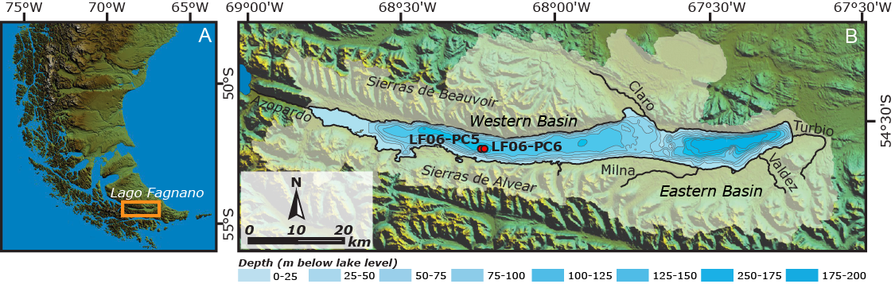
Figure 1: A) Location of Lago Fagnano in Tierra del Fuego. B) The Lago Fagnano watershed (white area) drawn on a SRTM map of the region. The two cores used for this study are marked: LF06-PC5 and LF06-PC6.

Following a two-sequential extraction procedure (Poulton and Canfield 2005), we aim at quantifying the most reactive Fe phases described in Lago Fagnano, i.e., Fe oxyhydroxides and Fe monosulfides (Neugebauer et al. in 2018), and determine their Fe isotope signature. The first leaching, using 1M Na-acetate, is efficient at dissolving carbonates (Tessier et al. 1979; Poulton and Canfield 2005), acid-volatile sulfides (AVS; Cornwell and Morse, 1987; Henkel et al. 2016) and surface-reduced Fe²⁺ (Crosby et al. 2005; Crosby et al. 2007; Henkel et al. 2016).

Since carbonates are absent in Lago Fagnano, we expect the recovery of amorphous Fe monosulfides and, to a lesser extent, adsorbed Fe. For instance, Na-acetate gave complete recovery of AVS from a fine-grained coastal sediment from Young Sound, NE Greenland (Poulton and Canfield, 2005). To confirm this, we tested Na-acetate for the dissolution of 15 mg of pure crystalline Fe²⁺ sulfide (Sigma Aldrich), with only 21% of mineral dissolution. However, Heron et al. (1994) recovered 28% of crystalline FeS by Na-acetate (and full recovery by 0.5M HCl), stating that samples with naturally less stable FeS should yield higher recoveries.

Forty samples from the topmost 40 cm were collected in continuous 1 cm steps on the working half of the core, from the central part of the sedimentary record using cut syringes (ø = 1 cm) in order to avoid contamination from the sides. Samples were weighted in the wet-state (ca. 0.4 g) and directly inserted in Na-acetate (first extraction step) to avoid oxygen exposure and prevent potential oxidation of very redox-sensitive Fe fractions during generally used freeze-dry-grinding steps. Moreover, poorer extraction efficiencies have been reported after freeze-drying, which has been shown to alter the initial chemical speciation contribution of heavy metals, particularly in the exchangeable and carbonate bound fraction (FeS in our case) (Zhang et al. 2001). We calculated the water content and dry weight for each sample. Water content fluctuated around 50% (44-58%) and dry samples around 0.2 g. Duplicates were taken every 10 cm with a third replica close to the liner to constrain the oxidation effect.

A volume of 20 ml of 1 M Na-acetate adjusted to pH 4.5 with acetic acid was used for an average 210 mg of dry sediment. Reaction was performed in 50 ml centrifuge polypropylene tubes and shaken for 24 h at room temperature. After extraction, samples were centrifuged at 1600 g for 6 minutes and the supernatant was filtered through a 0.20 µm nylon/polyethersulfone filter. The precipitate was rinsed with 25 ml milli-Q water that was discarded after a second centrifugation.

The second extraction uses 1M of hydroxylamine-HCl in 25% v/v acetic acid (Chester and Hughes 1967). It is designed for the dissolution of ‘easily reducible’ iron such as amorphous Fe (oxy)hydroxides) (i.e., ferrihydrite and lepidocrocite) (Poulton and Canfield 2005; Henkel et al. 2016). Samples were digested and shaken in 20 ml reagent for 48 hours, at room temperature, and processed in the same way as the first step of the sequential extraction. Previous studies (Poulton and Canfield, 2005; Henkel et al. 2016) demonstrated that Na-acetate (pH 4.5) dissolved less than 2% of the Fe oxyhydroxides in sediments.
Between 10 (Na-acetate) and 50-fold (hydroxylamine-HCl) dilutions with ultra-pure 1% HNO₃ were prepared to measure major and trace elements in leachates using a quadrupole ICP-MS at the University of Geneva, Switzerland. For accuracy, the international TMDA 51.4 standard was measured and replicated three times. The measured Fe (122 µg/L) was within the error of the reference material (118 ± 15 µg/L).

Fe was extracted using ion-exchange chromatography. To avoid any interaction with the reagents and any undesired matrix-induced bias encountered during the measurement of Fe isotope ratios an oxidation routine was previously applied (Henkel et al. 2016). Briefly, the matrix of the different Fe pools was destroyed by oxidation, in a mixture of aqua regia (concentrated HNO₃ and HCl, 1:3) with H₂O₂ following the method developed by Henkel et al. (2016). The process was repeated twice, and the second oxidation included heating at 120°C for 12 hours. Once the matrix is destroyed, a solution of NH₄OH 25% and H₂O₂ was used to recover Fe as hydroxides. The precipitates were rinsed, centrifuged and re-dissolved in 8 N distilled HCl prior the application of ion-exchange chromatography following the method described by Sheng-Ao et al. (2014).

A Bio-Rad AG-MP-1M strong anion exchange resin (100-200 mesh; chloride form) was rinsed 10 times with milli-Q water and adjusted to 2 ml in pre-cleaned Poly-Prep columns (Sheng-Ao et al. 2014). The resin was conditioned with 8 N distilled HCl prior to elution and samples and standards were diluted to match a Fe concentration of around 3.5 mg/L to reach voltages of 35-45 mV. Matrix elements and copper were eluted and discarded with the first 34 ml of 8 N distilled HCl. Iron was recovered with 20 ml of 2 N distilled HCl, evaporated, and re-dissolved in 2% HNO₃ for analysis.

Fe isotope analyses were performed on a Neptune Plus MC-ICP-MS at the University of Geneva, Switzerland. We followed a standard-sample bracketing calibration method using the IRMM-524a international reference material, which has nearly identical values (𝛿⁵⁶Fe = - 0.001 ± 0.013 ‰; Craddock and Dauphas, 2011) to the widely used and discontinued IRMM-014. Fe isotope measurements were performed with standard Ni cones in a medium mass resolution mode. Polyatomic interferences of ⁴⁰Ar¹⁴N, ⁴⁰Ar¹⁶O, ⁴⁰Ar¹⁶O¹H, ⁴⁰Ar¹⁸O with the different Fe isotopes (⁵⁴Fe, ⁵⁶Fe, ⁵⁷Fe, ⁵⁸Fe, respectively) produced intensities below 1 mV, except for ⁴⁰Ar¹⁶O whose intensity was 2-3 mV. Potential interferences of ⁵⁴Cr on ⁵⁴Fe and ⁵⁸Ni on ⁵⁸Fe were monitored at masses ⁵²Cr and ⁶⁰Ni and corrections to Fe isotope ratios were made. Four international standards were measured along with our samples and yielded excellent results, well within the error (Table S1, supplementary material). Fe isotope results are reported relative to the IRMM-524a, using the standard delta notation:
δ ⁵⁶Fe [‰] = [ (⁵⁶Fe/ ⁵⁴Fe_{sample}) / (⁵⁶Fe/ ⁵⁴Fe_{IRMM524a}) -1 ] ^{x} 1000

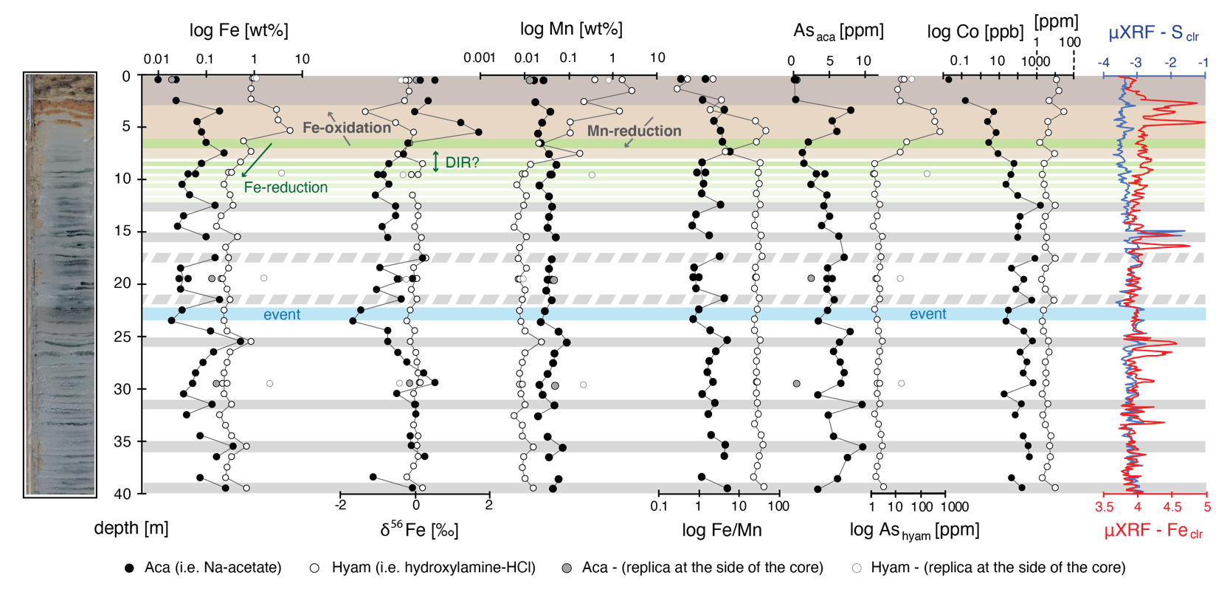
Figure 2: Chemical characterization of the uppermost 40 cm of core LF06-PC6. μXRF profiles of bulk S and Fe given as centered log-ratios (clr) (Neugebauer et al., 2018) and major and trace elements obtained by sequential extraction. Gray bands show redox transitions and solid gray bands likely represent paleo-redox fronts, supported by Fe_{hyam} concentrations peaks and high Fe/Mn ratios. See text for more details.

Results

Fe and Mn concentrations and Fe isotopes
The hydroxylamine-HCl reagent, targeting Fe oxyhydroxides, recovered variable Fe_{hyam} concentrations (averaging 0.63 wt%; Table S1) with maximal abundancies between 3 and 6 cm depth (up to 5.5 wt%). However, concentrations are nearly constant below 10 cm at 0.31 wt% and disrupted by at least 6 peaks of < 0.86 wt% Fe_{hyam} enrichment along the profile (Fig. 2).

In contrast to the hydroxylamine-HCl solution that targets stable Fe phases under oxic conditions, Na-acetate extracts Fe reduced phases (Fe_{aca}) with lower recoveries of 0.10 wt% (Table S1). Eight high Fe concentrations peaks characterizes the Fe_{aca} fraction (up to 0.49 wt%), matching the same horizons of Fe_{hyam} (Fig. 2). The difference in concentration of both fractions is of up to two orders of magnitude at the top 6 cm of the profile with decreasing values with depth and at Fe rich horizons.

The δ⁵⁶Fe_{hyam} values are generally stable (-0.03‰), except between 4 and 5 cm depth, with values reaching -1.3 ‰ (Fig. 2). The δ⁵⁶Fe_{aca} values (-0.29‰) are more variable along the profile and oscillate between -1.6‰ and +1.7‰. Below 8 cm sediment depth, both fractions positively correlate (R² = 0.50; Fig. 3).

Even though the sequential extraction protocol is designed for Fe phases, Mn minerals are dissolved as well. In the upper 8 cm, Mn_{hyam} reaches much higher and variable concentrations (0.80 wt%) than under that level (104 mg/L; Fig. 2). Conversely, Mn_{aca} concentrations are low and relatively constant along the profile (387 mg/L). From the SWI until 6 cm depth, Fe_{hyam}/Mn_{hyam} ratios progressively increase with depth (Fig. 2). Between 6 and 8 cm these ratios decrease, before reaching an average value of ca. 29.1 until the bottom of the core. Fe_{aca}/Mn_{aca} values (averaging 2.3) show a similar profile (Fig. 2) and are generally one or two order of magnitudes lower than Fe_{hyam}/Mn_{hyam}. Additionally, high Fe/Mn are associated with Fe rich peaks.

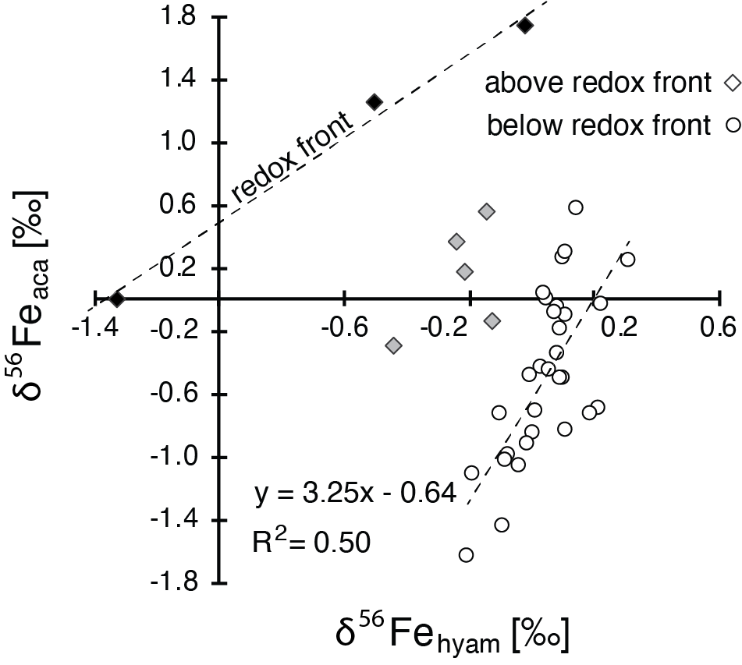

Figure 3: Fe isotopes measured above and below 8 cm depth (diamonds and circles, respectively) showing different correlation between the reduced and oxidized Fe phases (Fe_{aca} and Fe_{hyam}, respectively). Between 4 and 6 cm (black diamonds), the positive relation between both Fe pools are linked to the consumption of dissolved Fe during its oxidation. Below 8 cm, δ⁵⁶Fe_{aca} dispersion and low δ⁵⁶Fe_{hyam} suggest two end-members. Negative δ⁵⁶Fe_{aca} are typical of pore waters with a high amount of dissolved Fe (likely resulting from reducing conditions). Near zero values suggest low Fe reduction or near complete precipitation of dissolved Fe as reduced Fe phases.

Trace elements in the Na-acetate fraction
Many major and trace elements recovered with Na-acetate are relatively low in the topmost 8 cm. Elements such as As (averaging 4.9 mg/L), Co (200 mg/L), Sb (22 µg/L) and Ni (26 µg/L) increase with depth at different extents and positively relate with the reduced Fe_{aca} fraction (Fig. 2 and Fig. S1, supplementary material), especially where Fe_{aca} values peak. However, some elements such as Mn (averaging 387 mg/L; Fig. 2), Al (166 mg/L), Cu (17 µg/L) and Ba (1.5 mg/L) do not show major variations throughout the core stratigraphy (Table S1).

Trace elements in the hydroxylamine-HCl fraction
Besides Fe and Mn (previously discussed), many of the acquired trace elements in the hydroxylamine-HCl fraction show high concentrations (namely, As: 200 mg/L, V: 4.4 mg/L, and Ba: 38 mg/L; Table S1), especially at the topmost 8 cm. As_{hyam} concentrations are the highest (up to 412 mg/L) occurring in parallel with the same interval of the highest measured Fe_{hyam} values (Fig. 2). While As_{hyam} abruptly decreases below 8 cm, Sb and V concentrations slightly and progressively decrease with depth (Fig. S1). Among the measured trace elements, only Mg (averaging 260 mg/L) and Zn (72 mg/L) have lower values at the top of the profile, while Zn shows a peak (158 mg/L) between 15 and 16 cm, depth at which elevated S was detected by high-resolution XRF scanning (Fig. S1). Elements commonly associated with detrital fractions (Al and Ti) as well as Ni, Co, Cr, Cu and V do not show major stratigraphic variations in the hydroxylamine-HCl fraction (Table S1).

Na-acetate and hydroxylamine-HCl leaching tests
Replicas close to the border of the core were retrieved every 10 cm to constrain post-coring oxidation effects in both fractions (Fig. 2). Any variation between replicas can be identified at the top of the core (0-1 cm). Below 10, 20 and 30 cm depth, Fe_{aca} and especially Fe_{hyam} values are much higher than at the center (Table S1). Fe_{hyam} oscillate between 1.6 wt% and 4 wt% and Fe_{aca} results in percentages of ca. 0.15 wt%. Likewise, Mn_{hyam} concentrations at the border are multiplied by 3. Conversely, there is no chemical variation between replicas in the Na-acetate fraction targeting reduced Mn (Mn_{aca}). Regarding trace elements, they are lower at the borders in the Na-acetate leaching (As_{aca}, Ni_{aca}, Sb_{aca}; Fig. 2). The opposite generally applies with hydroxylamine-HCl (As_{hyam}, Sb_{hyam}), suggesting post-coring oxidation only at the borders and preservation of the diagenetic signal at the center of the core.

Discussion

The sequential extraction
The hydroxylamine-HCl leaching efficiently dissolved and recovered Fe³⁺ (Fe_{hyam}) and Mn⁴⁺ (Mn_{hyam}) oxides. Indeed, concentrations of both elements are the highest just below the SWI and decrease considerably afterwards, suggesting the presence of a redox boundary between 5 and 8 cm depth responsible for dissolved metal oxidation. Additionally, test extractions from samples at the sides of the core, more likely to be in contact with oxygen (i.e., richer in Fe oxides), yielded higher element concentrations than replicas at the center of the core. It converges with a good preservation of reduced conditions in the targeted sediments of the core.

Concentrations of Mg_{hyam} (averaging 260 mg/L) – not expected along Fe oxyhydroxides dissolution – and Zn_{hyam} (72 mg/L) are relatively high throughout the anoxic sediments. Clay minerals such as illite can be at the origin of high Mg_{hyam} concentrations, whose dissolution has already been proven with the hydroxylamine-HCl solution (Chester and Hughes 1967). The Zn_{hyam} concentration peak at 15-16 cm matches that of bulk sulfur (obtained by μXRF; Fig. S1). If Zn can be a trace element in sulfides, the recovery of Zn along ferric oxyhydroxides is not consistent with the dissolution of Fe monosulfides, specially recovered with Na-acetate. Alternatively, Zn can be sorbed on binding sites of Fe oxyhydroxides and organic matter (Mertens and Smolders 2013). Other trace elements acquired with the hydroxylamine-HCl leaching average less than 20 mg/L (Table S1) and variations of lithogenic elements such as Al and Ti throughout the core are low. Indeed, while Fe oxyhydroxides can form at the redox boundary, Fe concentrations (ca. 1 wt%) in the first 3 cm of sediment are rather an evidence of the input of detrital and mostly unreactive Fe, Al and Ti phases. Therefore, a detrital component of ca. 1 wt% Fe can be expected in Lago Fagnano sediments.

The Fe_{aca} fraction, obtained by leaching the sediments with Na-acetate, includes acid-volatile sulfides (Cornwell and Morse 1987; Henkel et al. 2016) and surface-reduced Fe²⁺ (Crosby, 2005, Crosby 2007; Henkel et al. 2016). Accordingly, the Fe_{aca} is low at the top of the core and more abundant below the redox boundary, where Fe²⁺ is more stable. While, the reagent is very efficient at dissolving carbonates (Tessier et al. 1979; Poulton and Canfield 2005), these are absent in Fagnano sediments.

Moreover, average concentrations of Fe_{aca} (965 mg/L) might not only result from the leaching of Fe²⁺ phases. As with hydroxylamine-HCl, Na-acetate leaching tests at the oxidized borders of the core recovered much more Fe_{aca} than at the center. Thus, Na-acetate is able to dissolve Fe minerals with different oxidation states and Fe³⁺ and/or mixed-valence oxides should as well be considered as part of the Fe_{aca} fraction. A similar situation is shown by arsenic (As). For instance, Na-acetate recovered relatively abundant As_{aca} in the oxic part (3-6 cm) that can be associated with a Fe³⁺ bounded fraction, plus a likely reduced diagenetic fraction between 8 and 40 cm, increasing with depth.

The production of reduced phases during early diagenesis can be inferred from the regular increase of As_{aca}, Co_{aca}, Ni_{aca} and Sb_{aca} with depth and at Fe rich horizons (Fig. 2 and Fig. S1). These are common traces elements in Fe sulfides (Huerta-Diaz and Morse 1992; Huerta-Diaz et al. 1998). Diagenetic minerals might have a substantial contribution to the Fe_{aca} fraction, especially considering the absence of past water column stratification (Neugebauer et al. 2018) that could provide an explanation for the formation of these reduced Fe phases in the open water.

If Na-acetate could recover divalent Fe phases, there is no evidence that Mn⁴⁺ phases integrate the Mn_{aca} fraction since Mn_{aca} recoveries (averaging 387 mg/L) are generally similar, whether samples are at the center, sides or top of the core. Therefore, Mn_{aca} can be associated with Mn²⁺ oxides and Mn_{hyam} with Mn⁴⁺ oxides. In summary, hydroxylamine-HCl efficiently reduced Fe³⁺ and Mn⁴⁺ fractions. In contrast, Na-acetate recovered Mn²⁺ phases and may have integrated both Fe²⁺ and Fe³⁺, likely under the form of adsorbed iron, Fe sulfides and amorphous divalent oxides and clays.

The active redox front
Under reducing conditions, Mn is more soluble than Fe (Davison 1993; Burdige 1993) and therefore, Mn and Fe/Mn ratios can be used to determine the onset of sedimentary anaerobic conditions as a result of oxygen depletion (Schaller et al. 1997). Mn_{hyam} concentrations vary with ca. three orders of magnitude within the top 8 cm, with the highest values at the SWI (Fig. 4), which agrees with the diagenetic reduction of substantial Mn⁴⁺ oxides. Moreover, very low Fe/Mn (in both oxidized and reduced fractions) occurring within the top 4 cm and overlying a nearly-progressive increase until 8 cm is a clear evidence for the transition of Mn to Fe oxidation and that Fe²⁺_{aq} oxidation couple with MnO₂ reduction fronts (Dellwig et al. 2010; Song et al. 2011). This is particularly obvious between 6 and 8 cm, where low availability of Mn⁴⁺ phases (Mn_{hyam}) can be tied to low contents of Fe oxyhydroxides (Fe_{hyam}; Fig. 4A).
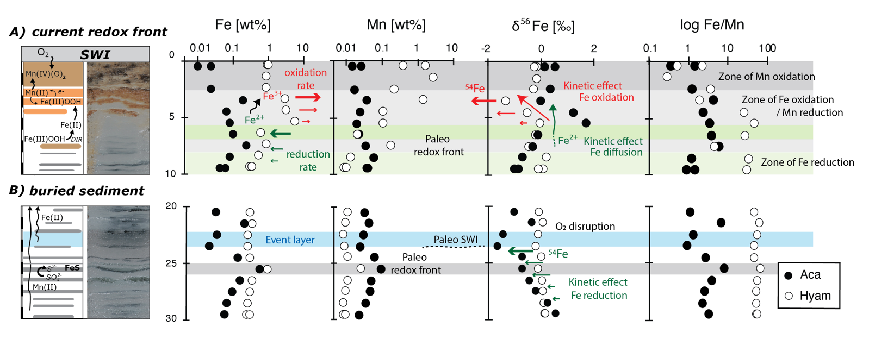
Figure 4: Solid circles refer to the Na-acetate extraction (aca) whereas open circles to hydroxylamine-HCl. (A) Active redox front: From the sediment-water interface down to 3 cm depth, high contents of Mn_{hyam} indicate oxidation of Mn²⁺. Between 3 and 4 cm, Fe oxides (Fe_{hyam}) with very low δ⁵⁶Fe agree with kinetic fractionation likely as a result of high precipitation rates. Between 5 and 6 cm, much higher amounts of Fe (oxy)hydroxides with near zero δ⁵⁶Fe values possibly indicate near quantitative oxidation of aqueous Fe, attaining near equilibrium conditions. The decrease in the Mn_{hyam} fraction suggests that Fe oxidation is coupled to Mn-reduction. Most of Fe reduction occurs below 8 cm depth. (B) Buried redox front: High amounts of Fe (oxy)hydroxides below 25 cm covered by a turbiditic event suggests the preservation of a redox front. The partial reduction of ferric phases generates light Fe²⁺_{aq} which following O₂ disruption relocates in the Fe_{aca} fraction (e.g., adsorbed Fe²⁺, amorphous Fe monosulfides and Fe oxides).

The main Fe oxidation zone (3-6 cm) is characterized by high Fe_{hyam} (3 to 5.5 wt%) and significant δ⁵⁶Fe_{hyam} variability. The δ⁵⁶Fe_{hyam} is maximal (0‰) at the base of the oxidation zone (5-6 cm) and minimal (-1.3‰) at the top (3-4 cm) (Fig. 4A). The same feature appears at other similar lacustrine systems, such as at the redox boundary of Lake Kutsasjarvi (Sweden) where Fe oxidation occurs between 8 and 11 cm below the SWI (Malinovsky et al. 2005). In that study, Fe oxides at 11 cm depth constitute more than 69% of the bulk fraction and have a δ⁵⁶Fe of +0.2‰, while at 9 cm Fe oxides decrease to 32% of the bulk Fe and their δ⁵⁶Fe get as low as -0.8‰.

Low isotope values in Fe oxides and Fe oxyhydroxides have been widely studied and are the result of a two-step process. First, the oxidation of Fe²⁺_{aq} to Fe³⁺_{aq} under equilibrium conditions ($∆$^{56/54}Fe _{Fe}³⁺_{aq –} _{Fe}²⁺_{aq}) fractionate iron up to 3 ‰ (Johnson et al. 2002; Crosby et al. 2005). Later, the formation of Fe oxyhydroxides follows an equilibrium or kinetic fractionation depending on the precipitation rates of Fe³⁺_{aq}. Low rates result in $∆$^{56/54}Fe _{hematite –} _{Fe}³⁺_{aq} of 0.10‰ ± 0.20‰ whereas high rates reach a fractionation of -1.32‰ ± 0.12‰ (Skulan et al. 2002). At the end, the whole process generally results in Fe³⁺ minerals with positive δ⁵⁶Fe, between 1 and 2‰ higher than Fe²⁺_{aq} as already confirmed by several studies in natural systems (Bullen et al. 2001; Severmann et al. 2006; Staubwasser et al. 2013). However, the Fe_{hyam} fraction measured in this study and targeting Fe oxyhydroxides, reaches negative δ⁵⁶Fe values. Other studies described the formation of authigenic Fe oxyhydroxides with negative δ⁵⁶Fe as a consequence of strong kinetics during mineral precipitation (Skulan et al. 2002; Staubwasser et al. 2013) or the persistent recycling of Fe following a chain of redox processes (Song et al. 2011).

Different scenarios can explain the bottom-up decrease in Fe_{hyam} and δ⁵⁶Fe_{hyam} in the active redox front of Lago Fagnano (and lake Kutsasjarvi, Malinovsky et al. 2005). These features likely require oxidation of Fe²⁺_{aq} transported from below via pore water diffusion (Davison 1993; Torres et al. 2014). Vertical chemical variability can be first explained via a Rayleigh distillation effect. Oxidation dynamics below the SWI is different than in stratified water-columns in which Fe oxyhydroxides can form below the chemocline and are removed by decantation (Busigny et al. 2014). In ferruginous sediments, bottom-up diffused pore-water is charged in Fe²⁺_{aq}. Eventually, it meets the redox front and Fe oxyhydroxides with high δ⁵⁶Fe can form (Bullen et al. 2001; Balci et al. 2006). Once oxidants are consumed, the Fe²⁺_{aq} in excess, enriched in the light isotope, continues its upwards diffusion and oxidizes with a lower isotopic signature. Molecular diffusion can have a substantial kinetic effect in the fractionation of iron at this scale (LaBolle et al. 2008; Staubwasser et al. 2013; Druhan et al. 2019), which might trigger faster diffusion in the light Fe isotopes at the top of the oxidation zone.

Alternatively, isotope variability could result from different precipitation rates of Fe oxyhydroxides, likely controlled by the concentration of Fe²⁺_{aq}, the availability of Mn oxides as electron acceptors (Och et al. 2012) and/or the partial pressure of oxygen (Bullen et al. 2001). High precipitation rates between 3-4 cm sediment depth agree with a kinetic Fe fractionation (Skulan et al. 2002; Staubwasser et al. 2013) triggering negative δ⁵⁶Fe_{hyam} values. Conversely, lower rates at 5-6 cm sediment depth might approach equilibrium conditions in which δ⁵⁶Fe_{hyam} reflects only an equilibrium fractionation component (Crosby et al. 2005; Crosby et al. 2007). The δ⁵⁶Fe_{aca} profile in the active redox front, although similar to δ⁵⁶Fe_{hyam}, is shifted towards positive values. Considering a mass balance dominated by the Fe_{hyam} fraction, the δ⁵⁶Fe_{aca} values are controlled by the formation of Fe oxyhydroxides at the oxic-anoxic boundary.

If the active redox front at the topmost 8 cm reveals Fe and Mn oxidation, redox processes are likely active at least down to 12 cm. Although between 6 and 7 cm there is a sharp decrease of Fe_{hyam} and an increase of δ⁵⁶Fe_{hyam} (Fig. 4A), it is between 8 and 12 cm that Fe_{hyam} and Mn_{hyam} concentrations decrease considerably. Likewise, there is fractionation between Fe_{aca} and Fe_{hyam} in this range. These features are consistent with DIR processes, promoting higher δ⁵⁶Fe in the solid phases and the production of Fe²⁺ with negative δ⁵⁶Fe (Crosby et al. 2005, 2007), At this stage, the formation of Fe²⁺ minerals and/or adsorption of Fe_{aq} could be expected. However, the scarcity of reduced Fe phases (i.e., Fe_{aca}) with negative δ⁵⁶Fe are evidence for Fe²⁺_{aq} recycling towards the oxidation zone (Fig. 4A). Alternatively, the production of sulfides via sulfate reduction could have enhanced the dissolution of ferric phases (Berner 1970). However, sulfate contents in Lago Fagnano are low and this process might be much more important below the active redox front, where partial pyritization during early diagenesis has been previously suggested (Neugebauer et al. 2018).

Paleo redox fronts
Dark green laminae in Lago Fagnano sediments are thin layers (1-2 mm) rich in Fe oxyhydroxides and have been suggested to represent paleo redox fronts (Neugebauer et al. 2018), similar to those described in other settings (Granina et al. 2004; Och et al. 2012; Torres et al. 2014). A very likely mechanism responsible for the preservation of redox fronts is the increase of sedimentation rates (Granina et al. 2004), here suggested to be triggered by fast turbiditic deposition and probably seasonal changes of run-off water flows (Neugebauer et al. 2018). This would increase the diffusive pathway between oxygen and reduced aqueous phases within sediments.

Black laminae are thinner layers enriched in Fe sulfides and other trace metals due to reducing conditions and partial diagenetic pyritization. They occur below the redox front and at a higher frequency. The sampling resolution in this study (1 cm) and the narrower thickness of black laminae (< ca. 1 cm) does not allow to distinguish geochemical variations between them. However, eight horizons suggest redox changes (i.e., high Fe_{aca}/Mn_{aca}) and six of them present a higher content of oxidized Fe phases (Fe_{hyam}) and Mn oxides (Mn_{hyam}) (Fig. 2), suggesting that at least six horizons constitute paleo redox fronts. These peaks are as well consistent with the high resolution µXRF profile of bulk Fe (Fig. 2). Since a decrease in the Fe_{hyam} fraction is not observed below 13 cm, Fe reduction of this fraction should not be a major diagenetic process in the anoxic sediments. Moreover, given the low δ⁵⁶Fe variability, DIR can as well be excluded as a major pathway for Fe_{hyam} reduction (Crosby et al. 2005).

Conversely, at the trace element scale, diagenetic remobilization of elements and the production of authigenic Fe phases can be deduced from relatively high Fe_{aca} values at Fe rich horizons (Fig. 2). For instance, while some trace elements such as Sb and V in the hydroxylamine-HCl fraction decrease diagenetically, Sb, V, As and Co in the Na-acetate fraction concentrate at depths and at Fe rich horizons (Fig. S1). In addition, trace elements like As, Co and Ni support the production of diagenetic phases such as Fe monosulfides, as already reported in these (Neugebauer et al. 2018) and other sediments (Huerta-Diaz and Morse 1992; Huerta-Diaz et al. 1998). In particular, partial pyritization has been inferred from As enrichment in association with turbiditic events (Fig. 4B), which appear to still contain ferric phases or patches of Mn oxides scattered along the anoxic sediments (Neugebauer et al. in 2018).

Although the relationship between dark laminae and the increase of sedimentation rates as a burial mechanism of redox fronts cannot be established in this study, the deposition of turbiditic events constitutes itself a clear trigger of redox front preservation. A turbidite layer, detected between 22 and 24 cm depth lies above a Fe and Mn rich horizon at 25-26 cm depth (Fig. 4B). Moreover, the isotopic trend in the reduced fraction (Fe_{aca}) at the paleo redox front mirrors that of the oxidized fraction (Fe_{hyam}) at the active redox front (i.e., a bottom up enrichment in the light isotope). This suggests that the isotopically light Fe²⁺_{aq} resulting from DIR is preserved from degradation by oxidation following the turbiditic event that disrupts the oxygen flux and perpetuates anoxic conditions. As a consequence, Fe cycling is altered and reduced Fe phases with negative δ⁵⁶Fe can develop instead of Fe oxyhydroxides. This isotopic pattern is not visible in other paleo redox fronts in which an increase of the sedimentation rate, although higher than usual, might not be enough to avoid oxidation of redox sensitive elements.

Fe isotopes and Lago Fagnano sedimentary Fe cycle
The sedimentary profile of Lago Fagnano shows strong chemical differences and, according to the trends defined by the Fe_{hyam} fraction, the δ⁵⁶Fe_{hyam} and Fe/Mn ratios, it can be subdivided in two sections. The upper 8 cm of the profile clearly illustrate chemical variations likely resulting from redox processes taking place in a redox boundary below the SWI. This agrees with the presence of an active redox front within the sediments and the well oxygenated bottom waters reported in Neugebauer et al. (2018). The following 32 cm show a more homogenous chemical profile regularly disrupted by Fe and Fe/Mn peaks agreeing with Fe enrichment, in both of the Fe pools. Moreover, it has been suggested that Fe rich horizons are paleoredox fronts, preserved through changes in the sedimentation rates (Neugebauer et al. 2018).

Fe isotopes reveal at least three mobilizing iron processes. Consistent values of Fe_{hyam} at near zero appear above 3 cm and below 8 cm, associated with less reactive and allochthonous Fe phases. Within the redox front (3-8 cm), where Fe oxidation occurs, the few δ⁵⁶Fe_{hyam} and δ⁵⁶Fe_{aca} values relate positively and suggest equilibrium between Fe oxyhydroxides and Fe²⁺ phases (Fig. 3). Below 8 cm δ⁵⁶Fe_{aca} values are highly dispersed (Fig. 3) and show two main Fe components. Negative δ⁵⁶Fe_{aca} suggest pore waters with a high amount of dissolved iron, likely resulting from reducing conditions. Close to zero, such values suggest low Fe reduction or near complete precipitation of dissolved Fe as reduced Fe phases.

Conclusions
Fe speciation and Fe isotopes reveal the dynamics of the redox cascade in Lago Fagnano and give insights on the active mechanisms in redox boundaries in lacustrine sediments. We were able to disentangle such processes at an active redox front and found a reasonable explanation to the nearly absent mid-term preservation of Fe reduction signatures.
The Fe cycling model comprises two steps:
- in a stable ventilated Lake Fagnano, reduced light iron isotopes diffuse upward and oxidize at the SWI producing δ⁵⁶Fe values down to -1.3‰, at the top of the redox front.
- newly formed Fe oxyhydroxides are further reduced as sedimentation carries on at constant rates, resolubilizing light iron isotopes. If the sedimentation rate is constant the redox front continuously migrates upwards. However, a considerable increase of the sedimentation rate (e.g., turbiditic event) allow the preservation of a redox front and its light δ⁵⁶Fe signature.

Considering the sampling resolution of this study, at least eight paleo redox fronts could be identified in a 40 cm core thanks to their high content of bulk Fe and the Fe_{aca}/Mn_{aca} relating Fe²⁺ and Mn²⁺. it is only after an abrupt change in the sedimentation rate that Fe isotopes can be used as a proxy for paleo redox fronts. The Fe_{aca} profile, their wide range of Fe isotopes (3‰) and trace elements such as As indicate diagenetic cycling. Moreover, the production of authigenic phases, such as Fe monosulfides, can be inferred from the high Fe_{aca} concentration peaks associated with Co and Ni. These findings confirm Fe redistribution during early diagenesis and questions the isotopic record of redox processes in a long term, in situations in which sedimentation rates are constant.

Acknowledgments
The recovery of the sedimentary cores was funded by the SNF Project 200021-100668 to DA. The analytical expenses were covered through the European Union's Horizon 2020 research and innovation programme under the Marie Skłodowska-Curie grant agreement 706244 to IN, and the SNSF Project 200021-166308 to DA. The Geneva-based Foundation Ernest Boninchi provided additional funds to DA to accomplish LO thesis research.

Bibliography
Anbar, A. D., J. E. Roe, J. Barling, and K. H. Nealson. 2000. Nonbiological fractionation of iron isotopes. Science (80-. ). 288: 126–128. doi:10.1126/science.288.5463.126
Balci, N., T. D. Bullen, K. Witte-Lien, W. C. Shanks, M. Motelica, and K. W. Mandernack. 2006. Iron isotope fractionation during microbially stimulated Fe(II) oxidation and Fe(III) precipitation. Geochim. Cosmochim. Acta 70: 622–639. doi:10.1016/j.gca.2005.09.025
Beard, B. L., and C. M. Johnson. 2004. Ancient Earth and Other Planetary Bodies. Rev. Mineral. Geochemistry 55: 319–357.
Berner, R. A. 1970. Sedimentary pyrite formation. Am. J. Sci. 268: 1–23.
Bradley, R. S. 1999. Paleoclimatology: reconstructing climates of the Quaternary, Elsevier.
Bullen, T. D., A. F. White, C. W. Childs, and M. S. Schulz. 2001. Demonstration of significant abiotic iron isotope fractionation in nature. 699–702.
Burdige, D. J. 1993. The biogeochemistry of manganese and iron reduction in marine sediments. Earth-Science Rev. 35: 249–284. doi:10.1016/0012-8252(93)90040-E
Busigny, V., N. J. Planavsky, D. Jézéquel, S. Crowe, P. Louvat, J. Moureau, E. Viollier, and T. W. Lyons. 2014. Iron isotopes in an Archean ocean analogue. Geochim. Cosmochim. Acta 133: 443–462. doi:10.1016/j.gca.2014.03.004
Chester, R., and M. J. Hughes. 1967. A chemical technique for the separation of ferro-manganese minerals, carbonate minerals and adsorbed trace elements from pelagic sediments. Chem. Geol. 2: 249–262.
Cornwell, J. C., and J. W. Morse. 1987. The characterization of iron sulfide minerals in anoxic marine sediments. Mar. Chem. 22: 193–206.
Craddock, P. R., and N. Dauphas. 2011. Iron Isotopic Compositions of Geological Reference Materials and Chondrites. Geostand. Geoanalytical Res. 35: 101–123. doi:10.1111/j.1751-908X.2010.00085.x
Crosby, H. A., E. E. Roden, C. M. Johnson, and B. L. Beard. 2007. The mechanisms of iron isotope fractionation produced during dissimilatory Fe(III) reduction by Shewanella putrefaciens and Geobacter sulfurreducens. Geobiology 5: 169–189. doi:10.1111/j.1472-4669.2007.00103.x
Crosby, H. a, C. M. Johnson, E. E. Roden, and B. L. Beard. 2005. Coupled Fe ( II ) -Fe ( III ) Electron and Atom Exchange as a Mechanism for Fe Isotope Fractionation during Dissimilatory Iron Oxide Reduction. Environ. Sci. Technol. 39: 6698–6704.
Davison, W. 1993. Iron and manganese in lakes. Earth-Science Rev. 34: 119–163. doi:10.1016/0012-8252(93)90029-7
Dellwig, O., T. Leipe, C. März, and others. 2010. A new particulate Mn-Fe-P-shuttle at the redoxcline of anoxic basins. Geochim. Cosmochim. Acta 74: 7100–7115. doi:10.1016/j.gca.2010.09.017
Druhan, J. L., M. J. Winnick, and M. Thullner. 2019. Stable Isotope Fractionation by Transport and Transformation. Rev. Mineral. Geochemistry 85: 239–264.
Granina, L., B. Müller, and B. Wehrli. 2004. Origin and dynamics of Fe and Mn sedimentary layers in Lake Baikal. Chem. Geol. 205: 55–72. doi:10.1016/j.chemgeo.2003.12.018
Henkel, S., S. Kasten, S. W. Poulton, and M. Staubwasser. 2016. Determination of the stable iron isotopic composition of sequentially leached iron phases in marine sediments. Chem. Geol. 421: 93–102. doi:10.1016/j.chemgeo.2015.12.003
Heron, G., C. Crouzet, A. C. M. Bourg, and T. H. Christensen. 1994. Speciation of Fe (II) and Fe (III) in contaminated aquifer sediments using chemical extraction techniques. Environ. Sci. Technol. 28: 1698–1705.
Huerta-Diaz, M. A., and J. W. Morse. 1992. Pyritization of trace metals in anoxic marine sediments. Geochim. Cosmochim. Acta 56: 2681–2702. doi:10.1016/0016-7037(92)90353-K
Huerta-Diaz, M. A., A. Tessier, and R. Carignan. 1998. Geochemistry of trace metals associated with reduced sulfur in freshwater sediments. Appl. Geochemistry 13: 213–233. doi:10.1016/S0883-2927(97)00060-7
Johnson, C. M., B. L. Beard, N. J. Beukes, C. Klein, and J. M. O’Leary. 2003. Ancient geochemical cycling in the Earth as inferred from Fe isotope studies of banded iron formations from the Transvaal Craton. Contrib. to Mineral. Petrol. 144: 523–547. doi:10.1007/s00410-002-0418-x
Johnson, C. M., B. L. Beard, and E. E. Roden. 2008. The Iron Isotope Fingerprints of Redox and Biogeochemical Cycling in Modern and Ancient Earth. Annu. Rev. Earth Planet. Sci. 36: 457–493. doi:10.1146/annurev.earth.36.031207.124139
Johnson, C. M., B. L. Beard, E. E. Roden, D. K. Newman, and K. H. Nealson. 2004. Isotopic Constraints on Biogeochemical Cycling of Fe. Rev. Mineral. Geochemistry 55: 359–408. doi:10.2138/gsrmg.55.1.359
Johnson, C. M., J. L. Skulan, B. L. Beard, H. Sun, K. H. Nealson, and P. S. Braterman. 2002. Isotopic fractionation between Fe(III) and Fe(II) in aqueous solutions. Earth Planet. Sci. Lett. 195: 141–153.
LaBolle, E. M., G. E. Fogg, J. B. Eweis, J. Gravner, and D. G. Leaist. 2008. Isotopic fractionation by diffusion in groundwater. Water Resour. Res. 44: 1–15. doi:10.1029/2006WR005264
Liu, K., L. Wu, R. M. Couture, W. Li, and P. Van Cappellen. 2015. Iron isotope fractionation in sediments of an oligotrophic freshwater lake. Earth Planet. Sci. Lett. 423: 164–172. doi:10.1016/j.epsl.2015.05.010
Lyons, T. W., and S. Severmann. 2006. A critical look at iron paleoredox proxies: New insights from modern euxinic marine basins. Geochim. Cosmochim. Acta 70: 5698–5722. doi:10.1016/j.gca.2006.08.021
Malinovsky, D. N., I. V Rodyushkin, E. P. Shcherbakova, C. Ponter, B. Ohlander, and J. Ingri. 2005. Fractionation of Fe isotopes as a result of redox processes in a basin. Geochemistry Int. 43: 797–803.
McCoy, V. E., D. Asael, and N. Planavsky. 2017. Benthic iron cycling in a high-oxygen environment: Implications for interpreting the Archean sedimentary iron isotope record. Geobiology 15: 619–627. doi:10.1111/gbi.12247
Mertens, J., and E. Smolders. 2013. Zinc BT - Heavy Metals in Soils: Trace Metals and Metalloids in Soils and their Bioavailability, p. 465–493. In B.J. Alloway [ed.]. Springer Netherlands.
Moy, C. M., R. B. Dunbar, T. P. Guilderson, and others. 2011. A geochemical and sedimentary record of high southern latitude Holocene climate evolution from Lago Fagnano, Tierra del Fuego. Earth Planet. Sci. Lett. 302: 1–13. doi:10.1016/j.epsl.2010.11.011
Neugebauer, I., C. Thomas, L. Ordoñez, N. Waldmann, C. Recasens, and D. Ariztegui. 2018. Cyclic preservation of Fe/Mn-redox fronts in sediments of an oligotrophic, ventilated deep-water lake (Lago Fagnano, Tierra del Fuego). EarthArXiv 1–41.
Och, L. M., B. Müller, A. Voegelin, and others. 2012. New insights into the formation and burial of Fe/Mn accumulations in Lake Baikal sediments. Chem. Geol. 330–331: 244–259. doi:10.1016/j.chemgeo.2012.09.011
Percak-Dennett, E. M., J. L. Loizeau, B. L. Beard, C. M. Johnson, and E. E. Roden. 2013. Iron isotope geochemistry of biogenic magnetite-bearing sediments from the bay of vidy, lake geneva. Chem. Geol. 360–361: 32–40. doi:10.1016/j.chemgeo.2013.10.008
Poulton, S. W., and D. E. Canfield. 2005. Development of a sequential extraction procedure for iron: Implications for iron partitioning in continentally derived particulates. Chem. Geol. 214: 209–221. doi:10.1016/j.chemgeo.2004.09.003
Reinhard, C. T., T. W. Lyons, O. Rouxel, D. Asael, N. Dauphas, and L. R. Kump. 2013. Iron speciation and isotope perspectives on Palaeoproterozoic water column chemistry, p. 1483–1492. In Reading the Archive of Earth’s Oxygenation-Volume 3: Global Events and the Fennoscandian Arctic Russia-Drilling Early Earth Project. Frontiers.
Schaller, T., H. C. Moor, and B. Wehrli. 1997. Sedimentary profiles of Fe, Mn, V, Cr, As and Mo as indicators of benthic redox conditions in Baldeggersee. Aquat. Sci. 59: 345–361. doi:10.1007/BF02522363
Severmann, S., C. M. Johnson, B. L. Beard, and J. McManus. 2006. The effect of early diagenesis on the Fe isotope compositions of porewaters and authigenic minerals in continental margin sediments. Geochim. Cosmochim. Acta 70: 2006–2022. doi:10.1016/j.gca.2006.01.007
Sheng-Ao, L., L. Dandan, L. Shuguang, T. Fang-Zhen, K. Shan, H. Yongsheng, and L. Yinghuai. 2014. High-precision copper and iron isotope analysis of igneous rock standards by MC-ICP-MS. 122–133. doi:10.1039/c3ja50232e
Skulan, J. L., B. L. Beard, and C. M. Johnson. 2002. Kinetic and equilibrium Fe isotope fractionation between aqueous Fe(III) and hematite. Geochim. Cosmochim. Acta. doi:10.1016/S0016-7037(02)00902-X
Song, L., C. Q. Liu, Z. L. Wang, X. Zhu, Y. Teng, L. Liang, S. Tang, and J. Li. 2011. Iron isotope fractionation during biogeochemical cycle: Information from suspended particulate matter (SPM) in Aha Lake and its tributaries, Guizhou, China. Chem. Geol. 280: 170–179. doi:10.1016/j.chemgeo.2010.11.006
Staubwasser, M., R. Schoenberg, F. Von Blanckenburg, S. Krüger, and C. Pohl. 2013. Isotope fractionation between dissolved and suspended particulate Fe in the oxic and anoxic water column of the Baltic Sea. Biogeosciences 10. doi:10.5194/bg-10-233-2013
Tessier, a, P. G. C. Campbell, and M. Bisson. 1979. Sequential Extraction Procedure for the Speciation of Particulate Trace Metals. Anal. Chem. 51: 844–851. doi:10.1021/ac50043a017
Teutsch, N., M. Schmid, B. Müller, A. N. Halliday, H. Bürgmann, and B. Wehrli. 2009. Large iron isotope fractionation at the oxic-anoxic boundary in Lake Nyos. Earth Planet. Sci. Lett. 285: 52–60. doi:10.1016/j.epsl.2009.05.044
Torres, N. T., L. M. Och, P. C. Hauser, and others. 2014. Early diagenetic processes generate iron and manganese oxide layers in the sediments of Lake Baikal, Siberia. Environ. Sci. Process. Impacts 16: 879–889. doi:10.1039/c3em00676j
Waldmann, N., F. S. Anselmetti, D. Ariztegui, J. A. Austin Jr, M. Pirouz, C. M. Moy, and R. Dunbar. 2011. Holocene mass‐wasting events in Lago Fagnano, Tierra del Fuego (54°S): implications for paleoseismicity of the Magallanes‐Fagnano transform fault. Basin Res. 23: 171–190. doi:https://doi.org/10.1111/j.1365-2117.2010.00489.x
Waldmann, N., A. M. Borromei, C. Recasens, and others. 2014. Integrated reconstruction of Holocene millennial-scale environmental changes in Tierra del Fuego, southernmost South America. Palaeogeogr. Palaeoclimatol. Palaeoecol. 399: 294–309. doi:10.1016/J.PALAEO.2014.01.023
Zachara, J. M., R. K. Kukkadapu, J. K. Fredrickson, Y. a. Gorby, and S. C. Smith. 2002. Biomineralization of Poorly Crystalline Fe(III) Oxides by Dissimilatory Metal Reducing Bacteria (DMRB). Geomicrobiol. J. 19: 179–207. doi:10.1080/01490450252864271
Zhang, C. L., J. Horita, D. R. Cole, J. Zhou, D. R. Lovley, and T. J. Phelps. 2001. Temperature-dependent oxygen and carbon isotope fractionations of biogenic siderite. Geochim. Cosmochim. Acta 65: 2257–2271. doi:10.1016/S0016-7037(01)00596-8

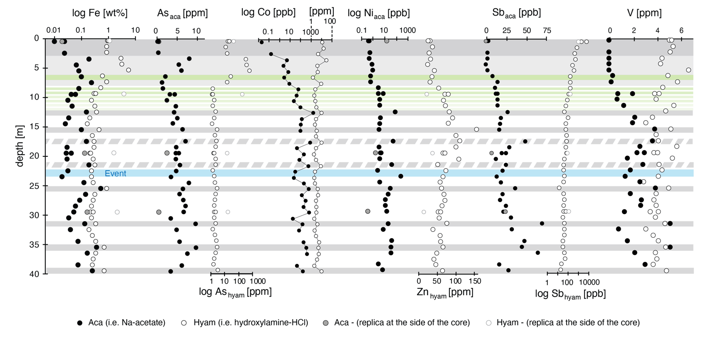
Supplementary material
Figure S1: Chemical characterization of the uppermost 40 cm of core LF06-PC6. Iron concentrations and major trace elements obtained by sequential extraction. Gray bands show redox transitions and solid gray bands likely represent paleo-redox fronts, supported by Fe_{hyam} concentrations peaks and high Fe/Mn ratios. The hydroxylamine-hydrochloride (hyam) fraction dissolves Fe and Mn (oxy)hydroxides. The Na-acetate (aca) fraction targets adsorbed Fe, amorphous Fe monosulfides, and to a lesser extent, amorphous (divalent) Fe oxides and Mn-oxides.

