Fate of intertidal microphytobenthos nitrogen under enhanced nutrient availability: Evidence for reduced nitrogen retention revealed through ¹⁵N-labeling

Philip M Riekenberg^{a,b *}, Joanne M. Oakesª, Bradley D. Eyreª

ª Centre for Coastal Biogeochemistry, Southern Cross University, PO Box 157, Lismore, NSW 2480, Australia
^{b} NIOZ, Royal Netherlands Institute for Sea Research and Utrecht University, Department of Marine Microbiology and Biogeochemistry, PO Box 59, Den Hoorn, 1790AB, Netherlands

* Corresponding author: phrieken@gmail.com

Keywords: ¹⁵N, amino acid, denitrification, pulse-chase, intertidal, flood

Running head: Fate of microphytobenthos nitrogen
Abstract
Sediment microbial communities are an important sink for both organic and inorganic nitrogen (N), with microphytobenthos (MPB) biomass having the largest contribution to short-term N-assimilation and retention. Coastal waters are increasingly subject to anthropogenic nutrient enrichment, but the effect of this nutrient enrichment on microbial assimilation, processing, and fate of MPB-derived N (MPB-N) remains poorly characterized. In this study, an MPB community was labeled in situ with a pulse of ¹⁵NH₄⁺-N. Laboratory core incubations of this labeled sediment under different nutrient concentrations (NH₄⁺ and PO₄³⁻: ambient, 2× ambient, 5× ambient, and 10× ambient) were used to investigate changes in the processing and flux pathways of the ¹⁵N-labeled MPB-N across 10.5 d under nutrient enrichment. Initial production of MPB-N was stimulated by nutrient addition, with higher ¹⁵N incorporation into MPB in the nutrient amended treatments (71-93%) than in the ambient treatment (38%). After 10.5 d, the nutrient amended treatments had increased turnover of MPB-N out of MPB biomass into an uncharacterized pool of sediment ON (45-75%). Increased turnover of MPB-N likely resulted from a decoupling between EPS production and bacterial remineralization as inorganic nutrients were preferentially used as an N source. This decoupling decreased the efflux of MPB-N via DON in the amended (3.9-5.2%) versus the ambient treatment (10.9%). Exports of MPB-N to the water column were relatively small, accounting for a maximum of 14% of ¹⁵N exported from the sediment, and were dominated by export of DON and N₂ (denitrification). Overall, there was considerable retention of MPB-N over 10.5 d, but increased nutrient loading shifted N from MPB biomass into other sediment ON.

1 Introduction
Within shallow photic sediments, microphytobenthos (MPB) contribute significantly to primary production and biomass by fixing carbon (C) and utilizing nitrogen (N) from the water column and porewater (Dalsgaard, 2003; Ferguson et al., 2004; McGlathery et al., 2007). Coupling between MPB production and bacterial remineralization within these sediments can result in strong retention of N and recycling of C. Bacteria utilize the extracellular polymeric substances (EPS) produced by MPB, while MPB rely on inorganic sources or bacterially-excreted NH₄⁺ from remineralization of organic matter (Cook et al., 2007; Forehead et al., 2013). The fate and processing of MPB-derived C (MPB-C) within sediments has been well described, with studies quantifying the incorporation of MPB-C into sediment organic matter and its loss from the sediment via efflux of dissolved organic carbon (DOC) and dissolved inorganic carbon (DIC) (Middelburg and Nieuwenhuize, 2001; Oakes et al., 2012; Oakes and Eyre, 2014; Oakes et al., 2016). Multiple studies have observed that respiration to DIC is the dominant pathway for MPB-C loss in coastal sediments while little MPB-C was exported as DOC (Oakes et al., 2012; Oakes and Eyre, 2014; Oakes et al., 2016). In contrast to MPB-C, the processing and fate of MPB-derived N (MPB-N) in coastal sediments is poorly understood, with only two comprehensive studies having quantified MPB-N incorporation into sediment compartments and its loss via sediment-water fluxes of dissolved inorganic nitrogen (DIN), dissolved organic nitrogen (DON) and dinitrogen (N₂) (Eyre et al., 2016). These studies quantified processing and loss of N via effluxes of DIN (37.3%, 1.9%, Eyre et al. 2016, Oakes et al., in press; respectively throughout), DON (12.6%, 0.5%) and N₂ during tidal inundation (20.7%, 0.9%), with only 27% and 12.4% (lower due to physical loss) of the initially incorporated ¹⁵N retained within the sediment after ~30 d. MPB dominated initial uptake of ¹⁵N (50% and 75% MPB vs. 2% and 9% bacteria, respectively), but was only the dominant reservoir for MPB-N within sediment organic nitrogen (sediment ON) by day 23 in the subtidal study (80.4 % MPB, 2.7% bacteria, and 15.9% uncharacterized; Eyre et al., 2016). In the intertidal study, MPB and uncharacterized material contained comparable amounts of MPB-N by day 31 (50% MPB, 1.6% bacteria, and 48.4%, Oakes et al., in press). Increased turnover into the uncharacterized pool between these two studies may indicate quicker turnover of newly assimilated MPB-N into sediment ON in intertidal settings.
Coastal waters are increasingly subject to anthropogenic nutrient enrichment (Howarth and Marino, 2006) which alters biogeochemical pathways and can cause eutrophication within otherwise healthy estuaries (Howarth and Marino, 2006; Rabalais et al., 2009). Within intertidal sediments, increased availability of inorganic nutrients from anthropogenic sources is expected to alter the processing of MPB-N as the microbial community responds to an additional source of N that was previously in limited supply. Efflux of N as DIN or N₂ occurs as the net result of mineralization and competition between MPB, heterotrophic bacteria, and denitrifying bacteria for uptake of available NH₄⁺. In N-limited settings, strong competition for nutrients arising from bacterial remineralization of sediment ON results in strong retention of remineralized MPB-N within sediment organic matter (OM) compartments (MPB, bacteria, and uncharacterized) (Fig.1A) and little N is available for export via DIN or the coupled nitrification-denitrification pathways (Cook et al., 2004; Cook et al., 2007; McGlathery et al., 2007; Sundback et al., 2000). With additional nutrient inputs stimulation of MPB productivity has been observed to coincide with decreasing efflux of DIN and N₂ to the water column (Dalsgaard, 2003; Ferguson and Eyre, 2013; Ferguson et al., 2004). Few studies have examined how increased N availability in the water column affects the processing and fate of MPB-N within shallow photic coastal settings. A laboratory study partitioned the algal and bacterial contribution to uptake of ¹⁵N within the sediment microbial community through the use a biomarker technique (D/L-Alanine) and found that the addition of nutrients (NH₄⁺, Si(OH)₄, HPO₄⁻) increased MPB incorporation of ¹⁵N and decreased competition for inorganic nutrients between MPB and bacteria (Cook et al. (2007); Fig. 1B). However, this study did not quantify water column efflux of DIN, DON or N₂.
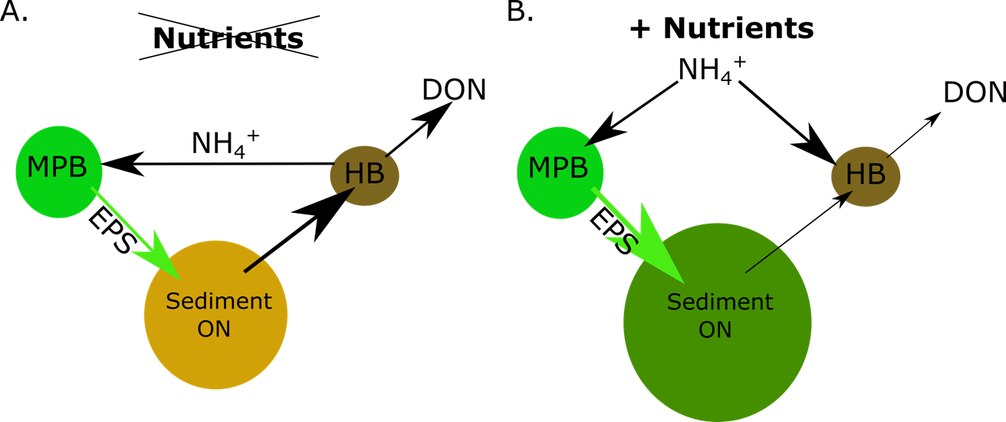
Figure 1: Conceptual diagram of the hypothesized mechanism and change in relationship between microphytobenthos (MPB) and heterotrophic bacteria (HB) under A) nutrient limiting and B) nutrient replete settings. A) When nutrients are scarce there is a strong coupling between bacterial remineralization of MPB-N within sediment ON and competition for nutrients between MPB and HB. Tight coupling results in significant turnover of MPB-N between the three sediment compartments and increased export of MPB-N as DON as EPS is remineralized. B) When inorganic nutrients are available, bacterial remineralization decreases as inorganic nutrients are preferentially used over sediment ON and results in decreased competition between MPB and HB for nutrients. Decoupling between HB remineralization of MPB-derived OM results in the buildup of MPB-N in sediment ON and decreased production of DON as remineralization is decreased.
In this ¹⁵N pulse-chase study we aimed to quantify changes in the processing and fate of MPB-N within subtropical intertidal sediments due to increased water column nutrient availability. Pathways considered included transfer of MPB-N through sediment ON compartments (MPB, bacteria and uncharacterized), and export via efflux of NH₄⁺, DON, and N₂ to the overlying water column. We expected decreased remineralization, re-capture, and recycling of processed MPB-N through the sediment compartments as introduced inorganic nutrients were preferentially utilized by the microbial community. This could result in either increased retention of MPB-N within the uncharacterized sediment organic matter pool due to decreased utilization by both MPB and bacteria, or increased MPB-N export as MPB-N is effluxed to the water column without being re-captured and recycled. As a result of decreased recycling of MPB-N within the microbial community, we expect that export of ¹⁵N via efflux of NH₄⁺, DON, and N₂ would be reduced as a result of increased sediment retention within N replete treatments (Fig. 1B).

2 Methods
2.1 Study site
The study site was a subtropical intertidal shoal ~2 km upstream of the mouth of the Richmond River estuary in New South Wales, Australia (28°52’30”S, 153°33’26”E) that was simultaneously used for a ¹³C pulse-chase study (Riekenberg et al. 2018). The 6900 km² Richmond River catchment has a mean annual rainfall of 1300 mm (McKee et al., 2000) and an average flow rate of 2200 ML d⁻¹ (daily gauged flow adjusted for catchment area, averaged over years for which data was available; 1970–2013). Although the Richmond River estuary has highly variable flushing, salinity, and nutrient concentrations associated with frequent episodic rainfall events and flooding (Eyre, 1997; McKee et al., 2000), this study was undertaken during a period of average rainfall (~200 mm in the month prior). The site experiences semidiurnal tides with a range of ~2 m. Samples were collected in January 2015 (summer) with average site water temperature of 25.6 ± 2.3ºC. Sediment at depths of 0-2 cm, 2-5 cm and 5-10 cm was dominated by fine sand (66%-73%) and sediment across 0-10 cm had an organic N content of 1.2 ± 0.1 mol N m⁻². Sediment molar C:N was lowest at 2-5 cm, but comparable across other depths (0-2 cm 17.2 ± 1.7, 2-5 cm 10.9 ± 0.5, 5-10 cm 16.2 ± 2.2). The MPB assemblage was dominated by pennate diatoms with few larger heterotrophs (>500 µM) and no cyanobacteria observed under light microscopy (1000 ×) as has been described previously for this site (Oakes and Eyre, 2014; Riekenberg et al., 2017; Riekenberg et al., 2018). Foraminifera were the dominant heterotrophs observed within site sediments, but were not considered in the current study, as they have previously been found to make only a minimal contribution to uptake of MPB-N (~1%) in sediments in the adjacent Brunswick Estuary (Eyre et al., 2016).
2.2 Experimental overview
An in situ application of ¹⁵N (99% NH₄⁺) was used to introduce a pulse of ¹⁵N-labeled MPB-N into sediment. Unincorporated ¹⁵N was flushed from the sediment during the next tidal inundation of the site. Sediment cores were then collected and incubated in the laboratory under four nutrient enrichment scenarios (ambient, minimal, moderate, and elevated) using pulsed nutrient additions. Laboratory incubation of cores allowed for explicit control of nutrient additions and was used to examine the fate and processing of the pulse of MPB-N over 10.5 d. Sediments remained inundated during incubation to minimize loss of MPB-N through physical processes as we were primarily interested in biological sediment processing and previous studies have shown that physical loss processes can have an important seasonal role in the processing of MPB-N (Nielsen et al., 2017).
2.3 ¹⁵N labeling
An experimental plot (2 m²) of bare sediment free of large animal burrows was labeled with ¹⁵N (99% ¹⁵NH₄⁺) when sediments were initially exposed during the ebbing tide in the middle of the day. To ensure even application, the plot was divided into 400 cm² subplots and a 20 ml aliquot of 40µmol ¹⁵NH₄⁺ solution was sprayed onto each subplot using motorized sprayers. This gave a label application rate of 2 mmol ¹⁵NH₄⁺ m⁻². The labeled solution was prepared with NaCl amended Milli-Q to match site salinity (34.6). Assimilation of ¹⁵N by the sediment community occurred during the 4 h prior to tidal inundation. The tide then removed unincorporated ¹⁵N; as confirmed by measurement of removal of ¹⁵N from the initial application (90.3%) in 0-10 cm of sediment during initial sampling.
2.4 Sample collection
Prior to application of ¹⁵N, 3 cores (9 cm diameter, 20 cm depth) were collected immediately adjacent to the treatment plot and were immediately extruded and sectioned (0-2 cm, 2-5 cm, and 5-10 cm) to provide unlabeled control samples for sediment ON δ¹⁵N. At the next low tide (11 h after label application), 43 sediment cores were collected from the labeled plot using clear acrylic core liners (9 cm diameter, 47 cm height). Immediately, three cores were extruded and sectioned, as described above. The sediment samples were placed into plastic bags, transported to the laboratory on ice, stored frozen in the dark (-20°C), and were later used to determine initial ¹⁵N uptake, grain size distribution across sediment depths, and chlorophyll-α (Chl-α) concentration within 0-1 cm sediments. The 40 remaining core liners were sealed with acrylic bottom plates and transported to the laboratory for incubation within 2 h of sampling. Site water (400 L) was collected and transported to the laboratory for use during incubations.
2.5 Nutrient Amendment
Sediment cores were incubated in the laboratory with a range of nutrient concentrations in the overlying water that were below the sediment capacity for uptake. Incubation tanks (85 L volume), each containing ten cores, were established with nutrients at ambient concentration (site water: DIN of 2.5 ± 0.04 µM N L⁻¹, TP 0.9 ± 0.09 µM P L⁻¹ measured on incoming tide), and with N (NH₄⁺) and P (H₃PO₄) amendments to site water at 2× (minimal treatment), 5× (moderate treatment), and 10× (elevated treatment) average water column concentrations near the study site (4 µM L⁻¹ NH₄⁺ and 5 µM L⁻¹ PO₄³⁻, Eyre (2000)). Nutrient amendments were added to the incubation tanks and to bags of replacement water an hour prior to cores being transferred into treatment tanks for incubation. Two additional identical amendments of NH₄⁺ were added to maintain the respective treatment concentrations to the incubation tanks after sampling at 1.5 d and 3.5 d of incubation to ensure that nutrient limitation did not develop after uptake of the initial treatment addition (Appendix Fig. 1). There was no significant accumulation of NH₄⁺ within treatment tank waters, as nutrients were readily processed and removed from the water column within 24 h of additions. An addition of sodium metasilicate (Na₂SiO₃, 17 µmol Si L⁻¹) was also added to all incubation tanks at the end of the 2.5 d of incubation to prevent secondary limitation of Si.
2.6 Benthic flux incubations
In the laboratory, cores were fitted with magnetic stir bars positioned 10 cm above the sediment surface, filled with ~2 L of site water, and randomly allocated to one of the four treatment tanks (ambient, minimal, moderate, elevated; ten cores per treatment). Water within treatment tanks and cores was continuously recirculated, held at in situ temperature (25 ± 1ºC) using a temperature controller, and aerated. Cores were stirred at a rate below the threshold for sediment resuspension (Ferguson et al., 2003) via a rotating magnet at the center of each treatment tank, which interacted with the magnetic stir bars. Three sodium halide lamps suspended above the treatment tanks approximated the average light level measured at the sediment surface during inundation (941.4 ± 139 µE m⁻² s⁻¹) by providing 824 ± 40 µE m⁻² s⁻¹ to the sediment/water interface within the cores on a 12 h light/12 h dark cycle. Cores were allowed to acclimate in the treatment tanks for 6 h prior to the start of incubation, allowing sediment microhabitats to re-establish. Cores remained open to the tank water until 30 min before sampling when clear Plexiglas lids were fitted to each core liner to seal in overlying water within the core for the duration of the incubation (~16 h). On each sampling occasion, 8 cores (2 per treatment at 1.5, 2.5, 3.5 and 10.5 d) were sampled for dissolved oxygen (± 0.01 mg/L) and temperature (± 0.01°C) using a Hach HQ40d multi-parameter meter via a sampling port in the core lid. For each sampling period, measurements were made at three time points (initial, dark end/light start, and light end) to allow dark, light, and net flux calculations. Initial samples were taken 30 min after closure of the lids, dark end/light start samples were taken after ~12 hours incubation with no light, and light end samples were taken 3 hours after illumination at the end of the dark sampling. At each initial, dark end/light start, and light end sampling duplicate samples for N₂:Ar analysis were collected by allowing water from suspended replacement water bags to gently displace sample water out of the core via tubing into 7 ml gastight glass-stoppered glass vials. These vials were allowed to overflow by 2-3 volumes, killed with 20 µl of saturated HgCl₂ and stored submerged at ambient temperature. To determine NH₄⁺, NO₃⁻, and DON concentrations and δ¹⁵N values, sample water was syringe-filtered (0.45 µm cellulose acetate) into 10 ml and 50 ml polyethylene vials, leaving a headspace, and stored frozen (-20°C). To determine δ¹⁵N values for N₂, sample water was filtered (0.45 µm cellulose acetate) into a 20 ml glass vial containing 500 µl of 2M NaOH. These samples were sealed without headspace using a lid containing a teflon-coated septum and refrigerated for storage. After completion of the dark/light flux incubation, cores were sacrificed and sediment was extruded and sectioned (top scrape, 0.2-2 cm, 2-5 cm, and 5-10 cm depths). A subsample (1 cm³) of sediment was taken for Chl-α analysis from the 0-1 cm depth prior to sectioning of the 0-2 cm layer using a spatula and placed in a 10 ml centrifuge vial containing 5 ml of 90% acetone. Sediment samples were placed in ziplock bags and stored in the dark at -20°C until analysis.
2.7 Sample analysis-
A portion of each sediment sample was freeze-dried and KCl-extracted (2M KCl) for analysis of concentration and δ¹⁵N of sediment ON. Both washed (KCl-extracted) and raw (non KCl-extracted) sediment samples were dried (60°C) and weighed into tin capsules for analysis of δ¹⁵N and %N using a Flash elemental analyzer coupled on-line to a Thermo Fisher Delta V Plus isotope ratio mass spectrometer (IRMS). Reproducibility of δ¹⁵N values for samples with δ¹⁵N enrichment <100‰ was ± 0.2‰. Precision decreased with enrichment beyond 100‰. Additional freeze-dried sediment was analyzed for D- and L- alanine concentration and δ¹⁵N to determine the relative contribution to uptake of ¹⁵N by both MPB and bacteria, as described below.
N₂ concentrations were analyzed using N₂:Ar measured with a membrane inlet mass spectrometer with O₂ removal (Eyre et al., 2002). Concentrations for DON, NH₄⁺, and NO₃⁻ were determined through colorimetric analysis on a four channel Flow Injection Analyzer (FIA, Lachat QuickChem 8000) (Eyre et al., 2011). DON was quantified via measurement of total nitrogen (TN) through flow injection analysis using persulfate digestion (Valderrama, 1981) and subsequent subtraction of DIN (NH₄⁺ + NO₃⁻) concentrations (Lachat, 1994). Prior to analysis, vials for N₂ analysis had 4 ml of water displaced with a helium headspace and were held at ambient temperature. δ¹⁵N₂ concentration of the He headspace in N₂ samples was determined via gas chromatography isotope ratio mass spectrometry using a Thermo Trace Ultra Gas Chromatograph coupled to a Delta V Plus IRMS via a Thermo Conflo III interface.
δ¹⁵N for NH₄⁺ was measured for samples with a concentration of >0.5 µmol N L⁻¹ (as determined by Flow Injection Analyis) via chemical conversion of NH₄⁺ to NO₂⁻ followed by azide conversion of NO₂⁻ to N₂O (Zhang et al., 2007). Samples with a concentration <0.5 µmol N L⁻¹ were below the detection limit for this method and were assumed to contribute a negligible amount of δ¹⁵N for calculations of MPB-N efflux. Concentrations of NO₃⁻ were consistently below the detection limit (0.5 µmol N L⁻¹) for the dentrifier method (Sigman et al., 2001) for the analysis of ¹⁵NO₃⁻; NO₃⁻ was assumed to have a minimal contribution to the efflux of MPB-N. The isotopic composition of DON was determined after persulfate oxidation of TN to NO₃⁻, followed by conversion to N₂O using the denitrifier method. The δ¹⁵N-DON was calculated using a two source mixing model based on δ¹⁵N of TN and ¹⁵NH₄⁺ for samples with sufficient concentrations (Erler et al., 2014). Where NH₄⁺ concentrations were <0.5 µmol N L⁻¹, no correction was applied and δ¹⁵N-TN was used as δ¹⁵N-DON. NO₃⁻ was not considered in this calculation because it was consistently below 0.5 µmol N L⁻¹ while DON concentrations were ~18 µmol N L⁻¹ (~36 × greater).
The relative contribution of MPB and bacteria to ¹⁵N uptake and transfer was determined through compound-specific analysis of D- and L- alanine following acid hydrolysis and extraction of total hydrolysable amino acids from 7 g of freeze-dried sediment. Due to the laborious extraction process, only single replicates from the 0.2-2 cm, 2-5 cm and 5-10 cm depths of each core at each time were analyzed. Extraction and analysis was performed as described by Veuger et al. (2005) and Veuger et al. (2007a), with minor modifications. Briefly, freeze-dried sediment (7 g) was rinsed with 2 M HCl, centrifuged (5 min, 900 g), and the supernatant discarded. This was repeated with milli-Q water 3×, and the sediment pellet was then hydrolyzed with 6 M HCl (110°C, 20 h). After hydrolysis, a standard spike of L-norleucine (2.5 mg ml⁻¹) was added and the sample shaken and centrifuged again. The supernatant was removed and retained. The pellet was then resuspended in 10 ml milli-Q water, centrifuged 2×, and the additional supernatant also retained. The combined supernatant (25 ml) was purified through cation exchange chromatography (Dowex 50WX8-100), and the amino acids were derivatized with isopropanol and penta-fluoropropionic anhydride, and further purified via solvent extraction with chloroform. Concentrations and δ¹⁵N of the derivatized amino acids were determined via gas chromatography-combustion-isotope ratio mass spectrometry (GC-c-IRMS) on a HP 6890 GC interfaced via a Thermo Conflo III interfaced with a Thermo Delta V Plus IRMS using the column and ramp schedule described in Eyre et al. (2016).
Chl-α was extracted by adding a 9/1 acetone/water mix followed with sonication (15 min), centrifugation (5 min, 9 g), and removal of the supernatant for analysis by colorimetry (Lorenzen, 1967). ON within bulk sediment was analyzed for δ¹⁵N after KCl-extraction to remove any N adsorbed to sediment particles. Briefly, 2 g of homogenized freeze-dried sediment were combined with 5 ml of 2M KCl in a centrifuge tube, shaken for 5 min, and centrifuged (15 min, 9 g). The supernatant was discarded, and three times thereafter 5 ml of milli-Q was added to the pellet prior to shaking (5 min), centrifugation (15 min, 9 g), and removal of the supernatant. The KCl-extracted pellet was dried at 60°C to constant weight and weighed into a tin capsule for analysis of δ¹⁵N and %N using a Flash elemental analyzer coupled on-line to a Thermo Fisher Delta V Plus IRMS. Reproducibility of δ¹⁵N for samples with enrichment < 100 ‰ was ± 0.2 ‰. Precision decreased with enrichment beyond 100 ‰.
2.8 Calculations
The total ON mass (biomass) of sediment was calculated as the product of %N and dry mass of sediment per unit area. Incorporation of ¹⁵N into sediment ON, bacteria and MPB (mmol ¹⁵N m⁻²) was calculated as the product of excess ¹⁵N (fraction ¹⁵N in sample – fraction ¹⁵N in control) and the mass of ON within each pool.
Biomass and excess ¹⁵N contained in bacteria and MPB was estimated based on the excess ¹⁵N contained within the amino acids D- and L- alanine (Ala). The assumptions and uncertainty associated with this method are discussed in detail by Veuger et al. (2005) and Veuger et al. (2007b) and estimates of error propagation for individual variables are provided in Riekenberg et al. (2017). During acid hydrolysis, some racemization of L- Ala to D- Ala occurs, resulting in a D- : L- Ala ratio of 0.015-0.02 for algal cultures (Veuger et al., 2007b) and 0.006 for dissolved free amino acids (Kaiser and Benner, 2005). In the current study, uncorrected D/L-Ala ratios as low as 0.009 were observed, and therefore a racemization rate of 0.006 was applied to correct for L-Ala racemization. This value corresponded well to measured values for racemization of L-Ala standards during hydrolysis under laboratory conditions. Measured D- and L- Ala concentrations were corrected for racemization using the equations of Kaiser and Benner (2005):
- L*₀ = (L* - D* (0.6)) / 100 - 0.6
- D*₀ =D* + L*- L*₀
where L*₀ and D*₀ and L* and D* are the concentrations of L- and D-Ala occurring originally and after hydrolysis, respectively. Original concentrations of D- and L-Ala represent concentrations of both forms of alanine derived from bacterial and algal biomass prior to hydrolysis induced racemization.
Biomass of heterotrophic bacteria (HB), MPB, and total microbial biomass were calculated as described by Veuger et al. (2005) and Veuger et al. (2007b), as follows:
- HB L-Ala = D*₀-Ala × 20
- HB contribution to microbial biomass (%) = (HB L-Ala / L*₀-Ala) ×100
- MPB contribution to microbial biomass (%) = 1 – HB contribution to microbial biomass
- HB biomass = D*₀-Ala × 400
where 20 is the conversion for excess ¹⁵N in D-Ala (5%) that represents excess ¹⁵N present in bacterial L-Ala (20×). This conversion factor is based on culture analysis (Veuger et al., 2005; Veuger et al., 2007b), is further discussed in Eyre et al. (2016), and assumes a negligible contribution of Gram positive bacteria or cyanobacteria to the benthic community. The lack of cyanobacteria in the current study was confirmed through both microscope work and PLFA analysis (Riekenberg et al. 2018). The conversion factor of 400 (Veuger et al., 2005) accounts for the % N in dry bacterial biomass (12%; (Madigan et al., 2000), and yields a D-Ala content of 0.25. ¹⁵N uptake into HB, MPB, and total microbial biomass were calculated using equations 3-8, substituting excess ¹⁵N values for L*₀- and D*₀-Ala in place of L*₀- and D*₀-Ala contents.
Total excess ¹⁵N within water column NH₄⁺, DON and N₂ were calculated for the beginning and end of dark incubation period and the end of the light incubation period as the product of excess ¹⁵N in NH₄⁺, DON and N₂ (excess ¹⁵N_{sample} – excess ¹⁵N_{control}), core volume, and concentration of NH₄⁺, DON, and N₂. Total excess flux of ¹⁵N in NH₄⁺, DON, and N₂ was calculated as:
- Excess ¹⁵N flux = (Excess ¹⁵N_{start} – Excess ¹⁵N_{end}) / SA / t
where excess ¹⁵N_{start} and excess ¹⁵N_{end} represent excess ¹⁵N in NH₄⁺, DON, and N₂ at the start and end of the dark and light incubation period, SA is sediment surface area, and t is the incubation period (h) in the light or the dark. Net flux of excess ¹⁵N (excess ¹⁵N m⁻² h⁻¹) for NH₄⁺, DON, and N₂ was calculated as:
- Net flux = (dark flux * dark hours) + (light flux * light hours) / 24 h
export of ¹⁵N to the water column via ¹⁵NH₄⁺, DO¹⁵N, and ¹⁵N₂ was estimated through interpolation between efflux measurements for each treatment by calculation of the area beneath the curve during each sampling period. Incubations for dark periods were ~12 h while light periods were limited to ~4 h as required to prevent supersaturation and bubble development samples taken to measure N₂/Ar for N₂ fluxes. Fluxes of excess ¹⁵NO₃⁻ were assumed to be negligible and were therefore not included in excess flux measurements for DIN because core water column concentrations were consistently low and below the detection limit required for analysis of δ¹⁵N values via the denitrifier method (0.5 uM N L⁻¹; Sigman et al. (2001).
2.9 Data Analysis
In the initial sampling period, there was incorporation of MPB-N below 2 cm (2-10 cm) within all of the treatments. A one-way analysis of variance was used (ANOVA) to determine whether there was a significant difference amongst treatments (α = 0.05). A one-way ANOVA was also used to determine if there was a significant difference among treatments in ¹⁵N uptake into MPB during the initial sampling period. Levene’s tests indicated that variances were homogenous in all cases. When significant differences were indicated, post-hoc Tukey tests investigated the differences between treatments (α = 0.05).
Two-way ANOVAs were separately applied to Chl-α and ¹⁵N incorporation with pooled depths of 0-2 cm and 2-10 cm across sampling times to determine whether significant differences occurred between treatments or depths within each time period. Additional two-way ANOVAs were used to investigate whether significant differences occurred between sediment compartments (uncharacterized, MPB, and bacteria) within ambient or nutrient amended treatments. Levene’s tests indicated that variances were homogenous in all cases, and there were no significant interactions indicated during these analyses. Where ANOVAs indicated a significant difference (α = 0.05), post-hoc Tukey tests were applied to investigate significant differences between variables (α = 0.05).

3 Results
3.1 Sediment characteristics
Sediment Chl-α at 0.2-2 cm depth averaged 48.3 ± 2.9 mg m⁻² (mean ± SE) across all cores collected in this study and was not affected by time or treatment (two-way ANOVA: F_{3,20}=0.8, p=0.5). Sediment organic matter across the 0-10 cm depth had a molar C:N ratio of 18.1 ± 1.1 and contained 1.2 ± 0.1 mol N m⁻². The %N of sediment was low and even across all sediment layers (0.02%). Within initial cores taken after labeling, but prior to incubation, MPB biomass had the greatest contribution to sediment ON (20%) in the 0-2 cm depth, with bacteria representing only 4% (Table 1). Due to uptake of ¹⁵N being largely confined to ON in the uppermost sediment layer (0-2 cm) in the initial cores, deeper depths (2-5 cm and 5-10 cm) were not examined for uptake into MPB, bacteria, and uncharacterized sediment compartments. Within the ambient treatment across samplings, MPB had the greatest contribution to ON in the uppermost layer (0-2 cm, 28.4%) and contributed less in deeper depths (2-5 cm, 10.7%; 5-10 cm, 6.4 %, Table 1). Bacterial contribution to ON was less than MPB in the uppermost layer (0-2 cm, 17.4%) and decreased with depth (2-5 cm, 7.1%; 5-10 cm, 6.0%). Uncharacterized ON made the largest contribution to both initial (75%) and ambient (54-88%, Table 1) sediments within this study.

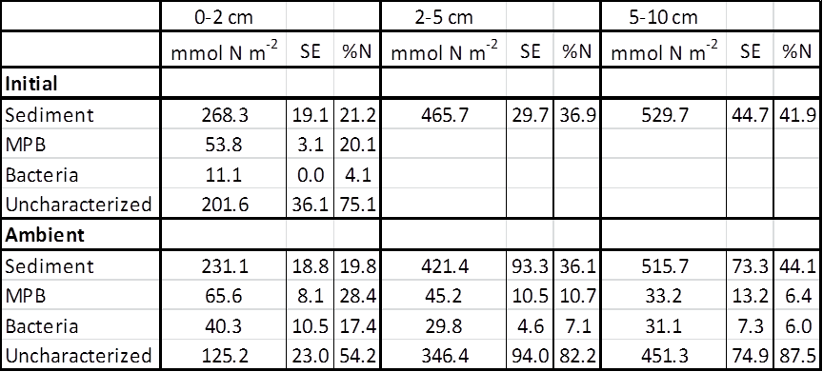
Table 1: Mean biomass for sediment compartments for 0-2 cm for initially sampled cores after tidal flushing and for 0-2 cm, 2-5 cm, and 5-10 cm for all cores sampled in the ambient treatment (mean ± SE). %N is the percentage N within each sediment depth for individual sediment compartments (MPB, Bacteria, and Uncharacterized) except for sediment N, where it represents the portion of N relative to the total N in 0-10 cm of sediment.
3.2 Uptake of ¹⁵N
The pulse of ¹⁵N was rapidly incorporated into sediment ON, with 193 ± 44.8 µmol ¹⁵N m⁻² detected in 0-2 cm of sediment 11 h after label application, when the first ¹⁵N-labeled cores were collected after tidal flushing. At 0-2 cm, ¹⁵N uptake into the microbial community was dominated by MPB (MPB 53.8 mmol N m⁻², 83%; bacteria 11.1 mmol N m⁻², 17%, Table 1). At this time ¹⁵N was largely confined to the top scrape (upper 2 mm of sediment) and 0-2 cm depths (84.8 mmol N m⁻², 43.8% and 85.4 mmol N m⁻²; 44.1% of total incorporated ¹⁵N, 193.4 mmol N m⁻², respectively), but some downward transport of ¹⁵N was evident in the 2-5 cm and 5-10 cm depths (10.2 mmol N m⁻², 5.3%; 13.1 mmol N m⁻², 6.8%, respectively). Due to limited labeling uptake within the lower depths during the initial sampling, we did not run D/L-Ala analysis for the microbial community in the 2-5 cm and 5-10 cm depths.
¹⁵N was incorporated into deeper sediments (2-5 cm and 5-10 cm) within all treatments by the initial sampling time (Fig. 2). By 0.5 d, comparable amounts of the assimilated MPB-N (8-16%) was in sediment below 2 cm (One-way ANOVA: F_{3,7}=5.3, p=0.07, ambient 12%; minimal 16%; moderate 8%; and elevated 10%). After 10.5 d there was significantly more ¹⁵N contained in the 0-2 cm layer (TS + 0.2-2 cm) than the 2-5 cm or 5-10 cm layers across all treatments (two-way ANOVA: F_{2, 108} =1070, p<0.001; Fig. 2; ambient 83.4%, minimal 81.9%, moderate 79.1%, and elevated 78.6%). Tukey tests indicated that incorporation into the 2-5 and 5-10 cm depths were similarly low for all treatments across sampling times.
Uptake of ¹⁵N into microbial biomass (MPB and bacteria) accounted for 22-95% of the total ¹⁵N incorporated into sediment ON across all treatments and sampling times (Fig. 3). Initial ¹⁵N contained (0.5 d) in MPB during the incubation was higher in the elevated treatment (one-way ANOVA: F_{3,7}=6.9, p=0.046, minimal, 71±21% ; moderate, 75±12%; and elevated, 93±1%, mean±SE) than in the ambient treatment (38±4%) with Tukey tests indicating a significant difference between elevated and ambient treatments (p=0.04) with values for minimal and moderate treatments falling intermediate between them. This indicates that initial production of MPB-N was stimulated by increased nutrient availability and remained in MPB at 0.5 d. Within the microbial community after 0.5 d, distribution of ¹⁵N continued to be dominated by MPB for all treatments (ambient 83±3%; minimal 79±4%; moderate 74±2%; elevated 75±5%, Fig. 4). Bacterial contribution to ¹⁵N uptake was comparable or higher during the later sampling times (1.5 to 10.5 d) in the nutrient amended treatments (minimal, 15-23%; moderate, 2-49%; elevated, 2-40%, Fig.15) compared to the ambient treatment (10-23%).
In the ambient treatment, distribution of ¹⁵N between microbial biomass and uncharacterized sediment ON remained comparable across the 10.5 d incubation (one-way ANOVA: F_{4,9} =0.5, p =0.8; Fig.14). In contrast, in the nutrient amended treatments ¹⁵N incorporation was initially dominated by microbial biomass, primarily MPB, but shifted towards increased incorporation into the uncharacterized pool as the incubations progressed (two-way ANOVAs: minimal, F_{1, 10} =10, p=0.01; moderate, F_{1, 10} =10, p<0.001; elevated, F_{1, 10} =10, p<0.001; Fig. 3). In the nutrient amended treatments, the ¹⁵N contributing to the increased uncharacterized pool appeared to be largely sourced from MPB, resulting in reduced MPB contributions by 10.5 d (minimal 38%; moderate 12%; elevated 16%; Fig. 3). Bacterial contributions to ¹⁵N remained comparable across the incubation period in nutrient amended treatments (two-way ANOVA: F_{2, 15} =0.1, p =0.9).
3.3 Loss of ¹⁵N from sediments
There was relatively little efflux of ¹⁵N from the sediment to the water column in this study, with loss pathways accounting for a maximum of 14% of the initially incorporated ¹⁵N across treatments (Fig. 2). Across all treatments, most of this loss to the water column occurred in the form of DON and N₂ fluxes (Fig. 5), with only a minor contribution from DIN (NH₄⁺, maximum of 0.3%). Within the ambient treatment, DON was the largest export pathway accounting for loss over 10.5 d of 10.5% of the initially incorporated ¹⁵N (Fig. 5 & 6). Loss of ¹⁵N from the sediments via DON effluxes was lower within the nutrient amended treatments (minimal, 4.8%; moderate, 5.2%; elevated, 5.2%) but was not statistically significant. Export of ¹⁵N via N₂ was comparably low between ambient, minimal and elevated treatments (3.3%, 2.8%, and 2.3%, respectively), but was higher in the moderate treatment (7.1%, Fig. 4 & 6). Overall export via combined efflux pathways was low across all treatments, with the bulk of MPB-N remaining within the sediment by 10.5 d (ambient 86 ± 4%, minimal 90 ± 2%, moderate 88 ± 2%, and elevated 94 ± 3%, Fig. 6). The majority of ¹⁵N remaining in the sediment was found in the 0-2 cm depth for all treatments (ambient 70%; minimal 63%; moderate 69%; and elevated 80%, Fig.2 while ¹⁵N incorporation remained lower for depths below 2 cm (ambient 16%; minimal 27%; moderate 18%; and elevated 14%).
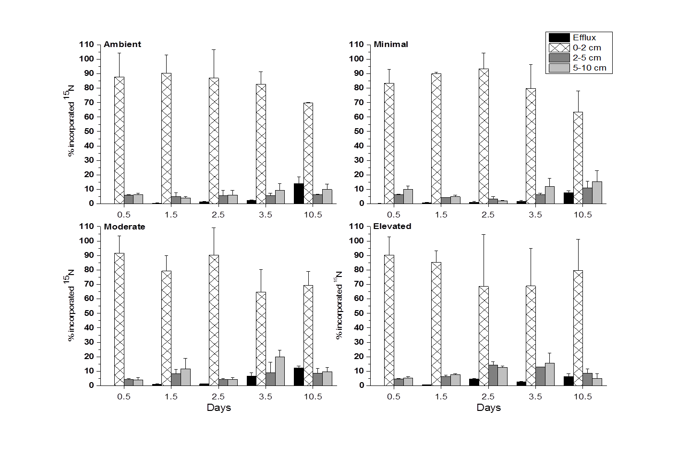
Figure 2: Nitrogen budget for excess ¹⁵N within sediment ON at 0 to 2 cm, 2 to 5 cm, and 5-10 cm, and cumulative excess ¹⁵N exported to the water column combined via effluxes of NH₄⁺, DON, and N₂ for each treatment at each sampling time. All values are as a percentage of the ¹⁵N initially incorporated into sediment ON (0-10 cm). Some error bars are too small to be seen (mean + SE).

4 Discussion
By combining a pulse-chase application of the rare isotope ¹⁵N with the D/L-Ala biomarker technique, we identified that increased nutrient availability as a pulsed addition of 5 to 50 µM L⁻¹ NH₄⁺ across 3 treatments: 1) stimulated initial production of MPB-N 2) increased microbial turnover of MPB-N into the uncharacterized sediment ON compartment, and 3) decreased the amount of MPB-N lost via DON effluxes. By the end of the incubation (10.5 d) 86-94% of the ¹⁵N incorporated remained in the sediment, with 3.9 - 10.9% effluxed as DON, 2.3 -7.1% effluxed as N₂, and less than 1% effluxed as NH₄⁺ (Fig. 6). Of the ¹⁵N contained in the sediment 12-40% was in MPB, 6-15% was in bacteria and the remaining 45-75% was uncharacterized (Fig. 6). This study is the first to track the fate and processing of a pulse of MPB-N produced in situ under an increasing gradient of water column nutrient availability.
4.1 Initial incorporation and downward transfer of ¹⁵N
Initial uptake of ¹⁵N into microbial biomass was dominated by MPB across all treatments (0.5 d, Fig. 4) and increased nutrient amendment stimulated initial retention of MPB-N within MPB (ambient 53% versus 84-95% nutrient amended treatments, 0.5 d, Fig. 3). Retention of MPB-N may have resulted from the decoupling of bacterial processing from MPB-N production, with inorganic nutrients preferentially utilized in lieu of MPB-N in the nutrient amended treatments. Decoupling is further supported by a decrease in MPB-N turnover into uncharacterized ON; there was the considerable initial turnover of MPB-N into the uncharacterized ON in the ambient treatment (47.3%, 0.5 d), but turnover within the nutrient amended treatments (5-16%, Fig. 3) was considerably lower (t= 3.8, p= 0.009). The uncharacterized pool represents ¹⁵N within bulk sediment OM that was not accounted for by ¹⁵N contained within microbial biomass. This pool is composed of ¹⁵N-containing compounds such as EPS, enzymes, and OM derived from the remineralization of MPB-N. Increased breakdown and initial transfer of MPB-N into the uncharacterized pool is consistent with increased bacterial utilization of MPB-N during remineralization that resulted in increased initial turnover in low nutrient settings (Fig. 3). Increased coupling between MPB and bacteria in low nutrient settings (Cook et al., 2007; Oakes et al., 2012) has previously been attributed to increased reliance on the limited nutrients arising from bacterial remineralization.
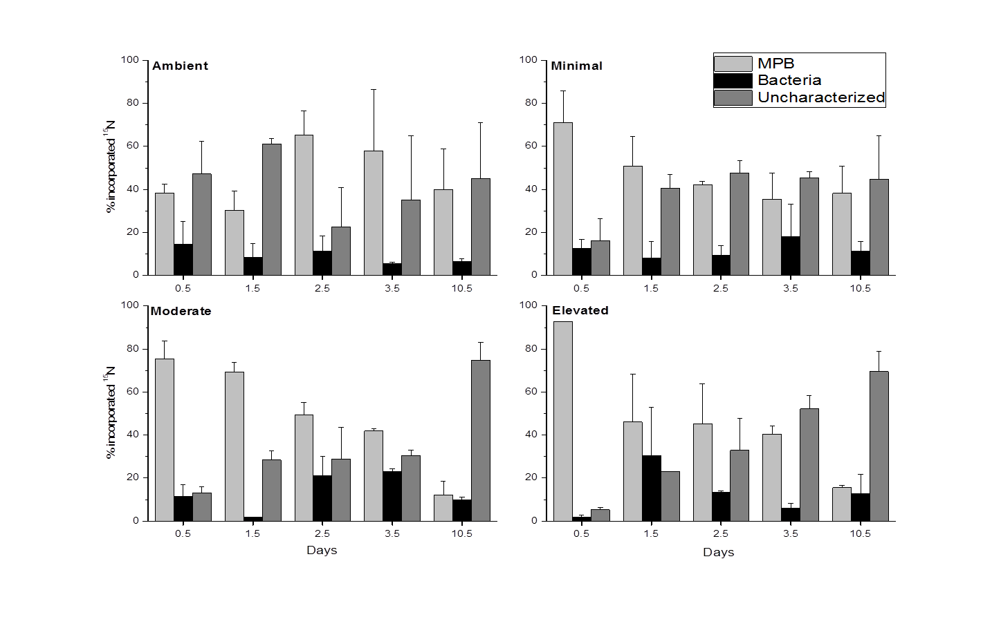
Figure 3: Incorporation of ¹⁵N into bacteria, MPB, and uncharacterized sediment compartments (mean + SE). The uncharacterized compartment is derived by subtracting ¹⁵N contained in microbial biomass from bulk sediment organic ¹⁵N.

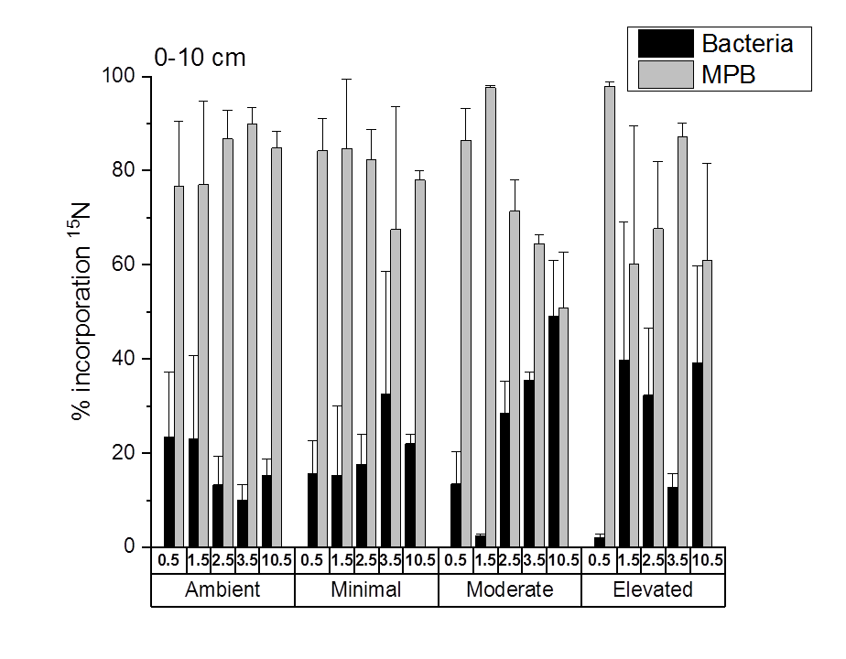
Figure 4: Excess ¹⁵N incorporation into MPB and bacterial biomass within 0-10 cm depth as a percentage of the total ¹⁵N incorporated into the microbial community for each treatment at each time period (mean + SE).
Ratios of ¹³C:¹⁵N uptake into microbial biomass were estimated based on the excess ¹³C incorporation determined in a complementary study (Riekenberg et al., 2018). Due to phospholipid fatty acid analysis only accounting for the ¹³C contained in living biomass and D/L-Ala accounting for ¹⁵N in both living and dead biomass, this ¹³C:¹⁵N ratio potentially over-estimates the relative uptake of ¹⁵N into the microbial community, particularly as incubations progress. Therefore, we only considered the ¹³C:¹⁵N ratios for microbial biomass during the initial sampling (0.5 d) and not for subsequent samplings. The ¹³C:¹⁵N ratio in the ambient treatment (16.7±2.8) was considerably higher than in the nutrient amended treatments (minimal 8.3±3.8; moderate 5.2±3.4, and elevated 7.5±2; One-way ANOVA, F_{3,7}=5.4, p=0.068), and aligns well with previous estimates where preferential excretion of fixed C as EPS would occur due to N limitation within algal cells (e.g., ~20, Van den Meersche et al. (2004). The lower ¹³C:¹⁵N ratios within nutrient amended treatments indicate uptake occurring at a ratio closer to that of the Redfield ratio expected for algal uptake (6.7) as a result of increased N availability (Cook et al., 2007). The current study suggests that under N replete conditions, bacteria will utilize inorganic nutrients that are present to support production of low C:N biomass regardless of the C:N ratio of the substrate being processed to produce that biomass, as has been previously proposed (Goldman and Dennett, 2000).
Over 10.5 d, the majority (81%) of the ¹⁵N incorporated into the sediment was recovered from the 0-2 cm depth, but incorporation of ¹⁵N into deeper sediment layers occurred rapidly (within 0.5 d, Fig. 2), equating to a transport rate of ¹⁵N to sediment below 2 cm of 2.7 – 4.4 µmol ¹⁵N m⁻² h⁻¹. This rate of downward transport was substantially lower than previously observed at this site (e.g., 19.6 µmol ¹⁵N m⁻² h⁻¹ over 1.5 d, Oakes et al., in press) which may have been driven by the draining and re-filling of cores to simulate intertidal conditions in that study resulting in additional transport. The rates of downward transport for ¹⁵N in this study are similar to that observed for MPB-N in subtropical subtidal sediments (e.g., ~2.7 µmol ¹⁵N m⁻² h⁻¹ over 3 d with ambient DIN of ~8 µmolL⁻¹, Eyre et al. (2016), but represent a smaller portion of the total incorporated ¹⁵N (8.3 – 16.4% compared to ~29%). The similar rates of downward transport for MPB-N between the two studies likely reflect comparable downward migration by MPB within subtropical sands (Saburova and Polikarpov, 2003). Incorporation of ¹⁵N into the 2-10 cm depths increased relatively slowly thereafter but resulted in higher downward transport in the nutrient amended treatments as the incubations progressed (average over 3.5-10.5 d; ambient 15.6 ± 2.0%; minimal 22.6 ± 2.8%; moderate 23.6 ± 2.7%; and elevated 21.2 ± 2.0%, Fig. 2). Downward migration of MPB can be enhanced by light stress (Underwood 2002), but given that light intensity was consistent across treatments, the increased downward transfer of MPB-N within the nutrient amended treatments more likely reflects increased downward migration for nutrients and mitosis as water column nutrients quickly became limiting later in the incubations (Saburova and Polikarpov, 2003).
4.2 Transfer of MPB-N within sediments
The transfer and processing of MPB-N within the sediment compartments varied between the ambient and nutrient amended treatments, potentially as a result of tight coupling between bacterial remineralization and EPS production by MPB providing efficient recycling and transfer of MPB-N between all sediment compartments within sediment ON (Fig. 5). In the ambient treatment, as the incubation progressed, the contribution of MPB to ¹⁵N within microbial biomass increased (77-90%), bacterial contributions declined (10-23%, Fig. 3), and the uncharacterized pool of ¹⁵N contributed considerably to the excess ¹⁵N in sediment ON (23-61%, Fig. 3). These combined factors suggest that MPB-N is efficiently recycled when nutrients are relatively scarce. Bacteria in the ambient treatment likely re-mineralized MPB-N within the uncharacterized pool (Fig. 1A), providing inorganic nutrients that were increasingly used by MPB they competed for available nutrients under nutrient limitation (Cook et al., 2007).
In contrast, as incubations progressed in the nutrient amended treatments, decoupling between MPB and recycled nutrients from bacterial remineralization likely resulted in accumulation of ¹⁵N within sediment ON as MPB-N was not utilized by bacteria and quickly recycled. With increased nutrient loading, MPB contributions to ¹⁵N within microbial biomass declined, bacterial contributions increased (Fig. 3), and coincided with an increased contribution of ¹⁵N to the uncharacterized pool (minimal, 41-47%; moderate 29-75%; elevated 23-70%; Fig. 3). The accumulation of ¹⁵N in the uncharacterized sediment compartment reflects decreased recycling of MPB-N contained in EPS and detritus (derived from MPB and bacterial biomass) as bacteria preferentially utilize inorganic nutrients instead of MPB-N within the uncharacterized pool (Fig. 1B). The increased contribution of bacteria to the microbial community largely reflects increased turnover of ¹⁵N out of MPB as increased production shunts MPB-N into the uncharacterized pool.
4.3 Effluxes of MPB-N
Export of ¹⁵N from the sediments to the water column primarily occurred via fluxes of DON, N₂, and NH₄⁺ (Fig. 2 & 16). Fluxes of NH₄⁺ resulting from remineralization (0-0.3%) contributed little to the export of ¹⁵N across all treatments, indicating strong retention of nutrients arising from MPB-N remineralization. Strong retention of this N is not unexpected, as competition between MPB and heterotrophic bacteria for N has been previously observed under nutrient limiting settings (Agogue et al., 2014). Limited export of ¹⁵N as NH₄⁺ across all treatments in this study suggests that the microbial community maintained capacity for further N uptake throughout the incubations. The cumulative flux of NH₄⁺ observed in this study was considerably smaller than that observed in subtropical subtidal sediments over 33 d (20.8%, Eyre et al. 2016) but was comparable to that found previously for this site across 31 d (0.2%, Oakes et al. in press). These comparable fluxes are likely due to the decreased bacterial remineralization and increased retention of MPB-N that was observed within this study.
Low fluxes of N₂ may also relate to the competition for inorganic nutrients between MPB and bacteria. The intense competition for recycled inorganic nutrients between MPB and bacteria would have starved denitrifying bacteria of NO₃⁻ (McGlathery et al., 2007; Sundbäck and Miles, 2002) and greatly reduced the amount of N₂ efflux from denitrification (2.3-7.1%, 10.5 d; Fig. 6). This finding is comparable with previously reported denitrification rates reported for this site (2.6% by 31 d; Oakes et al. in press), and suggests that competition from MPB for NH₄⁺ was similarly limiting during that period as ambient NH₄⁺ was higher in Oakes et al. in press (2.1±1.8 µmolL⁻¹) than observed in this study (0.9±0.1 µmolL⁻¹). Limited availability of NO₃⁻ required for denitrification due to intense competition for the substrate for nitrification would help to explain the low N₂ efflux observed within this study compared to that found previously for this site as well as in subtropical subtidal sediments (20.7%, Eyre et al. (2016). The enhanced efflux of MPB-N as both N₂ and NH₄⁺ that was previously observed in a subtidal subtropical setting (20.7% N₂ and 20.8% NH₄⁺, Eyre et al. 2016a versus 2.3-7.1% N₂ and 0.02-0.09% NH₄⁺, this study; Figs. 3 & 6) suggests that remineralization produced inorganic nutrients in excess of what was required by the microbial community in that system and resulted in increased export of ¹⁵N via DIN and denitrification.

Within the current study, increased inorganic nutrient availability appeared to decouple remineralization of MPB-N by bacteria as inorganic nutrients were preferentially utilized instead of sediment ON (Fig. 1B). In the ambient treatment, efflux of MPB-N via DON accounted for 10% of the ¹⁵N assimilated within the system and is evidence of considerable remineralization, hydrolysis of freshly deposited material (Ferguson et al., 2004), and export of MPB-N from the uncharacterized pool within sediment ON. With nutrient amendment, export of MPB-N via DON decreased to 3.9-5.2% (Fig. 6) and occurred despite enhanced MPB-N production and the equal or increased presence of ¹⁵N within the uncharacterized pool within the nutrient amended treatments. This indicates that bacteria preferentially utilized inorganic nutrients instead of MPB-N derived from ¹⁵N-labeled EPS contained within the uncharacterized sediment pool, likely as a result of preferential remineralization of other non-labeled EPS or organic matter that is present in the sediments.
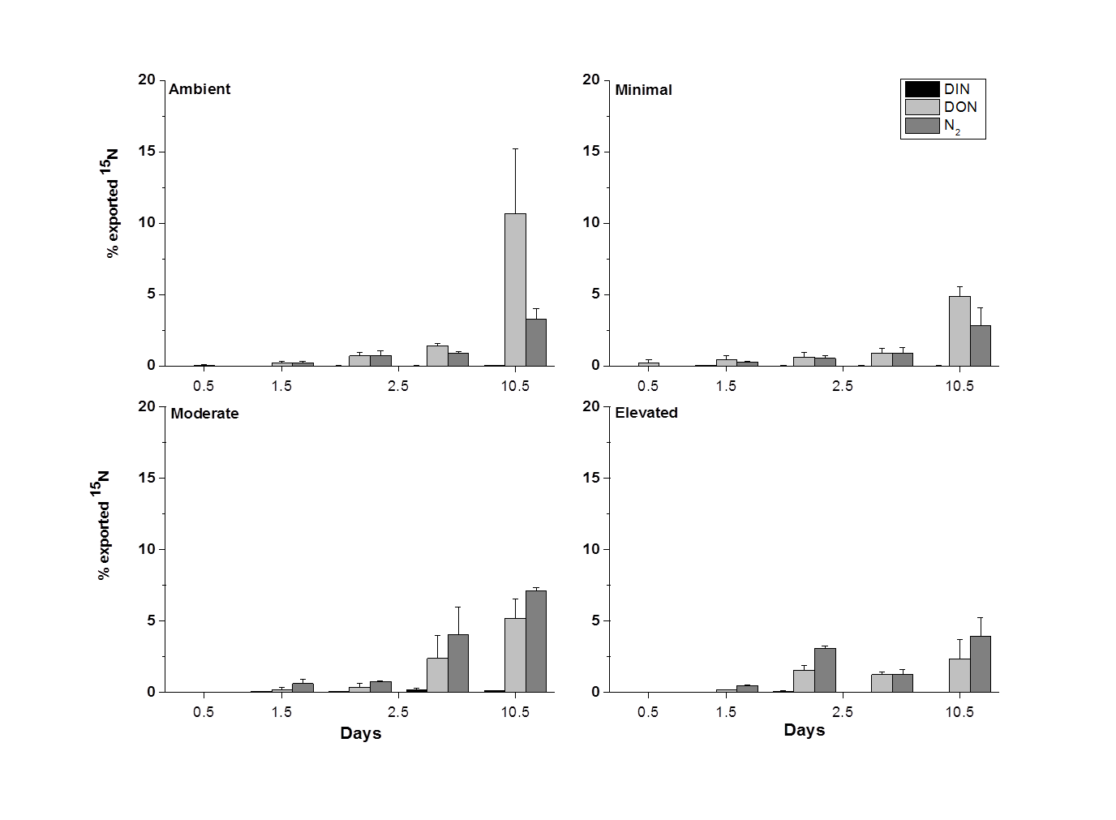
Figure 5: Cumulative excess ¹⁵N lost via efflux of DIN, DON, and N₂ at each sampling time. All values are as a percentage of the ¹⁵N incorporated into sediment ON (0-10 cm). Some bars and error bars are too small to be seen (mean + SE).

4.4 Retention of MPB-N
MPB have a considerable role in regulating the processing of nutrients within shallow unvegetated benthic settings through primary production and N uptake (Ferguson and Eyre, 2013; Ferguson et al., 2004; McGlathery et al., 2007; Nielsen et al., 2017; Sundbäck and Miles, 2002). Newly assimilated N has been typically considered to be retained within MPB biomass, with increased MPB biomass resulting in reduced N efflux from sediments (Sundbäck et al., 2006). Excluding Eyre et al. (2016) and Oakes et al. (in press), previous studies have not used biomarkers to partition sediment ON into compartments representing the contributions from microbial groups (MPB, bacteria) as well as processed MPB-N remaining in the sediment (uncharacterized). Partitioning out the uncharacterized pool within sediment ON reveals that much of the initially assimilated MPB-N is transferred into the uncharacterized pool, presumably via excretion of EPS by MPB and turnover of microbial cellular material. Under nutrient-limiting conditions, this EPS is quickly remineralized by bacteria, releasing ¹⁵NH₄⁺ that is then recycled as MPB and bacteria compete for available nutrients (Fig. 1A). Under ambient conditions, this coupling resulted in efficient recycling of MPB-N and caused considerable turnover of ¹⁵N between the uncharacterized, MPB and bacteria sediment compartments, although sediment retention was somewhat reduced by increased efflux of DON through increased hydrolysis and bacterial remineralization of freshly deposited MPB-N. When nutrient amendments were added, hydrolysis and bacterial remineralization of MPB-N appeared to slow, resulting in reduced processing and accumulation of MPB-N within sediment ON and decreased loss of ¹⁵N via DON efflux. The net result of these changes is increased retention of MPB-N under nutrient amendment, as processing and export of assimilated N is reduced. Where MPB-N was retained it was largely contained outside of the microbial biomass, largely within the uncharacterized sediment ON pool (i.e., it was retained as EPS and other N-containing molecules). This is in stark contrast to previous findings that MPB-N is predominately strongly retained in MPB-biomass (Eyre et al., 2016; Nielsen et al., 2017) and likely reflects the considerable turnover of MPB-N within this system.
5 Conclusion
The microbial community is an important sink for both organic and inorganic N within benthic coastal settings (Ferguson et al., 2004; McGlathery et al., 2007; Thornton et al., 2002). Uptake of N is typically viewed as being MPB dominated, with N predominately retained in MPB biomass (Evrard et al., 2008; Hardison et al., 2011; Sundbäck et al., 2006; Veuger et al., 2007a) unless grazing leads to trophic transfer of MPB-N. The addition of inorganic nutrients appears to initially stimulate incorporation of N into MPB, but then leads to decoupling between bacterial remineralization and production of MPB-N as inorganic nutrients are utilized to drive breakdown of other non-labeled organic matter. This leads to decreased MPB-N retention within MPB biomass, greater accumulation of MPB-N within sediment ON as uncharacterized material and corresponds with decreased efflux of MPB-N as DON. This material is composed of a mixture of EPS, enzymes and other N-bearing OM that is either associated with the biofilm formed by MPB and bacteria and fairly resistant to export or has accumulated due to the low physical transport processes associated with this study. In either case, turnover of MPB-N between the sediment compartments has decreased, with MPB-N being less efficiently recycled, and no longer strongly solely retained within MPB biomass. The net effect of these changes appears to be increased presence of relatively labile MPB-N in the shallow surface sediments which may lead to longer term support of increased bacterial respiration. If MPB production slows, there is potential to shift the benthic metabolism from net autotrophy towards net heterotrophy.

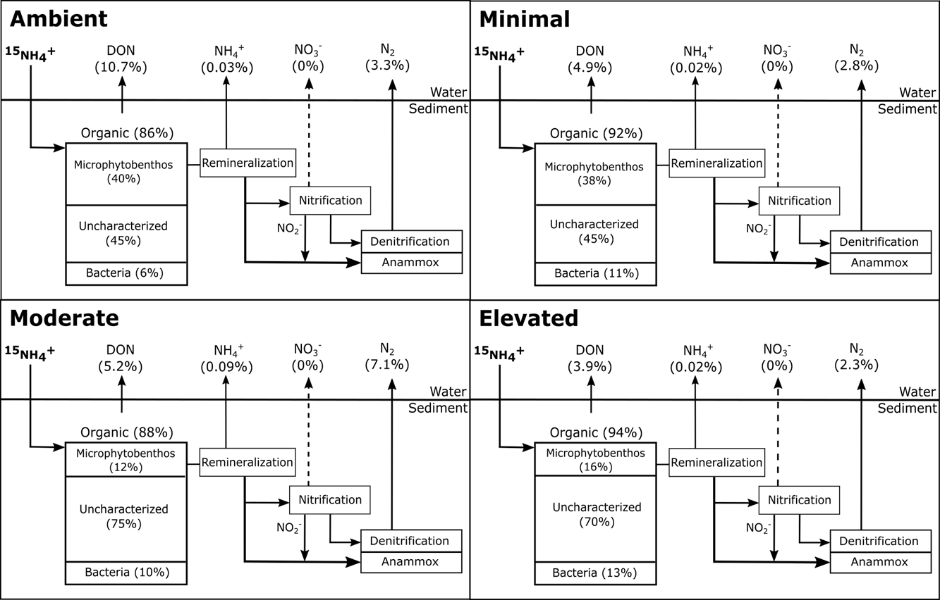

Figure 6: Conceptual model comparing the processing and fate of microphytobenthos nitrogen after 10.5 d of incubation amongst treatments. Sediment organic nitrogen is partitioned into sediment compartments (microphytobenthos, bacteria, and uncharacterized) as a percentage of ¹⁵N contained in 0-10 cm depth using biomarker analyses for 0-2 cm, 2-5 cm, and 5-10 cm depths. The dashed line for efflux of NO₃⁻ indicates that concentrations were consistently below the detection limit for ¹⁵NO₃⁻ analysis (figure modified from Eyre et al. 2016)
Acknowledgements
We thank Natasha Carlson-Perret and Jessica Riekenberg for field assistance, Iain Alexander for laboratory analysis, and Matheus Carvalho for isotope analysis. This study was funded by an Australian Research Council (ARC) Linkage Infrastructure, Equipment and Facilities grant to B.D.E. (LE0668495), an ARC Discovery Early Career Researcher Award to J.M.O. (DE120101290), an ARC Discovery grant to B.D.E. (DP160100248), and ARC Linkage Grants to B.D.E. (LP110200975; LP150100451; LP150100519).

References
Agogue H., Mallet C., Orvain F., De Crignis M., Mornet F., Dupuy C. (2014) Bacterial dynamics in a microphytobenthic biofilm: A tidal mesocosm approach. Journal of Sea Research 92, 36-45.
Cook P.L.M., Revill A.T., Butler E.C.V., Eyre B.D. (2004) Carbon and nitrogen cycling on intertidal mudflats of a temperate australian estuary. Ii. Nitrogen cycling. Marine Ecology Progress Series 280, 39-54.
Cook P.L.M., Veuger B., Boer S., Middelburg J.J. (2007) Effect of nutrient availability on carbon and nitrogen and flows through benthic algae and bacteria in near-shore sandy sediment. Aquatic Microbial Ecology 49, 165-180.
Dalsgaard T. (2003) Benthic primary production and nutrient cycling in sediments with benthic microalgae and transient accumulation of macroalgae. Limnology and Oceanography 48, 2138-2150.
Erler D.V., Wang X.T., Sigman D.M., Scheffers S.R., Shepard B.O. (2014) Control on the nitrogen isotopic composition of shallow water corals across a tropical reef flat transect. Coral Reefs 34, 329-338.
Evrard V., Cook P.L.M., Veuger B., Huettel M., Middelburg J.J. (2008) Tracing carbon and nitrogen incorporation and pathways in the microbial community of a photic subtidal sand. Aquatic Microbial Ecology 53, 257-269.
Eyre B. (1997) Water quality changes in an episodically flushed sub-tropical australian estuary: A 50 year perspective. Marine Chemistry 59, 177-187.
Eyre B., Ferguson A.P., Webb A., Maher D., Oakes J. (2011) Denitrification, n-fixation and nitrogen and phosphorus fluxes in different benthic habitats and their contribution to the nitrogen and phosphorus budgets of a shallow oligotrophic sub-tropical coastal system (southern moreton bay, australia). Biogeochemistry 102, 111-133.
Eyre B., Oakes J.M., Middelburg J.J. (2016) Fate of microphytobenthos nitrogen in subtropical sediments: A ¹⁵n pulse-chase study. Limnology and Oceanography 61, 1144-1156.
Eyre B.D. (2000) Regional evaluation of nutrient transformation and phytoplankton growth in nine river-dominated sub-tropical east australian estuaries. Marine Ecology Progress Series 205, 61-83.
Eyre B.D., Rysgaard S., Dalsgaard T., Christensen P.B. (2002) Comparison of isotope pairing and n2:Ar methods for measuring sediment denitrification—assumption, modifications, and implications. Estuaries 25, 1077-1087.
Ferguson A., Eyre B. (2013) Interaction of benthic microalgae and macrofauna in the control of benthic metabolism, nutrient fluxes and denitrification in a shallow sub-tropical coastal embayment (western moreton bay, australia). Biogeochemistry 112, 423-440.
Ferguson A.J.P., Eyre B.D., Gay J.M. (2003) Organic matter and benthic metabolism in euphotic sediments along shallow sub-tropical estuaries, northern new south wales, australia. Aquatic Microbial Ecology 33, 137-154.
Ferguson A.J.P., Eyre B.D., Gay J.M. (2004) Benthic nutrient fluxes in euphotic sediments along shallow sub-tropical estuaries, northern new south wales, australia. Aquatic Microbial Ecology 37, 219-235.
Forehead H., Thomson P., Kendrick G.A. (2013) Shifts in composition of microbial communities of subtidal sandy sediments maximise retention of nutrients. FEMS Microbiology Ecology 83, 279-298.
Goldman J.C., Dennett M.R. (2000) Growth of marine bacteria in batch and continuous culture under carbon and nitrogen limitation. Limnology and Oceanography 45, 789-800.
Hardison A., Anderson I., Canuel E., Tobias C., Veuger B. (2011) Carbon and nitrogen dynamics in shallow photic systems: Interactions between macroalgae, microalgae, and bacteria. Limnology and Oceanography 56, 1489-1503.
Howarth R.W., Marino R. (2006) Nitrogen as the limiting nutrient for eutrophication in coastal marine ecosystems: Evolving views over three decades. Limnology and Oceanography 51, 364-376.
Kaiser K., Benner R. (2005) Hydrolysis-induced racemization of amino acids. Limnology and Oceanography: Methods 3, 318-325.
Lachat. (1994) International methods list for the quickchem automated ion analyzer. Lachat Instruments, Milwaukee, WI
Lorenzen C. (1967) Determinations of chlorophyll and peopigments: Spectrophotometric equations. Limnology and Oceanography 12, 343-346.
Madigan M.T., Martinko J.M., Parker J. (2000) Brock biology of microorganisms, 9th ed., Prentice-Hall
McGlathery K.J., Sundbäck K., Anderson I.C. (2007) Eutrophication in shallow coastal bays and lagoons: The role of plants in the coastal filter. Marine Ecology Progress Series 348, 1-18.
McKee L.J., Eyre B.D., Hossain S. (2000) Transport and retention of nitrogen and phosphorus in the sub-tropical richmond river estuary, australia: A budget approach. Biogeochemistry 50, 241-278.
Middelburg J.J., Nieuwenhuize J. (2001) Nitrogen isotope tracing of dissolved inorganic nitrogen behaviour in tidal estuaries. Estuarine, Coastal and Shelf Science 53, 385-391.
Nielsen S.L., Risgaard-Petersen N., Banta G.T. (2017) Nitrogen retention in coastal marine sediments—a field study of the relative importance of biological and physical removal in a danish estuary. Estuaries and Coasts, 1-12.
Oakes J.M., Eyre B., D., Middelburg J.J. (2012) Transformation and fate of microphytobentos carbon in subtropical shallow subtidal sands: A ¹³c-labeling study. Limnology and Oceanography 57, 1846-1856.
Oakes J.M., Eyre B.D. (2014) Transformation and fate of microphytobenthos carbon in subtropical, intertidal sediments: Potential for long-term carbon retention revealed by 13c-labeling. Biogeosciences 11, 1927-1940.
Oakes J.M., Rysgaard S., Glud R.N., Eyre B.D. (2016) The transformation and fate of sub-arctic microphytobenthos carbon revealed through ¹³c-labeling. Limnology and Oceanography, 2296-2308.
Oakes J.M., Riekenberg P.M., Eyre B.D. (In Press) Fate of intertidal microphytobenthos nitrogen under enhanced nutrient availability: Evidence for reduced nitrogen retention revealed through ¹⁵N-labeling. Limnology and Oceanography: 10.1002/lno.11459
Rabalais N.N., Turner R.E., Díaz R.J., Justić D. (2009) Global change and eutrophication of coastal waters. ICES Journal of Marine Science 66, 1528-1537.
Riekenberg P.M., Oakes J.M., Eyre B.D. (2017) Uptake of dissolved organic and inorganic nitrogen in microalgae-dominated sediment: Comparing dark and light in situ and ex situ additions of ¹⁵n. Marine Ecology Progress Series 571, 29-42.
Riekenberg P.M., Oakes J.M., Eyre B.D. (2018) Short-term fate of intertidal microphytobenthos carbon under enhanced nutrient availability: A ¹³c pulse-chase experiment. Biogeosciences 15, 2873-2889.
Saburova M.A., Polikarpov I.G. (2003) Diatom activity within soft sediments: Behavioural and physiological processes. Marine Ecology Progress Series 251, 115-126.
Sigman D.M., Casciotti K.L., Andreani M., Barford C., Galanter M., Bohlke J.K. (2001) A bacterial method for the nitrogen isotopic analysis of nitrate in seawater and freshwater. Analytical Chemistry 73, 4145-4153.
Sundbäck K., Miles A. (2002) Role of microphytobenthos and denitrification for nutrient turnover in embayments with floating macroalgal mats: A spring situation. Aquatic Microbial Ecology 30, 91-101.
Sundback K., Miles A., Goransson E. (2000) Nitrogen fluxes, denitrification and the role of microphytobenthos in microtidal shallow-water sediments: An annual study. Marine Ecology Progress Series 200, 59-76.
Sundbäck K., Miles A., Linares F. (2006) Nitrogen dynamics in nontidal littoral sediments: Role of microphytobenthos and denitrification. Estuaries and Coasts 29, 1196-1211.
Thornton D.C.O., Dong L.F., Underwood G.J.C., Nedwell D.B. (2002) Factors affecting microphytobenthic biomass, species composition and production in the colne estuary (uk). Aquatic Microbial Ecology 27, 285-300.
Valderrama J. (1981) The simultaneous analysis of tp and tn in natural waters. Marine Chemistry 10, 109-122.
Van den Meersche K., Middelburg J.J., Soetaert K., Rijswijk P.v., Boschker H.T.S., Heip C. (2004) Carbon-nitrogen coupling and algal-bacterial interactions during an experimental bloom: Modeling a ¹³c tracer experiment. Limnology and Oceanography 49, 862-878.
Veuger B., Eyre B., D., Maher D., Middelburg J.J. (2007a) Nitrogen incorporation and retention by bacteria, algae, and fauna in a subtropical intertidal sediment: An in situ ¹⁵n-labeling study. Limnology and Oceanography 52, 1930-1942.
Veuger B., Middelburg J.J., Boschker H.T.S., Houtekamer M. (2005) Analysis of ¹⁵n incorporation into d-alanine: A new method for tracing nitrogen uptake by bacteria. Limnology and Oceanography: Methods 3, 230-240.
Veuger B., Middelburg J.J., Boschker H.T.S., Houtekamer M. (2007b) Update of “analysis of 15n incorporation into d-alanine: A new method for tracing nitrogen uptake by bacteria” Limnology and Oceanography: Methods 5, 192-194.
Zhang L., Altabet M.A., Taixing W., Hades O. (2007) Sensitive measurement of nh₄⁺ ¹⁵n/¹⁴n (δ¹⁵nh₄⁺) at natural abundance levels in fresh and saltwaters. Analytical Chemistry 79, 5297-5303.

Appendix
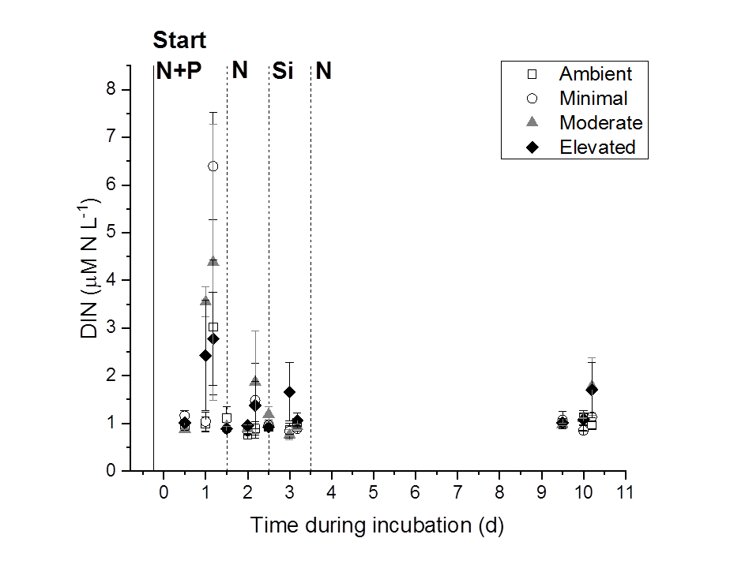
Appendix Figure 1: Dissolved inorganic nitrogen in the overlying core waters during sampling for light and dark incubations. The y-axis intercept represents the initial application of ¹⁵NH₄⁺ to the sediment. The solid line is when cores were placed into treatment tanks prior to the start of incubation. Dashed lines represent additional treatment pulses (N=NH₄⁺, P=PO₄³⁻, Si=SiO₃) that occurred during incubation.

