Shining light on priming in euphotic sediments: Nutrient enrichment stimulates export of stored organic matter
Philip M. Riekenberg^{1,2*}, Joanne M. Oakes², Bradley D. Eyre²

¹NIOZ, Royal Netherlands Institute for Sea Research and Utrecht University, Department of Marine Microbiology and Biogeochemistry, PO Box 59, Den Hoorn, 1790AB, Netherlands
²Centre for Coastal Biogeochemistry, Southern Cross University, PO Box 157, Lismore, NSW, 2480, Australia

* Corresponding author: phrieken@gmail.com +31644994652

Keywords: nutrient enrichment, microphytobenthos, carbon, priming

Teaser: Priming effects drive increased export of organic carbon from refractory sediment organic matter in euphotic intertidal zones.
Author created TOC graphic
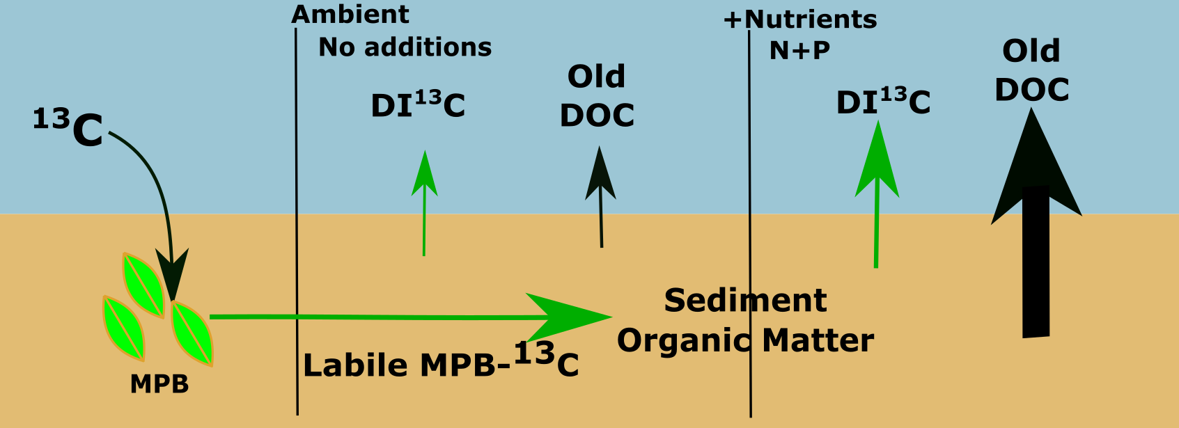
Estuarine sediments are important sites for the interception, processing and retention of organic matter, prior to its export to the coastal oceans. Stimulated microbial co-metabolism (priming) potentially increases export of refractory organic matter through increased production of hydrolytic enzymes. By using the microphytobenthos community to directly introduce a pulse of labile carbon into sediment, we traced a priming effect and assessed the decomposition and export of pre-existing organic matter. We show enhanced efflux of pre-existing carbon from intertidal sediments enriched with water column nutrients. Nutrient enrichment increased production of labile microphytobenthos-carbon which stimulated degradation of previously unavailable organic matter and led to increased liberation of “old” (6855 ± 120 years BP) refractory carbon as dissolved organic carbon. These enhanced DOC effluxes occurred at a scale that decreases estimates for global organic carbon burial in coastal systems and should be considered as an impact of eutrophication on estuarine carbon budgets.

Introduction
Estuaries, and particularly shallow photic estuarine sediments (<40 m)¹, are hotspots for organic matter (OM) processing, altering terrestrial OM received from rivers prior to its export to the coastal ocean²⁻⁴. The extent of terrestrial OM processing that occurs along the estuarine continuum largely determines whether estuaries function as carbon (C) sources or sinks⁴. The priming effect (PE) describes the additional release of C from a refractory source of OM (pre-existing sediment OM in this study, or added refractory material in others) stimulated by addition of a labile form of C. In terrestrial environments, increased C release from soils is usually measured as evolution of additional CO₂ into a headspace from amended treatments (with labile C added) when compared to non-amended controls⁵. Although PE has been well-described and explored within soils⁶, PE has only recently gained recognition in aquatic systems. Within aquatic sciences, PE has primarily been investigated as a potential pathway for additional OM processing within settings where heterotrophy dominates (e.g., riverine dissolved OM, hyporheic zone, deep sediment; Fig. 1)⁷⁻¹⁰ and has not been consistently demonstrated to occur¹¹. Occurrence of PE is highly dependent on substrate composition, sediment structure, and/or microbial community composition¹¹. Studies examining priming within coastal benthos are limited^{8,12,13}, but have found positive PEs within their limited scope (i.e., vial incubations of sediment slurries).
PE studies in aquatic environments have thus far relied on the evolution of ¹³CO₂ from dissolved inorganic carbon (DI¹³C) derived from either labile or refractory C sources (study dependent) to quantify the relative contributions from microbial processing of the ¹³C addition. A number of approaches have been used in various environments in an attempt to identify PEs, i.e., to demonstrate that microbial degradation of refractory terrestrial organic C has been stimulated following the addition of labile C^{10,14-16}. These approaches use additions of both refractory OM and labile C to stimulate mineralization of added OM^{13,17} or pre-existing sediment OM (Fig. 2A)^{8,9,12,18}. Addition of unlabeled C (refractory or labile) into the sediment confounds partitioning of export pathways by introducing new OM. Any exported C derived from this newly added OM is indistinguishable from that derived from pre-existing sediment OM. In this study, we used the in situ MPB community to inject a pulse of labile MPB¹³C into coastal sediments (Fig. 2B). This approach was intended to preserve both the production (loading rate) and composition (proportion of relative sugars) of priming additions produced daily by diatoms within highly productive shallow coastal environments^{12,19}. This method preserves the microbial community, as boundary layers and sediment structure are maintained during label addition with minimal disturbance. This differs from all other PE studies, which have directly added single labile and/or refractory compounds to homogenized sediment (Fig. 2A)^{8,9,12,13,20}.
Some PE studies account for both dissolved inorganic C (DIC) and dissolved organic carbon (DOC) pools when identifying additional stimulated breakdown and release of C^{8,14-16}, but it remains common to solely measure the evolution of DI¹³C and DIC^{9,10,13,18}. This approach works well for systems where heterotrophic evolution of DIC is the only or major pathway for C loss. However, relying on DIC effluxes alone to identify PE becomes problematic in systems where primary production during light exposure utilizes DIC at rates exceeding the evolution of respired DIC (Fig. 1B). This scenario occurs in shallow coastal benthic sediments, where there is considerable DIC demand by MPB during light periods, and can result in the re-capture and recycling of previously respired carbon. Strong uptake of DIC in euphotic settings could potentially be wrongly interpreted as a negative priming effect as labeled DIC is recycled and reincorporated into biomass instead of being evolved as ¹³CO₂. This is especially the case in systems that are DIC-limited or have elevated rates of primary productivity due to eutrophication. We argue that recycling of DIC in euphotic situations can be partially offset by refining the definition of priming to encompass all C remineralized from refractory OM (i.e., including DOC effluxes from sediment OM). In productive systems, heterotrophic bacteria are provided with rich algal-derived organic matter that can fuel breakdown of otherwise refractory pre-existing sediment OM as DOC. Measuring PEs using the evolution of DOC in addition to DIC from both labile and refractory OM sources will account for all substrates produced by the microbial community during remineralization.
From this study, we infer that: 1) amendment with nutrients (N as NH₄⁺ and phosphorous as H₃PO₄) stimulated release of labile C by MPB, leading to a PE that released additional stored refractory carbon from coastal sediments, and 2) simultaneous monitoring of both DIC and DOC fluxes was required to detect this PE. Through consideration of both DIC and DOC fluxes, we determined that there was significantly increased export of both MPB¹³C and pre-existing C despite the high productivity evidenced by negative DIC fluxes (DIC uptake). We further confirmed that additional exported DOC was derived from previously stored refractory sediment OM. Interactions between MPB and heterotrophic bacteria, stimulated through an equimolar nutrient addition of N and P equivalent to 2.5× the trigger concentration for increased trophic status under ANZECC guidelines²¹, increased the export of old carbon to the continental shelf that would otherwise be considered “locked away” in sediment OM and unavailable for processing and export. This carbon was primarily exported as DOC, representing a poorly quantified pathway for increased mobilization of blue carbon in euphotic settings that could be a significant component of OC budgets for intertidal systems²².

Methods
In January 2015 a subtropical intertidal shoal was sampled ~2 km upstream of the mouth of the Richmond River estuary in New South Wales, Australia (28°52’30”S, 153°33’26”E). A number of previous labeling studies have been undertaken at this site^{33,36}. Site sediment (0-10 cm) was mostly fine sand (66%-73%), with a total organic C content of 17.5±0.02 mol C m⁻², an average molar C:N ratio of 14.7 ± 1.5, and a MPB assemblage dominated by pennate diatoms. There was no evidence of cyanobacteria and few heterotrophs (>500 µM) observed under light microscopy (1000 ×). Foraminifera were the dominant heterotrophs (>500 µM) within site sediment.
Labeling of MPB Exudates
We applied ¹³C to MPB in situ to track the production of algal carbon that occurred during a single tidal minimum within the intertidal setting in order to track production and processing of MPB derived C. Application of stable isotope (SI) tracer material (99% NaH¹³CO₃) during a tidal low allowed for incorporation across ~ 4 hours of 1549±140 µmol ¹³C m⁻² into sediment OC followed by significant flushing of non-incorporated ¹³C from the sediment during tidal inundation of the site as confirmed by loss of 99.0% of the material in the label application based on measured incorporation in the sediment within the initial cores³². Of the ¹³C incorporated into sediment OC, ~46% or 716 µmol ¹³C is expected to be in the form of carbohydrates as calculated from uptake rates for ¹³C presented in Oakes, et al.¹⁹ for mannose, fucose, rhamnose, galactose, glucose, xylose, and OC. Bare sediment within two experimental plots (1 m²) was labeled with 99% NaH¹³CO₃ when sediments were first exposed at low tide, following the method outlined in Oakes and Eyre³³. Label applications were prepared using NaCl-amended Milli-Q to match site salinity (34.6) and 20 mL aliquots (1.7 mmol ¹³C) were applied to each individual 400 cm² subplot, resulting in a label application of 42.5 mmol ¹³C m⁻². The use of motorized sprayers and individual aliquots of label ensured even ¹³C application across the sediment surface. Assimilation of label by the sediment community occurred over ~4 hours during sediment exposure under an average light level of 1376 µE m⁻² s⁻¹. Removal of unincorporated DI¹³C by tidal flushing was confirmed, with only ~1% of the initially added ¹³C application found in the inorganic sediment C fraction within the initial cores prior to incubation.
Core Incubations
Sediment cores (20 cm depth, 9 cm diameter) were taken from the labeled plots on the second low tide after labeling, transported to the laboratory, randomly allocated between treatment tanks, and incubated under two nutrient enrichment scenarios (ambient and elevated) using 2 pulsed nutrient additions. Duplicate cores (n=2) were incubated for each time period (0.5 d, 1.5 d, 2.5 d, 3.5 d and 10.5 d) for each treatment (ambient and elevated, total core n=20). Laboratory core incubations allowed explicit control of nutrient additions, reducing the variability in water quality that occurs naturally across the tidal cycle. Pulsed applications of nutrients were used to mimic a range of nutrient concentrations without exceeding sediment capacity for uptake ³². NH₄⁺ pulses were completely taken up within 24 h of application. Treatment tanks were set up at ambient concentration (site water), and with N (NH₄⁺) and P (H₃PO₄) amendment for the elevated treatment at 10 × water column concentrations observed previously for this site (4 µmol L⁻¹ TN and 5 µmol L⁻¹ TP). These loadings are ~2× equimolar concentrations observed in the Richmond River for both TN and TP in 2006 (25.8 µmol L⁻¹ and 24.5 µmol L⁻¹, respectively) (33) and ~2.5× concentrations observed directly after flooding events in the Richmond River ³⁷ and are comparable to increased nutrient loading observed in other estuaries subject to eutrophication³⁸. The initial pulse of nutrients was added to incubation tanks and bags holding replacement water for sampling shortly prior to cores being randomly allocated to the two incubation tanks. An additional pulse of NH₄⁺ was applied to the elevated treatment tank at the end of 1.5 d in an effort to mimic the nutrient availability that occurs with regular inundation of tidal sediments. An addition of sodium metasilicate (Na₂SiO₃, 17 µmol Si L⁻¹) was added to both treatment tanks at the end of the 2.5 d to ensure that isolation of the benthic diatom-dominated sediment from regular water turnover did not result in secondary limitation of Si.
Benthic flux incubations
Cores were fitted with magnetic stir bars positioned 10 cm above the sediment surface and filled with ~2 L of site water. Water in the treatment tanks and cores was continuously recirculated, held at 25 ± 1°C by a chiller on each tank, and aerated via continuous direct injection of ambient air into the water via an air stone. Cores were stirred via a rotating magnet at the center of each treatment tank, which interacted with the magnetic stir bars fitted within each core. Stirring occurred at a rate below the threshold for sediment resuspension^{39,40}. Three high pressure sodium lamps (correlated color temperature ~2100)⁴¹ suspended above the treatment tanks provided 824 ± 40 µE m⁻² s⁻¹ to the sediment/water interface within the cores on a 12 h light/12 dark cycle. This light level is similar to the measured light level for the in situ site sediment surface during inundation (941.4 ± 139 µE m⁻² s⁻¹).
Cores were allowed to acclimate for 6 h before the incubation time began and remained open to the tank water until 30 min before initial sampling when clear Plexiglas lids were fitted to each core liner to seal in overlying water without headspace for the duration of the incubation. Rapid processing of the added MPB-C likely occurred during the 6 h acclimation period, but flux measurements were not possible during re-establishment of sediment redox layers immediately after coring. The acclimation period allowed for a robust baseline to develop prior to sampling for diel water column flux incubations. During sampling, 50 mL of water was syringe-filtered (precombusted GF/F) into precombusted 40 mL glass vials with Teflon coated septa, killed with HgCl₂ (20 µL saturated solution), and refrigerated prior to analysis for concentration and δ¹³C of DIC and DOC. Initial samples were taken 30 min after closure of the lids, dark samples were taken after ~12 hours incubation with no light, and light samples were taken 3 hours after illumination after the end of the dark sampling. Oxygen measurements were taken for the overlying water with oxygen saturation never occurring below 86.1% during the dark incubations (oxygen fluxes presented in Riekenberg, et al.³²). DIC and DOC concentrations and δ¹³C values (‰) were measured via continuous-flow wet oxidation isotope-ratio mass spectrometry using an Aurora 1030W total organic C analyzer coupled to a Thermo Delta V isotope ratio mass spectrometer (IRMS)⁴². Sodium bicarbonate (DIC) and glucose (DOC) of known isotopic composition dissolved in He-purged Milli-Q were used to correct for drift and verify both concentration and δ¹³C of samples. Reproducibility was ± 0.2 mg L⁻¹ and ± 0.1 ‰ for DIC and ± 0.2 mg L⁻¹ and ± 0.4 ‰ for DOC.
Total ¹³C in water column DIC and DOC was calculated for initial, the end of the dark period, and the end of the light period as the product of excess ¹³C (excess ¹³C in labeled sample versus relevant natural abundance control), core volume, and concentration. Total excess flux of ¹³C as DIC or DOC was then calculated as:
Excess ¹³C flux = (Excess ¹³C_{start} – Excess ¹³C_{end}) / SA / t
where excess ¹³C_{start} and excess ¹³C_{end} represent excess ¹³C of DIC or DOC at the initial and dark samplings to calculate dark flux and the dark sampling to the end of the light incubation periods to calculate the light flux, SA is sediment surface area, and t is incubation period length (h). Net fluxes of excess ¹³C (excess ¹³C m⁻² h⁻¹) for DIC and DOC were calculated as:
Net flux = ((dark flux * dark hours) + (light flux * light hours))/ 24 hours
Total carbon fluxes for DIC and DOC as well as DI¹³C and DO¹³C exported to the water column from initial labeling to each sampling period was interpolated using measured net flux values for each treatment during each sampling period (0.5 d, 1.5 d, 2.5 d, 3.5 d, and 10.5 d). Carbonate dissolution made a negligible contribution to total CO₂ during incubations and therefore no corrections were applied to DIC fluxes³².
Global flux estimates for DOC (Tg C yr⁻¹) were calculated as in Maher and Eyre²³:
DOC_{Glob} = 6.7 * (DOC_{Net} * Inter_{Area} * 365 * 12.011 ) / 10¹⁵
where 6.7 represents the increased DOC flux observed from PEs in this study, DOC_{Net} are minimum and maximum average diel DOC fluxes observed in Maher and Eyre²³ (2.7 and 3.7 mmol C m⁻² d⁻¹), Inter_{Area} is the global intertidal area 0.62 (10¹² m²)⁴³ , and 12.011 is the atomic mass of carbon required to convert from molar weight to grams of C.
Characterization of DOC Efflux
The UV-visible absorption spectra was measured from 300-700 nm on a Horiba Aqualog using a 1 cm cell. Absorbance (A) is converted to absorption coefficients (a) using a_{(λ)} = 2.303 A(λ) / l, where A(λ) is absorbance at wavelength λ and l is the path length of the cell in meters. Spectral slope was determined by fitting a₍₃₀₀₋₇₀₀₎ to a single exponential decay function using non-linear regression²⁴. The spectral slopes from both 275-295 nm (S₂₇₅₋₂₉₀) and 350-400 nm (S₃₅₀₋₄₀₀) were calculated through linear regression of the log transformed spectra. Slopes are reported as positive numbers following mathematical convention. The slope ratio (S_{R}) was calculated the ratio of S₂₇₅₋₂₉₅ and S₃₅₀₋₄₀₀. S_{R} is inversely related to the molecular size of the chromophoric dissolved organic matter (CDOM) within the sample and is expected to increase with decreasing molecular size.
SUVA 254 (L mg⁻¹ m⁻¹) is an indicator of relative aromaticity of the molecules comprising the pool of CDOM ²⁵ and is calculated as:
SUVA 254 = a₂₅₄ / DOC
where a₂₅₄ is the absorption coefficient at 254 nm (m⁻¹) and DOC is concentration of DOC (mg L⁻¹) within the sample. Elevated SUVA 254 indicates the increased presence of aromatic moieties contained within CDOM.
Radiocarbon dating of Dissolved Organic Carbon
Samples from the dark flux incubations from ambient (n=2) and elevated treatments (n=2) at 10.5 d analyzed for ¹⁴C of DOC. The ambient samples failed to successfully graphitize during analysis and were lost. Samples were selected from the dark flux to target the high concentration measurements for DOC that occurred during respiration and to avoid the potentially confounding signal from newly produced EPS from diatoms that is expected during light periods. The ¹⁴C-DOC samples were analyzed by accelerator mass spectrometry at the Australian Nuclear Science and Technology Organisation⁴⁴. DOC samples were acidified to pH < 2 and dried under vacuum in a rotary evaporator. The residue was heated in a glass tube containing CuO, Ag, and Cu wire to 600°C for 2 h to remove any sulfur compounds. The sample was then graphitized by reduction with hydrogen gas in the presence of an iron catalyst at 600°C. Results were reported in percent Modern carbon (pMC) normalized against the δ¹³C of the graphite, with an average 1σ error of the AMS readings at ± 0.3 pMC. Radiocarbon age calculations are presented as ‘conventional radiocarbon ages’ (years Before Present)⁴⁵ and not calendar ages using the equation:
¹⁴C age = -8033 × ln[(1+ Δ¹⁴C_{initial} / 1000) / (1+ Δ¹⁴C_{atm} / 1000)] ¹⁴C years
with Δ¹⁴C_{initial} as the initial radiocarbon content and Δ¹⁴C_{atm} as the radiocarbon content of the atmosphere at the time of deposition.
Results and Discussion
Treatment application and labeled exports
The pulse of labeled MPB-C produced by the in situ MPB community (1549 µmol ¹³C m⁻² added as OC) quickly underwent processing by the microbial community. Significantly more of this newly fixed C was remineralized and exported as DI¹³C under increased nutrient availability than under ambient conditions (two-way ANOVA: treatment F_{1,19}=12.3, p<0.01, day F_{4,19} =2.4, p=0.1, interaction p=0.08; Fig. 3A). Increased export in the elevated treatment was observed at 0.5 d after nutrient addition and maintained for at least 10.5 d. Cumulative export of DO¹³C was similar across treatments, with lower DO¹³C fluxes than DI¹³C fluxes, and increased significantly over 10.5 d (two- way ANOVA: treatment F_{1,19}=4.3, p=0.02, day F_{4,19} =9.4, p<0.01, interaction p=0.9; Fig.3B).
Increased DOC Efflux
MPB-C stimulated breakdown and export of pre-existing sediment OM and increased the efflux of DOC derived from this material to the water column under increased nutrient concentrations (Elevated treatment, 10.5 d, Fig. 4B). Increased efflux of DOC from pre-existing sediment OM in the elevated treatment was significantly in excess of the ambient treatment across 10.5 d (two-way ANOVA: treatment F_{1,19}=51.2; p<0.001, day F_{4,19}=27.6, p<0.001; interaction p<0.001). Efflux of DOC derived from sediment OM was larger for the elevated treatment (1.2-6.6 ×; Fig. 4B) than for the only positive efflux observed within the ambient treatment (10.5 d; 670 ± 212 µmol C m⁻² h⁻¹; Fig. 4B). Because we were able to partition completely both the non-labeled and labeled pools of C that composed DIC and DOC effluxes, we were able to identify a substantial increase in the efflux of unlabeled DOC, which comprised 86% of the cumulative total C export (Elevated 10.5 d, Fig. 4B) under increased nutrient availability. The statistically significant differences in fluxes between treatments indicate that the effects observed were robust to low power caused by limited replication (n=2 per time period).
Global DOC fluxes from intertidal zones are estimated at 7 to 10 Tg C yr⁻¹(minimum to maximum) ²³ with similarly scaled estimates from the elevated treatment in this study resulting in estimated DOC fluxes of 46.9 to 67.0 Tg C yr⁻¹. Although this estimate reflects a 6.7 × increase in DOC flux measured for this site-specific study and has considerable associated error, the magnitude of increased export of DOC from the elevated treatment is concerning given that the global estimate for total OC burial within coastal sediments is at a similar scale (300 Tg C yr⁻¹) ³. Our estimate of enhanced DOC flux likely overemphasizes the global role of PEs, given that not all intertidal zones are microphytobenthos-dominated. However, our estimate would conservatively decrease current organic carbon burial estimates by ~8 to 11% at a spatial occurrence of 50%. The scale of this effect highlights that the DOC flux increase stimulated by PEs are potentially globally significant for enhancing the removal of refractory carbon from coastal sediments.

Characterization of exported DOC
To verify that effluxed material resulted from the additional breakdown of old and refractory sediment OM, we used three approaches: UV-visible absorption spectra, C/N, and Δ¹⁴C dating. We characterized the DOC efflux for both treatments by UV-visible absorption spectra, using both slope ratio (S_{R})²⁴ and SUVA 254²⁵ to characterize size and relative aromaticity of the molecules comprising the effluxed DOC. Molecules comprising the DOC efflux within the elevated treatment had higher C/N ratios, a reduced molecular size, and increased aromaticity (Fig. 5). These combined results indicate that the DOC produced over 10.5 d was more refractory than control DOC effluxes. Although increased DOC effluxes can be associated with hypoxic or anoxic events in the sediment²⁶, the increased export of more refractory molecules in the elevated treatment here occurred under oxic conditions (lowest O₂ measurement 4.85 mg L⁻¹ at the end of dark period at 10.5 d) and DOC fluxes were comparable during dark and light periods. It is therefore unlikely that increased DOC efflux was due to either the development of hypoxic or anoxic conditions, or large shifts in redox conditions in the 20 cm sediment cores.
The old radiocarbon age (6855 ± 120 years BP) for DOC in the elevated treatment further showed that old sediment OM was broken down and exported as DOC as a result of PE. The old age of DOC resulting from the breakdown of sediment OM at the study site suggests that the material forming the sediment was composed of older scour material deposited on the mudflat. Flooding within the Richmond River occurs at regular intervals^{27,28} and dating of basal core organic matter just upstream from our study site showed an age of 5,312 - 5,583 y BP²⁹, which is similar to the age of the effluxed DOC. Given the tendency for material composed of older Δ¹⁴C to be less photo-reactive and bioavailable, and the refractory nature of the characterized compounds, the exported material is likely directly transported to the coastal shelf with minimal reworking after hydrolysis by heterotrophic bacteria in the sediment.
Is this priming?
The high C:N ratio, small molecular size, and radiocarbon age of effluxed DOC provide compelling evidence that PE occurred within the intertidal sediments in this study. Microbial processing of MPB-C under elevated nutrient loads resulted in carbon released from breakdown of older sediment OM via hydrolysis³⁰ that was largely exported via DOC effluxes (Fig.1B). The combination of a labile pulse of C, enhanced by increased nutrient availability, stimulated microbial degradation of older refractory OM, likely through increased bacterial production of hydrolytic extracellular enzymes³¹. Although we did not measure enzyme activity, increased breakdown of sediment OM was indicated by the old radiocarbon age and increased aromaticity of the increased DOC effluxes produced in the elevated treatment (Fig. 5A & B). The pulse of labile MPB-C was strongly retained within sediment OM in both treatments across 3.5 d (Fig. 3), with relatively low effluxes for DI¹³C and DO¹³C across this time resulting in relatively long estimates for MPB-C turnover (419 d ambient vs 199 d elevated)³². Strong short-term retention of MPB-C in both treatments indicates that the microbial community readily utilized the newly produced labile ¹³C and subsequently recycled respired DI¹³C to support productivity.
Respiration of older sediment OM provided increased DIC to support MPB productivity (Fig. 3A) within a system that has been previously found to be DIC-limited³³. Algal production supported by recycled DIC was captured by oxygen fluxes and production to respiration measurements, as increased bacterial respiration of OM increasingly offset initial productivity in the elevated treatment (Supplemental Fig. 1). However, these dynamics are not supported by consideration of DIC fluxes alone, as the considerable primary productivity that occurred during light periods offset the respired carbon that would have been exported in a less productive system. A potential solution to this problem could be to include DOC exports from sediment OM, a byproduct of remineralization that has not previously been considered in evaluation of PEs (Fig. 3B & 4B). It is important to acknowledge that DOC exports can also consist of MPB exudates, therefore exported DOC must be characterized as having arisen from bacterial remineralization of sediment OM. Characterization of DOC effluxes (using both molecular and radiocarbon techniques) serves to confirm that the DOC is not predominately composed of labile compounds copiously produced by MPB. Inclusion of the fluxes of DIC and DOC together enabled more complete accounting of the export of C that arose during a priming event within a highly productive benthic environment.
We posit that some of the difficulty identifying positive PEs in aquatic systems¹¹ may be due to the examination of solely heterotrophic relationships during the processing of OM. Exclusion of any interactions with primary producers misses potential co-metabolism or processes that occur in situ (Fig. 1 bottom), including the recapture and recycling of the products of PE (CO₂/DIC) during high productivity. This is largely an artefact of PE studies having been developed in soils^{5,34} where remineralization is the sole process affecting the respiratory CO₂ evolution, primary producers (MPB) are absent, and CO₂ is easily monitored as a production only function (Fig. 1 top). In aquatic systems, the evolution of CO₂ is likely to be at least partially offset by primary productivity in many settings where priming is likely to occur (e.g. shallow benthic microbial communities, suspended estuarine microbial communities). Therefore CO₂ production alone does not adequately represent microbial heterotrophic processing in eupthotic systems. Further development of a standard metric for quantifying potential PEs that accounts for both respiration and production would be useful in investigating the dynamics of co-metabolism in communities containing both microbial producers and bacterial heterotrophs.
Implications
This study suggests that nutrient enrichment of coastal systems³⁵ may be an additive factor in stimulating the decomposition and export of C from sediment OM. Increased nutrient availability stimulated increased efflux of DOC sourced from older OM most likely through increased bioavailability of OM to heterotrophic bacteria. Bacterial processing increased export of sediment OC that was previously immobilized and unavailable for processing and export. DIC and nutrients that arose from bacterial remineralization likely supported MPB productivity and were recycled within the sediment by co-metabolism within the microbial community. Increased microbial recycling resulted in increased contribution of uncharacterized material to ¹³C within sediment OM in the elevated treatment³². Therefore, inclusion of the byproducts of remineralization from sediment OM (DOC) allows for more complete accounting of the C arising from PEs, especially in highly productive systems.
Increased remineralization and export of DOC under elevated nutrient conditions provides a potential PE resulting in increased C export from estuarine sediments to the continental shelves and should be further considered within blue carbon inventories for coastal sediments. This study has shown that immobilized OM in shallow photic sediments that is otherwise considered to be non-reactive and buried may become bioavailable through the combination of benthic algal production and elevated nutrient inputs. Inclusion of the DOC export from sediment OM in priming studies may allow identification of PEs in systems that include primary producers. Further development of this method has considerable potential for broad application to aquatic systems containing algal producers.
References
1 Glud, R. N. Oxygen dynamics of marine sediments. Marine Biology Research 4, 243-289 (2008).
2 Raymond, P. A. & Bauer, J. E. Use of ¹⁴C and ¹³C natural abundances for evaluating riverine, estuarine, and coastal DOC and POC sources and cycling: a review and synthesis. Organic Geochemistry 32, 469-485 (2001).
3 Bauer, J. E. et al. The changing carbon cycle of the coastal ocean. Nature 504, 61-70 (2013).
4 Cai, W.-J. Estuarine and coastal ocean carbon paradox: CO₂ sinks or sites of terrestrial carbon incineration? Annual Review of Marine Science 3, 123-145 (2011).
5 Kuzyakov, Y., Friedel, J. & Stahr, K. Review of mechanisms and quantification of priming effects. Soil Biology and Biochemistry 32, 1485-1498 (2000).
6 Blagodatskaya, Е. & Kuzyakov, Y. Mechanisms of real and apparent priming effects and their dependence on soil microbial biomass and community structure: critical review. Biology and Fertility of Soils 45 (2008).
7 Bianchi, T. S. The role of terrestrially derived organic carbon in the coastal ocean: a changing paradigm and the priming effect. Proceedings of the National Academy of Sciences 108, 19473-19481 (2011).
8 Hee, C. A., Pease, T. K., Alperin, M. J. & Martens, C. S. Dissolved organic carbon production and consumption in anoxic marine sediments: A pulsed‐tracer experiment. Limnology and oceanography 46, 1908-1920 (2001).
9 van Nugteren, P. et al. Seafloor ecosystem functioning: the importance of organic matter priming. Marine Biology 156, 2277-2287 (2009).
10 Bianchi, T. S. et al. Positive priming of terrestrially derived dissolved organic matter in a freshwater microcosm system. Geophysical Research Letters 42, 5460-5467 (2015).
11 Bengtsson, M. M., Attermeyer, K. & Catalán, N. Interactive effects on organic matter processing from soils to the ocean: are priming effects relevant in aquatic ecosystems? Hydrobiologia (2018).
12 Hannides, A. K. & Aller, R. C. Priming effect of benthic gastropod mucus on sedimentary organic matter remineralization. Limnology and Oceanography 61, 1640-1650 (2016).
13 Gontikaki, E., Thornton, B., Cornulier, T. & Witte, U. Occurrence of priming in the degradation of lignocellulose in marine sediments. PLoS ONE 10 (2015).
14 Koch, B. P., Kattner, G., Witt, M. & Passow, U. Molecular insights into the microbial formation of marine dissolved organic matter: recalcitrant or labile? Biogeosciences 11, 4173-4190 (2014).
15 Catalán, N., Kellerman, A. M., Peter, H., Carmona, F. & Tranvik, L. J. Absence of a priming effect on dissolved organic carbon degradation in lake water. Limnology and Oceanography 60, 159-168 (2015).
16 Bengtsson, M. M. et al. No evidence of aquatic priming effects in hyporheic zone microcosms. Scientific Reports 4, 5187 (2014).
17 Danger, M. et al. Benthic algae stimulate leaf litter decomposition in detritus-based headwater streams: a case of aquatic priming. Ecology 94, 1604-1613 (2013).
18 Guenet, B. et al. Fast mineralization of land-born C in inland waters: First experimental evidences of aquatic priming effect. Hydrobiologia 721, 35-44 (2014).
19 Oakes, J. M., Eyre, B., D., Middelburg, J. J. & Boschker, H. T. S. Composition, production, and loss of carbohydrates in subtropical shallow subtidal sandy sediments: rapid processing and long-term retention revealed by ¹³C-labeling. Limnology and Oceanography 55, 2126-2138 (2010).
20 Kristensen, E. & Holmer, M. Decomposition of plant materials in marine sediment exposed to different electron acceptors (O₂, NO₃⁻, and SO₄²⁻), with emphasis on substrate origin, degradation kinetics, and the role of bioturbation. Geochimica et Cosmochimica Acta 65, 419-433 (2001).
21 ANZECC. Australia and New Zealand guidelines for fresh and marine water quailty, <https://www.waterquality.gov.au/guidelines/anz-fresh-marine> (2018).
22 Macreadie, P. I. et al. The future of Blue Carbon science. Nature communications 10, 1-13 (2019).
23 Maher, D. T. & Eyre, B. D. Benthic fluxes of dissolved organic carbon in three temperate Australian estuaries: Implications for global estimates of benthic DOC fluxes. Journal of Geophysical Research: Biogeosciences 115 (2010).
24 Helms, J. R. et al. Absorption spectral slopes and slope ratios as indicators of molecular weight, source, and photobleaching of chromophoric dissolved organic matter. Limnology and Oceanography 53, 955-969 (2008).
25 Weishaar, J. L. et al. Evaluation of specific ultraviolet absorbance as an indicator of the chemical composition and reactivity of dissolved organic carbon. Environmental Science and Technology 37, 4702-4708 (2003).
26 Skoog, A. C. & Arias-Esquivel, V. A. The effect of induced anoxia and reoxygenation on benthic fluxes of organic carbon, phosphate, iron, and manganese. Science of the total environment 407, 6085-6092 (2009).
27 Eyre, B. Water quality changes in an episodically flushed sub-tropical Australian estuary: A 50 year perspective. Marine Chemistry 59, 177-187 (1997).
28 McKee, L. J., Eyre, B. D. & Hossain, S. Transport and retention of nitrogen and phosphorus in the sub-tropical Richmond River estuary, Australia – A budget approach. Biogeochemistry 50, 241-278 (2000).
29 Logan, B., Taffs, K., Eyre, B. & Zawadski, A. Assessing changes in nutrient status in the Richmond River estuary, Australia, using paleolimnological methods. J Paleolimnol 46, 597-611 (2011).
30 Arnosti, C. Microbial Extracellular Enzymes and the Marine Carbon Cycle. Annual Review of Marine Science 3, 401-425 (2011).
31 Steen, A. D., Quigley, L. N. M. & Buchan, A. Evidence for the Priming Effect in a Planktonic Estuarine Microbial Community. Frontiers in Marine Science 3 (2016).
32 Riekenberg, P. M., Oakes, J. M. & Eyre, B. D. Short-term fate of intertidal microphytobenthos carbon under enhanced nutrient availability: a ¹³C pulse-chase experiment. Biogeosciences 15, 2873-2889 (2018).
33 Oakes, J. M. & Eyre, B. D. Transformation and fate of microphytobenthos carbon in subtropical, intertidal sediments: Potential for long-term carbon retention revealed by ¹³C-labeling. Biogeosciences 11, 1927-1940 (2014).
34 Kuzyakov, Y. Priming effects: Interactions between living and dead organic matter. Soil Biology and Biochemistry 42, 1363-1371 (2010).
35 Cloern, J. E. Our evolving conceptual model of the coastal eutrophication problem. Marine ecology progress series 210, 223-253 (2001).
36 Riekenberg, P. M., Oakes, J. M. & Eyre, B. D. Uptake of dissolved organic and inorganic nitrogen in microalgae-dominated sediment: comparing dark and light in situ and ex situ additions of ¹⁵N. Marine Ecology Progress Series 571, 29-42 (2017).
37 Eyre, B. D. Regional evaluation of nutrient transformation and phytoplankton growth in nine river-dominated sub-tropical east Australian estuaries. Marine Ecology Progress Series 205, 61-83 (2000).
38 Cloern, J. E. et al. Human activities and climate variability drive fast-paced change across the world's estuarine–coastal ecosystems. Global Change Biology 22, 513-529 (2016).
39 Ferguson, A. J. P., Eyre, B. D. & Gay, J. M. Benthic nutrient fluxes in euphotic sediments along shallow sub-tropical estuaries, northern New South Wales, Australia. Aquatic Microbial Ecology 37, 219-235 (2004).
40 Eyre, B. D., Maher, D. T. & Squire, P. Quantity and quality of organic matter (detritus) drives N2 effluxes (net denitrification) across seasons, benthic habitats, and estuaries. Global Biogeochemical Cycles 27, 1083-1095 (2013).
41 Elvridge, C. D., Keith, D. M., Tuttle, B. T. & Baugh, K. E. Spectral identification of lighting type and character. Sensors 10, 3961-3988 (2010).
42 Oakes, J. M., Eyre, B. D., Ross, D. J. & Turner, S. D. Stable Isotopes Trace Estuarine Transformations of Carbon and Nitrogen from Primary- and Secondary-Treated Paper and Pulp Mill Effluent. Environmental Science & Technology 44, 7411-7417 (2010).
43 Jickells, T. & Rae, J. Biogeochemistry of Intertidal Sediments. Biogeochemistry of Intertidal Sediments, Edited by TD Jickells and JE Rae, pp. 205. ISBN 0521483069. Cambridge, UK: Cambridge University Press, June 1997., 205 (1997).
44 Fink, D. et al. The ANTARES AMS facility at ANSTO. Nuclear Instruments and Methods in Physics Research Section B: Beam Interactions with Materials and Atoms 223–224, 109-115 (2004).
45 Stuiver, M. & Polach, H. A. Reporting of ¹⁴C data. Radiocarbon 19, 355-363 (1977).

Acknowledgements: We thank I. Alexander, M. Carvalho, N. Carlson-Perret, R. Murray, B. Riekenberg, and J. Riekenberg for technical assistance and field support. Funding: This work was supported by grants from the Australian Research Council (ARC), specifically an Early Career Research Award to J.M.O (DE120101290) and a Discovery Project to B.D.E. (DP160100248). Author contributions: P.M.R., J.M.O., and B.D.E. conceived the project and designed the experiment, P.M.R. and J.M.O. performed the experiment processed samples, P.M.R., J.M.O. and B.D.E. analyzed the data, and P.M.R. wrote the manuscript with input from J.M.O. and B.D.E. Competing Interests: The authors declare that they have no competing interests. Data and materials availability: All data needed for evaluation of the conclusions within this paper are present in the paper and/or Supplementary Materials, but additional data is available from authors upon request.

Supplementary Materials:
Table S1: δ¹³C (‰) values for DIC and DOC diel fluxes across the 10.5 d incubation period.
S1: Oxygen fluxes and production/respiration measurements.
Figures
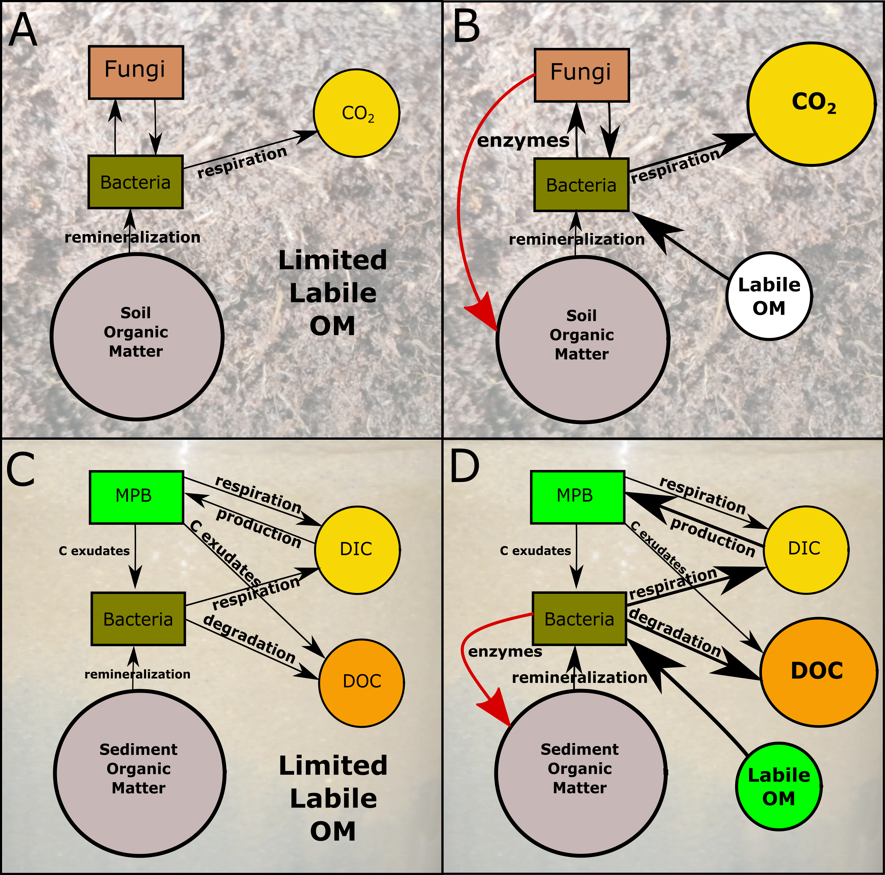
Figure 1: Fluxes of C within heterotophic dominated soil (top) and autotrophic dominated benthic sediment (bottom) under normal (left panels A and C) and B) and priming (right panels, B and D) scenarios. The red arrows indicate stimulated production of hydrolytic enzymes by fungi (B) and heterotrophic bacteria (D). Note the bi-directional flows of carbon associated with productive benthic sediments. Soil conceptual diagram (top) adapted from Kuzyakov (2010) (30). Photo credit: Philip Riekenberg, NIOZ.

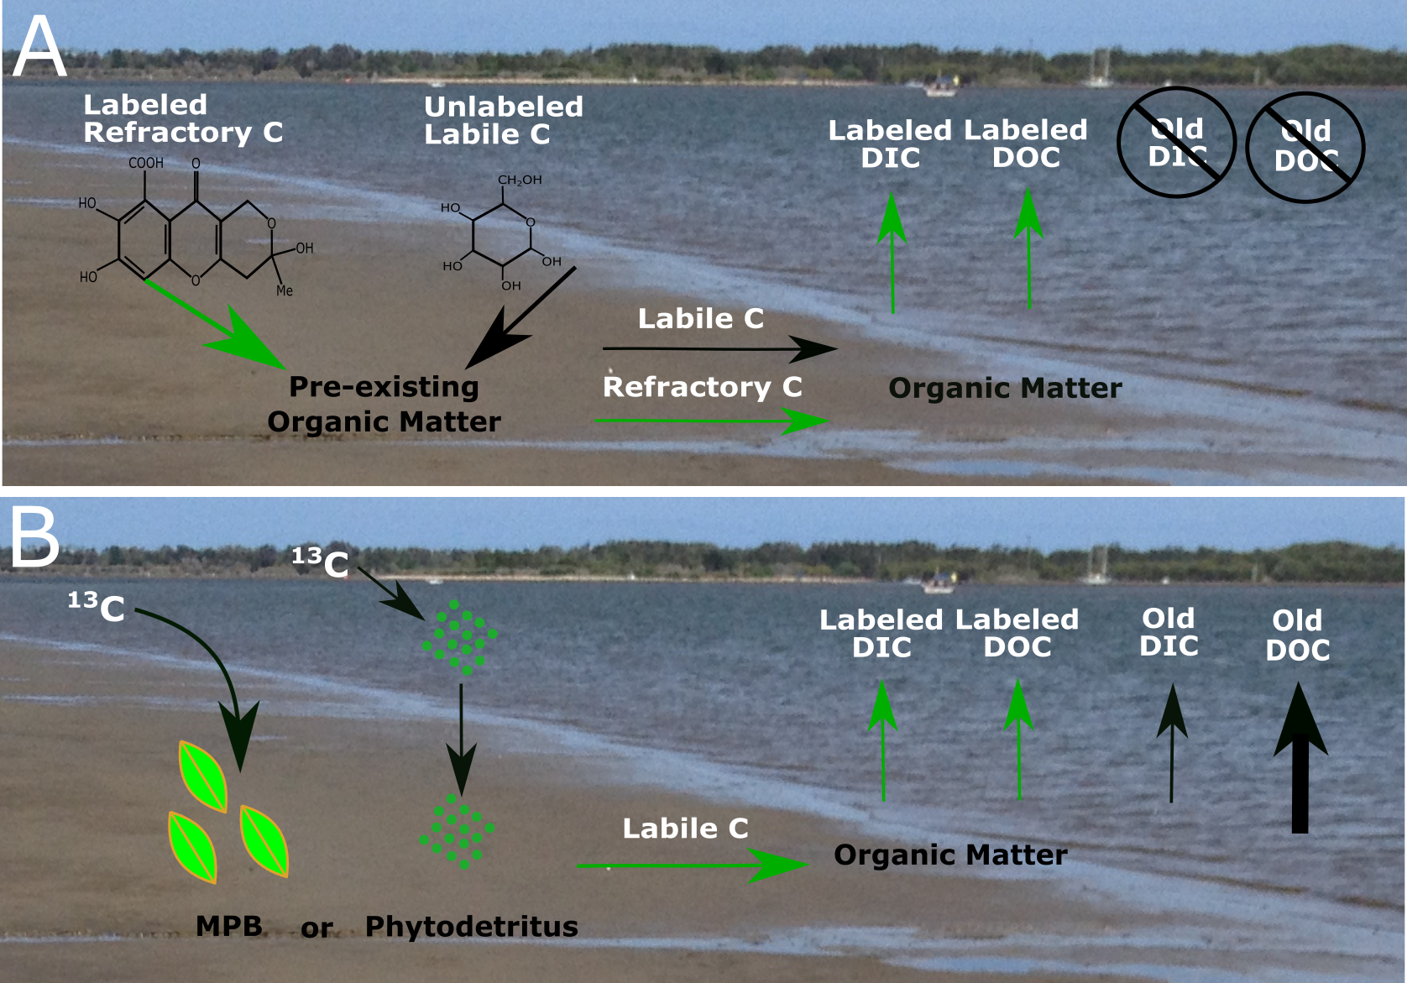
Figure 2: Method diagram comparing priming addition methods. A) Priming experiments typically introduce ¹³C-labeled labile and/or refractory material to sediment OM. The export of labeled material can then be traced as additional export occurs, but the unlabeled OM pool is muddled, making it impossible to track decomposition of pre-existing sediment OM. B) Additions of ¹³C-labeled algal-derived carbon from prepared phytodetritus or label additions processed by the in situ microphytobenthos community allow for simultaneous quantification of both non-labeled and labeled DIC and DOC effluxes. In the current study the combined addition of microphytobenthos (MPB) derived C and nutrients enhanced export of both pre-existing C from sediment OM, primarily as DOC, as well as labeled DIC. Photo credit: Philip Riekenberg, NIOZ.

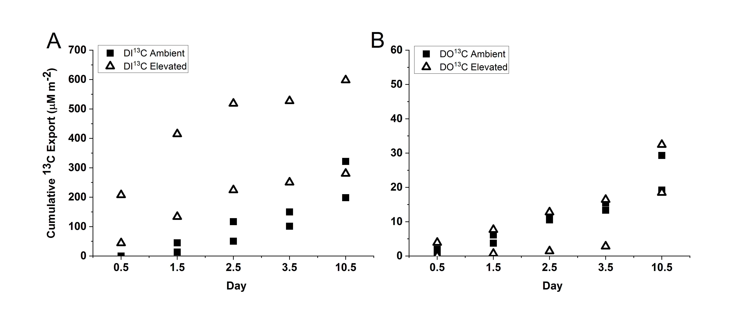
Figure 3: Cumulative export of A) DI¹³C and B) DO¹³C from the sediment for individual replicates within each treatment. Export of ¹³C represents microbial utilization and export of fixed microphytobenthos carbon from the treatment application. DI¹³C export was significantly higher in the elevated treatment than ambient (two-way ANOVA: treatment F_{1,19}=12.3, p<0.01, day F_{4,19}=2.4, p=0.1, interaction p=0.08).

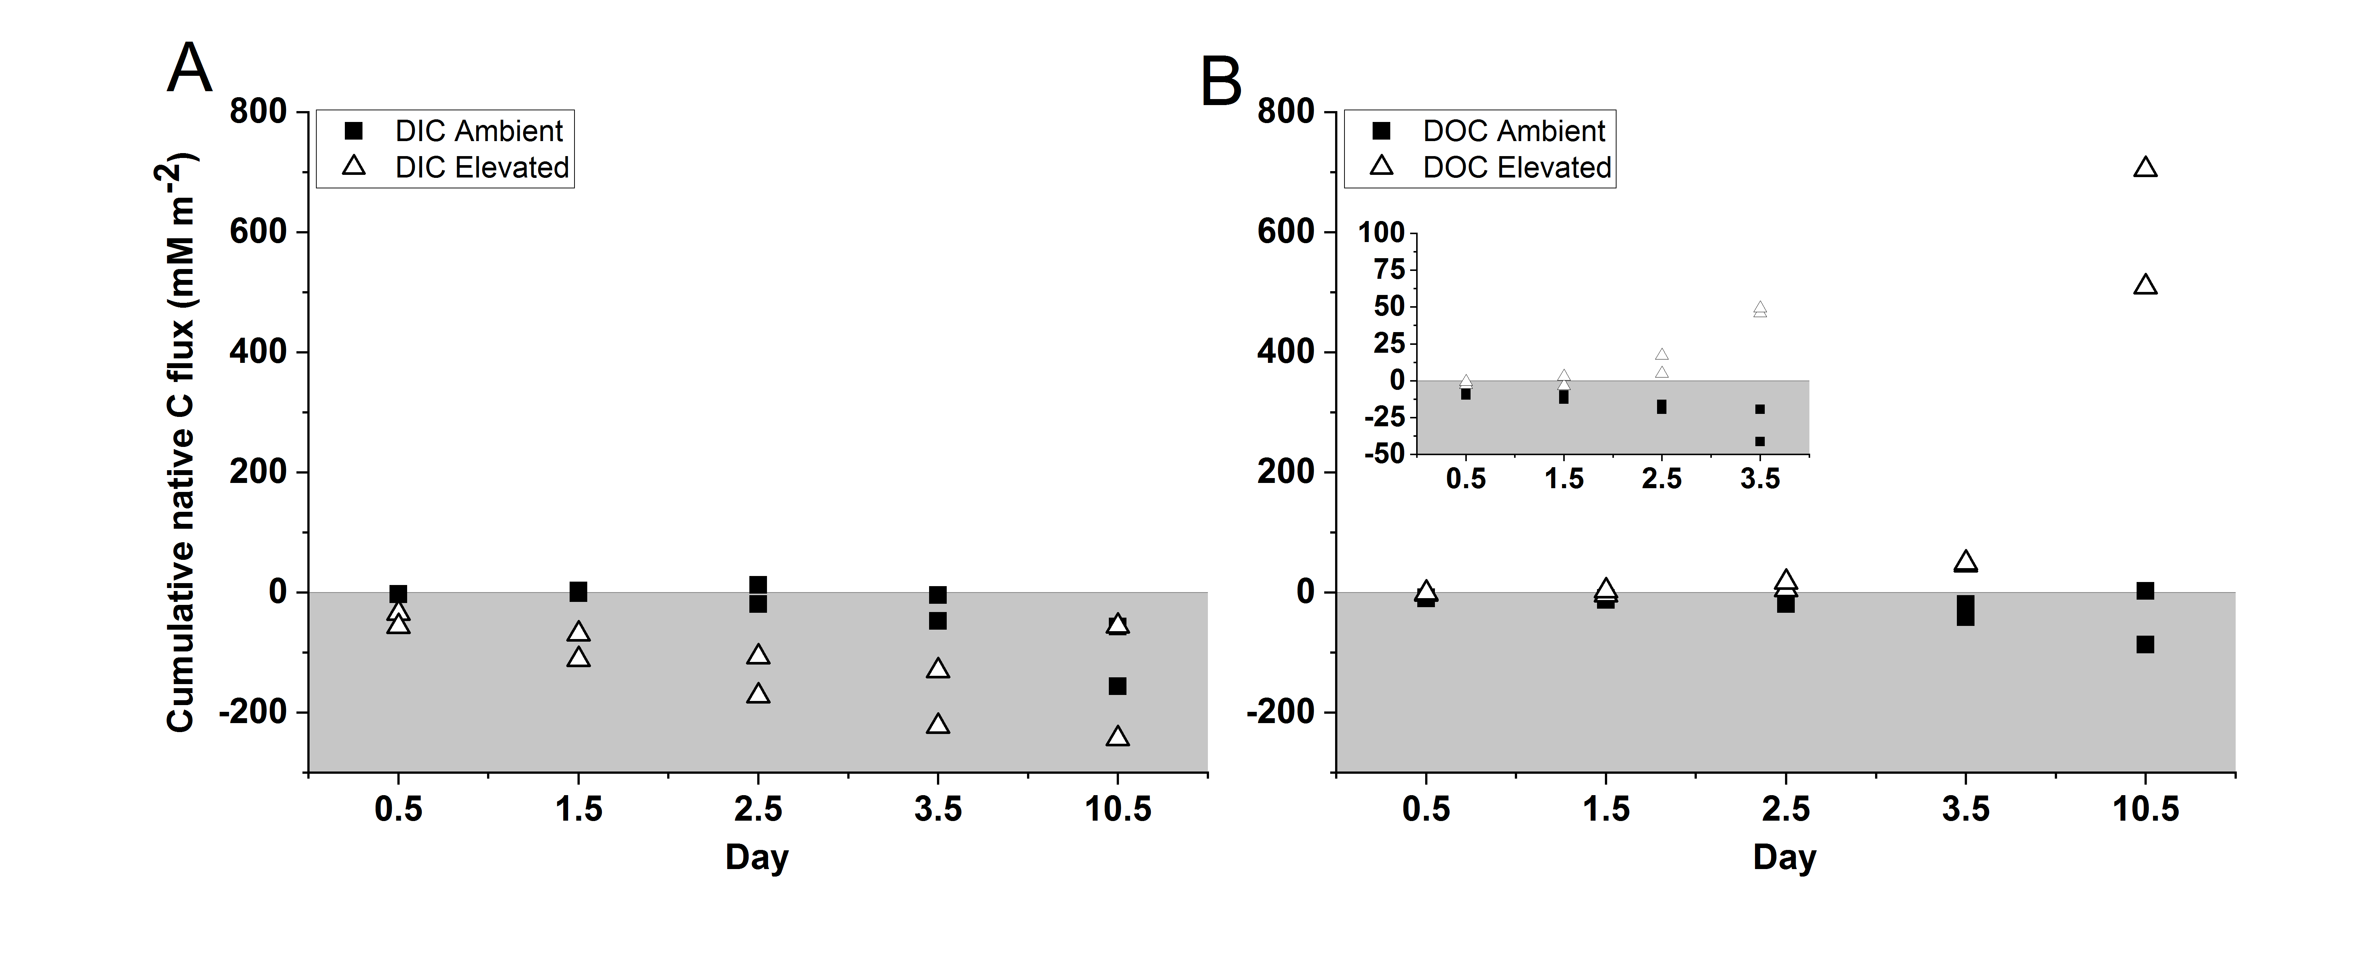
Figure 4: Cumulative flux of non-labeled A) DIC and B) DOC. DOC flux was significantly higher in the elevated treatment than ambient (two-way ANOVA: treatment F_{1,19}=51.2; p<0.001, day F_{4,19}=27.6, p<0.001; interaction p<0.001) and represents export derived from pre-existing sediment OM. Inset graph highlights the differences between ambient and elevated fluxes of DOC at 0.5-3.5 d. Grey region indicates uptake of carbon.
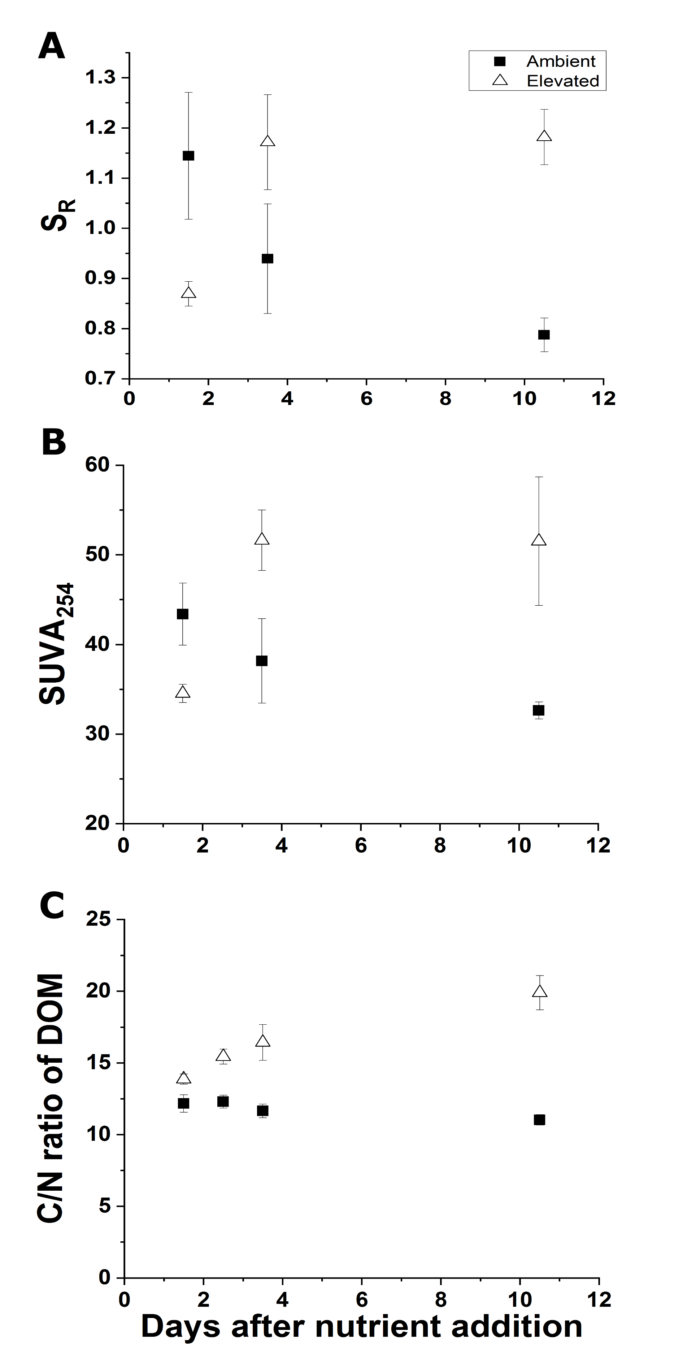
Figure 5: Characterization of DOC efflux via A) slope ratio of DOC for both treatments, B) SUVA₂₅₄ of DOC for both treatments, and C) C/N ratios for dissolved organic material efflux. All measurements for indicated treatments were performed on duplicate cores (mean±SD).
Supplemental Material
Supplemental Table 1: δ¹³C (‰) values for DIC and DOC diel fluxes across the 10.5 d incubation period. Initial measurements represent the initial dark period measurement at dusk, “Dark” measurements are the end of the dark period measured at dawn, and “Light” measurements represent the end of the photoperiod prior to supersaturation of oxygen (>100% dissolved oxygen) as required for a simultaneous measurement.
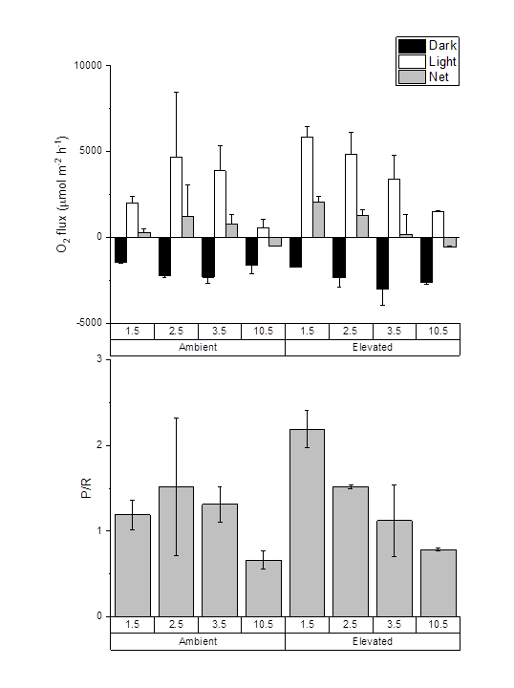
Supplemental Figure 1: Oxygen fluxes and production/respiration measurements. All measurements for indicated treatments were performed on duplicate cores.

