This manuscript has been submitted for publication in Journal of Structural Geology.
Please note that, despite having undergone peer-review, the manuscript has yet to be formally accepted for publication.
Subsequent versions of this manuscript may have slightly different content.
If accepted, the final versions of this manuscript will be available via the “Peer-reviewed Publication DOI” link on the EARTHARXIV webpage.

Please feel free to contact any of the authors; we welcome constructive feedback.

The off-fault deformation on the North Anatolian Fault Zone and assessment of slip rate from carbonate veins

Volkan KARABACAKª*, Uwe RING^{b}, I. Tonguç UYSAL^{c}

ª Department of Geological Engineering, Eskisehir Osmangazi University, Eskisehir, Turkey, karabacak@ogu.edu.tr
^{b} Department of Geological Sciences, Stockholm University, Stockholm, Sweden, uwe.ring@geo.su.se
^{c} Department of Geological Engineering, Ankara University, Ankara, Turkey, t.uysal@uq.edu.au

* corresponding author:
Professor Volkan Karabacak, PhD
Eskişehir Osmangazi University,
Department of Geological Engineering,
26040, Eskişehir, Turkey
Fax: +90 222 2290535,
Phone: +90 222 2393750/3408,
e-mail: karabacak@ogu.edu.tr

Keywords: off-fault deformation, carbonate vein, slip-rate, distributed deformation, sigmoidal simple-shear, North Anatolian Fault

Abstract
In the easternmost segment of the North Anatolian Fault (NAF) zone there are discrepancies in earthquake characteristics arising from differences between geodetically determined and geologically observed slip rates. We investigated the spatial distribution of deformation across a NAF fault segment, Turkey. Field observations were conducted on the offset of physiographic features along the principle fault and on a carbonate-filled fissure system a few hundred meters away from the main slip zone. Considering the rheology of the geological units, we propose distributed deformation across the principal fault strand in a stretching zone causing sigmoidal simple-shear rotation of the carbonate-filled fissure system. Since the fissure system is made up by previously dated alternating carbonate bands formed during distinct rupture events, the sigmoidal deformation provides an opportunity to understand the off-fault deformation rate in the stretching zone. Comparing displacement data of the sigmoidal carbonate vein with isotopic age results indicates an off-fault deformation of 15.72±2.83 mm per year for the Holocene, which corresponds to at least 50% of the geodetically estimated annual slip across the fault. The results indicate that distributed deformation needs to be taken into account in terms of the discrepancies on earthquake characteristics of active fault systems.

1. Introduction
During an earthquake, the crustal stress on different blocks is commonly released by discrete offsets along a single or a few principal fault planes (Fig. 1a-i and ii). Measurements of offsets on these discrete faults yield a slip rate that can be used to forecast the regional seismic hazard potential (e.g. Barka 1996; Rockwell et al. 2009). In some cases, the on-fault offset does not account for the total deformation monitored with geodetic measurements, since the deformation is distributed partially or even entirely to one or either side(s) of the principal fault plane, i.e. there is significant off-fault deformation in a stretching zone (Ramsay and Graham 1970; Ramsay 1980) (striped areas in Fig. 1b). Strain compatibility in this stretching zone could be preserved through brittle (e.g., microcracking, tensile/shear fractures, shifted/deformed veins) or ductile deformation (e.g., granular flow, folding, pressure-solution and dislocation creep) (e.g. Duebendorfer et al. 1998; McClymont et al. 2009; Shelef and Oskin 2010; Titus et al. 2011; Herbert et al. 2014; Bürgmann 2018; Kaduri et al. 2018). In such cases, the stress is partially unloaded in the stretching zone on one or either side of the principal fault strand. However, in this case, one or more faults are still capable of slipping along the principal planes (as is the case of the southern and northern Hayward Fault) (Lienkaemper and Williams 1999; Schimdt et al. 2005) (Fig. 1b-ii).

If crustal stress is released along principal fault planes and within the stretching zone, the distributed deformation may lead to discrepancies between geodetically determined and geologically observed slip rates (e.g. McClymont et al. 2009; Herbert et al. 2014; Milliner et al. 2016). Although total deformation can be monitored through geodetic positioning data, the resolution of satellite geodesy cannot often effectively separate on-fault and off-fault slip partitioning in the distributed deformation zone. Thus, direct geological field evidence is important for on-fault offsets and also for off-fault deformation features to characterize the total offset along a seismically active fault zone.
There are diﬀerent mechanisms leading to distributed deformation, depending on the nature of the boundaries of the fault zone with its wall rock (Fossen and Cavalcante 2017). The rheology of different rock types can control the stretching behaviour along fault zones (Burgmann 2018). For example, in some cases, deformation in stretching zones can occur on both blocks of the fault (e.g. McClymont et al. 2009; Herbert et al. 2014; Milliner et al. 2016) (Fig. 1b-i and ii); in other cases, stretching may only occur on one side of the main fault plane (e.g. Rutter et al. 2012; Fossen and Cavalcante 2017) (Fig. 1b-iii). Thus, it is crucial to understand the spatial distribution of the deformation in a fault zone to evaluate the seismic hazard of the region.
Slip rate estimations are central to seismic hazard studies and commonly rely on the interpretation of datable displacement data along the active faults (Segall 2002; Chéry and Vernant 2006; Meade et al. 2013). Different approaches for estimating slip rates have different advantages/disadvantages in providing time-resolution and/or spatial-width data of the displacement. For example, geodetic studies use spatial displacement data collected over a wide area across a central principal fault. Although the geodetic slip rate is equal to the far-field plate velocity, it is restricted to a short (recent) time period (i.e., <10² yrs). Standard geological slip rate estimations are favourable if one aims to capture longer time resolution (i.e., >10² yrs). Geological and geomorphological ﬁeld surveys for estimating a slip rate are usually conducted across restricted areas next to the principal fault. However, in some sections of the fault zone, the slip could be partitioned between parallel branches (Fig. 1a-ii). This has been demonstrated, for example, for the 1944 earthquake along the Gerede segment of the North Anatolian Fault (NAF), which ruptured a number of parallel and subparallel fault segments of various lengths, ranging from 0.4 km to 22 km (Ayhan and Koçyiğit 2010). Moreover, distributed deformation can take place over a wider zone on either side of the principal fault plane(s). For the 1944 Gerede earthquake, geodetic data suggest that the width of the deformation zone is 4.4 km, while geologic observations suggest a much more limited width of 1 km (Kaduri et al. 2018). The deformation can also be accommodated by aseismic creep across a discrete fault plane or distributed creep over a wider zone (Fig. 1b). Therefore, it is important to trace offsets on each fault segment for evaluating whether crustal stress has been released solely on the principal fault plane(s) or if there was additional distributed deformation in the wider fault zone for assessing earthquake hazards along fault zones.
Geodetic positioning of a wider area can yield an average rate of deformation for distributed deformation. However, the difference between the dominant time periods of geodetic and geological methods could restrict the comparison of the slip rate results. Extending the geodetic results to geological time scales cannot address slip rate variations with time, especially if aseismic creep processes are taken into account. Thus, it is important to 1) understand whether there is distributed deformation across a fault zone; 2) evaluate the deformation mechanism of distributed deformation in the fault zone; and 3) date the distributed deformation structures.
In this study, we focus on the distributed deformation along one of the narrowest parts of the NAF near Erzincan (Fig. 2). Direct field studies are sparse along the “1939 Erzincan Earthquake surface rupture” (1939 ER) segment of the NAF and these are limited to on-fault studies. In previous studies, results of on-fault ﬁeld surveys (i.e. paleoseismological slip rate estimation along the surface ruptures) (e.g. Hubert-Ferrari et al. 2002; Zabcı et al. 2015) yielded systematically smaller rates than geodetic results that also cover distributed deformation across a wider zone (i.e. the sum of on-fault and off-fault offsets) along the 1939 ER segment (e.g. Hubert-Ferrari et al. 2002; Reilinger et al. 2006; Walters et al. 2011; 2014; Tatar et al. 2012; Cavalié and Jónsson 2014; Çakır et al. 2014). However, the spatial resolution and time period of geodetic studies are insufficient to resolve rate differences between on-fault and off-fault deformation. In this study, we conducted a geological ﬁeld study of a fissure ridge travertine occurring a few hundred meters away from the principal fault of the 1939 ER segment (Fig. 2). The sigmoidal deformation on this carbonate-filled fissure system reflects distributed deformation across this fault segment of the NAF. The fissure system is made up by alternating carbonate bands that formed during distinct rupture events and are suitable for direct dating by the U-series technique. Therefore, investigating the carbonate vein system helps to better understand the off-fault slip rate and thus resolve the slip-rate deficit along the 1939 ER segment of the NAF.

2. Setting
The NAF is one of the best-known and largest active continental fault systems in the world. It represents a ca.1200 km-long dextral strike-slip fault zone separating the Eurasian Plate to the north and the Anatolian block to the south (Fig. 2a). The NAF is composed of a series of right lateral strike-slip segments extending from eastern Anatolia to the northern Aegean Sea (Fig. 2a). Because of its remarkable seismic activity, its importance for the neotectonics of the eastern Mediterranean region, and its close analogy to the San Andreas Fault System in California, the NAF has been the subject of numerous geological, geomorphological and seismological studies since its recognition as a major active strike-slip fault in the middle of the 20th century (Şengör et al. 2005).
Our current understanding of the origin and displacement history of the NAF has remained limited and highly controversial despite many new studies from various Earth Science disciplines having been conducted in recent years, particularly after two large earthquakes in 1999 (Kocaeli M=7.4 and Duzce M=7.2). There is an ongoing debate as to whether the NAF was initiated in the Late Miocene-Early Pliocene (Barka et al. 1992) or in the Middle Miocene (Şengör et al. 2005). More recently, geochronological work on fault gouge and hydrothermal calcite veins from the central and eastern part of the NAF (Uysal et al. 2007; Mutlu et al. 2010; Nuriel et al. 2019) obtained Late Miocene ages (8-10 Ma) that may represent either the initiation or an important reactivation episode of the NAF. Two main models have been proposed to explain the development of the NAF. (1) Aegean slab rollback creates a WSW-directed pull that “sucks” the Anatolian plate westward. Accordingly, the NAF is supposed to propagate from west to east (Chorowicz et al. 1999). (2) The tectonic escape model (Şengör 1980; Şengör et al. 1985) suggesting that the collision of the Arabian and Eurasian plates in SE Turkey is the causative event for the development of the NAF. Accordingly, the NAF is supposed to propagate from east to west (Şengör et al. 2005).

2.1. 1939 Erzincan earthquake segment of the NAF
The NAF has a relatively simple geometry in its eastern part (Barka and Kadinsky-Cade 1988; Şengör and Zabcı 2019) and the deformation is conﬁned to a narrow zone along the segment of the 1939 ER (Şengör and Zabcı 2019). The epicentre of the 1939 earthquake is near Erzincan (Barka 1996; Zabcı et al. 2011; Gürsoy et al. 2013). The 1939 ER consists of five major geometric segments (Erzincan, Mihar-Tümekar, Ortaköy-Suşehri, Kelkit Valley and Ezinepazarı) (Barka 1996; Zabcı et al. 2011; Fraser et al. 2012) (Fig. 2a). The Kelkit segment between the Suşehri and Niksar Basins is approximately 100 km long. Towards the west, the Kelkit segment is separated from the Ezinepazarı segment by bending of the fault zone to the west, and from the 1942 rupture by a releasing step-over. The Kelkit segment of the 1939 ER is represented by the narrowest morphology throughout the Kelkit River Valley (Fig. 2). The Reşadiye site forms one of the widest parts of the valley with a maximum width of 750 m in the N-S direction (Fig. 2b). The strike of the fault east of Reşadiye is 290⁰ (Fig. 2b). It extends towards the west as two parallel branches (Fig. 2b).
Kaduri et al. (2017) argue that the NAF ruptures along principal fault strands in massive limestones, while it is creeping along sections in various incompetent and less cohesive volcanic rocks. A few sections of the NAF have been identified in recent years as aseismically creeping fault strands (1943-Ladik segment, 1944-Gerede segment, 1999-Izmit segment, Fig. 1a) (Karabacak et al. 2011; Kaduri et al. 2018). Moreover, Gürsoy et al. (2013) assert that at least two sites along the Kelkit Valley segment exhibit distributed deformation within a few 10-m-wide deformation zone (5 km and 35 km west of the Reşadiye). For example, stretching of a 50 m deformation zone exists on both blocks of the principal strand of the 1939 ER around Çimenli (Gürsoy et al. 2013). At both sites of the NAF near Çimenli, the geological units are similar to the Reşadiye site on the northern block of the fault zone (see Figs. 1 and 12 in Gürsoy et al. 2013). Around Reşadiye, except for the Plio-Quaternary units, the geological units on the northern block are entirely older than those on the southern block (Fig. 2b). On the northern block, the UK3 unit is exposed to a 1-2-m-wide belt (Blumental 1950; Seymen 1975; Herece and Akay 2003) (Fig. 2b). This unit is composed of sandstone, limestones, shale, marl and volcanoclastics interbedded with marl and bentonite layers that was formed by the alteration of the tuffs (Blumental 1950; Seymen 1975; Terlemez and Yılmaz 1980). There are active hot springs along well-developed fracture systems precipitating travertines in UK3 (Fig. 2b).

2.2. Slip rate estimates for the Erzincan segment of the NAF
Since the NAF has produced a sequence of large-magnitude earthquakes in the 20th century, it represents a natural laboratory for active fault studies (Fig. 2a). As such, great efforts have been made to assess earthquake characteristics and slip rate estimates of the NAF (e.g., Barka 1996; Hubert-Ferrari et al. 2002; Zabcı et al. 2015). Particularly, the 1939 ER segment has been considered as representing a relatively simple geometry that can be easily understood in terms of slip rate evolution and assessing the seismic hazard. However, there are some remarkable discrepancies on earthquake characteristics of the 1939 ER segment, mostly related to slip rate estimates, recurrence time, and offset measurements. For example, previous studies have reported differences between slip rate measurements. Geological, geomorphological and geodetic constraints, as well as kinematic modelling yielded various displacement rates ranging from 6.5 mm/yr to 26 mm/yr for the 1939 ER segment (e.g. Hubert-Ferrari et al. 2002; Reilinger et al. 2006; Walters et al. 2011, 2014; Tatar et al. 2012; Cavalié and Jónsson 2014; Çakır et al. 2014). Hubert-Ferrari et al. (2002) suggested a Neogene slip rate of 6.5 mm/yr over 13 Myr by using large river valleys and structural markers. McClusky et al. (2000) used Euler pole estimates of the NAF for deriving a slip rate of ∼22–24 mm/yr. Reilinger et al. (2006) estimated a slightly higher slip rate of 25.3±0.2 mm/yr based on kinematic block modelling. Tatar et al. (2012) used GPS data and calculated a slip rate that increases from 16.3±2.3 mm/yr in the east to 24.0±2.9 mm/yr in the western part of the segment, with an average rate being 20.1±2.4 mm/yr. Walters et al. (2011, 2014), Cavalié and Jónsson (2014), Çakır et al. (2014) used InSAR-based velocity profiles over a >100 km region to estimate a slip rate of 20–26 mm/yr across a wide deformation zone. A geomorphological-based study about 30 km NW of Erzincan provides an average slip rate of 18.5±3.5 mm/yr for the last 11 kyr (Hubert-Ferrari et al. 2002), while offset terrace deposits east of Erzincan give a slip rate of 13-14 mm/yr for the last 7 kyr (Zabcı et al. 2015).
Discrepancies on the slip rate are explained by three main assumptions: 1) InSAR-based velocity proﬁles claim relatively constant rates (Walters et al. 2011; Cavalié and Jónsson 2014; Çakır et al. 2014), while GPS-based slip rates increase from the east to the west along the 1939 ER segment (e.g. Reilinger et al. 2006; Tatar et al. 2012; Aktuğ et al. 2013), which is interpreted to be a consequence of the Anatolian block being pulled due to Aegean slab rollback, 2) The slip rate increases from the Neogene to the Holocene associated with the recent establishment of the current plate geometry after the NAF growth (e.g. Hubert-Ferrari at al. 2002), 3) The total deformation is not only concentrated along the principal fault plane(s) of the NAF but is distributed over a wider zone (e.g. Zabcı et al. 2015).
These interpretations have implications for geologic-geodetic rate comparisons on 1939 ER segment. Most of the direct field evidence on offset along the segment comes from on-fault studies like paleoseismic trenching and offset measurements on the 1939 ER. Based on paleoseismic studies, Hartleb et al. (2006) and Kozacı (2008) suggested that the eastern NAF does not always rupture in sequences similar to the 20th‐century cluster of the fault. Moreover, along the Kelkit Valley sub-segment of the 1939 ER segment, paleoseismic trenching results on principal fault strand suggest a wide recurrence interval of large-magnitude earthquakes, as a result of relatively less strain accumulation over long periods of time (Fraser 2009; Fraser et al. 2010). The measured offsets along the 1939 ER show an abrupt and dramatic decrease on the Kelkit Valley segment (from 5-7.5 m in the eastern part to 2-4 m on the Kelkit Valley segment in the western part) (Pamir and Ketin 1941; Parejas et al. 1942; Koçyiğit 1989; Barka 1996; Zabcı et al. 2011; Gürsoy et al. 2013).
Whilst previous studies focused mainly the on-fault deformation, the off-fault deformation along the 1939 ER segment has not been investigated yet. However, as reported for other major plate boundary faults, the unrecognized oﬀ-fault deformation may be responsible for a large portion of the slip deﬁcit along the principal fault strand. For example, McClaymont et al. (2009) showed that the deformation like drag folding and horizontal rotation represents an off-fault slip deﬁcit of 41% within the Taupo Rift, New Zealand. Similarly, up to 46% off-fault deformation contributes to the overall offset in the eastern California shear zone, USA (Herbert et al. 2014; Milliner et al. 2016). In the Carboneras fault zone (Spain), Rutter et al. (2012) argues that off-fault distributed deformation occurs in a 100-km-long region on just one side of the fault zone, which takes up 50% of the overall deformation of the zone.

3. Data and Results
Offset physiographic features delineate the principal strand of the 1939 ER along the Kelkit Valley segment (Fig. 3a). Stream channels and field borders near Reşadiye are systematically cut by the principal fault (Figs. 3a-c). Right-lateral offsets range from 3 m to 11 m and are regarded as evidence of repeated Holocene activity (e.g. Zabcı et al. 2011; Gürsoy et al. 2013). The field borders and stream channels are concave on the northern block of the fault, while they are abruptly offset on the southern block (Figs. 3a-c). This geomorphological evidence indicates that the blocks on either side of the principal fault plane behave differently. Thus, if there is a distributed deformation, it is important to evaluate the deformation mechanism on the northern block of the fault plane.
Hot springs and travertine depositions occur within well-developed fracture systems on the northern block of the Kelkit segment (Fig. 2b). The Reşadiye fissure ridge is the most prominent of these travertine deposits. The travertines precipitated in a NW-striking vein system that acts as a conduit for hot waters. Since pressurized CO₂-rich spring waters in subsurface reservoirs are mobilized during sudden strain cycles (Berardi et al. 2016; Karabacak et al. 2019), carbonate deposition is associated with episodic fault activity. There are secondary fissure veins parallel to the local S_{Hmax} direction (315-320⁰) (World Stress Map Project database; Heidbach et al. 2016) (Fig. 4a). Fault planes and slickenlines on bedrocks also support NW-trending S_{Hmax} (Figs. 3d and e).
Alternating bands with thicknesses of a few millimetres to several centimetres occur parallel to the vein walls consisting of successively deposited bedded travertines (Figs. 4b and c). In line with previous studies, deposition of vertically banded carbonate bands is considered to be a result of repeated strain cycles and episodic dilation (e.g., Altunel and Karabacak 2005; Uysal et al. 2011; Nuriel et al. 2012; Brogi and Capezzuoli 2014; Brogi et al. 2017; Karabacak et al. 2017). Karabacak et al. (2019) studied the Reşadiye fissure ridge travertines in detail and correlated the timing of carbonate precipitation with historical earthquake records. U-series age data from banded travertines along the fissure-ridge reflect the frequency of carbonate precipitation over the last 7000 years (i.e. the oldest travertine at 6.957±0.657 kyr BP) (Fig. 4c). Recently, Mesci et al. (2019) reported the oldest carbonate precipitations along the Reşadiye fissure ridge (i.e. the oldest 12.529±1.898 kyr BP). In total, 24 carbonate bands were dated on the both studies (Table 1). We assessed the statistical distributions of U‐series age results using relative probability plots (calculated from DensityPlotter 8.5, Vermeesch 2012) (Fig. 5). The probability plot shows the oldest age peak at 12.3±1.9 kyr, a date that indicates the onset of vein formation.
The Reşadiye fissure ridge presents a sigmoidal geometry in plain view (Figs. 2b and 4a), which has long been known to be one of the most characteristic structures of shear zones (Ramsay and Graham 1970; Hancock 1972). The sigmoidal structures originate as tensile fractures evolve towards a sigmoidal geometry with progressive right-lateral deformation (Beach 1975) (Fig. 6a). The total lateral displacement across the shear zone, dx, can be calculated assuming a straight pre-deformation strike across a simple shear zone (Ramsay 1980; Lisle 2013) (Figs. 6b and c).
Since we assumed that the pre-deformation tensile fracture was parallel to S_{Hmax}, we could use the S_{Hmax} as a pre-deformation tensile fracture axis. When we superpose the S_{Hmax} axis and the current sigmoidal fractures, maximum distances between them appear towards east and west. If we measure the maximum distances parallel to the principle fault line (i.e. dx in Fig. 6d), it gives a total 188±5 m right lateral deformation.

4. Discussions and Conclusion
Although the 1939 ER segment has a relatively simple geometry and is conﬁned to a narrow zone (Barka and Kadinsky-Cade 1988; Şengör et al. 2005), there are some remarkable discrepancies on earthquake characteristics along the Kelkit Valley segment in terms of slip rate estimates, recurrence time and offset measurements. To explain these discrepancies, we propose that the fault zone behaves as a stretching zone (Fig. 7). This model does not require uniform stretching on both blocks. While one block is deformed by distributed deformation, the other one remains undeformed so that a fault could develop between them (Rutter et al. 2012; Fossen and Cavalcante 2017) (Fig. 7).
In the study area, physiographic features of offset stream channels and field borders along the principal fault demonstrate different behaviours between the northern and southern blocks. A stream channel offset by the fault is almost perpendicular to the fault on the southern block (“r” in Fig. 3a), while it has a concave geometry on the northern block. Moreover, with increasing offset on the older stream channels, the concavity decreases and the alignment of the northern channels changes from oblique to subparallel to the principal fault plane (from “r3” to “r1” on the northern block in Fig. 3a). After they are deflected abruptly like a brittle string, linear elements like stream channels are deflected to a concave geometry by lateral migration processes on the other block towards the topographic slope direction with time (e.g. Huang 1993). The concavity of the offset stream channels and field borders occur on the opposite block towards the slope direction. This phenomenon could be interpreted in two ways: 1) the northern block may be more prone to erosional processes than the southern block, and/or 2) there could be stretching in a wide deformation zone on the northern block of the principal fault strand. On the northern block of the Kelkit segment, the UK3 unit outcrops in a belt with 1-2 km width (Fig. 2b). This belt extends about 20 km along strike. The principal fault strand of the NAF that ruptured during the 1939 ER forms the southern boundary of the unit. The UK3 unit consists of interbedded marl and bentonite and exhibits a fractured and fragmented structure in the study area. Moreover, mineralogical investigations around Reşadiye show intense hydrothermal alteration along the principal fault plane (Mutlu et al. 2010). Considering the alterations and the fractured and fragmented structure, it can be assumed that the UK3 unit may be a suitable candidate for a distributed deformation in the stretching zone leading the sigmoidal deformation of Reşadiye fissure ridge on this block.
Sigmoidal fractures episodically filled with datable material provide valuable information about the deformation rate. Thus, comparing displacement data (dx= 188±5 m) with the isotopic age results (12.3±1.9 kyr) reveals a deformation rate of 15.72±2.83 mm per year for the Holocene. This rate is lower than geodetic measurements focused on wider deformation area along the fault zone (e.g. Reilinger et al. 2006; Walters et al. 2011, 2014; Tatar et al. 2012; Cavalié and Jónsson 2014; Çakır et al. 2014). If we take the geodetic slip rate in consideration, it requires a distributed deformation on a wider zone. Estimated off-fault rate (i.e. between 12.89 and 18.55 mm/yr) corresponds to at least 50% of the geodetically estimated yearly slip (~25 mm/yr). Thus considering a 15.72±2.83 mm/yr stretching rate, we can conclude that the strain on the NAF around Reşadiye is partially unloaded in a 1-1.5 km width zone on the northern block of the NAF principal strand. However, these sections of the NAF are still capable of generating discrete oﬀset, since ~50% of the annual slip still accumulates on the principal fault. Thus, the proposed model can explain the discrepancies on earthquake characteristics (i.e. slip rate, recurrence time and offset measurements) of the Kelkit Valley segment principal fault. The distribution of the on-fault and off-fault slip in the region could not be resolved with the resolution of geodetic methods due to narrower deformation zone. In any case, further detailed field studies are needed to resolve this issue.
In conclusion, our results indicate that the deformation of the NAF should not be interpreted simply as a discrete offset and/or creep process along only the principal fault strand. The distributed deformation controlled by geological properties (e.g., microcracking, tensile/shear fractures, shifted/deformed veins, granular flow, folding, pressure-solution and dislocation creep) should also be taken in consideration. Future studies should not only rely on high-resolution geodetic monitoring of distributed deformation, but also consider geological field surveys of off-fault properties in terms of slip estimations and probabilistic earthquake hazards.

References
Aktuğ, B., Dikmen, Ü., Doğru, A., Özener, H., 2013. Seismicity and strain accumulation around Karlıova Triple Junction (Turkey), J. Geodyn., 67, 21–29, doi:10.1016/j.jog.2012.04.008.
Altunel, E., Karabacak, V., 2005. Determination of horizontal extension from fissure-ridge travertines: a case study in the Denizli Basin, southwestern Turkey, Geodinamica Acta, 18/3-4 (2005) 333-342.
Ayhan, M.E., Koçyiğit, A., 2010. Displacements and Kinematics of the February 1, 1944 Gerede Earthquake (North Anatolian Fault System, Turkey): Geodetic and Geological Constraints, Turkish Journal of Earth Sciences, 19, 285-311.
Barka, A.A., 1992. The North Anatolian fault zone, Annales Tectonicae, v. 6, suppl., p. 164–195.
Barka, A.A., 1996. Slip distribution along the North Anatolian Fault associated with the large earthquakes of the period 1939 to 1967, B. Seismol. Soc. Am., 86, 1238-1254.
Barka, A.A., Kadinsky-Cade, K., 1988. Strike-slip fault geometry in Turkey and its inﬂuence on earthquake activity, Tectonics, 7(3), 663–684, doi:10.1029/TC007i003p00663.
Beach, A., 1975. The geometry of en-echelon vein arrays. Tectonophysics 28, 245-263.
Berardi, G., Vignaroli, G., Billi, A., Rossetti, F., Soligo, M., Kele, S., Baykara, M.O., Bernasconi, S.M., Castorina, F., Tecce, F., Shenet, C.C., 2016. Growth of a Pleistocene giant carbonate vein and nearby thermogene travertine deposits at Semproniano, southern Tuscany, Italy: estimate of CO2 leakage, Tectonophysics, 690, 219-239.
Blumenthal, M., 1950. Orta ve Aşağı Yeşilırmak Bölgelerinin (Tokat, Amasya, Havza, Erbaa, Niksar) jeolojisi hakkında, Maden Tetkik ve Arama Genel Müdürlüğü, Seri D, No.4, Ankara-Turkey.
Brogi, A., Capezzuoli, E., 2014. Earthquake impact on fissure-ridge type travertine deposition, Geological Magazine, 151, 1135-1143.
Brogi, A., Capezzuoli, E., Kele, S., Baykara, M.O., Shen, C.C., 2017. Key travertine tectofacies for neotectonics and palaeoseismicity reconstruction: effects of hydrothermal overpressured fluid injection, Journal of the Geological Society, 174(4), 679.
Burgmann, R., 2018. The geophysics, geology and mechanics of slow fault slip. Earth and Planetary Science Letters, 495, 112–134.
Cavalié, O., Jónsson, S., 2014. Block-like plate movements in eastern Anatolia observed by InSAR, Geophys. Res. Lett., 41, 26–31, doi:10.1002/2013GL058170.
Chéry, J., Vernant, P., 2006. Lithospheric elasticity promotes episodic fault activity, Earth Planet. Sci. Lett., 243(1–2), 211–217, doi:10.1016/j.epsl.2005.12.014.
Chorowicz, J., Dhont, D., Gündoğdu, N., 1999. Neotectonics in the eastern North Anatolian fault region (Turkey) advocates crustal extension: mapping from SAR ERS imagery and Digital Elevation Model, Journal of Structural Geology 21, 511-532.
Çakır, Z., Ergintav, S., Akoğlu, A.M., Çakmak, R., Tatar, O., Meghraoui M., 2014. InSAR velocity field across the North Anatolian Fault (eastern Turkey): Implications for the loading and release of interseismic strain accumulation, J. Geophys. Res. Solid Earth, 119, 7934–7943, doi:10.1002/2014JB011360.
Duebendorfer, E.M., Vermilye, J., Geiser, P.A., Davis, T.L., 1998. Evidence for aseismic deformation in the western Transverse Ranges, southern California: Implications for seismic risk assessment, Geology, 26(3), 271–274.
Emre, Ö., Duman, T.Y., Kondo, H., Özalp, S., Elmacı, H., 2012. 1:250,000 Scale Active Fault Map Series of Turkey, Tokat (NK 37-13) Quadrangle. Serial Number: 35, General Directorate of Mineral Research and Exploration, Ankara-Turkey.
Fossen, H., Cavalcante, G.C.G., 2017. Shear zones—a review. Earth-Science Reviews, 171, 434–455. https://doi.org/10.1016/j.earscirev.2017.05.002
Fraser, J.G., 2009. Four new paleoseismic investigations on the North Anatolian Fault, Turkey, in the context of existing data, PhD thesis, Univ. Libre de Bruxelles, Belgium, Brussels, 284 pp.
Fraser, J.G., Hubert-Ferrari, A., Verbeeck, K., Garcia-Moreno, D., Avşar, U., Maricq, N., Coudijzer, A., Vlamynck, N., Vanneste, K., 2012. A 3000-year record of surface-rupturing earthquakes at Günalan: variable fault-rupture lengths along the 1939 Erzincan earthquake-rupture segment of the North Anatolian Fault, Turkey, Annals of Geophysics, 55, 5, 895-927.
Fraser, J.G., Vanneste, K., Hubert-Ferrari, A., 2010. Recent behavior of the North Anatolian Fault: Insights from an integrated paleoseismological data set, J. Geophys. Res., 115, B09316; doi:10.1029/2009JB006982.
Gürsoy, G., Tatar, O., Akpınar, Z., Polat, A., Mesci, L., Tunçer, D., 2013. New observations on the 1939 Erzincan Earthquake surface rupture on the Kelkit Valley segment of the North Anatolian Fault Zone, Turkey, Journal of Geodynamics, 65, 259-271.
Hancock, P.L., 1972. The analysis of en-echelon veins. Geological Magazine 109, 1591-1599.
Hartleb, R.D., Dolan, J.F., Kozacı, O., Akyüz, H.S., Seitz, G.G., 2006. A 2500-yr-long paleoseismologic record of large, infrequent earthquakes on the North Anatolian fault at Cukurcimen, Turkey, Bull. Seismol. Soc. Am., 118, 823-840; doi:10.1130/B25838.1.
Heidbach, O., Custodio, S., Kingdon, A., Mariucci, M.T., Montone, P., Müller, B., Pierdominici, S., Rajabi, M., Reinecker, J., Reiter, K., Tingay, M., Williams, J., Ziegler, M., 2016. Stress Map of the Mediterranean and Central Europe 2016. GFZ Data Services. http://doi.org/10.5880/WSM.Europe2016.
Herbert, J.W., Cooke, M.L., Oskin, M., Difo O., 2014. How much can off-fault deformation contribute to the slip rate discrepancy within the eastern California shear zone?, Geology, 42(1), 71–74.
Herece, E., Akay, E., 2003. 1:100,000 Scale Geological Map Series along the North Anatolian Fault (NAF), Special Publication series, Reşadiye-Koyulhisar (appendix 10), General Directorate of Mineral Research and Exploration, Ankara-Turkey.
Huang, W., 1993. Morphologic patterns of stream channels on the active Yishi Fault, southern Shandong Province, Eastern China: Implications for repeated great earthquakes in the Holocene: Tectonophysics, v. 219, no. 4, p. 283-304.
Hubert-Ferrari, A., Armijo, R., King, G., Meyer, B., Barka, A.A., 2002. Morphology, displacement, and slip rates along the North Anatolian Fault, Turkey, J. Geophys.Res., 107; doi:10.1029/2001JB000393.
Kaduri, M., Gratier, J.-P., Lesser, C., Çakır, Z., Renard, F., 2018. Quantifying the partition between seismic and aseismic deformation along creeping and locked sections of the North Anatolian Fault, Turkey. Pure Appl. Geophys., 176, 1293-1321, https://doi.org/10.1007/s00024-018-2027-2.
Kaduri, M., Gratier, J.-P., Renard, F., Çakır, Z., Lasserre, C., 2017. The implications of fault zone transformation on aseismic creep: Example of the North Anatolian Fault, Turkey. Journal of Geophysical Research Solid Earth., 122, 4208–4236.
Karabacak, V., Altunel, E., Çakır, Z., 2011. Monitoring aseismic surface creep along the North Anatolian Fault (Turkey) using ground-based LIDAR, Earth and Planetary Science Letters, 304 (2011), 64-70.
Karabacak, V., Uysal, I.T., Mutlu, H., Ünal-İmer, E., Dirik, R.K., Feng, Y-X., Akiska, S., Aydoğdu, I., Zhao, J-X., 2019. Are U-Th dates correlated with historical records of earthquakes? Constraints from co-seismic carbonate veins within the North Anatolian Fault Zone, Tectonics, 38, 7, 2431-2448.
Karabacak, V., Uysal, İ.T., Ünal-İmer, E., Mutlu, H., Zhao, J-X., 2017. U-Th age evidence from carbonate veins for episodic crustal deformation of Central Anatolia Volcanic Province, Quaternary Science Reviews, 177, 158-172.
Koçyiğit, A., 1989. Suşehri Basin; an active fault wedge basin. Tectonophysics , 167, 13–29.
Kozacı, Ö., 2008. Constancy of strain release rates along the North Anatolian Fault, PhD thesis, 174 pp, Univ. of South. Calif., Los Angeles
Lienkaemper, J.J., Williams, P.L., 1999. Evidence for surface rupture in 1868 on the Hayward fault in north Oakland and major rupturing in prehistoric earthquakes. Geophys. Res. Lett. 26, 1949–1952.
Lisle, R.J., 2013. Shear zone deformation determined from sigmoidal tension gashes. Journal of Structural Geology 50, 35-43.
McClusky, S.C., Balassanian, S., Barka, A., Ergintav, S., Georgie, I., Gurkan, O.,Hamburger,M., Hurst, K., Kahle, H., Kastens, K., Kekelidse, G., King, R., Kotzev, V., Lenk, O.,Mahmout, S., Mishin, A., Nadaria, M., Ouzounis, A., Paradisissis, D., Peter, Y., Pirilepin, M., Reilinger, R.E., Şanli, I., Seeger, H., Teableb, A., Toksöz, N., Veis, V., 2000. Global Positioning System constraints on plate kinematics and dynamics in the eastern Mediterreanen Caucasus, Journal of Geophysical Research, 105, 5695–5719.
McClymont, A.F., Villamor, P., Green, A.G., 2009. Assessing the contribution of off-fault deformation to slip-rate estimates within the Taupo Rift, New Zealand, using 3-D ground-penetrating radar surveying and trenching, Terra Nova, 21(6), 446–451, doi:10.1111/j.1365-3121.2009.00901.x.
Meade, B.J., Klinger, Y., Hetland, E.A., 2013. Inference of multiple earthquake-cycle relaxation timescales from irregular geodetic sampling of interseismic deformation, Bull. Seismol. Soc. Am., 103(5), 2824–2835, doi:10.1785/0120130006.
Mesci, L., Gürsoy, H., Galheb, B., Tatar, O., 2020. An extensional fracture acting as hot water source for travertine deposition on the North Anatolian Fault Zone, Turkey: the Reşadiye fissure-ridge, Geological Bulletin of Turkey, 63 (2020), 1-16.
Milliner, C. W. D., Dolan, J.F., Hollingsworth, J., Leprince, S., Ayoub, F., 2016. Comparison of coseismic near-ﬁeld and off-fault surface deformation patterns of the 1992 Mw 7.3 Landers and 1999 Mw 7.1 Hector Mine earthquakes: Implications for controls on the distribution of surface strain, Geophysical Research Letters, 43, 19, 115-124.
Mutlu, H., Uysal, I.T., Altunel, E., Karabacak, V., Feng, Y., Zhao, J-X., Atalay, O., 2010. Rb–Sr systematics of fault clays from the North Anatolian Fault Zone (Turkey), Journal of Structural Geology, 32, 2 (2010), 216-221.
Nuriel, P., Craddock, J., Kylander-Clark, A.R.C., Uysal, I.T., Karabacak, V., Dirik, R.K., Hacker, B.R., Weinberger, R., 2019. Reactivation history of the North Anatolian Fault Zone based on calcite age-strain analyses, Geology, 47 (5), 465-469.
Nuriel, P., Rosenbaum, G., Zhao, J.-X., Feng, Y., Golding, S.D., Villemant, B., Weinberger, R., 2012. U-Th dating of striated fault planes, Geology, 40, 7, 647-650.
Pamir, H.N., Ketin, I., 1941. Das Anatolische Erdbeben Ende 1939. Geologische Rundschau, 32, 278–287.
Parejas, E., Akyol, I.H., Altınlı, E., 1942. Le tremblement de terre d’Erzincan du 17 Decembre 1939. Review of the Faculty of Science, University of Istanbul NVI, 177–222.
Ramsay, J.G., 1980. Shear zone geometry: a review. Journal of Structural Geology 2, 83-99.
Ramsay, J.G., Graham, R.H., 1970. Strain variation in shear belts. Canadian Journal of Earth Sciences 7, 786-813.
Reilinger, R., McClusky, S.,Vernant, P., Lawrence, S., Ergintav, S., Cakmak, R., Ozener, H., Kadirov, F., Guliev, I., Stepanyan, R., Nadariya, M., Hahubia, G., Mahmoud, S., Sakr, K., ArRajehi, A., Paradissis, D., Al-Aydrus, A., Prilepin,M., Guseva, T., Evren, E., Dmitrotsa, A., Filikov, S.V., Gomez, F., Al-Ghazzi, R., Karam, G., 2006. GPS constraints on continental deformation in the Africa–Arabia–Eurasia continental collision zone and implications for the dynamics of plate interactions. Journal of Geophysical Research—Solid Earth 111, No. B05411, doi:10.1029/2005JB004051.
Rockwell, T., Ragona, D., Seitz, G., Langridge, R., Aksoy, M.E., Ucarkus, G., Ferry, M., Meltzner, A.J., Klinger, Y., Meghraoui, M., Satir, D., Barka, A., Akbalik, B., 2009. Palaeoseismology of the North Anatolian Fault near the Marmara Sea: Implications for fault segmentation and seismic hazard, in Palaeoseismology: Historical and Prehistorical Records of Earthquake Ground Effects for Seismic Hazard Assessment, edited by K. Reicherter, A. M. Michetti, and P. G. Silva, Geol. Soc. Spec. Publ., 316(1), 31–54, doi:10.1144/SP316.3
Rutter, E.H., Faulkner, D.R., Burgess, R., 2012. Structure and geological history of the Carboneras Fault Zone, SE Spain: Part of a stretching transform fault system, Journal of Structural Geology 45 (2012) 68-86.
Schimdt, D.A., Bürgmann, R., Nadeau, R.M., d'Alessio, M.A., 2005. Distribution of aseismic slip-rate on the Hayward fault inferred from seismic and geodetic data. J. Geophys. Res. 110, B08406. doi:10.1029/2004JB003397.
Segall, P., 2002. Integrating geologic and geodetic estimates of slip rate on the San Andreas fault system, Int. Geol. Rev., 44(1), 62–82, doi:10.2747/0020-6814.44.1.62
Seymen, İ., 1975. Kelkit Vadisi kesiminde Kuzey Anadolu Fay Zonu’nun tektonik özellikleri, Doktora Tezi, İstanbul Teknik Üniversitesi, Maden Fakültesi, İstanbul-Turkey.
Shelef, E., Oskin, M., 2010. Deformation processes adjacent to active faults: Examples from eastern California, J. Geophys. Res., 115, B05308, doi:10.1029/2009JB006289.
Şengör, A., Tuysuz, O., Imren, C., Sakinc, M., Eyidogan, H., Gorur, N., Le Pichon, X., Rangin, C., 2005. The North Anatolian Fault: A New Look, Annu. Rev. Earth .Pl. Sc., 33, 37-112, doi:10.1146/annurev.earth.32.101802.120415.
Şengör, A.M.C, Zabcı, C., 2019. The north Anatolian fault and the north Anatolian shear zone. In: Landscapes and Landforms of Turkey, 481-494.
Şengör, A.M.C., 1980. Türkiye’nin neotektoniğinin esasları [Fundamentals of the neotectonics of Turkey]. Publication of Geological Society of Turkey, p. 40.
Şengör, A.M.C., Görür, N., Şaroğlu, F., 1985. Strike-slip deformation basin formation and sedimentation: Strike-slip faulting and related basin formation in zones of tectonic escape: Turkey as a case study, in Biddle, K.T. and Christie-Blick, N. eds., Strike-slip faulting and basin formation. Society of Economic Paleontologists and Mineralogist, Special Publication 37, pp. 227-264.
Tatar, O., et al., 2012. Crustal deformation and kinematics of the Eastern Part of the North Anatolian Fault Zone (Turkey) from GPS measurements, Tectonophysics, 518–521, 55–62, doi:10.1016/j.tecto.2011.11.010
Terlemez, İ., Yılmaz A., 1980. Ünye-Ordu-Koyulhisar-Reşadiye arasında kalan yörenin stratigrafisi, Türkiye Jeoloji Kurumu Bülteni, 23/2, 179-192.
Titus, S.J., Dyson, M., DeMets, C., Tikoff, B., Rolandone, F., Bürgmann, R., 2011. Geologic versus geodetic deformation adjacent to the San Andreas fault, central California, Geol. Soc. Am. Bull., 123(5–6), 794–820, doi:10.1130/b30150.1.
Uysal, I.T., Feng, Y., Zhao, J-X., Altunel, E., Weatherley, D., Karabacak, V., Cengiz, O., Golding, S.D, Lawrance, M.G., Collerson, K.D., 2007. U-series dating and geochemical tracing of late Quaternary travertine in co-seismic fissures, Earth and Planetary Science Letters, 257 (2007) 450-462.
Uysal, I.T., Feng, Y.-X., Zhao, J.-X., Bolhar, R., Isik, V., Baublys, K.A., Yago, A., Golding, S.D., 2011. Seismic cycles recorded in late Quaternary calcite veins: geochronological, geochemical and microstructural evidence, Earth and Planetary Science Letters, 303, 84-96.
Vermeesch, P., 2012. On the visualisation of detrital age distributions, Chemical Geology, 312-313, 190-194, doi: 10.1016/j.chemgeo.2012.04.0210.
Walters, R. J., Holley, R.J., Parsons, B., Wright, T.J., 2011. Interseismic strain accumulation across the North Anatolian Fault from Envisat InSAR measurements, Geophys. Res. Lett., 38, L05303, doi:10.1029/2010GL046443.
Walters, R.J., Parsons, B., Wright, T.J., 2014. Constraining crustal velocity fields with InSAR for Eastern Turkey: Limits to the block-like behavior of Eastern Anatolia, J. Geophys. Res. Solid Earth, 119, 5215–5234, doi:10.1002/2013JB010909.
Zabcı, C., Akyüz, H.S., Karabacak, V., Sancar, T., Altunel, E., Gürsoy, H., Tatar, O., 2011. Paleoearthquakes on the Kelkit Valley segment of the North Anatolian Fault, Turkey: implications for the surface rupture of the historical 17 August 1668 Anatolian Earthquake, Turkish Journal of Earth Sciences, 20, 411-427.
Zabcı, C., Sancar, T., Akyüz, H.S., Kıyak, N.G., 2015. Spatial slip behavior of large strike-slip fault belts: Implications for the Holocene slip rates of the eastern termination of the North Anatolian Fault, Turkey, J. Geophys. Res. Solid Earth, 120, 8591–8609, doi:10.1002/2015JB01187.

Figure Captions
Figure 1. A simplified model of a right-lateral fault zone and types of deformation. a. Discrete offset along a single fault plane (i), or various fault branches (ii). b. Cases of distributed deformation across the fault zone. (i) Distributed deformation in an uniform zone. (ii) Partially distributed deformation in an uniform zone. (iii) Distributed deformation confined to only one block. Red lines with black arrows show surface rupturing faults and blue lines show the offset of a marker line (note that total lateral displacement is the same in all cases).
Figure 2. a. Surface rupturing earthquakes during the last century along the NAF (generated using GTOPO30 digital data). 1: Ezinepazarı, 2: Kelkit Valley, 3: Ortaköy-Suşehri, 4: Mihar-Tumekar, 5: Erzincan Segments. b. Geological setting of the study area and location of the Reşadiye fissure-ridge travertine along the NAF (simplified from Blumental 1950; Seymen 1975; Terlemez and Yılmaz 1980; Herece and Akay 2003, on the basis of authors' ﬁeld observations). Red line indicates the trace of the Holocene fault (redrawn from Zabcı et al. 2011; Emre et al. 2012; Gürsoy et al. 2013; Karabacak et al. 2019 and ﬁeld observations by V. Karabacak).
Figure 3. Field evidence of discrete faulting around the study area. a. Offset physiographic features of the fault east of Reşadiye (red line shows 1939 ER, blue lines show streams) (modified after Zabcı et al. 2011). b - c. Offset field borders (black dashed lines) (satellite images from Google Earth software). d - e. Fault planes on bedrocks west of Reşadiye.
Figure 4. a. Detailed geometry of the carbonate bands and sampling sites. The dashed line shows the maximum horizontal compressional stress axis (S_{Hmax}) (from the World Stress Map Project database WSM, Heidbach et al. 2016) (the image in (a) is from Google Earth software). b. Field views of the Reşadiye fissure-ridge travertine from location L2. c. Sampled carbonate bands and U-series age results. Note that the ages indicate episodic precipitation of the alternating bands.
Figure 5. Relative probability curve of the of U-series ages of carbonate samples (24 samples, Table 1) (purple plot: Probability density, light blue plot: Kernel density, rectangles: histograms of the samples). x and y axes represent U-series ages in kyr BP and number of samples respectively. Note that the vertical lines show the possible age distributions in kyr BP (2 sigma).
Figure 6. a. Evolution of a tensile fracture into sigmoidal geometry in a right-lateral simple shear zone (vein 1 is the oldest). b. Initial geometry of tension gash in a shear zone. c. The development of the sigmoidal geometry and total lateral displacement (dx). d. Sketch of the Reşadiye carbonate vein in the NAF fault zone. The total lateral displacement (dx) measurements were taken parallel to the S_{Hmax} axis (315-320⁰). Note that probable pre-deformation tensile fracture geometry is assumed parallel to S_{Hmax}.
Figure 7. Schematic illustration of a stretching deformation zone between different rock units on either side of the principal fault. The fault block at the bottom remains undeformed so that a stretching fault develops between the lower and upper layer. Note that, while the discrete oﬀset occurs on the stretching fault (on-fault), there is also horizontal deformation in the stretching deformation zone (off-fault) above the principal fault (v1 shows the oldest vein while v3 shows the youngest, r1 shows the oldest river offset while r3 shows the youngest).

Tables
Table 1. Summary of the published age data on Reşadiye carbonate veins. See Fig. 4a for the sample locations.
location | sample | sample ID | corr. age (ka) | ±2δ | references
L1 | 1 | RS-1a | 1.060 | 0.124 | Karabacak et al. 2019
L1 | 2 | RS-1b | 0.661 | 0.092 | Karabacak et al. 2019
L1 | 3 | RS-1c | 0.245 | 0.182 | Karabacak et al. 2019
L1 | 4 | RS-2 | 0.373 | 0.143 | Karabacak et al. 2019
L1 | 5 | RS-3 | 0.650 | 0.126 | Karabacak et al. 2019
L1 | 6 | RS-4 | 6.957 | 0.657 | Karabacak et al. 2019
L1 | 7 | RS-6 | 1.579 | 0.136 | Karabacak et al. 2019
L1 | 8 | RS-7 | 3.961 | 1.507 | Karabacak et al. 2019
L2 | 9 | A1 (B) | 3.386 | 0.809 | Karabacak et al. 2019
L2 | 10 | A4 (T) | 6.744 | 5.890 | Karabacak et al. 2019
L2 | 11 | B1 (B) | 4.918 | 5.353 | Karabacak et al. 2019
L2 | 12 | B4 (T) | 3.615 | 2.340 | Karabacak et al. 2019
L2 | 13 | A3 | 4.656 | 2.993 | Karabacak et al. 2019
L2 | 14 | B3 | 2.530 | 2.329 | Karabacak et al. 2019
L2 | 15 | B2 | 5.525 | 1.527 | Karabacak et al. 2019
L3 | 16 | R8a | 2.657 | 0.480 | Karabacak et al. 2019
L3 | 17 | R8b | 1.545 | 0.485 | Karabacak et al. 2019
L3 | 18 | R8c | 2.006 | 0.357 | Karabacak et al. 2019
L3 | 19 | R8d | 2.314 | 0.296 | Karabacak et al. 2019
L3 | 20 | R8e | 0.290 | 0.486 | Karabacak et al. 2019
L3 | 21 | R8f | 0.889 | 0.152 | Karabacak et al. 2019
L3 | 22 | R8g | 1.041 | 1.235 | Karabacak et al. 2019
L4 | 23 | 1 | 7.563 | 2.092 | Mesci et al. 2020
L4 | 24 | 2 | 12.529 | 1.898 | Mesci et al. 2020

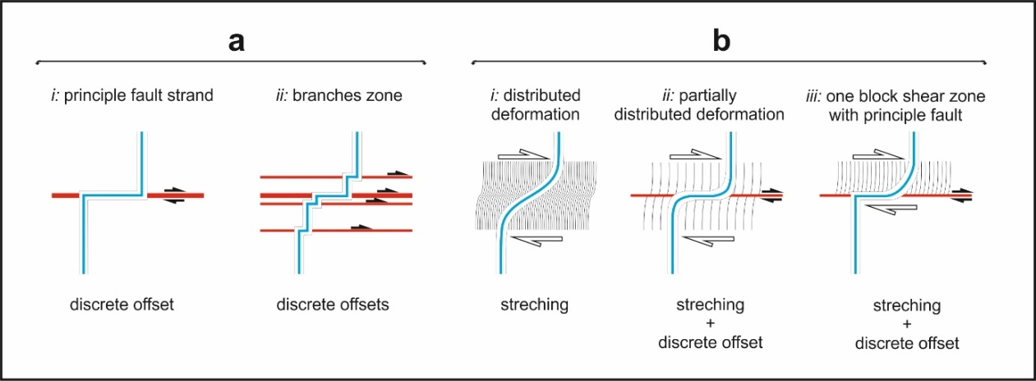
Figure 1.

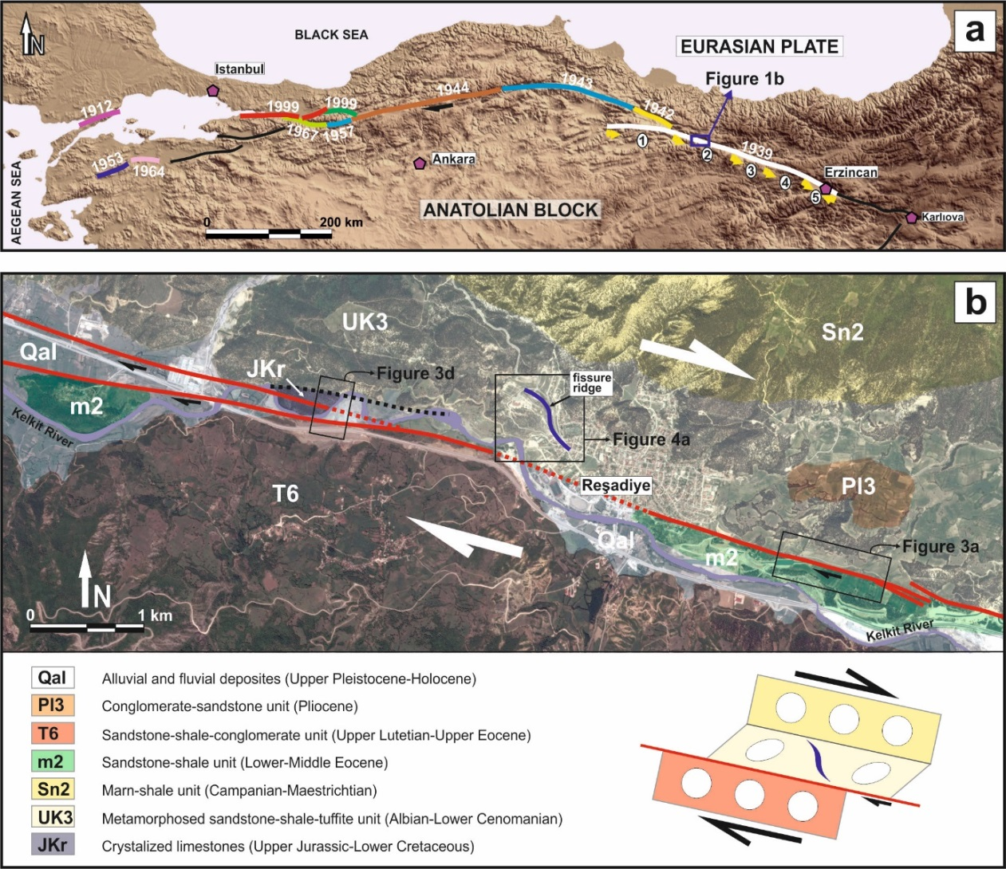
Figure 2.

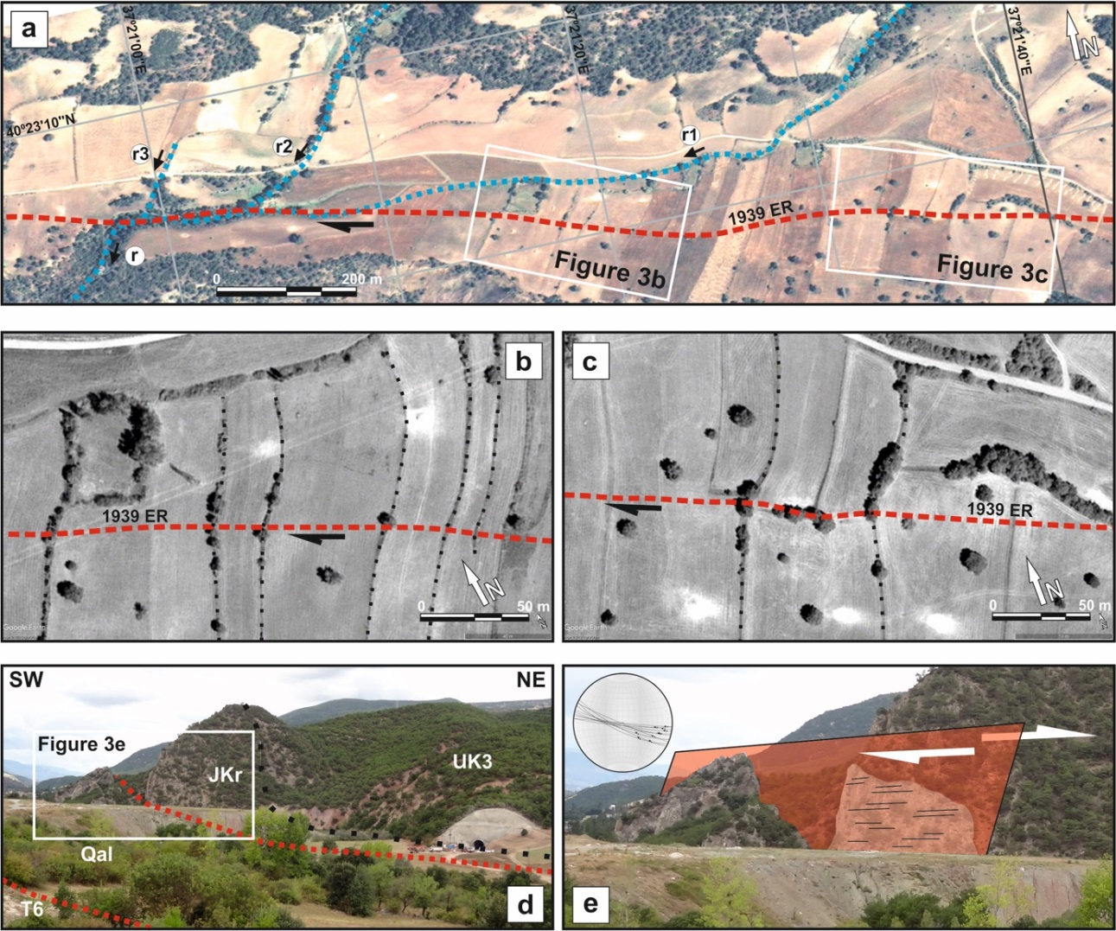
Figure 3.

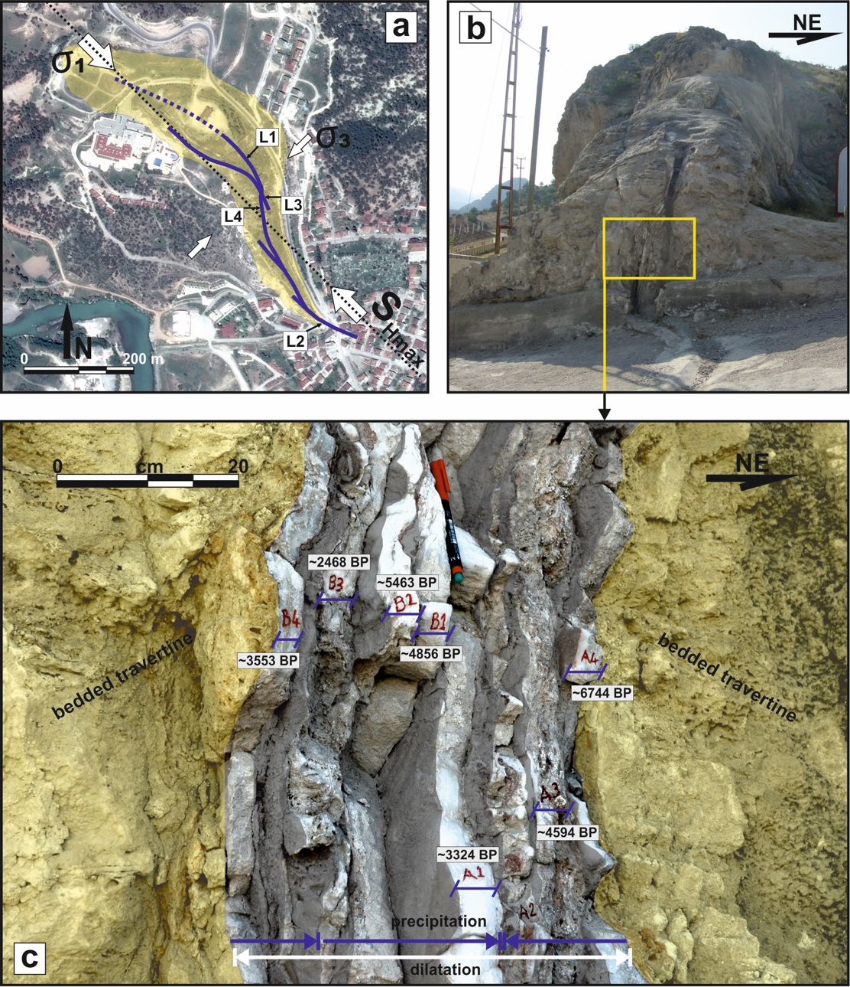
Figure 4.

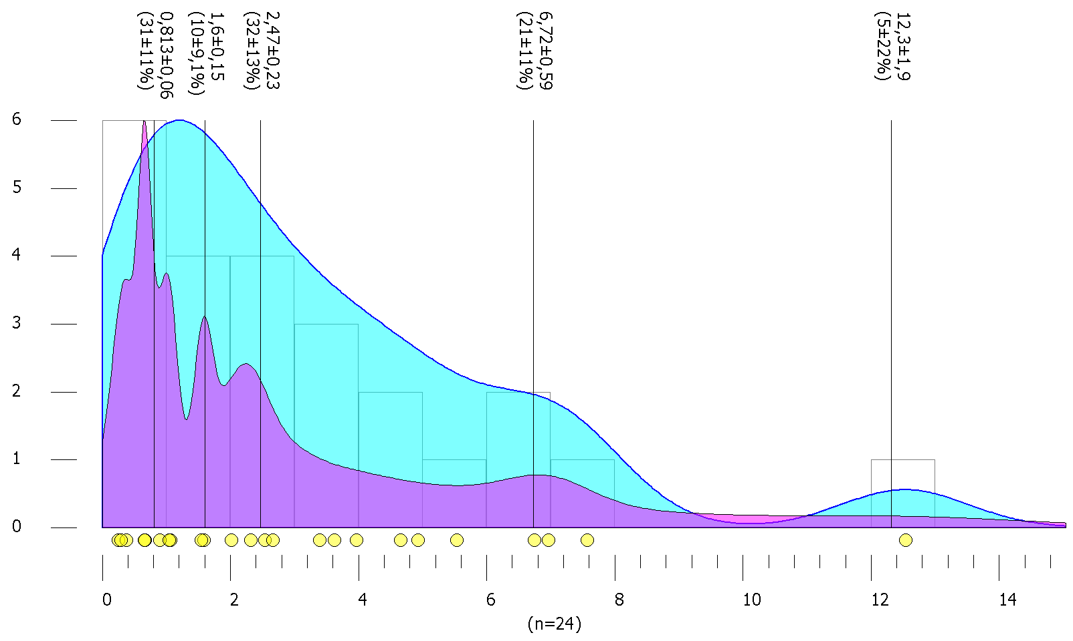
Figure 5.

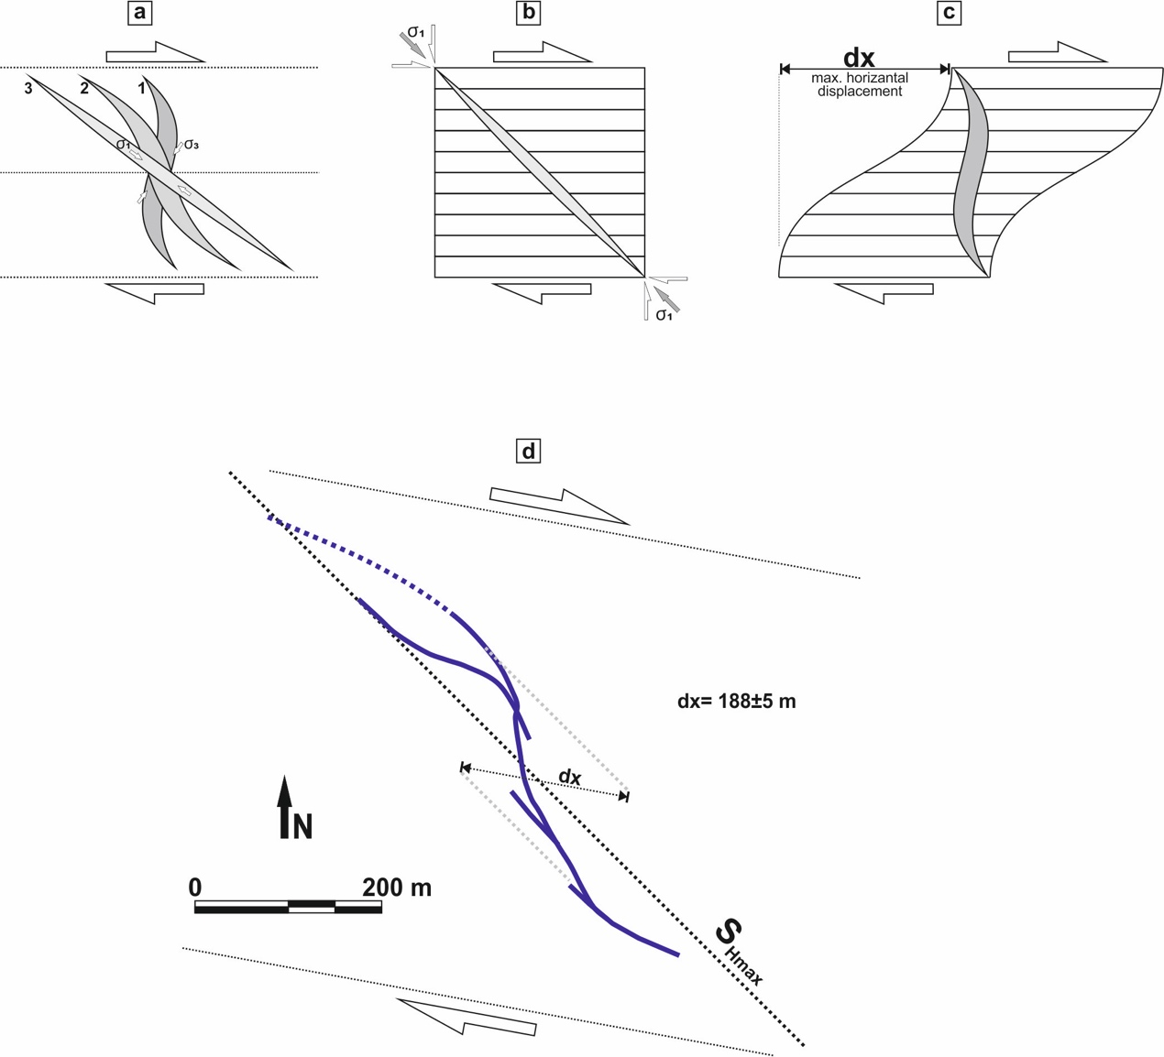
Figure 6.

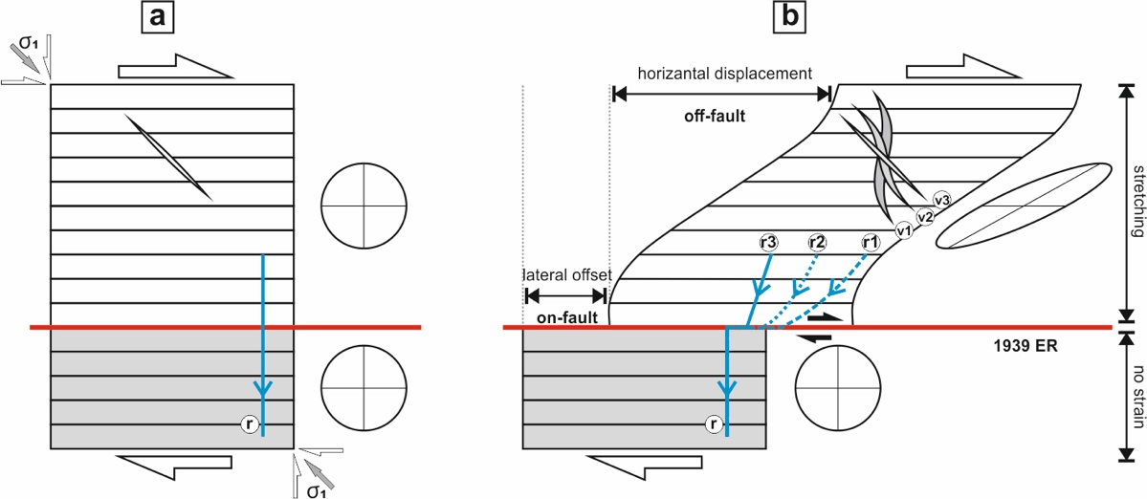
Figure 7.

