Diversity Crisis in UK Geoscience Research Training

Natasha Dowey, Jenni Barclay, Ben Fernando, Sam Giles, Jacqueline Houghton, Christopher Jackson, Keely Mills
Alicia Newton, Steven L. Rogers and Rebecca Williams

Geoscientists have a key role to play in the great challenges of the 21st Century, but solving these problems requires diverse collaborations and engagement with stakeholders from all backgrounds, both in the fundamental science and its implementation. How can we break down the barriers that have made Geoscience amongst the worst for racial minority representation and make our discipline equitable?

The great social, environmental and economic challenges of the 21st Century, as exemplified by the United Nations Sustainable Development Goals, require the work of Geoscientists¹. We must collectively address the increasing vulnerability to geological hazards presented by rapid population growth, meet the demand for rare minerals and renewable energy, and sustainably manage resources (such as water) as our climate changes. Ironically this ‘fourth industrial revolution’ of technological, economic and societal change is occurring at a time when UK STEM businesses have warned of a growing skills shortage as they struggle to recruit suitably qualified workers².

For us to tackle these challenges, Geoscience needs to attract more researchers than ever, from a variety of backgrounds and experiences. To work sustainably across communities and face global problems that impact people from all walks of life, we must remove the biases and barriers that have led to inequity in our subject. We need to develop diverse collaborations for more innovative problem solving³ and new ways of thinking⁴. However, postgraduate Geoscience research is facing an ongoing diversity crisis. In the USA, Geoscience is “the least diverse of all STEM fields”, with just 6% of doctorate degrees awarded to students from underrepresented minorities (defined as American Indian or Alaska Native, Black or African American, and Hispanic or Latino groups), despite comprising 31% of the population^{5,6}. Here we present data from the Higher Education Statistics Authority (HESA)⁷ that paints a similarly dismal picture in the UK.

The data
In the UK, 18.5% of 18-24 year olds identify as BAME⁸ (defined by ‘Black’, ‘Asian’, ‘Mixed’ and ‘Other’ in UK Census and HESA ethnicity data). While the absolute number of UK-domiciled students who identify as BAME in UK Higher Education (HE) has grown by >150,000 since 2003, there remain pronounced disparities between white and BAME students in their continuation into postgraduate research⁹. These disparities vary between disciplines, and between ethnic groups within the BAME identifier.

In the 2018/19 academic year, the proportion of UK-domiciled BAME students enrolled in UK HE overall was 24.8% at undergraduate level⁷, dropping to 18.1% in postgraduate research.
Physical Sciences has a particularly poor record of BAME representation. The subject group had 16.8% BAME student undergraduate enrolment in 2018/19 (third lowest of the nine Science, Engineering, and Technology subject groups assessed; only Veterinary and Agricultural Sciences were lower). This number drops to just 12.1% at research postgraduate level⁷. Geoscience disciplines perform worse than the average: Geology and Physical Geography were amongst the three Physical Sciences subjects with the poorest BAME representation in 2018/19. BAME enrolment in undergraduate Geology was just 10.1%, and in postgraduate Geology research just 10.4%. Physical Geography was the worst of all the Physical Sciences, with 8.5% BAME representation on undergraduate courses, dropping to just 5.2% in postgraduate research⁷ (see Figure for five year averages).

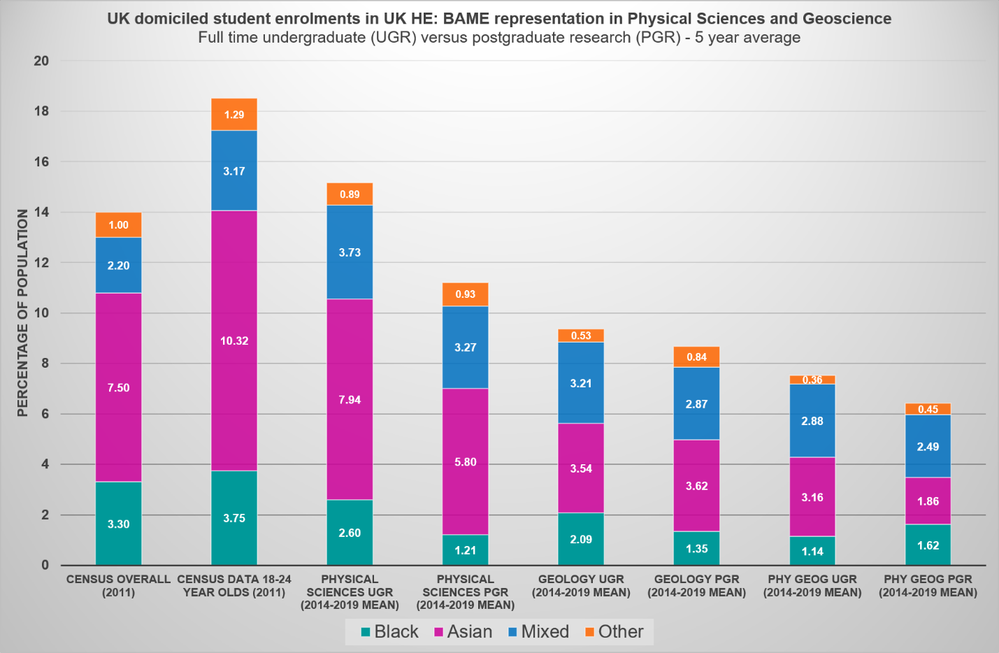
Representation of BAME (Black, Asian, Mixed and Other ethnic minorities) in Physical Sciences and Geosciences from Higher Education Statistics Agency data⁷, alongside ethnicity data from the 2011 UK Government Census⁸. HESA data is based on full-time “all undergraduate” (UGR) and full-time “postgraduate research” (PGR) categories and is a five-year mean average of data from 2014/15 to 2018/19.
In addition to underrepresentation at undergraduate level, the decrease at the transition to postgraduate research in Geology is particularly significant for Black students (i.e. the ‘B’ of BAME). Since 2015, the proportion of Black students in postgraduate Geology research has been consistently lower than the proportion taking up undergraduate study. On average, over the past 5 years, just 1.35% of postgraduate Geology research students were Black (10 Black students in 2018/19)⁷, even though 3.75% of the UK 18-24 population is Black⁸.

Factors involved in BAME inequity in research training across UK HE
Location of study, awarding gaps, unconscious and structural bias, and an application system that fails to account for these biases all contribute to the drop in BAME representation between undergraduate study and postgraduate research.

Rates of BAME students entering undergraduate study in the UK have grown considerably in recent years⁹. However, BAME students applying to high tariff universities (e.g. Russell Group and Oxbridge) are less likely to be offered places than white students with comparable A-level qualifications¹⁰. For example, BAME applicants to Mathematical, Physical and Life Sciences subjects at Oxford are 5.8% less likely to receive an offer than their white counterparts¹¹. In 2018/19, Black students made up just 3.9% of students at ‘high-tariff’ universities, compared to 12.2% at low-tariff universities⁷.

Once at university, the well-documented awarding (also known as attainment) gap means that BAME students are less likely to gain a first or 2:1 degree classification than their white counterparts¹². BAME students are also particularly vulnerable to exiting their undergraduate degree before completion¹³. Leading Routes, a UK initiative to prepare and support the next generation of Black students, report that although a range of factors have been proposed to explain this attainment gap, an “unexplained gap” still exists; it is likely that unconscious bias and inequitable frameworks within higher education systematically disadvantage Black and minority ethnic students¹⁴. A lack of BAME representation at faculty level likely contributes to this hostile environment and has been linked to BAME students not continuing to PhD level¹⁵. Across the UK 10.8% of professors are BAME; just 0.74% are Black¹⁶.

Aspects of the PhD application process that negatively affect marginalised and underrepresented students, such as emphasis on prior attainment, preference for graduates from research-intensive universities, and fixed notions of academic excellence, have recently been raised in an open letter to UK Research and Innovation (UKRI), the UK national funding agency¹⁷. Although these factors affect students from a broad range of underrepresented groups, many of them are particularly relevant to BAME applicants. The letter outlines nine short-term actions to be taken, including the publication of candidate demographic data at application, interview, offer and acceptance stages, which would provide a clearer picture of postgraduate recruitment diversity. UKRI have recently published a diversity report¹⁸ that reveals just 9% of UKRI studentships were awarded to ethnic minorities (the Office for National Statistics uses ‘ethnic minority’ rather than BAME) in 2018/2019; a dismal statistic considering that 19.4% of 18-34 year olds (the demographic to which the majority of studentships were awarded) are BAME⁸. For the Natural Environment Research Council (NERC), the national funder of environmental sciences, these numbers are even lower, with just 6% of studentships going to ethnic minorities¹⁸. However, in 19% of cases ethnicity was “unknown” or “not disclosed”, highlighting the need for improved reporting and transparency.

Factors involved in BAME inequity in UK Geoscience
Geoscience programmes involve a melting pot of subject-specific barriers to BAME accessibility.

In a recent unpublished Geological Society survey of undergraduate students, 60% of respondents mentioned a lifelong interest in the natural environment. Rural environments may be less accessible to children who grow up in urban settings, which are more ethnically diverse than rural settings¹⁹, or to children from low-income households, who in the UK are disproportionately more likely to be Pakistani, Bangladeshi, Chinese or Black than white²⁰.

A lack of diverse role models, the perpetual stereotype of a geoscientist as a white man²¹, and the link between Geoscience and both past and contemporary imperialist or colonialist attitudes²² are perception issues that may be particularly off-putting to those from minority ethnic backgrounds. Furthermore, a career pathway in Geoscience, particularly in postgraduate Geoscience research, may not be seen to offer the financial security of other professions such as Law or Medicine²³ by some minority or low-income communities.

In addition to the academia-wide issues outlined by Leading Routes¹², once in Geoscience there are ‘hostile climates’²⁴ that can deter BAME students from continuing in postgraduate research. Fieldwork requirements create barriers to racial and ethnic minorities, for reasons including cost, inclusivity and racial harassment²⁵. The ‘alcohol culture’ in many Geoscience departments and at conferences²⁶ presents barriers to inclusivity for students who do not drink, who are more likely to be from BAME backgrounds²³. Representation and presence of role models is likely an issue; there is a pronounced lack of BAME faculty members in Geoscience (<10% in both ‘Earth Science’ and Physical Geography in 2015/16²⁷) and BAME geoscientists are invited to give fewer talks at conferences²⁴.

Although all these factors are found in Geoscience, some overlap with those encountered in other Physical Sciences. If we can work towards acknowledging and resolving these issues in Geoscience, and increase the diversity of our particularly white subject, we can develop strategies transferable to other UK HE subjects. Furthermore, a framework of intersectionality, identifying the multiple individual, cultural, and structural dimensions that shape the way individuals navigate the discipline of Geoscience, is key for broadening participation to a range of minority groups²⁸.

What can we do about it?
A number of suggestions have been made in recent years to improve BAME diversity in Geoscience^{5,24,25,29,30}. These include making application processes more transparent, adapting fieldwork requirements and experiences so they are more inclusive, broadening participation through summer schools and paid internships, ringfencing funding or fellowships for underrepresented groups, increasing diversity in faculty staff, and acknowledging the ‘colonial and exclusionary’ foundations of our institutions to address hostile environments.

In the UK, we must push our professional bodies, such as the Geological Society, for the accreditation reform that may help improve inclusivity. We can also continue to pressure funding organisations to be more transparent in their recruitment practices and encourage our own Centres for Doctoral Training (CDTs) and Doctoral Training Partnerships (DTPs) to break down competitive barriers and share ideas for broadening participation. We need to modernise our curriculum and improve perceptions, by exploring links between Geoscience and colonialism³¹ with our students, embedding sustainable development into our teaching, and considering the importance of Geoscience in urban landscapes and the ‘fourth industrial revolution’. We should develop stronger links with industry, both to encourage more paid (ringfenced) internships, and also to change career perceptions of our subject. We need to change how we talk about and market Geoscience, developing more diverse promotional materials and ambassador schemes - without disproportionately placing the burden of such work on BAME members of our community³². We need to put forward progressive funding bids for evidence-driven action research that works to address datagaps, advocates for real change, and develops effective strategies to broaden participation. We can be more multidisciplinary, and work with other subjects and bodies facing similar challenges, sharing transferable solutions across the HE sector.

Crucially, we need to acknowledge the hostile environments that deter BAME students from applying to, and continuing with, our discipline. We must address personal and structural biases, and go beyond this to be actively anti-racist. The less diverse a field is, the more prevalent implicit biases become⁶. We must act now, and have those difficult conversations, to create a modern Geoscience research culture that reflects the diverse nature of the planet we study.

Acknowledgements: Many thanks to Catherine Souch of the Royal Geographical Society for comments on this piece.

References
1. Gill, J. C. Geology and the Sustainable Development Goals. Episodes 40, 70–76 (2017).
2. Skills shortage costing STEM sector £1.5bn. STEM Learning (2018).
3. Hong, L. & Page, S. E. Groups of diverse problem solvers can outperform groups of high-ability problem solvers. Proc. Natl. Acad. Sci. U. S. A. 101, 16385–16389 (2004).
4. Phillips, K. W. How Diversity Makes Us Smarter. Greater Good Magazine (UC Berkeley, 2017).
5. Bernard, R. E. & Cooperdock, E. H. G. No progress on diversity in 40 years. Nat. Geosci. 11, 292–295 (2018).
6. Dutt, K. Race and racism in the geosciences. Nat. Geosci. 13, 2–3 (2020).
7. Higher Education Statistics Authority. Higher Education Student Data. (2019).
8. GOV.UK. Population of England and Wales. (2018).
9. Advance HE. Equality in higher education: statistical report 2019. (2019).
10. Boliver, V. Why are British ethnic minorities less likely to be offered places at highly selective universities? in Aiming Higher: Race, Inequity and Diversity in the Academy. 15–18 (Runnymede, 2015).
11. Inge, S. Scale of Oxford’s ‘white bias’ laid bare by internal report. Research Professional News (2020).
12. National Union of Students & Universities UK. Black, Asian and Minority Ethnic Student Attainment at Universities. (2019).
13. Woodfield, R. Undergraduate retention and attainment across the disciplines. (The Higher Education Academy, 2014).
14. Williams, P., Bath, S., Arday, J. & Lewis, C. The Broken Pipeline. (2019).
15. Fazackerley, A. ‘Look at how white the academy is’: why BAME students aren’t doing PhDs. The Guardian (2019).
16. Higher Education Statistics Authority. Higher Education Staff Data. (2019).
17. Giles, S. et al. Open letter concerning CDT and DTP student recruitment across the UK. (2020).
18. UK Research and Innovation. Diversity Results for UKRI funding data 2014/15 to 2018-19. (2020).
19. GOV.UK. Rural Population and Migration. (2018).
20. Office for National Statistics. Child poverty and education outcomes by ethnicity. (2020).
21. Goldberg, E. Earth Science Has a Whiteness Problem - The New York Times. The New York Times (2019).
22. Roy, R. Science Still Bears the Fingerprints of Colonialism. Smithsonian Magazine (2018).
23. Fernando, B. & Antell, G. Recommendations for improving racial equality, diversity, and inclusion in the Department of Earth Sciences, University of Oxford. (2020).
24. Marín-Spiotta, E. et al. Hostile climates are barriers to diversifying the geosciences. Adv. Geosci. 53, 117–127 (2020).
25. Giles, S., Jackson, C. & Stephen, N. Barriers to fieldwork in undergraduate geoscience degrees. Nat. Rev. Earth Environ. 1, 77–78 (2020).
26. Guertin, L. Want to be more inclusive? Stop making geology conferences about the beer. GeoEd Trek- AGU Blogosphere (2019).
27. REF.ac.uk. HE Staff Equalities Tables by Ethnicity. (2016).
28. Núñez, A. M., Rivera, J. & Hallmark, T. Applying an intersectionality lens to expand equity in the geosciences. J. Geosci. Educ. 68, 97–114 (2020).
29. Thomas, D., Ashworth, P., Nield, J. & Souch, C. International Benchmarking Review of UK Physical Geography. (2017).
30. Dutt, K. Promoting Racial Diversity Through Transparency. Eos (Washington. DC). 100, (2019).
31. Stafford, R. A. Geological Surveys, Mineral Discoveries, and British Expansion, 1835–71. J. Imp. Commonw. Hist. 12, 5–32 (1984).
32. Gewin, V. The time tax put on scientists of colour. Nature (2020).
33. Stevenson, J., O’Mahony, J., Khan, O., Ghaffar, F. & Stiell, B. Understanding and overcoming the challenges of targeting students from under-represented and disadvantaged ethnic backgrounds. (2019).

We use the term 'BAME' in this piece for consistency with HESA public data and terminology. However, we recognise the problems with using this identifier as it artificially homogenises many different backgrounds and identities³³. It also obscures discrimination that is overwhelmingly felt by one race or ethnicity. In some places we refer to data from a distinct ethnic group (e.g. Black) to highlight particularly wide disparities in the data.
Physical Sciences includes Chemistry, Materials Science, Astronomy, Physics, Geology and Physical Geography

