Unexpected meteotsunamis prior to the Typhoon Wipha
[This article is a non-peer reviewed preprint submitted to EarthArXiv]
Li-Ching Lin^{1*} and Chin H. Wu²
¹National Applied Research Laboratories, 3F., No. 106, Sec. 2, Heping E. Rd., Taipei city 106, Taiwan
²Department of Civil and Environmental Engineering, University of Wisconsin-Madison, Madison, Wisconsin 53706, USA

Abstract
On October 15, 2013, unexpected meteotsunamis occurred prior to Typhoon Wipha located the distance of ~1,100 km from the center of the cyclone to the Tokyo bay. The occurrences were observed around the east coast of Japan coincidentally with atmospheric pressure disturbances induced by this typhoon. The observed wave height of meteotsunamis was up to ~0.5 m with the pressure fluctuation of ~2 hPa before this approaching typhoon. This study reveals the causes of the unexpected metetotsunamis in association with atmospheric forcings of the typhoon. The possible origin is identified from typhoon activities at the outer circulation that produced traveling pressure disturbances as a driving force to generate meteotsunamis. The causality of meteotsunami is revealed by time-frequency analysis of water level, atmospheric pressure, and wind speed. Results show that a combination of atmospheric forcings, pressure and wind stress, is responsible for the onset of meteotsunamis. The pressure fluctuation is found to be an indicator to determine the origin of atmospheric forcings and the formation of corresponding meteotsunamis when the meteorological condition is relative calm before a typhoon.
Keywords: Meteotsunami, Typhoon Wipha, Typhoon induced pressure disturbances, Tokyo Bay

* Corresponding Author: Li-Ching Lin¹, E-mail: plih@narlabs.org.tw
1. Introduction
On October 15, 2013, unexpected meteotsunamis occurred along the eastern coast of Japan when Typhoon Wipha at a distance of ~1,100 km from the center of cyclone was approaching to the Tokyo bay. During this typhoon, strong storm surges and large wind waves locally produced by the low pressure centered at the cyclone (Marcos et al. 2019) are expected. Normally, warning for typhoon induced flooding or other hazards are issued. However, the observed heights of such tsunami-like high frequency waves with periods ranging from minutes to hours were abnormally enhanced at least 12 hours prior to this typhoon. Specifically, meteotsunamis without any warning can inundate coastal areas, overtop coastal structures, or even generate rip currents (Bechle and Wu, 2014; Linares et al. 2019; Pattiaratchi and Wijeratne 2015; Vilibić et al. 2016) that cause people injury or even fatalities. In view of the safety concern, it is of interest and importance to better understanding of the occurrences, causes, and statistics of unexpected meteotsunamis prior to any typhoon events.
Meteotsunamis, the analogy of tsunamis that are generated by earthquakes and volcanic eruptions, are long wavelengths that are caused by meteorological forcings with a rapid change of atmospheric pressures and winds disturbances (Bechle and Wu 2014; Monserrat et al. 2006; Šepić et al. 2016). The period of meteotsunamis ranges from tens of minutes to 2 hours (Rabinovich 2009). Previous studies found that there is strong similarity between tsunami and meteotsunami in physical dynamics of incoming waves (Monserrat et al. 2006; Rabinovich 2009). Classification of the driving mechanism shows that meteotsunami consists of 2.8% in 244 of total tsunami events from global tsunami catalogues in 25 years (1992-2016) and the resulting damage is much rarer than this statistics (Gusiakov 2019). Nevertheless, Bechle et al. (2016) statistically characterized the occurrence frequency of meteotsunamis in the Laurentian Great Lakes region and found that meteotsunamis are much more frequent than follow from historic anecdotal reports.
Destructive meteotsuanmis are more common in relation to meteorological conditions. Rabinovich (2020) showed that detrimental damages of 51 strongest meteotsunamis among the 27 years (1992-2018) records are associated with perturbing atmospheric pressures and winds in microscale and mesoscale systems. In most cases, unstable and intensive meteorological changes are the primary factor for the occurrence of destructive meteotsunamis. However, some destructive meteotsunamis can occur due to the stable and calm meteorological conditions (Rabinovich 2019). For example, speciﬁc systems like atmospheric gravity waves induced pressure propagations across shallow seas appear to be the most unpredictable factor. (Hibiya and Kajiura 1982; Vilibić et al. 2014). A recent study by Shi et al. (2020) shows that tropical cyclone rainbands and atmospheric gravity waves during the Atlantic hurricane seasons have the greatest potential to trigger meteotsunamis along the continental shelf of the Gulf of Mexico, Eastern United States, and Puerto Rico. Nevertheless, no study, as far as the authors are aware, shows the occurrences of unexpected meteotsunamis prior to typhoons in the Northwest Pacific Ocean.
The purpose of this paper is to reveal the causality of the unexpected metetotsunamis in association with meteorological conditions in the Pacific Oceans. Specifically, the sources in generating meteotsunamis prior to typhoons in Japan would be identified and characterized by observations of unexpected meteotsunamis and atmospheric disturbances. Causalities of unexpected meteotsunamis are examined by wavelet power spectrum for the contribution of pressure disturbances and wind stresses. Statistics of historical meteotsunamis is carried out to provide insight of the most affected region by the typhoon approaching and further to identify the origin of atmospheric forcings. In the following, we report event observations and data sources in section 2. Section 3 describes methods employed in this study. In section 4, the analysis result of occurrences, causes, and statistics of unexpected meteotsunamis prior to typhoons are presented. Discussion and summary are given in section 5.

2. Event Observations and Data Sources
Two typhoon events are examined in this study. First, Typhoon Wipha moved to the eastern coast of Japan and rapidly passed through during 15-16 of October 2013 (see the red curve in Figure 1a). Wipha originated from a tropical depression and transitioned from a weakening tropical cyclone into a hybrid storm, with characteristics of both a tropical storm with winds of 165 km/h (105 mph) and an atmospheric pressure of 930 mbar and an extratropical system. The typhoon didn’t make landfall but did bring significant rainfalls near the Tokyo Bay region. It also triggered massive landslides at Izu-Oshima Island located 120 km south of Tokyo and caused 35 fatalities and property damages (Yang et al. 2015). Storm surges with 1-2 m height occurred around the Tokyo Bay but fortunately did not cause significant flooding for coastal regions. The second event is Typhoon Neoguri that occurred in 2019. The orange curve in Figure1b depicts the track points of the Typhoon Neoguri. Figure 1b shows the zoom-in area in Figure 1a with a bathymetric map that shows an average depth of the bay about 20 m and changes sharply to 200 m at the mouth area of Tokyo Bay. From the satellite imagery (Figure 1c), the cloud distribution of the storm was covered over half of Japan when this typhoon was ~1,100 km away from the Tokyo Bay.
Sea level data (see symbols in Fig. 1a) are obtained from three sources: Japan Meteorological Agency (JMA, http://www.ioc-sealevelmonitoring.org/index.php), Japan Coast Guard (JCG, http://near-goos1.jodc.go.jp/vpage/index_en.html), and Geospatial Information Authority of Japan (GSI, http://www.gsi.go.jp/kanshi/tide_furnish.html). Data of JCG and GSI is obtained at 30-sec intervals and that of JMA is at 1-minute intervals. To examine sea level fluctuations, we focus on five selected sea level stations: T05 (Kainan), TOM (Omaezaki), T23 (Yaizu), T01 (Aburatsubo), and T18 (Soma) that are shown in Figures 1a and 1b. Meteorological data of pressure and wind speed with 10 minute intervals are collected from JMA (http://www.data.jma.go.jp/obd/stats/etrn/index.php). Monthly statistics of meteotsunamis from 1998 to 2019, locally called secondary undulations (Hayashi 1959; Kowalik and Murty 1993), are collected from JMA stations (http://www.data.jma.go.jp/gmd/kaiyou/db/tide/gaikyo/nenindex.php, in the Japanese version).

3. Methods
Several methods are used here. To detect meteotsunamis, we process the data in three steps. First, sea levels are subtracted the harmonic tidal prediction provide by JMA to remove tides. Second, the time series is filtered using a high-pass filter (cut-off period of 2-h). Last, filtered wave heights larger than 0.1m are deemed as meteotsunamis. To obtain storm surges induced by the passage of typhoons, an hourly average of the residual signals between the sea levels and the high-pass filtered signals is employed. To reveal the linkage between meteotsunamis and meteorological conditions, the wavelet spectral analysis (Torrence and Compo 1998) is applied here. Previous studies (Linares et al. 2016; Vilibić et al. 2014) show that transient oscillations of meteotusnamis can be depicted by wavelet multi-resolution analysis. To examine the joint variability in the time‐frequency content of meteorological conditions and meteotsunamis, we use cross‐wavelet spectral analysis (Grinsted et al. 2004). Following the method in Linares et al. (2016), we normalize the cross‐wavelet power spectra against noise above the 95% confidence level to isolate sectors of common power that are statistically significant at the α = 5% level. To investigate the relative role of atmospheric disturbances responsible for meteotsunamis, a heuristic approach is applied to calculate pressure and wind stress contributions (Linares et al. 2016). Details of calculations of the pressure term, P* = $∆P/{ρ_{w}}_{ }g$, where ρ_{w} is the density of water, g is gravitational acceleration and ΔP is the largest pressure perturbation and the wind stress term, W* = $τUt_{w}/ρ_{w}gH$, where τ is wind stress, U is the disturbance velocity, t_{w} is the duration of the wind disturbance, can be referred to Linares et al. (2016). The combination of two estimations indicates the initial height of a meteotsunami driven by pressure and wind forcings. To obtain meteotsuami statistics for characterizing the occurrence of meteotsunamis, we calculate the monthly maximum height of meteotsunamis at T01 from the total dataset of 2006-2019. In addition, A Peaks Over Threshold (POT) approach of extreme value statistics is used to represent extreme meteotsunami size-frequency data of JMA stations following the method used in Bechle et al. (2016).

4. Results
4.1. Unexpected meteotsunamis
Time series of sea level fluctuations and pressure disturbances for Typhoon Whipa is depicted here. Figure 2 shows the meteotsunamis and storm surges from five selected sea level stations. Unexpected meteotsunamis, with the maximum wave height of 0.2-0.5 m, appeared to be generated at T01 right before storm surges generated by Typhoon Whipa at the east coast of Japan. Figure 3a further examines meteorological parameters at JMA46760 (Yokohama) meteorology station located on the western shore of Tokyo Bay, about 30 km north of T01). For the 2013 event, prior to the typhoon Wipha, an unexpected meteotsunami with wave heights of ~0.5 m occurred at approximately 0730 UTC and lasted over 3 hours on October 15. The local meteorological pressure decreased to 1010 hPa and wind of less than 10 m/s at JMA47670. A rate of pressure change over a 10-min window shows 1.8 hPa drop. Since the meteorological condition was continuously affected by the approaching typhoon, the 10-min time interval may not be fine enough to characterize the shape-like atmospheric disturbances (Monserrat et al. 2006). Pressure fluctuations with 1-minute time interval at a close-by meteorology station (SOAR) in Yokohama National University, as shown in Figure 4, confirms the similar train of pressure disturbances with less than 0.5hPa difference before the Typhoon Whipa. Overall, it is shown that unexpected meteotsunamis can be generated prior to typhoons at the east coast of Japan.
In the 2019 event, after 1200 UTC on October 21, Typhoon Neoguri has transitioned from weakening tropical storm into an extratropical cyclone. The local meteorological pressure was 1013 hPa and the wind speed was less than 15 m/s at JMA46760 (Figure 3b). The largest pressure change of the train of pressure disturbances was ~2 hPa/10 min. An unexpected meteotsunami with wave heights of ~0.4 m occurred at about 1900 UTC when the Typhoon Neoguri was approximate 430 km southwest of T01. Overall, large rates of pressure change prior to typhoons can induce the occurrence of unexpected meteotsunamis at the east coast of Japan.

4.2. Relationship of rates of propagating pressure disturbances and meteotsunamis
Figure 5 shows the forcing-response relations between pressure disturbances and unexpected meteotsunamis prior to Typhoon Whipa. The arrival time of pressure disturbances is calculated when pressure fluctuations exceed 2 times of their standard deviation in the previous hour shown in Figure 5a. It shows that the pressure forcing appears to propagate northward at an averaged velocity of ~10.1 m/s and the affecting area of pressure disturbances is close to the outer circulation of the cyclone. The maximum variation of pressure disturbances during the propagating forcing is shown in Figure 5b. It indicates that most significant area is focused on the Tokyo Bay region when the outer circulation of Typhoon Wipha is approaching. Figure 5c shows the height of unexpected meteotsunamis affected by the pressure forcing. Significant changes of meteotsunamis are only found in few sea level stations as shown in Figure 2. Findings show typhoon activities at the outer circulation appear to be the possible origin in generating meteotsunamis.

4.3. Causalities of meteotsunamis
Causes of unexpected meteotsunamis are examined by wavelet power spectrum for the sea level at T01 and the corresponding atmospheric pressure and wind at SORA in 2013. Figure 6a and 6b show that atmospheric disturbances of pressure and wind speed at SOAR station prior to the Typhoon Whipa have energy with periods from 8 minutes to 2 hours. Figure 6c shows that the dominant period of sea level fluctuations at T01 station occurs 14.7 min, which is believed to the meteotsunami and consistent to the fundamental mode of Aburatsubo Bay (Hayashi 1959). Relationships between atmospheric disturbances and sea level fluctuations are depicted by the wavelet coherence in Figure 7. For the unexpected meteotsunami at 0730 UTC of October 15, the wavelet coherence between atmospheric pressure and sea level shows dominated energy with periods between 8 and 20 min. Similar periods of the dominated energy are seen in the wavelet coherence between wind speed and sea level. Before that at approximately 0630 UTC, it only shows significant common power between atmospheric pressure and sea level for periods between 8 and 20 min, whereas wind speed shows less extent in association with sea level. For meteotsunami occurred after 1800 UTC when Typhoon Whipa close to the Tokyo Bay region, the energetic sea level oscillations occur in pressure with periods between 8 and 50 min and wind speed with periods between 8 and 20 min, respectively. During Typhoon Whipa, meteotsunamis suggests that both pressure and wind speed plays the important role to force meteotusnamis in periods less than 2 h, sharing the similar finding with Linares et al. (2016).

4.3. Relative role of pressure and wind
Contributions of atmospheric forcings to the unexpected meteotsunami are calculated by the heuristic approach. For the 2013 occurrence, the largest pressure disturbance of 1.8 hPa and that of wind disturbance of 19 m/s are selected. The velocity of 10.1m/s, U, has been identified from the analysis of pressure disturbances and the duration of the wind disturbance, t_{w}, shows about 70 min when wind disturbs the sea surface in the 70 m depth off Aburatsubo Bay. Those given parameters are taken into account in the heuristic approach to estimate contributions that the pressure term, P*, is 0.018 m and wind stress term, W*, is 0.042 m. This result attributes 30% of meteotsunamis to pressure and 70% to wind and further agrees with the wavelet coherence analysis (see Figure 6 or 7). For the 2019 occurrence, the largest pressure and wind disturbances are 2 hPa and 15 m/s, respectively. Given the velocity of 11 m/s observed from pressure disturbance and wind duration of 50 min, the pressure and wind stress term yield 0.02 m (53%) and 0.018 m (47%), respectively. Findings show that two unexpected meteotsunamis are forced by both pressure and wind disturbances. Results indicate that atmospheric forcings can provide a way to quantify relative contributions to meteotsunamis by using the heuristic approach (Linares et al. 2016).

4.4. Occurrences of meteotsunami statistics
Figure 8 shows the occurrence frequency of meteotsunamis based upon the monthly maximum height of meteotsunamis at T01 over 14 years (2006-2019). It is shown that an annual meteotsunami height (i.e. 1 exceedance per year) is 0.4 m. This height is smaller than those (0.5 ~ 1.0 m) found in the Laurentian Great Lakes (Bechle et al, 2016) Of the identified meteotsunami occurrences (168 events) over 2006-2019, approximately 1.2% (the 2013 and 2019 events) is related to unexpected meteotsunamis before typhoons, further illustrating the importance of the unforeseen and destructive meteotsunamis.
Figure 9a shows the spatial patterns of seasonable maximum meteotsunami occurrences along the coast of Japan in the Pacific Oceans, based upon data from JMA stations for more than 20 years (1998 ~ 2019). The meteotsuanmi occurrences along the east coast of Japan are likely affected by typhoons in late summers. The occurrences of meteotsuanmis at the southwest coast of Japan are associated with the passage of cold fronts or extratropical systems in winter and spring seasons (Tanaka 2010). Figure 9b shows that extreme meteotsunamis (height > 0.3m) are more frequently occurred in the coastal area of the latitude less than 36°N. About 30-70% meteotsunami occurrences are extreme and noticeable in the same region. One possible explanation for the spatial feature of extreme meteotsunamis is that typhoon induced extreme meteotsunamis is that the low pressure center of a cyclone or a typhoon is usually close to the Tokyo Bay region. In this study, it is noticed that unexpected and rare meteotsunamis are generated ahead of the typhoon approaching the Tokyo Bay region in the distance of about 400-1000 km.

5. Summary and Conclusions
In this paper, we report two unexpected meteotsunamis prior to typhoons approaching the Tokyo Bay region in the distance about 400-1000 km. In 2013, the unexpected occurrence was forced by Typhoon Wipha when it transitioned into a hybrid storm. In 2019, a similar occurrence was also detected when the intensity of Typhoon Neoguri was weakening to an extratropical cyclone. Both occurrences are found in the changing status of typhoons and have associated with typhoon induced atmospheric disturbances ahead of the typhoon approaching the same region. The analysis reveals the propagating pressure disturbances move northeastward across more than half of Japan in the travel velocity of ~10 m/s. Findings show typhoon activities at the outer circulation appear to be the possible origin in generating meteotsunamis.
Casualties of meteotsunamis are revealed by wavelet analysis and heuristic approach. The characteristics of unexpected meteotsunamis can be determined by pressure disturbances when the meteorological condition is relative calm before a typhoon. As the meteorological condition is continuously affected by the approaching typhoon, the single shape-like disturbance of atmospheric forcings is not clearly characterized. The proposed pressure fluctuation is found to be an indicator to determine the origin of atmospheric forcings and the formation of corresponding meteotsunamis prior to typhoons. In the unexpected meteotsunami of 2013, the result of relative contributions to meteotsunamis shows 30% in pressure and 70% in wind, respectively. From two presented occurrences, it reveals that wind stress could provide a considerable contribution as the pressure in meteotsunami formations (Linares et al. 2016).
From the JMA statistics of 1998-2019, the east coast of Japan is the most affecting area when meteotsunamis are generated at the center area of typhoons. In addition, the frequent occurrence of dangerous meteotsunamis (height > 0.3m) shows the focus on the Tokyo Bay region and other coastal area of the latitude less than 36°N. At T01, only two unexpected and rare meteotsunamis are detected in the 14-year dataset. To better understand the risk of unexpected meteotsunamis, a further detection for all sea level sites is subsequently required. And both unexpected occurrences reach dangerous height indicating that Tokyo Metropolis could be potentially susceptible to meteotsunami floods.
Numerical studies (e.g., Mercer et al. 2002; Mecking et al. 2009; Shi et al. 2020) suggest that the metetosuanmis could result from typhoons, tropical cyclone rainbands, atmospheric gravity waves, etc. Of all records, we find that one special case occurs at Kushiro sea level site of JMA by pressure dip formation (Fudeyasu et al. 2007) of Typhoon Jelawat in 2012 (JMA report 2013) and generates a meteotsunami up to 1.2 m. Nevertheless, it may suggest that the formation of the cyclonic circulations is the key to trigger meteotsunamis, which could detail the driven mechanism through air-sea interactions in the future.

Acknowledgements
The authors would like to thank Dr. Fudeyasu Hironori of Yokohama National University for providing the meteorology data of 1-min sampling from SORA meteorological station (http://www.fudeyasu.ynu.ac.jp/sorasystem.html, in Japanese).

References
- Bechle AJ, Kristovich DAR, Wu CH (2015) Meteotsunami occurrences and causes in Lake Michigan. J Geophys Res Oceans 120:8422–8438. https://doi.org/10.1002/2015JC011317
- Bechle AJ, Wu CH (2014) The Lake Michigan meteotsunamis of 1954 revisited. Nat. Hazards 74:155–177. https://doi.org/10.1007/s11069-014-1193-5
- Bechle AJ, Wu CH, Kristovich, DAR, Anderson EJ, Schwab DJ, Rabinovich AB (2016) Meteotsunamis in the Laurentian Great Lakes. Sci Rep 6:37832. https://doi.org/10.1038/srep37832
- Fudeyasu H, Iizuka S, Hayashi T (2007) Meso-β-scale pressure dips associated with typhoons. Mon Weather Rev 135:1225-1250. https://doi.org/10.1175/MWR3337.1
- Grinsted A, Moore JC, Jevrejeva S (2004) Application of the cross wavelet transform and wavelet coherence to geophysical time series. Nonlinear Proc Geoph 11:561-566
- Gusiakov VK, Dunbar PK, Arcos N (2019) Twenty-ﬁve years (1992–2016) of global tsunamis: Statistical and analytical overview. Pure Appl Geophys 176:2795–2807. https://doi.org/10.1007/s00024-019-02113-7
- Hayashi T (1959) Results of simultaneous observation of secondary undulation in Aburatsubo Bay, Journal of the Geodetic Society of Japan 5:42-48. https://doi.org/10.11366/sokuchi1954.5.42 (Japanese version)
- Hibiya T, Kajiura K (1982) Origin of the Abiki phenomenon (a kind of seiche) in Nagasaki bay. J Oceanogr Soc Jpn 38:172–182. https://doi.org/10.1007/BF02110288
- JMA report (2013) https://www.jma.go.jp/jma/kishou/books/sokkou/80/vol80p033.pdf (in Japanese)
- Kowalik Z, Murty TS (1993) Numerical modeling of ocean dynamics. World Scientific.
- Linares Á, Bechle AJ, Wu CH (2016) Characterization and Assessment of the meteotsunami hazard in northern Lake Michigan. J Geophys Res Oceans 121:7141–7158. https://doi.org/10.1002/2016JC011979
- Linares Á, Wu CH, Bechle AJ, Anderson EJ, Kristovich DAR (2019) Unexpected rip currents induced by a meteotsunami. Sci Rep 9:2105. https://doi.org/10.1038/s41598-019-38716-2
- Marcos M, Rohmer J, Vousdoukas MI, Mentaschi L, Le Cozannet G, Amores A (2019). Increased extreme coastal water levels due to the combined action of storm surges and wind waves. Geophys Res Lett 46:4356-4364. https://doi.org/10.1029/2019GL082599
- Mercer D. (2002) Barotropic waves generated by storms moving rapidly over shallow water. J Geophys Res Ocean 107:16-1-16-17. https://doi.org/10.1029/2001JC001140
- Mecking JV, Fogarty CT, Greatbatch RJ, Sheng J, Mercer D. (2009) Using atmospheric model output to simulate the meteorological tsunami response to Tropical Storm Helene (2000). J Geophys Res Ocean 114:C10005. https://doi.org/10.1029/2009JC005290
- Monserrat S, Rabinovich AB, Casas B (1998) On the reconstruction of the transfer function for atmospherically generated seiches. Geophys Res Lett 25:2197–2200. https://doi.org/10.1029/98GL01506
- Pattiaratchi CB, Wijeratne EMS (2015) Are meteotsunamis an underrated hazard ?. Phil Trans R Soc A 373: 20140377. https://doi.org/10.1098/rsta.2014.0377
- Rabinovich AB (2020) Twenty-seven years of progress in the science of meteorological tsunamis following the 1992 Daytona Beach event. Pure Appl Geophys 177:1193-1230. https://doi.org/10.1007/s00024-019-02349-3
- Šepic J, Vilibić I, Rabinovich AB, Monserrat S (2015) Widespread tsunami-like waves of 23–27 June in the Mideierranean and Black Sea generated by high-altitude atmospheric forcing. Sci Rep 5:11682. https://dx.doi.org/10.1038/srep11682
- Shi L, Olabarrieta M, Nolan DS, Warner JC (2020) Tropical cyclone rainbands can trigger meteotsunamis. Nat Commun 11:1-14. https://doi.org/10.1038/s41467-020-14423-9
- Tanaka K (2010) Atmospheric pressure-wave bands around a cold front resulted in a meteotsunami in the East China Sea in February 2009. Nat Hazards Earth Syst Sci 10:2599–2610. https://doi.org/10.5194/nhess-10-2599-2010
- Torrence C, Compo, GP (1998) A practical guide to wavelet analysis. B Am MeteoroL Soc 79: 61-78
- Vilibic´ I, Mihanovic´ H, Charrayre F (2014) Assessing meteotsunami potential of high-frequency air pressure oscillations observed in the middle Adriatic. Nat Hazards 74:217–232. https://doi.org/10.1007/978-3-319-12712-5_12
- Yang H, Wang FW, Miyajima M (2015) Investigation of shallow landslides triggered by heavy rainfall during typhoon Wipha (2013), Izu Oshima Island, Japan. Geoenviron Disasters 2:1-10. https://doi.org/10.1186/s40677-015-0023-8

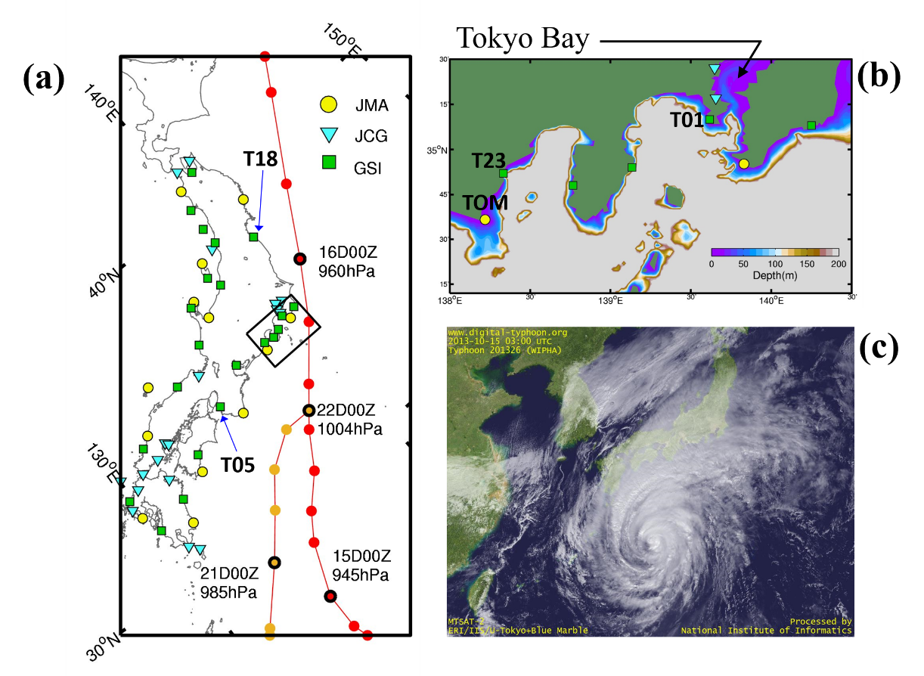
Figure 1. (a) Sea level stations (T05 and T18) and typhoon tracks with tracking points of Typhoon Wipha (red curve) and Neoguri (orange curve) at 3- and 6-hr intervals, respectively. (b) The bathymetry of Tokyo bay area in the inset of (a) with sea level stations T01, T23, and TOM. Water depth more than 200 m displays the same grey color. (c) Satellite image retrieved at 0300 UTC on October 15, provided by the National Institute of Informatics.

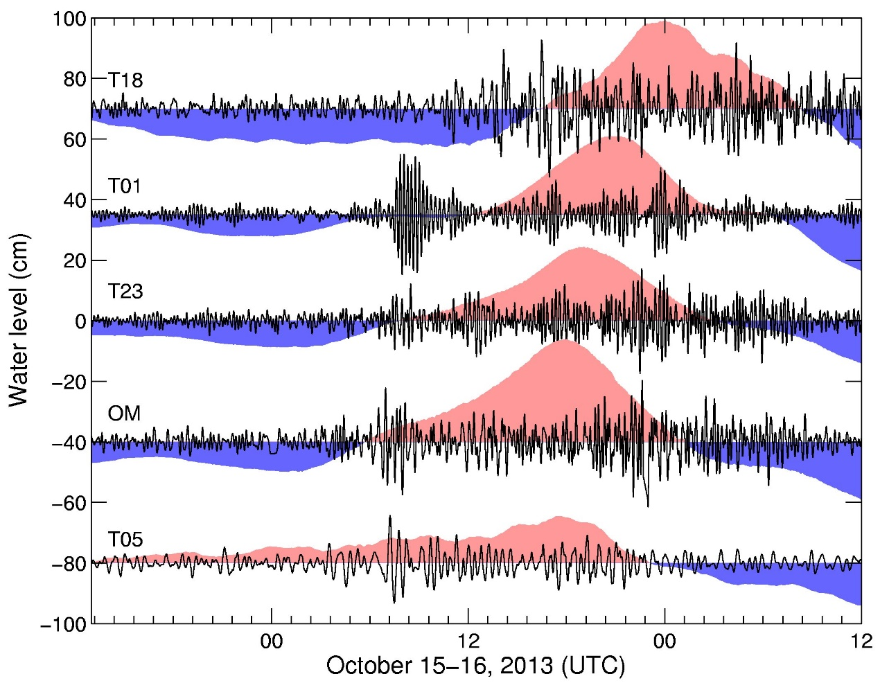

Figure 2. (a) Unexpected meteotsunamis (black lines) and storm surges (shaded areas with blue and red denoting abnormally low and high water levels, respectively) occurred at the east coast of Japan observed at five selected sea level stations T18, T01, T23, TOM, and T05.

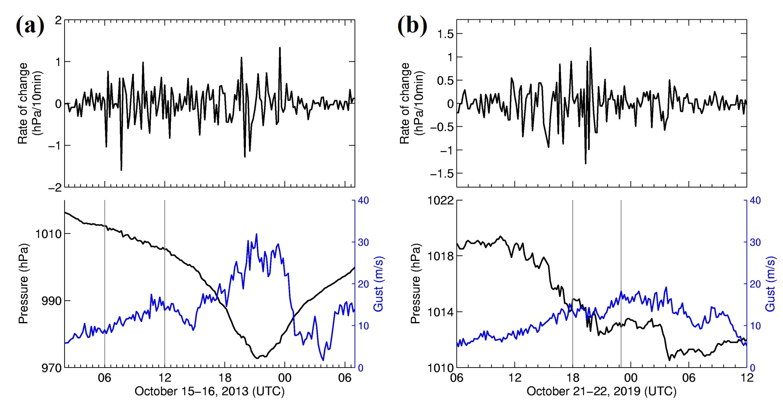
Figure 3. Two typhoon events in (a) 2013 and (b) 2019. Top panels are the rate of pressure changes and bottom panels show the meteorological conditions at JMA46760 (Yokohama). The area between two vertical lines indicates the unexpected meteotsunamis.

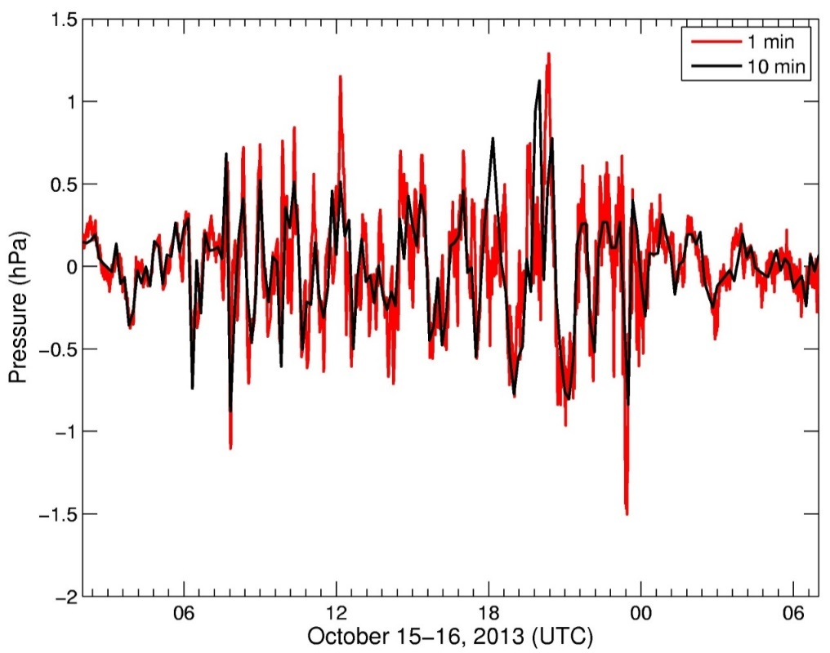

Figure 4. Pressure disturbances obtained from JMA47670 (10-min sampling intervals) and SORA (1-min sampling intervals) provided by Dr. Fudeyasu Hironori of Yokohama National University. Pressure disturbances are obatined by high-passed filter with a 3-hour window to remove the trend.

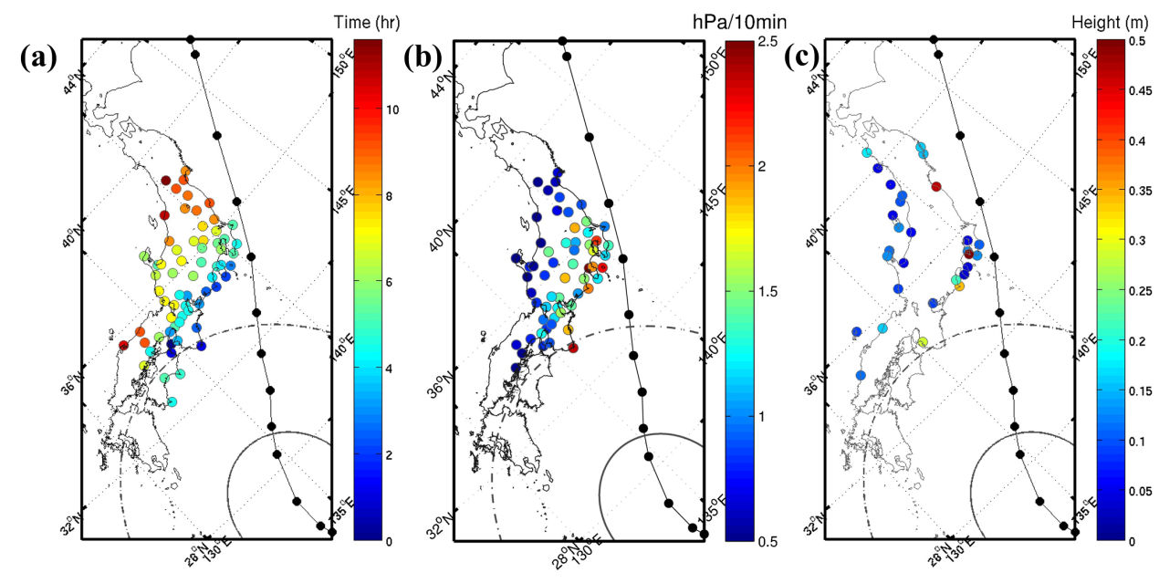
Figure 5. (a) Propagation of pressure disturbances, (b) the largest rates of pressure changes, and (c) meteotsunami wave heights. Solid and dashed curves indicate the radius of major and minor storm axis at 0000 UTC of October 15, respectively.

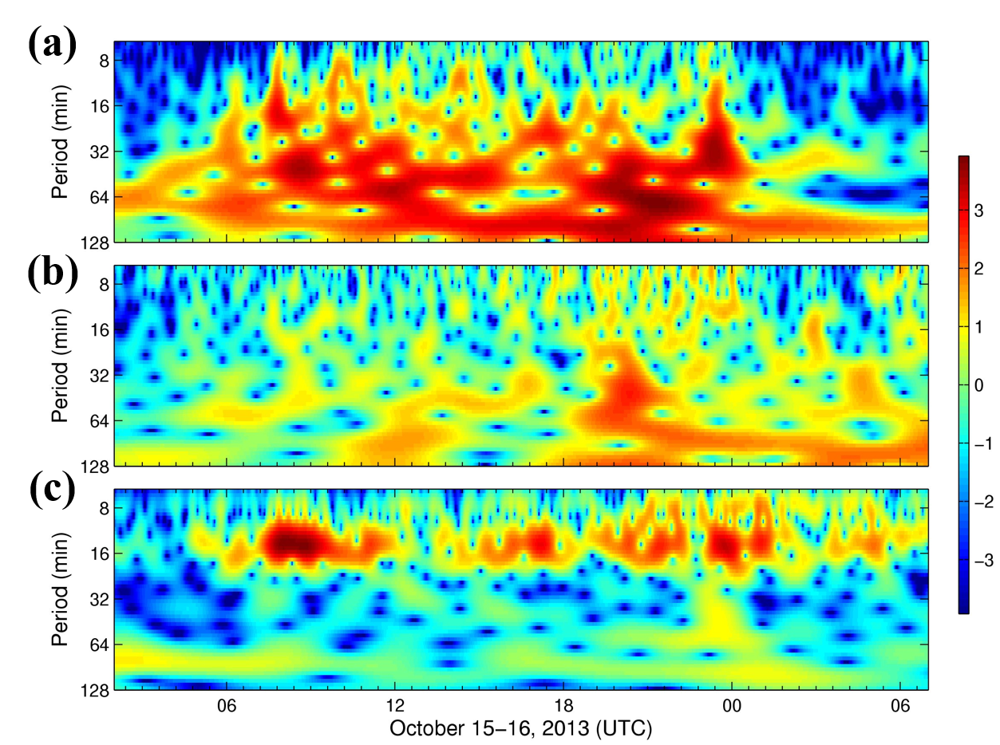
Figure 6. Wavelet power spectrum of (a) atmospheric disturbances of pressure and (b) wind at SORA station and (c) sea level fluctuations at T01 station. Colors are the base-2 logarithm of normalized wavelet spectra.

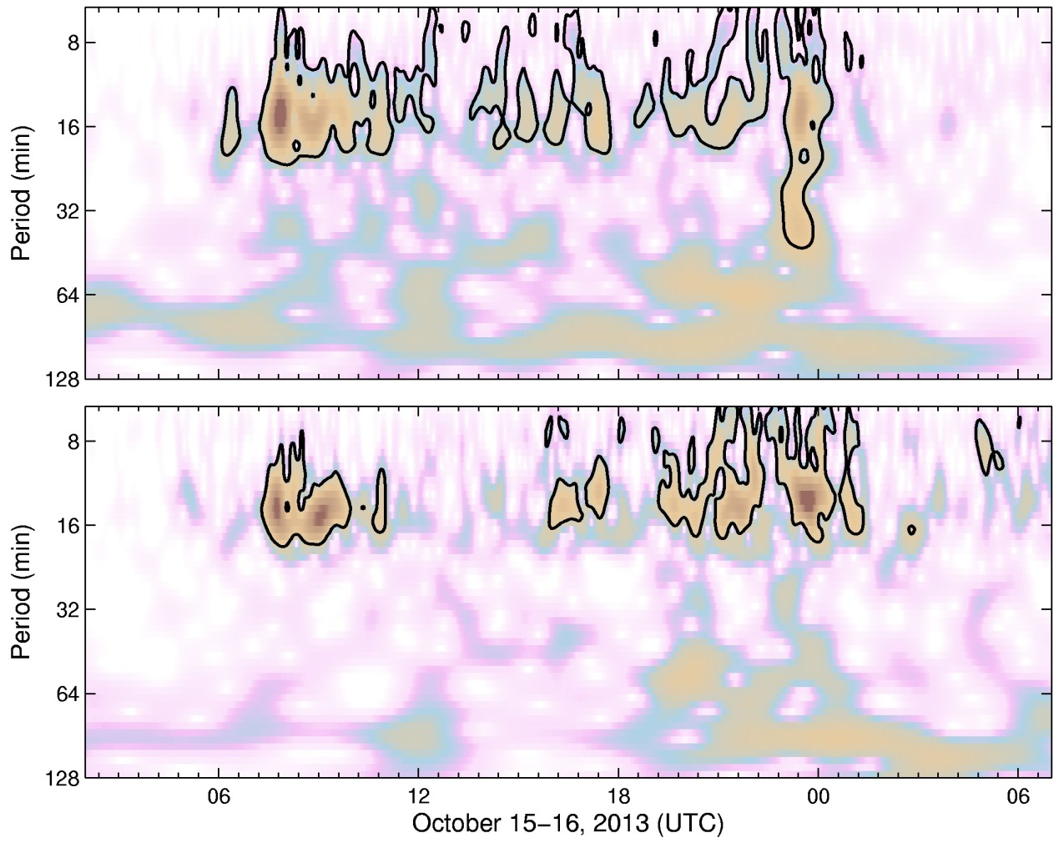
Figure 7. Wavelet coherence of pressure and sea level (upper) and wind and sea level (bottom). Bold contours indicate 95% conﬁdence level for the corresponding red-noise spectrum. Colors are wavelet squared coherencies

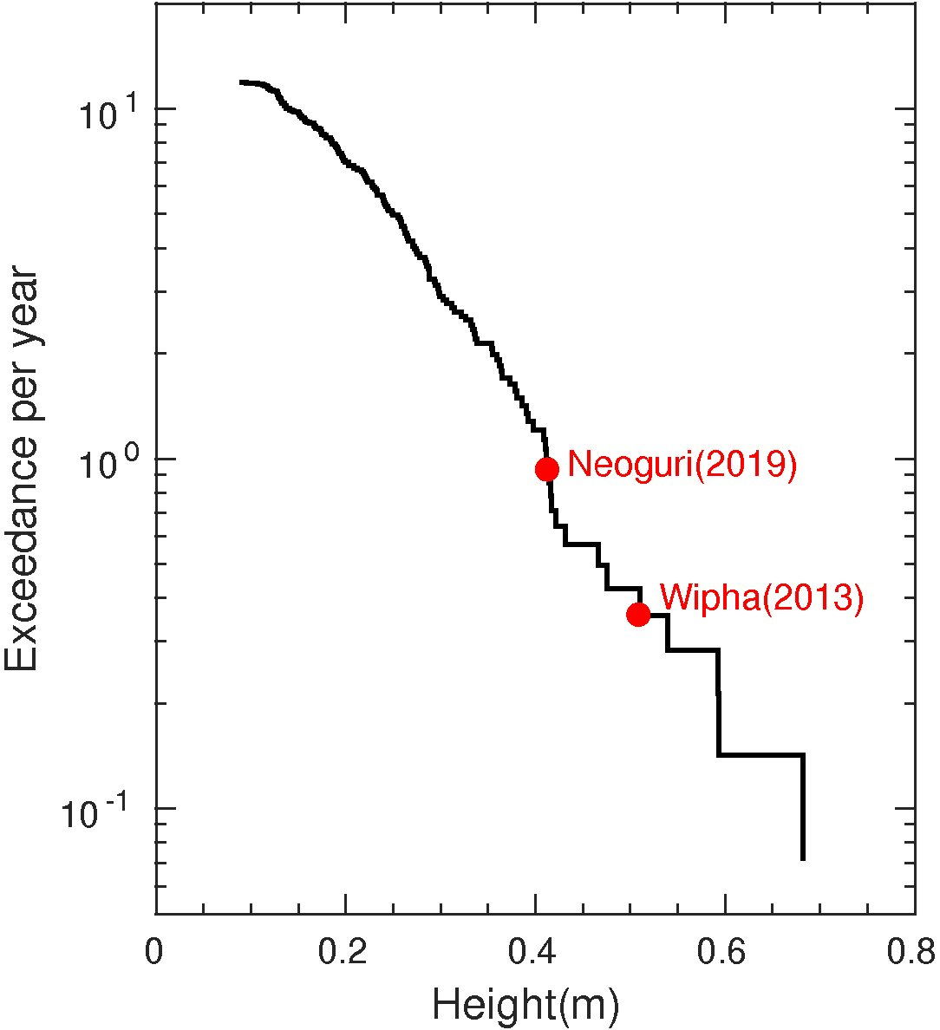
Figure 8. Probability distributions for meteotsunamis height observed at T01. The two dots are the 2013 and 2019 typhoon events.

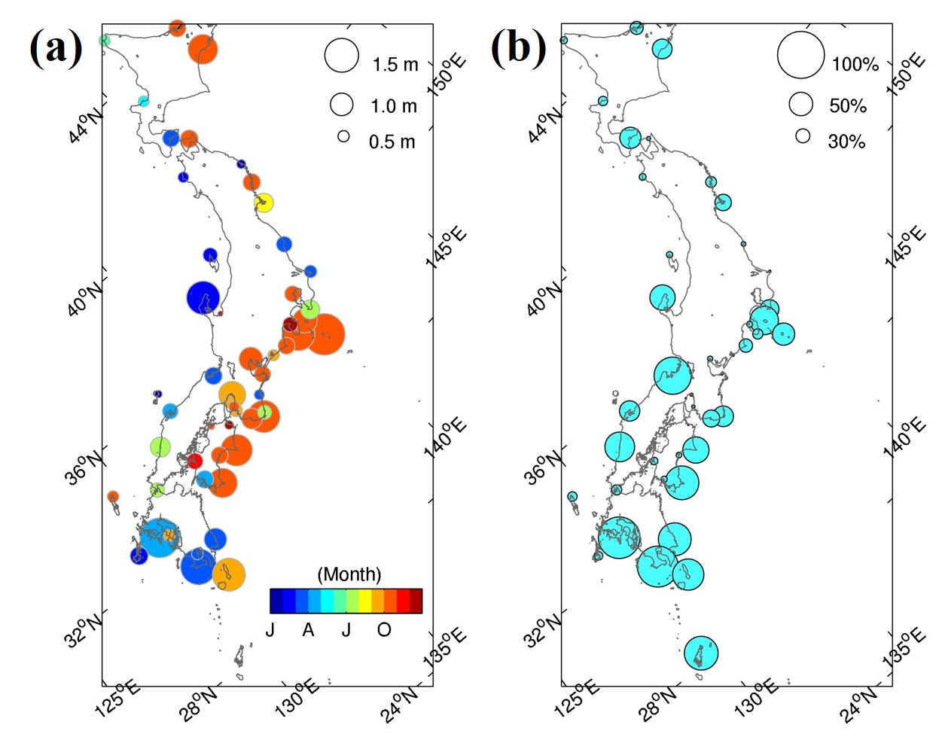
Figure 9. (a) Seasonable meteotsunami occurrences around Japan from 1999-2019 with the size of circles representing the the maximum height of meteotsunamis. The color scale shows the seasonal occurrences. (b) Occurrence of meteotsunamis heights larger than 0.3 m around Japan with the size of circles representing occurrence probability over 20 year data.

