***Please note that this is a non-peer reviewed EarthArXiv preprint***

Sandy beaches can survive sea-level rise
J.A.G. Cooper^{1,2}, G. Masselink³, G. Coco⁴, A.D. Short⁵, B. Castelle^{6,7}, K. Rogers⁸, E. Anthony^{9,10}, A.N. Green², J.T. Kelley¹¹, O.H. Pilkey¹², D.W.T. Jackson¹

Arising From: Vousdoukas et al. Nature Climate Change https://doi.org/10.1038/s41558-020-0697-0

1. Geography and Environmental Science, Ulster University, Coleraine, BT52 1SA, UK: email: jag.cooper@ulster.ac.uk
2. Geological Sciences, University of KwaZulu-Natal, Durban, South Africa
3. Coastal Processes Research Group, Plymouth University, Drake Circus, PL4 8AA Plymouth, UK
4. School of Environment, Faculty of Science, University of Auckland, New Zealand.
5. School of Geosciences, University of Sydney, NSW 2006, Australia
6. UMR EPOC 5805, Univ. Bordeaux, 33615 Pessac, France
7. UMR EPOC 5805, CNRS, 33615 Pessac, France
8. School of Earth, Atmospheric and Life Sciences, University of Wollongong, Northfields Ave, Wollongong, NSW, 2522, Australia
9. Aix Marseille University, CNRS, IRD, INRA, Coll France, CEREGE, Aix-en-Provence, France
10. USR LEEISA, CNRS, Cayenne, French Guiana
11. School of Earth and Climate Sciences, University of Maine, Orono ME 04469-5790, USA
12. Nicholas School of the Environment, Duke University, Durham, NC, USA

It has been asserted by Vousdoukas et al.¹, that climate change, in particular global sea-level rise (SLR), poses a threat to the existence of sandy beaches. The authors used global data bases of sandy beaches, bathymetry, wave conditions and SLR to drive a simple model based on the ‘Bruun Rule’ to quantitatively evaluate shoreline retreat. To this modelled retreat, they add a background ambient trend in shoreline dynamics and the modelled response of an extreme storm, that together contribute c. 20% of the shoreline retreat. When retreat was more than 100 m by 2100, they declared those beaches extinct. This is an incorrect and potentially damaging finding that must be repudiated along with the associated implications. Critical to the paper’s erroneous conclusions is the overlooked fact that, provided accommodation space is available, beaches migrate landwards as sea level rises and shorelines recede. In SW France, for example, many open ocean shorelines that have receded >100 m in the past century still have wide and healthy beaches². Many contemporary beaches originated thousands of years ago and migrated landwards during postglacial SLR³. The underlying false premise is linked to the use of an inappropriate simplistic model, the ‘Bruun Rule’, in which SLR promotes offshore sediment transport. As stated in the Methods section of Vousdoukas et al.¹: the magnitude of SLR-induced shoreline retreat “…depends on the amplitude of SLR and the transfer of sediment from the subaerial to the submerged part of the active beach profile”. Offshore sediment transport might happen in cases of very steep topography, but in most cases sediment transport is onshore during SLR³.
Sandy beaches are highly variable in form and setting, and, importantly, there is no common response to SLR^{3,4}. They may (i) migrate landwards due to onshore sediment transport via overwash without loss of beach width (this is the case for many barrier beaches and coastal plain systems on relatively gentle substrates), (ii) experience recession due to offshore sediment transport (this is the case for beaches backed by non-erodible cliffs or sea walls), or (iii) be stranded on the seabed (overstepped) as intact sand bodies (this requires rapid SLR, in excess of the worst RCP scenarios and/or particular combinations of surrounding morphology and sediment supply)⁵. Beaches may even (iv) prograde under the influence of SLR when the sediment budget is overwhelmingly positive⁶. Sandy shoreline response to SLR depends on many local environmental factors including coastal morphology, sediment supply and transport (onshore, offshore, longshore), rate (not just amount) of SLR, and the combined effect of shoreline dynamics. These key determinants of shoreline response to SLR are acknowledged but uniformly ignored in this paper.
The paper’s methodology is based on only the Bruun Rule, despite the acknowledgement by one of the co-authors in a previous paper⁶ that “…we cannot continue to depend on the highly uncertain coastal recession estimates obtained via the simple, deterministic method (Bruun rule)…”. While its shortcomings and generalisations have been well-documented⁷, it is necessary to reiterate them here. The Bruun Rule, as applied in this paper, requires a space and time-invariant cross-shore profile, ignores sediment supply, is strictly 2-dimensional and considers only amount of SLR. Crucially, it takes no account of the topography, or material nature of the basement over which the beach is migrating (Fig.1). Importantly, even in locations where the Bruun Rule’s underlying mode of shoreline retreat may be a valid mechanism, a beach is still predicted to remain (this point seems to be overlooked in the paper). Where it is not a valid description of shoreline behaviour it should not be applied.
There are many additional methodological shortcomings that space does not permit us to discuss in detail. They are incidental to the main criticism outlined above but include: an arbitrary constant (E factor) to moderate the predicted shoreline retreat by a median value of 75%; a very coarse wave model grid (0.5º–1.5º), resulting in overestimation of depth of closure (d_{c}) in embayed settings, underestimation of the active beach gradient and overestimation of recession; ignoring back-beach morphology; misidentification of sandy beaches from satellite imagery; double accounting the future effect of SLR as the impact of the current rate of SLR is included in the ambient shoreline dynamics; arbitrary use of 1:300 beach gradient cut-off to avoid excessive recession rates; ignoring regionally important sediment sources and sinks that will dominate long-term shoreline response in many locations; and using MSL as the top of beach profile leading to underestimation of gradient of the active beach profile and overestimation of recession rates. The headline result of this paper – “the near extinction of almost half of the world’s sandy beaches” – is the direct result of using an arbitrary and unjustified amount of shoreline retreat of 100 m.
Coastal erosion is a complex process that requires rigorous consideration of local, regional and global factors, and reliable models. Collectively, the assumptions and shortcomings that characterise the approach in this paper significantly inhibit the formulation of reliable and robust predictions of shoreline change due to SLR.
Some coasts for which application of the Bruun model is especially inappropriate are, somewhat ironically, highlighted¹. The complex Suriname coast, for example, is subject to the overarching influence of large periodic mud banks from the Amazon migrating along the inner shoreface⁹. On the northeast Brazilian coast, the authors misunderstand the sediment source and sinks¹⁰. Australia is singled out as having an especially high risk of beach loss, primarily because it has a very long coastline; however, in reality, Australia has a low risk of beach loss because the overwhelming majority of the coastline is undeveloped, allowing for unimpeded beach migration. Moreover, Australian beach systems have been predominantly stable over the past 50 years¹¹, despite SLR of c. 0.3 m. Several developing countries are identified as being at high risk. Contrary to the paper’s assertion, these do not have major beach-related tourism sectors and they have few artificial impediments to shoreline migration. Their beaches are consequently NOT threatened by sea-level rise, except in dense urban centres where sea defences exist. In the latter cases, paradoxically, beach extinction will occur without a great deal of shoreline recession.
The paper’s explicit advocacy of Dutch engineering is also problematic. The expertise, economy, and nearshore sand supplies necessary to maintain that approach to shoreline stabilization exists in few locations outside the Netherlands and are certainly absent from developing countries. Locking other nations into large-scale efforts to hold the line would be economically and environmentally disastrous.
Shoreline change models, are only as good as their structure and input data, and scientists have made some progress in this area¹². However, generalization of complex processes and extrapolations of limited data sets to large spatial (i.e. global) and long temporal (i.e. to 2100) scales have limited value since shoreline response to SLR is highly site-specific and temporally variable¹³. Incorrect model outputs may unnecessarily cause alarm, as has been the case with this paper. We need better methods for predicting impacts of sea-level rise on the coast, not more global and simplified applications of flawed concepts. As sea-level rises, sandy shoreline retreat must, and will, happen. Beaches, however, will survive. The biggest threat to the continued existence of beaches is coastal defence structures that limit their ability to migrate¹⁴.
References
- Vousdoukas, M.I., Ranasinghe, R., Mentaschi, L., Plomartis, T.A., Athanasiou, P., Luijendyk, A., Feyen, L. 2020. Sandy Beaches under threat of erosion. Nat. Clim. Chan.,
- Castelle, B., Guillot, B., Marieu, V., Chaumillon, E., Hanquiez, V., Bujan, S. and Poppeschi, C., 2018. Spatial and temporal patterns of shoreline change of a 280-km high-energy disrupted sandy coast from 1950 to 2014: SW France. Est. Coast. Shelf Sci., 200, 212-223.
- Carter, R.W.G. and Woodroffe, C.D. 1994. Coastal Evolution. Cambridge University Press.
- Woodroffe, C.D., 2002. Coasts: form, process and evolution. Cambridge University Press.
- Green, A.N., Cooper, J.A.G. and Salzmann, L., 2014. Geomorphic and stratigraphic signals of postglacial meltwater pulses on continental shelves. Geology, 42, 151-154.
- Brooke, B.P., Huang, Z., Nicholas, W.A., Oliver, T.S., Tamura, T., Woodroffe, C.D. and Nichol, S.L., 2019. Relative sea-level records preserved in Holocene beach-ridge strandplains–An example from tropical northeastern Australia. Mar. Geol., 411, 107-118.
- Ranasinghe, R., Callaghan, D. and Stive, M.J., 2012. Estimating coastal recession due to sea level rise: beyond the Bruun rule. Clim. Chan., 110, 561-574.
- Cooper, J.A.G. and Pilkey, O.H., 2004b. Sea-level rise and shoreline retreat: time to abandon the Bruun Rule. Glob. Planet. Chan., 43, 157-171.
- Anthony, E., Brunier, G., Gardel, A. and Hiwat, M., 2019. Chenier morphodynamics and degradation on the Amazon-influenced coast of Suriname, South America: implications for beach ecosystem services. Frontiers in Earth Science, 7, 35.
- Short, A.D. and Klein, A.H.D.F. eds., 2016. Brazilian beach systems Coastal Research Library 17. Springer, Switzerland.
- Short, AD, 2019, Australian coastal systems: beaches, barriers and sediment compartments. Coastal Research Library 32, Springer, Switzerland, 1241 pp.
- Montaño, J., Coco, G., Antolínez, J.A., Beuzen, T., Bryan, K.R., Cagigal, L., Castelle, B., Davidson, M.A., Goldstein, E.B., Ibaceta, R. and Idier, D., 2020. Blind testing of shoreline evolution models. Sci. Reps., 10(1), pp.1-10.
- Cooper, J.A.G., Green, A.N. and Loureiro, C. 2018. Geological constraints on mesoscale coastal barrier behaviour. Glob. Planet. Chan., 168, 15-34
- Pilkey, O.H. and Cooper, J.A.G., 2014. The Last Beach. Duke University Press.

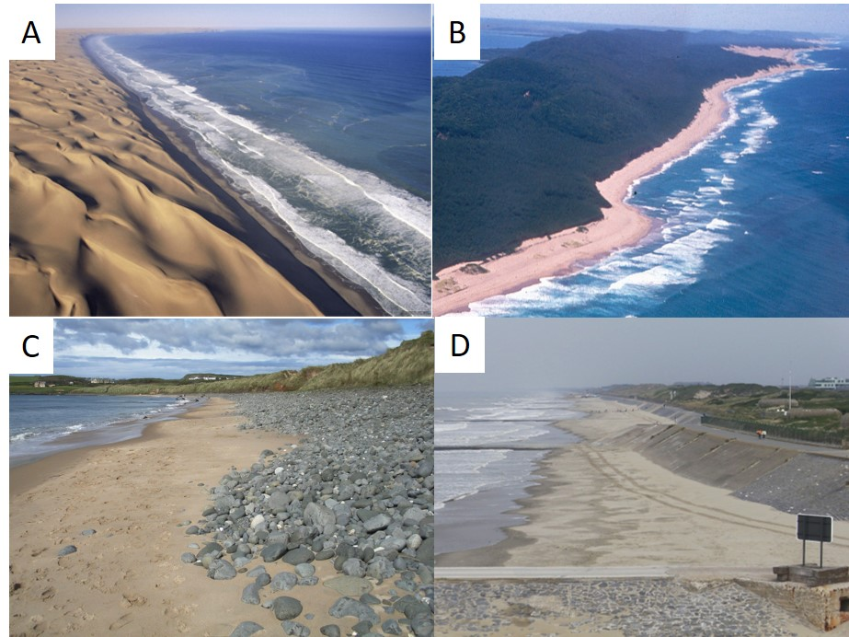

Figure 1. The geomorphology and material landward of a sand beach is an important determinant of its behavior under sea level rise. Sea level rise can tap into onshore sand supplies, thus ensuring continued healthy beaches. The arid Namibian coast (A) with its bare sand and the subtropical KwaZulu-Natal coast (B) with vegetated sand dunes are dramatic examples. The paraglacial coast of Northern Ireland also contains beaches backed by erodible, sediment-supplying glacigenic sediments (C). A cliff or seawall-backed beach such as at Oostend, Belgium (D), however, is cut off from adjacent sand suppling dunes. It will suffer coastal squeeze and disappear or need to be artificially replenished. The paper states, in the Supplementary Material, that ‘the present analysis assumes unlimited backshore space for shoreline retreat’; in fact, the reference to beaches becoming extinct actually suggests that the analysis disregards the role of the backshore space and material, which is to provide accommodation space for the beach to migrate into, as well as sediment to sustain it.

