Determining optimum use of thermal imaging for detecting deceased individuals

The authors wish to explicitly state that this manuscript is a non-peer reviewed preprint submitted to EarthArXiv on 26th February 2020.

Determining optimum use of thermal imaging for detecting deceased individuals
Kristopher D. Wisniewski Ph.D.^{1,2*}, Jamie K. Pringle Ph.D.¹, Vivienne Heaton Ph.D.³ & Andrew J. Mitten M.Geo¹
¹School of Geography, Geology and Environment, Keele University, Keele, Staffs, ST5 5BG, UK.
²Department of Criminal Justice and Forensics, School of Law, Policing & Forensics, Science Centre, Staffordshire University, Leek Road, Stoke on Trent, ST4 2DF, UK.
³School of Chemical and Physical Sciences, Keele University, Keele, Staffs, ST5 5BG, UK.
Emails: k.d.wisniewski@keele.ac.uk ; j.k.pringle@keele.ac.uk; v.g.heaton@keele.ac.uk ; a.j.mitten@keele.ac.uk
*Corresponding author: K. D. Wisniewski (k.d.wisniewski@keele.ac.uk)

ABSTRACT

Thermal imaging is commonly used by forensic search investigators to locate missing persons, but there is little research on it’s actual effectiveness to detect individuals after death. This paper aims to answer fundamental questions on how long thermal imaging is effective to detect a body lying on the surface and when is the optimal time in a day to survey.
A simulated murder victim, using a freshly dispatched pig (Sus scrofa) carcass, was left on the soil surface of a test site and imaged three times a day over a 61-day study period. Images were quantitatively analysed to determine what the relative thermal response the cadaver had with respect to background values, with results corrected for daily temperature (ADD) and decomposition rate (TBS scores).
Results evidenced the surface cadaver could be detectable throughout the 61 day study period, but there were differences depending on when the survey was conducted during the day. Morning surveys were found to be optimal up to 10 days PMI (0-90 ADD), evening/dusk surveys optimal from 10 to 40 days PMI (90-400 ADD), midday surveys optimal from 40 to 50 days PMI (400-530 ADD) and then evening surveys to the end of the 61-day (400-680 ADD) study period.
Implications suggest that thermal imaging is recommended to detect missing persons even after death and surveys should be undertaken at specific time periods during the day to improve search detection success if PMI can be estimated.
KEYWORDS: forensic science, thermal, search, surface remains, survey, missing persons
The use of forensic geoscientific techniques and methods in the search for missing persons is increasing; as locating them is of vital importance for their families and for criminal convictions to proceed (1). Current forensic search methods are highly varied and have been reviewed elsewhere (1,2), with best practice suggesting a phased approach, moving from large-scale remote sensing techniques (3) to ground reconnaissance and control studies before full searches are initiated (4). Full searches have involved a variety of methods, including forensic geomorphology (5), forensic botany (6,7), entomology (8) and scent-trained search dogs (9,10).
Remote sensing has commonly been used at both the large scale, where potential positions are identified, (see 2,11) and at smaller scales, such as using infrared imaging to capture blood spatter patterns at crime scenes (12), or diagnosing death by fire (13). Hyperspectral imagery is a common technique for detecting both explosive residues (14), trace evidence (e.g. 15) and even providing age estimations of blood stains (see 16). Originally adopted for military use in the 1950s, thermal detection has been utilised for the detection of landmines (17) and Improvised Explosive Devices (IEDs) (18). In forensics thermal imaging is commonly used to detect fleeing fugitives and heat by-products of illegal cannabis operations (19), and even facial analysis to detect intoxication (20).

Recent forensic research has used control studies to determine optimal body detection method(s) and equipment configuration(s). Results can be highly variable, depending upon a large number of factors, the most important being postmortem interval (PMI), body wrapping, local soil type, vegetation and climate (21-30). However, there has been little controlled research into the effectiveness of thermal imaging to detect surface remains after death.
Depending on climatic conditions, a body will cool after death, reaching ambient temperatures within ~24 h (31), thus providing no detectable thermal contrast. However, the human body has a higher specific heat capacity (~3,500 J/Kg ºC) (32), when compared to typical wet (~1480 J/Kg ºC) and dry (~800 J/Kg ºC) soil (33). Therefore, even when deceased, it will take longer for a human body to warm up and cool down, particularly at dawn and dusk when temperature changes are at their most rapid. Bone has a much lower specific heat capacity (~440 J/Kg ºC) and thus should also be able to be differentiated from background soil, with the contrast greatest in wet soil. It is also commonplace for necrophagous insects, particularly blowflies, to colonise a corpse immediately following death, given appropriate environmental conditions (34-37). Female flies will oviposit eggs on the cadaver, targeting natural orifices, wound sites and folds in clothing (38,39). These eggs will hatch after ~6 h - 40 h, depending on species and ambient temperature, and first instar larvae will immediately begin feeding on soft tissue (34). During this feeding phase larvae will aggregate, usually during second and third larval instar (34,35), to form a ‘maggot mass’. Masses, often composed of thousands of larvae, generate significant levels of heat as a result of feeding and fast metabolisms, particularly during active body decay. Controlled laboratory research has shown masses containing as few as 1,200 larvae producing significantly warmer than ambient temperatures (40), whilst field studies using animal proxies have recorded mass temperatures up to 50°C (36,41,42). Not only does mass size mass influence heat, but also density (43), species composition (44), stage of larval development (45), and sun exposure (46).
This paper’s aims are to investigate: (1) the length of time that a surface cadaver would be detectable, post-mortem, using thermal imaging and (2) the optimal time of day for undertaking such a thermal imaging survey.

Materials and methods

Study test site
The test site at Keele University, Staffordshire, is situated in a restricted area of grassed semi-rural ground surrounded by deciduous woodland and hedges (FIG. 1). The site lies ~200 m above sea level. The local soil is a sandy loam with nearby borehole records (27) with a bedrock of Carboniferous (Westphalian) Butterton Sandstone bedrock present at ~2.5 m below ground level (bgl). This site has been previously used for forensic geophysical studies (27-29,47) but these are downslope of this investigation site so avoiding any soil contamination issues.
Surveying was carried out between the 10th April and 9th June 2017, when warmer temperatures would facilitate insect cadaver activity. Meteorological data was available from the weather station situated ~200 m east of the study site. Average monthly rainfall was 24 mm (April/May) and 70.2 mm (June), with average daily air temperatures varied from 6.6 °C to 23.6 °C and averaged 13.7 °C over the study period. Having temperature data allowed Accumulated Degree Days (ADD) to be calculated which corrects for local site temperature variations (see (21) for details).

Pig cadaver
The use of pig cadavers as human analogues is well established in forensic science studies as they have similar chemical compositions, body sizes, tissue-to-body fat ratios, gut fauna, skin ⁄ hair types, and emissivity value to humans (27,28,48-50). At the current research site their use has been approved by the Department for Environment, Food & Rural Affairs (DEFRA) and the School’s Ethics Committees.
A single, naked, (~31 kg) pig (Sus scrofa) cadaver, sourced from a local abattoir and dispatched by a bolt gun to the temporal bone less than 6 h beforehand, was placed on the ground surface that was cleared of any vegetation (FIG. 1). The pig cadaver had a metal cage placed over the top after each survey to avoid/reduce scavenging activities.
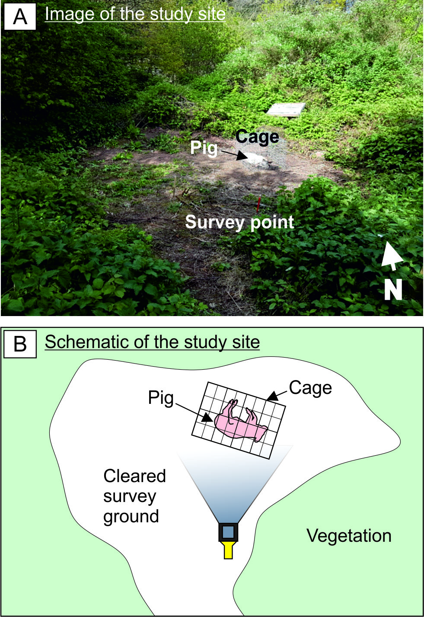
FIG. 1-A) Image and B) schematic of survey site, survey point denotes location where all thermal image data were acquired (2.5 m from cadaver).

Thermal radiation
At temperatures above absolute zero all objects emit infrared (IR) or thermal radiation (51). IR radiation has a wavelength range of 0.75 µm –1000 µm, commonly subdivided into near-infrared or NIR (0.76 µm – 1.5 µm), medium-infrared or MIR (1.5 µm– 5.6 µm) and far-infrared or FIR (5.6 µm – 1000 µm). A warmer/cooler object (Po) will continue to emit/absorb thermal radiation until it reaches equilibrium with its surroundings (P_{b}). Thermal imagers are able to distinguish between objects of the same temperature due to their contrasting emissivities. A thermal imager is only able to detect the differences between emitted powers (Eq. 1) and not absolute temperatures:
$∆P=P_{o}−P_{b}$ (1)
During day time surveys all measured radiation will include reflected radiation, with the major component being solar radiation (52). Other sources of radiation will also be detected i.e. if the target is self-heating (51). Most mammal skins have emissivities greater than 0.9, making them a good emitter/radiator, but a poor reflector of thermal radiation. Both human (53) and pig skin (50) have an emissivity of 0.98. In contrast, a shiny surface (e.g. ε = < 0.2) is a poor absorber and a poor emitter but a good reflector of thermal radiation (52). The benefits of thermal imaging, compared to photographs, is that it does not rely on visible light, but instead thermal energy, making it possible to detect targets in total darkness, through low visibility (e.g. smoke and fog) and in low contrast situations.

Thermal imaging surveys
A Fluke™ TiR125 thermal imaging camera was used for this study that acquires quantitative temperature matrix data (*.IS2 format) over the surveyed area - this camera has an accuracy of 0.1 °C. This allows quantitative comparisons of repeat thermal image data to be calculated. It is beyond the scope of this study to provide rigorous thermal emissivity corrections for all materials imaged; rather relative changes of the target surface pig cadaver versus background will be utilised. After initial equipment testing, the instrument was used following the equipment manufacturers instructions, in particular, for the instrument to warm up for ~15 mins before each thermal imaging survey was undertaken to optimise results.

Immediately after the pig cadaver had been placed on the cleared ground surface on day 1, an initial thermal imaging survey was undertaken, with readings taken at 2 h - 3 h intervals over a 24 h period, in order to determine when optimal survey time(s) for the subsequent thermal imaging surveys should be undertaken. During the first 24 hours the thermal anomaly over the pig cadaver changed diurnally, from a relative high anomaly, with respect to background values, during midday and evening surveys to no thermal anomaly overnight and a relative low anomaly in the morning (see FIG. 2). Therefore, the best times for the subsequent thermal surveys over this pig cadaver were noted to be ~08:00-09:59 (morning), ~12:00-13:59 (Midday) and ~20:00 to 21:59 (evening) respectively, due to there being a good thermal response over the surface pig cadaver, when compared to background site values (FIG. 2).

The subsequent daily thermal imaging surveys over the surface pig cadaver, throughout the course of the survey period, were then taken at these three chosen time periods up to day 49; after this daily surveys were only taken up to day 61 at evening survey times due to equipment availability. By day 61 the Total Body Score (TBS) of 35 was reached, which signifies the end of the active decomposition period (see (54)Megyesi, 2005) and thus this experiment. Vegetation regrowth had also meant thermal surveys were taking vegetation temperature by this point. Throughout the thermal survey experiment, each thermal image was taken from the same marked location (see FIG. 1) by the same operator at a set height of 1.4 m above the ground for consistency purposes.
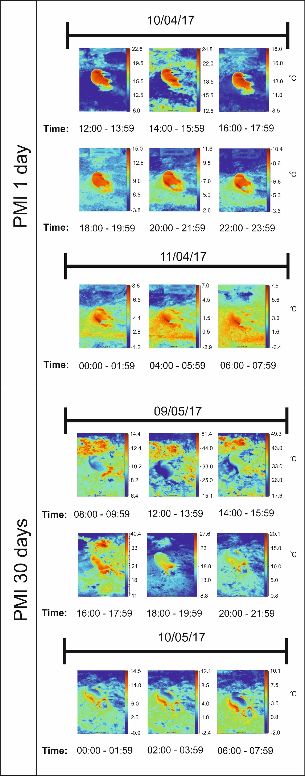
FIG. 2-Graphical summary of day 1 and day 30 thermal image surveys collected over the surface pig cadaver every 2-3 h, each over a 24 h survey period (times given).

Thermal image data analysis

Fluke SmartView® 4.3 software was used for thermal temperature matrix image data processing. For all thermal data collections, the thermal emissivity value was set to 0.98 (rather than 1 default), as 0.98 is emissivity of both pig/human skin as has been previously stated. Digital polygons were used to differentiate between the respective pig cadaver and background area, to obtain minimum/average/maximum thermal image temperatures (see FIG. 3 for example). The thermal difference data, between pig and background, from the continuous 60-day study was treated separately, dependent upon the time of day it was collected. This data was plotted against postmortem interval (PMI) and accumulated degree days (ADD; correcting for daily temperature fluctuations). A simple 5-point moving average was fitted to the thermal difference data so that any further weather anomalies are accounted for.
Total Body Scores (TBS) were also assigned during regular site visits; with TBS being the current standard forensic anthropology method used to quantify decomposition (see 54). The PMI, ADD and TBS data were then summarised, and the type (positive or negative) of relative thermal anomaly, when compared to background values, that a surface cadaver would produce.
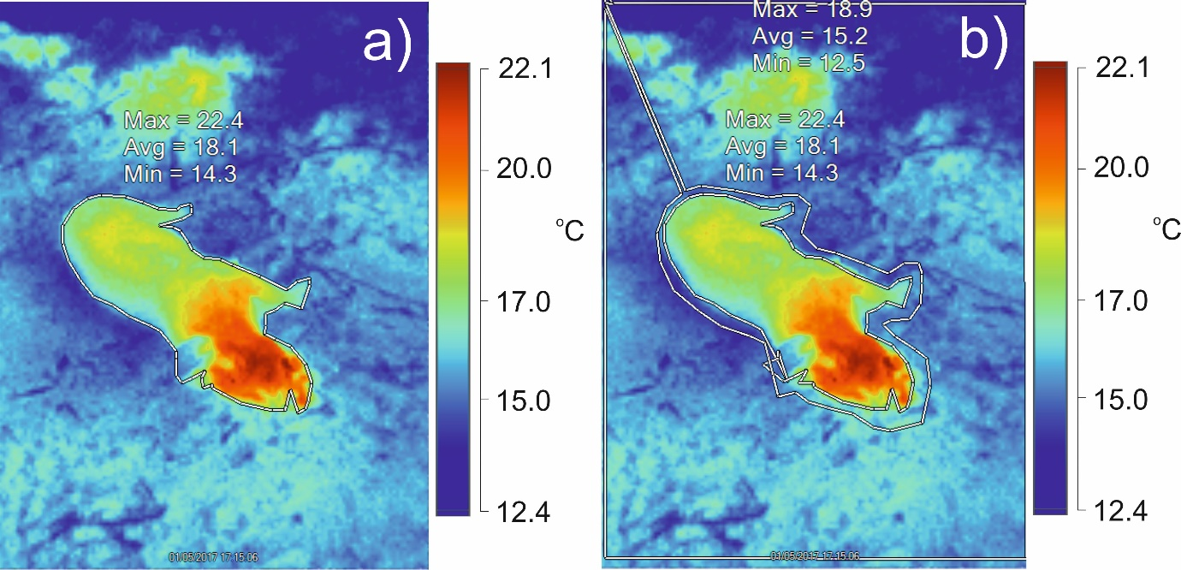
FIG. 3-Graphical summary detailing an example of thermal image data processing used in this study. A digital polygon was drawn around a) the surface pig cadaver and b) the background area, with minimum/average/maximum temperature values of both a/b areas (shown) extracted.

Results

The thermal signature associated with the pig cadaver, when compared to background thermal image values, varied as either a low, high or, in fact, no anomaly being imaged, when compared to background values. This variation was witnessed across each of the morning, midday and evening surveys (see FIG. 4 and FIG. 5 for respective thermal image data examples and graphical thermal summaries throughout the survey period).
For PMI days 1-10 (0 ADD - 90 ADD), morning and midday surveys generally had -1 ℃ to -2 ℃ anomalies, and evening surveys had +1 ℃ to +2 ℃ anomalies over the surface pig cadaver, when compared to background values respectively. Morning surveys determined to be optimal over this survey period.
For PMI days 10-20 (90 ADD - 170 ADD), morning surveys generally had -1 ℃ to 0 ℃ anomalies, midday surveys had -1 ℃ to +1 ℃ anomalies, and evening surveys had +1 ℃ to +2 ℃ anomalies over the surface pig cadaver, when compared to background values respectively. Evening surveys were determined to be optimal over this survey period.
For PMI days 20-30 (170 ADD - 270 ADD), morning surveys generally had -1 ℃ to 0 ℃ anomalies, midday surveys had 0 ℃ to +1 ℃ anomalies, and evening surveys had +2 ℃ to +5 ℃ anomalies over the surface pig cadaver, when compared to background values respectively. Evening surveys were determined to be optimal over this survey period.
For PMI days 30-40 (270 ADD - 400 ADD), morning surveys generally had 0 ℃ to +2 ℃ anomalies, midday surveys had +1 ℃ to +3 ℃ anomalies, and evening surveys had +2 ℃ to +4 ℃ anomalies over the surface pig cadaver, when compared to background values respectively. Evening surveys were determined to be optimal over this survey period.
For PMI days 40-50 (400 ADD - 530 ADD), morning surveys generally had +2 ℃ to +3 ℃ anomalies, midday surveys had +3 ℃ to +6 ℃ anomalies, and evening surveys had +2 ℃ to +3 ℃ anomalies over the surface pig cadaver, when compared to background values respectively. Midday surveys were determined to be optimal over this survey period.
For PMI days 50-61 (530 ADD - 680 ADD), evening surveys had +1 ℃ to +2 ℃ anomalies over the surface pig cadaver, when compared to background values respectively.
Table 1 summarises these key findings which, as well as including the PMI, also includes the Accumulated Degree Days (ADD) and Total Body Scores (TBS) of the target surface cadaver. Finally, it also summarises the perceived optimal time during the day for a thermal imaging survey to be undertaken as discussed here.
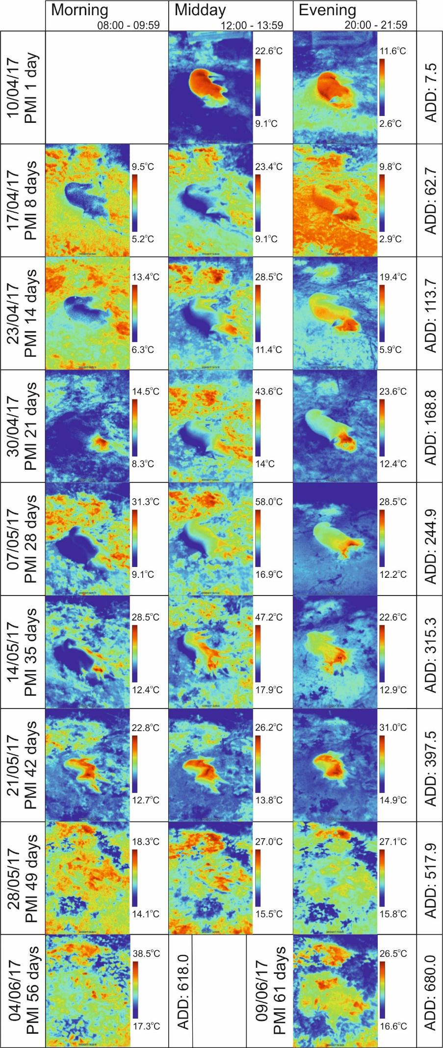
FIG. 4-Thermal image survey examples taken over the study period (PMI/ADD shown for comparison). Note the morning, midday and evening surveys and thermal anomaly over the surface pig cadaver varies as either low, no anomaly or high anomaly with respect to background values.
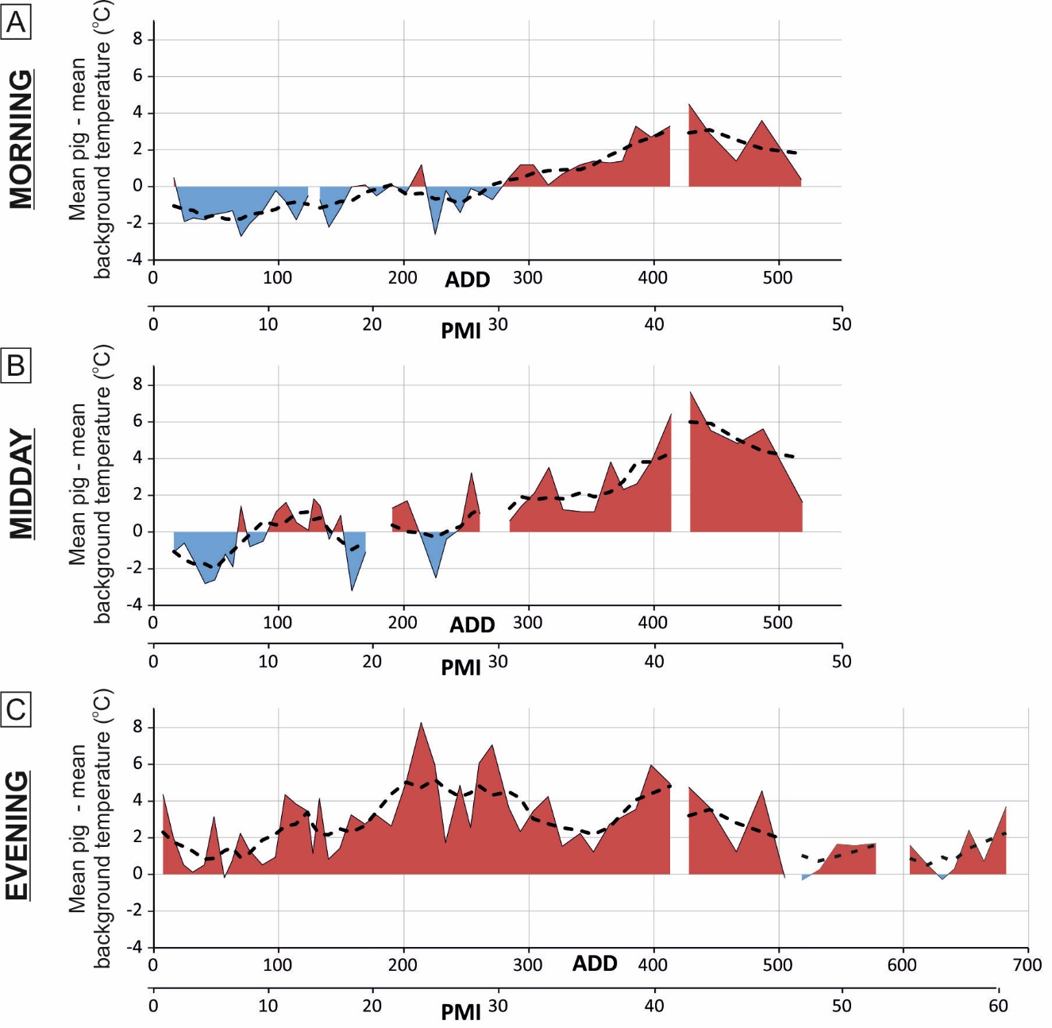
FIG. 5-Graphical summary of thermal imaging data quantitative analysis, showing the relative thermal difference (average pig anomaly minus background values) for (a) morning, (b) midday and, (c) evening surveys respectively. Dotted line gives five-point running average values. Note bottom axes are both Post-Mortem Interval (PMI) and Accumulated Degree Days (ADD), see text for details.
PMI (days) | ADD (℃) | TBS | Morning anomaly (ᵒC) | Midday anomaly (ᵒC) | Evening anomaly (ᵒC) | Optimal time for thermal survey
0-10 | 0-90 | 0-4 | -1 to -2 | -1 to -2 | +1 to +2 | Morning
10-20 | 90-170 | 5-12 | -1 to 0 | -1 to +1 | +2 to +3 | Evening
20-30 | 170-270 | 13-20 | -1 to 0 | 0 to +1 | +2 to +5 | Evening
30-40 | 270-400 | 20-26 | 0 to +2 | +1 to +3 | +2 to +4 | Evening
40-50 | 400-530 | 26-29 | +2 to +3 | +3 to +6 | +2 to +3 | Midday
50-61 | 530-680 | 29-35 |  |  | +1 to +2 | Evening
Table 1. Thermal imaging summary of relative average temperatures of surface pig cadaver minus background values. PMI = Postmortem interval (days), ADD = Accumulated Degree Days, TBS = Total Body Score, see text for details.

Discussion

This paper’s first stated aim was ‘to investigate the length of time that a surface cadaver would be detectable, post-mortem, using thermal imaging’. From the results of this study, thermal imaging surveys could detect the surface remains of the pig cadaver for the 61 days PMI / 681 ADD / 35 TBS study period. Two studies, using a ground-based study (55), similar to this study, and using airborne helicopter thermal imagery (56), have shown detectable [elevated] thermal signatures of maggot masses on pig carcasses, but only over 14- and 21-day survey periods, respectively. This supports the findings reported elsewhere (57), following investigations into whether thermal imaging could successfully be used to detect thermal emissions on seven pig cadavers as they decomposed in woodland in New England, USA. Pig cadavers were detectable between 2- and 26-days PMI, largely due to the larval aggregations colonising the cadavers, which were generating significant amounts of heat. By day 26 the cadavers had reached the advanced stage of decay, and the absence of any remaining soft tissues caused the larval masses to disperse away from the remains and all associated heat to be lost, signifying the end of their experiment (57). It is possible that the cadaver used in the current research was detectable for longer due to the cooler ambient temperatures recorded at Keele, slowing the rate of decomposition and allowing soft tissue to persist for longer, which would support the larval communities over an extended period of time.
The advantage of using the Fluke™ TiR125 thermal imaging camera was that the data can be saved quantitatively and analysed, particularly to calculate average temperature differences of the anomaly over the pig cadaver when compared to the background. This is an important development for such thermal monitoring studies; rather than simply producing an image that could only be qualitatively assessed, and has other broad forensic applications, not just for thermal imaging, but perhaps for other search technique data types, for example electrical resistivity datasets (see (58).
This paper’s second stated aim was ‘to investigate the optimal time of day for undertaking such a thermal imaging survey’. Surprisingly this was found to be important, with different times of day optimal, depending upon the PMI and TBS, when adjusting for the local temperature variations (Table 1). This should therefore be of great interest and use to forensic search teams if the PMI/ADD of the missing individual is known. If the thermal imaging survey is taken at the optimum time, then search teams should have the greatest chance of success at detecting the missing individual, which could potentially maximum any remaining forensic evidence, advance the case efficiently, reduce expenditure and provide more rapid closure for the victim’s family.
As decomposition enters the active stage, the relative thermal anomaly over the pig carcass, with respect to background values became much more elevated. Initially following death the remains will cool to ambient, a process known as algor mortis, making the pig less discernible from its surroundings. However, shortly thereafter temperatures will increase, likely due to a number of factors including larval aggregations, bacterial activity and heat loading (40). In regards to heat loading, the size of the carcass, the nature of the ground it is laid on, and its exposure to direct sunlight, can all have an effect on its temperature (59). As bodies begin to decompose the bacteria in the intestines proliferate as they break down the body further during putrefaction. Some researchers have proposed that bacterial metabolism plays a significant role in carcass thermogenesis, reporting that even in the absence of maggot masses and solar radiation, cadavers can peak at temperatures of 32 °C whilst ambient temperature remains a constant 23 °C (55).
Despite these factors, it is the heat generated by feeding larval masses that is believed to be the biggest contributor to increased localised temperatures recorded on cadavers. The increase in temperature from ambient correlates with the emergence of first instar larvae, usually during the bloated stage of decay, and continues to rise as colonising larvae increase in numbers, as well as in physical size, with temperatures peaking during the third larval instar and the active stage of decay (36,40,44,45). It would be during this time, when larval aggregations are at the hottest, that the use of thermal imagery in searches is most proficient (60). Once larvae consume the remaining soft tissues on the carcass, they cease feeding and migrate away from the body in search of a place to pupate and complete development. It is at this point where temperatures on the cadaver begin to decline, gradually returning to ambient (40). The thermal anomaly associated with the remains on day 61 is likely a result of heat absorption by the skeletal elements and bacterial activity in the soil. The latter was also suggested by a recent study which reported that carcasses were detectable during the advanced stages of decay using aircraft mounted thermal imaging due to the soils being contaminated with decompositional fluids and supporting larger than expected bacterial communities, resulting in slightly elevated soil temperatures (60). This is likely why all the later thermal imaging surveys had slightly elevated temperatures regardless of the time of day that the survey was undertaken.

Conclusion

This study aimed to answer fundamental questions on how effective thermal imaging surveys are to detect deceased individuals on the ground surface using a simulated individual of a pig (Sus scrofa) carcass. Thermal imaging could detect the carcass over the 61 day (680 ADD) study period, with morning surfaces determined to be optimal from 0 -10 days PMI (0-90 ADD), evening surveys optimal for 10-40 days PMI (90-400 ADD) and midday/evening surveys optimal from 50 days PMI to the end of the 61 day PMI (680 ADD) survey period.
Study limitations included using one and not multiple pig cadavers for replication purposes and of course this was undertaken on one study site for a 61 day period, with unique soil compositions and local vegetation type. The later thermal imaging surveys had growing vegetation on the surface next to the pig cadaver, which was starting to mask the target pig cadaver, but this does replicate what would happen if a deceased person was left in such depositional environments.
Since the current research has demonstrated that thermal imaging has the potential to be used as a search tool for missing persons who are presumed dead, further investigation should be carried out in order to test its capabilities in a range of scenarios that may be encountered in casework. This might involve researching its success at locating bodies wrapped in some form of covering, or drowned victims floating on the water surface (as below surface victims will not be detectable as water absorbs IR). Cadavers decomposing in both of these scenarios will be exposed to insect activity, however insect numbers are expected to be smaller and more localised as the water and coverings limit larval access. Some researchers have already investigated the use of aircraft mounted thermal imaging on locating decomposing remains (56,61), but with current policing budget cuts it may be worthwhile to look at drone mounted thermal imaging as a cheaper alternative for police forces, focusing on their ability to detect remains at different heights, speeds and over different types of terrain.

Role of the funding source
This research did not receive any specific grant from funding agencies in the public, commercial, or not-for-profit sectors.

Acknowledgements
The Nuffield Foundation are thanked for providing financial support for summer Further Education studentships. Keele University estates team are thanked for allowing site access and logistical support. Liz Deakin of Staffordshire University is thanked for logistical support. This project was undertaken on a DEFRA-approved controlled test area and gained School ethical approval.

References
- Pringle JK, Ruffell A, Jervis JR, Donnelly L, McKinley J, Hansen J, et al. The use of geoscience methods for terrestrial forensic searches. Earth Sci Rev 2012;114:108–23.
- Ruffell A, Pringle JK, Cassella JP, Morgan M, Ferguson M, Heaton VG, et al. The use of geoscience for aquatic forensic searches. Earth Sci Rev 2017;171:323-37.
- Kalacska M, Bell LS, Sanchez-Azofeifa GA, Caelli T. The application of remote sensing for detecting mass graves: an experimental animal case study from Costa Rica. J Forensic Sci 2009;54:159–66.
- Harrison M, Donnelly LJ. Locating concealed homicide victims: developing the role of geoforensics. In: Ritz K, Dawson L, Miller D, editors. Criminal and environmental soil forensics. Dordrecht: Springer, 2009;197–219.
- Ruffell A, McKinley J. Forensic geomorphology. Geomorphology 2014;206:14–22.
- Caccianiga M, Bottacin S, Cattaneo C. vegetation dynamics as a tool for detecting clandestine graves, J. Forensic Sci 2012;57:983-88.
- Aquila I, Ausania F, Di Nunzio C, Serra A, Boca S, Capelli A, et al. The role of forensic botany in crime scene investigation: case report and review of literature. J Forensic Sci 2014;59:820–4.
- Amendt J, Campobasso CP, Gaudry E, Reiter C, Le Blanc HN, Hall MJR. Best practice in forensic entomology: standards and guidelines. Int J Legal Med 2007;121:90–104
- Lasseter A, Jacobi KP, Farley R, Hensel L. Cadaver dog and handler team capabilities in the recovery of buried human remains in the Southeastern United States. J Forensic Sci 2003;48:617–21.
- Riezzo I, Neri M, Rendine M, Bellifemina A, Cantatore S, Fiore C, et al. Cadaver dogs: unscientific myth or reliable biological devices? Forensic Sci Int 2014;244:213–21.
- Ruffell A, McKinley J. Geoforensics. Chichester: Wiley, 2008.
- Edelman GJ, Hoveling RJM, Roos M, van Leeuwen TG, Aalders MCG. Infrared imaging of the crime scene: possibilities and pitfalls, J Forensic Sci 2013;58:1156-62.
- Yamauchi S, Hitosugi M, Kimura H, Tokudome S. A novel application of infrared imaging for the diagnosis of death by fire. J Forensic Sci 2013;58:1022-25.
- de la Ossa ÁF, Amigob JM, García-Ruiza C. Detection of residues from explosive manipulation by near infrared hyperspectral imaging: A promising forensic tool, Forensic Sci Int 2014;242:228-35.
- Edelman GJ, Gaston E, van Leeuwen TG, Cullen PJ, Aalders MCG. Hyperspectral imaging for non-contact analysis of forensic traces, Forensic Sci Int 2012;223:28-39.
- Edelman GJ, van Leeuwen TG, Aalders MCG. Hyperspectral imaging for the age estimation of blood stains at the crime scene, Forensic Sci Int 2012;223:72-77.
- Deans J, Gerhard J, Carter LJ. Analysis of a thermal imaging method for landmine detection using infrared heating of the sand surface, Infrared Phys Tech 2006;48:202–16.
- Gurton KP, Felton M. Remote detection of buried land-mines and IEDs using LWIR polarimetric imaging, Opt Express 2012;20:22344–59.
- Stowell C. Thermal imaging by law enforcement, Proc SPIE 2001;4360:192–202.
- Koukiou G, Anastassopoulos V. Neural networks for identifying drunk persons using thermal infrared imagery, Forensic Sci Int 2015;252:69-76.
- France DL, Griffin TJ, Swanburg JG, Lindemann JW, Davenport GC, Trammell V, et al. A multidisciplinary approach to the detection of clandestine graves. J Forensic Sci 1992;37:1445–58.
- Schultz JJ, Collins ME, Falsetti AB. Sequential monitoring of burials containing large pig cadavers using ground-penetrating radar. J Forensic Sci 2006;51:607–16.
- Schultz JJ. Sequential monitoring of burials containing small pig cadavers using ground-penetrating radar. J Forensic Sci 2008;53:279–87.
- Schultz JJ, Martin MM. Controlled GPR grave research: comparison of reflection profiles between 500 and 250 MHz antennae. Forensic Sci Int 2011;209:64–9.
- Pringle JK, Jervis J, Cassella JP, Cassidy NJ. Time-lapse geophysical investigations over a simulated urban clandestine grave. J Forensic Sci 2008;53:1405–17.
- Pringle JK, Holland C, Szkornik K, Harrison M. Establishing forensic search methodologies and geophysical surveying for the detection of clandestine graves in coastal beach environments. Forensic Sci Int 2012;219:e29–36
- Pringle JK, Jervis JR, Hansen JD, Cassidy NJ, Jones GM, Cassella JP. Geophysical monitoring of simulated clandestine graves using electrical and Ground Penetrating Radar methods: 0-3 years. J Forensic Sci 2012;57:1467-86.
- Pringle JK, Jervis JR, Roberts D, Dick HC, Wisniewski KD, Cassidy NJ, et al. Geophysical monitoring of simulated clandestine graves using electrical and ground penetrating radar methods: 4-6 years. J Forensic Sci 2016;61:309–21.
- Jervis JR, Pringle JK, Tuckwell G. Time-lapse resistivity surveys over simulated clandestine graves. Forensic Sci Int 2009;192:7–13
- Ruffell A, Pringle JK, Forbes S. Search protocols for hidden forensic objects beneath floors and within walls. Forensic Sci Int 2014;237:137– 45.
- Henssge C, Madea B. Estimation of the time since death in the early post-mortem period. Forensic Sci Int 2004;144:167–75.
- Faber P, Garby L. Fat content affects heat capacity: a study in mice. Acta Physiol Scand 1995;153:185-87.
- Bristow KL, Kuitenberg GJ, Goding CJ, Fitzgerald TS. A small multi-needle probe for measuring soil thermal properties, water content and electrical conductivity. Comp Elect In Agri 2001;31:265-80.
- Campobasso CP, Di Vella G, Introna F. Factors affecting decomposition and Diptera colonization, Forensic Sci Int 2001;120:18-27.
- Grassberger M, Frank C. Initial study of arthropod succession on pig carrion in a Central European urban habitat. J Med Entomol 2004;41:511-23.
- Slone DH, Gruner SV. Thermal regulation in larval aggregations of carrion-feeding blow flies (Diptera: Calliphoridae). J Med Entomol 2007;44:516-23.
- VanLaerhoven SL. Blind validation of post-mortem interval estimates using developmental rates of blow flies. Forensic Sci Int 2008;180:76-80.
- Amendt J, Richards CS, Campobasso CP, Zehner R, Hall MJ. Forensic Entomology: Application and Limitations. Forensic Sci Med Pat 2011;7:379-92.
- Cross P, Simmons T. The influence of penetrative trauma on the rate of decomposition. J Forensic Sci 2010;55:295-301.
- Heaton VG, Moffatt C, Simmons T. Quantifying the Temperature of Maggot Masses and its Relationship to Decomposition. J Forensic Sci 2014;59:676-82.
- Richards EN, Goff ML. Arthropod succession on exposed carrion in three contrasting tropical habitats on Hawaii Island, Hawaii. J Med Entomol 1997;34:328-39.
- Richards CS, Price BW, Villet MH. Thermal ecophysiology of seven carrion-feeding blowflies in Southern Africa. Entomol Exp Appl 2009;131:11-19.
- Charabidze D, Bourel B, Gosset D. Larval-mass effect: Characterisation of heat emission by necrophagous blowflies (Diptera: Calliphoridae) larval aggregates. Forensic Sci Int 2011;211:61-66.
- Rivers DB, Ciarlo T, Spelman M, Brogan R. Changes in development and heat shock protein expression in two species of flies (Sarcophaga bullata [Diptera: Sarcophagidae] and Protophormia terraenovae [Diptera: Calliphoridae]) reared in different sized maggot masses. J Med Entomol 2010;47:677-89.
- Charabidze D, Bourel B, Hedouin V, Gossett D. Repellent effect of some household products on fly attraction to cadavers, Forensic Sci Int 2009;189:28-33.
- Joy JE, Liette NL, Harrah HL. Carrion fly (Diptera: Calliphoridae) larval colonisation of sunlit and shaded pig carcasses in West Virginia, USA. Forensic Sci Int 2006;164:183-92.
- Pringle JK, Cassella JP, Jervis JR, A. Williams, Cross P, Cassidy NJ. Soilwater conductivity analysis to date and locate clandestine graves of homicide victims. J. Forensic Sci 2015a;60:1052-60.
- Carter DO, Tibbett M. Cadaver decomposition and soil: processes, in: M. Tibbett, D.O. Carter, eds. Soil analysis in forensic taphonomy: chemical and biological effects of buried human remains. CRC Press, 2009;29–52.
- Stokes KL, Forbes SL, Tibbett M. Human versus animal: contrasting decomposition dynamics of mammalian analogues in experimental taphonomy. J Forensic Sci 2013;58:583-91.
- Soerensen DD, Clausen S, Mercer JB, Pedersen LJ. Determining the emissivity of pig skin for accurate infrared thermography. Comp Elect in Agri 2014;109:52–58.
- Lloyd JM. Thermal imaging systems. Boston MA, Springer 1975;18-30.
- Havens KJ, Sharp EJ, editors. Thermal imaging techniques to survey and monitor animals in the wild. Academic Press, 2016;89-99.
- Steketee J. Spectral emissivity of skin and pericardium, Phys in Med & Bio 1973;18:686-94.
- Megyesi MS, Nawrocki SP, Haskell NH. Using accumulated degree-days to estimate the postmortem interval from decomposed human remains. J Forensic Sci 2005;50:618-26
- Johnson A, Wallman J. Infrared imaging as a non-invasive tool for documenting maggot mass temperatures. Australian J Forensic Sci 2014;46:73-78.
- Amendt J, Rodner S, Schuch CP, Sprenger H, Weidlich L, Reckel F. Helicopter thermal imaging for detecting insect infested cadavers. Sci Justice 2017;57:366–72.
- DesMarais AM. Detection of Cadaveric Remains by Thermal Imaging Cameras. J Forensic Identif 2014;64:489-510.
- Pringle JK, Jervis JR. Electrical resistivity survey to search for a recent clandestine burial of a homicide victim, UK. Forensic Sci Int 2010;202: e1–7.
- Greenberg B, Kunich JC. Entomology and the Law: Flies as Forensic Indicators. Cambridge University Press, 2002.
- Lee MJ, Voss SC, Franklin D, Dadour IR. Preliminary investigation of aircraft mounted thermal imaging to locate decomposing remains via the heat produced by larval aggregations. Forensic Sci Int 2018;289:175-85.

