WORKSHOP REPORT

Securing Legacy Seismic Data to Enable Future Discoveries
September 18-19, 2019
Albuquerque, New Mexico

NSF-1917159

Organizing Committee
Lorraine Hwang, UC Davis, Chair
Tim Ahern, IRIS emeritus
Cynthia Ebinger, Tulane University
William Ellsworth, Stanford University
Garrett Euler, Los Alamos National Lab
Emile Okal, Northwestern University
Paul Okubo, HVO US Geological Survey
Bill Walter, Lawrence Livermore National Laboratory


One Shields Avenue
University of California, Davis 95616

Table of Contents
Executive Summary ii
Introduction 1
Value of Historical data 2
Traditional and Emerging Uses of Historical Data 3
Preservation and Access 7
The Need to Standardize Metadata 9
Metadata Elements 10
Identifying Important Metadata Elements 13
Post Workshop 14
Use Cases 15
Repositories and Inventory 16
Next Steps 16
Conclusions 19

Table of Tables
Table 1. Surveyed Metadata Elements. 11
Table 2. Element Categories. 13
Table 3. Additional Metadata Elements 14

Executive Summary
On September 18-19, 2019 a workshop on Securing Legacy Data to Enable Future Discoveries was held in Albuquerque, New Mexico engaging 29 researchers representing universities, national laboratories, and governmental agencies that included 4 international and 10 early career participants. The need and funding for this workshop grew out of a June 2018 event focused on legacy seismic data organized by the National Academy of Science Committee on Seismology and Geodynamics (NAS COSG) which sparked interest at both NSF and USGS. The NAS COSG event identified a number of technical as well as financial challenges in trying to collect and build the datasets necessary to address key problems spanning large time periods that require legacy data. Not only are such datasets essential to evaluate global change in microseisms and extend time series of precursory phenomena, they are a crucial first step toward machine learning and other data intensive processing. Regardless, critical paper and tape records are at risk of loss or severe degradation.
Presentations and discussions at the meeting were organized in three main themes: science drivers, data preservation, and future directions. Through a series of presentations by the participants, the workshop reviewed examples of tectonic, volcanic, national security and climate science questions that can best be addressed using legacy data. Next the workshop reviewed past and ongoing legacy data preservation efforts in the US and internationally, enabling participants to consider best practices. This second theme included a number of different software products to better scan analog legacy data. Several large-scale international scanning and digitizing projects, such as by Insituto Nazionale di Goefisica e Vulcanologia in Italy, SISMOMEx by the Universidad Nacional Autonaom de Mexico, and Harvard University were described in detail. These efforts show that with sufficient resources, significant volumes of analog data can be preserved and securely archived. However, these efforts are currently only addressing a small fraction of the available high-value, legacy data worldwide.
The workshop participants identified opportunities to coordinate activities internationally to achieve consensus on metadata standards. Initially, 39 metadata elements were identified. These elements can be grouped into 6 broad categories that parameterize the data including: 1) Time of Data, 2) Station/Channel , 3) Sensor, 4) Recording System, 5) Image File, and 6) Other. Participants were surveyed as to whether these elements should be required, recommended, optional, or omitted. Post-workshop, 20 additional metadata elements were contributed to the list. To reach consensus and maximize the utility of these efforts, additional vetting by the international community is warranted.
At the end of the workshop, a list of next steps for legacy data activities was developed and summarized below:

Analog holdings catalog. Create an inventory of analog seismic data holdings to identify current resources, connect potential users to resources, and aid in metadata discovery.
Publications database. Create a database of research publications that use analog data as a resource to other researchers, inspire new studies, and provide evidence to the importance of this data.
Data Availability. Develop policies to encourage legacy data submission to data centers working with existing centers on sustainable financial models.
Standards. Begin work on creating FAIR compliant metadata standards to enable federated discovery and access. Establish best practices and standards for imaging and digitizing, learning from established projects.
Pilot Project. Identify existing repositories to pilot federated data search and access utilizing proposed metadata standards, and retrieval of multiple data and metadata types. A pilot study will help to demonstrate the data’s value, enable consensus on standardization, and advance data processing workflows.
Future Research. Identify strategies to enable future research through open source and standardization of both data and software. Identify targeted campaigns with specific research objectives defining the high priority science questions such as the identification of key stations to conduct imaging of all records and the identification of specific earthquakes for historical analysis.
New Technologies. Identify enabling technologies to reduce human intervention in the end-to-end process of creating research ready, time series data.
Other Communities. Attract a broader scientific community to apply seismological data in nontraditional research domains and communities with similar needs in preserving analog time series data.
Outreach. Create a larger community of users through outreach at all career levels.

Introduction
New seismological data mining methods are supporting discoveries and cross-disciplinary research across Earth system science. Such research is challenged by the relatively short time period of observation for which digital records are readily available. Historical data, recorded on paper and other physical media, potentially extend the time period of Earth observation to many decades. However, if such data are to be preserved and made available digitally to harness the data revolution, there are compelling challenges. The historical data is largely siloed; data are only available to scientists who can commit to traveling to specific archives or from archives capable of serving data requests. In addition, some of the physical media have been damaged or lost and/or at risk of losing stewardship. If converted to digital media, these collections conservatively represent upwards of 100’s of petabytes of raw data. As a generation of scientists retires, both the data itself and the expertise required to use it are in danger of being lost.
In confronting this challenge, the first U.S. workshop focused on seismic legacy data was held September 18-19, 2019 in Albuquerque, New Mexico. The need and funding for this workshop grew out of a June 2018 session organized by the National Academy of Science Committee on Seismology and Geodynamics (NAS COSG) focusing on legacy seismic data. The NAS COSG event identified technical as well as financial challenges in trying to collect and build the datasets necessary to address key problems that span large time periods that require legacy data. Building these data sets is not only a crucial first step toward machine learning and other data intensive processing but is urgently needed before critical paper and tape records are lost. The session showed the need for a more focused workshop addressing legacy data preservation and understanding its modern usage in research and development resulting in funding by NSF EarthCube for the September 2019 workshop.
The 2019 Securing Legacy Seismic Data to Enable Future Discoveries workshop, engaged 29 researchers (including 4 international and 10 early career) representing universities, scientific consortia, national laboratories, and governmental agencies (Appendix A). Over two days, the participants discussed the science drivers, new and old, and the state of preservation of collections worldwide (Appendix B). This workshop was the first to focus on creating the framework to enable the availability of digitally imaged legacy seismic data. A primary focus of discussions was the identification of necessary metadata. Previous efforts have largely been siloed with little discussion on standards and how the collections can meet modern data principles such as FAIR; that the data be Findable, Accessible, Interoperable and Reusable. Wilkinson et al., 2016 provides guidance for data management and stewardship in the modern digital ecosystem but must also be supplemented with domain requirements and leverage existing standards and infrastructure that the community has built over the last several decades.
Building upon community interests, the workshop activities were designed to lay the foundation to make progress on two broad goals:
Goal 1: Work towards developing the framework for preservation of longitudinal seismic data. This includes recommendations for prioritizing scanning efforts, defining metadata and data imaging standards to improve discovery and (re)use, and identifying the associated technical and social challenges.
Goal 2: Create an interdisciplinary network of data, domain, and computational
scientists to facilitate management, federated access, and use of digitally imaged legacy data.
In the report the following terms are used:
- Legacy seismic data. Any raw data or derived data products not originally captured in digital form. This may include station event bulletins and additional seismic informationnon-digital media (e.g. paper, magnetic tape, or analog film.
- Digital image, image, or scan. Legacy data that has been scanned or photographed and represented in a standard image file format.
- Vectorization. The process of converting a seismogram into a digital time series.
- Digital time series. A regularly spaced series of points that represents the seismogram after vectorization.
It is important to note that preservation, may also include the safe storage of the physical records themselves, the act of scanning into a digital format, and vectorization. Each step holds different importance and priorities as discussed below in more detail.

Value of Historical data
In numerous cultures world-wide, earthquake lore spans centuries. Seismology began its transformation into a modern observational science during the mid- to late-19th century, when the first seismographs were built and installed, notably, in parts of Europe and Japan - regions known for volcanic as well as earthquake activity. Researchers from UC Berkeley installed the first seismographs in the western hemisphere in 1887 (Litehiser, 1989). Seismographs afforded the ability to record and preserve for later study details of ground motions generated from earthquakes and other sources. Subsequent efforts to understand these recordings drove the development of the theoretical underpinnings of wave propagation and solid mechanics transforming seismology into its somewhat uniquely quantitative position among the Earth sciences.
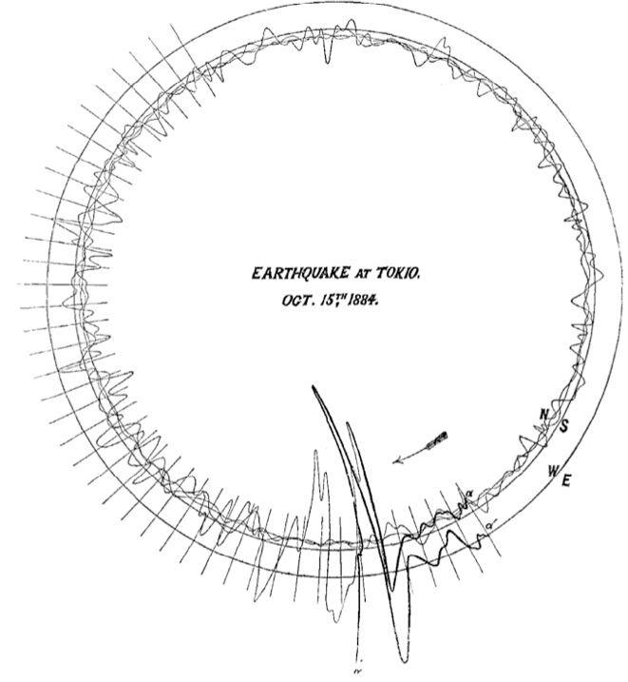
The earliest seismographs, triggered into operation by significant shaking, wrote data onto paper recording media. In the early years, the smoked paper surfaces were etched by a stylus. Later seismographs recorded to thermographic, light sensitive, and photographic papers. As interests in seismology grew, seismographs were eventually operated continuously. Seismographic recordings resulted in collections of hard-copy seismograms, most typically large sheets of paper (~30x90cm) that recorded ground motions registered for a single instrument on a single day. Specific monitoring requirements would call for other recording formats like reels of microfilm, FM tapes, scrolling chart papers, or recording more than a single instrument or a different length of record onto a single physical record. Significant expansion during the 1960s and 1970s of seismographic monitoring at global and regional scales [e. g., Lee and Stewart, 1981] resulted in a corresponding increase in the number of collected seismograms.
Historical seismograms, as continuous recordings of ground motions spanning decades, and in many cases approaching a century from numerous sites around the world, comprise unique geophysical datasets that are invaluable complements to modern, continuously-recorded digital seismograms. They contain unique data from the past including unique events, allow studies of phenomena over a longer time span, foster the development of new methods, and confirm new insights.
Figure 1. One of the earliest surviving seismograms captures strong motion data from the Tokyo, Japan earthquake of October 4, 1884. Time marks appear at 1 second intervals. Note the clear S-wave arrival at an S-trigger time of 4 seconds. Ewing (1885) estimated a peak velocity of 3.7 cm/s, the duration of the strong motion at 10 seconds and also noted the long persistence of shaking.

Traditional and Emerging Uses of Historical Data
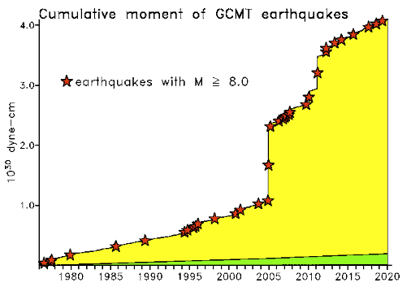
The analog era in seismology lasted for more than a century, from the first recording of an earthquake in Japan (Figure 1) by one of the earliest functional seismometers by John Ewing in 1881 (Ewing, 1881; Matsu’ura et al., in press; Satake et al., 2020) to the deployment of modern digital seismic networks in the 1980s. The study of seismograms from the analog era developed our basic knowledge of the Earth including its radial structure, tectonic plates, distribution and rate of seismicity, size of earthquakes, mechanics of fault slip, etc. Progress in the digital era has, of course, greatly refined our knowledge of Earth structure, fault zones, earthquake dynamics, while also leading to the discovery of new phenomena, such as tectonic tremor (Obara, 2002) and the development of new methods, such as recovery of the Green’s tensor from the ambient seismic field (Shapiro and Campillo, 2004).
Figure 2a. Seismic moment release from earthquakes beginning from the analog era. Courtesy of M. Ishii.

Figure 2b. Cumulative moment of earthquakes since 1976. Downloaded 24 January 2020 from globalcmt.org.

Despite the improvements in data quality, station density and availability, much of what we know about natural and man-made hazards and comes from the pre-digital era (Figure 2). Seismogram analysis, when combined with pre-instrumental historical accounts and paleoseismic investigations plays a central role in seismic hazard analysis in many regions of the world. Basic issues of earthquake rates, expected magnitudes, and recurrence intervals depend on the accurate assessment of past events. Notably the systemic determination of global centroid moment tensors (M>5.5) began in the year 1976 (Figure 2b) (Dziewonski et al., 1981; Ekstrom et al., 2012).
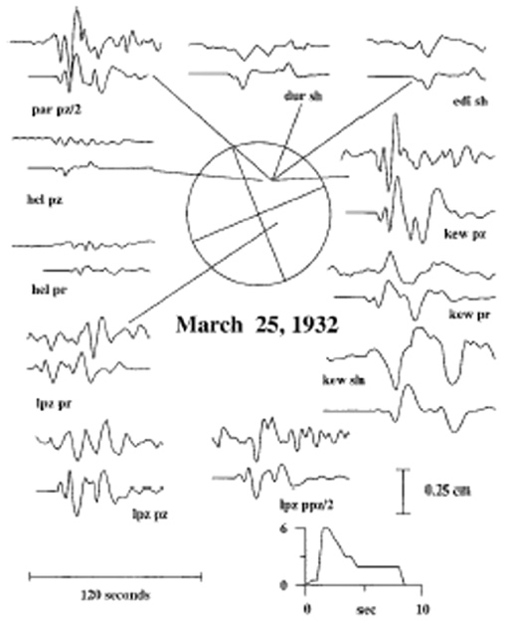

Figure 1. Analysis of the MW 6.8 Prince William Sound earthquake of March 25, 1932 by Doser and Brown (2001). Observed seismograms (top) and synthetic seismograms (bottom). Labels shown below seismograms refer to station code and waveform type (pz, vertical P; pr, radial P; sh, transverse S; pp, PP phase). Vertical scales show seismogram amplitudes in cm. Inset source time function plots have amplitudes of 10¹⁸ N m/sec. First motion data (that were used to help constrain the inversion process) are shown.

Consequently, much sound and socially relevant science remains to be done with “pre-digital seismograms (Batlló et al., 2008). For example, time series recovered by digitization of paper and film records can be well-matched by synthetics and used to determine accurate earthquake locations, focal mechanisms and even moment rate through comparison with analog records such as in the case of historical activity in Prince William Sound, Alaska before the 1964 earthquake (Figure 3; Doser and Brown, 2001). Our ability to do more with pre-digital data continues to advance thanks to improvements in Earth models on local, regional and global scales, and improved methods for computing synthetic seismograms.
Tsunamigenic earthquakes represent a particularly important class of earthquakes that benefit from modern analysis. A recent re-evaluation of the 1933 Sanrkiu, Japan earthquake and tsunami using a variety of historical seismograms for the mainshock and aftershock adds new detail to the mechanism of the event, including the possible activation of high-angle east-dipping normal faults in addition to long-assumed west-dipping faults (Uchida et al., 2016). Similarly, reanalysis of the 1941 Andaman earthquake helped explain why no significant tsunami was reported for this M8.1 event (Okal 2018) and reanalysis of the 1932 Manzanillo mainshock-aftershock led to further understanding of tsunami generation for this sequence (Okal and Borrero, 2011). Important questions about other tsunamigenic earthquakes, such as the 1957 Alaska event, remain targets of opportunity for improved modeling of old data.
Seismic hazard assessment provides the underpinnings for seismic safety provisions of building codes for both critical and ordinary structures, and guides risk reduction and resiliency planning. Earthquake catalogs underpin forecast models for the rate of seismicity and are usually the most important information used to construct a probabilistic seismic hazard analysis. Accurate earthquake magnitudes are essential for this purpose. Using modern methods, historical catalogs can be significantly improved, but requires access to waveforms and station metadata. It is worth noting that the 2800x magnification of the Wood-Anderson seismograph (foundation of local magnitude, M_{L}) was found to be too high by 1/3 by Uhrhammer and Collins (1990). After correction for the change, earthquakes in southern California, for example have moments 1/3 larger than previously determined which has a profound effect on the seismic moment rate and estimates of moment deficit in hazard models.
Assessment of volcanic hazards shares many of the same needs – and opportunities – with earthquake hazard assessment. The 2018 eruption of Kilauea in Hawaii was unprecedented in the 200+ year history of observations (Wright and Klein, 2014), and serves as a reminder of the importance of systematic cataloging of volcanic activity. A growing body of observations suggest that imminent eruptions are heralded by recognizable changes in seismic wave speeds measured from analyses of ambient seismic noise (Brenguier et al., 2008). The emerging understanding of the importance of volcano-tectonic earthquakes for forecasting eruptions (White and McCausland, 2016) points to the need for better catalogs of volcano-related and unrelated seismicity, especially where populations are at risk from explosive volcanism, lahars, tsunamis, and similar hazards.
Human induced earthquakes caused by petroleum extraction, enhanced geothermal system development and the construction of high dams have disrupted the conventional wisdom of seismic hazard in many locations around the world, and in particular in the central U.S. (Ellsworth et al., 2015). Long seismicity records are needed to assess the change in hazard and to identify factors that make some project sites riskier than others. Unfortunately, more attention has been given to reporting teleseismic phases than local events at many observatories and as a consequence the answers to pressing questions of background seismicity rates remain locked in the original seismograms.
Large-scale atmospheric nuclear explosions were only recorded on analog media. Since most nuclear testing ceased with signing of the Comprehensive Nuclear-Test-Ban Treaty in 1996 (Figure 4), these unique data provide key information to improved nuclear monitoring methods and yield estimates. Data from free-field and free-surface ground motion records from US underground nuclear testing (e.g., Perret and Bass, 1975; Patton, 1990; Deupree et al., 1991) are currently being recovered to study non-linear wave propagation, rock damage, and spall and how these processes affect the elastic wavefield, and hence, energy release.
Figure 4. Number of nuclear tests per year by country from 1945 to 2017. The vast majority of nuclear testing took place in the analog and temporary digital era. This figure is based on publicly available data at: www.armsconrol.org/factsheets/nuclearteststally.
Seismic activity rates are not the only feature of the Earth that change with time. It has become clear in recent decades that seismic velocities can change as a consequence of seismic shaking, pressurization from fluid injection and from fault movement. Seismic evidence also points to the super-rotation of the inner core (Song and Richards, 1996), which raises the prospect that evolutionary changes occurring in the outer core or in the mantle could someday be detected using seismic methods. Recordings of earthquakes, explosions and the ambient field all provide the essential data for understanding temporal changes in the Earth. Successful measurement requires precisely curated ground motion time series data. While we sometimes take timing for granted in the era of GPS/GNSS and high-accuracy local clocks, time keeping of legacy data faces many challenges (Agnew, 2020).
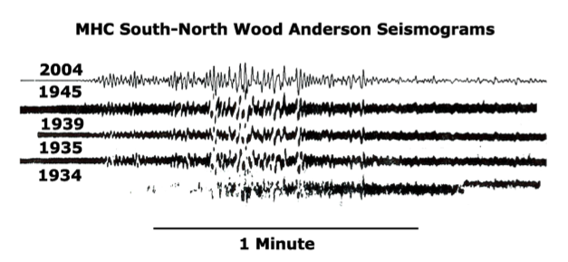
The seismogram encodes a wealth of information about Earth structure that can be used to study the source using approaches such as template matching (Shelly et al., 2007) and the path using approaches such as coda interferometry (Snieder, 2006). Even when precise timing is an issue, waveform similarity can be used to identify repeating earthquakes and other phenomena from well-curated seismograms (Figure 5). Repeating earthquakes play an important role in the current debate about the role of aseismic slip in the earthquake nucleation process (Bouchon, et al., 2019; Ellsworth, 2019).
Figure 5. Seismograms of a repeating M_{L} 4.2 Parkfield, California earthquake recorded at the Mt. Hamilton (MHC) seismic station. This earthquake was a foreshock to the 1934 mainshock, a late aftershock in 1935, occurred at times unrelated to larger earthquakes in 1939 and 1945, and was an aftershock in 2004. Optical Wood Anderson records for all but 2004 which was synthesized from a broad band seismometer (Ellsworth, 2019).

There is clearly great potential for using pre-digital seismograms to address a host of identified problems of Earth structure and dynamics. But there is also great potential to use the century plus of instrumental seismograms to tackle emerging issues of climate change such as changes in storm intensity (Aster et al., 2010; Ebeling, 2012; Sufri et la., 2014; Koper, 2013; Gerstoft and Tanimoto, 2007) and glacial retreat to name but two (Ekstrom et al. 2006; Nettles and Ekstrom, 2010) as well as in the application of new and emerging methods such as machine learning for traditional problems (Kong et al. 2018; Ross et al., 2019; Wang et al. 2019).

Preservation and Access
Seismograms have been recorded on an astonishingly wide range of media, with each new generation of instrumentalists leveraging the latest technology to improve the fidelity of the seismogram. From the earliest surviving recordings of scratch marks on a lampblack coated surface and photographic paper to digital tapes and disks, the challenges for preservation of data are numerous.
Early efforts summarized by Lee and Benson (2008) concentrated on rescue efforts for “important” earthquakes, it is less obvious today what wiggles in the seismogram will be important in the future. Keeping continuous data rather than just data around particular events enables future discoveries. Modern methods generally require information on the response characteristics of the record, emphasizing the involved task of metadata preservation and access, as well as knowledge of the Rube Goldberg-esque mechanical systems for transferring mass movement onto paper.
Many of the data preservation efforts in the U.S. from the 1970s and 1980s made photographic copies of original paper records. While this preserves the data, it makes access no better than for the original. In addition, some of these records on microfilm have begun to deteriorate or have been threatened by disposal (Okal, 2015; See supplemental material). Recently, universities and research organizations world-wide have begun or have completed ambitious scanning projects transforming paper records into digital images making them more widely accessible. See Appendix C. These preservation projects of pre-digital era seismograms set a standard that the U. S. should carefully consider as a model for going forward.
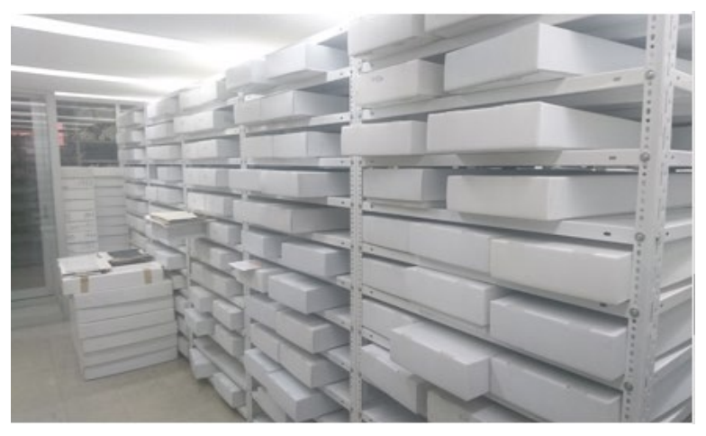
Digital storage is cheap in comparison to physical storage. As much is practically possible, however, all original data should be kept (Figure 5). Caveats to this are data that contain no identifying marks. In addition, some data may have deteriorated beyond usability. Criteria in each case may change with time with improvement in methods and technologies. In fact, scanning everything immediately may not be a priority as such improvements may produce better quality scans faster, and hence, cheaper.
Figure 5. The SISMOMex project aims to scan all 310,000 seismograms that have been moved to an ambient storage facility. The seismograms are protected from the Sun and moisture. The area is fumigated yearly to prevent fungus and insect proliferation. The catalog of records has been integrated into the UNAM’s ALEPH system with the help of their university’s library. Courtesy of X. Perez-Campos.
Prioritization should be given to preserve collections at risk. Microfilm, FM tapes, digital objects as well as paper are subject to “rot”. Microfilm decays. In some cases, it becomes unreadable due to the lack of access to equipment or the deterioration of the medium itself e.g. sprockets in reels become too fragile. FM tapes suffer from sticky tape syndrome as their binders deteriorate. Digital objects are subject to degradation if not properly maintain. High quality paper so far has been the most robust storage media. However, Institutions may no longer have the capacity to store original records. Identifying at risk collections on the institutional, national, and global scale and raising the awareness of their value is of prime concern.
Current digital preservation projects employ a range of practices in scanning and products provided. In producing digital images, projects have used large format scanners, flatbed scanners, and photographic methods either contracting to private companies or using institutional resources. High resolution formats are typically tiff with some projects providing lower resolution copies and/or .jpgs for reviewing. High resolution copies are either available for download or by request. HRV provides a digitized time series in SAC format for some records. Some metadata information is also available.
Projects also engaged archivists. In these cases, archivists provided valuable expertise in restoration of records (Ishii et al., 2015) and cataloguing (See Appendix C. SISMOMex). Archivists bring valuable experience in best practices for scanning as well as modern practices in accessing digital archives.
No agreement exists on standards or guidelines for processing these data. Scan quality is a balance between minimum fidelity to the data driven by the instrument response and the costs of scanning and storing at higher resolution. Once scanned, several methods exist to convert scanned images to digital time series (Bartlett et al., 2018; Bogiatzis and Ishii, 2018; Pintore et al., 2005). These methods still require a great deal of human intervention especially for complex records or records with poor data quality. Improved methods in the future may not only produce higher fidelity time series data but also automate more processes. Producing such data should not be a community priority but as researchers digitize data for their own uses, they should be encouraged to deposit these to an open access repository. Lastly, benchmarking these software using pairs of records recorded digitally and by analog methods and as analyzed by different operators would lead to a better understanding of both systematic and unsystematic errors.
The larger issue of metadata standardization is discussed in the following section.

The Need to Standardize Metadata
The community is at a critical juncture in which it is estimated that we will begin losing institutional knowledge of the necessary metadata in 5 to 10 years as aging network operators and scientists with long-term involvement with these networks and the data the networks generated will retire. In order to ensure continuity and consistency in data preservation projects, it is important that this knowledge is captured, and standards are established, ideally before significant work begins. This will ensure high quality products and comprehensive capture of key information. High-quality metadata will enable professional curation of products resulting from preservation projects. Standards are needed in the initial capture stage such as well-defined and consistent analog to digital conversion parameters regarding the capture of images (e.g. scanning parameters) or analog to digital conversion (e.g. sample rates, bits of resolution, etc.). It is also essential that the types of metadata captured are consistent across projects with all required metadata captured and made available thorugh standardized mechanisms.
By identifying and enforcing key metadata, it will allow centers managing these products to develop uniform tools that can discover data products and return legacy data in formats that are useful and with enough metadata to ensure the usability of the data.
The workshop contained several sessions dedicated to metadata. Prior to the workshop several individuals that had been involved in one or more legacy data preservation projects were contacted and asked to identify key types of metadata they had captured as part of those projects. Approximately 10 projects participated. Not too surprisingly, the types of metadata collected for each of these projects had some overlap in metadata (e.g. station name, geographical location) but there was a great deal of heterogeneity in other metadata collected. There were more differences than similarities in the overall metadata captured.
Workshop participants articulated a need to identify core metadata for legacy data. Metadata discussed not only included traditional metadata but metadata about the scanning and vectorization process as well. A key artifact of this workshop is the identification of metadata that should be 1) required, 2) recommended, or 3) optional and could be provided if captured. Perhaps equally useful is the identification of some metadata that was sometimes captured but likely was not deemed to be essential metadata for all legacy data rescue projects.
If an effective project to capture and manage legacy data is ever funded, it would be necessary to agree on metadata that should be captured during the preservation process. The availability of required and recommended metadata early in the process will allow systems to be developed that enable FAIR (Findable, Accessible, Interoperable, Reusable) data (Wilkinson, 2016).
Experience within the International Federation of Digital Seismograph Networks (FDSN) has demonstrated the importance of standards development in order to manage diverse collections in a distributed system. The federated system of FDSN Data Centers is a mature system that allows access to time series data across the FDSN members that are geographically distributed across the globe. By putting metadata standards into place early in the legacy data effort it will allow holdings adhering to the FAIR principles to be managed by and using financial resources from a wide collection of organization, those that are responsible for the networks that originally recorded the data in most cases. This is viewed to be superior to any system that would rely on just one entity system and one funding organization and would increase the viability and sustainability of such a project.

Metadata Elements
During the review of previous projects and drawing upon current state of the art in managing digital data, we identified 39 metadata elements to consider. These elements can be grouped into 6 broad categories that parameterized the data: 1) Time of Data, 2) Station/Channel, 3) Sensor, 4) Recording System, 5) Image File, and 6) Other. See Table 1.
Table 1. Surveyed Metadata Elements.
Metadata Element | Description | Units or Format
Time of Data (3)
Start Time | The time of the first sample in the image. | YYYMMDDTHH:MM:SS.FFFF
End Time | The time of the last sample in the image. | YYYYMMDDTHH:MM:SS.FFFF
Time Correction | Any time correction applied to the data. | YYYYMMDDTHH:MM:SS.FFFF
Station/ Channel (11)
Latitude | Latitude using WGS84 datum. | SEED format convention
Longitude | Longitude using WGS84 datum. | SEED format convention
Elevation | Elevation above (+) or below (-) sea level. | real in meters
Depth of sensor below ground surface | Depth below ground surface at specified longitude and latitude. | real in meters
Network Name | network to which the station belongs (e.g. WWSSN, GSN, EREBUS). | text
FDSN Network Code | FDSN network code (use SS if not associated with a network) | text
Site Name/Station Name | Site name (e.g. Albuquerque, New Mexico, USA). | text
IR Station Code | Station's code in the International Registry (ISC). | text
Channel/component | Channel code as in SEED format. | text as in SEED Manual Appendix A
Open Date | Date when station was opened. | YYYYMMDDTHH:MM:SS.FFFF
Close Date | If closed, Date when station was closed. Leave empty if still operating or not known. | YYYYMMDDTHH:MM:SS.FFFF
Sensor (7)
Type of sensor | type of sensing instrument (e.g. Streckheisen STS-2, Beniof) | text
Sensor serial number | Manufacturer's serial number of seismometer, if known’ | text
Free period | The free period of the instrument. | real in seconds
Damping constant | The instrument's damping constant. | real dimensionless
Horizontal 1 dip/azimuth | The dip/azimuth of the first horizontal. | SEED convention
Horizontal 2 dip/azimuth | The dip/azimuth of the second horizontal. | SEED convention
Vertical dip/azimuth | The dip/azimuth of the vertical channel. | SEED convention
Recording System (4)
Type of recording system | The type of recording system (e.g. Teledyne helicorder). | text
Recording system serial number | Manufacturers serial number, if known. | text
Scale/gain/amplification | Scale or gain factor (scaler) | real dimensionless
Period of scale/gain | Period at which the gain is valid. | real in seconds
Image file (12)
Date of Scanning | The date the image was scanned. | YYYYMMDDTHH:MM:SS.FFFF
Resolution | The resolution of the scanned image. | pixels per meter
Vertical pixels | The number of pixels in the vertical dimension. | number of pixels
horizontal pixels | The number of pixels in the horizontal dimension. | number of pixels
Image format | The image file type. | e.g. heic, jpeg, jpeg-2000, openEXR, pdf, png, tiff in ASCII
image size | The total size of the image in bytes. | integer
Analog image length | Length of the original document. | real in meters
Analog image width | Width of the original document. | real in meters
Color depth | The color depth of the scanner, if applicable. | integer
Original recording type | Photographic paper, drum recordings (smoke, hot stylus, ink) | text
Location of original record | Country, state or province, city, institution, room of original analog document when scanned. | text
Contact information of owner | Contact information for the original owner of the data. | text
Other (2)
Notes and Comments | Optional Notes and/or Comments. | text
Date of metadata creation | The date and time when the metadata was created or last updated. | YYYYMMDDTHH:MM:SS.FFFF

Identifying Important Metadata Elements
During the workshop all participants were asked to consider each of the 39 metadata elements and identify which of the following categories each element belonged (Table 2).
Table 2. Element Categories.
Category | Meaning
Required | The metadata element should be required and to values verified before submission for management at a data center.
Recommended | The metadata elements should be provided if the information is easily available.
Optional | The metadata element should be totally optional.
Omitted | The metadata elements should not be requested or managed by a data center.

Elements identified as Required would have to be submitted with the legacy data. Systems that manage search and discovery would assume that this metadata is available to use as a search parameter.
Elements identified as Recommended, would be used to refine searches if they are available. While not required for submission to a data center, these metadata elements could increase the power and flexibility of a search.
Elements identified as Optional would be kept with the legacy data and can be provided but would not be used for search or increased flexibility.
Elements identified as Omitted would not be managed by data centers in any way. These elements will not become part of any standard.
Responses for most all metadata fields surveyed were either Required or Recommended. None polled as Omitted and only metadata fields associate with serial numbers polled highly for Optional. Surprisingly was the split in votes between Required and Recommended for some fields. This may be a stronger indication of intended use and/or experience in using data of these types. Results of the survey are given in Appendix D.
The survey focused on search and discovery of assets and should not be considered a complete list of descriptive metadata necessary for research uses of the data. For example, specific information, for some recording systems are not captured such as pen length arm and drum speed that would be necessary to accurately account for these distortions.

Post Workshop
Workshop attendees were requested to make comments about definitions of the 39 elements presented at the workshop and also were allowed to make suggestions for more metadata elements. There were 20 requests from 8 different workshop participants to consider modifications of the definitions of the current metadata elements in the survey or to consider adding new elements (Table 3).
Table 3. Additional Metadata Elements
Possible Additional Metadata Element | Description | Units or Format
DOI | Authoritative Resource Identifier for Scanned Image. | DOI
DOI | Authoritative Resource Identifier for Original Recording. | DOI
Timing drift | Estimated drift or error in time progression. | [+/-] seconds
Contrast Ratio | Estimate or specification of ratio of light to dark intensity. | float ratio to 1
Pen radius | Length of the pen arm from pivot to marking tip (optional). | mm
Drum surface velocity | Scrolling speed of the drum surface (optional). | mm/s
Trace direction | Direction of flow of the seismogram (optional). | L-R (left to right), R-L, U-D (up to down), D-U
Phase markings | Indicate true if phase notations were placed in the image. | True/False
Occlusions | Indicate true if tears or other flaws obscure trace data. | True/False
Condition | An index to indicate the condition of the image | e.g. SSIM
Earthquake signal | Indicate true if an earthquake signal is present | True/False
Timemark Format | Positive real to indicate length of vertically offset timemark negative real to indicate length of gapped timemarks, null to indicate no timemarks. | real numbers (pixels?)
Source of information | Information about source of metadata entered - e.g., lat/lon adopted from a published source, or response assumed based on X information or publication. Optional or recommended. | text
Nature of instrument | Logical variable: either mechanical (e.g., Wiechert) or electromagnetic (e.g., Golitsyn). This logical variable would control the instrument constants (T, V, epsilon; or Tp, hp, Tg, hg, mu, Vmax).
Polarity of recording | Either ground motion up = up on paper or down on paper.
Sensor | Include poles/zeros from the damping and free-period. This would allow for NRL type responses and would avoid developing new types of metadata as you could put most information into blockette 53.
Drum radius | The drum radius is necessary to apply corrections. | real (mm or cm)
Associated bulletin | In case of earthquake trace, the time of the phases present on the seismogram may have been reported in the station bulletin or elsewhere. If true, provide bulletin name, url or DOI if published | if True, provide url or DOI of the bulletin.
Vectorized_trace | This field to be added if the trace has been vectorized. Provide the url/DOI where it can be obtained. | if True, provide url or DOI of the vector trace.
date-time of time-correction | Necessary, together with tabulated time-correction and timing-drift, to calculate correction for time of data-sample. | Same as for other date-time metadata.

Based on the results of the metadata survey, the next activity will be to incorporate the new or modified elements into an updated survey and submit it to the FDSN mailing lists for broader consideration This will ensure broad international consensus and set the stage for an eventual endorsement of the metadata elements needed for legacy data. After receiving results back from this larger survey, a working group will be able to identify Required, Recommended, and Optional metadata for legacy data.

Use Cases
Workshop attendees were requested to describe how they would want to discover and use legacy data. These use cases describe not only described how the data would be accessed and used, but also how the system should respond including expected outputs and error messaging. In this context, use cases were of interest to ensure the necessary metadata is being collected and that any systems designed to access data leverage the available metadata.
For this exercise, attendees were asked to provide a summary of their use case, describe the workflow, conditions, expectations, and requirements. In all, seven use cases were completed which can be categorized as follows:
- Multi-decadal studies. Studies over large time spans to understand regional seismicity or changes in Earth properties on a global scale.
- Historic events. Re-analysis of historical events e.g. earthquakes and volcanic eruptions using modern analyses.
- Climate change. Investigating changes in storm intensity over time.
- History of science. Understanding the development of instrumentation and the development of observational seismology.
See Appendix E.

Repositories and Inventory
Further waiting or delaying preservation of the physical media puts these resources at risk. What to preserve and estimates of the resources necessary to ensure their continuity are needed but are difficult to make without knowing the scope and status of collections worldwide. A large number of collections of scanned images were identified at the workshop, but it is clear that the worldwide collection of non-scanned images is much larger. To understand the scope of the effort to capture legacy data using standard digitizing techniques and standard metadata, it will be necessary to survey our community to produce an inventory of as many collections of legacy data as possible. For collections not necessarily at risk, this helps to establish decision-making, preservation priorities and enables the ability to assess the uniqueness of the dataset.
Appendix E lists the collections of imaged records both presented at this workshop and those currently known to this effort.
A starting place in defining the inventory of legacy data collections is to approach the membership of the FDSN to help identify legacy data collections known to its members. Once completed, information about additional collections can be solicited through IASPEI. Collection of basic metadata and standardization of indexing will be helpful in defining the scope of the problem related to legacy data, inform proposals to funding agencies, and help safeguard collections around the world.

Next Steps
Workshop participants discussed and proposed several activities that would increase awareness of research enabled by the use of legacy data and available resources. Standardization was emphasized both to guide preservation and to enable sharing.
Next steps include:
Analog holdings catalog. Create an inventory of analog seismic data holdings to identify current resources, connect potential users to resources, and aid in metadata discovery. Necessary information includes the institution responsible for the data, network name, station metadata, data types, and the condition of the collection. Legacy data includes not only the data e.g. paper, tapes, digital signal, or images but data products such as station catalogs and other historical artifacts.
Publications database. Create a database of research publications that use analog data as a resource to other researchers, inspire new studies, and provide evidence to the importance of this data.
Data Availability. Develop policies to encourage legacy data submission to data centers working with existing centers on sustainable financial models.
Standards. Begin work on creating FAIR compliant metadata standards to enable federated discovery and access. Establish best practices and standards for imaging and digitizing learning from established projects.
Pilot Project. Identify existing repositories to pilot federated data search and access utilizing proposed metadata standards, and retrieval of multiple data and metadata types. A pilot study will help to demonstrate the data’s value, enable consensus on standardization, and advance data processing workflows.
Future Research. Identify strategies to enable future research through open source and standardization of both data and software. Identify targeted campaigns with specific research objectives defining the high priority science questions e.g. identify key stations to conduct imaging of all records and specific earthquakes for historical analysis.
New Technologies. Identify enabling technologies to reduce human intervention in the end-to-end process of creating research ready, time series data.
This includes:
- image capture. Faster and cheaper ways to image the data would increase the ability of repositories to make these available over the internet.
- image compression. Smaller files decrease storage costs and download times.
- time series creation. Identifying new algorithms and techniques e.g. machine learning to reduce human intervention would speed-up the conversion process and improve reproducibility.
Other Communities. Attract a broader scientific community to apply seismological data in nontraditional research domains and communities with similar needs in preserving analog time series data. Potential research applications include, tsunamis, geomagnetic field, ocean sciences, glaciology, climate change, civil engineering (especially outside COSMOS and NGA countries), and natural resource extraction. In addition, techniques could be transferable to other analog time series observations. Lastly, archivists, historians, and the image processing community both contribute to the preservation of these data and broaden its impact. Leverage professional societies and international organizations in engaging these communities.
Outreach. Create a larger community of users through outreach at all career levels (Figure 6). Continued visibility of legacy data in the form of workshops, special issues, special interest groups, and sessions at professional meetings. Focusing on specific topics will attract new participants and advance progress on identified issues.
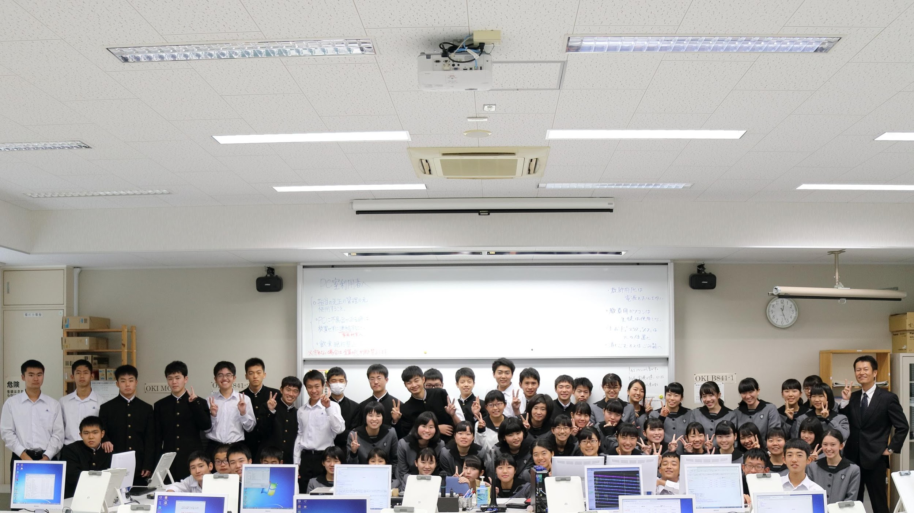
Figure 6. Researchers from Harvard University are working with High Schools in Japan to digitize seismograms and interest students in careers in seismology. Picture here are student from the Miyazaki Prefectural Nobeoka High School. Courtesy of T. Lee and M. Ishii.

The vision outlined above is to create a community and the infrastructure necessary to enhance the preservation, access, and usage of analog seismic data. Knowledge of this resource is essential in describing current holdings and identifying the metadata necessary to find data and make them available to modern research techniques. Lowering the barriers to usage includes easing access and creating the tools necessary to transform the data to digital forms, whether as scanned images or a digital time series, in making them accessible to modern seismic analysis methods. Building a community of users includes inspiring early career researchers through an NSF Research Experiences for Undergraduates program, leading special sessions at professional meetings on research uses, volunteering to be an Editor of a special issue, or teaching workshops on tools and methods. Only good stewardship by the community will secure these primary observations for future generations and preserve our scientific heritage. We invite you to join the effort to safeguard this resource and make it FAIR for current and future generations of earth scientists.

Conclusions
As we are faced with unprecedented changes to climate, understanding the deeper patterns and trends in natural systems through time have taken on new importance (Research Data Alliance, 2019). The call to reuse data is driven not only by economics but also by the recognition of their uniqueness (observations of natural systems are not repeatable) and scientific value in enhancing current understandings as well as potential new discoveries especially in the era of big data. These data are part of the historical record and our scientific heritage (American Geophysical Union, 2019) not only in explicitly recording earth observations but implicitly recording, and thus providing the evidence that addresses the manner in which science was conducted. The importance of these efforts was affirmed at the 2017 IASPEI meeting in Kobe, Japan, with the following unanimous resolution:
IASPEI strongly encourages efforts to conserve archives of analogue seismograms, metadata and seismological bulletins, making them usable by future generations of Earth scientists.
In response to the pressing need to organize and preserve legacy seismic data, a workshop was held September 18-19, 2019 in Albuquerque, New Mexico on Securing Legacy Data to Enable Future Discoveries. This international workshop addressed two broad needs of the community in discussing the framework for preservation of longitudinal seismic data and creating interdisciplinary connections to facilitate its management, use, and access. Participants identified underlying community needs to advance these goals in creating the knowledge bases, technology, and community around preservation and access of these valuable data to a larger user base.
A small number of institutions are leading the way in their efforts to preserve these data and make them accessible to a wider international community. Projects at these institutions provide a model and experience to draw upon on the end-to-end process from conservation, archival, digital preservation, digital repository through online access. Such knowledge will benefit FAIR data practices and the establishment of standards throughout the process to enable Findable, Accessible, Interoperable, and Reusable legacy seismogram data.

Acknowledgements
This workshop was funded through NSF-1917159. The workshop organizers would like to thank all workshop participants and contributors of supplemental materials to this report for their commitment to improving the visibility and usage of legacy seismic data.
"… old seismograms, if properly interpreted, provide invaluable information on earthquakes in the past, and every effort should be made to save them, regardless of their quality, from possible loss and to make copies in an easily readable form." Hiroo Kanamori (1988)

http://dels.nas.edu/resources/static-assets/besr/miscellaneous/COSG/COSG-6-5-18.pdf
Presentations are available on the workshop website. https://geodynamics.org/cig/events/calendar/2019-seismic-legacy/).
https://www.force11.org/group/fairgroup/fairprinciples
https://www.archives.gov/preservation/technical/guidelines.html

