This manuscript is a non reviewed preprint. The manuscript has not yet been submitted for publication. This is the second uploaded and improved version but there will be more. Subsequent versions of this manuscript will have updated content, including the journal of submission and DOI.

Feedback is encouraged, questions are welcomed, feel free to contact the author:
stanislav.jelavic@sund.ku.dk

Fate of organic compounds during transformation of ferrihydrite: implications for iron formations
S. Jelavić,^{1,2*} A. Mitchell³ and K.K. Sand^{1,2,3}
¹Nano-Science Center, Department of Chemistry, University of Copenhagen, Universitetsparken 5, Copenhagen, Denmark
²Section for GeoGenetics, Globe Institute, University of Copenhagen, Øster Voldgade 5-7, Copenhagen, Denmark
³University of Aberystwyth, Geography & Earth Sciences, Aberystwyth, UK
*stanislav.jelavic@sund.ku.dk

ABSTRACT
The absence of organic compounds from Precambrian iron formations (IF) challenges the hypothesis of their biogenic origin. Here we address the fate of adsorbed organic compounds during transformation from ferrihydrite to hematite. We determined the binding energy between hematite and common molecular terminations found in extracellular polymeric substances and biofilms: carboxylic, alcohol and phosphate functional groups. We found that the bond between hematite and alcohol group is approximately 2 times stronger than the bond between hematite-carboxyl and -phosphate groups. We then transformed synthetic ferrihydrite to hematite in presence of glycerol, which has a high density of alcohol groups and measured the amount of mineral associated glycerol before and after the transformation. We showed that the transformation releases glycerol highlighting that at least some organic compounds from initial IFs were desorbed very early during the process of sedimentation. Our results suggest that the absence of organic compounds in IF cannot be an evidence against their biogenic origin.
Introduction
Traditionally, iron formations (IFs) have been classified as a chemical sediment but an increasing amount of evidence points toward an active role of microbes in their precipitation (Koehler et al., 2010). The role of anoxygenic phototrophic bacteria in the formation of IFs has been speculated since the work of Garrels et al.(Garrels et al., 1973) and an improved understanding of microbial induced Fe oxidation highlight oxidizing bacteria, such as Rhodobacter ferrooxidans, as likely drivers for the formation of IFs (Kappler et al., 2005). Further, mass balance calculations have showed that Fe (II)-oxidising phototrophic bacteria had the capacity to oxidise all Fe(II) from the Precambrian ocean, causing formation of iron (oxyhydr)oxide (FeOx) (Hegler et al., 2008). However, the lack of sufficient amount of organic compounds in IF, or their diagenetic or metamorphic derivatives, challenges the hypothesis of their biogenic origin.

Extracellular polymeric substances (EPS) promote FeOx nucleation (Sand et al., 2019) and microbially formed FeOx are often found in close association with the EPS. When the EPS get encrusted with FeOx, the polymers are shed and new EPS are formed. This prevents the encrustation of the microbe itself (Phoenix et al., 2000; Chan et al., 2004). The FeOx-EPS would have settled through the water column and get deposited on the sea floor as IFs. Such mechanism of IF deposition implies the presence of a significant amount of organic compound in just formed IFs. Microbial breakdown of organic compounds in the largely anoxic Precambrian oceans would have been minor (Canfield, 1998). However, diagenesis and metamorphism would have promoted degradation of the organic compounds. In anoxic environments, siderite can be a main product of such degradation (Köhler et al., 2013) but siderite is only found in some IFs and in insufficient amounts to account for the missing organic mass.

Hematite is a major component of IFs found today (Konhauser et al., 2017) but, initially, the FeOx in the FeOx-polymer complexes were most likely composed of ferrihydrite (Chan et al., 2004). The transformation to hematite would have happened both before (Sun et al., 2015) and after deposition on the seabed. Depending on the solution conditions, ferrihydrite to hematite transformation can involve lepidocrocite and goethite as intermediary phases, e.g., through Fe(II) catalysed transformation (Hansel et al., 2003), or it can be direct (Cudennec & Lecerf, 2006). Transformation involving intermediary phases is a dissolution-precipitation process (Schwertmann & Murad, 1983) implying that the interface between ferrihydrite and organic compounds is eliminated. In this scenario, organic compounds would have been liberated to solution where they could have been readsorbed to the newly formed phases or released in the water column and subsequently degraded. The direct transformation from ferrihydrite to hematite is a solid-state transition where atoms move only locally to occupy new structural positions (Cudennec & Lecerf, 2006), without the loss of interface with adsorbed complexes. Thus, the direct transformation of ferrihydrite to hematite is not necessarily accompanied by a removal of organic compounds. However, the Gibs free energy of binding (ΔG_{bu}) between ferrihydrite and EPS is larger than between hematite and EPS (Sand et al., 2019) implying that the polymers were more likely to desorb from hematite than from ferrihydrite even if the transformation process itself did not release any polymers. In such a case, the absence of organic compounds from IFs cannot be an argument against their biogenic origin.

To understand the behaviour of organic compounds during a direct transformation pathway, we used dynamic force spectroscopy (DFS) to measure the energy of binding between hematite and organic functional groups represented in EPS. Subsequently we identified the functional group least likely to desorb during transformation and made transformation experiments where we used thermogravimetric analysis (TGA) to measure the loss of organic compounds during transformation.

Materials and Methods
DFS. We used an Asylum MFP3D atomic force microscope (AFM) and functionalized gold coated AFM tips (MSCT, Bruker) with carboxyl (COO⁻), alcohol (OH), and phosphate (HPO₄⁻) headgroups pointing away from the AFM probe (Figure 1a). Tips were functionalized following the protocol described in Jelavić et al. (2017) (details in SI).
Specular hematite monocrystal {0001} face was cleaned prior to analysis following the protocol described in Jelavić et al. (2017) (details in SI). For DFS measurements, we collected >500 force curves per experiment. The tip approaching velocity was set to 500 nms⁻¹ and the retraction velocity varied between 10 - 10000 nms⁻¹. The trigger force was set to 100 pN and dwell time to 0.5 s. The spring constant of the probe was calculated using a thermal calibration method (Hutter & Bechhoefer, 1993). During the measurement, the head groups bound to the hematite surface (Fig. 1a) and we measured the forces applied to break the bond (i.e. the force curve, Fig. 1b). We fit the rupture forces vs. the loading rate to a multibond model (Friddle et al., 2012) enabling calculation of ΔG_{bu} (eqs S1-S4). The measurements were done in 10 mM NaCl solution at pH=5.6. We chose this conditions, rather than conditions at which the transformation experiments were conducted, to maximise the interaction forces between the tip and hematite surface (Lützenkirchen et al., 2013; Newcomb et al., 2017).
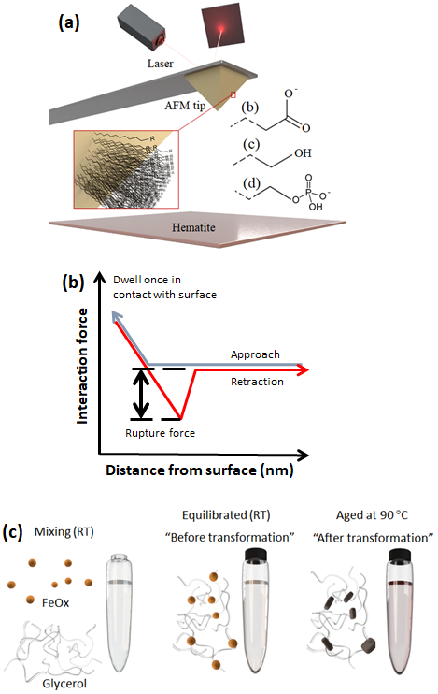

Figure 1. a) Schematics of the DFS: SAMs with carboxyl, alcohol and phosphate headgroups covalently bonded to AFM tip. b) A scheme of a force curve. c) In transformation experiments, ferrihydrite and glycerol were mixed at room temperature and left to equilibrate overnight. One sample was then taken for TGA (equilibrated sample) and the rest was placed in the oven at 90 ºC until the transformation was complete (aged sample).

Transformation experiments. Ferrihydrite was synthesised using the method of Schwertmann & Cornell (2000). We used 0.5 M NaCl solution and pH=7 as a proxy for Precambrian seawater. We chose glycerol (CH₂OH-CHOH-CH₂OH) as a model for an OH-rich molecule. Adsorption of polymers is a complex function of degree of branching, length and hydrophobicity (van Oss, 1997). The aim here is not to account for such variations but to isolate the effect of ΔG_{bu} on the magnitude of desorption during transformation. We mixed 15 mg of ferrihydrite with 15 ml of 0.5 M NaCl and added glycerol to a final concentration of 0.5% (Figure 1c). In control sample, we omitted glycerol. Samples were shaken at 100 rpm overnight to equilibrate. The next day, a batch of samples was rinsed with 20 ml of 0.5 M NaCl (adjusted to pH=7 with 1 M NaOH) by ultracentrifugation (equilibrated sample) and another batch was placed in the oven heated to 90 °C. Once the transformation was over, the samples from the oven were rinsed with 20 ml of 0.5 M NaCl and adjusted to pH=7 (aged sample). All samples were freeze dried after rinsing. The samples from the oven were sampled at specific time steps to follow the transformation pathway using X-ray diffraction (XRD).
XRD. Samples for XRD were washed with ultradeionised water. 1.5 ml of suspension was pipetted on the zero background Si holders and left to dry at room temperature. We collected diffractograms in reflection mode on the Bruker D8 Advance instrument using Cu Kα radiation (λ = 1.5418 Å) operated at 40 kV and 40 mA, and a LynxEye detector. Diffractograms were collected from 10-90 °2θ with step size of 0.02° and 1.7 s counting time per step. The sample was spun at 20 rpm. We used 0.3° divergence and 3° antiscatter slits, 2.5° Soller slits on incident and diffracted beams and a 0.02 mm thick Ni-filter. The opening of detector window was 2.94°.
TGA. We used Netzsch TG 209 F1 Libra. Samples were heated at a rate of 10 °Cmin⁻¹ from 30 to 1000 °C under N₂ atmosphere. ~15 mg of sample was placed into the Pt crucible and the weight loss was measured as a function of temperature.
TEM. Images were taken with a Philips CM 20 TEM equipped with a thermionic LaB₆ filament. We used an accelerating voltage of 200 kV. Samples were prepared by placing a droplet of sample suspension on a formvar coated TEM grid and left for 5 - 10 s. Subsequently, the grid was washed in ultradeionised water and water droplets were removed with the edge of a paper towel.

Results and Discussion
Energy of binding. The force spectra (Fig. 2) shows that the rupture force between hematite and the OH group is ~6 times higher than between COO⁻ and HPO₄⁻ groups (Fig. 2, Table S1). Recalculated to ΔG_{bu} (eq S4), that is an increase in ~2 kT. Considering that the {0001} hematite surface is completely hydroxylated in water (Trainor et al., 2004), our results follow the trend where OH-OH bonds are twice as strong as COO⁻-OH bonds at circumneutral pH (Vezenov et al., 1997) present in Precambrian ocean. Thus, irrespective of the transformation pathway, biopolymers rich in acidic groups desorb more easily from hematite than those rich in alcohol groups.
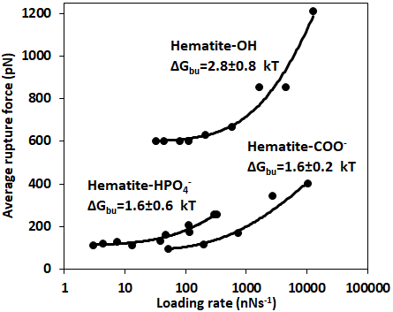
Figure 2. Multibond fit (Friddle et al., 2012) to the dynamic force spectra between hematite surface and alkyl thiol SAMs with OH, HPO₄⁻ and COO⁻ head groups. The uncertainty represents the error propagated from the standard deviations of the fit. Loading rate is a nominal retraction velocity (nms⁻¹) multiplied with the spring constant of the cantilever (nNnm⁻¹).

Transformation pathway. To investigate the fate of a ferrihydrite-associated OH-containing molecule during transformation to hematite, we transformed the ferrihydrite-glycerol complex, monitored the transformation pathway with XRD and determined the weight loss with TGA. The ferrihydrite-glycerol complex transformed directly to hematite without any intermediary phases (Figure S-3, Supplementary Information File) suggesting a solid-state transformation pathway. As a control, we transformed ferrihydrite in absence of glycerol using the same solution conditions. Even though the hematite was the first phase to occur after 17 h, goethite started forming after 43 h indicating that, in pure system, some ferrihydrite dissolves and reprecipitates as goethite, as previously shown (Das et al., 2011).
The transformation is accompanied by glycerol release. In general, the ferrihydrite-gycerol complex lost more weight than the pure ferrihydrite (Figure 3, Table 1). Ferrihydrite is more hydrated than hematite so the loss of loosely adsorbed water (<125 ºC) and tightly bound water (125-700 ºC) is higher for ferrihydrite than hematite (Hiemstra & Van Riemsdijk, 2009). Comparing the weight loss of ferrihydrite-glycerol (5.4%, Table 1) to pure ferrihydrite (4.7%, Table 1) in the 125-700 ºC range, shows that the tightly bound water accounts only for 87% of the weight loss in this region, indicating that the remaining 13 % is the loss of glycerol. This implies that hematite produced by aging ferrihydrite-glycerol contains less glycerol than the original ferrihydrite-glycerol (equilibrated), and that glycerol is released during transformation.
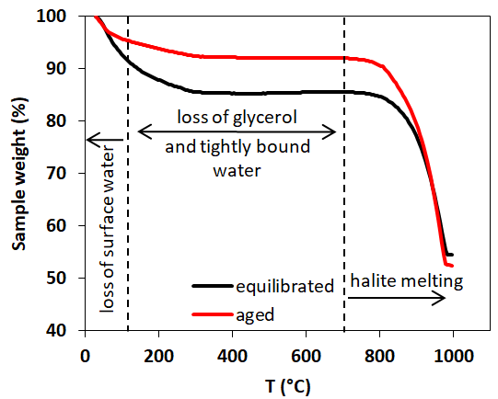
Figure 3. Comparison of TG curves of ferrihydrite-glycerol (equilibrium-black curve) and resulting hematite-glycerol (aged- red curve). The smaller mass loss in the region 125-700 °C (dashed vertical lines) for the aged sample compared to the equilibrium sample suggests bigger loss of tightly bound water and glycerol during the transformation.

Table 1. Weight loss during the TGA analysis in <125 °C and 125-700 °C regions.
Sample |  | % weight loss
 |  | <125 °C | 125-700 °C
Glycerol | equilibrated | 8.9 | 5.4
Glycerol | aged | 4.8 | 3.2
Control | equilibrated | 9.8 | 4.7
Control | aged | n.a.* | n.a.
* transformation yielded both goethite and hematite making comparison impossible

The reason for the loss of the glycerol during transformation can also be the smaller specific surface area (SSA) of the produced hematite (Fig. S-4, eqs S5-S6) and not only the lower affinity for glycerol compared to ferrihydrite. From TEM images, we estimated the SSA of ferrihydrite to be 374-790 m²g⁻¹ and of hematite to be 10-46 m²g⁻¹. Thus, the decrease in the SSA during transformation is between 9-70 times which alone is possible to explain the decrease in glycerol content. However, the loss must be amplified by the lower ΔG_{bu} for hematite-OH than for ferrihydrite-OH system. Both the decrease of SSA and the decrease of ΔG_{bu} are likely explanations for our observations and both scenarios are likely to have contributed to the loss of organic compounds during the formation of IFs.
We have demonstrated that glycerol, a molecule with a high ΔG_{bu} to hematite, desorbs during the transformation of ferrihydrite to hematite. We propose that a significant amount of organic compounds has been desorbed early in the process of sedimentation of iron oxides because of transformation of precursor ferrihydrite to more stable hematite. This loss in organic compounds is probably further enhanced by the grain coarsening of hematite during diagenetic and metamorphic processes.
ACKNOWLEDGMENTS
We thank Heloisa N. Bordallo for access to TGA instrument (Carlsbergfondets, grant no. 2013_01_0589). KKS and ACM are grateful for funding from the European Union’s Horizon 2020 Research and Innovation Programme under Marie Skłodowska-Curie Grant Agreement No 663830 and the Welsh Government and Higher Education Funding Council for Wales through the Sêr Cymru National Research Network for Low Carbon, Energy and Environment. KKS is grateful for funding from the Danish Council for Independent Research Sapere Aude Programs (0602-02654B).

REFERENCES:
Canfield DE (1998) A new model for Proterozoic ocean chemistry. Nature 396, 450.
Chan CS, Stasio GD, Welch SA, Girasole M, Frazer BH, Nesterova MV, Fakra S, Banfield JF (2004) Microbial Polysaccharides Template Assembly of Nanocrystal Fibers. Science 303, 1656–1658.
Cudennec Y, Lecerf A (2006) The transformation of ferrihydrite into goethite or hematite, revisited. Journal of Solid State Chemistry 179, 716–722.
Das S, Hendry MJ, Essilfie-Dughan J (2011) Transformation of Two-Line Ferrihydrite to Goethite and Hematite as a Function of pH and Temperature. Environmental Science & Technology 45, 268–275.
Friddle RW, Noy A, Yoreo JJD (2012) Interpreting the widespread nonlinear force spectra of intermolecular bonds. Proceedings of the National Academy of Sciences 109, 13573–13578.
Garrels RM, Perry EA, Mackenzie FT (1973) Genesis of Precambrian Iron-Formations and the Development of Atmospheric Oxygen. Economic Geology 68, 1173–1179.
Hansel CM, Benner SG, Neiss J, Dohnalkova A, Kukkadapu RK, Fendorf S (2003) Secondary mineralization pathways induced by dissimilatory iron reduction of ferrihydrite under advective flow. Geochimica et Cosmochimica Acta 67, 2977–2992.
Hegler F, Posth NR, Jiang J, Kappler A (2008) Physiology of phototrophic iron(II)-oxidizing bacteria: implications for modern and ancient environments. FEMS Microbiology Ecology 66, 250–260.
Hiemstra T, Van Riemsdijk WH (2009) A surface structural model for ferrihydrite I: Sites related to primary charge, molar mass, and mass density. Geochimica et Cosmochimica Acta 73, 4423–4436.
Hutter JL, Bechhoefer J (1993) Calibration of atomic‐force microscope tips. Review of Scientific Instruments 64, 1868–1873.
Jelavić S, J. Tobler D, Hassenkam T, Yoreo JJD, S. Stipp SL, K. Sand K (2017) Prebiotic RNA polymerisation: energetics of nucleotide adsorption and polymerisation on clay mineral surfaces. Chemical Communications 53, 12700–12703.
Kappler A, Pasquero C, Konhauser KO, Newman DK (2005) Deposition of banded iron formations by anoxygenic phototrophic Fe(II)-oxidizing bacteria. Geology 33, 865–868.
Koehler I, Konhauser K, Kappler A (2010) Role of Microorganisms in Banded Iron Formations. In: Geomicrobiology: Molecular and Environmental Perspective (eds. Barton LL, Mandl M, Loy A). Springer Netherlands, Dordrecht, pp. 309–324.
Köhler I, Konhauser KO, Papineau D, Bekker A, Kappler A (2013) Biological carbon precursor to diagenetic siderite with spherical structures in iron formations. Nature Communications 4, 1–7.
Konhauser KO, Planavsky NJ, Hardisty DS, Robbins LJ, Warchola TJ, Haugaard R, Lalonde SV, Partin CA, Oonk PBH, Tsikos H, Lyons TW, Bekker A, Johnson CM (2017) Iron formations: A global record of Neoarchaean to Palaeoproterozoic environmental history. Earth-Science Reviews 172, 140–177.
Lützenkirchen J, Preočanin T, Stipić F, Heberling F, Rosenqvist J, Kallay N (2013) Surface potential at the hematite (001) crystal plane in aqueous environments and the effects of prolonged aging in water. Geochimica et Cosmochimica Acta 120, 479–486.
Newcomb CJ, Qafoku NP, Grate JW, Bailey VL, Yoreo JJD (2017) Developing a molecular picture of soil organic matter–mineral interactions by quantifying organo–mineral binding. Nature Communications 8, 396.
Oss CJ van (1997) Hydrophobicity and hydrophilicity of biosurfaces. Current Opinion in Colloid & Interface Science 2, 503–512.
Phoenix VR, Adams DG, Konhauser KO (2000) Cyanobacterial viability during hydrothermal biomineralisation. Chemical Geology 169, 329–338.
Sand KK, Jelavic S, Dobberschütz S, Ashby PD, Marshall MJ, Dideriksen K, Stipp SLS, Kerisit SN, Friddle RW, DeYoreo JJ (2019) Mechanistic Insight into Biopolymer Induced Iron Oxide Mineralization Through Quantification of Molecular Bonding.
Schwertmann U, Cornell RM (2000) Ferrihydrite. In: Iron Oxides in the Laboratory. John Wiley & Sons, Ltd, Weinheim, Federal Republic of Germany, pp. 103–112.
Schwertmann U, Murad E (1983) Effect of pH on the Formation of Goethite and Hematite from Ferrihydrite. Clays and Clay Minerals 31, 277–284.
Sun S, Konhauser KO, Kappler A, Li Y-L (2015) Primary hematite in Neoarchean to Paleoproterozoic oceans. GSA Bulletin 127, 850–861.
Trainor TP, Chaka AM, Eng PJ, Newville M, Waychunas GA, Catalano JG, Brown GE (2004) Structure and reactivity of the hydrated hematite (0001) surface. Surface Science 573, 204–224.
Vezenov DV, Noy A, Rozsnyai LF, Lieber CM (1997) Force Titrations and Ionization State Sensitive Imaging of Functional Groups in Aqueous Solutions by Chemical Force Microscopy. Journal of the American Chemical Society 119, 2006–2015.

