Version 9 (24-08-2020): this manuscript is a non-peer reviewed preprint shared via the EarthArXiv server while being considered for publication in a peer-reviewed academic journal. Please refer to the permanent digital object identifier (https://doi.org/10.31223/osf.io/e69bz).

Under the Creative Commons license (CC-By Attribution-NonCommercial-NoDerivatives 4.0 International) you are free to share the material as long as the authors are credited, you link to the license, and indicate if any changes have been made. You may not share the work in any way that suggests the licensor endorses you or your use. You cannot change the work in any way or use it commercially.

The environmental impacts of palm oil in context
Authors: Erik Meijaard^{1,2,3*}, Thomas Brooks^{4,5,6}, Kimberly M. Carlson^{7,8}, Eleanor M. Slade⁹, John Garcia Ulloa¹⁰, David L.A. Gaveau¹¹, Janice Ser Huay Lee⁹, Truly Santika^{1,2}, Diego Juffe-Bignoli¹², Matthew J. Struebig², Serge A. Wich^{13,14}, Marc Ancrenaz^{1,15}, Lian Pin Koh¹⁶, Nadine Zamira¹⁷, Jesse. F. Abrams^{18, 19}, Herbert H.T. Prins²⁰, Cyriaque N. Sendashonga²¹, Daniel Murdiyarso ^{10,22}, Paul R. Furumo²³, Nicholas Macfarlane⁴, Rachel Hoffmann²⁴, Marcos Persio²⁵, Adrià Descals²⁶, Zoltan Szantoi^{27,28}, Douglas Sheil²⁹.
Affiliations:
¹ Borneo Futures, Bandar Seri Begawan, Brunei Darussalam
² Durrell Institute of Conservation and Ecology, University of Kent, Canterbury, UK
³ School of Biological Sciences, University of Queensland, St Lucia, Australia
⁴ Science and Knowledge Unit, IUCN, 1196 Gland, Switzerland
⁵ World Agroforestry Center (ICRAF), University of The Philippines Los Baños, Laguna, Philippines
⁶ Institute for Marine & Antarctic Studies, University of Tasmania, Hobart, Tasmania 7001, Australia
⁷ Department of Natural Resources and Environmental Management, the University of Hawai’i at Mānoa, HI, USA
⁸ Department of Environmental Studies, New York University, New York NY USA
⁹ Asian School of the Environment, Nanyang Technological University of Singapore, Singapore
¹⁰ Department of Environmental Systems Science, ETH Zürich, Zürich, Switzerland
¹¹ Center for International Forestry Research, Bogor, Indonesia
¹² UN Environment Programme World Conservation Monitoring Centre (UNEP-WCMC), Cambridge, UK
¹³ School of Biological and Environmental Sciences, Liverpool John Moores University, Liverpool, UK
¹⁴ Institute for Biodiversity and Ecosystem Dynamics, University of Amsterdam, Amsterdam, The Netherlands
¹⁵ Kinabatangan Orang-Utan Conservation Programme, Kota Kinabalu, Sabah, Malaysia
¹⁶ Conservation International, Arlington, Virginia, USA
¹⁷ Rainforest Alliance, Washington, DC 20005, USA
¹⁸ Department of Ecological Dynamics, Leibniz Institute for Zoo and Wildlife Research, Berlin, Germany
¹⁹ Global Systems Institute, University of Exeter, Laver Building, Exeter, UK
²⁰ Animal Sciences Group, Wageningen University, the Netherlands
²¹ IUCN Policy and Programme Group, IUCN, 1196 Gland Switzerland
²² Department of Geophysics and Meteorology, IPB University, Bogor 16680, Indonesia.
²³ Earth System Science, Stanford University, CA, USA
²⁴ Department of Veterinary Medicine, University of Cambridge, UK
²⁵ Instituto de Ciências Biológicas, Universidade Federal do Pará, Belém, Brazil
²⁶ Centre de Recerca Ecològica i Aplicacions Forestals, Cerdanyola del Vallès, Barcelona, Spain
²⁷ European Commission, Joint Research Centre, Ispra, Italy
²⁸ Stellenbosch University, Stellenbosch, South Africa
²⁹ Department of Ecology and Natural Resource Management, Norwegian University of Life Sciences, Ås, Norway
*e-mail: emeijaard@gmail.com

Abstract
Delivering the Sustainable Development Goals (SDGs) requires balancing demands on land between agriculture (SDG 2) and biodiversity (SDG 15). The production of vegetable oils in general, and palm oil in particular, is perhaps the most controversial illustration of these trade-offs. Global annual demand for vegetable oil for food, animal feed and fuel is currently at 210 million tons¹ (Mt), with 84 Mt of this comprising palm oil². Oil palm covers ca. 21.5 - 23.4 million hectares (Mha)³ —all in the humid tropics, with other oil crops covering at least 425 Mha⁴. Most oil palm expansion has occurred in Borneo, Sumatra, and the Malay Peninsula, where >90% of global palm oil is produced⁵. Although direct conversion of forest to oil palm caused less than 0.5% of global deforestation between 2000 and 2013⁶, this percentage is locally as high as 58%⁷. Negative environmental impacts include wildlife declines, greenhouse gas emissions, and atmospheric pollution from deforestation and the draining and burning of peatlands. However, oil palm generally produces more oil per area than other oil crops⁸, is economically viable in sites unsuitable for most other crops, and offers otherwise scarce economic opportunities to many rural people⁹. As global demand for vegetable oils increases to a projected 307 Mt by 2050¹⁰, consideration of the relative yields, land requirements, and environmental impacts of different oil crops is crucial to guide decision-making. Meeting this demand either through continued expansion of palm oil production, or through increasing land allocation for producing other types of vegetable oil, will trade-off against biodiversity, food security, climate change, land degradation and rural livelihoods.

Over the past 25 years, global oil crops have expanded with major impacts on land use and global trade¹⁰. The land used for growing oil crops grew from 170 million ha (Mha) in 1961 to 450 Mha in 2017 ⁴ or ~30% of all cropland world-wide¹¹. Many of these crops, such as soy (125 Mha planted area⁴) and maize (197 Mha planted area⁴), also produce food and animal feed. The fastest expanding crop primarily used for oil is oil palm (for species names see Table 1), which accounts for ~40% of global vegetable oil² on 9% of the land planted with vegetable oil crops⁵ (Figure 1). This palm originates from Africa where it has been widely cultivated for millennia, but it is now widely grown in Southeast Asia. Between 2008 and 2017, oil palm expanded globally at an average rate of 0.7 Mha per year⁴. Oil palm, soy, and rapeseed together produce >80% of all vegetable oils with cotton, groundnuts, sunflower, olive and coconut comprising most of the remainder (Table 1, Figure 1). While it has been estimated that palm oil is an ingredient in 43% of products found in British supermarkets¹², comparable studies for other vegetable oils are lacking.
As a wild plant, the oil palm is a colonising species that establishes in open areas. Cultivated palms are commonly grown as plantation monocultures, although the tree is also used in mixed, small-scale and agroforestry settings. To maximize photosynthetic capacity and fruit yields, oil palm requires a warm, wet climate, high solar radiation, and high humidity. It is thus most productive in the humid tropics, while other oil crops, with the exception of coconut, grow primarily in subtropical and temperate regions (Table 1). Moreover, because oil palm tolerates many soils including deep peat and sands, it is often profitable in locations where few other crops are viable. The highest yields from planted oil palm are reported from Southeast Asia⁵. Yields are generally lower in Africa¹³ and the Neotropics⁵, likely reflecting differences in climatic conditions including humidity and cloud cover¹³, as well as management, occurrence of pests and diseases, and planting stock¹⁴.

Palm oil is controversial due to its impacts and opportunities. Loss of natural habitats, along with the biomass loss and peatland drainage that occur during site preparation, are the main direct environmental impacts from oil palm development¹⁵. Such conversion reduces biodiversity and water quality and increases greenhouse gas emissions, and, when fire is used, smoke and haze^{5,16}. Industrial oil palm expansion by large multi-national and national companies has also been associated with land tenure conflict¹⁷, although emerging literature suggests substantial livelihood benefits when smallholders adopt oil palm¹⁸. In producing countries, oil palm is a valued crop bringing economic benefits to regions with few alternative agricultural development options⁹, producing more oil per unit land than other crops and yielding good rates of return on investment. However, it is not without social problems, such as land grabbing and conflicts, labour exploitation, social inequity¹⁹ and declines in village-level well-being²⁰. Here we review the current understanding of the environmental impacts from oil palm cultivation and assess what we know about other oil crops in comparison. Our focus is on the environmental aspects of sustainability, and we recognise the importance of considering these alongside socio-cultural, political and economic impacts.

DEFORESTATION AND OIL PALM EXPANSION

Oil palm plantations covered at least 19.5 Mha globally in 2019 (Figure 2), of which 67.2% were industrial-scale plantings and the remainder smallholders (see ³ for details). With 17.5 Mha, Southeast Asia has the largest area under production, followed by South and Central America (1.31 Mha), Africa (0.58 Mha) and the Pacific (0.14 Mha). However, the actual area under oil palm production could be 10–20% greater than the area detected from satellite imagery, i.e. 21.5–23.4 Mha, as young plantations (< ca. 3 years), open-canopy plantations, or mixed-species agroforests were omitted³. Estimates suggest that the proportion of oil palm area under smallholder cultivation varies from 30–60% in parts of Malaysia and Indonesia²⁰ to as much as 94% in Nigeria⁵.

The reported contribution of oil palm plantings to global deforestation varies widely with the scope and methods of the specific assessments. We reviewed 21 studies that reported land use or land cover change due to oil palm agriculture (Table S1 and S2). High oil palm deforestation rates were found in Malaysian Borneo²¹, for example, where oil palm development accounted for 47% of deforestation from 1972 to 2015 using a 5-year cut-off between deforestation and oil palm development to link the two²² (Figure 3, Figure S2, Table S3). In contrast, one global sample-based study suggested that between 2000 and 2013, just 0.2% of global deforestation in “Intact Forest Landscapes” was caused by oil palm development⁶.
The degree to which oil palm expansion has replaced forests (defined as naturally regenerating closed canopy forests) thus also varies with context. We estimate that around 46% of new plantation land between 1972 and 2015 expanded into forest, with the remainder replacing croplands, pasturelands, scrublands (including secondary regrowth), and other land uses⁵. A breakdown of this number reveals that the percentage planting area that replaced forest ranged from 68% in Malaysia and 44% in the Peruvian Amazon, to just 5-6% in Central America, South America excluding Peru, and West Africa (Figure 3). In general, oil palm expansion in the Neotropics is characterized by the conversion of previously cleared lands instead of forests^{23,24}, although the extent to which oil palm displaces other land uses into forests remains uncertain. In Indonesia and Malaysian Borneo, industrial plantation expansion and associated deforestation have declined since ca. 2011^{7,25}. However, smallholder oil palm may be expanding. To date, only two studies have clearly differentiated between smallholders and industrial scale oil palm (Table S2). In Peru, 30% of smallholder expansion resulted in deforestation²⁶, while, in Sumatra, Indonesia this percentage is 39%²⁷. While we still lack understanding of deforestation impacts of smallholders²⁷, recent studies from Indonesian Borneo show that smallholders often convert more fragile ecosystems such as tropical peatlands into oil palm plantations²⁸. None of the other oil crops have been mapped globally with similar levels of accuracy, precluding assessments of global ecosystem impacts from those crops.

PALM OIL’S DIRECT IMPACTS ON SPECIES

The International Union for the Conservation of Nature (IUCN) Red List of Threatened Species²⁹ documents 321 species for which oil palm has been indicated as one of the reported threats, significantly more than for other oil crops (Figure 4, Table 1). This comprises 3.5% of taxa threatened by annual and perennial non-timber crops (9,088 species) and 1.2% of all globally threatened taxa (27,159 species) in 2019 (Supplementary Materials). Species threatened by oil palm include orangutans Pongo spp., gibbons Hylobates spp. and the tiger Panthera tigris. Results are somewhat biased as most plant groups have not been comprehensively assessed, and threat studies may have focused more on certain oil crops and their most recent history than on others. For example, perennial crops (oil palm, coconut, olive) might be more easily identified as a threat to a species than annual crops which might be locally rotated and less obvious as specific threats to a species. Also, the IUCN coverage focuses on what has happened in the recent past, rather than the marginal impacts of additional production. Better information is needed for all oil crops about where they are grown, and how their expansion has affected and could affect natural and semi-natural ecosystems and biodiversity. We note that coconut stands out for the high range-size rarity of species in its range, as it is primarily grown in tropical island nations with high endemism and small species ranges³⁰.

Oil palm plantations contain lower species diversity and abundance for most taxonomic groups when compared to natural forest^{31,32}. Plant diversity in some plantations is less than 1% of that in natural forests³¹, but because oil palm is perennial, associated plant diversity may exceed that of annual oil crops (Table 1). One study, for example, found 298 plant species in the oil palm undergrowth³³, and another found 16 species of fern on oil palm trunks³⁴, while a meta-analysis of plant diversity in a range of annual crops, including oil crops, found between one and 15 plant species³⁵. Plant diversity in any oil crops also depends on management choices such as tillage, weeding and the use of herbicides or other chemicals.
Recorded mammal diversity in oil palm is 47–90% lower than in natural forest^{36,37}, and strongly depends on the presence and proximity of natural forests. Oil palm plantations generally exclude forest specialist species^{38,39}, which are often those species of greatest conservation importance. For example, forest-dependent gibbons cannot survive in stands of monocultural oil palm, but can make use of interspersed forest fragments within an oil palm matrix³¹. Some species, although unable to survive solely in oil palm, will utilise plantations. For instance, plantations in Malaysian Borneo, excluding surrounding forest fragments, supported 22 of the 63 mammal species found in forest habitats³⁶, and 31 of 130 bird species⁴⁰, most of them relatively common species. Oil palm in Guatemala and Brazil supported 23 and 58 bird species respectively^{39,41}, while 12 species of snakes were found in a Nigerian oil palm plantation⁴². In Africa, various species, such as Palm-nut Vultures Gypohierax angolensis⁴³ and Chimpanzee Pan troglodytes⁴⁴, and in Southeast Asia, porcupines, civets, macaques, elephants and orangutans will enter plantations to feed on palm fruit⁴⁵. The highest diversity of animal species in oil palm areas, however, is generally found in the wider landscape when that includes remnant patches of native vegetation^{46,47}. Factors that are likely to positively influence biodiversity values in both industrial-scale and smallholding plantations include higher landscape heterogeneity, the presence of large forest patches and connectivity among these⁴⁸, and the plant diversity and structure of undergrowth vegetation. For example, in palm areas where there is systematic cattle grazing, bird and dung beetle abundance and diversity increase^{49,50}.

Oil palm cultivation involves the introduction and spread of invasive species including the oil palm itself (noted in Madagascar and Brazil’s Atlantic Forests⁵¹), as well as non-native cover crops and nitrogen-fixing plants (e.g., Mucuna bracteata or Calopogonium caeruleum). Similarly, management of oil palm plantations can increase the local abundance of species such as Barn Owls Tyto alba, introduced into plantations to control rodents⁵². Oil palm plantations also support pests such as the Black Rat Rattus rattus, pigs Sus spp., and beetles such as the Asiatic Rhinoceros Beetle Oryctes rhinoceros and the Red Palm Weevil Rhynchophorus ferrugineus⁵³. These organisms have a range of local effects, both positive and negative for biodiversity, including attracting snakes, owls, monkeys and cats preying on small mammals⁵⁴, while increasing Wild Boar Sus scrofa populations that reduce seedling recruitment in forests neighbouring oil palm⁵⁵. Such species can also impact palm oil productionnegatively, for example in reducing oil palm yields through damage to the palm or fruit predation⁵⁶.

Management within oil palm to retain riparian reserves and other set-asides containing natural forest may contribute to pollination and pest control within the plantation, although they may also harbour pests and disease⁵⁷. Studies to date suggest overall limited, or neutral, effects on pest control services, spill over of pest species, or oil palm yield⁵⁸. There are also plenty of unknowns, for example, the African beetle Elaiedobius kamerunicus has been introduced as an effective oil palm pollinator and is now widely naturalised in Southeast Asia and America where it also persists in native vegetation and visits the inflorescences of native palms but its impacts, if any, are unexamined (DS pers. obs.). No systematic analysis has been conducted to assess the impact of non-native and invasive species associated with other oil crops relative to those from oil palm.

Smallholder plantations tend to be smaller and more heterogeneous than industrial developments (often < 50 ha⁵), potentially benefiting wildlife, but this remains poorly studied³². A handful of studies indicate that smallholdings support similar or slightly more birds and mammals species than do industrial plantations, e.g.⁵⁹. However, species in smallholder plantations may be more exposed to other pressures, such as hunting, when compared to industrial plantations⁵⁹.
OTHER ENVIRONMENTAL IMPACTS

Oil palm plantations have a predominantly negative net effect on ecosystem functions when compared to primary and selectively logged and secondary forest¹⁶. The clearance of forests and drainage of peatlands for oil palm emits substantial carbon dioxide⁶⁰. Though oil palms can maintain high rates of carbon uptake⁶¹ and their oil can potentially be used to substitute fossil fuels, and thus contribute towards sustainable energy (SDG 7) and climate change response (SDG 13), it cannot compensate for the carbon released when forests are cleared and peatlands drained over medium time-scales⁶². Compared to other vegetable oil crops, however, the carbon opportunity cost, which reflects the land’s opportunity to store carbon if it is not used for agriculture, is not very different⁶² (Table 1). Oil palm plantations, and the production of palm oil, can also be sources of methane⁶³ and nitrous oxide⁶⁴, both potent greenhouse gases that contribute further to climate change, although the former is sometimes used as biogas, reducing net greenhouse gas release⁶⁵. Other emissions associated with oil palm development include elevated isoprene production by palm trees, which influences atmospheric chemistry, cloud cover and rainfall, although how this affects the environment remains unclear⁶⁶. In addition, there is some evidence that emissions of other organic compounds, e.g., estragole and toluene ⁶⁷, are also higher in oil palm plantations than in forest, but these emissions appear relatively minor compared to isoprene⁶⁸.

Forest loss and land use change to oil palm impact the local and regional climate, although the extent of these impacts remains debated⁶⁹. For example, the increased temperatures and reduced rainfall recorded over Borneo since the mid-1970s, is thought to relate to the declining forest cover on the island concurrent with the expansion of oil palm, with the changes being greater in areas where forest losses were higher⁷⁰. Such processes may be connected to the fact that oil palm plantations tend to be hotter, drier and less shaded than forests due to the less dense canopy, with higher evapotranspiration rates than forests⁷¹. A drier hotter climate increases the risk of fire and concomitant smoke pollution, especially in peat ecosystems⁷². In addition to human health consequences (e.g., respiratory diseases, conjunctivitis), such fires can impact wildlife and ecological processes⁷³. For example, aerosols from fires can scatter solar radiation, disrupt evaporation, and promote drought⁶⁹. Few of these impacts are well-studied.

Conversion of natural forests to oil palm plantations increases run-off and sediment export due to loss or reduction of riparian buffers, reduced ground cover, and dense road networks⁷⁴. Streams flowing through plantations tend to be warmer, shallower, sandier, more turbid, and have reduced abundance of species such as dragonflies than streams in forested areas⁷⁵. Fertilizers, pesticides, and other chemicals also impact water quality and aquatic habitats⁷⁶. The effluent from most modern mills is minimized, but release into local rivers has been known to cause negative impacts on people and aquatic and marine ecosystems⁷⁷. Some hydrological impacts may be viewed as positive: for example, construction of flood-control channels and sedimentation ponds for palm oil effluent can serve as habitat for some water birds⁷⁸.

Drainage of peatlands and other wetlands to establish oil palm disrupts the seasonal hydrological cycles, potentially impacting neighbouring forests and other habitats⁷⁹. The protection and restoration of riparian buffers and reserves within oil palm plantations is therefore key to preserving water quality, with recent research also showing the importance of these landscape features for biodiversity and ecosystem function⁸⁰. Riparian reserve widths typical of many tropical countries (20–30 m on each bank) can support substantial levels of biodiversity, maintain hydrological functioning, and improve habitat connectivity and permeability for some species within oil palm⁸⁰. However, urgent research is needed into minimum width and size requirements under different contexts, for different taxa and for different oil crops.

THE FUTURE OF OIL PALM

Demand for agricultural commodities is growing. Some predict that oil palm production will accelerate across tropical Africa⁸¹. However, due to current socio-cultural, technical, political and ecological constraints only around one-tenth of the potential 51 million ha in the five main producing countries in tropical Africa is likely to be profitably developed in the near future¹⁴, although this might change as technological, finance and governance conditions improve⁸². The expansion of oil palm in the Neotropics is also uncertain because of greater challenges the sector faces compared to Southeast Asia, including lower yields, high labour costs, volatile socio-political contexts, and high investment costs⁵. Although the importance of these factors varies from country to country, in general the expansion of the oil palm industry in the Americas depends heavily on economic incentives and policies, and access to international markets.

Meeting the growing demand for palm oil, while adhering to new zero deforestation policies⁸³, and consumer pressure to be more sustainable, will likely require a combination of approaches, including increasing yields in existing production areas–especially of smallholders¹⁰, planting in deforested areas and degraded open ecosystems, such as man-made pastures⁶¹, and opening up new frontiers in Africa and the Americas⁵. These strategies span a land-sparing and land-sharing continuum, with higher-yielding oil palm cultivation sparing land and perhaps reducing overall impacts on biodiversity³⁸, although intermediate strategies on the sparing-sharing continuum may be better at meeting broader societal goals⁸⁴. Irrespective of the optimal strategy, replanting with high-yielding palms or land sharing agroforestry techniques are challenging for smallholders, who often lack the resources, technical knowledge and access to improved varieties required to increase yields⁸⁵. In such situations, provision of technical support from government agencies, non-government organisations or private companies may help smallholders choose intensification over clearing more land to increase palm oil production¹³.

The extent to which biofuel use for international markets will drive oil palm expansion remains unclear. The topic is subject to disputed international claims and resulting legislative decisions. There is resistance from non-governmental organizations and governments in the European Union to the use of palm oil as a biofuel, in part because of the high CO₂–emissions from oil palm-driven deforestation and associated peatland development⁸⁶, and also because, through crop displacement, it is thought to affect food security⁹. It has been argued, however, that if oil palm is developed on low carbon stock lands, it has lower carbon emissions than other oil crops like European rapeseed⁸⁷, and the carbon costs of both rapeseed and palm oil are in turn lower than soy⁶². Information on the extent and consequences of other oil crops is therefore required to clarify the benefits and costs of trade-restricting policies and tariffs.

GOVERNANCE OPTIONS

Efforts to address the impacts of oil palm cultivation and palm oil trade have been the focus of several initiatives. For example, the two main producer countries have set up the Malaysian Sustainable Palm Oil and Indonesian Sustainable Palm Oil certification schemes. Internationally, however, the largest focus has been on avoiding the conversion of areas important for biodiversity through the High Carbon Stock and High Conservation Value approaches⁸⁸. These frameworks are used by producers to meet the requirements of palm oil sustainability initiatives, notably, through the Roundtable on Sustainable Palm Oil certification standards, which have recently been expanded to include protection, management, and restoration of riparian areas within certified plantations, a prohibition on new planting on peat, and zero-deforestation commitments⁵. There is evidence for positive impacts of palm oil certification, through improved farm-level management practices, on agrochemical use, forest protection, reducing fires, and biodiversity losses, although these effects are still small^{47,89}.

Many producers and buyers of palm oil now have committed to “zero deforestation”. A 2017 cross-commodity survey⁹⁰ found that companies in the palm oil sector have the highest proportion of no-deforestation commitments across four commodity supply chains (palm oil, soy, timber and cattle) linked to global deforestation. Although most of these commitments have been made by retailers and manufacturers⁹⁰, palm oil producing companies are also increasingly moving in this direction. In 2018, 41 of the 50 palm oil producers with the largest market capitalization and land areas had committed to address deforestation, with 29 of them pledging to adhere to zero deforestation practices⁹¹. These commitments have likely contributed to reduced expansion of oil palm in parts of Malaysia and Indonesia^{7,25}, although recent low prices of palm oil may have played a role too⁷. Such private supply chain initiatives like certifications and zero-deforestation commitments may be most effective in reducing environmental impacts when leveraged with public and institutional support such as plantation moratoria for certain areas and national low-carbon rural development strategies, as has been demonstrated, for example, in Brazilian soy production⁹².

LAND USE TRADE-OFFS AMONG VEGETABLE OILS

While the environmental impacts of oil palm are overwhelmingly negative compared to retention of natural ecosystems, they also need to be considered in relation to other land uses, including competing vegetable oil systems, all of which have their own implications for biodiversity, carbon emissions and other environmental impacts (Table 1). Global vegetable oil production is expected to expand at around 1.5% per year between 2017 and 2027⁹³, while use is projected to expand at 1.7% per year globally between 2013 and 2050 from a baseline of 165 million tons (Mt), including for use in food, feed and biofuel¹⁰. Unless demand for oil decelerates, this implies an additional production of an average of 3.86 Mt of vegetable oil per annum. If this production was delivered by oil palm alone, yielding ca. 4 tons of crude palm oil per ha^{5,8}, 31.3 Mha of extra land would be needed between 2020 and 2050. If, on the other hand, the addition all came from soy, yielding about 0.7 tons of oil per ha¹⁰, 179 Mha of extra land, or nearly six times as much, would be required. This simple calculation glosses over nuances of substitutability⁹⁴ or differential yield increases among crops, but illustrates the magnitude of land needs influenced by the debate⁹⁵.

Understanding impacts is, however, not just a matter of comparing current and projected distributions and yields of different crops and thus land needs, but also requires clarifying how each hectare of land converted to a different crop in a different region impacts the environment and people. For example, soy is known to have a large negative impact on biodiversity, with few vertebrates occurring in this annual monoculture crop⁹⁶, and is responsible for loss of high biodiversity habitats in the South American Cerrado and forests⁹⁷. Thus, sustainable development, including simultaneous delivery of SDGs 2 on agriculture and 15 on biodiversity (alongside contributions to SDG 7 on energy and SDG 13 on climate), must consider the wider trade-offs across production of different vegetable oils⁹⁸. One key uncertainty is the extent to which demand can be met by increasing yields in established areas. An additional uncertainty is the extent and speed at which other oils, for example microalgal-derived lipids⁹⁹, may become viable alternatives.

THE WAY FORWARD

The expansion of oil palm has had negative environmental impact and continues to drive deforestation in some regions. Nevertheless, oil palm contributes to economic development⁵, has improved welfare for at least some people²⁰, and has potential to provide at least some conservation benefits especially relative to other tropical oil crops⁸². There are also still substantial gaps in our understanding of oil palm and its impacts, notably the relationship between environmental, socio-cultural and economic impacts, and the scope, stringency and effectiveness of governance initiatives. Moreover, none of these concerns and trade-offs are unique to oil palm: they also apply to other vegetable oil crops such as soy beans⁹⁷ or coconuts³⁰, as well as other agricultural products including cacao and coffee¹⁰⁰. In a world with finite land and growing demands, we must consider global demands for food, fuel and industrial uses hand-in-hand with maintaining nature. Oil palm’s high yield means that it requires relatively little land to meet global demand. However, minimising overall vegetable oil crop impacts requires evaluation for their past, current and projected distribution and impacts, and review of their yields, substitutability, and trade dynamics. Better planning and governance of land use for all oil crops, matching risks and opportunities with local conditions and realities, need such information to optimize the simultaneous delivery of the SDGs, including agricultural production through SDG 2 and biodiversity conservation through SDG 15.

LITERATURE CITED
1 USDA-FAS. Oilseeds: World Markets and Trade. Circular Series FOP 8-10 August. (United States Department of Agriculture Foreign Agricultural Service, Washington, DC, 2010 ).
2 USDA. Oil seeds: World markets and trade. November 2019. (Foreign Agricultural Service, United States Department of Agriculture, 2019).
3 Descals, A. et al. High-resolution global map of smallholder and industrial closed-canopy oil palm plantations. Earth Syst. Sci. Data Discuss. 2020, 1-22, doi:10.5194/essd-2020-159 (2020).
4 FAOSTAT. Food and agriculture data. http://www.fao.org/faostat/en/#home. (Food and Agriculture Organization of the United Nations, Rome, Italy, 2019).
5 Meijaard, E. et al. Oil Palm and Biodiversity – A Situation Analysis. DOI: 10.2305/IUCN.CH.2018.11.en. (IUCN Oil Palm Task Force, 2018).
6 Potapov, P. et al. The last frontiers of wilderness: Tracking loss of intact forest landscapes from 2000 to 2013. Sc. Adv. 3, doi:10.1126/sciadv.1600821 (2017).
7 Gaveau, D. L. A. et al. Rise and fall of forest loss and industrial plantations in Borneo (2000–2017). Cons. Lett. 0, e12622, doi:10.1111/conl.12622 (2019).
8 Johnston, M., Foley, J. A., Holloway, T., Kucharik, C. & Monfreda, C. Resetting global expectations from agricultural biofuels. Env. Res. Lett. 4, 014004, doi:10.1088/1748-9326/4/1/014004 (2009).
9 Meijaard, E. & Sheil, D. The Moral Minefield of Ethical Oil Palm and Sustainable Development. Front. Forests Glob. Change 2, doi:10.3389/ffgc.2019.00022 (2019).
10 Byerlee, D., Falcon, W. P. & Naylor, R. L. The Tropical Oil Crop Revolution: Food, Feed, Fuel, and Forests. (Oxford University Press, 2017).
11 Ramankutty, N. et al. Trends in Global Agricultural Land Use: Implications for Environmental Health and Food Security. Ann. Rev. Plant Biol. 69, 789-815, doi:10.1146/annurev-arplant-042817-040256 (2018).
12 Independent. The guilty secrets of palm oil: Are you unwittingly contributing to the devastation of the rain forests?. https://www.independent.co.uk/environment/the-guilty-secrets-of-palm-oil-are-you-unwittingly-contributing-to-the-devastation-of-the-rain-1676218.html. (2009).
13 Woittiez, L. S., van Wijk, M. T., Slingerland, M., van Noordwijk, M. & Giller, K. E. Yield gaps in oil palm: A quantitative review of contributing factors. Europ. J. Agron. 83, 57-77, doi:10.1016/j.eja.2016.11.002 (2017).
14 Feintrenie, L., Gazull, L., Goulaouic, R. & Miaro III, L. Spatialized production models for sustainable palm oil in Central Africa: Choices and potentials. Presented at Scaling Up Responsible Land Governance. Annual World Bank Conference on Land and Poverty, Washington DC, March 14-18, 2016. (2016).
15 Sheil, D. et al. The impacts and opportunities of oil palm in Southeast Asia. What do we know and what do we need to know? CIFOR Occ. Paper, no. 51 (2009).
16 Dislich, C. et al. A review of the ecosystem functions in oil palm plantations, using forests as a reference system. Biol. Rev. 92, 1539-1569, doi:10.1111/brv.12295 (2017).
17 Abram, N. K. et al. Oil palm–community conflict mapping in Indonesia: A case for better community liaison in planning for development initiatives. Appl. Geog. 78, 33-44, doi:10.1016/j.apgeog.2016.10.005 (2017).
18 Krishna, V., Euler, M., Siregar, H. & Qaim, M. Differential livelihood impacts of oil palm expansion in Indonesia. Agric. Econ. 48, 639-653, doi:10.1111/agec.12363 (2017).
19 Li, T., M. Evidence-based options for advancing social equity in Indonesian palm oil: Implications for research, policy and advocacy. (Center for International Forestry Research (CIFOR), 2018).
20 Santika, T. et al. Does oil palm agriculture help alleviate poverty? A multidimensional counterfactual assessment of oil palm development in Indonesia. World Dev. 120, 105-117, doi:10.1016/j.worlddev.2019.04.012 (2019).
21 Gaveau, D. L. A. et al. Four decades of forest persistence, loss and logging on Borneo. PLOS ONE 9, e101654, doi:10.1371/journal.pone.0101654 (2014).
22 Gaveau, D. L. A. et al. Rapid conversions and avoided deforestation: examining four decades of industrial plantation expansion in Borneo. Sci. Rep. 6, 32017, doi:10.1038/srep32017 (2016).
23 Vijay, V., Pimm, S. L., Jenkins, C. N. & Smith, S. J. The Impacts of Oil Palm on Recent Deforestation and Biodiversity Loss. PLOS ONE 11, e0159668, doi:10.1371/journal.pone.0159668 (2016).
24 Furumo, P. R. & Aide, T. M. Characterizing commercial oil palm expansion in Latin America: land use change and trade. Env. Res. Lett. 12, 024008, doi:10.1088/1748-9326/aa5892 (2017).
25 Austin, K. G., Schwantes, A., Gu, Y. & Kasibhatla, P. S. What causes deforestation in Indonesia? Env. Res. Lett. 14, 024007, doi:10.1088/1748-9326/aaf6db (2019).
26 Gutiérrez-Vélez, V., H. et al. High-yield oil palm expansion spares land at the expense of forests in the Peruvian Amazon. Env. Res. Lett. 6, 044029, doi:10.1088/1748-9326/6/4/044029 (2011).
27 Lee, J. S. H. et al. Environmental Impacts of Large-Scale Oil Palm Enterprises Exceed that of Smallholdings in Indonesia. Cons. Lett. 7, 25-33, doi:10.1111/conl.12039 (2014).
28 Schoneveld, G. C., Ekowati, D., Andrianto, A. & van der Haar, S. Modeling peat- and forestland conversion by oil palm smallholders in Indonesian Borneo. Env. Res. Lett. 14, 014006, doi:10.1088/1748-9326/aaf044 (2019).
29 IUCN. The IUCN Red List of Threatened Species. Version 2019-2. https://www.iucnredlist.org. (Gland, Switzerland, 2019).
30 Meijaard, E., Abrams, J. F., Juffe-Bignoli, D., Voigt, M. & Sheil, D. Coconut oil, conservation and the conscientious consumer. Curr. Biol. 30, R757-R758, doi:10.1016/j.cub.2020.05.059 (2020).
31 Foster, W. A. et al. Establishing the evidence base for maintaining biodiversity and ecosystem function in the oil palm landscapes of South East Asia. Phil. Trans Roy. Soc. B: Biol. Sc. 366, 3277, doi:10.1098/rstb.2011.0041 (2011).
32 Savilaakso, S. et al. Systematic review of effects on biodiversity from oil palm production. Env. Evidence 3, 4, doi:10.1186/2047-2382-3-4 (2014).
33 Germer, J. U. Spatial undergrowth species composition in oil palm (Elaeis guineensis Jacq.) in West Sumatra, Kommunikations-, Informations- und Medienzentrum der Universität Hohenheim, (2003).
34 Sato, T., Itoh, H., Kudo, G., Kheong, Y. S. & Furukawa, A. Species Composition and Structure of Epiphytic Fern Community on Oil Palm Trunks in Malay Archipelago. Tropics 6, 139-148, doi:10.3759/tropics.6.139 (1996).
35 Letourneau, D. K. et al. Does plant diversity benefit agroecosystems? A synthetic review. Ecol. Appl. 21, 9-21, doi:10.1890/09-2026.1 (2011).
36 Wearn, O. R., Carbone, C., Rowcliffe, J. M., Bernard, H. & Ewers, R. M. Grain-dependent responses of mammalian diversity to land use and the implications for conservation set-aside. Ecol. Appl. 26, 1409-1420, doi:10.1890/15-1363 (2016).
37 Pardo, L. E. et al. Land management strategies can increase oil palm plantation use by some terrestrial mammals in Colombia. Scient. Rep. 9, 7812, doi:10.1038/s41598-019-44288-y (2019).
38 Phalan, B., Onial, M., Balmford, A. & Green, R. E. Reconciling Food Production and Biodiversity Conservation: Land Sharing and Land Sparing Compared. Science 333, 1289-1291, doi:10.1126/science.1208742 (2011).
39 Almeida, S. M. et al. The effects of oil palm plantations on the functional diversity of Amazonian birds. J. Trop. Ecol. 32, 510-525, doi:10.1017/S0266467416000377 (2016).
40 Edwards, D. P. et al. Selective-logging and oil palm: multitaxon impacts, biodiversity indicators, and trade-offs for conservation planning. Ecol. Applic. 24, 2029-2049, doi:10.1890/14-0010.1 (2014).
41 Nájera, A. & Simonetti, J. A. Can oil palm plantations become bird friendly? Agrofor. Syst. 80, 203-209, doi:10.1007/s10457-010-9278-y (2010).
42 Akani, G. C., Ebere, N., Luiselli, L. & Eniang, E. A. Community structure and ecology of snakes in fields of oil palm trees (Elaeis guineensis) in the Niger Delta, southern Nigeria. Afr. J. Ecol. 46, 500-506, doi:10.1111/j.1365-2028.2007.00885.x (2008).
43 Carneiro, C. et al. Ecology and behaviour of Palm-nut Vultures Gypohierax angolensis in the Bijagós Archipelago, Guinea-Bissau. Ostrich 88, 113-121, doi:10.2989/00306525.2017.1291540 (2017).
44 Humle, T. & Matsuzawa, T. Oil palm use by adjacent communities of chimpanzees at Bossou and Nimba Mountains, West Africa. Int. J. Primatol. 25, 551-581, doi:10.1023/B:IJOP.0000023575.93644.f4 (2004).
45 Ancrenaz, M. et al. Of pongo, palms, and perceptions – A multidisciplinary assessment of orangutans in an oil palm context. Oryx 49, 465–472, doi:10.1017/S0030605313001270 (2015).
46 Mitchell, S. L. et al. Riparian reserves help protect forest bird communities in oil palm dominated landscapes. J. Appl. Ecol. 55, 2744-2755, doi:10.1111/1365-2664.13233 (2018).
47 Deere, N. J. et al. Implications of zero-deforestation commitments: Forest quality and hunting pressure limit mammal persistence in fragmented tropical landscapes. Cons. Lett. 13, e12701, doi:10.1111/conl.12701 (2020).
48 Knowlton, J. L. et al. Oil palm plantations affect movement behavior of a key member of mixed-species flocks of forest birds in Amazonia, Brazil. Trop. Cons. Sc. 10, 1940082917692800, doi:10.1177/1940082917692800 (2017).
49 Tohiran, K. A. et al. Targeted cattle grazing as an alternative to herbicides for controlling weeds in bird-friendly oil palm plantations. 37, 62, doi:10.1007/s13593-017-0471-5 (2017).
50 Slade, E. M. et al. Can cattle grazing in mature oil palm increase biodiversity and ecosystem service provision? . The Planter 90, 655-665 (2014).
51 IUCN. Global Invasive Species Database (GISD). Species profile Elaeis guineensis. Available from: http://www.iucngisd.org/gisd/species. [Accessed 27 February 2018]. (2015).
52 Wan, H. The introduction of barn owl (Tyto alba) to Sabah for rat control in oil palm plantations. Planter 76, 215-222 (2000).
53 Bessou, C. et al. Sustainable Palm Oil Production project synthesis: Understanding and anticipating global challenges. (Center for International Forestry Research (CIFOR), 2017).
54 Holzner, A. et al. Macaques can contribute to greener practices in oil palm plantations when used as biological pest control. Curr. Biol. 29, R1066-R1067, doi:10.1016/j.cub.2019.09.011 (2019).
55 Luskin, M. S. et al. Cross-boundary subsidy cascades from oil palm degrade distant tropical forests. Nature Comms. 8, 2231, doi:10.1038/s41467-017-01920-7 (2017).
56 Puan, C. L., Goldizen, A. W., Zakaria, M., Hafidzi, M. N. & Baxter, G. S. Relationships among rat numbers, abundance of oil palm fruit and damage levels to fruit in an oil palm plantation. Intergr. Zool. 6, 130-139, doi:10.1111/j.1749-4877.2010.00231.x (2011).
57 Mayfield, M. M. The importance of nearby forest to known and potential pollinators of oil palm (Elaeis guineensis Jacq.; Areceaceae) in southern Costa Rica. Econ. Botany 59, 190, doi:10.1663/0013-0001(2005)059[0190:TIONFT]2 (2005).
58 Woodham, C. R. et al. Effects of replanting and retention of mature oil palm riparian buffers on ecosystem functioning in oil palm plantations. Front. Forests Glob. Change, doi:10.3389/ffgc.2019.00029 (2019).
59 Azhar, B. et al. The influence of agricultural system, stand structural complexity and landscape context on foraging birds in oil palm landscapes. Ibis 155, 297-312, doi:10.1111/ibi.12025 (2013).
60 Wijedasa, L. S. et al. Denial of long-term issues with agriculture on tropical peatlands will have devastating consequences. Glob. Change Biol. 23, 977-982, doi:10.1111/gcb.13516 (2016).
61 Quezada, J. C., Etter, A., Ghazoul, J., Buttler, A. & Guillaume, T. Carbon neutral expansion of oil palm plantations in the Neotropics. Sc. Advan. 5, eaaw4418, doi:10.1126/sciadv.aaw4418 (2019).
62 Searchinger, T. D., Wirsenius, S., Beringer, T. & Dumas, P. Assessing the efficiency of changes in land use for mitigating climate change. Nature 564, 249-253, doi:10.1038/s41586-018-0757-z (2018).
63 Reijnders, L. & Huijbregts, M. A. J. Palm oil and the emission of carbon-based greenhouse gases. J. Cleaner Prod. 16, 477-482, doi:10.1016/j.jclepro.2006.07.054 (2006).
64 Murdiyarso, D., Van Noordwijk, M., Wasrin, U. R., Tomich, T. P. & Gillison, A. N. Environmental benefits and sustainable land-use options in the Jambi transect, Sumatra. J. Veget. Sc. 13, 429-438, doi:10.1111/j.1654-1103.2002.tb02067.x (2002).
65 Harsono, S. S., Grundmann, P. & Soebronto, S. Anaerobic treatment of palm oil mill effluents: potential contribution to net energy yield and reduction of greenhouse gas emissions from biodiesel production. J. Cleaner Prod. 64, 619-627, doi:10.1016/j.jclepro.2013.07.056 (2014).
66 Hewitt, C. N. et al. Nitrogen management is essential to prevent tropical oil palm plantations from causing ground-level ozone pollution. Proc. Natl. Acad. Sc. USA 106, 18447, doi:10.1073/pnas.0907541106 (2009).
67 Misztal, P. K. et al. Direct ecosystem fluxes of volatile organic compounds from oil palms in South-East Asia. Atmos. Chem. Phys. 11, 8995-9017, doi:10.5194/acp-11-8995-2011 (2011).
68 Guenther, A. et al. The Model of Emissions of Gases and Aerosols from Nature version 2.1 (MEGAN2. 1): an extended and updated framework for modeling biogenic emissions. (2012).
69 Ellison, D. et al. Trees, forests and water: Cool insights for a hot world. Glob. Env. Change 43, 51-61, doi:10.1016/j.gloenvcha.2017.01.002 (2017).
70 McAlpine, C. A. et al. Forest loss and Borneo's climate. Env. Res. Lett., doi:10.1088/1748-9326/aaa4ff (2018).
71 Fan, Y. et al. Reconciling canopy interception parameterization and rainfall forcing frequency in the community land model for smulating evapotranspiration of rainforests and oil palm plantations in Indonesia. J. Advan. Model. Earth Syst. 11, 732-751, doi:10.1029/2018MS001490 (2019).
72 Crippa, P. et al. Population exposure to hazardous air quality due to the 2015 fires in Equatorial Asia. Sci. Rep. 6, 37074, doi:10.1038/srep37074 (2016).
73 Nichol, J. Bioclimatic impacts of the 1994 smoke haze event in Southeast Asia. Atmosph. Env. 31, 1209-1219, doi:10.1016/S1352-2310(96)00260-9 (1997).
74 Carlson, K. M. et al. Consistent results in stream hydrology across multiple watersheds: A reply to Chew and Goh. J. Geophys. Res. Biogeosci. 120, 812-817, doi:10.1002/2014JG002834 (2015).
75 Luke, S. H. et al. The effects of catchment and riparian forest quality on stream environmental conditions across a tropical rainforest and oil palm landscape in Malaysian Borneo. Ecohydrol. 10, e1827, doi:10.1002/eco.1827 (2017).
76 Mayer, P. M., Reynolds, S. K., McCutchen, M. D. & Canfield, T. J. Meta-Analysis of Nitrogen Removal in Riparian Buffers. J. Env. Qual. 36, 1172-1180, doi:10.2134/jeq2006.0462 (2007).
77 Chellaiah, D. & Yule, C. M. Effect of riparian management on stream morphometry and water quality in oil palm plantations in Borneo. Limnologica, doi:10.1016/j.limno.2017.11.007 (2017).
78 Sulai, P. et al. Effects of water quality in oil palm production landscapes on tropical waterbirds in Peninsular Malaysia. Ecol. Res. 30, 941-949, doi:10.1007/s11284-015-1297-8 (2015).
79 Anda, M., Siswanto, A. B. & Subandiono, R. E. Properties of organic and acid sulfate soils and water of a ‘reclaimed’ tidal backswamp in Central Kalimantan, Indonesia. Geoderma 149, 54-65, doi:10.1016/j.geoderma.2008.11.021 (2009).
80 Luke, S. H. et al. Riparian buffers in tropical agriculture: Scientific support, effectiveness and directions for policy. J. Appl. Ecol. 56, 85-92, doi:10.1111/1365-2664.13280 (2019).
81 Wich, Serge A. et al. Will Oil Palm’s Homecoming Spell Doom for Africa’s Great Apes? Curr. Biol. 24, 1659-1663, doi:10.1016/j.cub.2014.05.077 (2014).
82 Sayer, J., Ghazoul, J., Nelson, P. & Boedhihartono, A. K. Oil palm expansion transforms tropical landscapes and livelihoods. Glob. Food Secur. 1, 114–119, doi:10.1016/j.gfs.2012.10.003 (2012).
83 RSPO. RSPO and HCSA Collaborate to Implement No Deforestation in High Forest Cover Landscapes. https://rspo.org/news-and-events/news/rspo-and-hcsa-collaborate-to-implement-no-deforestation-in-high-forest-cover-landscapes. (2018).
84 Law, E. A. et al. Mixed policies give more options in multifunctional tropical forest landscapes. J. Appl. Ecol. 54, 51-60, doi:10.1111/1365-2664.12666 (2017).
85 Budiadi et al. Oil palm agroforestry: an alternative to enhance farmers’ livelihood resilience. IOP Conf. Ser.: Earth Env. Sc. 336, 012001, doi:10.1088/1755-1315/336/1/012001 (2019).
86 Valin, H. et al. The land use change impact of biofuels consumed in the EU. Quantification of area and greenhouse gas impacts. (ECOFYS Netherlands B.V., Utrecht, the Netherlands, 2015).
87 Thamsiriroj, T. & Murphy, J. D. Is it better to import palm oil from Thailand to produce biodiesel in Ireland than to produce biodiesel from indigenous Irish rape seed? Appl. Energy 86, 595-604, doi:10.1016/j.apenergy.2008.07.010 (2009).
88 Rosoman, G., Sheun, S. S., Opal, C., Anderson, P. & Trapshah, R. The HCS Approach Toolkit. (HCS Approach Steering Group, Singapore, 2017).
89 Carlson, K. M. et al. Effect of oil palm sustainability certification on deforestation and fire in Indonesia. Proc. Natl. Acad. Sci. USA 115, 121-126 (2018).
90 Donofrio, S., Rothrock, P. & Leonard, J. Tracking Corporate Commitments to Deforestation-free Supply Chains, 2017. (Forest Trends, Washington, DC, 2017).
91 SPOTT. Palm oil: ESG policy transparency assessments. https://www.spott.org/palm-oil/. (2018).
92 Gibbs, H. K. et al. Brazil's Soy Moratorium. Science 347, 377, doi:10.1126/science.aaa0181 (2015).
93 OECD and FAO. OECD-FAO Agricultural Outlook 2018-2027. (2017).
94 Parsons, S., Raikova, S. & Chuck, C. J. The viability and desirability of replacing palm oil. Nat. Sust. 3, 412-418, doi:10.1038/s41893-020-0487-8 (2020).
95 Qaim, M., Sibhatu, K. T., Siregar, H. & Grass, I. Environmental, Economic, and Social Consequences of the Oil Palm Boom. Ann. Rev., doi:10.1146/annurev-resource-110119-024922 (2020).
96 VanBeek, K. R., Brawn, J. D. & Ward, M. P. Does no-till soybean farming provide any benefits for birds? Agricult. Ecosyst. Env. 185, 59-64, doi:https://doi.org/10.1016/j.agee.2013.12.007 (2014).
97 Green, J. M. H. et al. Linking global drivers of agricultural trade to on-the-ground impacts on biodiversity. Proc. Natl. Acad. Sci. USA 116, 23202, doi:10.1073/pnas.1905618116 (2019).
98 Strona, G. et al. Small room for compromise between oil palm cultivation and primate conservation in Africa. Proc. Natl. Acad. Sci. USA 115, 8811, doi:10.1073/pnas.1804775115 (2018).
99 Ajjawi, I. et al. Lipid production in Nannochloropsis gaditana is doubled by decreasing expression of a single transcriptional regulator. Nature Biotech. 35, 647, doi:10.1038/nbt.3865 (2017).
100 De Beenhouwer, M., Aerts, R. & Honnay, O. A global meta-analysis of the biodiversity and ecosystem service benefits of coffee and cacao agroforestry. Agric. Ecosyst. Env. 175, 1-7, doi:10.1016/j.agee.2013.05.003 (2013).
101 Payán, E. & Boron, V. The Future of Wild Mammals in Oil Palm Landscapes in the Neotropics. Front. Forests Glob. Change 2, doi:10.3389/ffgc.2019.00061 (2019).
102 Maddox, T., Priatna, D., Gemita, E. & Salampessy, A. The conservation of tigers and other wildlife in oil palm plantations Jambi Province, Sumatra, Indonesia. ZSL Conservation Report No.7. (The Zoological Society of London, London, UK, 2007).
103 Pangau-Adam, M., Mühlenberg, M. & Waltert, M. Rainforest disturbance affects population density of the northern cassowary Casuarius unappendiculatus in Papua, Indonesia. Oryx 49, 735-742, doi:10.1017/S0030605313001464 (2014).
104 Alamgir, M. et al. Infrastructure expansion challenges sustainable development in Papua New Guinea. PLOS ONE 14, e0219408, doi:10.1371/journal.pone.0219408 (2019).
105 Katiyar, R. et al. Microalgae: An emerging source of energy based bio-products and a solution for environmental issues. Renew. Sust. Energy Rev. 72, 1083-1093, doi:10.1016/j.rser.2016.10.028 (2017).
106 Nomanbhay, S., Salman, B., Hussain, R. & Ong, M. Y. Microwave pyrolysis of lignocellulosic biomass––a contribution to power Africa. Energy Sust. Soc. 7, 23, doi:10.1186/s13705-017-0126-z (2017).

Acknowledgements The development of this situation analysis was supported by the IUCN project “Global Commons: Solutions for a Crowded Planet”, funded by the Global Environment Facility. DJB received funding from the UK Research and Innovation’s Global Challenges Research Fund under the Trade, Development and the Environment Hub project (project number ES/S008160/1). MPDS was supported by the CNPq research productivity fellowships (# 308403 / 2017‐7).

Author contributions
EM, DS, and TB conceptualized this study and developed the initial manuscript, with KC, JGU, DG, JSHL, DJB, SAW, MA, SW, LPK, JFA, ZS and AD assisting in the acquisition, analysis, and interpretation of the data and further writing. ES, TS, JA, HP, CS, DM, PF, NM, RH, MP, and MS provided substantial input into the text revisions, and NZ, JA, DJB, KC, DG, AD and JFA designed the graphics.

FIGURE LEGENDS

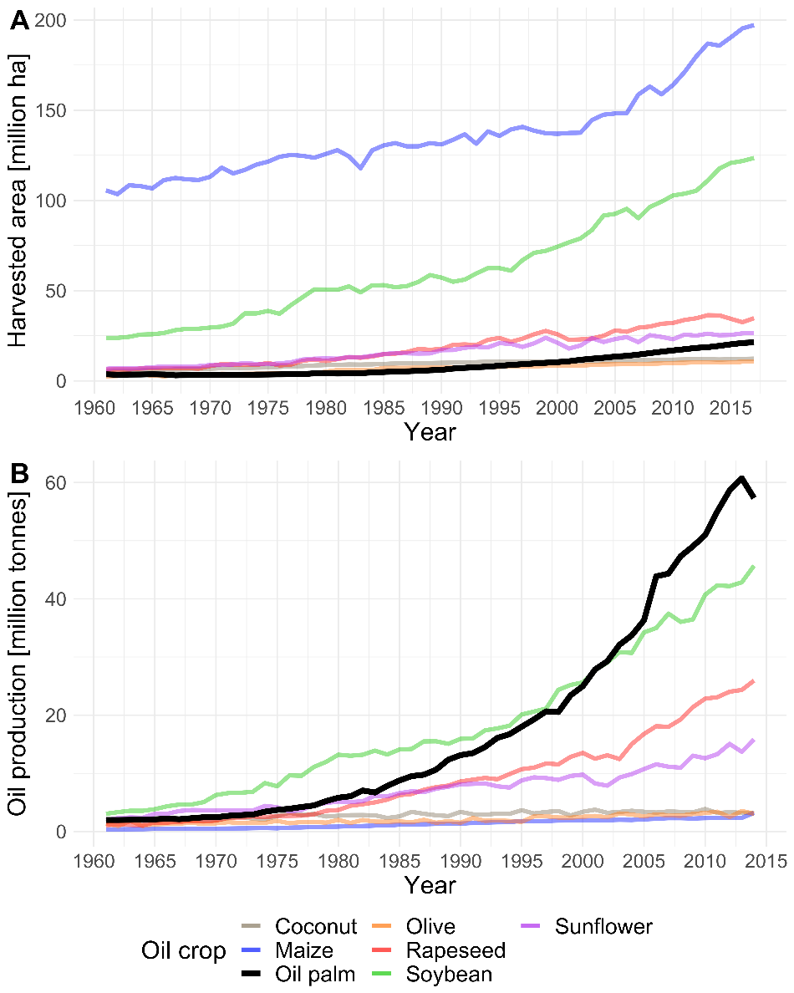
Figure 1. Main vegetable oil crops (see Table 1). (A) Harvested area from 1961 to 2017. (B) Vegetable oil production from 1961 to 2014. Data from FAOSTAT⁴

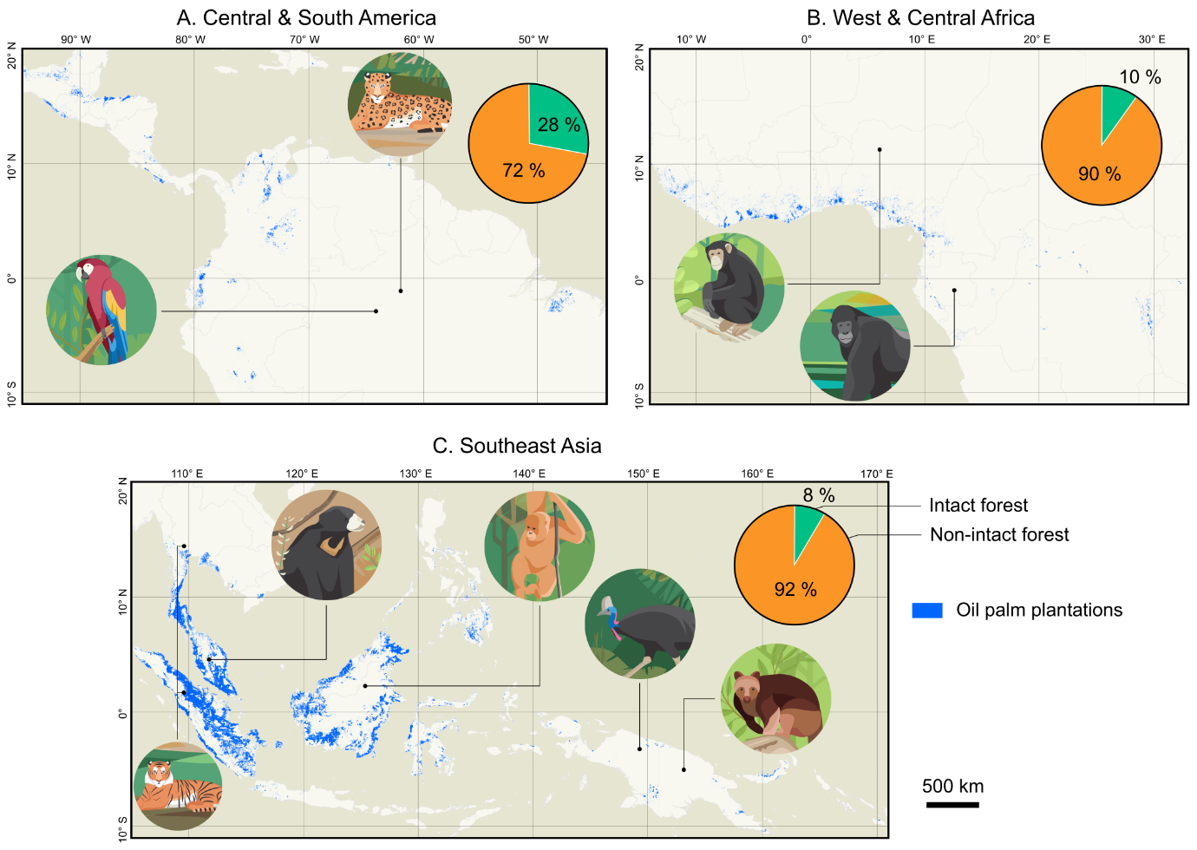

Figure 2. Maps of industrial and smallholder-scale oil palm according to satellite analysis³, and examples of species it affects negatively: A) Panthera onca (Near Threatened)¹⁰¹ and Ara macao (Least Concern)³⁹; B) Pan troglodytes (Endangered)⁸¹; C) Panthera tigris (Endangered)³², Helarctos malayanus (Vulnerable)¹⁰², Pongo pygmaeus (Critically Endangered)³⁰, Casuarius unappendiculatus (Least Concern)¹⁰³, and Dendrolagus goodfellowi (Endangered)¹⁰⁴. The maps lack information on plantations < 3 years old and semi-wild plantations, but provide the most up-to-date estimates available. For each region the percentages of intact (green) and non-intact forests (orange) are shown relative to the total extent of forest ecosystems⁶.

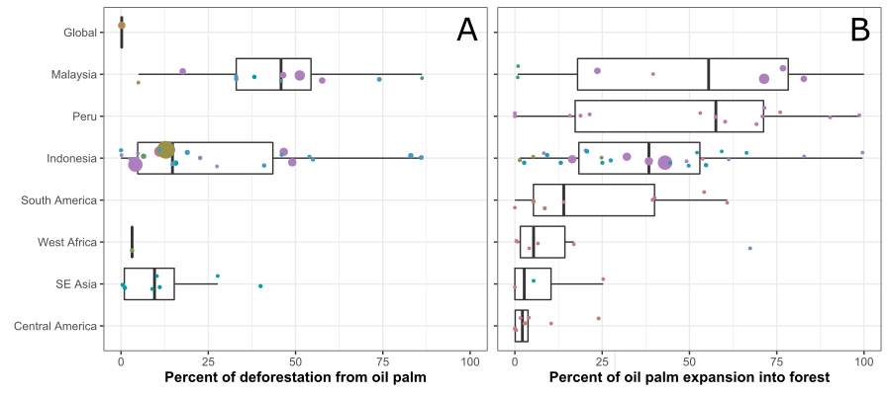

Figure 3. Oil palm’s role in deforestation aggregated across studies, years, and regions. Panel A depicts the contribution of oil palm to overall deforestation, while B shows the percentage of all oil palm expansion that cleared forest (Supplementary Methods). There were no data for Peru and South and Central America for panel A, and no global data for panel B. Southeast Asia (SE Asia) excludes Indonesia and Malaysia, which are shown separately, while South America excludes Peru. Each filled circle represents one time period from a single study, with individual studies represented by distinct colours. The size of the circle corresponds to the relative number of area-years represented in that time period (larger circles represent a larger study area and longer time period of sampling). Boxplot middle bars correspond to the unweighted median across study-time periods; lower and upper hinges represent the 25th and 75th percentiles of study-time periods; and whiskers extend from the upper (lower) hinge to the largest (smallest) value no further than 1.5 times the interquartile range from the hinge (Figure S2, Tables S2 and S3).

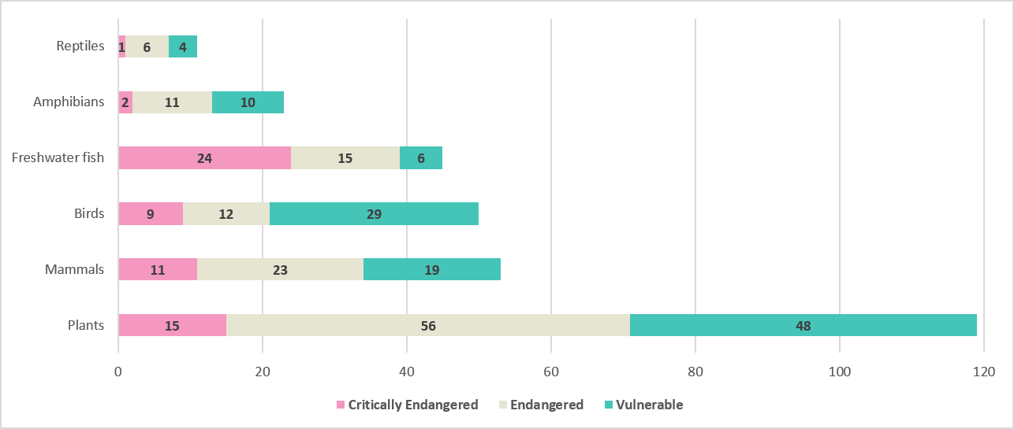

Figure 4 - Species groups with more than 8 threatened species with the terms "palm oil" or "oil palm" in the threats texts of the IUCN Red List of Threatened Species Assessments²⁹. In total 321 species assessments had oil palm plantations as one of the reported threats (301 when excluding groups with < 8 threatened species), which constitutes 3.5% of threatened species threatened by annual and perennial non-timber crops (9,088 species) and 1.2% of all globally threatened species (27,159 species) in 2019 (Supplementary Material and Table S4). CR = Critically Endangered; EN = Endangered; VU = Vulnerable.

Table 1. Overview of the major oil crops, typical production cycle, yields, main production countries, biomes in which impacts primarily occur, carbon emissions, the number of threatened species according to The IUCN Red List of Threatened Species²⁹ for which the specific crop is mentioned as a threat, and the median species richness and median range-size rarity (amphibians, birds and mammals) of species occurring within the footprint of each crop with first and third quartile in brackets (IUCN Red List) (see Supporting Online Methods, Figure S1, Table S4). Carbon emissions include carbon opportunity costs and production emissions⁶². “n/a” indicates that no data are available.
Oil crop | Type of crop | Oil yield (t ha-1)^{105,106} | Main oil production countries | Main biome impacted | Kg CO2e/MJ human kcal⁶² | # species threatened by crop²⁹ | Median Species Richness (number of species)²⁹ | Median range-size rarity (ha ha⁻¹ 10e5)²⁹
Oil palm Elaeis guineensis | Perennial (25 years cycle) | 1.9–4.8 | Indonesia, Malaysia, Thailand | Tropical rainforest | 1.2 | 321 | 472 [443, 504] | 36 [27, 57]
Soybean  Glycine max | Annual (~6 months cycle), rotated with other crops | 0.4–0.8 | China, USA, Brazil, Argentina | Subtropical grass savanna, temperate steppe, and broadleaf forest | 1.3 | 73 | 278 [251, 462] | 10 [5, 14]
Rapeseed  Brassica napus and B. campestris | Annual (~6 months cycle). Rotated with other crops | 0.7–1.8 | China, Germany, Canada | Temperate steppe and broadleaf forest and taiga | 1.2 | 1 | 227 [187, 308] | 4 [3, 10]
Cotton  Gossypium hirsutum | Annual (~6 months cycle). Rotated with other crops | 0.3–0.4 | China, India | Subtropical monsoon, dry and humid forest and temperate areas | 1.2 | 35 | 299 [234, 347] | 10 [7, 12]
Groundnuts or peanuts  Arachis hypogaea | Annual (4-5 months crop cycle). Rotated with other crops | 0.5–0.8 | China, India | Subtropical monsoon, dry and humid forest and temperate areas | 1.5 | 6 | 351 [308, 426] | 11 [7, 16]
Sunflower Helianthus annuus | Annual (3-4 months crop cycle). Rotated with other crops | 0.5–0.9 | Ukraine, Russia | Temperate steppe and broadleaf forest | 1.0 | 1 | 189 [177, 222] | 3 [2, 9]
Coconut  Cocos nucifera | Perennial (30 – 50 y cycle) | 0.4–2.4 | Philippines, Indonesia, India | Tropical and subtropical forest | n/a | 65 | 317 [264, 414] | 73 [35, 113]
Maize  Zea mays | Annual (5-6 months crop cycle). Rotated with other crops | 0.1–0.2 | USA, China, | Temperate steppe and broadleaf forest | 0.7 | 131 | 273 [222, 427] | 9 [5, 20]
Olive  Olea europaea | Perennial, long lived. Sometimes inter-cropped | 0.3–2.9 | Spain, Italy, Greece | Mediterranean vegetation | n/a | 14 | n/a | n/a

