The environmental impacts of palm oil in context
Erik Meijaard^{1,2,3*}, Thomas Brooks^{4,5,6}, Kimberly M. Carlson⁷, Eleanor M. Slade⁸, John Garcia Ulloa⁹, David L.A. Gaveau¹⁰, Janice Ser Huay Lee⁸, Truly Santika^{1,2}, Diego Juffe-Bignoli¹¹, Matthew J. Struebig², Serge A. Wich¹², Marc Ancrenaz^{1,13}, Lian Pin Koh¹⁴, Nadine Zamira¹⁵, Jesse. F. Abrams^{16, 17}, Herbert H.T. Prins¹⁸, Cyriaque N. Sendashonga¹⁹, Daniel Murdiyarso ^{10,20}, Paul R. Furumo²¹, Nicholas Macfarlane⁴, Rachel Hoffmann²², Douglas Sheil²³
¹ Borneo Futures, Bandar Seri Begawan, Brunei Darussalam
² Durrell Institute of Conservation and Ecology, University of Kent, Canterbury, UK
³ School of Biological Sciences, University of Queensland, St Lucia, Australia
⁴ Science and Knowledge Unit, IUCN, 1196 Gland, Switzerland
⁵ World Agroforestry Center (ICRAF), University of The Philippines Los Baños, Laguna, Philippines
⁶ Institute for Marine & Antarctic Studies, University of Tasmania, Hobart, Tasmania 7001, Australia
⁷ Department of Natural Resources and Environmental Management, the University of Hawai’i at Mānoa, HI, USA
⁸ Asian School of the Environment, Nanyang Technological University of Singapore, Singapore
⁹ Department of Environmental Systems Science, ETH Zürich, Zürich, Switzerland
¹⁰ Center for International Forestry Research, Bogor, Indonesia
¹¹ UN Environment Programme World Conservation Monitoring Centre (UNEP-WCMC), Cambridge, UK
¹² School of Biological and Environmental Sciences, Liverpool John Moores University, Liverpool, UK
¹³ Kinabatangan Orang-Utan Conservation Programme, Kota Kinabalu, Sabah, Malaysia
¹⁴ Conservation International, Arlington, Virginia, USA
¹⁵ Rainforest Alliance, Washington, DC 20005, USA
¹⁶ Department of Ecological Dynamics, Leibniz Institute for Zoo and Wildlife Research, Berlin, Germany
¹⁷ Global Systems Institute, University of Exeter, Laver Building, Exeter, UK
¹⁸ Animal Sciences Group, Wageningen University, the Netherlands
¹⁹ IUCN Policy and Programme Group, IUCN, 1196 Gland Switzerland
²⁰ Department of Geophysics and Meteorology, IPB University, Bogor 16680, Indonesia.
²¹ Earth System Science, Stanford University, CA, USA
²² Department of Veterinary Medicine, University of Cambridge, UK
²³ Department of Ecology and Natural Resource Management, Norwegian University of Life Sciences, Ås, Norway
*e-mail: emeijaard@gmail.com
Abstract (ideally 200 words)
Delivering the Sustainable Development Goals (SDGs) requires balancing demands on land between agriculture (SDG 2) and biodiversity (SDG 15). The production of vegetable oils in general, and palm oil in particular, is perhaps the most controversial illustration of these trade-offs. Global annual demand for vegetable oil for food, animal feed and fuel is currently at 210 million tons ¹ (Mt), with 84 Mt of this comprising palm oil ². Oil palm covers ca. 25 million hectares (Mha) ³—all in the humid tropics, with other oil crops covering ca. 425 Mha in 2017 ⁴. Although direct conversion of forest to oil palm caused less than 0.5% of global deforestation between 2000 and 2013 ⁵, this percentage is locally as high as 58% ⁶. However, oil palm generally produces more oil per area than other oil crops ⁷, is economically viable in sites unsuitable for most other crops ⁸, and offers otherwise scarce economic opportunities to many rural people ⁸. As global demand for vegetable oils increases to a projected 307 Mt by 2050 ⁹, consideration of the relative yields, land requirements, and environmental impacts of different oil crops is crucial to guide decision-making ¹⁰. Reducing palm oil production while the demand for vegetable oil is growing would disproportionately increase global land needs for oil production, impacting food security, climate change, land degradation and other concerns.

Over the past 25 years, global oil crops have expanded with major impacts on land use and global trade ⁹. The land used for growing oil crops grew from 170 million ha (Mha) in 1961 to 450 Mha in 2017 ⁴ or ~30% of all cropland world-wide ¹¹. Many of these crops, such as soy (125 Mha planted area ⁴) and maize (197 Mha planted area ⁴), also produce food and animal feed. The fastest expanding exclusively oil crop is oil palm (for species names see Table 1), which accounts for ~40% of global vegetable oil ² on 9% of the land planted with vegetable oil crops (25 Mha planted area) (Figure 1). This palm originates from Africa ¹² where it has been widely cultivated for millennia ¹³, but it is now intensively grown in Southeast Asia. Between 2008 and 2017, oil palm expanded at an average rate of 0.7 Mha per year ⁴. Oil palm, soy, and rapeseed together produce >80% of all vegetable oils with cotton, groundnuts, sunflower and coconut comprising most of the remainder (Table 1, Figure 1). By 2009, according to one estimate, palm oil was an ingredient of 43% of products found in British supermarkets ¹⁴.
As a wild plant, oil palm is a colonising species that establishes in open areas ¹⁵. The cultivated palms are commonly grown as plantation monocultures, although the tree is also used in mixed, small-scale and agroforestry settings. To maximize photosynthetic capacity and fruit yields, oil palm requires a warm wet climate, high solar radiation, and high humidity ¹⁶. It is thus most productive in the humid tropics, while other oil crops, with the exception of coconut, grow primarily in subtropical and temperate regions (Table 1). Moreover, because oil palm tolerates many soils including deep peat and sands, it is often profitable in locations where few other crops are viable. The highest yields from planted oil palm are reported from Southeast Asia ³. Yields are lower in Africa ^{17,18} and the Neotropics³, likely reflecting differences in climatic conditions including humidity and cloud cover ¹⁸, management, occurrence of pests and diseases and planting stock ¹⁷.
Palm oil is controversial due to its impacts and opportunities. Loss of natural habitats, along with the biomass loss and peatland drainage that occurs in site preparation, are the main direct environmental impacts from oil palm development ^{19,20}. Such conversion tends to reduce biodiversity and water quality and to increase greenhouse gas emissions, and, when fire is used, smoke and haze ^{3,21}. Yet, it is a valued crop bringing economic benefits to regions with few alternative agricultural development options ⁸, producing more oil per unit land than other crops and yielding good rates of return on investment for investors. Here we review the current understanding of the environmental impacts from oil palm cultivation, and assess how it compares to other oil seed crops.
Figure 1. Main vegetable oil crops (see Table 1). (A) Harvested area from 1961 to 2017. (B) Oil production from 1961 to 2014. Data from FAOSTAT ⁴
Table 1. Overview of the major vegetable oil crops and maize, typical production cycle, yields, main production countries, environmental impacts and biomes in which impact primarily occur, and the number of threatened species according to The International Union for Conservation of Nature’s (IUCN) Red List of Threatened Species ²² for which the specific crop is mentioned as threat (see Supporting Online Methods). Carbon emissions include carbon opportunity costs and production emissions ²³.
Oil crop | Type of crop | Oil yield (t ha-1) ^{24,25} | Main oil production countries | Main environmental impact | Kg CO2e/MJ human kcal ²³ | IUCN Red List species threatened by crop
Oil palm Elaeis guineensis | Perennial (25 years cycle) | 1.9–4.8 | Indonesia, Malaysia, Thailand | Mostly negative impact on tropical rainforest | 1.2 | 321
Soybean  Glycine max | Annual (~6 months cycle). Nitrogen fixer, rotated with other crops | 0.4–0.8 | China, USA, Brazil, Argentina | Mostly negative impact on subtropical grass savanna, temperate steppe, and broadleaf forest | 1.3 | 73
Rapeseed  Brassica napus and B. campestris | Annual (~6 months cycle). Rotated with other crops | 0.7–1.8 | China, Germany, Canada | Limited impacts in temperate steppe and broadleaf forest and taiga | 1.2 | 1
Cotton  Gossypium hirsutum | Annual (~6 months cycle). Rotated with other crops | 0.3–0.4 | China, India | Limited impacts in subtropical monsoon, dry and humid forest and temperate areas | 1.2 | 35
Groundnuts or peanuts  Arachis hypogaea | Annual (4-5 months crop cycle). Rotated with other crops | 0.5–0.8 | China, India | Limited impacts in subtropical monsoon, dry and humid forest and temperate areas | 1.5 | 6
Sunflower Helianthus annuus | Annual (3-4 months crop cycle). Rotated with other crops | 0.5–0.9 | Ukraine, Russia | Limited impacts in temperate steppe and broadleaf forest | 1.0 | 1
Coconut  Cocos nucifera | Perennial (30 – 50 y cycle) | 0.4–2.4 | Philippines, Indonesia, India | Mostly negative impact on tropical environments | n/a | 73
Maize  Zea mays | Annual (5-6 months crop cycle). Rotated with other crops | 0.1–0.2 | USA, China, | Limited impacts in temperate steppe and broadleaf forest | 0.7 | 131
Olive  Olea europaea | Perennial, long lived. Sometimes inter-cropped | 0.3–2.9 | Spain, Italy, Greece | Limited impacts in Mediterranean vegetation | n/a | 14

DEFORESTATION AND OIL PALM EXPANSION
Industrial-scale oil palm plantations covered at least 18.7 Mha globally in 2017 (Figure 2, Table S1). The most extensive areas are in Indonesia (11 Mha) and Malaysia (6 Mha). The true extent is likely to be greater since areas of smallholder plantation not associated with large plantations, and mixed plantings are underestimated via medium resolution (30m/pixel) satellite imagery, precluding a more comprehensive global mapping ²⁶. Estimates suggest that the proportion of oil palm area under smallholder cultivation varies from 30–60% in parts of Malaysia and Indonesia ²⁷ to as much as 94% in Nigeria ³. Thus, the global area of planted oil palm is likely around 25 Mha (+/-10%).
The reported contribution of oil palm plantings to global deforestation varies widely with the scope and methods of the specific assessments. We reviewed 21 studies that reported land use or land cover change due to oil palm agriculture (Table S2 and S3). High values were found in Malaysian Borneo ²⁸, for example, where oil palm development accounted for 47% of deforestation from 1972 to 2015 using a 5-year cut-off between deforestation and oil palm development to link the two ²⁹ (Figure 3). In contrast, one global sample-based study suggested that between 2000 and 2013, just 0.2% of global deforestation in “Intact Forest Landscapes” was caused by oil palm development ⁵.
The degree to which oil palm expansion has replaced forests (defined as naturally regenerating closed canopy forests) thus also varies with context. One global analysis estimated that 46±18% of new plantation land between 1972 and 2015 expanded into forest, with the remainder replacing croplands, pasturelands, scrublands (including secondary regrowth), and other land uses ³. A breakdown of this number reveals that the percentage planting area replacing forest ranged from 68% in Malaysia and 44% in the Peruvian Amazon, to just 5-6% in Central America, South America excluding Peru, and West Africa (Figure 3). In contrast, oil palm expansion in the neotropics is characterized by the conversion of previously cleared lands instead of forests ^{30,31}, although the extent to which oil palm displaces other land uses into forests remains uncertain. In Indonesia and Malaysian Borneo, industrial plantation expansion and associated deforestation have declined since ca. 2011 ^{6,32}. However, smallholder oil palm may be expanding. Only two studies to date have clearly differentiated between smallholders and industrial scale oil palm (Table S2). In Peru, 30% of smallholder expansion resulted in deforestation ³³, while, in Sumatra, Indonesia this percentage is 39% ³⁴. While there is still a lack of comprehension of deforestation impacts of smallholders ³⁴, recent studies from Indonesian Borneo show that smallholders often convert more fragile ecosystems such as tropical peatlands into oil palm plantations ³⁵.
Figure 2. Maps of planted industrial-scale oil palm globally according to satellite analysis reviewed and conducted in the current analysis (LANDSAT and MODIS, see Appendix 2), and examples of species it affects negatively: A) Panthera onca (Near Threatened, NT) ³⁶ and Ara macao (Least Concern, LC) ³⁷; B) Pan troglodytes (Endangered, EN) and Gorilla gorilla (Critically Endangered, CR) ³⁸; C) Panthera tigris (Endangered) ³², Helarctos malayanus (Vulnerable, VU) ³⁹, Pongo pygmaeus (Critically Endangered) ³⁰, Casuarius unappendiculatus (Least Concern) ⁴⁰, and Dendrolagus goodfellowi (Endangered) ⁴¹. The maps lack information on smallholder oil palm, and on semi-wild plantations.
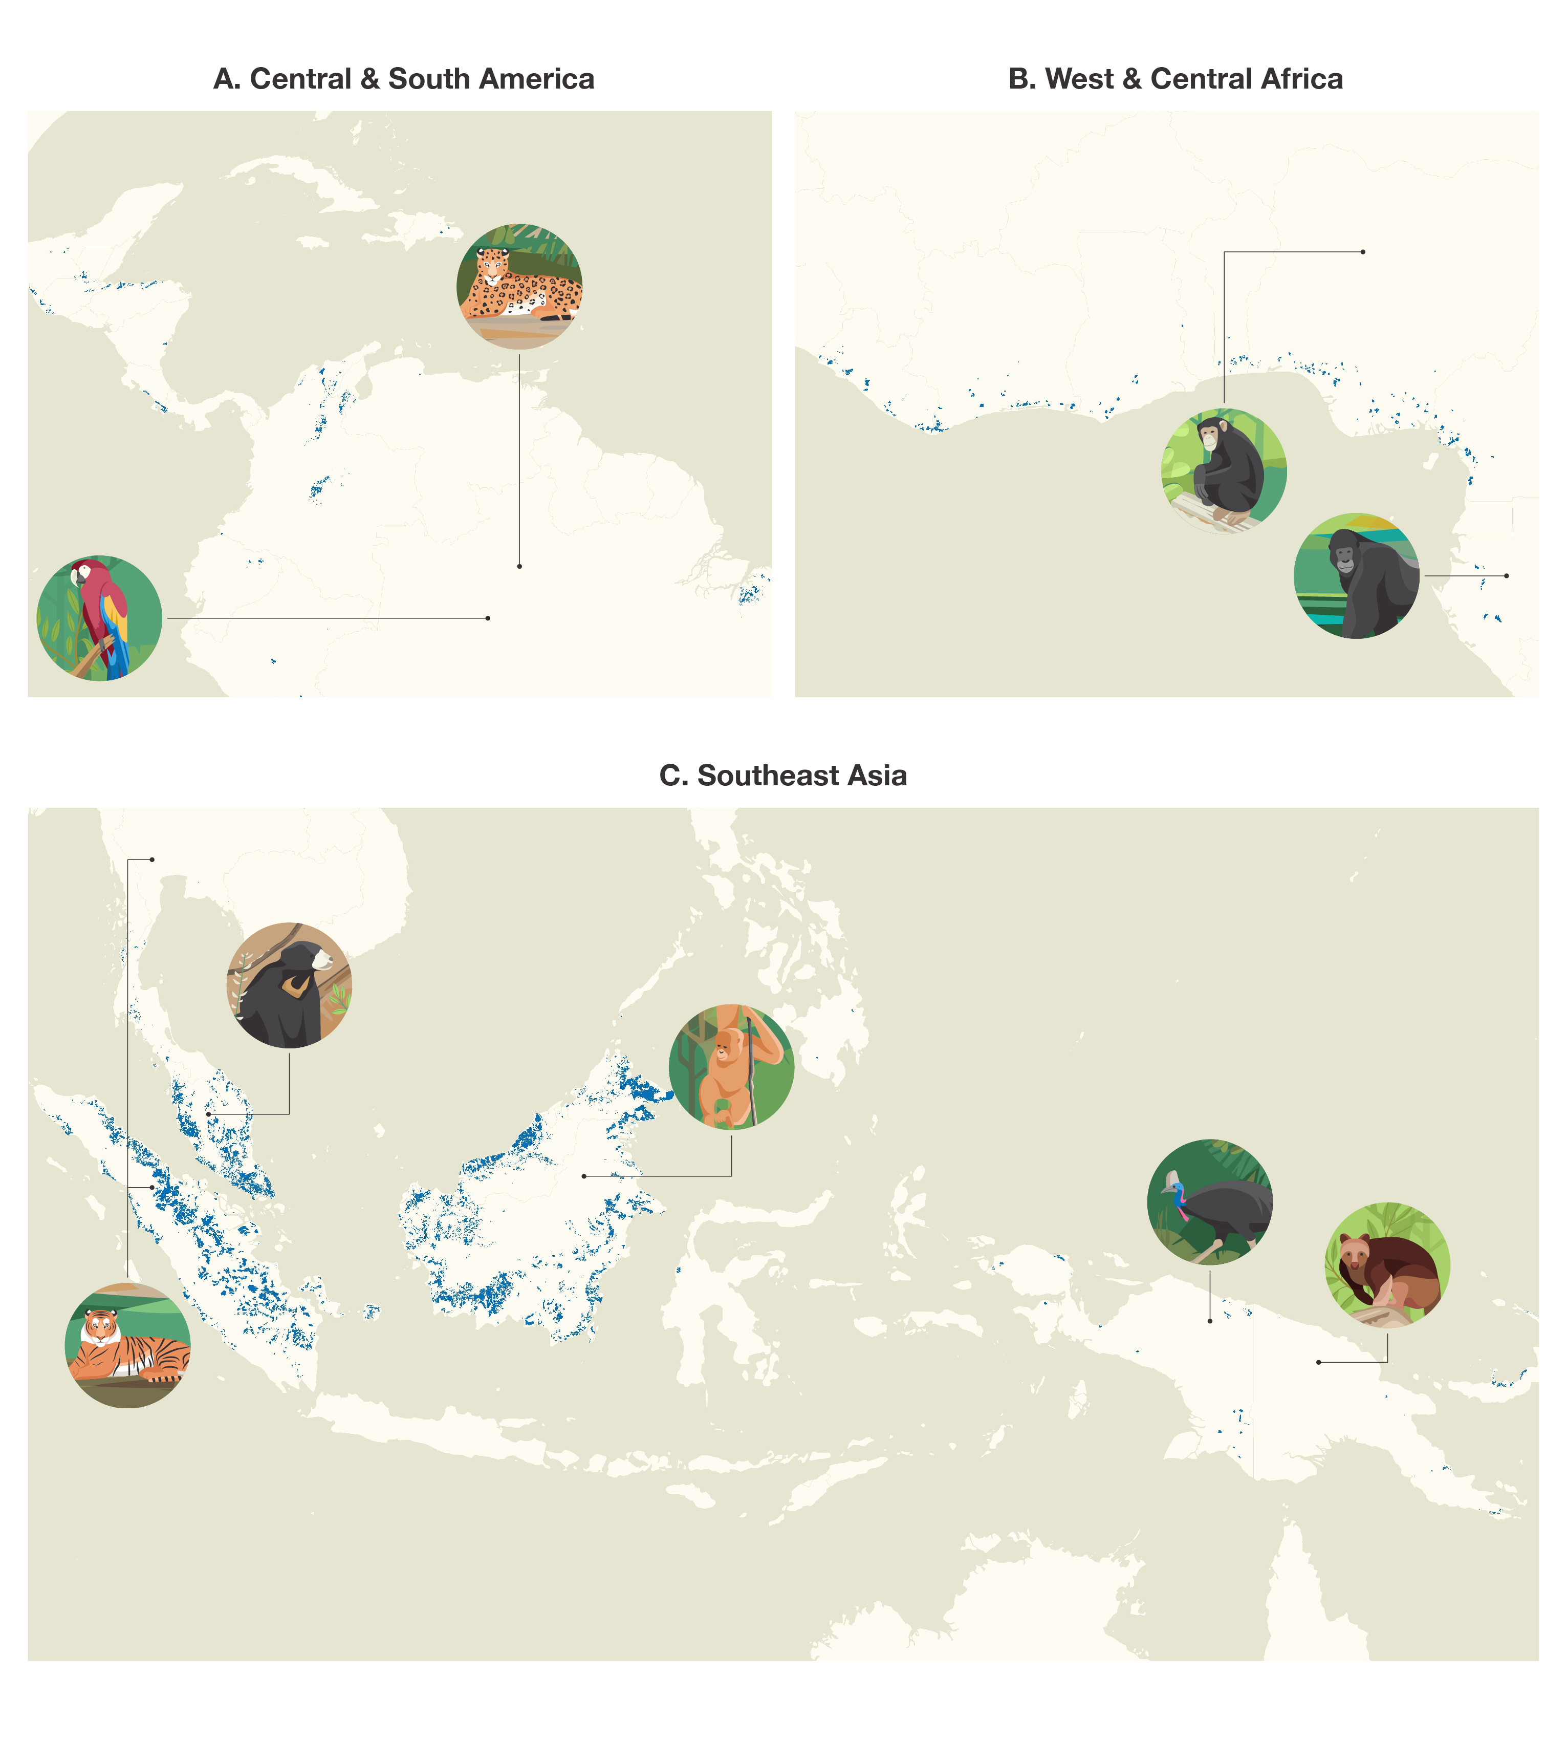

Figure 3. Oil palm’s role in deforestation. The figure on the left depicts the contribution of oil palm to overall deforestation, while the figure on the right shows the percentage of all oil palm expansion that cleared forest. Southeast Asia (SE Asia) excludes Indonesia and Malaysia, which are shown separately, while South America excludes Peru. Bars indicate the standard deviation of the sample mean weighted by study area.
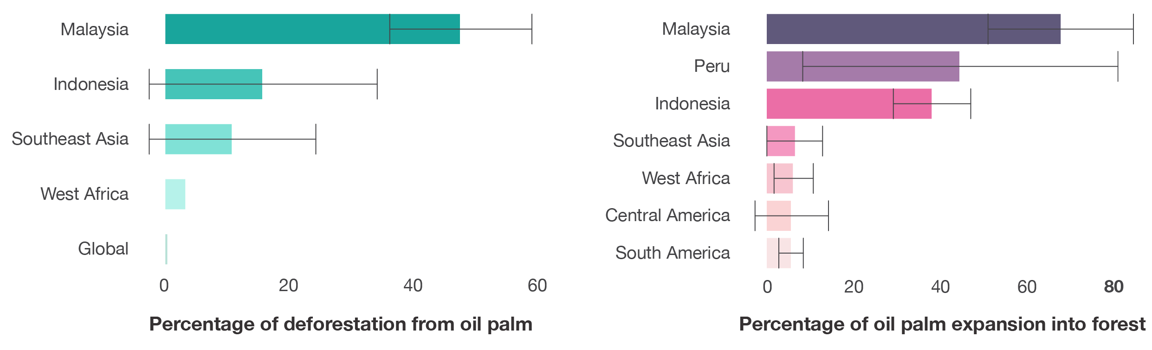
PALM OIL’S DIRECT IMPACTS ON SPECIES
The International Union for Conservation of Nature’s (IUCN) Red List of Threatened Species Version 2019.2 ²² documents 321 species for which oil palm has been indicated as one of the reported threats, significantly more than for other oil crops (Figure 4, Table 1). This comprises 3.5% of species threatened by annual and perennial non-timber crops (9,088 species) and 1.2% of all globally threatened species (27,159 species). Other threats reported in these assessments included timber extraction, unsustainable harvesting of species and habitat conversion for other crops (Supplementary Methods). Species threatened by oil palm include orangutans Pongo spp. ⁴², gibbons Hylobates spp. ⁴³ and tiger Panthera tigris ⁴⁴. Results may be biased as not all taxonomic groups have been comprehensively assessed (e.g., arthropods and freshwater mollusks), and threat studies may have focused more on certain oil crops than on others.
Oil palm plantations contain lower species diversity and abundance for most taxonomic groups when compared to natural forest, and only 22% of vertebrates and 29% of invertebrates are shared, on average, between the two habitats ⁴⁵. Plant diversity in some plantations is less than 1% of that in natural forests ⁴⁶, but because oil palm is perennial, associated plant diversity likely exceeds that of annual crops (Table 1). One study, for example, found 298 plant species in the oil palm undergrowth ⁴⁷, and another 16 species of fern on oil palm trunks ⁴⁸.
Recorded mammal diversity in oil palm appears to be 47–90% lower than in natural forest ^{49,50}, but strongly depends on presence and proximity of natural forests. Oil palm plantations generally exclude forest specialist species ⁵¹, which are often those species of greatest conservation importance⁵². For example, forest-dependent gibbons cannot survive in stands of monocultural oil palm, but can make use of in interspersed forest fragments within an oil palm matrix ^{46,53}. Some species, although unable to survive solely in oil palm, will utilise plantations. For instance, plantations in Malaysian Borneo, excluding surrounding forest fragments, supported 22 mammal ⁵⁴ of the 63 mammal species found in nearby forests ⁴⁹ and 31 of 130 bird species ⁵⁵, most of them relatively common species. Oil palm in Guatemala supports 23 bird species ⁵⁶, while 12 species of snake were found in a Nigerian oil palm plantation ⁵⁷. In Africa, various species, such as Palm-nut Vultures Gypohierax angolensis ⁵⁸ and Chimpanzee Pan troglodytes ^{59,60}, and in Southeast Asia, porcupines, civets, macaques, elephants and even orangutans will enter plantations to feed on palm fruit ⁶¹. The highest animal diversity in oil palm areas, however, is generally found in the wider landscape that includes patches of native vegetation⁶²⁻⁶⁴. Factors that increase wildlife values in both industrial-scale and smallholding plantations include higher landscape heterogeneity and the presence of large forest patches and the connectivity among these ^{65,66}.
Figure 4 - Species groups with more than 8 threatened species with the terms "palm oil" or "oil palm" in the threats texts of the IUCN Red List of Threatened Species Assessments (Version 2019-1) ²². In total 321 species assessments had oil palm plantations as one of the reported threats which constitutes 3.5% of threatened species threatened by annual and perennial non-timber crops (9,088 species) and 1.2% of all globally threatened species (27,159 species). Other threats reported in these assessments included logging, overharvesting and habitat conversion for other crops (Supplementary Material and Table S5). For abbreviations CR, EN, VU, see Fig. 2.
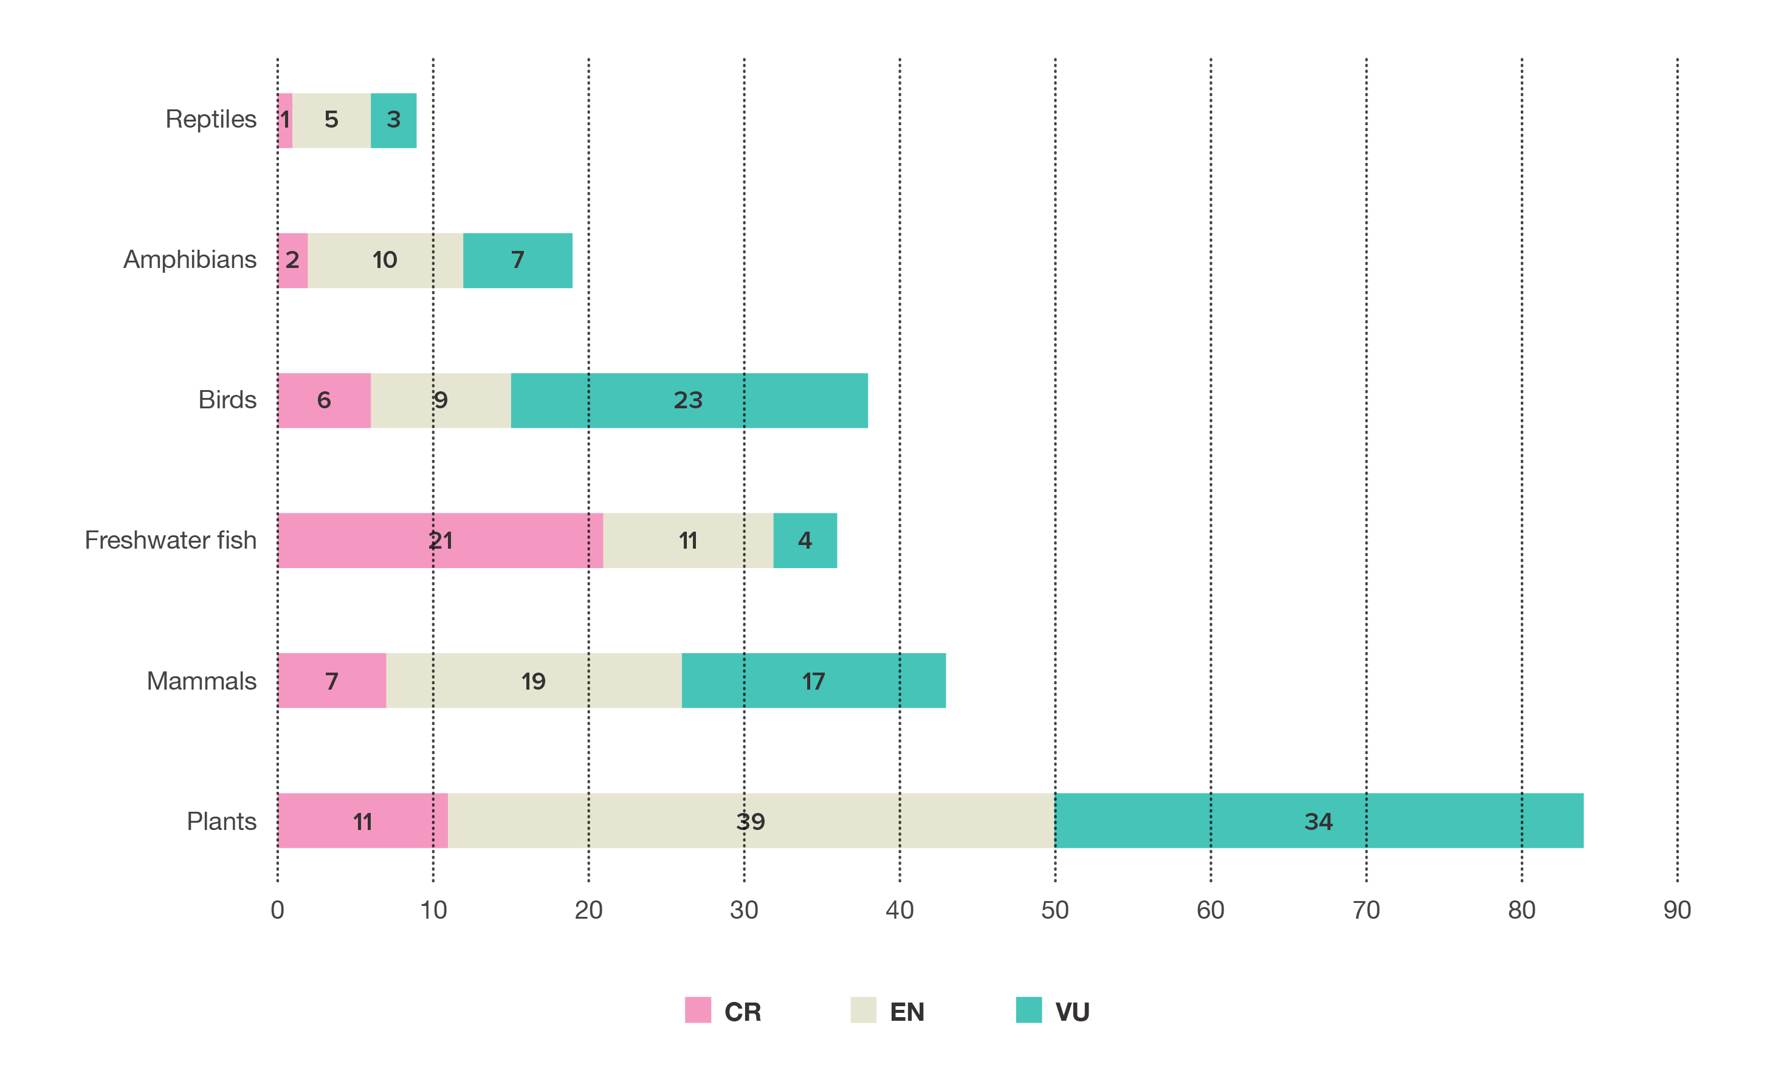
Oil palm cultivation involves the introduction and spread of invasive species including the oil palm itself (noted in Madagascar and Brazil’s Atlantic Forests ⁶⁷), non-native cover crops and nitrogen-fixing plants (e.g., Mucuna bracteata or Calopogonium caeruleum ⁶⁸). Similarly, management of oil palm plantations can increase local abundance of species such as Barn Owls Tyto alba, introduced into plantations to control rodents ^{69,70}. Oil palm plantations also support pests such as the Black Rat Rattus rattus, pigs Sus spp., beetles such as the Asiatic Rhinoceros Beetle Oryctes rhinoceros and the Red Palm Weevil Rhynchophorus ferrugineus ^{15,70}. These organisms have a range of local effects, both positive and negative for biodiversity, including attracting snakes, owls, monkeys and cats preying on small mammals ^{61,71,72}, and increasing Wild Boar Sus scrofa populations which reduce seedling recruitment in forests neighbouring oil palm ⁷³. Such species can also impact palm oil production. This impact can be negative, for example in reducing oil palm yields through damage to the palm or fruit predation ⁷⁴. It can also be positive, with riparian reserves and other set-asides containing natural forest potentially contributing to pollination and pest control within the plantation, although they may also harbour pests and disease ^{75,76}. Studies to date suggest overall limited, or neutral, effects on pest control services, spill over of pest species, or oil palm yield ⁷⁷⁻⁷⁹. There are also plenty of unknowns, for example, the African beetle Elaiedobius kamerunicus has been introduced as an effective oil palm pollinator and is now widely naturalised in Southeast Asia where it persists also in native vegetation and visits the inflorescences of native palms but its impacts, if any, are unexamined (DS pers. obs.).
Smallholders plantations tend to be smaller and more heterogeneous than industrial developments (often < 50 ha ^{3,80}), potentially benefiting wildlife, but this remains poorly studied ⁴⁵. A handful of studies indicate that smallholdings support similar or somewhat more birds and mammals species than do industrial plantations ^{52,65}. However, species in smallholder plantations may be more exposed to other pressures, such as hunting, when compared to industrial plantations ⁶⁵.
OTHER ENVIRONMENTAL IMPACTS
Oil palm plantations have a predominantly negative net effect on ecosystem functions when compared to primary and selectively logged secondary forest ²¹. The clearance of forests and drainage of peatlands for oil palm emits substantial carbon dioxide ^{81,82}. Though oil palms can maintain high rates of carbon uptake ⁸³ and their oil can potentially be used to substitute fossil fuels ⁸⁴, and thus contribute towards sustainable energy (SDG 7) and climate change response (SDG 13), it cannot compensate for the carbon released when forests are cleared and peatlands drained ^{23,85}. Compared to other vegetable oil crops, however, the carbon opportunity cost, which reflects the land’s opportunity to store carbon if it is not used for agriculture, is not very different ²³ (Table 1). Oil palm plantations, and the production of palm oil, can also be sources of methane ⁸⁶ and nitrous oxide ⁸⁷, both potent greenhouse gases that contribute further to climate change, although the former is sometimes used as biogas, reducing net greenhouse gas release ^{88,89}. Other emissions associated with oil palm development include elevated isoprene production by palm trees, which influences cloud cover and rainfall ⁹⁰. In addition, there is some evidence that emissions of other organic compounds are also higher in oil palm plantations than in forest, e.g., estragole and toluene ⁹¹, although these emissions appear relatively minor compared to isoprene ⁹².
Forest loss and land use change to oil palm impact the local and regional climate, although the extent of these impacts remains debated ⁹³⁻⁹⁶. For example, the increased temperatures and reduced rainfall recorded over Borneo since the mid-1970s, has been suggested to relate to the declining forest cover on the island concurrent with the expansion of oil palm, with the changes being greater in areas where forest losses were higher ⁹⁷. Such processes may be connected to the fact that oil palm plantations tend to be hotter, drier and less shaded than forests due to the less dense canopy ⁹⁸, with higher evapotranspiration rates than forests ⁹⁹. A drier hotter climate increases the risk of fire ¹⁰⁰ and concomitant smoke pollution, especially in peat ecosystems ¹⁰¹. In addition to human health consequences (e.g., respiratory diseases, conjunctivitis) ¹⁰², such fires can impact wildlife and ecological processes ¹⁰³. For example, aerosols from fires can scatter solar radiation, disrupt evaporation, and promote drought ⁹⁴. Few of these impacts are well-studied ^{104,105}.
Conversion of natural forests to oil palm plantations increases run-off and sediment export due to loss or reduction of riparian buffers, reduced ground cover, and dense road networks ¹⁰⁶. Streams flowing through plantations tend to be warmer, shallower, sandier, more turbid, and have reduced abundance of species such as dragonflies than streams in forested areas ¹⁰⁷⁻¹⁰⁹. Fertilizers, pesticides, and other chemicals also impact water quality and aquatic habitats ¹¹⁰. The effluent from most modern mills is minimized, but release into local rivers has been known to cause negative impacts on people and aquatic and marine ecosystems ^{111,112}. Some hydrological impacts can be positive: for example, construction of flood-control channels and sedimentation ponds for palm oil effluent can serve as habitat for some water birds ¹¹³.
Drainage of peatlands and other wetlands to establish oil palm disrupts the seasonal hydrological cycles, potentially impacting neighbouring forests and other habitats ¹¹⁴. The protection and restoration of riparian buffers and reserves within oil palm plantations is therefore key to preserving water quality, with recent research also showing the importance of these landscape features for biodiversity and ecosystem function (see ¹¹⁵ and references therein). Riparian reserve widths typical of many tropical countries (20–30 m on each bank) can support substantial levels of biodiversity ^{62,116} , maintain hydrological functioning ¹⁰⁸ and improve habitat connectivity and permeability for some species within oil palm ¹¹⁷. However, urgent research is needed into minimum width requirements under different contexts and for different taxa ¹¹⁵.
THE FUTURE OF OIL PALM
Demand for agricultural commodities is growing. Some predict that oil palm production will accelerate across tropical Africa ^{38,118}. However, due to socio-cultural, technical, political and ecological constraints only around one-tenth of the potential 50 million ha in tropical wet Africa could be developed in a sustainable way^{17,119}. The expansion of oil palm in the Neotropics is also uncertain because of greater challenges the sector faces compared to Southeast Asia, including lower yields, lower demand from national markets, high labour costs, volatile socio-political contexts, and high investment costs ³. Although the importance of these factors varies from country to country, in general the expansion of the oil palm industry in the Americas depends heavily on economic incentives and policies, and access to international markets.
Meeting the growing demand for palm oil, while adhering to new zero deforestation policies ¹²⁰, and consumer pressure to be more sustainable, will likely require a combination of approaches, including increasing yields in existing production areas–especially of smallholders ⁹, planting in deforested areas and degraded open ecosystems, such as man-made pastures ⁸³, and opening up new frontiers in Africa and the Americas ³. These strategies span a land-sparing and land-sharing continuum, with higher-yielding oil palm cultivation sparing land and perhaps reducing overall impacts on biodiversity ⁵¹, although mixed strategies may be better at meeting broader societal goals ¹²¹. Irrespective of optimal strategy, replanting with high-yielding palms is challenging for smallholders, who often lack the resources, technical knowledge and access to improved varieties required to increase yields. In such situations, interventions such as technical support through cooperatives may be appropriate ¹²², so as to make the choice of increasing yields more attractive for smallholders than clearing more land.
The extent to which biofuel use will drive oil palm expansion remains unclear. There is resistance from non-governmental organizations and governments in the European Union to the use of palm oil as a biofuel, in part because of the high CO₂–emissions from oil palm-driven deforestation and associated peatland development ^{86,123,124}, and also because, through crop displacement, it is thought to affect food security ⁸. It has been argued, however, that if oil palm is developed on low carbon stock lands, it has lower carbon emissions than other seed crops like European rapeseed ¹²⁵, and the carbon costs of both rapeseed and palm oil are lower than soy ²³. Information on the extent and consequences of other oil crops is therefore required to clarify the benefits and costs of trade-restricting policies and tariffs.
GOVERNANCE OPTIONS
Efforts to address the impacts of oil palm cultivation and palm oil trade have been the focus of a number of initiatives. For example, the two main producer countries have set up the Malaysian Sustainable Palm Oil and Indonesian Sustainable Palm Oil certification schemes ¹²⁶. Internationally, however, the largest focus has been on avoiding the conversion of areas important for biodiversity, primarily old growth forests through the High Carbon Stock and High Conservation Value approaches ^{127,128}. These frameworks are being used by producers that aim to meet the requirements of palm oil sustainability initiatives, notably, through the Roundtable on Sustainable Palm Oil certification standards, which now include protection, management, and restoration of riparian areas within certified plantations and prohibit new planting on peat ¹²⁰, as well as zero-deforestation commitments ³. There is evidence for positive impacts of palm oil certification on agrochemical use, forest protection, reducing fires, and biodiversity losses, through improved farm-level management practices ¹²⁹, although these effects are small ^{64,130,131}.
Many producers and buyers of palm oil now have committed to “no deforestation”. A 2017 cross-commodity survey ¹³² found that companies in the palm oil sector have the highest proportion of no-deforestation commitments across four commodity supply chains (palm oil, soy, timber and cattle) linked to global deforestation. Although most of these commitments have been made by retailers and manufacturers ¹³², palm oil producing companies are also increasingly moving in this direction. In 2018, 41 of the 50 palm oil producers with the largest market capitalization and land areas had committed to address deforestation, with 29 of them pledging to adhere to zero deforestation practices ¹³³. These commitments have likely contributed to reduced expansion of oil palm in parts of Malaysia and Indonesia ^{6,32}, although recent low prices of palm oil may have played a role too ⁶. Such private supply chain initiatives like certifications and zero-deforestation commitments may be most effective in reducing environmental impacts when leveraged with public and institutional support such as plantation moratoria for certain areas and national low-carbon rural development strategies, as has been demonstrated, for example, in Brazilian soy production ¹³⁴.
LAND USE TRADE-OFFS AMONG VEGETABLE OILS
While the environmental impacts of oil palm are overwhelmingly negative compared to natural ecosystems, they also need to be considered in relation to other land uses, including competing vegetable oil systems, all of which have their own implications for biodiversity, carbon emissions and other environmental impacts (Table 1). Global vegetable oil production is expected to expand at around 1.5% per year between 2017 and 2027 ¹³⁵, while use is projected to expand at 1.7% per year globally between 2013 and 2050 from a baseline of 165 million tons (Mt), including for use in food, feed and biofuel ⁹. Unless demand for oil decelerates, this implies an additional production of 2.8 Mt of vegetable oil per annum. If this production was delivered by oil palm alone, yielding ca. 4 tons of crude palm oil per ha ^{3,7}, 700,000 ha of extra land would be needed annually between now and 2050. If, on the other hand, the addition all came from soy, yielding about 0.7 tons of oil per ha ⁹, 4 million ha of extra land, or nearly six times as much, would be required annually.
Understanding impacts is, however, not just a matter of comparing current and projected distributions and yields of different crops and thus land needs, but also requires clarifying how each hectare of land converted to a different crop in a different region impacts the environment and people. For example, soy is known to have a large negative impact on biodiversity ¹³⁶, with few vertebrates occurring in this annual monoculture crop ¹³⁷, and is responsible for loss of high biodiversity habitats in the South American Cerrado and forests ¹³⁸. Thus, sustainable development, including simultaneous delivery of SDGs 2 on agriculture and 15 on biodiversity (alongside contributions to SDG 7 on energy and SDG 13 on climate), must consider the wider trade-offs across production of different vegetable oils ¹³⁹. One key uncertainty is the extent to which demand can be met by increasing yields in established areas, ^{18,140}. An additional uncertainty is the extent and speed at which other oils, for example microalgal-derived lipids ^{141,142}, may become viable alternatives ¹⁴³.
THE WAY FORWARD
The expansion of oil palm has had negative environmental impact and continues to drive deforestation in some regions. Nevertheless, oil palm contributes to economic development ³, has improved welfare for at least some people ^{27,144}, and has potential to provide at least some conservation benefits ¹⁴⁵. There are also still substantial gaps in our understanding of oil palm and its impacts, notably the relationship between environmental and socio-cultural and economic impacts, and the scope, stringency and effectiveness of governance initiatives. Moreover, none of these concerns and trade-offs are unique to oil palm: they also apply to other vegetable oil crops such as soy beans ¹³⁸, as well as other agricultural products including cocoa, corn and rice ¹⁴⁶. In a world with finite land and growing demands, we must consider global demands for food, fuel and industrial uses hand-in-hand with maintaining nature. Oil palm’s high yield minimises the land required to meet global demand. However, minimising its negative impacts requires evaluation of all vegetable oil crops for their past, current and projected distribution and impacts, and review of their yields, substitutability, and trade dynamics. Better planning (at landscape and jurisdictional scales) and governance of land use and trade decisions needs such information to optimize the simultaneous delivery of the SDGs, including agricultural production through SDG2 and biodiversity conservation through SDG15.
LITERATURE CITED
1 USDA-FAS. Oilseeds: World Markets and Trade. Circular Series FOP 8-10 August. (United States Department of Agriculture Foreign Agricultural Service, Washington, DC, 2010 ).
2 USDA. Oil seeds: World markets and trade. November 2019. (Foreign Agricultural Service, United States Department of Agriculture, 2019).
3 Meijaard, E. et al. Oil Palm and Biodiversity – A Situation Analysis. DOI: 10.2305/IUCN.CH.2018.11.en. (IUCN Oil Palm Task Force, 2018).
4 FAOSTAT. Food and agriculture data. http://www.fao.org/faostat/en/#home. (Food and Agriculture Organization of the United Nations, Rome, Italy, 2019).
5 Potapov, P. et al. The last frontiers of wilderness: Tracking loss of intact forest landscapes from 2000 to 2013. Sc. Adv. 3 (2017).
6 Gaveau, D. L. A. et al. Rise and fall of forest loss and industrial plantations in Borneo (2000–2017). Cons. Lett. 0, e12622, doi:doi:10.1111/conl.12622 (2019).
7 Johnston, M., Foley, J. A., Holloway, T., Kucharik, C. & Monfreda, C. Resetting global expectations from agricultural biofuels. Env. Res. Lett. 4, 014004, doi:10.1088/1748-9326/4/1/014004 (2009).
8 Meijaard, E. & Sheil, D. The Moral Minefield of Ethical Oil Palm and Sustainable Development. Front. Forests Glob. Change 2, doi:10.3389/ffgc.2019.00022 (2019).
9 Byerlee, D., Falcon, W. P. & Naylor, R. L. The Tropical Oil Crop Revolution: Food, Feed, Fuel, and Forests. (Oxford University Press, 2017).
10 Beyer, R. M. et al. Will substituting palm oil reduce the environmental impacts of global vegetable oil production? (in press).
11 Ramankutty, N. et al. Trends in Global Agricultural Land Use: Implications for Environmental Health and Food Security. Ann. Rev. Plant Biol. 69, 789-815, doi:10.1146/annurev-arplant-042817-040256 (2018).
12 Ergo, A. B. New evidence for the African origin of Elaeis guineensis Jacq. by the discovery of fossil seeds in Uganda. Annal. Gembloux 102, 191-201 (1996).
13 Hoyle, D. & Levang, P. Oil Palm Development in Cameroon. (WWF & IRD/CIFOR, Yaoundé, Cameroon, 2012).
14 Independent. The guilty secrets of palm oil: Are you unwittingly contributing to the devastation of the rain forests?. https://www.independent.co.uk/environment/the-guilty-secrets-of-palm-oil-are-you-unwittingly-contributing-to-the-devastation-of-the-rain-1676218.html. (2009).
15 Corley, R. H. V. & Tinker, P. B. The Oil Palm, Fifth edition. 639 (Wiley Blackwell Publishing, 2016).
16 Basri, W. M., Abdullah, S. N. A. & Henson, I. E. Oil Palm--Achievements and Potential. Plant Prod. Sc. 8, 288-297, doi:10.1626/pps.8.288 (2005).
17 Feintrenie, L., Gazull, L., Goulaouic, R. & Miaro III, L. Spatialized production models for sustainable palm oil in Central Africa: Choices and potentials. Presented at Scaling Up Responsible Land Governance. Annual World Bank Conference on Land and Poverty, Washington DC, March 14-18, 2016. (2016).
18 Woittiez, L. S., van Wijk, M. T., Slingerland, M., van Noordwijk, M. & Giller, K. E. Yield gaps in oil palm: A quantitative review of contributing factors. Europ. J. Agron. 83, 57-77, doi:https://doi.org/10.1016/j.eja.2016.11.002 (2017).
19 Sheil, D. et al. The impacts and opportunities of oil palm in Southeast Asia. What do we know and what do we need to know? CIFOR Occ. Paper, no. 51 (2009).
20 Murdiyarso, D., Hergoualc’h, K. & Verchot, L. V. Opportunities for reducing greenhouse gas emissions in tropical peatlands. Proc. Natl. Acad. Sci. USA 107, 19655, doi:10.1073/pnas.0911966107 (2010).
21 Dislich, C. et al. A review of the ecosystem functions in oil palm plantations, using forests as a reference system. Biol. Rev. 92, 1539-1569, doi:10.1111/brv.12295 (2017).
22 IUCN. The IUCN Red List of Threatened Species. Version 2019-2. https://www.iucnredlist.org. (Gland, Switzerland, 2019).
23 Searchinger, T. D., Wirsenius, S., Beringer, T. & Dumas, P. Assessing the efficiency of changes in land use for mitigating climate change. Nature 564, 249-253, doi:10.1038/s41586-018-0757-z (2018).
24 Katiyar, R. et al. Microalgae: An emerging source of energy based bio-products and a solution for environmental issues. Renew. Sust. Energy Rev. 72, 1083-1093, doi:https://doi.org/10.1016/j.rser.2016.10.028 (2017).
25 Nomanbhay, S., Salman, B., Hussain, R. & Ong, M. Y. Microwave pyrolysis of lignocellulosic biomass––a contribution to power Africa. Energy Sust. Soc. 7, 23, doi:10.1186/s13705-017-0126-z (2017).
26 Descals, A. et al. Oil Palm (Elaeis guineensis) Mapping with Details: Smallholder versus Industrial Plantations and their Extent in Riau, Sumatra. Remote Sensing 11, 2590 (2019).
27 Santika, T. et al. Does oil palm agriculture help alleviate poverty? A multidimensional counterfactual assessment of oil palm development in Indonesia. World Dev. 120, 105-117 (2019).
28 Gaveau, D. L. A. et al. Four decades of forest persistence, loss and logging on Borneo. PLOS ONE 9, e101654 (2014).
29 Gaveau, D. L. A. et al. Rapid conversions and avoided deforestation: examining four decades of industrial plantation expansion in Borneo. Sci. Rep. 6, 32017 (2016).
30 Vijay, V., Pimm, S. L., Jenkins, C. N. & Smith, S. J. The Impacts of Oil Palm on Recent Deforestation and Biodiversity Loss. PLOS ONE 11, e0159668, doi:10.1371/journal.pone.0159668 (2016).
31 Furumo, P. R. & Aide, T. M. Characterizing commercial oil palm expansion in Latin America: land use change and trade. Env. Res. Lett. 12, 024008 (2017).
32 Austin, K. G., Schwantes, A., Gu, Y. & Kasibhatla, P. S. What causes deforestation in Indonesia? Env. Res. Lett. 14, 024007, doi:10.1088/1748-9326/aaf6db (2019).
33 Gutiérrez-Vélez, V., H. et al. High-yield oil palm expansion spares land at the expense of forests in the Peruvian Amazon. Env. Res. Lett. 6, 044029 (2011).
34 Lee, J. S. H. et al. Environmental Impacts of Large-Scale Oil Palm Enterprises Exceed that of Smallholdings in Indonesia. Cons. Lett. 7, 25-33, doi:10.1111/conl.12039 (2014).
35 Schoneveld, G. C., Ekowati, D., Andrianto, A. & van der Haar, S. Modeling peat- and forestland conversion by oil palm smallholders in Indonesian Borneo. Env. Res. Lett. 14, 014006, doi:10.1088/1748-9326/aaf044 (2019).
36 Payán, E. & Boron, V. The Future of Wild Mammals in Oil Palm Landscapes in the Neotropics. Front. Forests Glob. Change 2, doi:10.3389/ffgc.2019.00061 (2019).
37 Almeida, S. M. et al. The effects of oil palm plantations on the functional diversity of Amazonian birds. J. Trop. Ecol. 32, 510-525, doi:10.1017/S0266467416000377 (2016).
38 Wich, Serge A. et al. Will Oil Palm’s Homecoming Spell Doom for Africa’s Great Apes? Curr. Biol. 24, 1659-1663, doi:10.1016/j.cub.2014.05.077 (2014).
39 Maddox, T., Priatna, D., Gemita, E. & Salampessy, A. The conservation of tigers and other wildlife in oil palm plantations Jambi Province, Sumatra, Indonesia. ZSL Conservation Report No.7. (The Zoological Society of London, London, UK, 2007).
40 Pangau-Adam, M., Mühlenberg, M. & Waltert, M. Rainforest disturbance affects population density of the northern cassowary Casuarius unappendiculatus in Papua, Indonesia. Oryx 49, 735-742, doi:10.1017/S0030605313001464 (2014).
41 Alamgir, M. et al. Infrastructure expansion challenges sustainable development in Papua New Guinea. 14, e0219408, doi:10.1371/journal.pone.0219408 (2019).
42 Voigt, M. et al. Global Demand for Natural Resources Eliminated More Than 100,000 Bornean Orangutans. Curr. Biol. 28, 761-769.e765, doi:10.1016/j.cub.2018.01.053 (2018).
43 Marshall, A. J. Are Montane Forests Demographic Sinks for Bornean White-bearded Gibbons Hylobates albibarbis? Biotropica 41, 257-267, doi:10.1111/j.1744-7429.2008.00461.x (2009).
44 Luskin, M. S., Albert, W. R. & Tobler, M. W. Sumatran tiger survival threatened by deforestation despite increasing densities in parks. Nature Comm. 8, 1783, doi:10.1038/s41467-017-01656-4 (2017).
45 Savilaakso, S. et al. Systematic review of effects on biodiversity from oil palm production. Env. Evidence 3, 4, doi:10.1186/2047-2382-3-4 (2014).
46 Foster, W. A. et al. Establishing the evidence base for maintaining biodiversity and ecosystem function in the oil palm landscapes of South East Asia. Phil. Trans Roy. Soc. B: Biol. Sc. 366, 3277 (2011).
47 Germer, J. U. Spatial undergrowth species composition in oil palm (Elaeis guineensis Jacq.) in West Sumatra, Kommunikations-, Informations- und Medienzentrum der Universität Hohenheim, (2003).
48 Sato, T., Itoh, H., Kudo, G., Kheong, Y. S. & Furukawa, A. Species Composition and Structure of Epiphytic Fern Community on Oil Palm Trunks in Malay Archipelago. Tropics 6, 139-148 (1996).
49 Wearn, O. R., Carbone, C., Rowcliffe, J. M., Bernard, H. & Ewers, R. M. Grain-dependent responses of mammalian diversity to land use and the implications for conservation set-aside. Ecol. Appl. 26, 1409-1420, doi:10.1890/15-1363 (2016).
50 Pardo, L. E. et al. Land management strategies can increase oil palm plantation use by some terrestrial mammals in Colombia. Scient. Rep. 9, 7812, doi:10.1038/s41598-019-44288-y (2019).
51 Phalan, B., Onial, M., Balmford, A. & Green, R. E. Reconciling Food Production and Biodiversity Conservation: Land Sharing and Land Sparing Compared. Science 333, 1289-1291 (2011).
52 Azhar, B. et al. The conservation value of oil palm plantation estates, smallholdings and logged peat swamp forest for birds. For. Ecol. Manag. 262, 2306-2315, doi:https://doi.org/10.1016/j.foreco.2011.08.026 (2011).
53 Meijaard, E. & Sheil, D. Oil palm and biodiversity. Encycl. Biod. 5, 600-612 (2013).
54 Yue, S., Brodie, J. F., Zipkin, E. F. & Bernard, H. Oil palm plantations fail to support mammal diversity. Ecol. Appl. 25, 2285-2292, doi:10.1890/14-1928.1 (2015).
55 Edwards, D. P. et al. Selective-logging and oil palm: multitaxon impacts, biodiversity indicators, and trade-offs for conservation planning. Ecol. Applic. 24, 2029-2049 (2014).
56 Nájera, A. & Simonetti, J. A. Can oil palm plantations become bird friendly? Agrofor. Syst. 80, 203-209 (2010).
57 Akani, G. C., Ebere, N., Luiselli, L. & Eniang, E. A. Community structure and ecology of snakes in fields of oil palm trees (Elaeis guineensis) in the Niger Delta, southern Nigeria. Afr. J. Ecol. 46, 500-506 (2008).
58 Carneiro, C. et al. Ecology and behaviour of Palm-nut Vultures Gypohierax angolensis in the Bijagós Archipelago, Guinea-Bissau. Ostrich 88, 113-121, doi:10.2989/00306525.2017.1291540 (2017).
59 Humle, T. & Matsuzawa, T. Oil palm use by adjacent communities of chimpanzees at Bossou and Nimba Mountains, West Africa. Int. J. Primatol. 25, 551-581 (2004).
60 Sousa, J., Barata, A. V., Sousa, C., Casanova, C. C. N. & Vicente, L. Chimpanzee Oil-Palm Use in Southern Cantanhez National Park, Guinea-Bissau. Am. J. Primatol. 73, 485-497 (2011).
61 Ancrenaz, M. et al. Of pongo, palms, and perceptions – A multidisciplinary assessment of orangutans in an oil palm context. Oryx 49, 465–472, doi:10.1017/S0030605313001270 (2015).
62 Mitchell, S. L. et al. Riparian reserves help protect forest bird communities in oil palm dominated landscapes. J. Appl. Ecol. 55, 2744-2755, doi:10.1111/1365-2664.13233 (2018).
63 Gray, C. L., Slade, E. M., Mann, D. J. & Lewis, O. T. Do riparian reserves support dung beetle biodiversity and ecosystem services in oil palm-dominated tropical landscapes? Ecol. Evol. 4, 1049-1060, doi:10.1002/ece3.1003 (2014).
64 Deere, N. J. et al. Implications of zero-deforestation commitments: forest quality and hunting pressure limit mammal persistence in fragmented tropical landscapes doi:DOI: 10.1111/conl.12701 (in press).
65 Azhar, B. et al. The influence of agricultural system, stand structural complexity and landscape context on foraging birds in oil palm landscapes. 155, 297-312, doi:10.1111/ibi.12025 (2013).
66 Azhar, B., Lindenmayer, D. B., Wood, J., Fischer, J. & Zakaria, M. Ecological impacts of oil palm agriculture on forest mammals in plantation estates and smallholdings. 23, 1175-1191, doi:10.1007/s10531-014-0656-z (2014).
67 IUCN. Global Invasive Species Database (GISD). Species profile Elaeis guineensis. Available from: http://www.iucngisd.org/gisd/species. [Accessed 27 February 2018]. (2015).
68 Samedani, B. et al. Effect of cover crops on weed community and oil palm yield. Int. J. Agric. Biol. 16, 23-31 (2015).
69 Wan, H. The introduction of barn owl (Tyto alba) to Sabah for rat control in oil palm plantations. Planter 76, 215-222 (2000).
70 Bessou, C. et al. Sustainable Palm Oil Production project synthesis: Understanding and anticipating global challenges. (Center for International Forestry Research (CIFOR), 2017).
71 Wearn, O. R. et al. Mammalian species abundance across a gradient of tropical land-use intensity: A hierarchical multi-species modelling approach. Biol. Cons. 212, 162-171, doi:https://doi.org/10.1016/j.biocon.2017.05.007 (2017).
72 Holzner, A. et al. Macaques can contribute to greener practices in oil palm plantations when used as biological pest control. Curr. Biol. 29, R1066-R1067, doi:https://doi.org/10.1016/j.cub.2019.09.011 (2019).
73 Luskin, M. S. et al. Cross-boundary subsidy cascades from oil palm degrade distant tropical forests. Nature Comms. 8, 2231, doi:10.1038/s41467-017-01920-7 (2017).
74 Puan, C. L., Goldizen, A. W., Zakaria, M., Hafidzi, M. N. & Baxter, G. S. Relationships among rat numbers, abundance of oil palm fruit and damage levels to fruit in an oil palm plantation. Intergr. Zool. 6, 130-139, doi:10.1111/j.1749-4877.2010.00231.x (2011).
75 Koh, L. P. Birds defend oil palms from herbivorous insects. Ecol. Appl. 18, 821-825 (2008).
76 Mayfield, M. M. The importance of nearby forest to known and potential pollinators of oil palm (Elaeis guineensis Jacq.; Areceaceae) in southern Costa Rica. Econ. Botany 59, 190, doi:10.1663/0013-0001(2005)059[0190:TIONFT]2 (2005).
77 Woodham, C. R. et al. Effects of replanting and retention of mature oil palm riparian buffers on ecosystem functioning in oil palm plantations. Front. Forests Glob. Change, doi:10.3389/ffgc.2019.00029 (2019).
78 Edwards, F. A., Edwards, D. P., Sloan, S. & Hamer, K. C. Sustainable Management in Crop Monocultures: The Impact of Retaining Forest on Oil Palm Yield. PLOS ONE 9, e91695, doi:10.1371/journal.pone.0091695 (2014).
79 Gray, C. L. & Lewis, O. T. Do riparian forest fragments provide ecosystem services or disservices in surrounding oil palm plantations? Basic Appl. Ecol. 15, 693-700, doi:https://doi.org/10.1016/j.baae.2014.09.009 (2014).
80 Nkongho, R. N., Feintrenie, L. & Levang, P. Strengths and weaknesses of the smallholder oil palm sector in Cameroon. Oilseeds fats Crops Lipids 21, D208 (2014).
81 Hooijer, A. et al. Subsidence and carbon loss in drained tropical peatlands. Biogeosc. 9, 1053-1071, doi:10.5194/bg-9-1053-2012 (2012).
82 Wijedasa, L. S. et al. Denial of long-term issues with agriculture on tropical peatlands will have devastating consequences. Glob. Change Biol. 23, 977-982, doi:10.1111/gcb.13516 (2016).
83 Quezada, J. C., Etter, A., Ghazoul, J., Buttler, A. & Guillaume, T. Carbon neutral expansion of oil palm plantations in the Neotropics. Sc. Advan. 5, eaaw4418, doi:10.1126/sciadv.aaw4418 (2019).
84 Corley, R. H. V. How much palm oil do we need? Environ. Sci. Policy 12, 134-139 (2009).
85 Danielsen, F. et al. Biofuel Plantations on Forested Lands: Double Jeopardy for Biodiversity and Climate. Conserv. Biol. 23, 348-358 (2009).
86 Reijnders, L. & Huijbregts, M. A. J. Palm oil and the emission of carbon-based greenhouse gases. J. Cleaner Prod. 16, 477-482 (2006).
87 Murdiyarso, D., Van Noordwijk, M., Wasrin, U. R., Tomich, T. P. & Gillison, A. N. Environmental benefits and sustainable land-use options in the Jambi transect, Sumatra. J. Veget. Sc. 13, 429-438, doi:10.1111/j.1654-1103.2002.tb02067.x (2002).
88 Stichnothe, H. & Schuchardt, F. Life cycle assessment of two palm oil production systems. Biomass Bioenerg. 35, 3976-3984, doi:https://doi.org/10.1016/j.biombioe.2011.06.001 (2011).
89 Harsono, S. S., Grundmann, P. & Soebronto, S. Anaerobic treatment of palm oil mill effluents: potential contribution to net energy yield and reduction of greenhouse gas emissions from biodiesel production. J. Cleaner Prod. 64, 619-627, doi:https://doi.org/10.1016/j.jclepro.2013.07.056 (2014).
90 Hewitt, C. N. et al. Nitrogen management is essential to prevent tropical oil palm plantations from causing ground-level ozone pollution. Proc. Natl. Acad. Sc. USA 106, 18447, doi:10.1073/pnas.0907541106 (2009).
91 Misztal, P. K. et al. Direct ecosystem fluxes of volatile organic compounds from oil palms in South-East Asia. Atmos. Chem. Phys. 11, 8995-9017, doi:10.5194/acp-11-8995-2011 (2011).
92 Guenther, A. et al. The Model of Emissions of Gases and Aerosols from Nature version 2.1 (MEGAN2. 1): an extended and updated framework for modeling biogenic emissions. (2012).
93 Bonan, G. B. Forests and Climate Change: Forcings, Feedbacks, and the Climate Benefits of Forests. Science 320, 1444-1449, doi:10.1126/science.1155121 (2008).
94 Ellison, D. et al. Trees, forests and water: Cool insights for a hot world. Glob. Env. Change 43, 51-61, doi:doi: 10.1016/j.gloenvcha.2017.01.002 (2017).
95 Spracklen, D. V., Arnold, S. R. & Taylor, C. M. Observations of increased tropical rainfall preceded by air passage over forests. Nature 489, 282-285, doi:10.1038/nature11390 (2012).
96 Mahmood, R. et al. Land cover changes and their biogeophysical effects on climate. Int. J. Climatology 34, 929-953, doi:10.1002/joc.3736 (2014).
97 McAlpine, C. A. et al. Forest loss and Borneo's climate. Env. Res. Lett. (2018).
98 Hardwick, S. R. et al. The relationship between leaf area index and microclimate in tropical forest and oil palm plantation: Forest disturbance drives changes in microclimate. Agric. Forest Meteorol. 201, 187-195, doi:https://doi.org/10.1016/j.agrformet.2014.11.010 (2015).
99 Fan, Y. et al. Reconciling canopy interception parameterization and rainfall forcing frequency in the community land model for smulating evapotranspiration of rainforests and oil palm plantations in Indonesia. J. Advan. Model. Earth Syst. 11, 732-751, doi:10.1029/2018MS001490 (2019).
100 Gaveau, D. L. A. et al. Overlapping Land Claims Limit the Use of Satellites to Monitor No-Deforestation Commitments and No-Burning Compliance. Cons. Lett. 10, 257-264, doi:10.1111/conl.12256 (2017).
101 Crippa, P. et al. Population exposure to hazardous air quality due to the 2015 fires in Equatorial Asia. Sci. Rep. 6, 37074, doi:10.1038/srep37074 (2016).
102 Afroz, R., Hassan, M. N. & Ibrahim, N. A. Review of air pollution and health impacts in Malaysia. Env. Res. 92, 71-77, doi:https://doi.org/10.1016/S0013-9351(02)00059-2 (2003).
103 Nichol, J. Bioclimatic impacts of the 1994 smoke haze event in Southeast Asia. Atmosph. Env. 31, 1209-1219, doi:https://doi.org/10.1016/S1352-2310(96)00260-9 (1997).
104 Lee, B. P. Y. H., Davies, Z. G. & Struebig, M. J. Smoke pollution disrupted biodiversity during the 2015 El Niño fires in Southeast Asia. Env. Res. Lett. 12, 094022, doi:10.1088/1748-9326/aa87ed (2017).
105 Erb, W. M., Barrow, E. J., Hofner, A. N., Utami-Atmoko, S. S. & Vogel, E. R. Wildfire smoke impacts activity and energetics of wild Bornean orangutans. Sci. Rep. 8, 7606, doi:10.1038/s41598-018-25847-1 (2018).
106 Carlson, K. M. et al. Consistent results in stream hydrology across multiple watersheds: A reply to Chew and Goh. J. Geophys. Res. Biogeosci. 120, 812-817, doi:10.1002/2014JG002834 (2015).
107 Luke, S. H. et al. The impacts of habitat disturbance on adult and larval dragonflies (Odonata) in rainforest streams in Sabah, Malaysian Borneo. Freshw. Biol. 62, 491-506, doi:10.1111/fwb.12880 (2017).
108 Luke, S. H. et al. The effects of catchment and riparian forest quality on stream environmental conditions across a tropical rainforest and oil palm landscape in Malaysian Borneo. Ecohydrol. 10, e1827-n/a, doi:10.1002/eco.1827 (2017).
109 Carlson, K. M. et al. Influence of watershed-climate interactions on stream temperature, sediment yield, and metabolism along a land use intensity gradient in Indonesian Borneo. J. Geophys. Res. Biogeosci., 2013JG002516, doi:10.1002/2013jg002516 (2014).
110 Mayer, P. M., Reynolds, S. K., McCutchen, M. D. & Canfield, T. J. Meta-Analysis of Nitrogen Removal in Riparian Buffers. J. Env. Qual. 36, 1172-1180, doi:10.2134/jeq2006.0462 (2007).
111 Chellaiah, D. & Yule, C. M. Effect of riparian management on stream morphometry and water quality in oil palm plantations in Borneo. Limnologica, doi:https://doi.org/10.1016/j.limno.2017.11.007 (2017).
112 Tulloch, V. J. D. et al. Improving conservation outcomes for coral reefs affected by future oil palm development in Papua New Guinea. 203, 43-54, doi:https://doi.org/10.1016/j.biocon.2016.08.013 (2016).
113 Sulai, P. et al. Effects of water quality in oil palm production landscapes on tropical waterbirds in Peninsular Malaysia. Ecol. Res. 30, 941-949, doi:10.1007/s11284-015-1297-8 (2015).
114 Anda, M., Siswanto, A. B. & Subandiono, R. E. Properties of organic and acid sulfate soils and water of a ‘reclaimed’ tidal backswamp in Central Kalimantan, Indonesia. Geoderma 149, 54-65, doi:https://doi.org/10.1016/j.geoderma.2008.11.021 (2009).
115 Luke, S. H. et al. Riparian buffers in tropical agriculture: Scientific support, effectiveness and directions for policy. J. Appl. Ecol. 56, 85-92, doi:10.1111/1365-2664.13280 (2019).
116 Gray, C. L., Slade, E. M., Mann, D. J. & Lewis, O. T. Designing oil palm landscapes to retain biodiversity using insights from a key ecological indicator group. Preprint at https://www.biorxiv.org/content/10.1101/204347v1. doi:10.1101/204347 (2017).
117 Gray, C. L., Lewis, O. T., Chung, A. Y. C. & Fayle, T. M. Riparian reserves within oil palm plantations conserve logged forest leaf litter ant communities and maintain associated scavenging rates. J. Appl. Ecol. 52, 31-40, doi:10.1111/1365-2664.12371 (2015).
118 Laurance, W. F., Sayer, J. & Cassman, K. G. Agricultural expansion and its impacts on tropical nature. Trends Ecol. Evol. 29, 107-116 (2014).
119 Gazull, L., Goulaouic, R. & Feintrenie, L. Cartographie du potentiel de production durable de palmier à huile certifiable RSPO dans le bassin du Congo. Rapport final. 90 (CIRAD and WWF, 2015).
120 RSPO. RSPO Principles & Criteria Certification For the Production of Sustainable Palm Oil. 2018. (Roundtable on Sustainable Palm Oil, Kualu Lumpur, Malaysia, 2018).
121 Law, E. A. et al. Better land-use allocation outperforms land sparing and land sharing approaches to conservation in Central Kalimantan, Indonesia. Biol. Cons. 186, 276-286 (2015).
122 Phalan, B. et al. How can higher-yield farming help to spare nature? Science 351, 450 (2016).
123 Scharlemann, J. P. W. & Laurance, W. F. How Green Are Biofuels? Science 319, 43 (2008).
124 Valin, H. et al. The land use change impact of biofuels consumed in the EU. Quantification of area and greenhouse gas impacts. (ECOFYS Netherlands B.V., Utrecht, the Netherlands, 2015).
125 Thamsiriroj, T. & Murphy, J. D. Is it better to import palm oil from Thailand to produce biodiesel in Ireland than to produce biodiesel from indigenous Irish rape seed? Appl. Energy 86, 595-604, doi:https://doi.org/10.1016/j.apenergy.2008.07.010 (2009).
126 Tinhout, B. & van den Hombergh, H. Setting the biodiversity bar for palm oil certification. Assessing the rigor of biodiversity and assurance requirements of palm oil standards. (IUCN NL, Amsterdam, the Netherlands, 2019).
127 HCV Resource Network. HCV-HCSA Assessment Manual. (High Conservation Value Resource Network, Oxford, 2017).
128 Rosoman, G., Sheun, S. S., Opal, C., Anderson, P. & Trapshah, R. The HCS Approach Toolkit. (HCS Approach Steering Group, Singapore, 2017).
129 Furumo, P. R., Rueda, X., Rodríguez, J. S. & Parés Ramos, I. K. Field evidence for positive certification outcomes on oil palm smallholder management practices in Colombia. J. Cleaner Prod. 245, 118891, doi:https://doi.org/10.1016/j.jclepro.2019.118891 (2020).
130 Carlson, K. M. et al. Effect of oil palm sustainability certification on deforestation and fire in Indonesia. Proc. Natl. Acad. Sci. USA 115, 121-126 (2018).
131 Morgans, C. et al. Evaluating the effectiveness of palm oil certification in delivering multiple sustainability objectives. Env. Res. Lett. 13 (2018).
132 Donofrio, S., Rothrock, P. & Leonard, J. Tracking Corporate Commitments to Deforestation-free Supply Chains, 2017. (Forest Trends, Washington, DC, 2017).
133 SPOTT. Palm oil: ESG policy transparency assessments. https://www.spott.org/palm-oil/. (2018).
134 Gibbs, H. K. et al. Brazil's Soy Moratorium. Science 347, 377 (2015).
135 OECD and FAO. OECD‑FAO Agricultural Outlook 2018‑2027. (2017).
136 Immerzeel, D. J., Verweij, P. A., van der Hilst, F. & Faaij, A. P. C. Biodiversity impacts of bioenergy crop production: a state-of-the-art review. GCB Bioenergy 6, 183-209, doi:10.1111/gcbb.12067 (2014).
137 VanBeek, K. R., Brawn, J. D. & Ward, M. P. Does no-till soybean farming provide any benefits for birds? Agricult. Ecosyst. Env. 185, 59-64, doi:https://doi.org/10.1016/j.agee.2013.12.007 (2014).
138 Green, J. M. H. et al. Linking global drivers of agricultural trade to on-the-ground impacts on biodiversity. Proc. Natl. Acad. Sci. USA 116, 23202, doi:10.1073/pnas.1905618116 (2019).
139 Strona, G. et al. Small room for compromise between oil palm cultivation and primate conservation in Africa. Proc. Natl. Acad. Sci. USA 115, 8811, doi:10.1073/pnas.1804775115 (2018).
140 Ray, D. K., Mueller, N. D., West, P. C. & Foley, J. A. Yield trends are insufficient to double global crop production by 2050. PLOS ONE 8, e66428, doi:10.1371/journal.pone.0066428 (2013).
141 Waltz, E. Biotech's green gold? Nature Biotechn. 27, 15-18, doi:10.1038/nbt0109-15 (2009).
142 Ajjawi, I. et al. Lipid production in Nannochloropsis gaditana is doubled by decreasing expression of a single transcriptional regulator. Nature Biotech. 35, 647, doi:10.1038/nbt.3865 (2017).
143 Fry, C. Slipping away from palm oil. Engineer. Techn. 6, 68-71, doi:10.1049/et.2011.0112 (2011).
144 Santika, T. et al. Changing landscapes, climate, livelihoods and human-wellbeing in the context of oil palm development. Land Use Pol. 87, 104073 (2019).
145 Rochmyaningsih, D. Courting controversy, scientists team with industry to tackle one of the world’s most destructive crops. Science, doi:10.1126/science.aay6967 (2019).
146 Jeswani, H. K., Hellweg, S. & Azapagic, A. Accounting for land use, biodiversity and ecosystem services in life cycle assessment: Impacts of breakfast cereals. Sci. Tot. Env. 645, 51-59, doi:https://doi.org/10.1016/j.scitotenv.2018.07.088 (2018).

Acknowledgements The development of this situation analysis was supported by the International Union for Conservation of Nature’s project “Global Commons: Solutions for a Crowded Planet”, funded by the Global Environment Facility.

Author contributions
EM, DS, and TB conceptualized this study and developed the initial manuscript, with KC, JGU, DG, JSHL, DJB, SAW, MA, LPK and JFA assisting in the acquisition, analysis, and interpretation of the data and further writing. ES, TS, HP, PF, NM and MS provided substantial input into the text revisions, and NZ, DJB, KC, DG and JFA designed the graphics.

Figures
Figure 1. Main vegetable oil crops (see Table 1). (A) Harvested area from 1961 to 2017. (B) Oil production from 1961 to 2014. Data from FAOSTAT ⁴

Figure 2. Maps of planted industrial-scale oil palm globally according to satellite analysis reviewed and conducted in the current analysis (LANDSAT and MODIS, see Appendix 2), and examples of species it affects negatively: A) Panthera onca (Near Threatened) ³⁶ and Ara macao (Least Concern) ³⁷; B) Pan troglodytes (Endangered) ³⁸; C) Panthera tigris (Endangered) ³², Helarctos malayanus (Vulnerable) ³⁹, Pongo pygmaeus (Critically Endangered) ³⁰, Casuarius unappendiculatus (Least Concern) ⁴⁰, and Dendrolagus goodfellowi (Endangered) ⁴¹. The maps lack information on smallholder oil palm, and on semi-wild plantations.
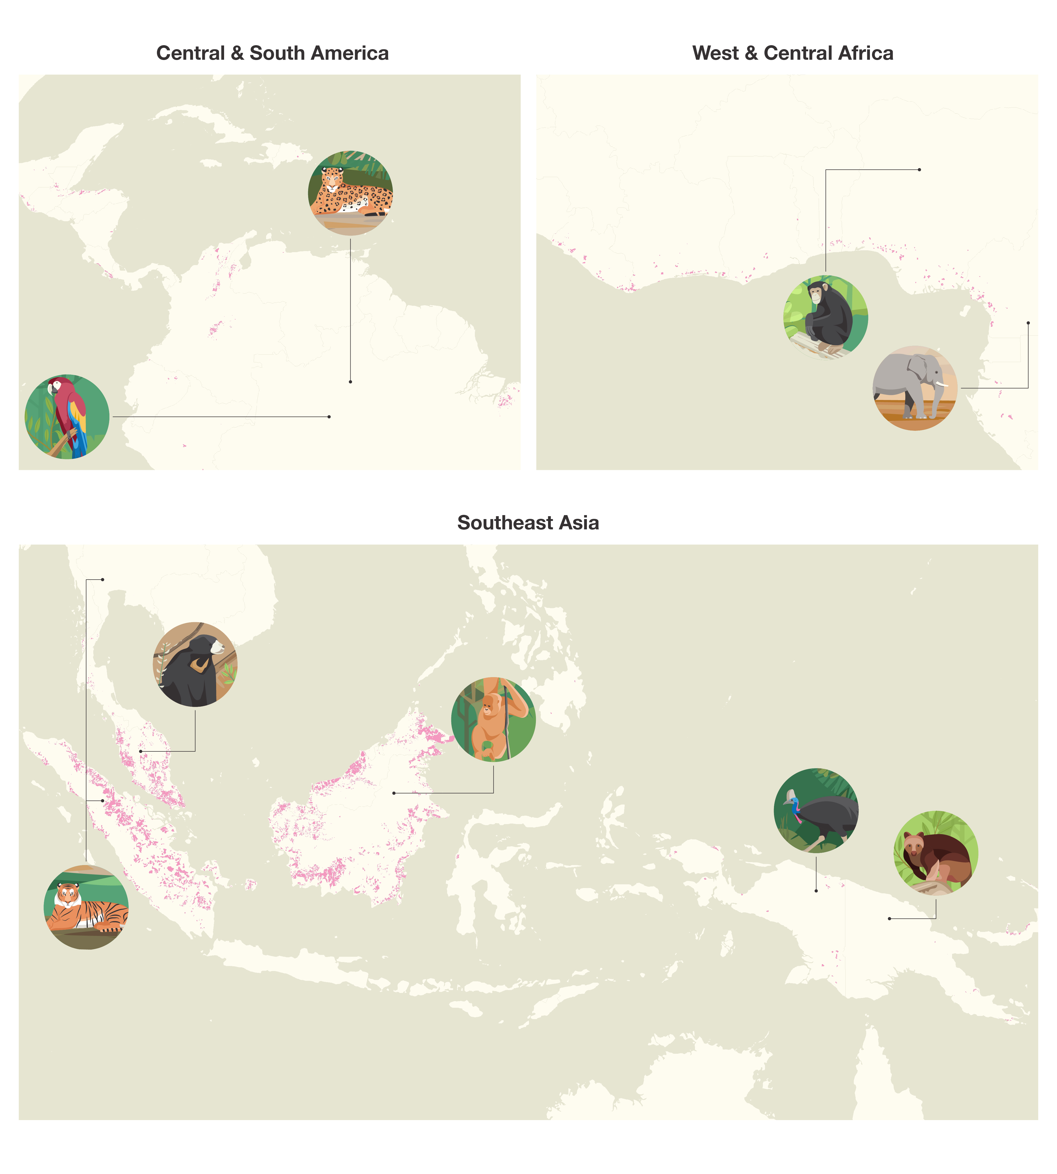

Figure 3. Oil palm’s role in deforestation. The figure on the left depicts the contribution of oil palm to overall deforestation, while the figure on the right shows the percentage of all oil palm expansion that cleared forest. Southeast Asia (SE Asia) excludes Indonesia and Malaysia, which are shown separately, while South America excludes Peru. Bars indicate the standard deviation of the sample mean weighted by study area.

Figure 4 - Species groups with more than 8 species with the terms "palm oil" or "oil palm" in the threats detailed text of the IUCN Red List of Threatened Species ²² assessments (Version 2019-1).

Table 1. Overview of the major vegetable oil crops and maize, typical production cycle, yields, main production countries, environmental impacts and biomes in which impact primarily occur, and the number of threatened species according to The IUCN Red List of Threatened Species ²² for which the specific crop is mentioned as threat (see Supporting Online Methods). Carbon emissions include carbon opportunity costs and production emissions ²³.
Oil crop | Type of crop | Oil yield (t ha-1) ^{24,25} | Main oil production countries | Main environmental impact | Kg CO2e/MJ human kcal ²³ | IUCN Red List species threatened by crop
Oil palm Elaeis guineensis | Perennial (25 years cycle) | 1.9–4.8 | Indonesia, Malaysia, Thailand | Mostly negative impact on tropical rainforest | 1.2 | 321
Soybean  Glycine max | Annual (~6 months cycle). Nitrogen fixer, rotated with other crops | 0.4–0.8 | China, USA, Brazil, Argentina | Mostly negative impact on subtropical grass savanna, temperate steppe, and broadleaf forest | 1.3 | 73
Rapeseed  Brassica napus and B. campestris | Annual (~6 months cycle). Rotated with other crops | 0.7–1.8 | China, Germany, Canada | Limited impacts in temperate steppe and broadleaf forest and taiga | 1.2 | 1
Cotton  Gossypium hirsutum | Annual (~6 months cycle). Rotated with other crops | 0.3–0.4 | China, India | Limited impacts in subtropical monsoon, dry and humid forest and temperate areas | 1.2 | 35
Groundnuts or peanuts  Arachis hypogaea | Annual (4-5 months crop cycle). Rotated with other crops | 0.5–0.8 | China, India | Limited impacts in subtropical monsoon, dry and humid forest and temperate areas | 1.5 | 6
Sunflower Helianthus annuus | Annual (3-4 months crop cycle). Rotated with other crops | 0.5–0.9 | Ukraine, Russia | Limited impacts in temperate steppe and broadleaf forest | 1.0 | 1
Coconut  Cocos nucifera | Perennial (30 – 50 y cycle) | 0.4–2.4 | Philippines, Indonesia, India | Mostly negative impact on tropical environments | n/a | 73
Maize  Zea mays | Annual (5-6 months crop cycle). Rotated with other crops | 0.1–0.2 | USA, China, | Limited impacts in temperate steppe and broadleaf forest | 0.7 | 131
Olive  Olea europaea | Perennial, long lived. Sometimes inter-cropped | 0.3–2.9 | Spain, Italy, Greece | Limited impacts in Mediterranean vegetation | n/a | 14

