Evaluating the Capabilities of Optical/TIR Imaging Sensing Systems for Quantifying Soil Water Content

G.P. Petropoulos^{1,2,3,*}, P.K. Srivastava⁴, K.P. Ferentinos⁵, D. Hristopoulos³

¹Department of Soil & Water Resources, Institute of Industrial & Forage Crops, Hellenic Agricultural Organization “Demeter”, (former “NAGREF”), 1, Theofrastou, 41335, Larissa, Greece
²Department of Geography and Earth Sciences, University of Aberystwyth, SY23 3DB, Wales, United Kingdom
³Department of Mineral Resources Engineering, Technical University of Crete, Crete, Greece;
⁴Institute of Environment and Sustainable Development, Banaras Hindu University, Varanasi, India
⁵Department of Agricultural Engineering, Institute of Soil & Water Resources, Hellenic Agricultural Organization “Demeter”, Athens, Greece

*. Correspondence to: petropoulos.george@gmail.com, Tel:+44 (0) 197201961

ABSTRACT

Surface Soil Moisture (SSM) is a key parameter of the global energy and water cycle and knowing its spatio-temporal variability is of key importance in an array of research topics and in several practical applications alike. Recent developments in Earth Observation (EO) have indicated that SSM can be retrieved from different regions of electromagnetic spectrum and numerous approaches have been proposed to facilitate this. Herein, are reviewed the SSM retrieval techniques exploiting optical and thermal EO data, including synergistic techniques with other types of EO datasets. The challenges and limitations of EO in this respect are also discussed, aiming in the end at providing a roadmap on which future research by the scientific community should be directed to provide more accurately estimates of SSM from space. A number of challenges still required to be addressed to allow deriving accurately SSM estimates using those specific types of EO data. It is also apparent that to satisfy the requirements for SSM information for many practical applications, efforts should be towards the investigation of the synergistic use of EO systems in deriving soil moisture for water resources applications.

Keywords: earth observation, remote sensing, soil moisture, satellite, optical, synergistic methods

1. INTRODUCTION
Soil moisture, the water contained in the Earth’s soil surface, can be broken up into surface soil moisture (SSM) content (defined as the water contained at the first 5 cm of the soil depth) and root zone soil moisture content (defined as the water content contained below 5 cm soil depth) (Figure 1). SSM is expressed as either a dimensionless ratio of two masses (gravimetric) or two volumes (volumetric), or as a ratio of a mass per unit volume. Accurate information on soil moisture is of key importance given its relevance to numerous physical processes occurring in the hydrosphere, atmosphere and biosphere (Seneviratne et al. 2010; Zhang et al. 2014; Srivastava, Han, et al. 2015).
Soil moisture is regarded as a very important parameter in the global energy and hydrological cycle as it controls the partitioning of available energy at the Earth’s surface (Patel et al. 2009; Piles et al. 2016). Accurate estimation of SSM is also required in surface and sub-surface water management for different applications such as irrigation scheduling for improving crop yield prediction (Brocca et al. 2012; Holzman et al. 2014). In addition, spatially information on the soil water status is of key value in hydrological studies; for example in determining the potential for runoff and erosion (Petropoulos, North, et al. 2015). In addition, through evapotranspiration, soil moisture provides a significant source of moisture for clouds and precipitation formation over land (Hassler and Schymanski 2016). Furthermore, measurements of SSM are also very valuable for studies related to ecological processes (García‐Baquero et al. 2016). Last but not least, SSM is a very important parameter in climatology, storing and later releasing heat (North et al. 2015).

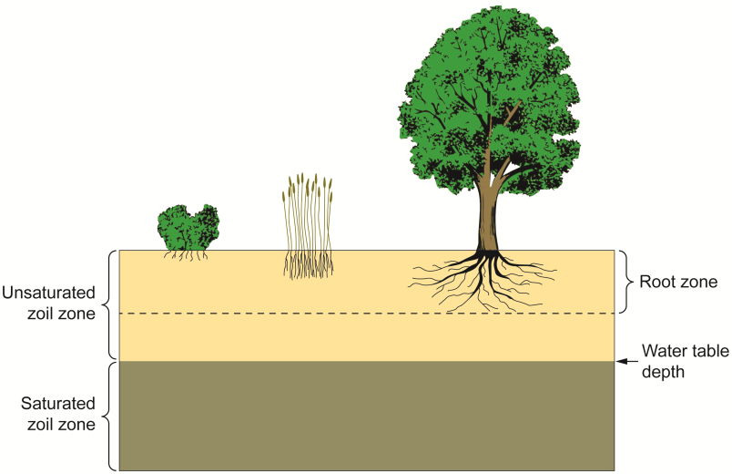
Figure 1. The soil zones (adopted from Petropoulos, Ireland, et al., 2015)

Ground measurements to infer SSM have certain advantages. Those provide a direct measurement, the instrument portability, the simple installation, operation and maintenance, the ability to provide measurement at a desired depth and also the relative maturity and stability of the methods. Nevertheless, those techniques are generally difficult to implement, especially over large areas. This is because deploying a network of in-situ sensors can be difficult, costly and labour-intensive. In addition, their use often requires the installation of extensive equipment in the field and this typically determines only localised estimates of SSM, which must be later aggregated for measuring the parameter over large spatial scales (Petropoulos and McCalmont 2017).
The advent of Earth Observation (EO) has led to a considerable amount of work being done towards the investigation of the utilisation of this technology for deriving spatio-temporal estimates of SSM (Srivastava et al. 2016). Many algorithms for soil moisture retrieval are in technical literature exploiting information from different remote sensing sensors. Nowadays, use of EO has generally been recognised as the only viable solution for obtaining estimates of SSM in a globally consistent and economically feasible manner and at the spatial and temporal scales and accuracy levels required by many applications (Cho and Choi 2014; Petropoulos et al. 2017).
This paper provides a synthesis of the efforts made towards the retrieval of SSM from EO data acquired from the optical and thermal infrared (TIR) parts of the electromagnetic radiation (EMR) spectrum, covering also synergistic approaches with microwave (MW) data. The paper is structured as follows: first the key advantages of EO technology for the estimation of SSM are outlined. Subsequently, an in-depth mapping of the state of the art in the EO-based estimation of SSM is provided underlining its advantages, limitations and future opportunities and challenges. After this, the main challenges in estimating SSM from the EO systems covered herein are discussed. The paper closes with a few suggestions on possible avenues on which future research could be directed to improve our ability to estimate SSM using such EO data.

2. EO TECHNOLOGY IN SSM ESTIMATION
EO is often the most cost-effective means of acquiring data, in contrast for example to ground-based instruments. Furthermore, remote sensing is particularly practical for areas in which man-made ground measurements are limited or unavailable. Besides, EO permits repeatedly monitoring parameters at a range of scales raging from local to even continental, allowing examination of the same area of study at multiple scales because of a number sensors available in the orbit. With remote sensing it is possible to assess the spatial variability of soil moisture, and if observations can be made repeatedly; it is also feasible to measure their temporal variability (Chen et al., 2014; Petropoulos, Ireland, et al. 2015; Bao et al., 2018).
Observations specifically from optical remote sensing systems acquiring information in the region of EMR spectrum between 0.4-0.7 µm, allow the derivation of information on the spatial distribution of a number of parameters characterising vegetation health, whilst thermal infrared observations allow detailing the land surface temperature structure which has a direct relationship to heat flux parameters. Particularly the exercise of TIR remote sensing data to infer regional and local scale SSM (acquired in the region between 3.0 to 14 µm) has been comprehensively studied during the past 3 decades and substantial progress has been made in this domain (Li et al. 2009; Petropoulos, Ireland, et al. 2015). On the other hand, microwave (MW) remote sensing (see Figure 2) – although is not covered herein extensively - offers some key advantages over other spectral remote sensing techniques in terms of SSM retrievals since in those wavelengths: 1) The atmosphere is effectively transparent and provide data in all weather conditions, 2) High capability in retrieving information of underlying surfaces beneath vegetative surface, 3) The MW measurement is very much dependent on the target dielectric properties which for bare soil is largely a function of the amount of water present, 4) Measurement is independent of solar illumination making both daytime and night observations.

3. OPTICAL & TIR REMOTE SENSING IN SSM RETRIEVALS
Recent advances in EO have shown that a number of techniques are available to facilitate SSM retrievals (e.g. Petropoulos, Ireland, et al. 2015; Zhang and Zhou 2016; Bao et al., 2018). Herein an overview of the EO techniques for SSM retrievals using optical, thermal as well as synergistic techniques is presented. A summary of the methods are provided below in Table 1 along with their advantages and disadvantages.

Table 1. Relative strengths and limitations of the different EO-based SSM retrieval approaches requiring data acquired ired in the regions of EMR covered in this paper (in agreement with Petropoulos, Ireland, et al. 2015 & Zhang and Zhou 2016)
METHODS | ADVANTAGES | DISADVANTAGES
Reflectance-based methods | Good spatial resolution, several satellites in orbit, hyperspectral sensors promising, mature technology | Weak relationship to SSM when increasing the vegetation cover, opaque during cloudy conditions and night time, poor temporal resolution
Thermal Infrared-based methods | Good spatial resolution, many satellites available, methods relating SSM to thermal inertia show promise | Weak relationship to SSM when increasing the vegetation cover, not applicable during cloudy conditions, poor temporal resolution, SSM retrievals sensitive to Earth's atmosphere
Optical & Thermal Infrared | High spatial resolution, wide range of satellite sensors to choose from, simple & straightforward implementation, based on mature technology | Algorithms are empirical and of site specific nature (transferability difficult), limited to cloud-free & daytime conditions, poor temporal resolution nadpenetration depth
MW & optical & TIR | Vegetation and surface roughness effects can be minimised | SSM scaling & validation issues, different SSM measurement depths

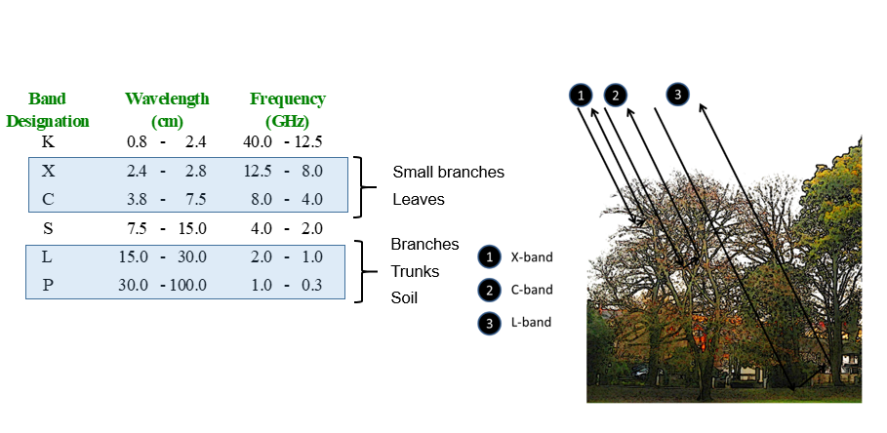
Figure 2. Left: The regions of the EMR spectrum in which MW data is acquired; Right: Vegetation influence on backscatter at three different wavelengths (adopted from Petropoulos, Ireland, et al. 2015)

3.1 Optical Sensing of Surface Soil Moisture
Use of optical remote sensing in SSM retrievals started mid of 1970's (Johannsen 1970). Herein, an overview of the available methods is provided, which, for consistency and efficiency purposes, has adopted the same methods’ categorisation proposed in the past (e.g., Zhang and Zhou 2016; Peng and Loew 2017). The available methods can be largely divided in two groups, i.e. the Single Spectral Analysis methods and (2) Vegetation Index Based methods.
In the Single spectral Analysis methods, Angstrom (1925) was the first who, using laboratory based measurements, demonstrated a decrease in reflectance as soil moisture increases. Jackson et al. (1976) in an early experimental study reported albedos of all dry soils to be two times higher than those of wet soils of the same soil types with exception being the sandy soils. Numerous other studies have proposed relationships linking soil surface reflectance to SSM. Various studies have also reported empirical relationships between single-channel reflectance and SSM (e.g. Stoner et al. 1980; Ishida et al. 1991). Such methods have generally showed reasonable results in terms of SSM prediction for specific soil samples and experimental site conditions. Bowers and Smith (1972) suggested a linear relationship between SSM and the water absorption band. In another study , Dalal and Henry (1986) proposed the retrievals of SSM by using the near infrared region. Nonetheless, as those are empirical approaches provide only a poor indication of SSM because are affected by the large variability in spectral characteristic of a soil which is affected by parameters such as organic carbon, soil texture and type, topography and surface roughness (Birchak et al, 1974; Wang and Chudhury 1981). The impact of these factors can lead to strong deviations when applied outside the local calibration conditions (Wang and Qu 2009).
Apart from empirical models, relationships between SSM and surface reflectance have been established using physically based models. For example, Lobell et al. (2002) proposed a physical model and showed an exponential relationship between soil reflectance and SSM on the basis of an analysis of four different soils at various moisture contents. Their model was expressed as:

(1)

Where R_{dry} is the dry soil reflectance, c is a variable used to characterise the change rate induced by SM, s refers to the soil saturation, and f to the saturation rate.
However, even if these empirically-based approaches have generally been proven adequate for estimating soil surface moisture under conditions close to those used for calibration, serious issues frequently emerge when they are applied outside these conditions as the spectral characteristic of soil is affected by various soil attributes (such as soil moisture, organic matter, soil type) that can vary significantly (Huan-Jun et al. 2009; Soriano-Disla et al. 2014). Additionally, since different spectral bands respond to variations of soil moisture in different ways, the quantification of SSM impacts on soil reflectance with different types of soils is a complex process using a single spectral analysis method alone. Last but not least, such techniques being statistical/empirical models are characterised by the lack of detail on describing the physical basis to quantitatively determine SSM.
One of the most widely used techniques is based on computing the relative reflectance that is then linked to surface soil moisture. This technique, using only one wavelength, aims to reduce the soil type effect by normalizing the reflectance by that observed under dry conditions over the same soil. A different approach exploits the change of reflectance sensitivity to moisture as a function of the wavelength for minimizing the effect of confounding factors, using derivatives of either reflectance or absorbance. Such methods reduce the effects of factors assuming that they are either constant or vary linearly with the wavelength over the limited spectral domain considered (Chen et al. 1992).
On the other hand, Vegetation Index methods, the underlying principle is to develop an empirical spectral vegetation index to estimate the degree of vegetation moisture stress, which can be used for indirect estimates of soil moisture. Examples of such techniques include the crop water stress index (Holzman et al. 2014; Martínez-Fernández et al. 2016) and the vegetation anomaly index (Petropoulos, Ireland, et al. 2015).
Given the high sensitivity of the vegetation index to water stress, some vegetation indices have been extensively used to detect and monitor drought conditions. Yet, interpretation of time analysis results from such indices should be cautiously interpreted, as changes depicted may be due to other factors (e.g., changes in vegetation types and ecosystem differences in an area). Among other researchers, Weidong et al. (2002) examined the changes in spectral reflectance of different soil types for variations of SSM ranging from very low to very high values, for diverse wavelengths and various soil types. This study reported that at low soil moisture levels, the reflectance is inversely proportional to the changes in moisture; however, after a critical point, soil reflectance show an increase with the changes in soil moisture.
An example of a widely used vegetation index linked to estimating SSM is the so-called normalized difference water index (NDWI), proposed by Gao et al. (1996). NDWI exploits spectral information acquired in the region of 1.24 µm because this part of the electromagnetic spectrum is sensitive to SSM content and also this index is insensitive to the atmospheric conditions. The NDWI is defined as:

(2)
where ρ is the reflectance.
Wang et al. (2008) suggested using the normalized multi-band drought index (NMDI), this essentially being a modified version of the NDWI offering an improved sensitivity to drought monitoring. NMDI uses spectral differences between the 1.64 µm and 2.13 µm for soil and vegetation, respectively, computed as follows:
(3)
Recent studies have focused on exploring the use of hyperspectral sensors in SSM retrieval. The hyperspectral data has generally shown promising results in SSM retrievals (e.g. Demattê et al. 2006; Heusinkueld et al. 2008). However, its usefulness needs to be further explored. Overall though, it is generally accepted that even to date, techniques utilising reflected spectral information from only the reflective part of electromagnetic radiation are not capable of accurately measuring SSM. This is because there are too many noise factors (e.g., organic matter, roughness, texture, plant cover), which eventually make the exploitation of such techniques impractical and non-viable (Moran et al. 2004).
In summary, despite the large number of optical EO systems currently in orbit, a limited body of literature exists on the exploitation of VIS, NIR, SWIR and/or hyperspectral remote sensing observations on the retrieval of SSM. This is due partly to the fact that optical EO measures the reflectance or emittance from only the top millimetre(s) of the surface. Besides, soil reflectance measurements are strongly affected by the soil composition, physical structure, and observation conditions. Because of these limitations, efforts to directly relate soil reflectance to moisture have achieved success only when models are fitted to specific soil types in the absence of vegetation cover (e.g., Muller and Décamps 2000). Nevertheless, one of the key advantages of reflectance-based methods is that those are based on a mature technology. Last but not least, the ability of satellite EO systems that operate in this part of electromagnetic radiation spectrum to provide estimates of SSM at high spatiotemporal resolutions, in comparison to other types of sensors such as microwave instruments, is an important advantage that cannot be underestimated.

3.2 Thermal infrared methods for SSM retrievals
SSM estimation using TIR observations is primarily based on the thermal properties of soil and water availability in the soil (Campbell and Norman 1988). These methods use thermal inertia, a parameter describing the ability of soil to resist to temperature change. The thermal inertia method is in common use for soil moisture content estimation from TIR observations (e.g., Cheng et al. 2006).
Generally, thermal inertia estimation requires information on the soil heat capacity and on soil thermal conductivity and can be computed as follows:

(4)

where λ is the soil thermal conductivity, ρ is the soil bulk density, and C is the soil heat capacity. An increase in SM results to an increase of the thermal inertia reducing the diurnal amplitude variations of the land surface temperature.
Surface temperature is primarily dependent upon the thermal inertia of the soil, while the latter is dependent upon both the thermal conductivity and the heat capacity of the soil water content (Olsen et al. 2013). Consequently, a measurement of the amplitude of the diurnal temperature change allows develop a relationship between the temperature change and soil moisture. A number of studies have been proposed for this purpose. For example, Ma and Xue (1990) proposed the following relationship between thermal inertia and soil moisture:

$$P={\left\{\left(2.1{ds}^{\left[1.2−0.02\left({ds}/d\right)w\right]}e^{\left[−0.007{\left(w\left({ds}/d\right)−20\right)}^{2}\right]}\right)+ds\left[0.8+0.02\left({ds}/d\right)w\right]\right\}}^{1/2}∙\left({0.2w}/d\right)d{s^{2}}/{0.01}$$
(5)

where ds is the soil density, d is the water density, and w is the weight percentage of soil moisture.
However, the association between diurnal temperature and soil moisture is dependent on soil type and is limited to bare soil conditions to a large degree (van de Griend et al. 1985). Therefore, it cannot be applied for large-scale soil moisture monitoring. In this regards, the other approaches for SSM retrievals from TIR observations is based on thermal bands in conjunction with vegetation indices derived from visible and NIR wavebands. In this context, various mainly empirical methods for mapping soil moisture over a given area were suggested based on correlations of SSM with radiometric satellite measurements in both visible and thermal bands (Price 1980; Friedl and Davis 1994). However, such methods are accompanied by all the limitations of empirically-derived methodologies discussed earlier as well (e.g., lack of transferability to other regions, fine-tuning, weakness to describe physical processes, etc). On the other hand, these approaches can provide estimates of SSM at high spatial resolution using mature technology in terms of sensor technology.

3.3 Synergistic methods for SSM retrievals
During the last three decades, a series of studies have focused in exploring the synergistic use of remote sensing observations acquired simultaneously in the optical (visible and near infrared, VNIR), TIR and MW parts of the electromagnetic spectrum in SSM retrievals. Those approaches aim to address the complementarity (independent information) and interchangeability (similar information) between EO data types for this purpose. The development of synergistic approaches is to address and resolve the difficulties encountered in discriminating the vegetation effect for soil moisture retrieval (Barrett et al. 2009). Most data fusion or synthesis studies in the past have dealt with synergies between (1) optical and thermal observations, (2) MW and optical/thermal observations, and (3) the synergy between active (SAR) and passive (radiometer) microwave remote sensing (with the last one not being covered herein). An overview of the first two types of those synergistic approaches is provided in the following sections.

3.3.1 Methods based on the synergies between Optical and TIR data
Since the early 1980’s, several studies have documented the presence of a triangular (or trapezoidal) shape when remotely sensed surface temperature (Ts) and vegetation index (VI) measures taken from heterogeneous areas are plotted in two-dimensional feature space, forming a Ts/VI scatterplot (e.g. Price 1990; Petropoulos et al. 2009). Many such studies have focused on analysing of biophysical properties encapsulated in the Ts/VI pixel envelope, and in associating these and the estimation of SSM as well as of other parameters that characterize land surface interactions. Petropoulos et al. (2009) reviewed the progress made on the topic since then, and the reader is referred to that work for a more detailed review.
In brief, if an image is cloud free and masked for water bodies , per pixel-level values of Ts and VI collected from any satellite imagery usually form a triangular (or trapezoidal) shape in the Ts/VI feature space, as shown in Figure 3:

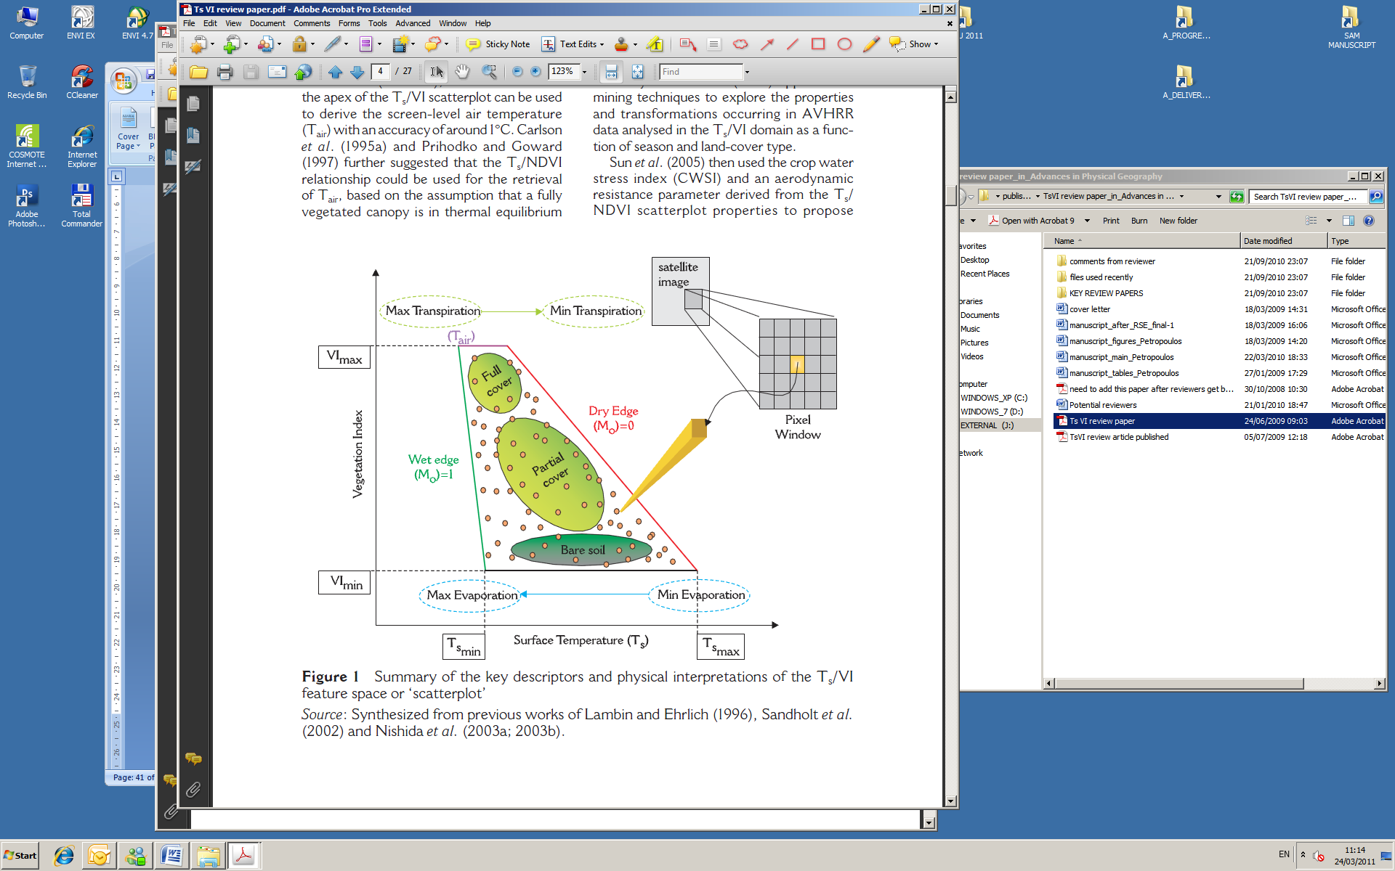
Figure 3. Key descriptors and physical interpretations of the Ts/VI feature space “scatterplot” (adopted from Petropoulos et al. 2009)

Each yellow circle represents the measurements for single pixel. Figure 3 showed the Ts/VI pixel envelope captured by each satellite scene. The triangular (or trapezoid) feature space is formed by the variability of Ts and its relation to vegetation with soil water content variations. The right-hand side border of the triangle (or trapezoid) (the so-called “dry edge” or “warm edge”) shown in Figure 3 is defined by the locus of points of highest temperature. This locus, however, contains points with differing amounts of bare soil and vegetation and is represents limited SSM. Likewise, the wet edge at left hand border (corresponds to low temperature pixels with maximum surface soil water content. Points within the triangular space correspond to pixels with varying vegetation index (i.e. fractional vegetation cover, F_{r}) and surface soil water content, between those with bare soil and those with dense vegetation. The relatively narrow vertex of the triangular envelope expresses the comparatively less sensitivity of leaf (i.e. vegetation) temperature to changes in soil water content, whilst the much wider base indicates that surface soil temperature is much more influenced by such changes. The potential of relating SSM with a VI and Ts has been thoroughly scrutinized since the early 1980’s. Carlson et al. (1981) were the first who found the existence of a marked relation in a Ts/VI scatterplot between soil moisture, evapotranspiration and vegetation cover.
The potential of relating soil surface moisture content with a spectral vegetation index (VI) and surface radiant temperature (Ts) has been thoroughly scrutinized since the early 1980’s. Carlson et al. (1986) were the first to find the existence of a marked relation in a Ts/VI scatterplot between soil moisture, evapotranspiration and vegetation cover. Recently, several studies have explored the possibility of linking the satellite-derived Ts/VI feature space directly to SSM, or to indirectly link the physical properties of this feature space to environmental variables, mainly drought conditions. Sandholt et al. (2002) were the first to propose linking the T_{s}/VI scatterplot with an index, which they termed the Temperature-Vegetation-Dryness-Index (TVDI) for deriving direct estimates of SSM. Validation of their methodology indicated spatially similar patterns in the distributed estimates of soil moisture (R² = 0.70). Perhaps, one of the key characteristics of this method is its independence from ancillary data used to define the limits of the T_{s}/NDVI space, which could lead to a broad scope of its application, potentially operationalisation. Nonetheless, the requirement of a full range of variability in land surface conditions within the scatterplot rendered the method inapplicable to uniform homogeneous regions.
Patel et al. (2009) explored the use of the Sandholt et al. (2002) method to map SSM in a region in India. Authors parameterized the TVDI method using 8-day composites of NDVI and land surface temperature products acquired from the MODIS sensor. TVDI-derived soil moisture maps were compared against in-situ estimates acquired concurrently to the satellite overpass. The authors found a high correlation between the Ts and NDVI parameters (R² = 0.8). Furthermore, their comparisons revealed a high correlation between the TVDI and in-situ soil moisture at different depths (0–15 cm, 15–30 cm and 30–45 cm). Correlations between the compared parameters were found higher during the period of sparse canopy cover (lower NDVI) during the spring season (R²=0.49-0.62). Results were attributed to the reduced sensitivity of the TVDI to soil moisture under high vegetation cover (i.e. more than the MODIS NDVI).
Various studies have been conducted attempting to relate the satellite-derived Ts/VI feature space to drought conditions, and thus indirectly to SSM distribution. A large number of those studies have their basis on the estimation of spectral indices allowing to combine information from both the reflected and TIR parts of electromagnetic radiation. For example, Wan et al. (2004) suggested the Vegetation Temperature Condition Index (VTCI) for retrieving information on the spatial variation in drought condition. The authors suggested that the VTCI isolines can be drawn in the NDVI versus T_{s} scatterplot with the upper limit of the triangle representing the NDVI maximum and the lower limit representing Ts at maximum NDVI. Ghulam et al. (2007) developed a new drought monitoring method, the perpendicular drought index (PDI) using reflectance of near infrared (NIR) and red (Red) bands of the ETM+ image.
A different group of approaches to the estimation of surface soil moisture content from T_{s}/VI feature space measures has been based on the coupling of these data with a Soil Vegetation Atmosphere Transfer (SVAT) model. In this method, the estimated soil water content is obtained from a parameter called the ‘moisture availability (M_{o})’, a parameter loosely equated with the fraction of field capacity for the SSM, the latter being typically about 0.34 by volume. In the beginning of 1990’s, Carlson et al. proposed a method that provided estimates of surface energy fluxes and SSM over partially vegetated canopies with the help of a boundary layer model (BML) and two image products: the Ts/NDVI scatterplot and the “arch” diagram (Coakley and Bretherton 1982). The two diagrams were used to identify the asymptotic limits of the sunlit leaf and the sunlit bare soil temperature and also to qualitatively assess the level of noise produced by small variations in soil moisture and leaf shading. The SVAT was used to estimate soil surface and root zone water contents, given the asymptotic vegetation and bare soil temperatures, derived from the aforementioned diagrams. Based on Carlson et al. (1990), Gillies and Carlson (1995) introduced a new method for the retrieval of spatially distributed maps of M_{o}. The outputs from a SVAT model were coupled with the T_{s} and VI (here the F_{r} was used as the latter is a physical quantity in terms of a SVAT model contrary to the NDVI) EO data via empirically-derived correlations developed between the relevant input (e.g. F_{r}, M_{o}) and output (e.g. LE, T_{s}) parameters of the physically-derived model, parameterised for the time of satellite overpass. These correlations were then used with the EO values of, for example F_{r} and T_{s}, to retrieve M_{o} at each image pixel as follows:

$Μ_{o}=\sum_{i=0}^{n}{\sum_{j=0}^{n}{{{}_{}^{}F}_{r}^{\left(i\right)}{{}_{}^{}{LST}}^{\left(j\right)}}}$ (6)

where *F_{r} and *LST can be obtained by using the following relations (7 and 8):

(7)
$\text{LST}=\left(\text{LST}−{\text{LST}}_{0}\right)/\left({\text{LST}}_{s}−{\text{LST}}_{0}\right)$ (8)

where, LST and NDVI are observed surface temperature and the Normalised Difference Vegetation Index used in the triangle model respectively, and the subscripts o and s stand for bare soil and dense vegetation respectively.
This method’s accuracy in retrieving Mo was evaluated by different investigators suggesting a promising ability of this technique (e.g., see studies by Capehart and Carlson 1997; Gillies et al. 1997; Carlson 2007; Wang et al. 2007; Petropoulos and Carlson 2011; Petropoulos et al. 2016 – see Figure 4).
All in all, the key advantages of the methods that utilise the synergy between optical and TIR EO data help in development of SSM algorithms and provide missing data in real time (namely a vegetation index and surface temperature). In addition, these techniques incorporate all the advantages of both the optical and TIR methods previously reviewed (i.e., they provide fine spatial and temporal resolution for SSM estimation, and they employ the use of mature technology with broad knowledge, data easily accessible from operational satellites, long historical data). Also, many of these techniques are able to provide relative satisfactory estimates of SSM over partially or fully-vegetated regions, conditions which limit the performance of other techniques for estimating soil moisture (e.g., when MW data is used, as it will be discussed next). Other key advantages of the T_{s}/VI methods with respect to SSM estimation generally include their ability to be largely independent of ancillary surface and atmospheric information and their ability to better deal with land surface heterogeneity. In addition, many of the aforementioned synergistic methods require for their practical implementation a full spatial coverage or at least very wide range of both VI and surface moisture within the study region, a condition that in general cannot be satisfied over large homogeneous areas. In our view these are some of the main reasons that justify the continuous interest of the scientific community in these methods to date.

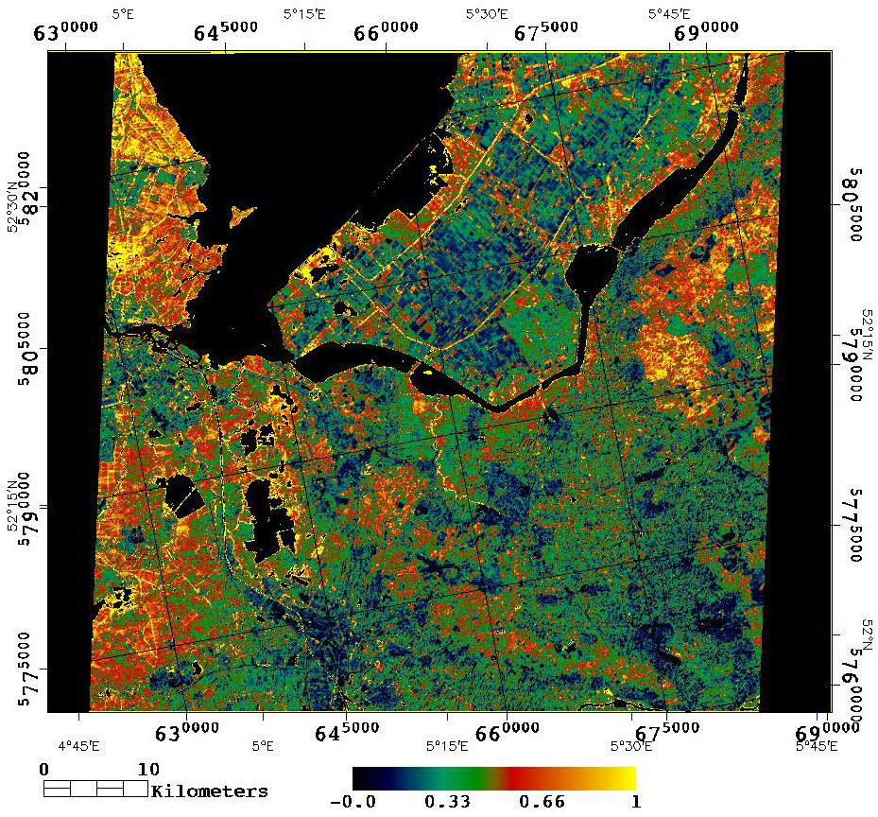

Figure 4. The “triangle”-inverted map of instantaneous (Mo) derived from the “triangle” method of Gillies et al. (1997) using ASTER imagery shown here for March 30th, 2004 for The Netherlands (adopted from Petropoulos et al. 2016)

3.3.2 Methods based on the Synergy between Optical, TIR & Microwave Data
A number of researchers have explored the relative advantages of microwave as well as optical/IR remote sensing approaches for a more accurate estimation of SSM. Researchers in this area utilises both the active and passive EO data in combination with optical/TIR data. This allows the minimisation of the vegetation biomass and surface roughness effects for SSM retrieval (Bao et al. 2007; Bao et al. 2014). However, in this method one major issue to tackle is that of data scaling and validation of the derived SSM estimates (Moran et al. 2004).
A number of studies have explored the synergy of microwave and optical/TIR data for SSM content retrieval. For example, Yang et al. (2006) developed a technique to estimate the change in the surface soil moisture using C band Radarsat ScanSAR mode data and optical data (Landsat TM and AVHRR). The optical data were used in their method in order to reduce the effects of vegetation cover to the radar backscatter that was later used for inferring the soil surface moisture. Authors validated their proposed scheme by comparing their predictions of soil moisture content with corresponding estimates derived from the Southern Great Plain Soil Moisture Experiment in 1997 (SGP97). Authors reported a good agreement with the ground soil moisture measurements in terms of ratio, with a Root Mean Square Error (RMSE) of 1.14.
Kuruku et al. (2009) proposed a pixel-based image fusion technique by using Radarsat-1 Fine Beam mode SAR image with SPOT-2 imagery for determining soil moisture. Hence the fused image gave a better result regarding the water/moisture content of the planted fields. The authors demonstrated their proposed method for a partially vegetated region in Turkey for which gravimetric soil moisture estimates were available at a time concurrently to the satellites overpass times. In another work, Temimi et al. (2010) suggested a technique for deriving SSM based on the synergy of passive MW data from AMSR-E instrument, data in the visible wavelengths from MODIS sensor and topographic attributes derived from the SRTM Digital Elevation Model. They applied their proposed scheme for mapping the spatial and temporal evolution of soil wetness in the Peace Athabasca Delta, PAD, located in the Mackenzie River Basin in Canada. In that study, AMSR-E at frequency 37 GHz data and discharge observations were used for development of basin wetness index (BWI), which can be used for assessment of flooded areas with correlation coefficients of ~0.7 (between the disaggregated wetness index and the observed precipitations). More specifically, Chauhan et al. (2003) revisited and developed a variation of the Ts/VI “triangle” method of Gillies et al. (1997) for high-resolution (1 km) SSM estimation for operational applications through National Polar-orbiting Operational Environmental Satellite System (NPOESS). The SSM estimated by the method was found in good agreement with an RMSD of the order of 5% in SSM estimation. More recently, Piles et al. (2014, 2016) proposed a variant of the “triangle” technique or downscaling the operational SSM estimates provided by the SMOS passive MW sensor using either polar orbiting (MODIS) or geostationary orbit (SEVIRI) data synergistically with the passive MW data acquired from the SMOS radiometer (e.g., see in Figure 5 an example of SMOS downscaled maps from the Piles et al. (2016) methodology). The Piles et al. (2016) methodology enabled: (1) enhancement of the spatial resolution of the SMOS SSM estimates to 3 km spatial resolution, and, (2) temporal extrapolation of the instantaneous fine-scale downscaled SSM estimates acquired every 15 minutes from SMOS between 6 a.m. to 6 p.m. to a “daytime SSM” estimate. This study was a key advocate of the synergy of SMOS and SEVIRI provides a pathway to enhance SSM retrievals accuracy taking full advantage of the new observational records of SSM and operational geostationary information.
At L-band, one popular model for soil moisture retrieval is τ–ω model, based on the two parameters i.e. the vegetation optical depth τ and the vegetation scattering albedo ω. Both the parameters are used to simulate vegetation attenuation properties and the scattering effects within the vegetation layer. The low vegetation τ − ω model can be expressed as:

${\text{TB}}_{P}=(1−ω_{p})(1−γ_{p})(1+γ_{p}r_{\text{gp}})T_{c}+(1−r_{\text{gp}})γ_{p}T_{g}$ (9)

where$T_{g}$ and $T_{c}$ are the effective soil and vegetation temperatures,$r_{\text{gp}}$ is the soil reflectivity, $ω_{p}$ the single scattering albedo,$γ_{p}$ the vegetation attenuation factor. The last term can be computed from the optical depth $τ_{p}$ as:
$γ_{p}=\text{exp}(−τ_{p}\text{/cos}θ)$ (10)

To model the optical depth$τ_{p}$, several studies found that $τ_{p}$ = b_{p}∙VWC, where VWC is vegetation water content. The VWC can be estimated from LAI following the approach developed by (Wigneron et al. 2007). An analysis made over agricultural crops from Institut National de la Recherche Agronomique (INRA) data sets showed that the VWC / LAI ratio is about 0.5 kg/m² when the vegetation is well-developed.

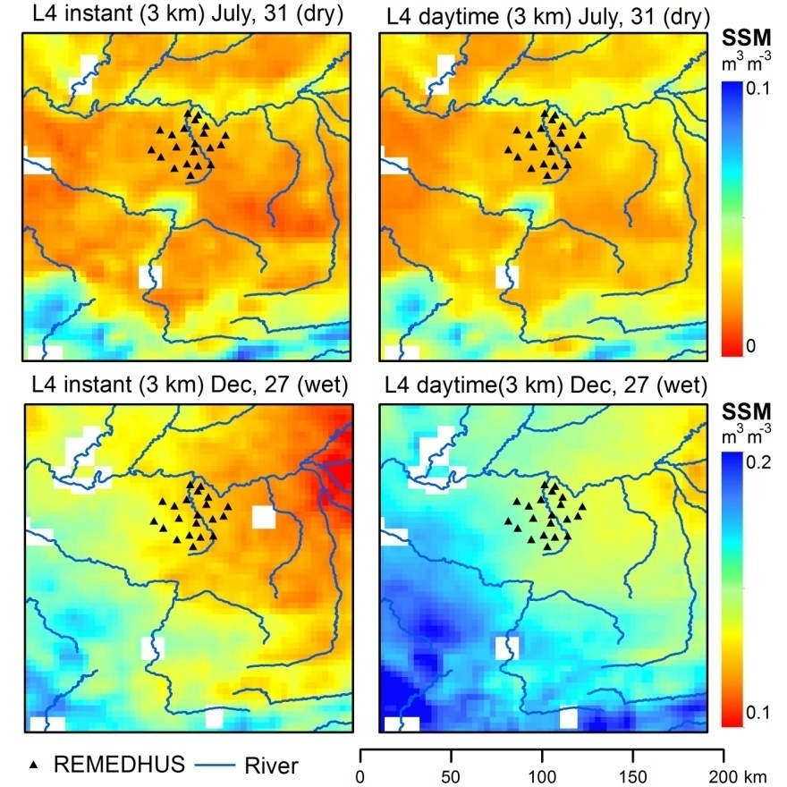

Figure 5. SSM distribution over the REMEDHUS network for the SMOS/SEVIRI L4 Instantaneous (left) and the SMOS/SEVIRI L4 Daytime Average (right) obtained for a dry day on July 31st 2011 (top) and a wet day on December 27th 2011 (bottom). Blue lines are rivers; black triangles denote REMEDHUS stations (adopted from Piles et al. 2016).

4. CHALLENGES & FUTURE OUTLOOK
From the review conducted, it is evident that at present, observation and prediction of SSM is performed by means of quite diverse and disconnected approaches.
Although there are number of EO sensors are in orbit with promising accuracy results (reported by different techniques) for SSM retrieval from space, still there are number challenges exist for an improved estimates of SSM. Perhaps the key challenge is that the spatial and/or temporal support volumes do not sufficiently represent the spatio-temporal dynamics/variations and uncertainties of SSM at small scales. In operational applications, sub-daily information of SSM is needed to initialise and update forecast, storm water management, flood or hydrological models. Therefore, the development of synergistic approaches by using the EO data would provide SSM information at the requisite spatio-temporal scale for the monitoring of hydrological processes and applications.
Given the above, it is clear that in order meet the high spatial and temporal resolutions SSM information for watershed management it is necessary to direct efforts towards the exploitation of the synergistic use of remote sensing systems in deriving more accurately estimates of surface heat fluxes and surface SSM from space. Therefore, the current availability of multiple satellite observations demands further investigation with respect to their potential synergies for development of new or improved SSM operational products and algorithms. This is an area of key priority of investigation at present, and the outcome of this research remains to be seen.
Several challenges exist for researchers to use satellite soil moisture for water resources applications. In visible/IR or microwave remote sensing of soil moisture, one major problem is the shallow penetration depth, which cause an incomplete information of soil moisture profile. Furthermore, during cloudy conditions the soil moisture retrieval from visible/IR satellite products becomes impossible. Microwave has some advantage over visible/IR, as it provides datasets in all weather conditions (Srivastava, O’Neill, et al. 2015). However, there is possibility of Radio Frequency Interference (RFI) contamination in the signals (Islam et al. 2015). In addition to the shallow penetration depth that limits remote sensing estimates of soil moisture, another problem is pixel heterogeneity, which can have significant impact in conditions of varying land use (Kerr et al. 2016). Another important problem in satellite soil moisture retrieval is the vegetation, which is not totally transparent in satellite remote sensing and hence causes uncertainty in soil moisture retrieval (Petropoulos, Ireland, et al. 2015). Besides the problem of vertical profile resolution due to penetration depth limitations, other important problems involve the spatial and temporal resolutions of the retrieved soil moisture (Srivastava et al. 2013). As soil moisture is highly variable both spatially and temporally, hourly records are needed in many applications such as irrigation water management, flood, drought and discharge prediction, which is currently not possible from any of the satellite in orbit.
There are several other challenges with respect to the uses of datasets and format in which the dataset are provided. Providing the dataset in easily accessible format may give users to utilize the data in an easier way (for e.g. geotiff, hdf etc). Further refining of soil moisture retrieval algorithms in terms of correct representation of roughness factors and vegetation scattering albedo are needed to provide better soil moisture estimates especially over forest. Further broad classes of land use/land cover are generally used in the soil moisture retrieval algorithms, systematic generation of high resolution land use/land cover with fine categories may provide a better soil moisture with high accuracy. Similarly with soil type also, incorporation of fine scale soil texture data in SSM retrieval algorithms can enhance the products for different applications. The shallow depths sampled by satellites are not ideal for many applications which require root-zone SM estimates. Hence, further work is needed to investigate the relationship between root-zone and SSM (Srivastava et al., 2016).

Acknowledgments
This work was supported by the UK Science and Technology Facilities Council (award STFC ST/N006836/1) and authors are grateful for the financial support provided. George Petropoulos’s participation was also supported by the Horizon 2020 Marie Curie Project ENViSIoN-EO (contract ID: 752094). GP wishes to also thank Dr J. G. Evans (CEH, UK) for the written feedback and edits provided in the initially submitted manuscript. All authors wish to thank the anonymous reviewers for their comments that resulted to improving the manuscript.

Conflict of Interest
Conflict of Interest – None.

REFERENCES
Angstrom A. 1925. The albedo of various surfaces of ground. Geografiska Annali. 7:323–327.
Bao Y, Liu L, Wang J. 2007. Soil moisture estimation based on optical and microwave remote sensing data. J Beijing Normal Univ. 43(3):228–233.
Bao Y, Zhang Y, Wang J, Min J. 2014. Surface soil moisture estimation over dense crop using Envisat ASAR and Landsat TM imagery: an approach, Int J Rem Sens. 35(16):6190–6212.
Bao, Y., L. Lin, S. Wu, K.A.K. Deng & G.P. Petropoulos (2018): Surface Soil Moisture Retrievals Over Partially Vegetated Areas From the Synergy of Sentinel-1 & Landsat 8 Data Using a Modified Water-Cloud Model. International Journal of Applied earth Observation & Geoinformation, 72, 76-85, /doi.org/10.1016/j.jag.2018.05.026.
Barrett BW, Dwyer E, Whelan P. 2009 Soil moisture retrieval from active spaceborne microwave observations: an evaluation of current techniques. Rem Sens. 1:210–242.
Birchak J, Gardner C, Hipp J, Victor J. 1974. High dielectric constant microwave probes for sensing soil moisture. Proc IEEE. 62(1):93–98.
Bowers S, Smith S. 1972. Spectrophotometric determination of soil water content. Soil Sc Soc Am J. 36(6):978–980.
Brocca L, Tullo T, Melone F, Moramarco T, Morbidelli R. 2012. Catchment scale soil moisture spatial–temporal variability. J Hydr. 422:63–75.
Campbell GS, Norman JM. 1988. Introduction to Environmental Biophysics. USA: Springer.
Capehart WJ, Carlson, TN. 1997. Decoupling of surface and near-surface soil water content: a remote sensing perspective. Water Resour Res. 33(6):1383–1395.
Carlson TN. 1986. Regional‐scale estimates of surface moisture availability and thermal inertia using remote thermal measurements. Rem Sens Rev. 1(2):197–247.
Carlson TN. 2007. An overview of the “triangle method” for estimating surface evapotranspiration and soil moisture from satellite imagery. Sensors. 7:1612–1629.
Carlson TN, Dodd JK, Benjamin SG, Cooper JN. 1981. Satellite estimation of the surface energy balance, moisture availability and thermal inertia, J Appl Meteorol. 20:6–87.
Carlson TN, Perry EM, Schmugge TJ. 1990. Remote estimation of soil moisture availability and fractional vegetation cover for agricultural fields. Agric For Meteor. 52:45–69.
Carlson TN, Capehart WJ, Gilies, RR. 1995. A new look at the simplified method for remote sensing of daily evapotranspiration, Rem Sens Envir 54:161–167.
Chauhan NS. 1997. Soil moisture estimation under a vegetation cover: combined active and passive microwave remote sensing approach. Int J Rem Sens. 18(5):1079–1097.
Chauhan NS, Miller S, Ardanuy P. 2003. Spaceborne soil moisture estimation at high resolution: a microwave-optical/IR synergistic approach. Int J Rem Sens. 24(22):4599–4622.
Chen T, De Jeu R, Liu YY, Van der Werf GR, Dolman AJ. 2014. Using satellite based soil moisture to quantify the water driven variability in NDVI: A case study over mainland Australia. Rem Sens Environ. 140:330–338.
Chen Z, Curran PJ, Hansom JD. 1992. Derivative reflectance spectroscopy to estimate suspended sediment concentration. Rem Sens Environ. 40:67–77.
Cheng Y, Chen LF, Liu QH, Zhang H, Gu XF. 2006. The soil moisture detection for different vegetation coverage based on the MODIS data. J Rem Sens China. 10(5):783–788.
Cho E, Choi M. 2014. Regional scale spatio-temporal variability of soil moisture and its relationship with meteorological factors over the Korean peninsula. J Hydr. 516:317–329.
Coakley JA, Bretherton FP. 1982. Cloud cover from high-resolution scanner data: detecting and allowing for partially fields of view. J Geophys Res. 87 4917–4932.
Demattê JAM, Sousa AA, Alves MC, Nanni MR, Fiorio PR, Campos RC. 2006. Determining soil water status and other soil characteristics by spectral proximal sensing. Geoderma. 135:179–95.
Friedl MA, Davis FW. 1994. Sources of variation in radiometric surface temperature over a tallgrass prairie. Rem Sens Environ. 48:1–17.
García‐Baquero G, Silvertown J, Gowing DJ, Valle CJ. 2016. Dissecting the hydrological niche: soil moisture, space and lifespan. J Veg Sc. 27(2):219–226.
Ghulam A, Qin Q, Zhan Z. 2007. Designing of the perpendicular drought index. Environ Geology. 52(6):1045–1052
Gillies RR, Carlson, TN. 1995. Thermal remote sensing of surface soil water content with partial vegetation cover for incorporation into climate models. J Appl Meteorol. 34:745–756.
Gillies RR, Carlson TN, Cui J, Kustas WP, Humes KS. 1997. Verification of the “triangle” method for obtaining surface soil water content and energy fluxes from remote measurements of the Normalized Difference Vegetation Index NDVI and surface radiant temperature. Int J Rem. Sens. 18:3145–3166.
Hassler SK, Schymanski SJ. 2016. Dominant controls of transpiration along a hillslope transect inferred from ecohydrological measurements and thermodynamic limits. Hydr Earth Syst Sci. 20(5):2063.
Heusinkueld BG, Berkowicz SM, Jacobs AFG, Hillen W, Holtslaq AAM. 2008. A new remote optical wetness sensor and its applications. Agr Forest Met. 148:580–91.
Holzman ME, Rivas R, Piccolo MC. 2014. Estimating soil moisture and the relationship with crop yield using surface temperature and vegetation index. Int J Appl Earth Obs Geoinf. 28:181–192.
Huan-Jun L, Yuan-Zhi Z, Xin-Le Z, Bai Z, Kai-Shan S, Zong-Ming W, Na T. 2009. Quantiative analysis of smoisture effect on black soil reflectance. Pedosphere. 19(4):532–540.
Ishida T, Ando H, Fukuhara M. 1991. Estimation of complex refractive index of soil particles and its dependence on soil chemical properties. Rem Sens Environ. 38:173–182.
Islam T, Srivastava PK, Dai Q, Gupta M, Zhuo L. 2015. An introduction to factor analysis for radio frequency interference detection on satellite observations. Meteor Appl. 22(3):436–443.
Jackson RD, Idso SB, Reginato RJ. 1976. Calculation of evaporation rates during the transition from energy-limiting to soil-limiting phases using Albedo data. Water Resour Res. 12:23–26.
Johannsen CJ. 1970. The detection of available soil moisture by remote sensing techniques.
Kerr YH, Wigneron JP, Al Bitar A, Mialon A, Srivastava PK. 2016. Soil Moisture from Space: Techniques and Limitations Satellite Soil Moisture Retrieval. In: Satellite Soil Moisture Retrieval. Elsevier; p. 3–27.
Kuruku Y, Sanli FB, Esetlili MT, Bolca M, Goksel C. 2009. Contribution of SAR images to determination of surafce moisture on the Menemen Plain, Turkey. J Rem Sens. 30(7):1805–1817.
Li Z-L, Tang R, Wan Z, Bi Y, Zou C, Tang B, Yan G, Zhang X. 2009. A review of current emthodologies for regional evapotranspiration estimation from remotely sensed data. Sensors. 9:3801–3852.
Lobell DB, Asner GP. 2002. Moisture effects on soil reflectance. Soil Sci Soc Am J. 66:722–727.
Ma AN, Xue Y. 1990. A study of remote sensing information model of soil moisture. In: Proceedings of the 11th Asian Conference on Remote Sensing; Nov; Beijing, China: International Academic Publishers. p. 15–21.
Martínez-Fernández J, González-Zamora A, Sánchez N, Gumuzzio A, Herrero-Jiménez CM. 2016. Satellite soil moisture for agricultural drought monitoring: Assessment of the SMOS derived Soil Water Deficit Index. Rem Sens Environ. 177:277–286.
Moran MS, Peters-Lidard CD, Watts JM, McElroy S. 2004. Estimating soil moisture at the watershed scale with satellite-based radar and land surface models. Can J Rem Sens. 30(5):805–824.
Muller E, Décamps H. 2000. Modeling soil moisture-reflectance. Rem Sens Environ. 76:173–180.
North MR, Petropoulos GP, Rentall DV, Ireland GI, McCalmont JP. 2015. Quantifying the prediction accuracy of a 1-D SVAT model at a range of ecosystems in the USA and Australia: evidence towards its use as a tool to study Earth’s system interactions. Earth Surf Dyn Disc. 6:217–265.
Olsen JL, Ceccato P, Proud SR, Fensholt R, Grippa M, Mougin E, Ardö J, Sandholt I. 2013. Relation between Seasonally Detrended Shortwave Infrared Reflectance Data and Land Surface Moisture in Semi-Arid Sahel. Rem Sens. 5(6):2898–2927.
Patel NR, Anapashsha, R, Kiumar S, Saha SK, Dadhwal VK. 2009. Assessing potential of MODIS derived temperature/vegetation condition index (TVDI) to infer soil moisture status. Int J Rem Sens. 30(1):23–39.
Peng J, Loew A. 2017. Recent advances in soil moisture estimation from remote sensing. Water. 9(7):530.
Petropoulos G, Carlson, TN. 2011. Retrievals of turbulent heat fluxes and soil moisture content by Remote Sensing. In: Advances in Environmental Remote Sensing: Sensors, Algorithms, and Applications. Taylor and Francis; p. 556.
Petropoulos GP, Ireland G, Griffiths H, Islam T, Kalivas D, Anagnostopoulos V, Hodges C, Srivastava PK. 2016. Spatiotemporal estimates of surface Soil Moisture from space using the Ts/VI feature space. In: Srivastava et al., editors. Satellite Soil Moisture Retrieval: Techniques and Applications. Elsevier; p. 87–104
Petropoulos GP, Griffiths H, Dorigo W, Xaver A, Gruber A. 2013. Surface Soil Moisture Estimation: Significance, Controls and Conventional Measurement Techniques. In: Petropoulos GP, editor. Remote Sensing of Energy Fluxes and Soil Moisture Content. Taylor and Francis; p. 29–48.
Petropoulos G, Carlson TN, Wooster MJ, Islam S. 2009. A Review of T_{s}/VI Remote sensing based methods for the retrieval of land surface fluxes and soil surface moisture content. Progr Phys Geogr. 33(2):1–27.
Petropoulos G, North M, Ireland G, Srivastava P, Rendall D. 2015. Validating a 1-D SVAT model in a range of USA and Australian ecosystems: evidence towards its use as a tool to study Earth's system interactions. Geosc Model Dev Disc. 8(3):2437–2495.
Petropoulos GP, Ireland G, Barrett B. 2015. Surface soil moisture retrievals from remote sensing: current status, products & future trends. Phys Chem Earth. Parts A/B/C 83: 36–56.
Petropoulos GP, McCalmont JP. 2017. An operational in-situ soil moisture and soil temperature monitoring network for west Wales, UK: The WSMN network. Sensors. 17:1481–1491.
Piles M, Petropoulos GP, Sanchez N, González-Zamora A, Ireland G. 2016. Towards improved spatio-temporal resolution soil moisture retrievals from the synergy of SMOS and MSG SEVIRI spaceborne observations. Rem Sens Environ. 180:403–417
Piles M, Sánchez N, Vall-llossera M, Camps A, Martínez-Fernández J, Martínez J, González-Gambau V. 2014. A downscaling approach for SMOS land observations: evaluation of high resolution soil moisture maps over the Iberian Peninsula. IEEE J Sel Topics Applied Earth Obs Rem Sens. 7(9):3845–3857.
Price JC. 1980. The potential of remotely sensed thermal infrared data to infer surface soil moisture and evaporation. Water Resour Res. 16:787–795.
Price JC. 1990. Using spatial context in satellite data to infer regional scale evapotranspiration. IEEE Trans Geosc Rem Sens. 28:940–948.
Qi Q, Ghulam A, Zhu L, Wang L, Li J, Nan P. 2008. Evaluation of MODIS derived perpendicular drought index for estimation of surface dryness over northwestern China. Int J Rem Sens. 29(7):1983–1995.
Sánchez-Ruiz S, Piles M, Sánchez N, Martínez-Fernández J, Vall-llossera M, Camps A. 2014. Combining SMOS with visible and near/shortwave/thermal infrared satellite data for high resolution soil moisture estimates. J Hydr. 516:273–283.
Sandhold I, Rasmussen K., Andersen J. 2002. A simple interpretation of the surface temperature/vegetation index space for assessment of surface moisture status. Rem Sens Environ. 79:213–224.
Seneviratne SI, Corti T, Davin EL, Hirschi M, Jaeger EB, Lehner I, Orlowsky B, Teuling AJ. 2010. Investigating soil moisture-climate interactions in a changing climate: a review, Earth-Sci Rev. 99:125–161.
Shakya N, Yamaguchi Y. 2010. Vegetation, water and thermal stress index for study of drought in Nepal and central northeastern India. Int J Rem Sens. 31(4):903–912.
Soriano-Disla JM, Janik LJ, Viscarra Rossel R A, Macdonald LM, McLaughlin MJ. 2014. The performance of visible, near-, and mid-infrared reflectance spectroscopy for prediction of soil physical, chemical, and biological properties. Appl Spectr Rev. 49(2):139–186.
Srivastava PK, Han D, Ramirez MR, Islam T. 2013. Machine learning techniques for downscaling SMOS satellite soil moisture using MODIS land surface temperature for hydrological application. Water Res Mgmt. 27(8):3127–3144.
Srivastava PK, O’Neill P, Cosh M, Kurum M, Lang R, Joseph A. 2015. Evaluation of dielectric mixing models for passive microwave soil moisture retrieval using data from ComRAD ground-based SMAP simulator. IEEE J Sel Top Appl Earth Obs Rem Sens. 8(9):4345–4354.
Srivastava PK, Han D, Rico-Ramirez MA, O’Neill P, Islam T, Gupta M, Dai Q. 2015. Performance evaluation of WRF-Noah Land surface model estimated soil moisture for hydrological application: Synergistic evaluation using SMOS retrieved soil moisture. J Hydr. 529:200–212.
Srivastava PK, Petropoulos G, Kerr YH. 2016. Satellite soil moisture retrieval: techniques and applications. Elsevier; ISBN: 9780128033883.
Stoner ER, Baumgardner MF. 1980. Physiochemical, Site and Bidirectional Reflectance Factor Characteristics of Uniformly Moist Soils. Lafayette (CO): LARS, Purdue University.
Temimi M, Leconte R, Chaouch N, Sukumal P, Khnbilvardi R, Brissette F. 2010. A combination of remote sensing data and topographic attributes for the spatial and tempeoral monitoring of soil wetness. J Hydr. 388:28–40.
van de Griend A, Camil]o PJ, Gurney RJ. 1985. Discrimination of soil physical parameters, thermal inertia and soil moisture from diurnal surface temperature fluctuations, Water Resour Res. 21(7):997–1009.
Wan Z, Wang P, Li X. 2004. Using MODIS Land Surface Temperature and Normalized Difference Vegetation Index products for monitoring drought in the southern Great Plains, USA. Int J Rem Sens. 25:61–72.
Wang J, Choudhury B. 1981. Remote sensing of soil moisture content, over bare field at 1.4 GHz frequency. J Geoph Res: Oceans (1978–2012). 86(C6):5277–5282.
Wang L, Qu JJ. 2007. NMDI: A normalized multi‐band drought index for monitoring soil and vegetation moisture with satellite remote sensing. Geoph Res Let. 34(20).
Wang L, Qu JJ. 2009. Satellite remote sensing applications for surface soil moisture monitoring: A review. Front Earth Sci in China. 3(2):237–247.
Wang L, Qu J, Zhang S, Hao X, Dasgupta S. 2007. Soil moisture estimation using MODIS and ground measurements in eastern China. Int J Rem Sens. 28(6):1413–1418.
Wang L, Qu JJ. 2007. NMDI: A normalized multi-band drought index for monitoring soil and vegetation moisture with satellite remote sensing. Geophys Res Lett. 34:L20405.
Wang L, Qu JJ, Hao X. 2008. Forest fire detection using the normalized multi-band drought index (NMDI) with satellite measurements. Agric For Meteorol. 11:1767–1776.
Weidong L, Baret F, Gu XF, Tong Q, Zheng L, Zhang B. 2002. Relating soil surface moisture to reflectance. Rem Sens Environ. 81:238–246.
Wigneron J-P, Kerr Y, Waldteufel P, Saleh K, Escorihuela M-J, Richaume P, Ferrazzoli P, De Rosnay P, Gurney R, Calvet JC, Grant JP. 2007. L-band Microwave Emission of the Biosphere (L-MEB) Model: Description and calibration against experimental data sets over crop fields. Rem Sens Environ. 107(4):639–655.
Yang H, Shi J, Li Z, Guo H. 2006. Temporal and spatial soil moisture change pattern detection in an agricultural area using multi-temporal Radarsat Scan SAR data. Int J Rem Sens. 27(19):4199–4212.
Zhang D, Zhou G. 2016. Estimation of soil moisture from optical and thermal remote sensing: a review. Sensors. 16:1308.
Zhang D, Tang R, Zhao W, Tang B, Wu H, Shao K, Li ZL. 2014. Surface soil water content estimation from thermal remote sensing based on the temporal variation of land surface temperature. Rem Sens. 6(4):3170–3187.

