This manuscript has been submitted for publication in Scientific Reports. Please note that the manuscript has yet to be formally accepted for publication. Subsequent versions of this manuscript may have slightly different content. If accepted, the final version of this manuscript will be available via the ‘Peer-reviewed Publication DOI’ link on the right-hand side of this webpage. Please feel free to contact any of the authors; we welcome feedback.

A 2,000-year Bayesian NAO reconstruction from the Iberian Peninsula
Armand Hernandez^{1+*}, Guiomar Sánchez-López¹⁺, Sergi Pla-Rabes², Laia Comas-Bru³, Andrew Parnell⁴, Niamh Cahill⁵, Adelina Geyer¹, Ricardo M Trigo^{6,7}, Santiago Giralt¹.
¹Geosciences Barcelona (GEO3BCN-CSIC), Barcelona, Spain
²CREAF, Campus de Bellaterra (UAB), Edifici C, 08193, Cerdanyola del Vallès
³School of Archaeology, Geography and Environmental Sciences, University of Reading, UK
⁴Hamilton Institute, Insight Centre for Data Analytics, Maynooth University, Kildare, Ireland
⁵Department of Mathematics and Statistics, Maynooth University, Maynooth, Kildare, Ireland.
⁶Instituto Dom Luiz (IDL), Faculdade de Ciências, Universidade de Lisboa, 1749-016, Lisboa, Portugal
⁷Departamento de Meteorologia, Universidade Federal do Rio de Janeiro, 21941-916, Rio de Janeiro, Brasil

⁺Both authors have contributed equally
*Corresponding author: armandhernandezh@gmail.com
Abstract
The North Atlantic Oscillation (NAO) is the major atmospheric mode that controls winter European climate variability because its strength and phase determine regional temperature, precipitation and storm tracks. The NAO spatial structure and associated climatic impacts over Europe are not stationary making it crucial to understanding its past evolution in order to improve the predictability of future scenarios. In this regard, there has been a dramatic increase in the number of studies aimed at reconstructing past NAO variability, but the information related to decadal-scale NAO evolution beyond the last millennium is scarce and inconclusive. We present a new 2,000-year multi-annual, proxy-based reconstruction of local NAO impact, with associated uncertainties, obtained by a Bayesian approach. This new local NAO reconstruction is obtained from a mountain lacustrine sedimentary archive of the Iberian Peninsula. This geographical area is not included in previous NAO reconstructions despite being a widely used region for instrumental-based NAO measurements. We assess the main external forcings (i.e., volcanic eruptions and solar activity) on NAO variability which, on a decadal scale, show that a low number of sunspots correlate to low NAO values. By comparison with other previously published NAO reconstructions in our analyses we can test the stationarity of the solar influence on the NAO signal across a latitudinal gradient based on the position of the employed archives for each NAO reconstruction. Inconclusive results on the volcanic forcing on NAO variability over decadal time-scales indicates the need for further studies. Moreover, we highlight the potential role of other North Atlantic modes of variability (i.e., East Atlantic pattern) on the non-stationary behaviour of the NAO throughout the Common Era, likely via solar forcing.

Keywords: Bayesian modelling, Holocene, Iberian Peninsula, Lakes, Modes of Variability, NAO, Palaeoclimate, Solar Activity
1.- Introduction
The North Atlantic Oscillation (NAO) is characterised by a dipole of sea-level pressure anomalies between the Azores and Iceland (Pinto and Raible, (2012) and references therein). Under positive NAO conditions, when the dipole is enhanced, storm tracks shift towards N Europe bringing more precipitation and warm anomalies into this region. Conversely, negative NAO conditions induce warming and more precipitation in S Europe. The NAO drives regional climates on different spatio-temporal scales, and controls important socio-economic activities. Climate change imposes new societal challenges and adaption strategies, so understanding NAO variability is key to wind-energy production, food security and important ecosystem services like global terrestrial CO₂ uptake and water availability (Bastos et al., 2016; Jerez et al., 2013; Zubiate et al., 2017). However, the NAO impact is non-stationary on decadal timescales (Dunstone et al., 2016) making its reconstruction a challenge for proxy-based records beyond the instrumental period. Recent dynamical method developments offer promise to improve seasonal NAO forecasting (Scaife et al., 2014) but assessing its predictability on decadal timescales requires documentation of past low-frequency NAO variability.
This importance of the NAO for explaining European climate variability (Fig. 1) has encouraged a number of initiatives to produce NAO reconstructions across different timescales (Glueck and Stockton, 2001; Goodkin et al., 2008; Luterbacher et al., 2001; Michel et al., 2020; Olsen et al., 2012; Ortega et al., 2015; Rogers, 1984; Trouet et al., 2009). However, these are still challenged within the paleoclimate community, partly because there is a widespread use of ambiguous terminology. Encouraging the use of more accurate definitions (i.e., local impacts vs regional reconstructions) would help to understand the discrepancies amongst NAO reconstructions. For instance, while a reconstruction that assembles a large dataset of multi-archive sub-decadal proxy records from different locations over the region of influence of the NAO (e.g., Greenland, Mediterranean, Scandinavia) could provide stronger constraints (Cook et al., 2019; Ortega et al., 2015; Sjolte et al., 2018) on NAO variability (Fig. 1a), each archive (e.g., ice cores, tree-rings, speleothems) may be recording a different aspect of the NAO according to their seasonal sensitivity, for example. Additionally, the extent to which the NAO impacts the climate may differ across locations, further reducing the ability to obtain a robust NAO reconstruction from a geographically spread multi-archive dataset. In fact, many studies use just one or two records (Baker et al., 2015; Faust et al., 2016; Olsen et al., 2012; Trouet et al., 2009) (Fig. 1a) to obtain a more accurate (avoiding over-smoothing) yet spatially limited reconstruction of the local NAO impact. Thus, the use of more accurate definitions according to the employed methodology would facilitate the determination of some of the current discrepancies between NAO reconstructions.

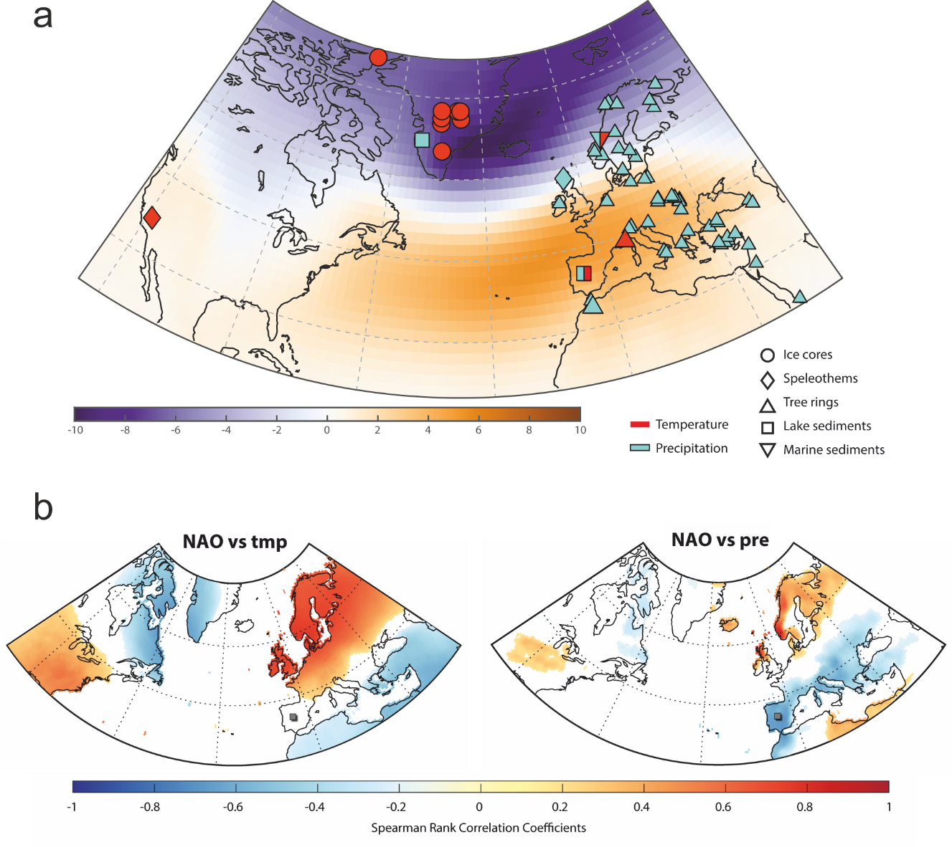

Fig.1. (a) Spatial display of the first eigenvector for the gridded winter (December – February) monthly sea-level pressure anomalies (in mb) for the North Atlantic domain—calculated using the Twentieth Century Reanalysis data set (20CRv2c) (Compo et al., 2011). Location of the proxy-based records (ice cores, lake sediments, speleothems, tree rings, and marine sediments) employed in this study, using symbols and colours to represent the different types of archives and the reconstructed climate variables. (b) Correlation distribution maps between the winter precipitation and temperature (wPre and wTmp) datasets and the NAO, for the boreal winters (December – February) between 1901 and 2016, calculated using the CRU-TS4.1 global climate dataset (Harris et al., 2014) and the NAO and EA indices from Comas-Bru and Hernández (2018). Positive Spearman rank correlations are shown in red and negative correlations are shown in blue. Location of record used for NAO_{IP} is indicated.
In general, most of the available proxy-based NAO reconstructions (Table 1) agree with each other on centennial timescales, and demonstrate broad agreement with instrumental NAO indices until as early as c. 1850 CE (Common Era). However, NAO variability only accounts for c. 40% of the climate variance that is ultimately captured by those regional palaeorecords sensitive to the NAO impact (Pinto and Raible, 2012). Thus, on this basis a perfect NAO reconstruction is a challenge beyond the instrumental period. In fact, considerable discrepancies amongst reconstructions are evident further back in time on decadal timescales. A clear example is the persistent positive NAO phases during the Medieval Climate Anomaly (MCA; 900 – 1300 CE) suggested by some authors (Baker et al., 2015; Olsen et al., 2012; Trouet et al., 2009) and questioned by others (Cook et al., 2019; Ortega et al., 2015). Besides factors such as chronological uncertainties, the use of diverse calibration periods and differences in the sensitivity of the archives to climate, amongst others; the inconsistencies between NAO reconstructions appear to be related to the large percentage of NAO internal variability that has been commonly associated with its non-stationary behaviour (Lehner et al., 2012; Raible et al., 2006). More recently, the amplitude of this internal variability has been attributed to the influence of other North Atlantic modes of climate variability (i.e., the East Atlantic (EA) and Scandinavian (SCA) patterns), which would thereby modulate the strength and location of the NAO dipole from annual to multidecadal scales (Comas‐Bru and McDermott, 2014; Mellado-Cano et al., 2019; Moore and Renfrew, 2012). The EA pattern is structurally similar to the NAO, being defined as a north–south dipole with sea level pressure (SLP) anomaly centres, spanning the entire North Atlantic Ocean (Bastos et al., 2016; Chafik et al., 2017), or a well-defined SLP monopole south of Iceland and west of Ireland (Comas‐Bru and McDermott, 2014; Josey and Marsh, 2005; Moore and Renfrew, 2012; Zubiate et al., 2017). Compared with the nodal lines of the NAO pattern, the anomaly centres of the EA pattern are displaced to the southeast (Barnston and Livezey, 1987). The SCA pattern is associated with strong positive SLP anomalies over Scandinavia and weaker centres of the opposite sign over Western Europe and eastern Russia–western Mongolia (Bueh and Nakamura, 2007).
From a methodological point of view, most previously published NAO reconstructions have been based on the use of some variant of regression models, often coupled with Principal Components Analysis (PCA) (Michel et al., (2020) and references therein). By contrast, richer models using Bayesian inference have been extensively used during the last decade for age-depth chronological building (Blaauw et al., 2007; Haslett and Parnell, 2008; Ramsey, 2008) as well as for climate and environmental reconstructions using biological proxies (Cahill et al., 2016; Haslett et al., 2006; Parnell et al., 2015; Tingley and Huybers, 2009). Nevertheless, neither Bayesian inference nor non-biological proxies have yet been used to reconstruct modes of variability (i.e., the NAO). The Bayesian approach holds a major advantage over traditional methods, as it is conceptually simpler to build a complex model which quantifies the relationship between multiple proxy and climate variables simultaneously—rather than relying on individual coefficients to describe the relationship (Birks et al., 2010; Li et al., 2010). Furthermore, it is possible to model observations under all conditions (i.e., modern analogues (Guiot and de Vernal, 2007)). The handicap for ''no modern analogue'' situations means considerably larger uncertainties which can be, however, accounted for in the resulting reconstructions.

Table 1: Previous NAO index reconstructions used in this work.
Authors | Reconstruction Period | Time Resolution | Predictors | Statistical Method
Luterbacher et al. 2001  (NAO_{LUT}) | 1659-1995 CE  1500-1658 CE | Monthly  Seasonal | Instrumental and proxy data predictors from Eurasia | Principal Component Regression (PCR)
Trouet et al. 2009  (NAO_{TRO}) | c. 1050-2000 CE | Seasonal | Reconstructed winter precipitation for  Scotland and February-to-June Palmer Drought Severity Index (PDSI) for Morocco | Normalised difference of the Scotland  and Morocco records
Olsen et al. 2012  (NAO_{OLS}) | c. 3250BCE - 1650 CE | Decadal | Paleo-redox proxy-based record of lake sediments from southwestern Greenland | 3rd component of a Principal Component Analysis (PCA) tuned by Monte-Carlo-Markov-Chain model (calibration based on Trouet et al. 2009)
Ortega et al. 2015  (NAO_{ORT}) | c. 1050 – 2000 CE | Annual | Proxy data predictors (ice cores, lake sediment, speleothem and tree ring) from around the North Atlantic (Greenland, Europe, North America and North Africa) | Ensemble reconstruction of Principal Component Regressions (PCR)
Baker et al 2015 (NAO_{BAK}) | 1000BCE – 2000 CE | Annual | Speleothem | Principal Component Analysis (PCA)
Faust et al. 2016  (NAO_{FAU}) | c. 800BCE – 1900 CE | Multiannual | Paleoproductivity (CaCO3 and Ca/Si) proxy-based record of fjord sediments from Central Norway | Kernel smoother
Sjolte et al. 2018  (NAO_{SJO}) | c. 1250 – 2000 CE | Seasonal | Reconstruction of atmospheric winter circulation for  the North Atlantic region based on Greenland ice core records and a 1200-year-long simulation with an isotope-enabled climate model | Principal Component Analysis (PCA) supported by a Chi-square goodness-of-fit test
Cook et al 2019 (NAO_{COOK}) | 910-2018 CE | Seasonal | Tree rings | Principal components regression

Recently, much attention has been cast toward disentangling the relative controls on the NAO from external forcings (e.g., solar, volcanic activity and/or greenhouse gases) and internal variability (e.g., ocean, atmosphere, sea ice) to develop reliable projections of its future evolution (Chiodo et al., 2019; Deser et al., 2017; Hall et al., 2017; Ineson et al., 2011; Scaife et al., 2014; Swingedouw et al., 2015). Although the relative impacts of external forcing mechanisms on the NAO are still a matter of debate (Swingedouw et al., 2017), it has been traditionally assigned to volcanic eruptions (Wanner et al., 2015), as highlighted by a predominance of positive NAO phases after these periods of increased volcanic activity (Ortega et al., 2015; Sjolte et al., 2018). The role of solar activity however is even more controversial, with contradictory evidence sourced from multiple proxy-based reconstructions (Brugnara et al., 2013; Faust et al., 2016; Ortega et al., 2015; Sjolte et al., 2018). Modelling (Chiodo et al., 2019; Woollings et al., 2010) and observational (Chiodo et al., 2012; Ineson et al., 2011) studies also yield contradictory conclusions between the 11-year solar cycle and the NAO relationship (Thiéblemont et al., 2015). The studies arguing for a solar impact on the NAO invoke a top-down mechanism related to the ultraviolet irradiance pattern (Scaife et al., 2013). An increase in UV radiation during periods of high solar activity results in an increased temperature in the middle atmosphere. The middle atmosphere refers to the region extending from the tropopause (∼ 10–16 km) to the homopause (∼ 110 km) where the atmosphere remains relatively well mixed (Fritts, 2015). This increase in UV radiation due to high solar activity would lead to an altered stratospheric circulation that propagates pole- and down-wards affecting tropospheric jet streams and thus atmospheric circulation (Ineson et al., 2011; Martin-Puertas et al., 2012). However, the response of the NAO to the solar cycle would not occur immediately but rather after a lag of c. 3 years. This is because the impact of solar heating accumulates for several years in the ocean causing a positive feedback between the ocean and atmosphere (Gray et al., 2013; Scaife et al., 2013). Low sunspot activity results in a climate pattern very similar to the negative phase of the NAO (Lockwood, 2012) with longer lasting and more intense blocking episodes than during high solar blocking events (Barriopedro et al., 2008). A recent proxy-based study(Faust et al., 2016) further supports a linkage between the Grand minima of solar activity and the negative NAO phases that accompany cooling events (e.g., Little Ice Age—LIA—) at decadal-to-centennial timescales.
Here we present a quantitative NAO reconstruction for the central Iberian Peninsula (IP) over the last two millennia, along with its uncertainties, by applying a Bayesian approach. We also assess the coherence between our new local NAO reconstruction and previously published reconstructions from other locations, as well as potential external forcing mechanisms that would lead to disagreements between them as a result of the non-stationary spatial behaviour of the NAO.

2.- DATA AND METHODS
2.1.- Proxy data
We used the chemical composition of a lacustrine sediment core (CIM12-04A, 124.8 cm long) retrieved from an alpine lake located in the Central Iberian Range (Cimera Lake, 40°15'N – 5°18'W, 2,140 m a.s.l.) (Sánchez-López et al., 2016). The chemical composition of the sediments was obtained by continuous X-ray fluorescence (XRF) analysis using the XRF Avaatech core scanner located at the University of Barcelona (Spain). The XRF settings (working conditions) were: 2 mm of spatial resolution, 2 mA, 15 s count times and 10 kV for lighter elements, with 55 s and 30 kV for heavier elements. Thirty chemical elements were measured, but only ten light (Al, Si, K, Ca, Ti, V, Cr, Mn, Fe, and Zn) and three heavy (Rb, Sr and Zr) elements had enough counts to be considered robust.
The chronology of the sediment deposition of the CIM12-04A core was previously determined by Sánchez-López et al. (2016). It was derived using the activity-depth profile of ²¹⁰Pb in the uppermost 9 cm of the core together with six AMS ¹⁴C dating. The resulting model shows that sedimentary infill of the Cimera Lake core spans from 172 ± 65 BCE to 2012 CE. See details in Supplementary Material.
2.2.- Climate datasets
We used the NAO extended winter index (Jan – May) spanning the period 1824 – 2012 CE to produce the NAO influence reconstruction. The data were obtained from the Climatic Research Unit (CRU) at the University of East Anglia (UK) (https://crudata.uea.ac.uk/cru/data/pci.htm). This NAO index was defined by Jones et al. (1997) and modified by Vinther et al. (2003) to be the difference between the normalized monthly sea level pressure anomalies recorded at Reykjavik (Iceland) and those observed at Iberia (Gibraltar/Cadiz). Precipitation and temperature datasets used in the figures were obtained from CRU-TS4.01 (Harris et al., 2014), whereas NAO and EA data were acquired from Comas-Bru and Hernández (2018).
2.3.- Bayesian Model
We follow a Bayesian modelling approach (Parnell et al., 2016, 2015) to produce a reconstruction of the NAO’s impact on the central IP. The relationship between proxy and climate is derived from a training data set for the instrumental/proxy calibration period and is expressed through a likelihood function. This function is combined with a prior probability density function containing parameter information in order to obtain a posterior probability distribution of the reconstructed NAO values using Bayes’ theorem(Juggins and Birks, 2012). Whilst Parnell et al. (2015) based their framework on reconstructing multivariate temperature and moisture measurements from raw pollen data, the method is easily adaptable to other proxies and climate variables. Indeed, Cahill et al. (2016) used a similar approach to reconstruct sea level from foraminifera. In all cases the measurements/counts of the proxy are required for a set of sediment layers (depths) in a core.
We summarize the mathematical details of the model in this section. Full technical details for the model fitting process are described in Parnell et al. (2015). We provide all the code used to create the reconstructions at www.github.com/andrewcparnell/NAO.
The notation we use is as follows:
• NAO(t) is the North Atlantic Oscillation value at time t. The goal of our model is to estimate NAO(t), and its uncertainty, for a set of chosen times.
• XRF_{ij} (expressed as counts per second) represents the chemical element j measured at a given depth i of the CIM12-04A core. We have i = 1, . . . , 647 depths and j = 1, . . . , 13 elements.
• We superscript both the quantities above with m and f so that XRF^{m} refers to the modern XRF data set, with associated known NAO^{m}, and XRF^{f} refers to the fossil data set, for which we wish to estimate NAO^{f}.
• t_{i} refers to the age of the core at depth i. The ages in our core are all given in years BC/AD.
• θ refers to the set of parameters governing the relationship between the NAO and the XRF measurements, as well as the dynamics of how the NAO changes over time.
Our model proceeds by creating a Bayesian joint posterior distribution:
$$p\left({\text{NAO}}^{f}\text{,θ}|{\text{NAO}}^{m}{\text{,XRF}}^{m}{\text{,XRF}}^{f}\right)∝p\left({\text{XRF}}^{f}|{\text{NAO}}^{f}\right)⋅p\left({\text{XRF}}^{m}|{\text{NAO}}^{m}\text{,θ}\right)⋅p\left({\text{NAO}}^{f}|θ\right)⋅p\left(θ\right)$$
The term on the left-hand side of the equation is the posterior distribution and represents the probability distribution of fossil NAO impacts given the observed data. The terms on the right-hand side represent respectively, the likelihood (the probability distribution of XRF^{f} given NAO^{f}), the distribution of XRF^{m} given NAO^{m}, and the prior distribution of the parameters governing the relationship between XRF and NAO.
For the distribution of XRF given the NAO, we standardise all the XRF values (by chemical element) and fit a multivariate normal polynomial regression model (MVN). This means, for the values k = 1,..., 13 chemical elements, we use:
$$\left[{\text{XRF}}_{\text{i,1}},\text{.}\text{.}\text{.}{\text{,XRF}}_{\text{i,13}}\right]|\text{NAO}\left(t_{i}\right)∼\text{MVN}\left(M_{i}\text{,Σ}\right)$$
where Mi = [μ_{i,1,...,}μ_{i,13}] with μ_{ik} = β_{0k} + β_{1k} NAO(t_{i}) + β_{2k} NAO(t_{i})², and ∑ is a covariance matrix which captures the extra dependence between elements not explained by differences in the NAO.
We set the prior distribution on NAO^{f} as a continuous-time random walk, which should reasonably match climate behaviour over the reconstructed time period (as in Haslett et al.(Haslett et al., 2006)). Other choices are available, such as long-memory or long-tailed stochastic processes(Parnell et al., 2015) use a Normal inverse Gaussian process. Our prior distribution is:

$$\text{NAO}\left(t_{i}\right)∼N\left(\text{NAO}\left(t_{i−1}\right){\text{,σ}}^{2}\left(t_{i}−t_{i−1}\right)\right)$$

where σ² is a parameter representing the variance of the NAO^{f} increments for a unit of time.
Finally, we set uninformative prior distributions for the remaining parameters:

$$β_{0k}{\text{, β}}_{\text{1k}}{\text{, β}}_{\text{2k}}∼N\left(\text{0,10}\right)\text{, σ}∼U\left(\text{0,10}\right){\text{, Σ}}^{−1}∼\text{Wishart}\left(I_{\text{13}}\text{, 14}\right)$$

where N and U represent Normal and Uniform distributions and I is the identity matrix.
The above model is computationally expensive to fit using the default tools for Bayesian model fitting due to the large number of parameters and the high data dimension. Instead, as stated above, we follow the approach of Parnell et al.(Parnell et al., 2015), which uses a computational approximation to fit the model in three steps. The first step fits the model to the modern data only. The second step estimates NAO^{f} for the fossil layers, and the third step constrains the estimated fossil NAO^{f} values according to a random walk model.
In the first step of the model, the total overlapping period between modern data, XRF proxy and observed NAO index (i.e., NAO^{m} and XRF^{m}, respectively), extends from 1825 until 2012 AD. However, the XRF data from 1825 until 1930 CE has a lower resolution (i.e., decadal) than the 1930-2012 CE period, owing to the usual slight decrease in the age-depth model accuracy. Thus we restricted the overlapping fitting period employed in the analysis to 1930 – 2012 CE. XRF^{m} data were resampled with a yearly resolution for the overlapping period using the R function "approxTime" from the package "simecol" (Petzoldt and Rinke, 2007).
We fit the model in R (R Core Team, 2016) using the JAGS software (Just Another Gibbs Sampler) (Plummer, 2003). The performance of the fitting algorithm can be determined by looking at the Brooks-Gelman Rubin (R̂) statistic(Brooks and Gelman, 1998; Gelman and Rubin, 1992) as well as trace plots of the parameter samples for each iteration of the algorithm. We run the algorithm until all R̂ values are less than 1.05, which indicates satisfactory convergence of the algorithm to the posterior distribution.
We evaluate the performance of the model by testing the predictive performance of the modern relationship between NAO^{m} and XRF^{m} (Step 1 as outlined above). As validation procedure, we compared NAO predicted values from the model using the modern NAO data (i.e, NAO instrumental data; Fig. 3). If the model estimates the NAO correctly there should be only 5% of the observations outside the 95% interval, and 50% outside the 50% interval. Finally, the complete impact reconstruction is created using a 10-year time grid, and includes both 95% and 50% uncertainty intervals.
2.4.- Statistical analyses
All NAO reconstructions have been converted to decadal time-scales to facilitate comparison. For each reconstruction, all NAO values within the same decade have been averaged and we use that average value for its particular decade. The magnitude of the relationships between NAOs were obtained according to Spearman’s rank correlation coefficients (ρ) and associated p values. Unless otherwise stated, significance (p-value) is always considered at values of p < 0.01.
We have analysed the NAO values for each decade with significant volcanic eruptions for the last 2k years according to two different thresholds (Toohey and Sigl, 2017): i) eruptions around the globe with more than 6 Tg S injected to the troposphere, and ii) eruptions from the Northern Hemisphere with accumulations larger than 0.5 Tg S injected to the troposphere. We have established a percentage of positive NAO values that occurred over the decades selected for each threshold.
Relationships between solar forcing and the NAO were established with linear regression models and verified with a number of diagnostic techniques (see supplementary material). We also applied two thresholds: i) all the sunspot number reconstruction values and, ii) values lower than 42. The latter was selected after we applied a breakpoint analysis which delivered the sunspot number of 42 as a potential breakpoint in the regression line (see supplementary material).
The statistical treatment of the data was performed with R software (R Core Team, 2016).
3.- A new local NAO reconstruction: Central Iberian Peninsula
The NAO has a significant effect on winter climate on the Iberian Peninsula (Comas-Bru and Hernández, 2018, p.; Hernández et al., 2015; Trigo et al., 2008) (IP; Fig. 1b). In particular, high-mountain lakes from the IP are highly influenced by the NAO; cold and wet conditions during negative NAO phases control annual ice-cover dynamics (i.e., freezing and thawing) via interactions between air temperature and precipitation (Sánchez-López et al., 2015). While the NAO is particularly relevant during the boreal winter, its impact on ecosystem and ice-cover dynamics is not restricted to this season (Gouveia et al., 2008). In fact, the NAO signal that is captured in lake records from the region spans from January to May (Sánchez-López et al., 2015).
A previous study (Sánchez-López et al., 2016) using geochemical (i.e., x-ray fluorescence and bulk organic matter nitrogen (TN), carbon (TC) and analyses of their stable isotopes analyses), as well as mineralogical (i.e., x-ray diffraction) data from the Cimera Lake sedimentary record (40°15'N – 5°18'W, 2,140 m a.s.l.) established a qualitative climatic and environmental reconstruction of the Iberian Central Range throughout the Common Era. Authors applied PCA to the normalized geochemical datasets to determine the main environmental processes controlling sediment input, distribution and deposition in the lake. The first (PC1cim) and second (PC2cim) eigenvectors explained c. 55% of the total variance. PC1cim was associated with most of the chemical elements and with Ti in particular. Therefore, it was interpreted as due to changes in the inputs of siliciclastic material from the catchment. Authors argued that runoff intensity was related to the occurrence of a well-defined melt season in terms of temperature and rainfall variations. Hence, rain-on-snow events were suggested as the main process governing the inputs of coarse siliciclastic material to Cimera Lake. PC2cim was related to TC, TN and Rb content and was associated with variations in the lake’s organic productivity which was in turn modulated by ice-cover duration. Cold (warm) and wet (dry) conditions lead to longer (shorter) ice-cover durations, which are partly the result of the enhanced (reduced) insulating effect of the snow deposited on the ice cover (Sánchez-López et al., 2015). Here we use their dataset (Sánchez-López et al., 2016) to quantitatively reconstruct the NAO impact on climate in the central IP (NAO_{IP}) for the last two millennia using a Bayesian modelling approach (see Methods).
The reconstructed local NAO impact ranges between -2 and 2 and represents the quantitative reconstruction of the NAO for the central IP (NAO_{IP}; Fig. 2). Only 2.9% of the observations fall outside the 95% confidence interval (Fig. 3). These results indicate satisfactory performance of the model and validate the NAO_{IP} (see Methods). The NAO_{IP} has not been reconstructed for the period c. 1200 – 1270 CE due to the lack of proxy data (Sánchez-López et al., 2016). Though the model permits such interpolation, the uncertainties would be too wide to enable any reasonable interpretation.
The NAO_{IP} shows decadal alternations between positive (> 0.5) and neutral (−0.5 to 0.5) phases of the NAO during the Roman Period (RP: ~200 BCE – 500 CE) (Fig. 2). Neutral to positive NAO_{IP} values characterize the first half of the RP period while there is a predominance of neutral values during its second half. During the Early Middle Ages (EMA: 500 – 900 CE) the NAO_{IP} shows two cycles of positive-to-neutral and positive-to-negative (< −0.5) values. During the Medieval Climate Anomaly (MCA: 900 – 1300 CE), the NAO_{IP} displays a trend from predominantly negative values (−1.4 to 0.5) to the most positive ones (~ 2.5) of the entire reconstruction. Negative NAO_{IP} values (−1.6 to 0.5) clearly dominate the Little Ice Age (LIA: 1300 – 1850 CE) recording the most negative NAO_{IP} values at ~ 1500 CE. In contrast, the Industrial Era (IE: 1850 – 2012 CE) shows a clear trend from neutral to positive values (−0.2 to 0.6) punctuated by large decadal oscillations (~ 2.5) during the second half.

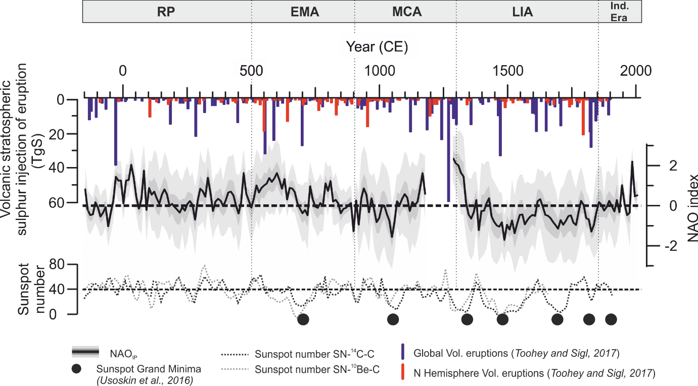
Fig.2: The NAO index data used in the fitting step of the model (thin black line), the median of the NAO impact reconstruction for the Central Iberian Peninsula (NAO_{IP}) obtained in this study (wide black line) and the 95% (light grey band) and 50% (dark grey band) uncertainty intervals. Sunspot number reconstruction (Usoskin et al., 2016) and volcanic eruption (Toohey and Sigl, 2017) for the studied period are also represented.

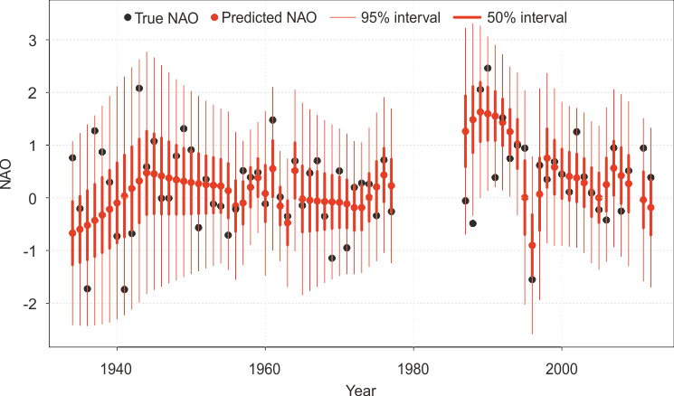
Fig.3: ﻿Black points correspond to true NAO data (i.e., NAO index data) and the red points show predicted median NAO impact values. The vertical red lines correspond to the 95% uncertainty interval (thin lines) and to the 50% uncertainty interval (wide lines), respectively.
4.- Comparison with previous NAO proxy-based reconstructions
The comparison between different proxy-based NAO reconstructions published in the last two decades (Table 1) points out a number of periods with consistent signals as well as some with notable differences (Fig. 4). All NAO reconstructions show a similar centennial timescale evolution with positive NAO values during the MCA and lower positive or negative NAO values during the LIA (Fig. 4). This coherence across regions suggests an hemispheric imprint of this climate mode at low frequencies compared to the local impacts that might be recorded by each reconstruction over annual to decadal timescales.
To establish the extent to which the decadal variability between positive and negative excursions in NAO_{IP} during the last 2 ka compares to previously published reconstructions, we calculated Spearman's Rank Correlation Coefficients for decadal timescales (Table 2; Fig. 4). The NAO_{IP} displays the highest correlations with the W Europe mid-latitude records such as the NAO reconstruction by Trouet et al. (2009) (NAO_{TRO}; ρ = 0.51; p < 0.01; DF = 171) and the NAO reconstruction by Baker et al. (2015) (NAO_{BAK}; ρ = 0.40; p < 0.01; DF = 206). However, if we analyse the results separately for climate periods, the NAO_{IP} shows higher correlations with high-latitude and eastern records such as NAO reconstruction by Ortega et al. (2015) and NAO reconstruction by Faust et al.¹⁸ during the MCA (ρ = 0.84; p < 0.01; DF = 25) and the IE (ρ = 0.94; p < 0.01; DF = 15), respectively.
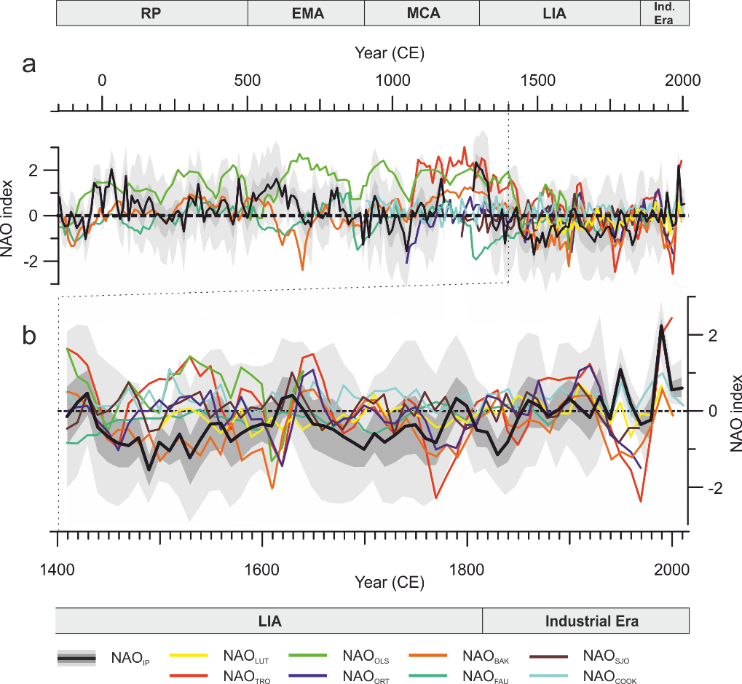
Fig.4: (a) Comparison of the NAO reconstructions for decadal timescales. (b) Magnified plots for the last six centuries.
Unlike instrumental-based NAO reconstructions arising from large-scale gridded sea-level pressure datasets proxy-based NAO reconstructions are usually based on a limited number of climate proxy records from restricted regions or locations (e.g., NAO_{TRO}, NAO_{BAK}, NAO by Sjolte et al. (2018) (NAO_{SJO})) or on single paleorecords (e.g., NAO reconstruction by Olsen et al. (2012), NAO_{FAU} and our NAO_{IP}). This constrained geographical area implies that the reconstructed NAO signal probably results from the local climatic response to this mode of variability rather than reflecting a regional signal. By contrast, other NAO reconstructions, such as those by Cook et al. (2019) (NAO_{COOK}), Luterbacher et al. (2001) (NAO_{LUT}) and NAO_{ORT} are based on a larger number of geographically distributed records that could be understood to represent a regional assemblage of local NAO impacts. Nevertheless, here we provide evidence supporting the fact that our local NAO_{IP,} which is based on a single palaeorecord, is representative of a wide regional signal (Fig. 5). Thus, we conclude that in some cases, reconstructions based on single archives may be more regionally representative than what can be achieved with multi-archive proxy-based NAO reconstructions. The rationale behind this could be that different archives capture different climate signals at different seasons and merging them into a single series without taking into account these mixed signals results in a low variance reconstruction that does not capture all the NAO variability.

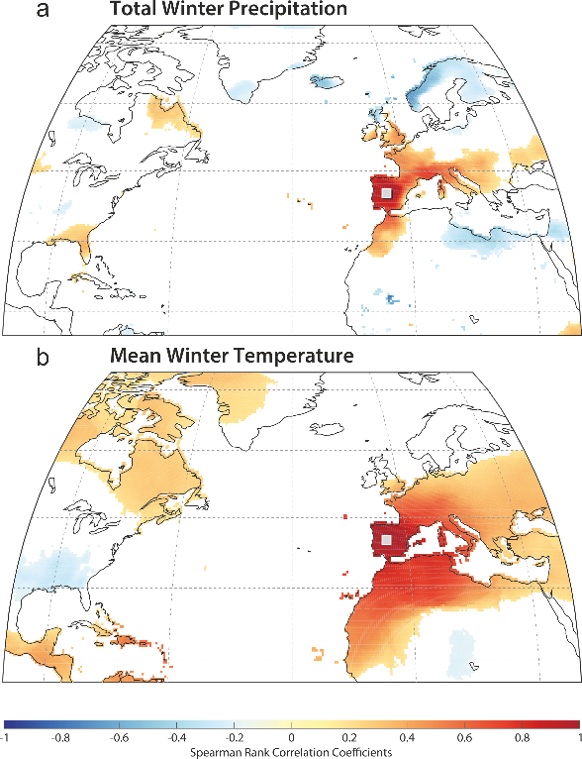
Fig 5. Correlation between winter (a) precipitation and (b) temperature at the site of NAO_{IP} (grey square) and each of the other grid cells to see how representative is the site for regional winter climate between 1901 and 2016, calculated using the CRU-TS4.1 global climate dataset (Harris et al., 2014). Positive Spearman rank correlations are shown in red and negative correlations are shown in blue.
Equally importantly, the NAO is not the sole driver of the large-scale atmospheric variability in the European North-Atlantic region; other modes of variability also play an important role —namely the EA and SCA (Trigo et al., 2008). Comas-Bru and McDermott (2014) previously showed that it is possible to explain a larger fraction of the European winter climate variability when different NAO/EA and NAO/SCA modulate the migrations of the North Atlantic SLP dipole and in turn, the climate signal recorded in the region. Across the IP, this is expressed by a more homogeneous spatial pattern in temperature and precipitation for periods with a predominance of in-phase NAO and EA indices (i.e., MCA and LIA) compared to periods when these modes have the opposite sign (i.e., RP and EMA) (Sánchez-López et al., 2016). Moreover, the geographical displacement of the southern pole of the North Atlantic SLP field (i.e., location of the highest correlated grid cells between combinations of the NAO and EA and North Atlantic SLP) is relatively smaller when the NAO/EA have the same sign compared to years of opposite sign (Fig. 6). Contour lines of teleconectivity maps show higher gradients and are northerly located for years with the same sign, whereas years with opposite sign show a lower gradient with a south-westerly migration of the dipole. As a result, differences in precipitation between years of the NAO and the EA with the same and opposite signs (Fig. 7) are generally small for mid-latitudes (e.g., IP and the Mediterranean Basin) and are larger for high-latitudes (e.g., Greenland, Ireland, and the UK). On the contrary, differences in temperature are larger for mid-latitudes and smaller for high-latitudes. These differences are almost non-existent in the western Atlantic sector (US and Canada) where the NAO impact is also significantly weaker. Hence, regional NAO reconstructions which use different archives (e.g., tree-rings, speleothems, ice-cores) that record different climate variables (e.g., precipitation, temperature) from different locations (high- vs mid-latitudes) could experience biases due to the above mentioned migrations of the SLP dipole due to NAO/EA interactions. This could potentially explain the latitudinal variability observed for NAO reconstructions over the last millennia (Fig. 4).
The largest discrepancies between NAO_{IP} and other published reconstructions are found for the RP and the EMA, while better agreements occur during the MCA, the LIA, and the IE (Table 2 and Fig. 4). During the RP and the EMA, the weakest agreement occurs for NAO reconstructions that are based on high latitude records (NAO_{OLS} and NAO_{FAU}) whereas a similar long-term evolution is observed between NAO_{IP} and NAO_{BAK}, which are based on mid-latitude records (Fig. 1 and 4). While we acknowledge the difficulty to fully assess the reasons for these discrepancies, our results indicate that they may be partly related to the location of the employed archives (higher latitudes for NAO_{OLS} and NAO_{FAU} than for NAO_{IP} and NAO_{BAK}); potentially it is also due to the different latitudinal impact of the EA pattern, as well as external forcings. Nonetheless, the type of archives employed for the different reconstructions (i.e., lake and marine sediments, speleothems), their variable sensitivity to climate, and the range of statistical approaches used to obtain the final reconstructions (i.e., Bayesian modelling, Principal Component Analysis), should not be discarded as being at least part of the cause of the disagreements observed across reconstructions.
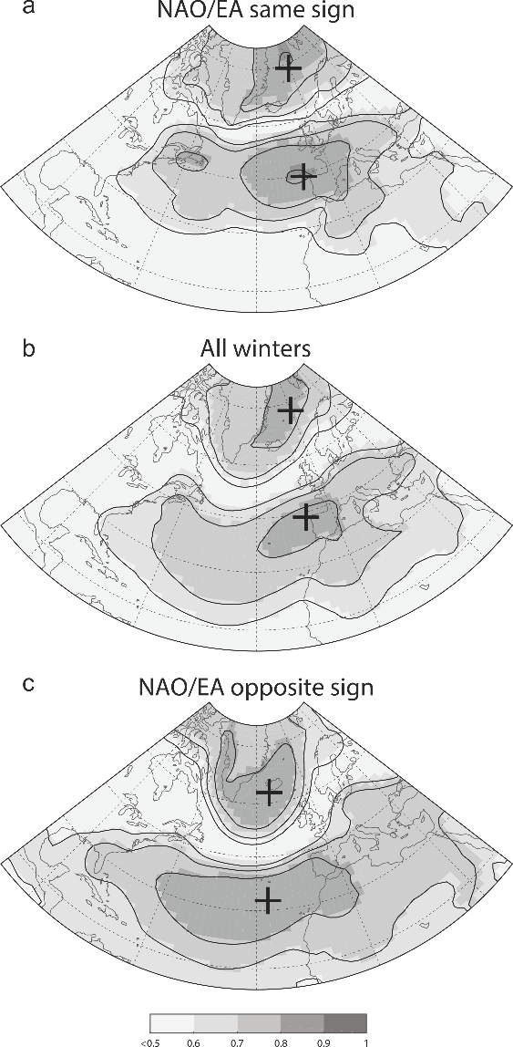
Fig.6: Teleconnectivity maps of the winter (DJF) monthly sea-level pressure field in the North Atlantic region for the period 1872 – 2009 and different linear combinations of the NAO-EA: a) winters with the NAO and the EA of the same sign; b) all winters; c) winters with the NAO and the EA of the opposite sign. Shaded areas represent Spearman correlations as per the colour bar. Black crosses indicate the location of the highest correlated grid cells. The NAO and the EA indices are the 1st and 2nd empirical orthogonal functions calculated from monthly SLPanomalies over a confined N. Atlantic sector using the Twentieth Century Reanalysis data set (20CRv2c) (Compo et al., 2011).

Table 2: Spearman's Rank Correlation Coefficients between decadal (10 years) NAO_{IP} and other NAO proxy-based reconstructions employed to build up NAO indices. Note: ª, ^{b}, ^{c}, ^{d} indicate correlations with p-val < 0.01, 0.01 < p-val < 0.05, 0.05 < p-val <0 .1 and p-val > 0.1, respectively.

 |  | NAO_{LUT} | NAO_{TRO} | NAO_{OLS} | NAO_{ORT} | NAO_{BAK} | NAO_{FAU} | NAO_{SJO} | NAO_{COOK}
NAO_{IP} | CE (200 BCE - Present) | 0.18^{d} | 0.51ª | 0.20^{b} | 0.22^{b} | 0.40ª | 0.08^{d} | 0.13^{d} | 0.07^{d}
NAO_{IP} | RP (200 BCE – 500 CE) | - | - | 0.24^{d} | - | 0.30^{b} | 0.19^{d} | - | -
NAO_{IP} | EMA (500 – 900 CE) | - | - | -0.31^{c} | - | 0.18^{d} | -0.19^{d} | - | -
NAO_{IP} | MCA (900 – 1300 CE) | - | 0.28^{d} | 0.30^{d} | 0.84ª | 0.57ª | -0.05^{d} | 0.50^{d} | -0.26^{d}
NAO_{IP} | LIA (1300 – 1850 CE) | -0.22^{d} | 0.29^{b} | 0.27^{d} | 0.06^{d} | 0.35ª | -0.33^{b} | 0.13^{d} | 0.10^{d}
NAO_{IP} | IE (1850 CE - Present) | 0.36^{d} | 0.11^{d} | - | 0.17^{d} | 0.27^{d} | 0.94ª | 0.01^{d} | 0.28^{d}

5.- Volcanic eruption impact
Previously published proxy-based NAO reconstructions show a robust positive NAO response in the 4 – 5 years following the major eruptions of the last millennial period (Ortega et al., 2015; Sjolte et al., 2018). In contrast, a recent review of the impact of explosive volcanic eruptions on the main climate variability modes determined that no firm conclusions can be drawn regarding volcanic forcing impacts on this mode of variability(Swingedouw et al., 2017).
We compared the NAO_{IP} with volcanic eruptions (Toohey and Sigl, 2017) responsible for the largest stratospheric sulphur injection (> 6 Tg S) during the last c. 2 ka for each decade (n=41; Table 3). We find positive reconstructed NAO values for approximately 50% of the decades when these large eruptions occurred. This result reinforces previous studies (Ortega et al., 2015; Sjolte et al., 2018) that did not reach compelling conclusions on the relationship between the NAO and volcanic activity. Nevertheless, if we relax the minimum injection threshold for volcanic eruptions in order to take into account stratospheric sulphur injections larger than 0.5 Tg S and only consider Northern Hemisphere latitudes eruptions (n = 86), we find that about 80% of the NAO reconstructed values of the decades encompassing these eruptions are predominantly positive (c. 80%). A further comparison including all the analysed NAO reconstructions (Table 1) shows a wide range of percentages (20 to 91% and 32 to 91% for all and for extratropical NH eruptions, respectively) for decades with positive NAO values when large volcanic eruptions occurred (Table 3). Hence, there is no apparent influence from volcanic eruptions on the preferred signal of the NAO pattern over decadal timescales.
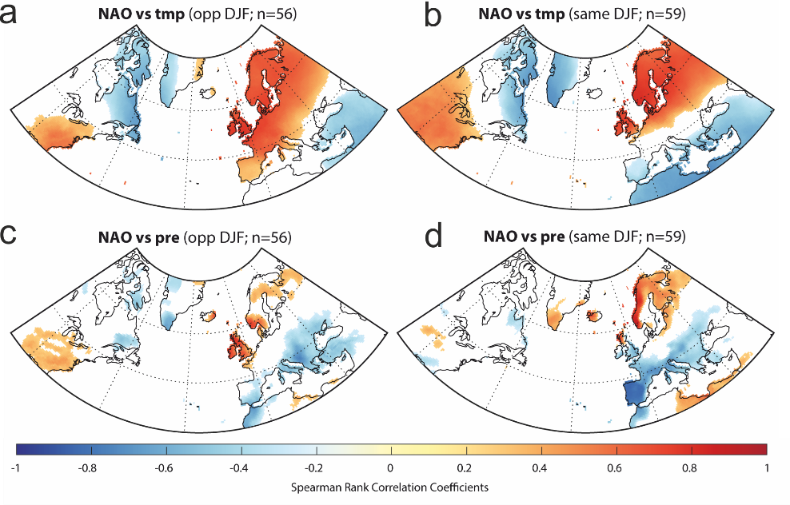
Fig. 7: Correlation distribution maps of winter NAO and (a, b) temperature and (c, d) precipitation. (a) and (c) are correlations for the subset of winters where NAO and EA are of opposite sign, whereas (b) and (d) are correlations for the subset of winters where NAO and EA are of the same sign. NAO and EA indices from Comas-Bru and Hernandez (2018) and climate data from the CRU-TS4.01 dataset (Harris et al., 2014). Location of NAO_{IP} is shown as a grey square.
Table 3: Percentage of positive NAO decades after the largest global (volcanic stratospheric sulphur injection > 6 TgS)) and NH (volcanic stratospheric sulphur injection > 0.5 TgS)) volcanic eruptions following Toohey and Sigl (2017).
 | Global  (150 BCE - 2012 CE) | NH  (150 BCE -2012 CE)
NAOip | 18/36 (50%) | 48/60 (80%)
NAO_{LUT} | 2/10 (20%) | 7/22 (32%)
NAO_{TRO} | 15/202 (75%) | 21/34 (64%)
NAO_{OLS} | 20/22 (91%) | 51/56 (91%)
NAO_{ORT} | 10/20 (50%) | 14/34 (41%)
NAO_{BAK} | 23/40 (58%) | 46/87 (53%)
NAO_{FAU} | 13/40(33%) | 37/87 (43%)
NAO_{SJO} | 8/16 (50%) | 15/26 (58%)
NAO_{COOK} | 20/24 (83%) | 36/43 (84%)

6.- Solar forcing modulation
We also compared the NAO_{IP} with a decadal sunspot number reconstruction (Usoskin et al., 2016) through the CE. To avoid volcanic eruption interferences in the analysis, we identified the decades corresponding to the fifteen largest volcanic eruptions (Fig. 2 and Table S1), considered to be outliers, and were removed from the solar forcing analysis.
The linear correlation (ρ) between the decadal NAO_{IP} index and the sunspot number is significant but relatively low, (ρ = 0.32; p < 0.01; DF = 177). However, a breakpoint analysis displayed an inflection point with the occurrence of 42 sunspots (Fig. 8). If we only consider sunspot numbers under 42, the linear correlation with NAO_{IP} is also significant and much higher (ρ =0.57; p < 0.01; DF = 112). This correlation is higher in the last millennium (1000 – 2012 CE; ρ = 0.59; p < 0.01; DF = 48), where the NAO_{IP} shows negative values between (1020 – 1070 CE; 1450 – 1550 CE; 1640 – 1720 CE and 1810 – 1850 CE) corresponding to Oort, Spörer, Maunder, and Dalton Grand solar minima, respectively, than in the previous millennium (0 – 1000 CE; ρ = 0.28; p > 0.1; DF = 60) with almost no Grand solar minima (Fig. 2).
To evaluate this relationship, we reproduced the same analysis for all the NAO reconstructions (Table 4 and Fig. S1). The results are similar to those obtained for the NAO_{IP} with low or non-significant correlation values when using all sunspot numbers (Table 4). However, those proxy-based NAO reconstructions where mid-latitude records have a prevailing role (e.g., NAO_{BAK} and NAO_{TRO}) also displayed a tipping point at a sunspot number of 42 (Fig. S1). In these cases, there is also a significant correlation between the decadal NAO values and this sunspot number (ρ > 0.22; p < 0.01; DF > 50). To test whether the NAO behaviour is indeed significantly influenced by solar activity for sunspot numbers below 42 for reconstructions based on lower latitude records, we have also compared the southernmost record of the NAO_{TRO}—Palmer Drought Severity Index (PDSI) based on tree ring data from Morocco (Esper et al., 2007)—with the sunspot number. This comparison confirms a significant correlation (ρ = 0.34; p < 0.01; DF = 51) between solar activity and the NAO for mid-latitudes. These latitudinal differences in solar activity impact can be attributed, among other criteria previously mentioned (e.g., type of proxy and methodology), to the fact that the solar variability signal is not uniformly distributed(Lean, 2017). Annual and decadal variations in solar activity have the largest impacts in the mid-latitudes (Haigh, 2011). Previous analyses of surface air temperatures (Lean and Rind, 2008) have demonstrated a tendency toward preferential warming in regions at 30° – 60° latitude for both hemispheres.

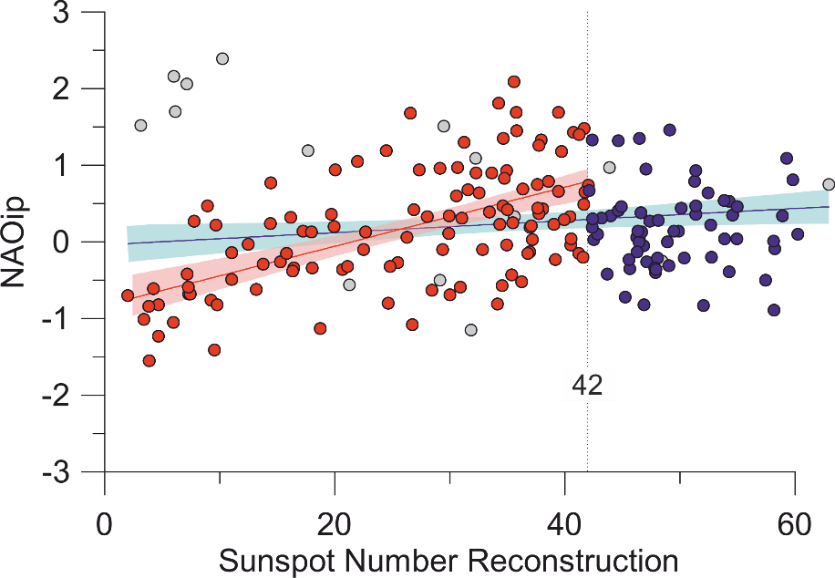
Fig. 8: NAO_{IP} values versus sunspot number reconstruction. Red dots represent samples with sunspot number values below 40, whereas blue dots indicate samples with sunspot number values above 40. Grey dots correspond to samples during decades with high volcanic eruptions and they have not been considered in the correlation analysis. Red line indicates linear correlation between NAO_{IP} and Sunspot number (< 40) and blue line for all data. Dotted line delimits samples with sunspot number values below and above 40.
Table 4: Spearman´s rank correlations coefficients from the preformed Linear Regression Models between proxy-based NAO reconstructions and Sunspot Number reconstruction. Decades with important volcanic eruptions have been removed from the analysis. In bold, significant correlation values at 0.01 significance. Note that NAO_{TRO} from Morocco is included to highlight the solar activity impact in lower latitudes.
 | SSN  (150 BCE - 2012 CE) | SSN<42  (150 BCE - 2012 CE)
NAO_{IP} | 0.32 | 0.57
NAO_{LUT} | 0.03 | 0.10
NAO_{TRO}  NAO_{TRO} _{(Morocco)} | 0.14  0.11 | 0.29  0.33
NAO_{OLS} | 0.10 | 0.01
NAO_{ORT} | 0.15 | 0.03
NAO_{BAK} | 0.09 | 0.22
NAO_{FAU} | 0.19 | 0.23
NAO_{SJO} | 0.22 | 0.07
NAO_{COOK} | 0.08 | 0.04
7.- Discussion and conclusions
There is an evident historical disagreement between all the available proxy-based reconstructions over decadal timescales for the Common Era. While there is a clear consensus for prevailing negative NAO phase conditions during the Little Ice Age and positive conditions for the Medieval Climate Anomaly over centennial timescales; discrepancies emerge when NAO variability is analysed at annual-to-decadal timescales. Moreover, the scarcity of NAO reconstructions at decadal resolutions makes it difficult to identify common patterns before the last millennium. Our results suggest mainly positive and neutral phases of the NAO during the Roman Period (~ 200 BCE – 500 CE), and two cycles: i) positive-to-neutral; and ii) positive-to-negative values during the Early Middle Ages (500 – 900 CE).
New applied statistical approaches (i.e., Bayesian) will help to improve the reliability of these results. We also suggest a more adaptable concept of proxy-based NAO reconstruction using appropriate distinctions, since it is impossible to understand the NAO as a single pattern. Rather, it should be regarded as a complex system that is controlled by multiple factors, some of which are stochastic and are therefore difficult to constrain. For this, the interpretation of available NAO reconstructions requires a careful re-examination. The sensitivity of different climate archives to the NAO may vary over different spatio-temporal scales. This highlights the need to select archives which are more sensitive to winter climate parameters (larger NAO impact season) and localities where the NAO impact on local climate variables is more stable (stationary).
Beyond these methodological issues, we have also analysed the distinct impact of potential external forcings (i.e., volcanic eruptions and solar activity) to puzzle out the reasons underpinning the observed disagreements between the NAO reconstructions throughout time.
Our results demonstrate that solar activity influences NAO variability over decadal timescales. The NAO reconstructions based on proxy records from mid-latitudes display significant positive correlations with the sunspot number, but this relationship is only found up to a certain solar activity threshold (number of sunspots = 42), after which the NAO index appears to be less influenced by solar activity. On the contrary, the impact of volcanic eruptions on the NAO is less clear, with disparate percentages showing some dominant positive NAO values after large volcanic eruptions.
Besides the influence of these two external forcing mechanisms we also assessed the role of an internal mechanism—namely the interaction of the NAO with the second most important large-scale pattern of atmospheric circulation in the North-Atlantic European sector, i.e., the Eastern Atlantic (EA) pattern. Combinations of NAO and EA phases can change the geographical position of the NAO centres of action and affect the strength and latitudinal location of the dominant westerlies entering Europe from the Atlantic (Mellado-Cano et al., 2019). Thus, the sensitivity of the archive to record the NAO impact (i.e., seasonality, climate variable, resolution) and its location are crucial to more accurately reconstruct NAO variability. Although a wide regional distribution of records could probably yield better results, the contrary impact of combined NAO and EA modes on some climate variables for the mid- and high-latitude records could be masking or, even, cancelling out the actual NAO pattern.
Further studies are required to better understand the NAO’s behaviour and the disagreements between the continuously increasing number of available NAO reconstructions. Regional NAO reconstructions like the ones derived by integrating a grid of instrumental or proxy-based regional data can be considered more robust—and can aid the understanding of general climate dynamics—only if the records employed are sensitive to the same forcing and therefore can capture the same signal. In contrast, local NAO reconstructions would be more useful for determining its impacts on local meteorological variables, being more relevant for local ecosystems and the socio-economic system. Therefore, local NAO reconstructions can help to develop better mitigation policies against problems derived from NAO climatic effects such as agricultural yield or water scarcity.
Acknowledgements
This work was financed by the Spanish Ministry of Economy and Competitiveness through the PaleoNAO (CGL2010-15767/BTE), RapidNAO (CGL2013-40608-R), and PaleoModes (CGL2016-75281-C2-1-R) projects and a PhD JAE grant (BOE 03/02/2011) for G.S.L. from the Spanish National Research Council (CSIC). A.H. is supported by a Beatriu de Pinós – Marie Curie Cofund programme fellowship (2016 BP 00023). A.G. is grateful for her Ramón y Cajal contract (RYC-2012-11024) and the MINECO grant VOLCLIMA (CGL2015-72629-EXP). A.P.'s work was supported by a Science Foundation Ireland Career Development Award grant 17/CDA/4695 and an SFI centre grant 12/RC/2289_P2. R.M.T. was supported by the Portuguese FCT project: HOLMDRIVE—North Atlantic Atmospheric Patterns Influence on Western Iberia Climate: From the Late Glacial to the Present (PTDC/CTA-GEO/29029/2017). This contribution is also part of the POLARCSIC activities. English editing by Grant George Buffett (www.terranova.barcelona).
Author Contributions
A.H. and G.S.L. have contributed equally. A.H., G.S.L., S.P.R., and S.G. conceived the study. G.S.L., A.P., and N.C. constructed the model. A.H., S.P.R., and L.C.B. analysed the data. A.H., G.S.L., and L.C.B. designed the figures. A.H. wrote the paper. A.H., G.S.L., S.P.R., L.C.B., A.P., N.C., A.G., R.M.T., and S.G. reviewed the manuscript.

References
Baker, A., Hellstrom, J.C., Kelly, B.F.J., Mariethoz, G., Trouet, V., 2015. A composite annual-resolution stalagmite record of North Atlantic climate over the last three millennia. Sci. Rep. 5, 1–8. https://doi.org/10.1038/srep10307
Barnston, A.G., Livezey, R.E., 1987. Classification, Seasonality and Persistence of Low-Frequency Atmospheric Circulation Patterns. Mon. Weather Rev. 115, 1083–1126. https://doi.org/10.1175/1520-0493(1987)115<1083:CSAPOL>2.0.CO;2
Barriopedro, D., García‐Herrera, R., Huth, R., 2008. Solar modulation of Northern Hemisphere winter blocking. J. Geophys. Res. Atmospheres 113. https://doi.org/10.1029/2008JD009789
Bastos, A., Janssens, I.A., Gouveia, C.M., Trigo, R.M., Ciais, P., Chevallier, F., Peñuelas, J., Rödenbeck, C., Piao, S., Friedlingstein, P., Running, S.W., 2016. European land CO 2 sink influenced by NAO and East-Atlantic Pattern coupling. Nat. Commun. 7, 1–9. https://doi.org/10.1038/ncomms10315
Birks, H.J.B., Heiri, O., Seppä, H., Bjune, A.E., 2010. Strengths and Weaknesses of Quantitative Climate Reconstructions Based on Late-Quaternary. Open Ecol. J. 3.
Blaauw, M., Bakker, R., Christen, J.A., Hall, V.A., Plicht, J. van der, 2007. A Bayesian Framework for Age Modeling of Radiocarbon-Dated Peat Deposits: Case Studies from the Netherlands. Radiocarbon 49, 357–367.
Brooks, S.P., Gelman, A., 1998. General Methods for Monitoring Convergence of Iterative Simulations. J. Comput. Graph. Stat. 7, 434–455. https://doi.org/10.1080/10618600.1998.10474787
Brugnara, Y., Brönnimann, S., Luterbacher, J., Rozanov, E., 2013. Influence of the sunspot cycle on the Northern Hemisphere wintertime circulation from long upper-air data sets. Atmospheric Chem. Phys. 13, 6275–6288. https://doi.org/10.5194/acp-13-6275-2013
Bueh, C., Nakamura, H., 2007. Scandinavian pattern and its climatic impact. Q. J. R. Meteorol. Soc. 133, 2117–2131. https://doi.org/10.1002/qj.173
Cahill, N., Kemp, A.C., Horton, B.P., Parnell, A.C., 2016. A Bayesian hierarchical model for reconstructing relative sea level: from raw data to rates of change. Clim. Past 12, 525–542. https://doi.org/10.5194/cp-12-525-2016
Chafik, L., Nilsen, J.E.Ø., Dangendorf, S., 2017. Impact of North Atlantic Teleconnection Patterns on Northern European Sea Level. J. Mar. Sci. Eng. 5, 43. https://doi.org/10.3390/jmse5030043
Chiodo, G., Calvo, N., Marsh, D.R., Garcia‐Herrera, R., 2012. The 11 year solar cycle signal in transient simulations from the Whole Atmosphere Community Climate Model. J. Geophys. Res. Atmospheres 117. https://doi.org/10.1029/2011JD016393
Chiodo, G., Oehrlein, J., Polvani, L.M., Fyfe, J.C., Smith, A.K., 2019. Insignificant influence of the 11-year solar cycle on the North Atlantic Oscillation. Nat. Geosci. 12, 94–99. https://doi.org/10.1038/s41561-018-0293-3
Comas-Bru, L., Hernández, A., 2018. Reconciling North Atlantic climate modes: revised monthly indices for the East Atlantic and the Scandinavian patterns beyond the 20th century. Earth Syst. Sci. Data 10, 2329–2344. https://doi.org/10.5194/essd-10-2329-2018
Comas‐Bru, L., McDermott, F., 2014. Impacts of the EA and SCA patterns on the European twentieth century NAO–winter climate relationship. Q. J. R. Meteorol. Soc. 140, 354–363. https://doi.org/10.1002/qj.2158
Compo, G.P., Whitaker, J.S., Sardeshmukh, P.D., Matsui, N., Allan, R.J., Yin, X., Gleason, B.E., Vose, R.S., Rutledge, G., Bessemoulin, P., Brönnimann, S., Brunet, M., Crouthamel, R.I., Grant, A.N., Groisman, P.Y., Jones, P.D., Kruk, M.C., Kruger, A.C., Marshall, G.J., Maugeri, M., Mok, H.Y., Nordli, Ø., Ross, T.F., Trigo, R.M., Wang, X.L., Woodruff, S.D., Worley, S.J., 2011. The Twentieth Century Reanalysis Project. Q. J. R. Meteorol. Soc. 137, 1–28. https://doi.org/10.1002/qj.776
Cook, E.R., Kushnir, Y., Smerdon, J.E., Williams, A.P., Anchukaitis, K.J., Wahl, E.R., 2019. A Euro-Mediterranean tree-ring reconstruction of the winter NAO index since 910 C.E. Clim. Dyn. 53, 1567–1580. https://doi.org/10.1007/s00382-019-04696-2
Deser, C., Hurrell, J.W., Phillips, A.S., 2017. The role of the North Atlantic Oscillation in European climate projections. Clim. Dyn. 49, 3141–3157. https://doi.org/10.1007/s00382-016-3502-z
Dunstone, N., Smith, D., Scaife, A., Hermanson, L., Eade, R., Robinson, N., Andrews, M., Knight, J., 2016. Skilful predictions of the winter North Atlantic Oscillation one year ahead. Nat. Geosci. 9, 809–814. https://doi.org/10.1038/ngeo2824
Esper, J., Frank, D., Büntgen, U., Verstege, A., Luterbacher, J., Xoplaki, E., 2007. Long-term drought severity variations in Morocco. Geophys. Res. Lett. 34. https://doi.org/10.1029/2007GL030844
Faust, J.C., Fabian, K., Milzer, G., Giraudeau, J., Knies, J., 2016. Norwegian fjord sediments reveal NAO related winter temperature and precipitation changes of the past 2800 years. Earth Planet. Sci. Lett. 435, 84–93. https://doi.org/10.1016/j.epsl.2015.12.003
Fritts, D.C., 2015. GRAVITY WAVES | Overview, in: North, G.R., Pyle, J., Zhang, F. (Eds.), Encyclopedia of Atmospheric Sciences (Second Edition). Academic Press, Oxford, pp. 141–152. https://doi.org/10.1016/B978-0-12-382225-3.00234-6
Gelman, A., Rubin, D.B., 1992. Inference from Iterative Simulation Using Multiple Sequences. Stat. Sci. 7, 457–472.
Glueck, M.F., Stockton, C.W., 2001. Reconstruction of the North Atlantic Oscillation, 1429-1983. Int. J. Climatol. 21, 1453–1465. https://doi.org/10.1002/joc.684
Goodkin, N.F., Hughen, K.A., Doney, S.C., Curry, W.B., 2008. Increased multidecadal variability of the North Atlantic Oscillation since 1781. Nat. Geosci. 1, 844–848. https://doi.org/10.1038/ngeo352
Gouveia, C., Trigo, R.M., DaCamara, C.C., Libonati, R., Pereira, J.M.C., 2008. The North Atlantic Oscillation and European vegetation dynamics. Int. J. Climatol. 28, 1835–1847. https://doi.org/10.1002/joc.1682
Gray, L.J., Scaife, A.A., Mitchell, D.M., Osprey, S., Ineson, S., Hardiman, S., Butchart, N., Knight, J., Sutton, R., Kodera, K., 2013. A lagged response to the 11 year solar cycle in observed winter Atlantic/European weather patterns. J. Geophys. Res. Atmospheres 118, 13,405-13,420. https://doi.org/10.1002/2013JD020062
Guiot, J., de Vernal, A., 2007. Chapter Thirteen Transfer Functions: Methods for Quantitative Paleoceanography Based on Microfossils, in: Hillaire–Marcel, C., De Vernal, A. (Eds.), Developments in Marine Geology, Proxies in Late Cenozoic Paleoceanography. Elsevier, pp. 523–563. https://doi.org/10.1016/S1572-5480(07)01018-4
Haigh, P.J., 2011. Solar influences on Climate 20.
Hall, R.J., Scaife, A.A., Hanna, E., Jones, J.M., Erdélyi, R., 2017. Simple Statistical Probabilistic Forecasts of the Winter NAO. Weather Forecast. 32, 1585–1601. https://doi.org/10.1175/WAF-D-16-0124.1
Harris, I., Jones, P.D., Osborn, T.J., Lister, D.H., 2014. Updated high-resolution grids of monthly climatic observations – the CRU TS3.10 Dataset. Int. J. Climatol. 34, 623–642. https://doi.org/10.1002/joc.3711
Haslett, J., Parnell, A., 2008. A Simple Monotone Process with Application to Radiocarbon-Dated Depth Chronologies. J. R. Stat. Soc. Ser. C Appl. Stat. 57, 399–418.
Haslett, J., Whiley, M., Bhattacharya, S., Salter‐Townshend, M., Wilson, S.P., Allen, J.R.M., Huntley, B., Mitchell, F.J.G., 2006. Bayesian palaeoclimate reconstruction. J. R. Stat. Soc. Ser. A Stat. Soc. 169, 395–438. https://doi.org/10.1111/j.1467-985X.2006.00429.x
Hernández, A., Trigo, R.M., Pla-Rabes, S., Valero-Garcés, B.L., Jerez, S., Rico-Herrero, M., Vega, J.C., Jambrina-Enríquez, M., Giralt, S., 2015. Sensitivity of two Iberian lakes to North Atlantic atmospheric circulation modes. Clim. Dyn. 45, 3403–3417. https://doi.org/10.1007/s00382-015-2547-8
Ineson, S., Scaife, A.A., Knight, J.R., Manners, J.C., Dunstone, N.J., Gray, L.J., Haigh, J.D., 2011. Solar forcing of winter climate variability in the Northern Hemisphere. Nat. Geosci. 4, 753–757. https://doi.org/10.1038/ngeo1282
Jerez, S., Trigo, R.M., Vicente-Serrano, S.M., Pozo-Vázquez, D., Lorente-Plazas, R., Lorenzo-Lacruz, J., Santos-Alamillos, F., Montávez, J.P., 2013. The Impact of the North Atlantic Oscillation on Renewable Energy Resources in Southwestern Europe. J. Appl. Meteorol. Climatol. 52, 2204–2225. https://doi.org/10.1175/JAMC-D-12-0257.1
Jones, P.D., Jonsson, T., Wheeler, D., 1997. Extension to the North Atlantic oscillation using early instrumental pressure observations from Gibraltar and south-west Iceland. Int. J. Climatol. 17, 1433–1450. https://doi.org/10.1002/(SICI)1097-0088(19971115)17:13<1433::AID-JOC203>3.0.CO;2-P
Josey, S.A., Marsh, R., 2005. Surface freshwater flux variability and recent freshening of the North Atlantic in the eastern subpolar gyre. J. Geophys. Res. Oceans 110. https://doi.org/10.1029/2004JC002521
Juggins, S., Birks, H.J.B., 2012. Quantitative Environmental Reconstructions from Biological Data, in: Birks, H.J.B., Lotter, A.F., Juggins, S., Smol, J.P. (Eds.), Tracking Environmental Change Using Lake Sediments: Data Handling and Numerical Techniques, Developments in Paleoenvironmental Research. Springer Netherlands, Dordrecht, pp. 431–494. https://doi.org/10.1007/978-94-007-2745-8_14
Lean, J.L., 2017. Sun-Climate Connections. Oxf. Res. Encycl. Clim. Sci. https://doi.org/10.1093/acrefore/9780190228620.013.9
Lean, J.L., Rind, D.H., 2008. How natural and anthropogenic influences alter global and regional surface temperatures: 1889 to 2006. Geophys. Res. Lett. 35. https://doi.org/10.1029/2008GL034864
Lehner, F., Raible, C.C., Stocker, T.F., 2012. Testing the robustness of a precipitation proxy-based North Atlantic Oscillation reconstruction. Quat. Sci. Rev. 45, 85–94. https://doi.org/10.1016/j.quascirev.2012.04.025
Li, B., Nychka, D.W., Ammann, C.M., 2010. The Value of Multiproxy Reconstruction of Past Climate. J. Am. Stat. Assoc. 105, 883–895. https://doi.org/10.1198/jasa.2010.ap09379
Lockwood, M., 2012. Solar Influence on Global and Regional Climates. Surv. Geophys. 33, 503–534. https://doi.org/10.1007/s10712-012-9181-3
Luterbacher, J., Xoplaki, E., Dietrich, D., Jones, P.D., Davies, T.D., Portis, D., Gonzalez‐Rouco, J.F., Storch, H. von, Gyalistras, D., Casty, C., Wanner, H., 2001. Extending North Atlantic oscillation reconstructions back to 1500. Atmospheric Sci. Lett. 2, 114–124. https://doi.org/10.1006/asle.2002.0047
Martin-Puertas, C., Matthes, K., Brauer, A., Muscheler, R., Hansen, F., Petrick, C., Aldahan, A., Possnert, G., Geel, B. van, 2012. Regional atmospheric circulation shifts induced by a grand solar minimum. Nat. Geosci. 5, 397–401. https://doi.org/10.1038/ngeo1460
Mellado-Cano, J., Barriopedro, D., García-Herrera, R., Trigo, R.M., Hernández, A., 2019. Examining the North Atlantic Oscillation, East Atlantic Pattern, and Jet Variability since 1685. J. Clim. 32, 6285–6298. https://doi.org/10.1175/JCLI-D-19-0135.1
Michel, S., Swingedouw, D., Chavent, M., Ortega, P., Mignot, J., Khodri, M., 2020. Reconstructing climatic modes of variability from proxy records using ClimIndRec version 1.0. Geosci. Model Dev. 13, 841–858. https://doi.org/10.5194/gmd-13-841-2020
Moore, G.W.K., Renfrew, I.A., 2012. Cold European winters: interplay between the NAO and the East Atlantic mode. Atmospheric Sci. Lett. 13, 1–8. https://doi.org/10.1002/asl.356
Olsen, J., Anderson, N.J., Knudsen, M.F., 2012. Variability of the North Atlantic Oscillation over the past 5,200 years. Nat. Geosci. 5, 808–812. https://doi.org/10.1038/ngeo1589
Ortega, P., Lehner, F., Swingedouw, D., Masson-Delmotte, V., Raible, C.C., Casado, M., Yiou, P., 2015. A model-tested North Atlantic Oscillation reconstruction for the past millennium. Nature 523, 71–74. https://doi.org/10.1038/nature14518
Parnell, A.C., Haslett, J., Sweeney, J., Doan, T.K., Allen, J.R.M., Huntley, B., 2016. Joint palaeoclimate reconstruction from pollen data via forward models and climate histories. Quat. Sci. Rev. 151, 111–126. https://doi.org/10.1016/j.quascirev.2016.09.007
Parnell, A.C., Sweeney, J., Doan, T.K., Salter‐Townshend, M., Allen, J.R.M., Huntley, B., Haslett, J., 2015. Bayesian inference for palaeoclimate with time uncertainty and stochastic volatility. J. R. Stat. Soc. Ser. C Appl. Stat. 64, 115–138. https://doi.org/10.1111/rssc.12065
Petzoldt, T., Rinke, K., 2007. simecol: An Object-Oriented Framework for Ecological Modeling in R. J. Stat. Softw. 22, 1–31. https://doi.org/10.18637/jss.v022.i09
Pinto, J.G., Raible, C.C., 2012. Past and recent changes in the North Atlantic oscillation. Wiley Interdiscip. Rev. Clim. Change 3, 79–90. https://doi.org/10.1002/wcc.150
Plummer, M., 2003. JAGS: A program for analysis of Bayesian graphical models using Gibbs sampling. Work. Pap. 8.
R Core Team, 2016. R: A language and environment for statistical computing. R Foundation for Statistical Computing, Vienna, Austria.
Raible, C.C., Casty, C., Luterbacher, J., Pauling, A., Esper, J., Frank, D.C., Büntgen, U., Roesch, A.C., Tschuck, P., Wild, M., Vidale, P.-L., Schär, C., Wanner, H., 2006. Climate Variability-Observations, Reconstructions, and Model Simulations for the Atlantic-European and Alpine Region from 1500-2100 AD. Clim. Change 79, 9–29. https://doi.org/10.1007/s10584-006-9061-2
Ramsey, C.B., 2008. Deposition models for chronological records. Quat. Sci. Rev., INTegration of Ice-core, Marine and Terrestrial records (INTIMATE): Refining the record of the Last Glacial-Interglacial Transition 27, 42–60. https://doi.org/10.1016/j.quascirev.2007.01.019
Rogers, J.C., 1984. The Association between the North Atlantic Oscillation and the Southern Oscillation in the Northern Hemisphere. Mon. Weather Rev. 112, 1999–2015. https://doi.org/10.1175/1520-0493(1984)112<1999:TABTNA>2.0.CO;2
Sánchez-López, G., Hernández, A., Pla-Rabes, S., Toro, M., Granados, I., Sigró, J., Trigo, R.M., Rubio-Inglés, M.J., Camarero, L., Valero-Garcés, B., Giralt, S., 2015. The effects of the NAO on the ice phenology of Spanish alpine lakes. Clim. Change 130, 101–113. https://doi.org/10.1007/s10584-015-1353-y
Sánchez-López, G., Hernández, A., Pla-Rabes, S., Trigo, R.M., Toro, M., Granados, I., Sáez, A., Masqué, P., Pueyo, J.J., Rubio-Inglés, M.J., Giralt, S., 2016. Climate reconstruction for the last two millennia in central Iberia: The role of East Atlantic (EA), North Atlantic Oscillation (NAO) and their interplay over the Iberian Peninsula. Quat. Sci. Rev. 149, 135–150. https://doi.org/10.1016/j.quascirev.2016.07.021
Scaife, A.A., Arribas, A., Blockley, E., Brookshaw, A., Clark, R.T., Dunstone, N., Eade, R., Fereday, D., Folland, C.K., Gordon, M., Hermanson, L., Knight, J.R., Lea, D.J., MacLachlan, C., Maidens, A., Martin, M., Peterson, A.K., Smith, D., Vellinga, M., Wallace, E., Waters, J., Williams, A., 2014. Skillful long-range prediction of European and North American winters. Geophys. Res. Lett. 41, 2514–2519. https://doi.org/10.1002/2014GL059637
Scaife, A.A., Ineson, S., Knight, J.R., Gray, L., Kodera, K., Smith, D.M., 2013. A mechanism for lagged North Atlantic climate response to solar variability. Geophys. Res. Lett. 40, 434–439. https://doi.org/10.1002/grl.50099
Sjolte, J., Sturm, C., Adolphi, F., Vinther, B.M., Werner, M., Lohmann, G., Muscheler, R., 2018. Solar and volcanic forcing of North Atlantic climate inferred from a process-based reconstruction. Clim. Past 14, 1179–1194. https://doi.org/10.5194/cp-14-1179-2018
Swingedouw, D., Mignot, J., Ortega, P., Khodri, M., Menegoz, M., Cassou, C., Hanquiez, V., 2017. Impact of explosive volcanic eruptions on the main climate variability modes. Glob. Planet. Change 150, 24–45. https://doi.org/10.1016/j.gloplacha.2017.01.006
Swingedouw, D., Ortega, P., Mignot, J., Guilyardi, E., Masson-Delmotte, V., Butler, P.G., Khodri, M., Séférian, R., 2015. Bidecadal North Atlantic ocean circulation variability controlled by timing of volcanic eruptions. Nat. Commun. 6, 1–12. https://doi.org/10.1038/ncomms7545
Thiéblemont, R., Matthes, K., Omrani, N.-E., Kodera, K., Hansen, F., 2015. Solar forcing synchronizes decadal North Atlantic climate variability. Nat. Commun. 6, 8268. https://doi.org/10.1038/ncomms9268
Tingley, M.P., Huybers, P., 2009. A Bayesian Algorithm for Reconstructing Climate Anomalies in Space and Time. Part I: Development and Applications to Paleoclimate Reconstruction Problems. J. Clim. 23, 2759–2781. https://doi.org/10.1175/2009JCLI3015.1
Toohey, M., Sigl, M., 2017. Volcanic stratospheric sulfur injections and aerosol optical depth from 500 BCE to 1900 CE. Earth Syst. Sci. Data 9, 809–831. https://doi.org/10.5194/essd-9-809-2017
Trigo, R.M., Valente, M.A., Trigo, I.F., Miranda, P.M.A., Ramos, A.M., Paredes, D., García‐Herrera, R., 2008. The Impact of North Atlantic Wind and Cyclone Trends on European Precipitation and Significant Wave Height in the Atlantic. Ann. N. Y. Acad. Sci. 1146, 212–234. https://doi.org/10.1196/annals.1446.014
Trouet, V., Esper, J., Graham, N.E., Baker, A., Scourse, J.D., Frank, D.C., 2009. Persistent Positive North Atlantic Oscillation Mode Dominated the Medieval Climate Anomaly. Science 324, 78–80. https://doi.org/10.1126/science.1166349
Usoskin, I.G., Gallet, Y., Lopes, F., Kovaltsov, G.A., Hulot, G., 2016. Solar activity during the Holocene: the Hallstatt cycle and its consequence for grand minima and maxima. Astron. Astrophys. 587, A150. https://doi.org/10.1051/0004-6361/201527295
Vinther, B.M., Johnsen, S.J., Andersen, K.K., Clausen, H.B., Hansen, A.W., 2003. NAO signal recorded in the stable isotopes of Greenland ice cores. Geophys. Res. Lett. 30. https://doi.org/10.1029/2002GL016193
Wanner, H., Mercolli, L., Grosjean, M., Ritz, S.P., 2015. Holocene climate variability and change; a data-based review. J. Geol. Soc. 172, 254–263. https://doi.org/10.1144/jgs2013-101
Woollings, T., Lockwood, M., Masato, G., Bell, C., Gray, L., 2010. Enhanced signature of solar variability in Eurasian winter climate. Geophys. Res. Lett. 37. https://doi.org/10.1029/2010GL044601
Zubiate, L., McDermott, F., Sweeney, C., O’Malley, M., 2017. Spatial variability in winter NAO–wind speed relationships in western Europe linked to concomitant states of the East Atlantic and Scandinavian patterns. Q. J. R. Meteorol. Soc. 143, 552–562. https://doi.org/10.1002/qj.2943

