  - Fault rupture during the December 26, 2018, Mw 4.9 Fleri earthquake (Mt. Etna): surface faulting in a volcano-tectonic environment
  - Bella D.¹, Livio F.A.², Ferrario M. F.², Groppelli G.³, Tringali G.¹, Boso D.⁴, Blumetti A.M.⁵, Di Manna P.⁵, Vittori E.⁵, Guerrieri L.⁵, Porfido S.⁶, Pettinato R.¹, Paradiso G.¹, Michetti A.M.²
Corresponding author: Franz Livio, Università degli Studi dell’Insubria, Dipartimento di Scienza ed Alta Tecnologia, Via Valleggio 11, 22100 Como (CO) Italy. franz.livio@uninsubria.it
Author affiliations:
- Studio di Geologia Domenico Bella, Via N. Martoglio 13, 95024 Acireale (CT), Italy.
- Università degli Studi dell’Insubria, Dipartimento di Scienza ed Alta Tecnologia, Via Valleggio 11, 22100 Como (CO) Italy.
- C.N.R. - Istituto di Geologia Ambientale e Geoingegneria– sezione di Milano, Milano, Italy
- Geoexpert di Maria Rita Arcidiacono, Via M. Panebianco, 10, 95024 Acireale (CT), Italy.
- ISPRA – Geological Survey of Italy, Via Brancati, 48 – 00144, Roma, Italy.
- CNR-Istituto Scienze dell'Alimentazione, Via Roma, 64 83100, Avellino and INGV- Osservatorio Vesuviano, via Diocleziano 328, 80124, Napoli.

Abstract (200 words)
On December 26, 2018, the largest instrumental earthquake ever recorded in Mt. Etna (Sicily, southern Italy) shook the eastern flank of the volcano, with epicenter near the Fleri village along the right-lateral Fiandaca Fault (focal depth less than 1 km, Mw 4.9). The mainshock was accompanied by widespread surface faulting. We surveyed and mapped the coseismic ground ruptures and collected structural data on their orientation, displacement and fabric at surface. We compared the fault zone characteristics with near surface and deeper driving factors (topography and morphology of the buried top of sedimentary basement). The shallow geological layering underneath influenced the surface expression of faulting during the 2018 event: the top surface of the basement could be considered as a detachment surface for a shallow sliding block. The earthquake occurred on top of a depression of the sedimentary basement forcing the sliding eastward, causing at surface the re-arrangement of the fault strand pattern and deformation style, switching from shear faulting to a tensile failure. The Fleri earthquake therefore provides an unprecedented dataset for understanding 1) active faulting in the European largest onshore volcano, 2) the complex dynamics of this edifice, and 3) contributing to a more refined seismic hazard assessment.

Introduction
The Etna volcano (Sicily, southern Italy) represents an exceptional natural laboratory for geologists, as suggested also by a recent monograph dedicated to Mt. Etna ¹. From the structural point of view, Mt. Etna is intriguing because of its peculiar position in the geodynamic context of the spreading of its southern and eastern flanks and of the different sources of stress acting on its edifice: tectonic, magmatic, gravitational ones. The interaction between these major controlling processes generates a local stress field responsible, for example, of driving the magma from the shallow magmatic system to the surface, of the opening of new eruptive fissures and of the continuous sliding of the edifice toward the sea. The study of volcano-tectonic seismic events ^{2,3} suggests that dike intrusions and eruptions, flanks instabilities and earthquakes are closely related. Therefore, the Etna laboratory offers also the opportunity to disentangle gravitational from purely tectonic and volcanic induced deformation, especially thanks to the detailed field observations in a relatively highly urbanized area coupled with remote sensing of surface deformation.
On December 26, 2018, at 3:19 a.m., an earthquake shook the eastern flank of the Etna Volcano, with epicenter located near the Fleri village (hypocentral depth less than 1 km, Mw 4.9; http://cnt.rm.ingv.it/en/event/21285011), accompanied by widespread surface faulting. This was the mainshock of an earthquake sequence involving large sectors of Etna volcano (tens of Ml > 2.5 events), which started on December 23, 2018, concurrent an intense Strombolian activity and a large dyke intrusion ^{4–6} (Figure 1a). The Fleri earthquake is the largest instrumental earthquake recorded at Mt. Etna and provides unprecedented datasets for understanding active faulting in the European largest onshore volcano.
Since the morning after the mainshock, we surveyed and mapped the ground ruptures caused by the earthquake along the Fiandaca Fault and nearby capable segments, and collected structural data on the ground breaks orientation, displacement and on the fault fabric at surface.
Volcano-tectonic earthquake surface faulting at Mt. Etna has been well documented since the nineteenth century through macroseismic investigations and studied in depth in the past decades^{7–9}. Paleoseismological analyses constrained Holocene slip-rates along the Moscarello and Pernicana Faults ^{10,11} (Figure 1). Recent surface rupturing seismic events, as the October 25, 1984, Fleri earthquake^{12,13} (Mw 4.4), and the October 29, 2002 Santa Venerina event^{14,15} (Mw 4.4) were investigated in detail also with increasing seismological and geodetic accuracy. It should be noted, however, that the Fleri earthquake occurred 16 years after the 2002 seismic event. In fact, with the 2018 event we had for the first time the opportunity to document a strong volcano-tectonic surface faulting event in the Etnean area with modern field techniques coupled with high-resolution InSAR-detected ground displacement and remotely sensed data with up-to-date technology.
Fault zone fabric at surface in volcanic environments is peculiar, since strongly dependent on the local geological, geomorphological and rheological setting. In particular, capable faults at Mt. Etna⁸ are characterized by i) relatively shallow earthquake foci (less than 1 km to a few kms), ii) concurrent role of gravity in driving shallow crustal deformation^{16–27} (Figure 1b), iii) the co-existence of locked and creeping segments during the inter-seismic phase^{3,16,17}, iv) significant post-seismic slip released after seismic events^{8,16,18} and v) the complexity of the near surface geological setting (volcano dynamics and morphology, thickness of the volcanic cover, morphology and rheology of the underlying sedimentary basement^{19,20}.
In this paper, we provide a detailed map of the surface faulting caused by the 2018 Fleri earthquake, and an accurate dataset of orientations and dimensioning data of the ruptured fault zones with associated slip vectors. Our survey dataset is complementary to another recently published mapping of the ground breaks²¹ that was surveyed independently, still with consistent results. Our datasets present a wider deformation zone interested by ground cracks (e.g., in the Fleri hamlet area) and extend the length of surface rupture along the Aci Platani fault for some hundreds of meters.
We process the collected data with the primary aim of constraining some of the several concurrent variables that control the fault zone fabric. Through a GIS approach, we analyze the role of geologic, geometric, and morphological factors (i.e., near-surface lithology, trends along strike and relationship with terrain slope and aspect) in determining the surface expression of faulting and discuss the likely slip mechanism at depth, also for improving our understanding of the fault displacement hazard assessment.

Geological and seismotectonic setting

Geological setting
The Fleri earthquake occurred on the eastern flank of Mt. Etna volcano, located in the Apennine–Maghrebian thrust and fold system, close to the Hyblean–Malta Escarpment ^{22,23}. Mt. Etna is around 3300 m high and is characterized by frequent explosive and effusive activity, mainly basaltic lava flows from the summit craters and the surrounding monogenetic craters and scoria cones. The volcanic activity started around 500 ka ago²⁴ with submarine eruptions in the Aci Castello area; however the present morphology has been built up more recently, by the Valle del Bove volcanic edifices (more than 100 ka) and the Ellittico volcano²⁴ (56 ka). The last one has been affected by a summit caldera collapse²⁴ (15 ka), whereas the eastern flank experienced a catastrophic flank collapse (Valle del Bove depression) between 10 and 9 ka²⁵.
The eastern and southern flanks of the Etna volcano are continuously sliding towards east and southeast^{8,26–34}. Active faulting takes place along well-defined structures (Figure 1b); mainly along the faults bordering the spreading blocks, particularly the Pernicana fault, to the north, Moscarello, Santa Venerina, Trecastagni and Tremestieri Faults to SE and Ragalna Fault to W.
These structures are characterized by fault creep alternating with frequent, low magnitude and shallow seismic events (Figure 1) that, notwithstanding a small magnitude range, locally induce remarkable shaking and ground surface ruptures. An elevation map of the Etna sedimentary basement, whose top is marked by Early-Middle Pleistocene marly clays (“Argille Grigio Azzurre Fm.”) has been recently published²⁰. The reconstruction of their top surface highlights a volcanic pile reaching 2500 m below the summit crater area and a horseshoe-shaped under the eastern flank of the Volcano. In fact, the latter experienced during Late Pleistocene a major gravitational instability, leading to its collapse and the consequent infilling of the depressed area by the volcanic products of the Timpe phase (ca. 200 ka²⁰).
The collapsed sector roughly corresponds to the volcano flank comprised between the Pernicana fault, to the north, and the Tre Castagni – Acicatena faults, to the south (Figure 1a), and is well recognizable also in the offshore area of the Volcano³⁵. In particular, Mt. Etna E flank is affected by NNW-trending the Timpe Fault System, for which different interpretations coexist on the meaning and driving mechanisms. Some models interpret the Timpe Fault System as the inland prosecution of the Malta Escarpment, a major Mesozoic lithospheric structure reactivated during the Late Pleistocene^{22,36–39} that drives magma to the surface. Other models consider the Timpe Fault System as part of the gravitational structures affecting the offshore margin of Mt. Etna^{35,40,41}. Recently, some Authors⁴² proposed a main dextral shear zone affecting the southern margin of Mt. Etna and regard the Timpe Fault System as a secondary dextral synthetic splay related to the regional-scale tectonics.

Seismotectonic setting along the capable faults of the Mt. Etna SE flank
The eastern flank of Mt. Etna is crosscut by several capable faults (Figure 1a). Fault kinematic indicators and fault scarps, where present, indicate a dominating dip-slip normal movement, with a mainly eastward downthrow and accompanied by a more or less significant dextral component³⁴. Below, we’ll provide a brief summary of the recent deformations detected along the capable faults of the Mt. Etna SE flank, including both creep and coseismic events (Figure 1b); eventually, we focus on the source of the 2018 mainshock, i.e. the Fiandaca fault.
The Moscarello fault (MOS in Figure 1b) has a length of 12 km with a scarp up to 125 m high. This is the minimum displacement of 126.4 ± 4.8 ka old volcanic deposits (Moscarello formation, Timpe phase²⁴), suggesting a long-term slip rate close to 1 mm/yr. Paleoseismological analysis carried out across the fault revealed a Holocene vertical slip rate of 1.4–2.7 mm/yr ^{10,11,43}. During the past two centuries, this fault has generated four seismic events (in 1855, 1865, 1911 and 1971^{9,10}) with intensities of VII–VIII to X MSK (Medvedev–Sponheuer–Karnik scale⁴⁴). All these events were accompanied by surface ruptures up to 6 km long and measured dip-slip displacements between 25 and 90 cm. The San Leonardello fault (LEO in Figure 1b), also belonging to the Timpe fault system, has a length of about 9 km and shows fault scarps up to 25–30 m high in alluvial and volcaniclastic deposits much younger than 10 ka BP^{24,45,46}. This fault is considered the source of the 1881, 1920, 1950 and 1989 earthquakes with intensities VII–VIII MSK. The 1920 and 1950 events were characterized by vertical displacement between 30 and 60 cm and minor strike-slip dextral components of a few centimeters^{9,47–49}. The Linera fault (LIN, in Figure 1), partially hidden by historical (i.e. 1329 A.D.) lava flow, extends from the village of Santa Tecla almost up to Zafferana, farther north than revealed by the field evidence given by the cliff named “Timpa di Santa Tecla”. This is demonstrated by repeated historical surface faulting occurred during the 1865, 1879, 1914, 1952, 1973 and 1981 seismic events. In particular, the 1914 Linera earthquake caused the most relevant faulting in the Etnean area, with rupture length of 6.5 km and 25-40 cm of throw^{50–52}. The Santa Venerina fault (VEN, in Figure 1b) is also mostly hidden, having a geomorphic expression only in its southern part, south of San Giovanni Bosco village, but caused extensive surface rupture in 1879 and 2002, for a length of 6 and 5 km respectively. The Acireale – Santa Maria la Scala fault (SCA, in Figure 1b) belongs to the southern part of the Timpe System. It has a length of about 7 km and shows rectilinear fault scarps up to 120 m high in about 130 ka old volcanic deposits (Timpe phase²⁴). This NNW trending fault is characterized by oblique kinematics with right-lateral component⁴⁸.
The NW-SE trending Fiandaca fault (FIA) also belonging to the Timpe System, stretches from Fleri to the Aci Catena area with a curvilinear trace, a dominant right-lateral, strike-slip kinematics, and an overall length of ca. 8 km (Figure 1b). In its southern part, FIA connects to Aci Catena (CAT) and Aci-Platani (PLA) faults through several fault splays and multiple parallel scarps. Typically, the FIA trace is marked by minute but clear evidence of long-term displacement, due to local vertical component of slip. Before the 2018 earthquake, the FIA activity had been demonstrated by several, well-documented historical and instrumental surface faulting earthquakes, in particular in 1875, 1894, 1907, 1914, 1984 and 1997^{9,34} (Figure 1b).
At the FIA southern termination, a distinct north-trending, east-dipping morphological flexure marks the transition to the PLA. Known since 1879⁵³, the PLA is ca. 6 km long, and in its southern part, approaching the coastline, its strike changes to NNE-SSW. Its kinematics is normal, east side down, with slip events by aseismic creep^{16,54}.

Results: ground rupture distribution and fault fabric analysis
Figure 2 outlines the ground breaks mapped after the 2018 earthquake and the position of segments A, B and C; the total length of the mapped ruptures is about 10 km (see electronic supplement to this article). Measured displacements are generally of a few centimeters, locally reaching up to 30 cm (Figure 3). A synthetic rendering of the data distribution is given in Figure 4, where we report the values of strike and slip orientations, color-coded according to the three segments. A brief description of such segments is provided below.
A segment:
It runs from the southwestern sector of Mt. Ilice through the hamlet of Fleri, down to Pennisi. The average strike is N297, length about 3500 m. We identified 86 ground breaks, which could be generally followed for tens of meters (average length: 102 m). Fractures are arranged as an anastomosed grid in the northwestern sector, passing to a left-stepping en-echelon pattern near the Fiandaca segment; the rupture zone width is 230 m on average, but reaches up to 1.5 km. The strike distribution of ground breaks is quite wide, centered on values close to N330-340 and with a secondary mode striking ca. NE-SW (Figure 4b and d). The angle between each ground break strike and its slip vector trend (i.e., the fault obliquity, Figure 4c) ranges between 42° and 82°, indicating the coexistence of normal to transtensive dextral faults, with an irregular spatial distribution of the data.
B segment:
It runs from Pennisi through Santa Maria la Stella with an average strike of N332 and a length of 4100 m. We mapped 54 ground breaks, which are on average shorter than those in the Fleri segment (average length: 84 m) and distributed in a much narrower zone (average fault width: 28 m). This segment is fully arranged in a left-stepping pattern with shorter average length of each ground rupture. The southeastern tip of this segment shows a horsetail splay, consistent with the dextral component of movement. Ground breaks regularly strike N340 with a secondary mode trending N20, representing Riedel faults associated to the main fault zone. Fault obliquity ranges between ca. 60° and 80°, with an average value of ca. 70°, indicating a transtensive accommodation of strain along localized shear zones.
C segment:
It runs from S. Maria la Stella to the southernmost tip of the rupture, with an average strike of N340 and a length of 2800 m (Figure 2a). The width of the rupture zone is highly variable, with values decreasing from north to south. Ground ruptures are typically organized in a single linear trace, with a rather narrow fault width. Ground breaks strike N350-360 with a secondary mode trending N30. Kinematics are normal, east side down, or purely dilational fractures, as illustrated by the numerous depressions in the paving of the houses. In the southern part, at the limit with agricultural land, traces of fracturing were found along the boundary walls of properties.

Discussion: factors affecting surface faulting behaviour
In order to explore possible factors affecting the style of surface faulting, we compared fault zone characteristics with near surface and deeper driving factors including the morphology of the topographic surface and of the buried top of sedimentary basement. Instead there is no apparent correlation with surface geology (Figure 2), mainly because of the similar age and rheology of the lava flows affected by ground ruptures.
Firstly, we compared the width of the rupture zone with the topographic slope (Figure 5), observing that the largest fault zone is located in segment A, closest to the upper flank of Mt. Etna, where an irregular topography and relatively steep slopes are present (i.e., up to 25°). Segment B, conversely, with a topographic slope angle smaller than 10°, shows a narrower fault zone, with a limited number of fault strands across strike. Along the southernmost sector of Segment B, between 6 and 8 km along-distance (Figure 5a), fault width significantly increases without a corresponding change in the topographic slope. These points lie where the left-stepping en-echelon pattern of the segment B passes to a horsetail splaying and kinematics deviates from transtensional to purely normal (Figure 4c).
Next, we compared the surface faulting characteristics with the geometry of the top of sedimentary basement. We moved from the hypothesis that the “Argille Grigio Azzurre Fm.” could be considered as a weak layer promoting the development of a detachment on which shallow deformation could be rooted, as already suggested in the literature ^{26,28,55,56}. We will discuss this point also considering the coseismic deformation field described by InSAR LOS⁵ (Line of Sight) displacement (Figure 6b).
The area lies on a basement that gently dips to the SE in the northern sector and shows an elongated depression centered at ca. N37°38’ and bordered, to the south, by a steep north-facing scarp (Figure 6a).
Segment A lies on top of a basement sector gently dipping to the southeast, parallel to the average slip trend. Here LOS displacement shows a symmetrical lobate pattern, ca. 3 km wide at each side, expected for such an oriented strike-slip faulting event and consistent with focal mechanism earthquake solution (Figure 6b). A slight depression of the top of basement running along the trace of segment A ruptures, could possibly suggest that the basement is displaced too by this segment of the fault. The shallow depth of the hypocenter from seismological data (less than 1 km – ISIDE dataset; 0.3 km a.s.l. from a more local seismic network - http://sismoweb.ct.ingv.it/maps/eq_maps/focals/index.php) clearly shows that the ruptured asperity was located inside the volcanic blanket (here ca. 700 m thick) and possibly detached, at the base on the sedimentary basement. This segment was modeled, based on the inversion of the coseismic deformation field, as a subvertical fault plane with a maximum displacement of ca. 0.7 m mainly constrained between 0.4 and 1 km of depth⁵.
Segment B lies on top of the elongated depressed area of the sedimentary basement, where the maximum thickness of the volcanic blanket is achieved. LOS displacement field shows a narrow deformation zone with movement mainly located in the eastern block of the rupture and with a striking absence of fringes in the western block (Figure 6b). A similar pattern for the coseismic deformation is observed also in the segment C. The absence of fringes in the western blocks indicates that the motion was limited mainly to one side of the rupture, suggesting a gravitational component rather than a tectonic one. Moreover, the LOS decomposition⁵ indicates for B and C segments a prevalent vertical component rather than the E-W one. It is noteworthy that the results of their inversion recognized three possible sources, roughly corresponding to our observed segmentation. For segments B and C, they obtained two inclined sources, dipping ca. 60° to the east, with very shallow slip patches.
These observations suggest that the geometry of the top of basement is the primary factor affecting the orientation of fault slip and strike. The northeastern block of the fault moved parallel to the average top of basement aspect (i.e., to the SE) and, locally, the strike of the fault strands is parallel too. The southernmost sector of the segment B, where the fault zone width increases and fault strands gradually rotate from NW-SE to N-S, lies where the top of basement steeply dips to the north, almost opposite to the average slip dip direction. The two sectors of the segment B are clearly clustered also if we consider the strike of fault strands plotted against the aspect of the underlying basement (Figure 7a). The strike of fault strands lying on a north-dipping basement ranges between north and NNW whereas NE to SE trending ground ruptures, dominating in the other sectors, are absent. We argue that the strong influence of the geometry of the top of the basement on the ground ruptures orientation can be partly ascribed to the fact that this horizon is a particularly weak layer, as suggested also by numerical modeling⁵⁶, implying a local stress re-orientation⁵⁷.
Another factor that can possibly influence the style and characteristics of faulting at surface is the thickness of the volcanic units above the sedimentary basement, if we consider this stratigraphic interval as a mechanically constrained layer. We calculated the thickness of the volcanic pile as the difference between a DTM and the top of basement surface. We found that displacement of ground ruptures is controlled by the thickness of the volcanic units, with a maximum slip along the segment B, where the depression depocenter is located (Figure 7b). Comparable values are recorded along segment A and minimum slip is associated with segment C.

Conclusions
Here, we document and interpret the detailed mapping of the ground ruptures associated to the December 26, 2018, Fleri earthquake, also based on a high-resolution dataset of detailed structural measurement of fault slip and orientation of fault strands.
Our observations on the amount and sense of movement at surface are consistent with the model of a block sliding to the ESE and detached at shallow levels above the Argille Grigio Azzurre Fm., a weak layer underlying the volcanic complex^{30,58,59}. Seismological data indicate a less than 1 km hypocentral depth. It is noteworthy that also the inversion of the InSAR-detected ground deformation⁵ results in a shallow source with an estimated fault slip of 60-70 cm located mainly at a depth of ca. 700 m or, conservatory, in a range of 400 – 1000 m (i.e., corresponding to the thickness of the volcanic pile at the epicentral location).
By means of a GIS approach, we spatially compare structural data on surface fault rupture with topographic variables and with a map of the top of sedimentary basement underlying the volcano. We conclude that the topographic slope strongly influenced the fault strand pattern and slip orientation above a critical slope angle of ca. 10°. The sector mostly affected by this variable is close to the northeastern tip of the fault, i.e., the segment A, the highest on the Mt. Etna flank. We also find that the top surface of the basement is the local detachment floor for the sliding block and influences the amount of fault displacement at surface and the fault strands pattern. In particular, the lateral rise of the detachment surface toward the south forces the sliding block to move seaward and causes the re-arrangement at surface of the fault strike and deformation style, switching from shear faulting along NW-trending segments to a tensile failure along N-trending structures normally oriented in respect to the sliding block. This transition in the failure mode can be ascribed to the change in overburden load as the thickness of the volcanic cover decreases.
Furthermore, we compare the rupture length from our survey with published empirical relationship for crustal and volcano-tectonic earthquakes (Figure 8). The mapped fault strands extend for a length of ca. 10 km, consistent with previous empirical regressions calculated for volcano-tectonic events^{7,9,60} (Figure 8) and with recent observations on other volcano-tectonic shallow events in Italy: i.e., the October 29, 2002, S. Venerina earthquake, Mw 4.4; and the August 21, 2017, Ischia earthquake, Mw 3.9⁶¹ (Figure 8). Arguably, the long-documented history of coseismic surface faulting at Mt. Etna follows an entirely different scaling law if compared with most shallow crustal earthquakes elsewhere in the world^{62,63}. The Fleri earthquake provides therefore new perspectives on the physical and rheological processes controlling surface rupture extent and characteristics in volcano-tectonic environment additionally interested by considerable flank instabilities.
From a seismic hazard perspective, such a thin seismogenic layer prevents the occurrence of large magnitude events; however, their macroseismic intensity and building damage can be large despite confined to narrow areas along the trace of the fault rupture. Of course, a more precise imaging of the sedimentary basement under the volcanic cover is indispensable to pinpoint deeper seismogenic structures, whose expected hazard in terms of magnitude might be much larger, possibly comparable to that of the major historical earthquakes (i.e., 1169, 1693, 1908 ⁶⁴) along the eastern margin of Sicily, north and south of the Etna region. In fact, the 1818 earthquake, with an estimated Mw 6.3 (CPTI catalogue ⁶⁵), appears enucleated at crustal depths under the thin volcanic blanket, suggesting that the Hyblean-Malta fault escarpment is active and penetrates under the volcanic cover.
In conclusion, the new insight offered by the prompt and comprehensive study of the Fleri earthquake, to which this paper contributes, is a key tile in the puzzle represented by the complex dynamics of the eastern flank of the Etna edifice and the sedimentary bedrock underneath.

Methods and datasets

Field survey
Field surveys started immediately after the December 26, 2018 earthquake. We took advantage also of information already available before the event or timely generated after it, including: i) a digital elevation model at 10 m resolution⁶⁶; ii) the database of the active and capable faults (ITaly HAzard from CApable faults - ITHACA, see Data and Resources); iii) interferograms generated from Sentinel 1 SAR imagery (images taken on December 22 and 28, processed with the SNAP software from ESA) and (iv) information collected through interviews with local inhabitants. A detailed and complete interferometric analysis, which was outside the aims of the present study, is found in De Novellis et al.⁵.
We systematically surveyed the epicentral region looking for any kind of coseismic effects: our collected data mostly refer to newly formed ground breaks affecting roads and sediments; small mass movements mainly occurring along road shoulders or stone walls were recorded as well. Our efforts focused on the FIA and PLA faults, where most of the damage was located.
Rupture traces were mapped on topographic maps at 1:5,000 scale or using iPad mini equipped with iGis software and Google Earth images. For each observation point, we collected an extensive photographic documentation and took the following measurements, wherever possible, on ground breaks: i) strike and length of the ground break; ii) heave (horizontal offset); iii) throw (vertical offset); iv) net displacement; v) slip vector orientation from piercing points (i.e., trend and plunge); v) fault plane orientation and slip on fault, if available. Alternatively, when only partial constraints were available, we reported at least the maximum heave or throw. All orientation measurements are expressed in Clar’s notation and the complete dataset is available in the electronic supplement of this article.
The coordinates of observation points were collected by means of a handheld GPS with an accuracy of ca. 2 meters. This accuracy, already rather precise, improves in correspondence of clear reference markers (e.g., crossroads, houses, etc.). Displacements and lengths were measured with a geological compass and a ruler or measuring tape; the obtained accuracy can be estimated in ca. 1 cm. Net displacements and slip vectors were measured only if clear piercing points were available on the two sides of the rupture.
The investigation of the epicentral region during an ongoing seismic crisis presents some challenges. Beside operative problems (e.g., road interruptions, unsafe movement in damaged areas, limited access to private properties), the surveys should be done as soon as possible after the earthquake, because minute coseismic evidence can be easily erased by degradation and/or road repairs. Post-seismic slip, creep processes and/or the possible occurrence of further seismic events can alter the amount of displacement, which implies that an acquired measure may represent a cumulative effect. All the field surveys were realized within one month since the earthquake, involving all the Authors (14 people). Most relevant to the issues highlighted above has been that part of our team lives inside or close to the epicentral area. This eased some relevant logistic issues (property access, interview with local witness) and allowed timely and extremely accurate update of the afterslip evolution during the weeks following the mainshock.

Database analysis
All data were organized in a GIS database (WGS84 - UTM Zone 33N, available in the electronic supplement to this article). We shared a common survey methodology for mapping and recording data; anyway, once collected, data were further processed and verified, to avoid duplication and inexact formats and to obtain a properly organized database. The latter includes 273 observation points, mainly located along the FIA fault.
We divided the observed ruptures along the FIA and PLA faults into 3 segments (namely the A, B and C segments in Figure 2), according to previous information (e.g., ITHACA fault strands) and a change in the fault strike. For each segment, we projected the data location on a baseline, based on the average strike of the observed ruptures (Figure 2), and derived along-strike profiles for selected variables (e.g., slip azimuth, strike, displacement); fault width was measured perpendicularly to the baseline every 50 m.
We derived slope and aspect maps from a DTM (10 m of grid spacing⁶⁶) and from a DEM of the top of basement (100 m of grid spacing derived from the elaboration of 50 m equidistance contour lines²⁰). These layers were compared with fault slip data and faulting characteristics by sampling the average value of each layer on a 100 x 100 m moving window centered on each observation point.

Data and resources
Seismological data were retrieved from the INGV website at http://cnt.rm.ingv.it/event/21285011 (last accessed November 8, 2019). The Ithaca database of capable fault is publicly available at http://sgi2.isprambiente.it/ithacaweb/viewer/ last accessed, November 8, 2019).
The electronic supplement to this article includes shapefiles of the ground breaks and point observations.

References
1. Bonaccorso, A., Calvari, S., Coltelli, M., Del Negro, C. & Falsaperla, S. Mt. Etna: volcano laboratory. Washington DC American Geophysical Union Geophysical Monograph Series 143, (2004).
2. Walter, T. R., Acocella, V., Neri, M. & Amelung, F. Feedback processes between magmatic events and flank movement at Mount Etna (Italy) during the 2002–2003 eruption. Journal of Geophysical Research: Solid Earth 110, (2005).
3. Mattia, M. et al. A comprehensive interpretative model of slow slip events on Mt. Etna’s eastern flank. Geochemistry, Geophysics, Geosystems 16, 635–658 (2015).
4. Bonforte, A., Guglielmino, F. & Puglisi, G. Large dyke intrusion and small eruption: The December 24, 2018 Mt. Etna eruption imaged by Sentinel-1 data. Terra Nova 31, 405–412 (2019).
5. De Novellis, V. et al. DInSAR analysis and analytical modelling of Mt. Etna displacements: the December 2018 volcano-tectonic crisis. Geophysical Research Letters 46, 5817–5827 (2019).
6. Laiolo, M. et al. Space-and Ground-Based Geophysical Data Tracking of Magma Migration in Shallow Feeding System of Mount Etna Volcano. Remote Sensing 11, 1182 (2019).
7. Riuscetti, M. Il terremoto di Macchia (Catania). (Osservatorio, 1971).
8. Azzaro, R., Ferreli, L., Michetti, A. M., Serva, L. & Vittori, E. Environmental Hazard of Capable Faults: The Case of the Pernicana Fault (Mt. Etna, Sicily. Natural Hazards 17, 147–162 (1998).
9. Azzaro, R. Earthquake surface faulting at Mount Etna volcano (Sicily) and implications for active tectonics. Journal of Geodynamics 28, 193–213 (1999).
10. Azzaro, R. et al. First study of fault trench stratigraphy at Mt. Etna volcano, Southern Italy: understanding Holocene surface faulting along the Moscarello fault. Journal of Geodynamics 29, 187–210 (2000).
11. Ferreli, L., Michetti, A. M., Serva, L. & Vittori, E. Stratigraphic evidence of coseismic faulting and aseismic fault creep from exploratory trenches at Mt. Etna volcano (Sicily, Italy). Ancient Seismites 359, 49 (2002).
12. Benina, A., Imposa, S., Gresta, S. & Patanè, G. Studio macrosismico e strumentale di due terremoti tettonici avvenuti sul versante meridionale dell’Etna. Proc. 3th Conv. GNGTS, CNR, Rome (1984), 3, 934–940 (1984).
13. Patanè, G. & Imposa, S. Atlante delle isosiste dei terremoti etnei dal 1971 al 1991. CNR-GNGTS, Ist. Geologia e Geofisica Università di Catania 81 (1995).
14. Monaco, C. et al. Tectonic control on the eruptive dynamics at Mt. Etna Volcano (Sicily) during the 2001 and 2002–2003 eruptions. Journal of Volcanology and Geothermal Research 144, 211–233 (2005).
15. Blumetti, A. M., DiManna, P., Ferreli, L., Fiorenza, D. & Vittori, E. Reduction of environmental risk from capable faults: the case of the Eastern Etna region (eastern Sicily, Italy). Quaternary International 173, 45–56 (2007).
16. Rasà, R., Azzaro, R. & Leonardi, O. Aseismic creep on faults and flank instability at Mount Etna volcano, Sicily. Geological Society, London, Special Publications 110, 179–192 (1996).
17. Azzaro, R., Mattia, M. & Puglisi, G. Fault creep and kinematics of the eastern segment of the Pernicana Fault (Mt. Etna, Italy) derived from geodetic observations and their tectonic significance. Tectonophysics 333, 401–415 (2001).
18. Palano, M., Gresta, S. & Puglisi, G. Time-dependent deformation of the eastern flank of Mt. Etna: After-slip or viscoelastic relaxation? Tectonophysics 473, 300–311 (2009).
19. Branca, S., Coltelli, M., Groppelli, G. & Lentini, F. Geological map of Etna volcano, 1: 50,000 scale. Italian Journal of Geosciences 130, 265–291 (2011).
20. Branca, S. & Ferrara, V. The morphostructural setting of Mount Etna sedimentary basement (Italy): Implications for the geometry and volume of the volcano and its flank instability. Tectonophysics 586, 46–64 (2013).
21. Civico, R. et al. Surface ruptures following the 26 December 2018, Mw 4.9, Mt. Etna earthquake, Sicily (Italy) Journal of Maps 15(2), 831-837 (2019).
22. Doglioni, C., Innocenti, F. & Mariotti, G. Why Mt Etna? Terra Nova 13, 25–31 (2001).
23. Barreca, G., Scarfì, L., Gross, F., Monaco, C. & De Guidi, G. Fault pattern and seismotectonic potential at the south-western edge of the Ionian Subduction system (southern Italy): New field and geophysical constraints. Tectonophysics 761, 31–45 (2019).
24. De Beni, E., Branca, S., Coltelli, M., Groppelli, G. & Wijbrans, J. R. 40Ar/39Ar isotopic dating of Etna volcanic succession. Italian Journal of Geosciences 130, 292–305 (2011).
25. Calvari, S., Tanner, L. H., Groppelli, G. & Norini, G. Valle del Bove, Eastern Flank of Etna Volcano: a Comprehensive Model for the Opening of the Depression and Implications for Future Hazards. in (American Geophysical Union, 2004).
26. Borgia, A., Ferrari, L. & Pasquarè, G. Importance of gravitational spreading in the tectonic and volcanic evolution of Mount Etna. Nature 357, 231–235 (1992).
27. Tibaldi, A. & Groppelli, G. Volcano-tectonic activity along structures of the unstable NE flank of Mt. Etna (Italy) and their possible origin. Journal of Volcanology and Geothermal Research 115, 277–302 (2002).
28. Neri, M., Guglielmino, F. & Rust, D. Flank instability on Mount Etna: Radon, radar interferometry, and geodetic data from the southwestern boundary of the unstable sector. Journal of Geophysical Research: Solid Earth 112, (2007).
29. Solaro, G. et al. Anatomy of an unstable volcano from InSAR: Multiple processes affecting flank instability at Mt. Etna, 1994–2008. Journal of Geophysical Research: Solid Earth 115, (2010).
30. Bonforte, A., Guglielmino, F., Coltelli, M., Ferretti, A. & Puglisi, G. Structural assessment of Mount Etna volcano from Permanent Scatterers analysis. Geochemistry, Geophysics, Geosystems 12, (2011).
31. Groppelli, G. & Norini, G. Geology and tectonics of the southwestern boundary of the unstable sector of Mt. Etna (Italy). Journal of volcanology and geothermal research 208, 66–75 (2011).
32. Norini, G. & Acocella, V. Analogue modeling of flank instability at Mount Etna: Understanding the driving factors. Journal of Geophysical Research: Solid Earth 116, (2011).
33. Ruch, J. et al. How do volcanic rift zones relate to flank instability? Evidence from collapsing rifts at Etna. Geophysical Research Letters 39, (2012).
34. Azzaro, R., Bonforte, A., Branca, S. & Guglielmino, F. Geometry and kinematics of the fault systems controlling the unstable flank of Etna volcano (Sicily). Journal of Volcanology and Geothermal Research 251, 5–15 (2013).
35. Chiocci, F. L., Coltelli, M., Bosman, A. & Cavallaro, D. Continental margin large-scale instability controlling the flank sliding of Etna volcano. Earth and Planetary Science Letters 305, 57–64 (2011).
36. Lanzafame, G. & Bousquet, J. C. The Maltese escarpment and its extension from Mt. Etna to Aeolian Islands (Sicily): importance and evolution of a lithosphere discontinuity. Acta Vulcanologica 9, 113–120 (1997).
37. Nicolich, R., Laigle, M., Hirn, A., Cernobori, L. & Gallart, J. Crustal structure of the Ionian margin of Sicily: Etna volcano in the frame of regional evolution. Tectonophysics 329, 121–139 (2000).
38. Argnani, A. & Bonazzi, C. Malta Escarpment fault zone offshore eastern Sicily: Pliocene-Quaternary tectonic evolution based on new multichannel seismic data. Tectonics 24, (2005).
39. Argnani, A., Mazzarini, F., Bonazzi, C., Bisson, M. & Isola, I. The deformation offshore of Mount Etna as imaged by multichannel seismic reflection profiles. Journal of Volcanology and Geothermal Research 251, 50–64 (2013).
40. Gross, F. et al. The limits of seaward spreading and slope instability at the continental margin offshore Mt Etna, imaged by high-resolution 2D seismic data. Tectonophysics 667, 63–76 (2016).
41. Urlaub, M. et al. Gravitational collapse of Mount Etna’s southeastern flank. Science Advances 4, eaat9700 (2018).
42. Firetto Carlino, M. et al. Time and space scattered volcanism of Mt. Etna driven by strike-slip tectonics. Scientific reports 9, 1–15 (2019).
43. Ferreli, L. et al. Analisi paleosismologiche ed evoluzione olocenica della fagliazione superficiale lungo la Timpa di Moscarello, M. Etna (Sicilia). BOLLETTINO-SOCIETA GEOLOGICA ITALIANA 119, 251–266 (2000).
44. Medvedev, S., Sponheuer, W., Karník, V. & Jena, V. Neue seismische Skala Intensity scale of earthquakes, 7. Tagung der Europäischen Seismologischen Kommission vom 24.9. bis 30.9. 1962. Jena, Veröff. Institut für Bodendynamik und Erdbebenforschung in Jena 77, 69–76 (1964).
45. Calvari, S. & Groppelli, G. Relevance of the Chiancone volcaniclastic deposit in the recent history of Etna Volcano (Italy). Journal of Volcanology and Geothermal Research 72, 239–258 (1996).
46. Monaco, C., Guidi, G. D. & Ferlito, C. The Morphotectonic map of Mt. Etna. Italian Journal of Geosciences 129, 408–428 (2010).
47. Lo Giudice, E. L. & Rasà, R. Very shallow earthquakes and brittle deformation in active volcanic areas: The Eatnean region as an example. Tectonophysics 202, 257–268 (1992).
48. Monaco, C., Tapponnier, P., Tortorici, L. & Gillot, P. Y. Late Quaternary slip rates on the Acireale-Piedimonte normal faults and tectonic origin of Mt. Etna (Sicily). Earth and Planetary Science Letters 147, 125–139 (1997).
49. Azzaro, R. Seismicity and active tectonics in the Etna Region: Constraints for a seismotectonic model. Washington DC American Geophysical Union Geophysical Monograph Series 143, 205–220 (2004).
50. Ghersi, A., Sabatini, V. & Platania, G. Relazione della commissione per la determinazione delle aree sismiche sulle quali debbono vietarsi le nuove costruzioni nella regione colpita dal terremoto dell’8 Maggio 1914 in provincia di Catania. (Consiglio Superiore dei Lavori Pubblici, Comitato Speciale, Roma, 1914).
51. Platania, G. Sul periodo sismico del maggio 1914 nella regione orientale dell’Etna. (Tip. orario delle ferrovie, 1915).
52. Sabatini, V. Note sul terremoto di Linera dell’8 Maggio 1914. Bolletino R. Com. Geol. Ital. 44, (1914).
53. Baratta, M. I terremoti d’Italia: saggio di storia, geografia e bibliografia sismica italiana. (Fratelli Bocca, 1901).
54. Silvestri, O. Fenomeni dell’Etna successivi all’ultima eruzione. Boll. Vulcan. Ital. 6, 8–11 (1879).
55. Groppelli, G. & Tibaldi, A. Control of rock rheology on deformation style and slip-rate along the active Pernicana Fault, Mt. Etna, Italy. Tectonophysics 305, 521–537 (1999).
56. Apuani, T., Corazzato, C., Merri, A. & Tibaldi, A. Understanding Etna flank instability through numerical models. Journal of volcanology and geothermal research 251, 112–126 (2013).
57. Faulkner, D. R., Mitchell, T. M., Healy, D. & Heap, M. J. Slip on’weak’faults by the rotation of regional stress in the fracture damage zone. Nature 444, 922–925 (2006).
58. Carveni, P. & Bella, D. Aspetti geomorfologici legati ad attività sismica su vulcani attivi: il basso versante orientale dell’Etna come modello di studio. Boll. Acc. Gioenia Sc. Nat 27, 253–285 (1994).
59. Carveni, P., Filetti, G. & Bella, D. Aspetti geomorfologici e sismologici connessia a fenomeni di tettonica gravitativa nel basso versante orientale dell’Etna. Geografia fisica e dinamica quaternaria 20, 43–49 (1997).
60. Azzaro, R. et al. When probabilistic seismic hazard climbs volcanoes: the Mt. Etna case, Italy – Part 1: Model components for sources parameterization. (2017) doi:10.5194/nhess-17-1981-2017.
61. Nappi, R. et al. The 21 August 2017 Md 4.0 Casamicciola Earthquake: First Evidence of Coseismic Normal Surface Faulting at the Ischia Volcanic Island. Seismological Research Letters 89, 1323–1334 (2018).
62. Wells, D. L. & Coppersmith, K. J. New empirical relationships among magnitude, rupture length, rupture width, rupture area, and surface displacement. Bulletin of the seismological Society of America 84, 974–1002 (1994).
63. Mohammadioun, B. & Serva, L. Stress Drop, Slip Type, Earthquake Magnitude, and Seismic Hazard. Bulletin of the Seismological Society of America 91, 694–707 (2001).
64. Azzaro, R. & Barbano, M. S. Analysis of the seismicity of Southeastern Sicily: a proposed tectonic interpretation. (2000).
65. Rovida, A., Locati, M., Camassi, R., Lolli, B. & Gasperini, P. Catalogo Parametrico dei Terremoti Italiani, versione CPTI15, release 1.5. 33 (2016) doi:https://doi.org/10.6092/INGV.IT-CPTI15.
66. Tarquini, S. et al. Release of a 10-m-resolution DEM for the Italian territory: Comparison with global-coverage DEMs and anaglyph-mode exploration via the web. Computers & Geosciences 38, 168–170 (2012).

Acknowledgments

We are indebted with the local people in Fleri, Fiandaca, Pennisi, Aci Catena, Santa maria La Stella, Acireale, Aci Platani and nearby areas who allowed us to enter in their properties and informed us about the details of the surface ruptures observed in their land and homes. Special thanks to Pippo Caruso for the critical assistance during field work. We are grateful to Raffaele Azzaro for scientific discussion and detailed data about the hypocentral depth of the mainshock. GG field work has been supported by Italgas project funds.

Author contributions
All the Authors participated to field data collection. DB(a) and GT were responsible for the logistic organization of fieldwork, supported by DB(b), RP and GP. Database realization was performed by GT and MFF, data analysis by FL, GG, EV and MFF. FL lead the writing, supported by GG, MFF, EV and AMM. All the authors read the manuscript and were involved in the discussion and interpretation of the results.

Competing interest statement
The authors declare no competing interests.
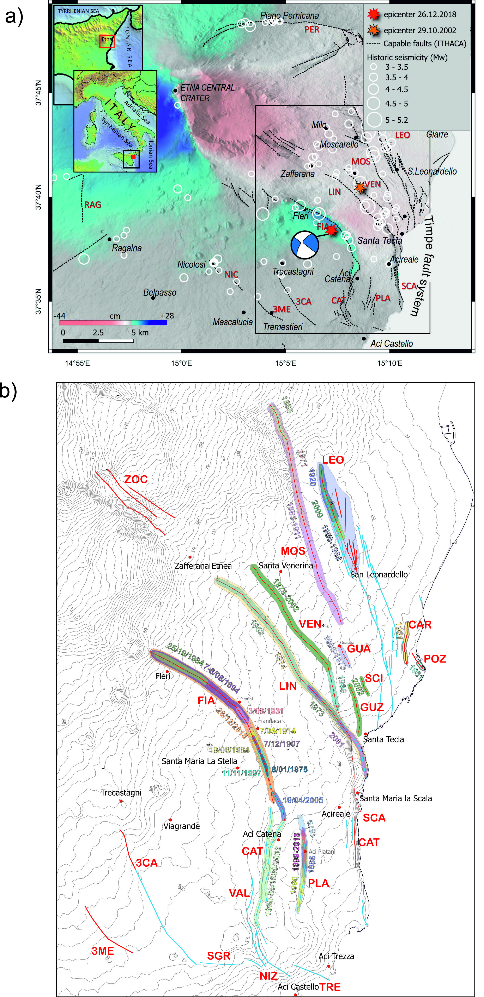
Figure 1: a) Regional capable fault map of M. Etna; the epicenters of the Nov. 10, 2002 (S. Venerina) and of the Dec. 26, 2018 (Fleri) earthquakes are reported together with historical seismicity (CPTI catalogue, Rovida et al. 2016); the black box indicates the extent of Figure 1b; b) zoom in on the Timpe Fault System: red traces map faults with stick-clip behavior, blue traces map mainly creeping faults; shaded areas encircle the fault segments that ruptured for earthquakes or creeped during well-defined events whose dates are reported with color-coded labels. Faults are labeled as follows: FIA: Fiandaca; CAT: Acicatena; PLA: Aci Platani; VEN: Santa Venerina; NIC: Nicolosi; MAS: Massanunziata, SGR: San Gregorio; NIZ: Nizzeti; TRE: Aci Trezza; 3ME: Tremestieri; 3CA: Trecastagni; VAL: Valverde; SCA: Santa Maria la scala; CAT: Santa Caterina; GUZ: Guzzi; SCI: Scillichenti; POZ: Pozzillo inferiore; CAR: Casa Carpinati; GUA: Guardia; LIN: Linera; MOS: Moscarello; LEO: San Leonardello; ZOC: Sistema M.te Zoccolaro; FIU: Fiumefreddo; PER: Pernicana.
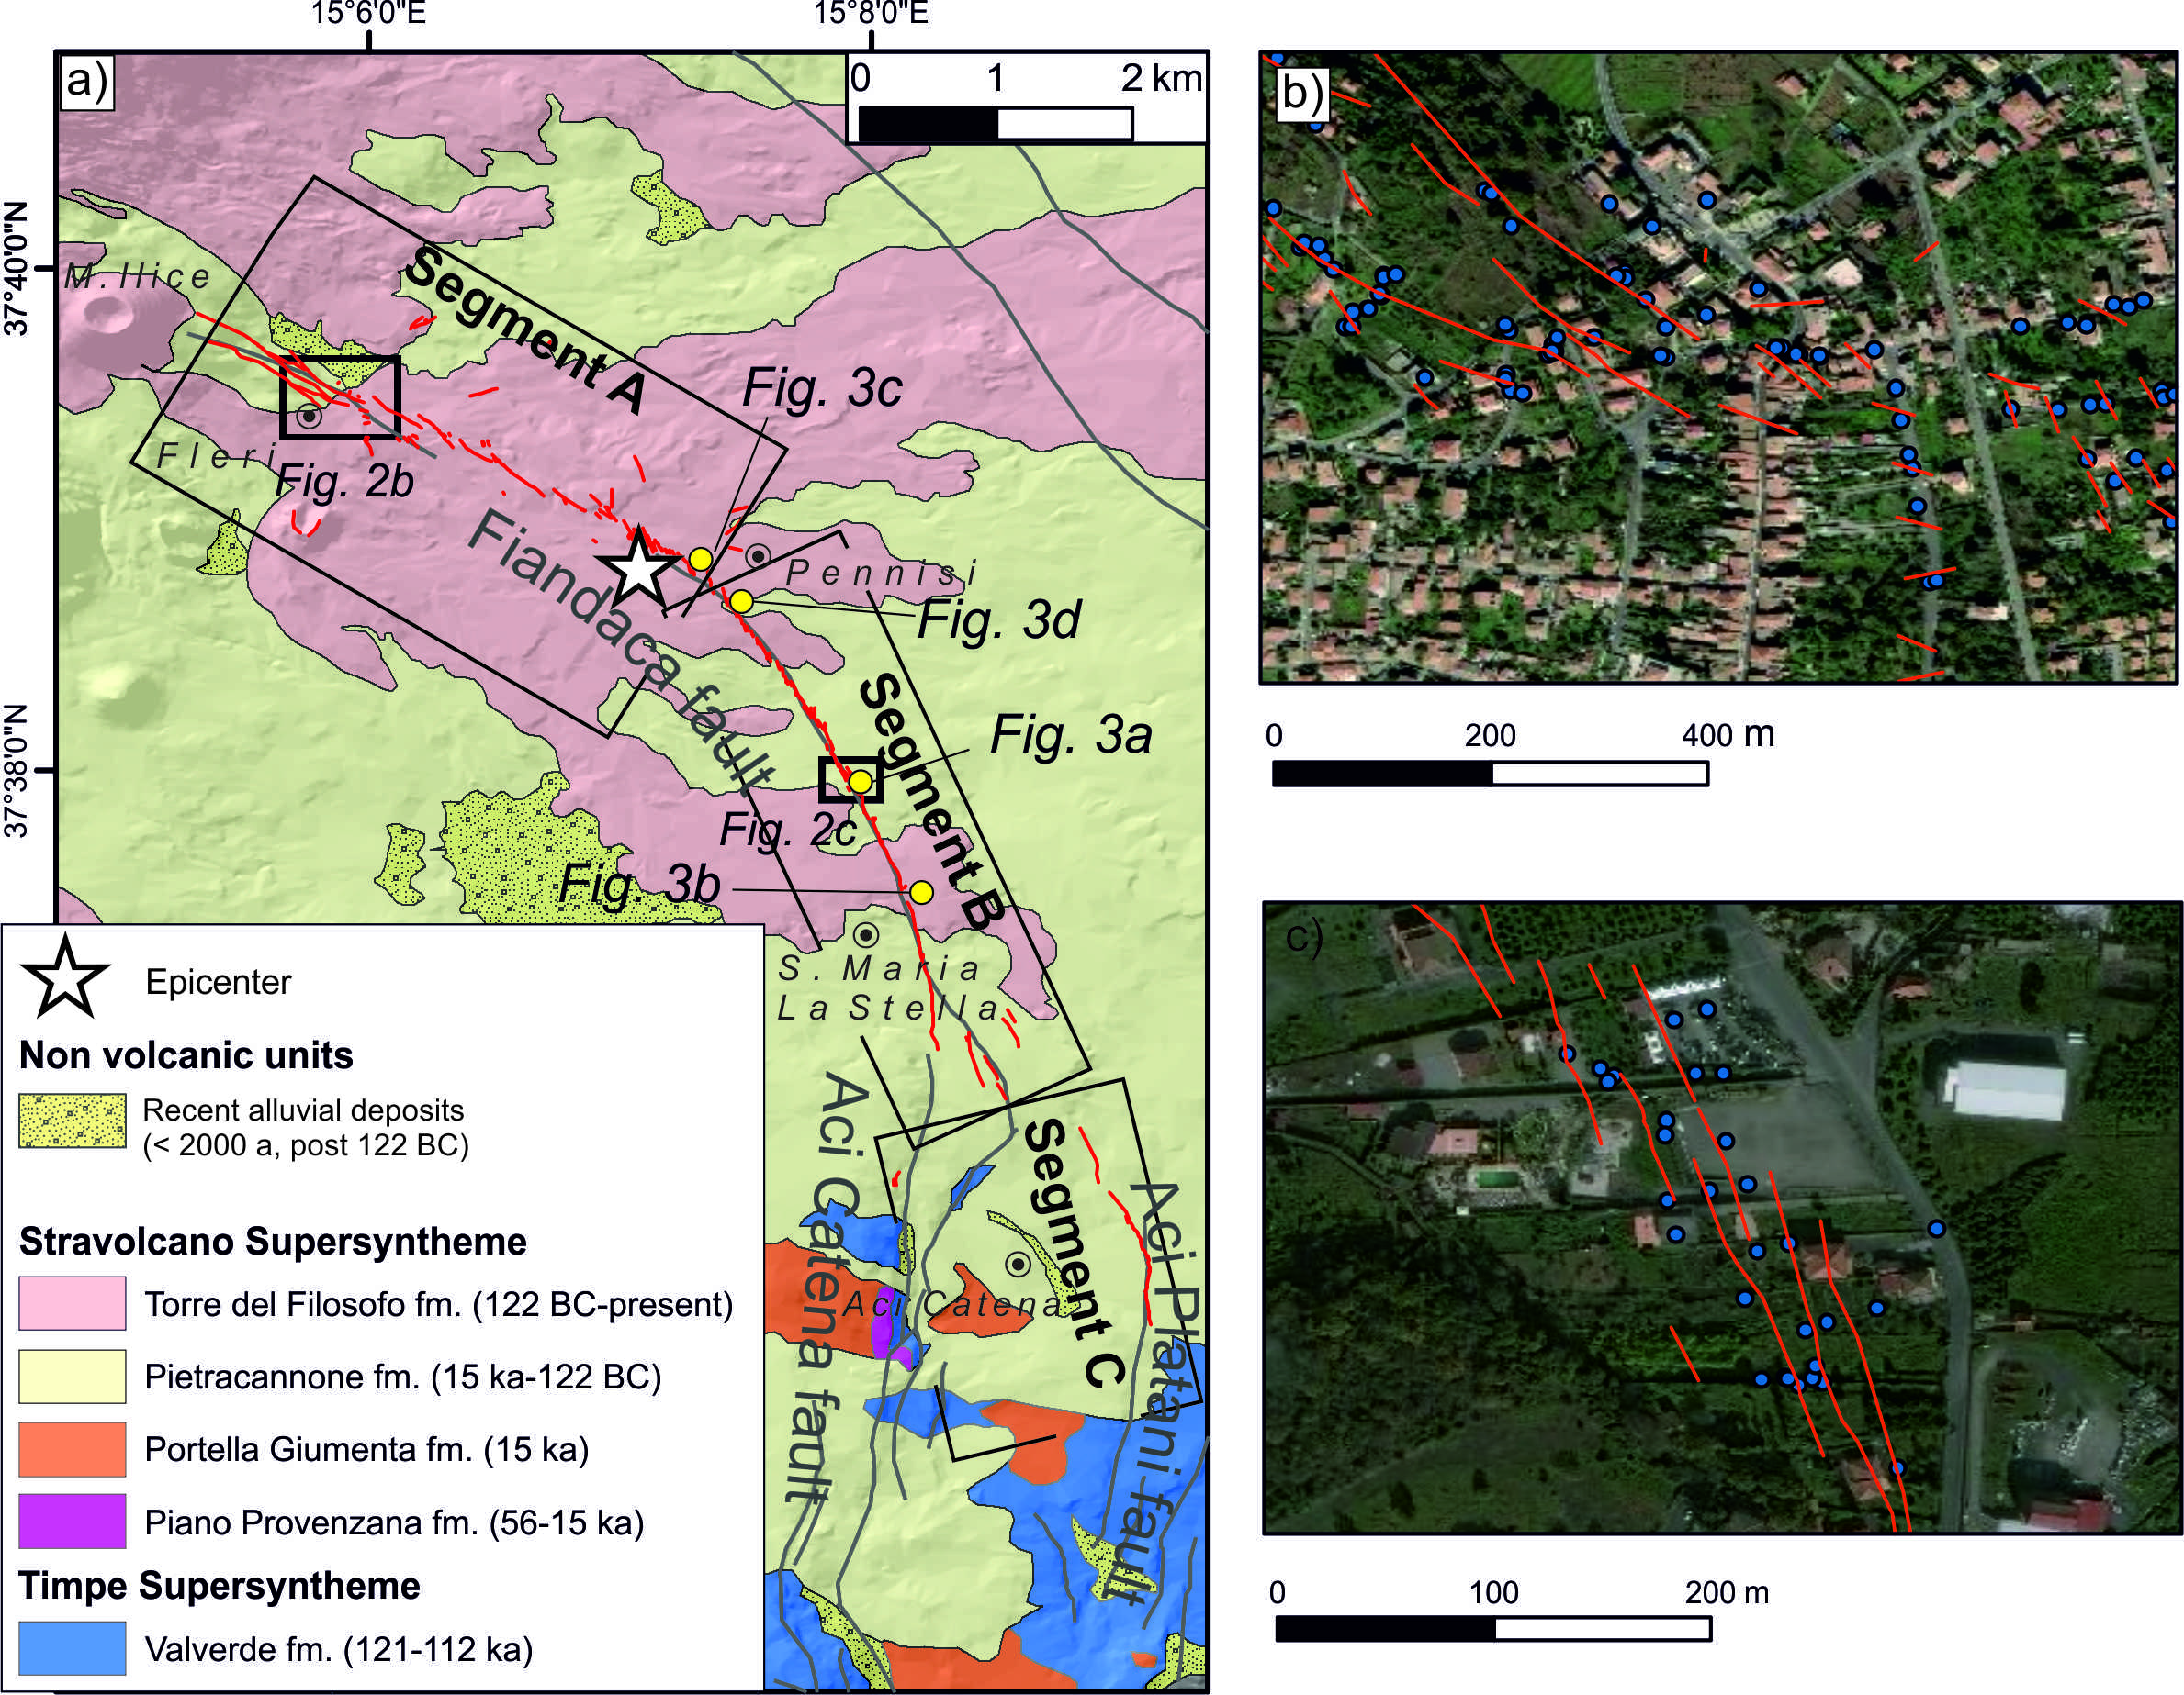
Figure 2: a) Geological basemap¹⁹ and ground breaks mapped after the 2018 earthquake: grey lines are capable faults (source ITHACA database), red lines are the trace of the ground ruptures for the 2018 event, the rectangle enclose the extent of the three segments we adopted for discussing and analyzing the data distribution (see text for details), location of photos in Figure 3 are also reported; b) zoom on the Fleri area and (c) on the Pennisi – Santa Maria la Stella area; blue dots represent point data including structural and geometrical measurements.
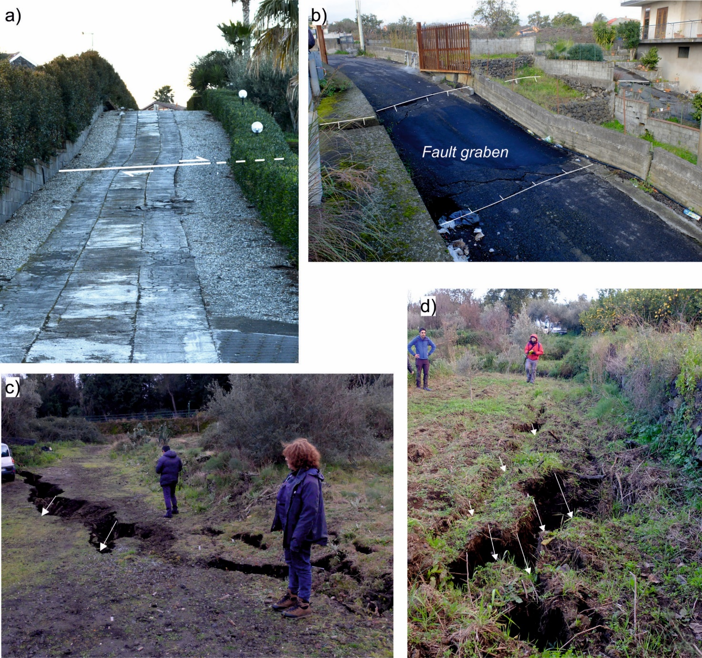
Figure 3: Field photos of ground cracks: a) a mainly dextral fault strand whose coseismic slip is highlighted thanks to the paved road; b) main and antithetic faults delimiting a locally lowered sector (fault graben); c) and d) examples of ground ruptures with identified piercing points for the measurement of slip vectors. Location is shown in Figure 2.
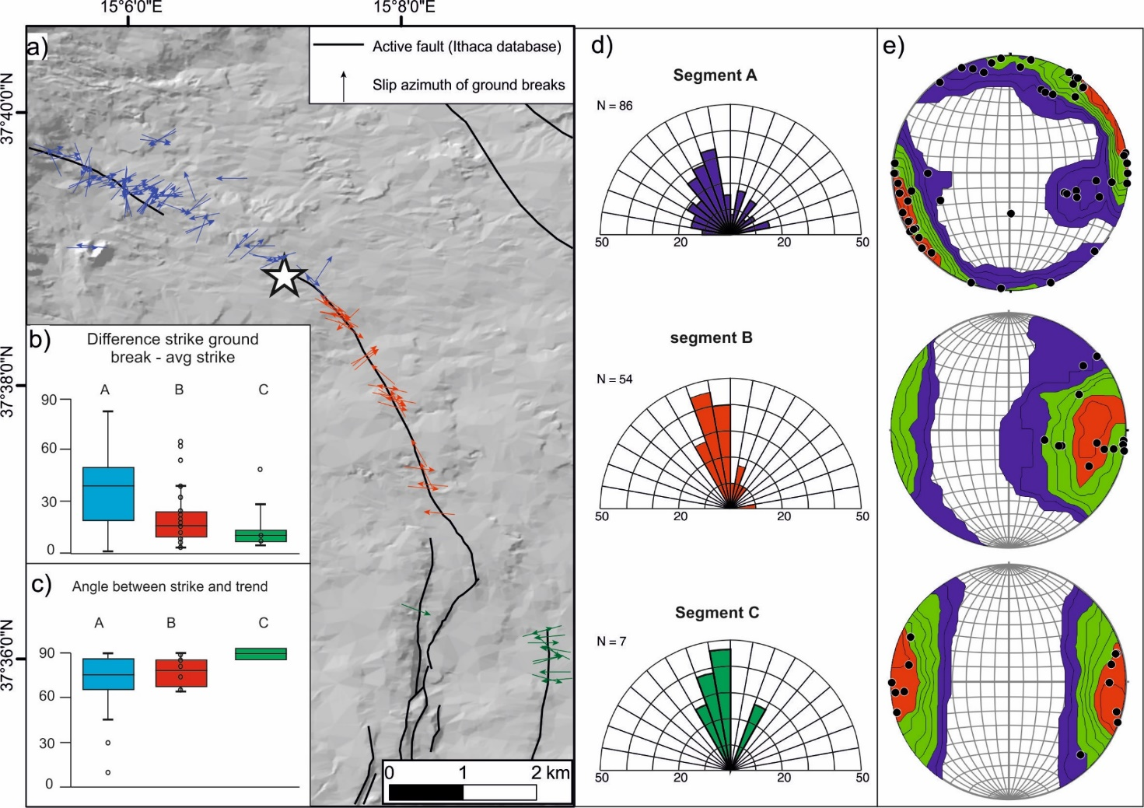
Figure 4: a) map of the slip azimuth of ground breaks. b) boxplot showing the difference between the strike of mapped ground breaks and the average strike of each segment. c) boxplot showing the angle between the strike of ground breaks and the trend of slip vectors. d) strike of mapped ground breaks. e) slip vectors mapped along the three segments.
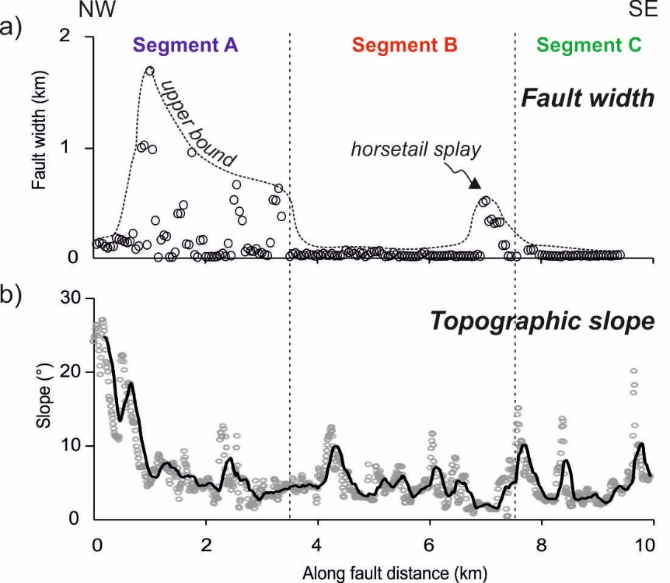
Figure 5: Along-strike variation of fault width (a) and corresponding topographic slope data (b) with a moving average line (20 points); see the methods section for a description of data extraction. Dotted lines represent the approximate upper bound of the dataset; the extension of the three segments is also shown.
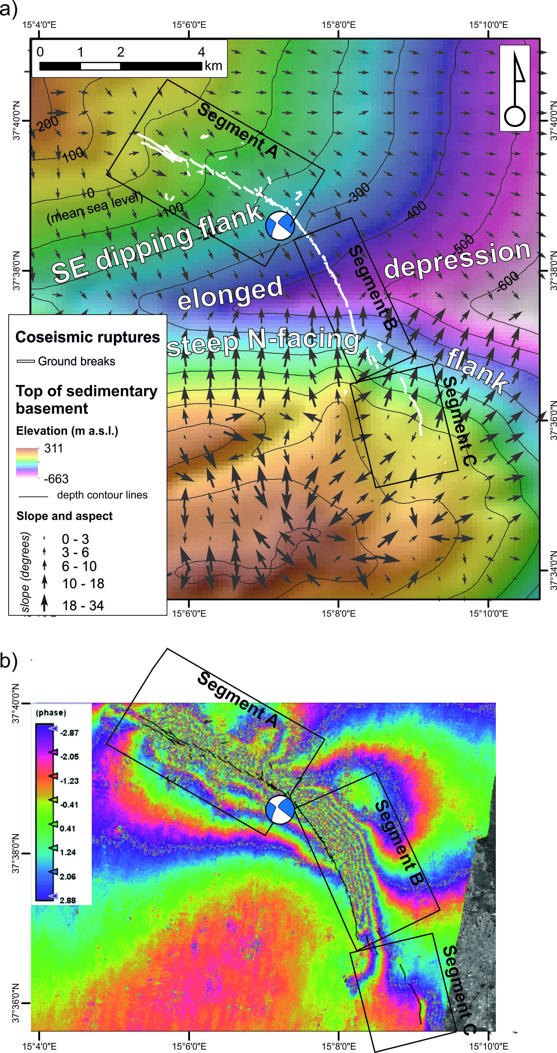
Figure 6: A) ground breaks projected onto the shaded relief model of the top of basement²⁰; arrows indicate aspect and slope of the surface; b) ground breaks and InSAR detected coseismic deformation field (line of sight – LOS).
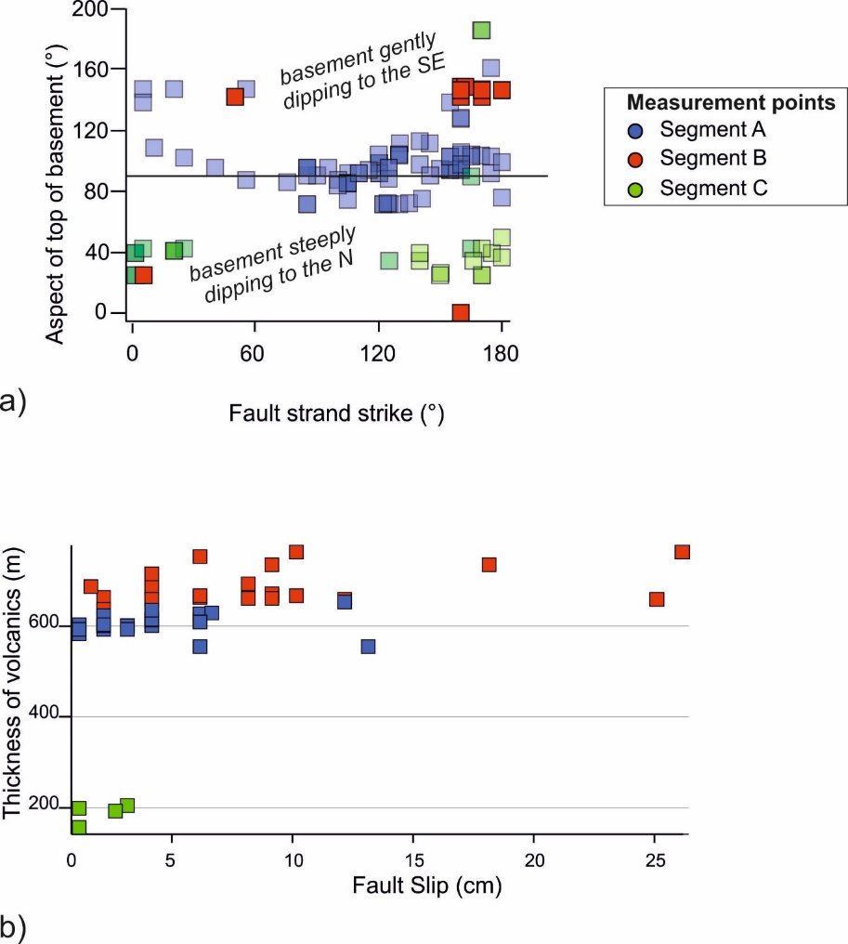
Figure 7: a) fault strand strike versus the aspect direction of the top of basement; b) fault slip versus thickness of the volcanic complex overlying the basement.

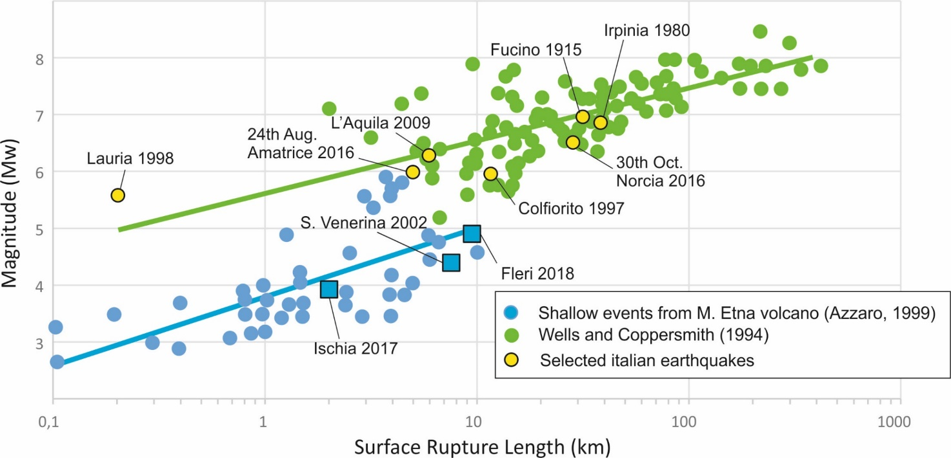
Figure 8: Magnitude plotted versus surface rupture length: shallow seismic events from the Etna volcano (after Azzaro, 1999) compared with the data from published works ⁶² and selected Italian earthquakes. In this graph we included also the August 21, 2017, Ischia earthquake - Mw 3.9 ⁶¹ and the October 29, 2002, S. Venerina earthquake ¹⁵ (Mw 4.4).

