Nowcasting submarine slope instability at local, margin, and global scales using machine learning

Jeffrey Obelcz, Warren T. Wood, Benjamin J. Phrampus, Taylor R. Lee
U.S. Naval Research Laboratory

Abstract
Submarine slope instability (SSI) is a broad term for events ranging from 100 km³ instantaneous open slope failures on continental margins to 0.001 km³ creeping mudflows on heavily sedimented river deltas. SSI events such as the 2018 Sunda Strait and 1929 Grand Banks submarine landslides extract high societal tolls, yet SSI predictive capability is limited. SSI observational studies are resource intensive and cover small areas, necessitating a method for estimating SSI geohazard potential where it is not measured. Here we use machine learning and a compilation of SSI observations and predictors to make the most comprehensive geospatial SSI predictions, or nowcasts, to date. Nowcasts on regional (100 km²) to global spatial scales identify SSI hotspots on glaciated and volcanic margins (global), offshore of lowstand depocenters (margin), and mudflow gullies on the Mississippi River Delta (regional). Global SSI nowcasts, normalized by total sediment deposited since the start of the Pleistocene (2.58 Ma), show that passive margins are on average composed of approximately twice as much SSI-derived sediment compared to active margins, affirming the prominent role seismic strengthening plays in millennial-scale slope stability. We also demonstrate the particular suitability of time-series bathymetric surveys for training SSI predictions in instability-prone areas; using machine learning prediction to interpolate between resurvey transects can decrease the necessary data volume required for hazard assessment by a factor of three.

Introduction
Submarine landslides, debris flows, and mudflows are all examples of submarine slope instability (SSI). SSIs can rapidly transport enormous volumes of sediment (> 100 km³) downslope¹, and trigger secondary turbidity currents and tsunamis². SSIs have a wide range of preconditioning and triggering factors for different geologic, oceanographic, and geographic settings³, therefore warning and monitoring systems akin to earthquake-generated tsunamis are unlikely to be developed soon. The Sunda Strait 2018 submarine landslide and ensuing tsunami killed over 400 largely due to no advance warning⁴. Our capability to predict SSIs lags behind terrestrial landslide hazard assessment despite the high societal toll. SSIs are also one of the most important sediment transport agents on the planet; large, infrequent SSIs can transport in one hour as much sediment as all rivers do in a year².

Despite their destructive potential and key role in source-to-sink sediment dynamics, location and magnitude of SSIs are relatively unconstrained³. SSIs are difficult to observe in real time⁵ and leave ambiguous and impermanent evidence⁶. Despite this, recent advances in seafloor and subsurface mapping techniques, including multibeam sonar and 3-D seismic reflection profiling, have enabled data-driven efforts to predict SSI location and/or magnitude^{7,8}. These efforts are generally exploratory in nature and drastically lag behind the data-rich and mature terrestrial slope instability prediction field⁹.

Here we present a scale-agonistic probabilistic framework for geospatially predicting, or nowcasting, the probability and magnitude of SSIs. We demonstrate this capability on regional (~100 km² domain, 0.01 km² cell size), margin (~10⁶ km² domain, 1 km² cell size), and global (5 arc-minute cell size) scales. We use the k-nearest neighbors machine learning algorithm to find correlations between SSI observations and predictors known or suspected to control SSI distribution. These nowcasts serve as the most comprehensive predictions of SSI location and magnitude to date, and substantially narrow the geospatial prediction gap between terrestrial and SSIs.

Nowcasting Submarine Slope Instability
The U.S. Naval Research Labratory’s Global Predictive Seabed Model is the framework we use to generate SSI nowcasts from a wide range of observations and predictors (Table 1; Table M1). We use machine learning algorithms (here, k-nearest neighbor) to develop best-fit relationships between sparse observations and full-coverage predictors. Depth change between repeat bathymetric surveys is used as training and validation data for regional scale predictions (Mississippi River Delta Front; MRDF), an area with a priori knowledge that depth change is primarily controlled by seabed instability¹⁰. For margin and global scale SSI nowcasts, repeat survey data is too sparse, so SSI morphologic evidence (landslide scarps, mass transport deposits) of roughly Pleistocene age (2.58 Ma) or younger derived from bathymetric and subsurface data is used instead. K-nearest neighbor requires both presence and absence data to make accurate nowcasts; SSI “absences” were generated using geologic intuition because SSI studies with negative results are rarely published.

Predictors of SSIs were dictated by availability and predictor-SSI relationships established in the literature (Table M1). For regional MRDF predictions, morphology, sediment shear strength, and sedimentation rate were identified as important factors for seabed instability¹¹. At the margin scale, river sediment discharge (proxy for sedimentation rate), seabed lithology, and thickness of key stratigraphic packages have been identified as controls on slope stability¹². A large library of physical, chemical, biological, and geological oceanographic predictors was used (described in Lee et al., 2019¹³) for global predictions. For more details on data acquisition and processing, prediction algorithms, uncertainty, and assumptions, see the methods section.

Table 1: Summary of observational data used for training and validation of SSI nowcasts.
Observational Data | Prediction Scale | Observations in Dataset | Data Range | Source
Difference of Depth (2005-2017), Mississippi River Delta Front Southwest Pass | Regional, 0.001 km² grid spacing | 334439 (1% or 3344 used for training predictions shown) | -4 – 6 m | ^{14,15}
Submarine landslide scarps, US Atlantic Margin | Margin, 1 km² grid spacing | 141 | 0.002 – 178.9 km³ | ¹⁶
Global submarine landslide deposits | Global, 5 arc-minute grid spacing | 293 | 0.0002 – 25500 km³ | ¹⁷
Submarine landslide scarps, Gulf of Mexico | Global | 313 | 0.0006 – 10.4 km³ | ¹⁸
Global submarine landslide scarps | Global | 979 | 0.0001 – 7.7 km³ | ⁷

Hotspots of Seabed Instability
Nowcasts at all spatial scales show distinct location trends in SSI probability and magnitude. At the global scale, SSI probability is unsurprisingly highest at continental shelf edges (Fig. 1); continental slopes are typically steep and heavily sedimented, two important predictors of slope failure³. Volcanic provenances and the Southwest Pacific demonstrate the highest probability of SSI occurrence, as well as the North Atlantic Ocean in the vicinity of Scandinavia and Greenland.

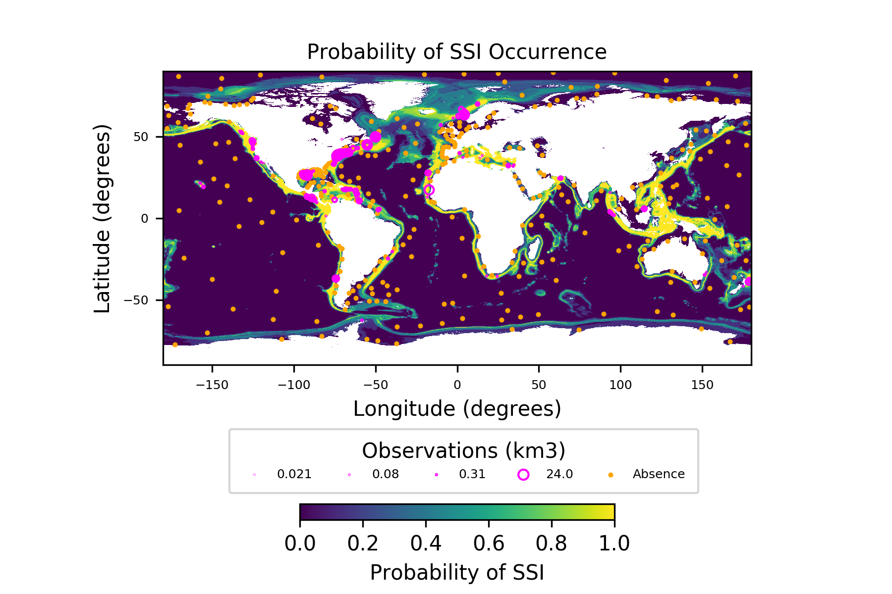
Figure 1: Predicted probability of SSI occurrence since the start of Pleistocene (2.58 Ma), global domain and 5 arc-minute grid cell size. Hot colors indicate high probability of SSIs, cool colors low. Pink circles are SSI observations < 25 km³, orange circles are synthetic SSI absences produced using geologic intuition. High probabilities of SSI occurrence are predicted along most continental margins, particularly in the Southwest Pacific, at polar latitudes, and on volcanic provenances.

The nowcast of the U.S. Atlantic continental margin (Fig. 2A) shows high SSI probability at the shelf edge and upper slope, gradually decreasing onto the lower slope and continental rise. Predicted volume of SSI-derived sediment varies along the margin (Fig. 2B) and is highest (12.9 km³ mean SSI volume) in the Carolina Trough offshore of lowstand depocenters fed by the paleo-James and Roanoke Rivers, and lowest offshore Georges Bank (3.3 km³ mean SSI volume).

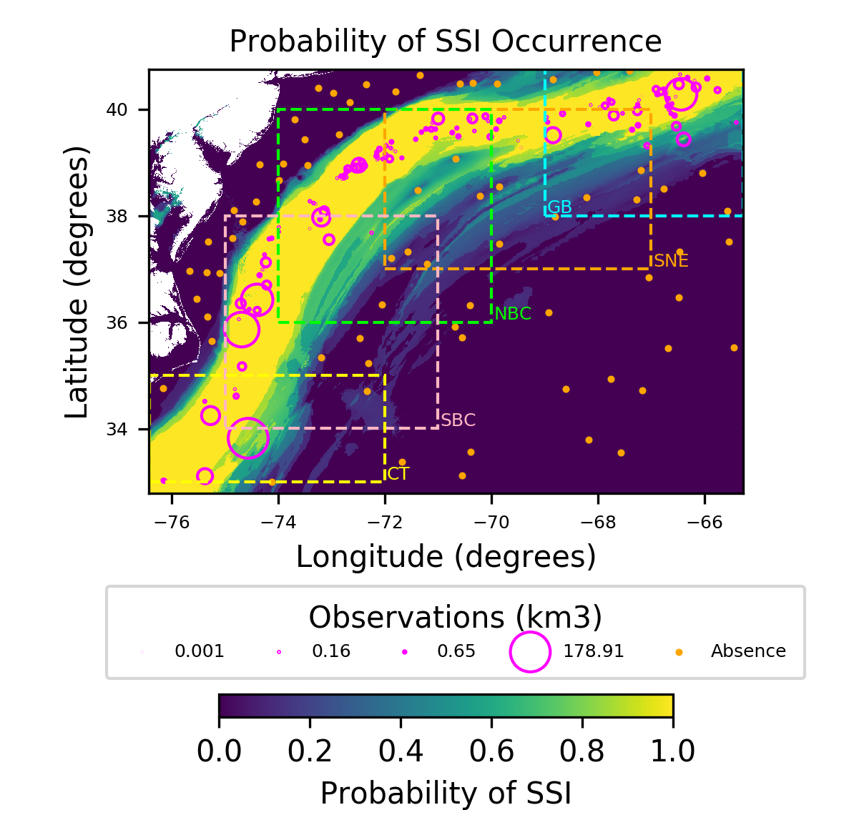
Figure 2A: Probability of SSI occurrence since the start of Pleistocene (2.58 Ma), US Atlantic Margin domain and 1 km² grid cell size. Hot colors indicate high probability of SSIs, cool colors low. Pink circles are SSI observations, orange circles are synthetic SSI absences produced using geologic intuition. Colored boxes indicate geographic provenances of the US Atlantic Margin as demarcated by Chaytor et al., 2009: Georges Bank (GB), Southern New England (SNE), North Baltimore Canyon Trough (NBC), South Baltimore Canyon Trough (SBC), and Carolina Trough (CT).
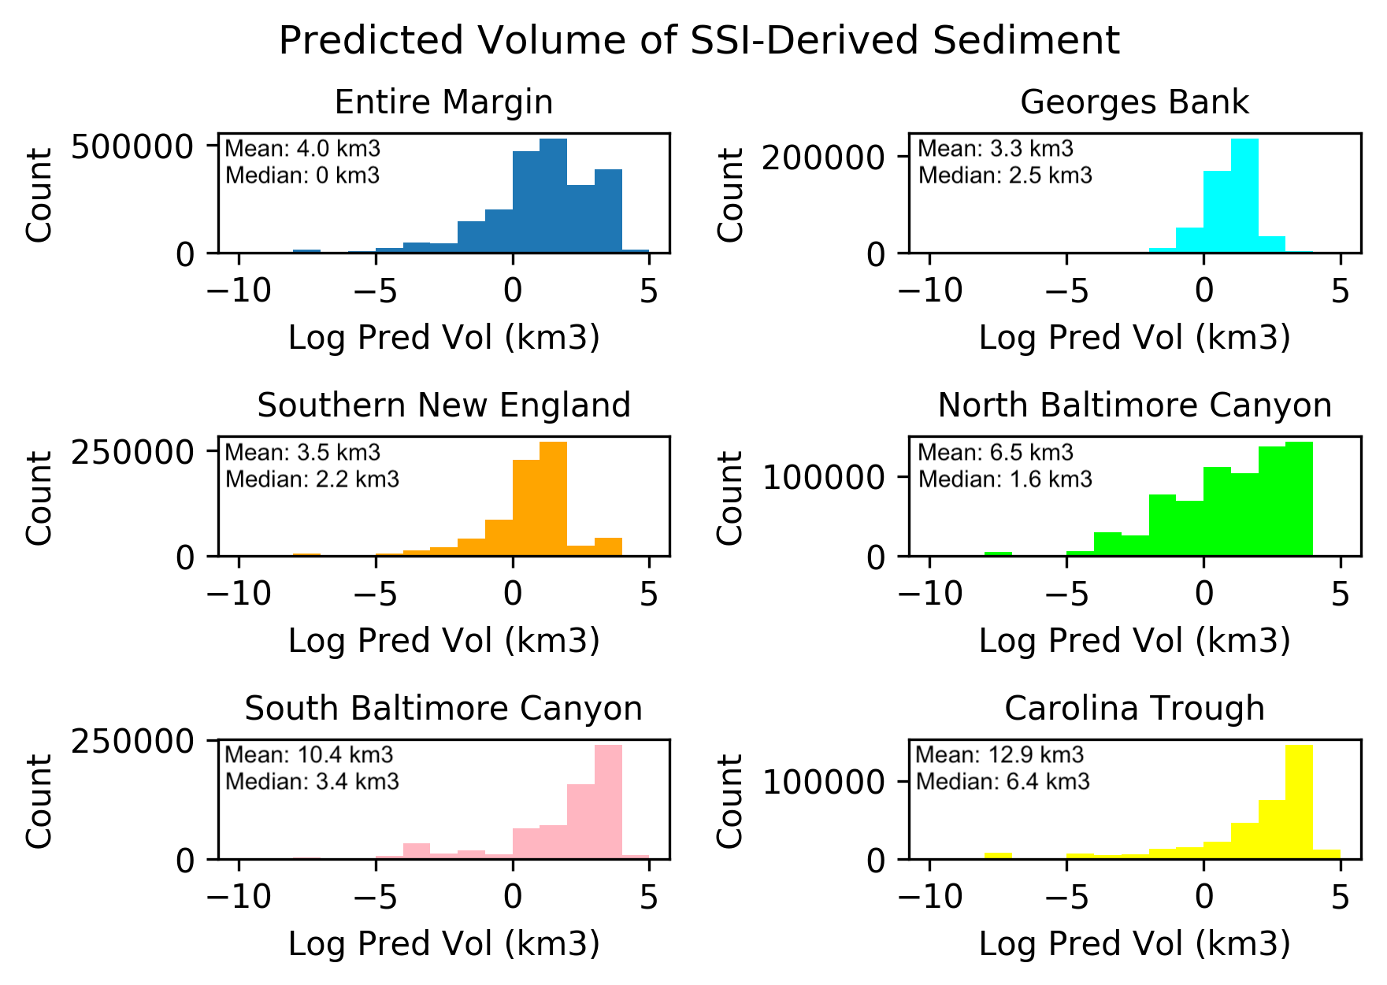
Figure 2B: Histograms of predicted SSI-derived sediment volume for U.S. Atlantic margin geographic regions demarcated in Fig. 2A. Predicted SSI volume increases southward, with the highest volume predicted in the Carolina Trough and South Baltimore Canyon Trough regions.

On the regional (~100 km² domain, 0.01 km² grid cells) scale, nowcasts trained on 1% of depth change data between 2005 and 2017 at the MRDF Southwest Pass yield realistic predictions of SSI-attributed depth change (Fig. 3A). Depth change maxima were predicted within mudflow gullies and lobes, dynamic areas where sediment creeps downslope in a quasi-continuous manner. The mudflow areas also exhibited the largest residual between predicted and observed values (Fig. 3B), and in fact SSI magnitude was generally positively correlated with prediction error and uncertainty at all scales.

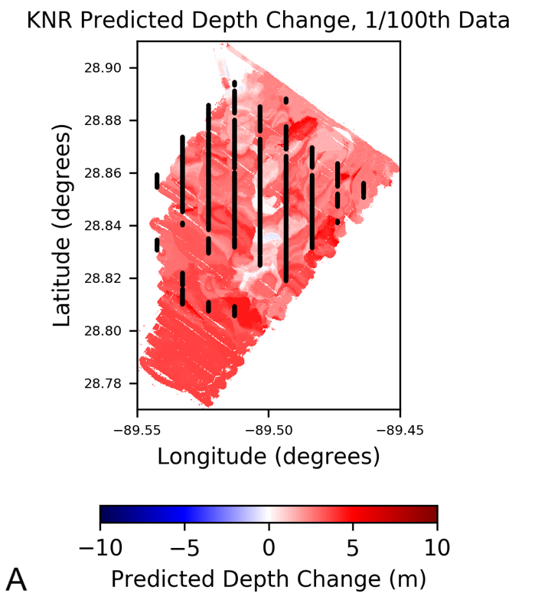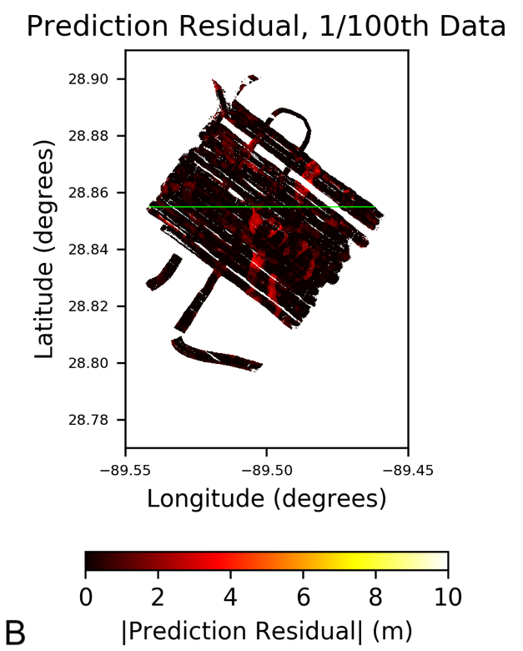
Figure 3A: Predicted depth change (2005-2017) as a proxy for SSI, MRDF Southwest Pass. Prediction trained on 1% of available data in the form of 1-D vertical transects (black lines). Figure 3B: Absolute value of prediction residual. Predictions had larger error in areas of greater depth change (SSI magnitude), i.e. mudflow gullies. Green line is location of Fig. 5B.

Tectonic Setting Governs Global Distribution of Seabed Instabilities
Global estimates of total sediment deposited since the beginning of the Pleistocene (2.58 Ma) made by Lee et al. (in prep, see methods for details) are used here to calculate the percentage of total sediment derived from SSIs. In particular, global SSI volume predictions are parsed into active and passive margin provenances¹⁹ (Fig. 4A) to assess the millennial-scale role of seismic strengthening in seabed stability. Seismic strengthening occurs when high frequency but low magnitude seismicity characteristic of convergent margins decreases porosity and thereby increases sediment shear strength²⁰.

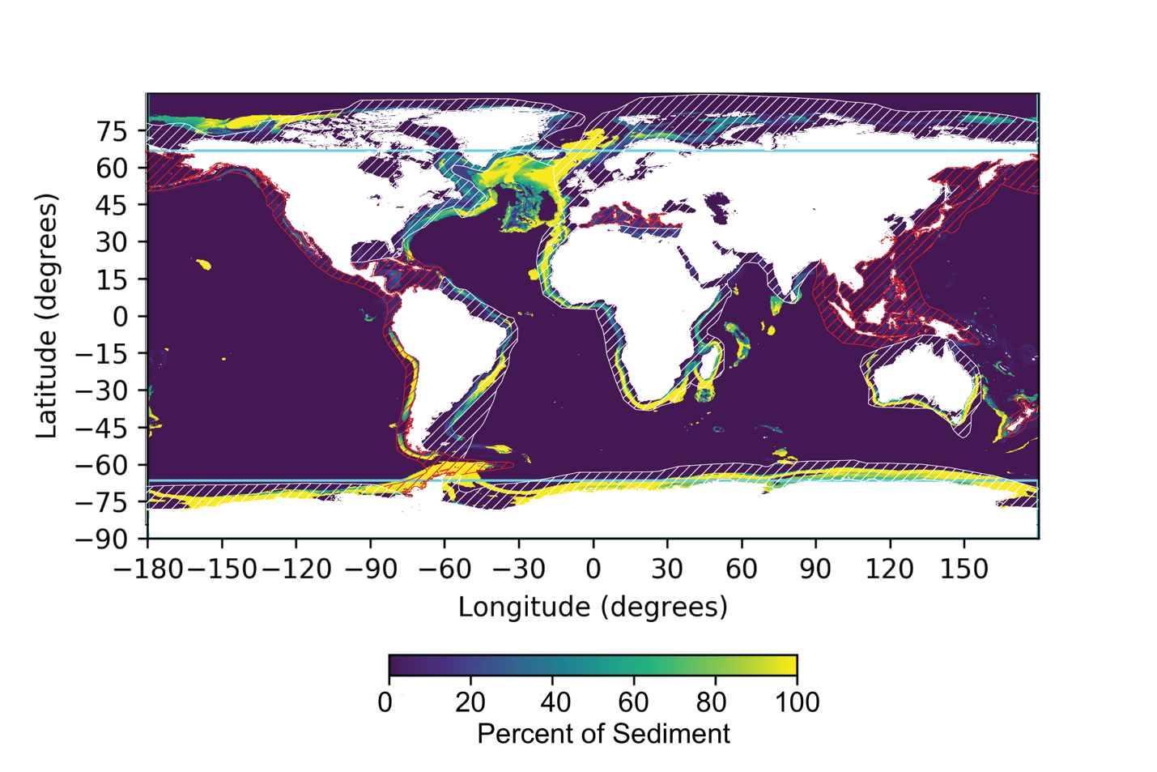
Figure 4A: Global prediction of SSI-derived percent of total sediment volume deposited since the start of the Pleistocene (2.58 Ma), 5 arc-minute grid cell size. Light blue lines demarcate polar latitudes (> | 66.5 deg |), red hatched regions represent active margins, white hatched regions represent passive margins.
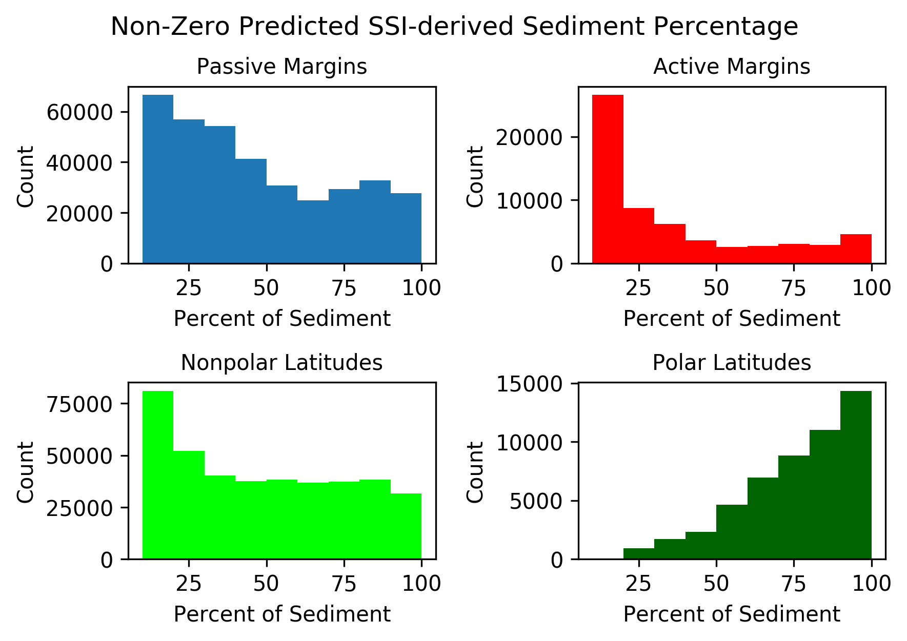
Figure 4B: Predicted SSI-derived sediment percentages deposited since 2.58 Ma for geologic/geographic regions demarcated in Fig. 4A. Passive and polar regions have a notably larger amount of high SSI percentage cells than active and nonpolar regions, respectively. 0-10% SSI percentage bin not shown as it is uniformly high for all regions.

Histograms of passive and active margin SSI-derived sediment percentages (Fig. 4B) show passive margins are on average constructed from more than twice the volume of SSI-derived sediment than active margins since the start of the Pleistocene (2.58 Ma). This is despite the uniformly high predicted probability of SSI on both active and passive margins (Fig. 1). The combination of high SSI probability but relatively low SSI-derived sediment volume on active margins is likely related to geologically frequent but relatively small-magnitude slope failures triggered by earthquakes and preconditioned by generally steeper margin gradients⁷. Conversely, passive margin sediments are not seismically strengthened, and are therefore prone to open slope failures many orders of magnitude larger than frequent active margin failures²⁰. These SSIs are instead triggered by infrequent shaking related to glacial isostatic adjustment¹, gas hydrate dissociation²¹, or salt tectonics²².

Machine Learning To “Resurvey” Instability-Prone Regions
Depth change can be quantified with repeat bathymetric surveys to assess seabed stability²³; this method is accurate but time-consuming and expensive. Nowcasts of depth change in SSI-prone regions (Fig. 3A) trained on a small fraction (here, 1% of predicted area) of depth change data are highly accurate (Fig. 5A). Prediction accuracy increases with training data density, with diminishing returns beyond 10% of data provided (Fig. 5B).
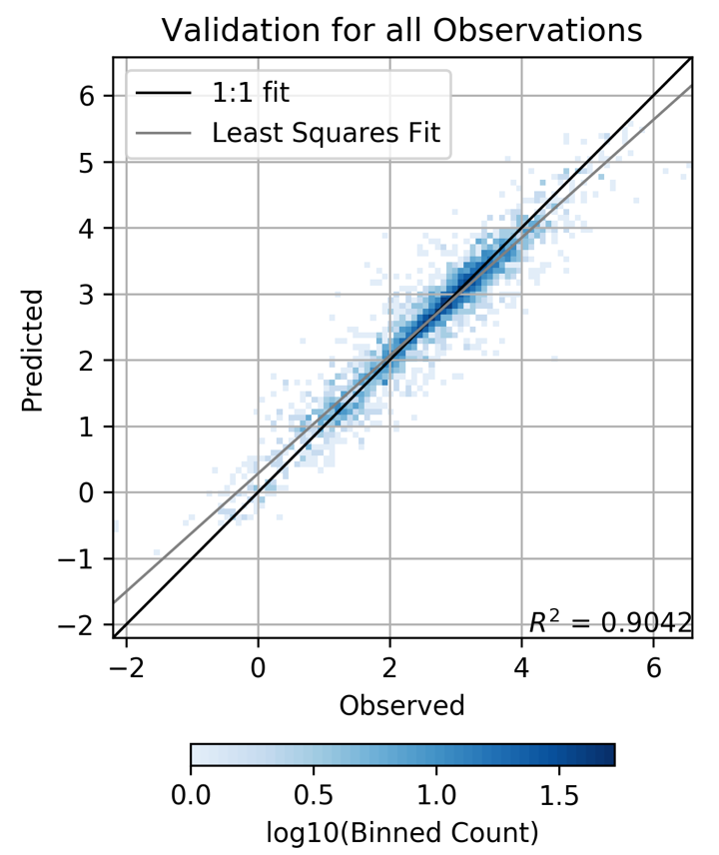
Figure 5A: Ten-fold cross validation of MRDF depth change prediction trained on 1% of survey area data (Fig. 3A).
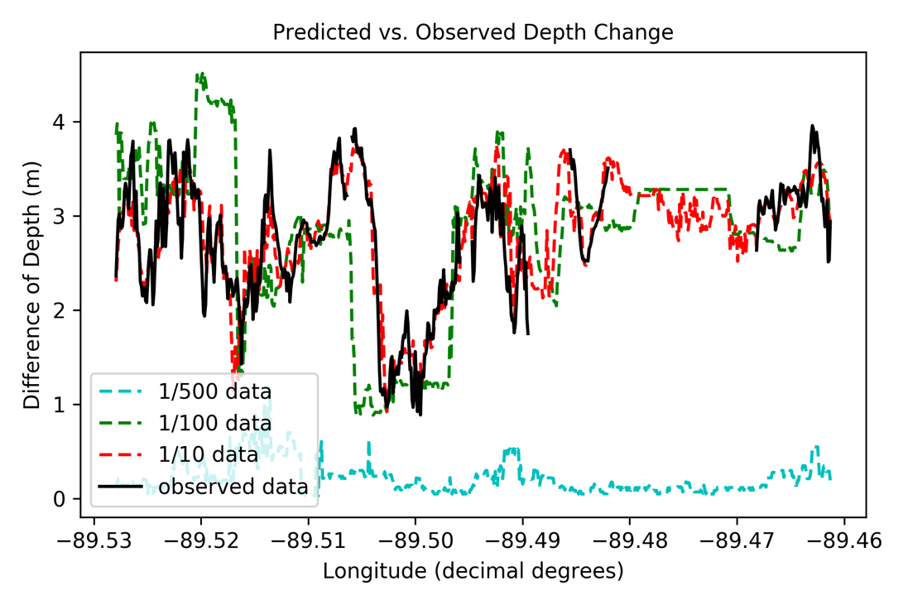
Figure 5B: Latitudinal transects across MRDF regional SSI prediction domain, location shown in Fig. 3B. Black line is observed depth change, while dashed lines are predictions given various data densities, from least (1/500th) to most (1/10th) dense. Predictive skill increases with data density, but converge with actual depth change around 1/10th data provided.

Training data were most effective as regularly spaced 1-D transects (Fig. 3A), emulating a singlebeam echosounder resurvey of a full-coverage multibeam initial survey. Provided the prediction uncertainty and error is acceptable for the required application, machine learning can be used to reduce required data for “remapping” (acquiring 1-D transects and then utilizing machine learning algorithms to interpolate between them) SSI-prone regions by a factor of three. This approach may or may not be applicable to regions where SSI is not strongly correlated with seabed morphology.

A Path Forward for Predicting Submarine Slope Instability
Our nowcasts integrate many observations from past SSI studies into the first multi-scale comprehensive and quantitative SSI assessment. The nowcasts identify areas of high predicted SSI probability and magnitude in polar and volcanic provenances on the global scale, offshore paleo-rivers on the margin scale, and within mudflow zones on the regional scale. SSI nowcasts are not substitutes for future investigation, but rather a “placeholder” and best estimate in lieu of measurements or deterministic models everywhere.

SSI nowcasts are data-driven predictions and the most direct route to more skilled and certain outputs is higher quantity and quality observed data. The global distribution of SSI observations is skewed towards larger events that leave persistent evidence and are observable with 20th century technology. Now that multibeam and chirp sonars are near-ubiquitous research vessel equipment, the bottleneck for rapid SSI catalogue expansion is the time-intensive and subjective digitization of SSI features from bathymetry and seismic profiles. Methods for the automated extraction of SSI morphologic evidence, including scarps and debris fields, have been demonstrated as proofs of concept²⁴ and should be developed further. Another obstacle to better SSI nowcasts is the almost complete lack of absence data, i.e. areas identified as being instability-free over a defined time range. The generation of synthetic absence data using geologic intuition was necessary for this effort but serves as a large uncertainty source.

In the short-term a path forward for integrating our findings into SSI-related geohazard assessment is nested SSI nowcasts augmented with repeat bathymetric transect resurveys. In this model, a margin scale nowcast (Fig. 2A) would identify SSI hotspots, and hotspot areas would then be nowcasted at higher spatial resolution (Fig. 3A). Periodic fast, inexpensive resurveys using sparse bathymetric transects (multibeam or singlebeam echosounder) would be interpolated using machine learning algorithms, providing updated SSI maps at regular intervals. This approach does not require dedicated oceanographic research platforms or supercomputing resources, making it particularly suitable for emergent countries vulnerable to SSI-related geohazards such as Indonesia, Malaysia, and the Philippines.

Geohazard Implications
Seismic strengthening has been implicated as the primary cause for greater prevalence of landslide scars on passive margins compared to active ones²⁰. We demonstrate that this phenomenon is persistent over millennial timescales and global extent (Fig. 4B). The confirmation that passive margins are much more prone to potentially tsunamigenic catastrophic (volume > 100 km³) slope failures should prioritize understudied passive margins such as Southern Australia²⁵ and Eastern Greenland²⁶.

One significant predictor not included in this effort due to lack of global measurements is a metric of gas hydrate stability. Gas hydrate dissociation related to glacial-interglacial transitions is an important triggering mechanism for massive slope failures²¹. While bottom water temperature change related to anthropogenic climate change is unlikely to destabilize deep (<1000 m) gas hydrates²⁷, the decadal-scale potential for shallow gas hydrate dissociation in SSI-prone areas like the Arctic (Fig. 4B) should prioritize their investigation. Predictors related to gas hydrate stability zone migration potential may be necessary to make skilled high-resolution SSI nowcasts in these regions.

Acknowledgements
This research effort was heavily supported by the submarine slope instability community. Initial planning and idea development was aided by consultations with Laura Brothers, Jenna Hill, Morelia Urlaub, Jaime Hizzett, and Derek Sawyer. Data were provided, either through publication or direct sharing, by Jason Chaytor, Uri ten Brink, Gauvain Weimer, Greg Keller, and Lorena Moscardelli. Informal manuscript reviews by Jillian Maloney, Patrick Robichaux, and Elena Steponaitis greatly improved quality and clarity.

References Cited
1. Bryn, P. et al. The Storegga Slide Complex; Repeated Large Scale Sliding in Response to Climatic Cyclicity. in Submarine Mass Movements and Their Consequences (eds. Locat, J., Mienert, J. & Boisvert, L.) vol. 19 215–222 (Springer Netherlands, 2003).
2. Talling, P. J. On the Triggers, Resulting Flow Types and Frequencies of Subaqueous Sediment Density Flows in Different Settings. Mar. Geol. (2014) doi:10.1016/j.margeo.2014.02.006.
3. Masson, D. G., Harbitz, C. B., Wynn, R. B., Pedersen, G. & Løvholt, F. Submarine landslides: processes, triggers and hazard prediction. Philos. Trans. R. Soc. Math. Phys. Eng. Sci. 364, 2009–2039 (2006).
4. Grilli, S. T. et al. Modelling of the tsunami from the December 22, 2018 lateral collapse of Anak Krakatau volcano in the Sunda Straits, Indonesia. Sci. Rep. 9, 11946 (2019).
5. Gwyn Lintern, D., Mosher, D. C. & Scherwath, M. Advancing from subaqueous mass movement case studies to providing advice and mitigation. Geol. Soc. Lond. Spec. Publ. SP477-2018–190 (2019) doi:10.1144/SP477-2018-190.
6. McAdoo, B. G., Pratson, L. F. & Orange, D. L. Submarine landslide geomorphology, US continental slope. Mar. Geol. 169, 103–136 (2000).
7. ten Brink, U. S., Andrews, B. D. & Miller, N. C. Seismicity and sedimentation rate effects on submarine slope stability. Geology 44, 563–566 (2016).
8. Piedade, A., Alves, T. M. & Zêzere, J. L. A new approach to assess ancient marine slope instability using a bivariate statistical method. Mar. Geol. 401, 129–144 (2018).
9. Chen, W. et al. Spatial prediction of landslide susceptibility using an adaptive neuro-fuzzy inference system combined with frequency ratio, generalized additive model, and support vector machine techniques. Geomorphology 297, 69–85 (2017).
10. Obelcz, J. et al. Sub-decadal submarine landslides are important drivers of deltaic sediment flux: Insights from the Mississippi River Delta Front. Geology 45, 703–706 (2017).
11. Maloney, J. M. et al. Mississippi River subaqueous delta is entering a stage of retrogradation. Mar. Geol. 400, 12–23 (2018).
12. Hill, J. C. et al. Geologic controls on submarine slope failure along the central U.S. Atlantic margin: Insights from the Currituck Slide Complex. Mar. Geol. 385, 114–130 (2017).
13. Lee, T. R., Wood, W. T. & Phrampus, B. J. A Machine Learning (kNN) Approach to Predicting Global Seafloor Total Organic Carbon. Glob. Biogeochem. Cycles 33, 37–46 (2019).
14. Walsh, J. P. et al. Mississippi Delta Mudflow Activity and 2005 Gulf Hurricanes. Eos Trans. Am. Geophys. Union 87, 477–478 (2006).
15. Baldwin, W. E., Ackerman, Seth D., Worley, Chuck R., Danforth, W. W. & Chaytor, J. D. High-resolution geophysical data collected along the Mississippi River Delta front offshore of southeastern Louisiana, U.S. Geological Survey Field Activity 2017-003-FA. https://www.sciencebase.gov/catalog/item/5a8c4bcbe4b00f54eb44044c.
16. Chaytor, J. D., ten Brink, U. S., Solow, A. R. & Andrews, B. D. Size distribution of submarine landslides along the U.S. Atlantic margin. Mar. Geol. 264, 16–27 (2009).
17. Moscardelli, L. & Wood, L. Morphometry of mass-transport deposits as a predictive tool. Geol. Soc. Am. Bull. B31221.1 (2015) doi:10.1130/B31221.1.
18. Bureau of Ocean Energy Management (BOEM). Seismic Water Bottom Anomalies Map Gallery. https://www.boem.gov/Seismic-Water-Bottom-Anomalies-Map-Gallery/.
19. Harris, P. T., Macmillan-Lawler, M., Rupp, J. & Baker, E. K. Geomorphology of the oceans. Mar. Geol. 352, 4–24 (2014).
20. Sawyer, D. & DeVore, J. R. Elevated shear strength of sediments on active margins: Evidence for seismic strengthening. Geophys. Res. Lett. 42, 10,216-10,221 (2015).
21. Nisbet, E. G. & Piper, D. J. W. Giant submarine landslides. Nature 392, 329–330 (1998).
22. Akinci, L. & Sawyer, D. Deriving the Rate of Salt Rise at the Cape Fear Slide Using New Seismic Data. in Submarine mass movements and their consequences (ed. G. Lamarche et al) vol. 41 393–400 (Springer International, 2016).
23. Kelner, M. et al. Frequency and triggering of small-scale submarine landslides on decadal timescales: Analysis of 4D bathymetric data from the continental slope offshore Nice (France). Mar. Geol. 379, 281–297 (2016).
24. Micallef, A., Berndt, C., Masson, D. G. & Stow, D. A. V. A technique for the morphological characterization of submarine landscapes as exemplified by debris flows of the Storegga Slide. J. Geophys. Res. 112, (2007).
25. Mollison, K. C., Power, H. E., Clarke, S. L., Baxter, A. T. & Hubble, T. C. T. Sedimentology, structure, and age of the Wide Bay Canyon submarine landslide on the southeast Australian continental slope. Mar. Geol. 419, 106063 (2020).
26. Laberg, J. S. et al. A submarine landslide complex affecting the Jan Mayen Ridge, Norwegian–Greenland Sea: slide-scar morphology and processes of sediment evacuation. Geo-Mar. Lett. 34, 51–58 (2014).
27. Reagan, M. T. & Moridis, G. J. Oceanic gas hydrate instability and dissociation under climate change scenarios. Geophys. Res. Lett. 34, L22709 (2007).
28. Keller, G. et al. River-plume sedimentation and 210Pb/7Be seabed delivery on the Mississippi River delta front. Geo-Mar. Lett. 37, 259–272 (2017).
29. Tornqvist, T. E. et al. Mississippi Delta subsidence primarily caused by compaction of Holocene strata. Nat. Geosci. 1, 173–176 (2008).
30. Moernaut, J. et al. The influence of overpressure and focused fluid flow on subaquatic slope stability in a formerly glaciated basin: Lake Villarrica (South-Central Chile). Mar. Geol. 383, 35–54 (2017).
31. Tozer, B. et al. Global Bathymetry and Topography at 15 Arc Sec: SRTM15+. Earth Space Sci. 2019EA000658 (2019) doi:10.1029/2019EA000658.
32. Reid, J. M. et al. usSEABED: Atlantic Coast Offshore Surficial Sediment Data Release. 50 (2005).
33. Ludwig, W., Amiotte-Suchet, P. & Probst, J.-L. ISLSCP II Global River Fluxes of Carbon and Sediments to the Oceans. 26.

Methods
M1) Observational data
M1.1) Regional Scale
Difference of depth (DoD) between multibeam bathymetric surveys is used as a proxy for submarine slope instability (SSI) in regional scale predictions. An investigation of depth change in the Mississippi River Delta Front (MRDF) region of the Gulf of Mexico by Obelcz et al. (2017)¹⁰ found that SSI-related seabed movement is the dominant decadal-scale driver of depth change in this region, outpacing other factors including sedimentation and consolidation by an order of magnitude (> 1 m/yr vs. < ~10 cm/yr^{27,28}). Multibeam/DoD processing details and uncertainty quantification for regional data used here can be found in Obelcz et al. (2017)¹⁰. The first multibeam survey was conducted after Hurricanes Katrina and Rita; acquisition details can be found in Walsh et al., (2006)¹⁴. The second survey was conducted in June 2017 by the USGS; data and acquisition details can be found in Baldwin et al., 2018¹⁵.

DoD data were subsampled into north-south and east-west transects at regular intervals of 10, 50, 100, 250, and 500 transects to produce the training and validation datasets (Fig. M1). This approach emulates singlebeam echosounder resurvey of a previous multibeam survey. DoD training data sets were also provided as continuous patches, but the results were less accurate.
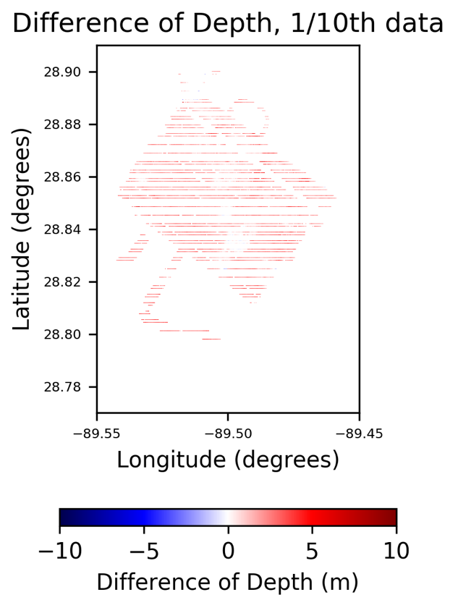
Figure M1: An example of east-west subsampled difference of depth data used for model training and validation. In this example, one of every ten east-west DoD transects was extracted. This approach emulates a singlebeam echosounder resurvey of a continuous initial multibeam survey.

M1.2) Margin Scale
For margin scale predictions, geomorphic evidence of previous landslides (escarpments) were used for training and validation data. Details regarding the interpretation of these features from bathymetric data, and reconstruction of landslide volumes, can be found in Chaytor et al., 2009¹⁶. The data were provided on request by Jason Chaytor of the USGS. The location of each landslide observation was collapsed to a single point by converting escarpment polygons to centroids using ArcGIS v10.1.

M1.3) Global Scale
Global SSI observations were collated from four different sources, as described in Table 1. The Moscardelli dataset is a compilation of SSI deposit locations and morphometrics (length, area, volume, thickness) compiled from published literature; a description of the literature review can be found in Moscardelli et al., 2015¹⁷. For SSIs with only area described, the empirical regression between SSI volume and area from Moscardelli et al., 2015¹⁷ was used to convert areas to volumes.

A database of Gulf of Mexico seafloor anomalies compiled by the Bureau of Ocean Energy Management¹⁸ has a subsection of slumps identified from shallow 3-D seismic data. These slumps are in ArcGIS polygon shapefile format; slump polygon area was converted to volume using the regression from Moscardelli et al., 2015¹⁷ and locations were converted to centroids. The final dataset used for global scale SSI prediction was compiled by ten Brink et al. (2016)⁷. The SSI observations are escarpments derived from bathymetry, and as such the volume and area were calculated in the same manner as the Chaytor et al., 2009¹⁶ dataset.

All observations were age filtered to the beginning of the Pleistocene (2.58 Ma) or younger, and observations of unknown age were not used. This temporal cutoff was used as it was the best compromise between data density and not accounting for continental drift. SSIs without location information were not used, and only entries with volume or area quantified were used.

SSI observations used for global predictions were filtered for volume < 25 km³. This was necessary as the global database is skewed towards extremely large observations and predicted volumes are accordingly unrealistically large (Fig. M2). Using all observations, maximum predicted SSI-derived sediment percentage of total sediment (which should never exceed 100% if mass is conserved) is 9870000% and the mean value is 55200%. Using all observations < 25 km³, 95% of predicted values fall between 0% and 100%. The 5% of predicted values that exceeded one were clipped to one in Figs. 4A and 4B, for ease of interpretation. Spatial variance of SSI probability and magnitude, which this manuscript focuses on, are preserved if the dataset is uniformly magnitude biased.

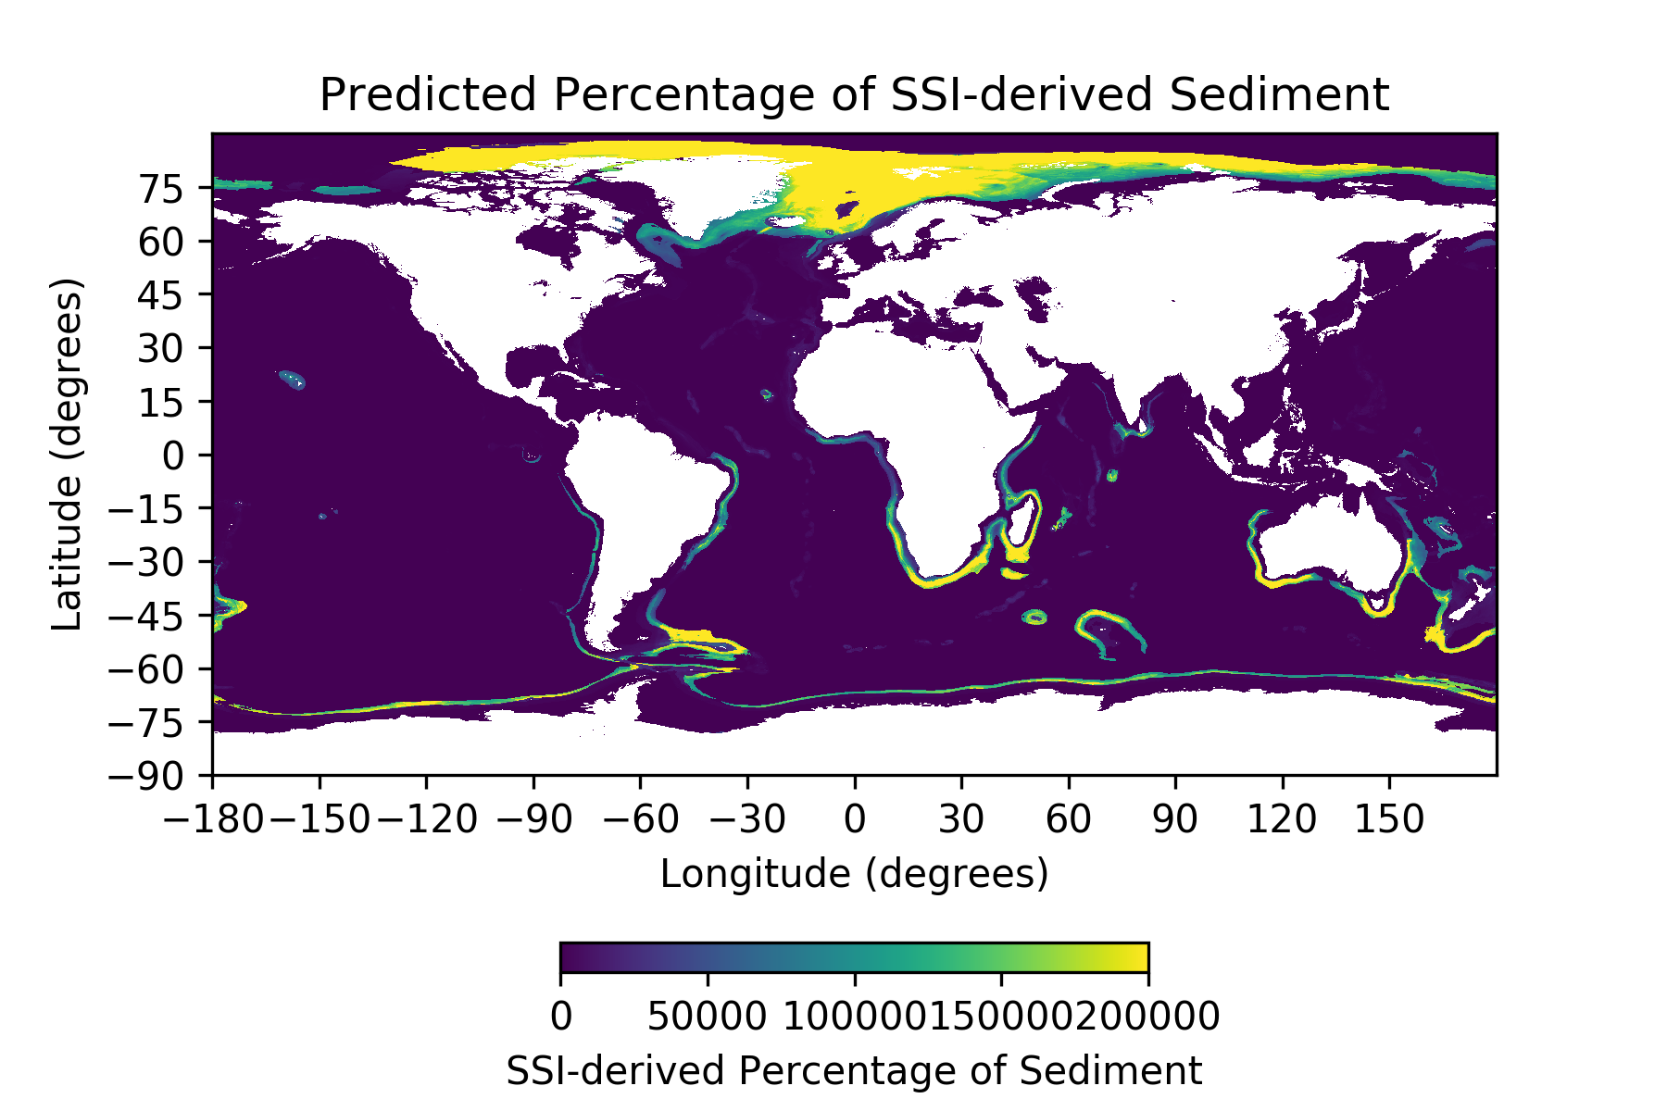
Figure M2: Global prediction of SSI-derived percentage of total sediment volume deposited since the start of the Pleistocene (2.58 Ma), 5 arc-minute cell size, using all observations instead of filtering out observations > 25 km³ as in Fig. 4A. Predicted SSI-derived sediment volume frequently exceeded total sediment volume deposited in the same timespan by several orders of magnitude, indicating a significant database bias towards large SSI observations.

M1.4) SSI absences
For regional scale SSI predictions, the DoD dataset used for training and validation contained both presence and absence of seafloor instability (depth change and lack of depth change, respectively). For margin and global scale predictions, observational data only represented the presence of SSI, and machine learning methods used can only predict within the range of observed data. To avoid unrealistically high estimates of SSI in areas known to contain little to no seabed instability (continental shelves away from river deltas, abyssal plains), absence data were generated at both the margin and global scale using geologic intuition. Absence points were initially added to areas of suspected seabed stability and iteratively increased in density until a ratio of approximately 5:1 observations:absences showed minimal instability on continental shelves and abyssal plains. Adding absence points beyond this density did not appreciably change classification or regression predictions. These data were created as point shapefiles in ArcGIS v10.1 using the srtm15+ global topographic dataset³¹, and are treated as observations of zero SSI-derived volume.

M2) Predictors
Predictors were selected based on correlation (usually qualitative) with SSI established in the literature. Predictors were tailored to the spatial and temporal domain of SSI observations, i.e. while significant wave height and associated peak-trough pressure differential is known to be a significant control on MRDF slope stability¹⁰, it is also likely invariant over the regional prediction domain (~100 km²) used here. A summary table of regional and margin predictors used and their origin is presented in Table M1. Global predictors number in the hundreds and are available from the supplementary section of Lee et al., (2019)¹³.

Table M1: Information regarding predictors used for margin and regional scale predictions presented in this manuscript.
Predictor (units) | Prediction Scale | Data Range | Source
Depth (m) | Regional, 0.001 km² grid spacing | 15 – 89 | ¹⁴
Slope (degrees) | Regional | 0 - 44 | ¹⁴ (calculated from depth)
Curvature (m⁻²) | Regional | -16 – 28 | ¹⁴ (calculated from depth)
Depth-averaged shear strength (kPa) | Regional | 2.8 – 10.0 | Gauvain Weimer (MARUM, unpublished data)
Depth-averaged ²¹⁰Pb sedimentation rate (cm/yr) | Regional | 1.3 – 5.3 | ²⁸
Depth-averaged ⁷Be sedimentation rate (mm/yr) | Regional | 0.25 – 1.5 | ²⁸
Depth-averaged clay fraction (percentage) | Regional | 25 – 34 | ²⁸
Depth-averaged median grain size (μm) | Regional | 7 – 12 | ²⁸
Depth-averaged porosity (fraction) | Regional | 0.69 – 0.78 | ²⁸
Depth (m) | Margin (1 km² grid spacing) | 552 – 5671 | ³¹
Slope (degrees) | Margin | 0 – 62 | ³¹
Median grain size (mm) | Margin | 0.001 – 0.77 | ³²
Clay fraction (percentage) | Margin | 0.4 – 54 | ³²
Suspended sediment river discharge (teragrams/year) | Margin | 0.06 – 0.72 | ³³
Subsurface depth to Calabrian (1.8 Ma) (m) | Margin | 3 – 273 | Taylor Lee (NRL, in prep)
Subsurface Depth to Pleistocene (2.58 Ma) (m) | Margin | 4 – 360 | Taylor Lee (NRL, in prep)
Subsurface Depth to Pliocene (5.33 Ma) (m) | Margin | 8 – 541 | Taylor Lee (NRL, in prep)
Subsurface Depth to Upper Miocene (11.63 Ma) (m) | Margin | 17 – 716 | Taylor Lee (NRL, in prep)
Subsurface Depth to Middle Miocene (15.97 Ma) (m) | Margin | 24 – 1017 | Taylor Lee (NRL, in prep)

Statistics (mean, log mean, average absolute deviation, log deviation) are calculated for all predictor grids at radii from (2x grid resolution) up to (500x grid resolution), at exponentially coarser intervals, yielding approximately 30-40 predictor statistics (depending on prediction scale) from each root predictor.

A sensitivity analysis was conducted to quantify the importance of various predictor categories to overall SSI predictive skill (Fig. M3). Results show that predictions were generally insensitive to the predictor category, with small variations in predictive skill and standard deviation between predictor groups. This implies that SSI variance is parsed approximately equally between processes, not dominated by one category, such as geology or physical oceanography.
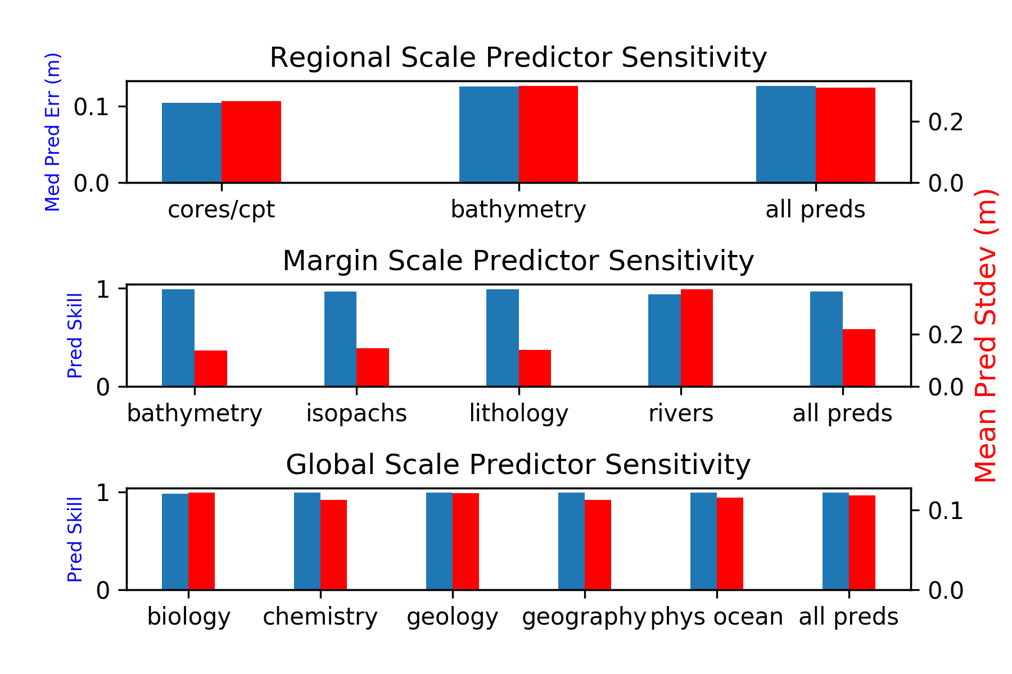
Figure M3: Skill and uncertainty for SSI predictions at all resolutions using different categories of predictors. Predictive accuracy at regional scale was quantified as median prediction error, and at margin and global scales as correct classification fraction of SSI presence. Mean standard deviation of k neighbors was used as a metric of prediction uncertainty at all scales. Prediction accuracy at all scales was generally invariant with predictors used.

M2.1) Regional Scale
A ~5 x 10 km continuous multibeam bathymetric surface from the Southwest Pass region of the Mississippi River Delta Front (MRDF) acquired by J.P. Walsh of East Carolina University was used as a regional scale SSI predictor (Walsh et al., 2006¹⁴). This surface was downsampled to the regional prediction resolution (0.01 km²), and slope and curvature (composite, profile, plan) surfaces were generated using ArcGIS.

Predictor grids were also generated from interpolating recent seabed geological and geotechnical measurements. Multicore-derived measurements are described in Keller et al. (2017)²⁸, collected in 2014, and include sedimentation rate (decadal and seasonal scale, ²¹⁰Pb and ⁷Be respectively), median grain size (d50), clay fraction, and porosity. Seabed shear strength measurements were acquired in 2017 using a cone penetrometer and methods described in Moernaut et al., (2017)³⁰. Shear strength profiles varied in depth below seabed from < 1 m to ~5 m. These measurements were depth averaged and interpolated into continuous surfaces via inverse distance weighting (IDW) using ArcGIS.

M2.2) Margin Scale
Bathymetry predictors are derived at the margin scale from the srtm15+ global topographic dataset²⁹. Bathymetry within the US Atlantic prediction domain was extracted and slope was calculated from the subset via ArcGIS. The native resolution of the srtm15+ dataset (~1 km²) was used for margin scale predictions.

Lithological parameters were used as predictors; the observational data were cores and grab samples compiled in the USSeabed database³⁰. The features derived from these samples are clay fraction and grain size (d16, d50, d84). A separate machine learning prediction of lithology was done at global (5 arc-minute) scale, and a subset of these predictions were extracted within the margin prediction domain and upsampled to 1 km² using bilinear interpolation.

Two proxies of sedimentation location and rate were used for margin scale prediction: river mouth sediment discharge and depth to various geologic unconformities. River mouth sediment discharge values, expressed in metric tons/year, were acquired from Ludwig et al., 2011³¹. These point measurements were inverse distance weighted outwards to 250 km to simulate diffusion of sediment onto the continental shelf, and then further dispersion by waves, currents, and resuspension is predicted via k-nearest neighbors. As with the lithological predictor grids, the calculation of river mouth sediment discharge was predicted at global 5 arc-minute scale, clipped to margin prediction domain, and upsampled.

A random forest machine learning algorithm was applied to globally predict the subsurface depth to horizons identified as important paleo-topographic surfaces on the U.S. Atlantic margin by Hill et al., 2017¹². These horizons are listed in Table M1. All horizons were clipped and upsampled to 1 km² resolution and used for margin-scale prediction, and only depth to base of Pleistocene (2.58 Ma) was used for global predictions. Observed data is sourced from Deep Sea Drilling Project (DSDP) well data. For each DSDP hole, depth-age points were linearly interpolated to determine the depth to ages of interest (1.8, 2.58, 5.33, 11.63, 15.97 million years). The differences in depth between each of these time horizons are added used to construct isopach (thickness) observations. These isopach observations are then used to geospatially predict isopachs at all marine locations, using a Random Forest machine learning algorithm, and a large library of previously assembled predictors similar to those described by Lee et al. (2019)¹³.

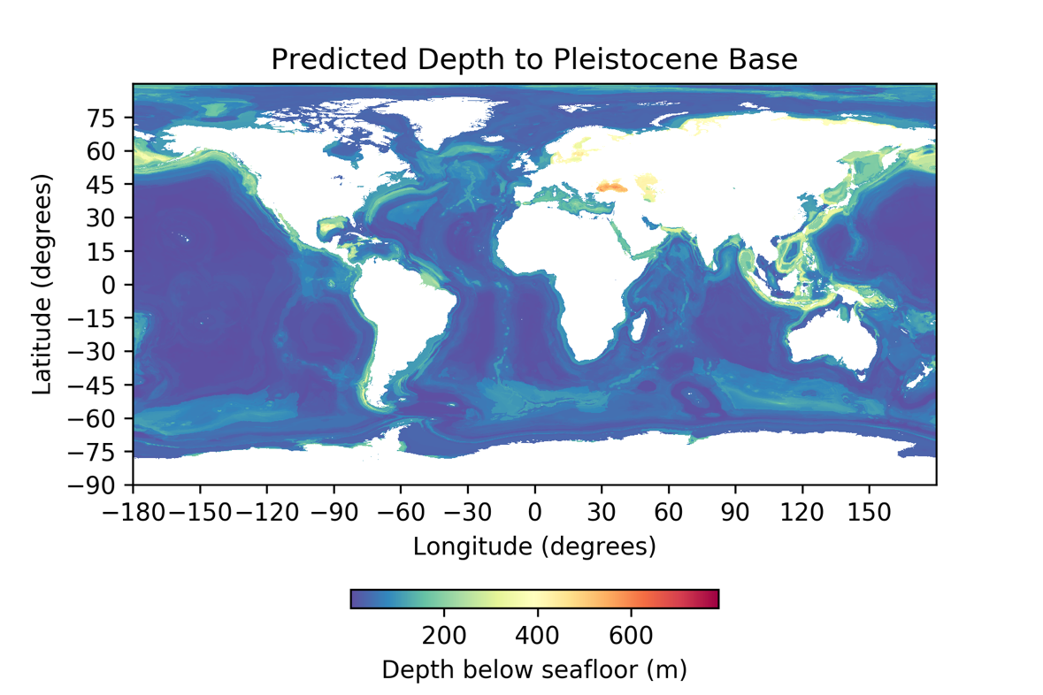
Figure M4: Predicted depth to Pleistocene base (2.58 Ma), global scale and 5 arc-minute resolution.

M2.3) Global Scale
Global scale predictions were made using an extensive library of 5 arc-minute predictor grids compiled from various public data repositories, and parameters derived from these public data sources. The repositories mined for these data are the World Ocean Atlas, NOAA’s NCEI, Pangaea, and several others. Example predictors from five general categories include physical oceanographic (seafloor current, mixed layer depth), biological oceanographic (particulate organic carbon, sea oxygen utilization), chemical oceanographic (salinity, nitrate), geographic (latitude, longitude, distance to landmass), and geologic (crustal thickness, deep and shallow earthquake locations). Global predictors are described in further detail and provided as a data supplemental in Lee et al, 2019¹³.

M3) Machine Learning Geospatial Prediction
Using the data from each resolution above, we conduct geospatial predictictions using the following methodology.

M3.1) Global Predictive Seabed Model (GPSM)
All predictions presented in this manuscript were conducted using the Naval Research Laboratory Global Predictive Seabed Model (GPSM). GPSM is a Python module constructed around several open source libraries including numpy, scikitlearn, and matplotlib. GPSM produces 2-D geospatial predictions, with associated uncertainty, using various machine learning algorithms. More details regarding GPSM can be found in Lee et al., 2019¹³.

M3.2) Prediction algorithms
All predictions presented in this manuscript were produced using the k-nearest neighbor (KNN) classifier or regressor algorithm. Random decision forest was also tested for use in final predictions but results generally showed weaker predictive skill (Table M2). Further details regarding the KNN algorithm can be found in Lee et al., 2019¹³.

M3.3) Feature selection
Prior to prediction, predictors were ranked based on the median prediction error using each predictor alone. Three random noise grids are included as predictors in each prediction, and any predictors with higher prediction error than random noise are withheld.

M3.4) Prediction validation
Validation for all predictions used ten-fold cross validation: a 10% random subsample of observational data are withheld, a prediction is made at the withheld locations using the remaining 90% of the data, and a prediction residual is calculated. This is iterated until 100% of the observational data has been withheld. Two metrics of regression predictive skill are used: 1) the linear regression coefficient of the observed-prediction validation scatter plot (Fig. M5), and the median prediction error (Table M2). The null hypothesis for regression predictions is assuming the median observation value for all prediction locations. For categorical predictions, as shown in Figs. 1 and 2A, a confusion matrix is generated to quantify false negative and false positive predictions of SSI (Fig. M6).

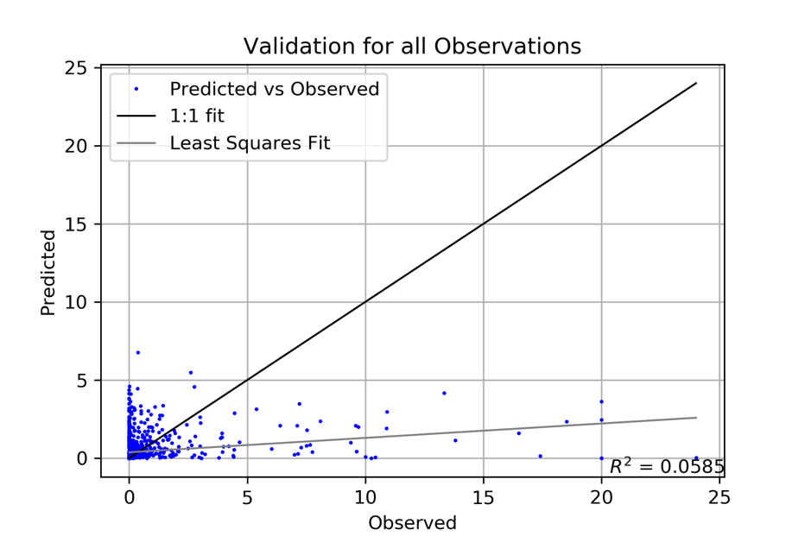
Figure M5: Prediction-observation validation plot, global scale SSI, k-nearest neighbor regressor. A perfect prediction would lie along the 1:1 fit line. In the margin and global scale, a poor fit was obtained between observed and predicted values, likely due to an undersampled parameter space.

Table M2: Median prediction errors for the three prediction spatial scales used in this paper, all using the k-nearest neighbor regression (KNR) algorithm where not indicated otherwise.
Prediction | Median Error Assuming Median Observation Value | Median Prediction Error
Regional Scale, N-S 1% data | 0.56 m | 0.13 m
Margin Scale | 0.17 km³ | 1.15 km³
Margin Scale, Random Decision Forest Regressor | 0.17 km³ | 2.3 km³
Global Scale | 0.05 km³ | 0.08 km³

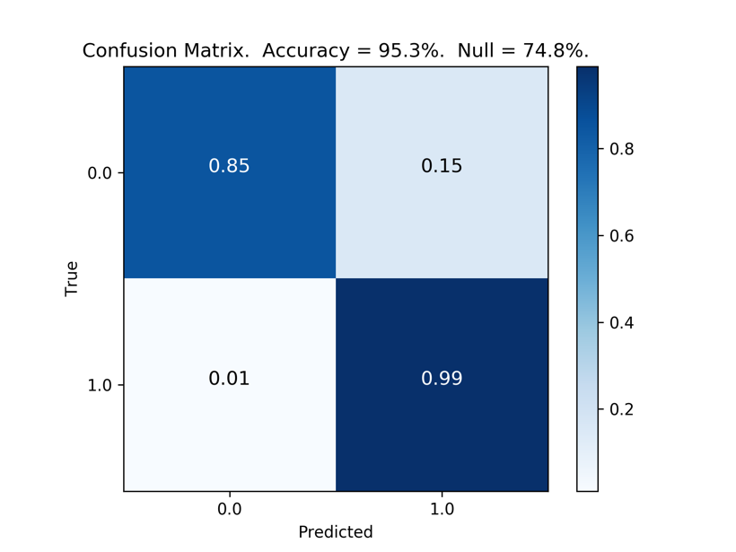
Figure M6: Confusion matrix for global-scale SSI categorical prediction. On axes, zero represents SSI absence, one is SSI presence. A perfect prediction would have 1.0 for the upper left and lower right quadrant values, and 0.0 for upper right and lower left. In this case, classification was almost 100% accurate for SSI presence, and slightly worse (85%) for SSI absence.

Regression predictions at the margin and global scale were inaccurate, i.e. the null hypothesis of assuming the median observation value at all grid cells was more accurate than using GPSM (Table M2). A strong predictive relationship was established at all scales for geospatial classification into SSI presence or absence (Fig. M6), indicating that SSI magnitude, not location, is problematic. The three most likely reasons for lack of regression prediction skill at the margin and global scales are 1) an undersampled parameter space, 2) incomplete catalog of predictors that control SSI variance, or 3) inaccurate synthetic absence observations.

We believe that the incomplete and highly biased datasets used to make the larger scale predictions adversely affect prediction skill. On the margin scale, all SSI observations are derived from bathymetry and therefore only subsurface SSIs are not included. On the global scale, observations are concentrated on a few overrepresented areas (Gulf of Mexico, Europe, US Atlantic) with extremely sparse samples from remote and polar regions (Fig. 1). SSI databases also tend to be skewed towards larger events, as they leave more persistent evidence of their occurrence³ and are more important for geohazard studies.

M3.5) Prediction uncertainty
Uncertainty for all KNN predictions (i.e. all predictions presented in this manuscript) are quantified as the standard deviation of the k neighbors (Fig. M7), due to a lack of standard method for quantifying KNN uncertainty. For a thorough description of standard deviation of k neighbors as KNN uncertainty, see Lee et al., 2019¹³.

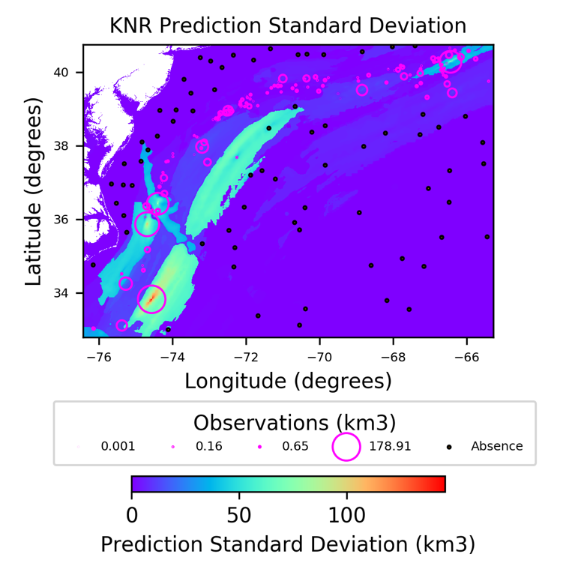
Figure M7: Margin scale KNR prediction standard deviation (standard deviation of k neighbors). Standard deviation was generally proportional with proximity in parameter space to large (and sparse) observations.

