This manuscript is a preprint and have be submitted for publication in Sedimentary Geology. Please note that, despite having undergone peer-review, the manuscript has yet to be formally accepted for publication. Subsequent versions of this manuscript may have slightly different content. If accepted, the final version of this manuscript will be available via the ‘Peer-reviewed Publication DOI’ link on the right-hand side of this webpage. Please feel free to contact any of the authors; we welcome feedback
From XRF and hyperspectral analyses to an automatic way to detect flood events on sediment cores
William Rapuc (1), Kévin Jacq (1, 2), Anne-Lise Develle-Vincent (1), Pierre Sabatier (1), Bernard Fanget (1), Yves Perrette (1), Didier Coquin (2), Maxime Debret (3) Bruno Wilhelm (4) et Fabien Arnaud (1)
(1) Univ. Grenoble Alpes, Univ. Savoie Mont Blanc, CNRS, EDYTEM, LE Bourget du lac, France
(2) Univ. Savoie Mont Blanc, LISTIC, 74944 Annecy Le Vieux, France
(3) Univ. De Caen, CNRS, LM2C, 76821 Mont-Saint-Aignan, France
(4) Institute for Geosciences and Environmental research (IGE), UGA, CNRS, IRD,Grenoble, France

Corresponding Author:
William Rapuc
UMR CNRS 5204 Environnements, Dynamiques et Territoires de la Montagne (EDYTEM)
Université Savoie Mont Blanc, Campus scientifique,
73376 Le Bourget du Lac cedex, France
william.rapuc@univ-smb.fr

Abstract
Long-term changes in flood activity have often been reconstructed to understand their relationships to climate changes. This requires to identify flood layers according to certain characteristics (e.g. texture, geochemical composition, grain-size) and then to count them using naked-eye observation. This method is, however, time-consuming, and intrinsically characterized by a low resolution that may lead to bias and misidentifications. To overcome this limitation, high-resolution analytical approaches can be used, such as X-ray fluorescence spectroscopy (XRF), X-ray computed tomography, or hyperspectral imaging (HSI). When coupled with discriminant algorithms, HSI allows to automatically identify event layers but HSI alone cannot be used for instance to interpret the triggering process of an event layers. Here, we propose a new method of flood layers identification and counting based on the combination of both HSI and XRF core scanner analyses, applied on a Lake Bourget (French Alps) sediment sequence. We use a hyperspectral sensor from the short wave-infrared (SWIR) spectral range to create a discrimination model between event layers and continuous sedimentation. This first step allows the estimation of a classification map, with a prediction accuracy of 0.96, and then the automatic reconstruction of a reliable chronicle of event layers (including occurrence and deposit thicknesses). XRF signals are then used to discriminate flood layers among all identified event layers based on site-specific geochemical elements (in the case of Lake Bourget: Mn and Ti). This results in an automatically generated floods chronicle. Changes in flood occurrence and event thickness through time reconstructed from the automatically generated floods chronicle are in good agreement with the naked-eye-generated chronicle. In detail, differences rely on a larger number of detected flood events (i.e. increase of 9% of the number of layers detected) and a more precise layer thickness estimation, thanks to a higher resolution. Therefore, the developed methodology opens a promising avenue to increase both the efficiency (timesaving) and robustness (higher accuracy) of paleoflood reconstructions from lake sediments. Also, this methodology can be applied to identify any specific layers (e.g. varve, tephra, mass-movement turbidite, tsunami) and, thereby, it has a direct implication in e.g. paleolimnology, paleoflood hydrology, paleoseismology from sediment archives.

Keywords
Lake sediment, hyperspectral analyses, XRF geochemical analysis, Automatic flood chronicle

Introduction
Changes in flood occurrence and magnitude are expected due to climate change in many regions, affecting an increasing number of people (Hirabayashi et al., 2013; Blöschl et al., 2019). Large uncertainties still exist on such changes and long-term flood records are of high value to fully understand the climate-flood relationships (Merz et al., 2014; Wilhelm et al., 2019). In this aim, numerous studies are undertaken on geological records such as lake sediments to reconstruct centennial to millennial flood records (Noren et al., 2002; Moreno et al., 2008; Giguet-Covex et al., 2012; Wilhelm et al., 2012; Glur et al., 2013; Wirth et al., 2013; Sabatier et al., 2017; Wilhelm et al., 2017; Corella et al., 2019; Rapuc et al., 2019). Flood events produce turbidity currents in the lake basin that will usually lead to a normal graded detrital layer that differs remarkably from the continuous sedimentation (Sturm and Matter, 1978; Gilli et al., 2013). However, other processes, such as earthquakes, spontaneous delta collapses, and considerable lake-level changes, can also produce turbidity currents in lakes (Sauerbrey et al., 2013; Wilhelm et al., 2017; Rapuc et al., 2018). In most of these studies, to count and differentiate the event layers, the sediment facies are first described visually, then several sedimentological and geochemical analyses are undertaken. From those results, the event layers are identified, allowing the interpretation of a potential trigger. Then, layers with the same characteristics are usually identified and counted all along with the core by naked-eye observation to ultimately produce a flood chronicle. Those methods are, however, time-consuming, have a low spatial resolution potential, and they can be destructive (e.g. grain-size measurements, TOC analyses). More importantly, naked-eye identification and counting can lead to accuracy bias and misidentifications due to human bias and the intrinsic low resolution. To overcome this limitation, an automatic layer detection method coupled to a high-resolution analysis is required and would also allow results to be fully reproducible.
As several parameters such as color, texture, grain-size and chemical composition vary between a flood event and the continuous sedimentation in a lake, we propose to go further than Vannière et al., (2013) that first propose an automatic way to detect events layers based on RGB images. In this study, we explore the use of short-wave infrared hyperspectral imaging applied on the Lake Bourget (France) sediment sequence. HSI had shown great interest to highlight organic matter (Butz et al., 2017; Schneider et al., 2018; Speta et al., 2018; Van Exem et al., 2018; Jacq et al., 2019b), mineral compounds (Lampinen et al., 2019; Tusa et al., 2019) and particle size (Jacq et al., 2019a) in lake sediments. The partial least squares discriminant analysis (PLS-DA) was used to discriminate event layers from the continuous sedimentation, as presented in a previous study (Jacq et al., 2020). This results in an event layers chronicle including depth and thickness for each event layer with a 200 µm resolution. In a second step, XRF element geochemistry performed with an Avaatech core-scanner analyses with a high resolution of 500 µm are used to interpret the trigger of the event layers and create a flood chronicle. To test the accuracy of this new method, we compare our results to a naked-eye flood chronicle.
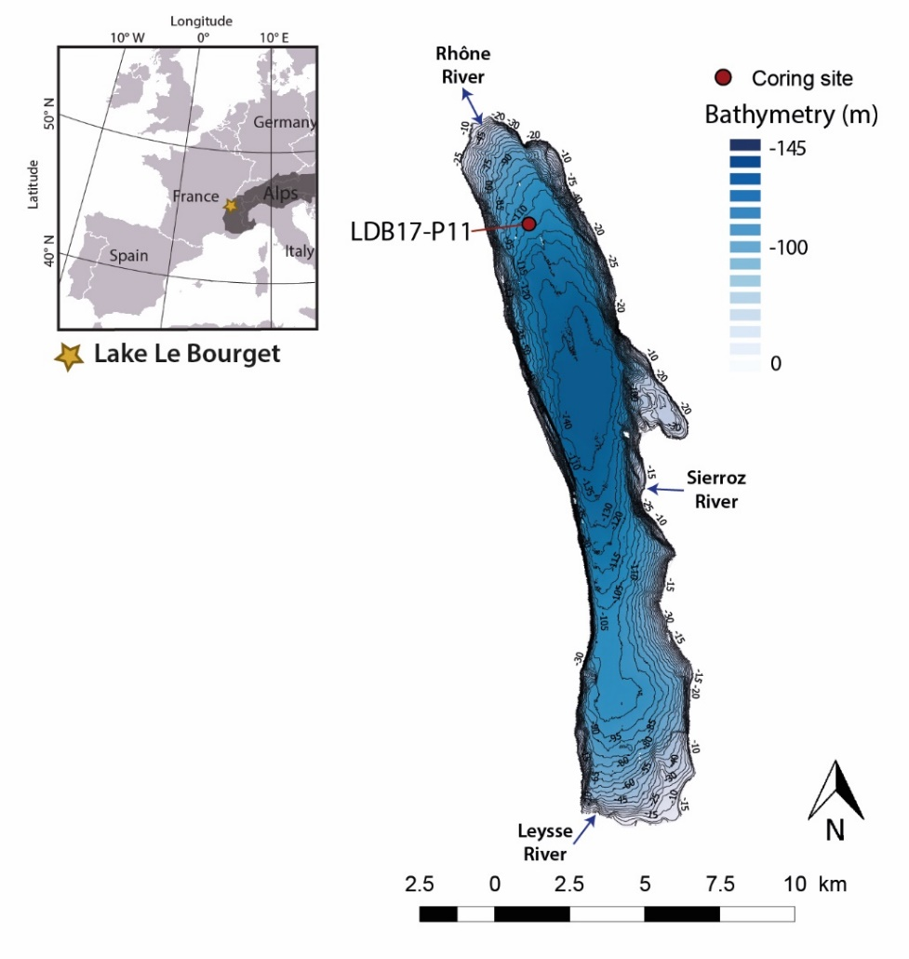
Figure 1 - Location of Lake Bourget in the Alps, its bathymetry, and location of the coring site (LDB17-P11).

Study Site
Lake Bourget (18 km long, 2.8 km wide, 231.5 m.a.s.l) is one of the largest natural lake in France (44.5 km²). This lake is a peri-alpine hard water lake located in the north-western part of the French Alps (Fig. 1) and was formed by the retreat of Wurmian glaciers (Nicoud et al., 1987). Three tributaries enter Lake Bourget: Leysse, Sierroz and the Rhône Rivers (Fig. 1). The Rhône River is usually the outflow of Lake Bourget, but, the current reverse during flood events and inflows in the lake. Including the Rhône River catchment, the catchment of Lake Bourget covers a large (approx. 4600 km²) and diverse lithologies including granitic rocks of the Mont Blanc massif as well as Cretaceous limestones in the peri-alpine area. Lake Bourget is a monomictic lake that presents a partial reoxygenation of its hypolimnion during the winter water mixing followed by hypoxia that increases progressively during thermal stratification (Jenny et al., 2013). Most of the year, the bottom water of the lake thus presents low oxygen concentration compared to the surface water and river water’s input. The sediments of Lake Bourget were already deeply studied to understand the history of the lake eutrophication (Giguet-Covex et al., 2010; Jenny et al., 2013), the evolution of the regional flood activity (Chapron et al., 2002; Chapron et al., 2005; Arnaud et al., 2005; Debret et al., 2010; Jenny et al., 2014; Evin et al., 2019), to characterize the evolution of the erosion in the watershed (Revel-Rolland et al., 2005; Arnaud et al., 2012) or to study seismically induced deposits (Chapron et al., 1999). From all those studies, it appears that the northern part of the lake basin is deeply influenced by flood events from the Rhône River, contributing from 10 to 40% to the total sedimentation and that can generate event layers due to underflows during high-energy flood events (Giguet-Covex et al., 2010; Arnaud et al., 2012).
The deposits linked to flood events in the proximal part of Lake Bourget basin are characterized by a dark to very dark grey color (10 YR 4/1, Munsell soil color chart) easily distinguishable from the light grey continuous sedimentation (Giguet-Covex et al., 2010). The thickness of these deposits varies from millimeter to centimeter. These fine-silty to clayey deposits are mainly composed of allochthonous silicates and enriched in detrital elements (Jenny et al., 2014). Some homogenites-type deposits were also observed in the sediment of Lake Bourget and correspond to light grey deposits rich in autochthonous carbonate (Chapron et al., 1999). Arnaud et al. (2012) showed that the Ti signal, from XRF data, is the best proxy to represent detrital input in Lake Bourget. Jenny et al. (2014) and Evin et al. (2019) evidenced that the flood-sediment pathways are always changing in Lake Bourget, which explains that grain-size was not used as a proxy of flood deposits.

Materials and Methods

3.1. Coring and lithological description
In 2017, a sediment core (LDB17-P11, length 271 cm) was retrieved from the northern basin of Lake Bourget (45° 46.778'N, 5° 50.552'E, 113 m water depth, Fig. 1) using a UWITEC gravity corer with a hammer. This site was selected because it is highly influenced by the detrital sediment input from the Rhône River (Jenny et al., 2014). The section was cut in two parts (A & B), split in half, photographed at high resolution (20 pixels.mm⁻¹), described and logged in detail using the Munsell color chart. Therein, the study focuses on the upper section (LDB17-P11A, 121.5 cm) that presents the highest number of event layers. The sediment retrieved in the LDB17-P11A sediment core can be subdivided into two different units (Fig. 2). The upper part (0 - 10.4 cm) of the core composed of dark-greenish-grey clay (5GY 4/4) presents a thin alternation of dark grey, light grey and brown laminae and is equivalent to the one observed and described previously in Lake Bourget by Giguet-Covex et al. (2010) and Jenny et al. (2013). This unit corresponds to a laminated organic gyttja linked to the recent eutrophication of the bottom water of Lake Bourget (Giguet-Covex et al., 2010; Jenny et al., 2013). The second unit (10.4 – 121.5 cm) is characterized by a homogeneous clayey to silty light grey sediment that is predominantly composed of carbonate particles and a few diatoms. This unit is often interrupted by darker deposits, rich in detrital compounds (silicate and carbonate) that were previously interpreted as turbidite-type deposits induced by an underflow linked to a flood event incoming from the Rhône river (Giguet-Covex et al., 2010; Jenny et al., 2014).

3.2. Spectroscopic analysis
Two non-destructive high-resolution spectroscopic methods were applied to the sediment core. The SWIR and the XRF were used to estimate the molecular and elementary properties.

3.2.1. Hyperspectral analysis
The SWIR sensor covers the spectral range from 1.000 nm to 2.500 nm with 12 nm bandwidth, so that the spectra is composed of 144 spectral bands, and the spatial resolution is 200 μm. The protocol proposed by (Butz et al., 2015) was followed to obtain relevant data. It is composed of three main steps : (1) The sample needs to be prepared to be as flat as possible and reveal the sedimentary structures ; (2) Both camera and scanner must be adjusted to obtain squared pixels and an optimal signal to noise ratio (SNR) ; (3) Finally, the data were calibrated with the white (spectralon) and dark (shutter closed) normalizations to obtain the reflectance spectra of the sample.
Several pre-processing can be used to remove noises or highlight discriminant spectral information. Spectral detrending (Barnes et al., 1989) was used to correct the spectra from the baseline as chosen in a previous study (Jacq et al., 2020).

3.2.2. Geochemical properties
XRF geochemical analysis was performed on the EDYTEM laboratory's Core Scanner (Avaatech XRF Technology) to characterize the variations of major elements throughout LDB17-P11A sediment sequence. A continuous 0.5 mm step measurement was applied with a run at 10 kV and 0.25 mA for 20 s to detect lightweight elements, such as Al, Si, K, Ca, Ti, and a second run was performed at 30 kV and 0.4 mA for 20 s to detect Mn, Fe, Br, Rb, Sr, and Zr. The XRF core scanner results are expressed hereafter as peak intensities by counts per second (cps). Then, a principal component analysis (PCA) was conducted on the XRF data to identify principal sediment end-members and correlations between the detected elements (Sabatier et al., 2010). Due to the 500 µm resolution, only the layers thicker or than 0.5 mm can be detected with XRF data, and only layers thicker or equal to 1 mm will be described to increase the reliability of the study.

3.3. The methodology of detection and interpretation of event layers
To detect and interpret the event layers present in a sediment core we used a combination of HSI and XRF that can be resume as follow (Fig. 2): (i) Opening and visual description of the core to identify and count the different types of event layers; (ii) Hyperspectral analysis associated with data treatment and the selection by the user of some event layers as reference layers to produce a chronicle; (iii) Perform XRF analysis at high-resolution; (iv) From the knowledge of the in-lake sedimentary processes, using previous researches and/or sedimentological and geochemical analyses (XRD, EDS, XRF, Grain-size, ASM), selection of one proxy of detrital input, one proxy of grain-size or transport processes and if needed one proxy of oxygenation of the lake bottom water from XRF data; (v) Combination of hyperspectral chronicle and XRF data to create (vi) an interpreted flood chronicle and calculate the thicknesses of each flood layers. The main step of this method will be developed hereafter. All these steps were processed on Matlab software (R2020a), using the following method: https://github.com/JacqKevin/HSI_SupervisedClassification.
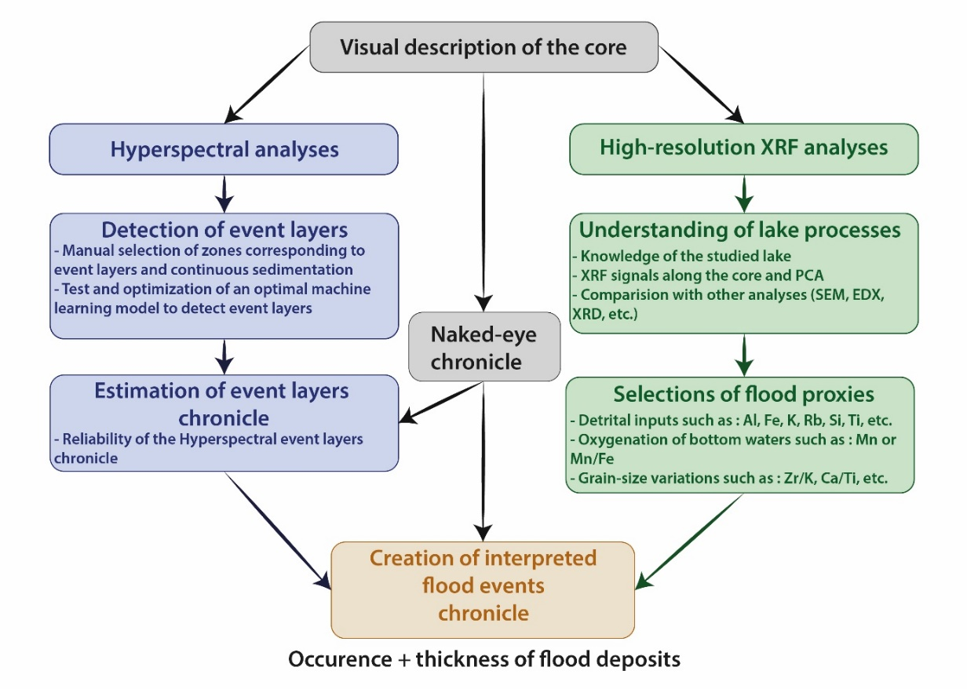
Figure 2 -Summary of the methodology developed for the semi-automatic detection and interpretation of flood event layers in lake sediments based on the combination of hyperspectral and XRF data and the comparison with a naked eye study

3.3.1. Hyperspectral classification and event layers chronicle estimation
First, data needs to be manually labelled to create a learning dataset. This requires that a user manually select rectangles on a pseudo-RGB image that correspond to reference event layers or continuous sedimentation. The selected pixels are then extracted to create a calibration set to estimate the classification model parameters and produce a validation set to test its performances. A PLS-DA is used for classification modelling (Wold et al., 1984; Barker and Rayens, 2003). This method is based on the PLS approach that reduces the spectral data in latent variables maximizing the spectral variability and the co-variability between the spectra and variables of interest. The model performances are estimated with the calibration and prediction accuracies that estimate the ratio of pixels that are successfully classified in their corresponding classes. A qualitative assessment is also realized to check the relevance of the prediction map. The optimal classification model allows discriminating the event layers from the continuous sedimentation with a classification map (Fig. 3).
Based on a previous study of Jacq et al. (2020), hyperspectral classification can discriminate event layers from continuous sedimentation with the SWIR image. A discrimination model was estimated (Fig. 3) and presents a calibration accuracy of 0.97, validation accuracy of 0.96, and qualitative relevance of 5/5.
Then, a summed profile of the classification map is calculated, normalized by the number of width pixels, it can be seen as the occurrence probability of an event (Fig. 3). This profile was smoothed to remove some artifacts and miss-classifications with a Savitzky-Golay filter (Savitzky and Golay, 1964). A double threshold was fixed to find the event layer boundaries and to create the chronicle. The first one was set at 50% of the width. It allowed us to find thin and thick deposits without selecting artifact or miss-classification, but thick deposits (upper than 5mm) can result from the amalgamation of several close layers. The second threshold at 15% of the width was used to divide them. Finally, each deposit can be separated, and their depth and thickness estimated to create an event layer chronicle without information about event triggers. In some lake environments, the thickness of flood layers may be informative about the flood intensity (Wilhelm et al., 2013; Sabatier et al., 2017; Wilhelm et al., 2019) but it is not the case in Lake Bourget. Here, thickness estimation is thus only considered for further applications on other lakes. Hence, a cumulative sum was also calculated to test the accuracy of an automatic model on the detection of the number and the thickness of the event layers. Therein, only layers with thickness upper than 1 mm are used because it is the naked-eye resolution limit, and the XRF analyses resolution did not allow to characterize thinner deposits. Once the method validated, the event layer chronicle can be exploited at the only limit of the XRF data resolution.

3.3.2. Flood proxies derived from XRF
In a lake system, several mechanisms can trigger an event layer : (i) lake level fluctuations, (ii) snow avalanches, (iii) eruptions, (iv) sediment overloading on slopes or deltas, (v) destabilization of slopes and deltas by seismic shaking and (vi) flood events (e.g. Sauerbrey et al., 2013; Rapuc et al., 2018). Regardless the lake system considered, to discriminate the triggering mechanisms of each deposit it is necessary to select a combination of proxies allowing to interpret (1) the sources and (2) the grain-size of the sediment composing the event layers and (3) the transport processes leading to the deposition of the sediment. Here we focused only on a way to discriminate flood layers from the rest of the sedimentation using XRF signals, but this method can apply to any other trigger. Floods induce an input of sediment-rich in detrital material coming from the watershed, they generally produce a turbiditic underflow in the lake, leading to sediment sorting and the deposition of a graded layer (Sturm and Matter, 1978). When the oxygen-rich water, coming from the watershed during a flood, reaches the water’s-sediment interface due to an underflow, the Mn and Fe present in dissolved form precipitate as Mn and Fe oxy-hydroxides at the base of the induced turbiditic layer. Thus, a peak of Mn or Fe can be interpreted as flood-induced lake bottom oxygenation and is linked to a detrital input (Wilhelm et al., 2016; Sabatier et al., 2017; Rapuc et al., 2019). However, changes in the oxic/anoxic state of the bottom water of the lake will also lead to similar changes in Fe and Mn signals (Davison, 1993; Elbaz-Poulichet et al., 2014). Because it can be affected by oxydo and reduction processes, the Fe signal does not seem to be a good proxy to trace detrital input from flood events and will not be used in this study. Thus, ratios such as Zr/Fe, used to represent grain-size variations into lake sediment and interpreted as a proxy of grain size (Wilhelm et al., 2013) should not be used with much confidence when studying a flood deposit in lakes influenced by changes in the oxygenation of the lake bottom water. Table 1 summarizes elements generally used as a proxy of detrital input, grain-size variations, and water oxygenation at the sediment-water interface and some limitations associated. Depending on the lake mechanics and the available knowledge, the user will select one or several proxies from this list to interpret the event layers.

Table 1 - Summary of XRF signals used in the literature as proxies of detrital input, grain-size variations, and oxygenation of deep water. Modified from Davies et al., (2015).
Proxy of | Element or ratio | Example reference | Limits
Detrital input | Al | (Kämpf et al., 2012; Lauterbach et al., 2011)
Detrital input | Fe | (Kylander et al., 2011; Moreno et al., 2008; Sabatier et al., 2020; Wirth et al., 2013b) | Depending on redox conditions
Detrital input | K | (Aufgebauer et al., 2012; Fouinat et al., 2017; Moreno et al., 2011, 2008)
Detrital input | Mn | (Moreno et al., 2008) | Depending on redox conditions
Detrital input | Ca | (Giguet-Covex et al., 2012; Bruno Wilhelm et al., 2012a)
Detrital input | Rb | (Kalugin et al., 2013; Kylander et al., 2011))
Detrital input | Si | (Marshall et al., 2011; Martín-Puertas et al., 2011)
Detrital input | Ti | (Arnaud et al., 2012; Balascio et al., 2011; Czymzik et al., 2013; Martin-Puertas et al., 2012; Stansell et al., 2013)
Detrital input | Ti/Ca | (Litt et al., 2009)
Detrital input | Zr | (Marshall et al., 2011)
Grain-size | Ca/Fe | (B. Wilhelm et al., 2012)
Grain-size | Si/Al | (Sabatier et al., 2012, 2010)
Grain-size | Si/Ti | (Shala et al., 2014) | For sand-rich layers
Grain-size | Ti/Ca | (Riou et al., 2020)
Grain-size | Ti/K | (Marshall et al., 2011)
Grain-size | Zr/Al | (Sabatier et al., 2012, 2010)
Grain-size | Zr/Fe | (Rapuc et al., 2019; Wilhelm et al., 2013) | Depending on redox conditions
Grain-size | Zr/K | (Cuven et al., 2011)
Grain-size | Zr/Rb | (Chawchai et al., 2013; Kylander et al., 2011)
Grain-size | Zr/Ti | (Rapuc et al., 2019)
Oxygenation of deep water | Mo | (Elbaz-Poulichet et al., 2014; Wirth et al., 2013a)
Oxygenation of deep water | Mn | (Kylander et al., 2011; Rapuc et al., 2019; Sabatier et al., 2017; Wilhelm et al., 2016)
Oxygenation of deep water | Mn/Fe | (Melles et al., 2012)
Oxygenation of deep water | Mn/Ti | (Kylander et al., 2011; Moreno et al., 2007)

3.3.3. XRF flood proxies and HSI chronicle combination
The selected XRF profiles were smoothed to reduced noise with a Savitzky-Golay filter (Savitzky and Golay, 1964). Then, all the peaks were detected with local maxima. Some constraints can be used with the peak height, prominence, width, and distance between two consecutive peaks, but no constraint was used in this study. Finally, a depth matching of the HSI event layers and the XRF profiles was made. For each event layer detected by hyperspectral, the presence or absence of the XRF peaks in this area will characterize the type of event. Thus, the instantaneous chronicle made by hyperspectral was interpreted thanks to the XRF to obtain a chronicle by type of event.
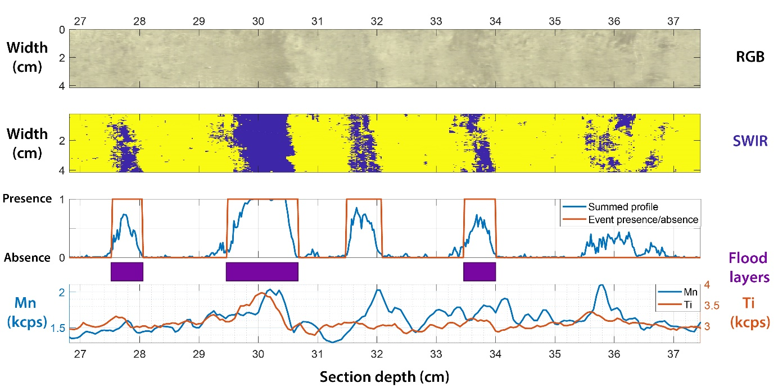
Figure 3 - Details of RGB images and SWIR classification map, associated with summed profile derived from HSI model. The orange line shows the detected event layers from HSI model. In the Lake Bourget example, Mn and Ti signals were chosen to interpret flood layers. Location and thickness of flood layers detected by the combination of HSI and XRF data are represented by purple rectangles.

3.3.4. Comparison with the naked eye chronicle
The comparison of the two (HSI+XRF and Naked-eye) chronicles relied on results of event frequency and cumulative thickness calculated as the sum of the number of deposits counted every 10 cm and the cumulative thickness of the deposits, respectively. Then correlation and standard error were calculated to measure similarity and distance between the naked-eye and estimated chronicles. A quantile-quantile plot was also used to compare the respective distributions in depth and thickness.

Results

4.1. Visual description of the core and Naked-eye chronicle
Event layers, characterized by a dark to very dark grey color (10 YR 4/1), were counted visually along with the LDB17-P11A sediment core (Fig. 2). As these layers are easily distinguishable from continuous sedimentation, we counted all the deposits with a thickness ≥ 1 mm. To improve the accuracy of our results, the counting of these deposits was repeated by another observer. Fifty-six event layers were counted, with a maximum thickness of 11.0 mm and a mean thickness of 3.4 mm. One other deposit, interrupting the continuous sedimentation, was identified between 31.5 and 32.1 cm deep (Fig. 3 & 4). This deposit is composed of light grey silty to clayey sediment rich in carbonates and corresponds to a homogenite-type deposit linked to a seismic event that occurs close to the lake in 1822 (Chapron et al., 1999). To build a flood chronicle, the homogenite-type deposit was removed, and the sum of the number of deposits counted every 10 cm and the cumulative thickness of the deposits was plotted against the depth of the core.
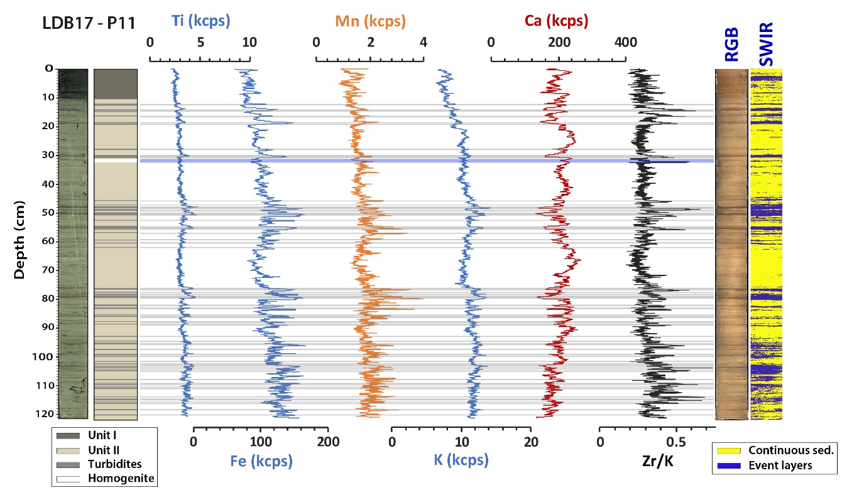
Figure 4 - Main results obtained on LDB17-P11A sediment section : the picture of the core, the stratigraphic log with the turbidite-type deposits identified by a visual description of the core represented in grey and the homogenite-type deposit in white, the main XRF data used hereafter (Ti, Fe, Mn, K, Ca and Zr/K ratio), the picture of the core in RGB colors, the discrimination model showing event layers identified using hyperspectral camera SWIR.

4.2. Hyperspectral analyses results
On the LDB17-P11 section, 21 rectangles were selected in approximately 5 minutes, covering 1.20 % of the total section area. From this selection, an HSI discrimination model was built on the entire sequence, allowing the estimation of a chronicle (Fig. 4), with the depth and the thickness of each layer. However, the model does not allow to distinguish turbidite-types deposits from the homogenite type-deposit (Fig. 3). Thus, the hyperspectral model only cannot be used directly to classify the different kinds of events layers and discuss their origin. One hundred and ten deposits were counted using the SWIR camera, 86 have a thickness greater than 1 mm, and are used hereafter. They present a mean thickness of 4.5 mm and a maximum thickness of 15.5 mm.

4.3. High-resolution XRF analyses results
From the XRF analyses, Unit I shows low values of Ti [> 3 kilo counts per second (kcps)], Fe (> 100 kcps), and K (> 9 kcps) and high values of Ca (> 145 kcps). From the top of the sediment section to the base of Unit II, the Ti, K, Fe, and Mn signals increase (Fig. 4). The Ca signal is quite constant over the first 121 cm of the LDB17-P11A sediment core. The event layers present peaks of Ti, Fe, Mn, and K signals and low values of Ca (Fig.4). The Zr/K ratio presents important peaks at the base of each event layers and low values at the top (Fig. 4). The only homogenite-type deposit identified in the core section presents relatively low values in Ti, Fe, and K signals and show a relatively high value of Ca and Mn signal. A peak of Zr/K is present at the base of this deposit. The variability of the Mn and Fe signal increases remarkably downward (Fig. 4).
From the XRF data, a PCA was conducted and provides variables and individual factor maps (Fig. 5), which highlight the relationships between the different elements and the geochemical distribution within sediment units. Dimensions 1 and 2 (denoted as Dim1 and Dim2) represent 73.9% of the total variability of the signal. From the variables factor map, three end-members were identified. The first one, which is denoted as terrigenous, is positively correlated with Dim1 and yields high positive loadings for the major terrigenous elements (Zr, Fe, Ti, Rb, Mn, Al, Si, and K). This pole can be subdivided into two-part, (i) the upper part including Zr, Fe, Rb, Ti, and Mn, that are particles usually linked to coarse grain or red/ox processes in lake sediment (Davies et al., 2015 and references therein) and (ii) the lower part including Al, Si and K. The second one, which is denoted as “organic matter” yields positive values for Br and is negatively correlated with Dim1 and positively with Dim2. The third one is negatively correlated with Dim1 and with Dim2 (Fig. 5A). This pole yields high positive values for Ca and is interpreted as representative of the carbonates produced by the biologic activity in the lake, as Sr is usually present in marine limestone that constitutes a significant part of the outcrops in the watershed of Lake Bourget and is here anticorrelated with Ca. The Individuals factor map (Fig. 5B) allows to highlight specificities of each unit: (i) Unit I is negatively correlated with terrigenous end-members, which is due to its high organic matter content. (ii) Unit II can be separated into two parts, one positively correlated with Dim1 and, thus, to the detrital end-member, and one part that is characterized by a high Ca content. Values for the event layers identified as turbidite by Giguet-Covex et al. (2010) are almost exclusively positively correlated with the terrigenous end-member and especially with the upper part of this pole, while values obtained for the homogenite-type deposit are closer to the carbonate pole. From the previous knowledge of the sedimentary processes in Lake Bourget (Giguet-Covex et al., 2010; Arnaud et al., 2012; Jenny et al., 2013), and XRF and PCA results, we selected Ti as a proxy of detrital input from the river and Mn as a proxy of oxygenation of the water at the sediment interface. Indeed, when it is present at the base of an event layer and combined with a peak of a proxy of detrital input, a peak of Mn signal can be used as a proxy of oxygenation of the bottom water, and thus be used to detect and interpret flood layers. As presented by several studies, grain-size cannot be used as a proxy of flood events in Lake Bourget as the sediment pathway is always changing (Jenny et al., 2014; Evin et al., 2019). The association of Ti and Mn peaks in a previously identified event layer is linked to a flood origin bringing detrital particles and well-oxygenated water to the water’s-sediment interface.
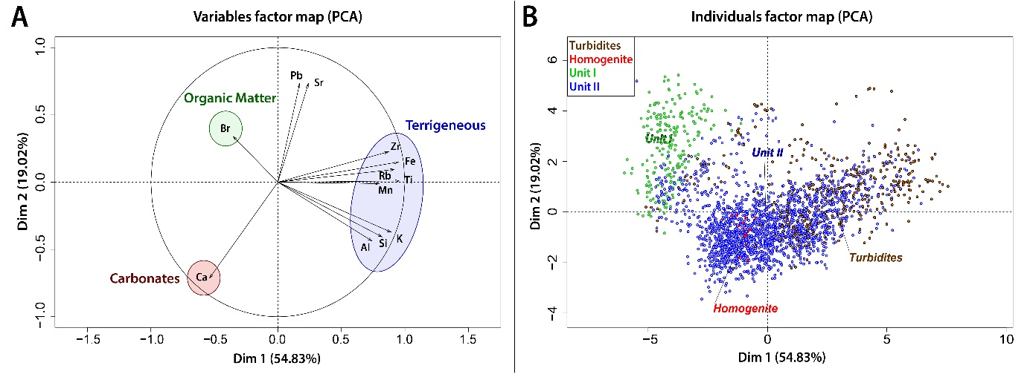
Figure 5 - Variable and individual factor maps from the PCA. (A) Variable factor map with three end-members (terrigenous, organic matter, and carbonates). (B) Individual factor map with sedimentological units added as an illustrative variable.

4.4. Creation of interpreted flood events chronicle
The combination of Ti and Mn signals allowed to automatically provide a paleoflood record from the HSI event layer chronicle. Sixty-one layers present both Ti and Mn peaks and are identified as flood events with a maximum thickness of 15.5 mm and a mean thickness of 5.6 mm. Twenty-one layers have only a peak of Mn signal, three layers only present a peak of Ti signal and one layer does not present any peak from Ti and Mn signals. The homogenite-type deposit between 31.50 and 32.10 cm deep, linked to a seismic event that occurs close to the lake in 1822 AD (Chapron et al., 1999) is correctly discarded by the model (Fig. 3). Then, a flood chronicle was estimated with the 61 identified flood layers.

Discussion

5.1. Naked-eye versus HSI chronicle
Naked-eye observation only could not be used to interpret the triggering mechanisms of event layers because different processes can lead to a turbiditic current into a lake. Then, from naked-eye observation, these deposits can only be considered as event layers interrupting the continuous sedimentation. The HSI chronicle of event layers is compared to the naked-eye one to test the robustness of the developed methodology (Fig. 6 A and B). The comparison is made on the event frequency and the cumulative thickness, both calculated as a sum of 10 cm. The HSI frequency is in great agreement with the naked-eye chronicle (r = 0.86 and SE = 3.04). The cumulative thickness derived from the SWIR camera is also very close to the one obtained from the naked-eye observation (r = 0.85 and SE = 1.94). Thus, HSI enables to differentiate event layers from the continuous sedimentation. However, differences can be seen at the base and the top of the sediment section between HSI and naked-eye chronicle. From 5 to 10.4 cm, the HSI chronicle presents a higher frequency. This deviation can be explained by the presence of varves (Fig. 4). Indeed, Unit I in Lake Bourget presents laminated sediment with a thin alternation of dark grey, light grey, and brown laminae that are hardly distinguishable visually. From 90 cm, HSI chronicle presents values of frequency higher than expected compared to the naked-eye chronicle. This can be explained by the presence of an increasing number of very thin laminae non-distinguishable visually (< 1 mm). The higher number of thin layers detected by the HSI model (Fig. 4) explains the higher values for the calculated cumulative thickness at the top and the base of the section. Differences between HSI and naked-eye frequencies are thus mainly linked to human identification bias and the intrinsic low resolution of the naked-eye observation. However, if ever HSI identification presents some bias, the combination with XRF signals will correct this effect by discarding layers that do not present peaks of selected signals. From HSI analysis, the detected layers can only be considered as event layers interrupting the continuous sedimentation, and the origin of those deposits cannot be discussed further on as the geochemical properties used for the differentiation are not available from HSI data.
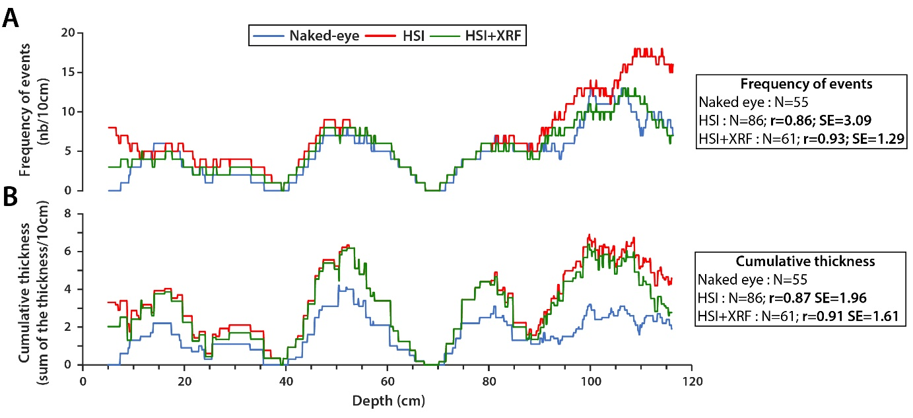
Figure 6 - Comparison between the different models of the event layers and flood chronicles obtained, the naked-eye models are represented in blue, the HSI chronicle in red and the combination HSI+XRF in green. (A) Frequency of events calculated as the sum of events layers per 10 cm. (B) Cumulative thickness derived from the above chronicles. N = number of event layers detected, r = correlation coefficient, SE = standard error.

5.2. Automatic detection of the flood layers
The HSI+XRF flood record is also compared to the naked-eye one to test the robustness of the flood chronicle obtained (Fig. 6 and Fig. 8). The frequency of this flood chronicle is highly comparable with the naked-eye chronicle, with an r of 0.92 and an SE of 1.27, as well as the cumulative thickness with an r of 0.88 and an SE of 1.61, respectively (Fig. 6). The HSI+XRF flood chronicle presents a better correlation with the naked-eye chronicle than the HSI chronicle alone. This can be explained by a potential over-detection of event layers by the HSI model that has been corrected by the addition of XRF signals. Indeed, a total of twenty-five deposits has been discarded. Compare to HSI chronicle, the correlation between HSI+XRF and naked-eye frequencies is also higher at the top and the base of the core (Fig. 6 & 8). Even if a higher number of floods are detected compare to the naked-eye chronicle, these events are confirmed by the XRF signals.
Twenty-one layers detected by the HSI model present only a peak of Mn signal (Fig. 8), generally located at their base (Fig. 3). The homogenite-type deposit located between 31.50 and 32.10 cm in the sediment sequence and corresponding to the 1822 seismic event is one of them. A majority of these layers is probably linked to destabilization of slope sediments due to earthquake shaking or sediment overloading (Chapron et al., 1999). The slopes of Lake Bourget are enriched in authigenic carbonate and present a lower concentration in detrital elements (Arnaud et al., 2005). During the slide of sediment, water from shallower part of the lake basin will be brought to the water’s-sediment interface where the concentration in oxygen is lower and will then lead to precipitation of Fe and Mn oxy-hydroxides without increasing the input of detrital elements to the lake floor. Five of these layers are located in Unit I, corresponding to a varved organic gyttja linked to the recent eutrophication of the lake. The presence of a Mn peak in these laminae can be the result of a change in the oxic/anoxic regime of the bottom water at the period of sediment deposition. All these statements confirm that the Mn signal alone cannot be used to distinguish the different triggering mechanisms of event layers in a lake presenting rapid changes in oxygenation state of the bottom waters, by mixing processes, and it needs to be associated with a proxy of detrital or carbonate inputs. This also indicates that the combination of HSI model and XRF signals allows us to distinguish different triggering mechanisms for the detected event layers. Three event layers present a peak of Ti signal only (Fig. 8), which can be the result of the presence of a higher content of detrital elements without a re-oxygenation of the deep water. This can be due to (i) a slide of previously deposited sediment from the delta, or to (ii) a weak flood event, or more probably to (iii) a flood event occurring during the winter period, when water mixing in the lake occurs. At that period, underflows cannot cause a re-oxygenation of the deep water which explains the lack of a peak of Mn signal. However, these layers present a respective thickness of 1.7, 1.9 and 2.9 mm, and are distributed all along the sediment section (Fig. 8), then, their removal from the chronicle will not have a significant impact. One last deposit does not present any peak of Mn or Ti signals and is located at 121 cm depth. This event layer is interpreted as an artifact linked to a change in the sediment color and surface geometry at the end of the sediment section.
The quantile-quantile plots in Fig. 7 allow comparing the event layers distribution identify by naked-eye with the HSI and XRF combination. The depth QQ-plot (Fig. 7 A), similarly to the event frequency (Fig. 6), shows a good agreement between chronicles. The thickness QQ-plot (Fig. 7 B) highlights differences with thicker deposits estimated by HSI+XRF. Two reasons can explain it, one due to the curvature of the deposits. The second shows the eye resolution to see precisely the layer limits with the colour variations, and this can also be seen with the millimeter steps of the naked eye chronicle.
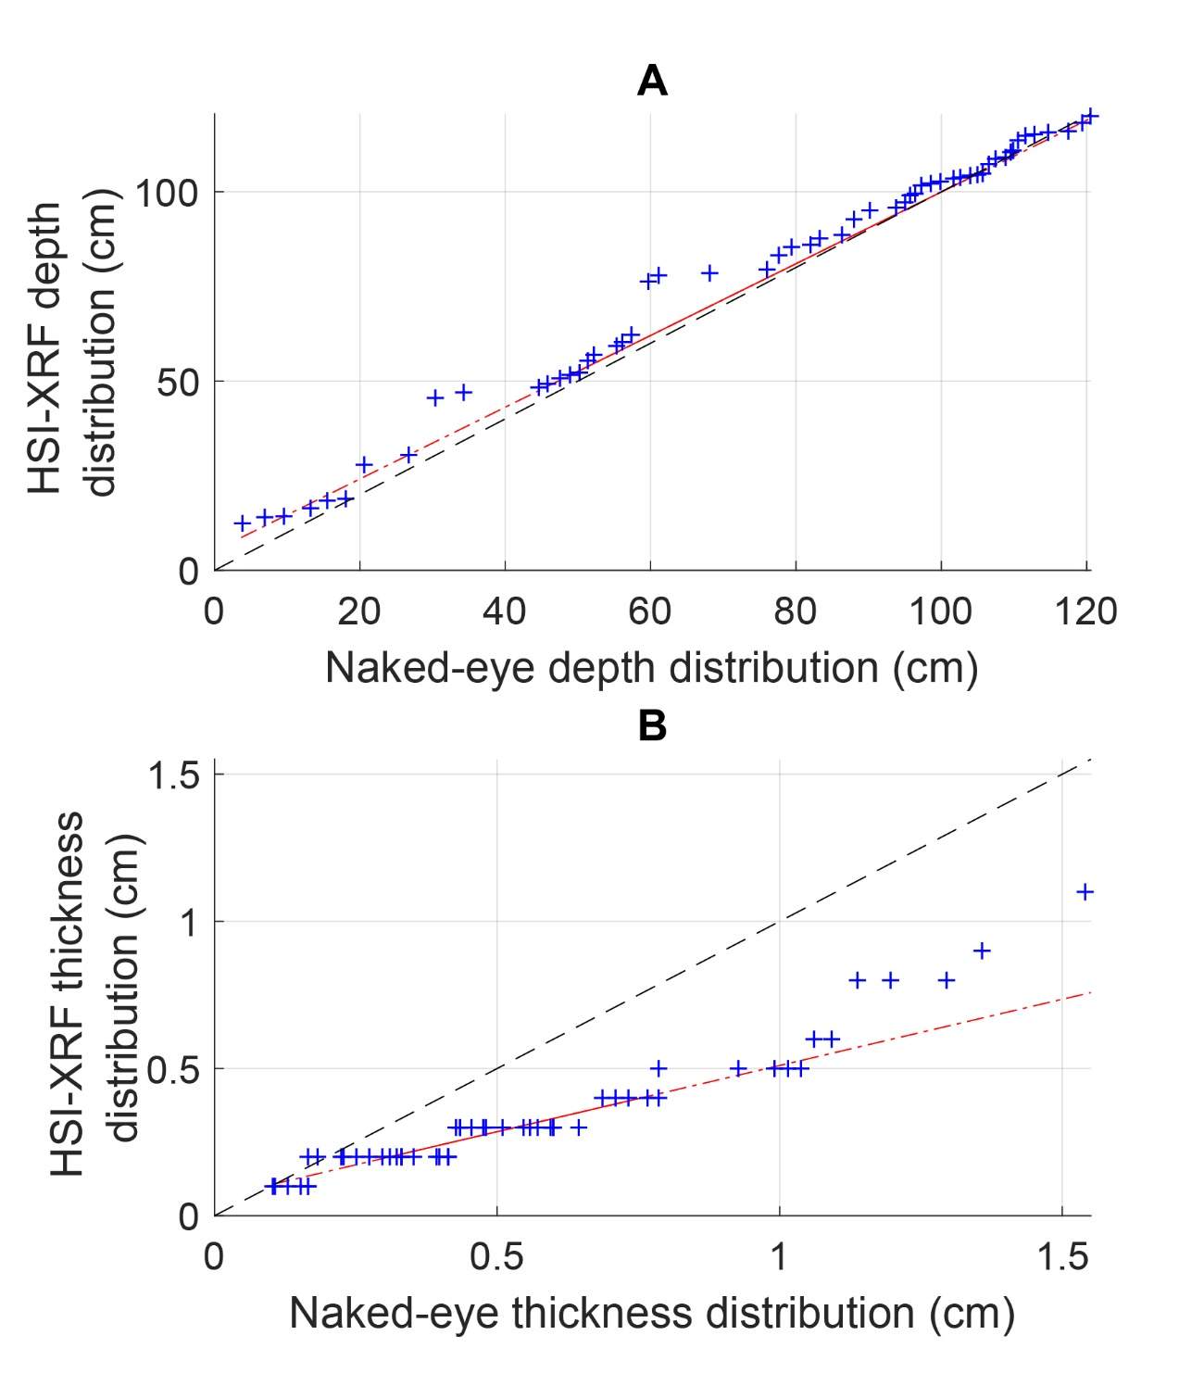
Figure 7 - Quantile-Quantile plot to compare the naked-eye and the HSI-XRF distributions of the (a) depth and the (b) thickness
Combining hyperspectral analysis and XRF data allowed to produce a reliable semi-automatized flood chronicle (Fig. 8). This method can easily be re-used on other lake sediment sections to automatically detect flood layers as well as other types of event layers in a sediment sequence. The methodology could also be developed by combining other types of sensors, e.g. VNIR, XRD, SEM, EDS. For an HSI-XRF combination, the only input parameters that will vary are the XRF signals chosen by the user for the interpretation of the deposit triggers, requiring a comprehensive understanding of the in-lake sedimentary processes. This method allows us to detect thinner deposits compare to a naked-eye observation with 24 deposits thinner than 1 mm on a 121 cm sequence-long and a more robust thickness estimation (Fig. 8) used as flood intensity proxy in some lake systems. However, the trigger of these thin deposits cannot be characterized due to the XRF resolution of this study. This methodology presents a strong advantage to be fast and non-destructive. Its limitations may be the large amount (here 450 Mo for 1 meter of core analyzed) of data generated by the hyperspectral analysis and by the requirement of a comprehensive understanding of the sedimentary processes in the studied lake. The over-detection of the event layers by the HSI will be corrected using XRF data. However, an interesting perspective for future works would be its development to automatically detect event layers related to more various triggers (e.g. lake level fluctuations, snow avalanches, eruptions, sediment overloading on slopes or deltas, destabilization of slopes and deltas by seismic shaking) and their classification by types of trigger. We think that the proposed methodology is highly useful to more precisely document sedimentary events and related natural hazards, but will also improve in a significant way the workflow by reducing the analysis time on long sediment sections, allowing the study of a higher number of sequences.
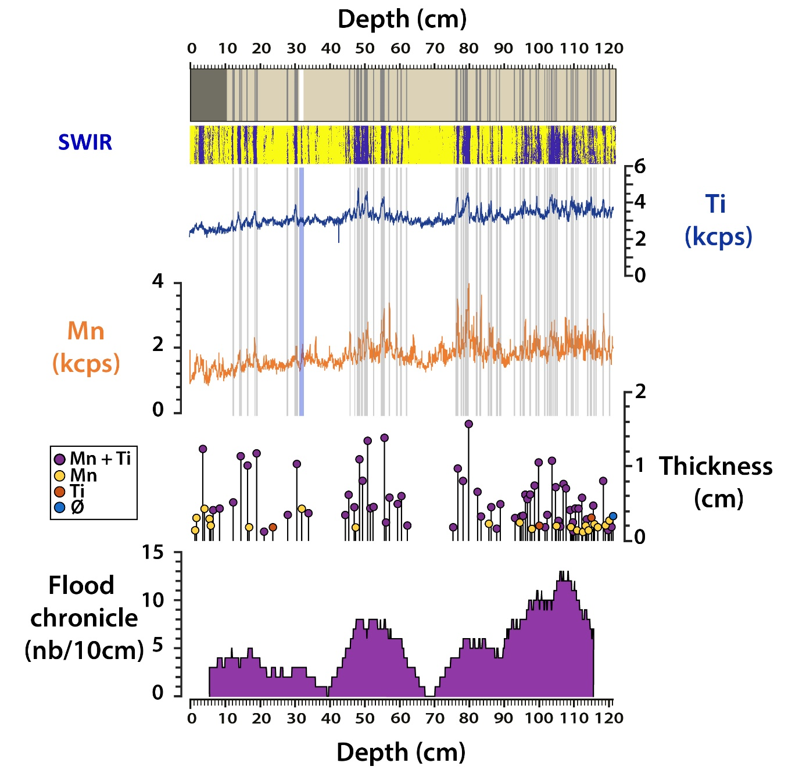
Figure 8 - Synthesis of data used to produce the flood chronicle (naked-eye description, the event layers identified using hyperspectral camera SWIR and XRF data) and the main results obtained from the combination of XRF and HSI data (thickness of the event layers deposits, flood layers chronicle). Grey and blue shadings correspond to event layers identified visually.

Conclusion
This study presents the first semi-automatic method using multiproxy analyses to detect event layers in lake sediment in a fast and non-destructive way and allowing the direct interpretation of the triggers of these deposits to create events chronicle. One proximal sediment section of Lake Bourget was described visually, analyzed with a SWIR hyperspectral camera and XRF core-scanner. A naked-eye chronicle was made to test the accuracy of the method. From HSI analysis, event layers that differ from the continuous sedimentation were detected and counted to build an event layers chronicle that is in good agreement with the naked-eye chronicle. From XRF analysis and previous knowledge, Ti and Mn signals were selected to disentangle flood layers from other event layers. Indeed, Ti signal is directly linked to detrital inputs into the lake coming from the main tributaries, and Mn variations are linked to water’s-sediment interface oxygenation during a flood event. If the event layer detected by the HSI analysis presents a peak of Mn and Ti signals, then they were interpreted as flood-induced deposits and added to the flood chronicle. The accuracy of this flood chronicle was then tested by comparison with the naked-eye chronicle previously made on this sediment section. The very good agreement between these two chronicles allows validating this new method that can be applied to other sediment sections to detect event layers and to produce interpreted chronicles and more widely used for event layers identification in other lake systems.

Acknowledgment
Hyperspectral imaging was processed at the University of Normandie-Rouen and was funded by the Region Normandie, which supports the scientific consortium SCALE UMR CNRS 3730.

References
Arnaud, F., Revel, M., Chapron, E., Desmet, M., Tribovillard, N., 2005. 7200 years of Rhône river flooding activity in Lake Le Bourget, France: a high-resolution sediment record of NW Alps hydrology. The Holocene 15, 420–428. https://doi.org/10.1191/0959683605hl801rp
Arnaud, F., Révillon, S., Debret, M., Revel, M., Chapron, E., Jacob, J., Giguet-Covex, C., Poulenard, J., Magny, M., 2012. Lake Bourget regional erosion patterns reconstruction reveals Holocene NW European Alps soil evolution and paleohydrology. Quat. Sci. Rev. 51, 81–92.
Aufgebauer, A., Panagiotopoulos, K., Wagner, B., Schaebitz, F., Viehberg, F.A., Vogel, H., Zanchetta, G., Sulpizio, R., Leng, M.J., Damaschke, M., 2012. Climate and environmental change in the Balkans over the last 17 ka recorded in sediments from Lake Prespa (Albania/F.Y.R. of Macedonia/Greece). Quat. Int., Temporal and spatial corridors of Homo sapiens sapiens population dynamics during the Late Pleistocene and Early Holocene 274, 122–135. https://doi.org/10.1016/j.quaint.2012.02.015
Balascio, N.L., Zhang, Z., Bradley, R.S., Perren, B., Dahl, S.O., Bakke, J., 2011. A multi-proxy approach to assessing isolation basin stratigraphy from the Lofoten Islands, Norway. Quat. Res. 75, 288–300. https://doi.org/10.1016/j.yqres.2010.08.012
Barker, M., Rayens, W., 2003. Partial least squares for discrimination. J. Chemom. 17, 166–173. https://doi.org/10.1002/cem.785
Barnes, R.J., Dhanoa, M.S., Lister, S.J., 1989. Standard Normal Variate Transformation and De-Trending of Near-Infrared Diffuse Reflectance Spectra. Appl. Spectrosc. 43, 772–777. https://doi.org/10.1366/0003702894202201
Blöschl, G., Hall, J., Viglione, A., Perdigão, R.A., Parajka, J., Merz, B., Lun, D., Arheimer, B., Aronica, G.T., Bilibashi, A., 2019. Changing climate both increases and decreases European river floods. Nature 573, 108–111.
Butz, C., Grosjean, M., Fischer, D., Wunderle, S., Tylmann, W., Rein, B., 2015. Hyperspectral imaging spectroscopy: a promising method for the biogeochemical analysis of lake sediments. J. Appl. Remote Sens. 9, 1–20. https://doi.org/10.1117/1.JRS.9.096031
Butz, C., Grosjean, M., Goslar, T., Tylmann, W., 2017. Hyperspectral imaging of sedimentary bacterial pigments: a 1700-year history of meromixis from varved Lake Jaczno, northeast Poland. J. Paleolimnol. 58, 57–72. https://doi.org/10.1007/s10933-017-9955-1
Chapron, E., Arnaud, F., Noël, H., Revel, M., Desmet, M., Perdereau, L., 2005. Rhone River flood deposits in Lake Le Bourget: a proxy for Holocene environmental changes in the NW Alps, France. Boreas 34, 404–416. https://doi.org/10.1080/03009480500231260
Chapron, E., Beck, C., Pourchet, M., Deconinck, J.-F., 1999. 1822 earthquake-triggered homogenite in Lake Le Bourget (NW Alps). Terra Nova 11, 86–92. https://doi.org/10.1046/j.1365-3121.1999.00230.x
Chapron, E., Desmet, M., De Putter, T., Loutre, M.F., Beck, C., Deconinck, J.-F., 2002. Climatic variability in the northwestern Alps, France, as evidenced by 600 years of terrigenous sedimentation in Lake Le Bourget. The Holocene, The Holocene 12, 177–185.
Chawchai, S., Chabangborn, A., Kylander, M., Löwemark, L., Mörth, C.-M., Blaauw, M., Klubseang, W., Reimer, P.J., Fritz, S.C., Wohlfarth, B., 2013. Lake Kumphawapi – an archive of Holocene palaeoenvironmental and palaeoclimatic changes in northeast Thailand. Quat. Sci. Rev. 68, 59–75. https://doi.org/10.1016/j.quascirev.2013.01.030
Corella, J.P., Benito, G., Wilhelm, B., Montoya, E., Rull, V., Vegas-Vilarrúbia, T., Valero-Garcés, B.L., 2019. A millennium-long perspective of flood-related seasonal sediment yield in Mediterranean watersheds. Glob. Planet. Change 177, 127–140. https://doi.org/10.1016/j.gloplacha.2019.03.016
Cuven, S., Francus, P., Lamoureux, S., 2011. Mid to Late Holocene hydroclimatic and geochemical records from the varved sediments of East Lake, Cape Bounty, Canadian High Arctic. Quat. Sci. Rev. 30, 2651–2665. https://doi.org/10.1016/j.quascirev.2011.05.019
Czymzik, M., Brauer, A., Dulski, P., Plessen, B., Naumann, R., von Grafenstein, U., Scheffler, R., 2013. Orbital and solar forcing of shifts in Mid-to Late Holocene flood intensity from varved sediments of pre-alpine Lake Ammersee (southern Germany). Quat. Sci. Rev. 61, 96–110.
Davies, S.J., Lamb, H.F., Roberts, S.J., 2015. Micro-XRF core scanning in palaeolimnology: recent developments, in: Micro-XRF Studies of Sediment Cores. Springer, pp. 189–226.
Davison, W., 1993. Iron and manganese in lakes. Earth-Sci. Rev. 34, 119–163. https://doi.org/10.1016/0012-8252(93)90029-7
Debret, M., Chapron, E., Desmet, M., Rolland-Revel, M., Magand, O., Trentesaux, A., Bout-Roumazeille, V., Nomade, J., Arnaud, F., 2010. North western Alps Holocene paleohydrology recorded by flooding activity in Lake Le Bourget, France. Quat. Sci. Rev. 29, 2185–2200. https://doi.org/10.1016/j.quascirev.2010.05.016
Elbaz-Poulichet, F., Sabatier, P., Dezileau, L., Freydier, R., 2014. Sedimentary record of V, U, Mo and Mn in the Pierre-Blanche lagoon (Southern France)–Evidence for a major anoxia event during the Roman period. The Holocene 24, 1384–1392.
Evin, G., Wilhelm, B., Jenny, J.-P., 2019. Flood hazard assessment of the Rhône River revisited with reconstructed discharges from lake sediments. Glob. Planet. Change 172, 114–123. https://doi.org/10.1016/j.gloplacha.2018.09.010
Fouinat, L., Sabatier, P., Poulenard, J., Etienne, D., Crouzet, C., Develle, A.-L., Doyen, E., Malet, E., Reyss, J.-L., Sagot, C., Bonet, R., Arnaud, F., 2017. One thousand seven hundred years of interaction between glacial activity and flood frequency in proglacial Lake Muzelle (western French Alps). Quat. Res. 87, 407–422. https://doi.org/10.1017/qua.2017.18
Giguet-Covex, C., Arnaud, F., Enters, D., Poulenard, J., Millet, L., Francus, P., David, F., Rey, P.-J., Wilhelm, B., Delannoy, J.-J., 2012. Frequency and intensity of high-altitude floods over the last 3.5 ka in northwestern French Alps (Lake Anterne). Quat. Res. 77, 12–22.
Giguet-Covex, C., Arnaud, F., Poulenard, J., Enters, D., Reyss, J.-L., Millet, L., Lazzaroto, J., Vidal, O., 2010. Sedimentological and geochemical records of past trophic state and hypolimnetic anoxia in large, hard-water Lake Bourget, French Alps. J. Paleolimnol. 43, 171–190. https://doi.org/10.1007/s10933-009-9324-9
Gilli, A., Anselmetti, F.S., Glur, L., Wirth, S.B., 2013. Lake sediments as archives of recurrence rates and intensities of past flood events, in: Dating Torrential Processes on Fans and Cones. Springer, pp. 225–242.
Glur, L., Wirth, S.B., Büntgen, U., Gilli, A., Haug, G.H., Schär, C., Beer, J., Anselmetti, F.S., 2013. Frequent floods in the European Alps coincide with cooler periods of the past 2500 years. Sci. Rep. 3, 2770.
Hirabayashi, Y., Mahendran, R., Koirala, S., Konoshima, L., Yamazaki, D., Watanabe, S., Kim, H., Kanae, S., 2013. Global flood risk under climate change. Nat. Clim. Change 3, 816.
Jacq, K., Giguet-Covex, C., Sabatier, P., Perrette, Y., Fanget, B., Coquin, D., Debret, M., Arnaud, F., 2019a. High-resolution grain size distribution of sediment core with hyperspectral imaging. Sediment. Geol. 393–394, 105536. https://doi.org/10.1016/j.sedgeo.2019.105536
Jacq, K., Perrette, Y., Fanget, B., Sabatier, P., Coquin, D., Martinez-Lamas, R., Debret, M., Arnaud, F., 2019b. High-resolution prediction of organic matter concentration with hyperspectral imaging on a sediment core. Sci. Total Environ. 663, 236–244. https://doi.org/10.1016/j.scitotenv.2019.01.320
Jenny, J.-P., Arnaud, F., Dorioz, J.-M., Covex, C.G., Frossard, V., Sabatier, P., Millet, L., Reyss, J.-L., Tachikawa, K., Bard, E., 2013. A spatiotemporal investigation of varved sediments highlights the dynamics of hypolimnetic hypoxia in a large hard-water lake over the last 150 years. Limnol. Oceanogr. 58, 1395–1408.
Jenny, J.-P., Wilhelm, B., Arnaud, F., Sabatier, P., Covex, C.G., Melo, A., Fanget, B., Malet, E., Ployon, E., Perga, M.E., 2014. A 4D sedimentological approach to reconstructing the flood frequency and intensity of the Rhône River (Lake Bourget, NW European Alps). J. Paleolimnol. 51, 469–483.
Kalugin, I., Darin, A., Rogozin, D., Tretyakov, G., 2013. Seasonal and centennial cycles of carbonate mineralisation during the past 2500 years from varved sediment in Lake Shira, South Siberia. Quat. Int., The Baikal-Hokkaido Archaeology Project: Environmental archives, proxies and reconstruction approaches 290–291, 245–252. https://doi.org/10.1016/j.quaint.2012.09.016
Kämpf, L., Brauer, A., Dulski, P., Lami, A., Marchetto, A., Gerli, S., Ambrosetti, W., Guilizzoni, P., 2012. Detrital layers marking flood events in recent sediments of Lago Maggiore (N. Italy) and their comparison with instrumental data. Freshw. Biol. 57, 2076–2090. https://doi.org/10.1111/j.1365-2427.2012.02796.x
Kylander, M.E., Ampel, L., Wohlfarth, B., Veres, D., 2011. High-resolution X-ray fluorescence core scanning analysis of Les Echets (France) sedimentary sequence: new insights from chemical proxies. J. Quat. Sci. 26, 109–117. https://doi.org/10.1002/jqs.1438
Lampinen, H.M., Laukamp, C., Occhipinti, S.A., Hardy, L., 2019. Mineral footprints of the Paleoproterozoic sediment-hosted Abra Pb-Zn-Cu-Au deposit Capricorn Orogen, Western Australia. Ore Geol. Rev. 104, 436–461. https://doi.org/10.1016/j.oregeorev.2018.11.004
Lauterbach, S., Brauer, A., Andersen, N., Danielopol, D.L., Dulski, P., Hüls, M., Milecka, K., Namiotko, T., Obremska, M., Grafenstein, U.V., 2011. Environmental responses to Lateglacial climatic fluctuations recorded in the sediments of pre-Alpine Lake Mondsee (northeastern Alps). J. Quat. Sci. 26, 253–267. https://doi.org/10.1002/jqs.1448
Litt, T., Krastel, S., Sturm, M., Kipfer, R., Örcen, S., Heumann, G., Franz, S.O., Ülgen, U.B., Niessen, F., 2009. ‘PALEOVAN’, International Continental Scientific Drilling Program (ICDP): site survey results and perspectives. Quat. Sci. Rev. 28, 1555–1567. https://doi.org/10.1016/j.quascirev.2009.03.002
Marshall, M.H., Lamb, H.F., Huws, D., Davies, S.J., Bates, R., Bloemendal, J., Boyle, J., Leng, M.J., Umer, M., Bryant, C., 2011. Late Pleistocene and Holocene drought events at Lake Tana, the source of the Blue Nile. Glob. Planet. Change 78, 147–161. https://doi.org/10.1016/j.gloplacha.2011.06.004
Martin-Puertas, C., Brauer, A., Dulski, P., Brademann, B., 2012. Testing climate–proxy stationarity throughout the Holocene: an example from the varved sediments of Lake Meerfelder Maar (Germany). Quat. Sci. Rev. 58, 56–65. https://doi.org/10.1016/j.quascirev.2012.10.023
Martín-Puertas, C., Valero-Garcés, B.L., Mata, M.P., Moreno, A., Giralt, S., Martínez-Ruiz, F., Jiménez-Espejo, F., 2011. Geochemical processes in a Mediterranean Lake: a high-resolution study of the last 4,000 years in Zoñar Lake, southern Spain. J. Paleolimnol. 46, 405–421. https://doi.org/10.1007/s10933-009-9373-0
Melles, M., Brigham-Grette, J., Minyuk, P.S., Nowaczyk, N.R., Wennrich, V., DeConto, R.M., Anderson, P.M., Andreev, A.A., Coletti, A., Cook, T.L., Haltia-Hovi, E., Kukkonen, M., Lozhkin, A.V., Rosén, P., Tarasov, P., Vogel, H., Wagner, B., 2012. 2.8 Million Years of Arctic Climate Change from Lake El’gygytgyn, NE Russia. Science 337, 315–320. https://doi.org/10.1126/science.1222135
Merz, B., Aerts, J., Arnbjerg-Nielsen, K., Baldi, M., Becker, A., Bichet, A., Blöschl, G., Bouwer, L.M., Brauer, A., Cioffi, F., 2014. Floods and climate: emerging perspectives for flood risk assessment and management. Nat. Hazards Earth Syst. Sci. NHESS 14, 1921–1942.
Moreno, A., Giralt, S., Valero-Garcés, B., Sáez, A., Bao, R., Prego, R., Pueyo, J.J., González-Sampériz, P., Taberner, C., 2007. A 14kyr record of the tropical Andes: The Lago Chungará sequence (18°S, northern Chilean Altiplano). Quat. Int., Lacustrine and marine archives of environmental variability across South America 161, 4–21. https://doi.org/10.1016/j.quaint.2006.10.020
Moreno, A., López-Merino, L., Leira, M., Marco-Barba, J., González-Sampériz, P., Valero-Garcés, B.L., López-Sáez, J.A., Santos, L., Mata, P., Ito, E., 2011. Revealing the last 13,500 years of environmental history from the multiproxy record of a mountain lake (Lago Enol, northern Iberian Peninsula). J. Paleolimnol. 46, 327–349. https://doi.org/10.1007/s10933-009-9387-7
Moreno, A., Valero-Garcés, B.L., González-Sampériz, P., Rico, M., 2008. Flood response to rainfall variability during the last 2000 years inferred from the Taravilla Lake record (Central Iberian Range, Spain). J. Paleolimnol. 40, 943–961.
Nicoud, G., Monjuvent, G., Maillet-Guy, G., 1987. Contrôle du comblement quaternaire des vallées alpines du nord par la dynamique lacustre. 457–468.
Noren, A.J., Bierman, P.R., Steig, E.J., Lini, A., Southon, J., 2002. Millennial-scale storminess variability in the northeastern United States during the Holocene epoch. Nature 419, 821–824. https://doi.org/10.1038/nature01132
Rapuc, W., Sabatier, P., Andrič, M., Crouzet, C., Arnaud, F., Chapron, E., Šmuc, A., Develle, A.-L., Wilhelm, B., Demory, F., 2018. 6600 years of earthquake record in the Julian Alps (Lake Bohinj, Slovenia). Sedimentology 65, 1777–1799.
Rapuc, W., Sabatier, P., Arnaud, F., Palumbo, A., Develle, A.-L., Reyss, J.-L., Augustin, L., Régnier, E., Piccin, A., Chapron, E., Dumoulin, J.-P., von Grafenstein, U., 2019. Holocene-long record of flood frequency in the Southern Alps (Lake Iseo, Italy) under human and climate forcing. Glob. Planet. Change 175, 160–172. https://doi.org/10.1016/j.gloplacha.2019.02.010
Revel-Rolland, M., Arnaud, F., Chapron, E., Desmet, M., Givelet, N., Alibert, C., McCulloch, M., 2005. Sr and Nd isotopes as tracers of clastic sources in Lake Le Bourget sediment (NW Alps, France) during the Little Ice Age: Palaeohydrology implications. Chem. Geol. 224, 183–200. https://doi.org/10.1016/j.chemgeo.2005.04.014
Riou, B., Chaumillon, E., Chagué, C., Sabatier, P., Schneider, J.-L., Walsh, J.-P., Zawadzki, A., Fierro, D., 2020. Backwash sediment record of the 2009 South Pacific Tsunami and 1960 Great Chilean Earthquake Tsunami. Sci. Rep. 10, 4149. https://doi.org/10.1038/s41598-020-60746-4
Sabatier, P., Dezileau, L., Briqueu, L., Colin, C., Siani, G., 2010. Clay minerals and geochemistry record from northwest Mediterranean coastal lagoon sequence: Implications for paleostorm reconstruction. Sediment. Geol. 228, 205–217.
Sabatier, P., Dezileau, L., Colin, C., Briqueu, L., Bouchette, F., Martinez, P., Siani, G., Raynal, O., Von Grafenstein, U., 2012. 7000years of paleostorm activity in the NW Mediterranean Sea in response to Holocene climate events. Quat. Res. 77, 1–11. https://doi.org/10.1016/j.yqres.2011.09.002
Sabatier, P., Nicolle, M., Piot, C., Colin, C., Debret, M., Swingedouw, D., Perrette, Y., Bellingery, M.-C., Chazeau, B., Develle, A.-L., Leblanc, M., Skonieczny, C., Copard, Y., Reyss, J.-L., Malet, E., Jouffroy-Bapicot, I., Kelner, M., Poulenard, J., Didier, J., Arnaud, F., Vannière, B., 2020. Past African dust inputs in the western Mediterranean area controlled by the complex interaction between the Intertropical Convergence Zone, the North Atlantic Oscillation, and total solar irradiance. Clim. Past 16, 283–298. https://doi.org/10.5194/cp-16-283-2020
Sabatier, P., Wilhelm, B., Ficetola, G.F., Moiroux, F., Poulenard, J., Develle, A.-L., Bichet, A., Chen, W., Pignol, C., Reyss, J.-L., Gielly, L., Bajard, M., Perrette, Y., Malet, E., Taberlet, P., Arnaud, F., 2017. 6-kyr record of flood frequency and intensity in the western Mediterranean Alps – Interplay of solar and temperature forcing. Quat. Sci. Rev. 170, 121–135. https://doi.org/10.1016/j.quascirev.2017.06.019
Sauerbrey, M.A., Juschus, O., Gebhardt, A.C., Wennrich, V., Nowaczyk, N.R., Melles, M., 2013. Mass movement deposits in the 3.6 Ma sediment record of Lake El’gygytgyn, Far East Russian Arctic. Clim. Past 9, 1949–1967.
Savitzky, Abraham., Golay, M.J.E., 1964. Smoothing and Differentiation of Data by Simplified Least Squares Procedures. Anal. Chem. 36, 1627–1639. https://doi.org/10.1021/ac60214a047
Schneider, T., Rimer, D., Butz, C., Grosjean, M., 2018. A high-resolution pigment and productivity record from the varved Ponte Tresa basin (Lake Lugano, Switzerland) since 1919: insight from an approach that combines hyperspectral imaging and high-performance liquid chromatography. J. Paleolimnol. 60, 381–398. https://doi.org/10.1007/s10933-018-0028-x
Shala, S., Helmens, K.F., Jansson, K.N., Kylander, M.E., Risberg, J., Löwemark, L., 2014. Palaeoenvironmental record of glacial lake evolution during the early Holocene at Sokli, NE Finland. Boreas 43, 362–376. https://doi.org/10.1111/bor.12043
Speta, M., Rivard, B., Feng, J., 2018. Shortwave infrared (1.0–2.5 µm) hyperspectral imaging of the Athabasca West Grand Rapids Formation oil sands. AAPG Bull. 102, 1671–1683. https://doi.org/10.1306/01081817264
Stansell, N.D., Rodbell, D.T., Abbott, M.B., Mark, B.G., 2013. Proglacial lake sediment records of Holocene climate change in the western Cordillera of Peru. Quat. Sci. Rev. 70, 1–14. https://doi.org/10.1016/j.quascirev.2013.03.003
Sturm, M., Matter, A., 1978. Turbidites and varves in Lake Brienz (Switzerland): deposition of clastic detritus by density currents. Mod. Anc. Lake Sediments 147–168.
Tusa, L., Andreani, L., Khodadadzadeh, M., Contreras, C., Ivascanu, P., Gloaguen, R., Gutzmer, J., 2019. Mineral Mapping and Vein Detection in Hyperspectral Drill-Core Scans: Application to Porphyry-Type Mineralization. Minerals 9, 122. https://doi.org/10.3390/min9020122
Van Exem, A., Debret, M., Copard, Y., Vannière, B., Sabatier, P., Marcotte, S., Laignel, B., Reyss, J.-L., Desmet, M., 2018. Hyperspectral core logging for fire reconstruction studies. J. Paleolimnol. 59, 297–308. https://doi.org/10.1007/s10933-017-0009-5
Vannière, B., Magny, M., Joannin, S., Simonneau, A., Wirth, S.B., Hamann, Y., Chapron, E., Gilli, A., Desmet, M., Anselmetti, F.S., 2013. Orbital changes, variation in solar activity and increased anthropogenic activities: controls on the Holocene flood frequency in the Lake Ledro area, Northern Italy. Clim. Past 9, 1193–1209.
Wilhelm, B., Arnaud, F., Enters, D., Allignol, F., Legaz, A., Magand, O., Revillon, S., Giguet-Covex, C., Malet, E., 2012. Does global warming favour the occurrence of extreme floods in European Alps? First evidences from a NW Alps proglacial lake sediment record. Clim. Change 113, 563–581. https://doi.org/10.1007/s10584-011-0376-2
Wilhelm, Bruno, Arnaud, F., Sabatier, P., Crouzet, C., Brisset, E., Chaumillon, E., Disnar, J.-R., Guiter, F., Malet, E., Reyss, J.-L., others, 2012a. 1400years of extreme precipitation patterns over the Mediterranean French Alps and possible forcing mechanisms. Quat. Res. 78, 1–12.
Wilhelm, Bruno, Arnaud, F., Sabatier, P., Crouzet, C., Brisset, E., Chaumillon, E., Disnar, J.-R., Guiter, F., Malet, E., Reyss, J.-L., Tachikawa, K., Bard, E., Delannoy, J.-J., 2012b. 1400 years of extreme precipitation patterns over the Mediterranean French Alps and possible forcing mechanisms. Quat. Res. 78, 1–12. https://doi.org/10.1016/J.YQRES.2012.03.003
Wilhelm, B., Arnaud, F., Sabatier, P., Magand, O., Chapron, E., Courp, T., Tachikawa, K., Fanget, B., Malet, E., Pignol, C., Bard, E., Delannoy, J.J., 2013. Palaeoflood activity and climate change over the last 1400 years recorded by lake sediments in the north-west European Alps. J. Quat. Sci. 28, 189–199. https://doi.org/10.1002/jqs.2609
Wilhelm, B., Cánovas, J.A.B., Macdonald, N., Toonen, W.H.J., Baker, V., Barriendos, M., Benito, G., Brauer, A., Corella, J.P., Denniston, R., Glaser, R., Ionita, M., Kahle, M., Liu, T., Luetscher, M., Macklin, M., Mudelsee, M., Munoz, S., Schulte, L., George, S.S., Stoffel, M., Wetter, O., 2019. Interpreting historical, botanical, and geological evidence to aid preparations for future floods. WIREs Water 6, e1318. https://doi.org/10.1002/wat2.1318
Wilhelm, B., Vogel, H., Anselmetti, F.S., 2017. A multi-centennial record of past floods and earthquakes in Valle d’Aosta, Mediterranean Italian Alps. Nat. Hazards Earth Syst. Sci. 17, 613.
Wilhelm, B., Vogel, H., Crouzet, C., Etienne, D., Anselmetti, F.S., 2016. Frequency and intensity of palaeofloods at the interface of Atlantic and Mediterranean climate domains. Clim. Past 12, 299–316.
Wirth, S.B., Gilli, A., Niemann, H., Dahl, T.W., Ravasi, D., Sax, N., Hamann, Y., Peduzzi, R., Peduzzi, S., Tonolla, M., Lehmann, M.F., Anselmetti, F.S., 2013a. Combining sedimentological, trace metal (Mn, Mo) and molecular evidence for reconstructing past water-column redox conditions: The example of meromictic Lake Cadagno (Swiss Alps). Geochim. Cosmochim. Acta 120, 220–238. https://doi.org/10.1016/j.gca.2013.06.017
Wirth, S.B., Gilli, A., Simonneau, A., Ariztegui, D., Vannière, B., Glur, L., Chapron, E., Magny, M., Anselmetti, F.S., 2013b. A 2000 year long seasonal record of floods in the southern European Alps. Geophys. Res. Lett. 40, 4025–4029. https://doi.org/10.1002/grl.50741
Wirth, S.B., Glur, L., Gilli, A., Anselmetti, F.S., 2013c. Holocene flood frequency across the Central Alps–solar forcing and evidence for variations in North Atlantic atmospheric circulation. Quat. Sci. Rev. 80, 112–128.
Wold, S., Ruhe, A., Wold, H., Dunn, I., W.J., 1984. The Collinearity Problem in Linear Regression. The Partial Least Squares (PLS) Approach to Generalized Inverses. SIAM J. Sci. Stat. Comput. 5, 735–743. https://doi.org/10.1137/0905052

