This manuscript is in final preparation for peer-review submission but has not yet undergone the peer-review process. The manuscript may change in future versions. Additionally, the link to the Environmental Data Initiative (EDI) staging area for the Global Lake area, Climate, and Population (GLCP) dataset is temporary until the dataset has undergone peer-review. Users accessing the GLCP through the link within this manuscript may notice changes in data and metadata once data have undergone peer-review and are formally hosted on EDI. Please contact Michael F. Meyer (michael.f.meyer@wsu.edu) with any feedback or questions.

Title
Global Lake area, Climate, and Population (GLCP) dataset
Authors
Michael F. Meyer ^{1 *+}
Stephanie G. Labou ^{2, 3 *}
Alli N. Cramer ¹
Matthew R. Brousil ²
Bradley T. Luff ¹

1. School of the Environment, Washington State University, Pullman, Washington
2. Center for Environmental Research, Education and Outreach, Washington State University, Pullman, Washington.
3. Present address: University of California San Diego, La Jolla, California, 92093, USA.
* These authors contributed equally to this work
+ Corresponding author, michael.f.meyer@wsu.edu

Abstract
An increasing population in conjunction with a changing climate necessitates a detailed understanding of water abundance at multiple spatial and temporal scales. Remote sensing has provided massive data volumes to track fluctuations in water quantity, yet contextualizing water abundance with other local, regional, and global trends remains challenging by often requiring large computational resources to combine multiple data sources into an analytically-friendly format. To bridge this gap and to facilitate future freshwater research opportunities, we harmonized existing global datasets to create the Global Lake area, Climate, and Population (GLCP) dataset. The GLCP is a compilation of lake surface area for over 1.4 million lakes and reservoirs from 1995 to 2015 with co-located basin-level temperature, precipitation, and population data. The GLCP was created with FAIR (findable, accessible, interoperable, reusable) data principles in mind and retains unique identifiers from parent datasets to expedite interoperability. The GLCP offers critical data for basic and applied investigations of lake surface area, and water quantity in general, at local, regional, and global scales.
Background & Summary
Local, regional, and global patterns in freshwater availability are increasingly important in times of a changing climate and growing human population. At the global scale, tracking changes in water abundance is more feasible than ever as a result of advances in remote sensing techniques. For instance, Richey et al.¹ employed GRACE data to assess change in recharge for 37 of the world’s largest aquifers, and Pekel et al.² used LANDSAT data to assess global surface water from 1984 to 2015. Similarly, local-scale investigations of water abundance have incorporated remote sensing data to explain hydrological and biological phenomena. For example, Anderson et al.³ paired remote sensing data with stable isotope and climate data to create water budgets for high-latitude boreal lakes. At both local and global scales these analyses conclude that trends in water abundance are highly heterogeneous over space and time, with regional patterns being explained by differences in human demand, climate, the physical landscape, or interactions between drivers.
Despite extensive data availability to address questions of water quantity at various scales, the pace of research is often limited by the amount of time and computational resources required to aggregate and harmonize disparate data sources. Likewise, managing and working with highly voluminous environmental data can hinder users without advanced computational skills and resources, such as knowledge of a coding language or access to high performance computers for analyses of “big” data^{4,5}. While recent efforts to capture global scale changes have created opportunities to address water quantity questions as they relate to human demand and climate variability, many researchers, especially those focused at local scales, may be limited by the computing infrastructure and researcher skill set required to integrate existing environmental datasets.
To help bridge this distance between available global water-related data sources and potential users with a range of computational capacity and experience managing large, disparate data sources, we integrated existing long-term datasets for lake locations and characteristics, water surface area, climate, and human population to create the unified Global Lake area, Climate, and Population (GLCP) dataset. The GLCP contains over 1.4 million lakes, with annual surface area (identified as permanent or seasonal water) from 1995-2015, paired with annual basin-level temperature, precipitation, and population values. With a focus on lake systems, the GLCP can be used to investigate water abundance of the larger hydrologic landscape, as lakes temporally integrate surface and subsurface flows^{6,7}. As a result of its interoperability, reproducibility, and extensive coverage, the GLCP is a highly flexible dataset capable of addressing a suite of research questions pertaining to both intensive study within and across specific systems. Additionally, the inclusion of co-located climate and human data as potential drivers of water surface area change makes the GLCP well suited to extensive, multi-scale analysis of heterogeneous environments globally and over decades.
Methods
Data Sources
Lake locations and boundaries
For the locations of lakes, we used the HydroLAKES database version 1.0⁸, which incorporates multiple lake datasets (e.g., SRTM Water Body Data, Global Lakes and Wetlands Database) and includes 1,427,688 lakes of at least 10 hectares in surface area. The majority of HydroLAKES lakes are defined as uncontrolled lakes (99.5%), with the remainder identified as reservoirs (0.47%) and controlled lakes (0.03%). HydroLAKES, which is available in the form of shapefiles, includes an extensive number of attributes for lake polygons including: lake surface area (polygon area), elevation, shoreline development, total volume, average depth, residence time, latitude and longitude of pour point, lake type, and others. The HydroLAKES v1.0 identifier (“Hylak_id”) is retained in the GLCP to facilitate future work making use of other attributes in the HydroLAKES data, which are not included in the GLCP. Additionally, the GLCP also contains lake centroids, which were calculated within ArcGIS version 3.1⁹.
Hereafter, HydroLAKES lake polygons are referred to as “lakes.”
Basins
Because lakes are products of the landscapes in which they reside, we calculated climate and population values relative to each lake’s basin. To identify basin boundaries, we used the HydroBASINS dataset, a basin-level analog to the HydroLAKES dataset. The HydroBASINS version 1.c format 1 database¹⁰ is derived from the HydroSHEDS database¹¹, which uses 15 arc-second resolution data to identify river basins, watersheds, and sub-basins globally. In HydroBASINS, basins are identified using the Pfafstetter coding system, with Level 1 as the highest level (i.e., continent level) and Level 12 as the smallest available sub-basin. Table 1 details the number and median size of basins within each Pfafstetter level for basins used within the GLCP. We retain the original HydroBASINS version 1.c identifier (“HYBAS_ID”) for each basin in the GLCP, for ease of future integration with existing HydroBASINS attributes, such as distance from basin outlet to next downstream sink and indicators of endorheic basins.
Hereafter, HydroBASINS polygons are referred to as “basins.”
Surface water extent
For changes in lake surface water area over time, we used the Joint Research Centre (JRC) Global Surface Water Dataset described in Pekel et al.², which used LANDSAT imagery (30 meter resolution) from March 1984 through October 2015 to identify changes in surface water area for lakes, rivers, streams, and wetlands. The data are hosted by the European Commission JRC and are formally referred to as the Global Surface Water Dataset. Hereafter, we use the abbreviation “JRC” to refer to this dataset.
The JRC data subsetted for Yearly Water Classification History v1.0 (1984-2015) are publicly available through Google Earth Engine as annually aggregated raster images. Each image contains a “waterClass” band with the following values: 0 = no observations, 1 = not water, 2 = seasonal water (defined as water that is present for at least one month but not an entire year), 3 = permanent water (defined as water that is present for all twelve months). For more detailed information on the complete LANDSAT processing workflow used to create the JRC, Pekel et al.² provides a methodology of how waterClasses were assigned based on raw LANDSAT data.
While the JRC dataset is the most extensive global surface water dataset available to date, it is limited by the LANDSAT data from which it is derived. Even though LANDSAT coverage began in 1984, portions of northeastern Siberia (Kolyma region and Central Siberian plateau) as well as central Greenland were not included in totality until 1999.
Additionally, the JRC is limited by the water identification algorithm used by Pekel et al.², which divided pixels into water, land, or non-valid observations, where non-valid observations may include snow and ice. This system therefore does not classify permanently frozen lakes as water. Seasonally frozen lakes, however, would be coded as entirely seasonal water.
Population estimates
We used the Gridded Population of the World (GPW) version 3¹² for 1995 and GPW version 4¹³ un-adjusted population count data for 2000, 2005, 2010, and 2015 population estimates. Resolution for the GPW version 3 is 2.5 arc-minutes and is available for download from NASA’s Socioeconomic Data and Applications Center (SEDAC). Resolution for GPW version 4 is 30 arc-seconds and is currently hosted on Google Earth Engine. Detailed methodology for the development of these datasets is available in Doxsey-Whitfield et al.¹⁴
Climate data
We used the Modern-Era Retrospective analysis for Research and Applications, Version 2 (MERRA-2)¹⁵ as the source for climate data. Both precipitation and temperature datasets¹⁶ were hourly aggregates with original spatial resolution of 0.5 x 0.625 decimal degrees. From these broader datasets, we extracted the variables PRECTOTCORRLAND (total precipitation land; bias corrected; in kg m⁻² s⁻¹, or volumetrically, mm s⁻¹) for precipitation and T2MMEAN (2-meter air temperature in K) for temperature. These subsets were exported from NASA Goddard Earth Sciences Data (GES) and Information Services Center (DISC) in a netCDF format for local analysis.
Data harmonization process
As this project involved harmonizing multiple global datasets at different resolutions, the workflow used required multiple steps, each of which resulted in a cleaned data subset. Here we detail the exact steps taken to integrate the HydroLAKES, HydroBASINS, JRC, climate, and human population datasets described above.
Step #1: Calculate lake surface area
Lake surface area for each lake from 1995 to 2015 was calculated using Google Earth Engine¹⁷. Lake polygons were uploaded and imported into Earth Engine as shapefiles. These lake polygons, which represent typical shape and area for individual lakes, were buffered by a specified distance to allow water area calculations to account for increases in lake area beyond the HydroLAKES polygon borders as specified in HydroLAKES. Buffered lake polygons were then used as boundaries within which to summarize pixels from annual JRC data for each waterClass category (i.e., no data, not water, seasonal water, or permanent water). We calculated “total water” as the sum of seasonal and permanent water pixels. Resulting area values were exported in .csv format to Google Drive, then downloaded for local analysis using the R statistical environment¹⁸. Commented Google Earth Engine code for lake area calculations (“jrc_water_class_sum.txt”) and the R script for formatting Google Earth Engine output (“01_import_format_JRC.R”)^{19–21} are available in the Environmental Data Initiative (EDI) GLCP repository²² within the entity “glcp.tar.gz”.
To evaluate how lake waterClass areas fluctuated with various buffer sizes, we calculated lake waterClass areas for 1995, 2000, 2005, 2010, and 2015 with 30 m, 60 m, 90 m, and 120 m buffers. Preliminary tests indicated smaller buffers were insufficient to capture large area increases, while larger buffers increased risk of overlapping neighboring lakes (especially in dense lake areas), smaller ponds, or input/output rivers and erroneously increasing lake area totals. Our analysis of waterClass areas between buffer sizes and years indicated 90 m as the most appropriate distance. Additional details are provided in the “Technical Validation” section.
We identified a minority of lakes that were unable to be included in the final data product. One lake in North America was identified as having a broken geometry (Hylak_id = 109424), making it incompatible with Earth Engine-based analyses. Rather than attempt to repair the lake shapefile boundaries and potentially change the size and shape, we chose not to include this lake. Additionally, a small number of lakes were identified to be outside the range of reliable LANDSAT data. The available JRC data has a maximum extent of 80°N and Pekel et al.² note that LANDSAT images above 78°N are sparse, partially due to the short LANDSAT observation season in high northern latitudes. As such, we limited further processing to lakes whose entire extent is below 78°N, which excluded 3,220 lakes (0.23% of original 1.4 million lakes).
Given the potential for lakes in this area to have inaccurate area measurements prior to 1999, we calculated ratios of “no data” pixel areas to “not water”, “seasonal water”, “permanent water”, and “total water” pixel areas. This ratio will enable future users to set desired thresholds of “no data” coverage that are specific to their research questions. Because of the computational demand to produce these ratios for each lake and year, the ratios are provided within a secondary .csv file (“JRC_all_no_data_proportions_yearly_95thru15.csv”) and can be merged efficiently with the full GLCP using the provided R script (“combine_data_availability_metrics_with_glcp.R”).
Step #2: Match lakes with basins
Because HydroBASINS is derived from river networks, rather than lake pour points, the HydroLAKES and HydroBASINS data do not come with a pre-existing 1:1 matching scheme for lake and basin. To match lakes with their equivalent basins, we performed spatial joins for the lake shapefiles and basin shapefiles to identify the smallest basin that enclosed a lake in its entirety. All lakes that fell within a Pfafstetter Level 12 basin (85% of lakes, Table 1) were tagged with the Level 12 basin identifier, because no smaller sub-basins were available. The highest level Pfafstetter basin used was Level 2 (Level 1 being near continent-level), which was sufficient to capture the watersheds of very large lakes, such as the Laurentian Great Lakes and the Caspian Sea. This basin matching procedure was performed within Google Earth Engine (“hylak_hybasin_matching.txt”) and outputs were formatted locally using R (“07_lake_basin_matching.R”)^{19,20}.
Using this lake/basin matching procedure, 1,949 lakes (0.14% of the original 1.4 million HydroLAKES lakes) were unable to be properly associated with a basin. Manual investigation indicated that these lakes were either located on islands (645 lakes, 0.05% of the original HydroLAKES) or would be associated with only a Level 1 basin (1,304 lakes, 0.09% of the original HydroLAKES). Lakes located on islands are excluded from the GLCP because their natural basins are not included in the continental basin schema that HydroBASINs employs. Similarly, the 1,304 lakes associated with Level 1 basins were consistently located on the boundary between neighboring basins and therefore never completely enclosed in a single basin. This peculiarity is largely because HydroBASINS is constructed for river networks, as opposed to lakes. Because it is unrealistic for these 1,304 lakes (average total area: 2.39 km²) to be influenced by near continental-scale climate and human population forcings, we excluded these lakes from further processing.
Step #3: Calculate basin-level precipitation and temperature estimates
Once basins were associated with lakes, basin-level climate values were calculated. Within the R environment, precipitation values from MERRA-2 were converted to annually accumulated precipitation by aggregating hourly data for each gridcell for each year^{23,24}. We also derived the average monthly volume of precipitation for each grid cell for each year (1995-2015) by taking the mean of each year’s total monthly precipitation volumes (“summing_hourly_data_precip_mm.R”)^{25–28}. Temperature values were similarly used to derive an average annual temperature for each year (“summing_hourly_data_temp_K.R”)^{25–29}. The resulting yearly data were saved as rasters. Yearly total precipitation, average monthly total precipitation, and temperature rasters (1995-2015) were then resampled at 1/10th cell size through a bilinear interpolation resampling. The original rectangular grids were converted to squares, with spatial resolution of 0.05 x 0.05 decimal degrees. Because MERRA-2 grid cells were originally sized at 0.5 x 0.625 decimal degree resolution, the initial conversion from a netCDF to a raster format induced extra space (e.g., 90.25°N in raster). As such, resampled rasters were clipped to 90°N/S and 180°W/E and converted to geotiff format for upload to Google Earth Engine (“manipulate_climate_rasters.R”)^{25–28}.
For each basin associated with a lake, basin-level average and total precipitation, as well as average temperature, were calculated for each year of interest in Earth Engine. The process was similar to the one described for lake polygons and JRC data, whereby the basins were used as boundaries from which to extract and aggregate pixels. Results were exported as .csv files to Google Drive, then downloaded for local analysis using R. R scripts for data aggregation of climate variables (“04_post_gee_processing_temp.R ”, “05_post_gee_processing_precip_sum.R”, “06_post_gee_processing_precip_average.R”)^{19,20,30} are available on the EDI GLCP repository²² within the entity “glcp.tar.gz”.
This process resulted in 10 matched basins (associated with 19 lakes) with missing values for climate variables. These basins and lakes were removed from the dataset. Manual assessment showed that these basins were located at higher northern latitudes in the United States and the Russian Federation. We note that other temperature and precipitation datasets are available; subsequent analyses can incorporate alternative climate data sources to match with these basins through the scripts and workflow provided in the EDI entity “glcp.tar.gz”.
Step #4: Calculate basin-level population estimates
While other data sources in this project are annual, the global population data we used, which was the current best available at the global scale, was for 5-year increments (1995, 2000, 2005, 2010, 2015). Rather than interpolate the intervening years’ values, we chose to leave these blank so that future researchers can personalize statistical methodology to best address these data gaps in context of a specific question.
For each 5-year increment, human population calculations were performed with a technique similar to the climate data aggregations. GPWv3 (1995 data) was converted to a geotiff and imported into Earth Engine. GPWv4 (2000, 2005, 2010, and 2015) rasters were available through the Earth Engine interface. Basin-level population totals were calculated from GPWv3 and GPWv4 data, with basin polygons as spatial boundaries. Results were exported as .csv files to Google Drive, and downloaded for local analysis within the R environment. R scripts for data aggregation of population counts (“02_load_shp_GPWv3.R”, “03_load_shp_GPWv4.R”)^{19,20,30} are available on the EDI GLCP repository within the entity “glcp.tar.gz” .
Step #5: Merge lake- and basin-level data
Lake- and basin-level output were merged within the R environment. The R script for GLCP production (“08_cleaning_glcp_production.R“)^{19–21} is available in the EDI GLCP repository within the entity “glcp.tar.gz”.

Synopsis of data harmonization procedures:

- One lake in North America contained broken geometry (Hylak_id = 109424) and was incompatible with Earth Engine-based analyses (99.99% of original lakes)
- 3,220 lakes extended beyond 78°N, maximum reliable extent of JRC data (99.77% of original lakes)
- 1,949 lakes were unable to be associated with a level 02-12 basins (99.64% of original lakes)
- 19 lakes were spatially outside range of temperature or precipitation MERRA-2 data (99.64% of original lakes)

A graphical summary of the harmonization process is provided in Figure 1.

The final GLCP dataset contains 1,422,499 lakes. These lakes were used to generate all dataset summary statistics reported below.

Code availability

All Google Earth Engine and R scripts are available from the Environmental Data Initiative GLCP repository within the entity “glcp.tar.gz”. The entity “glcp.tar.gz” also includes a standardized directory architecture that can be downloaded and run locally with little alteration of the original R scripts if users wish to reproduce the GLCP.

Data Records

Final data are provided in the form of one .csv file (“glcp.csv”). The GLCP can be found in the Environmental Data Initiative repository at https://portal.edirepository.org/nis/mapbrowse?packageid=edi.394.1. The repository also contains calculated values for quality control for a given lake and year that can also be downloaded in a separate .csv file (“JRC_all_no_data_proportions_yearly_95thru15.csv”). Future users may wish to combine these data quality metrics with the GLCP, and then set thresholds for their own analyses. While numerous potential thresholds exist, the authors encourage reporting thresholds in GLCP applications, so as to maintain future reproducibility of GLCP analyses.

The GLCP (“glcp.csv”) has a tabular set-up as described below:

year
Year, spans 1995-2015. Note that for the purposes of these data 2015 ends on October 31, consistent with the JRC data.

hylak_id
HydroLAKES unique identifier of lake. Preserved from HydroLAKES input data to enable future merge with HydroLAKES attributes.

centr_lat
Lake centroid latitude.

centr_lon
Lake centroid longitude.

continent
Continent on which lake is located (from HydroLAKES dataset).

country
Country in which lake is located (from HydroLAKES dataset).

bsn_lvl
Pfafstetter level of basin associated with lake.

HYBAS_ID
HydroBASINS unique identifier of basin associated with lake. Preserved from HydroBASINS input data to enable future merge with HydroBASINS attributes.

mean_monthly_precip_mm
Mean monthly basin-level precipitation, in mm.

total_precip_mm
Total annually accumulated basin-level precipitation, in mm.

mean_annual_temp_k
Mean annual basin-level temperature, in Kelvin.

pop_sum
Total basin-level human population. Note that this column only has valid values for 1995, 2000, 2005, 2010, and 2015. NA values are listed for all other years.

seasonal_km2
Water area, in square kilometers, of “seasonal” water, as defined by Pekel et al.².

permanent_km2
Water area, in square kilometers, of “permanent” water, as defined by Pekel et al.².

total_km2
Calculated “total” water, in square kilometers, as the sum of seasonal and permanent water.

Quality control variables

Additional waterClasses and calculated ratios between waterClasses for each lake and year are contained in a separate .csv file (“JRC_all_no_data_proportions_yearly_95thru15.csv”). Data availability metrics can be joined with the GLCP using the R script “combine_data_availability_metrics_with_glcp.R”.

no_data_km2
Area of 90 m buffered lake, in square kilometers, of no data, as defined by Pekel et al.².

not_water_km2
Area of 90 m buffered lake, in square kilometers, of not water, as defined by Pekel et al.².

no_data_to_not_water
Calculated ratio of no_data_km2 derived area to not_water_km2 derived area.

no_data_to_seasonal
Calculated ratio of no_data_km2 derived area to seasonal_km2 derived area.

no_data_to_permanent
Calculated ratio of no_data_km2 derived area to permanent_km2 derived area.

no_data_to_total
Calculated ratio of no_data_km2 derived area to total_km2 calculated area.

Technical Validation
Lake buffer size comparison
As mentioned above, we tested multiple lake buffer sizes, to capture fluctuations in water area that extend beyond the static border of the original HydroLAKES shapefiles. We calculated waterClass areas for lakes with 30 m, 60 m, 90 m, and 120 m buffers at five year intervals between 1995 and 2015. Ideally, water area values would increase, then plateau with increasing buffer distance, indicating that the buffer has captured all available water area changes of the lake. A continual increase in water area with buffer distance could indicate either very large increases in water area beyond typical lake boundaries or capture of non-target lake water, such as nearby ponds, rivers, or neighboring lakes.
We approached the issue of appropriate buffer distance in two ways: (1) comparing observed total water area to HydroLAKES expected lake area and (2) assessing proportional water increases with increasing buffer sizes across lakes. The first approach also served as validation that our methods were returning values on the same scale as expected.
To validate GLCP-calculated lake areas, we compared the observed total water area of all 1,422,499 valid lakes and reservoirs to their expected areas as provided in the HydroLAKES dataset, with 30 m, 60 m, 90 m, and 120 m buffers (Table 2). Across all buffers and years included, the ratio of observed to expected values had an approximate mean of 0.9 (Table 2). The median and mean for 1995 were smaller than 0.9, for all buffers, which was expected because of the higher number of zero values in 1995 due to the gaps in LANDSAT coverage.
In selecting the optimal buffer size, we wanted to minimize the proportion of lake area increases due to increased buffer distance capturing nearby water bodies, as opposed to true increase in lake size. We focused our analysis on the proportion of lakes that increase >1% in total water area as buffer distance increased. This percentage was lowest between 60 m and 90 m (Table 3). As the buffer was extended to 120 m, the proportion of lakes displaying >1% increase also increased. While this proportional increase may be valid in some cases, we broadly interpret this change to represent capture of nearby water bodies as buffer increases from 90 m to 120 m.
As a result of proportional increases from 90 m to 120 m, we determined that a 90 m buffer was the best option for minimizing under- and over-estimation of total water area. Interannual comparisons of HydroLAKES areas to GLCP-calculated total areas also demonstrated relatively consistent values for all lakes across all years (Figure 2; Table S1). Likewise, the same pattern was observed when comparing interannual GLCP-calculated water areas (Table S2). While 1995-1998 interannual comparisons deviated more markedly from the 1:1 line (Figure 2), this is largely an artifact of LANDSAT coverage missing from 1996-1998².
Zero lakes
Pekel et al.² report validation results for the JRC dataset, including errors by sensor type and seasonality class. Commission accuracy ranges from ~98-99% while omission accuracy varies more widely, from ~74-99%, with lowest accuracy for seasonal water pixels. Of the 1,422,499 lakes in the GLCP, only 12,534 lakes had a zero total water area value for all time points (i.e., water never identified within lake borders). Therefore, we have approximately 99% accuracy in terms of detecting water within a lake for the global lakes considered in the GLCP.
Assuming 99% accuracy in water detection, lakes with zero values for total water area represent a suite of possibilities. First, zeroes could represent real instances of zero water surface area (i.e., lake has dried up). Second, zeros could represent real missing (NA) values from incomplete LANDSAT coverage for certain locations and years. Third, zero values could be due to permanently frozen lakes, which the JRC algorithm does not identify as “water”. Temporal location of zero area lakes can guide interpretation of zero values. For instance, a zero value for 2005, but non-zero values for all other time points of interest, potentially indicates a “true” zero (i.e., a lake drying and refilling or a lake being frozen one year and thawing the next). Likewise, a lake with non-zero values for 1995-2005, with zero values subsequently, suggests a scenario of a lake drying and remaining dry. Conversely, zeros for 1995 only or 2015 only are more challenging to interpret: as end points of our temporal range, it is difficult to determine whether these zero values are true zeros or NA values. Temporal location of zero values is of less assistance in cases where lakes may be permanently frozen and therefore pixels were categorized as not water.
Climate comparison
While the JRC and GPW datasets represent the best available global datasets to date for water extent and population for our time range, there are multiple sources possible for global, long-term climate data. We selected MERRA-2 for GLCP climate data because MERRA2 had the finest spatial and temporal resolutions in comparison to similar global climate datasets. Additionally, along with including various temperature and precipitation variables, MERRA-2 includes a wide variety of other climate variables should future users wish to expand this workflow to investigate other possible correlates. To test that our workflow maintained the integrity the MERRA-2 data, as well as check for general scale of differences in results compared to alternative climate data sources, we compared MERRA2-derived climate data to equivalent basin-scale results derived from the University of Delaware Air Temperature and Precipitation V5.01 (UDATP) dataset³¹. The UDATP is a global gridded climate dataset with 0.05x0.05 decimal degree resolution of monthly average air temperature and accumulated precipitation.
Both MERRA-2 and UDATP mean annual temperature and mean monthly precipitation were broadly consistent throughout the 21 years. For temperature, greater incongruences between UDATP and MERRA2 were observed at colder temperatures, whereas warmer temperatures tended to be more consistent between data sources (Figure S1). For precipitation, we observed greater deviations from the 1:1 line, although trend lines were similar to a 1:1 trend (Figure S1). The discrepancies between MERRA-2 and UDATP are consistent with previous observations³².
Given the potential changes in interpretation of lake area change in the context of temperature and precipitation variables based on which climate dataset is used, we recommend future users interested in understanding how climate may correlate with or predict lake area should compare various climate datasets.
Manual quality control
To ensure integrity of data through each level of data harmonization, we sampled 250 lakes, stratified by continent, and manually evaluated their year-to-year percent differences (e.g., $\left(\frac{{{total}_{km2}}_{1995}−{{total}_{km2}}_{1996}}{\frac{{{total}_{km2}}_{1995}+{{total}_{km2}}_{1996}}{2}}\right)∗100$) in area and climate variables through visual inspection of individual lake values (Table 4). Variables were a priori hypothesized to have an overall low degree of interannual variation by assuming that most lakes do not undergo large annual changes in area and climate. In instances of high variation, this process would identify specific outliers that could be explained by local anomalies (e.g., extensive drought, ENSO). Of the 250 lakes and basins sampled, interannual percent differences for climate variables (i.e., temperature, total annual precipitation, and mean monthly precipitation) were smallest (Table 4). Water area interannual percent difference was smallest for permanent and total water, whereas seasonal water area had a comparably larger range of interannual percent differences (Table 4). Population interannual percent differences were highest among all variables (Table 4), which is likely due to the coarser temporal resolution of the population data. Percent difference values ranging from -200% to +200% indicates that variables went from a value of zero to a non-zero value. Because values consistently remained within a fairly constant range of year-to-year values, this comparison suggests that data integrity did not substantially degrade during the harmonization process.
To ensure integrity of the data across countries, we randomly sampled 60 countries from those represented within the GLCP (33.8%), and compared distributions of values for each variable with reported values from various online resources (e.g., World Bank, United Nations). This process confirmed that observed values and ranges for each calculated lake area, climate, and human demographic variables were largely consistent with independently reported values.
Quantifying effects of processor heterogeneity
When recreating the GLCP from its original inputs, we noted slight (e.g., 1e-12) differences between script runs. Because production of the GLCP required a heterogeneous computational architecture (in our case, Google Earth Engine), floating-point values may vary depending on the make and model of processor used if users create the GLCP de novo³³. While particular processors in the Google Earth Engine API were likely heterogeneous and not specified, post-GEE processing was completed with a homogeneous Intel Xeon Processor E5-2680 v2 (ivybridge) consisting of 20 cores (2 sockets and 10 cores per socket) and 256 GB memory. To quantify differences in GLCP-derived values as a result of processor heterogeneity, we recreated the GLCP three times and calculated percent difference for each computed value within the R environment (Table S3). Percent differences were very low for each variable (Table S3) and are likely not significant for most future applications. Care, however, should be taken if users recreate the GLCP from its raw inputs, as potential differences in floating decimals may lead to slightly different calculated values. The extent to which these values would influence results or conclusions of future studies will depend on the level of precision required.
Usage notes
The GLCP can be applied to a suite of research situations pertaining to lake water quantity, including using water area as a proxy for volume when such data are not available. We highlight two main areas for immediate application.
First, the GLCP can be joined with other global hydrologic and climate datasets to synthesize global changes in water quantity and quality. For example, the GLCP could be merged with measurements of change in subsurface water quantity from GRACE data¹ to assess how changes in lake water quantity may co-vary with changes in groundwater quantity. Similarly, the GLCP could be merged with lake water quality data from organizations such as the Global Lake Ecological Observatory Network (GLEON)³⁴ to address questions of how changes in lake water quantity may co-vary with changes in lake water quality. Beyond incorporating existing lake-related data sources, other climate variables (e.g., wind speed, humidity) could be calculated and incorporated by using the HydroBASINS shapefiles and Google Earth Engine in a similar process to that described above.
Second, the GLCP can be used to create a common georeference for multi-source data increase research efficiency by allowing users to quickly assimilate disparate data for location-specific studies. Similar to the manner in which the U.S. Environmental Protection Agency’s National Lake Assessment (NLA) has been used to compare individual lake’s water quality to that of the region³⁵, the GLCP can be used to: (1) compare how a given lake’s surface area may compare to any other lake’s during any given year and (2) create a time series of lake surface area as well as basin climate and population. In doing so, the GLCP could be used by local natural resource managers by providing long-term lake characteristics as a potential explanation for biological phenomena.
Given its potential for future applications, the GLCP dataset serves not only as a streamlined resource for exploring changes in lake-specific surface area over the past two decades, but also provides future data users a powerful tool to contextualize lake area changes with co-located climate and population data.
Acknowledgements
We would like to thank the following individuals for diverse technical and creative support:
Pekel et al.² for their herculean work and openness in making these data publicly available.
Sasha Richey and Julie Padowski for valuable feedback in developing this project.
The Washington State University Center for Institutional Research Computing, Peter Mills, Rohit Dhariwal, Nicholas B. Engdahl, Kirti Rajagopalan, and Anantharaman Kalyanaraman for computing advice and expertise.
Stephanie E. Hampton, Stephen L. Katz, Jason Williams, Christian D. Guzman, Stephen M. Powers, and Von P. Walden for reviewing an earlier version of this manuscript.
Brian P. Lanouette, John R. Loffredo, John Jorgensen, Stephen M. Powers, and Kim Castelin for reviewing this work prior to its presentation at the American Geophysical Union 2018 conference³⁶.
Gennadii Dochyts and Luca De Felice for reviewing Google Earth Engine scripts.
Kara. H. Woo and Stephen L. Katz for reviewing R scripts.
Kara H. Woo, Stephen L. Katz, Julian J. Reyes, and Jianning Ren for reviewing the dataset for integrity and ease of use.

The GLCP data product incorporates data from the HydroSHEDS database which is © World Wildlife Fund, Inc. (2006-2013) and has been used herein under license. WWF has not evaluated the data as altered and incorporated within GLCP, and therefore gives no warranty regarding its accuracy, completeness, currency or suitability for any particular purpose. Portions of the HydroSHEDS database incorporate data which are the intellectual property rights of © USGS (2006-2008), NASA (2000-2005), ESRI (1992-1998), CIAT (2004-2006), UNEP-WCMC (1993), WWF (2004), Commonwealth of Australia (2007), and Her Royal Majesty and the British Crown and are used under license. The HydroSHEDS database and more information are available at http://www.hydrosheds.org.
This work was funded in part by an NSF GRF to MFM (DGE-1347973).

Author contributions
Conceptualized the project: MFM, SGL, ANC
Created and contributed to the workflow for the project: SGL, MFM, MRB, ANC
Contributed to writing Google Earth Engine Scripts: BTL, MFM, SGL, ANC
Contributed to writing R Scripts: MFM, SGL, MRB, ANC
QA/QC process: MRB, MFM
Data management: MFM, MRB
Contributed to the writing and editing of the manuscript: all authors
Approved final version of the manuscript: all authors

Competing interests
The authors declare no competing financial interests.
References
1. Richey, A. S. et al. Quantifying renewable groundwater stress with GRACE. Water Resour. Res. 51, 5217–5238 (2015).
2. Pekel, J.-F., Cottam, A., Gorelick, N. & Belward, A. S. High-resolution mapping of global surface water and its long-term changes. Nature 540, 418–422 (2016).
3. Anderson, L., Birks, J., Rover, J. & Guldager, N. Controls on recent Alaskan lake changes identified from water isotopes and remote sensing. Geophys. Res. Lett. 40, 3413–3418 (2013).
4. LaDeau, S. L., Han, B. A., Rosi-Marshall, E. J. & Weathers, K. C. The next decade of big data in ecosystem science. Ecosystems 20, 274–283 (2017).
5. Hampton, S. E. et al. The Tao of open science for ecology. Ecosphere 6, art120 (2015).
6. Martin, S. L. & Soranno, P. A. Lake landscape position: relationships to hydrologic connectivity and landscape features. Limnol. Oceanogr. 51, 801–814 (2006).
7. Soranno, P. A. et al. Spatial variation among lakes within landscapes: ecological organization along lake chains. Ecosystems 2, 395–410 (1999).
8. Messager, M. L., Lehner, B., Grill, G., Nedeva, I. & Schmitt, O. Estimating the volume and age of water stored in global lakes using a geo-statistical approach. Nat. Commun. 7, 13603 (2016).
9. ESRI. ArcGIS Desktop: Release 10.3.1. (Environmental Systems Research Institute, 2015).
10. Lehner, B. & Grill, G. Global river hydrography and network routing: baseline data and new approaches to study the world’s large river systems: GLOBAL RIVER HYDROGRAPHY AND NETWORK ROUTING. Hydrol. Process. 27, 2171–2186 (2013).
11. Lehner, B., Verdin, K. & Jarvis, A. New Global Hydrography Derived From Spaceborne Elevation Data. Eos Trans. Am. Geophys. Union 89, 93–94 (2008).
12. Center for International Earth Science Information Network - CIESIN - Columbia University, United Nations Food and Agriculture Programme - FAO & Centro Internacional de Agricultura Tropical - CIAT. Gridded Population of the World, Version 3 (GPWv3): Population Count Grid. (2005).
13. Center for International Earth Science Information Network - CIESIN - Columbia University. Gridded Population of the World, Version 4 (GPWv4): Population Count, Revision 11.
14. Doxsey-Whitfield, E. et al. Taking advantage of the improved availability of census data: a first look at the gridded population of the world, version 4. Pap. Appl. Geogr. 1, 226–234 (2015).
15. Gelaro, R. et al. The Modern-Era Retrospective Analysis for Research and Applications, Version 2 (MERRA-2). J. Clim. 30, 5419–5454 (2017).
16. Global Modeling and Assimilation Office (GMAO). MERRA-2 tavg1_2d_flx_Nx: 2d,1-Hourly,Time-Averaged,Single-Level,Assimilation,Surface Flux Diagnostics V5.12.4. Goddard Earth Sci. Data Inf. Serv. Cent. GES DISC (2015) doi:10.5067/7MCPBJ41Y0K6.
17. Gorelick, N. et al. Google Earth Engine: Planetary-scale geospatial analysis for everyone. Remote Sens. Environ. 202, 18–27 (2017).
18. R Core Team. R: A Language and Environment for Statistical Computing. (2018).
19. Dowle, M. & Srinivasan, A. data.table: Extension of `data.frame`. (2019).
20. Wickham, H., Francois, R., Henry, L. & Muller, K. dplyr: A Grammar of Data Manipulation. (2018).
21. Wickham, H. & Henry, L. tidyr: Easily Tidy Data with ‘spread()’ and ‘gather()’ Functions. (2018).
22. Labou, S. G., Meyer, M. F., Brousil, M. R., Cramer, A. N. & Luff, B. T. The global lake area, climate, and population (GLCP) dataset.
23. Reichle, R. H. et al. Land surface precipitation in MERRA-2. J. Clim. 30, 1643–1664 (2017).
24. Reichle, R. H. et al. Assessment of MERRA-2 Land Surface Hydrology Estimates. J. Clim. 30, 2937–2960 (2017).
25. Pierce, D. ncdf4: Interface to Unidata netCDF (Version 4 or Earlier) Format Data Files. (2019).
26. Hijmans, R. J. raster: Geographic Data Analysis and Modeling. (2019).
27. Bivand, R., Keitt, T. & Rowlingson, B. rgdal: Bindings for the ‘Geospatial’ Data Abstraction Library. (2019).
28. Revolution Analytics & Weston, S. doParallel: Foreach Parallel Adaptor for the ‘parallel’ Package. (2019).
29. Tierney, L., Rossini, A. J., Li, N. & Sevcikova, H. snow: Simple Network of Workstations. (2018).
30. Wickham, H. stringr: Simple, Consistent Wrappers for Common String Operations. (2019).
31. Willmott, C. J. & Matsuura, K. Terrestrial Air Temperature and Precipitation: Monthly and Annual Time Series (1950 - 1999). (2001).
32. Bosilovich, M. G. et al. Technical report series on global modeling and data assimilation, volume 43. MERRA-2; initial evaluation of the climate. (2015).
33. Blackford, L. S. et al. Practical experience in the numerical dangers of heterogeneous computing. ACM Trans. Math. Softw. TOMS 23, 133–147 (1997).
34. Weathers, K. C. et al. The Global Lake Ecological Observatory Network (GLEON): the evolution of grassroots network science. Limnol. Oceanogr. Bull. 22, 71–73 (2013).
35. Pollard, A. I., Hampton, S. E. & Leech, D. M. The Promise and Potential of Continental-Scale Limnology Using the US Environmental Protection Agency’s National Lakes Assessment. Limnol. Oceanogr. Bull. 27, 36–41 (2018).
36. Meyer, M. F., Labou, S. G., Cramer, A. N. & Brousil, M. R. Global Lake Area, Climate, and Population (GLCP) Dataset. in (2018).

GLCP Citation: Labou, S.G., Meyer, M.F., Brousil, M.R., Cramer, A.N., Luff, B.T. Global lake area, climate, and population (GLCP). Environmental Data Initiative. https://portal.edirepository.org/nis/mapbrowse?packageid=edi.394.1.
Table 1. Number of HydroLAKES polygons matched with HydroBASINS polygons by Pfafstetter level.
HydroBASIN Pfafstetter level | Number of lakes | Percent of valid lakes | Median basin size (km²)
2 | 2595 | 0.18% | 2198593
3 | 6650 | 0.46% | 548263
4 | 8912 | 0.62% | 225882
5 | 15948 | 1.12% | 58705
6 | 23262 | 1.63% | 16967
7 | 41001 | 2.88% | 5042
8 | 55107 | 3.87% | 1632
9 | 55061 | 3.87% | 518
10 | 9747 | 0.69% | 353
11 | 196 | 0.01% | 333
12 | 1204020 | 84.64% | 156

Table 2. Ratios of JRC-derived total water area to water area as reported in HydroLAKES for five year intervals (N=1,422,499 lakes). Values greater than one indicate observed values greater than expected and values smaller than one indicate smaller than expected values.
Buffer (m) | Year | Min. | 1st Qu. | Median | Mean | 3rd Qu. | Max.
30 | 1995 | 0.000 | 0.414 | 0.874 | 0.690 | 0.968 | 2.106
30 | 2000 | 0.000 | 0.795 | 0.906 | 0.863 | 0.991 | 2.205
30 | 2005 | 0.000 | 0.813 | 0.919 | 0.870 | 0.997 | 2.181
30 | 2010 | 0.000 | 0.803 | 0.915 | 0.864 | 0.997 | 2.301
30 | 2015 | 0.000 | 0.818 | 0.921 | 0.871 | 0.997 | 2.515
60 | 1995 | 0.000 | 0.424 | 0.879 | 0.703 | 0.975 | 3.185
60 | 2000 | 0.000 | 0.805 | 0.917 | 0.891 | 1.011 | 3.481
60 | 2005 | 0.000 | 0.824 | 0.930 | 0.898 | 1.017 | 3.367
60 | 2010 | 0.000 | 0.814 | 0.925 | 0.892 | 1.017 | 3.769
60 | 2015 | 0.000 | 0.829 | 0.931 | 0.900 | 1.017 | 4.095
90 | 1995 | 0.000 | 0.432 | 0.883 | 0.714 | 0.981 | 4.208
90 | 2000 | 0.000 | 0.812 | 0.924 | 0.913 | 1.025 | 4.769
90 | 2005 | 0.000 | 0.831 | 0.937 | 0.921 | 1.032 | 4.579
90 | 2010 | 0.000 | 0.821 | 0.932 | 0.915 | 1.031 | 5.287
90 | 2015 | 0.000 | 0.835 | 0.938 | 0.924 | 1.032 | 5.667
120 | 1995 | 0.000 | 0.440 | 0.889 | 0.726 | 0.989 | 5.349
120 | 2000 | 0.000 | 0.818 | 0.931 | 0.935 | 1.041 | 6.240
120 | 2005 | 0.000 | 0.839 | 0.945 | 0.944 | 1.048 | 5.793
120 | 2010 | 0.000 | 0.829 | 0.940 | 0.938 | 1.047 | 6.891
120 | 2015 | 0.000 | 0.843 | 0.946 | 0.948 | 1.049 | 7.213
Table 3: Buffer comparisons for five year intervals with percent of lakes (N=1,422,499) <1% increase, 1-5% increase, 5-10% increase, and >10% increase in total water surface area.
Buffer:Buffer | Size Change | 1995 | 2000 | 2005 | 2010 | 2015
60m:30m | < 1% increase | 55.00% | 59.62% | 58.32% | 58.98% | 58.93%
60m:30m | > 1% increase | 15.64% | 20.16% | 20.81% | 20.18% | 20.22%
60m:30m | > 5% increase | 4.49% | 8.62% | 8.78% | 8.58% | 8.49%
60m:30m | > 10% increase | 3.65% | 9.86% | 10.14% | 10.23% | 10.44%
60m:30m | Decrease | 0.01% | 0.01% | 0.01% | 0.01% | 0.01%
60m:30m | Zero water area | 21.21% | 1.74% | 1.93% | 2.02% | 1.91%
90m:60m | < 1% increase | 58.01% | 64.68% | 63.62% | 64.04% | 63.86%
90m:60m | > 1% increase | 14.64% | 19.65% | 20.10% | 19.53% | 19.49%
90m:60m | > 5% increase | 3.72% | 7.66% | 7.85% | 7.83% | 7.83%
90m:60m | > 10% increase | 2.44% | 6.29% | 6.52% | 6.61% | 6.95%
90m:60m | Decrease | 0.03% | 0.03% | 0.03% | 0.03% | 0.03%
90m:60m | Zero water area | 21.16% | 1.70% | 1.88% | 1.96% | 1.84%
120m:90m | < 1% increase | 53.23% | 61.18% | 59.89% | 60.30% | 59.90%
120m:90m | > 1% increase | 18.11% | 23.72% | 24.37% | 23.86% | 23.92%
120m:90m | > 5% increase | 4.91% | 8.53% | 8.78% | 8.72% | 8.91%
120m:90m | > 10% increase | 2.61% | 4.88% | 5.10% | 5.18% | 5.46%
120m:90m | Decrease | 0.02% | 0.02% | 0.02% | 0.02% | 0.02%
120m:90m | Zero water area | 21.12% | 1.65% | 1.83% | 1.91% | 1.79%

Table 4: Summary table of interannual percent difference for 250 spatially stratified lakes used for manual QA/QC. The range of percent differences was bounded between -200 and +200 percent, implying a year-to-year change in value from zero to non-zero.
Variable | Min. | 1st Qu. | Median | Mean | 3rd Qu. | Max.
total_precip_mm | -122.22 | -13.22 | -0.89 | -0.35 | 11.99 | 130.86
mean_monthly_precip_mm | -122.22 | -12.75 | -0.32 | 0.09 | 12.42 | 130.86
mean_annual_temp_k | -1.74 | -0.36 | 0.02 | 0.02 | 0.37 | 1.79
pop_sum | -200.00 | -62.46 | -1.73 | -43.78 | 2.49 | 193.42
seasonal_km2 | -200.00 | -33.85 | 0.33 | 3.00 | 38.58 | 200.00
permanent_km2 | -200.00 | -2.58 | 0.00 | 1.94 | 2.70 | 200.00
total_km2 | -200.00 | -2.47 | 0.00 | 2.08 | 2.79 | 200.00

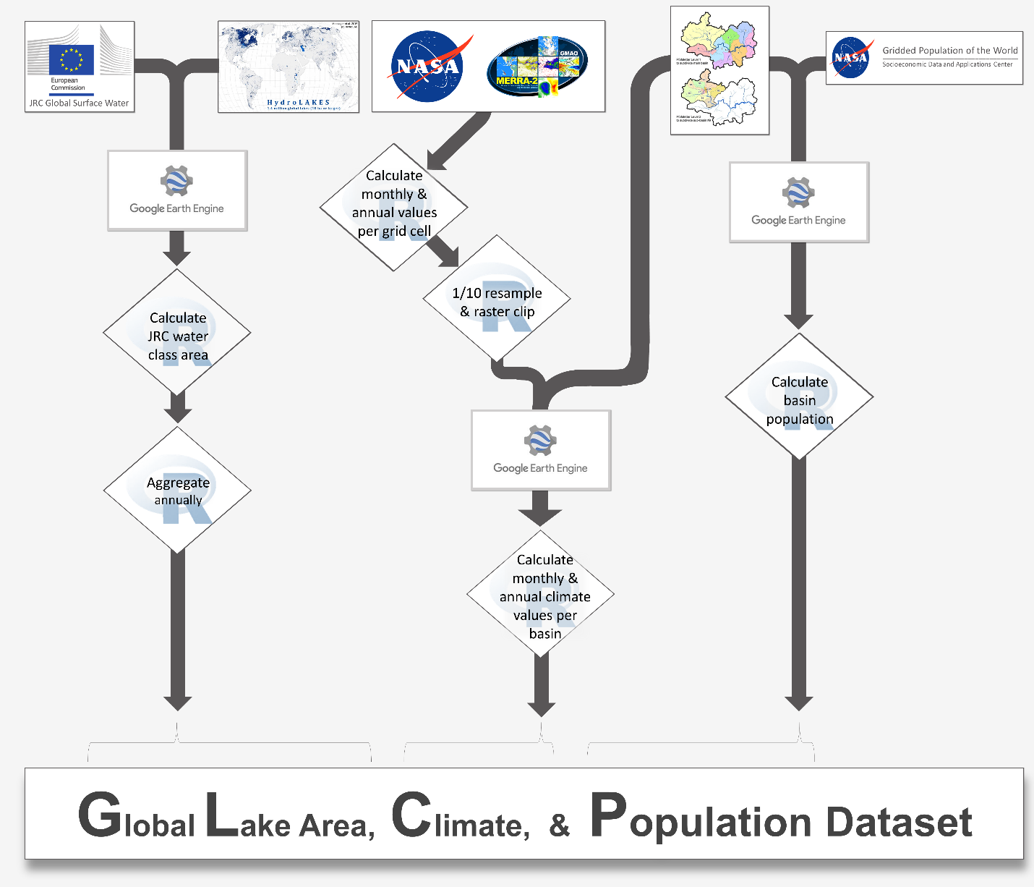
Figure 1: Workflow of data harmonization process. JRC Water area was calculated in Google Earth Engine (GEE), and then aggregated locally within the R environment. Similarly, basin population was calculated on GEE, and then aggregated locally within the R environment. Climate data from MERRA-2, however, was first aggregated from hourly to monthly and annual values, then resampled for 1/10th of their original resolutions with a subsequent and raster clipping was performed within the R environment. We then imported the tiff outputs to GEE to calculate basin climate variables. GEE output was then downloaded locally and aggregated within the R environment.

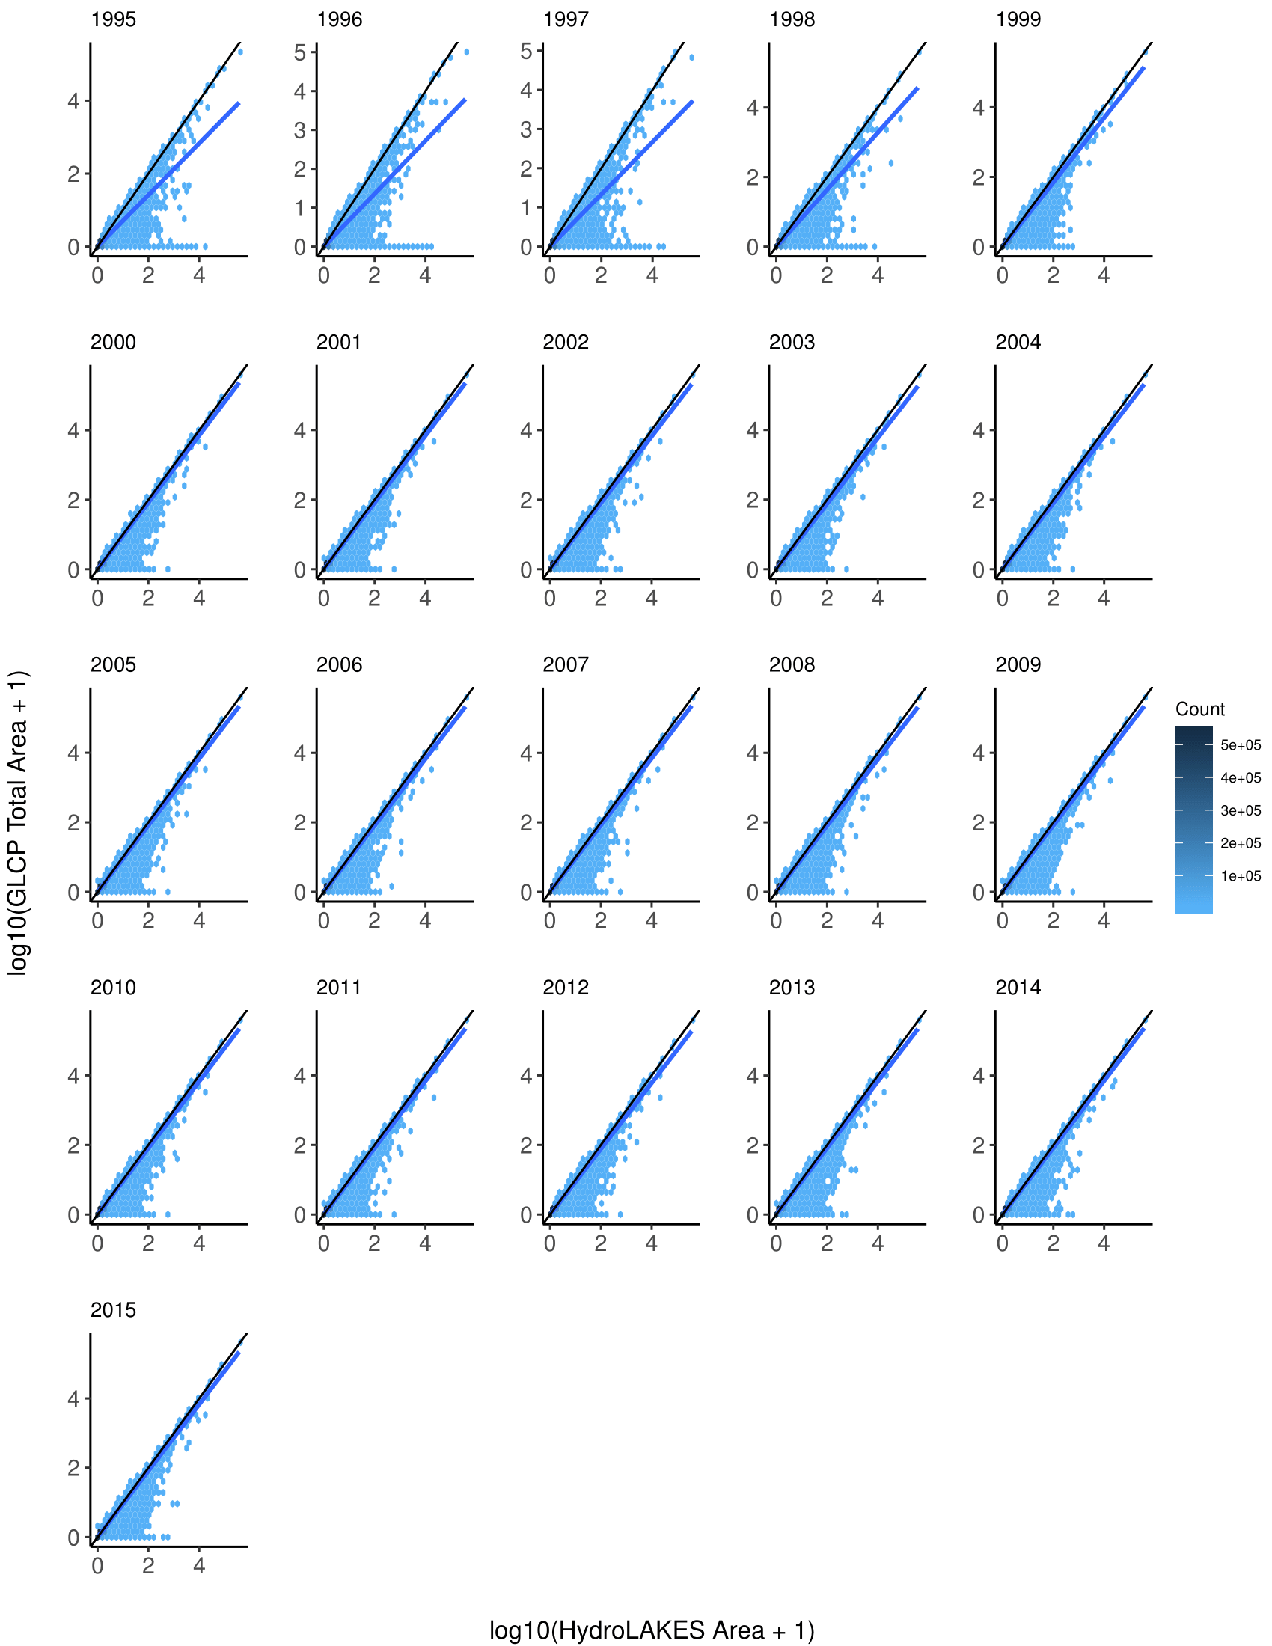
Figure 2: Comparison of 90 m buffer total water areas from JRC to reported lake areas in HydroLAKES. The black diagonal line is the 1:1 line, where a value on the 1:1 black line implies no difference between data sources. Color of hexbin indicates the number of lakes contained within a bin. The blue line is a linear regression for all points. The blue regression line tends to deviate more markedly for comparisons among the mid- to late-1990s. This is likely due to sparse LANDSAT coverage during the mid-to-late 1990s. Starting in 1999, though, the blue and black lines are nearly identical, which would be expected as LANDSAT coverage in 1999 and 2000 incorporated more complete global coverage, particularly in Siberia and Greenland. Scales have been log-transformed in order to show a more even spread of data points, as most lakes are less than 10 km².

Table S1: Summary statistics of interannual comparisons for each lake contained in the GLCP with the same lake’s area as defined in HydroLAKES. A value less than one indicates the JRC-derived area as less than the HydroLAKES reported area, whereas a value greater than one indicates the JRC-derived area as greater than the HydroLAKES area. Slightly higher mean deviations are observed in the mid-to-late 1990s in comparison to those after 2000, likely as a result of sparse satellite coverage. Even with these deviations, the data are consistent from year-to-year, giving confidence in interannual consistency for included lakes.
Year | Min. | 1st Qu. | Median | Mean | 3rd Qu. | Max.
1995 | 0.000 | 0.452 | 0.884 | 0.716 | 0.981 | 4.208
1996 | 0.000 | 0.000 | 0.876 | 0.685 | 0.977 | 5.385
1997 | 0.000 | 0.007 | 0.863 | 0.676 | 0.969 | 5.508
1998 | 0.000 | 0.716 | 0.897 | 0.786 | 0.992 | 4.400
1999 | 0.000 | 0.794 | 0.920 | 0.867 | 1.012 | 5.413
2000 | 0.000 | 0.813 | 0.924 | 0.915 | 1.026 | 4.769
2001 | 0.000 | 0.824 | 0.930 | 0.918 | 1.025 | 5.369
2002 | 0.000 | 0.822 | 0.930 | 0.909 | 1.021 | 4.830
2003 | 0.000 | 0.800 | 0.916 | 0.881 | 1.003 | 4.408
2004 | 0.000 | 0.828 | 0.935 | 0.916 | 1.030 | 5.731
2005 | 0.000 | 0.832 | 0.937 | 0.923 | 1.032 | 4.579
2006 | 0.000 | 0.835 | 0.939 | 0.926 | 1.034 | 5.714
2007 | 0.000 | 0.830 | 0.937 | 0.926 | 1.037 | 5.335
2008 | 0.000 | 0.827 | 0.935 | 0.916 | 1.031 | 5.558
2009 | 0.000 | 0.834 | 0.940 | 0.929 | 1.040 | 5.722
2010 | 0.000 | 0.822 | 0.933 | 0.917 | 1.031 | 5.287
2011 | 0.000 | 0.825 | 0.938 | 0.923 | 1.040 | 5.740
2012 | 0.000 | 0.760 | 0.892 | 0.868 | 0.996 | 5.665
2013 | 0.000 | 0.838 | 0.940 | 0.932 | 1.038 | 5.740
2014 | 0.000 | 0.842 | 0.943 | 0.938 | 1.042 | 5.636
2015 | 0.000 | 0.836 | 0.939 | 0.926 | 1.032 | 5.667

Table S2: Summary statistics of interannual comparisons for each lake contained within the GLCP. A value less than one indicates the latter year’s area as greater than the former year’s area, whereas a value greater than one indicates the latter year’s area as less than the former year’s area. Slightly higher mean deviations are observed in the mid-to-late 1990s in comparison to those after 2000, suggesting remnants from sparse satellite coverage. Even with sparse satellite coverage, the data are consistent from year-to-year, giving confidence in interannual consistency for included lakes.
year:year | Min. | 1st Qu. | Median | Mean | 3rd Qu. | Max.
1995:1996 | 0.000 | 0.973 | 1.000 | 2.059 | 1.026 | 99236.252
1996:1997 | 0.000 | 0.977 | 1.003 | 2.109 | 1.034 | 99831.287
1997:1998 | 0.000 | 0.926 | 0.993 | 1.272 | 1.022 | 55846.619
1998:1999 | 0.000 | 0.926 | 0.989 | 1.875 | 1.013 | 187756.835
1999:2000 | 0.000 | 0.957 | 1.005 | 1.163 | 1.046 | 19800.238
2000:2001 | 0.000 | 0.965 | 0.997 | 1.519 | 1.020 | 40847.822
2001:2002 | 0.000 | 0.975 | 1.000 | 1.832 | 1.021 | 96708.661
2002:2003 | 0.000 | 0.985 | 1.003 | 1.972 | 1.044 | 53962.583
2003:2004 | 0.000 | 0.948 | 0.992 | 1.347 | 1.008 | 26219.437
2004:2005 | 0.000 | 0.982 | 1.000 | 1.325 | 1.019 | 37402.580
2005:2006 | 0.000 | 0.980 | 1.000 | 1.280 | 1.015 | 35725.069
2006:2007 | 0.000 | 0.985 | 1.000 | 1.278 | 1.020 | 52901.691
2007:2008 | 0.000 | 0.984 | 1.000 | 1.562 | 1.023 | 46028.962
2008:2009 | 0.000 | 0.975 | 0.998 | 1.187 | 1.014 | 15288.290
2009:2010 | 0.000 | 0.988 | 1.002 | 1.299 | 1.028 | 16393.431
2010:2011 | 0.000 | 0.975 | 0.998 | 1.330 | 1.013 | 34720.477
2011:2012 | 0.000 | 1.005 | 1.035 | 1.621 | 1.101 | 44756.699
2012:2013 | 0.000 | 0.905 | 0.963 | 1.179 | 0.992 | 13833.978
2013:2014 | 0.000 | 0.988 | 1.000 | 1.064 | 1.007 | 3376.273
2014:2015 | 0.000 | 0.993 | 1.000 | 1.257 | 1.015 | 21168.566

Table S3: Summary statistics of percent differences in GLCP values when created de novo. Despite being created from the same data and source code, floating decimal values may vary due to heterogeneities in processor architecture.
Variable | Min. | 1st Qu. | Median | Mean | 3rd Qu. | Max.
total_precip_mm | -2.26E-13 | 0 | 0 | -2.01E-19 | 0 | 0
mean_monthly_precip_mm | -2.89E-13 | 0 | 0 | -2.37E-20 | 0 | 0
mean_annual_temp_k | -3.53E-13 | 0 | 0 | 3.06E-21 | 0 | 3.94E-13
pop_sum | -8.54E-13 | 0 | 0 | 9.04E-19 | 0 | 8.05E-13
seasonal_km2 | -9.63E-13 | 0 | 0 | -8.31E-20 | 0 | 9.59E-13
permanent_km2 | -7.76E-13 | 0 | 0 | 5.07E-20 | 0 | 9.62E-13
total_km2 | -9.88E-13 | 0 | 0 | -1.37E-20 | 0 | 9.57E-13

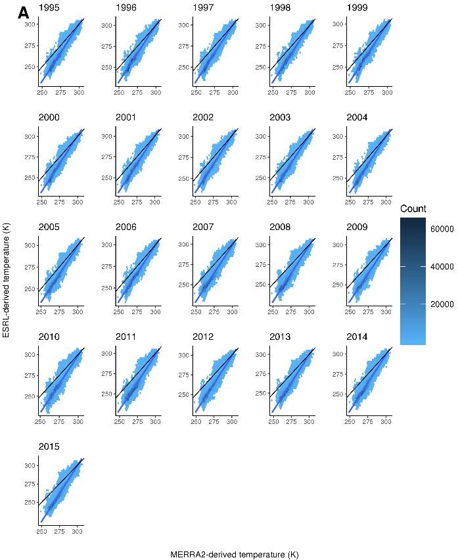 | 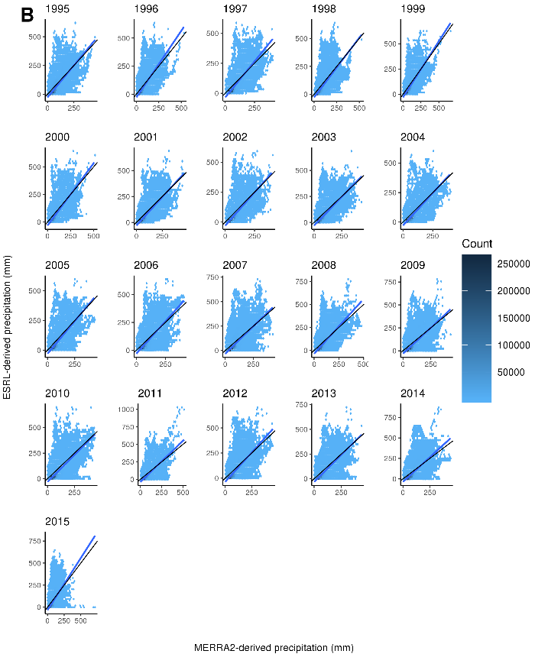

Figure S1: Comparison of basin-level MERRA2-derived climate data with University of Delaware Air Temperature and Precipitation (UDATP)-derived climate data. Each comparison plot contains a black 1:1 line, a blue linear regression line, and hexbins colored by number of basins. Comparisons for temperature data (A) demonstrate greater congruence between the two datasets at higher temperatures as opposed to lower temperatures. Throughout the time series, discrepancies between UDATP- and MERRA2-derived temperature values remain consistent. Differences between precipitation values (B) vary more than temperature values. Despite precipitation comparisons deviating from the 1:1 line more markedly than temperature, a linear regression line is broadly consistent with the 1:1 line.

