Explaining the dependence of M-site diffusion in forsterite on silica activity: a Density Functional Theory approach

Joshua M R Muir^{*1,2}, Michael Jollands^{3,4}, Feiwu Zhang¹, Andrew M. Walker²
Corresponding author: Joshua M R Muir j.m.r.muir@mail.gyig.ac.cn
- Institute of Geochemistry, Chinese Academy of Sciences, 99 West Lincheng Road, Guiyang, Guizhou 550081, China
- School of Earth and Environment, University of Leeds, LS2 9JT, United Kingdom
- Institute of Earth Sciences, University of Lausanne, 1015 Lausanne, Switzerland
- Lamont-Doherty Earth Observatory, 61 Rt 9W, Palisades, NY 10964, USA

Words: 9265

Key Words: Forsterite; Mg Diffusion; DFT; Point Defects; Enstatite; Aluminium

Explaining the dependence of M-site diffusion in forsterite on silica activity: a Density Functional Theory approach

Abstract:
Experimentally silica activity (aSiO₂) has been shown to have an effect on Mg diffusion in forsterite but without any obvious mechanism. We calculated the effects of aSiO₂ and aluminium content (the main contaminant in the experimental studies), and their co-effect, on Mg diffusion in forsterite, using thermodynamic minimisations of defect formation energies (calculated using Density Functional Theory (DFT)) and a Monte-Carlo diffusion model. These two variables, in isolation, do not appreciably change the defect concentrations of forsterite and thus do not affect the diffusivity of Mg. However, when elevated together, they cause large increases in the Mg vacancy content and thus can increase the Mg diffusivity by 1-6 orders of magnitude depending on temperature, with little pressure dependence. This effect is largely independent of Al₂O₃ concentration above ~1 wt. ppm, and thus, for all practical purposes, should occur wherever forsterite is in the presence of enstatite. It is also largely is dependent upon configurational entropy and is thus highly sensitive to the chemistry of the crystal. Small amounts of structurally bound hydroxyl groups at low temperatures (1000 K) suppresses this effect in perfect forsterite but it is likely robust in the presence of water when alternative water sinks (such as Ti or Fe) are present or at high temperatures (2000 K). This effect is also robust in the presence of ferrous iron (or other substitutional Mg defects) at all temperatures. Fe₂O₃ can operate like Al₂O₃ in this reaction and should enhance its effect. These findings explain the experimentally-observed dependency of diffusion of aSiO₂, and elucidate how chemical activity variations in both experiments and natural settings could affect not only the diffusivity of Mg in forsterite, but of olivine-hosted cations in general.

- Introduction
Understanding Mg diffusion in olivine is important for considerations of various geochemical transport process including electrical conductivity (Fei et al., 2018), rheology (Jaoul, 1990) and resolving the timescales of volcanic process (Costa et al., 2008), as well as for the understanding of point defect chemistry in silicates in general (Dohmen and Chakraborty, 2007, Nakamura and Schmalzried, 1983). Forsterite, the magnesian end-member of olivine (Mg₂SiO₄), can exist in the pure Mg-Si-O system along with either periclase (MgO) or enstatite (MgSiO₃). Whilst it has been understood for several decades that the buffering assemblage, and hence the silica activity, affects various properties of olivine such as its rheology (Bai et al., 1991, Ricoult and Kohlstedt, 1985), trace-element incorporation (e.g. H (Matveev et al., 2001)) and its point defect population (Nakamura and Schmalzried, 1983, Stocker and Smyth, 1978), the extent to which aSiO₂ affects trace, minor and major element diffusion in olivine is still being elucidated.
Specifically, it has been recently demonstrated that various M-site cations, including Ni²⁺,Co²⁺ (Zhukova et al., 2014); Cr²⁺, Cr ³⁺ (Jollands et al., 2018); Zr⁴⁺, Hf⁴⁺ (Jollands et al., 2014); Mn²⁺, Ni²⁺, Co²⁺, Ti³⁺, Ti⁴⁺ (Jollands et al., 2016b); Rh³⁺ (Zhukova et al., 2018) and Al³⁺ (Zhukova et al., 2017), all show higher diffusivities (0.5-2 orders of magnitude) in nominally-pure forsterite buffered with enstatite compared to equivalent experiments buffered with periclase. Only Be²⁺ (Jollands et al., 2016a), Ca²⁺ (Bloch et al., 2019) and H⁺ (Jollands et al., 2016c) have yet shown diffusivities independent of aSiO₂. Recently, Mg²⁺ diffusivity has been shown to be ~1 order of magnitude higher in enstatite versus periclase-buffered experimental assemblages (Jollands et al., 2020). It should be noted that some previous experimental campaigns showed no effect of aSiO₂ on Mg diffusion (Chakraborty et al., 1994, Andersson et al., 1989) - this has been proposed to relate to the inherent difficulty of controlling aSiO₂ in such experiments (Jollands et al., 2020). Additionally, previous theoretical studies (Walker et al., 2009, Bejina et al., 2009) have not considered the effect of aSiO₂ on diffusion. Previous attempts (e.g. Zhukova et al. (2014)) to link the experimentally-observed aSiO₂ – diffusivity relationship to the point defect population of forsterite have relied on the papers of Stocker and Smyth (1978), Pluschkell and Engell (1968), Smyth and Stocker (1975). These studies calculated the charge balance conditions of a set of defect-producing reactions, based on how variations of the defect concentrations would affect the equilibrium conditions. However, these works involved major assumptions due to a lack of quantification of the energetics of these reactions. In these studies it was assumed that changing aSiO₂ causes a change in Mg vacancy concentration that can be described by a simple exponent, which is unlikely when considering all of the Mg vacancies, that are formed by all the defect reactions, together.
To address this, we use Density Functional Theory (DFT) (Hohenberg and Kohn, 1964, Kohn and Sham, 1965) to examine the concentration at thermodynamic equilibrium of point defects in forsterite, and how this value is changed by the presence of enstatite or periclase (i.e. changing the aSiO₂). We also investigate the effect of small concentrations of Al, the only notable impurity in the crystals used in most of the experiments where an effect of aSiO₂ was demonstrated (Zhukova et al., 2014, Jollands et al. 2020). Whilst the results are only applicable to pure forsterite, we also use thermodynamics to speculate how Mg diffusion would operate in natural settings.
- Methods
Three steps were necessary to form a complete picture of Mg diffusion in forsterite. First, the number of defects present in forsterite was determined- for this the energetics of the defect formation reactions are needed. Thus, the energies of all the plausible defects forming reactions were calculated, both with and without enstatite, at various pressures and temperatures. This was done using lattice dynamics, with the force constants and energies provided by DFT calculations. This provides the energy of a series of isolated reactions. In real forsterite, the defect producing reactions will interact with each other. Therefore, in the second step, the energies of the reactions calculated in step one were used to build a thermodynamic model. With this model, the concentration of defects at thermodynamic equilibration can be found through a free-energy minimization, so that the number of defects present in forsterite under varying conditions can be obtained. Third, the effects of these defect concentrations on diffusion was determined. For this, the defect concentrations established from the first two steps were converted into diffusivities by inserting them into a Mg diffusion kinetic Monte-Carlo model.

2.1 Reaction Free energies
Free energies were calculated with the CASTEP code (Clark et al., 2005). This solves for the electronic structure (and thus the energy) of any structure using DFT with a plane-wave basis set for the valence electrons and pseudopotentials for the core electrons and nuclei. An approximation for the exchange-correlation functional is needed, for which we used the Perdew-Burke-Elmer (PBE) approximation (Perdew et al., 1997, Perdew et al., 1998). Ultrasoft pseudopotentials (Payne et al., 1992) were generated using the on-the-fly method of CASTEP 16.11 in the PBE scheme-- the valence shells are: Al: 3s and 3p; Mg: 2s, 3p and 3s; O: 2s and 2p; Si: 3s and 3p. To find minimum energy structures we used the standard quasi-newtonian minimisation routine (Pfrommer et al., 1997) found in CASTEP.
The energies of all (likely) relevant defects (Mg, Si and O interstitials and vacancies, and Al on Mg and Si sites) were calculated by placing them into a forsterite (2x1x2) supercell. The energies of forsterite (2x1x2 cell), MgO (2x2x2) and enstatite (1x1x2) supercells were also calculated. Enstatite energies were calculated in its ortho-, proto- and clino- forms, and the lowest energy phase used at any particular point in P,T space. All structures were relaxed with a plane wave cut-off of 1000 eV, 4x4x4 k-points and relaxed to a force tolerance of 0.01 eV/Å and an energy tolerance of 1×10⁻⁵ eV/atom, although for frequency calculations this was increased to 0.001 and 1×10⁻⁹, with plane wave and k-point cut-offs set to levels where the tolerances were repeated across runs. Calculations were done at 0, 5, 10 and 15 GPa. For cells that had a formal charge, the energy calculated by CASTEP includes a defect-defect interaction term between adjacent supercells which does not reflect our desired energy of a point charge in an infinite medium. We can approximately correct for this term, however, by assuming it is the energy of a periodic array of point charges in a uniform neutralising background charge. This was done using the method of Leslie and Gillan (1985), first used for forsterite by Brodholt and Refson (2000). To use this method the relative permittivity of the cell needs to be set - we used a value of 6.2 following Brodholt and Refson (2000). The Madelung constant also has to be determined. This can be obtained from the Ewald sum which we determined (to ease calculation) with the GULP code (Gale, 1997), This sum was determined for forsterite (2x1x2) unit cells using the TBH1 forcefield (Price et al., 1987) and the Wolf sum approximation to the Ewald sum with R_{cut} of 15 Å. Full details of this forcefield are given in Muir et al. (Submitted).
In all simulations we have a fixed concentration of defects but we desire to find the effect of introducing a defect at the “dilute limit” where the concentration of defects is small enough that the defect-defect interaction terms are non-existant and that the introduction of defects does not affect bulk parameters such as volume and permittivity. Simulating this point requires very large supercells which are computationally extremely demanding for little gain in accuracy. To test the inaccuracy caused by our supercells being too small we calculated the defect energy of $V_{Mg}^{''}$, $V_{O}^{∙∙}$, ${Al}_{Mg}^{∙}$ and ${Al}_{Mg}^{∙}$ in their most stable positions in our normal (2x1x2) and an extra large (4x2x4) supercell and we find the difference in defect energy to be less than 30 meV/defect in all cases and for $V_{Mg}^{''}$ to be less than 10 meV/defect. To further approximate the dilute limit we fixed the volume of all of our defect-containing supercells to the volume of a defect-free supercell to remove spurious unit-cell expansion terms which would not be present at the dilute limit. Similarly, when correcting for charge-charge interactions we always set the permittivity and the Madelung constant to that of a defect-free cell as at the dilute limit the introduction of defects should not change these constants.
To determine the free energy at temperature, we calculated the phonon frequencies for all perfect and defected systems using the finite displacement method of CASTEP (Frank et al., 1995) with finite displacements of 0.01 bohr (0.00053 Å). All phonons were calculated at q=(0,0,0) as with finite displacement this is the only physically meaningful q-point. While this single point calculation may introduce a significant sampling error, all of our calculations involve comparisons between two very similar structures - a perfect and a defected supercell. Thus, the effect of sampling errors is likely to be small. Additionally, the effects of vibrational entropy are very small when compared to those of configurational entropy, as discussed below. Therefore, additional q-points will not have any large effect upon the results as they change only the least significant term in the energy equation. To test these assumptions we calculated a perfect forsterite unit cell, one containing a $V_{Mg}^{''}$ and one containing a ${Al}_{Mg}^{∙}$ using both the method outlined above and density phonon perturbation theory (as implemented in CASTEP) with q-points (2x2x2). We then calculated the difference in defect energy determined with these two methods and found it to be less than 10 meV/defect which is much smaller than our reaction energies.
Frequencies were calculated at at least five different volumes and then the Gibbs free energy (G) at each volume (V), pressure (P) and temperature (T) was found with:
$G\left(P,T,V\right)=U\left(V\right)+{PV+E}_{ZP}\left(V\right)−TS\left(T,V\right)$ Equation 1
where U is the internal energy. E_{ZP} (zero point energy) and S (entropy) are calculated using Equations 2 and 3, respectively:
$E_{ZP}\left(V\right)=\sum_{k,i}{\frac{1}{2}ħν_{k,i}\left(V\right)}$ Equation 2
$S\left(V,T\right)=−\sum_{k,i}{ln\left[1−exp\left(\frac{−ħν_{k,i}\left(V\right)}{k_{B}T}\right)\right]−\frac{1}{T}\sum_{k,i}{ħν_{k,i}}\left(V\right){\left[exp\left(\frac{ħν_{k,i}\left(V\right)}{k_{B}T}\right)−1\right]}^{−1}}$ Equation 3
Where ν_{k,i} is the frequency of the phonon with wave vector k in the i-th band, k_{b} is the Boltzmann constant and $ħ$ is the reduced Planck constant. At the pressure and temperature of interest the appropriate volume and free energy was determined by fitting 2nd order polynomials across our volume range and minimising Equation 1. This method is quasi-harmonic as it includes thermal expansion of the crystal but ignores the effect of anharmonicity in phonon vibrations and thus fails when these are significant.

2.2 Pressure Correction
While DFT generally reliably reproduces pressure derivatives, the absolute pressures reported by DFT (P^{DFT}) are known to be systematically incorrect, in that they are shifted in one direction. This arises due to the use of an approximation of the exchange-correlation term as different approximations give different pressure shifts. Generalised Gradient Approximation (GGA) methods (such as the PBE approximation used here) overestimate volume and pressure whereas Local Density Approximation (LDA) methods have the opposite effect. As pressure differences are reliably reported (as the effects of the approximation largely cancel out) replication of experimental elasticities has been performed via simple correction schemes based on experimental values. As shown in Zhang et al. (2013) simple linear correction schemes often produce sensible results, e.g.:
$P\left(V,T\right)=P^{DFT}\left(V,T\right)−P^{DFT}\left(V_{0}^{exp}\right)$ Equation 4
where $V_{0}^{exp}$is the experimental volume at 0 pressure determined from fitting to an equation of state. While such corrections are likely possible for defect energies, which are strong functions of pressure, no rigorously tested formulations have been produced due to the paucity of reliable experimental defect energy data. Regardless, we can consider the magnitude of this pressure correction effect by using equation 4, i.e. assuming defect energies are linear functions of DFT pressure. For this equation we used $V_{0}^{exp}$ values of 287.4 Å³ for olivine (Isaak et al., 1989), 74.71 Å for MgO (Speziale et al., 2001) and 832.918 Å³ for enstatite (Kung et al., 2004). This provided corrections of -4.95, -4.45 and 3.91 GPa respectively. As we are assuming a dilute limit these pressure corrections are fixed regardless of the defects present in the unit cell. Adding in a different term to pressure correct for defects would add in spurious volume correction terms to our calculated defect energies. To simplify discussion, the values in this work have been corrected by -5 GPa such that values are presented at 0, 5 and 10 GPa but were calculated at a DFT pressure of 5, 10 and 15 GPa. This will provide pressure values closer to actuality while still being somewhat inaccurate. The pressure derivatives between these three runs at different pressures should be much more reliable.

2.3 Defect Sites
There are many different types of defect that can exist in forsterite. In this study, we focus on vacancies and interstitials of the major elements in forsterite as well as two substitutional sites of Al. Each of the defects were allowed to exist on the following sites in Kröger-Vink notation (Kroger and Vink, 1956): $V_{Mg}^{''}$: M1 and M2; $V_{O}^{∙∙}$: O1,O2 and O3; $V_{Si}^{''''}$: Si; ${Mg}_{I}^{∙∙}$: M1 and I2; $O_{I}^{''}:$ I1, I2, T1, T2, T3, T4 and T5; ${Si}_{I}^{∙∙∙∙}$: I1, I2, T1, T2, T3, T4 and T5; ${Al}_{Si}^{'}:$ Si; ${Al}_{Mg}^{∙}:$ M1 and M2; where I1 and I2 are vacant octahedral sites, T1-T5 are vacant tetrahedral sites, Si is the (unique) Si site, M1 and M2 are the two different Mg sites and O1-O3 are the three different O sites in forsterite. A picture of forsterite with some sites labelled is shown in Figure S1.
I1 and I2 sites are equivalent to M1 and M2 sites, respectively, that have been shifted by 0.5 of the [100] unit cell vector. T1-T5 can be related to the O sites. Each oxygen site has 2 tetrahedral sites that are shifted by ±0.34 in the [100] unit cell vector. The difference between the positive-shifted and negative-shifted tetrahedral sites are dependent on the local O environment in its SiO₄ tetrahedron rather than in absolute terms. Therefore, we define the sites by the relative location of the O from which the site is shifted, and the Si to which that O is bonded. So, sites T1, T3 and T4 are equivalent to the sites O1, O2 and O3 respectively shifted 0.34 in the [100] unit cell vector away from the Si and sites T2 and T5 are equivalent to the sites O2 and O3, respectively, shifted 0.34 in the [100] unit cell vector towards the Si. The site that occurs when O1 sites are shifted by 0.34 in the [100] unit cell vector towards the Si is simply the usually-occupied Si site.
Mg interstitials have unique geometry in forsterite, being able to occupy both empty octahedral sites (I1 and I2) as well as occupied octahedral sites (M1 and M2). This occurs through creating a “split” interstitial whereby two Mg occupy a single octahedral site. The two Mg are shifted either positively or negatively, respectively, in the [010] direction such that they are on either side of the site center (Walker et al., 2009, Jaoul et al., 1995, Muir et al., Submitted). Mg interstitials could not be stabilized on M2 or I1 sites, leaving split M1 and I2 as the only possible sites for Mg interstitials.

2.4 Thermodynamic Minimization
In a system at equilibrium, the concentration of the different types of defects will be whichever collective configuration of defects gives the lowest free energy. Thus, to find the concentrations of defects we need to be able to calculate the free energy for arbitrary concentrations of defects. This is done by firstly defining a set of reactions (R1...R11 see text) such that for any given set of defect concentrations (arrangement) a set of constants (1D reaction vectors) (x₁,x₂…x₁₁) are defined between 0 and 1. Thus, if reaction R1 is proceeded forward by x₁, R2 by x₂… R11 by x₁₁, then the correct defect concentration will be obtained. It should be noted that the overall defect concentration is varied by R1…R11 and thus it is not set and changes until it reaches the defect concentration that is the thermodynamic minimium. There are some additional constraints on the constants such that negative quantities of defects or of MgO/MgSiO₃/Mg₂SiO₄ are not created, but the values of the constants are so small in defect calculations that these constraints are not naturally violated. The energy of this arrangement is then determined as such:
$G=U+PV−TS_{Vib}−TS_{Config}$ Equation 5
Where U is the internal energy, T is the temperature, P and V are pressure and volume (enthalpy H is equal to U+PV) and S_{Vib} and S_{config} are the vibrational and configurational entropies, respectively. The first two terms of Equation 6 (the enthalpy and lattice vibration change) can be arrived at through Equation 6:
$U+PV−TS_{Lattice}=\sum_{i=1}^{11}{x_{i}∗G_{reaction}}$ Equation 6
Where G_{reaction} is the calculated change in the free energy for each reaction at the appropriate P and T (as calculated by CASTEP) without considering the configurational entropy term. The last term in Equation 5 represents the configurational entropy of the arrangement. This is complex in forsterite due to both the large number of defects that exist on Mg sites and their spread across four different sites (M1, M2, I1 and I2). To solve for this term, we used the Gibbs entropy formula:
$S=−k_{B}\sum_{j}{p_{j}lnp_{j}}$ Equation 7
Where k_{B} is the Boltzmann constant, j represents a specific configuration of defects within an arrangement and p_{j} the probability that configuration occurs. The probability of any specific configuration occurring is:
$p_{j}=\frac{1}{Z}e^{\left({−U_{j}}/{k_{B}}T\right)}$ Equation 8

Where U_{j} is the internal energy of each configuration as in Equation 5. Strictly, this should be determined with the free energy (G in Equation 5) of each configuration. However, we have assumed that the largest change in the energy of the different configurations comes from the enthalpy differences between them, thus we have ignored changes to vibrational entropy between different configurations except for Mg interstitials as outlined below. To approximate the dilute limit we have fixed the volume of all defect cells to that of perfect forsterite. Therefore, the PV term does not change between different configurations, and Equation 8 is calculated with changes in U only. Z in equation 8 is the canonical partition function:
$Z=\sum_{i}{e^{\left({−E_{j}}/{k_{B}}T\right)}}$Equation 9
We define a configuration as a state where each of the defects of each type is confined to a single type of site. This can be imagined by having a single defect of each type and so the different configurations simply change which site each defect occupies. With the defects listed above there are 1176 configurations, all of which were tabulated (the full list is not provided as it is elementary and long). Each configuration has many ways that it can be arranged in the cells and this degeneracy is not equivalent for different configurations. To calculate the degeneracy (W) of each configuration, we must first calculate the degeneracy at each site:

W=ln$\frac{N!}{a!b!…z!}$Equation 10
Where N is the total number of sites, and a,b,c…z are the different types of atoms/defects at each site including a final z term, which is simply (N-a-b….-y). To solve this numerically, all defect concentrations were written in terms of defects/mol and then the Stirling approximation was used ($lnn!≅nln−n$), giving:
$W=NlnN−N−alna+a−blnb+b…−zlnz+z$ Equation 11
To calculate the energy (U_{j}) of each configuration, the difference in enthalpy between placing a defect at the different sites was calculated as a function of pressure (Table S2), and energy penalties were assigned for defects that were not in their favoured site. As such, we assume in this formulation that the relative energy of placing defects in different sites is not a function of temperature, and temperature effects occur only in differences between different types of defect (such as $V_{Mg}^{''}$ and ${Mg}_{I}^{∙∙}$and not between the same defects at different sites ($V_{Mg}^{''}$ at M1 and M2 for example) as the different Mg sites are similar and thus their vibrational frequencies should be similar. This was tested for two of the most prominent defects- Mg vacancies and Al in Mg sites- where it was found that the vibrational entropy difference between the two sites was less than 10 meV/defect due to the large similarities between the two sites. One notable exception is Mg interstitials which have quite different geometries between their two sites (M1 and I2) Muir et al. (Submitted) and thus quite different phonons. The vibrational entropy difference between these two sites is tabulated in Table S2 and included in the model and thus for Mg interstitials we use G rather than U.
Knowing the degeneracy and relative energy of all configurations, the entropy was calculated using Equation 7 but summed across i, where i is simply a sum across every configuration (j) appearing a number of times equal to its degeneracy (W).
A major assumption in this minimization is that all defects are randomly distributed across the crystal and do not associate with one another and that their phonons are largely indepedent. This is justified by the fact that typical configurational entropy gain associated with randomly distributing defects is much larger than the pairing energy gain associated with placing two oppositely charged defects close to each other, when there is a small number of defects. This assumption was tested by calculating the pairing energy of the major defect pairs (Table S3) and how many defects would be needed before the pairing energy became larger than the configurational entropy in a simple ideal system with no other defects. Generally, much larger concentrations than were seen in reality were needed before this term became significant and so we assumed all defects were freely mobile and not associated with their charge pair. This conclusion shows that minimizing the phonon-phonon interaction between defects reduces the total energy and this is further proven by the fact that temperature has only a weak effect on the pairing energy (Table S3) even when defects are adjacents to each other and thus phonon-phonon interactions between defects must be small. These conclusions justify both treating configurational entropy as a series of isolated defects scattered throughout the crystal and treating the enthalpy and vibrational entropy of each defect as a separate addition to the energy of forsterite that do not interfere with each other.
In summary for each reaction proceeding to the right it produces a set of defects and then these defects are spread across their different sites according to the energy differences between the sites and the thermodynamic minimum of this distribution which is determined by the state of every other reaction. An alternative way to consider or calculate this is that (for example) Reaction 1 is 4 reactions- one producing an M1 vacancy and an M1 interstitial, one producing an M2/M1, one an M1/I2 and one an I2/M2 but this will produce the same answer as a single reaction producing a vacancy and an interstitial that are then thermodynamically distributed across their two sites.
Obtaining thermodynamic minima from these equations is difficult as the energy surfaces are complex, with many local minima. Furthermore, defect concentrations (and thus x₁..x₁₁) can have relative concentrations that vary by 50+ orders of magnitude.
To account for this, we used a customized numerical minimization procedure. For each temperature and pressure of interest the Al content was set to the highest considered concentration - 750 wt. ppm, and enstatite was set to zero. Then a brute force examination was run, varying all x values between 1x10⁻²⁰ and 1 with points spaced half an order of magnitude apart for an estimate of the range of each of the values. The 5000 most stable arrangements were extracted and a nonlinear minimization (GRG minimizer (Lasdon et al., 1974)) was run on them to obtain a minimum. Then, variations in Al content or the addition of excess enstatite were examined using non-linear minimization algorithms from the established starting point. Manual examination of various points was also performed to check if more relaxed points could be found, which they could not. This procedure is not guaranteed to find the thermodynamic minimum but should find how varying Al or enstatite content should change defect concentrations from a fixed starting point.

2.5 Diffusion Rates
To convert concentrations into diffusivities, the method outlined in Muir et al. (Submitted) was used. This method uses a Kinetic Monte Carlo algorithm to calculate the diffusion coefficients of Mg vacancies and interstitials. Then, diffusion rates for each defect (Mg vacancy or interstitial) are calculated by multiplying these diffusion coefficients by the concentration of the specific defect calculated in this paper and the total diffusion rate was determined by adding the diffusion rates of Mg vacancies and interstitials together. In Muir et al. (Submitted) it was shown that Mg vacancy diffusion was highly anisotropic (primarily proceeding in the [001] direction) and that Mg interstitial diffusion was fairly isotropic. The overall anisotropy of Mg diffusion in forsterite depends, therefore, upon the balance of vacancy vs interstitial diffusion and their relative concentrations. In this study, the variation of diffusion rate comes solely from the variation of vacancy and interstitial concentrations with changing enstatite and aluminium content. Therefore, the effect of enstatite and aluminium can be considered a multiplier on the diffusion rates presented in Muir et al. (Submitted).

- Results and Discussion

3.1 Point Defects in Forsterite
To calculate the effect of external components on the vacancy content of forsterite, and thus Mg diffusion, we first need to know the intrinsic sources of defects. These can be represented with a series of reactions (R1-R11) constructed using Kröger-Vink notation (Kroger and Vink, 1956). The first nine reactions represent all the intrinsic defect-forming reactions in forsterite. R10 represents the addition of MgSiO₃, and R11 a potential co-effect of aluminium and enstatite. This is discussed in more detail below. An alternate notation scheme (depicting the actual unit cells used in the calculation) is presented in the supplementary information.

R1) ${Mg}_{Mg}^{X}→V_{Mg}^{''}+{Mg}_{I}^{••}$
R2) $O_{O}^{X}→V_{O}^{••}{+O}_{I}^{''}$
R3) ${Si}_{Si}^{X}→V_{Si}^{''''}+{Si}_{I}^{••••}$
R4) ${Mg}_{Mg}^{X}+O_{O}^{X}→V_{Mg}^{''}{+V}_{O}^{••}+MgO$
R5) $MgO→{Mg}_{I}^{••}+O_{I}^{''}$
R6) ${4Mg}_{Mg}^{X}+{Si}_{Si}^{X}+{4O}_{O}^{X}→{{4V}_{Mg}^{''}+Si}_{I}^{••••}+V_{Si}^{''''}+{4V}_{O}^{••}+4MgO$
R7) ${Si}_{Si}^{X}+2O_{O}^{X}+2MgO→V_{Si}^{''''}+2V_{O}^{••}+{Mg}_{2}SiO_{4}$

R8) ${Si}_{Si}^{X}+4MgO→V_{Si}^{''''}+2{Mg}_{I}^{••}+{Mg}_{2}SiO_{4}$
R9) ${2Mg}_{Mg}^{X}+{Si}_{Si}^{X}+{4O}_{O}^{X}→{2V}_{Mg}^{''}+V_{Si}^{''''}+4V_{O}^{••}+{Mg}_{2}SiO_{4}$

R10) ${Mg}_{Mg}^{X}+O_{O}^{X}+MgSiO_{3}→V_{Mg}^{''}+V_{O}^{••}+{Mg}_{2}SiO_{4}$
R11)${2Al}_{Mg}^{•}+{2Al}_{Si}^{'}+{4Mg}_{Mg}^{X}+8MgSiO_{3}→4{Al}_{Mg}^{•}+2V_{Mg}^{''}+{2Si}_{Si}^{X}+6{Mg}_{2}SiO_{4}$
At any given temperature and pressure the energy of each reaction (ΔG_{reaction}) is calculated, which contains the change in both the enthalpy and the lattice vibration entropy. This reaction scheme assumes that the crystal does not develop a charge during any defect production. The starting position of Al in R11 is discussed below.
The presentation of the reactions in Kröger-Vink notation above uses the traditional formulation where the number of sites remain fixed in the defective crystal. This is an assumption (that the concentration of defects is extremely low) but one that makes it impossible to derive a free energy minimization. The reason for this is discussed in the supplementary information, but in practice it means that in our calculations the excess forsterite created by R7-R11 must be allowed to grow the crystal for thermodynamic consistency and increase the number of Mg, Si and O sites. In practice this does not matter, however, as the number of sites in the base crystal changes by <1% due to R7-R11. We confirmed that this was a negligible effect by finding the local minimum of the free energy when forsterite sites in the crystal are fixed (by introducing an arbitrary term into our equations to account for forsterite site fixing) and this fixed local minimum was found to be the same as the actual global minimum ie. the change introduced into our calculations by fixing the number of forsterite sites is smaller than the accuracy of our solver.
The energies of Reactions R1-R11 are listed in Tables 1 and S1. In the absence of Al at all pressures and temperatures examined, R1 (which creates a Mg Frenkel defect) is the most favourable reaction. This preference for R1 is relatively large (1-3 eV). Considering each reaction in an isolated system, R1 would be favoured by at least 3 orders of magnitude over the next most favourable reaction (R4) and by over 10 orders of magnitude more than the other reactions. This becomes even more pronounced when free energy minimisation is considered, as R1 proceeding forwards prevents the other reactions from proceeding forward due to configurational entropy effects. This is because all of these reactions have large positive energies (which drive the reactions strongly to the left and away from defect production) and only produce defects because of configurational entropy, which increases when the reactions proceed to the right and create defects (increasing the configurational entropy). The equilibrium defect concentration occurs when these two energies balance. If large numbers of defects are already present- as, for example, when considering the case of other reactions in the presence of large amounts of defects created by R1- then the gain in configurational entropy for any reaction proceeding to the right is much lower and so too are the equilibrium concentration of defects. Therefore, all reactions produce fewer defects than they do in isolation but this is primarily seen through the most favoured defect-producing reaction (R1) suppressing the production of defects of the other, less favoured reactions.
Therefore, when considered either in isolation or in a combined thermodynamic system, R2-R3 and R5-R9 can be ignored, as including them changes the Mg vacancy and interstitial concentration by less than 1×10⁻⁸%. Thus, these reactions are omitted in minimisations described in the rest of this paper.
Of particular note is R6, which involves the production of Mg vacancies and Si interstitials. This equation (in a slightly modified form) was invoked to describe the effect of enstatite activity on point defects in forsterite by Stocker and Smyth (1978), and has recently been used to explain the relationship between aSiO₂ and diffusivity of M-site cations in olivine (Zhukova et al., 2014). In contrast, we find that this reaction is extremely unfavourable, even if rewritten to produce enstatite (which lowers its energy by ~1.0-0.6 eV depending upon pressure between 5-15 GPa). This is because the production of Si interstitials is extremely unfavourable due to their high charge (4+). This reaction may be the easiest way to produce Si interstitials but is still very unfavourable (and so the concentration of Si interstitials should be very low), but is certainly not the most favourable way to form Mg vacancies. R10 is a considerably more favourable reaction for aSiO₂ control over the Mg vacancy population.

3.2 The effect of enstatite
The effect of the presence of enstatite (and thus SiO₂ activity) can be represented with reaction R10. Multiple reactions could be constructed here, but this was chosen as the most energetically favourable reaction between MgSiO₃ and forsterite defects and all other reactions are reachable via combinations of R10 with R1-R9.
As shown in Table 1, R10 is slightly more favourable than R4 (both of which form Mg and O vacancies) but R1 (Mg Frenkel defect formation) is still far more favourable than either of them. Thus, the addition of enstatite to pure forsterite causes effectively no change in the concentration of Mg vacancies or interstitials. Moreover, reaction R1 proceeding forward largely suppresses the forward procession of R4 and R10 (due to configurational entropy effects). Therefore, even in the presence of enstatite, Mg vacancies in forsterite are essentially entirely formed by R1. Under all conditions tested, the change to the concentration of Mg vacancies by the addition of enstatite was <0.00001%. Simply put, the addition of enstatite should not affect Mg vacancy concentrations in forsterite and, as a result, SiO₂ activity should have no effect on Mg (or other M-site cation) diffusion in forsterite, in contrast to the experimental data (Jollands et al., 2020).

3.3 The effect of aluminium
Natural mantle olivine generally contains between ~0.001 to ~0.1 wt% Al₂O₃ (De Hoog et al., 2010), and Al was the main contaminant (10s wt. ppm) in the nominally pure synthetic forsterite employed in several recent diffusion studies (Zhukova et al., 2014, Jollands et al., 2020) . Aluminium in forsterite is generally considered to exist as Tschermak’s defects (Evans et al., 2008, Grant and Wood, 2010) where 2 Al³⁺ cations occupy an Mg²⁺ and a Si⁴⁺ site, respectively. Though the production of Tschermak’s defects is sensitive to pressure and the presence of other charged species (Zhang and Wright, 2010, Berry et al., 2007) we find that the Tschermak’s defect is the most stable Al defect of those tested and thus use it as the starting point for our calculations (left hand side of R11).
There is no obvious reason that Al in the Tschermak’s configuration will affect the formation of Mg defects except through modifying the configurational entropy of defects that exist on Mg sites where Al also exists. This has the effect of lowering the relative gain in configurational entropy caused by forming Mg defects and thus suppressing their formation. This effect, however, was also found to be very small (<0.0001%) due to the small number of Mg defects that do form and thus the presence of Al, in isolation, does not affect the formation of Mg defects and thus does not affect Mg diffusion.

3.4 The co-effect of aluminium and enstatite on defect concentrations
The presence of aluminium alongside enstatite, however, enables a new reaction which creates Mg vacancies and thus affects Mg diffusion (R11). In this reaction, Al starts in the Tschermak’s defect. One Al moves from a Si site to a Mg site with charge balance accommodated by the formation of Mg vacancies. This reaction consumes Si and ejects Mg from the forsterite and so turns enstatite (or equivalently SiO₂) into forsterite. A version of this reaction which produces MgO instead of consuming enstatite is possible and can be represented as R11+(R4-R10)*8 but is much less favourable - the production of MgO is not favoured under these conditions (see Table S4). Zhukova et al. (2017) also demonstrated the presence of a fast-diffusing defect that was hypothesised to occur via an R11-equivalent reaction (using SiO₂ rather than MgSiO₃) that was dependant on SiO₂ activity.
One potential hurdle is that R11, as written, can only occur at the edge of the crystal where forsterite is in contact with free enstatite, or else must involve exsolution. The latter is unlikely due to the positive enthalpy of R11 when compared to the negative enthalpy of forming forsterite from MgO+MgSiO₃ but it may be favoured by kinetics. A reaction on the surface would be limited by the diffusion rate of Al and Mg vacancies back into the bulk as otherwise an excess of defects at the grain boundaries would occur. Such diffusion is likely to be faster than bulk diffusion of Mg, however, due to a high local concentration of vacancies causing electrostatic repulsion of vacancies into the bulk.
R11, while being generally unfavourable, is much more favourable than any of the intrinsic defect reactions (by at least 1.4/2.1/2.7 eV at 1500 K at 0/5/10 GPa, Table 1) and thus will strongly affect Mg diffusion. This is accomplished both by creating more Mg vacancies and by reducing Mg interstitials through suppressing R1 (Mg-Frenkel defect formation) through configurational entropy effects as explained above for the pure intrinsic system.
The co-presence of Al and enstatite in association with forsterite leads to two major effects. First, the presence of enstatite changes the distribution of Al between the Mg and Si sites (Figure 1). As R11 proceeds in the forward direction it converts ${Al}_{Si}^{'}$ into ${Al}_{Mg}^{•}$ and thus decreases the ${Al}_{Si}^{'}$:${Al}_{Mg}^{•}$ ratio. The progress of this reaction is driven by configurational entropy. This is because converting a Tschermak’s defect (one Mg site defect plus one Si site defect) into three defects on the Mg sites causes a large increase in the number of possible configurations, and thus in configurational entropy. R11 is therefore increasingly favoured by increasing temperature, and so with increasing temperature a higher proportion of Al exists on Mg sites. Increasing the pressure suppresses this reaction as this transition is associated with an increase in volume. This effect is thus only prominent at low pressures and high temperatures (Figure 1). At high pressures or low temperatures, the overwhelming majority of Al remains in Tschermak’s defects.
Second, the combination of Al and enstatite causes a significant increase in Mg vacancy concentration (Figure 2) and a decrease in concentrations of Mg interstitials (Figure 3). These changes are large, with Mg vacancy concentrations increasing by 1-2 orders of magnitude (with respect to the enstatite-free system) at 2000 K, and 5-6 orders of magnitude at 1000 K. Mg interstitial concentrations also decrease by up to 3 orders of magnitude, and thus this reaction (R11), not Mg Frenkel generation (R1), will define Mg diffusion in cases where enstatite and Al are present. This has important experimental implications as it suggests periclase buffered experiments study the true intrinsic diffusivity of forsterite - controlled by the Mg Frenkel defects - whereas enstatite buffered experiments have additional pathways of diffusion available.
This enstatite+aluminium effect is strongly temperature-controlled and only weakly affected by pressure or Al concentration. Decreasing the temperature increases the effect of enstatite+Al on Mg vacancy concentrations (Figure 2). At an average temperature of 1500 K this reaction causes the Mg vacancy concentration to increase by ~1000 times. Typically, the concentration of Al has no effect beyond an initial saturation point of <1 wt. ppm Al₂O₃. Even at such a low concentration, there are orders of magnitude more Al atoms than the intrinsic defect concentration. With increasing temperature or decreasing pressure this Al₂O₃ saturation point is pushed to greater concentrations.
Some complicated effects are seen- notably the effect of pressure on vacancy and interstitial concentrations and the effect of temperature on interstitial concentrations (Figure 2-3, S2-S3). These somewhat strange trends arise due to the interplay between absolute changes in defect concentrations induced by enstatite and aluminium and the base concentration of defects, which change with pressure and temperature in different ways. Therefore, the relative change of defect concentrations (absolute change divided by the base concentration) does not always demonstrate clear trends. Figure S2 and Figure S3 show the absolute changes of vacancy and interstitial concentrations rather than the relative changes shown in Figures 2 and 3. When visualised as an absolute change in defect concentration, pressure clearly increases the effect of enstatite and aluminium on the defect concentrations. Temperature, on the other hand, clearly decreases the effect of enstatite and aluminium. The temperature effect is much larger than the pressure effect. Overall, however, when considering the relative effect of enstatite and aluminium on the defect concentration, decreasing the temperature increases the effect of enstatite and aluminium and changing the pressure has little effect.

3.5 The coeffect of aluminium and enstatite on diffusion and its anisotropy
Converting from defect concentrations into diffusion rates is not straightforward, because as shown in Muir et al. (Submitted), both Mg vacancies and Mg interstitials are important for Mg diffusion. Moreover, the relative importance of each of these two components on diffusion depends on pressure and temperature. This is demonstrated in Figure S4 for perfect forsterite. Diffusion coefficients for Mg vacancies and interstitials at various pressures and temperatures were determined in Muir et al. (Submitted) by using constrained optimization DFT and these shall be used in this work. At each temperature and pressure we take two diffusion coefficients, one each for Mg vacancies and Mg interstitials, from Muir et al. (Submitted), multiply each coefficient by the concentration of that defect at that pressure and temperature to determine the diffusion rate for that defect and then added together the diffusion rate for each defect to determine the total Mg diffusion rate. This is demonstrated in Figure 4 where we show Mg diffusion rates in perfect forsterite as a function of defect concentration to stress how fundamental defect concentrations are to overall diffusion rate.
Figures 5 and S5 show the change in diffusion rates induced by enstatite as a function of Al content. These plots show that the change in diffusion rates caused by enstatite largely track the change in Mg vacancy concentrations caused by enstatite (seen in Figure 2), while the change in Mg interstitial concentrations caused by enstatite have little effect. This is largely due to the relative changes in the vacancy concentration caused by enstatite being much larger than the relative changes in the interstitial concentration. The overall effect, therefore, of enstatite in an aluminous system is a large increase in Mg diffusion rates.
A relative increase in Mg vacancy concentrations (compared to Mg interstitial concentrations) should lead to an increase in the anisotropy of diffusion, with [001] diffusion being favoured (Muir et al., Submitted). This is plotted in Figure 6 (with additional pressures in Figure S6 and S7). We see that at 2000 K enstatite induces no noticeable change in diffusional anisotropy, whereas at 1000 K enstatite induces a very strong increase in relative diffusion parallel to [001] (compared to diffusion parallel to [100] and [010]) leading to a strong (nearly 2 orders of magnitude) increase in diffusional anisotropy. This suggests that it may not always be reasonable to apply global fits to Arrhenius relationships using datasets from experiments conducted in different silica activity conditions. In such global fits, the activation energy for diffusion is kept constant and only the pre-exponential factor changes. Whilst such fits may appear reasonable over limited experimental temperature ranges, this has serious implications for the down-temperature extrapolation of experimental diffusion coefficients.

3.6 Site Occupancy of Al
In this work, we predict that a major defect forming reaction in forsterite, in the presence of Al₂O₃ (>~1 wt. ppm) and enstatite, is a reaction that moves trace Al from Si to Mg sites, and consumes enstatite. This assertion may be tested by examining the coordination number of Al in real forsterite. In recent Nuclear Magnetic Resonance (NMR ) experiments (McCarty and Stebbins, 2017) a ratio of 1:3 was determined for AlO₄:AlO₆ (i.e. tetrahedral to octahedral Al) in samples that had been heated to high temperature (~1800 K) with moderate Al contents (320 ppm Al₂O₃ wt%) and at ambient pressure. Without R11, or equivalent, this ratio should be 1:1 (i.e. representing the Tschermak’s defect) and so a ratio of 1:3 suggests either a reaction that drives the conversion of ${Al}_{Si}^{'}$ into ${Al}_{Mg}^{•}$, or that it was never in the ${Al}_{Si}^{'}$site to begin with. These experimental conditions are those in which R11 is significantly activated and we find a similar ratio (1:2), although this ratio would be highly dependent on pressure and temperature. As discussed in Zhukova et al. (2017), any Al incorporation mechanisms leading to a preference of ${Al}_{Mg}^{•}$ over ${Al}_{Si}^{'}$ may be more active in real systems than basic thermodynamic equilibration equations suggest, as the production of Tschermak’s defects requires the diffusion of Si, which is slow (Dohmen et al., 2002, Chakraborty, 2010). Thus, there is some evidence that an effect similar to R11 exists in real samples. This could be further tested by determining its pressure/temperature/Al content dependence of which the latter is the easiest in NMR.
It should be noted that in the experiments of McCarty and Stebbins (2017), aluminous forsterite was produced from SiO₂, spinel and MgO, with an MgO excess (1-3 wt%). This MgO excess should suppress, or prohibit, the formation of enstatite. There is a MgO equivalent of R11- (R11+(R4-R10)*8-see table S4) but it has a much weaker effect than R11 and under these conditions produces a 1:1 tetrahedral:octahedral ratio of Al according to our calculations and thus should not display the NMR patterns seen in the experiment. Interpreting the exact reactions that are occurring in this experiment is not straightforward, however, and there are possible ways that Al in forsterite could be exposed to SiO₂ containing compounds. Firstly, no periclase was detected at the end of the experiment and instead a silicate glass was formed. This suggests that the MgO was possibly not in excess and thus either some enstatite was available to catalyse R11 or the glass phase had a SiO₂ excess which could catalyse R11. Secondly MgO, SiO₂ and spinel were all ground together so that when spinel dissolves into forsterite, SiO₂ is likely present. Therefore, these reactions could potentially depend on the kinetics of forsterite formation from SiO₂ and MgO vs spinel dissolution into forsterite followed by R11. Further, there is no clear mechanism where the dissolution of spinel would lead to an excess of Al on the Mg sites in forsterite without some sort of SiO₂ analogue reaction, so it seems likely that some enstatite was present to catalyse the R11 reaction (or something similar). A useful test of this hypothesis could be obtained by tracking the ratio of tetrahedral:octahedral Al as a function of temperature.

3.7 Comparison of diffusion rates with literature
In Figure 7 the calculated diffusion rates are compared with some experimental data. There is a major problem with comparing to experimental diffusion rates in that real crystals will have some quantity of extrinsic defects which are not accounted for in our model and the type and quantity of these extrinsic defects will vary between different crystals and conditions. Our calculated rate is a baseline from which extrinsic vacancies will causes real crystals to deviate. This will occur typically by increasing the number of Mg vacancies and thus the diffusion rate but suppression of Mg vacancies (and thus decreasing of the diffusion rate) is possible. The fact that our results are fairly close to experimental results- and that experimental results are close to each other- suggests that extrinsic vacancies have a significant role but that it is small and that intrinsic defects explain a large proportion of the diffusion rate.

Following the arguments in Jollands et al. (2020), we assume that the Chakraborty et al. (1994) data is equivalent to periclase-buffered experiments (MgO film source) and the Morioka (1981) data was enstatite-buffered (quartz crucibles). In the periclase-buffered case we find that our diffusion rate is slightly slower than is seen experimentally. This case is also examined in Muir et al. (Submitted). This is unsurprising as our prediction of diffusion in the periclase buffered case is the minimum possible diffusion rate as our calculated forsterite contains only intrinsic defects. Real crystals should possess some quantity of extrinsic (impurity-associated) defects and these should typically increase the Mg diffusion rate by increasing the number of Mg vacancies. Conversely our predictions of enstatite-buffered diffusion are somewhat faster than is seen experimentally and this discrepancy has the same cause. Diffusion in the enstatite buffered case can be considered as a base diffusivity (diffusivity in periclase-buffered conditions) plus an addition to this diffusivity, which is caused by the additional Mg vacancie, which are added as a result of the presence of enstatite. The size of this additional enstatite effect is also dependant on the presence of extrinsic vacancies. We shall consider this in more detail later, but our calculated enstatite effect in the perfect crystal is close to its maximum size. The presence of extrinsic Mg vacancies will decrease the size of the enstatite effect. Thus the presence of a small amount of extrinsic Mg vacancies would cause the diffusion rate to increase in the periclase-buffered case and decrease in the enstatite-buffered case which is exactly what is observed in experiments, which always use real crystals with some unavoidable amount of extrinsic defects. Small pressure variations caused by the mismatch of DFT and experimental pressures would also have a significant effect – this is due to the large effect of pressure on the Frenkel reaction R1 (Table 1).
Our work shows a clear effect of enstatite on Mg diffusion rates. This does not necessitate, however, a change in how we generally consider Mg, or Fe-Mg, diffusion rates in natural mantle olivine. Olivine in the upper mantle is buffered by orthopyroxene (high SiO₂ activity) and most Mg-Fe interdiffusion work (Dohmen et al., 2007, Chakraborty, 1997) and Mg tracer diffusion (Fei et al., 2018, Chakraborty et al., 1994) have been performed in conditions of SiO₂ excess-i.e. similar conditions to the mantle. Instead we point out that it is important to consider chemical environment in diffusion experiments and that changes to these conditions can be critical.

3.8 The effect of other elements
We have shown that the presence of enstatite, which can be generalised to an increase in aSiO₂, causes a large increase in anisotropic Mg diffusivity in forsterite that is highly temperature-dependent. Thus, to properly model Mg diffusivity in mantle olivine, the background chemical environment needs to be considered. Mantle olivine is not pure forsterite, and so it is important to consider how the presence of other elements will affect these results. It is impossible currently to consider the thermodynamic properties of every major, minor and trace element but we can speculate on how various classes of elements will affect the thermodynamic reactions here. Most trace elements will not directly create or destroy vacancies or interstitials in forsterite but will instead change the configurational entropy of the crystal. As outlined above, defect production is the result of interplay between enthalpic and configurational effects. Increasing the background defect concentration changes the latter term, leading to lower intrinsic defect concentrations and likely does not change the former term as to do so would require the new elements to interact electronically with the defects which is unlikely. If we purely consider these changes to this latter term, we can model the effects of introducing other elements, without needing to know their electronic effects on the system. It is particularly important to consider the configurational effect of other elements in the system when modelling the Aluminium-enstatite reaction as it is mostly driven by configurational entropy differences and thus changing the configurational entropy balance of the starting crystal may significantly impair or enhance it.
Therefore, we can consider these other defects in general groups, based on which sites they occupy and thus how they affect the configurational entropy without considering their electronic effects. The following three generic categories of external defects will be considered: 1) cations that can exist on Mg and Si sites simultaneously (e.g. Fe³⁺); 2) divalent cations that can substitute for Mg²⁺ (e.g. Fe²⁺) and 3) cations that produce additional Mg vacancies (e.g. H⁺). 3+ cations that exist on Mg and Si simultaneously are unique in that they can also undergo an equivalent reaction to R11. For this first group of elements we will therefore also consider the electronics of the element in this group that is most likely to be present in olivine- ferric iron.

3.9 Ferric Iron
Iron in olivine is predominantly ferrous but can be converted between ferrous and ferric states by, for example:
R12)${2Fe}_{Mg}^{•}+{2Fe}_{Si}^{'}+{4Mg}_{Mg}^{X}+8MgSiO_{3}→4{Fe}_{Mg}^{•}+2V_{Mg}^{''}+{2Si}_{Si}^{X}+6{Mg}_{2}SiO_{4}$
Which is equivalent to R11. This reaction involves ferric iron and is dependent on MgSiO₃ (or SiO₂) activity. Another potential reaction is:

R13) ${Fe}_{Mg}^{X}+{Si}_{Si}^{X}+\frac{1}{2}{Fe}_{2}SiO_{4}+\frac{1}{2}O_{2}→{Fe}_{Mg}^{•}+{Fe}_{Si}^{'}+\frac{3}{2}SiO_{2}$
which is dependent upon oxygen fugacity. R12 is even more favourable than R11 (see Table S4 where the energies of this reaction are presented). In the presence of Fe³⁺ and enstatite (or Fe²⁺, enstatite and a high oxygen fugacity), therefore, very similar (though slightly more exaggerated) results as for Al and enstatite should be seen, with similar trends with concentration, pressure and temperature. The presence of large amounts of Fe³⁺ will push R12 to the right, which will in turn push R11 to the left (as they are both competing in configurational entropy terms and R12 is more favourable energetically). However, they both create the same number of Mg vacancies and so the effect on diffusion will be the same.
Modelling this effect is difficult, however, as it is dependent on the Fe³⁺ concentration and its site distribution, which is itself dependant on multiple variables (total Fe concentration, oxygen fugacity, silica activity and temperature). The relationship between the Fe³⁺:Fe²⁺ ratio and these variables is poorly constrained, but, according to the model of Dohmen and Chakraborty (2007) the Fe³⁺ concentration of an olivine crystal with a typical Mg/(Mg+Fe) value of 0.9 (De Hoog et al., 2010) would be around ~0.5-500 ppm. Only around 1-10 atomic ppm Fe³⁺ is needed to activate the effect of enstatite on Mg (or Fe-Mg) diffusion and so there is likely enough Fe³⁺ in natural mantle olivine to activate R12. However, a better definition of the Fe³⁺:Fe²⁺ ratio is needed to be certain.
At this point we would like to discuss another reaction:
R14) ${6Fe}_{Mg}^{X}+MgSiO_{3}+O_{2}→4{Fe}_{Mg}^{•}+2V_{Mg}^{''}+{Fe}_{2}SiO_{4}+MgO$
R14 has been invoked to provide the majority of defects in natural olivine above 1100 K until an even higher point when pure intrinsic defects take over (Chakraborty, 2010) and has been labelled the Transition Metal Extrinsic Diffusion (TaMED) regime. It should be noted that the TaMED reaction is typically written with SiO₂ instead of MgSiO₃ on the left, but these regimes should be equivalent.
While the exact chemical mechanism by which R14 occurs is unknown, R14 can be carried out in a two-step mechanism by first oxidising ferrous iron and pushing some of it onto the Si sites (R13) and then eliminating this tetrahedrally-coordinated ferric iron through an enstatite reaction (R12). It is highly unlikely that either ferric iron forms entirely on the Mg site or that Mg vacancies form spontaneously in the first step as these will create unbalanced charges with large energies. The activation barrier of R12 is not particularly high and R13 has been used in previous point defect models as one of the pathways for the oxidation of ferrous iron in forsterite (Dohmen and Chakraborty, 2007) and thus likely has a low barrier. Therefore, R13 followed by R12 is a plausible two step mechanism for carrying out R14. We cannot, however, rule out a single step mechanism by which some iron oxidises and some iron is expelled to create Mg vacancies in a single step.
If R14 indeed operates by the two step mechanism proposed above then our conclusions above R11 and R12 should also hold for R14 and the TAMED mechanism (Chakraborty, 2010). In this process R12 will be an important control on R14. Then, as R12 is more favourable than R11, the overall system should operate in the way that the TAMED regime predicts, when iron, aluminium, enstatite and oxygen are all present. This means that the system's response to changes in external chemistry (such as changes in silica activity and oxygen fugacity) will be controlled by how ferric iron responds to these changes rather than by how aluminium responds, in real cases where both ferric iron and aluminium are present.

3.10 Ferrous Iron
We next consider the effect of elements substituting isovalently for Mg²⁺, specifically Fe²⁺. Fe²⁺ was introduced as an inert substitutional defect that does not interact with any of the defect-forming reactions, but instead just changes the configurational entropy balances. Any atom that replaces Mg²⁺ will have a similar effect. The effect of introducing substitutional Mg defects is shown in Figure S8 and S9. Here we see that this can have a significant impact on the enstatite+aluminium effect (-15% to 10%) but that this is small relative to the orders of magnitude change that enstatite+aluminium normally induces. Thus, the main conclusion that enstatite and aluminium induce a very large change in Mg diffusion in forsterite, is robust, even with large amounts of Fe²⁺ in the system.

3.11 Hydrous Vacancies
Finally, we consider the effect of extrinsic Mg vacancies. One of the most plausible sources of Mg vacancies is associated with hydroxyl/hydrogen/’water’. While there is some debate about where exactly hydroxyl resides in olivine, and under what conditions (Matveev et al., 2001, Le Losq et al., 2019, Berry et al., 2005, Tollan et al., 2018, Lemaire et al., 2004, Mosenfelder et al., 2006, Mosenfelder et al., 2011, Padron-Navarta et al., 2014, Tollan et al., 2017) hydrated Mg vacancies ((2H)_{Mg}^{X}) are consistently observed by FTIR as low, broad bands in the 3150-3250 cm⁻¹ wavenumber region. The exact ratio of water fugacity to hydrous Mg vacancies is difficult to establish. For example, much of the incorporated hydrogen is likely to be associated with octahedral Ti⁴⁺ and a tetrahedral vacancy ${Ti}_{Mg}^{••}$ (Berry et al., 2007, Walker et al., 2007) however, the exact definition of this ratio of is unimportant to this work - more important is the amount of vacancies that are created in the crystal. The amount of vacancies that are created in the system should be a function of the fugacity of water and silica activity and thus can be represented with the following equations:
${Mg}_{Mg}^{X}+H_{2}O+\frac{1}{2}SiO_{2}=$ Equation 12
$f_{H2O}a_{SiO_{2}}^{1/2}∝γ$ Equation 13
Where$γ$ is some value that is roughly constant and represents the effect of other water forming defects. In this work we have set this to 1 which assumes no other water forming defects are important so that only variations in water fugacity are important. This would be the case in a perfect forsterite crystal which has no alternative water sinks and with high silica activity so that no forms (Walker et al., 2007).
Table S5 shows how adding additional inert vacancies changes the magnitude of the aluminium+enstatite effect. Creating a large number of additional Mg vacancies has a large suppressive effect on the aluminium+enstatite reaction. This is because R11 is driven by configurational entropy gains associated with creating a large number of Mg vacancies, but these gains are much smaller when a large number of Mg vacancies are already present. In this case, the strong positive enthalpy terms become more important. At 1000 K, even the addition of 0.1 ppm hydrated Mg vacancies (~1.3 wt. ppm H₂O using Equation 13 and$γ=1$ ) causes enstatite and aluminium to have no noticeable effect on Mg vacancy concentrations. In contrast, at 2000 K, 1000 ppm hydrated Mg vacancies (~12260 wt. ppm H₂O) are needed to eliminate all effects. This would suggest that at low temperatures even trace amounts of water can eliminate the enstatite effect but at high temperatures large amounts of water would be required. In a real crystal, however, this will change because $γ$ will be significantly lower than 1. The exact ratio of the concentration where water suppresses this effect on $γ$ is complex and has much discussion in the literature (see for example Tollan et al. (2017), Tollan et al. (2018) Walker et al. (2007), Le Losq et al. (2019) and Berry et al. (2005)). In general 4 major classes of hydroxylated defect are seen- hydrated Mg vacancies , hydrated Si vacancies , titanoclinohumite type defects ${Ti}_{Mg}^{··}$ and trivalent cation complexes ${Fe}_{Mg}^{·}$. While enstatite both enables this reaction and favours over formation (Walker et al., 2007) global equilibrium experiments (Tollan et al., 2017) show that is likely a minor product regardless of P, T and buffer and the maximum amount of water detected at this site is ~4 wt. ppm even when buffered by enstatite as other water containing defect sites dominate. Only in the absence of contaminants and in the presence of enstatite should be the dominant defect (Walker et al., 2007). Thus in real crystals $γ$ is considerably below 1 and the amount of , that is formed should be much less than the values required to significantly affect this reaction and water should not suppress it in real crystals even at low temperatures.

5 Conclusions
Recent experimental results have shown that the chemical environment of forsterite- in particular aSiO₂ - can affect its diffusional characteristics. In this work we examine the mechanism of this change and how the aSiO₂ specifically affects diffusion through its effect on defect concentrations. The sole addition of enstatite to pure forsterite makes no noticeable difference to the concentration of Mg vacancies and interstitials in forsterite and thus does not perceptibly change its diffusion rates. When forsterite includes even trace amounts of aluminium, or other 3+ cations in a Tschermak’s defect (e.g. ferric iron), these cations can react with enstatite to produce a large increase in Mg vacancy concentration and thus Mg diffusion, primarily favouring diffusion in the [001] direction. This increase is inversely proportional to temperature and not reliant on pressure. This increase can be very large (~6 orders of magnitude) in pure forsterite but is dependent on background chemistry and will be suppressed by significant numbers of external Mg vacancies. Ultimately, this study shows how the chemical environment of forsterite can have a large effect on its Mg-diffusivity and that changes in aSiO₂ can have profound effects on both the speed and anisotropy of Mg diffusion in forsterite. This means that when applying experimentally-determined diffusivities, one needs to consider the chemical environment in which those diffusivities were obtained and whether it matches that of the geological system in question.

Author Credit Statement:
Joshua Muir: Methodology, Software, Investigation, Formal Analysis, Writing-Original Draft Michael Jollands: Conceptualisation, Methodology, Writing- Review and Editing Andrew Walker: Conceptualisation, Methodology, Writing- Review and Editing, Supervision, Resources, Project Administration Funding Acquisition Feiwu Zhang: Funding Acquisition

Declaration
Funding was provided by the National Environment Research Council as part of the Volatiles, Geodynamics and Solid Earth Controls on the Habitable Planet research programme (NE/M000044/1) and by National Natural Science Foundation of China (41773057). JM is highly thankful to Chinese Academy of Sciences (CAS) for PIFI. MCJ acknowledges financial support from the University of Lausanne and the Swiss National Science Foundation (P400P2_183872). The authors declare no conflicts of interest.

References
ANDERSSON, K., BORCHARDT, G., SCHERRER, S. & WEBER, S. 1989. SELF-DIFFUSION IN MG2SIO4 (FORSTERITE) AT HIGH-TEMPERATURE - A MODEL CASE-STUDY FOR SIMS ANALYSES ON CERAMIC SURFACES. Fresenius Zeitschrift Fur Analytische Chemie, 333, 383-385.
BAI, Q., MACKWELL, S. J. & KOHLSTEDT, D. L. 1991. HIGH-TEMPERATURE CREEP OF OLIVINE SINGLE-CRYSTALS .1. MECHANICAL RESULTS FOR BUFFERED SAMPLES. Journal of Geophysical Research-Solid Earth and Planets, 96, 2441-2463.
BEJINA, F., BLANCHARD, M., WRIGHT, K. & PRICE, G. D. 2009. A computer simulation study of the effect of pressure on Mg diffusion in forsterite. Physics of the Earth and Planetary Interiors, 172, 13-19.
BERRY, A. J., HERMANN, J., O'NEILL, H. S. C. & FORAN, G. J. 2005. Fingerprinting the water site in mantle olivine. Geology, 33, 869-872.
BERRY, A. J., O'NEILL, H. S. C., HERMANN, J. & SCOTT, D. R. 2007. The infrared signature of water associated with trivalent cations in olivine. Earth and Planetary Science Letters, 261, 134-142.
BLOCH, E. M., JOLLANDS, M. C., GERSTL, S. S. A., BOUVIER, A. S., PLANE, F. & BAUMGARTNER, L. P. 2019. Diffusion of calcium in forsterite and ultra-high resolution of experimental diffusion profiles in minerals using local electrode atom probe tomography. Geochimica Et Cosmochimica Acta, 265, 85-95.
BRODHOLT, J. P. & REFSON, K. 2000. An ab initio study of hydrogen in forsterite and a possible mechanism for hydrolytic weakening. Journal of Geophysical Research-Solid Earth, 105, 18977-18982.
CHAKRABORTY, S. 1997. Rates and mechanisms of Fe-Mg interdiffusion in olivine at 980 degrees-1300 degrees C. Journal of Geophysical Research-Solid Earth, 102, 12317-12331.
CHAKRABORTY, S. 2010. Diffusion Coefficients in Olivine, Wadsleyite and Ringwoodite. In: ZHANG, Y. X. & CHERNIAK, D. J. (eds.) Diffusion in Minerals and Melts.
CHAKRABORTY, S., FARVER, J. R., YUND, R. A. & RUBIE, D. C. 1994. MG TRACER DIFFUSION IN SYNTHETIC FORSTERITE AND SAN-CARLOS OLIVINE AS A FUNCTION OF P, T AND FO2. Physics and Chemistry of Minerals, 21, 489-500.
CLARK, S. J., SEGALL, M. D., PICKARD, C. J., HASNIP, P. J., PROBERT, M. J., REFSON, K. & PAYNE, M. C. 2005. First principles methods using CASTEP. Zeitschrift fuer Kristallographie, 220, 567-570.
COSTA, F., DOHMEN, R. & CHAKRABORTY, S. 2008. Time Scales of Magmatic Processes from Modeling the Zoning Patterns of Crystals. In: PUTIRKA, K. D. & TEPLEY, F. J. (eds.) Minerals, Inclusions and Volcanic Processes.
DE HOOG, J. C. M., GALL, L. & CORNELL, D. H. 2010. Trace-element geochemistry of mantle olivine and application to mantle petrogenesis and geothermobarometry. Chemical Geology, 270, 196-215.
DOHMEN, R., BECKER, H.-W. & CHAKRABORTY, S. 2007. Fe-Mg diffusion in olivine I: experimental determination between 700 and 1,200 degrees C as a function of composition, crystal orientation and oxygen fugacity. Physics and Chemistry of Minerals, 34, 389-407.
DOHMEN, R. & CHAKRABORTY, S. 2007. Fe-Mg diffusion in olivine II: point defect chemistry, change of diffusion mechanisms and a model for calculation of diffusion coefficients in natural olivine. Physics and Chemistry of Minerals, 34, 409-430.
DOHMEN, R., CHAKRABORTY, S. & BECKER, H. W. 2002. Si and O diffusion in olivine and implications for characterizing plastic flow in the mantle. Geophysical Research Letters, 29.
EVANS, T. M., O'NEILL, H. S. C. & TUFF, J. 2008. The influence of melt composition on the partitioning of REEs, Y, Sc, Zr and Al between forsterite and melt in the system CMAS. Geochimica Et Cosmochimica Acta, 72, 5708-5721.
FEI, H. Z., KOIZUMI, S., SAKAMOTO, N., HASHIGUCHI, M., YURIMOTO, H., MARQUARDT, K., MIYAJIMA, N. & KATSURA, T. 2018. Mg lattice diffusion in iron-free olivine and implications to conductivity anomaly in the oceanic asthenosphere. Earth and Planetary Science Letters, 484, 204-212.
FRANK, W., ELSASSER, C. & FAHNLE, M. 1995. AB-INITIO FORCE-CONSTANT METHOD FOR PHONON DISPERSIONS IN ALKALI-METALS. Physical Review Letters, 74, 1791-1794.
GALE, J. D. 1997. GULP - a computer program for the symmetry adapted simulation of solids. JCS Faraday Trans, 93, 629-637.
GRANT, K. J. & WOOD, B. J. 2010. Experimental study of the incorporation of Li, Sc, Al and other trace elements into olivine. Geochimica Et Cosmochimica Acta, 74, 2412-2428.
HOHENBERG, P. & KOHN, W. 1964. INHOMOGENEOUS ELECTRON GAS. Physical Review B, 136, B864-B871.
ISAAK, D. G., ANDERSON, O. L., GOTO, T. & SUZUKI, I. 1989. ELASTICITY OF SINGLE-CRYSTAL FORSTERITE MEASURED TO 1700-K. Journal of Geophysical Research-Solid Earth and Planets, 94, 5895-5906.
JAOUL, O. 1990. MULTICOMPONENT DIFFUSION AND CREEP IN OLIVINE. Journal of Geophysical Research-Solid Earth and Planets, 95, 17631-17642.
JAOUL, O., BERTRANALVAREZ, Y., LIEBERMANN, R. C. & PRICE, G. D. 1995. FE-MG INTERDIFFUSION IN OLIVINE UP TO 9 GPA AT T=600-900-DEGREES-C - EXPERIMENTAL-DATA AND COMPARISON WITH DEFECT CALCULATIONS. Physics of the Earth and Planetary Interiors, 89, 199-218.
JOLLANDS, M. C., BURNHAM, A. D., O'NEILL, H. S. C., HERMANN, J. & QIAN, Q. 2016a. Beryllium diffusion in olivine: A new tool to investigate timescales of magmatic processes. Earth and Planetary Science Letters, 450, 71-82.
JOLLANDS, M. C., HERMANN, J., O'NEILL, H. S. C., SPANDLER, C. & PADRON-NAVARTA, J. A. 2016b. Diffusion of Ti and some Divalent Cations in Olivine as a Function of Temperature, Oxygen Fugacity, Chemical Potentials and Crystal Orientation. Journal of Petrology, 57, 1983-2009.
JOLLANDS, M. C., O'NEILL, H. S. C. & HERMANN, J. 2014. The importance of defining chemical potentials, substitution mechanisms and solubility in trace element diffusion studies: the case of Zr and Hf in olivine. Contributions to Mineralogy and Petrology, 168.
JOLLANDS, M. C., O'NEILL, H. S. C., VAN ORMAN, J., BERRY, A. J., HERMANN, J., NEWVILLE, M. & LANZIROTTI, A. 2018. Substitution and diffusion of Cr2+ and Cr3+ in synthetic forsterite and natural olivine at 1200-1500 degrees C and 1 bar. Geochimica Et Cosmochimica Acta, 220, 407-428.
JOLLANDS, M. C., PADRON-NAVARTA, J. A., HERMANN, J. & O'NEILL, H. S. C. 2016c. Hydrogen diffusion in Ti-doped forsterite and the preservation of metastable point defects. American Mineralogist, 101, 1571-1583.
JOLLANDS, M. C., ZHUKOVA, I. A., O'NEILL, H. S. & HERMANN, J. 2020. Mg diffusion in forsterite from 1250-1600 °C. American Mineralogist, DOI: 10.2138/am-2020-7286.
KOHN, W. & SHAM, L. J. 1965. SELF-CONSISTENT EQUATIONS INCLUDING EXCHANGE AND CORRELATION EFFECTS. Physical Review, 140, 1133-1138.
KROGER, F. A. & VINK, H. J. 1956. RELATIONS BETWEEN THE CONCENTRATIONS OF IMPERFECTIONS IN CRYSTALLINE SOLIDS. Solid State Physics, 3, 307-435.
KUNG, J., LI, B. S., UCHIDA, T., WANG, Y. B., NEUVILLE, D. & LIEBERMANN, R. C. 2004. In situ measurements of sound velocities and densities across the orthopyroxene -> high-pressure clinopyroxene transition in MgSiO3 at high pressure. Physics of the Earth and Planetary Interiors, 147, 27-44.
LASDON, L. S., FOX, R. L. & RATNER, M. W. 1974. NONLINEAR OPTIMIZATION USING GENERALIZED REDUCED GRADIENT METHOD. Revue Francaise D Automatique Informatique Recherche Operationnelle, 8, 73-103.
LE LOSQ, C., JOLLANDS, M. C., TOLLAN, P. M. E., HAWKINS, R. & O'NEILL, H. S. C. 2019. Point defect populations of forsterite revealed by two-stage metastable hydroxylation experiments. Contributions to Mineralogy and Petrology, 174.
LEMAIRE, C., KOHN, S. C. & BROOKER, R. A. 2004. The effect of silica activity on the incorporation mechanisms of water in synthetic forsterite: a polarised infrared spectroscopic study. Contributions to Mineralogy and Petrology, 147, 48-57.
LESLIE, M. & GILLAN, M. J. 1985. THE ENERGY AND ELASTIC DIPOLE TENSOR OF DEFECTS IN IONIC-CRYSTALS CALCULATED BY THE SUPERCELL METHOD. Journal of Physics C-Solid State Physics, 18, 973-982.
MATVEEV, S., O'NEILL, H. S., BALLHAUS, C., TAYLOR, W. R. & GREEN, D. H. 2001. Effect of silica activity on OH-IR spectra of olivine: Implications for low-aSiO(2) mantle metasomatism. Journal of Petrology, 42, 721-729.
MCCARTY, R. J. & STEBBINS, J. F. 2017. Constraints on aluminum and scandium substitution mechanisms in forsterite, periclase, and larnite: High-resolution NMR. American Mineralogist, 102, 1244-1253.
MORIOKA, M. 1981. CATION DIFFUSION IN OLIVINE .2. NI-MG, MN-MG, MG AND CA. Geochimica Et Cosmochimica Acta, 45, 1573-1580.
MOSENFELDER, J. L., DELIGNE, N. I., ASIMOW, P. D. & ROSSMAN, G. R. 2006. Hydrogen incorporation in olivine from 2-12 GPa. American Mineralogist, 91, 285-294.
MOSENFELDER, J. L., LE VOYER, M., ROSSMAN, G. R., GUAN, Y., BELL, D. R., ASIMOW, P. D. & EILER, J. M. 2011. Analysis of hydrogen in olivine by SIMS: Evaluation of standards and protocol. American Mineralogist, 96, 1725-1741.
MUIR, J., ZHANG, F. & WALKER, A. M. Submitted. The Controls of Pressure and Water on Highly Anisotropic Mg Diffusion in Forsterite., Preprint available at https://doi.org/10.31223/osf.io/ck3af.
NAKAMURA, A. & SCHMALZRIED, H. 1983. ON THE NONSTOICHIOMETRY AND POINT-DEFECTS OF OLIVINE. Physics and Chemistry of Minerals, 10, 27-37.
PADRON-NAVARTA, J. A., HERMANN, J. & O'NEILL, H. S. C. 2014. Site-specific hydrogen diffusion rates in forsterite. Earth and Planetary Science Letters, 392, 100-112.
PAYNE, M. C., TETER, M. P., ALLAN, D. C., ARIAS, T. A. & JOANNOPOULOS, J. D. 1992. ITERATIVE MINIMIZATION TECHNIQUES FOR ABINITIO TOTAL-ENERGY CALCULATIONS - MOLECULAR-DYNAMICS AND CONJUGATE GRADIENTS. Reviews of Modern Physics, 64, 1045-1097.
PERDEW, J. P., BURKE, K. & ERNZERHOF, M. 1997. Generalized gradient approximation made simple (vol 77, pg 3865, 1996). Physical Review Letters, 78, 1396-1396.
PERDEW, J. P., BURKE, K. & ERNZERHOF, M. 1998. Comment on "Generalized gradient approximation made simple" - Reply. Physical Review Letters, 80, 891-891.
PFROMMER, B. G., COTE, M., LOUIE, S. G. & COHEN, M. L. 1997. Relaxation of crystals with the quasi-Newton method. Journal of Computational Physics, 131, 233-240.
PLUSCHKELL, W. & ENGELL, H. 1968. Ionen and Elektronenleitung im Magnesiumorthosilikat. Ber. Dtsch. Keram. Ges., 45, 388-394.
PRICE, G. D., PARKER, S. C. & LESLIE, M. 1987. THE LATTICE-DYNAMICS OF FORSTERITE. Mineralogical Magazine, 51, 157-170.
RICOULT, D. & KOHLSTEDT, D. L. 1985. Experimental evidence for the effect of chemical environment upon the creep rate of olivine. In: SCHOCK, R. (ed.) Point Defects in Minerals. AGU.
SMYTH, D. M. & STOCKER, R. L. 1975. POINT-DEFECTS AND NONSTOICHIOMETRY IN FORSTERITE. Physics of the Earth and Planetary Interiors, 10, 183-192.
SPEZIALE, S., ZHA, C. S., DUFFY, T. S., HEMLEY, R. J. & MAO, H. K. 2001. Quasi-hydrostatic compression of magnesium oxide to 52 GPa: Implications for the pressure-volume-temperature equation of state. Journal of Geophysical Research-Solid Earth, 106, 515-528.
STOCKER, R. L. & SMYTH, D. M. 1978. EFFECT OF ENSTATITE ACTIVITY AND OXYGEN PARTIAL-PRESSURE ON POINT-DEFECT CHEMISTRY OF OLIVINE. Physics of the Earth and Planetary Interiors, 16, 145-156.
TOLLAN, P. M. E., O'NEILL, H. S. C. & HERMANN, J. 2018. The role of trace elements in controlling H incorporation in San Carlos olivine. Contributions to Mineralogy and Petrology, 173.
TOLLAN, P. M. E., SMITH, R., O'NEILL, H. S. C. & HERMANN, J. 2017. The responses of the four main substitution mechanisms of H in olivine to H2O activity at 1050 degrees C and 3 GPa. Progress in Earth and Planetary Science, 4.
WALKER, A. M., HERMANN, J., BERRY, A. J. & O'NEILL, H. S. 2007. Three water sites in upper mantle olivine and the role of titanium in the water weakening mechanism. Journal of Geophysical Research-Solid Earth, 112, 12.
WALKER, A. M., WOODLEY, S. M., SLATER, B. & WRIGHT, K. 2009. A computational study of magnesium point defects and diffusion in forsterite. Physics of the Earth and Planetary Interiors, 172, 20-27.
ZHANG, F. & WRIGHT, K. 2010. Coupled (H+, M3+) substitutions in forsterite. Geochimica Et Cosmochimica Acta, 74, 5958-5965.
ZHANG, Z., STIXRUDE, L. & BRODHOLT, J. 2013. Elastic properties of MgSiO₃-perovskite under lower mantle conditions and the composition of the deep Earth. Earth and Planetary Science Letters, 379, 1-12.
ZHUKOVA, I., O'NEILL, H. & CAMPBELL, I. H. 2017. A subsidiary fast-diffusing substitution mechanism of Al in forsterite investigated using diffusion experiments under controlled thermodynamic conditions. Contributions to Mineralogy and Petrology, 172.
ZHUKOVA, I., O'NEILL, H., CAMPBELL, I. H., FIORENTINI, M., KILBURN, M. & GUAGLIARDO, P. 2018. Diffusion and solubilities of Rh, Ru and Ir in olivine and spinel. Chemical Geology, 494, 19-29.
ZHUKOVA, I., O'NEILL, H. S., CAMBELL, I. H. & KILBURN, M. R. 2014. The effect of silica activity on the diffusion of Ni and Co in olivine. Contributions to Mineralogy and Petrology, 168.

Picture and Table Captions:
Figure 1- Concentration of Al in Silicon sites over concentration of Al in Mg sites as a function of pressure, temperature and aluminium content. Lines are at different pressures and temperatures with shading representing the temperature and solid/dashed/dotted lines representing the pressure. The perfect Tschermak’s defect has a ratio of 0 (log 1). At 1000 K and any pressure or 1500 K and 0 GPa the line is not distinguishable but is flat at 0.
Figure 2- Ratio of Mg vacancy concentrations produced in an aluminous+enstatite system vs those produced in an aluminous only system as a function of Al concentration in wt. ppm Al₂O₃. Lines are at different pressures and temperatures with shading representing the temperature and solid/dashed/dotted lines representing the pressure.
Figure 3: As Figure 2 but with the ratio of Mg interstitial concentration instead of Mg vacancy concentration.
Figure 4: Diffusion rates in periclase buffered perfect forsterite at 0 GPa as a function of vacancy Mg concentration. In each case an equal number of interstitials was added to the system so it was assumed this is a system dominated by R1 (Frenkel defects).
Figure 5 Ratio of absolute diffusion rate between aluminous forsterite with and without enstatite as a function of Al concentration, pressure and temperature. Lines are at different pressures and temperatures with shading representing the temperature and solid/dashed/dotted lines representing the pressure.
Figure 6: Plot of the preference for [001] diffusion (compared to the average of [010] and [100] diffusion as a function of Al₂O₃ content at 0 GPa and different temperatures (solid/dashed/dotted lines). Darker shades represent diffusion buffered by enstatite and lighter shades by periclase. At 2000 K these two cases are nearly identical, at 1500 K there is little diffusional anistropy difference between enstatite and periclase buffers, at 1000 K this difference is nearly 2 orders of magnitude.
Figure 7: Comparison of our diffusion rates (at 0 GPa) (solid, dotted and dashed lines representing different directions, shade representing buffer chemistry) with experimentally determined diffusion rates (symbols and dotted+dashed line).
Table 1: Energy (in eV) of the most favourable reactions as a function of pressure and temperature without considering configurational entropy.

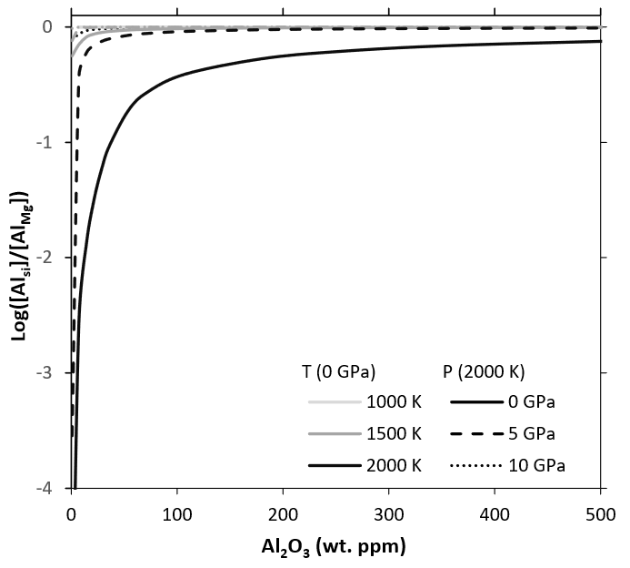
Figure 1- Concentration of Al in Silicon sites over concentration of Al in Mg sites as a function of pressure, temperature and aluminium content. Lines are at different pressures and temperatures with shading representing the temperature and solid/dashed/dotted lines representing the pressure. The perfect Tschermak’s defect has a ratio of 0 (log 1). At 1000 K and any pressure or 1500 K and 0 GPa the line is not distinguishable but is flat at 0.

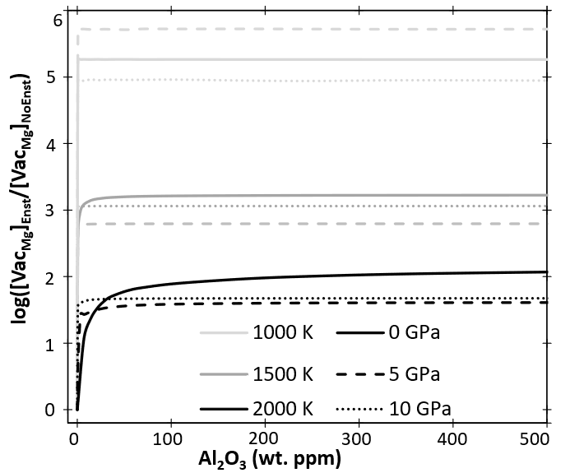
Figure 2- Ratio of Mg vacancy concentrations produced in an aluminous+enstatite system vs those produced in an aluminous only system as a function of Al concentration in wt. ppm Al₂O₃. Lines are at different pressures and temperatures with shading representing the temperature and solid/dashed/dotted lines representing the pressure.

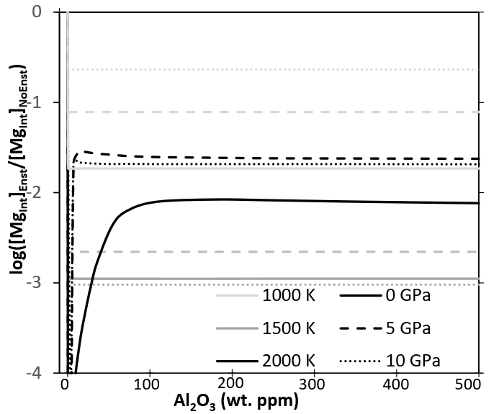
Figure 3: As Figure 2 but with the ratio of Mg interstitial concentration instead of Mg vacancy concentration.
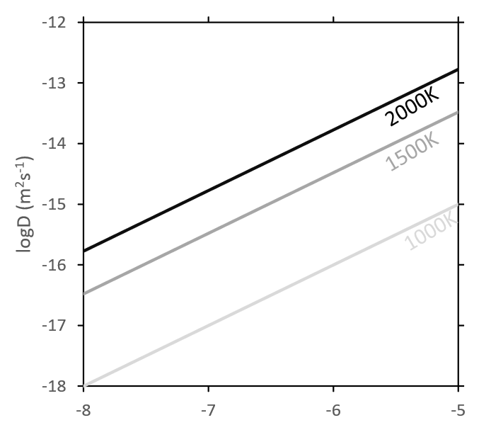
Figure 4: Diffusion rates in periclase buffered perfect forsterite at 0 GPa as a function of vacancy Mg concentration. In each case an equal number of interstitials was added to the system so it was assumed this is a system dominated by R1 (Frenkel defects).

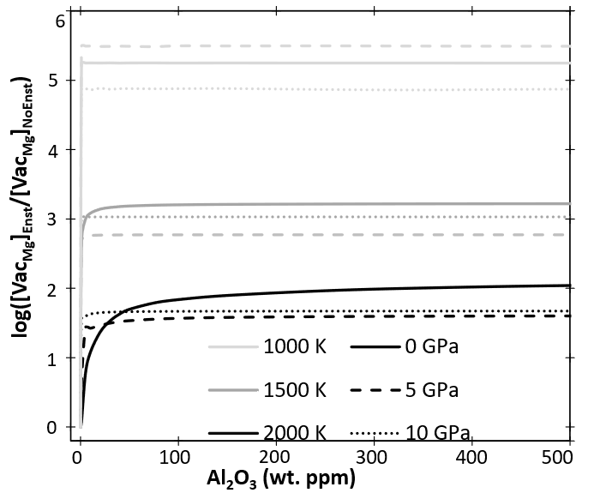
Figure 5 Ratio of absolute diffusion rate between aluminous forsterite with and without enstatite as a function of Al concentration, pressure and temperature. Lines are at different pressures and temperatures with shading representing the temperature and solid/dashed/dotted lines representing the pressure.
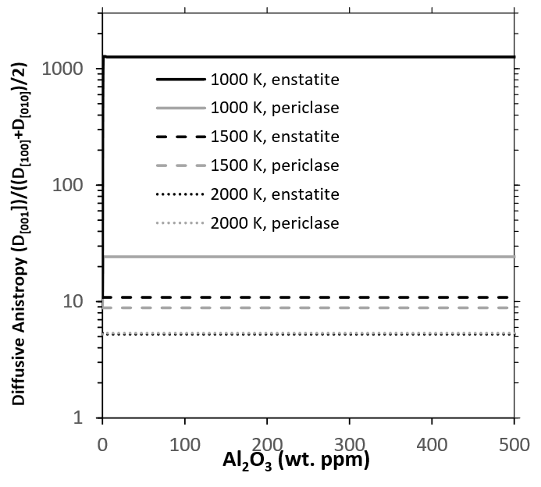
Figure 6: Plot of the preference for [001] diffusion (compared to the average of [010] and [100] diffusion as a function of Al₂O₃ content at 0 GPa and different temperatures (solid/dashed/dotted lines). Darker shades represent diffusion buffered by enstatite and lighter shades by periclase. At 2000 K these two cases are nearly identical, at 1500 K there is little diffusional anistropy difference between enstatite and periclase buffers, at 1000 K this difference is nearly 2 orders of magnitude.

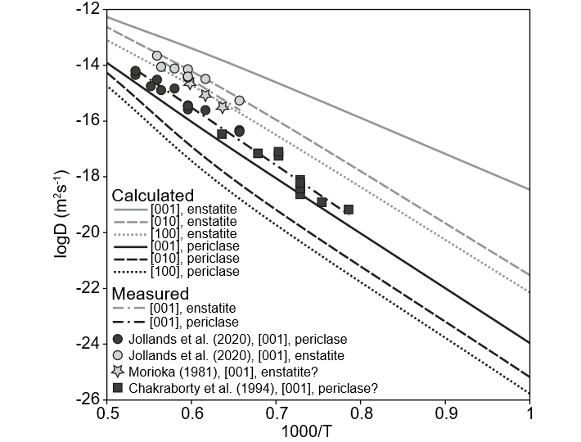
Figure 7: Comparison of our diffusion rates (at 0 GPa) (solid, dotted and dashed lines representing different directions, shade representing buffer chemistry) with experimentally determined diffusion rates (symbols and dotted+dashed line).

 |  | 0 K | 1000 | 1500 | 2000
R1) Mg Frenkel | 0 Gpa | 6.43 | 5.96 | 5.66 | 5.37
R1) Mg Frenkel | 5 | 6.54 | 6.37 | 6.18 | 5.94
R1) Mg Frenkel | 10 | 6.70 | 6.92 | 6.88 | 6.75
R4) Mg-O Vacancy | 0 | 7.47 | 7.42 | 7.33 | 7.23
R4) Mg-O Vacancy | 5 | 8.18 | 8.51 | 8.58 | 8.60
R4) Mg-O Vacancy | 10 | 8.83 | 9.59 | 9.84 | 10.00
R10) Mg-O Vacancy with Enst | 0 | 7.23 | 7.16 | 7.05 | 6.93
R10) Mg-O Vacancy with Enst | 5 | 7.99 | 8.27 | 8.32 | 8.31
R10) Mg-O Vacancy with Enst | 10 | 8.67 | 9.35 | 9.58 | 9.72
R11) Al+Enstatite Reaction | 0 | 3.27 | 3.71 | 3.74 | 3.66
R11) Al+Enstatite Reaction | 5 | 3.37 | 4.24 | 4.52 | 4.67
R11) Al+Enstatite Reaction | 10 | 3.46 | 4.51 | 5.07 | 5.44
Table 1: Energy (in eV) of the most favourable reactions as a function of pressure and temperature without considering configurational entropy.

