Machine Learning for Inferring CO₂ Fluxes: The New Metaphysics of Neural Nets
P. Nguyen¹, M. Halem¹
¹University of Maryland, Baltimore County, MD USA.

Corresponding authors: Phuong Nguyen phuong3@umbc.edu and Milton Halem halem@umbc.edu

Key Points:
- Evaluated and benchmarked deep learning models for inferring CO₂ fluxes
- Conducted sensitivity tests on the influence of surface variables and model hyper-parameters on the accuracy of the training and predicting.
- Proposed to use Recurrent Neural Network (RNN) with Long Short Term Memory (LSTM) architecture for improved CO₂ flux inferences.

Abstract
The advent of direct high-resolution global surface measurements of CO₂ from the recently launched NASA Orbiting Carbon Observatory (OCO-2) satellite offers an opportunity to improve the estimate of Net Ecosystem Exchange (NEE) over land. Long-term measurements of CO₂ flux obtained from eddy covariance instruments on Flux towers show large annual differences with NEE calculated by inverse methods using Land Surface Photosynthetic models. This suggests consideration of alternative approaches for calculating seasonal to annual global CO₂ flux over land. Recent advances in deep machine learning models, including recurrent neural nets, have been successfully applied to many inverse measurement problems in the Earth and space sciences. We present evaluations of two deep machine learning models for estimating CO₂ flux or NEE using station tower data acquired from the DOE Atmospheric Radiation Measurement (ARM), AmeriFlux and Fluxnet2015 station datasets. Our results indicate that deep learning models employing Recurrent Neural Networks (RNN) with the Long Short Term Memory (LSTM) provide significantly more accurate predictions of CO₂ flux (~22% -28% improvements) than Feed Forward Neural Nets (FFNN) in terms of Root Mean Square Errors, correlation coefficients and anomaly correlations with observations. It was found that using heat flux as input variables also produce more accurate CO₂ flux or NEE predictions. A non-intuitive machine learning metaphysical result was observed by the omission of CO₂ concentrations as an input variable. Neural net models, in most cases, produce comparable accuracies of CO₂ flux or NEE inferences, when trained with and without CO2 for the same station data.

Plain Language Summary
Vegetation annually removes 40% of global CO₂ emitted to the atmosphere by natural and anthropogenic processes through photosynthetic absorption of CO₂ (sinks) and CO₂ respiration (sources). Scientists have developed ecosystem surface models employing photosynthetic and respiratory processes to infer the annual absorption of CO₂ by plants in order to account for the influence of factors that affect the amount of CO₂ that remains in the atmosphere. However, these model predictions are largely inconsistent with station measurements. In this study, we apply deep machine learning models to train neural nets to predict the turbulent CO₂ flux or NEE based on station data from the Department of Energy (DOE) Atmospheric Radiation Measurement (ARM), AmeriFlux and Fluxnet2015 for different ecosystem sites. We used Recurrent Neural Networks (RNN) with the Long Short Term Memory (LSTM), which produced ~22% - 28% more accurate predictions than a more common Feed Forward Backward Propagation Neural Net.

1 Introduction
The successful launch of the NASA Orbiting Carbon Observatory-2 and its multi-year availability of high spatial resolution of CO₂ concentration and Sun-Induced Fluorescence (SIF) provide a new source of input for arriving at improved estimates of the global annual CO₂ uptake over land. The capacity of continents to take up CO₂ is largely affected by climate variability. Natural sinks over land seen in Figure 1 to have grown in response to the increasing emissions, but appears relatively level in the last decade, though year-to-year variability is large (Le Quéré et al., 2016). The large 2015 El Niño is suspected of producing the most significant anomalous low in the local estimate of continental CO₂ uptake over the past 60-year record. The annual global budget estimate of carbon sink over land has varying levels of uncertainty since it is calculated as a residual difference between the net of CO₂ emissions of fossil fuel and land cover change from the net growth rate of CO₂ in the atmosphere and the ocean sink (Le Quéré et al., 2016). Thus, improvements in the direct calculation of CO₂ flux over land has the potential of mitigating the largest uncertainty among the above individual components of the global CO₂ budget estimates (Li, W. et al. 2016). Machine learning algorithms trained on the network of CO2 flux stations hold the promise of leading to better continental estimates of annual CO₂ flux uptake.
The total global sink of CO₂ is estimated to remove about 55% of all CO₂ emissions for the period 2000-2008, while terrestrial CO₂ sinks account for removal of 29% of all anthropogenic emissions for the same period (Land 53%). Investigations of mid to high latitude atmospheric CO_{2,} shows growing amplitude in seasonal variations over the past several decades (Graven H.D. et. al.,2013; Piao et al.2017;Bousquet et al.2000;Bala G et al. 2013). Land surface ecosystem models poorly predict the net annual CO₂ flux exchange (NEE) (Keenan, T.F et al. 2012; Chen, B, 2008;Piao, S. et al. 2009). The Atmospheric Radiation Measurement (ARM) program of the ARM, AmeriFlux and Fluxnet2015 stations have been making long-term collections of CO₂flux measurements (in addition to CO₂ concentration and an array of other meteorological quantities) at several towers and mobile sites located around the globe at half-hour and hour frequencies. In addition, since the mid 90’s, the DOE, NASA, NOAA and the US Forest service have sponsored over 75 flux tower CO₂ measurement stations distributed over the contiguous US, Canada, Alaska, Brazil and now throughout North and South American continents.
Yet, inverse ecosystem model inferences of continental scale annual CO₂ flux by assimilating the Scanning Imaging Absorption Spectrometer for Atmospheric Chartography (SCIAMACHY) CO₂ satellite observations have been shown to be largely inconsistent (2x - 4x factor) with station observations (M. Reuter et. al., 2017), as well as inverse climate ecosystem models (Ott, L. E., et al. 2015). High-resolution satellite surface measurements of CO₂ concentration are now available for 4 years from the NASA OCO -2providing a global view of the seasonal cycles and spatial patterns of atmospheric CO₂ (Eldering, A et al. 2017). Recent advances in computing technologies have enabled significant improvements in the performance and accuracies of deep learning algorithms. We present in this paper, the evaluation of hyper parameters such as list of input variables, learning rate, number of layers and neurons etc.) of the Feed Forward and Recurrent Neural Net algorithms for determining the best learned parameters (optimized weights of neural network models) to employ for application with micro meteorological tower station data for inferring annual turbulent CO₂ flux from station towers at different latitudes and ecosystem types.

1.1 Prediction using neural networks
Can the deep learning models contribute to improved assessments of environmental and atmospheric variances in CO₂ flux or NEE estimation? An investigation of how the biosphere has reacted to changes in atmospheric CO₂ is essential to our understanding of potential climate-vegetation feedbacks. Further, given longer-term extreme climate events such as El Nino’s, can regional changes of CO₂ affect positive regional ecosystem feedbacks? The monitoring and understanding of carbon sinks and sources can be inferred from the amount of carbon dioxide (CO2) fluxes into and out of the atmosphere. Thus, global or regional season to annual investigations into new approaches for calculating CO₂ flux should improve the prediction of annual NEE.
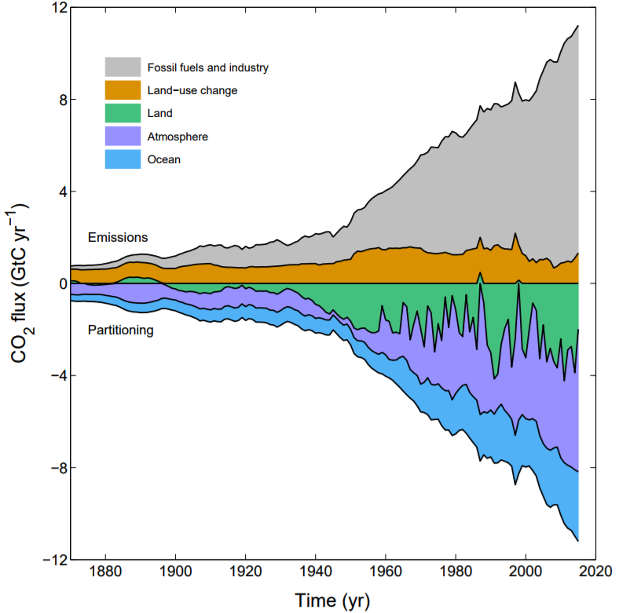
Figure 1 Global CO₂ flux sources and sinks. Source: Global carbon budget 2016(Le Quéré et al, 2016)
Studies show that CO₂ fluxes are correlated with the energy fluxes and environmental variables such as temperature, moisture, heat and others non-linear processes (HeHonglin, 2006). Artificial neural networks (ANNs) are often better candidates for modeling the non-linear process based on data driven input than other statistical methods. ANNs, Feed Forward Backward Propagation Neural Net are being used for the simulation of CO₂ fluxes using atmospheric CO₂ and other variables (Melesse, A.M, 2005; Papale, D.; HeHonglin, 2006; Tramontana, G., 2016).There have been prior efforts to map fluxes across North America with machine learning regression tree models by Xiao et al and globally by Jung et al. For example, Papale and Valentini, 2003 proposed a new methodology involving Feed Forward Neural Network to provide spatial (1 km×1 km) and temporal (weekly) estimates of carbon fluxes of European forests at continental scale. First a separate neural network was used to predict the daily Net Ecosystem Exchange (NEE) at each of 16 different European sites. The dataset used in this study consisted of measurements of CO₂ flux taken at those 16 sites using the eddy covariance technique. The inputs of the network trained for each site were air temperature, air relative humidity, photo synthetically active radiation (PAR) and two series of four fuzzy sets (month of the year and time of day). The original data from each site consisted of about 13,573 samples (one measurement every half an hour) but the dataset was composed only of those examples with complete input and output data. Results were very good with Root Mean Square Errors (RMSE) of 1.149 and Mean Absolute Errors (MAE) of 0.859. The second part of the work involved using another ANN for an assessment of European NEE. The network specifications were twelve input variables, one hidden layer of 5 nodes and one output node of mean NEE expressed in grams Carbon per day (g C day−1). Results of this part were an annual estimate of 0.47 Gigatons of Carbon per year (Gt C yr−1), which is within the range of Europe’s 0.2 - 0.7 Gt C yr−1 estimate in (Schulze, E.D., et al., 2001).
Melesse, A.M. and Hanley, R.S, 2005 showed that using a Feed Forward Neural Network (FFNN) to predict CO₂ flux over large areas is a promising technique which can be used instead of the eddy covariance method at a single point (Baldocchi, D., 2014). However, the study was limited to a very short period of data observations as well as the number of flux towers.

1.2 Objectives
Recent advances in deep learning (DL) models have been successfully applied to many applications including speed and image recognition (Hinton, G. E et al 2006;Bengio, Y., 2006;Ranzato, M.A, 2006; Krizhevsky, I. Sutskever et al, 2012;R. K. Srivastava et al 2015; Buduma, N., et al. 2015), which motivated us to investigate applying DL models for prediction of hourly CO₂ fluxes. In this study, we are going to build DL models including Feed Forward Neural Network (FFNN) and Recurrent Neural Network (RNN) with Long Short Term Memory (LSTM) models to learn the physical complexity, space and time dependency of the measurements of CO₂ concentration, humidity, pressure, temperature, wind speed etc. for predicting the CO₂ flux from long term measurements at Atmospheric Radiation Measurement (ARM), AmeriFlux, and Fluxnet2015 station data for different ecosystem sites.
The motivation for using LSTM is to utilize the temporal dependencies or patterns within the long-term measurements of the data. Data was separated by year into Training, Validation and Test data sets. These deep learning models are shown to be efficient, dependable, and very powerful and can be employed in predicting CO₂ flux or NEE. We will also show that RMSE is lower at high latitude sites because there is more variation in the input data. Deep learning models can be used with historical data to further infer the present state of the atmosphere in the future.

2 Methods
Deep Learning (DL) neural networks coupled with new advances in computer technologies attempt to mimic the human brain activity of neurons in the neocortex. DL models can be trained to recognize complex patterns in digital representations of sounds, images, and other data (Krizhevsky, I. Sutskever, 2012). Because of advances in computer technologies, one can now model many more layers of virtual neurons than ever before (Y. LeCun, 2015;R. K. Srivastava, 2015; J.C. Duchi, E. Hazan et al 2011). With deep layer architectures exploiting computational acceleration, new training techniques are producing remarkable advances in speech and image recognition; and in medicine by identifying molecules that are leading to new drugs. Recurrent neural networks (RNN) with the Long Short Term Memory (LSTM) model is one of the deep learning model, which are able to successfully learn data with long range temporal dependencies such as time series data, or machine translation in language modeling (S. Hochreiter et al 1997;Sutskever, I., et al 2014). Extending DL models for applications such as Earth and space science as well as other science disciplines requires more conceptual breakthroughs and further advances in processing power. In this paper, we apply deep FFNN and RNN, LSTM to train and predict CO₂ flux or NEE using ARM/AmeriFlux/Fluxnet2015 station tower data.

2.1 Feed Forward Neural Network
The FFNN model simulates and learns the relationship and interaction between input variables and CO₂ flux (Bebis, G. and Georgiopoulos, M., 1994). The model does not need to know the complicated relationship and dependencies between the CO₂ flux and the input variables in advance. We choose to use FFNN and RNN to model the CO₂ flux since the relationship between CO₂ flux and its input variables are known to be nonlinear.
A FFNN includes artificial neurons, which are arranged into layers (figure 2). The input layer consists of neurons, which takes on the input values. In this application the input values are variables such as temperature, sensible heat flux, latent heat flux and friction velocity, etc. The last layer is called output layer having neurons, which holds the output values that are the prediction target CO₂ flux. There can be many layers in between input layer and output layer as needed by the DL model. Each node is only connected to a node in a prior adjacent layer. Nodes at the same layer are not connected with each other.
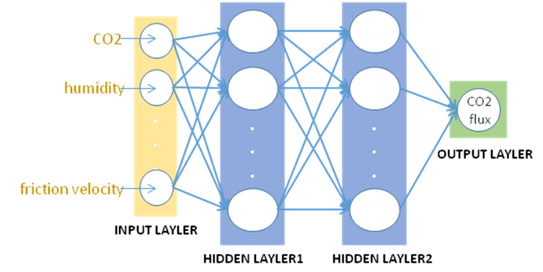
Figure 2 Feed Forward Neural Network model
Figure 2 presents the topological architecture of the multilayer FFNN. These layers are called the hidden layers. Let w^{k}_{ii,} be the weight of the connection between the i^{th} neuron in the k^{th} layer with the j^{th} neuron in the k + 1th layer, x_{i} is the value given to the i^{th} input node and a bias value b_{j} is considered as an additional input node that acts to shift the point of activation. The output value of the i^{th} neuron is determined by the below equation.
$y_{j}^{k}=f\left(θ_{j},x_{i}\right)=f\left(\sum{w_{ij}^{k}}x_{i}+b_{j}\right)$ (1)
If we use $θ_{j}$ as a vector, then the output of the node is modeled as a function $f\left(θ_{j},x_{i}\right)$ where x and y are the input and the output. These weights show the important nature of the connections in the network and the ability of solving the problem with a neural network depending on finding the optimal weights and the parameter value. The $f\left(θ_{j},x_{i}\right)$ function applied to the neuron is known as the activation function. The sigmoid function, $σ\left(x\right)=\frac{1}{1+e^{−x}}$ which is differentiable, monotonic, non-linear and is often used as the activation function. Non-linearity is fit to model non-linear patterns in our training dataset. The elu activation function, an Exponential Linear Unit,
$$σ\left(x\right)=\left\{\begin{aligned}α.\left(e^{x}–1\right),∧x<0 \\ x,∧x≥0\end{aligned}\right.$$
converge cost to zero faster and produce more accurate results. The training process will find the $θ_{j}$ vector, which produces the output $f\left(θ_{j},x_{i}\right)$, namely, the prediction value that is close to the desired output value y. In other words, given a set of inputs and their desired outputs, we try to find $θ_{j},$ which minimizes the difference between the desired outputs and the neural network outputs, for all of data points in the training dataset. The RMSE is used to measure the differences. Gradient-based methods such as Adaptive Gradient Algorithm (Adagrad) (J.C. Duchi 2011) are used to find the optimization weights and bias.
$$E\left(θ,XY\right)=\sqrt{\sum_{{x_{i},y}_{i∈XY}}{{\left(y | | i−f\left({,x}_{i}\right)\right)}^{2}}}$$
XY is the training set and $x_{i}$ and $y_{i}$ are the input and the desired output training values and $f\left({,x}_{i}\right)$ the neuron network output. A back propagation gradient descent training algorithm was performed using RMSE as error function to adjust the weight of neurons. We also use R², the coefficient of determination between true observation and model’s prediction to measure the performance of the models.
The modeling dataset is divided into three groups: (i) a training dataset used to determine the weights during neural network training; (ii) a test dataset used during network training to calculate the errors to prevent overtraining; and (iii) a validation dataset used to assess the network’s performance with ‘new’ data, which removes the possibility of the network over-fitting on training and test datasets. This is the case when the neural network models very well on training dataset and predicts poorly on unseen test dataset.

2.2 Recurrent Neural Network

A Long Short Term Memory (LSTM) network is a Recurrent Neural Network (RNN) where connections between units in a layer form a directed graph along a sequence (see figure 3). This RNN architect exhibits dynamic temporal behavior for a time sequence. Unlike FFNN, where input variables at particular times are trained independently and there are no connections within or between two adjoining layers of a network, RNN enables the insertion of state operations or gates between layers. Thus, when learning the model for a particular time using FFNN, there is no consideration of the historical data from prior times. The RNNs can use their internal state (memory in LSTM unit) to process sequences of inputs. For example, in this application, 12 input measurements of CO₂ concentration, humidity, pressure, temperature, wind speed, etc have been observed by every half hour forming a time sequence. Time dependency can be learned by LSTM. It can selectively learn when to remember or forget things by controlling information flow through block conditions in each LSTM unit state called gates. There are three types of gates in each LSTM unit. The Forget Gate decides which information to discard from the block. The Input Gate conditionally makes decision on which values from the input will be used to update memory state. The output Gate will conditionally decide which value will be output based on the input and the memory of the block. Gates of the LSTM units have weights that are learned during the training procedure. LSTM units are often implemented in deep multiple layer architects. This model capability is one of the advances made in deep machine learning models, which can be applied to solve difficult sequence problems in machine learning. It has been successfully implemented (Sutskever, I., et al 2014). The detail of LSTM units and the architecture of this model are referenced in (Hochreiter, J., and Schmidhuber, J.,1997;Sutskever, I., et al 2014).
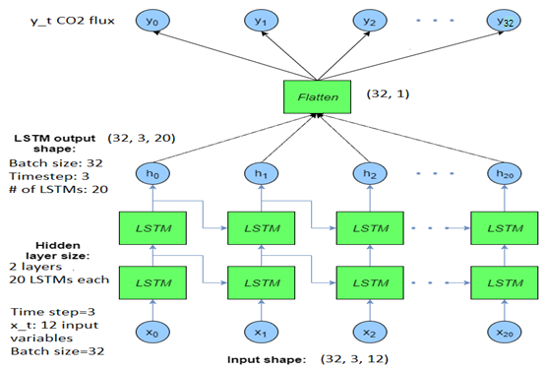
Figure 3 Recurrent neural network with LSTM model
Figure 3 shows the following structure of the RNN with LSTM model we will employ. Each observed time step consists of an observation of 12 input variables, and the number of time steps in each LSTM unit can be configured. A time step=3, means that the current observation is learned using two previous observations of the 12 input variables. The two layers of 20 LSTM units each are thus configured. A batch of 32 such input observations can be specified and trained at each LSTM. The Flatten unit is used to produce single output, which is the prediction of CO₂ flux. The DropOut technique is used for training to improve the performance of the neural network. On training, it drops x% of units in each layer (Baldi, Pierre and Sadowski, Peter, 2014). All de-activate units would not participate in the training propagation. This technique will block the error values from in each layer to the output level. The dropout technique only applies on the training phase. Advanced gradient algorithm such as SGD and AdaGrad (J.C. Duchi, E. Hazan, and Y. Singer, 2011) will be used to train the models.

3 Data description
AmeriFlux, Fluxnet2015 and Atmospheric Radiation Measurement (ARM) tower data at different sites have been used in this study. The site name, siteID, latitude, longitude, type, and date time ranges are showed in figure 4 and table 1. The half an hour and hourly data have been used for experiments.
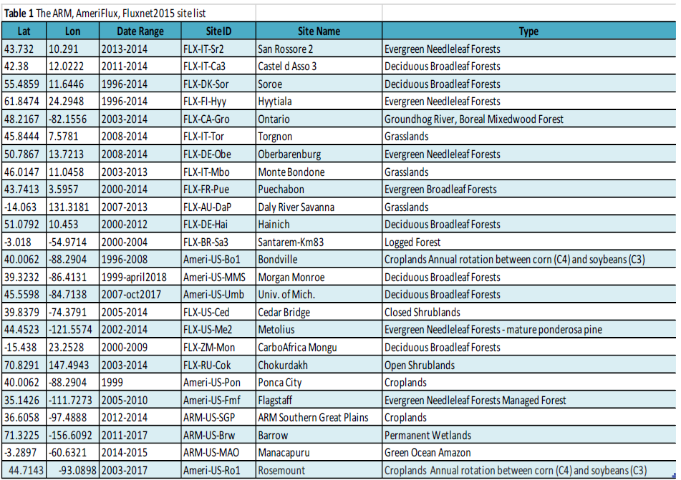

Two sets of input variables have been used. The first set uses heat fluxes including net radiance at the top of the atmosphere (W m-2), latent heat (W m-2), sensible heat (W m-2), soil heat flux (W m-2), air and soil temperatures (deg C). The second set of input variable does not use the heat fluxes since they are not typically available globally. In this case, we have incoming shortwave radiation (W m-2), outgoing shortwave radiation (W m-2), Carbon Dioxide (CO₂) mole fraction in wet air (µmolCO2 mol-1), Air temperature (deg C), and Precipitation (kPa) have been used as input variables. The output of both FFNN and RNN models predict CO2 flux (Carbon Dioxide (CO2) turbulent flux (µmolCO2 mol-1) for dataset at ARM/AmeriFlux or NEE (umolCO2 m-2 s-1) for dataset at Fluxnet2015. Figure 5 plots some of the variables of AmeriFlux tower data at MMS site from Jan 1, 1999 to April 12, 2018 including Temperature (deg C), CO₂ Flux (µmolCO2 m-2 s-1), Shortwave Radiation incoming (W m-2), Shortwave Radiation Outgoing (W m-2), Net Radiation (W m-2), CO2 (µmolCO2 mol-1), Precipitation (mm), Latent Heat (W m-2), Sensible Heat (W m-2), Soil Heat Flux (W m-2), Soil Temperature (deg C). As seen in figure 5, there are more variances in radiation, temperature, sensible heat flux and latent heat flux corresponding to the CO₂ flux.
CO₂ flux with reasonable accuracies. The preprocessing of the data includes two parts: filtering row data and normalizing all input variable data. Row data with filled values, which have flags 'y' and out of normal CO₂ flux ranges were filtered. Since the input variables have different value ranges (see fig. 5), which vary significantly, all input data are normalized to scale between 0 and 1 to improve the time to reach convergence.

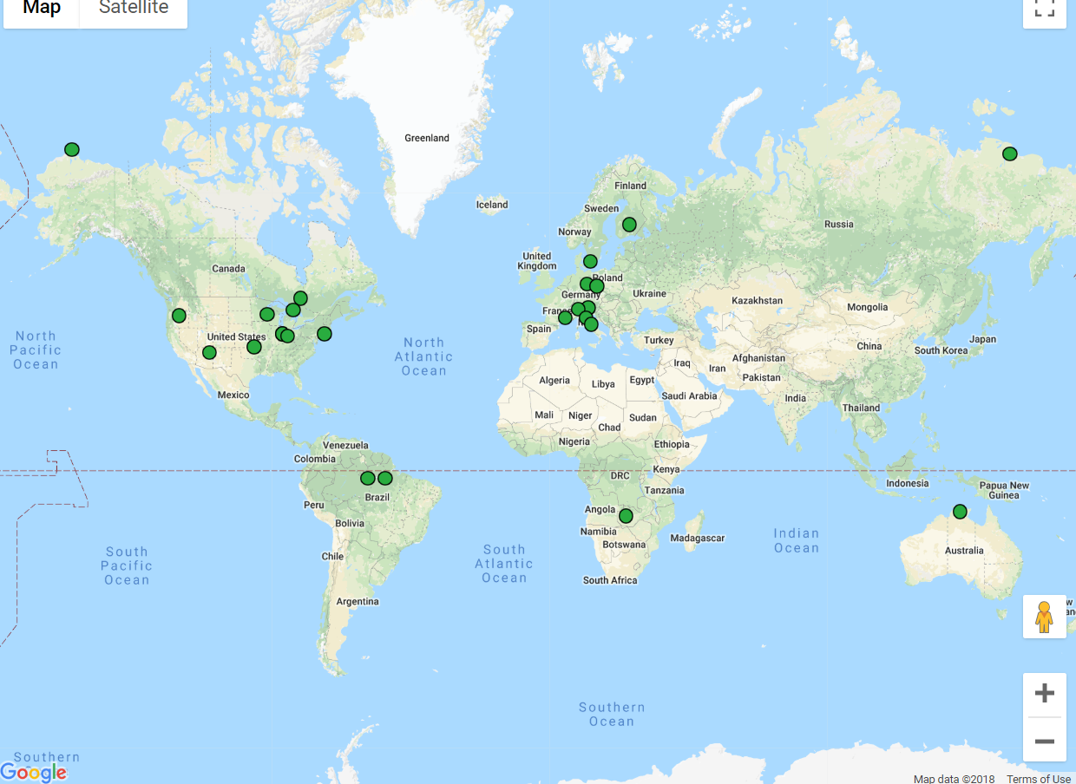
Figure 4 the map of ARM, AmeriFlux, Fluxnet all tower location used in this study
The input dataset needs to be preprocessed and cleaned in order for the neural nets to infer the The normalized equation is as follows:

$$X_{normalized}=\frac{x−x_{min}}{x_{max}−x_{min}}$$
Where $X_{normalized}$ is the normalized value of input variable, $X_{max}$ is the maximum value of the input variable and $X_{min}$ is the minimum value of the input variable.The only output variable of the learning model is CO₂ flux and it is de-normalized into original data ranges.

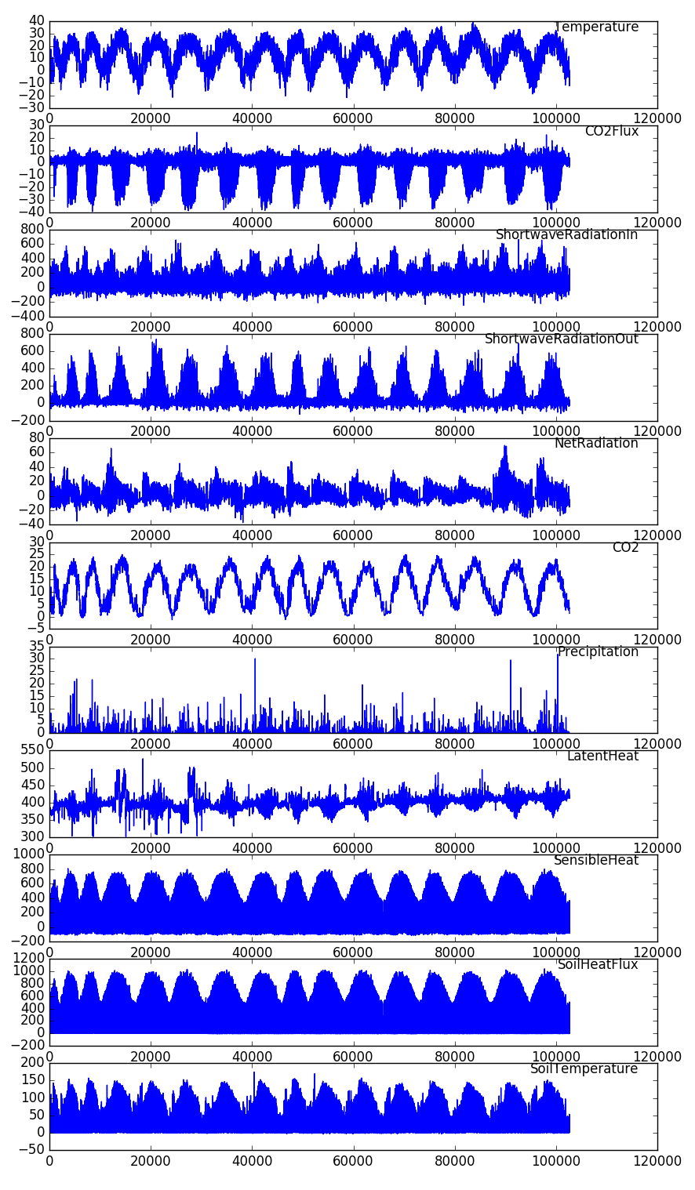

Figure 5 AmeriFlux hourly data at AmeriFlux at Morgan-Monroe, Indiana (MMS) Temperature, CO2 Flux, Shortwave RadiationIn, Shortwave RadiationOut, NetRadiation, CO2, Precipitation, Latent Heat, Sensible Heat, Soil Heat Flux, Soil Temperature from Jan 1, 1999 to April 12, 2018.

4 Experimental Results
In section 4.1, we present the experiments for the comparison of FFNN and RNN/LSTM models for predicting CO₂ flux from both the ARM and Ameriflux station data and predictions of NEE from the Fluxnet2015 stations. Neural net training and test results depend on a variety of selected hyperparameters. We use an algorithm, WEKA, that applies principal component analysis for the ranking of the input variables based on the station data. Slight differences in the rankings can occur for different AmeriFlux, ARM and Fluxnet2015 stations. Experimental results are presented utilizing a common set of input variables that are the highest or near highest ranked station variables obtained from WEKA for both FFNN and LSTM. The input variables selected for all the experiments in section 4.1 consisted of: net radiation, latent heat, sensible heat, soil heat flux, air and soil temperatures. It should be noted that CO₂ observations are not among the above input variables used in these experiments. When heat fluxes are not available at any station, the following set of input variables are used to predict CO₂ flux: shortwave radiation (incoming), shortwave radiation (outgoing), air temperature, and precipitation. These variables also appeared in the WEKA rankings. Again, CO₂ is not an input variable for both FFNN and RNN models for predicting CO₂ flux. Similar findings for calculating NEE without CO₂ as an input variable were obtained by Papali and Valentini, 2003 and Medlyn et. al., 2005. We show below that Recurrent Neural Networks (RNN) with the Long ShortTerm Memory (LSTM) improvements in the prediction of CO₂ flux by ~22% to 28% in terms of RMSE and R² scores, and 28% improvements in anomaly correlations. Section 4.2 shows the influence of selecting WEKA rankings of variables as input for both FFNN and LSTM. We also show that both neural nets are dependent on the influence of latitudinal variations of CO₂ flux and NEE station data. Both FFNN and LSTM produce their lowest CO₂ flux scores at high latitudes while stations near or at the equator produce the largest RMSE errors. We suspect this variability in performance is influenced by the variability of the input variables, i.e. larger seasonal variations temperature and net radiation occur at high latitudes and have less variability at low latitudes near or at the equator.

4.1 Comparison of FFNN and RNN models.
Table 2 reports the comparisons between FFNN and RNN models using RMSE and R² correlation metrics. These experiments use net radiation, latent heat, sensible heat, and soil heat flux, air and soil temperatures as input variables and predict CO₂ flux for ARM and AmeriFlux stations and predict NEE for the Fluxnet2015 tower stations. The dataset is divided into three groups: (i) 80% of dataset has been used to determine the weights during neural network training; (ii) 10% of dataset has been used during network training to calculate the errors to prevent overtraining; and (iii) 10% of dataset is used as validation dataset to assess the network’s performance with ‘new’ data. FFNN model used in this section was configured to run using 10 layers to 20 layers, 20 neurons each layer. RNN models used 2 layers each have 20 LSTM units. Both models were trained using back propagation gradient descent algorithm with ‘elu’ activation. The mean improvement for the 20 stations is 22% and the correlation improvement is 20%. Experiments also show that for the 14 stations with data having longer records than a decade, the mean improvement for the LSTM with respect to FFNN is 28% and the R2 correlation score is 27%. This is indicative of the influence of incorporating the time variations into the machine learning algorithm of RNNs.
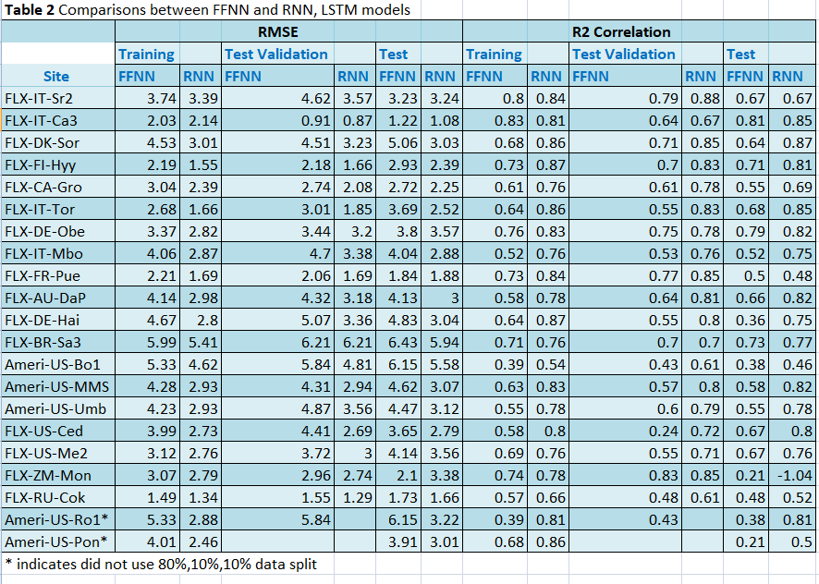

The Morgan Monroe State Forest station in Indiana, having the longest continuous record available to 2018, was selected for investigating the performance of Neural Nets using anomaly correlation metrics. Figure 7 shows a plot of the anomaly for the observed CO₂ flux for years 2011 to 2013, where the mean of the monthly data for the years 1999 to 2010 are removed. Superimposed are the predicted CO₂ flux anomalies for FFNN and LSTM anomalies with the same observed monthly means removed. The image shows that the LSTM fits the observed anomaly better for positive anomalies, but one cannot infer the values of the LSTM for negative anomalies form this image. Thus, in table 3, we present the anomaly correlation metrics for the above MMS station as well as two additional stations, one in Finland and the other in France. The anomaly correlation of three stations (Ameri- US- MMS, FLX-FI-Hyy, FLX-FR-Pue) shows that LSTM produces about ~29% improvements in the anomaly correlation metric compared with FFNN. This result is consistent with the mean performance improvements obtained in section 4.1 for the 20 station sites.

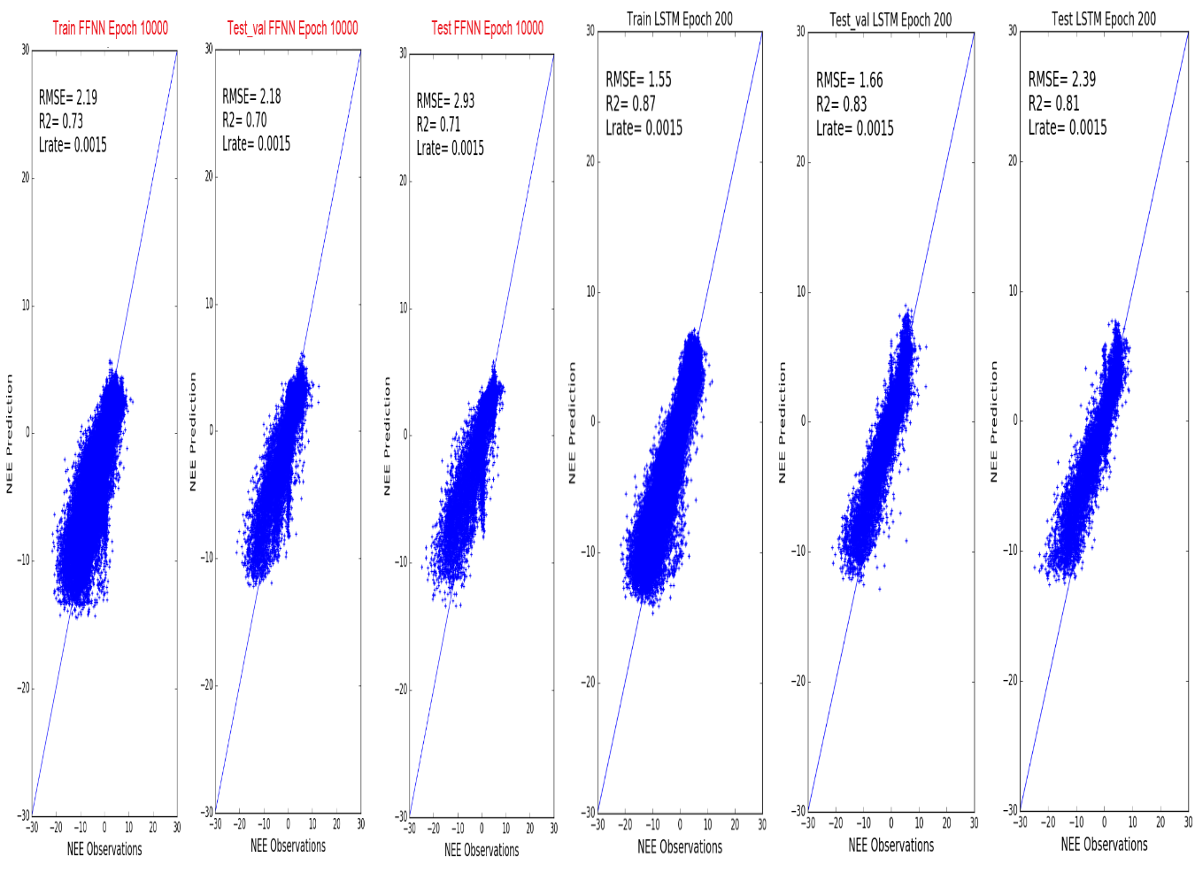
Figure 6Comparison of FFNN and RNN using Fluxnet2015, FLX-FI-Hyy station
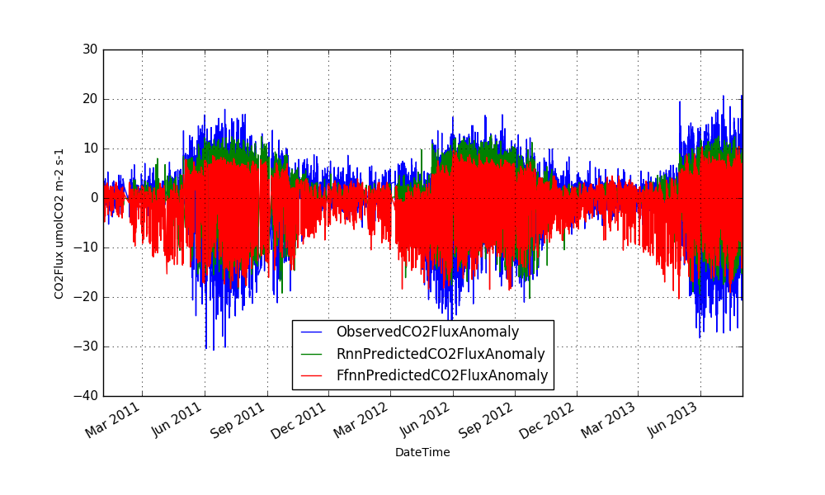
Figure 7 Anomaly correlation comparisons between FFNN and RNN, LSTM
Figure 6 shows that both FFNN and RNN models produce good predictions at a high latitude station with a long data history.

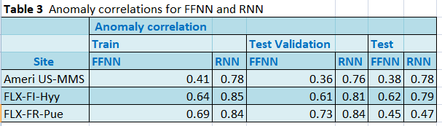
Figure 8 shows the LSTM model predictions of CO₂flux at the Ameriflux-US-Ro1 station, where the crop is rotated yearly between a C3 and C4 plant. The RMS error for the test is 3.22 and the model produces a good R2 correlation with observation of 0.81. The purpose of this image is to show that the inferences of CO2 flux are comparable for both crops.

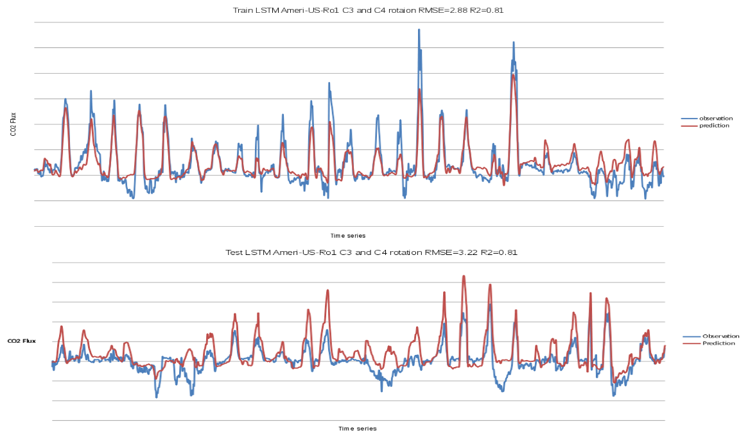
Figure 8 prediction of CO2 flux using Ameri-US-Ro1 C3 and C4 rotation station

4.2 The influence of input variables on model prediction

We used WEKA (a data mining tool) to perform a principal component analysis (PCA) in conjunction with a Ranker search which ranks attributes by their individual evaluations of the top eigen value on some of the selected sites. This software encapsulates a collection of Machine Learning techniques and provides a nice graphical user interface for quick exploration of those techniques on user’s provided dataset. The output of the PCA was a set of components formed by means of linear combinations of the correlated attributes.

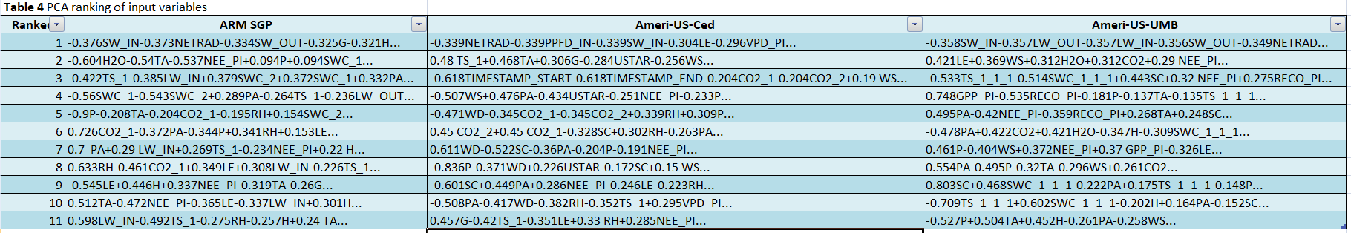

The results from WEKA’s PCA and Ranker attribute selector in table 4 showed the following set of variables to have the highest rank. The following variables had higher ranking attributes and were selected for experiments with both FFNN and LSTM in section 4.1 and 4.2: net radiation (NETRAD) (shortwave radiation incoming- SW_IN, outgoing- SW_OUT), temperature, latent heat (LE), sensible heat (H), soil heat (G), soil temperature(TS), pressure (PA),CO₂, H₂O, precipitation (P).
Since heat fluxes are not always available and they are a derived data product calculated from algorithms, we designed the experiments using the following two sets of input variables for evaluating the influence of variables for model prediction. The results are presented in table 5 and figure 9.
- Input variables with using heat fluxes (HF all): net radiation, latent heat, sensible heat, and soil heat flux, air and soil temperatures.
- Input variables without using heat fluxes (HF all except heat fluxes with CO₂): Shortwave radiation (incoming), Shortwave radiation (outgoing), Carbon Dioxide (CO₂) mole fraction in wet air, Air temperature, and Precipitation.
- Input variables without using heat fluxes (HF all except heat fluxes without CO₂): Shortwave radiation (incoming), Shortwave radiation (outgoing), Air temperature, and Precipitation.

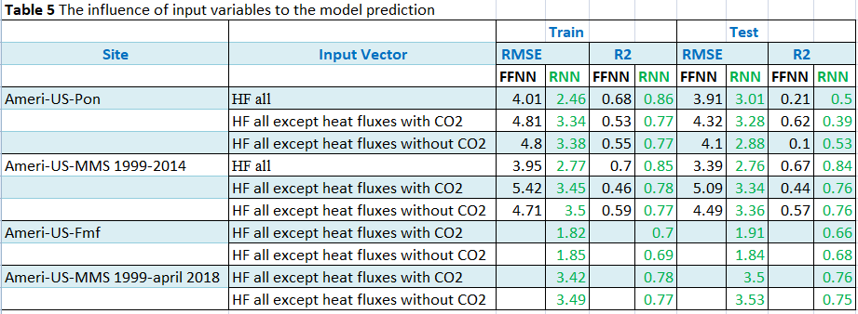

Table 5 presents results of calculating CO₂ fluxes at the 4 stations in table 5 for all heat flux input variables with and without CO₂ concentration. LSTM shows less than 0.1% difference while FFNN shows a 10% variation in RMSE.
Figure 9a shows the comparison of FFNN and RNN using AmeriFlux data at Morgan-Monroe State Forest, Indiana (MMS) using input variables: net radiation, latent heat, sensible heat, and soil heat flux, air and soil temperatures. The data used was from Jan 1, 1999 to Dec 31, 2014. Half of the data was used for training results in RMSE= 3.95 with R² =0.70 and RMSE=2.77 with R²=0.85 for FFNN and RNN respectively. The models tested using another half of MMS data show RMSE= 3.93 with R² =0.67 and RMSE=2.76 with R²=0.84 for FFNN and RNN, respectively.
Figures 9b and 9c show the difference with and without CO₂ for non-heat flux data. The input variables in Figure 9b for experiments using AmeriFlux data at Morgan-Monroe, Indiana (MMS) are: Shortwave radiation (incoming), Shortwave radiation (outgoing), CO₂ concentration, Air temperature, and Precipitation. The hourly data from Jan 1, 1999 to Dec 31, 2014 (131,400 samples) have been used. Half of the data was used for training results in RMSE= 5.42 with R² =0.46 and RMSE=3.45 with R²=0.78 for FFNN and RNN respectively. The models tested using another half of MMS data show RMSE= 5.09 with R² =0.44 and RMSE=3.34 with R²=0.76 for FFNN and RNN, respectively.
The input variables in figure 9c for experiments at AmeriFlux at Morgan-Monroe, Indiana (MMS) are: Shortwave radiation (incoming), Shortwave radiation (outgoing), Air temperature, and Precipitation. The data from Jan 1, 1999 to Dec 31, 2014 have been used. Half of the data was used for training results in RMSE= 4.71 with R² =0.59 and RMSE=3.50 with R²=0.77 for FFNN and RNN respectively. The models tested using another half of MMS data show RMSE= 4.49 with R² =0.57 and RMSE=3.36 with R²=0.76 for FFNN and RNN, respectively. The CO₂ concentration was absent in the input variables compared to the previous experiments in the figure 9b. The RMSE errors for MMS with and without CO₂ for RNN are 3.34 and 3.36, respectively, to the results for table 5.
FFNN and LSTM produce their lowest CO₂ flux scores of 2.30 and 1.75 resp., at high latitudes while stations near or at the equator produce the largest RMSE errors of 4.82 and 4.08. This variability in RMSE is a result of larger seasonal variations in temperature and net radiation at higher latitudes and less variability at low latitudes.
In conclusion, our experiments show that the RNN model produces on average about 28% improvement in RMSE with better R² for both CO₂ fluxes (for ARM/AmeriFlux stations) and NEE (Fluxnet2015 stations) prediction over FFNN model. It was also found that using heat fluxes as input variables produce improved CO₂ flux and NEE predictions. The most surprising result obtained from the machine learning studies was the omission of CO₂ concentrations as an input parameter produced comparable inferences of CO₂ fluxes. We refer to this property as the metaphysical nature of neural nets.

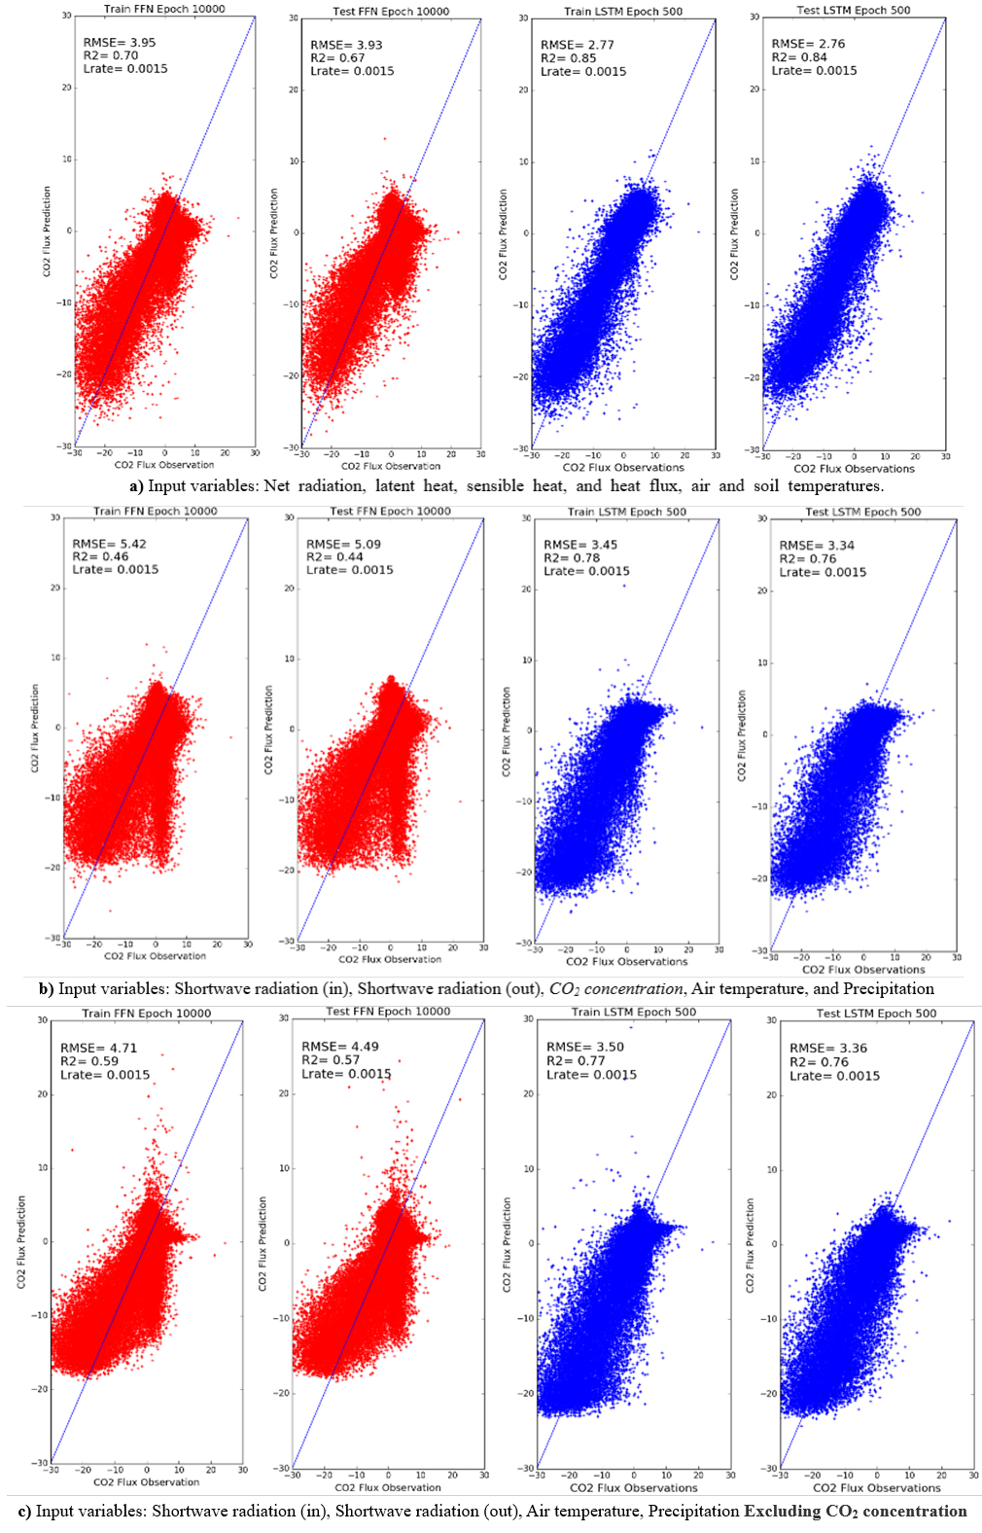
Figure 9 Comparisons of FFNN and RNN, LSTM using AmeriFlux tower data at Morgan-Monroe, Indiana. Data from 1999 to 2014 was used.

5. Conclusions
We have presented two deep learning models, FFNN and RNN (LSTM) for prediction of CO₂ flux at annual scales. We have used micro meteorological data from ARM, AmeriFlux, and Fluxnet2015 sites with different vegetation and regional climates distributed globally. In addition, we have examined the influence of meteorological variables as input to these neural nets as well as the sensitivity to different C3 and C4 crop types. We also presented CO₂ flux or NEE machine learning experiments from more than 24 distributed stations using hourly data for multiple years for training, testing and validity tests. The experiments show for the global distribution of station data with more than a decade of observations that the LSTM model produces ~ 22% to 28% improved predictions compared with FFNN models.

We have learned from the machine learning approach in these station experiments that (i) supervised learning from long historical records are critical for improved inferences of NEE and CO2 flux, (ii) the temporal aspect of recurrent neural nets can yield significant improvements for those applications where the supervised data are time dependent such as occurring in the station data sets and (iii) there is still considerable room for improving both neural net algorithms by utilizing available tools that can experiment with the full set of hyper parameters for these algorithms. Some of the parameters are number of layers, epochs, number of time steps in LSTM, sensitivity to input variables and more careful analysis of station data like gap filling, use of fuzzy time steps to account for seasons, daytime hours, vegetation cover maps, nighttime stratification of unexpected low eddy fluxes.

A most surprising machine learning result for inferring CO₂ flux was the lack of sensitivity on CO₂ concentration itself as an input variable, when training with available CO₂ flux data. Whether this holds away from stations will require further experiments. We assume that training the data with CO₂ flux compensates for the lack of CO₂ concentration as an input variable. In conclusion, these techniques can be applied to tower stations to infer and evaluate the present state of net ecosystem exchange. In the future, we plan to use these models to predict CO₂ flux from remote sensing observations of OCO-2.

Acknowledgments
This study was funded by the NASA grant number NNH16ZDA001N-AIST16-0091. Special thanks are due to IBM for providing two Minsky nodes with each node having dual IBM Power8+CPUs and4 Nvidia P100 GPUs. We also acknowledge the support of the NSF supported Center for Hybrid Multicore Productivity Research at UMBC for providing access to this High Performance Computing resource and supporting staff. Authors acknowledge Dr. Pierre Gentine at the Dept of Earth and Environmental Engineering, Columbia University for providing comments. The data underlying the analyses was downloaded from the DOE ARM station athttps://adc.arm.gov, AmeriFlux data at http://ameriflux.lbl.gov/ and http://fluxnet.fluxdata.org/.

References
Le Quéré, C. et al. Global carbon budget (2016). Earth Syst. Sci. Data 8, 605–649 (2016)
Li, W. et al. (2016) Reducing uncertainties in decadal variability of the global carbon budget with multiple datasets. Proc. Natl Acad. Sci. USA 113, 13104–13108
H. D. Graven et al., Enhanced Seasonal Exchange of CO2 by Northern Ecosystems Since 1960. (2013) Science 341, 1085; DOI 10.1126/ science.1239207
Piao, S., Liu, Z., Wang, Y., Ciais, P., Yao, Y., Peng, S., Chevallier, F., Friedlingstein, P., Janssens, I.A., Peñuelas, J. and Sitch, S., (2017). On the causes of trends in the seasonal amplitude of atmospheric CO₂.Global Change Biology.
Bousquet, P., Peylin, P., Ciais, P., Le Quéré, C., Friedlingstein, P. and Tans, P.P., (2000). Regional changes in carbon dioxide fluxes of land and oceans since 1980.Science, 290(5495), pp.1342-1346.
Bala, G., (2013). Digesting 400 ppm for global mean CO₂ concentration. Current science, 104(11), pp.1471-1472.
Keenan, T.F., Baker, I., Barr, A., Ciais, P., Davis, K., Dietze, M., Dragoni, D., Gough, C.M., Grant, R., Hollinger, D. and Hufkens, K., (2012). Terrestrial biosphere model performance for inter‐annual variability of land‐atmosphere CO₂ exchange. Global Change Biology, 18(6), pp.1971-1987.
Chen, B., Chen, J.M., Mo, G., Black, T.A. and Worthy, D.E., (2008). Comparison of regional carbon flux estimates from CO2 concentration measurements and remote sensing based footprint integration. Global Biogeochemical Cycles, 22(2).Vancouver
Reuter, M.; Buchwitz, M.; Hilker, M.; Heymann, J.; Bovensmann, H.; Burrows, J.P.; Houweling, S.; Liu, Y.Y.; Nassar, R.; Chevallier, F.; et al (2017). How much CO2 is taken up by the European Terrestrial Biosphere? Bull. Am. Meteorol. Soc. 98, 665–671
Ott, L. E., et al. (2015), Assessing the magnitude of CO₂ flux uncertainty in atmospheric CO₂ records using products from NASA’s Carbon Monitoring Flux Pilot Project, J. Geophys. Res. Atmos., 120, 734–765, doi:10.1002/2014JD022411.
Eldering, A., Wennberg, P. O., Crisp, D., Schimel, D. S., Gunson, M. R., Chatterjee, A.,Weir, B.(2017). The Orbiting Carbon Observatory‐2 early science investigations of regional carbon dioxide fluxes. Science, 358, eaam5745. https://doi.org/10.1126/science.aam5745
Schneider, T., Lan, S., Stuart, A., Teixeira, J.(2017) Earth System Modeling 2.0: A blueprint for models that learn from observations and targeted high-resolution simulations. arXiv preprint arXiv:1709.00037
Piao, S., Fang, J., Ciais, P., Peylin, P., Huang, Y., Sitch, S. and Wang, T., (2009).The carbon balance of terrestrial ecosystems in China.Nature, 458(7241), p.1009.
HeHonglin, YU Guirui, ZHANG Leiming, SUN Xiaomin& SU Wen (2006). Simulating CO₂ flux of three different ecosystems in ChinaFLUX based on artificial neural networks, Science in China Series D: Earth Sciences
Melesse, A.M. and Hanley, R.S., 2005. Artificial neural network application for multi-ecosystem carbon flux simulation.EcologicalModelling, 189(3), pp.305-314.
Papale, D. and Valentini, R., (2003). A new assessment of European forests carbon exchanges by eddy fluxes and artificial neural network spatialization. Global Change Biology, 9(4), pp.525-535.
Tramontana, G. et al, (2016) Predicting carbon dioxide and energy fluxes across global FLUXNET sites with regression algorithms Biogeosciences, 13, 4291–4313
Papale, D. and Valentini, R(2003). A new assessment of European forests carbon exchanges by eddy fluxes and artificial neural network spatialization, Glob.Change Biol., 9, 525–535, doi:10.1046/j.1365-2486.2003.00609.x.
Baldocchi, D.2014 Measuring fluxes of trace gases and energy between ecosystems and the atmosphere – the state and future of the eddy covariance method, Glob. Change Biol., 20, 3600–3609 doi:10.1111/gcb.12649
Hinton, G. E., Osindero, S. and Teh, Y., (2006) A fast learning algorithm for deep belief nets. Neural Computation 18:1527-1554
Bengio, Y., Pascal Lamblin, Dan Popovici and Hugo Larochelle, (2006) Greedy Layer-Wise Training of Deep Networks ,NIPS, pp. 153-160
Ranzato, M.A., Christopher Poultney, Sumit Chopra and YannLeCun (2006) Efficient Learning of Sparse Representations with an Energy-Based Model, NIPS
Krizhevsky, I. Sutskever, and G. Hinton (2012) Imagenet classification with deep convolutional neural networks.In NIPS.
R. K. Srivastava, K. Greff, and J. Schmidhuber. (2015) Training very deep networks. 1507.06228
Bebis, G. and Georgiopoulos, M., (1994). Feed-forward neural networks. IEEE Potentials, 13(4), pp.27-31.
Hochreiter S., and J. Schmidhuber. (1997) Long short-term memory. Neural computation, 9(8):1735–1780.
Baldi, Pierre and Sadowski, Peter. (2014) The dropout learning algorithm. Artificial intelligence, 210:78–122.
Sutskever, Ilya, Vinyals, Oriol, and Le, Quoc VV. (2014) Sequence to sequence learning with neural networks. In NIPS, pp. 3104– 3112
Buduma,N.(2015) Fundamentals of Deep Learning Designing Next-Generation Machine Intelligence Algorithms, O'Reilly Media
LeCun, Y., Y. Bengio, and G. Hinton. (2015) Deep learning.Nature, 521:436–444,
Duchi, J.C., E. Hazan, and Y. Singer (2011) Adaptive subgradient methods for online learning and stochastic optimization. Journal of Machine Learning Research
U.S. Department of Energy, ARM Climate Research Facility Atmospheric Radiation Measurement Climate Research Facility., https://www.arm.gov/ ,.
H. D. Graven et al., Science 341, 1085 (2013); 10.1126/ science.1239207
Fung, I. (2013). A Hyperventilating Biosphere.Science 341: 1075
Jung, M. et al., 2011. Global patterns of land-atmosphere fluxes of carbon dioxide, latent heat, and sensible heat derived from eddy covariance, satellite, and meteorological observations. Journal of Geophysical Research, 116.
Xiao, J. et al., 2011. Assessing net ecosystem carbon exchange of U.S. terrestrial ecosystems by integrating eddy covariance flux measurements and satellite observations. Agricultural and Forest Meteorology, 151(1): 60-69.
Medlyn, B.E., Robinson, A.P., Clement, R. and McMurtrie, R.E., 2005. On the validation of models of forest CO2 exchange using eddy covariance data: some perils and pitfalls. Tree Physiology, 25(7): 839-857.

