Lessons for Machine Learning from the Analysis of Porosity-Permeability Transforms for Carbonate Reservoirs
Frank Male*1, Ian J. Duncan2
1Hildebrand Department of Petroleum and Geosystems Engineering, University of Texas at Austin
2Bureau of Economic Geology, University of Texas at Austin
*frmale@utexas.edu
This is a non-peer reviewed manuscript (Preprint) submitted to EarthArXiv.
This manuscript is also submitted to the Journal of Petroleum Science and Engineering and is undergoing review.

Lessons for Machine Learning from the Analysis of Porosity-Permeability Transforms for Carbonate Reservoirs
Frank Male*1, Ian J. Duncan2
1Hildebrand Department of Petroleum and Geosystems Engineering, University of Texas at Austin
2Bureau of Economic Geology, University of Texas at Austin
*frmale@utexas.edu
Abstract
Prediction of permeability is one of the most difficult aspects of reservoir characterization because permeability cannot be directly measured by current well logging technology. This is particularly challenging for carbonate rocks. Machine learning (ML) and robust multivariate methods have been developed that have been used in many fields of study to make accurate estimators for variables of interest from both large and small datasets. ML has been criticized for utilizing approaches that are typically not interpretable. That is, it is not clear how the answers are arrived at and what aspects of input data may be resulting in inaccurate results. The current study uses a number of the mathematical algorithms that operate inside ML modules. It applies them to developing porosity-permeability transforms, with or without rock types, to two well-characterized data sets for carbonate reservoirs. One data set is from Jerry Lucia’s 1995 study of carbonate rock types, and the other is from a study of the Seminole, West Texas, San Andres Unit. This study of statistical analysis of porosity-permeability transforms includes: transforming the data to normal distributions; performing cross-validation blind testing; and detecting heteroscedasticity by creating plots of residuals. Heteroscedastic data (populations with variable variance) may have an adverse impact on ML algorithms such as Random Forests (RF). We find that including lithofacies information does not greatly improve porosity-permeability transforms. We also propose a number of strategies to make ML analyses of reservoir (and other geosciences) data sets more robust and accurate.
Keywords: Data analysis; reservoir characterization; permeability prediction
Introduction
Predicting permeability from porosity measurements of heterogeneous carbonate reservoir facies is of considerable importance in reservoir characterization. A model developed a few decades ago by Jerry Lucia (Lucia, 1995; Lucia, 2007) was widely regarded as a major step forward in developing porosity-permeability transforms for such reservoirs. Lucia’s (1995) model related rock fabric to the formulation of porosity-permeability transforms for carbonate lithologies. In recent years, Machine Learning (ML) models have been proposed as a different approach for classifying rock fabrics and predicting permeability.
Machine Learning is fast becoming a popular tool for attempting to solve a wide variety of problems in the earth sciences (Cranganu et al., 2015; Lary et al., 2016; Caté et al., 2017). ML uses algorithms such as Gradient Boosting Regressors, Random Forests, Support Vector Machines, and Neural Networks (Mishra and Datta-Gupta, 2017). It also utilizes improved versions of conventional algorithms, such as ordinary least squares (OLS). Recently developed variants of OLS provide more robust solutions to accomplish regression of complex data sets (James et al., 2013). These algorithms can process large amounts of data to facilitate rapid pattern recognition for large multi-variable data sets, make predictive inferences, estimate the relative importance of contributing factors in determining a specific outcome, and “to make and improve predictions of behaviors based on data” (Molnar, 2019).
Unfortunately, ML models for are viewed by some practitioners (and many end users) as “Black Boxes.” A black box model is either “too complicated for any human to comprehend,” or a model that is proprietary (Rudin, 2019). Even if these models can be used to make accurate predictions, if the nature of the underling mathematical and/or statistical basis for these predictions is not clear, then such a characterization is justified. The forecasts from ML models cannot typically be explained in a way that can readily understood by the researcher or the end-user of the research.
Interpretable Machine Learning, the focus of Molnar’s (2019) book, attempts to make Black Box Models explainable. Molnar (2019) asserted that there is “no real consensus about what interpretability is.” Others have suggested that interpretability is the capability to determine how an ML model arrives at its answers to the posed question. Interpretability requires understanding the effects that changes in the input data have on results (Gilpin et al., 2018; Murdoch et al., 2019). Interpretability is important in avoiding embedded bias as well as aiding researchers understanding the impact on the solution of trade-offs in their models. Attempting to explain Black Box models may elucidate some issues. However, as Rudin (2019) noted, “creating models that are interpretable in the first place” may be the preferred approach. Interpretable models include linear regression, logistic regression, other linear regression extensions, and decision trees (Molnar, 2019).
A particular ML research focus, of interest to geologists, has been classifying rock facies and predicting permeability from wireline log data (Hall, 2016; Al-Mudhafar, 2017; Ahmadi and Chen, 2018; Sudakovet al., 2019). Over the last decade, a variety of artificial intelligence and ML approaches have been brought to bear on the problem of estimating the permeability of carbonate reservoir rocks (see for example El-Sebakhy et al., 2012; Al-Mudhafar, 2015; Elkatatny et al., 2018).
In the current study, we examine the results from some specific ML models for predicting permeability. In addition, we utilize some of the key algorithms that are utilized in some ML models to test the validity (predictability) of permeability estimates made using regression-based transforms. The data comes from the seminal study of porosity-permeability relationships in carbonate reservoirs published by Lucia (1995) and from an ongoing study of the Seminole San Andres Unit (SSAU) reservoir by Baqués and Duncan.
Lucia’s methodology has been widely applied in rock typing and reservoir characterization studies. However, the Lucia transforms have not been subjected to a robust statistical analysis. In this paper, we study the uses and limitations of ML, using carbonate porosity-permeability measurements as an example. With machine learning approaches, we addressed the question, “Can rock typing techniques improve prediction of permeability from porosity?”
In order to address whether rock typing techniques assist in building porosity-permeability transforms, we used a number of approaches. First, we analyzed input data to establish its fitness for the application of ML algorithms. Then we made predictions of permeability based on models of differing degrees of complexity. The models included ordinary least squares (OLS) and regularized, Elastic-Net regressors. Finally, we analyzed the residuals from those predictions to determine how predictive the models are and whether their assumptions appear to be violated.

Materials and Methods
Lucia’s Model for Porosity, Permeability, and Rock Fabric
An important part of reservoir characterization is finding the spatial distribution of petrophysical properties for rocks. This is typically achieved through taking high confidence results from core and outcrop studies, generalizing them, and then applying these generalizations to lower confidence data set, such as well log interpretations. Two petrophysical properties are particularly important for reservoir characterization: porosity and permeability. Both can be measured in core samples, however only porosity can be directly estimated from wireline well logs. In clastic reservoirs, typically a tight correlation can be found between porosity and permeability. However, in carbonate reservoirs it is common to find 3 orders of magnitude variation in permeability for rocks of a specific porosity. Development of useful porosity-permeability transforms from core data proved elusive for many years.
There have been repeated attempts at relating porosity to permeability through the rock fabric of carbonate lithologies, starting with Gus Archie. Archie (1952) proposed a carbonate classification system that considered the pore-size distribution.
In the mid-1990s, Lucia proposed a new approach (Lucia, 1995). He split carbonate rocks into three classes, based on a modified Dunham texture nomenclature (Dunham, 1962) and on the average grain size. He also developed a set of transforms to predict permeability for a specific porosity and rock type. The Lucia rock type approach provided a framework to estimate the petrophysical parameters of carbonates. (Grötsch and Mercadier, 1999; Lucia, 2007; Wang et al., 1998).

Porosity/Permeability Data from the Seminole San Andres Unit, Permian Basin, Texas
In order to compare the rock typing approach to one utilizing lithological information, we built two complementary datasets. Cores from legacy wells in the Seminole San Andres Unit (SSAU) were put through routine core analysis, scanned using off-the-shelf desktop scanners, and logged to determine the lithofacies. The approach is documented in Baqués and Duncan (in prep.). Lucia rock types were based on a data set that spans many fields in the Permian Basin and Persian Gulf; it includes several SSAU wells.
The SSAU is a dolomitized carbonate ramp reservoir that has produced more than 700 million bbl of oil to date. It is located on the eastern shelf of the Central Basin Platform of the Permian Basin, West Texas, USA. There have been several reservoir characterization studies of the SSAU, including Wang et al. (1998), Sonnenfeld et al. (2003), Kerans et al. (1994), Honarpour et al. (2010), and Ren and Duncan (2019). The Seminole field was among those analyzed by Lucia (1995) during the development of his rock typing approach.
The lithological analysis dataset from the SSAU that we utilized includes 2803 porosity and permeability measurements. Lithological interpretations were placed into five facies groups (from deep to shallow deposition): 1) open marine mudstone, 2) bioclastic wackestone, 3) bioclastic grainstone-packstone-rudstone, 4) ooid-peloid grainstone, and 5) laminated mudstone, anhydrite and peloidal wackestone. These are shown in Table 1.
Table 1. Lithological classifications for the SSAU, giving the group, rock name, and approximate depostional environment for each lithological group.
Lithological group | Rock name | Depositional environment
1 | Mudstone | Outer ramp below storm wave base
2 | Bioclastic wackestone | Outer ramp to mid ramp
3 | Bioclastic packstone, grainstone, and rudstone | Mid ramp to shoal
4 | Ooid-peloid grainstone | Shoal
5 | Peloidal wackestone, laminated mudstone, and anhydrite | Back shoal, tidal flat, and sabhka

Another dataset comes from Lucia (1995). The Lucia rock types are 1, 2, and 3, which roughly correspond to grain-dominated grainstones, grain-dominated packstones, and mud-dominated fabrics (Lucia, 1995, Figure 16). These are derived from thin section analysis to determine the Lucia rock class and to estimate the interparticle porosity. This data is then merged with core measurements of the Klinkenberg-corrected permeability to air. The result is an approximately 400 sample dataset exactly corresponding to Lucia’s (1995) Figure 12.
Data exploration
Upon collecting the data, porosity and permeability univariate and bivariate distributions were plotted for each rock type. This included Q-Q plots, histograms and cross-plots. Q-Q plots are useful for identifying outliers, testing skewness of the data, testing the normality of the distribution, and determining the degree of difference between groups.
This data exploration provided the opportunity to consider how complex the model can be, for the available data. A highly unbalanced distribution of facies (if, for instance, one facies made up over 80% of the data) would indicate that facies splits could tell us little about the porosity-permeability relationships. If the histogram shows two distinct sub-distributions within one of the facies, that could indicate a natural division for an overbroad facies definition.
Cross-plots between porosity and permeability by facies give an idea of the likely effectiveness of a linear model. Clearly linear trends lead to good accuracy of the model, and plots without clear trends generally lead to ineffective models.
Preprocessing
In order to select a model that is likely to perform effectively on blind tests, we must measure and minimize over-fitting. When a model over-fits, its predictions are being influenced by noise in the data rather than true effects. Over-fitting is tested for by creating a hold-out dataset (the testing set), fitting models on the training set, then testing their performance on the excluded data.
After the data is split into testing and training datasets, preprocessing is applied to the testing dataset. Permeability is log-transformed to simplify comparison between this work and others, and to make its distribution more nearly Gaussian. The porosity data set is transformed, using the Box-Cox method (Box and Cox, 1964). This method transforms non-normal variables to approximate a normal distribution. Normality is a necessary assumption for a number of statistical techniques, including linear regression. After the porosity dataset is transformed, it is centered to a mean of zero and scaled to a standard deviation of 1.
After variable transformation, regressions follow equations of the form
$$\log_{e}k=A\frac{ϕ^{λ}−1}{λ}+B,$$
where $λ$ is the Box-Cox exponent used to transform porosity to approximate normality, $ϕ$ is porosity reported as a volume fraction, and A and B are fitting parameters. The Box-Cox exponent is estimated through optimization of a partial log-likelihood function (R Core Team, 2017, step_BoxCox documentation).

Building regression models
Regression models (also called regressors) are statistical techniques that approximate the relations between a dependent (response) and one or more independent (explanatory) variables. The OLS method has poor performance (in terms of bias and variance/uncertainty issues) for many data sets. The bias is the difference between the true value of a population parameter and the expected value from the model. It measures the accuracy (or deviation from truth) of the estimates. The variance is a measure of the uncertainty in these estimates. The best model minimizes both the bias and the variance. Statistical analysis has shown that the OLS linear regression model is often plagued by significant bias (Agterberg, 1974, Seber, 1977, Mann, 1987). For example, there are cases in which the predictor variables are cross-correlated with each other and with the response variable. When this cross-correlation exists, OLS regressions report high accuracy, but do not make accurate predictions of new data.
Alternatives to OLS regression include regularized linear regression approaches such as LASSO regression, Ridge regression, Elastic Net regression (that combines LASSO and Ridge regression), and non-parametric regressors, usually based on decision trees. Al-Mudhafar (2019) has applied LASSO regression to modeling the permeability of sandstone reservoirs. In contrast to the LASSO algorithm, the Elastic Net regression modifies the objective function to minimize a combination of the prediction error and the L1-norm and L2-norms of the coefficients (Zou and Hastie, 2005). Consequently, coefficients are shrunk (as happens in ridge regression) and specific coefficients may be zeroed out (as happens in LASSO regression). Elastic Net regression is generally considered to be the most robust linear regressor (Zou and Hastie, 2005) and is used in this study.
A common non-parametric regression approach is random forests (RF). Random forest regression aggregates an ensemble of decision trees in order to arrive at a result. The decision trees are generated in parallel, and each split is made from random subsets of the dependent variables. Breiman (2001) discovered that decision trees generated through taking random columns from the dependent variables are less prone to overfitting. This technique allows random forests to be more robust than decision trees. We use random forests built with the Ranger library on the SSAU dataset.
After data exploration, preprocessing, and regressor selection comes regression model building. In selecting the regression to be used, several factors must be taken into account. First, the objective of the regression: to predict permeability from porosity and facies (a different regression would be built to predict porosity from permeability and facies, for instance). Aiding this objective would be measures of which facies are most important for the porosity to permeability transformation. With this information, models can be simplified and designed to rely on the most robust predictors and on fewer assumptions. Simple, robust models are preferred because they are 1) easier to implement and interpret and 2) more likely to perform well on blind tests.

Testing regression models
Testing models includes considering the questions of predictability on the training set and of generalizability to the testing set. Generalizability can be assessed by finding how reliable the process is on new wells that do not have permeability measurements. The methods for testing generalizability include assessing model accuracy for training, cross-validated, and testing (holdout) data (Kearns, 1996).
During cross-validation, the training data is split into several groups. Each group is excluded from the training data as the model is built, then predicted (Kohavi, 1995). The regression is tuned during cross-validation to optimize the regression. In order to achieve the best cross-validation scores, regularization is imposed on the model to minimize over-fitting.
There are three common metrics used for assessing the accuracy of a regression: explained variance (R2), square root of the mean squared error (RMSE), and mean absolute error (MAE). Explained variance can be reported using the Pearson R, which assumes the target variable (log-transformed permeability) is normally distributed with no outliers and constant variance across predicted values. Q-Q plots of the inputs and residuals can be generated to test these assumptions. The equations for MAE, RMSE, and Pearson R are given by:
$$RMSE=$$
$$MAE=\sum_{i}^{n}{{\left|y_{i}−y_{i}'\right|}/n}$$
$$r=\frac{1}{n−1}\sum_{i}^{n}{\frac{y_{i}−\overline{y}}{σ_{y}}\frac{y_{i}^{'}−\overline{y'}}{σ_{y'}}}$$
where $n$ is the sample size $i$ represents the sample number, $y$ is the actual value, $y'$ is the predicted value, a bar over a quantity is the mean of that quantity, and $σ$ is the standard deviation of a quantity.
RMSE is the metric most commonly used for measuring the accuracy of regression models. This metric is better than MAE when the objective of the model is to reduce the magnitude of the largest errors. The MAE is less sensitive to outliers than MSE, and thus is preferable when large errors are not a concern. In the case of carbonate permeability prediction, outliers are common and RMSE is a superior metric.
However, MAE is easier to understand than RMSE, because its value is the expected value of the error of the regression. Therefore, for instance, an MAE of 5% on a prediction of 100 mD permeability would suggest that the average absolute error on that measurement is 5 mD. In this work, models are trained to minimize RMSE of log-permeability (such that the units of RMSE are log-mD), but both RMSE (in log-mD) and MAE (in log-mD) are reported.
Reporting performance is done on three subsets of data: the cross-validation dataset, the entire training dataset, and testing data that is held out until after the models have been completed. The first step in model building is separating the data into training and testing data. When it is possible, it is best to split the data in a way that reflects the data collection process. For core data, the most natural split is by well; after all, a petrophysical model is often only useful when it can predict the properties of a new well. This is not possible when re-analyzing Lucia’s (1995) data, and therefore we perform random K-fold cross-validation on his data.
Interpreting regression models
After regularization, some facies might be found to have little or no effect on the porosity-permeability transform. This can be useful when deciding which facies to focus on during core logging.
Feature importance is also assessed on each input to the regression. This is done through evaluating the RMSE of the model predictions of log-transformed permeability after randomly shuffling the values (see Molnar, 2019, Section 5.5). Random shuffling has the effect of removing the predictive ability of a predictor variable without otherwise affecting the model. For an important feature, random shuffling would increase the RMSE. Conversely, randomly shuffling an unimportant features would have limited to no effect on the RMSE of the model.

Results
Exploratory analysis of data
First, we created histograms for the porosity and permeability distributions of each facies from the Lucia dataset (Figure 1). Class 3 has a bimodal porosity distribution, which can be treated by splitting the class at a cutoff of 20% porosity (Figure 1a). A Shapiro-Wilk test (1965) confirms that porosity of rock type 3 does not follow a normal distribution with a p-value of less than 0.05. The permeability values are not log-normally distributed, nor unimodal for classes 1 and 2, according to both visual inspection (Figure 1b) and a Shapiro-Wilk normality test.
Next, we recreated Lucia’s porosity-permeability cross-plot, with regression lines and uncertainty bands (Figure 2a), also providing a plot of the residuals for his transformation (Figure 2b). The residuals plot shows that the errors are heteroscedastic, that is to say, they do not hold a constant variance as porosity and permeability increase. Performing a Box-Cox transformation of permeability before regressing does not remove the heteroscedasticity from the residuals.

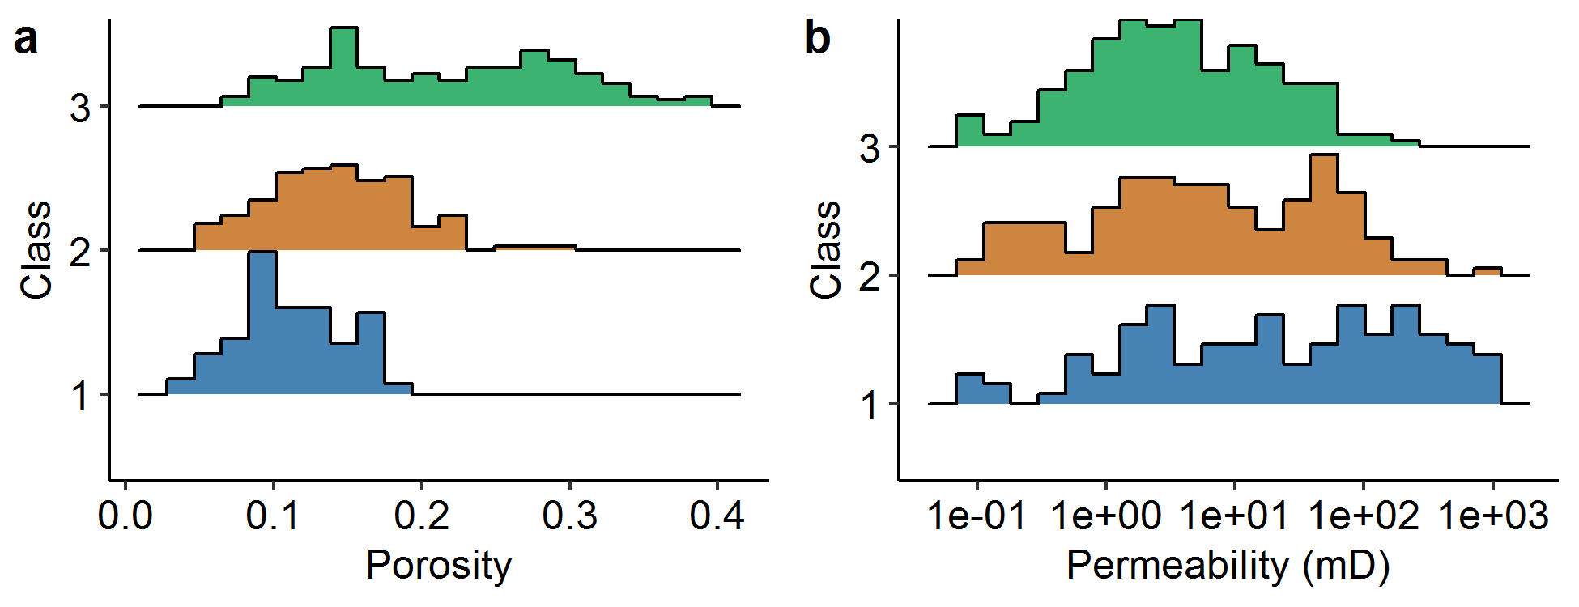
Figure 1. Histograms of interparticle porosity (a) and permeability (b) distributions for each Lucia rock type in the Lucia (1995) dataset. Porosity for rock class three is bi-modal. Permeability values for each class do not follow a normal distribution.
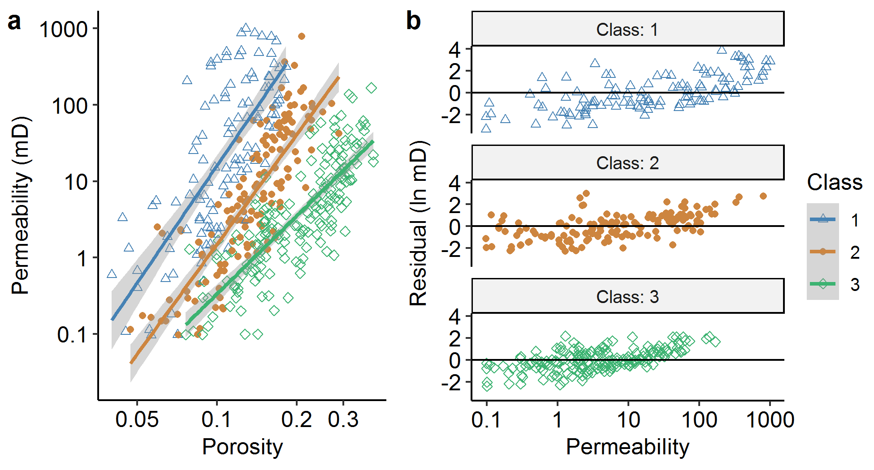
Figure 2. a) Cross-plot of porosity and permeability for each Lucia rock class (modified from Lucia, 1995). Both the x- and y-axes are logarithmic. Color indicates the rock class. b) Residuals plot for a regression of log-porosity against log-permeability by rock class. A black line shows zero residual. The color of the points indicates the Lucia rock type.

For the SSAU dataset we also created histograms of the porosity and permeability distributions for each lithology (Figure 3). From this analysis, we identified several cores that had been fractured in the core extraction process and screened those sections from further analysis. The average porosity is highest for grainstone and packstone lithologies (3 and 4) and lowest for mudstone and anhydrite lithologies (5). Porosity for lithology 4 (ooid-peloid grainstone) is multi-modal, suggesting that this lithology could be further subdivided.
Cross-plots for permeability and porosity are shown in Figure 4. Lithologies 2 and 3 are the most abundant, and also have the highest porosity and permeability values. A linear trend between porosity and permeability can be detected, albeit with significant scatter. The multimodal porosity distribution for lithology 4 does not affect the porosity-permeability trend (This might be due to the small number of samples.).

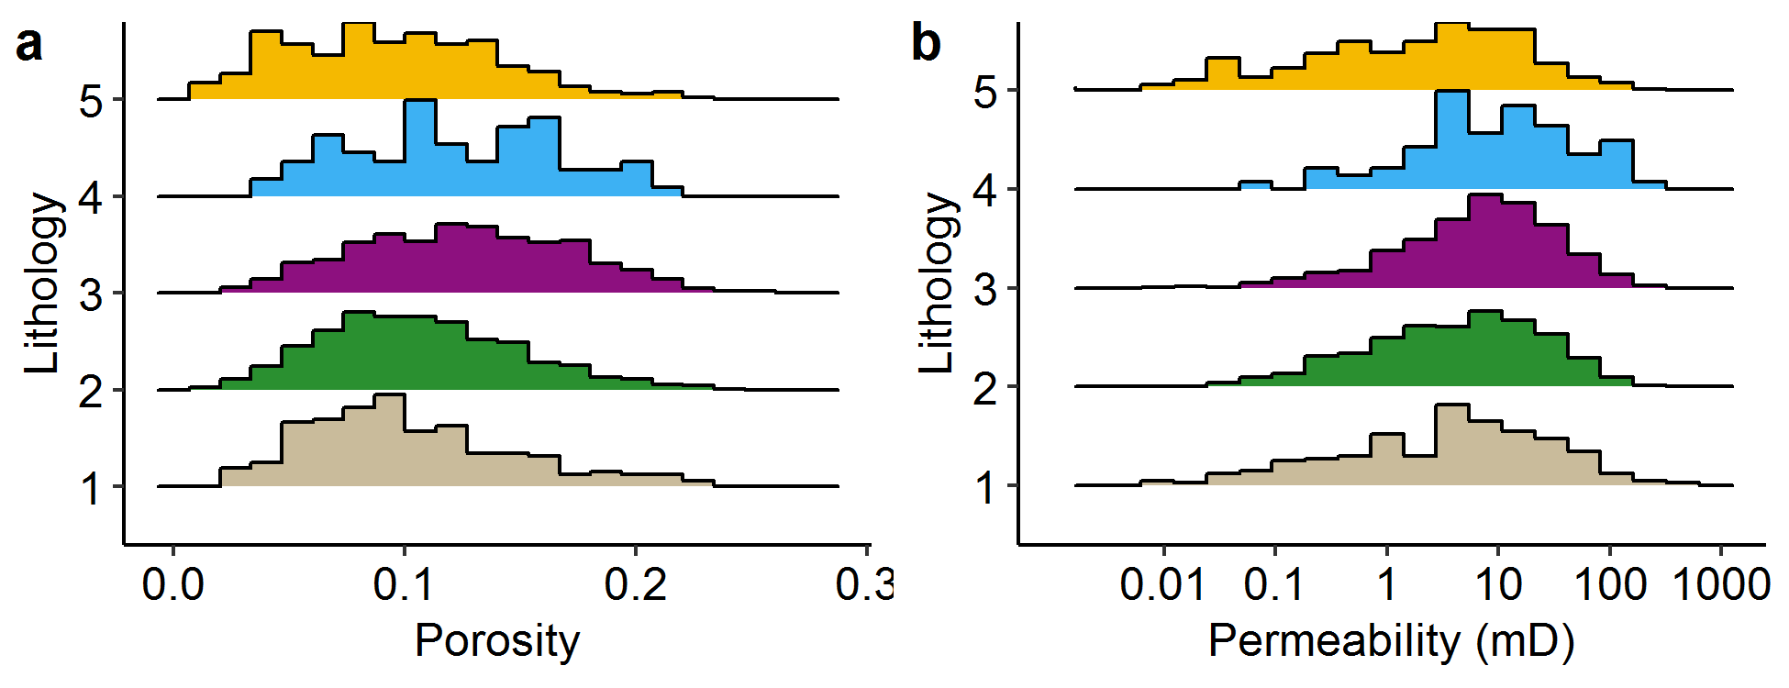
Figure 3. a) Histograms for porosity for each lithology in the SSAU dataset. B) Histograms for log-permeability for each lithology in the SSAU dataset. While, for most lithologies, the property distributions are unimodal, the porosity and permeability distributions for lithology 4 are multimodal. Lithologies are listed in Table 1.
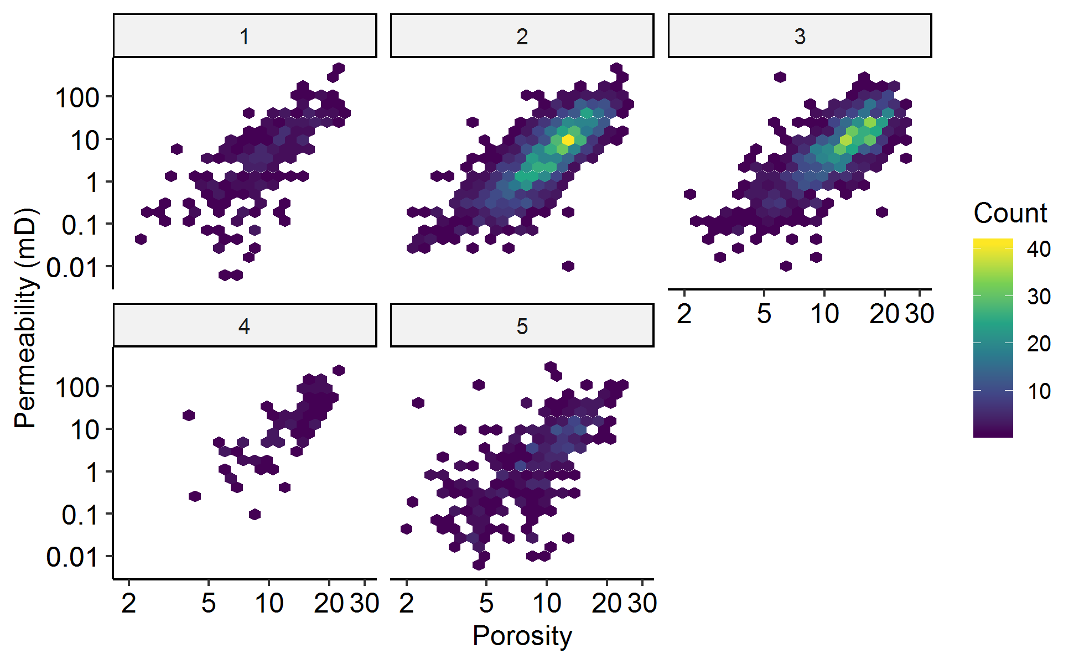
Figure 4. Hexbin cross-plot of permeability versus porosity for each lithology in the SSAU dataset. Permeability and porosity axes are both log-transformed. The box at the top of each plot gives the lithology (listed in Table 1). Color indicates the number of points in the hexbin, from 1 (dark blue) to 40 (bright yellow).
Results of the Lucia Model
In his paper, Lucia (1995) provided best fit lines for each of his petrophysical classes. The results of applying Lucia’s proposed permeability transforms (Lucia, 1995, his Figure 12) using his dataset are shown in Table 2. Lucia’s transformations do not account for bias from performing the fit in logarithmic space (see Jensen, et al., 2000, Chapter 10). Bias is calculated using the relation Bias = $e^{RMS{E^{2}}/2}$.
Table 2. Measures of model accuracy for the predictions proposed by Lucia (1995) transforming interparticle porosity ($ϕ_{ip}$) to permeability to air ($k$). Values are reported in the natural logarithm of permeability in mD. RMSE = Root-mean squared error, and MAE = mean absolute error. The bias is the approximate amount the given equation will underestimate the permeability.
Rock Type | Equation  (mD) | R2 | RMSE (log-e mD) | MAE  (log-e mD) | Approximate Bias (%)
1 | $$k=\left(45.35×{10}^{8}\right)ϕ_{ip}^{8.537}$$ | 0.55 | 2.00 | 1.64 |  | 740%
2 | $$k=\left(1.595×{10}^{5}\right)ϕ_{ip}^{5.184}$$ | 0.69 | 1.20 | 0.99 |  | 200%
21 | $$k=\left(2.040×{10}^{6}\right)ϕ_{ip}^{6.380}$$ | 0.69 | 1.31 | 1.05 |  | 230%
3 | $$k=\left(2.884×{10}^{3}\right)ϕ_{ip}^{4.275}$$ | 0.66 | 1.04 | 0.82 |  | 170%
1. Lucia offers two transforms for rock type 2.
We also ran an elastic net regression on the data from Lucia’s Figure 12 with three-repeat ten-fold cross-validation, after randomly selecting 20% of the data to hold out for testing. Porosity was transformed on the training data (the other 80% of the data-set) using Box-Cox, then centering, then scaling to unit standard deviation. Interactions were built between porosity and Lucia Rock Type, and elastic net regression was run. The results of this analysis are shown in Table 3.
The most accurate elastic net regression had no regularization, resulting in OLS regression (much like Figure 2). The model accuracy for this regression on the three data extents (testing, cross-validation and testing) are provided in Table 3. Each class has a statistically significant difference in its porosity-permeability transformation, as evidenced by the feature importance plot (Figure 5).
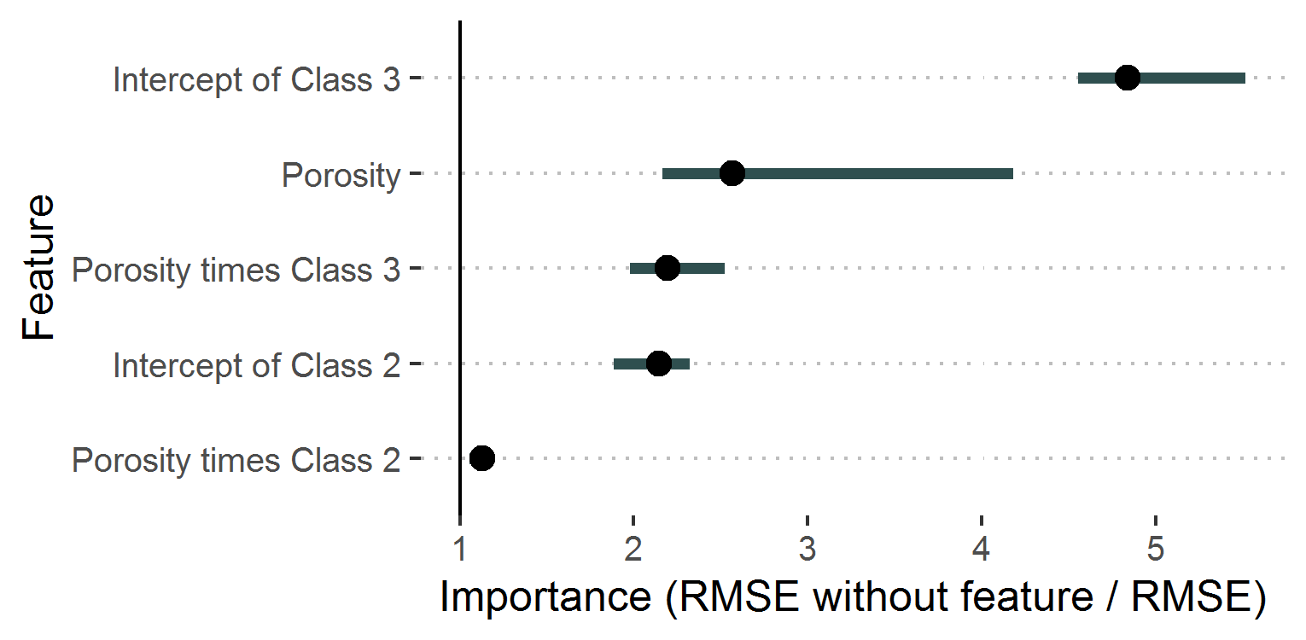
Figure 5. Feature importance plot for Lucia rock typing on the Lucia data set. Points indicate average importance after 40 shuffling repetitions, while bars indicate 95% confidence intervals. A feature with no importance would have a 95% confidence interval that drops below an importance of 1. All features show importance for this regression. The intercept of each class is the permeability where transformed porosity is zero. The porosity times class X is the slope of log-permeability versus transformed porosity for class X.
It is desirable to develop a relationship between total porosity and permeability, rather than interparticle porosity, because total porosity is easier to measure from log and core data than interparticle porosity. Jerry Lucia has graciously provided us with total porosity and interparticle porosity measurements. The comparison is plotted in Figure 6. From this figure, it is clear that there is a strong, unit slope correlation between total and interparticle porosity. The R2 is exceeds 0.9 for each rock type.
For all classes, $ϕ_{ip}>ϕ_{total}$. The regression line for class 1 is $lnϕ_{ip}=1.13lnϕ−0.63$, for class 2, it is $lnϕ_{ip}=1.07lnϕ−0.28$, and for class 3, it is $lnϕ_{ip}=1.06lnϕ−0.31$, where porosity is measured in p.u. Thus, in these samples, total porosity overestimates interparticle porosity by less than 15%. We therefore expect total porosity to perform about as well as interparticle porosity in developing permeability predictors for non-vuggy carbonates.

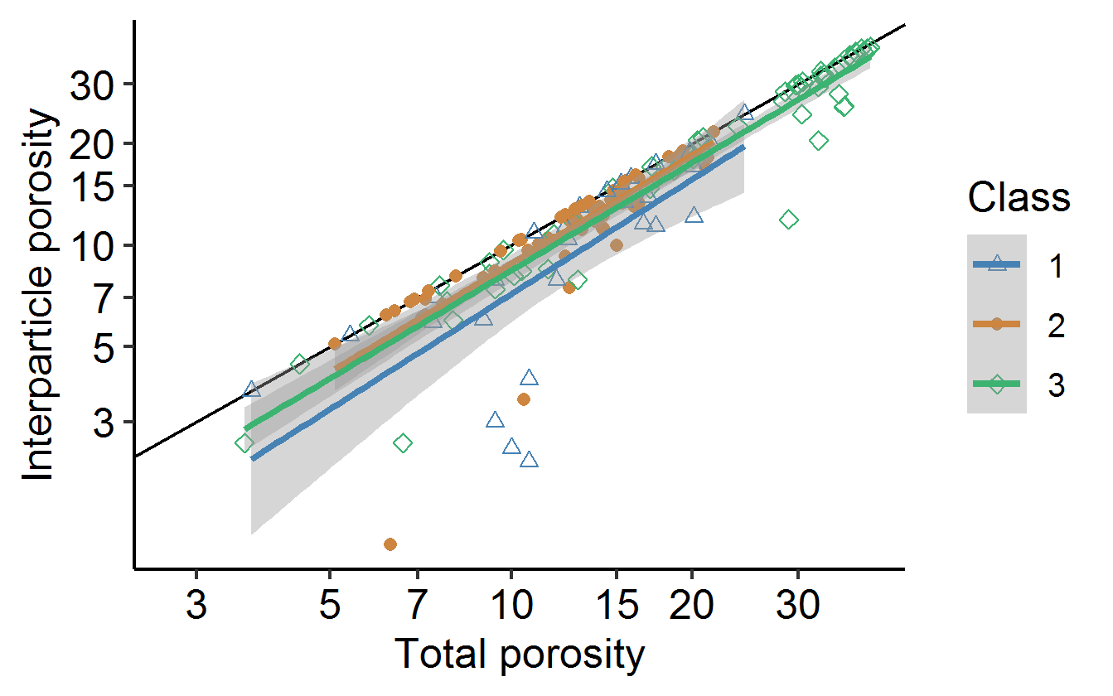
Figure 6. Comparison of total porosity versus Lucia’s calculated interparticle porosity from point counting. Points indicate individual observations, lines the OLS regression between points of the same rock class, and shading the confidence intervals for those regressions. Color and shape vary with Lucia rock class. Both the x- and y-axes are logarithmic.
Frequently, Lucia rock types are not determined from measuring the particle size. Instead, core is visually inspected and assigned Dunham rock fabric categories. In theory, grainstone should correspond to Lucia rock type 1, packstone to rock type 2, etc. Therefore, lithofacies interpretation is often an input for determining permeability from porosity data. With the SSAU data, we have the opportunity to compare porosity-permeability transforms arising from lithofacies.

Results of Lithofacies Model
Creating a testing-training split for the SSAU data was accomplished by holding out the data from the well SSAU #5505R, representing 8.2% of the data, for testing. During preprocessing, porosity was transformed using the same method as above, and interactions were built between porosity and lithofacies. The Box-Cox transformation exponent used to maximize normality of the distribution was 0.640.
Elastic net regression returns an R2 = 0.60, RMSE = 1.21, and MAE = 0.90 on cross validation. Residuals for the training dataset are shown in Figure 7. The residuals are slightly heteroscedastic, which disappears if the permeability is transformed using Box-Cox before fitting (unlike in Lucia’s dataset).
The best fit elastic net model has a mixing fraction of 0.66 and a regularization parameter of 0.002. The regressor assigns weights to the porosity and the slopes for each lithology. A plot of predicted and observed permeability against depth is given in Figure 8. Shuffling features indicates that the statistically significant variables are transformed porosity and lithologies 2 and 3 (Figure 9). Model statistics are reported in Table 3.
Random forest regression yielded the best cross-validated results with 3 randomly selected predictors, a variance split rule, and a minimum node size of 40 points. The features with larger-than-zero importance were porosity, presence of lithology 5, presence of lithology 3, and presence of lithology 2. Shuffling features indicated that both porosity and lithology were important. A plot of residuals is given in Figure 10, and the permutation importances in Figure 11. The model statistics are available in Table 3. The random forest slightly underperforms the linear model on cross validation and the testing data.
A reduced model that does not use lithofacies, but instead only uses porosity to predict permeability, has an R2 = 0.59, RMSE = 1.18, and MAE = 0.90 on the training data (Table 3, last row). This MAE corresponds to $e^{0.90}≈2.5$ times the predicted value. For example, if the porosity-only model has $ϕ=0.067,$ it predicts k = 1 mD, and the MAE range is from 0.4 to 2.5 mD. For comparison, the model including lithofacies, with a porosity of 0.067 and lithofacies 3, would predict a permeability of 1.09 mD, with an MAE range of 1.5 to 2.7 mD.
With the porosity-only model, the regression equation is
$$\log_{e}k=13.9\frac{ϕ^{0.640}−1}{0.640}+17.9$$
where porosity is reported as a volume fraction and permeability is reported in milliDarcy. The accuracy of this regression is shown in Table 2.
Table 3 shows model performance for the Lucia rock type-based model, full core / full lithofacies model, and baseline porosity-permeability model. Each measure is calculated to compare the natural log transformed permeability to its predicted value. The data extents include Full (all data from that sample source), Training (all of the data used in training the final model) CV (cross-validation data, where each fold of the training data is held out of the fitting, then tested), and Testing (data that is never used for building the model, but is blind tested afterwards). The accuracy on each rock type and lithofacies are aggregated to provide the mean accuracy for the data extent.
Using R2 values, the elastic net regression performs better on the SSAU testing data than on the SSAU training data. This is because the accuracy of the model on individual wells varies from an MAE of 0.7 to 1.3 log-mD, and through chance, one of the better-behaved wells comprised the training data.
Table 3. Accuracy and residual metrics for several porosity-permeability transforms. The models presented are 1) Lucia’s (1995) regression, 2) a new regression on the data from Lucia (1995), after careful preprocessing and regression regularization, 3) a lithofacies and porosity model trained on SSAU data, 4) a random forest model trained on SSAU lithofacies data and 5) a model only using porosity, trained on SSAU data. Models 2-4 were trained through cross-validation, then model accuracy was calculated on the training data, cross-validation, and testing data.
Model | Sample source | Data extent | R2 | RMSE (log-mD) | MAE (log-mD)
1. Lucia (1995)1 | Lucia | Full | 0.65 | 1.40 | 1.09
2.  Lucia rock type  Elastic net | Lucia | Training | 0.69 | 1.21 | 0.96
2.  Lucia rock type  Elastic net | Lucia | CV | 0.69 | 1.22 | 0.98
2.  Lucia rock type  Elastic net | Lucia | Testing | 0.59 | 1.29 | 1.04
3.  Lithofacies  Elastic net | SSAU | Training | 0.60 | 1.19 | 0.88
3.  Lithofacies  Elastic net | SSAU | CV | 0.59 | 1.17 | 0.88
3.  Lithofacies  Elastic net | SSAU | Testing | 0.70 | 1.20 | 0.94
4.  Lithofacies  Random forest | SSAU | Training | 0.66 | 1.11 | 0.83
4.  Lithofacies  Random forest | SSAU | CV | 0.59 | 1.17 | 0.88
4.  Lithofacies  Random forest | SSAU | Testing | 0.68 | 1.22 | 0.97
5.  Porosity  (no rock type) | SSAU | Training | 0.58 | 1.21 | 0.90
5.  Porosity  (no rock type) | SSAU | CV | 0.59 | 1.17 | 0.88
5.  Porosity  (no rock type) | SSAU | Testing | 0.72 | 1.18 | 0.92
1. See Table 2 for equations. Metrics are aggregated from all three Lucia rock types.

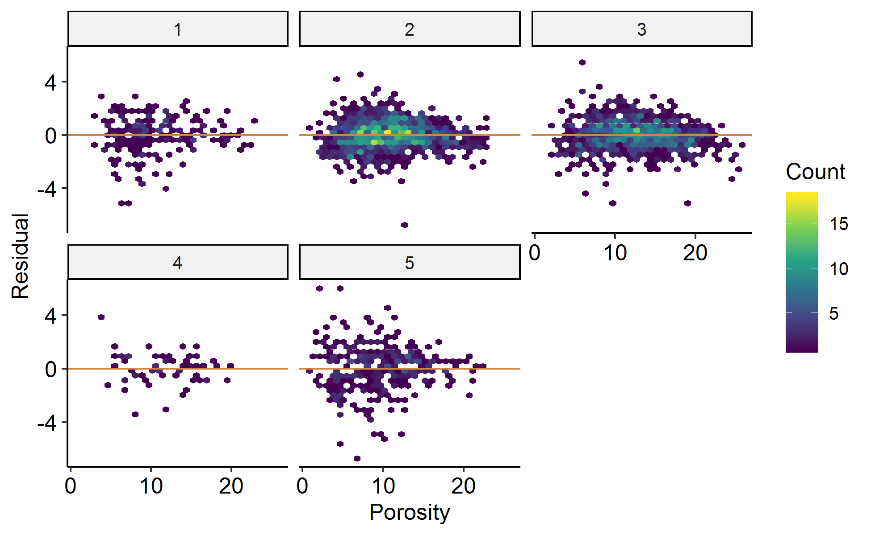
Figure 7. Residuals plot for Elastic-net regressions using the SSAU data. The boxes at the top of each facet provide the lithology, while the y-axis gives the residual (in log-transformed permeability) and the x-axis gives the porosity. An orange line indicates zero residual. Colors for each hexagonal bin give the number of points within, with 1 dark blue, and 18 bright yellow.
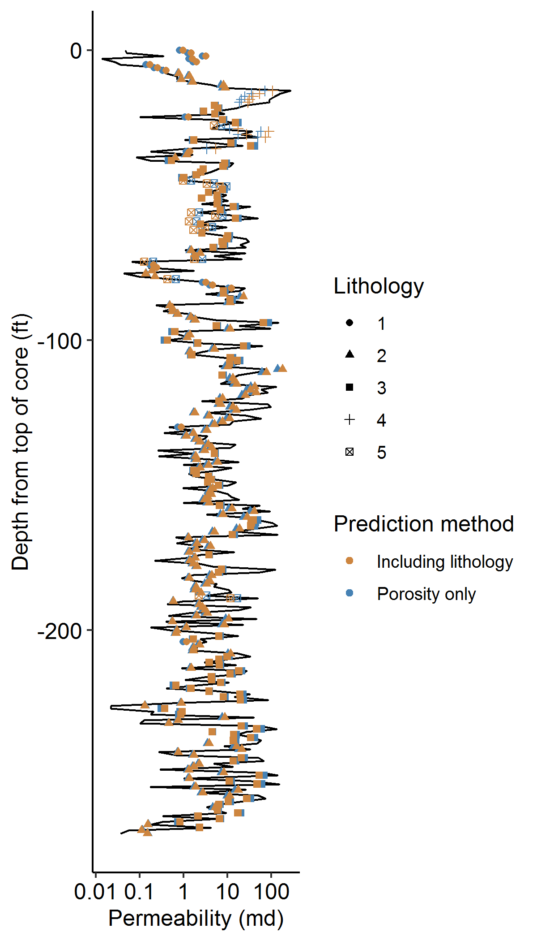
Figure 8. Plot of permeability versus depth for the testing well in the SSAU data. Measured permeability is the black line, while predicted permeability from the model including porosity and lithology (orange) and using only porosity (blue) are shown as points. The point shape is used to show the interpreted lithology.
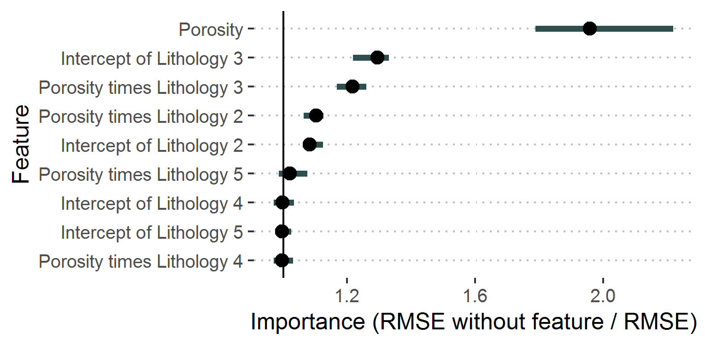
Figure 9. Importance plot for elastic-net regression of permeability for the SSAU data. Dots show the average effect on the RMS error after shuffling each feature. Porosity and lithologies 2 and 3 have a persistent effect on the RMSE after shuffling.
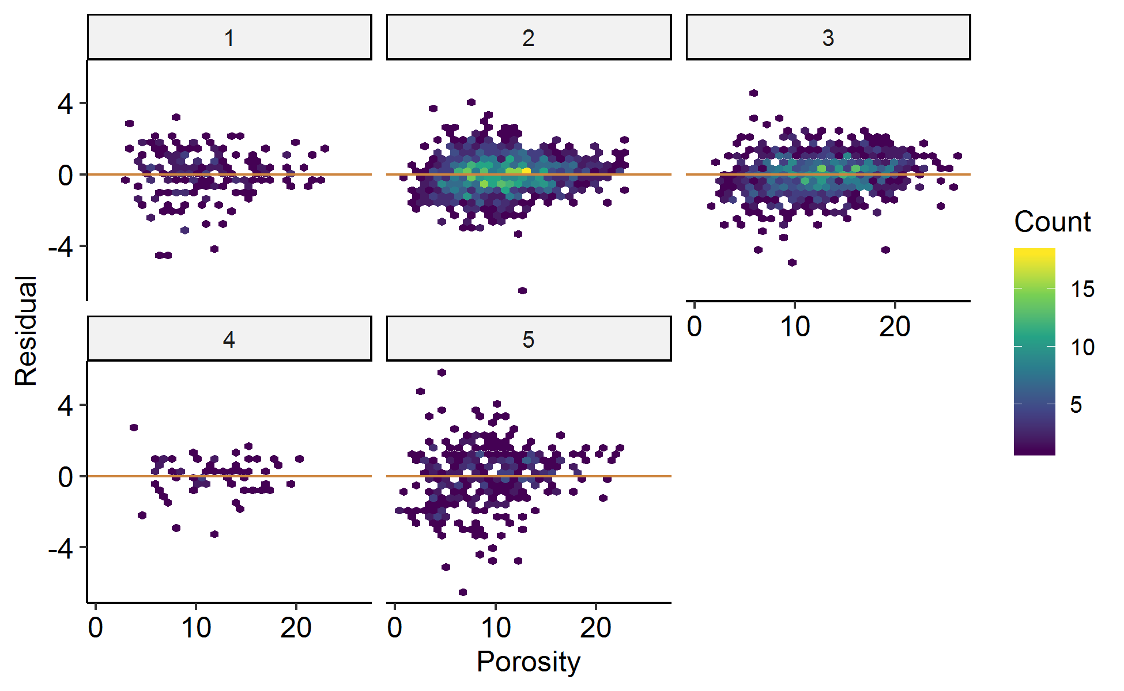
Figure 10. Plot of residuals for the random forest model trained on lithofacies and porosity for the SSAU data. Each pane represents the lithofacies numbered at the top. An orange line indicates zero residual (a perfect fit). Hexbins are colored from blue (one data point) to yellow (18 data points) based on how many samples had a residual and porosity corresponding to that location. There are only slight differences in the residuals between this model and the residuals of the linear model.
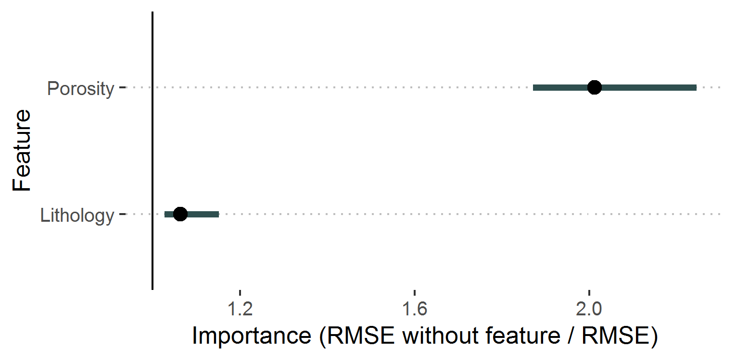
Figure 11. Feature importances for the random forest model. The dot provides the average importance on the residuals, with the bar representing 95% confidence intervals. Porosity strongly influences the residuals of the model, but lithology is weakly important.
Discussion
Data preprocessing and residuals analysis
This study has set out to inform approaches to ML analyzes and related next generation statistical analyses to ensure that they are interpretable (in the sense of Molnar, 2019). In the first step, the raw data sets were analyzed to establish that they were appropriate for the application of ML algorithms. In his paper on facies classification using machine learning, Hall (2016) noted that “many machine-learning algorithms assume the feature data are normally distributed” (i.e., Gaussian with zero mean and unit variance). Hall suggested that data should be conditioned such that they meet this criterion using includes a Standard Scalar class. This methodology is inadequate for the task. As written in the Sci-kit Learn (2019) manual, the preprocessor used by Hall “ignores the shape of the distribution” and transforms the data “to center it by removing the mean value of each feature”, and scaling it “by dividing non-constant features by their standard deviation.” This approach does not assure Gaussian distributions for the transformed feature; for instance, it does not remove skew. A superior approach (as noted above), is to first apply a test for normalcy such as the Shapiro-Wilk, followed if needed by a Box-Cox transform. Jensen and Lake (1985) showed that using a Box-Cox transform to provide symmetry is sufficient to improve predictor performance in geostatistical workflows.
In the case of the Lucia (1995) data, a Shapiro-Wilk test confirmed that permeability for rock type 3 is not log-normally distributed, and visual inspection of the distributions show it is not unimodal for classes 1 and 2. Further data analysis revealed that the data Lucia used to build his model is polymodal, and that regressions of such data are heteroscedastic. Heteroscedasticity is characterized by a systematic variation in the spread of the residuals from a regression analysis. Frequently it results from the effects of outliers in the data set or the population being multimodal. Note that ordinary least squares (OLS) regression is based on an assumption that residuals are drawn from a population with constant variance. Heteroscedasticity can result in p-values that are unrealistically small. Bartlett’s test for homogeneity of variances (Parra-Frutos, 2013) is one of several tests that can be used to identify heteroscedasticity in data sets.
Utilizing the results of regressions with strongly heteroscedastic residuals will be prone to performing poorly on test data. This can be seen by the large decrease in R2 for the test data using Lucia’s rock types. Heteroscedastic residuals that decrease as the prediction increases are indicative of non-Gaussian variables. The heteroscedasticity of Lucia’s data cannot be eliminated, even after careful transformation, due to the multi-modal nature of the permeability distribution. If these kinds of tests and data conditioning are not accomplished prior to running ML algorithms, the resultant solutions may not be robust or accurate.
We find that the residuals from the random forest model are heteroscedastic. Not surprisingly, a study by Gelfand (2015) found that heteroscedastic data may have an adverse impact on ML algorithms such as Random Forests (RF) and Gradient Boosting Regressors (GBR). However, Gelfand does note that GBR “may perform better than random forests”. Similarly, Henry (2016) concluded that RF algorithms “are inefficient at estimating means when the data are heteroscedastic”. He suggested that the effectiveness of RF could be improved by utilizing a “likelihood-based regression trees as a base learner”. In general, testing for heteroscedasticity should be a standard procedure in application of ML models to geoscience data sets, particularly if the RF algorithm is to be deployed.
In ML based projects to analyze data sets from reservoirs including rock typing, porosity, permeability and perhaps wireline log data, Elastic Net regression will likely be preferred (in preference to ridge and LASSO regression). If the data is characterized by highly correlated explanatory variables this will be the case. O’Brien (2007) discusses the uses (and abuses) of the Variance Inflation Factor as a measure of the extent of “multi-collinearity of the ith independent variable with the other independent variables in regression models.”
The elastic net regression run on Lucia’s data performed best without regularization. This is because regularization is less likely to be applicable when the number of variables being tested is small. Sufficiently simple models with smaller numbers of variables are already interpretable and explainable in the sense of Molnar (2019), and might not require regularization. Similarly, the data sets that we have analyzed are not sufficiently complex to evaluate the advantages of the Elastic Net regression over less robust alternatives such as the LASSO algorithm. LASSO was used by Al-Mudhafar (2019) to model permeabilities in sandstone reservoirs. He asserted that this approach had resulted in “significant progress in the application of statistical learning models to petrophysical modeling” and had improved reservoir characterization. It would seem that further exploration of Elastic Net Regression as a tool for ML approaches to reservoir characterization could be fruitful.
Factors influencing permeability
Another set of important issues arise when it comes to taking the output from ML algorithms and applying them to making predictions of parameters such as permeability. If permeability is predicted from porosity alone, and then compared to permeability predicted from porosity and lithofacies information, for the SSAU data we find that there is very little improvement of the prediction. The elastic net regression utilizing lithology shows a significant contribution from lithofacies 2 and 3 to the permeability. However, this contribution improves the error metrics in the regression by less than 1% (Table 3, bottom two regressions). The contrasting results (whether lithofacies do or do not improve permeability predictions) show the value of building simple models for benchmarking.
In the SSAU data, we have identified a contribution from lithofacies 2 and 3, but this effect is either too small to impact the regression, or it is not present in the testing data. This indicates that even after regularization, un-useful parameters remain in the elastic net regression of the SSAU data. Therefore, application of the elastic net algorithm has over-fit on the training data. These kind of phenomena are likely to occur in more complex ML models, but may go unnoticed unless carefully searched for.
The limited effectiveness of lithofacies information in determining the porosity-permeability transform does not necessarily hold for other types of reservoir. In clastic (Al-Mudhafar (2017)) and mixed clastic-carbonate (Wood, 2019) reservoirs, a much stronger influence of lithofacies on permeability is observed. Also, carbonate reservoirs that have undergone less pervasive dolomitization might have a stronger correlation between lithology and permeability.
On the topic of interparticle porosity versus total porosity, we performed a regression between the two (Figure 6). These measures of porosity are nearly identical, except in cases where there are significant vugs creating porosity. Vuggy porosity can be disconnected from the flow paths, and therefore should be removed from the porosity when large, disconnected vugs are identified. This result is in keeping with Lucia’s (1995) conclusions. However, when significant vuggy porosity is not present, total porosity is an accurate measure of the interparticle porosity. The analysis of SSAU data shows that similar model accuracy to the interparticle porosity can be achieved using total porosity.
Finally, we note that despite repeated warnings about de-transforming log-transformed predictions (e.g. Jensen and Lake, 1985; Delfiner, 2007), analysts continue to ignore the bias these transforms introduce into the predictions. Given the weak porosity-permeability relationships typical of carbonate rocks, the relationships can under-predict by a factor of 3 or more when bias is ignored. Using the Box-Cox transformation with $λ≠0$ helps, because the bias correction term is additive rather than multiplicative to the prediction (Jensen et al., 1987).
Guidelines for future research
There is a dearth of published data in dolomitized carbonates where the accuracy of porosity-permeability transforms has been systematically measured. For instance, Haro (2004) suggests several permeability models, but does not provide R2, MAE, or RMSE errors for those models. Al-Ajmi and Holditch (2000) offer R2, but neither MAE nor RMSE. (They also build rock groups from the porosity-permeability transforms, rather than the other way around.) Lønøy (2006) and Lucia (1995) provide R2, but neither MAE nor RMSE. None of these papers perform cross-validation, and they do not perform blind well tests of their final models.
In future reservoir studies where core is available, a critical evaluation of lithofacies should be performed with robust statistical checks. This is necessary to verify that differences between porosity-permeability transforms of different lithofacies are significant. When possible, cross-validation should be performed between wells, in an approach similar to the industry-standard blind well test. To compare results with literature, it is valuable to report the R2, mean absolute error, and root-mean squared error.
To build generalizable machine learning models for geoscientific datasets, the statistical character of the data should be carefully examined as part of the exploratory analysis. A testing data set that does not bleed into the model-building data should be selected. The machine learning model needs to have regularization parameters to prevent over-fitting, and these parameters need to be tuned with cross-validation. Finally, after model building, the residuals of the model predictions need to be analyzed for the squared error, absolute error, and heteroscedasticity. These are all necessary parts of the geoscience machine learning workflow.
There are other approaches for permeability prediction that have not been analyzed in this study. These include neural networks and gradient boosting regressors, as applied to a clastic reservoir (Al-Mudhafar, 2017), and a nonparametric model applied to a mixed carbonate-clastic reservoir (Wood, 2019). These methods could be applied to carbonate reservoirs such as the Seminole in future studies.

Conclusions
This study has developed a set of strategies that will support ML studies of reservoir facies and associated petrophysical properties (particularly permeability) being more transparent and/or more robust. The first step involves characterizing the data set to understand key aspects of its statistical distribution. In this study, we generated histogram plots to examine the univariate statistics of porosity and permeability in these rocks. As many ML algorithms require data have approximately normal distributions, tactics such as applying the Box-Cox transform should be utilized.
Following transformation of the data sets, we performed a regularized linear regression on the porosity-permeability. We validated the regression results through cross-validation and test-training splits. Finally, we discussed the fraction of explained variance and expected error for these porosity-permeability transforms.
Polymodal, heteroscedastic, data sets are common in petrophysical studies such as Lucia’s (1995). In this data set heteroscedasticity was identified from the observed variation in the spread of the residuals from the regression.
In view of the broad interest in the use of porosity-permeability transforms for characterizing carbonate reservoirs, an analysis of Lucia’s (1995) model (utilizing newly available statistical tools), seems timely. In this paper, we took Lucia’s data and another dataset from the Seminole San Andres Unit and performed a robust statistical analysis of his findings. Lucia’s results rely upon poorly conditioned data, impacting the generalizability of his work to new datasets. Permeability does not follow a unimodal, log-normal distribution, leading to heteroscedasticity in permeability prediction. Lithofacies interpretations do not lead to permeability predictions that outperform simple porosity-only relations. It was also found that statistically significant effects do not necessarily lead to better performance on holdout data.
This study has used a variety of state of the art Machine Learning tools to analyze the generation of porosity-permeability transforms from core data. Our conclusion has been that the complexity of the data is such that knowledge of the rock type or facies does not result in a significantly improved prediction of permeability, given a porosity measurement. The overarching conclusion of this study is that using Machine Language packages to investigate complex petrophysical and geologic data is likely to be fraught with significant problems if the approach lacks interpretability. If the nature of the data being processed (such as normality and heteroscedasticity) is not understood and accounted for, then model predictions may be erroneous.

Acknowledgements
We are grateful to F. Jerry Lucia for providing the raw data, thin sections and image analyses that he used in his 1995 paper. Vinyet Baqués generously provided porosity, permeability, and facies data from the SSAU reservoir as well as providing useful discussion. Statistical analysis was performed in the R language (R Core Team, 2014). Plots were generated using the GGPlot2 package (Wickham, 2009). This study was funded by the US Department of Energy (DOE) grant FE0024375 (PI: Duncan). The authors are in debt to Drs. Jerry Jensen, Larry Lake, and Bo Ren for valuable conversations and feedback.

References Cited
Agterberg, F.P., 1974. Geomathematics. Amsterdam: Elsevier.
Al-Ajmi, F.A. and Holditch, S.A., 2000. Permeability estimation using hydraulic flow units in a central Arabia reservoir. In SPE Annual Technical Conference and Exhibition. Society of Petroleum Engineers.
Al-Mudhafar, W.J., 2015. Integrating component analysis & classification techniques for comparative prediction of continuous & discrete lithofacies distributions. In Offshore Technology Conference. Offshore Technology Conference.
Al-Mudhafar, W.J., 2017. Integrating well log interpretations for lithofacies classification and permeability modeling through advanced machine learning algorithms. Journal of Petroleum Exploration and Production Technology, 7(4), pp.1023-1033
Al-Mudhafar, W.J., 2019. Bayesian and LASSO Regressions for Comparative Permeability Modeling of Sandstone Reservoirs. Natural Resources Research, 28 (1), pp.47-62
Ahmadi, M.A. and Chen, Z., 2018. Comparison of machine learning methods for estimating permeability and porosity of oil reservoirs via petro-physical logs. Petroleum.
Archie, G.E., 1952. Classification of carbonate reservoir rocks and petrophysical considerations. AAPG Bulletin, 36(2), pp.278-298.Box, G.E. and Cox, D.R., 1964. An analysis of transformations. Journal of the Royal Statistical Society: Series B (Methodological), 26(2), pp.211-243.
Breiman, L., 2001. Random forests. Machine learning, 45(1), pp.5-32.
Caté, A., Perozzi, L., Gloaguen, E. and Blouin, M., 2017. Machine learning as a tool for geologists. The Leading Edge, 36(3), pp.215-219.
Cranganu, C., Luchian, H. and Breaban, M.E. eds., 2015. Artificial intelligent approaches in petroleum geosciences. Berlin: Springer.
Delfiner, P., 2007. Three statistical pitfalls of phi-k transforms. SPE Reservoir Evaluation and Engineering. 10(6), pp. 609-617.
Dunham, R.J., 1962. Classification of carbonate rocks according to depositional textures. AAPG Memoir, A038, pp. 108-121.
Elkatatny, S., Mahmoud, M., Tariq, Z. and Abdulraheem, A., 2018. New insights into the prediction of heterogeneous carbonate reservoir permeability from well logs using artificial intelligence network. Neural Computing and Applications, 30(9), pp.2673-2683.
El-Sebakhy, E.A., Asparouhov, O., Abdulraheem, A.A., Al-Majed, A.A., Wu, D., Latinski, K. and Raharja, I., 2012. Functional networks as a new data mining predictive paradigm to predict permeability in a carbonate reservoir. Expert Systems with Applications, 39(12), pp.10359-10375.
Gelfand S., 2015, Understanding the Impact of Heteroscedasticity on the Predictive Ability of Modern Regression Methods, MSc Thesis. Simon Fraser University.
Gilpin, L.H., Bau, D., Yuan, B.Z., Bajwa, A., Specter, M. and Kagal, L., 2018, October. Explaining explanations: An overview of interpretability of machine learning. In 2018 IEEE 5th International Conference on data science and advanced analytics (DSAA) (pp. 80-89). IEEE.
Grötsch, J. and Mercadier, C., 1999. Integrated 3-D reservoir modeling based on 3-D seismic: The Tertiary Malampaya and Camago buildups, offshore Palawan, Philippines. AAPG bulletin, 83(11), pp. 1703-1728.
Hall, B., 2016. Facies classification using machine learning. The Leading Edge, 35(10), pp.906-909.
Haro, C.F., 2004. The perfect permeability transform using logs and cores. In SPE annual technical conference and exhibition. Society of Petroleum Engineers.
Henry, A.J.D., 2016. Statistical Learning Tools for Heteroskedastic Data, PhD dissertation. Simon Fraser University.
Hoerl, A.E. and Kennard, R.W., 1970. Ridge regression: Biased estimation for nonorthogonal problems. Technometrics, 12(1), pp. 55-67.
Honarpour, M.M., Nagarajan, N.R., Grijalba Cuenca, A., Valle, M. and Adesoye, K., 2010. Rock-fluid characterization for miscible CO2 injection: residual oil zone, Seminole field, Permian Basin. In SPE Annual Technical Conference and Exhibition. Society of Petroleum Engineers.
James, G., Witten, D., Hastie, T. and Tibshirani, R., 2013. An introduction to statistical learning (Vol. 112, p. 18). New York: Springer.
Jensen, J.L., and Lake, L.W., 1985. Optimization of regression-based porosity-permeability predictions. In Transactions of the 10th Formation Evaluation Symposium. Calgary.
Jensen, J., Lake, L.W., Corbett, P.W. and Goggin, D., 2000. Statistics for petroleum engineers and geoscientists (Vol. 2). Gulf Professional Publishing.
Jensen, J.L., Lake, L.W., and Hinkley, D.V., 1987. A statistical study of reservoir permeability: Distributions, correlations, and averages. SPE Formation Evaluation, 2, pp. 461-468.
Kearns, M.J., 1996. A bound on the error of cross validation using the approximation and estimation rates, with consequences for the training-test split. In Advances in Neural Information Processing Systems (pp. 183-189).
Kerans, C., Lucia, F.J., Senger, R.K., 1994. Integrated characterization of carbonate ramp reservoirs using Permian San Andres Formation outcrop analogs, AAPG Bulletin, 78 (2) pp. 181-216.
Kohavi, R., 1995, August. A study of cross-validation and bootstrap for accuracy estimation and model selection. In Ijcai(Vol. 14, No. 2, pp. 1137-1145).
Lary, D.J., Alavi, A.H., Gandomi, A.H. and Walker, A.L., 2016. Machine learning in geosciences and remote sensing. Geoscience Frontiers, 7(1), pp.3-10.
Lindley, D.V., 1957. A statistical paradox. Biometrika, 44(1/2), pp.187-192.
Lønøy, A., 2006. Making sense of carbonate pore systems. AAPG bulletin, 90 (9), pp. 1381-1405.Lucia, F.J., 1995. Rock-fabric/petrophysical classification of carbonate pore space for reservoir characterization. AAPG Bulletin, 79(9), pp.1275-1300.
Lucia, F.J., 2007. Carbonate reservoir characterization: An integrated approach. Springer Science & Business Media.
Mann, C.J., 1987. Misuses of linear regression in earth sciences. In Use and abuse of statistical methods in the earth sciences, W.B Size (ed.) Oxford: OUP, pp. 74-106.
Mishra, S. and Datta-Gupta, A., 2017. Applied Statistical Modeling and Data Analytics: A Practical Guide for the Petroleum Geosciences. Elsevier.
Molnar, C., 2019, Interpretable machine learning: a guide for making black box models explainable. ISBN 9780244768522.
Murdoch, W.J., Singh, C., Kumbier, K., Abbasi-Asl, R. and Yu, B., 2019. Interpretable machine learning: definitions, methods, and applications. arXiv preprint arXiv:1901.04592.
O’Brien, R.M., 2007. A caution regarding rules of thumb for variance inflation factors. Quality & quantity, 41(5), pp.673-690.
Parra-Frutos, I., 2013. Testing homogeneity of variances with unequal sample sizes. Computational Statistics, 28(3), pp.1269-1297.
R Core Team, 2017. R: A language and environment for statistical computing. R Foundation for Statistical Computing, Vienna, Austria. URL http://www.R-project.org/
Ren, B. and Duncan, I., 2019. Modeling oil saturation evolution in residual oil zones: Implications for CO2 EOR and sequestration. Journal of Petroleum Science and Engineering, 177, pp. 528-539.
Rudin C. 2019, Stop explaining black box machine learning models for high stakes decisions and use interpretable models instead. Nature Machine Intelligence, 1(5):206.
Sci-kit Learn, 2019, Standardization, or mean removal and variance scaling, https://scikit-learn.org/stable/modules/preprocessing.html#preprocessing-scaler. Accessed September 29, 2019.
Seber, G.A.F., 1977. Linear regression analysis. New York: J. Wiley.
Shapiro, S.S. and Wilk, M.B., 1965. An analysis of variance test for normality (complete samples). Biometrika, 52(3/4), pp.591-611.
Sonnenfeld, M.D., Canter, L., Meng, H.Z., Wingate, T.P. and Zahm, L.C., 2003. Operational Sequence Stratigraphy for 3-D Reservoir Modeling of Seminole Andres Unit (SSAU), Permian Basin, West Texas. In Annual AAPG-SEPM Meeting, Salt Lake City, UT (Vol. 5, pp. 11-14).
Sudakov, O., Burnaev, E. and Koroteev, D., 2019. Driving digital rock towards machine learning: predicting permeability with gradient boosting and deep neural networks. Computers & geosciences, 127, pp.91-98.
Wang, F.P., Lucia, F.J. and Kerans, C., 1998. Integrated reservoir characterization study of a carbonate ramp reservoir: Seminole San Andres Unit, Gaines County, Texas. SPE Reservoir Evaluation & Engineering, 1 (02), pp. 105-113.
Wickham, H. (2009) ggplot2: elegant graphics for data analysis. Springer New York.
Zou, H. and Hastie, T., 2005. Regularization and variable selection via the elastic net. Journal of the Royal Statistical Society: Series B (statistical methodology), 67(2), pp.301-320.
Wood, D.A., 2019. Predicting porosity, permeability and water saturation applying an optimized nearest-neighbour, machine-learning and data-mining network of well-log data. Journal of Petroleum Science and Engineering, p.106587.

