This manuscript is a pre-print and has been submitted for publication in Basin Research. This manuscript has not yet undergone peer-review. Subsequent versions of this manuscript may have different content. If accepted, the final version of the manuscript will be available via the “Peer-reviews publication DOI” link on the right hand side of this webpage. Please feel free to contact the corresponding author directly to discuss or comment on the manuscript. We welcome and encourage your feedback!
The influence of local low-density basement anomalies on the distribution of fluvio-deltaic sediment in rift basins: the early Carboniferous Fell Sandstone Formation, northern England

Louis Howell¹*, Andy Mitten¹, Stuart Egan¹, Stuart Clarke¹, Graham Leslie²

¹School of Geography, Geology and the Environment, William Smith Building, Keele University, Keele, Staffordshire ST5 5BG, UK
²BGS Scotland, Lyell Centre, Research Avenue South, Edinburgh EH14 4AP, UK

*Corresponding author. E-mail address: l.p.howell@keele.ac.uk

ABSTRACT

Local low-density basement anomalies are an important part of a rift basin’s inherited structural framework that can influence basin stratigraphy. Large granitic intrusions can cause local alterations in the basement’s density and often spatially correlate with fault-bounded highs (blocks) or convex-shaped regional flexural highs due to their isostatic responses. We investigate the influence of local low-density basement anomalies on the deposition of the fluviodeltaic Fell Sandstone Formation in the northern Pennine rift basin, northern England. The integration of a variety of data sources has enabled regional correlation of the Fell Sandstone Formation with basinal, time-equivalent stratigraphy. Spatial variations in the preserved facies, palaeocurrent and sedimentological characteristics of the Fell Sandstone are documented and the most important controls upon these variations are considered. Along the eastern margin of the granite-cored, flexural Cheviot High, the Fell Sandstone fluvial system is locally confined by the High leading to preservation of ~98% well-sorted sandstone. In the Northumberland-Solway Basin, the Fell Sandstone fluvial system is less confined, leading to sediment dispersal and downstream reduction of net sand. Based on this study, proximity to the dominant clastic sediment source, regional subsidence variations and basin palaeotopography are considered important controls upon spatial variations across the Fell Sandstone Formation. Regional subsidence variations and basin palaeotopography in the northern Pennine Basin are influenced by the Cheviot High and the Maryport-Stublick-Ninety Fathom fault system, which bounds the Northumberland-Solway Basin and the Lake District and Alston Blocks. Both the Cheviot High and the Lake District and Alston Blocks are structures caused by the isostatic responses of local granite-induced low-density basement anomalies. This study shows that flexural highs can act as baffles to fluvial systems, locally confining them and leading to the deposition of high quality reservoir. Fault-bounded highs can act as barriers and their deep bordering half-graben troughs can act as confines for clastic sediment, leading to starvation further down system.

INTRODUCTION

Inherited structures exert a strong control on the characteristics and evolution of rift basins and the distribution of lithofacies within them. Varying subsidence rates and topography across rift basins, for example, can prompt preferential drainage pathways and local confinement of fluviodeltaic systems (Leeder and Gawthorpe, 1987; Gawthorpe and Leeder, 2000; Hemelsdaël et al., 2017; Barrett et al., 2018), which host some of the key elements of the World’s most prolific petroleum plays (Mitchener et al., 1992; Stewart et al., 2016). Understanding these relationships is important, therefore, for the prediction of potential reservoir and source rock. Pre-existing weak basement lineaments (Morley et al., 2004; Bladon et al., 2015; Phillips et al., 2016; Fossen et al., 2017) as well as the rheological properties of the crust (Vauchez et al., 1998; Magee et al., 2014; Jackson et al., 2019) are crucial aspects of a rift basin’s inherited structural framework. Local basement density variations, however, are not often considered.
Plutonic intrusions can cause significant local alterations in the bulk density of the basement as well as changes in the basement’s mechanical strength (Bott et al., 1978; Donato et al., 1982; Donato et al., 1983; Howell et al., 2019a). Intruded low-density granite bodies have been recognised within the basements of the Great South Basin, offshore New Zealand (Phillips and McCaffrey, 2019), within the intra-basinal Utsira High of the north Viking Graben, offshore Norway (Zervos, 1987; Lundmark et al., 2014; Phillips et al., 2019), as well as the Lüderitz Basin, offshore Namibia (Scrutton and Dingle, 1976; Dingle, 1992) and elsewhere. In each instance, the local low-density basement anomaly, induced by the presence of granite, correlates with a slowly subsiding intra-basinal high. Given that the distribution of facies within fluvio-deltaic systems respond strongly to basin topography and differential subsidence (Kraus, 1992; Venus et al., 2015; Hartley and Evenstar, 2018), understanding this tectonic framework is vital to understanding stratigraphy in these basins. This association remains poorly understood.
In this study, we investigate the influence of local low-density basement anomalies on the deposition of the fluviodeltaic Fell Sandstone Formation in the northern early Carboniferous Pennine rift basin, northern England. This study area is the type-locality for the ‘block and basin’ style rift basins within which low-density granite bodies underpin intra-basinal highs (blocks) that separate smaller sub-basins (Leeder, 1982; Besly, 2018). The sedimentological characteristics of the Fell Sandstone Formation, and laterally equivalent units, and their spatial variability are described based on outcrop and borehole observations. We determine the primary controls on the sedimentological characteristics of the Fell Sandstone Formation. The direct and indirect controls exerted by the presence of local low-density basement anomalies on deposition are then discussed with regard to the northern Pennine Basin and other rift basins.

GEOLOGICAL SETTING

The northern province of the early Carboniferous Pennine Basin (herein: the northern Pennine Basin) constitutes a subset of smaller distinct extensional basins and intra-basinal highs (cf. Chadwick et al., 1995; Howell et al., 2019a) within the broader North West European Carboniferous Basin (cf. Coward, 1993; Kombrink, 2008). The northern Pennine Basin crops out across northern England, exposing latest Devonian-late Carboniferous aged basin fill (Fig. 1a). Its northern margin with the Southern Uplands of Scotland is distinct. The central and southern provinces of the Pennine Basin border to the south (Soltan and Mountney, 2016; Hennissen et al., 2017), which are then met by the Wales-Brabant Massif of the English Midlands further south (Pharaoh, 1999).

Structure

The northern early Carboniferous Pennine Basin typifies the ‘block and basin’ style rift basin that is so frequently referenced throughout British literature (Leeder, 1982; Fraser and Gawthorpe, 1990; Howell et al., 2019b). Early Carboniferous half-grabens and sag basins, such as the Northumberland-Solway Basin (cf. Chadwick et al., 1995) (elsewhere referred to as the Northumberland Trough and Solway Basin) and more minor Tweed Basin (cf. Smith, 1967; Leeder, 1975; Chadwick and Holliday, 1991), are separated by intra-basinal highs (blocks), such as the fault-bounded Lake District and Alston Blocks and convex-shaped regional flexural Cheviot High (Fig. 1b). The Cheviot High marks the eastern limit of the Scottish Southern Uplands, which are believed to have formed a prominent ridge during the Carboniferous Period. Large Ordovician-Devonian low-density granite bodies spatially correlate with intra-basinal highs (Bott, 1967; Kimbell et al., 2010). Fault-bounded blocks and regional flexural highs, such as those described here, are widely believed to form due to the isostatic response of the lithosphere to local low-density basement anomalies caused by the presence of large granite plutons (Bott et al., 1958; Donato et al., 1983; Howell et al., 2019a; Phillips et al., 2019). The Cheviot Pluton and Lake District and North Pennine Batholiths can be identified within the subsurface because of their strong negative gravitational anomalies (Fig. 2). Areas of thick (>5 km) low-density basin fill are also characterised by strong negative gravitational anomalies. Given that local gravitational attraction is proportional to the bulk subsurface density, it is unlikely, therefore, that deeper basins are underpinned by buoyant basement rock (cf. Bott and Smithson, 1967).
Rifting of the northern early Carboniferous Pennine Basin was initiated at the end of the Devonian Period by extensional-transtensional reactivation of the deep Iapetus Suture (Leeder, 1982; Coward, 1993; Chadwick and Holliday, 1991; Soper et al., 1992). Both major and minor intra-basinal lineaments adhere to the local WSW-orientated inherited structural grain (Coward, 1993; Corfield et al., 1996). Prolonged early Carboniferous rifting gave way to post-rift thermal subsidence during the late Visean Stage (late Mississippian) before the basin was later inverted during late Westphalian (middle Pennsylvanian) Variscan uplift (Corfield et al., 1996). Subsequent deformation episodes have further modified northwestern European Carboniferous basins (Green, 1989; Holford et al., 2008). However, the northern Pennine Basin has undergone relatively mild modification since early Carboniferous rifting in comparison to basins further south.

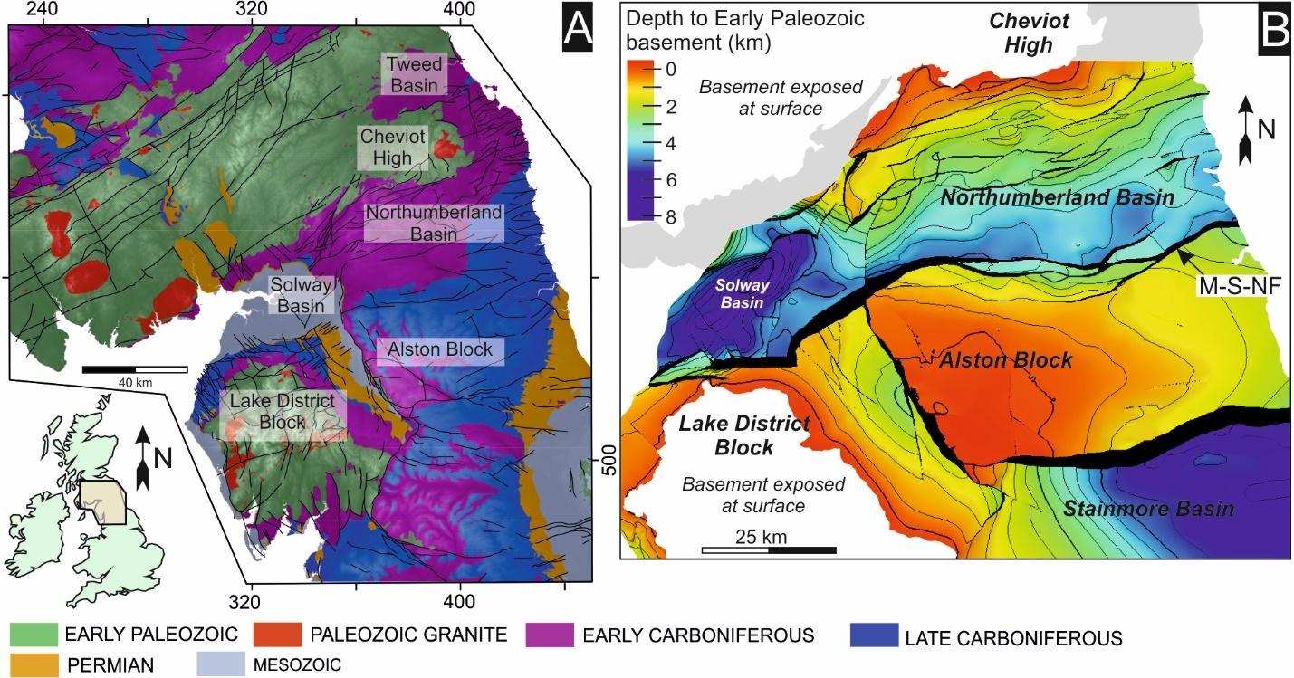

Figure 1a: The outcropping geology of the northern Pennine Basin and surrounding areas (map courtesy of the British Geological Survey). 1b: Depth to present-day top Caledonian basement (base latest Devonian-early Carboniferous basin fill). Based on the structural interpretations of Chadwick et al (1995). Structural model courtesy of Terrington and Thorpe (2013). M-S-NF = Maryport-Stublick-Ninety Fathom Fault System.

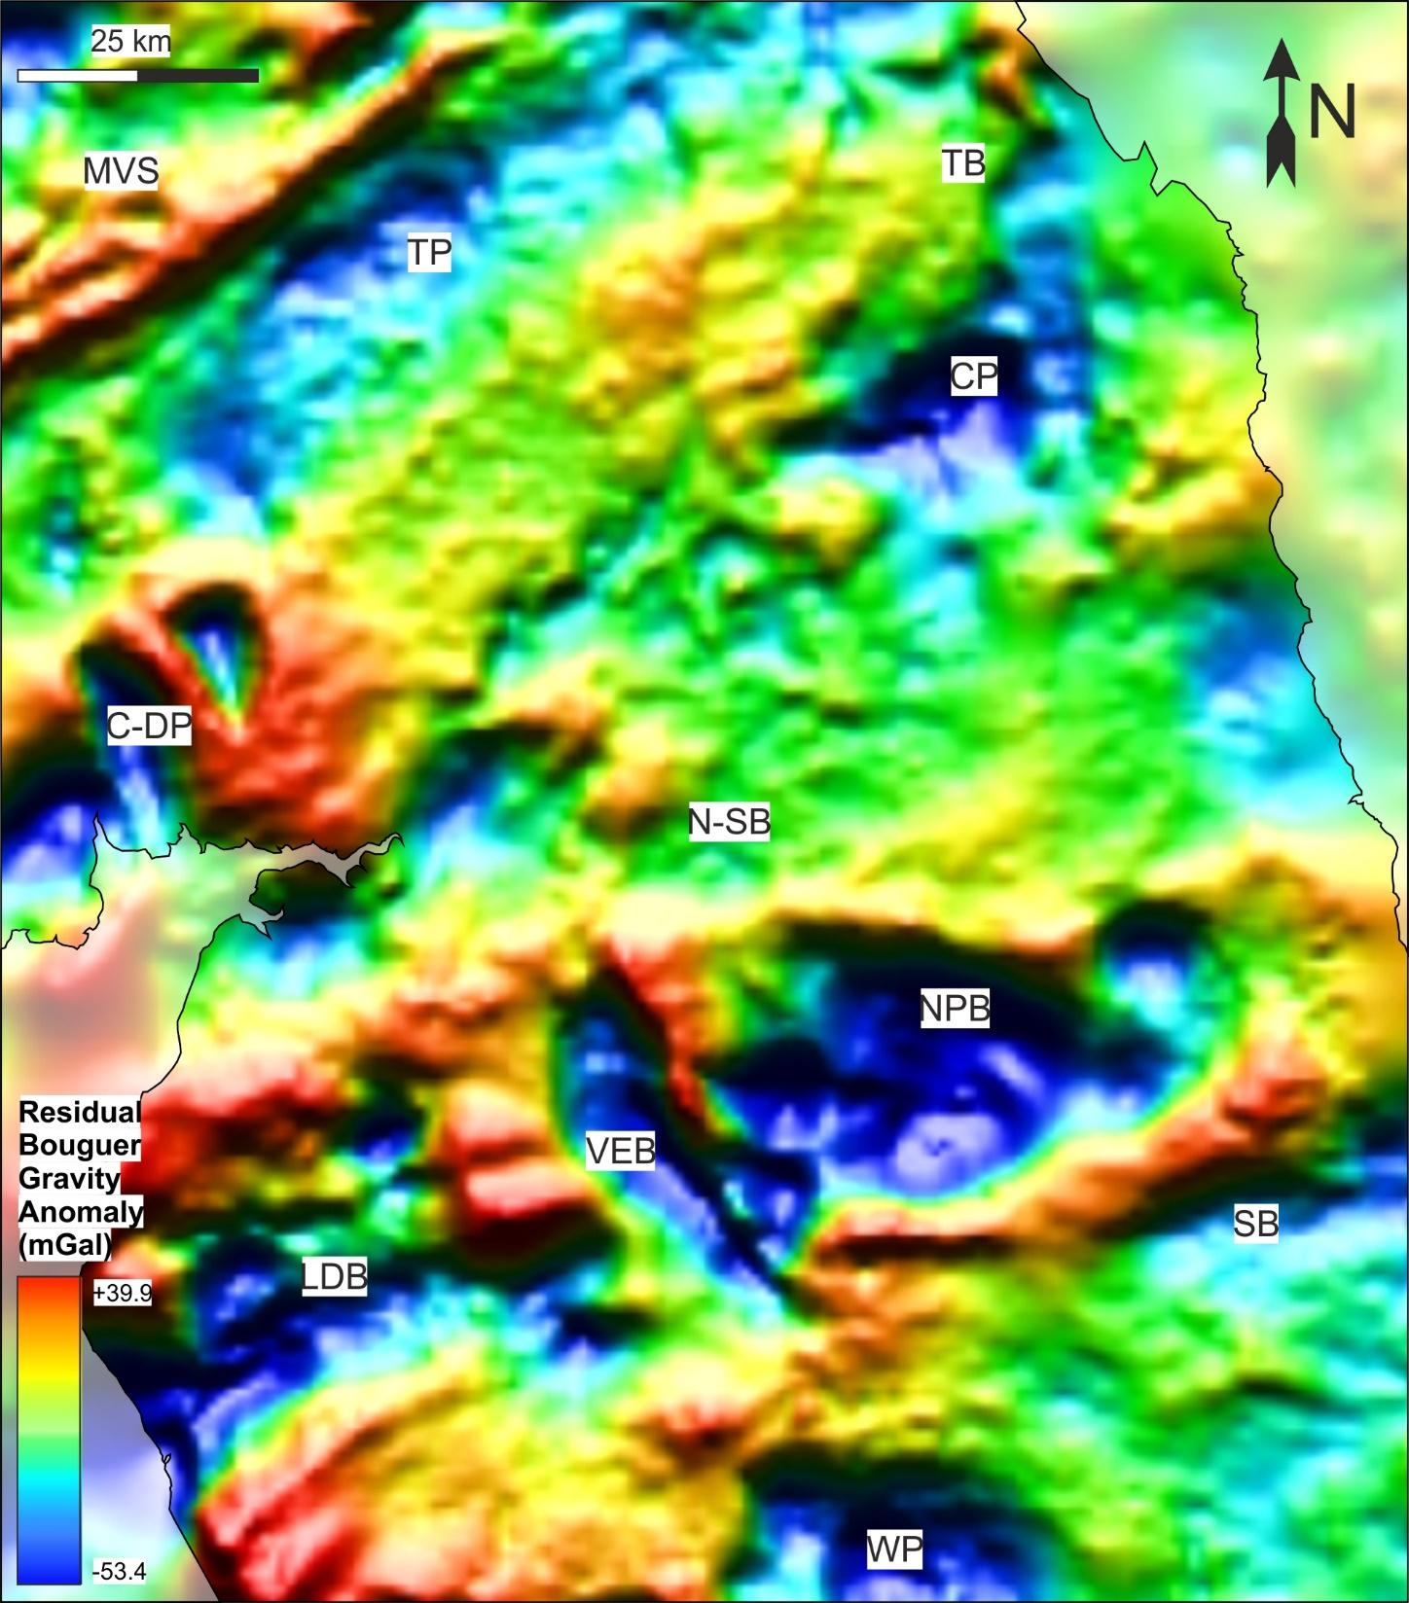

Figure 2: Residual Bouguer gravity anomaly map of the northern Pennine Basin with annotated granite-induced low-density basement anomalies (courtesy of the British Geological Survey; Kimbell and Williamson, 2015). TP = Tweedale Pluton; CP = Cheviot Pluton; C-DP = Criffel-Dalbeattie Pluton; NPB = North Pennine Batholith; LDB = Lake District Batholith; WP = Weardale Pluton. For information on how the subsurface extent of low-density granite bodies can be detracted from gravity data, see Kimbell et al. (2006; 2010). MVS = Midland Valley of Scotland; TB = Tweed Basin; N-SB = Northumberland-Solway Basin; VEB = Vale of Eden Basin; SB = Stainmore Basin.

Stratigraphy

So that this study adheres to previous UK literature, the traditional NW European Carboniferous chronostratigraphic subdivisions have been adopted. A correlation between these subdivisions and current international subdivisions can be found in Figure 3.
The Fell Sandstone Formation was deposited during the middle rifting phase of the northern Pennine Basin. The earliest rift deposits are characterised by the Inverclyde Group (Deegan, 1973; Leeder, 1974) within which the Kelso Lavas and Birrenswark Volcanics are considered synonymous with the initiation of rifting (Leeder, 1987; Kimbell et al., 1989; Chadwick et al., 1995). Above the Inverclyde Group, the Lyne Formation (Lower Border Group), and deposits thereafter, represent sedimentation in wetter conditions with increasingly variable bathymetry (Waters et al., 2007). The Fell Sandstone Formation (Middle Border Group) is typified by sand-rich fluvial deposits that crop out across northern Northumberland (Hodgson, 1978; Turner et al., 1987). These deposits span the Arundian-Holkeirian Substages (Fig. 3) (Waters et al., 2010). The Fell Sandstone Formation pinches out significantly towards the southwest where deposits are mixed clastic-carbonate deltaic and shallow marine (Day, 1970). These more mixed deposits belong partly to the Cambeck Member of the Lyne Formation as well as the locally overlying Fell Sandstone Formation (Fig. 3) (Day, 1970; Waters et al., 2011). In the northern Pennine Basin, successions belonging to this stratigraphic interval have been informally grouped as the Fell Sandstone succession (Day, 1970; Turner et al., 1993; Dean et al., 2011; Bell et al., 2017). This informal nomenclature is adopted here to describe successions of the Fell Sandstone Formation and Cambeck Member deposited by dominantly fluvio-deltaic or shallow marine processes in the Tweed Basin, around the margins of the Cheviot High, the Northumberland-Solway Basin and around the eastern margin of the Alston Block. The naming of the Fell Sandstone succession does not necessarily reflect the, often mixed, sedimentological composition of the succession across the area. To the north, submerged beneath the offshore UK northern North Sea, further Fell Sandstone Formation equivalent deposits have been correlated (Fell Sandstone Formation and Firth Coal Formation; Kearsey et al., 2019) with similar north-easterly-derived, dominant east Greenland and more minor Scottish Grampian Highland provenance (Morton et al., 2001). This major clastic sediment source is thought to have underpinned deposition of the Fell Sandstone Formation and laterally equivalent deposits as well as younger syn-rift and post-rift deposits, such as the Yoredale and Millstone Grit Groups, during the Visean-Namurian throughout the UK (Lancaster et al., 2017). Similar deposits have been encountered in the UK central North Sea (Kearsey et al., 2019), to the east of our study area, whereas to the south and west, coeval deposits are typically starved of clastic sediment (Andrews, 2013; Wakefield et al., 2016; Pharoah et al., 2019).

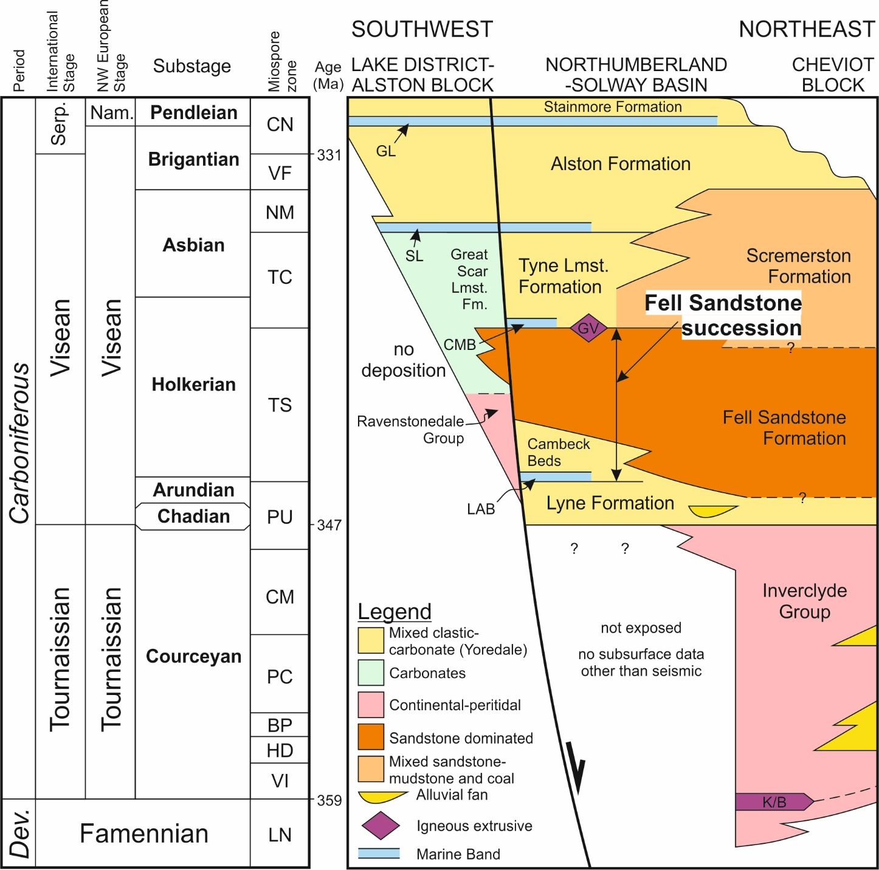

Figure 3: Latest Devonian-early Carboniferous stratigraphy of the northern Pennine Basin. The miospore zonation of Waters et al (2010) is used. The former Carboniferous stratigraphic subdivisions of NW Europe are adopted and a comparison is made with current international stratigraphic nomenclature based on Davydov et al (2004; 2011). Note that the Tournaissian, Visean and Serpukhovian Stages constitute the Mississippian Series under the current International stratigraphic subdivisions and the Tournaissian, Visean and Namurian Stages constituted the Dinantian Series under the former Carboniferous stratigraphic subdivisions of NW Europe. The annotated facies associations are partly based on Waters et al’s (2007) principle facies for the onshore Carboniferous succession of the UK. GL = Great Limestone; SL = Sixth Limestone; CMB = Clattering Marine Band (Knightsbridge Limestone); LAB = Lower Antiquatonia Beds; K/B = Kelso Lavas and Birrenswark Volcanics; GV = Glencartholm Volcanics.

DATASET AND METHODOLOGY

This study combines borehole data derived from industrial reports and literature (Frost and Holliday, 1980; Turner et al., 1993) with outcrop data derived from the field and literature (Day, 1970; Bell, 1978; Jones, 1978; Monro, 1986) as well as results from structural and geodynamic modelling. Where available, composite logs, wireline petrophysical logs (gamma, callipers, sonic and neutron) and biostratigraphical reports were examined. The quality and completeness of borehole data vary widely. These datasets are accompanied by 3D structural data for the Northumberland-Solway Basin (Terrington and Thorpe, 2013) based on Chadwick and others’ (1995) interpretation of regional seismic data and a regional residual Bouguer gravitational anomaly survey courtesy of the British Geological Survey (Kimbell and Williamson, 2015). All data used are either freely available or within the public domain.
Data derived from literature and the subsurface are supplemented with field data. Traditional sedimentary log and palaeocurrent data were collected from five relatively well-exposed localities (Fig. 4) along a down depositional dip profile of the Fell Sandstone succession (Fig. 5). Based on field observations, the Fell Sandstone succession has been divided into distinct facies associations according to their interpreted shared depositional water depth (Fig. 6). The idealised gamma ray responses of the three facies associations have been predicted (cf. Davies and Elliott, 1996) (Fig. 6) so that wireline data can be incorporated within the study. The occurrence, characteristics and spatial variability of these facies associations across the northern Pennine Basin are described (Fig. 4). Multiple borehole and outcrop-derived successions are correlated regionally across the northern Pennine Basin (Fig. 7), in order to determine the key influences on facies distribution. The biostratigraphic zonation scheme (ammonoids and palynology) for the onshore Carboniferous succession (Waters et al., 2011) is adopted (Fig. 3). The main controls on deposition of the Fell Sandstone succession are considered.

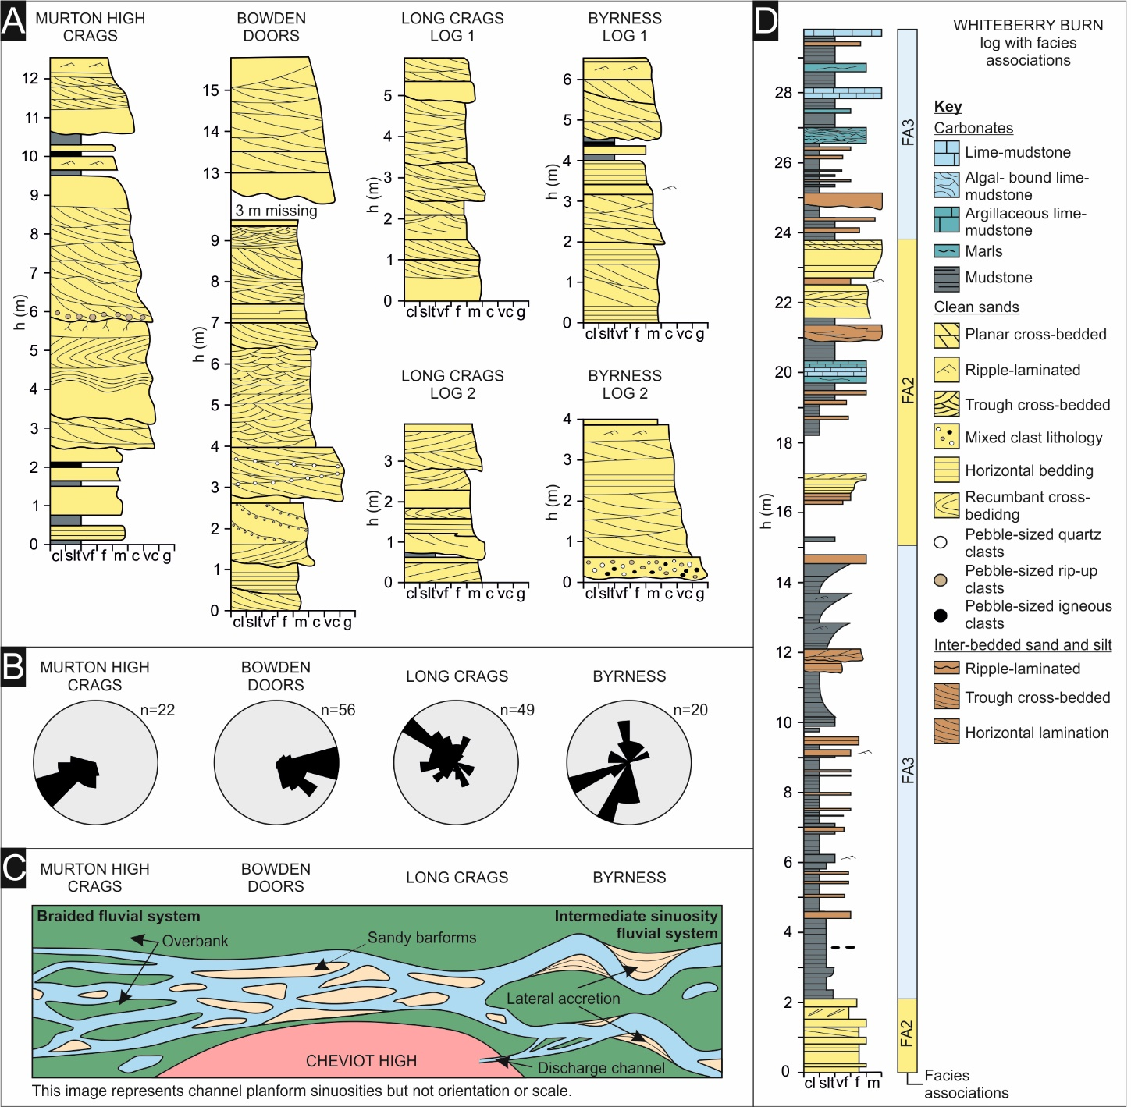

Figure 4a: Fluvial sedimentary logs collected from field locations. There is no spatial scale between the logs and no attempt at correlation on this scale is possible or has been attempted. The key for the logs is provided in figure 4d. 4b: Rose diagrams showing the palaeocurrent direction and dispersion for each outcrop, recorded from foresets. 4c: A plan view reconstruction of sinuosity for each field location. Scale is relative with regards to channel thickness and does not account for orientation and temporal variation. 4d: Whiteberry Burn sedimentary log with distal facies associations interpreted. See Fig. 5 for outcrop locations.

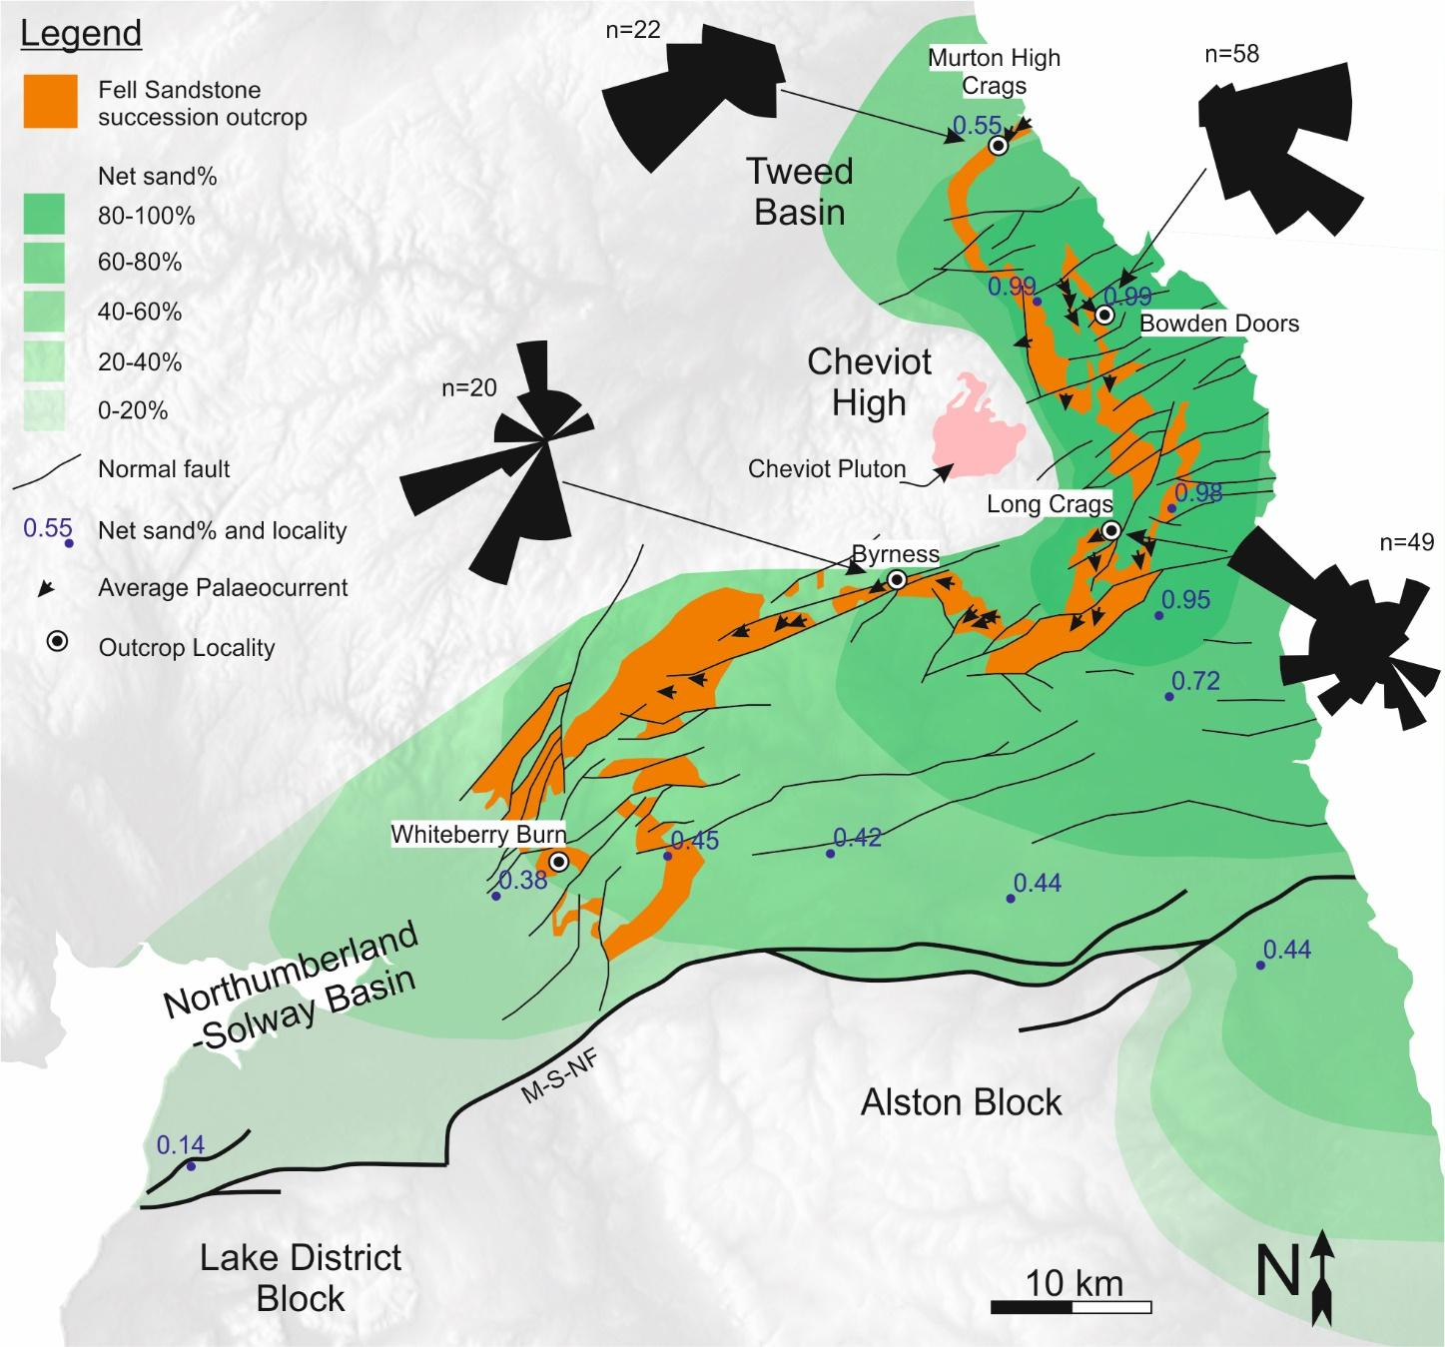

Figure 5: A map of the onshore northern Pennine Basin depicting the net to gross distribution of the Fell Sandstone succession, average palaeocurrent direction, palaeocurrent dispersal and normal fault distribution. Average palaeocurrent directions are derived from field measurements and various prior studies of the Fell Sandstone Formation (Monro, 1986; Turner et al., 1993). Net to gross data is derived from borehole successions (table 1) and literature (Turner et al., 1987; Jones, 1973). M-S-NF = Maryport-Stublick-Ninety Fathom Fault System.
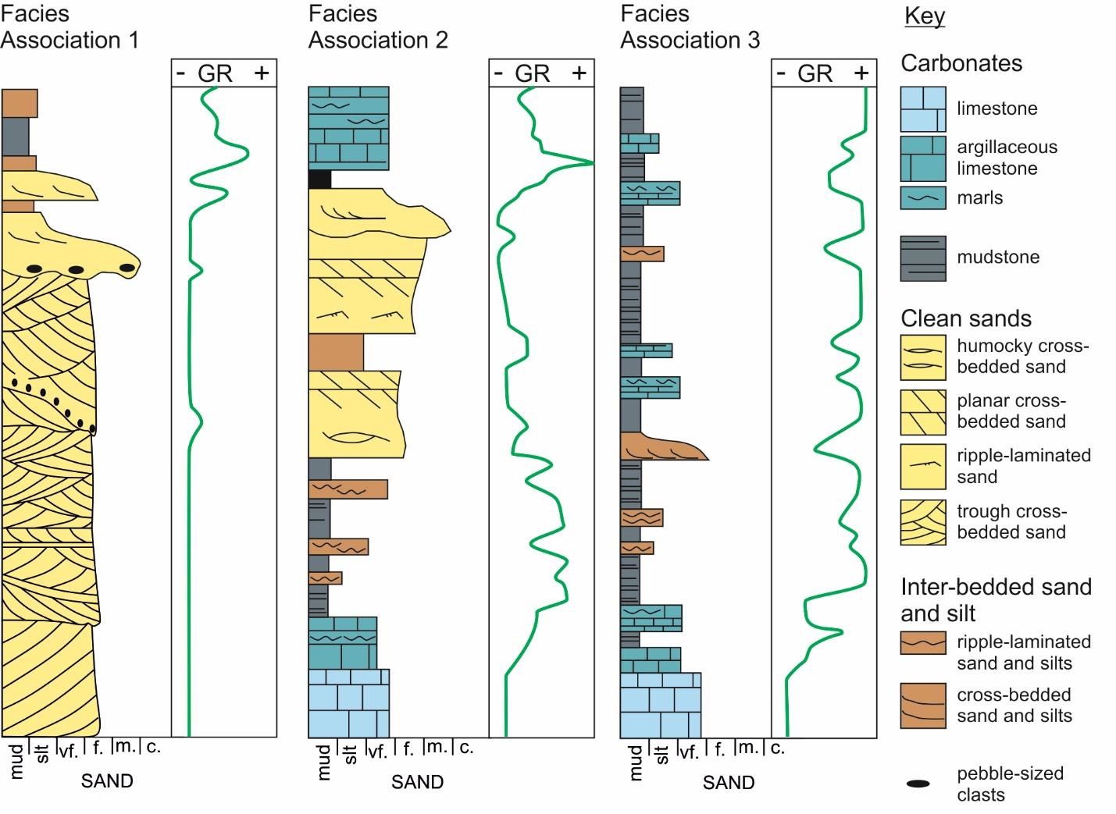
Figure 6: A schematic illustration of the three major facies associations of the Fell Sandstone succession of the northern Pennine Basin with gamma ray response. Facies association 1 = fluviatile facies. Facies association 2 = fluviodeltaic shoreface facies. Facies association 3 = shallow marine carbonate and offshore marine facies.

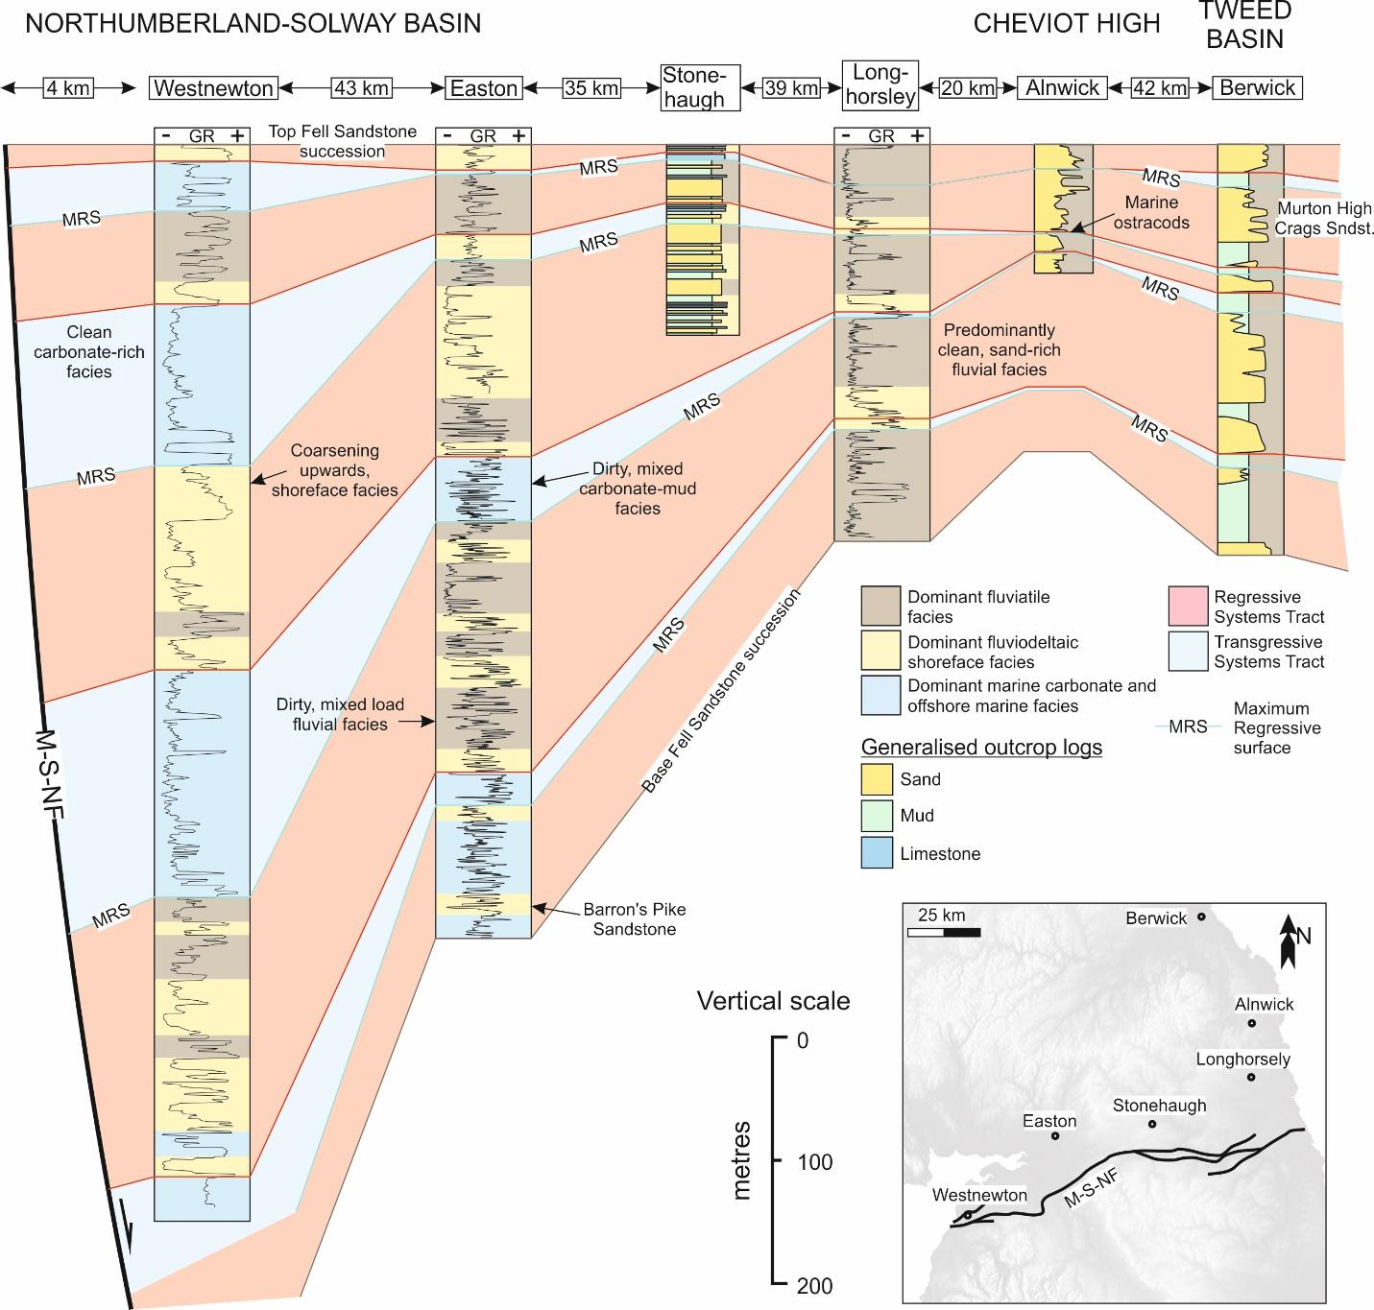

Figure 7: Regional correlation of the Fell Sandstone succession across the northern Pennine Basin. Newcastle Science Central (NCS) wireline (gamma ray) data from Younger et al (2016). Other wireline data courtesy of the UK Oil and Gas Authority. Generalised vertical logs from the Stonehaugh borehole, the Alnwick borehole and Berwick from Turner et al (1993), Turner et al (1997) and Turner et al (1993) respectively. M-S-NF = Maryport-Stublick-Ninety Fathom Fault System.

FACIES ASSOCIATIONS

Fluviatile Facies Association (FA1)

Description
This association consists partly of thin (<3 m) laterally restricted (<50 m) fining-upwards, well-sorted, sub-rounded litharentitic and quartz arenitic, erosive sandstones with a concave-upwards to tabular base (Fig. 6) (Fig. 8a). Rare basal pebble horizons are inclined (Monro, 1986) and overlain by set and coset forming trough-cross-bedded and planar-cross-bedded facies (Fig. 8c), structureless sandstones also occur (Fig. 8b) (Robson 1956; Turner et al., 1987). These coarser successions are overlain sporadically by ripple-laminated silts and fine-grained sands (Fig. 8e). Mudstone to siltstone planar-laminated facies commonly overly these sandstones. Grain sizes range from coarse-very fine-grained sands with subordinate siltstone and mudstone beds (Fig. 8d) (<1 m thick). Mudstones units are generally devoid of marine fossils but commonly contain seatearths and rare coal (Frost and Holliday, 1980). Vertically thin (<30 cm) marine ostracod-bearing mudstones have been observed in core (Turner et al., 1997) and thin (<1 m), often laterally extensive, argillaceous limestones occasionally interbed. In wireline logs, the gamma ray response varies from blocky, low gamma signatures to more distinctive, between 15 and 30-metre thick, dirtying-upwards curves (Fig. 6).

Interpretation
Associations with a characteristic concave-up erosive basal bounding surface and a fining upward fill are interpreted as the deposits of channels within fluvial systems (Miall, 1977). Conglomeratic basal units represent channel lag deposits formed from bedload transport within high-energy flows (Bridge 1993; Fielding et al. 2018; Ellen et al. 2019). Set and coset forming crossbedded facies indicate barform development (Miall 1985; Ashworth 2000). Ripple- and planar-horizontal-laminated very fine-grained sandstone to siltstone bartop facies constitutes further evidence for barform development (Hajek and Heller 2012). Thick massive sandstones are interpreted to have been produced from marginal sandbank collapse (Turner et al., 1987). The lack of marine fossils, pervasive pedogenesis and coal development suggest that the mudstones are terrestrial in origin; forming in a humid to semi-humid environment (Kraus, 1999; Spears 2012). Seatearth and coal provide evidence of cohesive, vegetated overbank material with a high water table. Such overbank material may be attributed to the low W/T ratio (roughly 16:1) of channel elements (Gibling 2006; Davies and Gibling 2013). The presence of marine ostracod-bearing mudstones and argillaceous limestones indicate short-lived marine incursions (Uba et al 2009). The blocky and upwards increasing gamma ray profiles are indicative of sand-dominant, amalgamated fluvial channels and mixed sediment-load, isolated fluvial channel deposits with inter-bedded overbank respectively (cf. Aigner et al., 1995; Evans et al., 2007).

Fluviodeltaic Shoreface Facies Association (FA2)

Description
The shallow marine shoreface facies association consists of coarsening upwards successions of mudstones to sandstones (Fig. 6) (cf. Leeder, 1974; Frost and Holliday, 1980). Mudstones are vertically thin, generally weakly bioturbated and contain shell and crinoid fragments as well as marine ostracods (Frost and Holliday, 1980). Sandstone units (<5 m in vertical thickness), further up succession, are variably bioturbated, fine-medium grained with planar and trough cross-bedding forming in large sets (Fig. 8h) (Monro, 1986). Seatearths are commonly found capping the association. The vertically thinnest examples of these coarsening upwards successions are only several metres thick and barely distinguishable in wireline gamma ray logs. Vertically thicker examples (< 20 metres) however, are often marked by a thick, laterally extensive basal limestone unit and have an easily recognised cleaning upwards gamma ray profile bounded at the top by a strong gamma peak (Fig. 6). Frost and Holliday (1980) report that these facies associations share similarities with the Yoredale cyclothems that make up the overlying Alston and Stainmore Formations (Maynard, 1992; Waters et al., 2007).

Interpretation
Thick basal limestone units are suggestive of a temporarily low clastic supply accommodating the production of carbonate in shallow water (Mount, 1984). The descriptions of coarsening-upwards mudstone-sandstone successions are suggestive of deltaic deposition in a marginal marine environment (Mount, 1984). The presence and type of bioturbation and marine fossiliferous assemblages suggest deposition in shallow-very shallow marine conditions (Turner et al., 1997). Mudstones are likely to have been deposited through suspension settling away from the sediment source (Stow and Shanmugam, 1980), whilst inter-bedded parallel-ripple laminated sandstones are likely to have been transported from up-dip deltaic systems (Blair and McPherson, 2008). Large sets of cross beds within fine to medium-grained sandstone indicate the deposition of channel fill material, as dune-scale bedform trains fill distributary channels (Bristow, 1993). Thin seatearth caps are suggestive of prolonged periods of non-deposition and subarieal exposure, perhaps due to the up-dip avulsion of alluvial feeder systems (Nemec and Postma, 1993). The progressive coarsening upwards throughout the facies association indicates progradation and outgrowth of the deltaic complex (Smith and Holliday, 1991). There is limited evidence to suggest significant tidal influence during deposition of the Fell Sandstone Formation (Smith and Holliday, 1991; Chadwick et al., 1993).

Shallow Marine Carbonate and Mudstone Facies Association (FA3)

Description
The shallow marine carbonate and mudstone facies association is dominated by rhythmic alternations of mudstone and limestone with inter-bedded sandstone and siltstone (Fig. 6) (cf. Leeder, 1974; Day, 1970). Thick mudstone units show signs of burrowing and bioturbation (Teichichus and Phycodes; Day, 1970; Frost and Holliday, 1980). They are often inter-bedded with vertically thin (<30 cm), parallel-ripple-laminated siltstone and fine-very fine grained sandstones (Fig. 8f) (Leeder, 1974). Limestones and dolostones are often poorly developed and nodular (Fig. 8g). However, occasional well-developed, metre-thick, limestone units or nodular algal horizons often contain characteristic fossiliferous assemblages, are laterally extensive and can be correlated across the entirety of the northern Pennine Basin accordingly (e.g. Lower Antiquatonia Marine Bed; Antiquatonia teres; Hudson and Philcox, 1964). These successions are inter-bedded with vertically thin, coarsening upwards mudstone-sandstone successions that are occasionally capped by seatearth and may bear resemblances with the shallow marine-deltaic succession (Frost and Holliday, 1980). The wireline gamma ray response is generally clean but interrupted by high gamma peaks (Fig. 6).

Interpretation
Dominant mudstone and limestone facies associations are interpreted as having been deposited in low clastic supply, low-energy, shallow (based upon the presence of ichnogenus Phycodes; Seilacher, 2007; MacNaughton, 2007) marine conditions (cf. Newport et al., 2017). Bioturbated mudstones and ripple-laminated sands are interpreted to have been deposited from suspension settling and distal turbidity currents (Stow and Shanmugan, 1980). Clastic supply, however, most likely fluctuated; preventing extended periods of carbonate build-up (Mount, 1984). Poorly developed dolostone may be indicative of pulsated freshwater influxes (Sun, 1995; Gregg et al., 2001) resulting from variable base-level and upstream avulsion mechanisms. The presence of seatearth signifies that occasionally, in these settings, clastic supply was sufficient to outpace sea level rise and prompt short-lived subaerial exposure (Smith and Holliday, 1991). These thin coarsening upwards, clastic-rich sequences are interpreted to represent the distal toe-sets of up-dip deltaic systems (Blair and McPherson, 2008). The largely clean gamma ray response is indicative of a highly calcareous mudstone. High gamma peaks may reflect short-lived transgressions (Davies and Elliot, 1996).

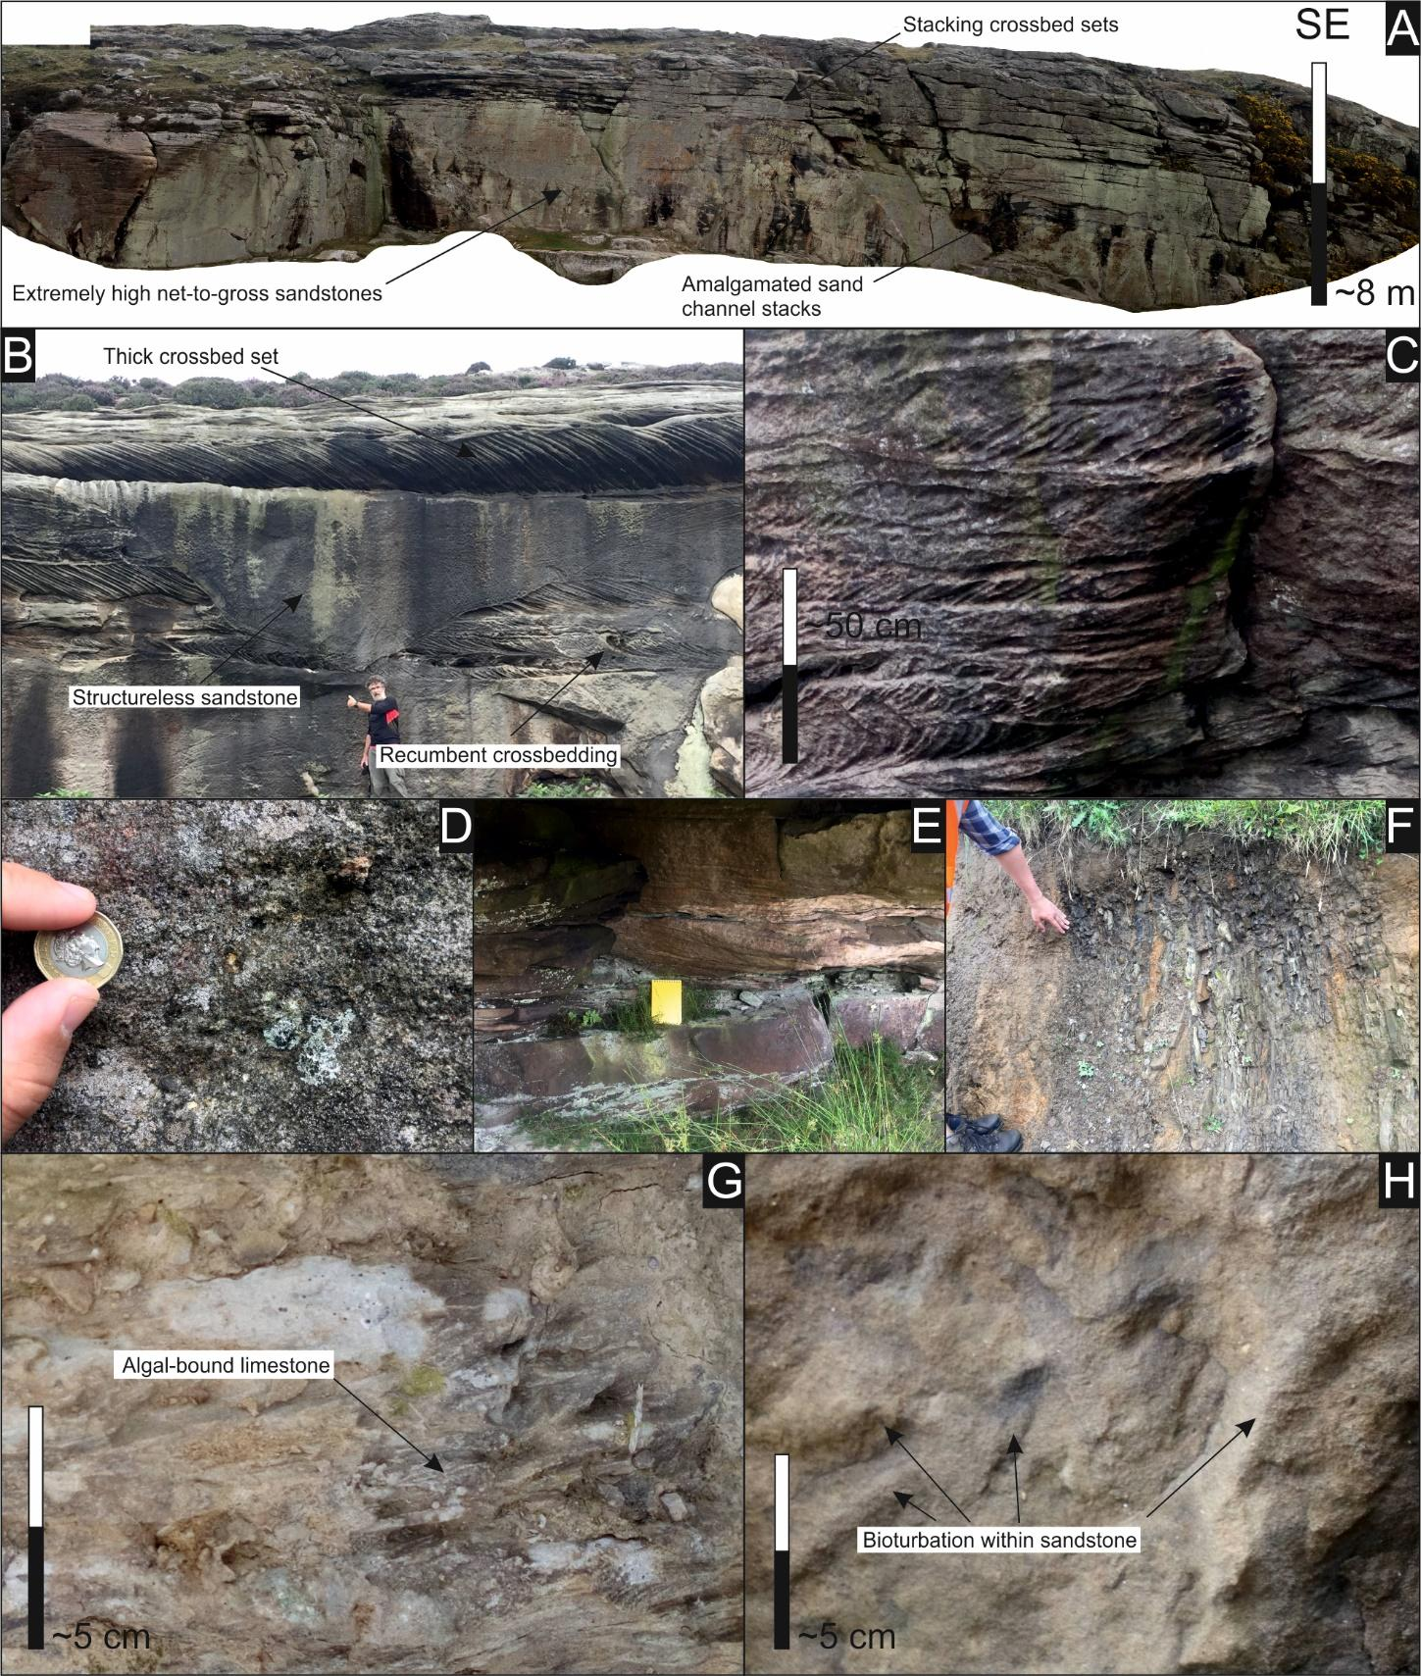

Figure 8: Photoplate showing the facies of the Fell Sandstone and contemporaneous distal sediments from the northern Pennine Basin (see Figure 5 for location of outcrops). 8a: Orthorecitified image of the upper Bowden Doors section (see Fig. 5 for localities) showing an extremely high sand content, amalgamated channel sets and stacked crossbed sets that form during early stage bar growth. 8b: Thick tabular cross-bedded set overlying a massive structureless concave-up sandstone from Bowden Doors, deposited by bank collapse (Turner et al. 1987). 8c: Trough-cross-bed sets showing some soft sediment deformation and recumbence at Long Crag section, near Rothbury. 8d: Very coarse, poorly sorted sandstone with andesitic and lithic clasts suggesting additional minor local provenance for the Fell Sandstone at Byrness. 8e: Mixed fine sand-silt overbank deposits at Long Crag with coarse-grained trough cross-bedded sandstone sets overlying. 8f: Distal mudstone and siltstone facies from Whiteberry Burn, note bedding is near vertical. 8g: Algal-bound limestone from the Whiteberry Burn section. 8h: Bioturbated shallow marine sandstone bedding plane from Whiteberry Burn.

ONSHORE STRATIGRAPHY OF THE NORTHERN PENNINE BASIN

The characteristics and spatial variability of the onshore Fell Sandstone succession are documented in this section using outcrop-derived observations (Fig. 8, 4) and borehole data (Fig. 7; table 1). The controls on facies distribution will be determined based on these observations. The northern Northumberland Basin, Tweed Basin and Cheviot High constitute more proximal settings of the fluviodeltaic system that deposited the Fell Sandstone succession. The central Northumberland Basin and western Northumberland Basin, Solway Basin and Lake District and Alston Blocks represent increasingly distal settings (Fig. 1a, 5).

Northern Northumberland Basin, Tweed Basin and Cheviot High

The northern Northumberland and Tweed Basins are bound by the Cheviot High to the north-west and south-west respectively. The Fell Sandstone is locally exposed along a north-south transect between the two basins (Fig. 1a). The Northumberland and Tweed Basins are considered to have been part of the same depositional system from the Asbian onwards but are believed, and our palaeocurrent results suggest (Fig. 5), to have remained geographically distinct during deposition of the Fell Sandstone succession (Johnson, 1984). Locally the maximum thickness of the Fell Sandstone succession is approximately 200 m, increasing towards the east (Chadwick et al., 1995). A number of disparate, poorly exposed outcrops are complemented by shallow borehole data (Fordham, 1989).
Outcrop exposures are dominated by laterally extensive (<50 m) highly amalgamated fluviatile (FA1) sandsheet deposits (Fig. 8a). Along the eastern flank of the Cheviot High in particular (Bowden Doors; Fig. 5, 8a), fine-grained overbank material is rarely preserved. At Bowden Doors, the Fell Sandstone largely consists of subarkosic-litharenitic pale grey, fluvial channel sandstone. Channels grade from coarse-fine-grained sand. The fill typically consists of variably deformed trough-cross-beds (Fig. 8b). Moving upwards in succession, cross-bedding appears to form more complex sets; indicating barform development. Channel sands are largely tabular, weakly erosive and characterised by high frequency erosional bounding surfaces indicating frequent reworking of sediment (Fig. 4a), perhaps due to high sediment supply or low accommodation space creation. Together, with the Longframlington and Alnwick borehole successions (see table 1 or Fig. 7 for borehole locations), the Bowden Doors succession is the most sandstone-rich Fell Sandstone succession of the northern Pennine Basin, where net sand constitutes 90 to 100% of the succession (Fig. 5). North of Bowden Doors, in the area immediately surrounding Berwick-upon-Tweed (Murton High Crags; Fig. 5), cross-bedded sand channel facies are inter-bedded with thin reddened overbank facies and bounded at the top by parallel-laminated sand and silt channel facies, suggesting sporadic waning flow (Fig. 4a). At their base, channel facies show pebble lags and rip-up clasts. Bell (1978) suggests a local sand content for the entire succession of between 60 and 80%. Jones (1973, as cited in Turner et al., 1993) suggests an even lower sand content of between 50 and 60% (Fig. 5).
In the Tweed Basin, around Berwick, the dominant palaeocurrent direction is SW (Fig. 5, 4b). This is in broad agreement with most accounts of regional early Carboniferous clastic successions in northern England and the immediate offshore area (Morton et al., 2001; Kearsey et al., 2019). Further south along the eastern flank of the Cheviot High, however, the dominant palaeocurrent direction is generally SSE (Fig. 5, 4). Here, there is a markedly low variation in this dominant palaeocurrent direction, which is reflected further in the dominant downstream lateral accreting barforms. Observed palaeocurrent direction is roughly parallel with the eastern margin of the westwards Cheviot Pluton. The absence of palaeocurrent trends perpendicular to the Cheviot High and the largely uniform petrographical characteristics of the Fell Sandstone along the Cheviot High’s eastern flank (Bell, 1978) suggest that the high was not contributing significantly to local clastic supply at the time. The abundance of trough cross-bedding, minor overbank preservation, coarse grain size and unidirectional nature of their palaeocurrent suggests that Murton High Crags and Bowden Doors were deposited under dominantly sandy braidplain conditions (Fig. 4c) (Miall, 1985; Le Roux 1992).

Central Northumberland Basin

South-west of the Cheviot High, the Northumberland-Solway Basin opens up into a WSW-orientated half-graben that extends beyond the width of present day Cumbria and Northumberland (Fig. 2b). The basin floor dips southwards towards the Maryport-Stublick-Ninety Fathom fault system, which bounds the granite-cored Lake District and Alston Blocks to the south. Locally the Fell Sandstone reaches a maximum thickness of approximately 400 m, increasing towards the south (Chadwick et al., 1995). South-west of the Cheviot High, within a 25 km radius of the high, the Northumberland Basin is characterised by a series of WSW-orientated tilted fault block mini-basins (Fig. 2b) that are believed to have been active during the deposition of the Fell Sandstone (Leeder, 1987; Kimbell et al., 1989).
Fluvial channel sand facies (FA1) still dominate in the central Northumberland Basin. The outcropping fluvial deposits of Long Crag, near Rothbury (Fig. 5), are channel-dominated sandstones with minor siltstone (Fig. 4a). The channels consists of planar- and trough-cross-bedded, medium to fine-grained sandstones. However, numerous deep boreholes intersecting the Fell Sandstone in the area reveal an increasing degree of preserved heterogeneity towards the south-west (Fig. 5) (Smith and Holliday, 1991; Turner et al., 1997) and the increasingly sparse and flaggy exposure of the Fell Sandstone suggests greater presence of finer-grained material. At Byrness (Fig. 5), outcrop reveals isolated to amalgamated fine to medium-grained planar-cross-bedded sandstones overlain with ripple laminations sandstones (Fig. 4a). Channel deposits are overlain by overbank fines. In addition, several sandstone channels within the succession are poorly sorted and incorporate a basal channel lag of angular, up to pebble-sized, locally derived, andesitic and other lithic clasts (Fig. 8d). These successions comprise trough-cross-beds and fine upwards into medium sandstone and have an additional dominant southerly palaeocurrent (Fig. 4b). These are interpreted as alluvial outwash channels (cf. Rust, 1977). These sandstone channels comprise only a minor amount of the local Fell Sandstone succession and are situated most proximal to the Cheviot High, from which the andesitic clasts were most likely derived (Stone et al., 2012). This secondary clastic source is likely comparatively minor. The gamma ray response to intermittent, <30 metre-thick, coarsening upwards fluviatile shoreface successions (FA2) is recognised in the Longhorsley borehole succession (Fig. 7) and the abundance of marine ostracods within intervals of the Fell Sandstone succession towards the south and west within the central Northumberland Basin (Smith and Holliday, 1991) suggests an alternation between fluvial and marine deltaic depositional environments.
The downstream profile of the Fell Sandstone shows a broad increase in the dispersion of palaeocurrent data, inherent with more complex bar growth and sinuous migration of fluvial channels in a less confined setting (Fig. 5, 4c). The dominant palaeocurrent rotates some 100° from the dominant palaeocurrent direction of the northern Northumberland Basin towards WSW; parallel with the dominant fault trend of the Northumberland Basin. This dominant palaeocurrent trend diverges towards the south only around sites of fault linkage (Turner et al., 1993), producing an overall dog-leg pattern.

Western Northumberland Basin, Solway Basin and Lake District and Alston Block

The Fell Sandstone Formation pinches out towards the south-west 50-60 km from Long Crags (Fig. 5). Contemporaneous lateral equivalents of the Fell Sandstone Formation, such as the Holkerian-aged Cambeck Member of the Lyne Formation (Middle Border Group) (Day, 1970; Leeder, 1974) and the Holkerian-Asbian-aged Tyne Limestone Formation (Upper Border Group) (Frost and Holliday, 1980), reach a maximum thickness of approximately 1 km in the Northumberland-Solway Basin (Chadwick et al., 1995). The Alston and Lake District Blocks, further south, were largely areas of non-deposition during this time. Outcrop exposure in the Northumberland-Solway Basin is sparse. Several hydrocarbon exploration wells drilled during the late 1980s and early 1990s complement this limited dataset. Arundian-Holkerian aged units in these areas more strongly reflect marine depositional processes and a lower coarse clastic supply.
At Whiteberry Burn (Fig. 5), in the western Northumberland Basin, the steeply dipping exposed Fell Sandstone succession (Cambeck Member and Fell Sandstone Formation) is dominated by shallow marine carbonate and mudstone facies (FA3) (Fig. 8f) and coarsening upwards fluvio-deltaic shoreface facies (FA2) (Fig. 8h, 4d) (cf. Day, 1970). The succession shows cyclic changes from shallow marine sandstone, offshore mud and siltstone and tropical carbonate facies. The overall trend throughout the section is a progradational one, in which the clastic offshore facies transitions into tropical carbonate facies. The fossil assemblages (mostly soft body), coupled with mudstone and carbonate deposition indicate a relatively limited clastic supply. Smaller scale coarsening-upwards trends can be seen inter-bedded within the more shallow marine carbonate and mudstone facies dominated succession, indicating possible parasequence development within the longer wavelength progradational cycle or, alternatively, upstream feeder channel avulsion. The Kershopefoot Basalt interrupts the succession at approximately 50 m below the Asbian-aged Clattering marine band, which marks the upper boundary of the Fell Sandstone Formation (Fig. 3; Armstrong and Purnell, 1987). Contemporaneous deposits of the Solway Basin are largely obscured by Permian-Mesozoic cover. The Westnewton borehole, southwestern onshore Solway Basin (table 1), offers the most complete perspective of the Fell Sandstone succession here. Shallow marine carbonate and offshore marine facies dominate (FA3) the incomplete, 260-metre thick Holkerian succession. Sand is largely absent, only thin, <8-metre, fine-very fine-grained shoreface sands (FA2) persist. In the Fell Sandstone succession of the Westnewton borehole, variably thick, <10-metre, largely coarsening upwards fine-very fine-grained, shoreface sandstone successions (FA2) are observed inter-bedded sporadically with shallow marine carbonate and mudstone facies (FA3). These are interpreted as being basinal equivalents of the up-dip fluviodeltaic shoreface succession (FA2).
Arundian-Holkerian-aged deposits are largely absent from the western Alston Block. Conglomeratic ‘basal beds’ unconformably overlay the early Palaeozoic basement and conformably underlay the mixed clastic-carbonate Asbian succession (Ridd et al., 1970; Johnson et al., 2011). Towards the east, still upon the Alston Block, the Fell Sandstone is surprisingly thick and sand-rich. The Newcastle Science Central borehole intersects a complete, roughly 380-metre thick mixed sandstone-siltstone succession in an area where it had been previously suspected that deposition of the Fell Sandstone had not occurred. The gamma ray response log for this borehole indicates several, mostly clean sand-rich, coarsening upwards fluviodeltaic shoreface successions (FA2) towards the top of the Fell Sandstone succession (Younger et al., 2016). Considering the dominantly westwards palaeocurrent of the onshore Fell system, the presence of a sand-rich succession on the eastern margin of the Alston Block suggests an additional eastern clastic sediment source or that the Fell system was much broader upstream than just its onshore extent.

REGIONAL CORRELATION OF THE FELL SANDSTONE FLUVIO-DELTAIC SUCCESSION

In this section, we correlate Fell Sandstone successions from borehole and outcrop-derived data across the northern Pennine Basin in order to better appreciate potential controls on facies distribution (Fig. 7). Biostratigraphic constraints are poor throughout the Arundian-Holkerian Fell Sandstone succession in the northern Pennine Basin and only bookend the succession (Waters et al., 2010). The conformable base of the Lower Antiquatonia Marine Bands of the Cambeck Member (Lyne Formation) in the western Northumberland and Solway Basin is believed to represent the temporal equivalent of the uncomfortable base Fell Sandstone Formation in the central-northern Northumberland Basin (Smith, 1967); although some degree of diachronity is anticipated. The upper boundary of the Fell Sandstone towards the south-west is marked by the conformable base of the laterally extensive Clattering Marine Band, elsewhere referred to as the Knightsbridge Limestone, or the roughly contemporaneous Glencartholme Volcanic Member (Tyne Limestone Formation) (Fig. 3) (Day, 1970). The upper boundary of the Fell Sandstone succession in the northern Northumberland Basin and the Tweed Basin beneath the Scremerston Formation is less clear. Offshore, it is described by Smith and Holliday (1991) as the abrupt transition from thick sandstones to argillaceous coals and by Cameron (1993) as being marked by a sharp down-hole decrease in gamma ray response. Despite limitations, transgressive and regressive cycles have been traced across the basin (cf. Embry and Johannessen, 1993; 2017) using maximum regressive surfaces and maximum flooding surfaces. For simplicity’s sake, the maximum regressive surface is considered a subaerial unconformity or a laterally equivalent unconformable shoreline ravinement surface (Catuneanu et al., 2011; Catuneanu 2019).
The abundance of shallow marine carbonate and offshore marine facies associations increases towards the south-west and the Maryport-Stublick-Ninety Fathom fault system, where characteristic coarsening upwards shoreface successions and occasional fluvial successions sporadically interrupt dominantly marine carbonate and offshore mudstone sequences (Fig. 7). Proximal fluvial facies are more common towards the northeast and beyond the Cheviot High. At least four maximum regressive surfaces, indicating the onset of base level rise, are interpreted based on the vertical distribution of facies associations within and between the four most basinal successions of the fluvio-deltaic system. These surfaces are overlain by deeper water successions of variable thickness and subsequently followed in succession by the progressive upwards shallowing of facies associations, representing progradation of the fluvio-deltaic system. The succession at Longhorsley, where two stratigraphically thin (<30 metres) shoreface sequences interrupt a dominantly coarse fluviatile succession, appears to mark the northeastern limit beyond which these maximum regressive surfaces are barely recognisable. The thicknesses of transgressive system tracts, in proportion to the entire Fell Sandstone succession, generally decreases towards the northeast away from the deep, more rapidly subsiding, basin. Towards the top of the Fell Sandstone succession, more minor maximum regressive surfaces occur with high frequency. Turner et al (1997) observe a cyclic parasequence-style architecture within the more mixed clastic-carbonate Scremerston Formation. This may be attributed to higher amplitude late Visean eustatic sea level fluctuations (Maynard, 1992) or late Visean accelerated widespread tectonic-induced subsidence (e.g. Kimbell et al., 1989) subduing the smaller scale cycles observed in the distal portion of the Fell Sandstone succession.

DISCUSSION
Controls on facies distribution

The study of clastic systems has long focussed on better understanding the controls on facies and potential reservoir distribution. We summarise the main controls on facies distribution within the Fell Sandstone Formation and time-equivalent successions of the northern Pennine Basin and discuss their importance (also see Fig. 9). These include: 1) intra-basinal normal-faulted mini-basins; 2) proximity to clastic sediment source; 3) eustatic sea level changes; 4) regional subsidence variations and; 5) basin palaeotopography. The rate of clastic sediment supply constitutes a sixth, highly important control. However, there is limited evidence to suggest that this varied significantly throughout deposition of the Fell Sandstone succession.

Intra-basinal normal-faulted mini-basins
Based on alleged high frequency lateral facies variations, Turner et al (1993) argued that the arrangement of, dominantly WSW-orientated, normal faults and normal-faulted mini-basins within the central Northumberland Basin exerted a dominant control on the lateral distribution of fluvial-deltaic sandbodies. There is a wide range of case studies where the subsidence profiles within and between active half-grabens prompt axial drainage of fluvial systems (Leeder and Gawthorpe, 1987; Gawthorpe and Leeder, 2000). The lateral pinch-out of normal faults as well as their interaction with adjacent structures can cause impersistent doglegging of the fluvial axis. This model mirrors the dogleg palaeocurrent pattern of the Fell Sandstone fluvial system in the central Northumberland Basin. Whilst the overall drainage pattern remains directed towards the Northumberland-Solway Basin trough, the area of ultimate maximum subsidence (Fig. 5). The sporadic movement of normal faults in the central Northumberland Basin likely triggered temporary avulsion of channel systems upstream and the abandonment of localised fluvial and deltaic systems downstream. More localised upwards facies changes are perhaps better accounted for by localised fluviodeltaic system abandonment due to upstream feeder channel avulsion, as opposed to being entirely due to base level alterations. Based on this study, however, the influence of intra-basinal normal-faulted mini-basins on facies distribution in the northern Pennine Basin appears to have been somewhat overstated. The alleged high frequency lateral facies variations within the Fell Sandstone Formation, upon which this model was based (Turner et al., 1993) are not apparent, due to either poor exposure, too sparsely distributed borehole data or the genuine lack of actual high frequency facies variation. In addition, the dogleg palaeocurrent pattern of the central Northumberland Basin is absent along the eastern flank of the Cheviot High where palaeocurrent is invariably perpendicular to local normal fault orientation (Fig. 5). Our dataset is considered insufficient to fully determine the role of intra-basinal normal-faulted mini-basins on facies distribution; although in the central Northumberland Basin, a significant influence on drainage is considered likely due to palaeocurrent measurements. Convincing arguments can be made that other factors more strongly influence facies distribution.

Proximity to clastic sediment source
Proximity to clastic sediment source appears to have been a more obvious control on facies distribution within the northern Pennine Basin. Progressively further from the eastern margin of the Cheviot High, net sand within the Fell Sandstone Formation and the laterally equivalent succession decreases from approximately 100% to 15% in the western Solway Basin (Fig. 5, 4a, 4c). Recent studies of modern day systems suggest that, provided they are relatively unconfined, aggradational fluvial systems disperse clastic sediment in a radial pattern from an apex (Weissman et al., 2010; Hartley et al., 2010). As a result, finer-grained material is progressively better preserved and sand-rich channel bodies are progressively more isolated downstream. Monro (1986) assigned a proximal, medial and distal fluvial setting and a fluviodeltaic setting to areas of the Northumberland Basin based on lateral changes in the concentration of coarse clastic sediment preserved within the succession and sedimentological characteristics. However, the moderate preservation of overbank fines at Murton High Crags (Fig. 4a), upstream of the almost entirely sand succession of Bowden Doors, contradicts this simplistic quasi-distributive fluvial system-type model. Furthermore, the Fell Sandstone succession of the onshore Northumberland-Solway Basin is correlatable with similarly mixed coarse-fine fluvial successions in the northern UK North Sea, several hundred kilometres north (Kearsey et al., 2019). The sand-rich Fell Sandstone Formation deposits along the eastern margin of the Cheviot High cannot, therefore, be regarded as proximal fluvial deposits.

Eustatic sea level changes
Eustatic sea level cycles are frequently cited as a strong control on the distribution of facies within extensional basins and other depositional settings (Gawthorpe et al., 1997; Jackson et al., 2005; Barrett et al., 2018; 2019). Given that major changes in base level for the early Fell Sandstone succession appear to have been restricted to basinal settings (Fig. 4c, 7), it seems unlikely that eustatic sea level cycles were a major influence on facies distribution. As alluded to previously, the early Carboniferous high amplitude eustatic sea level changes did not occur until the late Visean (Crowley and Baum, 1991; Maynard, 1992). The more minor high frequency transgressive surfaces observed towards the top of the Fell Sandstone succession (Fig. 7), below the Scremerston Formation, perhaps represent the early onset of high amplitude eustatic sea level cycles (Turner et al., 1997). Higher frequency vertical facies alterations, particularly those in basinal settings, are perhaps better accounted for by upstream channel avulsion.

Regional subsidence variations
A further control on lateral facies variations within the northern Pennine Basin is the regional subsidence profile and its likely variability over time. This subsidence profile is most strongly influenced by the Cheviot High, an area of low subsidence, and the Maryport-Stublick-Ninety Fathom fault system that bounds the Alston and Lake District Blocks, another area of low subsidence, and the Northumberland-Solway Basin, an area of variably high subsidence (Fig. 7). Base level changes, restricted to the deeper Northumberland-Solway Basin, may have been facilitated by pulsated syn-depositional movement along the Maryport-Stublick-Ninety Fathom fault system. Within half-graben troughs such as the Northumberland-Solway Basin, accelerated movement along basin-bounding fault systems invokes periods of accelerated subsidence, leading to transgression and the deepening of facies upwards in succession (Barrett et al., 2018). Conversely, during periods of relative tectonic quiescence, subsidence decelerates which aids progradation of clastic systems and shallowing of facies upwards in succession. Areas characterised by low subsidence rates or even uplift, further up the hangingwall dipslope for example, host highly reworked, relatively thin successions (Fig. 5; Fig. 7). A model orientated strongly around regional subsidence variations does account for many of the facies variations observed within the Fell Sandstone succession across the northern Pennine Basin. The succession around the margins of the Cheviot High, which is also effectively the eastern upper hangingwall dipslope of the Northumberland-Solway Basin half-graben, is thin, heavily reworked and characterised by shallower facies associations (Fig. 7). Conversely, the succession in the Northumberland-Solway Basin trough is thick and preserves localised, yet significant, transgressive sequences as well as deeper facies associations. The lack of deeper facies associations to the north of the Cheviot High, such as at Murton High Crags, within the Fell Sandstone Formation, in areas of greater subsidence (Jones, 1978; Kearsey et al., 2019), suggests proximity to clastic sediment source as well as regional subsidence were both strong controls on facies distribution.

Basin palaeotopography
Topography strongly influences the drainage of fluviodeltaic systems and therefore the distribution of facies (Venus et al., 2015; Hartley and Evenstar, 2018). The palaeotopography of the northern Pennine Basin is of course partly influenced by tectonic-induced regional subsidence variations but also partially inherited from prior Caledonian orogenic activity (Deegan, 1976) as well as from flexural isostatic compensation in response to large low-density Ordovician-early Devonian granite bodies (Howell et al., 2019a). Palaeocurrent analysis suggests that the regional topography consisted of a gentle southwards-dipping half-graben slope within the Northumberland-Solway Basin and that the Cheviot High was a convex-shape bulge, capable of deflecting and confining the fluvial system that deposited the Fell Sandstone Formation. At Bowden Doors, along the Cheviot High’s eastern margin, intra-basinal WSW-orientated normal faults appear to have little or no bearing on measured palaeocurrent direction (Fig. 5, 4b). The poor preservation of overbank facies, coarse grain size and dominant SSE-orientated palaeocurrent here, parallel with the high’s eastern margin, as well as its limited dispersion suggest that the topographic expression of the Cheviot High strongly confined drainage. The increased preservation of overbank material progressively upstream in the Tweed Basin (Murton High Crags) and downstream in the Northumberland Basin (Long Crags, Byrness; Fig. 4a) and the far greater dispersion of palaeocurrent data, particularly in the Northumberland Basin (Fig. 4b), indicate that the confinement along the Cheviot High’s eastern margin is local. An increase in overbank deposition may also represent inherent changes in the fluvial system. However, given the large rotation in dominant palaeocurrent direction between Bowden Doors and adjacent field localities (Fig. 5), it is more likely the Cheviot High is behaving as a palaeotopographic barrier. The topographic expression of the Cheviot High and its apparent influence on the local fluvial system can account for the comparatively high net sand values along the high’s eastern margin, with respect to upstream areas, far more convincingly than a simplistic proximal-distal fluvial model. Highly confined fluvial systems, such as the Fell Sandstone system at Bowden Doors, are characterised by frequent sediment reworking, amalgamated sand channel stacks and poor preservation of finer-grained material with respect to unconfined systems (Venus et al., 2015). Where the system is less confined, fluvial channel avulsion can become more dispersed allowing for the increased preservation of overbank material.

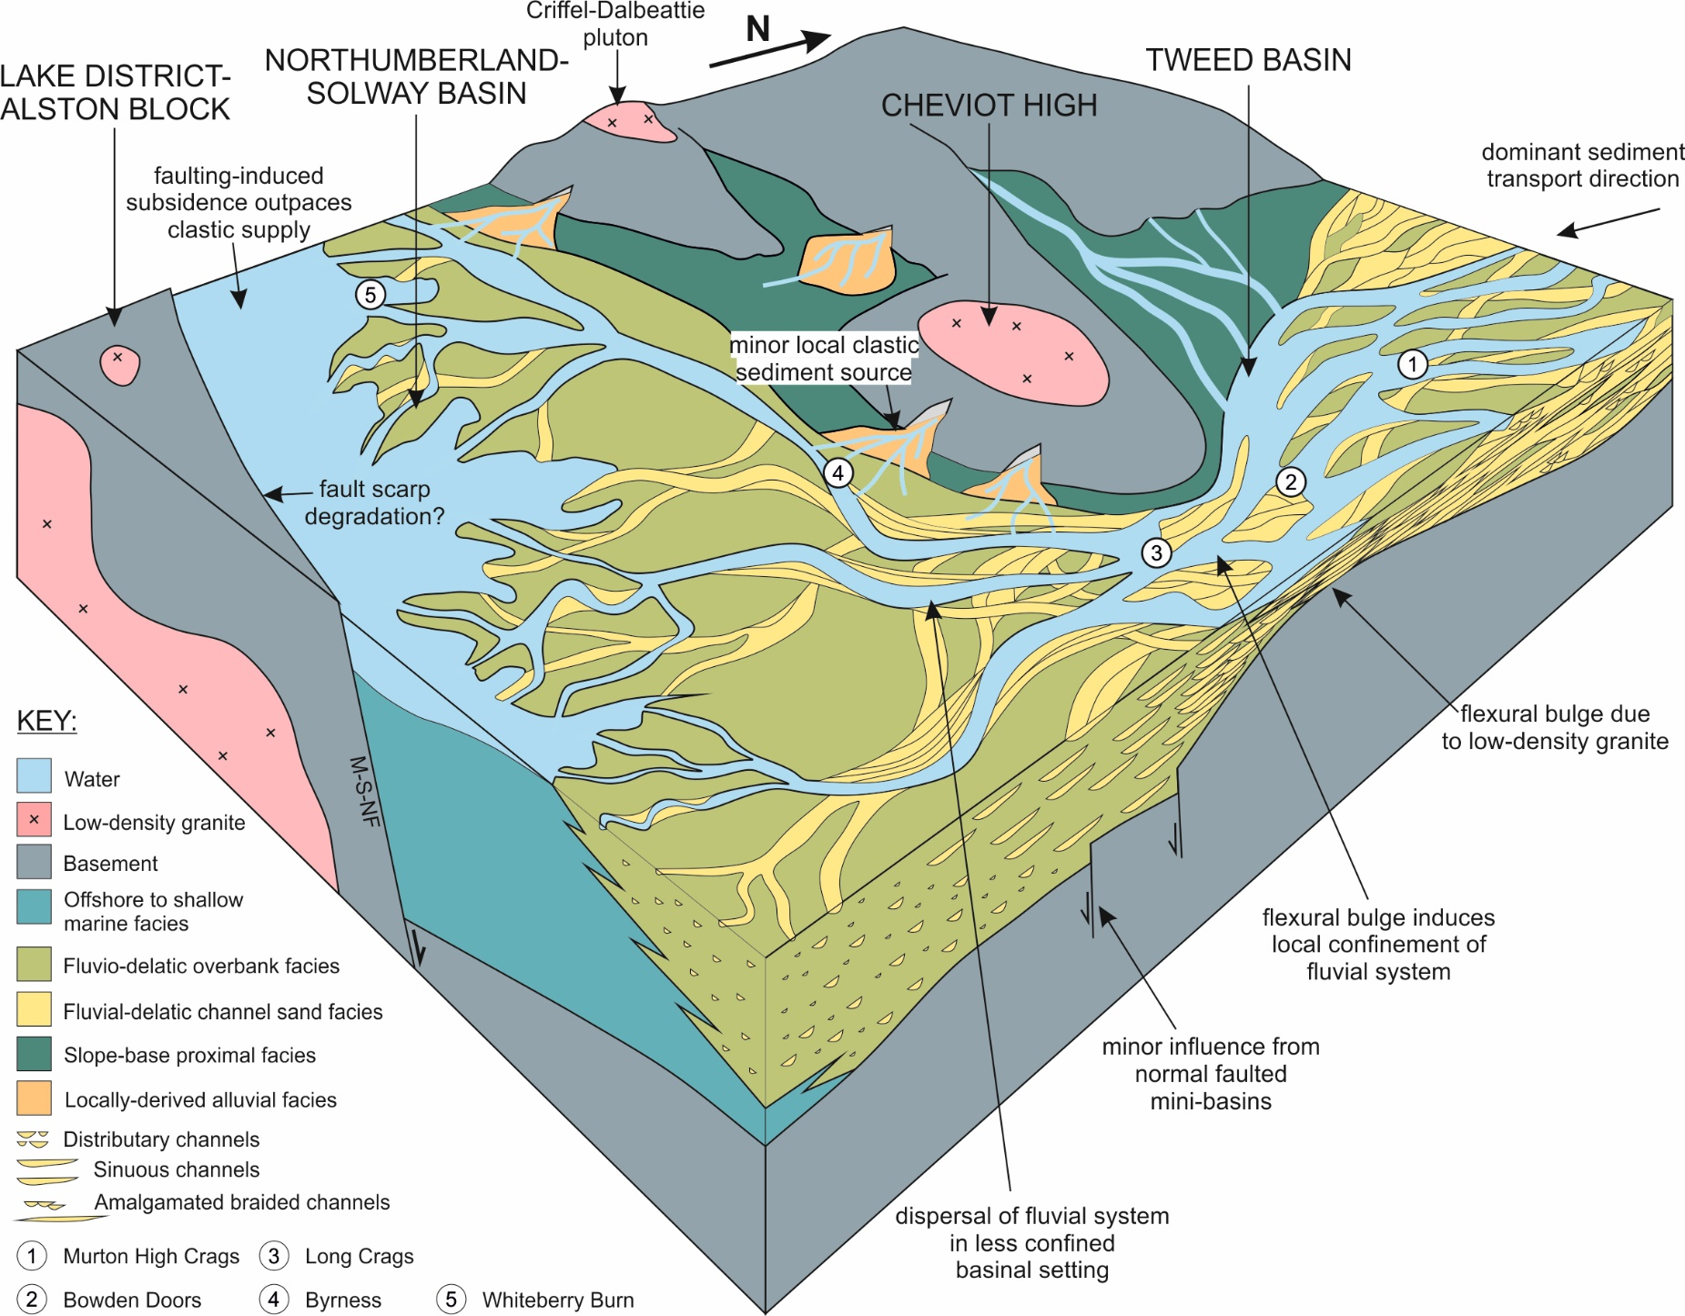

Figure 9: A schematic 3D tectono-stratigraphic model for the deposition of the Fell Sandstone succession in the northern Pennine Basin. The influences of normal faulted mini-basins, proximity to the dominant (north-easterly-derived) clastic sediment source, eustatic sea level, regional subsidence variations and basin palaeotopography are considered. The influences of proximity to sediment supply, regional subsidence variations and basin palaeotopography are considered the most important. Spatial variations in regional subsidence and basin palaeotopography can be partly attributed to the occurrence of low-density granite bodies within the basement.

The influence of low-density granite bodies on facies distribution within rift basins

Based on this study, basin palaeotopography and regional subsidence variations, along with proximity to clastic sediment source and the assumed constant rate of sediment supply, are considered two of the dominant controls on facies distribution (Fig. 9). Basin palaeotopography and regional subsidence variations within the Northumberland-Solway Basin are controlled by the Cheviot High and the Maryport-Stublick-Ninety Fathom fault system, which bounds the southern margin of the Northumberland-Solway Basin and the northern margin of the Lake District and Alston Blocks. Regional residual Bouguer gravity surveys (Fig. 3) and the outcropping basement (Fig. 2a) suggest that these structures are strongly influenced by the presence of local low-density basement anomalies induced by the presence of large granite bodies (Kimbell et al., 2010; Stone et al., 2012).
Recent revisions have been proposed regarding our understanding of how large low-density, mechanically strong granite bodies influence the characteristics of rift basins (Howell et al., 2019a). Large granite bodies can induce local low-density basement anomalies (Bott and Smithson, 1967; Donato et al., 1983). These anomalies invoke an isostatic response, a topographic high, and prompt local non-tectonic stresses that may interact with rift-related stresses (Howell et al., 2019a). In rift basins, there are two end-member types of low-density basement anomaly-induced highs: 1) flexural highs and; 2) fault-bounded highs.
A flexural high occurs when comparatively low-density basement is isostatically compensated for by an overlying regional-scale flexural bulge (Fig. 10a; Howell et al., 2019a). The magnitude of a flexural high is determined by the density contrast between local low-density basement and the surrounding crust as well as lithospheric flexural rigidity, widely expressed in terms of effective lithospheric elastic thickness ($T_{e}$) (Watts, 1978; Burov and Diament, 1995; Watts, 2001) (Fig. 10a, 10b). These highs occur prior to lithospheric extension. The rigidity of the lithosphere effectively restricts full isostatic compensation (Watts, 2001), leaving a series of unresolved non-tectonic stresses prior to lithospheric extension (Fig. 10c).
When the local crust is comparatively buoyant, these non-tectonic stresses can constructively interfere with extensional tectonic stresses, creating localised areas of preferential lineament reactivation (Howell et al., 2019a). The reader can refer to Spencer and Chase (1989), Sonder (1990), Zoback (1992) or Mandal (1999) for further examples of the interactions between tectonic and non-tectonic stresses. A fault-bounded high may occur when the influence of interacting non-tectonic and tectonic stresses give rise to extensive outwardly dipping normal faults systems; with respect to the low-density basement anomaly. This faulting arrangement can accommodate further isostatic compensation in response to local low-density basement anomalies (Fig. 10d). Fault-bounded highs are most strongly associated with large granite bodies, which are also often mechanically stronger, and therefore more resistant to hosting extensive fault systems, than accommodating basement (Phillips and McCaffrey, 2019; Phillips et al., 2019). Fault-bounded highs are bordered by deep half-grabens or thick syn-rift successions (Zervos, 1987).

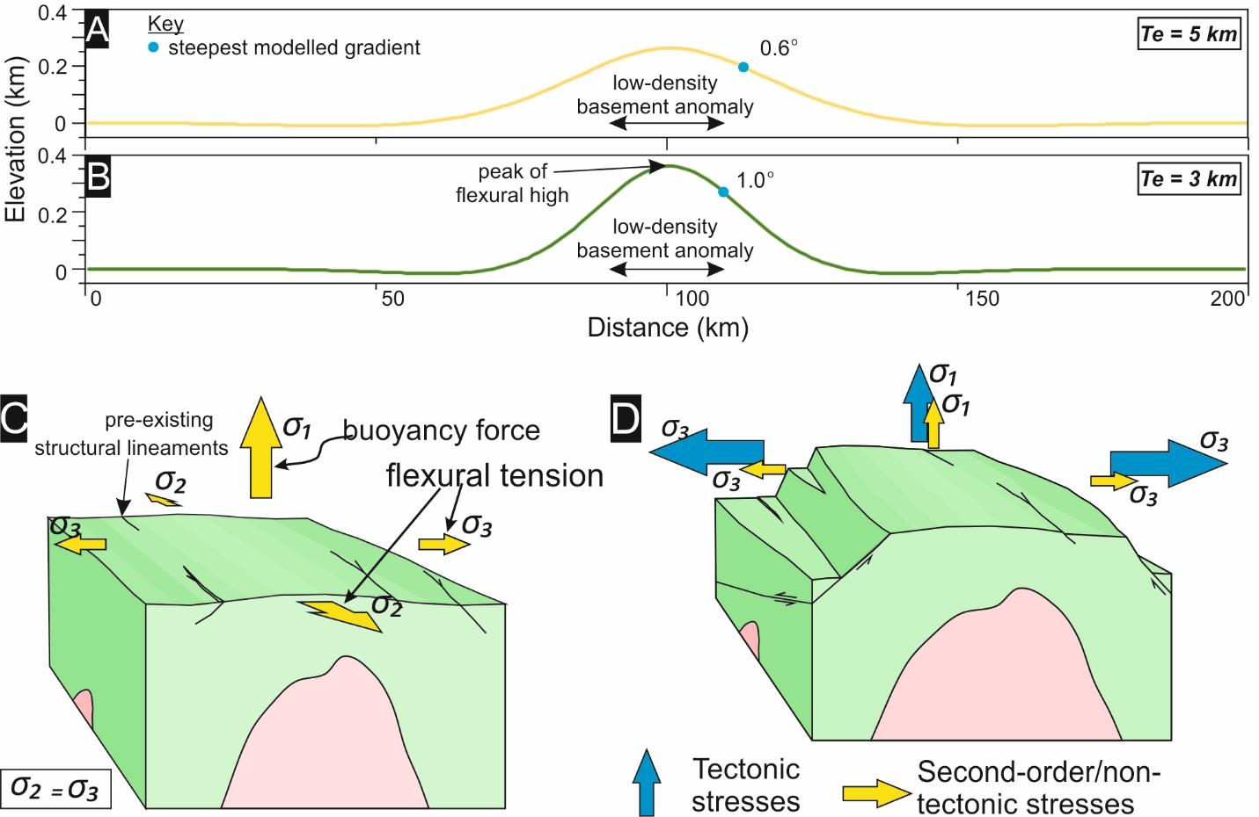

Figure 10a and b: Modelled basin topography across a flexural high; induced by the flexural isostatic response to a low-density basement anomaly (annotated). The low-density basement anomaly is calculated assuming a 10 km high by 15km wide granite body with a density of 2.63 g cm⁻³, a ‘standard’ basement density of 2.8 g cm⁻³ and complete substitution of ‘standard’ basement rock with low-density granite (cf. Howell et al., 2019a). 10a: Effective lithospheric elastic thickness = 5 km. 10b: Effective lithospheric elastic thickness = 3 km. c: A flexural high, produced by the flexural isostatic response to a granite-induced low-density basement anomaly with annotated non-tectonic stresses relating to the incomplete isostatic compensation of the basement anomaly. d: A fault-bounded high, produced by the extensional reactivation of pre-existing lineaments around the peripheral margins of a granite body, due to the interaction of non-tectonic and tectonic stresses and the relative mechanical strength of the crystalline granite body (after Howell et al., 2019a).

The Cheviot High is a flexural high (Fig. 10a, 10b) and the Lake District and Alston Blocks are fault-bounded highs (Fig. 10c) induced by local low-density basement anomalies. This next section will discuss how local granite-induced low-density basement anomalies, and their isostatic responses and influences on regional structural framework, influence the characteristics of local- and regional-scale rift basin fill.

Fault-bounded highs
Fault-bounded highs (Fig. 10d) can form due to low-density basement anomalies and strongly influence sedimentation in rift basins (Howell et al., 2019a). These are typically associated with granitic plutons (Zervos, 1987; Kimbell et al., 2010; Phillips and McCaffrey, 2019; Phillips et al., 2019). The normal faults that form at the margins of granite-cored highs accommodate large amounts of strain, tectonically- and non-tectonically-derived (Howell et al., 2019a), that are not accommodated by additional significant faults hosted within mechanically strong igneous intrusions (de Castro et al., 2008; Phillips and McCaffrey, 2019; Phillips et al., 2019). As a result, fault-bounded highs are often bordered by deep half-graben troughs (Dingle, 1976). These deep half-graben troughs are characterised by very high subsidence rates whilst the basinward strain shadow of extensive high-bounding faults appears to restrict the development of intra-basinal normal fault-bounded mini-basins within the immediate half-graben (Fig. 2b). Deep half-graben troughs with locally high subsidence rates can host deeper facies associations and provide preferential pathways for axial drainage (Leeder and Gawthorpe, 1987). Fault-bounded highs are known to act as a significant source of additional clastic sediment (Elliot et al., 2017); although, due to locally poor outcrop exposure and sparse borehole penetration there is limited evidence to suggest that this occurred during the deposition of the Fell Sandstone succession in the Northumberland-Solway Basin. With regard to more regional-scale deposition in rift basins, fault-bounded highs, caused by low-density basement anomalies, act as barriers to clastic sediment supply and the deep half-grabens that border them provide a confine for the accumulation of clastic sediment. In doing so, the broader rift basin system further away from the dominant clastic sediment source can become starved of sediment supply. This is observed in the southern Pennine Basin and Irish Basin where further sequences of granite-cored fault-bounded highs and bordering half-grabens can host shallow carbonate platforms and deeper, often organic-rich, basinal mudstones respectively (Southern et al., 2010; Andrews, 2013; Ter Borgh et al., 2019; Pharaoh et al., 2019).

Flexural highs
Comparatively less is understood about regional flexural highs (Fig. 10 c), which may have a more minor, yet still significant, influence on sedimentation in rift basins. Low-density basement anomalies can influence basin topography by prompting non-fault-bounded regional flexural highs (Fig. 10c). A two-dimensional flexural high responding isostatically to a 10 km high by 20 wide kilometre low-density granite body, assuming varying lithospheric rigidities or elastic thicknesses, is modelled in figure 10 (see Howell et al., 2019a for modelling theory). When a lower lithospheric flexural rigidity (effective lithospheric elastic thickness) is assumed, the vertical relief of a flexural high is greater and the marginal slopes of the high are steeper (Fig. 10b). Basin topography has a greater influence on basin infill where topography is more pronounced. Therefore, the potential of a flexural high to influence the characteristics of basin fill, as the Cheviot High appears to have, is also greater when the lithosphere is less rigid. Low lithospheric rigidities, or low effective elastic thicknesses ($T_{e}$), are observed for many rift basins around the world: 3 km for the Viking Graben, North Sea (Kusznir et al., 1991); 4 km for the Danish Graben, North Sea (Korstgard and Lerche, 1992); 5 km for Sergipe Alagos, Brazil (Karner et al., 1992). This is partly believed to relate to the high geothermal gradients associated with extended continental lithosphere (McNutt and Menard, 1982; Kusznir and Park, 1987; Sahagian and Holland, 1993; Burov and Diament, 1995). These observations support the idea that lithospheric flexure may significantly influence deposition in rift basins by inducing pronounced topography. By providing a range of elastic thickness values from analogue rift basins, these observations also help determine the likely distance away from a flexural high at which the marginal slope is steepest and the influence on deposition is, in theory, greatest. The maximum slope angle, assuming a lithospheric elastic thickness of 5 km, is 10-20 km away from the peak of the flexural high (Fig. 10a). Incidentally, in our case study the outcropping Fell Sandstone along the eastern margin of the Cheviot High is situated roughly 20 km from the centre of the currently exposed Cheviot Pluton (Fig. 7). Therefore, if the centre of the currently exposed Cheviot Pluton were assumed to be the centre of the flexural Cheviot High, then the exposed, highly confined, high net to gross, succession of the Fell Sandstone along the Cheviot High’s eastern margin would have presumably been deposited in an extended area most strongly influenced by flexure-induced basin topography. Beyond the area of maximum slope gradient, 20-30 km from the flexural high peak, the slope gradient decreases (Fig. 10a). Based on this study, the influence of flexural highs on facies distribution, induced by local low-density basement anomalies, is considered significant, yet localised. Flexural highs are capable of locally confining fluvial-fluviodeltaic systems, resulting in localised frequent sediment reworking, lower preservation of finer-grained material and the deposition of high quality reservoir facies. In terms of broader-scale rift basins however, flexural highs act only as local baffles to clastic sediment supply rather than barriers.

CONCLUSIONS

- This study has shown that high quality reservoir facies, ~98% sand, successions of the Fell Sandstone Formation along the eastern margin of the intra-basinal Cheviot High of the northern early Carboniferous Pennine rift basin, northern England, were deposited in a locally highly confined braided fluvial system.

- Proximity to the dominant, north-easterly derived clastic sediment source, regional subsidence variations and basin palaeotopography are considered the most important controls upon the spatial facies variations of the Fell Sandstone Formation and more basinal time-equivalent stratigraphy in the northern Pennine Basin.

- Regional subsidence variations and basin palaeotopography in the northern Pennine Basin are influenced strongly by the Cheviot High and the Maryport-Stublick-Ninety Fathom fault system, which bounds the Northumberland-Solway Basin and the Lake District and Alston Blocks. The Cheviot High and the Lake District and Alston Blocks are structures caused, at least in part, by the isostatic responses of local granite-induced low-density basement anomalies.

- Convex-shaped regional flexural highs, such as the Cheviot High, have the capacity to act as baffles to clastic sediment supply, locally confining fluvio-deltaic systems resulting in localised frequent sediment reworking, lower preservation of fine-grained material and the deposition of well-connected, high quality reservoir facies.

- Fault-bounded highs such as the Lake District and Alston Blocks, caused by a combination of the mechanical strength and low-density of large granitic bodies within their basements, can act as barriers and their deep bordering half-grabens can act as confines for clastic sediment supply, leading to sediment starvation further down system. Their bordering half-grabens can be characterised by high subsidence rates and deeper water facies assemblages.

ACKNOWLEDGEMENTS

Louis Howell would like to thank Ross Pettigrew and Charlotte Priddy for their assistance and discussion during preliminary fieldwork. David Armstrong and others encountered when conducting fieldwork in Northumberland and Cumbria are thanked for their friendliness and granting us permission to access their land.
This manuscript contains work conducted during a PhD study undertaken as part of the Natural Environment Research Council (NERC) Centre for Doctoral Training (CDT) in Oil & Gas [grant number: NEM00578X/1]. It is sponsored by Natural Environment Research Council, the Keele University Acorn Fund and the National Productivity Investment Fund (NPIF) whose support is gratefully acknowledged.

DATA AVAILABILITY

The data that support the findings of this study are available from the corresponding author upon reasonable request.
Tables

Borehole name | Grid reference | Net to gross | Top Fell Sandstone MD (m) | Bottom Fell Sandstone MD (m) | Date | Reference
Longhorsley | 41444 59254 | 0.7 | 1320 | 1632 | 1986 | -
Errington | 39774 57135 | 0.44 | 662 | 1976 | 2004 | -
Easton | 34412 57169 | 0.38 | 262 | 909 | 1990 | -
Westnewton | 31230 54355 | 0.14 | 1179 | 2045 | 1989 | -
Stonehaugh | 37899 57619 | 0.42 | ? | ? | 1975 | Smith and Holliday (1991)
Longframlington | 41323 60089 | 0.95 | ? | ? | 1964 | Turner et al (1993)
Alnwick | 41462 61210 | 0.98 | 0 | 104 | 1989 (?) | Fordham (1989); Turner et al (1997)

Table 1: Borehole data used in this study.
References
Adams, M.M. and Bhattacharya, J.P., 2005. No change in fluvial style across a sequence boundary, Cretaceous Blackhawk and Castlegate Formations of central Utah, USA. Journal of Sedimentary Research, 75(6), pp.1038-1051. https://doi.org/10.2110/jsr.2005.080
Aigner, T., Schauer, M., Junghans, W.D. and Reinhardt, L., 1995. Outcrop gamma-ray logging and its applications: examples from the German Triassic. Sedimentary Geology, 100(1-4), pp.47-61. https://doi.org/10.1016/0037-0738(95)00102-6
Andrews, I.J. 2013. The Carboniferous Bowland Shale gas study: geology and resource estimation. British Geological Survey for Department of Energy and Climate Change, London, UK. http://nora.nerc.ac.uk/id/eprint/503839/1/BGS_DECC_BowlandShaleGasReport_MAIN_REPORT.pdf
Armstrong, H.A. and Purnell, M.A., 1987. Dinantian conodont biostratigraphy of the Northumberland Trough. Journal of Micropalaeontology, 6(2), pp.97-112. https://doi.org/10.1144/jm.6.2.97
Ashworth, P.J., Best, J.L., Roden, J.E., Bristow, C.S. and Klaassen, G.J., 2000. Morphological evolution and dynamics of a large, sand braid‐bar, Jamuna River, Bangladesh. Sedimentology, 47(3), pp.533-555. https://doi.org/10.1046/j.1365-3091.2000.00305.x
Barrett, B.J., Hodgson, D.M., Collier, R.L. and Dorrell, R.M., 2018. Novel 3D sequence stratigraphic numerical model for syn-rift basins: Analysing architectural responses to eustasy, sedimentation and tectonics. Marine and Petroleum Geology, 92, pp.270-284. https://doi.org/10.1016/j.marpetgeo.2017.10.026
Barrett, B.J., Collier, R.E.L., Hodgson, D.M., Gawthorpe, R.L., Dorrell, R.M. and Cullen, T.M., 2019. Quantifying faulting and base level controls on syn‐rift sedimentation using stratigraphic architectures of coeval, adjacent Early‐Middle Pleistocene fan deltas in Lake Corinth, Greece. Basin Research. https://doi.org/10.1111/bre.12356
Bell, F.G., 1978. Petrographical factors relating to porosity and permeability in the Fell Sandstone. Quarterly Journal of Engineering Geology and Hydrogeology, 11(2), pp.113-126. https://doi.org/10.1144/GSL.QJEG.1978.011.02.01
Bell, R.A., Darling, W.G., Ward, R.S., Basava-Reddi, L., Halwa, L., Manamsa, K. and Dochartaigh, B.Ó., 2017. A baseline survey of dissolved methane in aquifers of Great Britain. Science of the Total Environment, 601, pp.1803-1813. https://doi.org/10.1016/j.scitotenv.2017.05.191
Besly, B., 2019. Exploration and development in the Carboniferous of the Southern North Sea: a 30-year retrospective. Geological Society, London, Special Publications, 471(1), pp.17-64. https://doi.org/10.1144/SP471.10
Bladon, A.J., Clarke, S.M. and Burley, S.D., 2015. Complex rift geometries resulting from inheritance of pre-existing structures: Insights and regional implications from the Barmer Basin rift. Journal of Structural Geology, 71, pp.136-154. https://doi.org/10.1016/j.jsg.2014.09.017
Blair, T.C. and Mcpherson, J.G., 2008. Quaternary sedimentology of the Rose Creek fan delta, Walker Lake, Nevada, USA, and implications to fan‐delta facies models. Sedimentology, 55(3), pp.579-615. https://doi.org/10.1111/j.1365-3091.2007.00913.x
Bott, M.H.P., Day, A.A. and Masson-Smith, D., 1958. The geological interpretation of gravity and magnetic surveys in Devon and Cornwall. Philosophical Transactions of the Royal Society of London. Series A, Mathematical and Physical Sciences, 251(992), pp.161-191. https://doi.org/10.1098/rsta.1958.0013
Bott, M.P. and Smithson, S.B., 1967. Gravity investigations of subsurface shape and mass distributions of granite batholiths. Geological Society of America Bulletin, 78(7), pp.859-878. https://doi.org/10.1130/0016-7606(1967)78[859:GIOSSA]2.0.CO;2
Bott, M.P., Robinson, J. and Kohnstamm, M.A., 1978. Granite beneath Market Weighton, east Yorkshire. Journal of the Geological Society, 135(5), pp.535-543. https://doi.org/10.1144/gsjgs.135.5.0535
Bridge, J.S., 1993. Description and interpretation of fluvial deposits: a critical perspective. Sedimentology, 40(4), pp.801-810. https://doi.org/10.1111/j.1365-3091.1993.tb01361.x
Bridge, J.S. and Tye, R.S., 2000. Interpreting the dimensions of ancient fluvial channel bars, channels, and channel belts from wireline-logs and cores. AAPG bulletin, 84(8), pp.1205-1228. https://doi.org/10.1306/A9673C84-1738-11D7-8645000102C1865D
Bristow, C.S., 1993. Sedimentology of the Rough Rock: a Carboniferous braided river sheet sandstone in northern England. Geological Society, London, Special Publications, 75(1), pp.291-304. https://doi.org/10.1144/GSL.SP.1993.075.01.18
Cameron, T.D.J., 1993. Carboniferous and Devonian of the Southern North Sea. In Lithostratigraphic Nomenclature of the UK North Sea (pp.93). British Geological Survey.
Carminati, E. and Santantonio, M., 2005. Control of differential compaction on the geometry of sediments onlapping paleoescarpments: Insights from field geology (Central Apennines, Italy) and numerical modeling. Geology, 33(5), pp.353-356. https://doi.org/10.1130/G21262.1
Catuneanu, O., 2019. Model-independent sequence stratigraphy. Earth-science reviews, 188, pp.312-388. https://doi.org/10.1016/j.earscirev.2018.09.017
Catuneanu, O., Galloway, W.E., Kendall, C.G.S.C., Miall, A.D., Posamentier, H.W., Strasser, A. and Tucker, M.E., 2011. Sequence stratigraphy: methodology and nomenclature. Newsletters on stratigraphy, 44(3), pp.173-245. https://doi.org/10.1127/0078-0421/2011/0011
Chadwick, R.A. and Holliday, D.W., 1991. Deep crustal structure and Carboniferous basin development within the Iapetus convergence zone, northern England. Journal of the Geological Society, 148(1), pp.41-53. https://doi.org/10.1144/gsjgs.148.1.0041
Chadwick, B.A., Holliday, D.W., Holloway, S., Hulbert, A.G. and Lawrence, D.J.D., 1995. The structure and evolution of the Northumberland-Solway Basin and adjacent areas. London: HMSO.
Corfield, S.M., Gawthorpe, R.L., Gage, M., Fraser, A.J. and Besly, B.M., 1996. Inversion tectonics of the Variscan foreland of the British Isles. Journal of the Geological Society, 153(1), pp.17-32. https://doi.org/10.1144/gsjgs.153.1.0017
Coward, M.P., 1993, January. The effect of Late Caledonian and Variscan continental escape tectonics on basement structure, Paleozoic basin kinematics and subsequent Mesozoic basin development in NW Europe. In Geological Society, London, Petroleum Geology Conference series (Vol. 4, No. 1, pp. 1095-1108). Geological Society of London. https://doi.org/10.1144/0041095
Crowley, T.J. and Baum, S.K., 1992. Modeling late Paleozoic glaciation. Geology, 20(6), pp.507-510. https://doi.org/10.1130/0091-7613(1992)020<0507:MLPG>2.3.CO;2
Davies, N.S. and Gibling, M.R., 2013. The sedimentary record of Carboniferous rivers: continuing influence of land plant evolution on alluvial processes and Palaeozoic ecosystems. Earth-Science Reviews, 120, pp.40-79. https://doi.org/10.1016/j.earscirev.2013.02.004
Davies, S.J. and Elliott, T., 1996. Spectral gamma ray characterization of high resolution sequence stratigraphy: examples from Upper Carboniferous fluvio-deltaic systems, County Clare, Ireland. Geological Society, London, Special Publications, 104(1), pp.25-35. https://doi.org/10.1144/GSL.SP.1996.104.01.03
Davydov, V., Wardlaw, B.R., Gradstein, F.M., Ogg, J.G. and Smith, A.G., 2004. The carboniferous period (pp. 222-248). Na.
Davydov, V.I., Crowley, J.L., Schmitz, M.D. and Poletaev, V.I., 2010. High‐precision U‐Pb zircon age calibration of the global Carboniferous time scale and Milankovitch band cyclicity in the Donets basin, eastern Ukraine. Geochemistry, Geophysics, Geosystems, 11(2). https://doi.org/10.1029/2009GC002736
Day, J.B.W., 1970. Geology of the country around Bewcastle. Memoires of the Geological Survey of Great Britain, pp.95-99.
Dean, M.T., Browne, M.A.E., Waters, C.N. and Powell, J.H., 2011. A lithostratigraphical framework for the Carboniferous successions of northern Great Britain (onshore). British Geological Survey. http://nora.nerc.ac.uk/id/eprint/13985/1/RR10007.pdf
de Castro, D.L., Bezerra, F.H. and Branco, R.M.C., 2008. Geophysical evidence of crustal-heterogeneity control of fault growth in the Neocomian Iguatu basin, NE Brazil. Journal of South American Earth Sciences, 26(3), pp.271-285. https://doi.org/10.1016/j.jsames.2008.07.002
Deegan, C.E., 1973. Tectonic control of sedimentation at the margin of a Carboniferous depositional basin in Kirkcudbrightshire. Scottish Journal of Geology, 9(1), pp.1-28. https://doi.org/10.1144/sjg09010001
Dingle, R.V., 1992. Structural and sedimentary development of the continental margin off southwestern Africa. Communications of the Geological Survey of Namibia, 8, pp.35-43.
Donato, J.A. and Tully, M.C., 1982. A proposed granite batholith along the western flank of the North Sea Viking Graben. Geophysical Journal International, 69(1), pp.187-195. https://doi.org/10.1111/j.1365-246X.1982.tb04943.x
Donato, J.A., Martindale, W. and Tully, M.C., 1983. Buried granites within the mid North Sea High. Journal of the Geological Society, 140(5), pp.825-837. https://doi.org/10.1144/gsjgs.140.5.0825
Ellen, R., Browne, M.A.E., Mitten, A.J., Clarke, S.M., Leslie, A.G. and Callaghan, E., 2019. Sedimentology, architecture and depositional setting of the fluvial Spireslack Sandstone of the Midland Valley, Scotland: insights from the Spireslack surface coal mine. Geological Society, London, Special Publications, 488, pp.SP488-2. https://doi.org/10.1144/SP488.2
Elliott, G.M., Jackson, C.A.L., Gawthorpe, R.L., Wilson, P., Sharp, I.R. and Michelsen, L., 2017. Late syn‐rift evolution of the Vingleia Fault Complex, Halten Terrace, offshore Mid‐Norway; a test of rift basin tectono‐stratigraphic models. Basin Research, 29, pp.465-487. https://doi.org/10.1111/bre.12158
Embry, A.F. and Johannessen, E.P., 1993. T–R sequence stratigraphy, facies analysis and reservoir distribution in the uppermost Triassic–Lower Jurassic succession, western Sverdrup Basin, Arctic Canada. In Norwegian Petroleum Society Special Publications (Vol. 2, pp. 121-146). Elsevier. https://doi.org/10.1016/B978-0-444-88943-0.50013-7
Embry, A.F. and Johannessen, E.P., 2017. Two approaches to sequence stratigraphy. In Stratigraphy & Timescales (Vol. 2, pp. 85-118). Academic Press. https://doi.org/10.1016/bs.sats.2017.08.001
Evans, R., Mory, A.J. and Tait, A.M., 2007. An outcrop gamma ray study of the Tumblagooda Sandstone, Western Australia. Journal of Petroleum Science and Engineering, 57(1-2), pp.37-59. https://doi.org/10.1016/j.petrol.2006.02.004
Fielding, C.R., Alexander, J. and Allen, J.P., 2018. The role of discharge variability in the formation and preservation of alluvial sediment bodies. Sedimentary Geology, 365, pp.1-20. https://doi.org/10.1016/j.sedgeo.2017.12.022
Fraser, A.J. and Gawthorpe, R.L., 1990. Tectono-stratigraphic development and hydrocarbon habitat of the Carboniferous in northern England. Geological Society, London, Special Publications, 55(1), pp.49-86. https://doi.org/10.1144/GSL.SP.1990.055.01.03
Frost, D.V. and Holliday, D.W., 1980. Geology of the country around Bellingham (No. 13). Memoir of the Geological Society.
Fordham, C.E., 1989. The Influence of sedimentary structures and facies on the fluid flow (permeability) in the Fell Sandstone, Northumberland (Doctoral dissertation, University of Newcastle upon Tyne).
Fossen, H., Khani, H.F., Faleide, J.I., Ksienzyk, A.K. and Dunlap, W.J., 2017. Post-Caledonian extension in the West Norway–northern North Sea region: the role of structural inheritance. Geological Society, London, Special Publications, 439(1), pp.465-486. https://doi.org/10.1144/SP439.6
Gawthorpe, R.L., Sharp, I., Underhill, J.R. and Gupta, S., 1997. Linked sequence stratigraphic and structural evolution of propagating normal faults. Geology, 25(9), pp.795-798. https://doi.org/10.1130/0091-7613(1997)025<0795:LSSASE>2.3.CO;2
Gawthorpe, R.L. and Leeder, M.R., 2000. Tectono-sedimentary evolution of active extensional basins. Basin Research, 12(3-4), pp.195-218. https://doi/pdf/10.1111/j.1365-2117.2000.00121.x
Gibling, M.R., 2006. Width and thickness of fluvial channel bodies and valley fills in the geological record: a literature compilation and classification. Journal of sedimentary Research, 76(5), pp.731-770. https://doi.org/10.2110/jsr.2006.060
Gregg, J.M., Shelton, K.L., Johnson, A.W., Somerville, I.D. and Wright, W.R., 2001. Dolomitization of the Waulsortian limestone (lower Carboniferous) in the Irish Midlands. Sedimentology, 48(4), pp.745-766. https://doi.org/10.1046/j.1365-3091.2001.00397.x
Hajek, E.A. and Heller, P.L., 2012. Flow-depth scaling in alluvial architecture and nonmarine sequence stratigraphy: example from the Castlegate Sandstone, central Utah, USA. Journal of Sedimentary Research, 82(2), pp.121-130. https://doi.org/10.2110/jsr.2012.8
Hartley, A.J., Weissmann, G.S., Nichols, G.J. and Warwick, G.L., 2010. Large distributive fluvial systems: characteristics, distribution, and controls on development. Journal of Sedimentary Research, 80(2), pp.167-183. https://doi.org/10.2110/jsr.2010.016
Hartley, A. and Evenstar, L., 2018. Fluvial architecture in actively deforming salt basins: Chinle Formation, Paradox Basin, Utah. Basin Research, 30(1), pp.148-166. https://doi.org/10.1111/bre.12247
Hemelsdaël, R., Ford, M., Malartre, F. and Gawthorpe, R., 2017. Interaction of an antecedent fluvial system with early normal fault growth: Implications for syn‐rift stratigraphy, western Corinth rift (Greece). Sedimentology, 64(7), pp.1957-1997. https://doi.org/10.1111/sed.12381
Hennissen, J.A., Hough, E., Vane, C.H., Leng, M.J., Kemp, S.J. and Stephenson, M.H., 2017. The prospectivity of a potential shale gas play: An example from the southern Pennine Basin (central England, UK). Marine and Petroleum Geology, 86, pp.1047-1066. https://doi.org/10.1016/j.marpetgeo.2017.06.033
Hodgson, A.V., 1978. Braided river bedforms and related sedimentary structures in the Fell Sandstone Group (Lower Carboniferous) of north Northumberland. Proceedings of the Yorkshire Geological Society, 41(4), pp.509-532. https://doi.org/10.1144/pygs.41.4.509
Holford, S.P., Green, P.F., Turner, J.P., Williams, G.A., Hillis, R.R., Tappin, D.R. and Duddy, I.R., 2008. Evidence for kilometre-scale Neogene exhumation driven by compressional deformation in the Irish Sea basin system. Geological Society, London, Special Publications, 306(1), pp.91-119. https://doi.org/10.1144/SP306.4
Hopper, J.R. and Roger Buck, W., 1998. Styles of extensional decoupling. Geology, 26(8), pp.699-702. https://doi.org/10.1130/0091-7613(1998)026<0699:SOED>2.3.CO;2
Howell, L., Egan, S., Leslie, G. and Clarke, S., 2019a. Structural and geodynamic modelling of the influence of granite bodies during lithospheric extension: application to the Carboniferous basins of northern England. Tectonophysics, 755, pp.47-63. https://doi.org/10.1016/j.tecto.2019.02.008
Howell, L., Egan, S., Leslie, G., Clarke, S., Mitten, A. and Pringle, J., in press. The influence of low-density granite bodies on extensional basins. Geology Today
Hudson, R.G.S. and Philcox, M.E., 1964. The Lower Carboniferous stratigraphy of the Buttevant area, Co. Cork. In Proceedings of the Royal Irish Academy. Section B: Biological, Geological, and Chemical Science (pp. 65-79). Royal Irish Academy.
Hunt, D., Allsop, T. and Swarbrick, R.E., 1996. Compaction as a primary control on the architecture and development of depositional sequences: conceptual framework, applications and implications. Geological Society, London, Special Publications, 104(1), pp.321-345. https://doi.org/10.1144/GSL.SP.1996.104.01.18
Hurley, N.F., 1984. Geology of Oscar Range (Devonian) Reef Complex, Canning Basin, Western Australia. AAPG Bulletin, 68(4), pp.490-490.
Jackson, C.A.L., Gawthorpe, R.L., Carr, I.D. and Sharp, I.R., 2005. Normal faulting as a control on the stratigraphic development of shallow marine syn‐rift sequences: the Nukhul and Lower Rudeis Formations, Hammam Faraun fault block, Suez Rift, Egypt. Sedimentology, 52(2), pp.313-338. https://doi.org/10.1111/j.1365-3091.2005.00699.x
Jackson, C.A.L., Elliott, G.M., Royce‐Rogers, E., Gawthorpe, R.L. and Aas, T.E., 2019. Salt thickness and composition influence rift structural style, northern North Sea, offshore Norway. Basin Research, 31(3), pp.514-538. https://doi.org/10.1111/bre.12332
Japsen, P. and Chalmers, J.A., 2000. Neogene uplift and tectonics around the North Atlantic: overview. Global and Planetary Change, 24(3-4), pp.165-173. https://doi.org/10.1016/S0921-8181(00)00006-0
Johnson, G.A.L., 1984. Subsidence and sedimentation in the Northumberland Trough. Proceedings of the Yorkshire Geological Society, 45(1-2), pp.71-83. https://doi.org/10.1144/pygs.45.1-2.71
Johnson, G.A.L., Somerville, I.D., Tucker, M.E. and Cózar, P., 2011, May. Carboniferous stratigraphy and context of the Seal Sands No. 1 Borehole, Teesmouth, NE England: the deepest onshore borehole in Great Britain. Geological Society of London. https://doi.org/10.1144/pygs.58.3.231
Jones, J. M., 1973. Berwick upon Tweed water supply… geological assessment. Unpublished note, University of Newcastle upon Tyne.
Karner, G.D., Egan, S.S. and Weissel, J.K., 1992. Modeling the tectonic development of the Tucano and Sergipe-Alagoas rift basins, Brazil. Tectonophysics, 215(1-2), pp.133-160. https://doi.org/10.1016/0040-1951(92)90078-K
Kearsey, T.I., Millward, D., Ellen, R., Whitbread, K. and Monaghan, A.A., 2019. Revised stratigraphic framework of pre-Westphalian Carboniferous petroleum system elements from the Outer Moray Firth to the Silverpit Basin, North Sea, UK. Geological Society, London, Special Publications, 471(1), pp.91-113. https://doi.org/10.1144/SP471.11
Kimbell, G.S. and Williamson, J.P., 2015. A gravity interpretation of the Central North Sea. http://nora.nerc.ac.uk/id/eprint/516759
Kombrink, H., 2008. The Carboniferous of the Netherlands and surrounding areas; a basin analysis. (Doctoral dissertation, University of Utrecht)
Kooi, H., Cloetingh, S. and Burrus, J., 1992. Lithospheric necking and regional isostasy at extensional basins 1. Subsidence and gravity modeling with an application to the Gulf of Lions margin (SE France). Journal of Geophysical Research: Solid Earth, 97(B12), pp.17553-17571. https://doi.org/10.1029/92JB01377
Korstgård, J.A. and Lerche, I., 1992. Flexural plate representation of Danish Central Graben evolution. Journal of geodynamics, 16(3), pp.181-209. https://doi.org/10.1016/0264-3707(92)90025-N
Kimbell, G.S., Chadwick, R.A., Holliday, D.W. and Werngren, O.C., 1989. The structure and evolution of the Northumberland Trough from new seismic reflection data and its bearing on modes of continental extension. Journal of the Geological Society, 146(5), pp.775-787. https://doi.org/10.1144/gsjgs.146.5.0775
Kimbell, G.S., Young, B., Millward, D. and Crowley, Q.G., 2010, November. The North Pennine batholith (Weardale Granite) of northern England: new data on its age and form. Proceedings of the Yorkshire Geological Society, 58(2), pp.107-128. https://doi.org/10.1144/pygs.58.1.273
Kraus, M.J., 1999. Paleosols in clastic sedimentary rocks: their geologic applications. Earth-Science Reviews, 47(1-2), pp.41-70. https://doi.org/10.1016/S0012-8252(99)00026-4
Kusznir, N.J. and Park, R.G., 1987. The extensional strength of the continental lithosphere: its dependence on geothermal gradient, and crustal composition and thickness. Geological Society, London, Special Publications, 28(1), pp.35-52. https://doi.org/10.1144/GSL.SP.1987.028.01.04
Kusznir, N.J., Marsden, G. and Egan, S.S., 1991. A flexural-cantilever simple-shear/pure-shear model of continental lithosphere extension: applications to the Jeanne d’Arc Basin, Grand Banks and Viking Graben, North Sea. Geological Society, London, Special Publications, 56(1), pp.41-60. https://doi.org/10.1144/GSL.SP.1991.056.01.04
Lancaster, P.J., Daly, J.S., Storey, C.D. and Morton, A.C., 2017. Interrogating the provenance of large river systems: multi-proxy in situ analyses in the Millstone Grit, Yorkshire. Journal of the Geological Society, 174(1), pp.75-87. https://doi.org/10.1144/jgs2016-069
Leeder, M.R., 1974. Lower Border Group (Tournaisian) fluvio-deltaic sedimentation and palaeogeography of the Northumberland Basin. Proceedings of the Yorkshire Geological Society, 40(2), pp.129-180. https://doi.org/10.1144/pygs.40.2.129
Leeder, M.R., 1975. The origin of the Northumberland basin. Scottish Journal of Geology, 10(4), pp.283-296. https://doi.org/10.1144/sjg10040283
Leeder, M.R., 1982. Upper Palaeozoic basins of the British Isles—Caledonide inheritance versus Hercynian plate margin processes. Journal of the Geological Society, 139(4), pp.479-491. https://doi.org/10.1144/gsjgs.139.4.0479
Leeder, M.R. and Gawthorpe, R.L., 1987. Sedimentary models for extensional tilt-block/half-graben basins. Geological Society, London, Special Publications, 28(1), pp.139-152. https://doi.org/10.1144/GSL.SP.1987.028.01.11
Le Roux, J.P., 1992. Determining the channel sinuosity of ancient fluvial systems from paleocurrent data. Journal of Sedimentary Research, 62(2), pp.283-291. https://doi.org/10.1306/D42678E3-2B26-11D7-8648000102C1865D
Lundmark, A.M., Sæther, T. and Sørlie, R., 2014. Ordovician to Silurian magmatism on the Utsira High, North Sea: implications for correlations between the onshore and offshore Caledonides. Geological Society, London, Special Publications, 390(1), pp.513-523. https://doi.org/10.1144/SP390.21
MacNaughton, R.B., 2007. The application of trace fossils to biostratigraphy. In Trace Fossils (pp. 135-148). Elsevier. https://doi.org/10.1016/B978-044452949-7/50134-0
Magee, C., McDermott, K.G., Stevenson, C.T. and Jackson, C.A.L., 2014. Influence of crystallised igneous intrusions on fault nucleation and reactivation during continental extension. Journal of Structural Geology, 62, pp.183-193. https://doi.org/10.1016/j.jsg.2014.02.003
Mandal, P., 1999. Intraplate stress distribution induced by topography and crustal density heterogeneities beneath the south Indian shield, India. Tectonophysics, 302(1-2), pp.159-172. https://doi.org/10.1016/S0040-1951(98)00282-0
Maynard, J.R., 1992. Sequence stratigraphy of the upper Yeadonian of northern England. Marine and Petroleum Geology, 9(2), pp.197-207. https://doi.org/10.1016/0264-8172(92)90091-R
McLaurin, B.T. and Steel, R.J., 2007. Architecture and origin of an amalgamated fluvial sheet sand, lower Castlegate Formation, Book Cliffs, Utah. Sedimentary Geology, 197(3-4), pp.291-311. https://doi.org/10.1016/j.sedgeo.2006.10.005
McNutt, M.K. and Menard, H.W., 1982. Constraints on yield strength in the oceanic lithosphere derived from observations of flexure. Geophysical Journal International, 71(2), pp.363-394. https://doi.org/10.1111/j.1365-246X.1982.tb05994.x
Miall, A.D., 1977. A review of the braided-river depositional environment. Earth-Science Reviews, 13(1), pp.1-62. https://doi.org/10.1016/0012-8252(77)90055-1
Miall, A.D., 1985. Architectural-element analysis: a new method of facies analysis applied to fluvial deposits. Earth-Science Reviews, 22(4), pp.261-308. https://doi.org/10.1016/0012-8252(85)90001-7
Minshull, T.A. and Charvis, P., 2001. Ocean island densities and models of lithospheric flexure. Geophysical Journal International, 145(3), pp.731-739. https://doi.org/10.1046/j.0956-540x.2001.01422.x
Mitchener, B.C., Lawrence, D.A., Partington, M.A., Bowman, M.B.J. and Gluyas, J., 1992. Brent Group: sequence stratigraphy and regional implications. Geological Society, London, Special Publications, 61(1), pp.45-80. https://doi.org/10.1144/GSL.SP.1992.061.01.05
Monro, M., 1986. Sedimentology of the Carboniferous Fell Sandstone Group of Northumberland (Doctoral dissertation, University of Newcastle upon Tyne).
Mount, J.F., 1984. Mixing of siliciclastic and carbonate sediments in shallow shelf environments. Geology, 12(7), pp.432-435. https://doi.org/10.1130/0091-7613(1984)12<432:MOSACS>2.0.CO;2
Morley, C.K., Haranya, C., Phoosongsee, W., Pongwapee, S., Kornsawan, A. and Wonganan, N., 2004. Activation of rift oblique and rift parallel pre-existing fabrics during extension and their effect on deformation style: examples from the rifts of Thailand. Journal of Structural Geology, 26(10), pp.1803-1829. https://doi.org/10.1016/j.jsg.2004.02.014
Morton, A.C., Claoué-Long, J.C. and Hallsworth, C.R., 2001. Zircon age and heavy mineral constraints on provenance of North Sea Carboniferous sandstones. Marine and Petroleum Geology, 18(3), pp.319-337. https://doi.org/10.1016/S0264-8172(00)00065-9
Nemec, W. and Postma, G., 1993. Quaternary alluvial fans in southwestern Crete: sedimentation processes and geomorphic evolution. In Alluvial sedimentation (Vol. 17, pp. 235-276). Oxford: International Association of Sedimentologists. https://doi.org/10.1002/9781444303995.ch18
Pharaoh, T.C., 1999. Palaeozoic terranes and their lithospheric boundaries within the Trans-European Suture Zone (TESZ): a review. Tectonophysics, 314(1-3), pp.17-41. https://doi.org/10.1016/S0040-1951(99)00235-8
Pharaoh, T.C., Gent, C.M.A., Hannis, S.D., Kirk, K.L., Monaghan, A.A., Quinn, M.F., Smith, N.J.P., Vane, C.H., Wakefield, O. and Waters, C.N., 2019. An overlooked play? Structure, stratigraphy and hydrocarbon prospectivity of the Carboniferous in the East Irish Sea–North Channel basin complex. Geological Society, London, Special Publications, 471(1), pp.281-316. https://doi.org/10.1144/SP471.7
Phillips, T. and McCaffrey, K., 2019. Terrane boundary reactivation, barriers to lateral fault propagation and reactivated fabrics - Rifting across the Median Batholith Zone, Great South Basin, New Zealand. https://doi.org/10.31223/osf.io/g4n2e
Phillips, T.B., Jackson, C.A., Bell, R.E., Duffy, O.B. and Fossen, H., 2016. Reactivation of intrabasement structures during rifting: A case study from offshore southern Norway. Journal of Structural Geology, 91, pp.54-73. https://doi.org/10.1016/j.jsg.2016.08.008
Phillips, T., Fazlikhani, H., Gawthorpe, R., Fossen, H., Jackson, C.A., Bell, R., Faleide, J.I., Rotevatn, A., 2019. The influence of structural inheritance and multiphase extension on rift development, the northern North Sea. https://doi.org/10.31223/osf.io/ztqck
Reynolds, A.D., 1992. Storm, wave and tide-dominated sedimentation in the Dinantian Middle Limestone Group, Northumbrian Basin. Proceedings of the Yorkshire Geological Society, 49(2), pp.135-148. https://doi.org/10.1144/pygs.49.2.135
Ridd, M.F., Walker, D.B. and Jones, J.M., 1970. A deep borehole at Harton on the margin of the Northumbrian Trough. Proceedings of the Yorkshire Geological Society, 38(1), pp.75-103. https://doi.org/10.1144/pygs.38.1.75
Robson, D.A., 1956. A sedimentary study of the Fell Sandstones of the Coquet Valley, Northumberland. Quarterly Journal of the Geological Society, 112(1-4), pp.241-262. https://doi.org/10.1144/GSL.JGS.1956.112.01-04.12
Rust, B.R., 1977. Depositional models for braided alluvium. In Fluvial Sedimentology (Vol. 5, pp.605-625). Canadian Society of Petroleum Geology.
Sahagian, D.L. and Holland, S.M., 1993. On the thermo‐mechanical evolution of continental lithosphere. Journal of Geophysical Research: Solid Earth, 98(B5), pp.8261-8274. https://doi.org/10.1029/93JB00152
Scrutton, R.A. and Dingle, R.V., 1976. Observations on the processes of sedimentary basin formation at the margins of southern Africa. In Developments in Geotectonics (Vol. 12, pp. 143-156). Elsevier. https://doi.org/10.1016/B978-0-444-41549-3.50014-1
Seilacher, A., 2007. Arthrophycid Burrows. Trace Fossil Analysis, pp.117-130.
Smith, T.E., 1967. A preliminary study of sandstone sedimentation in the Lower Carboniferous of the Tweed Basin. Scottish Journal of Geology, 3(2), pp.282-305. https://doi.org/10.1144/sjg03020282
Smith, S.A. and Holliday, D.W., 1991. The sedimentology of the Middle and Upper Border groups (Visean) in the Stonehaugh Borehole, Northumberland. Proceedings of the Yorkshire Geological Society, 48(4), pp.435-446. https://doi.org/10.1144/pygs.48.4.435
Soltan, R. and Mountney, N.P., 2016. Interpreting complex fluvial channel and barform architecture: Carboniferous Central Pennine Province, northern England. Sedimentology, 63(1), pp.207-252. https://doi.org/10.1111/sed.12224
Sonder, L.J., 1990. Effects of density contrasts on the orientation of stresses in the lithosphere: Relation to principal stress directions in the Transverse Ranges, California. Tectonics, 9(4), pp.761-771. https://doi.org/10.1029/TC009i004p00761
Soper, N.J., Strachan, R.A., Holdsworth, R.E., Gayer, R.A. and Greiling, R.O., 1992. Sinistral transpression and the Silurian closure of Iapetus. Journal of the Geological Society, 149(6), pp.871-880. https://doi.org/10.1144/gsjgs.149.6.0871
Southern, S.J., Mountney, N.P. and Pringle, J.K., 2014. The Carboniferous Southern Pennine Basin, UK. Geology Today, 30(2), pp.71-78. https://doi.org/10.1111/gto.12044
Spears, D.A., 2012. The origin of tonsteins, an overview, and links with seatearths, fireclays and fragmental clay rocks. International Journal of Coal Geology, 94, pp.22-31. https://doi.org/10.1016/j.coal.2011.09.008
Spencer, J.E. and Chase, C.G., 1989. Role of crustal flexure in initiation of low‐angle normal faults and implications for structural evolution of the Basin and Range province. Journal of Geophysical Research: Solid Earth, 94(B2), pp.1765-1775. https://doi.org/10.1029/JB094iB02p01765
Stewart, S.A., Reid, C.T., Hooker, N.P. and Kharouf, O.W., 2016. Mesozoic siliciclastic reservoirs and petroleum system in the Rub'Al-Khali basin, Saudi Arabia. AAPG Bulletin, 100(5), pp.819-841. https://doi.org/10.1306/02021615112
Stone, P., McMillan, A.A., Floyd, J.D., Barnes, R.P. and Phillips, E.R., 2012. South of Scotland 4th ed. British Geological Survey.
Stow, D.A. and Shanmugam, G., 1980. Sequence of structures in fine-grained turbidites: comparison of recent deep-sea and ancient flysch sediments. Sedimentary Geology, 25(1-2), pp.23-42. https://doi.org/10.1016/0037-0738(80)90052-4
Sun, S.Q., 1995. Dolomite reservoirs: porosity evolution and reservoir characteristics. AAPG bulletin, 79(2), pp.186-204.
Ter Borgh, M.M., Eikelenboom, W. and Jaarsma, B., 2019. Hydrocarbon potential of the Visean and Namurian in the northern Dutch offshore. Geological Society, London, Special Publications, 471(1), pp.133-153. https://doi.org/10.1144/SP471.5
Terrington, R.L. and Thorpe, S., 2013. Metadata report for the Northumberland and Solway Basin 1: 250 000 geological model. http://nora.nerc.ac.uk/id/eprint/507069
Turner, B.R. and Monro, M., 1987. Channel formation and migration by mass‐flow processes in the Lower Carboniferous fluviatile Fell Sandstone Group, northeast England. Sedimentology, 34(6), pp.1107-1122. https://doi.org/10.1111/j.1365-3091.1987.tb00595.x
Turner, B.R., Younger, P.L. and Fordham, C.E., 1993. Fell Sandstone lithostratigraphy south-west of Berwick-upon-Tweed: implications for the regional development of the Fell Sandstone. Proceedings of the Yorkshire Geological Society, 49(4), pp.269-281. https://doi.org/10.1144/pygs.49.4.269
Turner, B.R., Dewey, C. and Fordham, C.E., 1997. Marine ostracods in the Lower Carboniferous fluviatile Fell Sandstone Group: evidence for base level change and marine flooding of the central graben, Northumberland Basin. Proceedings of the Yorkshire Geological Society, 51(4), pp.297-306. https://doi.org/10.1144/pygs.51.4.297
Uba, C.E., Hasler, C.A., Buatois, L.A., Schmitt, A.K. and Plessen, B., 2009. Isotopic, paleontologic, and ichnologic evidence for late Miocene pulses of marine incursions in the central Andes. Geology, 37(9), pp.827-830. https://doi.org/10.1130/G30014A.1
Vauchez, A., Tommasi, A. and Barruol, G., 1998. Rheological heterogeneity, mechanical anisotropy and deformation of the continental lithosphere. Tectonophysics, 296(1-2), pp.61-86. https://doi.org/10.1016/S0040-1951(98)00137-1
Venus, J.H., Mountney, N.P. and McCaffrey, W.D., 2015. Syn-sedimentary salt diapirism as a control on fluvial-system evolution: An example from the proximal Permian Cutler Group, SE Utah, USA. Basin Research, 27(2), pp.152-182. https://doi.org/10.1111/bre.12066
Wakefield, O., Waters, C.N. and Smith, N.J.P., 2016. Carboniferous stratigraphical correlation and interpretation in the Irish Sea. http://nora.nerc.ac.uk/id/eprint/516783/1/CR16040.pdf
Waters, C., Browne, M., Dean, M. and Powell, J., 2007. Lithostratigraphical framework for Carboniferous successions of Great Britain (onshore). British Geological Survey. http://nora.nerc.ac.uk/id/eprint/3235/1/RR07001.pdf
Waters, C. N., Somerville, I. D., Jones, N. S., Cleal, C. J., Collinson, J. D., Waters, R. A., Besly, B. M., Dean, M. T., Stephenson, M. H., Davies, J. R., Freshney, E. C., Jackson, D. I., Mitchell, W. I., Powell, J. H., Barclay, W. J., Browne, M. A. E., Leveridge, B. E., Long, S. L. & Mclean, D. 2011. A revised correlation of Carboniferous rocks in the British Isles. Geological Society, London, Special Report 26, 1–186.
Watts, A.B., 1978. An analysis of isostasy in the world's oceans 1. Hawaiian‐Emperor seamount chain. Journal of Geophysical Research: Solid Earth, 83(B12), pp.5989-6004. https://doi.org/10.1029/JB083iB12p05989
Watts, A.B., 2001. Isostasy and Flexure of the Lithosphere. Cambridge University Press.
Weissmann, G.S., Hartley, A.J., Nichols, G.J., Scuderi, L.A., Olson, M., Buehler, H. and Banteah, R., 2010. Fluvial form in modern continental sedimentary basins: distributive fluvial systems. Geology, 38(1), pp.39-42. https://doi.org/10.1130/G30242.1
Younger, P.L., Manning, D.A., Millward, D., Busby, J.P., Jones, C.R. and Gluyas, J.G., 2016. Geothermal exploration in the Fell Sandstone Formation (Mississippian) beneath the city centre of Newcastle upon Tyne, UK: the Newcastle Science Central deep geothermal borehole. Quarterly Journal of Engineering Geology and Hydrogeology, 49(4), pp.350-363. https://doi.org/10.1144/qjegh2016-053
Zervos, F., 1987. A compilation and regional interpretation of the northern North Sea gravity map. Geological Society, London, Special Publications, 28(1), pp.477-493. https://doi.org/10.1144/GSL.SP.1987.028.01.30
Zoback, M.L., 1992. First‐and second‐order patterns of stress in the lithosphere: The World Stress Map Project. Journal of Geophysical Research: Solid Earth, 97(B8), pp.11703-11728. https://doi.org/10.1029/92JB00132

