This manuscript has been submitted for publication in Weather and Climate Extremes. Please be aware that subsequent versions of the manuscript may be different following the formal peer-review process. If accepted for publication, the final version of this manuscript will be made available via the ‘Peer-reviewed Publication DOI’ link on this page. Please do not hesitate to contact either of the authors to provide feedback.

Revealing day-to-day evolution of snowpack and snow drought conditions with phase diagrams
Benjamin J. Hatchett^{1*}, Daniel J. McEvoy¹
¹Western Regional Climate Center, Desert Research Institute, Reno, Nevada, 89512, USA
*Correspondence to: Benjamin J. Hatchett (Benjamin.Hatchett@gmail.com)
Abstract: Snow droughts commonly are defined as below average snowpack at a point in time, typically 1 April. This definition is valuable for interpreting the state of the snowpack for resource management but obscures the temporal evolution of snow drought. Borrowing from dynamical systems theory, we applied phase diagrams to visually examine the evolution of ephemeral snowpack conditions in maritime, intermountain, and continental snow climates in the western United States using station observations. Phase diagrams of snow water equivalent and precipitation highlighted snow drought onset and termination timing at daily timescales. This visualization approach may facilitate communicating snow drought conditions to broader audiences, especially in years characterized by notable hydroclimate variability or extreme events. When combined with additional hydrologic data, such as streamflow or spatially distributed estimates of snow water equivalent, phase diagrams can help monitor snow drought conditions and link them to impacts on ecosystems, water resources, and recreation.

Keywords: Drought, Extremes, Hydroclimate, Mountains, Seasonal Snow, Visualization

1 Introduction
Snow-dominated mountains provide critical water resources to ecosystems and society (Viviroli et al., 2007; Sturm et al., 2017), but their snowpacks are susceptible to climate warming (Beniston, 2003; Pepin et al., 2015; Rhoades et al., 2018). Warming impacts mountain regions in many ways, including reductions in the amount of water stored snowpacks (Mote et al., 2018), earlier springtime snowpack melting (Kapnick and Hall, 2012), slower snowmelt (Musselman et al., 2017) and reductions in runoff efficiency as rain falls instead of snow (Berghuijs et al., 2014) and as evapotranspiration increases (Foster et al., 2016). In addition to downstream economic impacts (Lund et al., 2018), snowpack reductions also decrease opportunities for recreation and tourism (Scott, 2006; Hatchett and Eisen, 2019), which are pillars of mountain economies (Hagenstad et al., 2018).

Tracking snowpack throughout the western United States cool season (defined broadly as October-May) and identifying below-normal snow conditions known as “snow drought” (Cooper et al., 2016; Hatchett and McEvoy, 2018) aids resource managers in making informed decisions based on past, current, and forecast snowpack conditions. Often, a point-in-time approach is used by water resource management agencies to assess snowpack conditions pertaining to runoff. The date of 1 April is codified into many western U.S. water management agencies. The relation of this date-to-peak snowpack timing, however, varies by location and season (Margulis et al., 2019). Hatchett and McEvoy (2018) highlight other challenges of the point-in-time definition. Notably, they pointed out that pre-1 April snow droughts can be obscured by later heavy snowfall and that anomalous warm spells can create warm snow drought conditions not directly related to precipitation.

These challenges and the need to communicate mountain hydroclimate conditions to broad audiences illustrate the value of a visualization approach that captures the signals of interest and allows tracking them through time. Here, we introduce the application of phase diagrams, which are a straightforward way to show how two variables change through time with respect to one another, to show the temporal co-evolution of snow water equivalent (SWE) and precipitation at daily timescales. We demonstrated this approach using examples from a range of western United States snow climates. We highlighted intraseasonal and interannual snowpack variability, snow drought variation along an elevational and longitudinal transect, and how dry versus warm snow droughts (above-average precipitation but below-average snowpack) differ.

2 Data
Daily observations of SWE and accumulated water year precipitation (the water year begins on 1 October and ends 30 September) were acquired from five SNOwpack TELemetry (SNOTEL) stations from the Natural Resources Conservation Survey (https://www.wcc.nrcs.usda.gov/snow/; Fig. 1; Table 1). SNOTEL is a long-term, quality-controlled, surface-based network for observing precipitation and snow in western U.S. mountains. We used SNOTEL stations located in California, Colorado, Nevada, and Washington. We acquired SNOTEL data spanning the period of record observations (typically beginning in the early 1980s) through 31 May 2020.
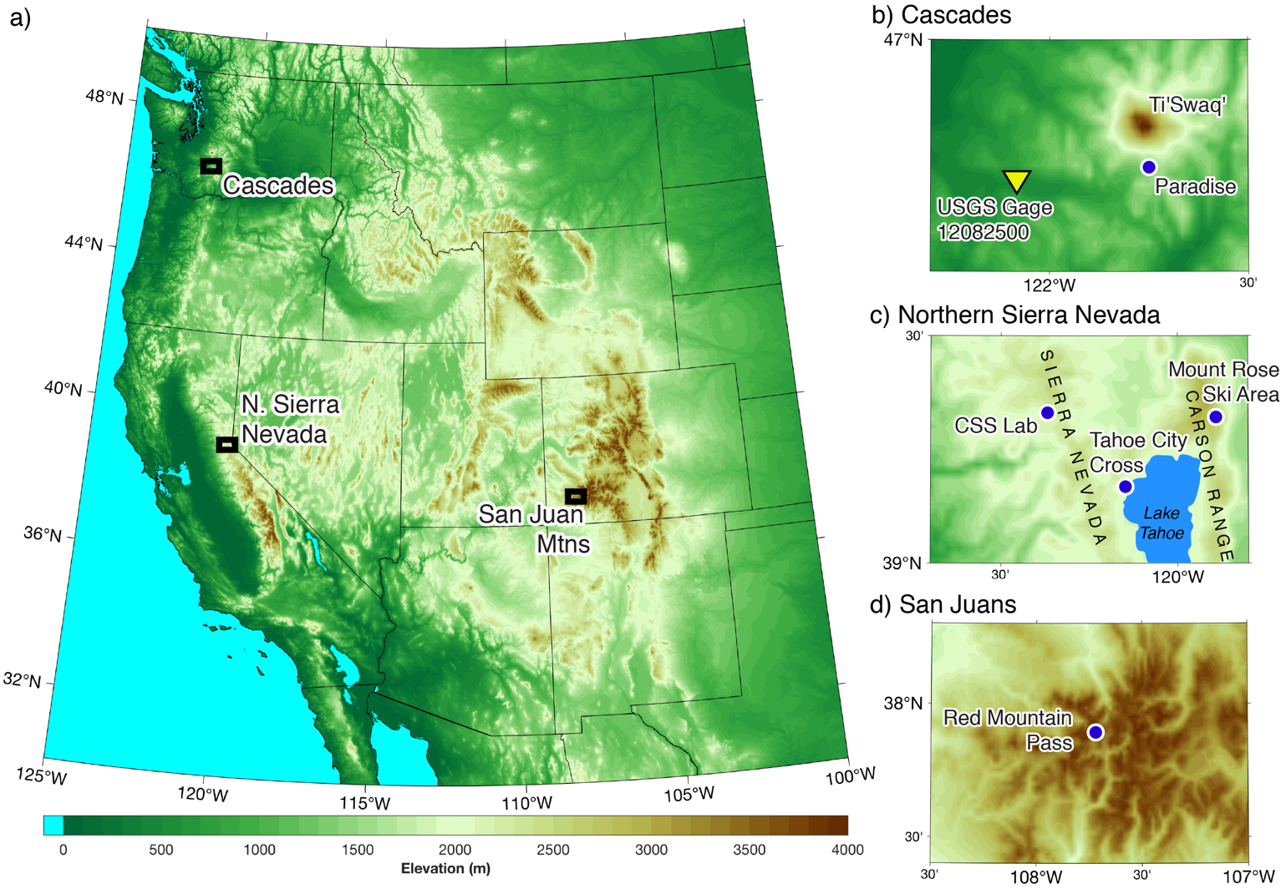
Figure 1: (a) Map of western U.S. topography showing study areas of focus: (b) the Cascade Mountains, (c) the Northern Sierra Nevada, and (d) the San Juan Mountains. SNOTEL stations are shown by blue dots. The yellow triangle indicates the United States Geological Survey (USGS) stream gage. [Two column; color]
Station Name | Elevation (m) | Latitude (°N) | Longitude (°W) | Period of Record | Snow Climate
Central Sierra Snow Laboratory, California | 2201 | 39.33 | 120.37 | 1 Oct 1983-1 May 2020 | Maritime
Mount Rose Ski Area, Nevada | 2683 | 39.32 | 119.89 | 1 Oct 1980-1 May 2020 | Intermountain
Paradise, Washington | 1564 | 46.78 | 121.75 | 1 Oct 1980-1 May 2020 | Maritime
Red Mountain Pass, Colorado | 3414 | 37.89 | 107.71 | 1 Oct 1980-1 May 2020 | Continental
Tahoe City Cross, California | 2072 | 39.32 | 120.15 | 1 Oct 1980-1 May 2020 | Maritime
Table 1: Metadata for SNOwpack TELemetry (SNOTEL) stations used to generate phase diagrams.
To add a spatial component to station-based SWE and precipitation, we utilized daily gridded 4 km spatial resolution estimates of SWE for the continental U.S. (Zeng et al., 2018). This SWE reanalysis spans water years 1982–2017. We also acquired daily streamflow for water years 1943–2019 from the United States Geological Survey Gage 12082500, located on the unimpaired Nisqually River, near the Paradise, Washington SNOTEL (Fig. 1b).

3 Visualizing snow drought with a phase diagram
The concept of phase diagrams initially was developed by Ludwig Boltzmann, Henri Poincaré, and Josiah Willard Gibbs with the intent to represent all possible states of a dynamical system, such as a particle’s position and momentum (Nolte, 2010). Many disciplines use phase diagrams (also referred to as phase space diagrams)—including nonlinear dynamics, chaos theory, as well as statistical and quantum mechanics. Each parameter of the system of study is represented by an axis of a multidimensional space. In a two-dimensional system, each point on the phase plane (phase diagram) represents a combination of the system’s parameters, with the evolution of the system’s state through time tracing a line called the phase space trajectory. The phase space trajectory begins at the point representing the initial conditions. Depending on the application, the trajectory continues indefinitely or until the time period of interest has elapsed.

Inspired by the simplicity of phase diagrams, specifically the Wheeler-Hendon phase diagrams used to track the phase and life cycle of the tropical intraseasonal Madden-Julian Oscillation (Wheeler and Hendon, 2004), our purpose is to show how this visualization approach can track SWE and precipitation conditions during the cool season. We aim to track the phase space of cool season mountain hydroclimate to link the phase trajectory to snow drought definitions (dry and warm; Harpold et al., 2017) and hydrometeorological events generating the trajectories.

3.1 Creating the snow drought phase space diagram
For each station, we calculated daily climate normals of median accumulated precipitation and median SWE (a state variable) from 1 October–31 May. We calculated normals using the 1981–2010 base period. If the observations began at a later time, we used the shorter period. The % of normal is calculated as follows:
$\text{\%}ofNormal=100∗\left(\frac{ObservedValue}{NormalValue}\right)$ . (1)
Accumulated precipitation % of normal was plotted on the abscissa and SWE % of normal on the ordinate. Each daily point was coloured by the corresponding month and connected by a line to create the phase trajectory. Following Hatchett and McEvoy (2018), we defined snow drought conditions as less than 80% of normal SWE. These conditions were denoted by a dashed red line. Values in exceedance of 200% of normal were set to 200%. These extreme values are most common at the start and end of the cool season when SWE normal values (the denominator) approach zero.

We defined the initial conditions of snow drought phase diagrams as 0% of normal one month after the start of the water year on 1 November. This was done to avoid highly varying phase trajectories often caused by anomalously snowy or wet Octobers (when SWE climatologies are zero or near-zero). We selected 31 May for the termination of trajectories.

3.2 Analysis of gridded SWE
For each 4 km SWE grid cell, we calculated daily normals of median SWE from 1 November–31 May for water years 1982–2010. We report differences (in mm) between the date of interest and the normal median SWE for this date.

3.3 Cumulative discharge calculations
Cumulative discharge at the Nisqually gage was calculated for all complete water years starting on the first day of the water year. For each day until the end of the water year, the cumulative streamflow from all prior days (inclusive) was calculated. For each water year, we then calculated the date when 50% of the water year total cumulative streamflow occurred. Median dates of 50% of water year total discharge were calculated using the full period of record.

4 Results and Discussion

4.1 An example annotated phase diagram
Water year (WY) 2020 was characterized by notable weather and climate variability throughout the cool season. Figure 1a shows intraseasonal variability at the Central Sierra Snow Laboratory (CSS Lab) WY2020. The upper right quadrant represents wet and snowy “big year” conditions when both accumulated precipitation and SWE were above normal. The upper left indicates SWE was above normal but accumulated precipitation is below normal. Trajectories into this “dry but snowy” quadrant can result from dry fall conditions followed by appreciable snowfall, especially in places that normally receive fall precipitation as rain, or in lower elevation, warmer locations when anomalous snowfall has occurred instead of mixed rain and snow events. During the melt season, persistent cold and dry conditions can drive trajectories upwards into the first or second quadrants as snow melts slower than climatology. Dry snow drought conditions (“meteorological drought”) are identified in the lower left when SWE is below 80% of normal and accumulated precipitation is below 100% of normal. We defined warm snow drought when SWE is below 80% of normal and accumulated precipitation is above 100% of normal (lower right). To facilitate connecting various trajectories of phase diagrams with driving processes, the annotated figure is paired with a conceptual diagram showing potential physical interpretations of trajectories (Figure 1b).

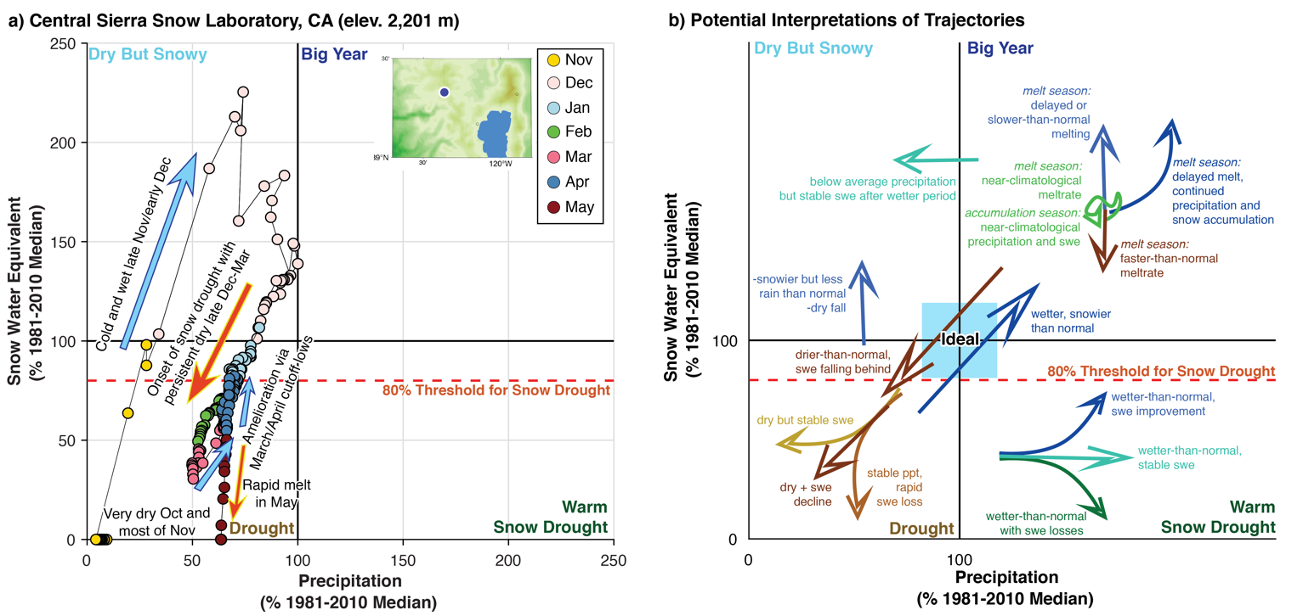
Figure 2: (a) Annotated phase diagram showing 1 November 2019-31 May 2020 at the Central Sierra Snow Laboratory, California. (b) Conceptual phase diagram showing potential interpretations of processes leading to trajectories. [Two column; color]
The start of WY2020 was characterized by very dry conditions with no snowpack at the CSS Lab. Heavy precipitation falling as snow led to rapid improvement from drought into the “dry and snowy’’ quadrant during late November into December, with near-normal precipitation occurring in mid-December. Persistent meteorological drought lasting from late December through mid-March, driven by a blocking ridge west of North America (Gibson et al., 2020), produced snow drought onset in late January. Above-normal temperatures, dry conditions, and increasing solar radiation in late February and early March caused snowpack declines to accelerate (approaching a vertical line; Fig. 1b). December-March is when California receives the majority of its annual precipitation, meaning dry spells will lead to declines in precipitation % of normal (trajectories move leftward; Fig. 1b). WY2020, like other drought years, was notable for its lack of atmospheric river landfalls that produce abrupt upwards and/or rightwards trajectories via heavy precipitation (Guan et al., 2010). Snow drought amelioration occurred in late March when heavy snowfall resulted from a slow-moving cutoff low pressure system. By 1 April, both SWE and precipitation were approximately 60% of normal. Another cutoff low in early April provided additional snow that nearly terminated snow drought conditions. The remainder of April and May were drier-than-normal, leading to rapid snowpack melting.

4.2 Snow drought variation in time and space
Weather events drive elevation-dependent changes in snowpack and snow drought conditions (Hatchett and McEvoy, 2018). In regions located near climatological rain-snow transition elevations (e.g., Mediterranean climates; Jennings et al., 2018), individual storms can produce dramatically different responses. Atmospheric rivers, which are elongated plumes of strong moisture transport associated with midlatitude cyclones, are a common type of storm event yielding variable snowpack and hydrologic responses because of heavy precipitation with corresponding high (Guan et al., 2016; Hatchett et al., 2017) or varying snow levels (Lundquist et al., 2008; Hatchett et al., 2020).

Both elevation- and longitude-dependent responses to storms and dry spells occurred during WY2018 in the Sierra Nevada (Fig. 2). WY2018 began with varying precipitation and SWE % of normal between three stations. A late November atmospheric river event was followed by a multi-month dry spell that terminated in late February. Snowpack and precipitation conditions improved markedly during “Miracle March” that was characterized by persistent stormy conditions and multiple atmospheric rivers.
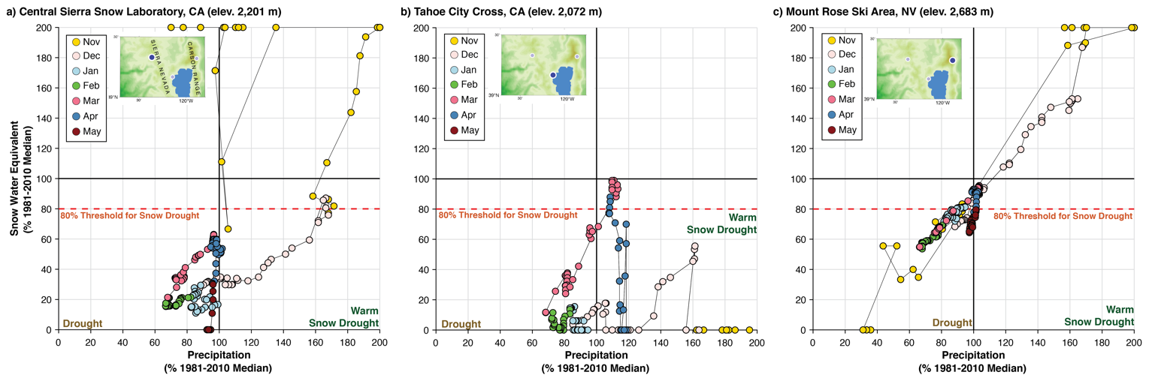
Figure 3: An elevation-longitudinal examination of snow drought conditions during water year (WY) 2018 in the northern Sierra Nevada of California and Nevada. Stations are ordered from (a) west to (c) east. [Two column; full color]
The late November warm and wet storm caused the CSS Lab and Tahoe City Cross (Figs. 3a-b; both maritime snow climates) to fall into the warm snow drought quadrant because much of the precipitation fell as rain. The CSS Lab is located along the Sierra Nevada crest while Tahoe City Cross is located further east in the rain shadow of the Sierra Nevada crest. The higher elevation Mount Rose Ski Area (hereafter “Mount Rose”), located further east in the Carson Range in an intermountain snow climate, received all snow. Mount Rose began the meteorological winter with well-above-normal precipitation and SWE (Fig. 3c). The CSS Lab and Tahoe City Cross received some snow early in December, briefly moving CSS Lab out of warm snow drought. During the subsequent dry spell, the lower elevation CSS Lab and Tahoe City Cross stations both moved leftward from warm snow drought into dry snow drought. Dry snow drought conditions began at Mount Rose in late December. Throughout January and February, below-normal SWE values were observed at all three locations. The role of elevation is highlighted with the colder Mount Rose experiencing less dramatic snowpack declines (to approximately 50% of normal) compared to the warmer CSS Lab (below 20% of normal) and Tahoe City Cross where several instances of no snow (0% of normal) were observed.

The return of an active North Pacific storm track during “Miracle March” brought notable improvement in precipitation and snowpack conditions. This month also highlighted the role of snow climate and elevation in snow drought amelioration. During March, Mount Rose—a more intermountain snow climate—received all precipitation as snow. As a result, SWE improved from approximately 55% to 97% of normal while precipitation improved from 65% to 105% of normal (Fig. 3c). The maritime CSS Lab (Fig. 3a) improved from 18% to 65% of normal SWE and from 65% to 95% of normal precipitation. The cold March storms demonstrated a weaker rain shadow and generally low (cold) snow levels. This favored improvements in SWE at Tahoe City Cross from 15% to 99% of normal while precipitation improved from 65% to 110% of normal (Fig. 3b). As a result of “Miracle March”, 1 April SWE conditions were closer to normal than reflected by the majority of the winter, similar to WY2020 (Fig. 1). If one were to only use 1 April to identify snow drought, only the CSS Lab would satisfy the constraints, despite all stations undergoing various snow drought conditions throughout extended winter.

4.3 Warm versus dry snow drought and implications for runoff timing
The warming-induced shift in precipitation phase from snow to rain is a historic trend in the western U.S. (Knowles et al., 2006; Lynn et al., 2020) that is projected to continue (Klos et al., 2014). Precipitation phase transition from snow to rain will result in more frequent warm snow droughts (Marshall et al., 2019). This increase will disproportionately impact climatologically warmer maritime snow climates (Dieraurer et al., 2019) as well as alter the hydrology and reservoir management strategies of these watersheds (Rhoades et al., 2018).

The WY2015 warm snow drought (precipitation above 100% of normal but SWE below 80% of normal) in the Pacific Northwest was a motivating event for early snow drought research (Cooper et al., 2016). To provide a comparison of years with similar SWE anomalies (40-60% of normal) but different precipitation and hydrologic outcomes, we compared a dry snow drought (WY2001; Figure 4a) to the WY 2015 warm snow drought (Figure 4b) at Paradise, Washington in the Pacific Northwest on the south flank of Ti’Swaq’ (Mount Rainier). Paradise spent the majority of the cool season in WY2001 with precipitation anomalies approximately 50% of normal, a substantial difference from WY2015 when precipitation anomalies were on the order of 120-140% of normal. The warm snow drought resulted from this anomalous precipitation largely falling as rain. Snowpack conditions slowly improved throughout WY2001 from 40% of normal to near 80% by the end of the season, however in WY2015, Paradise maintained consistent SWE % of normal anomalies of 35-55% from February to April. The general downward and leftward trajectory of precipitation during February 2015 is indicative of drier-than-normal conditions. During spring of WY2015, the clustering of points indicated consistent precipitation that maintained snowpack but did not contribute to snow drought amelioration. The rapid decline of SWE % of normal in May 2015 highlighted earlier-than-normal snowpack melting.

The differences between these dry and warm snow drought years are exemplified by differing hydrologic outcomes and spatial expressions of SWE (Figs 4c-3k). WY2001 had the second lowest cumulative flows in the period studied (WY1943–2019), but 50% of the cumulative WY2001 flow occurred 33 days later than the median date (24 February) at which half the Nisqually flow occurs. In contrast, WY2015 demonstrated middle-of-the-range total WY flow (48th of 77 years) but achieved 50% of the water year flow 48 days earlier than average. This indicates a large volume of water was not stored as snow for later release into the river. Depending on reservoir conditions and operations rules, this water may not have been allowed to be captured and stored for later use. During both seasons, spatial SWE anomalies are not notably different during mid-December (Figs. 4d and 4h), mid-January (Figs. 3e and 3i), or late February (Figs. 4f and 4j). This is consistent with similar SWE anomalies throughout the seasons at Paradise shown on the phase diagrams. By mid-April, the lack of mountain snowpack during WY 2015 was more notable than WY 2001 (Figs. 4g and 4k). The comparatively better spring snowpack in WY2001 likely helped maintain streamflow later into the year (steeper slope of WY2001 cumulative discharge between water year days 150–250), despite an otherwise dry year.
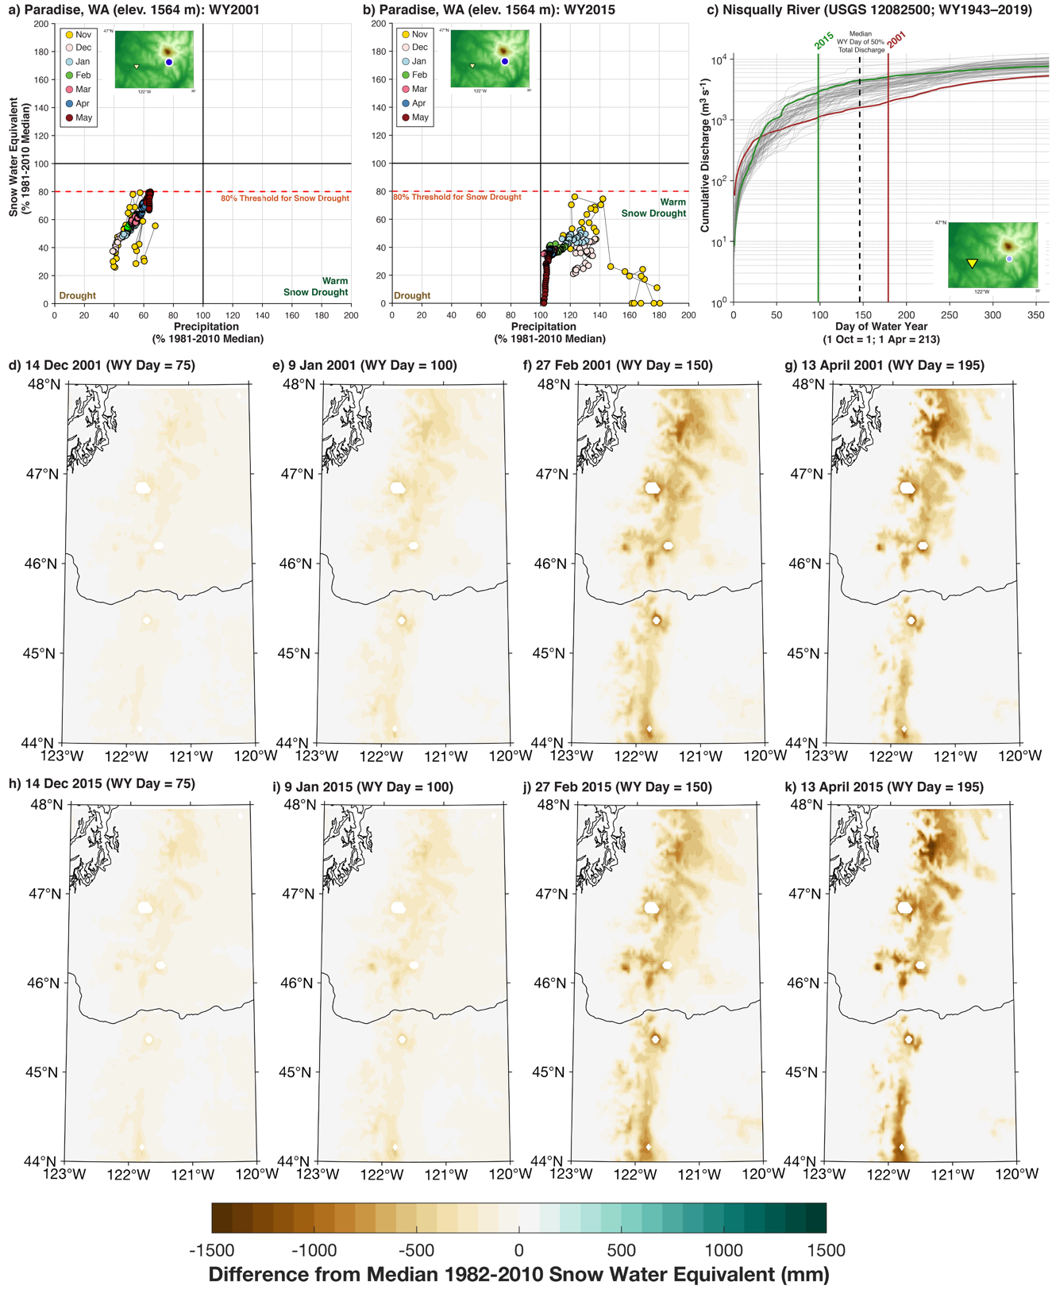
Figure 4: Comparison of dry (a) and warm (b) snow drought conditions in the Pacific Northwest at Paradise, Washington during water years (WY) 2001 and 2015, respectively. (c) Cumulative discharge from the Nisqually River with vertical lines indicating the date at which 50% of the total WY runoff occurred. (d-g) Spatial snow water equivalent anomalies during WY2001. (h-k) As in (d-g) but for WY2015. [Two column; color]

4.4 Interannual variability
Phase diagrams allow direct comparisons of years for case studies of interannual variability. Red Mountain Pass, located at high elevation in a continental snow climate in the San Juan Mountains of southwestern Colorado, is used to compare two late cool season outcomes that represent two hydroclimate extremes. The majority of WY2011 showed phase trajectories in the ‘wet and snowy’ first quadrant (Fig 5a). An active December brought SWE and precipitation anomalies to well-above-normal, though the bulk of the winter saw declines back towards near-normal conditions by the end of March. Active weather continued in April and May, preventing snowpack melting and causing precipitation, and especially SWE, % of normal values to increase. WY2012 started off well in November but drier-than-normal conditions throughout winter caused dry snow drought onset in December (Fig 5b). Snow drought amelioration and termination occurred in early March, but with a few exceptions in April, dry conditions persisted through May. This led to the re-onset of dry snow drought via rapid melting and below-normal precipitation.

Spatial SWE distributions (Figs. 5c-j) are consistent with the phase diagrams. In both years, SWE anomalies increased throughout the accumulation season and then accelerated in late spring. Compared to the emerging drought signal during WY2012, WY2011 did not demonstrate widespread positive SWE anomalies throughout the year. Between January and April, lower elevation regions experienced below-normal SWE anomalies (Figs. 5c-d), whereas higher elevations had above-normal SWE. This difference resulted from above-normal temperatures and below-normal precipitation, with snow-albedo feedbacks (Walton et al., 2017) likely further driving low elevation melting.
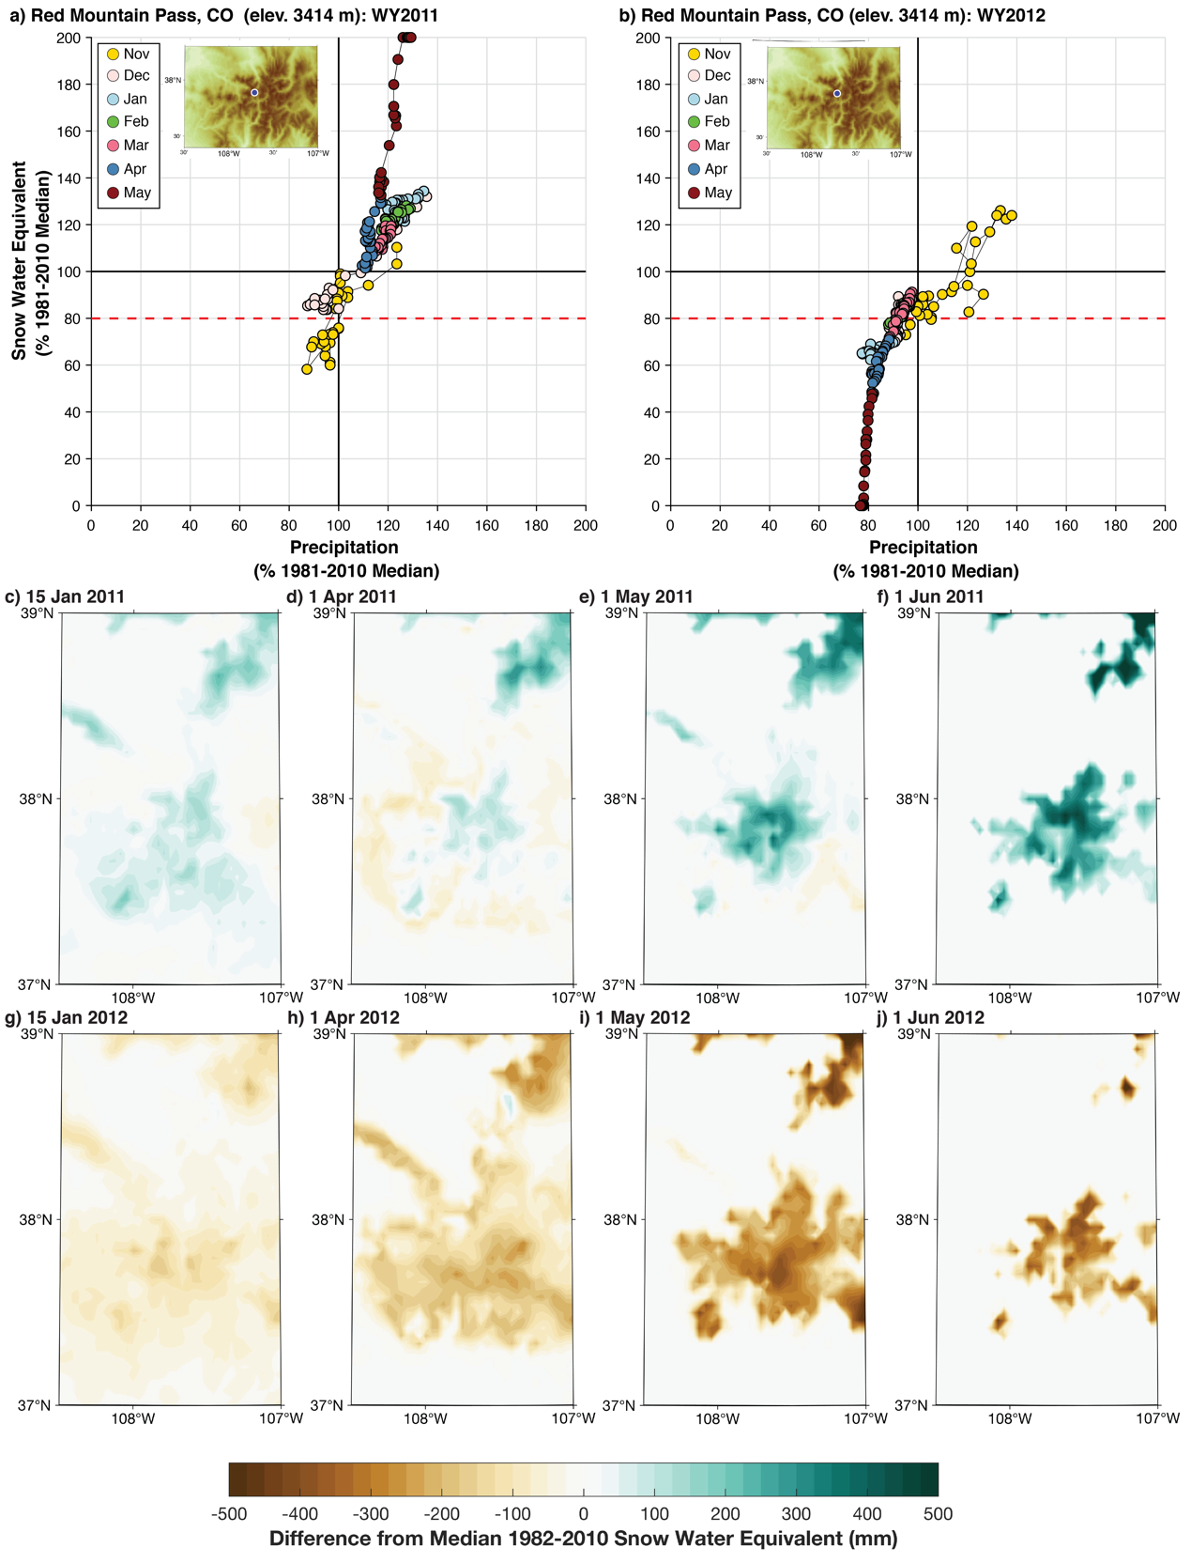
Figure 5: Comparison of a snowier- and wetter-than-normal “big year” (a) and drier-than-normal year (b) in the San Juan Mountains at Red Mountain, Colorado during water years (WY) 2011 and 2012, respectively. (c-f) Spatial snow water equivalent anomalies during WY2011. (g-j) Spatial snow water equivalent anomalies during WY2012. [Two column; color]
Spring melting rates are clearly different between the two years (Figs. 4a-b). These rates are not singularly controlled by near-surface air temperatures. Dust is an important temperature-independent control of snowpack melt rate and runoff magnitude and timing in the southwestern US (Painter et al., 2018). Spring dust flux as well as weather conditions create different outcomes in terms of snowpack behaviour (e.g., Skiles and Painter, 2016). Phase diagrams indirectly highlight these impacts. WY2011 and WY2012 had similar numbers of dust-on-snow events but different timing (Center for Snow and Avalanche Studies (CSAS), 2020). Mean dust-on-snow radiative forcing and time from peak snowpack to no snow conditions was similar for the two years (Skiles and Painter, 2016), but with late season melt trajectories leading to above-average (Fig. 5f) and below-average (Fig. 5j) SWE in the high country. According to CSAS, dust-on-snow was exposed at the snow surface in early March of WY2012, enhancing spring melt by increasing absorption of radiation at the snow surface. Though smaller storms in April reduced melting, rates accelerated in late April and May from dust radiative effects and likely additional snow-albedo feedbacks at the basin-scale. In contrast, the wet spring in WY2011 limited dust-enhanced melting until June by burying exposed dust and maintaining higher broadband albedo, as evidenced by the upwards trajectory of SWE % of normal throughout May. Hydrographs from the Senator Beck Basin (north of Red Mountain Pass) showed peak flows were 40 days earlier compared to WY2011. Earlier timing of the hydrograph’s falling limb resulted in June streamflow that is more characteristic of late summer conditions (CSAS, 2020).

5 Limitations
Our simple visualization approach is not without limitations. By failing to include additional environmental controls of snowpack, such as temperature, radiation, and relative humidity, phase diagrams cannot tell a complete story. The signal of rain-on-snow can be captured, such as when precipitation increases but SWE remains constant or declines (e.g.,
Tahoe City Cross (Fig. 3b) caused by a warm April atmospheric river (Hatchett, 2018)). However, when a rain-on-snow event increases SWE, the phase diagram will not explicitly differentiate this from a snow accumulation event. Dry periods have differing snowpack outcomes during both the accumulation and ablation season depending on temperature (Hatchett and McEvoy, 2018) as well as how the snowpack energy budget is influenced by spring dust deposition on snow (Skiles and Painter, 2016), cloud cover (Sumargo and Cayan, 2018), and moisture (Harpold and Brooks, 2018). How best to include these additional parameters, as well as capturing early season variability in a meaningful way, are areas where improvement is needed. Our phase diagram start- and end-points (1 Nov and 31 May, respectively), while informed by experience, remain arbitrary. In practice, these dates, as well as the diagram maximum values (200%) and snow drought thresholds (80%), are easily adjusted. Collaborations with natural resource managers and other practitioners and decision makers will be instrumental in the development of locally- or regionally-specific thresholds.

We applied station data to create the phase diagrams, but a challenge in mountain environments is the lack of reliable, well-distributed, long-term observations. In lieu of station data, gridded observational products commonly inform natural resource decision-making and research efforts. The necessary components exist to create phase diagrams using gridded meteorological products (Daly et al., 2008; Abatzoglou, 2013), observationally-based snow datasets (Margulis et al., 2016; Zeng et al., 2018), or output from hydrological simulations (Livneh et al., 2013). Climate projections are also often provided in a gridded format. The challenge is how to aggregate spatial information to become meaningful in complex terrain, as our visualization approach focused on individual stations. Initial methods to broaden the approach could be performed by: (1) binning regions by similar elevation, slope, aspect, and/or land cover; (2) identifying areas that co-vary together in time and space using techniques such as principal component or cluster analysis; and (3) subjective grouping based on anecdotal information from managers. Creating meaningful phase diagrams using spatially distributed information is the primary goal of our ongoing research. This will allow evaluation of snow drought in regions without long-term snow-observing networks (e.g., the northeastern U.S. or other high mountain areas).

6 Concluding Remarks
Our goal was to demonstrate a visualization approach to show the temporal evolution of snow drought conditions, and more broadly mountain hydroclimate conditions, through the cool season. When annotated, phase diagrams “tell the story” of a snow season and can help communicate the weather and climate events that shaped the outcome and behaviour of the snowpack. Provided examples showed a range of applications in various snow climates and how additional data such as spatially distributed SWE and river discharge augment the phase diagrams.

Our approach can be extended beyond addressing the noted limitations. While our primary purpose was to show the evolution of conditions in the current year, phase diagrams are easily produced for all previous years to allow comparisons of trajectories at seasonal or monthly timescales. These diagrams can be extended using forecasts of precipitation and SWE to show how snow drought conditions may evolve. For example, inclusion of bias corrected ensembles of medium range to subseasonal forecasts of precipitation and SWE can create multiple outcomes, providing a probabilistic perspective to explore snow-drought evolution. Forecasts of SWE can be generated either from direct output from atmospheric models or from physically-based snowpack models. More complex snowpack models also can also be applied to estimate how factors controlling snowpack energy balance will influence snowmelt.

Ultimately, phase diagrams may become useful tools to provide climate services to public and decision-making audiences. We are preparing the release of a Web-based tool using western U.S. SNOTEL stations that produces phase diagrams (https://wrcc-staging.dri.edu/my/climate/snow-drought-tracker). This tool will be used to explore applications of phase diagrams with groups responsible for communicating snowpack and mountain hydroclimate information to the public such as the National Weather Service as well as water and natural resource managers and their partners. We anticipate this information will aid mountain hydroclimate monitoring and drought early warning efforts.

Acknowledgements
We appreciate feedback from Michael Anderson, Sasha Gershunov, Tim Bardsley, and Zach Tolby. Roger Kreidberg provided technical editing and writing advice. This research was supported by the Desert Research Institute Foundation under an Institutional Research Project (IRP) grant.

Declaration of Interest
The authors declare no conflicts of interest.

CRediT Author Contributions
Benjamin Hatchett: Conceptualization, Investigation, Visualization, Software, Formal Analysis, Writing – Original Draft, Writing – Review and Editing, Funding Acquisition. Daniel McEvoy: Conceptualization, Investigation, Funding Acquisition, Writing – Review and Editing.

References
Abatzoglou, J. T.: Development of gridded surface meteorological data for ecological applications and modelling. Int. J. Climatol., 33, 121-131, doi:10.1002/joc.3413, 2013
Beniston M.: Climatic Change in Mountain Regions: A Review of Possible Impacts, in: Diaz H.F. (eds) Climate Variability and Change in High Elevation Regions: Past, Present & Future. Advances in Global Change Research, vol 15. Springer, Dordrecht, doi:10.1007/978-94-015-1252-7_2, 2003
Berghuijs, W. R., Woods, R. A. and Hrachowitz, M.: A precipitation shift from snow towards rain leads to a decrease in streamflow, Nat. Clim. Chang., 4(7), 583, doi:10.1038/nclimate2246, 2014
Center for Snow and Avalanche Studies, Water year 2012 CODOS summary for Senator Beck Basin Study Area
Available at: https://snowstudies.org/dust/SBBSA/summary.html, accessed January 2020
Cooper, M. G., Nolin, A. W., and Safeeq, M.: Testing the recent snow drought as an analog for climate warming sensitivity of Cascades snowpacks, Environ. Res. Lett., 11, 084009, doi:10.1088/1748-9326/11/8/084009, 2016
Daly, C., Halbleib, M., Smith, J. I., Gibson, W. P., Doggett, M. K., Taylor, G. H., Curtis, J. and Pasteris, P. P.: Physiographically sensitive mapping of climatological temperature and precipitation across the conterminous United States. Int. J. Climatol., 28, 2031-2064. doi:10.1002/joc.1688, 2008.
Dettinger, M. D., Ralph, F. M., Das, T., Neiman, P. J., and D. R. Cayan, D.R.: Atmospheric rivers, floods, and the water resources of California, Water, 3, 445-478, doi:10.3390/w3020445, 2011
Dierauer, J. R., Allen, D. M. and Whitfield, P. H.: Snow drought risk and susceptibility in the western United States and southwestern Canada, Wat. Resour. Res., 55(4), 3076-3091, doi:10.1029/2018WR023229, 2019
Foster, L. M., Bearup, L. A., Molotch, N. P., Brooks, P. D., & Maxwell, R. M.: Energy budget increases reduce mean streamflow more than snow–rain transitions: Using integrated modeling to isolate climate change impacts on Rocky Mountain hydrology, Env. Res. Lett., 11(4), 044015, 2016
Guan, B., Molotch, N. P., Waliser, D. E., Fetzer, E. J., and Neiman, P. J.: Extreme snowfall events linked to atmospheric rivers and surface air temperature via satellite measurements, Geophys. Res. Lett., 37, L20401, doi:10.1029/2010GL044696, 2010
Gibson, P. B., Waliser, D.E. Guan, B., DeFlorio, M. J., Ralph, F. M., and Swain, D.L.: Ridging associated with drought across the western and southwestern United States: Characteristics, trends, and predictability sources. J. Clim., 33, 2485–2508, doi:10.1175/JCLI-D-19-0439.1, 2020
Hagenstad, M., E.A. Burakowski, and R. Hill.: Economic Contributions of Winter Sports in a Changing Climate. Protect Our Winters, Boulder, CO, USA, available at: https://scholars.unh.edu/cgi/viewcontent.cgi?article=1190&context=ersc, 2018
Harpold, A. A. and Brooks, P. D.: Humidity determines snowpack ablation under a warming climate. Proc. Nat. Acad. Sci., 115(6), 1215-1220, 2018
Harpold, A. A., M. Dettinger, M. D., and S. Rajagopal, S.: Defining snow drought and why it matters, Eos, Trans. Amer. Geophys. Union, 98, doi:10.1029/2017EO068775, 2017
Hatchett, B. J. and Eisen, H. G.: Brief Communication: Early season snowpack loss and implications for oversnow vehicle recreation travel planning, The Cryosphere, 13, 21–28, doi:10.5194/tc-13-21-2019, 2019
Hatchett, B., Daudert, B., Garner, C., Oakley, N., Putnam, A. and White, A.: Winter snow level rise in the northern Sierra Nevada from 2008 to 2017, Water, 9(11), 899, doi:10.3390/w9110899, 2017
Hatchett, B., Snow level characteristics and impacts of a spring typhoon-originating atmospheric river in the Sierra Nevada, USA, Atmos., 9(6), 233, doi:10.3390/atmos9060233, 2018
Hatchett, B. J. and McEvoy, D. J.: Exploring the origins of snow drought in the northern Sierra Nevada, California, Earth Inter., 22(2), 1-13, doi:10.1175/EI-D-17-0027.1, 2018
Hatchett, B. J., and 19 co-authors: Observations of an extreme atmospheric river storm with a diverse sensor network, Earth and Space Science, in press, doi: 10.1029/2020EA001129, 2020
Kapnick, S. and Hall, A.: Causes of recent changes in western North American snowpack, Clim. Dyn., 38(9-10), 1885-1899, doi:10.1007/s00382-011-1089-y, 2012
Klos, P. Z., Link, T. E. and Abatzoglou, J. T.: Extent of the rain‐snow transition zone in the western US under historic and projected climate, Geophys. Res. Lett., 41(13), 4560-4568, doi:10.1002/2014GL060500, 2014
Livneh B., Rosenberg, E. A., Lin, C., Nijssen, B., Mishra, V., Andreadis, K.M., Maurer, E. P., and D.P. Lettenmaier, D. P.: A Long-Term Hydrologically Based Dataset of Land Surface Fluxes and States for the Conterminous United States: Update and Extensions, J. Clim., 26, 9384–9392, 2013
Lund, J., Medellin-Azuara, J., Durand, J. and Stone, K.: Lessons from California’s 2012–2016 drought, J. Water Res. Plan. Manage., 144(10), p.04018067, doi:10.1061/(ASCE)WR.1943-5452.0000984, 2018
Lynn, E., Cuthbertson, A., He, M., Vasquez, J. P., Anderson, M. L., Coombe, P., Abatzoglou, J. T., and Hatchett, B. J.: Technical note: Precipitation phase partitioning at landscape-to-regional scales, Hydrol. Earth Syst. Sci. Discuss., doi:10.5194/hess-2020-122, in revision, 2020
Marshall, A. M., Abatzoglou, J. T., Link, T. E. and Tennant, C. J.: Projected changes in interannual variability of peak snowpack amount and timing in the Western United States, Geophys. Res. Lett., 46(15), pp.8882-8892, 2019
Margulis, S. A., G. Cortés, G., Girotto, M. and Durand, M.: A Landsat-Era Sierra Nevada Snow Reanalysis (1985–2015). J. Hydrometeor., 17, 1203–1221, doi:10.1175/JHM-D-15-0177.1, 2016
Margulis, S. A., Fang, Y., Li, D., Lettenmaier, D. P., and Andreadis, K.: The utility of infrequent snow depth images for deriving continuous space‐time estimates of seasonal snow water equivalent, Geophys. Res. Lett., 46, 5331–5340, doi:10.1029/2019GL082507, 2019
Mote, P. W., Li, S., Lettenmaier, D. P., Xiao, M. and Engel, R.: Dramatic declines in snowpack in the western US, npj Climate and Atmospheric Science, 1(1), 2, doi:10.1038/s41612-018-0012-1, 2018
Musselman, K.N., Clark, M. P., Liu, C., Ikeda, K. and Rasmussen, R.: Slower snowmelt in a warmer world, Nat. Clim. Chang., 7(3), 214, doi:10.1038/nclimate3225, 2017
O’Hara, B. F., Kaplan, M. L. and Underwood, S. J.: Synoptic climatological analyses of extreme snowfalls in the Sierra Nevada, Wea. Forecast., 24(6), 1610-1624, 2009
Painter, T. H., Skiles, S. M., Deems, J. S., Brandt, W. T. and Dozier, J.: Variation in rising limb of Colorado River snowmelt runoff hydrograph controlled by dust radiative forcing in snow, Geophy. Res. Lett., 45(2), 797-808, doi: 10.1002/2017GL075826, 2018
Pepin, N., Bradley, R., Diaz, H. Baraer, M., Caceres, E. B., Forsythe, N., Fowler, H., Greenwood, G., Hashmi, M. Z., Liu, X. D., Miller, J. R., Ning, L., Ohmura, A., Palazzi, E., Rangwala, I., Schner, W., Severskiy, I., Shahgedanova, M., Wang, M. B., Williamson S. N., and Yang, D. Q.: Elevation-dependent warming in mountain regions of the world, Nat. Clim. Chang., 5, 424–430, doi:10.1038/nclimate2563, 2015
Scott, D.: Global Environmental Change and Mountain Tourism, in: S. Gössling and C. M. Hall (eds), Tourism and Global Environmental Change, Routledge, London, pp. 54–75, doi:10.4324/9780203011911, 2006
Skiles, S.M.K. and Painter T. H.: A nine-year record of dust on snow in the Colorado River Basin, in: Ralston, B.E.,
ed., Proceedings of the 12th Biennial Conference of Research on the Colorado River Plateau: U.S. Geological Survey Scientific Investigations Report 2015–5180, 128 p., doi:10.3133/sir20155180, 2016
Sturm, M., Goldstein, M. A. and Parr, C.: Water and life from snow: A trillion dollar science question, Wat. Resour. Res., 53(5), 3534-3544, doi:10.1002/2017WR020840, 2017
Sumargo, E. and Cayan, D. R.: Variability of cloudiness over mountain terrain in the Western United States, J. Hydrometeor., 18(5), 1227-1245, doi:10.1175/JHM-D-16-0194.1, 2017
Rhoades, A. M., Jones, A. D., and Ullrich, P. A.: The changing character of the California Sierra Nevada as a natural reservoir, Geophys. Res. Lett., 45, 13,008– 13,019, doi:10.1029/2018GL080308, 2018
Viviroli, D., Dürr, H. H., Messerli, B., Meybeck, M., and Weingartner, R.: Mountains of the world, water towers for humanity: Typology, mapping, and global significance, Water Resour. Res., 43, W07447, doi:10.1029/2006WR005653, 2007
Walton, D. B., Hall, A., Berg, N., Schwartz, M. and Sun, F.: Incorporating snow albedo feedback into downscaled temperature and snow cover projections for California’s Sierra Nevada, J. Clim., 30(4), 1417-1438, doi:10.1175/JCLI-D-16-0168.1, 2017
Zeng, X., Broxton, P., and Dawson, N.: Snowpack change from 1982 to 2016 over conterminous United States, Geophys. Res. Lett., 45, 12,940– 12,947, doi:10.1029/2018GL079621, 2018

