Title: Grainstone cross-set geometry as a resilient physical proxy for ancient marine cements

Authors: Benjamin T. Cardenas*, Benjamin P. Smith

Jackson School of Geosciences, University of Texas at Austin, Austin, TX, USA

*Corresponding Author Information
Telephone: (210) 240-0382
Email: benjamin.cardenas@utexas.edu

THIS IS A NON-PEER REVIEWED PRE-PRINT SUBMITTED TO EARTHARXIV AND UNDER REVIEW AT GEOLOGY

Pages: 17

Characters (title through conclusions): 16,451 (16,500 character limit)

Abstract: 241 words (250 word limit)

Figures: 4 (4 figure limit)

References: 30
Grainstone cross-set geometry as a resilient physical proxy for ancient marine cements
Benjamin T. Cardenas*, Benjamin P. Smith
Jackson School of Geosciences, University of Texas at Austin, Austin, TX, USA

ABSTRACT
Preserved cross-set thicknesses are powerful tools for unravelling past environmental conditions. The relative rate of bedform aggradation to migration (climb angle) is encoded into the distribution of cross-set thicknesses. In siliciclastic strata, climb angles have been used to reconstruct properties of the depositional system, including ancient topography, which exerted a control on local aggradation rates. Cross-set thickness distributions in early-cemented carbonate environments should prove equally useful. If sedimentation and cementation are contemporaneous, cementation might be a unique driver for cross-set accumulation and preservation. It follows that analysis of preserved cross sets might reveal information about local—and possibly global—factors that enhance seafloor cementation.
To test this idea, we analyze the distribution of cross-set thicknesses in a grainstone interval of the Cretaceous Glen Rose Formation at an outcrop in Austin, TX, USA. Bedform climb angles associated with the distribution of cross-set thicknesses are on the order of 0.5° to 5°. In siliciclastic systems, climb angles this high are typically driven by the filling of local relief; no such relief is observed in this carbonate system. We interpret this as evidence for rapid bed aggradation driven by early cementation, producing a uniquely carbonate mode of bedform-substrate interactions. We suggest that at geologic time scales, global trends in carbonate bedform preservation should be sensitive to both carbonate chemistry and biotic innovations in animal-substrate interactions. If so, our results provide both a precedent and a quantitative method for exploring these topics in deep time.

INTRODUCTION
Bedform motion is a small-scale element which defines the larger-scale kinematics of sedimentary systems (Reesink et al., 2015; Cardenas et al. A and B). This motion is encoded into sets of cross strata, which record the migration and aggradation of dunes. Bedform migration and aggradation are sensitive to external conditions including changing sediment availability and antecedent topography, as well as internal autogenic factors such as dune interactions (Brothers et al., 2017; Day and Kocurek, 2017; Swanson et al., 2017), variable sedimentation across multi-scale topography (Reesink et al., 2015; Swanson et al. in review), and bedform deformation (Ganti et al., 2013). As a result, numerous studies have used cross-set thicknesses to understand bedform motion using theory (Paola and Borgman, 1991), physical and numerical experiments (Bridge, 1997; Bridge and Best, 1997; Leclair et al., 1997; Jerolmack and Mohrig, 2005; Ganti et al., 2013), and field studies of ancient strata (Cardenas et al. A and B).
With the appropriate geologic context, cross-set analysis reveals a significant amount of information about ancient depositional systems. For example, this analysis has been used to distinguish pre-existing topography from dune-scour topography in aeolian sandstones (Cardenas et al., 2019), and to estimate bed aggradation and bar migration rates in fluvial channel-belt strata (Cardenas et al., in review). Although the quantitative analysis remains unchanged among systems, the geologic context determines the nature of external and internal forcings, making this tool applicable to a wide number of problems. Here, we extend this analysis to carbonate settings using cross-stratified grainstones from the Cretaceous Glen Rose Formation, Austin, TX, USA. Unlike siliciclastics, carbonate minerals are reactive at earth surface conditions, making syndepositional cements and crusts a common component of shallow marine settings (Moore et al., 1973; Lamb et al., 2012). The goal of this study is to understand whether grainstone cross sets record kinematics and forcings that are unique to carbonate bedforms.

METHODS
The roadcut exposing the Glen Rose Formation grainstones studied here is located along the eastern side of Highway 360 in Austin, Texas, USA, located at 30.3332° N, 97.8072° W. A vertical section describing facies changes over ~5.4 m was constructed. A scaled photopan of the outcrop was built by flattening 38 high-resolution photos to a plane, imaging an area 30 m long by 1.2 m high with mm-scale resolution. The resolution of the photopan allowed for the identification of bounding surfaces, which were mapped as continuously as possible, as well as identifying grainstone versus mudstone on the basis of sedimentary structures, roughness, and protrusion, informed by field examination. Thickness measurements of individual grainstone beds were made along 15 vertical sections with 1.45 m spacing. Following the analysis of Cardenas et al. (accepted), the distribution of set thicknesses (s) was then compared to fitted exponential and gamma curves using a two-sample Kolmogorov-Smirnov test. The coefficient of variation (c_{v}) for set thicknesses was calculated as

c_{v} = s_{σ} / s_{m} (1),

where s_{m} and s_{σ} are the mean and standard deviation of the measured set thicknesses. This method quantifies the significance of bed aggradation in the construction of the deposit. Assuming bedform heights were gamma distributed as is often observed (Paola and Borgman, 1991; van der Mark et al., 2008; Ganti et al., 2013), a system undergoing net bypass (zero net bed aggradation) will have a c_{v} = 0.88 and exponentially distributed set thicknesses (Paola and Borgman, 1991). The creation of any record at all in this scenario is dependent on the variability in scour depths, and is limited to the fills of the deepest scours to move past a given location, and thin, truncated fragments of sets (Paola and Borgman, 1991). Bed aggradation, forced by a spatial deceleration driven by some external or internal process (Reesink et al., 2015), creates a gamma distribution of set thicknesses and a lower c_{v}, as preservation is not limited to the thickest and thinnest sets. With significant aggradation, the set thickness gamma distribution and c_{v} reflect those of the formative bedform heights (Jerolmack and Mohrig, 2005).

RESULTS
The outcrop shows a consistent vertical arrangement of facies ~5.4 m thick, shown in the vertical log in Figure 1. Facies D (Fig. 1) is the focus of the 1.2 m high panorama and is exposed continuously across it (Fig. 2A). Mapped surfaces bound the cross-bedded grainstone interval, as well as individual cross sets and mudstone drapes within the interval (Fig. 1B). The majority of sets continue laterally across the studied interval for many times their thickness without being truncated. Dolomitized mudstones lacking mudcracks within the cross-bedded grainstone interval fill local lows defined by cross-set bounding surfaces (Fig. 2A), as well as draping topographic highs (Fig. 2B). Together, the drapes and plugs compose 9% of this facies. Rippled grainstone surfaces are preserved within these mudstones (Fig. 3A). The cross beds contain rip-up clasts of this dolomitized mudstone throughout (Fig. 3B). The contact between the laminated mudstone below the grainstone interval follows the relief of the laminations with few deep truncations of the laminated interval (Fig. 3C).
The distribution of cross-set thicknesses (n = 195) have s_{m} = 54 mm, s_{σ} = 25 mm, and c_{v} = 0.46 (Eq. 1), and is shown as a cumulative distribution function (CDF; Fig. 4A) and a probability density function (PDF; Fig. 4B) along with fitted distributions. The gamma distribution is not rejected at a significance level of 0.05 (p < 0.70), while the exponential fit is rejected (p < 0.001).

DISCUSSION
Depositional setting and bedform kinematics
The facies succession is interpreted to record two shallowing-upward cycles separated by a deepening cycle (Fig. 1). The first shallowing-upward cycle is represented by the coarsening from MDP (A) to GDP (B), and ultimately to the laminated mudstones which are interpreted as microbial laminations associated with subaerial exposure in a peritidal environment (C; Pratt, 2010). The cycle containing the cross-bedded grainstones with mudstone drapes and plugs (D), burrowed grainstone (E), and wackestone (F) records an upward fining interpreted as a deepening. The final transition from wackestone (F) to GDP (G) is interpreted to record another shallowing cycle (Tucker, 1985). Together, these cycles are interpreted to record local water depth changes within a supratidal to subtidal environment. Given this context, the compound nature of the grainstone interval composed of smaller cross-sets, and the interbedded mudstone drapes and plugs without mudcracks (Figs. 3A-B), the cross-bedded grainstone interval (D) is interpreted to represent a subtidal bar (Gonzalez and Eberli, 1997). The 9% mudstone content measured in this interval is similar to the mud content observed in modern tidal bars (Reeder and Rankey, 2008).
The fit of the gamma curve to the distribution of set thicknesses, the rejection of the exponential fit, and the low c_{v} of 0.46 are all indicators that a relatively high ratio of aggradation rate to bedform migration rate (i.e., climb angle) was required to construct these cross sets (Fig. 4A-B; Jerolmack and Mohrig, 2005). A c_{v} = 0.46 is associated with climb angles on the order of 0.5° - 5°, whereas nearly bypass systems would be associated with a c_{v} = 0.88, an exponential distribution (Fig. 3A-B) and essentially zero climb (Paola and Borgman, 1991; Bridge and Best, 1997; Jerolmack and Mohrig, 2005). Rapid bed aggradation is also supported by the spatial relationships between mudstone and grainstone. Mudstone drapes are preserved over topographically low and high parts of the bar (Figs. 3A-B), yet mudstone rip-ups ubiquitous throughout the grainstone interval (Figs. 2B and 3B) suggest transport conditions were capable of re-mobilizing these drapes. Drapes over high relief would be particularly susceptible to reworking. An interpretation consistent with these observations and the quantitative analysis is that aggradation was rapid enough to remove these drapes from the active scouring zone before complete reworking could occur. Finally, the observed continuity of the cross sets and the lack of lateral truncation in this exposure (Fig. 2B) are inconsistent with a low aggradation rate model, which should produce significant lateral variability in set thickness and the complete truncation of cross sets by other cross sets (Jerolmack and Mohrig, 2005; Cardenas et al., 2019).
In fluvial and aeolian settings where similar c_{v} values and aggradational architectures are recorded, aggradation was driven by the spatial deceleration of bedforms into local topographic lows (Reesink et al., 2015; Cardenas et al. 2019, in review). Local topography is certainly capable of exerting a control on carbonate deposition (Kocurek et al., 2019), but the cross-bedded grainstone interval of the Glen Rose shows no indicators of a topographic control, such as a thickening of sets climbing into depressions or downlapping structures. Additionally, the presence of intertidal facies such as microbial laminites indicates that accommodation was extremely limited. Without a clear topographic driver, another forcing must be invoked. The cementing of the seafloor is a common occurrence in shallow carbonate settings (Moore et al., 1973) and can occur at rates significant to bedform development (Lamb et al., 2012). We hypothesize that surface cementation drove the aggradation of this tidal bar by trapping sediment at the bottom of bedform troughs, preventing major remobilization of accumulated cross sets and promoting climb overall, although some reworking is recorded by erosional bounding surfaces and mudstone rip-ups (Fig. 3B). Rapid cementation of this facies is generally supported by the preserved ripples within the mudstone plug, which were clearly lithified enough by the time of their burial to prevent deformation (Figs. 3A and 4C). Based on the c_{v} of 0.46, sediment trapped at the bed drove bed aggradation at rates of 0.01 to 0.1 times the average bedform migration rate (Jerolmack and Mohrig, 2005), producing the high climb angles observed here. Another possible scenario is aggradation was forced by a spatial deceleration related to tides. Still, the lack of topography to then protect these accumulations from later reworking (e.g., Cardenas et al., 2019) requires surface cementation, but on the time scale of changing tides instead of migrating bedforms. Siliciclastic tidal bar strata presented in Fenies and Tastet (1998) are not as continuous, and reworking is observed on at least the time scale of spring tides (twice monthly). In either case, the high c_{v} value for the carbonate grainstone in the absence of a topographic forcing likely reflects fundamental differences in bedform-substrate interactions between carbonate and siliciclastic environments.

Implications for the evolution of marine substrates
If synsedimentary cements can drive bedform preservation, then carbonate strata should be sensitive to changes in the early cementation potential of the seafloor. Bedforms associated with seafloor precipitates—carbonate cements that grew at the sediment-water interface—provide a basic test for this concept. In the case of Marinoan (Neoproterozoic) cap carbonates, seafloor precipitates directly overlie intervals of unusual bedform preservation (Allen and Hoffman, 2005). The basal units in these strata are long-lived, globally correlative giant ripples that cross at least one paleomagnetic reversal, indicating stability over time scales of at least 10⁴ years (Trindade et al., 2003; Lamb et al., 2012). Lamb et al. (2012) concluded that bedform preservation and longevity is best explained by high saturation states and rapid cementation after the snowball-earth deglaciation, providing concrete linkages among carbonate bedform preservation, cementation, and ocean chemistry.
While the Neoproterozoic provides critical evidence that carbonate bedforms may be sensitive to seafloor cementation, seafloor precipitates and preservation of full carbonate bedforms are extremely rare in the rock record. The preservation of sharp-crested, oscillatory wave ripples appears almost unique in Earth history, limiting the value of this analog for other time periods. In contrast, set-thickness measurements of subcritically climbing bedforms provide a more widely applicable metric for the relative importance of early seafloor cementation. This novel proxy has several immediate applications to outstanding problems. First, quantitative evidence for the long-term saturation state of the Phanerozoic oceans is scarce (Tyrrell and Zeebe, 2004; Zeebe, 2012). Measurements of well-preserved set thicknesses could offer an important constraint, provided there is good spatial and temporal coverage. Second, several short-term carbon cycle perturbations are associated with ‘anomalous’ carbonate precipitates such as globally extensive, large oolites (Trower et al., 2017). The combination of set thicknesses and quantitative models of ooid growth (i.e., Trower et al., 2017) could improve our understanding of ocean chemistry surrounding major carbon cycle perturbations. Lastly, the rise of seafloor bioturbation in the early Paleozoic physically mixed substrates and changed pore-water chemistry, providing a competing driver to early cementation (Tarhan et al., 2015). Combining ichnofabrics with set thicknesses could lend insight into changing dynamics of animal-substrate interactions throughout time.

CONCLUSIONS
Syndepositional seafloor cementation can exert a significant control on the construction of cross-bedded grainstone strata. This external forcing is likely unique to carbonate depositional settings. The degree of early cementation likely reflects both carbonate chemistry and reworking by organisms, making set thickness distributions a unique and complimentary proxy for understanding the evolution of marine substrates. This proxy should be collected in future field studies, and it will be especially critical for the majority of history where direct geochemical proxies are ambiguous or poorly preserved. Indeed, cements inducing high climb angles may explain some non-exponential bed-thickness distributions observed in other shallow-water carbonates (Burgess, 2008).

ACKNOWLEDGEMENTS
The authors acknowledge Charlie Kerans for his photography of the outcrop. B.T.C. acknowledges funding from the Jackson School of Geosciences and the RioMAR industry consortium, and thanks his colleagues in the Carbonate and Evaporite Depositional Systems class of Fall 2018 for useful discussions and Rebekah Grmela for help accessing outcrop. B.P.S. acknowledges funding from the RCRL industry consortium. We thank Paul Myrow for helpful discussions and _____ for early reviews of this manuscript.

REFERENCES CITED
Bridge, J., 1997, Thickness of sets of cross strata and planar strata as a function of formative bed-wave geometry and migration, and aggradation rate: Geology, v. 25, p. 971-974.
Bridge, J., and Best, J., 1997, Preservation of planar laminae due to migration of low-relief bed waves over aggrading upper-stage plane beds: comparison of experimental data with theory: Sedimentology, v. 44, p. 253-262.
Brothers, S.C., Kocurek, G., Brothers, T.C., and Buynevich, I.V., 2017, Stratigraphic architecture resulting from dune interactions: White Sands dune field, New Mexico: Sedimentology, v. 64, p. 686-713.
Burgess, P.M., 2008, The nature of shallow-water carbonate lithofacies thickness distributions: Geology, v. 36, p. 235-238.
Cardenas, B.T., Kocurek, G., Mohrig, D., Swanson, T., Hughes, C.M., and Brothers, S.C., 2019, Preservation of autogenic processes and allogenic forcings in set-scale aeolian architecture II: the scour-and-fill dominated Jurassic Page Sandstone, Arizona, USA: Journal of Sedimentary Research, accepted.
Cardenas, B.T., Mohrig, D., Goudge, T.A., Hughes, C.M., Levy, J.S., Swanson, T., and Mason, J., and Zhao, F., Anatomy of an exhumed river-channel belt: Reconstructing bedform- and belt-scale kinematics from the Cretaceous Cedar Mountain Formation, Utah, USA: In review, Sedimentology.
Day, M.D., and Kocurek, G., 2017, Aeolian dune interactions preserved in the ancient rock record: Sedimentary Geology, v. 358, p. 187-196.
Fenies, H., and Tastet, J.-P., 1998, Facies and architecture of an estuarine tidal bar (the Trompeloup bar, Gironde Estuary, SW France): Marine Geology, v. 150, p. 149-169.
Ganti, V., Paola, C., and Foufoula-Georgiou, E., 2013, Kinematic controls on the geometry of the preserved cross sets: Journal of Geophysical Research: Earth Surface, v. 118, p. 1296-1307.
Gonzalez, R., and Eberli, G.P., 1997, Sediment transport and bedforms in a carbonate tidal inlet; Lee Stocking Island, Exumas, Bahamas: Sedimentology, v. 44, p. 1015-1030.
Jerolmack, D.J., and Mohrig, D., 2005, Frozen dynamics of migrating bedforms: Geology, v. 33, p. 57-60.
Kocurek, G., Martindale, R.C., Day, M., Goudge, T.A., Kerans, C., Hassenruck-Gudipati, H.J., Mason, J., Cardenas, B.T., Petersen E.I., Mohrig, D., Aylward, D.S., Hughes, C.M., and Nazworth, C.M., 2019, Antecedent aeolian dune topographic control on carbonate and evaporite facies: Middle Jurassic Todilto Member, Wanakah Formation, Ghost Ranch, New Mexico, USA: Sedimentology, v. 66, p. 808-837.
Lamb, M.P., Fischer, W.W., Raub, T.D., Perron, J.T., and Myrow, P.M., 2012, Origin of giant wave ripples in snowball Earth cap carbonate: Geology, v. 40, p. 827-830.
Leclair, S.F., Bridge, J.S., and Wang, F., 1997, Preservation of cross-strata due to migration of subaqueous dunes over aggrading and non-aggrading beds: comparison of experimental data with theory: Geoscience Canada, v. 24, p. 55-66.
Moore, C. H. Jr., 1973, Intertidal carbonate cementation, Grand Cayman, West Indies: Journal of Sedimentary Petrology, v. 43, p. 591-602.
Paola, C., and Borgman, L., 1991, Reconstructing random topography from preserved stratification: Sedimentology, v. 38, p. 553-565.
Paola, C., Ganti, V., Mohrig, D., Runkel, A.C., and Straub, K.M., 2018, Time not our time: physical controls on the preservation and measurement of geologic time: The Annual Review of Earth and Planetary Sciences, v. 46, p. 409-438.
Pratt, B.R., 2010, Peritidal Carbonates, Chapter 16 from Facies Models 4, ed. James, N.P., and Dalrymple, R.W., Geological Association of Canada.
Prokocki, E.W., Best, J.L., Perillo, M.M., Ashworth, P.J., Parsons, D.R., Sambrook Smith, G.H., Nicholas, A.P., and Simpson, C.J., in review, Thalweg dune morphology across the fluvial-tidal transition: lower Columbia River, OR/WA, USA. Earth Surface Processes and Landforms.
Reeder, S.L., and Rankey, E.C., 2008, Interactions between tidal flows and ooid shoals, Northern Bahamas: Journal of Sedimentary Research, v. 78, p. 175-186.
Reesink, A.J.H., van den Berg, J.H., Parsons, D.R., Amsler, M.L., Best, J.L., Hardy, R.J., Orfeo, O., and Szupiany, R.N., 2015, Extremes in dune preservation: Controls on the completeness of fluvial deposits: Earth-Science Reviews, v. 150, p. 652-665.
Swanson, T., Mohrig, D., Kocurek, G., and Liang, M., 2017, A surface model for aeolian dune topography: Mathematical Geosciences, v. 49, p. 635-655.
Swanson, T., Mohrig, D., Kocurek, G., Cardenas, B.T., and Wollinsky, M.A., 2019, Preservation of autogenic processes and allogenic forcings within set-scale aeolian architecture I: numerical experiments: Journal of Sedimentary Research, accepted.
Tarhan, L. G., Droser, M. L., Planavsky, N. J., and Johnston, D. T., 2015, Protracted development of bioturbation through the early Palaeozoic Era: Nature Geoscience, v. 8, no. 11, p. 865.
Trindade, R. I. F. d., Font, E., D'Agrella‐Filho, M. S., Nogueira, A., and Riccomini, C., 2003, Low‐latitude and multiple geomagnetic reversals in the Neoproterozoic Puga cap carbonate, Amazon craton: Terra Nova, v. 15, no. 6, p. 441-446.
Trower, E. J., Lamb, M. P., and Fischer, W. W., 2017, Experimental evidence that ooid size reflects a dynamic equilibrium between rapid precipitation and abrasion rates: Earth and Planetary Science Letters, v. 468, p. 112-118.
Tucker, M.E., 1985, Shallow-marine carbonate facies and facies models: Geological Society, London, Special Publications, v. 18, p. 147-169.
Tyrrell, T., and Zeebe, R. E., 2004, History of carbonate ion concentration over the last 100 million years: Geochimica et Cosmochimica Acta, v. 68, no. 17, p. 3521-3530.
van der Mark, C.F., Blom, A., and Hulscher, S.J.M.H., 2008, Quantification of variability in bedform geometry: Journal of Geophysical Research, v. 113, F03020.
Zeebe, R. E., 2012, History of seawater carbonate chemistry, atmospheric CO₂, and ocean acidification: Annual Review of Earth and Planetary Sciences, v. 40, p. 141-165.

FIGURES
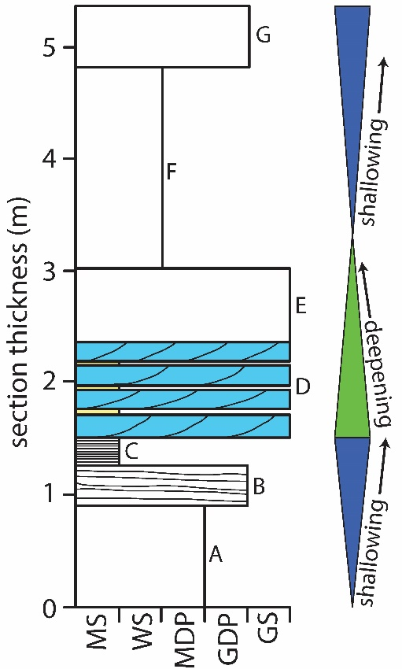
Figure 1 - The outcrop shows a consistent vertical arrangement of facies ~5.4 m thick, labeled A-G from bottom to top: A: Burrowed mud-dominated packstone (MDP; ~0.9 m). B: Laminated grain-dominated packstone (GDP; ~0.4 m). C: Microbial laminated mudstone (MS; 0.3 m). D: cross-bedded GS MS plugs and drapes (~0.8 m); E: Partially-burrowed GS (~0.7 m); F: Burrowed wackestone (WS; ~1.8 m); G: Burrowed GDP (0.5 m). Facies D, colored in blue, is the focus of the 1.2 m high panorama and is exposed continuously across it (Fig. 2A). Interpreted shallowing and deepening cycles are shown to the side.

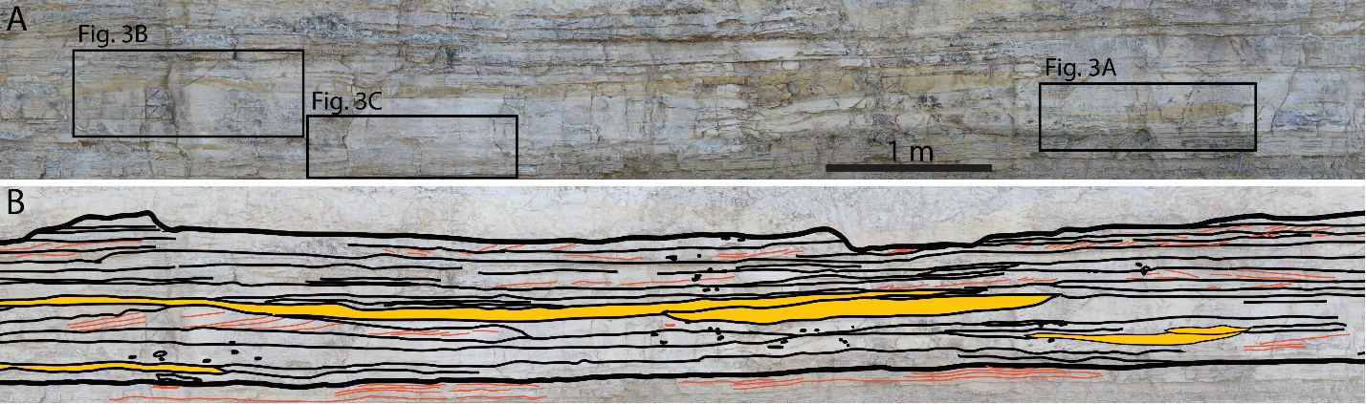
Figure 2 - A: Representative subset of the interval with cross-bedded grainstone and mudstone drapes and plugs. From the panorama, the two rock types can be reliably identified by differences in sedimentary structures, roughness, and protrusion. Locations of panels 3A-C are shown. B: Interpretation of panel A with bounding surfaces mapped in thin black lines and larger mudstone drapes colored in yellow. Smaller mudstone drapes were omitted from this interpretation, but were not included in thickness analysis. The top and bottom of the interval are mapped with bold black lines. Cross strata within the interval are mapped in orange. Orange lines beneath the interval follow the microbial laminations below. Small black circles outline mudstone rip-up clasts within grainstone beds. Note the lateral continuity of the cross-sets.

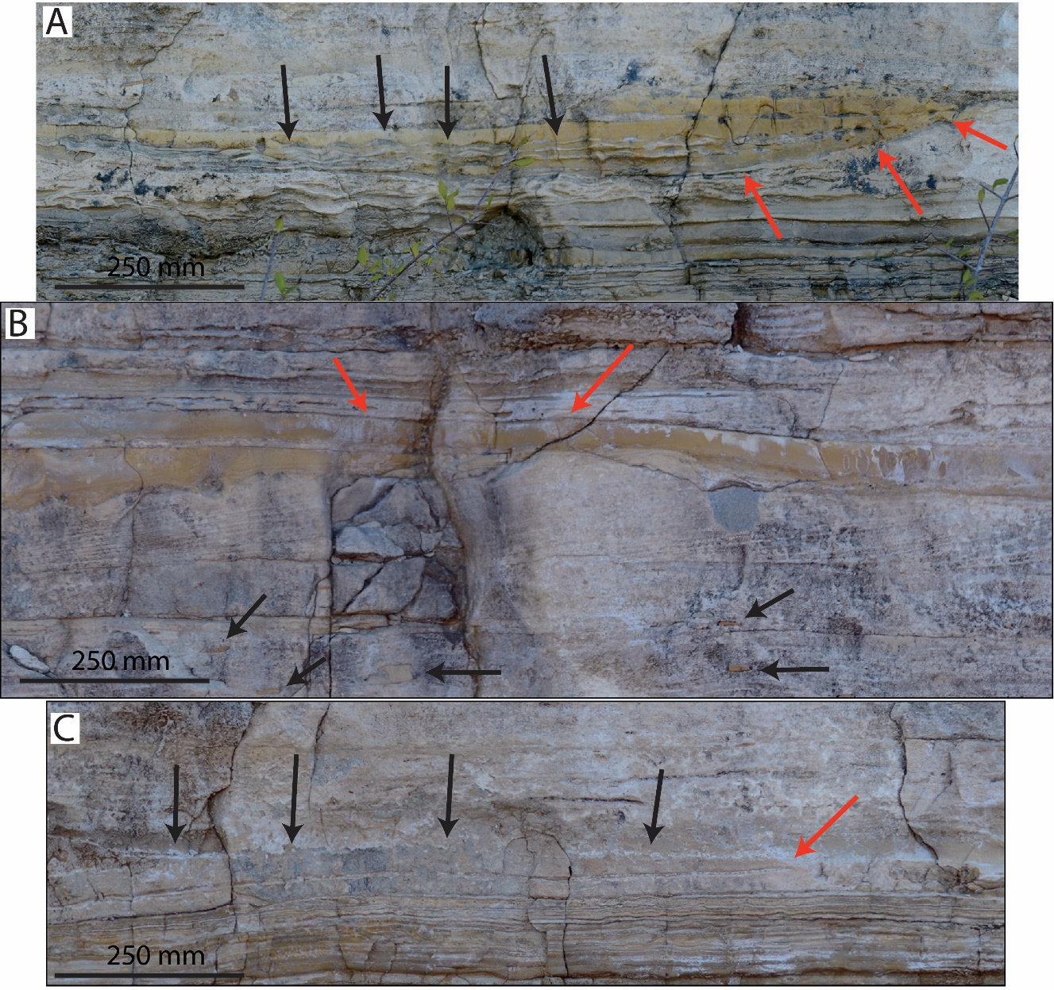
Figure 3 - Key observations recording the unusually complete preservation and rapid aggradation of this interval. A: Mudstones preserved in topographic lows (red arrows) contain within them apparently undeformed rippled grainstone surfaces (black arrows). B: Mudstone rip-up clasts within grainstone beds (black arrows) indicate flows were capable of reworking local deposits, yet mudstones still drape topographic highs (red arrows). C: Grainstone contact with microbial laminites below follows the laminations below well (black arrows), although some scouring of the microbial laminites do exist (red arrow).

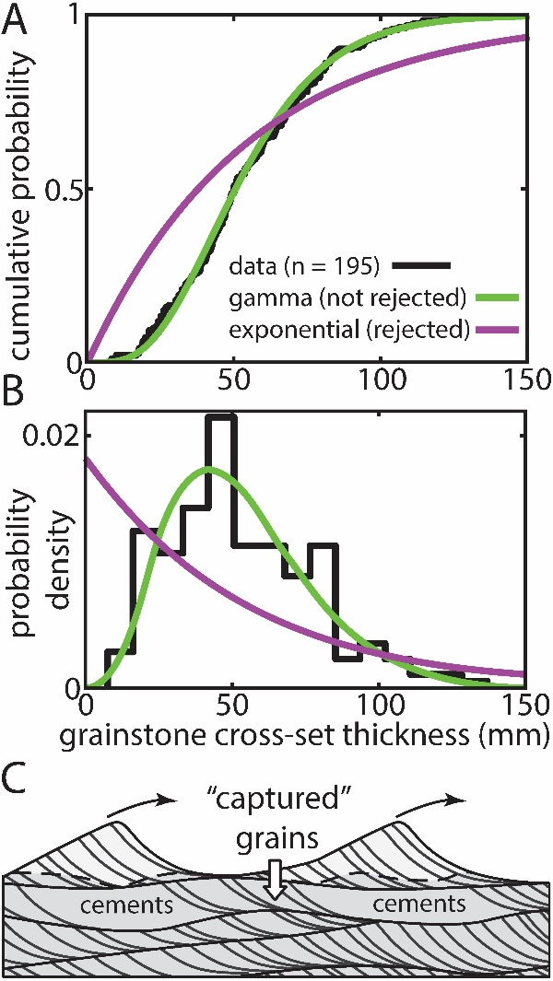
Figure 4 – A and B: Cumulative distribution (A) and probability density (B) function comparisons of gamma and exponential fits to set thickness data. The gamma fit is not rejected by a Kolmogorov-Smirnov test, indicating bedform climb on the order of 0.5° to 5° was required to produce this distribution (Jerolmack and Mohrig, 2005). Kolmogorov-Smirnov tests reject the exponential fit; non-rejection would indicate a bypass system with no net bed aggradation (Paola and Borgman, 1991; Cardenas et al., 2019). (C) Bedforms migrating through a region undergoing syndepositional cementation. Surface cements capture the grains at bedform troughs, inhibiting their reworking, driving troughs upward, and promoting high climb angles in the absence of a topographic forcing. Syndepositional cementation may be a unique external forcing to carbonate depositional systems.

