Energetic Rupture and Tsunamigenesis during the 2020 M_{w} 7.4 La Crucecita, Mexico Earthquake
Diego Melgar¹, Angel Ruiz-Angulo², Xyoli Pérez-Campos³, Brendan W. Crowell⁴, Xiaohua Xu⁵ Enrique Cabral-Cano³, Michael R. Brudzinski⁶ & Luis Rodriguez-Abreu⁷
¹Department of Earth Sciences, University of Oregon
²Icelandic Meteorological Office
³Instituto de Geofísica, Universidad Nacional Autónoma de México
⁴Department of Earth and Space Sciences, University of Washington
⁵Scripps Institution of Oceanography, University of California San Diego
⁶Department of Geology & Environmental Earth Science, Miami University
⁷Grillo Sistemas, Mexico

Abstract

The La Crucecita earthquake ruptured on the megathrust generating strong shaking and a modest, long-lived tsunami. This is a significant earthquake that illuminates important aspects of the behavior of the megathrust as well as the potential related hazards. The rupture is contained within 15-30km depth, ground motions are elevated and the energy to moment ratio is high. We argue that it represents a deep megathrust earthquake, the 30km depth is the down dip-edge of slip. The inversion is well constrained ruling out any shallow slip. It is the narrow seismogenic width and the configuration of the coastline that allow for deformation to occur offshore. The deep asperity is solely responsible for tsunamigenesis. There is significant uplift at the coast above it which leads to negative maximum tsunami amplitudes. Finally, tide gauge recordings show edge wave modes were excited and produce larger amplitudes and durations in the Gulf of Tehauntepec.

Plain language summary

The 23 June 2020 magnitude 7.4 La Crucecita earthquake is an important earthquake for southern Mexico. By comparing it to other past events of the 20th and 21st centuries we use it to establish systematic patterns of behavior of earthquakes in the region. For example, we find that large earthquakes like this one are likely not possible below 30 km depth. This is very important for the region, knowing where earthquakes are and are not likely is fundamental to adequately constrain estimates of future shaking in the region. We also study a modest tsunami generated by the earthquake. We show that the coastline above the earthquake moved up by more than half a meter after the rupture and this lessened the tsunami impacts. Finally, we also show that even though the tsunami was modest in size, it lasted a long time at the localities within the Gulf of Tehuantepec. This serves as a warning that future large events in the region might generate tsunami waves that are particularly hazardous. The shape of the coast and seafloor in the Gulf of Tehuantepec is particularly prone to amplifying the tsunami waves to a larger size than in other parts of Mexico.
- Introduction
The 23 June 2020 M_{w} 7.4 La Crucecita, Mexico earthquake (Figure 1) nucleated in the southeast of the state of Oaxaca at a depth of 21 km. The location and the low-angle thrust faulting mechanism are consistent with the expected location of the megathrust in the region (Pardo & Suárez, 1995; Melgar & Pérez-Campos, 2011; Hayes et al., 2018). Convergence rates in the Mexican subduction zone (MSZ) increase systematically from north to south and in this part of the country are about 70 mm/yr (DeMets et al., 2010), similarly, interseismic coupling has been inferred to be high (at least 50%) throughout the state between –99.0° and –95.5° longitude (Rousset et al., 2017). Further east of the Tehuantepec ridge (Figure 1) coupling is interpreted to remain high at least to the Mexico-Guatemala border (Franco et al., 2012).

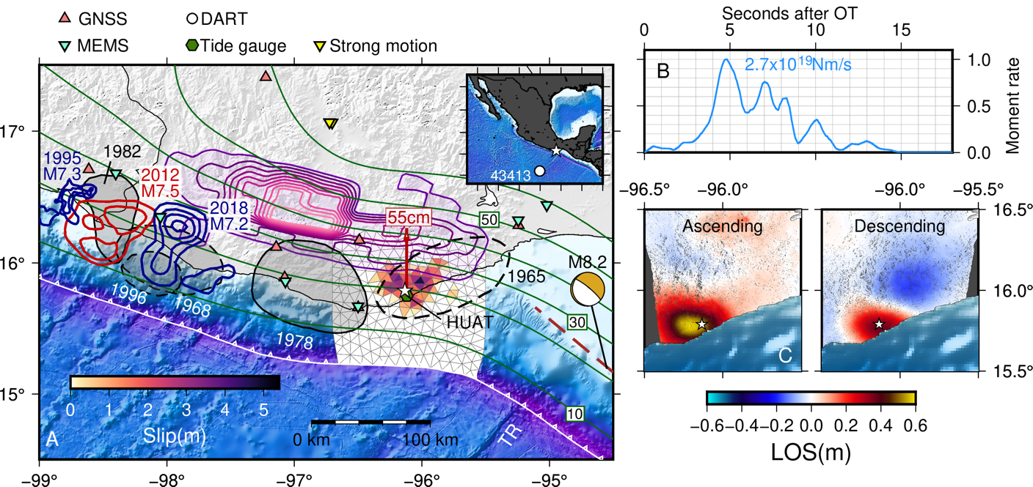
Figure 1. (A) Tectonic context and slip inversion results. The surface used for inversion is shown as triangles colored by the amount of slip. The white star is the epicenter. The different station types are shown as well. The green contours are the depths to the slab from Slab 2.0 (Hayes et al., 2018) at 10 km intervals. The blue and red contours are slip models for past large events in the region (Courboulex et al., 1997; UNAM Seismology Group, 2013; Li et al., 2020). Shaded grey regions are aftershock areas of older events of the 20th century. Those indicated with dashed lines are less well constrained (UNAM Seismology Group, 2013). Purple shaded contours at 10 mm intervals are the slow slip event preceding the 2012 Ometepec earthquake (Graham et al., 2014a), The red arrow indicates 55 cm of coseismic uplift measured at the HUAT tide gauge. The moment tensor is for the 2017 M_{w} 8.2 Tehuantepec earthquake. The brown dashed line is the surface projection of its causative fault (Melgar et al., 2018). TR is the Tehuantepec Ridge (B) Event source time function. (C) Line of sight deformation from ascending and descending tracks, positive is motion towards the satellite. The white star is the same epicenter as in (A).

Due to this tectonic configuration large earthquakes in the region are common. Figure 1 shows aftershock areas of large events going back to 1965 and the slip regions of three modern events, the 1995 M_{w} 7.3 Copala, 2012 M_{w} 7.5 Ometepec and 2018 M_{w} 7.2 Pinotepa earthquakes (Courboulex et al., 1997; UNAM Seismology Group, 2013; Li et al., 2020). Singh et al. (1981,1983) noted that large events in this part of the MSZ have a characteristic magnitude of ~M_{w} 7.5 and an average recurrence of 30-50 yrs. Interestingly the 2012 Ometepec earthquake occupies the same location as the aftershock area of the 1982 doublet (Astiz & Kanamori, 1984), the Pinotepa earthquake re-occupies a significant portion of the aftershock area of the 1968 M_{w} 7.3 earthquake (Chael & Stewart, 1982), while the La Crucecita earthquake nucleates within the aftershock region of the 1965 M_{w} 7.5 earthquake (Chael & Stewart, 1982).
Two important patterns are suggested from previous events. During large earthquakes, rupture rarely, if ever, extends below the 30 km depth contour of the subducted slab. The only exception to this is the 1965 aftershock area which is poorly constrained by the data (UNAM Seismology Group, 2013). This indicates that perhaps this is the down-dip edge of coseismic slip; an important demarcation to identify because it is a key constraint for evaluating the seismic hazard of the region. At deeper depths transient deformation from slow slip events (SSEs) and much weaker seismic release in the form of tectonic tremor have been well documented (Kostoglodov et al., 2003; Brudzinski et al., 2010; Graham, et al., 201). In Oaxaca, this occurs largely at depths deeper than 40 km, however shallow slow slip has also been identified and hypothesized to have contributed to triggering the 2012 Ometepec-Pinotepa Nacional earthquake (Graham et al., 2014a; Colella et al., 2017).
The second pattern that emerges is the dearth of slip at depths shallower than ~10 km. This is consistent with the observation that the tsunami record in Mexico shows a predominance of modestly sized events with coastal amplitudes in the ~1-2 m range (e.g. Ramírez-Herrera et al., 2012; Corona et al., 2012). Only two large tsunamigenic events have been identified, the 1932 M_{S} 8.2 event in Jalisco at the northern edge of the subduction zone (Corona et al., 2015) and the 1787 ~M 8.6 San Sixto earthquake offshore Oaxaca (Suárez & Albini, 2009) whose tsunami deposits have been identified several kilometers inland (Ramírez-Herrera et al., 2020). Despite most tsunamis being of modest amplitude, for the Gulf of Tehuantepec (east of –96° longitude) there is an added hazard. The wide, shallow, and flat shelf very efficiently traps tsunami energy in the form of edge-waves and through wholesale resonance of the shelf (Melgar & Ruiz-Angulo, 2018). As a result, comparatively small events can be amplified and can last for many hours. This was the case during the 2017 M_{w} 8.2 Tehuantepec earthquake (Figure 1, Melgar et al., 2018; Suárez et al., 2019). That event was a deep (~50 km), normal faulting earthquake with limited coseismic deformation which nonetheless led to a ~3 m tsunami at the coasts of the Gulf of Tehuantepec (Ramírez-Herrera et al., 2018). The tsunami was observed at coastal tide gauges above the background noise for almost 48 hrs (Melgar & Ruiz-Angulo, 2018).
Within this context, the 2020 earthquake is important. It occurs within the aftershock region of a previously identified large earthquake. It was observed by varied regional geophysical instrumentation (Figure 1) including high-rate Global Navigation Satellite System (HR-GNSS) data, strong motion, tide gauge, ocean-bottom pressure, novel micro-electromechanical (MEMS) accelerometers, and by Interferometric Synthetic Aperture Radar (InSAR). Here we will show that the rupture was relatively simple with one well-defined asperity but with an energetic source process that led to slightly elevated ground motions and which is consistent with rupture close to the down-dip edge of slip. We conclusively establish that there is no shallow slip and show that a large portion of the coast is significantly uplifted leading to negative peak tsunami values (drawdown of the ocean), helping to explain why tsunamis are not always well recorded in the geologic record in Mexico. Finally, we will discuss how, within the Gulf of Tehuantepec, this event excited edge waves which led to larger amplitudes within the shelf and to a longer duration of the event like in 2017. Though the tsunami in the 2020 La Crucecita earthquake was not particularly damaging, it serves as a reminder of the prevailing hazard for the region.
- Methods and Data
2.1 Observations and processing
2.1.1 Geodetic data
We computed 5 Hz displacement and velocity waveforms for seven stations from the TLALOCNet GNSS network (Cabral-Cano et al., 2018). Displacement waveforms, which are used for slip inversion, were obtained using the relative positioning algorithm implemented in the TRACK software (Herring et al., 2010). We use station UXAL 450 km north of the event as a reference. Only the first 100 s of information after the earthquake origin time are analyzed and no motion at the reference site is propagated into the solutions (Figure S1). The velocity waveforms (Figure S2), which are used to study the ground motion intensities, are obtained using the variometric technique described by Colosimo et al. (2011).
For inversion we also use InSAR line‐of‐sight measurements from two tracks from the Sentinel‐1A/1B satellites operated by the European Space Agency (Figure 1, S3-S4). For ascending track 107 and descending track 070 (Figure 1), the interferometric pairs span the dates 06/19/2020 to 06/25/2020 and 06/22/2020 to 06/28/2020 respectively. The Sentinel‐1 data processing, phase unwrapping, and downsampling (Chen & Zebker, 2002; Lohman & Simons, 2005; Sandwell et al., 2016; Xu et al., 2017) are summarized in Text S1.
2.1.2 Tsunami data
We use tsunami observations from two tide gauge stations at Huatulco (HUAT, Figure 1) and Salina Cruz (SALI, Figure 2). The HUAT tide gauge samples at 6 min and recorded a significant co-seismic offset (Figure 2). We removed the tidal signals using the TPXO9-atlas tidal model with 1/30 degree resolution interpolated at the location of the station (Egbert & Erofeeva, 2002) after that we estimated an uplift of 55 cm simply by taking the mean of 1 hr of data before the event and 1 hr after the earthquake. Note that the record shows a negative value consistent with the sea-level retreating in response to the coseismic deformation. The record at SALI has a faster sample rate (1 min) and was also corrected for tides. It shows no measurable coseismic offset.
In order to resolve shallow slip, we also use data from one ocean-bottom pressure sensor from station 43413 from the Deep-ocean Assessment and Reporting of Tsunamis (DART) network (Figure 1). The data is sampled at 15 s and is bandpass filtered between 2 hr and 5 min in order to remove tides and surface-wave arrivals which produce noticeable pressure signals. After filtering the record shows a small (0.5 cm) tsunami (Figure S5).
2.1.3 Seismological data
We use two sets of regional data to study ground motion intensities (Figure 3). The first is from a network of MEMS accelerometers deployed by Grillo Sistemas, a private company using them for earthquake early warning. The sensors are triaxial with an 18-bit digitizer and are sampled at 32 Hz. We applied a basic baseline correction by removing the pre-event mean for each trace and high-pass filtering with a 20 s corner to remove baseline offsets. We also use strong motion data from the regional network operated by the Instituto de Ingeniería at UNAM (II-UNAM). Raw data are not openly available but processed intensities (PGA, and spectral accelerations) were obtained from the network's web page. For the energy and source spectrum estimation, we use the vertical component of 31 teleseismic stations at epicentral distances between (30º - 90º). We use a 60 s window around the P-wave group comprising the P, pP, and sP phases.
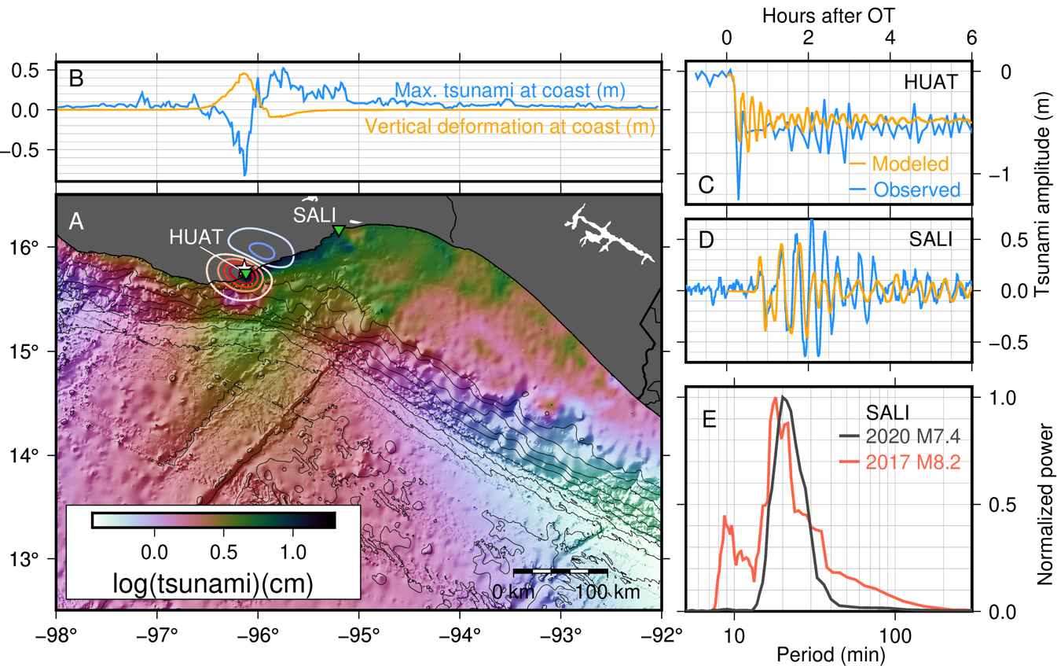
Figure 2. (A) Peak tsunami amplitude in the model domain. Contours are the coseismic vertical deformation from the slip model at 10 cm intervals, red is uplift, blue is subsidence. Locations of the Huatulco and Salina Cruz (HUAT, SALI) are shown. (B) Vertical coseismic deformation from the slip model at the coastline. and maximum modeled tsunami amplitude at the coast. (C)-(D) Comparison between modeled and observed records at tide gauge locations. (E) Normalized amplitude spectrum at SALI, comparing the recorded tsunami in this event to that of the 2017 M_{w} 8.2 Tehuantepec earthquake.
2.2 Modeling methods
2.2.1 Slip inversion
We jointly invert the coseismic offset at the HUAT tide gauge, three component displacements from 7 HR-GNSS stations along with the two InSAR scenes and one DART buoy waveform (Figure 1). We use the linear multi-time window approach implemented in the MudPy code and described by Melgar & Bock (2015). We assume the Slab 2.0 geometry for the megathrust (Hayes et al., 2018) and discretize its 3D geometry into triangles of approximately 5 km sides using a finite element mesh. We employ a radially symmetric Earth model used by Hernandez et al. (2001) for slip inversion of earthquakes in Southern Oaxaca. Green’s functions for each data type are obtained using frequency-wave number integration for the deformation and waveform data and solving the shallow water equations for the tsunami data. The process is outlined in in Melgar & Bock (2015). For rupture initiation we use the local network hypocenter (- 96.120°, 15.784°, 22.6 km) which is closer to the coast than the hypocenter reported by the USGS which is about 16 km to the northeast of this location. This is a well-known bias of tele-seismic hypocenters studied systematically by Hjörleifsdóttir et al. (2016) and observed for the 2017 M_{w} 8.2 Tehuantepec earthquake and its aftershocks as well (Melgar et al., 2018). We run the inversion at several rupture speeds between (2.0 km/s and 4.0 km/s) and select the best fitting one. We use two sets of weights for the data, one to account for measurement uncertainties and one to account for the different sizes (quantified by the norms) of each data type. Details of this approach are in Text S2. The rake is constrained to a window around pure thrust and the inversion is solved using non-negative least squares with Tikhonov (minimum-norm) regularization. The regularization parameter is chosen using the L-curve criterion.
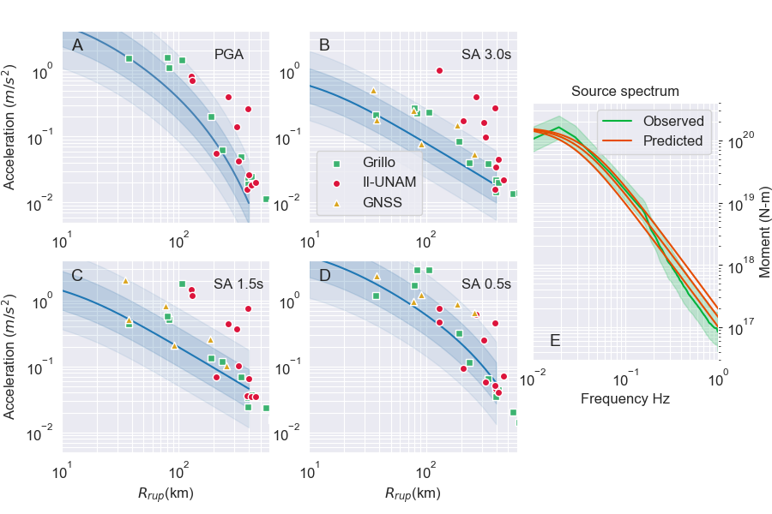
Figure 3. (A)-(D) Ground motion intensities at Grillo MEMS accelerometer sites, HR-GNSS sites and II-UNAM strong motion sites. The reference line is the ground motion model (GMM) of Arroyo et al. (2010) with one and two standard deviation regions shaded in. R_{rup} is the shortest distance to the slip model in Figure 1. (E) Observed far-field P-wave spectrum (green) with interquartile range shaded in as uncertainty. Red is the theoretical spectrum for a rupture with stress drop of 2.5, 3.0 and 3.5 MPa respectively.

2.2.2 Tsunami modeling
For tsunami modeling we use the open source code GeoClaw (LeVeque et al., 2011) which solves the non-linear shallow water equations using a depth-averaged finite volume method. The initial condition is the vertical deformation from the slip model obtained using the triangular dislocation algorithm of Meade (2007). We assume that rupture is instantaneous given that tsunami propagation is far slower than rupture velocity (Williamson et al., 2019). Bathymetry and topography are a combination of SRTM15+ (Tozer et al., 2019) which has ~450 m onshore/offshore pixels with SRTM3 which has 90 m onshore-only pixels for more detailed shorelines. GeoClaw uses adaptive mesh refinement to dynamically refine the relevant regions of the model. We used six levels of refinement from an upper coarse level with 10 arcmin resolution down to the final level with 3 arcsec resolution. At each step the solver uses a Courant-Friedrichs-Levy condition of 0.75 to ensure numerical stability. The tsunami model is run for 6 hours of model time using Manning’s bottom friction coefficient of 0.025. We collect model output at the locations of the two tide gauges as well as tracking the maximum amplitude of the tsunami at the coast and everywhere within the model domain (Figure 2).
2.2.3 Far field analysis, energy and spectra
We follow Boatwright & Choy (1986) as modified by Pérez-Campos & Beroza (2001) to obtain the seismic energy from the teleseismic P-wave group records. The source spectrum was estimated by correcting the teleseismic data for the instrument response, attenuation, and site effect, assuming a very hard rock site, as defined by Boore & Joyner (1997) and suggested by Pérez-Campos et al. (2003). Figure (2E) shows the source spectra and its confidence interval.
2.2.4 Ground motion processing
Ground motion intensities are obtained from the MEMS acceleration time series and from the HR-GNSS velocities. The MEMS are baseline corrected (Section 2.1.1) after which we extract the peak ground acceleration (PGA) as well as the spectral accelerations (SA) at several periods of interest (Figure 3). The HR-GNSS velocities are differentiated to acceleration using a 4th order finite difference scheme. Because the sample rate is 5 Hz, we do not extract SA for these data past the Nyquist frequency (2.5 Hz or 0.4 s). The SAs are obtained from the two horizontal components of motion using the RotD50 methodology which takes the median value after rotating the accelerations through every possible orientation (Boore et al., 2006). We compare the observed intensities against those predicted by the ground motion model (GMM) of Arroyo et al. (2010). As noted by Sahakian et al. (2018) during the 2017 earthquakes in Mexico, global GMMs underperform in Mexico compared to regional ones. The GMM of Arroyo et al. (2010) was designed specifically from megathrust events in Mexico so it is a sensible choice.

- Results
The slip distribution for the earthquake is compact with a single ~60x50 km elliptical asperity with 5.3 m of peak slip and a final magnitude of M_{w} 7.39 (Figure 1). The slip is well constrained in depth with most of it occurring between 15 and 30 km. The source process lasts 15 s with peak moment 5 s after rupture nucleation. The hypocenter is in the upper quarter of the rupture, so rupture propagates mostly down-dip of the initiation point and is bi-lateral along-strike. The preferred rupture speed is 3 km/s (Figure S6) which corresponds to 75-83% of shear wave speed in the 1D Earth model. This is consistent with the mean of what is observed worldwide (e.g. Melgar & Hayes, 2017). The fits to the data are high with low RMS values to all data types (Figures S1, S5, S7). Peak values for all the waveforms both onshore and offshore are well matched and the residuals to the InSAR show no systematic biases. Overall, this is a very well resolved slip model (Figure S8, Text S2).
Almost 90% of moment is released in the onshore portion of the fault which explains the coseismic deformation pattern imaged by the InSAR. The fact that both the ascending and descending look directions show positive LOS change is indicative of a large vertical component to the crustal deformation (Figure 1). Indeed, the coseismic deformation model from the slip distribution (Figure 2) shows uplift in the epicentral coastline with a peak value of 0.6 m. Subsidence occurs further inland and in the northeaster portion of the coast with a peak value of 0.15-0.2 m. This is also consistent with the 0.55 m of uplift measured at the HUAT tide gauge; the slip model predicts this well with a value of 0.52 m of uplift at this location.
The tsunami model shows an interesting pattern. Figure 2B shows the uplift/subsidence at the coastline compared to the modeled peak tsunami amplitude. The coastline between –96.5º and –96º has a negative maximum peak tsunami amplitude which correlates with the predominantly positive vertical coseimic deformation. This is confirmed by the tide gauge recording from HUAT (Figure 2C) which shows that, while there are tsunami waves after the initial uplift signal, these are not large enough to overcome the initial vertical deformation and thus the peak tsunami value remains negative. The tsunami model also shows that the amplitudes inside the Tehuantepec shelf (east of –96º) are systematically larger than outside of the shelf to the west of the source region. At the SALI tide gauge recording there are multiple large tsunami arrivals with the peak value being reached until the 4th wave crest more than 2 hours after event origin time and ~80 min after the first tsunami arrival. This feature is captured well by the tsunami model although the peak value is underestimated, and the energy decay is faster in the model than in the recorded signal. Snapshots of the model (Figure 4) show that these repeated arrivals are from edge waves trapped near the coast between HUAT and SALI.

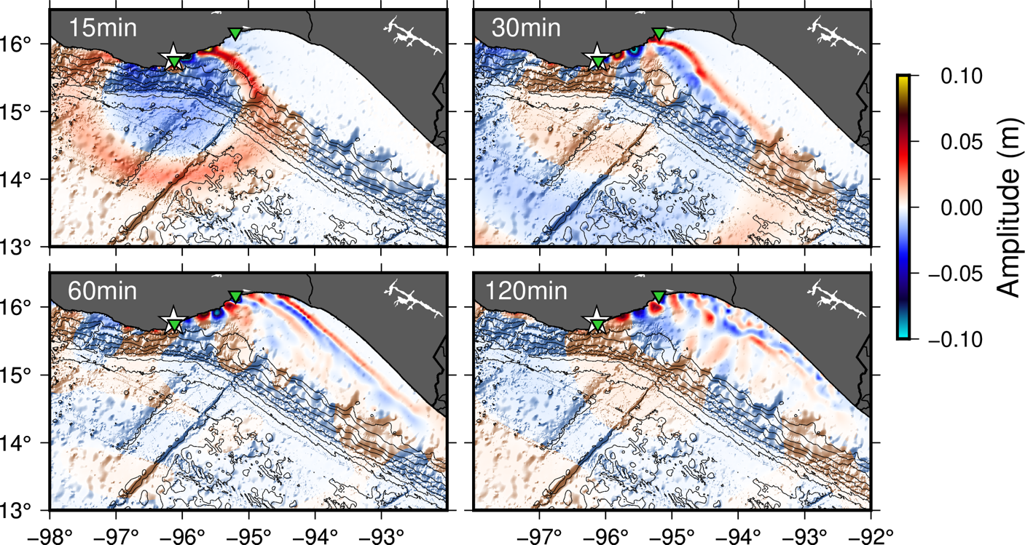
Figure 4. Snapshots of tsunami propagation from the model based on the coseismic deformation pattern of Figure 2A. The alternating lobes of positive and negative amplitude between HUAT and SALI (green triangles) are the edge wave modes. The white star is the event epicenter.
The ground motion intensities (Figure 3) are consistently higher than what is expected for an event of this magnitude. There are no values below the one sigma uncertainty region while there are many above the 2-sigma uncertainty. The intensities from the strong motion network (II-UNAM), which are mostly deployed within city basins, are much higher than for the MEMS or GNSS data. The far-field source spectrum (Figure 3E) is nonetheless consistent with a stress drop between 2.5 and 3.5 MPa which is close to the mean value when compared to other subduction events worldwide. Meanwhile the broadband energy magnitude is M_{e} 7.5, corresponding to 4.16x10¹⁵ ± 1.84x10¹⁴ J, higher than what is expected for an M_{w} 7.4 earthquake. As a result, the energy to moment ratio for this event is 2.53x10⁻⁵ which is meaningfully higher than the global average of ~1x10⁻⁵ (Ye et al., 2016). This value is however only 1.3 times higher than for thrust events along the MSZ, as reported by Ordaz & Singh (1992), after considering a site effect factor (Plata-Martínez et al., 2019). The value is still 1.2 times higher than the ratio observed for the 2012 Ometepec-Pinotepa Nacional and 2018 Pinotepa earthquakes and their aftershocks closer to the coast (Plata-Martínez et al., 2019).
- Discussion
The 2020 M_{w} 7.4 La Crucecita earthquake occurs in a region of the Mexican subduction zone that is complex and exhibits both coseismic rupture and slow slip events. There is limited overlap between the rupture area and the slow slip region identified in previous work (Figure 1). Indeed, when this event is compared to other slip models and aftershocks areas it is possible to conclude that rupture does not seem to penetrate past the 30 km depth contour. We posit this represents the down-dip edge of megathrust slip that generates significant seismic radiation for this part of the MSZ. Seismically detectable tectonic tremor occurs below this depth, but the low-frequency earthquakes that comprise tremor appear to be limited in fault dimension to magnitudes below M_{w} 3 (Brudzinski et al., 2010; Bostock et al., 2015). A comparison with the slip contours from the slow slip event preceding the 2012 M_{w} 7.5 Ometepec earthquake (Graham et al., 2014a, Figure 1A) show some potential overlap between the two. Extensive afterslip from the 2012 earthquake also indicates aseismic slip occurred within areas of previous coseismic rupture (Graham et al., 2014b). Dynamic models and recent observations show that under certain circumstances seismogenic rupture can penetrate areas previously dominated by slow-slip (Ramos & Huang, 2019; Lin et al., 2020). In the MSZ, the resolution of the SSE models is modest and geodetic coupling in this deep portion of the megathrust is low (Rousset et al., 2017), suggesting wholesale coseismic slip into the SSE region is limited and not a common occurrence. Neither this event nor the historical aftershock areas suggest it.
The rupture process has a stress drop that is comparable to other subduction zone events but an energy to moment ratio that places it in the upper limits of what is commonly seen in other similar events worldwide (Ye et al., 2016) and higher than the 2012 and 2018 events (Plata-Martínez et al., 2019). This is indicative of an efficient rupture process and can justify the systematically elevated ground motions. These features are also consistent with a rupture near the down-dip edge of slip.
And yet the event was modestly tsunamigenic. This is not due to any shallow slip; the time dependent data and the DART buoy information are both sensitive to any shallow slip and produce a very well resolved slip model (Figure S8, Text S2) which conclusively discards this. Rather, this is because, while the MSZ has a very short continental shelf, the seismogenic width is modest such that this “deep” event still produces some offshore deformation (Figure 2A). Additionally, at the source region, the coast juts to the north, widening the shelf and allowing for more of the coseimsic deformation to occur offshore.
This peculiar configuration leads to a substantial portion of the coastline being uplifted and thus producing negative maximum peak tsunami amplitudes. During uplift, sea-level drops and any resulting tsunami waves do not reach a high enough amplitude to overcome this, as confirmed by the HUAT tide gauge (Figure 2C). This is important, it is a clear example of why tsunamis are not always well recorded in the geologic record in Mexico. Specifically, in Oaxaca, none of the modern events dating back to at least 1965 (Figure 1) seem to have any slip shallower than 10-15 km. This makes correctly assessing the tsunami hazard difficult. Is shallow slip possible? Suárez & Albini (2009) postulated from an analysis of historical data that the 1787 San Sixto earthquake which occurred offshore Oaxaca had a magnitude of ~M 8.6. Recently Ramírez-Herrera et al. (2020) identified tsunami deposits from this event several kilometers inland. Given the modest seismogenic width and the propensity of the coast in this part of the MSZ to uplift during rupture, it seems likely that in order to produce such long inundation distances the 1787 event must have had substantial shallow slip. Singh et al. (1981, 1983) hypothesized that the Oaxaca segment of the MSZ fails repeatedly at semi-regular ~30-50 yr intervals on distinct asperities. Recent well-modeled events suggest there is some credence to this model, modern slip inversions regularly show overlap with aftershock areas of older events. In fact, the 2020 La Crucecita earthquake overlaps with a significant portion of the 1965 M 7.5 earthquake (UNAM Seismology Group, 2013). However, if events of the size of the 1787 San Sixto earthquake are also possible, it suggests that any given earthquake does not release the entirety of the accumulated slip deficit. Instead, over many earthquake cycles, enough slip deficit can accumulate that neighboring asperities can fail together in one large event. The frequency with which this synchronization might occur is completely unknown. There is the added complexity that slow-slip events can potentially accelerate failure of an asperity (Graham et al., 2014) so whether “super cycles” (Sieh et al., 2008) exist in the MSZ remains speculative.
Finally, we note that the observations and modeling of the tsunami in the Gulf of Tehuantepec once more point to a higher hazard in this region compared to other parts of the MSZ. Melgar & Ruiz-Angulo (2018) noted that the morphology of the shelf is particularly prone to amplification by resonance and by trapping edge waves close to shore. The observed and modeled tide gauge at SALI (Figure 2) and snapshots of the tsunami model (Figure 4) show a very well-developed edge wave train between HUAT and SALI during the 2020 event. A comparison of the spectra between the 2017 M_{w} 8.2 record and the 2020 record (Figure 2E) show that this same ~20 min spectral peak was excited in both events. Geodetic coupling in this part of the subduction zone has also been estimated to be high (Franco et al., 2012) and if the seismogenic width is like other parts of the subduction zone then, because the shelf is far wider, we can expect wholesale subsidence of the coast during a future large event. This, compounded with the ability of the shelf to amplify and protract the duration of tsunamis, highlights the elevated hazard facing the Gulf of Tehuantepec region.
Conclusions
We find that the M_{w} 7.4 La Crucecita earthquake is completely contained between the 15 and 30 km depth contours. The rupture process is energetic when compared to regional and global megathrust events. Based on this we posit that 30 km is likely the down-dip edge of coseismic rupture for this portion of the Mexican subduction interface. Updip of the hypocenter we conclusively rule out any shallow slip. The slip inversion includes multiple geophysical data sets and is very well constrained, even offshore. We find that it is the narrow seismogenic width and the peculiar configuration of the coastline that allow for a significant fraction of the coseismic deformation to occur offshore. The deep asperity is solely responsible for tsunamigenesis. The earthquake leads to significant uplift at the coast above it which leads to negative maximum tsunami amplitudes and exemplifies why tsunamis are not always well recorded int eh geologic record in Mexico. Finally, analysis of the tide gauge recordings and tsunami propagation model show how edge wave modes in the Gulf of Tehuantepec were excited and produce larger amplitudes and longer durations than elsewhere in the subduction zone.
Acknowledgments
All the data and modeling codes in this paper are openly available. This work was partially funded by NASA grant 80NSSC19K1104. The material is partly based on GPS/GNSS data provided by the Trans-boundary Land and Atmosphere Long-term Observational and Collaborative Network (TLALOCNet) operated by the Servicio de Geodesia Satelital from Instituto de Geofísica-UNAM in collaboration with UNAVCO Inc.and supported by NSF grant EAR-1724794, CONACyT projects 253760 and 2017-01-5955 and UNAM-PAPIIT projects IN104213,IN109315-3 and IN104818-3. Luis Salazar-Tlaczani at Servicio de Geodesia Satelital-UNAM provided invaluable support for the TLALOCNet field operations and stations maintenance. GPS-Met data from the TLALOCNet archive is open and freely available at http://tlalocnet.udg.mx. We thank the European Space Agency for access to the Sentinel‐1 data (https://sentinel.esa.int). Grillo MEMS accelerometer data is available through Amazon Web Services at https://registry.opendata.aws/grillo-openeew/. Tide gauge data was provided by the Servicio Mareográfico Nacional of Mexico (http://www.mareografico.unam.mx/portal/). SSN data products are from the Servicio Sismológico Nacional (México) and can be obtained at http://www.ssn.unam.mx/, station maintenance, data acquisition and distribution are thanks to its personnel. Strong motion intensities were provided by the Strong Ground Motion Database System (http://aplicaciones.iingen.unam.mx/) and are the product of the Seismic Instrumentation group at the Instituto de Ingeniería of the Universidad Nacional Autónoma de México (II-UNAM), as well as its IT infrastructure. DART buoy data are provided by the National Oceanographic and Atmospheric Administration (https://www.ndbc.noaa.gov/dart.shtml). The processed HR-GNSS and strong motion waveforms are available in Datasets S1 and S2. The slip inversion code MudPy, can be obtained from https://github.com/dmelgarm/mudpy. The tsunami modeling code can be obtained from http://www.clawpack.org/

References
Albuquerque Seismological Laboratory (ASL)/U.S. Geological Survey (USGS) (1980). US Geological Survey Networks, International Federation of Digital Seismograph Networks, Other/Seismic Network, doi: 10.7914/SN/GS.
Albuquerque Seismological Laboratory (ASL)/U.S. Geological Survey (USGS) (1988). Global Seismograph Network (GSN - IRIS/USGS), International Federation of Digital Seismograph Networks, Other/Seismic Network, doi: 10.7914/SN/IU.
Arroyo, D., García, D., Ordaz, M., Mora, M. A., & Singh, S. K. (2010). Strong ground-motion relations for Mexican interplate earthquakes. Journal of Seismology, 14(4), 769-785.
Astiz, L., & Kanamori, H. (1984). An earthquake doublet in ometepec, Guerrero, Mexico. Physics of the earth and planetary interiors, 34(1-2), 24-45.
Boatwright, J., & Choy, G. (1986). Teleseismic estimates of the energy radiated by shallow earthquakes. Journal of Geophysical Research, 91, 2095–2112.
Boore, D. M., Watson-Lamprey, J., & Abrahamson, N. A. (2006). Orientation-independent measures of ground motion. Bulletin of the seismological Society of America, 96(4A), 1502-1511.
Boore, D. M., & Joyner, W. B. (1997). Site amplifications for generic rock sites. Bulletin of the Seismological Society of America, 87, 327–341.
Bostock, M. G., Thomas, A. M., Savard, G., Chuang, L., & Rubin, A. M. (2015). Magnitudes and moment‐duration scaling of low‐frequency earthquakes beneath southern Vancouver Island. Journal of Geophysical Research, 120(9), 6329-6350.
Brudzinski, M. R., Hinojosa-Prieto, H. R., Schlanser, K. M., Cabral-Cano, E., Arciniega-Ceballos, A., Diaz-Molina, O., and DeMets, C., (2010). Nonvolcanic tremor along the Oaxaca segment of the Middle America subduction zone, Journal of Geophysical Research, 115, B00A23.
Cabral‐Cano, E., Pérez‐Campos, X., Márquez‐Azúa, B., Sergeeva, M. A., Salazar‐Tlaczani, L., DeMets, C., ... & Serra, Y. L. (2018). TLALOCNet: A continuous GPS‐Met backbone in Mexico for seismotectonic and atmospheric research. Seismological Research Letters, 89(2A), 373-381.
Chael, E. P., & Stewart, G. S. (1982). Recent large earthquakes along the middle American trench and their implications for the subduction process. Journal of Geophysical Research, 87 (1982), pp. 329-338
Chen, C. W., & Zebker, H. A. (2002). Phase unwrapping for large SAR interferograms: Statistical segmentation and generalized networ models. IEEE Transactions on Geoscience and Remote Sensing, 40(8), 1709–1719. https://doi.org/10.1109/TGRS.2002.802453
Colella, H. V., Sit, S. M., Brudzinski, M. R., Graham, S. E., DeMets, C., Holtkamp, S. G., Skoumal R. J., Ghouse, N., Cabral-Cano, E., Kostoglodov, V., Arciniega-Ceballos, A., (2017). Seismicity rate increases associated with slow slip episodes prior to the 2012 Mw 7.4 Ometepec earthquake, Earth and Planetary Science Letters, doi:10.1016/j.epsl.2016.12.032.
Colosimo, G., Crespi, M., & Mazzoni, A. (2011). Real‐time GPS seismology with a stand‐alone receiver: A preliminary feasibility demonstration. Journal of Geophysical Research, 116 (B11).
Corona, N., & Ramírez-Herrera, M. T. (2012). Mapping and historical reconstruction of the great Mexican 22 June 1932 tsunami. Natural Hazards and Earth System Sciences, 12(5), 1337.
Courboulex, F., Santoyo, M. A., Pacheco, J. F., & Singh, S. K. (1997). The 14 September 1995 (M= 7.3) Copala, Mexico, earthquake: A source study using teleseismic, regional, and local data. Bulletin of the Seismological Society of America, 87(4), 999-1010.
DeMets, C., Gordon, R. G., & Argus, D. F. (2010). Geologically current plate motions. Geophysical Journal International, 181(1), 1-80.
Egbert, G.D. & Erofeeva, S.Y. (2002). Efficient inverse modeling of barotropic ocean tides. Journal of Atmospheric and Oceanic Technology, 19.2, 183-204.
Franco, A., Lasserre, C., Lyon-Caen, H., Kostoglodov, V., Molina, E., Guzman-Speziale, M., ... & Barrier, E. (2012). Fault kinematics in northern Central America and coupling along the subduction interface of the Cocos Plate, from GPS data in Chiapas (Mexico), Guatemala and El Salvador. Geophysical Journal International, 189(3), 1223-1236.
Graham, S. E., DeMets, C., Cabral-Cano, E., Kostoglodov, V., Walpersdorf, A., Cotte, N., ... & Salazar-Tlaczani, L. (2014a). GPS constraints on the 2011–2012 Oaxaca slow slip event that preceded the 2012 March 20 Ometepec earthquake, southern Mexico. Geophysical Journal International, 197(3), 1593-1607.
Graham, S. E., DeMets, C., Cabral-Cano, E., Kostoglodov, V., Walpersdorf, A., Cotte, N., ... & Salazar-Tlaczani, L. (2014b). GPS constraints on the Mw=7.5 Ometepec earthquake sequence, southern Mexico: Coseismic and postseismic deformation, Geophysical Journal International, 199(1), 200-218.
Graham, S., DeMets, C., Cabral-Cano, E., Kostoglodov, V., Rousset, B., Walpersdorf, A., ... & Salazar-Tlaczani, L. (2015). Slow slip history for the Mexico subduction zone: 2005 through 2011. In Geodynamics of the Latin American Pacific Margin (pp. 3445-3465). Birkhäuser, Cham.
Hayes, G. P., Moore, G. L., Portner, D. E., Hearne, M., Flamme, H., Furtney, M., & Smoczyk, G. M. (2018). Slab2, a comprehensive subduction zone geometry model. Science, 362(6410), 58-61.
Hernandez, B., Shapiro, N. M., Singh, S. K., Pacheco, J. F., Cotton, F., Campillo, M., ... & Alcántara, L. (2001). Rupture history of September 30, 1999 intraplate earthquake of Oaxaca, Mexico (Mw= 7.5) from inversion of strong‐motion data. Geophysical Research Letters, 28(2), 363-366.
Herring, T. A., King, R. W., & McClusky, S.C. (2010). Introduction to Gamit/Globk. Massachusetts Institute of Technology, Cambridge, Massachusetts.
Hjörleifsdóttir, V., Singh, S. K., & Husker, A. (2016). Differences in epicentral location of Mexican earthquakes between local and global catalogs: An update. Geofísica Internacional, 55(1), 79-93.
Institut De Physique Du Globe De Paris (IPGP) & Ecole Et Observatoire Des Sciences De La Terre De Strasbourg (EOST) (1982). GEOSCOPE, French Global Network of Broad Band Seismic Stations, Institut de Physique du Globe de Paris (IPGP), doi: 10.18715/geoscope.g.
Kostoglodov, V., Singh, S. K., Santiago, J. A., Franco, S. I., Larson, K. M., Lowry, A. R., & Bilham, R. (2003). A large silent earthquake in the Guerrero seismic gap, Mexico. Geophysical Research Letters, 30(15).
LeVeque, R. J., George, D. L., & Berger, M. J. (2011). Tsunami modelling with adaptively refined finite volume methods. Acta Numerica, 20, 211.
Li, Y., Shan, X., Zhu, C., Qiao, X., Zhao, L., & Qu, C. (2020). Geodetic Model of the 2018 M w 7.2 Pinotepa, Mexico, Earthquake Inferred from InSAR and GPS Data. Bulletin of the Seismological Society of America, 110(3), 1115-1124.
Lin, J. T., Aslam, K. S., Thomas, A. M., & Melgar, D. (2020). Overlapping regions of coseismic and transient slow slip on the Hawaiian décollement. Earth and Planetary Science Letters, 544, 116353.
Lohman, R. B., & Simons, M. (2005). Some thoughts on the use of InSAR data to constrain models of surface deformation: Noise structure and data downsampling. Geochemistry, Geophysics, Geosystems, 6(1), n/a. https://doi.org/10.1029/2004GC000841
Meade, B. J. (2007). Algorithms for the calculation of exact displacements, strains, and stresses for triangular dislocation elements in a uniform elastic half space. Computers & Geosciences, 33(8), 1064-1075.
Melgar, D., & Pérez-Campos, X. (2011). Imaging the Moho and subducted oceanic crust at the Isthmus of Tehuantepec, Mexico, from receiver functions. Pure and applied geophysics, 168(8-9), 1449-1460.
Melgar, D., & Bock, Y. (2015). Kinematic earthquake source inversion and tsunami runup prediction with regional geophysical data. Journal of Geophysical Research: Solid Earth, 120(5), 3324-3349.
Melgar, D., & Hayes, G. P. (2017). Systematic observations of the slip pulse properties of large earthquake ruptures. Geophysical Research Letters, 44(19), 9691-9698.
Melgar, D., & Ruiz‐Angulo, A. (2018). Long‐lived tsunami edge waves and shelf resonance from the M8.2 Tehuantepec earthquake. Geophysical Research Letters, 45(22), 12-414.
Melgar, D., Ruiz-Angulo, A., Garcia, E. S., Manea, M., Manea, V. C., Xu, X., ... & Pérez-Campos, X. (2018). Deep embrittlement and complete rupture of the lithosphere during the M w 8.2 Tehuantepec earthquake. Nature Geoscience, 11(12), 955-960.
Ordaz, M., & Singh, S. K. (1992). Source spectra and spectral attenuation of seismic waves from Mexican earthquakes and evidence of amplification in the hill zone of Mexico City. Bulletin of the Seismological Society of America, 82, 24–43.
Pardo, M., & Suárez, G. (1995). Shape of the subducted Rivera and Cocos plates in southern Mexico: Seismic and tectonic implications. Journal of Geophysical Research: Solid Earth, 100(B7), 12357-12373.
Pérez-Campos, X., & Beroza, G. C. (2001). An apparent mechanism dependence of radiated seismic energy. Journal of Geophysical Research, 106, 11,127–11,136.
Pérez-Campos, X., Singh, S. K., & Beroza, G. C. (2003). Reconciling teleseismic and regional estimates of seismic energy. Bulletin of the Seismological Society of America, 93, 2123–2130.
Plata‐Martínez, R., Pérez‐Campos, X., & Singh, S. K. (2019). Spatial distribution of radiated seismic energy of three aftershocks sequences at Guerrero, Mexico, subduction zone. Bulletin of the Seismological Society of America, 109(6), 2556-2566.
Ramírez-Herrera, M., Corona, N., Cerny, J., Castillo-Aja, R., Melgar, D., Lagos, M., …, &Ruiz-Fernández, A-C (2020). Sand deposits reveal great earthquakes and tsunamis at Mexican Pacific Coast. Scientific Reports, 10, 11452. https://doi.org/10.1038/s41598-020-68237-2
Ramírez-Herrera, M. T., Corona, N., Ruiz-Angulo, A., Melgar, D., & Zavala-Hidalgo, J. (2018). The 8 September 2017 tsunami triggered by the M w 8.2 intraplate earthquake, Chiapas, Mexico. Pure and Applied Geophysics, 175(1), 25-34.
Ramírez-Herrera, M. T., Lagos, M., Hutchinson, I., Kostoglodov, V., Machain, M. L., Caballero, M., ... & Ruiz-Fernández, A. C. (2012). Extreme wave deposits on the Pacific coast of Mexico: Tsunamis or storms?—A multi-proxy approach. Geomorphology, 139, 360-371.
Ramos, M. D., & Huang, Y. (2019). How the transition region along the Cascadia megathrust influences coseismic behavior: Insights from 2‐D dynamic rupture simulations. Geophysical Research Letters, 46(4), 1973-1983.
Rousset, B., Campillo, M., Lasserre, C., Frank, W. B., Cotte, N., Walpersdorf, A., ... & Kostoglodov, V. (2017). A geodetic matched filter search for slow slip with application to the Mexico subduction zone. Journal of Geophysical Research: Solid Earth, 122(12), 10-498.
Sahakian, V. J., Melgar, D., Quintanar, L., Ramírez‐Guzmán, L., Pérez‐Campos, X., & Baltay, A. (2018). Ground motions from the 7 and 19 September 2017 Tehuantepec and Puebla‐Morelos, Mexico, earthquakes. Bulletin of the Seismological Society of America, 108(6), 3300-3312.
Sandwell, D. T., Xu, X., Mellors, R., Wei, M., Tong, X., & Wessel, P. (2016). GMTSAR: An InSAR processing system based on Generic Mapping Tools (Second Edition), http://topex.ucsd.edu/gmtsar/tar/GMTSAR_2ND_TEX.pdf
Scripps Institution of Oceanography (1986). IRIS/IDA Seismic Network, International Federation of Digital Seismograph Networks, Other/Seismic Network, doi: 10.7914/SN/II.
Sieh, K., Natawidjaja, D. H., Meltzner, A. J., Shen, C. C., Cheng, H., Li, K. S., ... & Edwards, R. L. (2008). Earthquake supercycles inferred from sea-level changes recorded in the corals of west Sumatra. Science, 322(5908), 1674-1678.
Singh S. K., Astiz, L., & Havskov, J. (1981). Seismic gaps and recurrence periods of large: A reexamination earthquakes along the Mexican subduction zone. Bulletin of the Seismological Society of America, 71 (1981), pp. 827-843
Singh S. K., Rodríguez M., & Esteva L. (1983). Statistics of small earthquakes and frequency of occurrence of large earthquakes along the Mexican subduction zone. Bulletin of the Seismological Society of America, 73 (1983), pp. 1779-1796
Suárez, G., & Albini, P. (2009). Evidence for great tsunamigenic earthquakes (M 8.6) along the Mexican subduction zone. Bulletin of the Seismological Society of America, 99(2A), 892-896.
Suárez, G., Santoyo, M. A., Hjörleifsdóttir, V., Iglesias, A., Villafuerte, C., & Cruz-Atienza, V. M. (2019). Large scale lithospheric detachment of the downgoing Cocos plate: The 8 September 2017 earthquake (Mw 8.2). Earth and Planetary Science Letters, 509, 9-14.
Tozer, B., Sandwell, D. T., Smith, W. H. F., Olson, C., Beale, J. R., & Wessel, P. (2019). Global bathymetry and topography at 15 arc sec: SRTM15+. Earth and Space Science, 6(10), 1847-1864.
UNAM Seismology Group (2013). Ometepec-Pinotepa Nacional, Mexico Earthquake of 20 March 2012 (Mw 7.5): A preliminary report. Geofísica Internacional, 52(2), 173-196.
Williamson, A., Melgar, D., & Rim, D. (2019). The Effect of Earthquake Kinematics on Tsunami Propagation. Journal of Geophysical Research: Solid Earth, 124(11), 11639-11650.
Xu, X., Sandwell, D. T., Tymofyeyeva, E., González‐Ortega, A., & Tong, X. (2017). Tectonic and anthropogenic deformation at the Cerro Prieto geothermal step‐over revealed by Sentinel‐1A InSAR. IEEE Transactions on Geoscience and Remote Sensing, 55(9), 5284–5292. https://doi.org/10.1109/TGRS.2017.2704593
Ye, L., Lay, T., Kanamori, H., & Rivera, L. (2016). Rupture characteristics of major and great (Mw≥ 7.0) megathrust earthquakes from 1990 to 2015: 1. Source parameter scaling relationships. Journal of Geophysical Research: Solid Earth, 121(2), 826-844.

