TITLE
Convergent human and climate forcing of late-Holocene flooding in northwest England

AUTHORS
Schillereff, D.N.¹, Chiverrell, R.C.², Macdonald, N.², Hooke, J.M.², Welsh, K.E.³, Piliposian, G.⁴, Croudace, I.W.⁵

¹Department of Geography, King’s College London, London, UK
²School of Environmental Sciences, Roxby Building, University of Liverpool, Liverpool, UK
³Department of Geography and International Development, University of Chester, Chester, UK
⁴Department of Mathematical Sciences, Environmental Radioactivity Research Centre, University of Liverpool, Liverpool, UK
⁵GAU-Radioanalytical, Ocean and Earth Science, National Oceanography Centre, University of Southampton, Southampton, UK

ABSTRACT
River floods have pervasive economic and social impacts. Concern is mounting that climate change will amplify river flood risks on a global scale, but hazard assessments are often hampered by short hydrological data series that may not capture the rarer, high-magnitude events. Lake sediments are increasingly being used to discern long-term flood histories, but the UK has lagged behind polar and alpine regions in their exploitation. We report the longest lake-derived flood reconstruction for the UK to date, a 1500-year record from Brotherswater, northwest England. Brotherswater has a catchment physiography well-suited to palaeoflood research, but its homogeneous, dark brown sediment matrix precludes visual identification of flood layers. Coarse-grained units identified by applying an outlier detection routine to high-resolution particle size measurements showed a >90% match, in stratigraphic sequence, to high flows recorded since CE 1800. Catchment sediment availability and event sequencing in part govern the preservation of individual flood signatures. As a result, sediments record floods of geomorphological significance rather than all peak flows. The late-Holocene palaeoflood record comprises episodes of more frequent flooding at CE 510-630, 890-960, 990-1080, 1470-1560, 1590-1620, 1650-1710, 1740-1770, 1830-1890 and since 1920. Their timings show a significant (r = -0.65, p<0.001) association with negative winter North Atlantic Oscillation (wNAO) conditions and four flood-rich episodes coincide with prominent solar minima. These links conform to theory that ocean-atmosphere connectivity over the North Atlantic propagates westerly, flood-generating storm systems. Episodes of frequent sedimentary floods also overlap local and regional land-use intensification. We propose that human activity has altered sediment availability in the catchment, thereby amplifying the sedimentary flood signal. Disentangling the respective influence of anthropogenic and climatic forcings is challenging but human-induced landscape transformation should not be underestimated in palaeoflood reconstructions. These findings show flood histories from temperate lakes are an under-utilised evidence base to inform natural flood management and capture a fuller picture of the threat posed by geomorphologically impactful floods to infrastructure and ecosystems.

KEY WORDS
Flood risk; Human activity; Lake sediments; North Atlantic Oscillation; Paleofloods; Solar forcing

- INTRODUCTION
Flooding accounted for 39% of global natural disasters between 2000 and 2016, with severe social and economic consequences (CRED, 2018). Growing concern that climate change is amplifying river flood risk (Blöschl et al., 2017; Otto et al., 2018) has directed a focus on the uncertainties attached to the most extreme and inherently rare events (Kjeldsen and Prosdocimi, 2018). Flood frequency calculations—usually reported as return periods—are conventionally derived from instrumental river flow data (Institute of Hydrology, 1999). Unfortunately, the operational lifespan of river gauging stations (~40 years in the UK; Hannaford, 2015) is rarely of sufficient duration to capture the full range of hydrological variability. Pooling methods that incorporate regional data can augment flood frequency analysis (Miller et al., 2013; Reed and Robson, 1999) but short time series are a persistent obstacle when calculating return periods of rare, high-magnitude floods (Macdonald and Sangster, 2017). As a result, non-conventional sources of flood data that extend beyond the instrumental record are increasingly sought (Lam et al., 2017).
Alongside documentary records (Kjeldsen et al., 2014; Parkes and Demeritt, 2016), botanical indicators (Wilhelm et al., 2018b) and alluvial deposits (Munoz et al., 2018), there has been a growing focus on lake sediments as a palaeoflood archive a promising palaeoflood archive (Gilli et al., 2013; Schillereff et al., 2014; Wilhelm et al., 2018a). Under favourable catchment and lake basin physiographic conditions, a signal of the catchment sediment cascade preserved at a lake bed can be sensitive to variations in river discharge, yielding event-scale palaeoflood records spanning centuries or millennia (e.g., Czymzik et al., 2013; Vasskog et al., 2011; Wilhelm et al., 2013; Wirth et al., 2013a).
Lakes in alpine and polar settings can offer annually-resolved stratigraphies from which flood deposits can be clearly differentiated from the background matrix and attributed to a single year (Amann et al., 2015; Kämpf et al., 2014; Wirth et al., 2013a). Despite decades of palaeolimnological research, notably few lake-based palaeoflood reconstructions have emerged in temperate settings, where lakes typically lack annual laminations. The dark-brown, organic-rich, homogeneous sediment matrix that dominates many temperate lakes (Pennington, 1991) presents a challenge to the visual detection of flood laminations. Moreover, their drainage basins have been widely subjected to anthropogenic landscape modification through the Holocene (Edwards and Whittington, 2001). Such perturbations to the catchment-to-lake sediment conveyor may blur the link between high discharges and their sedimentological and geomorphological effects through time (Hooke, 2015). The UK, in particular, lags behind other parts of the world in the use of lake sediments as palaeoflood archives.
We report a >1500-year palaeoflood record from Brotherswater, a lake in the headwaters of the flood-prone Eden Catchment, northwest England (Macdonald and Sangster, 2017; Parkes and Demeritt, 2016; Pattison and Lane, 2012). This is the longest lake-derived reconstruction of late-Holocene flooding to date for the UK. Schillereff et al. (2016a) revealed the basin controls on contemporary sediment flux to Brotherswater that result in signatures of recent floods being preserved as variation in particle size deposition. The sequence of storms that swept across northern Britain in winter 2015/16 delivered unprecedented levels of rainfall and triggered severe flooding (Burt et al., 2016; Marsh et al., 2016). Floods in 2005 (Environment Agency, 2006) and 2009 (Eden and Burt, 2010; Miller et al., 2013; Sibley, 2009) had similar-scale impacts and pooled peak flow return periods for the River Eamont (downstream of Brotherswater) were revised downwards by an order of magnitude (5877 to 460 years; Miller et al. 2013). Re-assessment after Storm Desmond (December 2015) further reduced this estimate to 350 years (Spencer et al., 2017). Longer hydrological time series that capture greater numbers of extreme floods are needed to contextualise these regional flood frequency estimates.
The Brotherswater palaeoflood record provides an important test of the viability of extracting flood data from these homogeneous sediment sequences and their fidelity when evaluated against independent river flow data. This record should shed new light on the long-term dynamics of climate forcings that propagate westerlies from the North Atlantic. These storm tracks are responsible for most recent floods in the UK and Europe (De Luca et al., 2017). Situated in a region with a long history of anthropogenic impacts (Chiverrell, 2006; Winchester, 1987), the paper also aims to disentangle the influence of land-use change on palaeohydrological dynamics via parallel sedimentological and geochemical analysis.

2. REGIONAL SETTING
2.1 Regional hydroclimate
Meteorological patterns in northwest England are largely driven by moisture-laden westerly zonal air masses, owing to the maritime setting (Burt and Ferranti, 2012). Westerly and south-westerly cyclonic systems have been linked to regional 21st-century floods (Spencer et al., 2017) and earlier historical extreme events (Pattison and Lane, 2012) and their formation appears correlated with the winter North Atlantic Oscillation (wNAO) Index (Jones et al., 1997; Wilby et al., 1997). The NAO appears to exert some control over the timing and duration of regional wet phases (Fowler and Kilsby, 2002; Pattison and Lane, 2012) but linkages between both positive and negative NAO phases and high flows in Britain (Foulds and Macklin, 2016; Hannaford and Marsh, 2008) emphasise its role as a flood generating mechanism is complex. Similarly, the statistical link between flood frequency and multi-decadal fluctuations in North Atlantic Sea Surface Temperatures (SSTs) driven by the Atlantic Multi-decadal Oscillation (AMO) varies spatially across the UK and temporally over the last three centuries (Macdonald and Sangster, 2017). There is good evidence that solar forcing drives Holocene flooding in western Europe (Moreno et al., 2008) and the European Alps (Czymzik et al., 2016; Wilhelm et al., 2012; Wirth et al., 2013b) through ocean-atmosphere interactions in the North Atlantic, whereas links between solar activity and wet/dry periods recorded in UK peat sequences is rather more equivocal (Charman et al., 2006). Macdonald and Sangster (2017) advocate developing longer palaeoflood records that extend beyond documentary sources to help untangle such complexities.

2.2 Field site
Brotherswater is a small, mesotrophic upland lake located in the eastern Lake District National Park, northwest England (54.5066°N, 2.9249°W; 158 m above sea level) (Figures 1a, 1b). The physical characteristics of the lake basin and its catchment meet many criteria conducive to preservation of palaeoflood records (Schillereff et al., 2014). The lake surface area (0.18 km²) to catchment area (13.01 km²) ratio is 72:1 and the deep, bowl-like basin with a flat, central abyssal zone has a maximum water depth of 16 m. These water depths limit the potential for wind or wave-induced remobilisation of profundal sediments (Dearing, 1997) and induce moderate thermal stratification in summer (Maberly et al., 2011). The visually homogeneous sediment matrix poses a challenge to discerning palaeoflood information, however (Chambers, 1978; Schillereff et al., 2016a).
Brotherswater lies in a glacial trough with steep catchment slopes formed by ice movement, most recently during Greenland Stadial 1 (McDougall, 2013). Catchment geology is dominated by Ordovician andesitic tuffs of the Borrowdale Volcanic Series, overlain by Pleistocene morainic and talus deposits on the lower slopes and valley floor. This paraglacial legacy (Ballantyne, 2002) yields a readily mobilised supply of sediment. Shallow (<30 cm), mineral-rich podzol and podzolic brown earth soils are found on lower slopes and thicker peaty soils cover higher ridges. Today, catchment forest cover developed during the Holocene has been almost entirely replaced by open hill grazing and some improved pasture (Figure 1), increasing the susceptibly of soils to erosion.
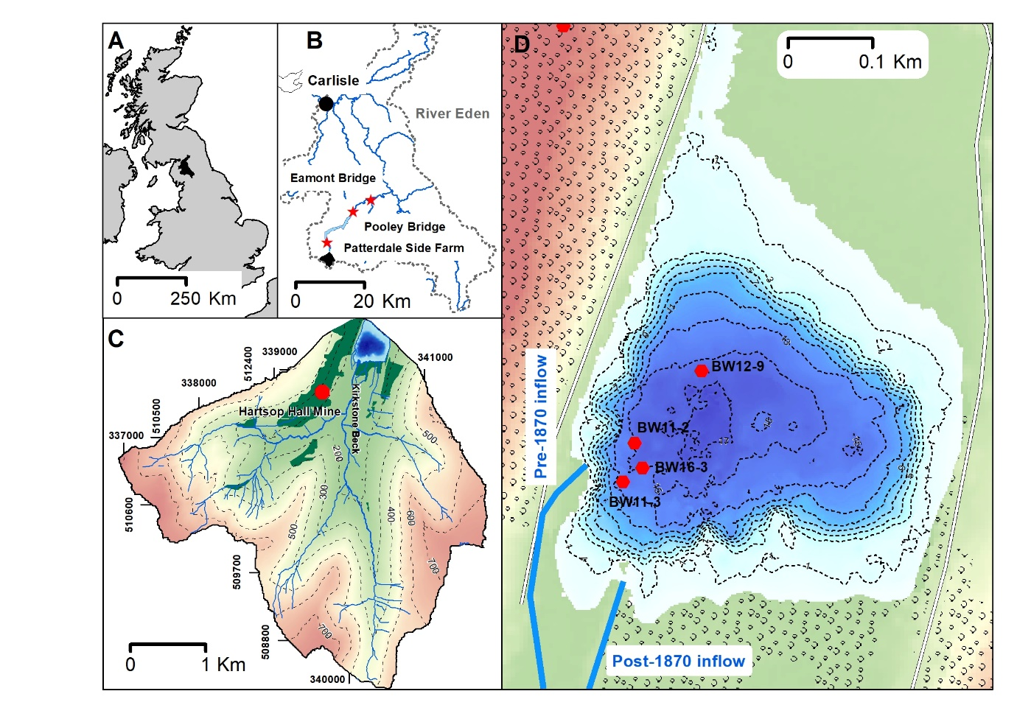
Figure 1. A) The River Eden drainage basin (black fill) in northwest England. B) The Brotherswater subcatchment (black fill) of the River Eden (grey dashes). River gauging stations used in this study (Patterdale, Pooley Bridge, Eamont Bridge) and the city of Carlisle are shown. Grisedale Bridge (rainfall data) is adjacent to Patterdale Side Farm. C) Hartsop Hall Lead Mine, woodland cover (dark green) and topography of the Brotherswater catchment. D) Bathymetric map (2-m contours) of Brotherswater showing the four coring locations and the position of the pre- and post-CE 1870 inflows.

Kirkstone Beck is fed by five tributaries draining upland headwaters and currently enters the lake at the southeast corner (Figure 1c). Ordnance Survey maps from Common Era (CE) 1897 (OS, 2018a) show the inflow in the current position, whereas the 1861 product (OS, 2018b) shows the inflow ~50 metres to the west. Peak mining at Hartsop Hall Lead Mine (Figure 1c) lasted from 1863 to 1871 (Tyler, 1992). The river was most likely diverted at this time to stabilise the western shoreline and allow mine access road construction. A sketch dated to CE 1794 confirms the inflow in the southwest corner, which we interpret as its long-term position. Palaeochannels on the pre-lake floodplain and southern littoral waters point to previous inflow-delta configurations but cores from their toes suggests long-term inactivity.
Mean annual precipitation (MAP) near Brotherswater is 2400 mm, with significant inter-annual variability. Minimum and maximum MAP, based on the incomplete but lengthy (since CE 1878) Grisedale Bridge record (Figure 1), are 1600 and 3000 mm, respectively. The 2009 and 2015 floods, which had major regional impacts across the Lake District (Spencer et al., 2017), were produced by 24-hour rainfall volumes of 153.4 and 245 mm. The previous daily maximum rainfall was 138.7 mm on 10 October 1977.

3. METHODS
3.1 Core acquisition and logging
Lake bathymetry was determined using a Garmin 50/200 kHz dual frequency echo-sounder. Total lead (Pb) profiles measured by X-ray Fluorescence (XRF) analysis across the profundal basin (see Schillereff et al., 2016b) revealed more rapid sediment accumulation in the SW quarter of the lake. This pattern and the historical inflow configuration guided site selection. We recovered four deep water cores along an inflow proximal to distal transect (Figure 1d) and short gravity cores (0.16 – 0.25-m length, 0.08-m diameter; Boyle, 1995) to capture the sediment-water interface, which were extruded and sliced at 0.5-cm intervals (Table 1). The longer record was sampled as overlapping 1- or 1.5-m drives using a hand-percussive Russian-type corer (0.075-m diameter). Complete sediment profiles varied in length between 1.35 – 3.5 m (Figure 2; Table 1). Drives were retained in plastic guttering, sealed tightly in polythene sleeving and stored at 4°C.
Digital line-scan photography of the core surface and x-radiographic greyscale images of sediment density were acquired for BW16-3 on an Itrax core scanner housed at the National Oceanography Centre–Southampton (Croudace et al., 2006) prior to sub-sampling. The lack of a visual stratigraphy precluded event sampling thus sediments were subsampled at 5-mm contiguous intervals (Table 1). All samples were weighed, freeze-dried and re-weighed after drying to estimate moisture content. Dry bulk densities were calculated using a value of 2.65 g cm⁻³ as catchment bedrock and surficial deposits are dominated by quartz (Chambers, 1978).

3.2 Sedimentology and geochemistry
Geochemical composition was determined by XRF analysis using different instruments (Table 1). Core BW11-2 was measured as dry sediment on a Bruker S2 Ranger ED-XRF under a helium atmosphere at three x-ray intensity settings (20, 40 and 50 keV tube excitement). Homogenised loose powders were pressed into sample cups lined with 6µm polypropylene film. Mass attenuation was corrected for organic matter concentrations, calculated thermogravimetrically (PerkinElmer S6000) as the mass loss between burn intervals of 230° and 530°C under a nitrogen atmosphere. XRF instrument consistency checks were made using certified geochemical reference materials (Boyle et al., 2015). Other cores were measured on a wet sediment basis using either a portable Thermo-Niton ED-XRF, the Geotek Multi-sensor core logger (MSCL-XZ) (University of Liverpool) or the Itrax µXRF system (Cox Analytical Systems, Gothenburg; Table 1). The Geotek houses an Olympus Delta hand-held energy-dispersive XRF (ED-XRF) analyser with a Rh X-ray tube. Cores were scanned under Soil mode (40 kV, 40 kV (filtered) and 15 kV beam intensities were applied successively for 20 seconds) for heavier elements and MiningPlus mode (40 kV and 15 kV) for lighter elements. The Olympus Delta completes a daily calibration check against a known standard (Alloy 316 Stainless Steel). The Itrax, fitted with a 3-kW molybdenum X-ray tube, scanned the cores at 300-µm step size and 30-second dwell time.

Table 1. Technical details of the four sediment cores.
Core label | Core length (cm) | Measurement resolution (cm) | XRF instrument | Other proxies
BW11-2 | 350 | 0.5 | S2 Ranger | Particle size
BW11-3 | 264.5 | 0.5 | Thermo-Niton | Particle size
BW12-9 | 135 | 0.5 | Geotek Olympus | Particle size
BW16-3 | 287 | 0.3 | Itrax | Line scan imagery X-radiograph

Particle size measurements were performed on a Beckman CoulterTM LS200 laser granulometer (University of Liverpool). The dimensions of individual grain sizes within discrete classes from 0.375 to 2000 µm were computed using a combined Fraunhofer and Mie optical model. Reference materials of known distribution were measured before and after each sample set and the standard error of all repeat measurements is 2.03%. Organic matter (OM) was digested with a 30% H₂O₂ solution for a period of 24 to 96 hours dependant on OM content and evaporated to a moist paste on a hot plate. Samples were mixed with a deflocculating solution of 1% sodium hexametaphosphate ((NaPO₃)₆) and dispersed ultrasonically to minimise the risk of adhesion between individual grains. Final results were the average of three successive runs after replicate distributions were compared manually to verify complete dispersion. Particle size parameters were calculated using the geometric measurement formulae of Folk and Ward (1957), which are sensitive to the presence of coarse tails (Folk, 1966). End-member modelling using the R package ‘EMMAgeo’ (Dietze and Dietze, 2013) partitioned the particle size data into statistically meaningful groupings using a principle components algorithm. Individual end-members likely reflect differing sediment sources and transport mechanisms. The procedure is described in detail in Dietze et al. (2012).

3.3 Dating methods
We used multiple chronological methods to construct age-depth models for Brotherswater. Radiometric dating (²¹⁰Pb, ²²⁶Ra, ¹³⁷Cs, ²⁴¹Am) was applied to BW11-2 and BW12-9 cores by direct gamma assay using Ortec HPGe GWL series well-type coaxial low background intrinsic germanium detectors at the Liverpool Environmental Radioactivity Laboratory (Appleby et al., 1986). Sub-samples were measured at non-regular intervals (BW11-2: 1.5- to 4-cm; BW12-9: 1- to 2-cm) dictated by sediment accumulation rates estimated from the Pb mining profiles.
The longer BW11-2 sequence was dated using fourteen ¹⁴C measurements that targeted hand-picked terrestrial plant macrofossils (Table 2). Sub-sampling depths were guided by Pb mining chronological indicators and samples were sieved at 160 µm in deionised water and picked for identifiable macrofossils. Radiocarbon measurements were performed at the NERC Radiocarbon Facility (East Kilbride) after a standard pre-treatment using a standard Acid- Alkali-Acid wash to remove dissolved humic acids, conversion to carbon dioxide by combustion in quartz tubes and graphitisation by iron-zinc reduction.
The legacy of acute metal pollution from Hartsop Hall Mine (Figure 1C) offers further well-constrained chronological markers. Records show the mine operated periodically between 1696 and 1942 (Tyler, 1992) and rates of ore extraction are in good agreement with Pb profiles in all cores (Schillereff et al., 2016b). We incorporated the three most reliable ages (see Schillereff et al., 2016b) into the age-depth model to refine uncertainty in the radionuclide dating: the onset of mining in CE 1696, peak ore extraction in CE 1863, when Pb concentrations exceeded 10,000 ppm (Figure 2), and CE 1931, the final phase prior to permanent mine closure.
The primary age-depth model was generated for BW11-2 using the Bayesian routine ‘Bacon’ (Blaauw and Andrés Christen, 2011) in R version 3.5.1 (R Core Team, 2018) that integrated the sediment surface, artificial (¹³⁷Cs and ²⁴¹Am peaks) and natural (²¹⁰Pb) radionuclide chronologies, ¹⁴C ages and Pb markers.

Table 2. Radiocarbon dates from Brotherswater. The IntCal13 curve was used for calibration (Reimer et al., 2013) within the Bayesian modelling (Blaauw and Andrés Christen, 2011).

Publication Code | Sample Identifier | ¹⁴C Enrichment (% Modern ± 1σ) | Conventional Radiocarbon Age (years BP ± 1σ ) | Carbon content  (% by wt.) | δ¹³C_{VPDB} ‰  ± 0.1
SUERC-48896 | BW11-2 RC1 41-42 | 95.42 ± 0.53 | 377 ± 45 | 46.3 | -27.765
SUERC-48897 | BW11-2 RC2 49-50.5 | 95.48 ± 0.53 | 371 ± 45 | 43.7 | -27.879
SUERC-48898 | BW11-2 RC3 61-62.5 | 97.55 ± 0.54 | 199 ± 45 | 48.7 | -28.3
SUERC-48899 | BW11-2 RC4 81-81.5 | 97.02 ± 0.54 | 243 ± 45 | 44.2 | -26.098
SUERC-48903 | BW11-2 RC6 127-128.5 | 89.84 ± 0.50 | 860 ± 45 | 40.6 | -27.351
SUERC-48904 | BW11-2 RC7 150-151 | 90.38 ± 0.51 | 812 ± 45 | 41.2 | -29.119
SUERC-48906 | BW11-2 RC9 172-174 | 92.26 ± 0.52 | 647 ± 45 | 50.5 | -28.752
SUERC-48907 | BW11-2 RC10 197-198.5 | 90.85 ± 0.52 | 771 ± 46 | 46.1 | -27.862
SUERC-48908 | BW11-2 RC11 224-224.5 | 92.99 ± 0.54 | 584 ± 47 | 54.9 | -30.719
SUERC-48909 | BW11-2 RC12 269-270 | 87.03 ± 0.49 | 1116 ± 45 | 53.7 | -28.506
SUERC-48910 | BW11-2 RC13 321.5-323.5 | 84.08 ± 0.47 | 1393 ± 45 | 50.4 | -28.959
SUERC-48913 | BW11-2 RC14 335.5-336 | 82.66 ± 0.46 | 1530 ± 45 | 52.5 | -28.384
SUERC-35378 | BW11-2 (3) 258 |  | 930 ± 30 |  | -25.0
SUERC-37679 | BW11-3 137.5-138.5 |  | 200 ± 30 |  | -28.0

3.4 Time series analysis of particle size data
Long-term variations in sediment supply from catchments to lake basins may alter the association between hydrology and particle size through time. We isolated the particle size signal of individual floods in this dynamic sediment regime by using the time series outlier-detection function in R package ‘tsoutliers’ (López-de-Lacalle, 2017) in R version 3.5.1 (R Core Team, 2018). This function implements the autoregressive integrated moving average approach of Chen and Liu (1993) to account for non-stationary environmental data. It takes the form ARIMA(p, d, q), where p is the number of time lags of the autoregressive model, d reflects the number of differencing steps to eliminate non-stationarity and q represents the order of the moving average model. Outliers are identified where the t-statistic (T) is greater than two. These T>2 outliers in the particle size record represent anomalously coarse material that we interpret as deposits lain down during high-magnitude floods. Two types of outliers were considered: a temporary change (TC), which represents a marked initial impact with no lasting system memory, and an innovational outlier (IO), which influences some subsequent observations before returning to background sedimentation. We hypothesise that this separates abrupt, high-energy events that probably produce the coarsest laminations from floods causing greater fluvial erosion and charging the system with excess coarse material, potentially inducing a new baseline particle size regime.

4. RESULTS
4.1 Chronostratigraphy
Two peaks in ¹³⁷Cs are relatively well-defined in BW11-2 and BW12-9 (Schillereff et al., 2016b) and a widespread phenomenon of Brotherswater radioisotope stratigraphy (Semertzidou et al., 2018). The deeper peak coincides with maximum ²⁴¹Am concentrations, which we attribute to CE 1963 atmospheric weapons testing. The more recent spike records the CE 1986 Chernobyl accident. These markers corroborate the ²¹⁰Pb-derived chronology, which for BW12-9 extends to CE 1880 (Schillereff et al., 2016b). Unsupported ²¹⁰Pb concentrations decline exponentially with depth, enabling sedimentation rates to be calculated using the Constant Rate of Supply (CRS) model (Appleby et al. 1978).
The ‘Bacon’ model (Figure 3A) implemented Markov Chain Monte Carlo repetitions constrained by a gamma distribution with mean 5-yr mm⁻¹ and shape 2 and a beta distribution with mean 0.5 and memory strength 20. The ¹⁴C ages were calibrated using the IntCal13 curve (Reimer et al. 2013). The mining markers were integrated into the ‘Bacon’ framework using narrower Student’s-t uncertainty distributions (i.e., parameters t.a and t.b were set to 33 and 34, respectively) that reflect their greater chronological certainty.
The primary ‘Bacon’ age-depth model, in which all ¹⁴C distributions were equally likely, revealed a coherent sequence of radiocarbon ages with some apparent outliers at shallower depths (Figure 2A). Pairs of consecutive ages at 41- and 50-cm depth and 127- and 151-cm plot as anomalously old. These correspond to phases of increased mineral supply (Figure 3). Several lakes across the region reveal contemporaneous age reversals around CE 1000, which were attributed to ‘old carbon’ locked in soils that became mobilised during landscape clearance episodes (Pennington, 1991; Edwards and Whittington, 2001; Chiverrell, 2006). This age-depth model shows a single age at 224 cm as too young that is more difficult to explain, though contamination during core processing is a possibility. We tested an alternative scenario in which the ‘Bacon’ model was forced through the sample at 224 cm (Figure 2B). This assumed, a priori, that the four ages between 127 and 199-cm depth were all affected by old carbon. This scenario is explored in the Discussion.

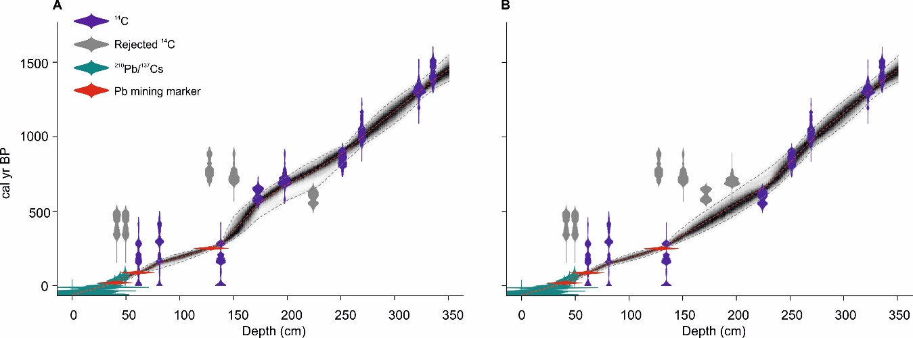
Figure 2. A) ‘Bacon’ age-depth model for core BW11-2 based on fourteen radiocarbon ages, ²¹⁰Pb and ¹³⁷Cs radionuclide dating and three reliable mining markers: the onset of mining in CE 1696, peak ore extraction (CE 1863) and the final phase prior to mine closure (CE 1931). B) Alternate chronology that assumes, a priori, a reliable date at 224-cm below four sequential ¹⁴C reversals.

Ages are quoted as weighted means in the output from ‘Bacon’. The primary chronology extends to CE 519, although depths 335–351 cm are extrapolated from the deepest ¹⁴C age. This 1500-year sediment sequence represents, to date, the longest lake-derived palaeoflood record in the UK. Maximum and minimum 95% confidence ranges are 2.9 (2-cm depth) and 190 (225-cm depth) years, respectively. Sediment accumulation rates at core site BW11-2 are fairly high throughout the record (mean 0.26 cm yr⁻¹), with most rapid accumulation since peak mining in the 1860s. The BW11-2 chronology was transferred to other cores based on the repeatable geochemical stratigraphy for multiple elements across the basin (Schillereff et al. 2016b).

4.2 Sedimentology and geochemistry
The dominant constituent of all cores is a visually-homogeneous, grey-brown limnic mud, which our monthly sediment trapping showed is regular background sedimentation (Schillereff et al., 2016a). Some variation in sediment colour occurs at the decimetre scale, with lighter deposition parallelling increased bulk density (0.3–0.8 g cm⁻³), reduced organic matter content (5-8% lower) and higher concentrations of elements reflecting catchment mineral supply (Ti, Zr) (Figure 3). Upper sediments in all cores shift to very dark brown to black. Occasional light-brown layers are visible in ITRAX line-scan imagery (e.g., 90- and 100-cm depth in BW16-3), which X-radiographs show as higher density (Figure 3). This stratigraphy suggests cores are not affected by bioturbation, reinforced by the tight repeatability across the XRF geochemistry and particle size profiles. A systematic visual signature of peaks in particle size does not emerge from the background matrix, however. This analysis depends on the high-resolution particle size measurements as a result.

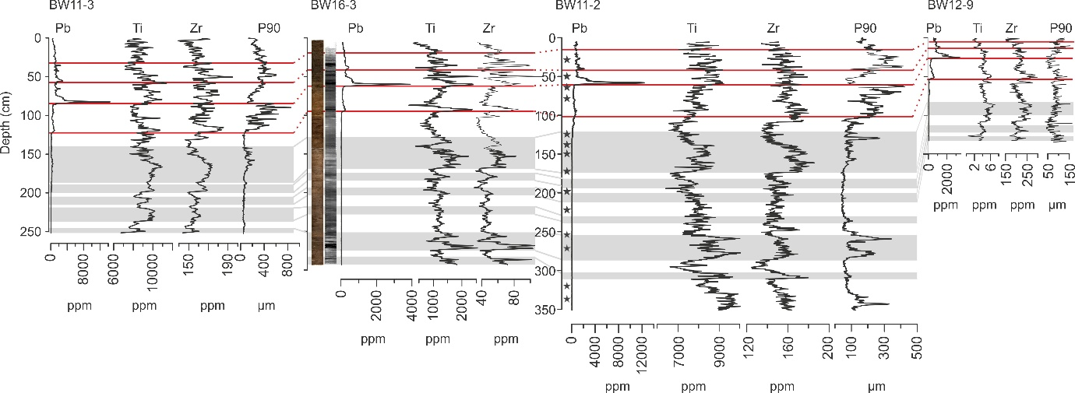

Figure 3. Lithology of Brotherswater cores, plotted from left to right as moving from the inflow (BW11-3) to the basin centre (BW12-9). The Pb profile relates to the catchment mining history, Ti and Zr are interpreted as proxies for minerogenic input from eroded soils and fluvial sediment and the 90th percentile (P90) of particle size distributions isolates the coarsest fraction. Red bars indicate stratigraphical changes across multiple proxies and grey boxes show the correlation of geochemical marker horizons. Dark grey stars represent sampling depths for radiocarbon dating.

4.3 Particle size
Variation in the calibre of deposition in Brotherswater is observed across all cores (Figure 3). The dominant mode in most particle size distributions (PSDs) lies in the silt range and reflects background sedimentation. The coarsest deposition lies in the sand fraction, with maximum P90 (P90_{max}) in BW11-3 exceeding 800 µm. We calculate the 90th percentile (P90) for the particle size distributions to focus on size variations in the coarsest fraction, which requires the greatest fluvial energy to transport. Zones of decimetre thickness characterised by coarse deposition feature in all cores (Figure 3) and these correspond with phases of elevated mineral supply (Ti and Zr). This longer-term variation in P90 is overprinted by numerous thin (5-20 mm), sharp peaks that reflect more abrupt depositional events.
End-member modelling analysis (EMMA) confirms these patterns of particle size deposition. Sensitivity tests following Dietze et al. (2012) using a low weight transformation (0.005; R² = 0.86) reveal the optimum number of end-members capable of explaining more than 95% of the variance in the dataset is 3 (4 in BW12-9). The EMMA decomposes the particle size distributions into three end-member groupings with modes in the clay, medium silt and fine/medium sand (Figure 4). Four end-members were required to model BW12-9 (explaining 86% of the variance) including an additional coarse-silt component (EM3) and a significantly finer sand class (EM4 mode = 146.82 µm) in this more distal sector of the lake.

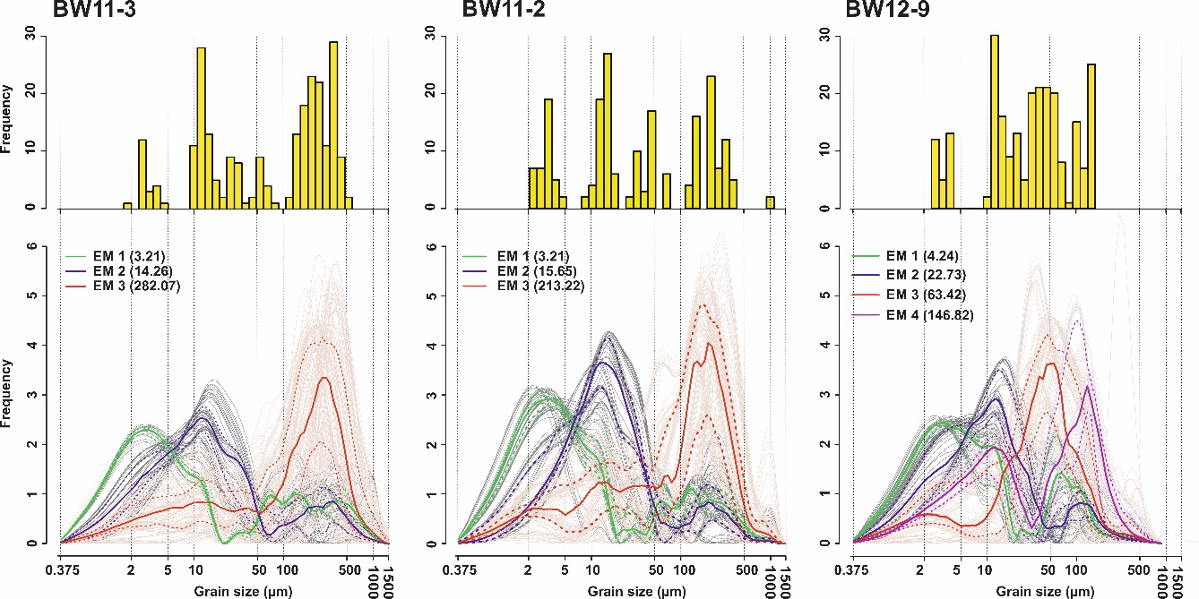

Figure 4. Modal histograms and unmixed particle size distributions from the optimal end-member models. Solid (dotted) lines represent mean (±2σ) of the robust end-members. Green: clay/very fine silt EM1; blue: fine/medium silt EM2; red: fine sand EM3. Note BW12-9 deciphers four end-members: red: coarse silt (EM3); purple: very fine sand (EM4).

Most PSDs in all cores are uni- or bi-modal so the use of conventional frequency statistics is appropriate (Beierle et al., 2002). Laser diffraction instruments most effectively differentiate silt-dominated samples (Roberson and Weltje, 2014), further increasing our confidence in the robustness of the particle size measurements. Lastly, plotting mean versus sorting and skewness and skewness versus sorting produces sinusoidal, circular and helical curves, respectively, patterns commonly observed in other depositional settings (Folk, 1966).

4.4 Particle size-inferred flood series
Variation at the decimetre scale in Ti and Zr mirrors the P90 profiles and points towards a non-stationary sediment regime through the late-Holocene (Figure 2). The tsoutliers package fitted an ARIMA(2, 1, 1) model and, based on the recommended sensitivity threshold (T) of 2, isolated 162 anomalously coarse deposits through the 1500-year record (Figure 5). To avoid performing a circular comparison having transferred the BW11-2 chronology, we compare outlier time series based on the geochemical zonation presented in Figure 2. A good match is revealed between BW11-2 and BW11-3 for the overlapping timeframe since CE 1050 (Figure 5B and 5C). The absence of flood deposits in BW11-3 around CE 1600 is the one exception.
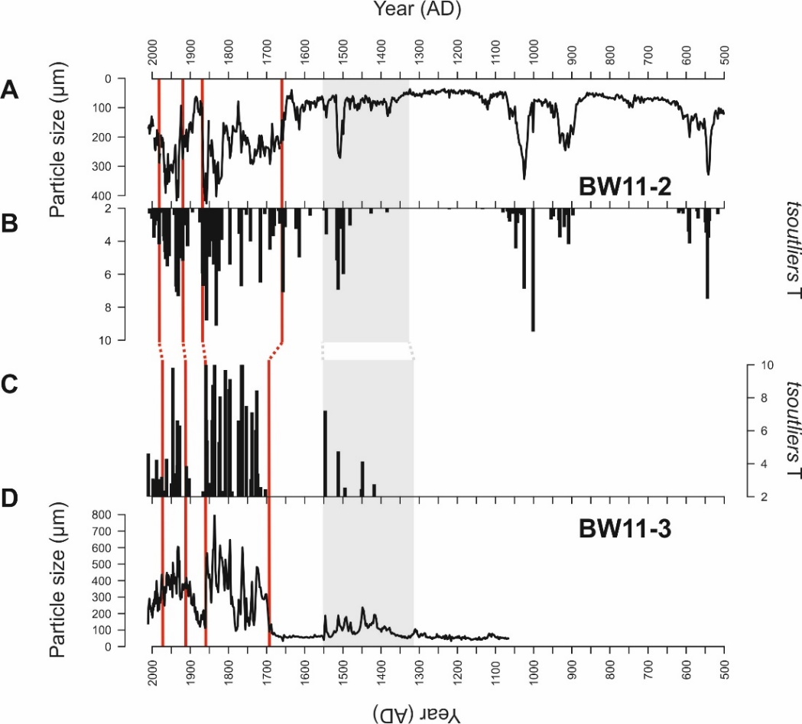
Figure 5. A) The 90th percentile (P90) particle size parameter for BW11-2. B) Combined temporary chance and innovational outliers detected by the ARIMA model applied to the BW11-2 P90 time series. We infer coarse outliers where T>2 as indicative of flood deposits. C) As (B) but for BW11-3. D) As (A) but for BW11-3. Red lines reflect correlating points in the Pb profiles and the grey box reflects correlating zones identified from multi-proxy geochemical data (see Figure 2).

Overall, flood outliers form discrete event laminations that do not occur consistently through the record. Rather, based on the primary age-depth model, clusters of coarse deposits occur around CE 510-630, 890-960, 990-1080, 1470-1560, 1590-1620, 1650-1710, 1740-1770, 1830-1890 and since 1920. Using a time window of equivalent duration to gauged river flow records and climate regimes (i.e., 30 years), event frequency during flood-rich episodes is 2-8, falling to one or zero events during intervening flood-poor episodes (Figure 8). Intervals of low or inactivity are longer (>200 years) in the earlier record.
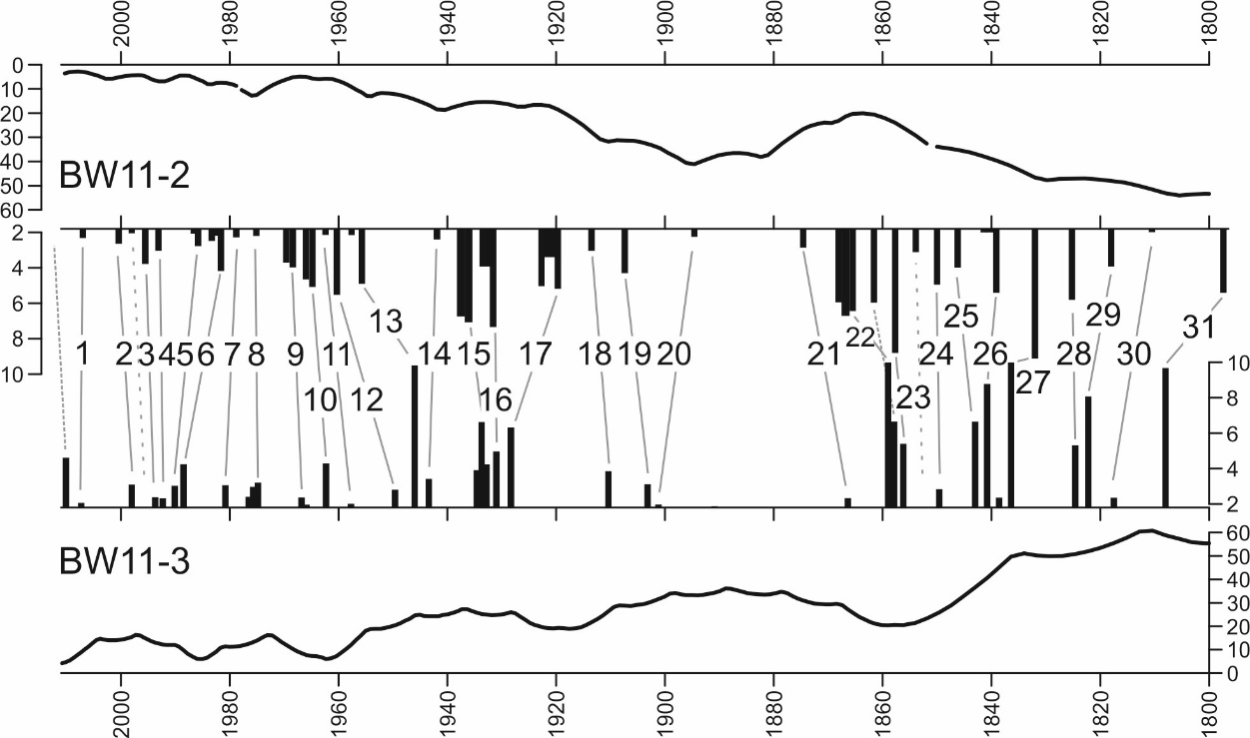
B
C
A
D

Figure 6. A) The chronological minimum/maximum difference for BW11-2. B) The tsoutliers-derived palaeoflood record for BW11-2 spanning 1800-2010, the period for which independent historical flood records are available (see Figure 7; Section 5.1). C) As (B) but for BW11-3. D) As (A) but for BW11-3. Grey lines show matched flood units that follow stratigraphic sequence and fall within the chronological uncertainty. The 2009 deposit was not recovered at the surface of BW11-2. Long dashed lines indicate minor above-threshold deposits in BW11-2 that cannot be correlated to a BW11-3 layer. Sequential above-threshold deposits are considered single events.

Correlating discrete deposits in BW11-2 and BW11-3 after CE 1800 reveals a strong match (Figure 6). A total of 31 flood units can be correlated across both cores, following stratigraphic sequence and within the chronological uncertainty. The unit at the top of BW11-3 almost certainly corresponds to the major 2009 regional flood. Two T>2 units (weighted mean year of deposition: 1998 and 1854) detected in BW11-2 cannot be linked to an equivalent deposit in BW11-3, although in both cases an outlier slightly below the T>2 threshold occurs. The 1862 flood is also difficult to correlate but could be part of the unit 22 cluster.

5 Discussion
5.1 The Brotherswater palaeoflood record
Our study has produced the longest lake-based palaeoflood record for the UK, with 162 flood units identified since CE 500. The reconstruction is characterised by periods of high-frequency flooding at CE 510-630, 890-960, 990-1080, 1470-1560, 1590-1620, 1650-1710, 1740-1770, 1830-1890 and since 1920 (Figure 5; Figure 8). Few flood records of comparable length exist in the UK, although Jones et al. (2012) also show frequent flooding CE 800-1200 followed by a multi-centennial absence and a recurrence of frequent flooding after CE 1550 along the River Severn. This broader tendency for floods to cluster at the multi-decadal scale is evident in palaeoflood reconstructions from the UK (Foulds and Macklin, 2016; Macdonald and Sangster, 2017), western and central Europe (Benito et al., 2008; Wirth et al., 2013b) and further afield (Munoz et al., 2018). This behaviour has implications for flood frequency analysis: trends identified in a 30-year flow record may be artefacts if that time window is unrepresentative of the longer-term hydrological regime (Hannaford, 2015; Hooke, 2006).
Over the historical era (post-CE 1800), the timing of some flood-rich episodes (especially the late-19th century) aligns with regional historical records (Macdonald and Sangster, 2017; Parkes and Demeritt, 2016; Pattison and Lane, 2012) but diverges elsewhere (e.g., before CE 1850). Archive sensitivity is likely to be a crucial factor. Pattison and Lane (2012) compiled documentary evidence of 137 floods in Carlisle (Figure 1) since CE 1800 while we identified only 32 flood deposits. Historical records from Carlisle such as newspaper accounts probably document most overbank inundations, whereas sediment trapping in Brotherswater showed a discharge threshold controls flood unit preservation (Schillereff et al., 2016a). Encouragingly, our lake reconstruction shows good agreement to the highest-magnitude floods since CE 1800 at Carlisle estimated from documentary sources (Parkes and Demeritt, 2016; Smith and Tobin, 1979). Rather than directly integrating these dates into the Brotherswater chronology, a systematic comparison shows our age probability distributions for 14 of 16 flood units overlap with the highest-ranked river discharges between CE 1800 and 1930.
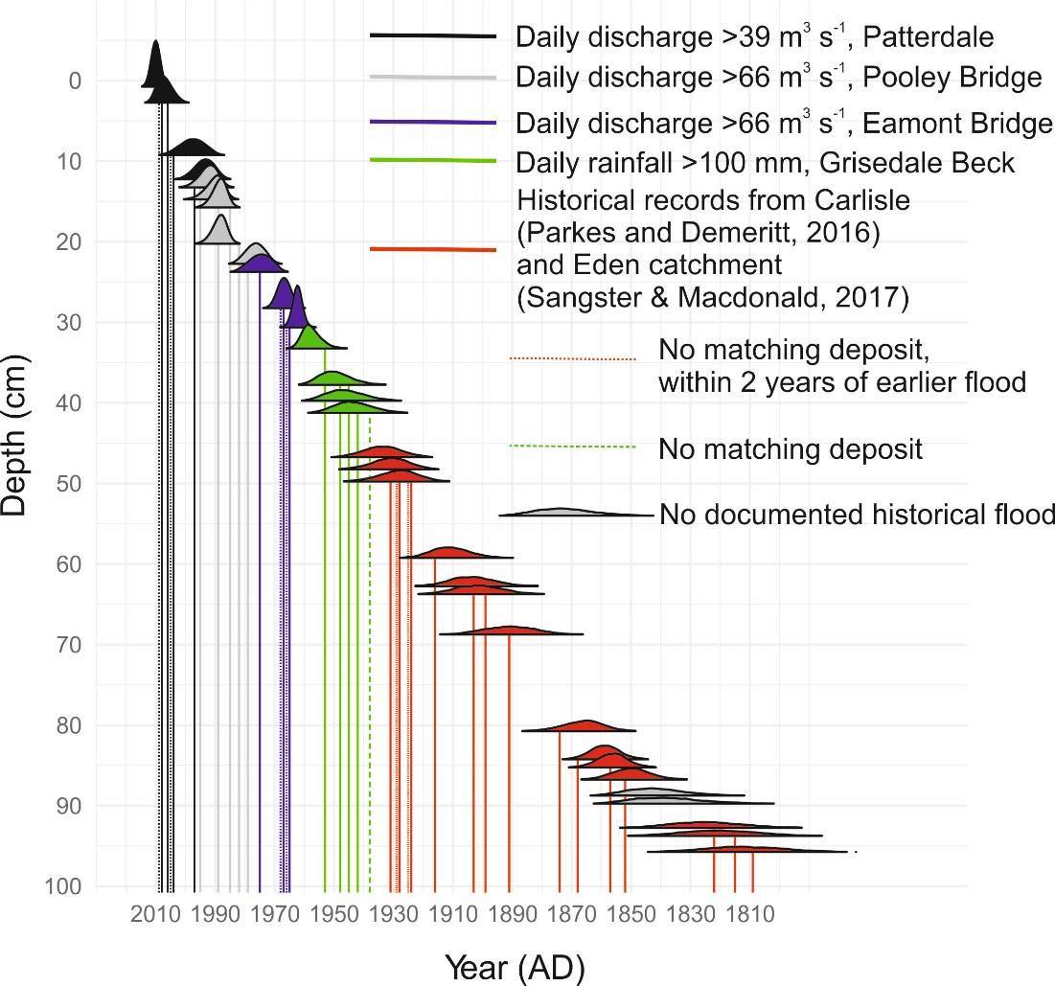
Figure 7. Age probability distributions generated using ggjoy and Bacon.Age.d() function of flood deposits identified in the BW11-3 ARIMA model. Vertical lines denote independently-recorded floods: black line = high discharges at Patterdale Side Farm; grey lines = Pooley Bridge; blue lines = Eamont Bridge discharge; green lines = daily rainfall >100 mm at Grisedale Beck; red lines represent years with historically documented floods at Carlisle (Macdonald and Sangster, 2017; Parkes & Demeritt, 2016). Dotted lines reflect documented floods without a matching deposit but where a flood occurred within the preceding 1-2 years. Dashed lines cannot be stratigraphically ascribed to a deposit.

There are some stratigraphic mismatches. A succession of five documented floods in the 1920-30s corresponds to three flood deposits. We propose event sequencing as the most plausible explanation for under-representativeness in the sedimentary record (Magilligan et al. 1998). There is widespread evidence that catchment sediment stores are flushed during major floods, leaving insufficient material to exploit the transport capacity of subsequent high flows (Cockburn and Lamoureux, 2008; Kämpf et al., 2014). Sediment availability can be a key factor in determining the scale of sedimentological and geomorphological change during major floods (Hooke, 2015). At Brotherswater, Chambers (1978) noted suspended sediment load plummeted nearly 100% through three successive floods of equivalent rainfall and discharge. Our contiguous 0.5-cm sampling strategy should not miss the sedimentary signal of annual maximum flows because the sediment accumulation rate through that section (0.55 cm yr⁻¹) approximates to annual resolution and documented floods occurred 1-2 years apart. Using the contemporary discharge thresholds established for Brotherswater (Schillereff et al., 2016a) means twelve of sixteen 20th century events can be tied to a flood unit (Figure 7). Removing sub-two-year flood couplets from the discharge data produces a like-for-like match since CE 1800, suggesting the timescale for sediment recharge is approximately two years. This supply-limited regime generates a non-linear discharge-sedimentation pattern, meaning signatures of high flows may not be preserved on occasion (Magilligan et al., 1998; Sambrook Smith et al., 2010). As a result, means Brotherswater provides a record of sedimentologically and geomorphologically significant floods. While this precludes future attempts to estimate historical event magnitudes, the Brotherswater record provides a conservative estimate of flood frequency and reliably identifies the timing of multi-decadal flood-rich and flood-poor episodes.

Table 3. Correlating ranked daily maximum discharges for three gauging stations progressively downstream from Brotherswater (Figure 1B) for the period 02/02/1997 to 01/01/2011. Green shading indicates Top 10 floods at all sites. Brown shading denotes Top 10 at Pooley Bridge and River Lowther.
Daily maximum rank | Patterdale Side Farm |  |  | Pooley Bridge |  | Eamont Bridge
1 | November 2009 |  |  | November 2009 |  | November 2009
2 | January 2005 |  |  | January 2005 |  | January 2005
3 | February 2004 |  |  | December 2006 |  | February 2002
4 | October 2008 |  |  | February 1997 |  | February 2004
5 | December 2006 |  |  | February 2004 |  | October 1998
6 | February 1997 |  |  | October 2008 |  | December 2000
7 | September 2004 |  |  | December 2000 |  | December 2006
8 | December 1999 |  |  | October 1998 |  | February 1997
9 | December 2007 |  |  | February 2002 |  | January 1999
10 | July 2009 |  |  | January 2009 |  | October 2008

Two deposits in the 1840s do not correspond stratigraphically to known floods. The region experiences spatially heterogeneous, orographical rainfall (Burt and Howden, 2013) and the eastern headwaters of the River Eden lie in a rain shadow, so localised weather systems that do not trigger flooding in Carlisle do occur. That said, the highest-magnitude floods appear to persist through the catchment (Table 3). Overall, our evidence suggests a strong degree of fidelity to the Brotherswater palaeoflood record.

5.2 Depositional mechanisms under high-flow conditions
Pb profiles that shallow towards the lake centre confirm that fluvial supply dominates lake sedimentation (Figure 2; Schillereff et al., 2016b). This is mirrored by a fining trend towards the basin centre, where sediments are also, on average, better sorted and less negatively skewed. This processing by the lake is a response to decelerating fluvial plumes. The negative correlation between particle size and skewness (r = -0.60) reflects suspension of excess fine particles under high flow conditions that eventually fill the pore spaces in coarse deposits (Bøe et al., 2006). We interpret these patterns to indicate inflow dynamics are dominated by homopycnal or mesopycnal, laminar flows (Cockburn and Lamoureux, 2008; Kämpf et al., 2014). Brotherswater displays no thermal stratification during winter when most floods occur and flood waters are warmer than ambient lake temperature (Schillereff et al., 2016a). As a result, the less dense plume expands laterally near the lake surface and particles settle vertically at rates dictated by their diameter and mass. This explains why the central and delta-distal sectors are less sensitive to floods and preserve fewer coarse deposits (Figure 2; Schillereff et al., 2016a). This depositional mechanism contrasts with lakes dominated by powerful turbidity currents that can transport coarse material at the lake bed over extended distances (Girardclos et al., 2007; Osleger et al., 2009; Sturm and Matter, 1978). There is negligible likelihood of deposits induced by seismic events.
These basin-wide sediment dynamics indicate particle size measurements can reliably detect high flows and overcome difficulties posed by the dark brown, homogeneous sediment matrix. This was reinforced by sediment trapping over an 18-month period (Schillereff et al., 2016a), which detected a particle size and discharge threshold for flood deposits. Earlier sediment-source monitoring at Brotherswater (Chambers, 1978) showed high flows dominate the transport of coarse material and particle size distributions mirror our end-member populations (Figure 4; Chambers, 1978). The fine-grain (mode = 2-5 µm) EM1 derives from catchment soil weathering and erosion, while streambank material lies predominantly in the medium-silt fraction, reflected in EM2 (10-40 µm). EM2 is the dominant sediment supply under regular flow conditions to the delta proximal sector of Brotherswater, with PSDs at BW11-2 comprising 50-75% silt. Scour at the river bed and lateral erosion of hummocky moraines on the valley floor are important sources of the coarse EM3 component (100-500 µm). Mineralogical evidence shows material of this calibre can only reach the lake during flood events (Chambers, 1978). Contemporary measurements also showed lower organic matter input accompanied higher discharge (Chambers, 1978; Schillereff et al., 2016a), meaning the strong, negative correlations between organic matter and P90 (r = -0.61) and sediment bulk density (r = -0.61) are also diagnostic of flood units. Certain geochemical ratios are known to be sensitive to particle size fractionation, but Rb/Sr (Vasskog et al., 2011) and Zr/Rb (Dypvik and Harris, 2001) show weak, non-significant associations (r ≤ 0.2) at Brotherswater. The Brotherswater catchment is almost entirely underlain by andesitic tuffs of varying clast size (Chambers, 1978; Rae and Parker, 1996). Products of parent material weathering will therefore maintain similar geochemical composition regardless of particle diameter and fluvial transport capacity, negating the application of geochemical proxies for particle size. In summary, the Brotherswater stratigraphy identifies two modes of deposition: finer-grained material (EM1 and 2) dominates the sediment sequence is overprinted by abrupt deposition of coarse material (EM3) during floods.

5.3 Climate drivers of flooding in northwest England
Trends in climate forcings linked to late-Holocene river floods across western Europe show some similarity with the Brotherswater record (Figure 8). Four of the flood-rich episodes overlap with solar minima in the 10-11th (Oort), 15-16th (Spörer) and 17-18th (Maunder) centuries (Figure 8). The non-significant match (p>0.05) between Total Solar Irradiance (TSI) and binned flood frequency mirrors the intermittent relationship between solar forcing and UK hydroclimate observed in peat and historical archives (Charman et al., 2006; Macdonald and Sangster, 2017). The first flood-rich episode (CE 520-620) precedes a phase with low TSI (Steinhilber et al., 2009), although the offset falls within the chronological uncertainty of the age-depth model. Any palaeoflood response to the Wolf solar minimum (13-14th century) is not evident in the Brotherswater record. Alignment between flood-rich conditions and low TSI fit well with mechanisms linking solar lows to a shrinking of the Hadley cell in the Northern Hemisphere (Gray et al., 2010). Persistent atmospheric blocking and ensuing southward shift in storm tracks across the North Atlantic have been identified as a trigger for major flooding across western and central Europe over multi-centennial timescales (Czymzik et al., 2016; Wirth et al., 2013b).
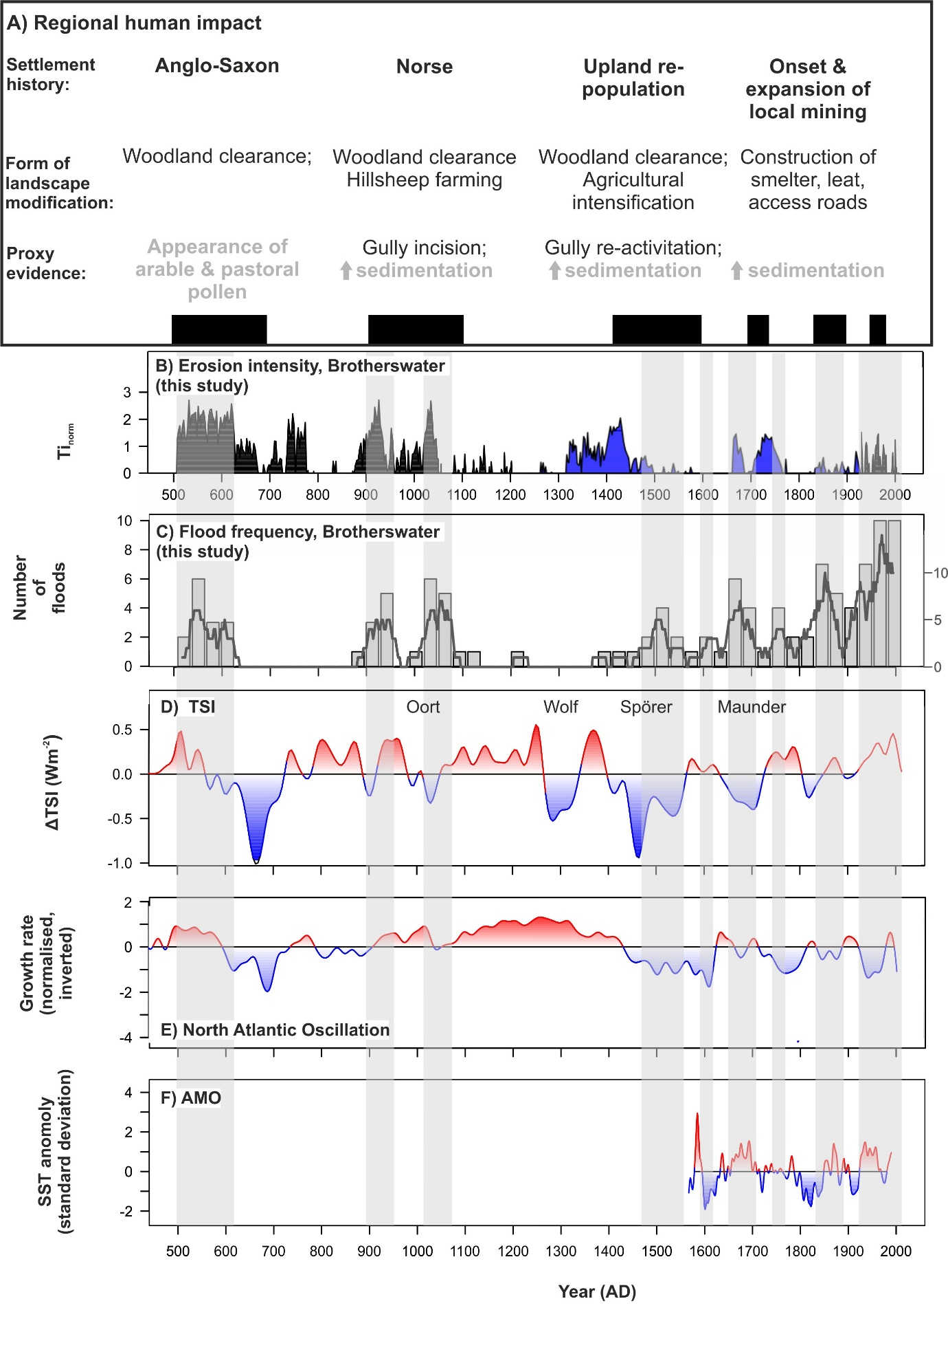
Figure 8. A) Summary of regional geomorphological (black text) and palaeolimnological (grey text) evidence for anthropogenic modification of the landscape. References provided in the text. B) Normalised Ti from cores BW11-2 (black) and BW12-9 (blue) as a proxy of catchment erosion at Brotherswater. C) Time series of flood frequency at Brotherswater. Particle size outliers (T>2) were summed into climatically-representative 30-year bins. The dark grey line is the 31-year running sum. D) Variation in TSI through the late-Holocene (Steinhilber et al., 2009). Known solar minima are named. E) Normalised growth rate of speleothems from Scotland as a proxy for North Atlantic Oscillation behaviour (Proctor et al., 2002). F) Reconstruction of the Atlantic Multi-decadal Oscillation, reflected by variations in sea surface temperatures (SST) (Gray, 2004). Vertical grey bars demarcate flood-rich episodes (n > 2).

Comparing the frequency of flooding at Brotherswater with a proxy record proposed for the late-Holocene winter NAO (Proctor et al., 2002) shows a significant, negative correlation (r = -0.65, p<0.001; Figure 8D). The CE 890-960 and 990-1080 flood-rich periods align with minor negative excursions, whereas sedimentary evidence for floods is scarce through the persistent positive NAO phase CE 1100-1400 (Baker et al., 2015; Trouet et al., 2009). There is a good agreement between flooding episodes and negative NAO behaviour since CE 1400. This reinforces historical and instrumental evidence that negative winter NAO conditions are an important driver of UK and pan-European flood frequency (Foulds and Macklin, 2016; Macdonald and Sangster, 2017; Moreno et al., 2008; Wirth et al., 2013a) as the mid-latitude pressure gradient exerts a strong influence on the genesis of westerly air masses (Jones et al., 1997; Wilby et al., 1997). Comparison to a daily weather classification scheme (Neal et al., 2016) confirms cyclonic westerlies are a dominant driver of winter flooding. Since CE 1800, type 20 (cyclonic westerly), 21 (cyclonic south-westerly) or 30 (cyclonic west-north-westerly) weather systems occurred in the three days preceding 52%, 35% and 39% of floods (Figure 7).
The three lengthiest (>50 year) flood-rich episodes since CE 1600 align with positive AMO excursions (Gray, 2004), mirroring patterns in documented floods across western Britain (Macdonald and Sangster, 2017). Overall, there is no significant correlation with the frequency of floods at Brotherswater (r=0.33, p>0.05) but this is hampered by the short AMO reconstruction. Climate models associate the positive phase of the AMO with increased cyclonic weather systems and greater rainfall over northwest Europe, especially in winter, potentially triggered by enhanced ocean-atmosphere energy transfer from warmer SSTs (Knight et al., 2006).
The sediment record indicates floods have been more frequent in the 20th century and in particular since the CE 1930s (Figure 8). This ties into persistent negative NAO and positive AMO modes for several decades. Independent evidence of flooding corroborates this trend, with Macdonald and Sangster (2017) showing more frequent high-magnitude floods after CE 1930 in northern England. Pattison and Lane (2012) trawled documentary sources to reconstruct moderate flood frequency after CE 1940. Archive sensitivity probably explains this divergence because their approach almost certainly documents floods undetected by the discharge-sedimentation regime at Brotherswater (Section 5.1). The final phase of mining (CE 1931-1942) brought major mechanisation (Schillereff et al., 2016b; Tyler, 1992) and large spoil heaps adjacent to tributary streams are still present. This enhanced sediment availability probably lowered the discharge threshold for sedimentary floods.
The alternative chronology (Figure 3b) has a minor effect on these hydroclimate-palaeoflood linkages. It renders the 15-17th century flood-rich episode slightly more recent and coincident with the Maunder rather than Spörer solar minimum. In either case, an interpretation that solar irradiance influences the frequency of flooding is supported.

5.4 Human influence on late-Holocene flooding
Six flood-rich episodes (CE 510-630, 890-960, 990-1080, 1470-1560, 1650-1710 and 1830-1890) also overlap with periods of agricultural intensification in the region and mining expansion in the catchment (Figure 8a). Woodland clearance and grazing pressure can reduce geomorphic thresholds for erosion (Orr and Carling, 2006); the relatively steep slopes and shallow soils around Brotherswater are particularly vulnerable. While the outlier treatment isolates coarse laminations, it does not account for longer-term step-changes driven by human activity in the sediment supply-limited system. Ti should be an effective proxy for catchment erosion as it is tightly correlated with K and Zr (Schillereff et al. 2016b), with positive excursions in normalised Ti (Ti_{norm}) profiles distinguishing active soil erosion. The late-Holocene record of minerogenic input to the lake centre (BW12-9) is more sensitive to long-term variations in sediment supply than event deposition (Schillereff et al. 2016a), with BW11-2 used only for the earlier record (Figure 8b).
The earliest three flood-rich episodes align with maximum Ti_{norm} values and regional palynological and geomorphological evidence for greater human impact on the landscape (Figure 8). Flooding in the earliest part of the record (CE 510-630) overlaps with pollen evidence of Anglo-Saxon pastoral activity in the Eden valley (Langdon et al. 2004) while the two periods of frequent flooding between CE 900 and 1100 coincided with major Norse settlement in the region (Winchester, 1987). The resulting expansion of upland grazing triggered slope destabilisation across the region (Chiverrell, 2006; Chiverrell et al., 2007; Pennington, 1991; Wild et al., 2001), which released ‘old carbon’ from soils and produced ¹⁴C reversals in nearby lakes (Chiverrell, 2006; Edwards and Whittington, 2001; Pennington, 1991). Rapid aggradation of a debris cone in the Brotherswater catchment was dated to ~CE 1000-1200 (Clark et al., 2007) and mirrors two successive peaks in Ti_{norn} (Figure 8b). Contemporaneous shifts in climatic drivers are modest, however, considering the amplitude of the shift in flood frequency (Figure 8c). An anthropogenically enhanced sediment conveyor that amplified catchment sensitivity to moderate storm activity is the most plausible explanation. For example, Munoz et al. (2018) showed channelisation has amplified climatically induced flooding on the Mississippi.
Radiocarbon reversals in Brotherswater around 600 years ago (Figure 2) and concurrent elevated Ti_{norm} (Figure 8B) provide strong evidence of intense soil erosion. Expansion of sheep rearing triggered gully re-activation across northwest England (Chiverrell et al., 2007) and faster sediment accumulation in Cumbrian lakes during the 15-16th centuries (Chiverrell, 2006; Pennington and Lishman, 1984). This timing precedes the CE 1470-1560 flood-rich episode, but the most plausible interpretation involves anthropogenic and climatic interplay. Despite the enhanced erosion regime, only a minor increase in flooding begins around CE 1380 after a three-century lull. We propose the positive NAO and TSI did not create the necessary hydroclimate for more intense flooding. The later shift to negative wNAO and low solar activity thus swept through a sediment system primed by human modification. That Ti_{norm} often rises before the episodes rich with sedimentary floods lends support to this theory.
Mining in the Brotherswater catchment started in CE 1696 (Tyler, 1992) and brought an acceleration in sedimentation rate, greater mineral supply and coarser material to the lake (Figures 2 and 4; Schillereff et al., 2016b). This pronounced land-use change also coincides with a steady, multi-centennial rise in the baseline frequency of sedimentary floods that persists today (Figure 8C). This trajectory is most likely a function of anthropogenic perturbations to sediment supply, overprinted by short-lived episodes of climatically induced frequent flooding. Phases of elevated Ti_{norm} align with documented excavation of new mining levels, smelter construction, dumping of spoil and installation of an access road at Hartsop Hall Mine (Tyler, 1992). As well as increasing sediment supply, maximum ore extraction rates in the 1860s (Schillereff et al., 2016b) delivered darker sediments (Figure 2) and documented fish die-offs were attributed to contaminated mining effluent (Chambers, 1978). This illustrates the scale and effects of anthropogenic landscape alteration. The propensity for frequent sedimentary floods during the 20th century can be partly explained by negative wNAO but also reflects mechanised ore extraction and inflow diversion. These catchment modifications probably streamlined catchment-lake sediment routing (Figure 1D) and led to delta progradation.
Human-induced fluctuations in sediment regime clearly impose severe challenges where refining return period calculations using palaeoflood data is the objective. On the other hand, hazards posed by sedimentologically intense flooding have serious management implications for floodplain development (Hudson et al., 2008) and aquatic health (Jones et al., 2011). Greater loading of fine sediment has particularly harmful effects on fish spawning grounds, for example (Kemp et al., 2011). Such risks to infrastructure and ecosystems highlights the importance of establishing long time series of geomorphologically impactful floods (Hooke, 2015). Future palaeoflood reconstructions must clearly establish and attempt to disentangle signals of hydrological extremes from catchment-lake sedimentological dynamics.

6. Conclusion
We have developed the longest lacustrine palaeoflood reconstruction for the UK resolved at the event-scale, spanning the last 1500 years. Although the homogeneous sediment matrix extracted from Brotherswater (northwest England) precluded visual identification, an outlier detection routine detected 162 coarse event laminations. That 31 of 33 coarse deposits lain down since CE 1800 link stratigraphically to independent records of high flows in the River Eden catchment lends support to their interpretation as flood units. End-member modelling and sediment-source monitoring reveals a consistent sedimentary signature, sourced from valley moraines and the river bed. However, there is also evidence that the system is supply limited. Event sequencing appears to mask the imprints of hydrological floods where major events occur within two successive years. This means Brotherswater preserves a signal of sedimentologically intense floods—i.e., those causing greater geomorphic change—rather than capturing every high flow. Although this information cannot be integrated into conventional flood frequency analysis, it suggests the flood reconstruction is likely to be a conservative estimate and offers valuable data to re-assess risks posed to floodplain infrastructure and ecosystems.
The late-Holocene is characterised by multi-decadal episodes with more frequent sedimentological floods. These occurred at CE 510-630, 890-960, 990-1080, 1470-1560, 1590-1620, 1650-1710, 1740-1770, 1830-1890 and 1920-2012. Flood-rich episodes are significantly associated with negative winter NAO conditions and four coincide with distinct solar minima. This is further evidence that ocean-atmosphere connectivity over the North Atlantic generates the westerly storm systems responsible for most winter flooding in northwest England and across Europe. Nevertheless, temporal inconsistency and low statistical correlation with other climatic drivers highlights the complexities of elucidating flood-generating mechanisms.
Episodes with the most frequent flooding also align with geochemical evidence for a lower threshold for catchment soil erosion. Regional palynological and geomorphological evidence indicates human activity (woodland clearance, grazing pressure and mining expansion) has accelerated the sediment conveyor in this supply limited system. We ascribe the slow, centennial-scale increase in the baseline frequency of sedimentary floods to human-induced catchment erosion and we propose that destabilised hillslopes conditioned the catchment to be more sensitive to climatically-driven flood events. Disentangling and quantifying the respective roles of anthropogenic and climatic drivers is a major challenge in palaeoflood research. Simulating their effects on long-term catchment sediment flux using landscape evolution models may begin to address this task. Future reconstructions should also stipulate whether flood deposits reflect extremes in discharge or changes in sediment availability. Our findings highlight the potential for palaeoflood records from lakes in temperate regions with homogeneous sediments, which have been widely overlooked to date, to transform hazard assessments of geomorphological impactful floods and inform natural flood management planning.

Acknowledgements
DNS acknowledges the support of a Graduate Bursary from the University of Liverpool and
Kinsey Fund. Natural England, The National Trust, the Lake District National Park Authority and The Brotherswater Inn are thanked for their on-going support for research at Brotherswater. This work was supported by the NERC Radiocarbon Facility NRCF010001
(allocation number 1706.0413). We acknowledge the National River Flow Archive and BADC for hydrological and meteorological data and the BGS is thanked for access to their
G-BASE dataset. KEW gratefully acknowledges financial support from the Manchester Geographical Society to conduct fieldwork and ²¹⁰Pb dating. IWC thanks the BOSCORF laboratory for access to the Itrax facility. The authors thank Jeff Warburton and John Boyle for critical comments on earlier drafts.

References
Amann, B., Szidat, S., Grosjean, M., 2015. A millennial-long record of warm season precipitation and flood frequency for the North-western Alps inferred from varved lake sediments: implications for the future. Quat. Sci. Rev. 115, 89–100. https://doi.org/10.1016/j.quascirev.2015.03.002
Appleby, P.G., Nolan, P.J., Gifford, D.W., Godfrey, M.J., Oldfield, F., Anderson, N.J., Batterbee, R.W., 1986. 210Pb dating by low background gamma counting. Hydrobiologia 143, 21–27.
Baker, A., C. Hellstrom, J., Kelly, B.F.J., Mariethoz, G., Trouet, V., 2015. A composite annual-resolution stalagmite record of North Atlantic climate over the last three millennia. Sci. Rep. 5, 10307. https://doi.org/10.1038/srep10307
Ballantyne, C.K., 2002. A general model of paraglacial landscape response. The Holocene 12, 371–376. https://doi.org/10.1191/0959683602hl553fa
Beierle, B.D., Lamoureux, S.F., Cockburn, J.M.H., Spooner, I., 2002. A new method for visualizing sediment particle size distributions. J. Paleolimnol. 27, 279–283.
Benito, G., Thorndycraft, V.R., Rico, M., Sánchez-Moya, Y., Sopeña, a., 2008. Palaeoflood and floodplain records from Spain: Evidence for long-term climate variability and environmental changes. Geomorphology 101, 68–77. https://doi.org/10.1016/j.geomorph.2008.05.020
Blaauw, M., Andrés Christen, J., 2011. Flexible Paleoclimate Age-Depth Models Using an Autoregressive Gamma Process. Bayesian Anal. 6, 457–474. https://doi.org/10.1214/11-BA618
Blöschl, G., Hall, J., Parajka, J., Perdigão, R.A.P., Merz, B., Arheimer, B., Aronica, G.T., Bilibashi, A., Bonacci, O., Borga, M., Čanjevac, I., Castellarin, A., Chirico, G.B., Claps, P., Fiala, K., Frolova, N., Gorbachova, L., Gül, A., Hannaford, J., Harrigan, S., Kireeva, M., Kiss, A., Kjeldsen, T.R., Kohnová, S., Koskela, J.J., Ledvinka, O., Macdonald, N., Mavrova-Guirguinova, M., Mediero, L., Merz, R., Molnar, P., Montanari, A., Murphy, C., Osuch, M., Ovcharuk, V., Radevski, I., Rogger, M., Salinas, J.L., Sauquet, E., Šraj, M., Szolgay, J., Viglione, A., Volpi, E., Wilson, D., Zaimi, K., Živković, N., 2017. Changing climate shifts timing of European floods. Science (80-. ). 357, 588–590. https://doi.org/10.1126/science.aan2506
Bøe, A.-G., Dahl, S.O., Lie, Ø., Nesje, A., 2006. Holocene river floods in the upper Glomma catchment, southern Norway: a high-resolution multiproxy record from lacustrine sediments. The Holocene 16, 445–455. https://doi.org/10.1191/0959683606hl940rp
Boyle, J.F., 1995. A simple closure mechanism for a compact, large-diameter, gravity corer. J. Paleolimnol. 13, 85–87.
Burt, S., McCarthy, M., Kendon, M., Hannaford, J., 2016. Cumbrian floods, 5/6 December 2015. Weather 71, 36–37. https://doi.org/10.1002/wea.2704
Burt, T.P., Ferranti, E.J.S., 2012. Changing patterns of heavy rainfall in upland areas: A case study from northern England. Int. J. Climatol. 32, 518–532. https://doi.org/10.1002/joc.2287
Burt, T.P., Howden, N.J.K., 2013. North Atlantic Oscillation amplifies orographic precipitation and river flow in upland Britain. Water Resour. Res. 49, 3504–3515. https://doi.org/10.1002/wrcr.20297
Chambers, K.C., 1978. Source-sediment relationship in Cumbrian Lakes. University of Reading.
Charman, D.J., Blundell, A., Chiverrell, R.C., Hendon, D., Langdon, P.G., 2006. Compilation of non-annually resolved Holocene proxy climate records: stacked Holocene peatland palaeo-water table reconstructions from northern Britain. Quat. Sci. Rev. 25, 336–350. https://doi.org/10.1016/j.quascirev.2005.05.005
Chen, C., Liu, L.-M., 1993. Joint Estimation of Model Parameters and Outlier Effects in Time Series. J. Am. Stat. Assoc. 88, 284–297. https://doi.org/10.2307/2290724
Chiverrell, R.C., 2006. Past and future perspectives upon landscape instability in Cumbria, northwest England. Reg. Environ. Chang. 6, 101–114. https://doi.org/10.1007/s10113-005-0005-6
Chiverrell, R.C., Harvey, a. M., Foster, G.C., 2007. Hillslope gullying in the Solway Firth — Morecambe Bay region, Great Britain: Responses to human impact and/or climatic deterioration? Geomorphology 84, 317–343. https://doi.org/10.1016/j.geomorph.2005.12.014
Clark, R., Parker, A., Anderson, D., Wilson, P., 2007. Late Holocene debris cone development and vegetation and land-use history in the Pasture Beck valley, Lake District, NW England. Proc. Yorksh. Geol. Soc.
Cockburn, J.M.H., Lamoureux, S.F., 2008. Inflow and lake controls on short-term mass accumulation and sedimentary particle size in a High Arctic lake: implications for interpreting varved lacustrine sedimentary records. J. Paleolimnol. 40, 923–942. https://doi.org/10.1007/s10933-008-9207-5
Croudace, I.W., Rindby, A., Rothwell, R.G., 2006. ITRAX: description and evalutation of a new multi-function X-ray core scanner, in: Rothwell, R.G. (Ed.), New Techniques in Sediment Core Analysis. Geological Society of London Special Publications, pp. 51–63.
Czymzik, M., Brauer, A., Dulski, P., Plessen, B., Naumann, R., von Grafenstein, U., Scheffler, R., 2013. Orbital and solar forcing of shifts in Mid- to Late Holocene flood intensity from varved sediments of pre-alpine Lake Ammersee (southern Germany). Quat. Sci. Rev. 61, 96–110. https://doi.org/10.1016/j.quascirev.2012.11.010
Czymzik, M., Muscheler, R., Brauer, A., 2016. Solar modulation of flood frequency in central Europe during spring and summer on interannual to multi-centennial timescales. Clim. Past 12, 799–805. https://doi.org/10.5194/cp-12-799-2016
De Luca, P., Hillier, J.K., Wilby, R.L., Quinn, N.W., Harrigan, S., 2017. Extreme multi-basin flooding linked with extra-tropical cyclones. Environ. Res. Lett. 12. https://doi.org/10.1088/1748-9326/aa868e
Dearing, J.A., 1997. Sedimentary indicators of lake-level changes in the humid temperate zone: a critical review. J. Paleolimnol. 18, 1–14.
Dietze, E., Hartmann, K., Diekmann, B., IJmker, J., Lehmkuhl, F., Opitz, S., Stauch, G., Wünnemann, B., Borchers, A., 2012. An end-member algorithm for deciphering modern detrital processes from lake sediments of Lake Donggi Cona, NE Tibetan Plateau, China. Sediment. Geol. 243–244, 169–180. https://doi.org/10.1016/j.sedgeo.2011.09.014
Dypvik, H., Harris, N.B., 2001. Geochemical facies analysis of fine-grained siliciclastics using Th/U , Zr/Rb and (Zr + Rb) / Sr ratios. Chem. Geol. 181, 131–146.
Eden, P., Burt, S., 2010. Extreme monthly rainfall: November 2009. Weather 65, 82–83. https://doi.org/10.1002/wea.568
Edwards, K.J., Whittington, G., 2001. Lake sediments, erosion and landscape change during the Holocene in Britain and Ireland. Catena 42, 143–173. https://doi.org/10.1016/S0341-8162(00)00136-3
Environment Agency, 2006. Cumbria floods technical report: factual report on the meteorology, hydrology and impacts of the January 2005 flooding in Cumbria.
Folk, R.L., 1966. A review of grain-size parameters. Sedimentology 6, 73–93.
Folk, R.L., Ward, W.C., 1957. Brazos River bar (Texas); A study in the significance of grain size parameters. J. Sediment. Res. 27, 3–26.
Foulds, S. a., Macklin, M.G., 2016. A hydrogeomorphic assessment of twenty-first century floods in the UK. Earth Surf. Process. Landforms 41, 256–270. https://doi.org/10.1002/esp.3853
Fowler, H., Kilsby, C.G., 2002. Precipitation and the North Atlantic Oscillation. Int. J. Climatol. 22, 843–866.
Gilli, A., Anselmetti, F.S., Glur, L., Wirth, S.B., 2013. Lake Sediments as Archives of Recurrence Rates and Intensities of Past Flood Events, in: Schneuwly-Bollschweiler, M., Stoffel, M., Rudolf-Miklau, F. (Eds.), Dating Torrential Processes on Fans and Cones, Advances in Global Change Research. Springer Netherlands, Dordrecht, pp. 225–242. https://doi.org/10.1007/978-94-007-4336-6
Girardclos, S., Schmidt, O.T., Sturm, M., Ariztegui, D., Pugin, A., Anselmetti, F.S., 2007. The 1996 AD delta collapse and large turbidite in Lake Brienz. Mar. Geol. 241, 137–154. https://doi.org/10.1016/j.margeo.2007.03.011
Gray, L., Beer, J., Geller, M., Haigh, J., Lockwood, M., Matthes, K., Cubasch, U., Fleitmann, D., Harrison, G., Hood, L., Luterbacher, J., Meehl, G., Shindell, D., van Geel, B., White, W., 2010. Solar Influences on Climate. Rev. Geophys. 48, RG4001. https://doi.org/10.1029/2009RG000282.1.INTRODUCTION
Gray, S.T., 2004. A tree-ring based reconstruction of the Atlantic Multidecadal Oscillation since 1567 A.D. Geophys. Res. Lett. 31, L12205. https://doi.org/10.1029/2004GL019932
Hannaford, J., 2015. Climate-driven changes in UK river flows: A review of the evidence. Prog. Phys. Geogr. 39, 29–48. https://doi.org/10.1177/0309133314536755
Hannaford, J., Marsh, T.J., 2008. High-flow and flood trends in a network of undisturbed catchments in the UK. Int. J. Climatol. 28, 1325–1338. https://doi.org/10.1002/joc
Hooke, J., 2006. Hydromorphological adjustment in meandering river systems and the role of flood events. IAHS-AISH Publ. 127–135.
Hooke, J.M., 2015. Variations in flood magnitude-effect relations and the implications for flood risk assessment and river management. Geomorphology In Press.
Hudson, P.F., Middelkoop, H., Stouthamer, E., 2008. Flood management along the Lower Mississippi and Rhine Rivers (The Netherlands) and the continuum of geomorphic adjustment. Geomorphology 101, 209–236. https://doi.org/10.1016/j.geomorph.2008.07.001
Hydrology, I. of, 1999. Flood Estimation Handbook. Wallingford.
Jones, J., Murphy, J., Collins, A., Sear, D., Naden, P., Armitage, P.D., 2011. The impact of fine sediment on macro-invertebrates. River Res. Appl. 25, 1800–1821. https://doi.org/10.1002/rra
Jones, P.D., Jonsson, T., Wheeler, D., 1997. Extension to the North Atlantic oscillation using early instrumental pressure observations from Gibraltar and south-west Iceland. Int. J. Climatol. 17, 1433–1450. https://doi.org/10.1002/(SICI)1097-0088(19971115)17:13<1433::AID-JOC203>3.0.CO;2-P
Kämpf, L., Brauer, A., Swierczynski, T., Czymzik, M., Mueller, P., Dulski, P., 2014. Processes of flood-triggered detrital layer deposition in the varved Lake Mondsee sediment record revealed by a dual calibration approach. J. Quat. Sci. 29, 475–486. https://doi.org/10.1002/jqs.2721
Kemp, P., Sear, D., Collins, A., Naden, P., Jones, I., 2011. The impacts of fine sediment on riverine fish. Hydrol. Process. 25, 1800–1821. https://doi.org/10.1002/hyp.7940
Kjeldsen, T.R., Macdonald, N., Lang, M., Mediero, L., Albuquerque, T., Bogdanowicz, E., Brázdil, R., Castellarin, a., David, V., Fleig, a., Gül, G.O., Kriauciuniene, J., Kohnová, S., Merz, B., Nicholson, O., Roald, L. a., Salinas, J.L., Sarauskiene, D., Šraj, M., Strupczewski, W., Szolgay, J., Toumazis, a., Vanneuville, W., Veijalainen, N., Wilson, D., 2014. Documentary evidence of past floods in Europe and their utility in flood frequency estimation. J. Hydrol. 517, 963–973. https://doi.org/10.1016/j.jhydrol.2014.06.038
Kjeldsen, T.R., Prosdocimi, I., 2018. Assessing the element of surprise of record-breaking flood events. J. Flood Risk Manag. 11, S541–S553. https://doi.org/10.1111/jfr3.12260
Knight, J.R., Folland, C.K., Scaife, A. a., 2006. Climate impacts of the Atlantic Multidecadal Oscillation. Geophys. Res. Lett. 33, L17706. https://doi.org/10.1029/2006GL026242
Lam, D., Thompson, C., Croke, J., Sharma, A., Macklin, M., 2017. Reducing uncertainty with flood frequency analysis: The contribution of paleoflood and historical flood information. Water Resour. Res. 53, 2312–2327. https://doi.org/10.1002/2016WR019959
López-de-Lacalle, J., 2017. Package “tsoutliers.”
Maberly, S., De Ville, M., Thackeray, S., Feuchtmayr, H., Fletcher, J.M., James, J.B., Kelly, J.L., Vincent, C.D., Winfield, I.J., Newton, A., Atkinson, D., Croft, A., Drew, H., Saag, M., Taylor, S., Titterington, H., 2011. A survey of the lakes of the English Lake District: The Lakes Tour 2010.
Macdonald, N., Sangster, H., 2017. High-magnitude flooding across Britain since AD 1750. Hydrol. Earth Syst. Sci. 21, 1631–1650. https://doi.org/10.5194/HESS-21-1631-2017
Magilligan, F.J., Phillips, J.D., James, L.A., Gomez, B., 1998. Geomorphic and Sedimentological Controls on the Effectiveness of an Extreme Flood. J. Geol. 106, 87–96. https://doi.org/10.1086/516009
Marsh, T., Kirby, C., Muchan, K., Barker, L., Henderson, E., Hannaford, J., 2016. The winter floods of 2015/2016 in the UK -a review, National Hydrological Monitoring Programme.
McDougall, D., 2013. Glaciation style and the geomorphological record: evidence for Younger Dryas glaciers in the eastern Lake District, northwest England. Quat. Sci. Rev. 73, 48–58. https://doi.org/10.1016/j.quascirev.2013.05.002
Miller, J.D., Kjeldsen, T.R., Hannaford, J., Morris, D.G., 2013. A hydrological assessment of the November 2009 floods in Cumbria, UK. Hydrol. Res. 44, 180–197. https://doi.org/10.2166/nh.2012.076
Moreno, A., Valero-Garcés, B.L., González-Sampériz, P., Rico, M., 2008. Flood response to rainfall variability during the last 2000 years inferred from the Taravilla Lake record (Central Iberian Range, Spain). J. Paleolimnol. 40, 943–961. https://doi.org/10.1007/s10933-008-9209-3
Munoz, S.E., Giosan, L., Therrell, M.D., Remo, J.W.F., Shen, Z., Sullivan, R.M., Wiman, C., O’Donnell, M., Donnelly, J.P., 2018. Climatic control of Mississippi River flood hazard amplified by river engineering. Nature 556, 95–98. https://doi.org/10.1038/nature26145
Neal, R., Fereday, D., Crocker, R., Comer, R.E., 2016. A flexible approach to defining weather patterns and their application in weather forecasting over Europe. Meteorol. Appl. 23, 389–400. https://doi.org/10.1002/met.1563
Orr, H.G., Carling, P.A., 2006. Hydro-climatic and land use changes in the River Lune catchment, northwest England: implications for catchment management. River Resour. Appl. 22, 239–255.
Osleger, D.A., Heyvaert, A.C., Stoner, J.S., Verosub, K.L., 2009. Lacustrine turbidites as indicators of Holocene storminess and climate: Lake Tahoe, California and Nevada. J. Paleolimnol. 42, 103–122. https://doi.org/10.1007/s10933-008-9265-8
Otto, F.E.L., Van Der Wiel, K., Van Oldenborgh, G.J., Philip, S., Kew, S.F., Uhe, P., Cullen, H., 2018. Climate change increases the probability of heavy rains in Northern England/Southern Scotland like those of storm Desmond -a real-time event attribution revisited Climate change increases the probability of heavy rains in Northern England/Southern Scotlan. https://doi.org/10.1088/1748-9326/aa9663
Parkes, B., Demeritt, D., 2016. Defining the hundred year flood: A Bayesian approach for using historic data to reduce uncertainty in flood frequency estimates. J. Hydrol. 540, 1189–1208. https://doi.org/10.1016/j.jhydrol.2016.07.025
Pattison, I., Lane, S.N., 2012. The relationship between Lamb weather types and long-term changes in flood frequency, River Eden, UK. Int. J. Climatol. 32, 1971–1989. https://doi.org/10.1002/joc.2415
Pennington, W.T.G., 1991. Palaeolimnology in the English Lakes - some questions and answers over fifty years. Hydrobiologia 214, 9–24.
Pennington, W.T.G., Lishman, J.P., 1984. The post-glacial sediments of Blelham Tarn: geochemistry and palaeoecology. Archaeol. Hydrobiol. Suppl. 69, 1–54.
Proctor, C., Baker, A., Barnes, W., 2002. A three thousand year record of North Atlantic climate. Clim. Dyn. 19, 449–454. https://doi.org/10.1007/s00382-002-0236-x
Rae, J., Parker, A., 1996. Techniques for validating the historic record of lake Sediments. A demonstration of their use in the English Lake District. Appl. Geochemistry 11, 211–215.
Reed, D.W., Robson, A.J., 1999. Statistical Procedures for Flood Frequency Estimation, in: Flood Estimation Handbook, Volume 3. Institute of Hydrology, Wallingford.
Reimer, P.J., Bard, E., Bayliss, A., Beck, J.W., Blackwell, P.G., Bronk, C., Caitlin, R., Hai, E.B., Edwards, R.L., 2013. Intcal13 and Marine13 radiocarbon age calibration curves 0 – 50,000 years cal BP. Radiocarbon 55, 1869–1887.
Roberson, S., Weltje, G.J., 2014. Inter-instrument comparison of particle-size analysers. Sedimentology 61, 1157–1174. https://doi.org/10.1111/sed.12093
Sambrook Smith, G.H., Best, J.L., Ashworth, P.J., Lane, S.N., Parker, N.O., Lunt, I. a., Thomas, R.E., Simpson, C.J., 2010. Can we distinguish flood frequency and magnitude in the sedimentological record of rivers? Geology 38, 579–582. https://doi.org/10.1130/G30861.1
Schillereff, D.N., Chiverrell, R.C., Macdonald, N., Hooke, J.M., 2016a. Hydrological thresholds and basin control over paleoflood records in lakes. Geology 44, 43–46. https://doi.org/10.1130/G37261.1
Schillereff, D.N., Chiverrell, R.C., Macdonald, N., Hooke, J.M., 2014. Flood stratigraphies in lake sediments: A review. Earth-Science Rev. 135, 17–37. https://doi.org/10.1016/j.earscirev.2014.03.011
Schillereff, D.N., Chiverrell, R.C., Macdonald, N., Hooke, J.M., Welsh, K.E., 2016b. Quantifying system disturbance and recovery from historical mining-derived metal contamination at Brotherswater, northwest England. J. Paleolimnol. 1–17. https://doi.org/10.1007/s10933-016-9907-1
Semertzidou, P., Piliposian, G.T., Chiverrell, R.C., Appleby, P.G., 2018. Long-term stability of records of fallout radionuclides in the sediments of Brotherswater, Cumbria (UK). J. Paleolimnol. 7. https://doi.org/10.1007/s10933-018-0055-7
Sibley, A., 2009. Analysis of extreme rainfall and flooding in Cumbria. Weather 65, 287–292.
Smith, K., Tobin, G.A., 1979. Topics in Applied Geography: Human adjustment to the Flood Hazard. Longman, London.
Spencer, P., Faulkner, D., Perkins, I., Lindsay, D., Dixon, G., Parkes, M., Lowe, A., Asadullah, A., Hearn, K., Gaffney, L., Parkes, A., James, R., 2017. The floods of December 2015 in northern England: description of the events and possible implications for flood hydrology in the UK. Hydrol. Res. 48, 1–29. https://doi.org/10.2166/nh.2017.092
Steinhilber, F., Beer, J., Fröhlich, C., 2009. Total solar irradiance during the Holocene. Geophys. Res. Lett. 36, 1–5. https://doi.org/10.1029/2009GL040142
Sturm, M., Matter, A., 1978. Turbidites and varves in Lake Brienz (Switzerland): deposition of clastic detritus by density currents, in: Matter, A., Tucker, M. (Eds.), Modern and Ancient Lake Sediments. Blackwell Scientific Publications, Oxford, pp. 145–166.
Team, R.C., 2018. R: A language and environment for statistical computing.
Trouet, V., Esper, J., Graham, N.E., Baker, A., Scourse, J.D., Frank, D.C., 2009. Persistent positive North Atlantic oscillation mode dominated the Medieval Climate Anomaly. Science 324, 78–80. https://doi.org/10.1126/science.1166349
Tyler, I., 1992. Greenside: A Tale of Lakeland Miners. Red Earth Publications, Cumbria.
Vasskog, K., Nesje, a., Storen, E.N., Waldmann, N., Chapron, E., Ariztegui, D., 2011. A Holocene record of snow-avalanche and flood activity reconstructed from a lacustrine sedimentary sequence in Oldevatnet, western Norway. The Holocene 21, 597–614. https://doi.org/10.1177/0959683610391316
Wilby, R.L., O’Hare, G., Barnsley, N., 1997. The North Altantic Oscillation Index and British Isles climate variability. Weather 52, 266–276.
Wild, C., Wells, C., Anderson, D., Boardman, J., Parker, A., 2001. Evidence for medieval clearance in the Seathwaite Valley, Cumbria. Trans. Cumberl. Westmorl. Antiq. Archaeol. Soc. 1, 54–68.
Wilhelm, B., Arnaud, F., Sabatier, P., Crouzet, C., Brisset, E., Chaumillon, E., Disnar, J.-R., Guiter, F., Malet, E., Reyss, J.-L., Tachikawa, K., Bard, E., Delannoy, J.-J., 2012. 1400years of extreme precipitation patterns over the Mediterranean French Alps and possible forcing mechanisms. Quat. Res. 78, 1–12. https://doi.org/10.1016/j.yqres.2012.03.003
Wilhelm, B., Arnaud, F., Sabatier, P., Magand, O., Chapron, E., Courp, T., Tachikawa, K., Fanget, B., Malet, E., Pignol, C., Bard, E., Delannoy, J.J., 2013. Palaeoflood activity and climate change over the last 1400 years recorded by lake sediments in the north-west European Alps. J. Quat. Sci. 28, 189–199. https://doi.org/10.1002/jqs.2609
Wilhelm, B., Ballesteros Canovas, J.A., Corella Aznar, J.P., Kämpf, L., Swierczynski, T., Stoffel, M., Støren, E., Toonen, W., 2018a. Recent advances in paleoflood hydrology: From new archives to data compilation and analysis. Water Secur. 3, 1–8. https://doi.org/10.1016/J.WASEC.2018.07.001
Wilhelm, B., Ballesteros Cánovas, J.A., Macdonald, N., Toonen, W.H.J., Baker, V., Barriendos, M., Benito, G., Brauer, A., Corella, J.P., Denniston, R., Glaser, R., Ionita, M., Kahle, M., Liu, T., Luetscher, M., Macklin, M., Mudelsee, M., Munoz, S., Schulte, L., St. George, S., Stoffel, M., Wetter, O., 2018b. Interpreting historical, botanical, and geological evidence to aid preparations for future floods. Wiley Interdiscip. Rev. Water e1318. https://doi.org/10.1002/wat2.1318
Winchester, A., 1987. Landscape and society in medieval Cumbria. John Donald, Edinburgh.
Wirth, S.B., Gilli, A., Simonneau, A., Ariztegui, D., Vannière, B., Glur, L., Chapron, E., Magny, M., Anselmetti, F.S., 2013a. A 2000 year long seasonal record of floods in the southern European Alps. Geophys. Res. Lett. 40, 4025–4029. https://doi.org/10.1002/grl.50741
Wirth, S.B., Glur, L., Gilli, A., Anselmetti, F.S., 2013b. Holocene flood frequency across the Central Alps – solar forcing and evidence for variations in North Atlantic atmospheric circulation. Quat. Sci. Rev. 80, 112–128. https://doi.org/10.1016/j.quascirev.2013.09.002

