Assessment of the community vulnerability to extreme spring floods: The case of the Amga River, central Yakutia, Siberia
Tananaev N.I.^{1*}, Efremova V.A.¹, Gavrilyeva T.N.², Parfenova O.T.²
¹ Melnikov Permafrost Institute SB RAS, Yakutsk, Russia
² North-Eastern Federal University Yakutsk, Russia;
* Corresponding author; TananaevNI@mpi.ysn.ru; 36 Merzlotnaya Str., Yakutsk, Sakha (Yakutia) Republic, Russia, 677010

Abstract
Spring floods in Sakha (Yakutia) Republic, Siberian Russia, annually induce a significant damage to the population and infrastructure of communities of this Arctic region. Most major urban settlements are protected from floods by dams and dikes, so rural areas take a heavy beat. In 2018, spring flooding severely hit numerous rural communities in the Amga River basin, central Yakutia, exposing deficient flood damage prevention and risk management practices in this Subarctic rural community. Hydrological data analysis shows that the 2018 flood had a 50-yr return period, and was caused by an ice jam in a nearby channel bend. Highest water stage is unrelated to both winter snow water equivalent or early May rainfall. The cold spells of late April and early May in Central Yakutia appear to promote ice-jam development in the middle section of the river, causing extreme water stage rise. Several river segments downstream Amga village, with shallow mid-channel sand bars with ground-fast ice during winter, impede ice movement during breakup that may lead to ice-jam formation. The Kritsky-Menkel distribution was used to evaluate a 100-yr flood water stage that was used in flood extent and depth mapping. Estimated tangible direct damage to the Amga village equals ₽5.1B, or $75.6M in 2018 prices, though the community reclaimed only ₽0.13B, or 2.5% of this total. Questionnaire survey revealed that most residents report important deterioration of drinking water quality and health after flooding.
Key words: hydrological hazard; spring floods; ice jams; central Yakutia; tangible damage assessment; tangible direct damage.

Introduction
Natural disasters are acknowledged to be both natural and social phenomena (de Goyet et al. 2006). From one hand, disaster risk and associated accumulated losses are defined by an event probability and exposure level; population and infrastructure assets at risk; vulnerability to disaster (Handbook of Hazards… 2012; Twigg 2015). From the other hand, the adverse effects of natural hazards indicate deficient decision-making in spatial planning, territorial development and socio-economic forecasting (Hewitt 1983; Oliver-Smith 1994; Heijmans et al. 2001). Three key components of natural hazard risk, i.e. occurrence probability, exposure level and vulnerability of communities, are closely related to shortcomings in regional planning and management, marginalisation of population, and are affected by climate change and overall degradation of the environment (Wisner et al. 2004).
International practice, reflected in the UN recommendations, directs decision-makers toward renouncement from prioritizing spendings on disaster response and recovery. Yokohama Strategy (1994) and Hyogo Framework for Action (2005) both suggest active risk management for natural hazards, implying priority action from National platforms, in wide collaboration with universities and research entities. Active risk management requires the in-depth understanding of natural and social risk factors and drivers, and physical processes behind hazards. At country-wide and regional levels, important tasks include the unification of hazard forecasting techniques, and regional adaptation of mitigation and risk/damage reduction practices.
Floods are the most important natural hazards in terms of damage in many countries all across the globe. In Russian Federation, mean annual flood damage reaches ₽42B, in 2001 prices, of which ca. ₽1.2B falls on the Sakha (Yakutia) Republic. At a regional scale, cumulative flood damage for the period from 1998 to 2018 in the Sakha (Yakutia) Republic exceeds ₽19B. In years with the most severe floods, annual damage touched a significant GRP fraction, from 2.8% (1998) to 7% (2001). In May 2018, the Sakha (Yakutia) Republic was hit by severe floods, and a federal level emergency state was declared. Flood damage was recorded in 63 rural communities, affecting ca. 5500 residents in more than 1500 households. Associated heavy financial losses, exceeding ₽1.5B, or ca. $23.5M, prove that the region falls short of employing effective practices of risk reduction and mitigation. Active and informed risk management policy is highly required but is currently nonexistent.
This paper discusses the physical processes behind this 2018 flood in central Yakutia, which suffered worst flooding since 2008. It reviews spring hydrology of the Amga River, and evaluates tangible direct damage to the community, aiming at assessing the cumulative impact of an extreme spring flood on the Amga village, a small Subarctic rural community. The aims of this paper are multiple: (1) to provide a comprehensive description of the case study, including physical basis and hydrology behind recurrent floods in the Amga River basin, central Yakutia; (2) to present and apply the most used direct damage assessment technique currently employed in Russian Federation; (3) to evaluate the impact of an extreme spring flood on social aspects of living in a remote rural community.

Study region
The Amga River basin with an area of 69 300 km², occupies an interfluve surface between the Lena and the Aldan Rivers in southern and central Yakutia (Fig. 1). The river headwaters drain the north-western flank of the Aldan Plateau between the Aldan and Olyokma R. headwaters, with altitudes from 1200 to 1300 m a.s.l. In its middle section, the river is incised into the Lena Plateau with altitudes between 350 and 650 m a.s.l. Downstream the Amga village, ca. 450 km from the river mouth, the river enters the Central Yakutian lowland, becoming highly sinuous and representing a typical lowland river.
The Amga village was founded in 1652, i.e. twenty years after Yakutsk, as an agricultural community, and is since a local regional center of the Amga Ulus (district). The settlement occupies the left side of the Amga River valley, and is located on a high floodplain surface dissected by abandoned channels and oxbow lakes (Fig. 1, bottom), that increases its vulnerability to flooding.
According to Soviet and Russian State Census data, the population had increased from 1230 inhabitants in 1939 to 6626 in 2018, owing at least partially to the Soviet policy of promoting large Yakutian villages in order to cut and centralize budgetary spendings (Gavrilyeva & Kolomak 2017). Major economical activities are agriculture and public services. In recent years, the Amga district also evolves as a popular weekend tourism location for Yakutsk citizens, about 200 km to NW, owing to decent connection by a local road.
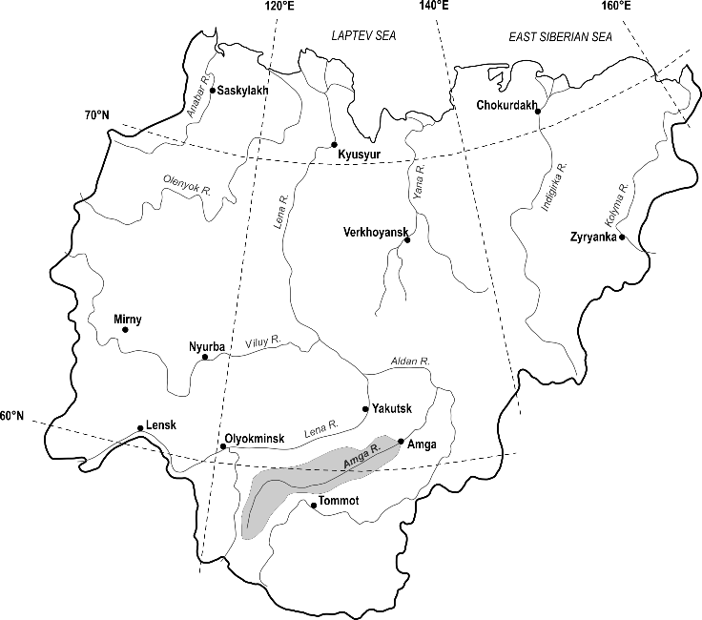
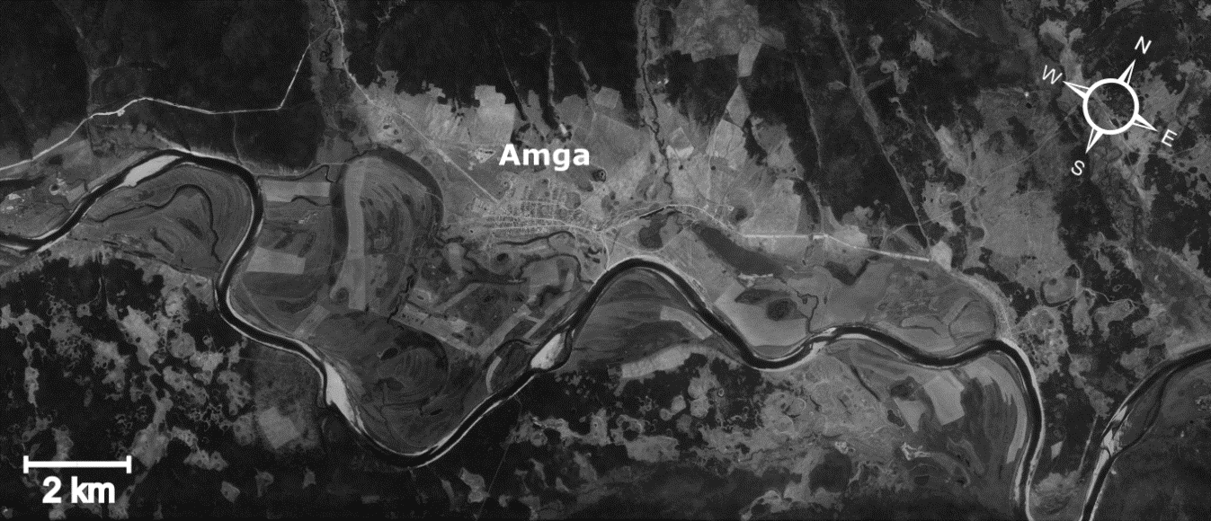
Fig. 1 Geographical position of the Amga R. and the Amga village (top), and its detailed overview (bottom); Corona KH-3 image, acquisition date: 8 August 1969.
Materials and methods
Our hydrological analysis is based on the highest annual water stages dataset for the Amga R. in the Amga village, provided by the Yakutian Hydrometeorology Agency. This dataset covers a period from 1933 to 2018. Water stage is observed at a pile water stage gauge twice-daily at 8am and 8pm, or at increased frequency during spring freshet and floods. Mean daily stage is obtained by averaging the values, while highest annual stage is selected from observed and not averaged values. Stage data are published in cm above gauge datum, and were recalculated to a Russian reference height datum, a so-called Baltic 1977 datum (EPSG: 5705).
Highest annual water stage (H_{max}) exceedance probability was estimated using (1) manual fitting; (2) a modification of three-parameter gamma distribution, known in Russia as Kritsky-Menkel distribution (Rozhdestvensky & Zvereva 1975); (3) a family of extreme value distributions, including Gumbel, Weibull, Generalized Extreme Value and Generalized Pareto distributions, based on Fisher-Tippett theorem (Hosking et al. 1985). The Kritsky-Menkel distribution parameters were defined according to Russian Building Code 33-101-2003 (2004). Extreme value distribution parameters, and corresponding return periods, were calculated using RStudio (2019), a GUI envelope for R language, and a distLextreme() function from package ‘extremeStat’ (Boessenkool 2017).
Flooding area was mapped in ArcGIS v. 10.2 using ArcticDEM Release 7 data with 2m resolution (Porter et al. 2019), provided by the University of Minnesota Polar Geospatial Center from their website at https://www.pgc.umn.edu/data/arcticdem/. This pan-Arctic elevation coverage is referenced to the WGS-84 ellipsoid surface (EPSG: 6893), currently aligned with EGM2008 reference system. A positive offset of +0.49 m is reported between the Baltic 1977 datum and EGM2008 for the Baltic countries (Ellmann et al. 2009), which is expected to not exceed this published value in the region of interest.
Weather pattern analysis for years with extreme floods was performed descriptively, using NCEP/NCAR Reanalysis daily composite plots for 10-day intervals from 11 April to 20 May. Data and images were provided by the NOAA ESRL Physical Sciences Division, Boulder, Colorado, USA, from their website at http://www.esrl.noaa.gov/psd.
Tangible direct damage was estimated based on a technique developed by Russian Institute of mineral commodities economics and mining, Russian Academy of Sciences (VIEMS) and officially published as a calculation guideline (Technique 2006). This guideline provides, in tabular form, the unit costs of flood damage in per 1 ha, by region of the Russian Federation, or by river basin, in 2006 prices. Official values of deflator indices, published annually by the Russian Ministry of Economical Development, are used as multipliers to switch to actual prices. Separate tables are provided for floods with probability range from 1 to 5%; 5 to 10%; 10 to 25%, 25 to 50%; 50 to 75%. Total flood damage is calculated separately for residential areas, industrial grounds and communications/engineering facilities. The VIEMS technique has been recommended by the Federal Agency of Water Resources in flood damage forecasting; otherwise, no uniform methodology of tangible direct damage estimation exists in Russia, which is officially approved at federal level.
Questionnaires were distributed on-site during the 2018 flood to assess its impact on local ecology and social security expectations. This questionnaire was successfully tested earlier in Namsky district, central Yakutia, in the aftermath of the heavy 2013 flood, by the researchers from North-Eastern Federal University, based in Yakutsk; its design and structure is thoroughly discussed by Kontar et al. (2018). Most questions aimed at assessing the efficacy of the authorities in informing the general population about flooding and in post-flood mitigation measures.
Findings
Spring flood hydrology, the Amga River
In South and Central Yakutia, spring season starts around mid-April, but can shift to as late as mid-May because of frequent cold returns. Snowmelt runoff contributing to spring freshet originates mostly from the mountainous headwaters of the Amga R. on the Aldan Plateau, South Yakutia. Snow water equivalent in Central Yakutia at the onset of snowmelt is negligible because of marked climate continentality and an important role of snow sublimation. The Amga R. water regime is pluvio-nival, or East-Siberian, in a classical Russian typology, with a pronounced spring high-flow period, numerous rain events during summer, and long winter low-flow without flow cessation.
Spring freshet on the Amga R. in Amga peaks in May; in a single case, in 1943, a late April peak was observed. In four cases, the highest water stage was observed during summer rain events; in 1956 and 1987, in early June, and in 2006 and 2016, in August. None of these rain events caused any damage to the community. Highest flood level is most frequently observed between May 11 and 20, in 49% of years, less frequently – between May 21 and 31 (28%), or between May 1 and 10 (23%). In the last decade, spring freshet mostly peaks earlier than usual, in the first ten days of May – six years out of ten.
During spring freshet, the water stage can rise as fast as several meters per day, that is most frequently caused by ice jams developing downstream the Amga village. Spring floods, i.e. events with floodplain inundation and damage to the community, were observed in 16 out of 85 years of record (20%). The most severe floods were observed in 1957, 1980, 2008 and 2018 (Fig. 2). Record floods were preceded by prolonged periods of low water stages during spring, which could lead to ‘false safety’ expectations in the community, as we observed previously in both Central Yakutia and Interior Alaska in a recent comparative study (Kontar et al., 2018).
Highest annual water stage time series appear to share cyclic behaviour with snow water equivalent and spring rainfall, with ca. 40-yr cycles (Fig. 2), but is statistically unrelated to both. Therefore, though both winter snow and spring rainfall contribute to spring freshet volume, there are other local factors at play, expectedly related to ice jam formation, that trigger catastrophic flooding in the studied area.

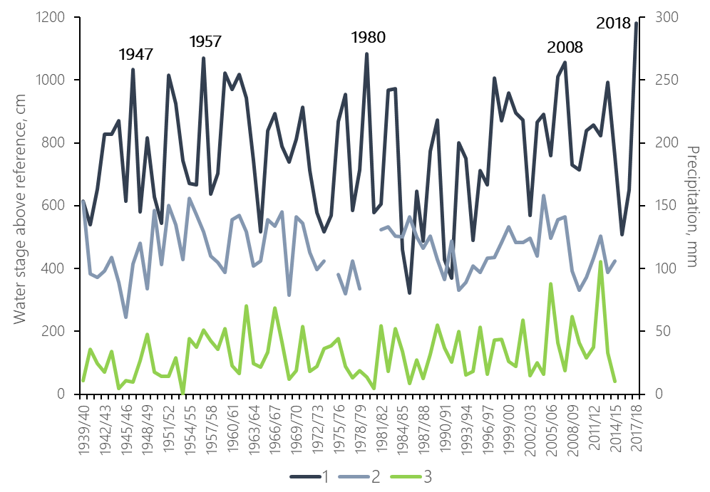
Fig. 2 Highest annual water stage, Amga R. at Amga (1); winter snow water equivalent (2) and May rainfall (3) at Dikimdya meteo station close to the Amga R. headwaters
Weather patterns in extreme flood years (1980, 2008, 2018)
The Amga R. is flowing from SW to NE, and the spring freshet wave moves from southern headwaters toward downstream river sections with intact and stable ice cover, promoting ice-jam formation (Lindenschmidt et al., 2018). With this, high spring freshet wave is expected to rapidly reach the middle section of the river, and push the moving ice from the south toward stable ice cover farther northward. Therefore, early warm spring and rapid snowmelt in the headwaters along with cold spring in central Yakutia should, other factors being equal, favour ice jam development. Spring weather patterns during years with major ice-jam flooding – 1980, 2008 and 2018 – were qualitatively compared.
In 1980, spring in the Amga R. catchment was by 1 to 3°C colder that average till early May, when a rapid warming occurred in central Yakutia (Fig. 3). Snowmelt and flood wave buildup were in the midst, when air temperatures dropped in mid-May after a cold spell from the Okhota Sea reached Transbaikalia. This cold blast could provoke ice cover refreezing during breakup and subsequent ice jamming. Highest water stage was observed on two consequent days, 13 and 14 May, evidencing equilibrium ice-jam conditions (Beltaos, 1995). The water stage observed in 1980 set a new record high, which was exceeded in 2018.
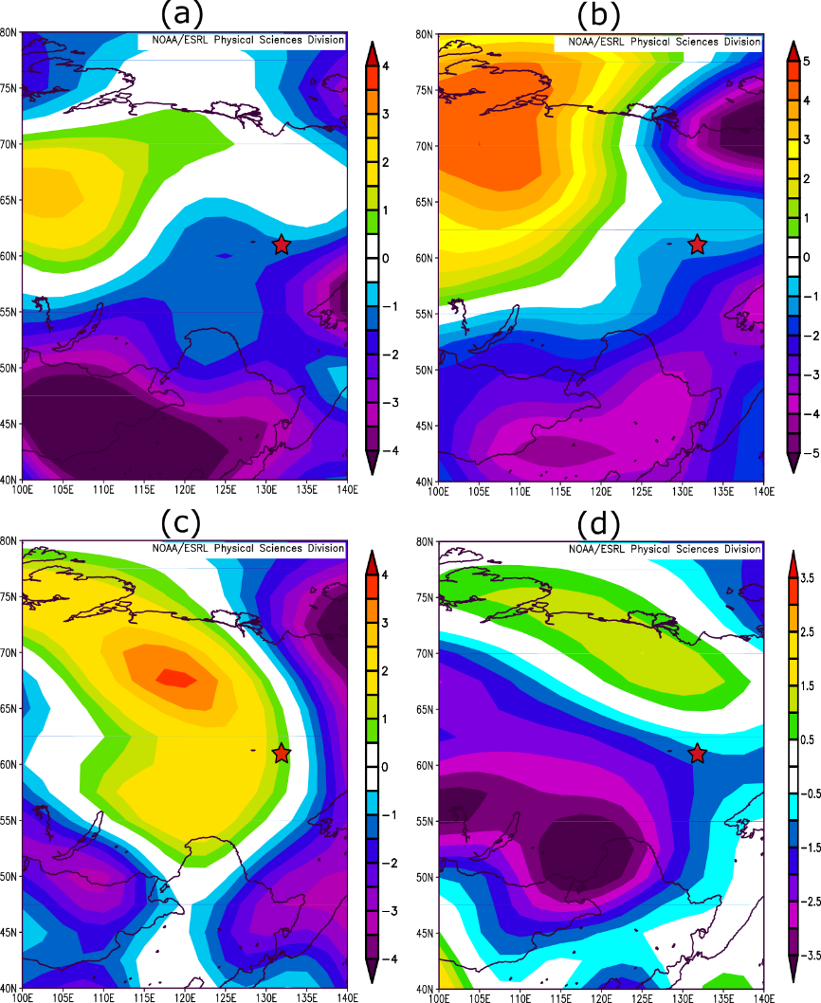
Fig. 3 NCEP/NCAR Reanalysis averaged daily composite air temperature fields in spring 1980: (a) 11 to 20 April; (b) 21 to 30 April; (c) 1 to 10 May; (d) 11 to 20 May. Here and below, the Amga village location is shown with a red star.
In 2008, cold anomaly persisted over Central Yakutia and the Amga village until early May, and spring began later than on average (Fig. 4). Low temperatures over the Amga R. catchment and, in particular, in its middle section, maintained stable ice cover and limited its thermal deterioration at the onset of spring freshet, which peaked at 16 May 2008.
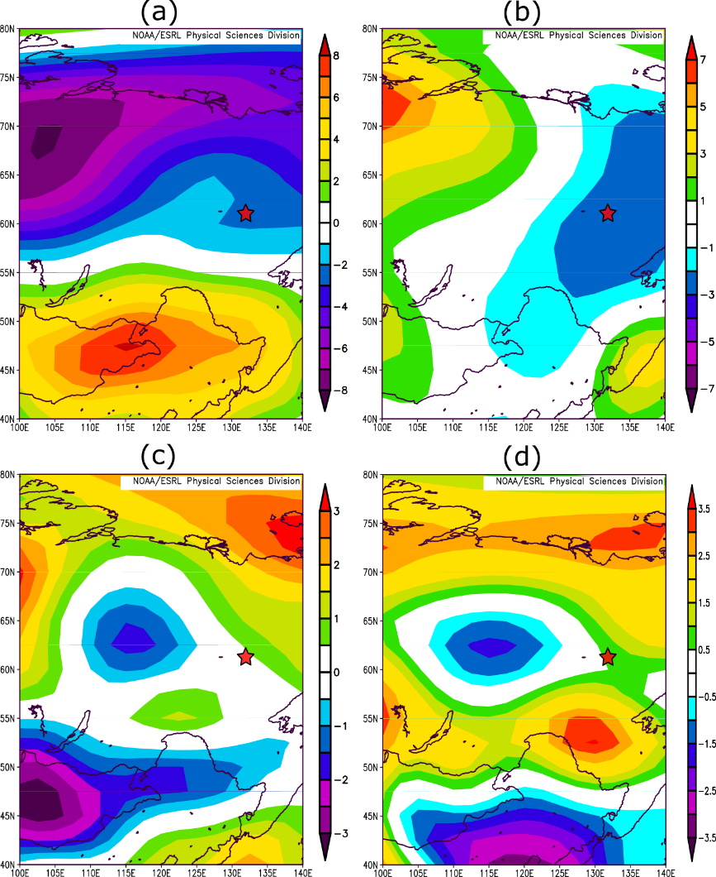
Fig. 4 NCEP/NCAR Reanalysis averaged daily composite air temperature fields in spring 2008: (a) 11 to 20 April; (b) 21 to 30 April; (c) 1 to 10 May; (d) 11 to 20 May.
In mid-April 2018, Siberian Asia was 2 to 5°C warmer than average (Fig. 5), contributing to earlier snowmelt and ice breakup on most Yakutian rivers south of Arctic Circle. Late April was however 1 to 2°C colder than average in central Yakutia, and the lower Amga R. was the epicentre of this cold region (Fig. 5b). Again, the thermal deterioration of ice cover could be significantly retarded during this cold spell. Early May, in its turn, was up to 5°C warmer than average in the Amga R. headwater area, promoting intense snowmelt. By this time, starting from 7 May, ice jams were forming several kilometers downstream from the Amga village. Numerous ice blasts gave only temporary relief, and emergency was finally declared on 11 May; water stage started to decline slowly after 14 May.

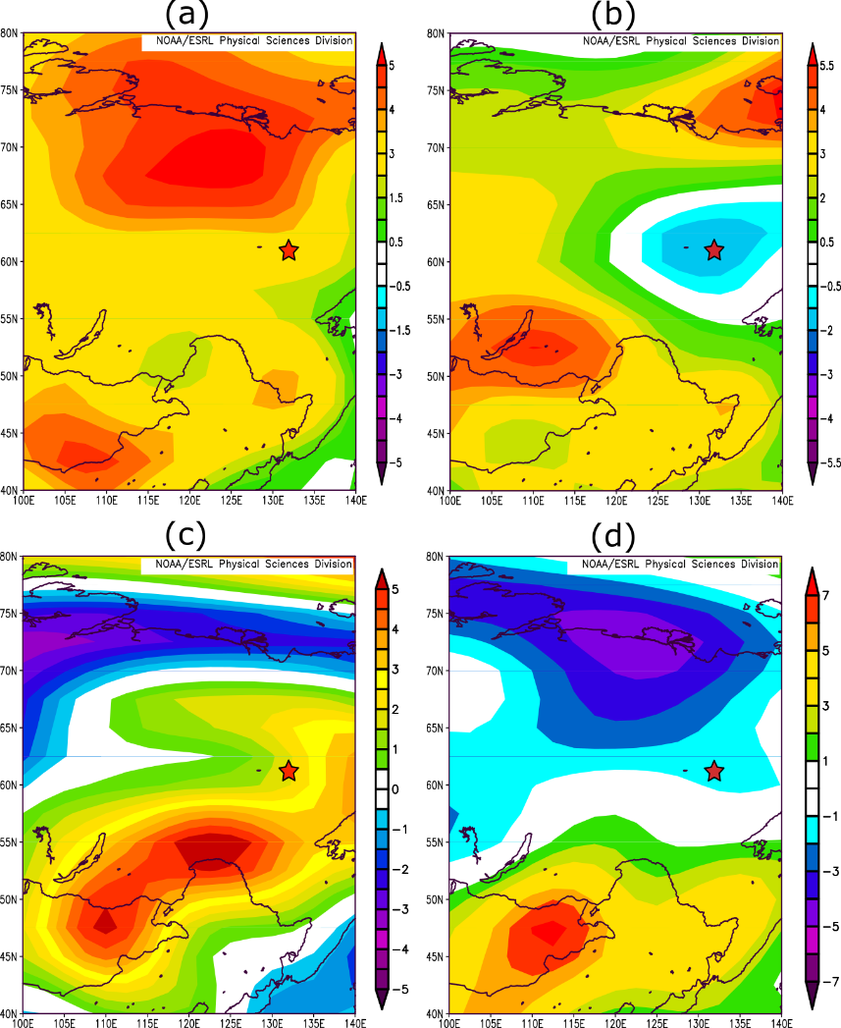
Fig. 5 NCEP/NCAR Reanalysis averaged daily composite air temperature fields in spring 2008: (a) 11 to 20 April; (b) 21 to 30 April; (c) 1 to 10 May; (d) 11 to 20 May.
Descriptive analysis of spring weather patterns over Siberian Asia shows no marking similarities between three years in question, but one major point is to be made. The alteration of warm and cold spells during snowmelt season and breakup appears to be common in years with severe ice jam floods. Air temperature field in late April and early May shows a dipole with warm air in the headwaters and cold air in the middle reach. Warm spells in the headwater area intensify snowmelt while cold blasts in the middle part of the catchment enhance ice cover stability and provoke ice jamming. Otherwise, this pattern may well have occurred in years with no significant flooding, in which case it may serve a prerequisite for flooding but not its major cause. An ensemble of local conditions then comes into play, ultimately transforming this weather pattern to an emergency situation, i.e. a water stage rise above the critical threshold.
Highest annual water stage statistics
In Russian Federation, as in many Nordic countries, flood-prone areas are defined as areas inundated at least once in 100 years, or during 1% exceedance probability flood. Delineation of potentially flooded areas is based on the statistical analysis of water stage data in Amga, and can vary depending on the probability distribution function used in this analysis (Majumdar & Sawhney, 1965).
Russian federal regulations, e.g. Building Code 33-101-2003 (2004), require that Kritsky-Menkel distribution is used in hydrological statistic analysis. This distribution is derived from a gamma distribution family and has three parameters, related to its first three moments: mean, coefficient of variation C_{v} and ratio C_{s}/C_{v}, where C_{s} is Pearson’s moment coefficient of skewness. The probability distribution function of highest annual water stage at Amga village has negative asymmetry, with C_{v} = 0.246, C_{s}/C_{v} = –1, and a 100-yr flood stage H_{1%} is 145.82 m a.s.l. Manual fitting of the distribution curve gives H_{1%} = 145.35 m a.s.l.
Fifteen distributions were fitted to the Amga R. at Amga highest stage dataset to test their performance against the Kritsky-Menkel distribution (Table 1). Group V average yields exactly the same mean value as presented above, with H_{1%} = 145.82 m a.s.l. Therefore, this value can be reliably used in flood-prone area mapping, at least at this probability level.
Table 1
Water stage at 100-yr flood from selected Extreme Value distributions
Group | Distribution | H_{1%}, m a.s.l. | Group mean
I | Exponential | 149.69 | 149.69
II | Gumbel | 148.18 | 148.14
II | Laplace | 148.10 | 148.14
III | Rayleigh | 147.15 | 147.13
III | Gamma | 147.10 | 147.13
IV | Normal | 146.36 | 146.34
IV | Generalized Logistic | 146.32 | 146.34
V | Generalized Pareto* | 145.95 | 145.82
V | Generalized Normal | 145.87 | 145.82
V | Pearson Type III | 145.85 | 145.82
V | Weibull | 145.82 | 145.82
V | Fisher-Tippett (GEV) | 145.59 | 145.82
VI | Modified Gumbel | 145.19 | 145.16
VI | Kappa | 145.18 | 145.16
VI | Wakeby | 145.09 | 145.16

In 2018, the water stage at Amga reached 145.38 m a.s.l., which is close to a 50-yr flood, or 2% exceedance probability, and in 1980 it was some 0.2 m less, 145.18 m a.s.l., corresponding to a 33-yr return period. We can conclude that what is an extreme flood and a severe blow for the community, is, from a statistical viewpoint, a routine event well below the catastrophic limits. A catastrophic 1000-yr flood will exceed this 100-yr level by ca. 1 m, equalling 146.66 m a.s.l.
Flood area mapping
Highest water stage at Amga, observed 11 May 2018, was used in mapping flood area and evaluating tangible direct damage to the community (Fig. 6). Flood mapping is based on an elevation model; in Russia, the official topographic data scaled below 1:100000 are classified, so the researchers are limited to open data with significantly lower quality (Hawker et al., 2018).
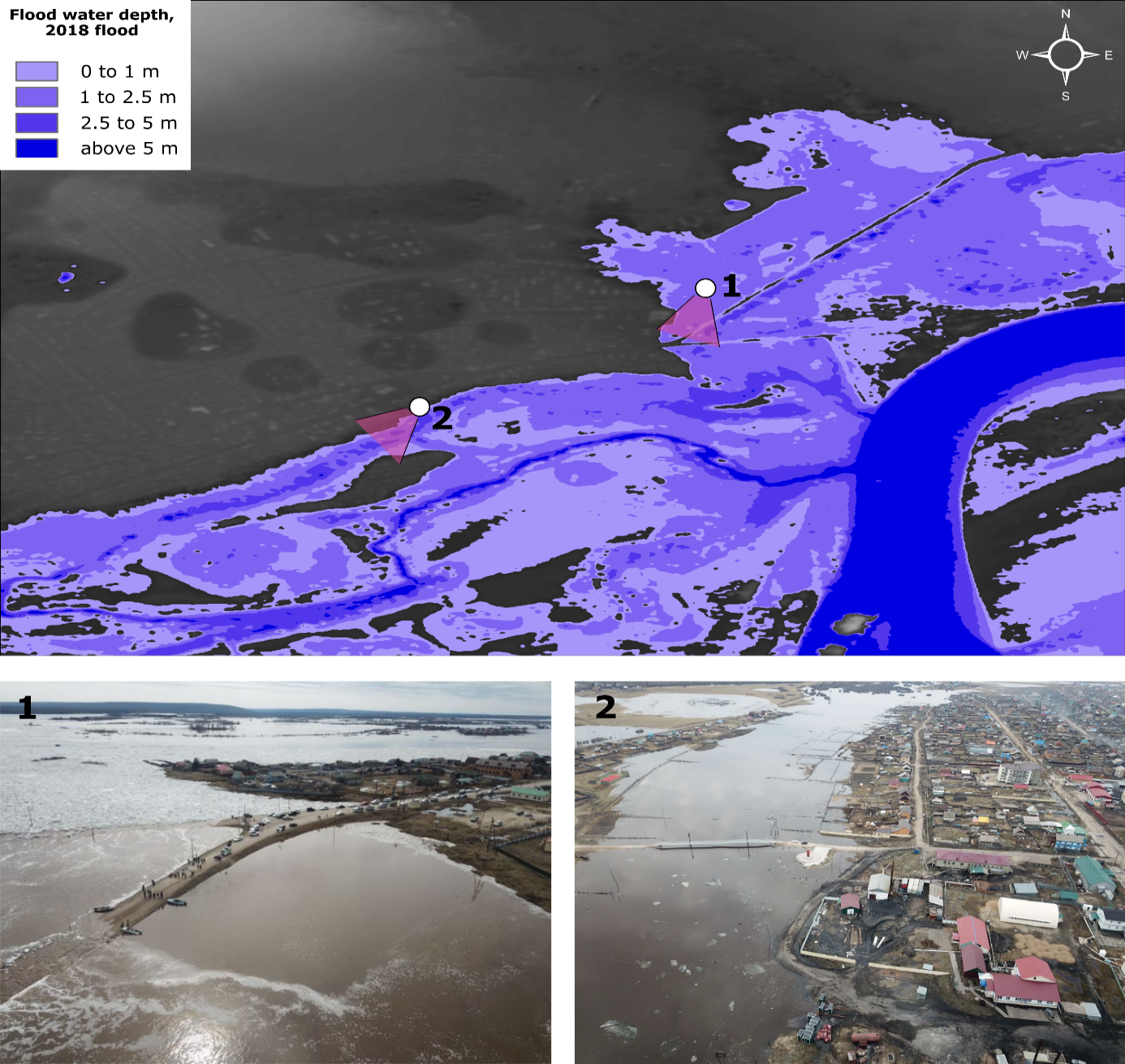
Fig. 6 Flood water extent and depth during 2018 flood (top); numbered points and shaded areas show point-of-view and shooting angle of corresponding photos (bottom)
In present study, ArcticDEM mosaic was used as a base elevation layer in test mode only, as it is known to be: (a) a digital surface model (DSM), uncorrected for vegetation and urban features, e.g. housing; (b) referenced to WGS-84 ellipsoid and is offset related to Baltic 1977 datum. Rather unexpectedly, however, the use of ArcticDEM yielded reasonable results concerning flood water extent and depth. Flooding extent matches local topography and corresponds well with helicopter imagery acquired around the flood peak dates (Fig. 6, bottom). Total flooded area within the community limits equals 3.74 km².
The drawbacks of a DSM become clearly visible in built-up areas, where elevation is 3 to 5m higher than expected, corresponding to an average rural house height. Even a single building can affect DSM elevation in a spot at least three times its size. In densely built-up areas, where the ground elevation is virtually undetectable, these areas are erroneously marked as non-inundated. Besides, evident blunder, e.g. non-inundated patches in the river channel, at the lower right of Fig. 6, are present in the DSM data.
Tangible direct damage
Tangible direct damage was estimated using flooding limits derived from the ArcticDEM surface model and is hence somewhat undervalued. The VIEMS technique requires data on the surface of residential and industrial areas, and communications/engineering facilities directly affected by flooding (Table 2). These values were calculated in ArcGIS from an overlay of flooding area limits and a Federal Cadastre Map, available as a standard WMS Server layer. De facto, only 29.4 ha, or less than 10% of total flooded area, were subject to direct damage. A deflator multiplier 2.538 is used to switch from 2006 prices to 2018. Estimated total tangible direct damage exceeds ₽5.1B, or ca. 0.55% of the gross regional product (Table 2).
Table 2
Tangible direct damage to the Amga village during 2018 flood, estimated by the VIEMS technique

 | Flooded area, ha | Tangible direct damage, x 10⁶ rubles
 | Flooded area, ha | Unit value, per ha (Technique 2006) | 2006 prices | 2018 prices
Residential areas | 17.4 | 59.7 | 1041 | 2642
Industrial areas | 11.8 | 82.1 | 971 | 2465
Communication lines | 0.2 | 37.3 | 8.0 | 20
Total | 29.4 | – | 2020 | 5127

Official post-flood statistics reports significantly lower damage to the communities. Moreover, official sources refer to mitigation and recovery costs, and not tangible direct damage. The annual report of the Sakha (Yakutia) Republic government, available online in Russian at https://prav.sakha.gov.ru/ot-31-yanvarya-2019-g-----74-r, claims total mitigation & recovery spendings reaching ₽1.5B throughout the Republic, of which ₽0.3B, or ₽65000 per household ($1000 using an exchange rate of ₽65/$), were spent as household recovery assistance, in form of both direct and indirect money transfers, building materials supply. The Amga village community reclaimed ca. ₽0.13B in response and recovery funding, and neither direct nor indirect damage was assessed to be put on table as an argument in future discussions on the flood prevention strategies and risk reduction planning.
Survey data analysis
The questionnaire survey involved 45 households with an average of four family members per household. Among the respondents, 11 men ((24%) and 34 women (76%), with average age of 45 years. The aggregate income level of five households (11%) does not exceed ₽30000, in 19 households (42%) it was from ₽30000 to ₽50000, in 18 households (40%) – from ₽50000 to ₽100000, and in one household it exceeded ₽100000.
General population (80% of the respondents) is aware of the preparative measures taken by the local administration in face of flood, including forming operational headquarters, which organise and supervise alerting and evacuating the residents from flood-affected areas. The majority (27 respondents, 60%) evaluate the effectiveness of local government actions positively, 18% (8 households) – negatively, and 22% found it difficult to answer.
Among the preparations for the spring flood, the evacuation of the population received most positive assessment among the population; 21 respondents (47%) rated it positively. However, the effectiveness of other preventive and preparatory measures, such as channel dredging, ice blackening and sawing, ice jam blasting, was questioned – 33% of respondents (15 people) rated them negatively, 62% (28 people) found it difficult to answer.
At the same time, only 35% of respondents reported that they had received an alert more than 5 days ahead of flood, while one third of respondents were alerted only one day or less before the flood peaked. In addition, more than half of the respondents (23 households, 51%) received information about emergency evacuation not from the local administration representatives, but from their relatives or neighbours.
Eighty seven percent of respondents, or 39 households, kept track of the spring flood progress. When asked about the sources of information about the flood wave advance, respondents could choose several answers. Among the most popular sources, the respondents named mobile social network applications (29%, or 21 of 72 answers), television (21%, 15 of 72) and phone calls to/from relatives living upstream (14%, 10 of 72).
When asked about preparatory measures undertaken by their households, sixteen respondents, or 36%, named the transfer of their belongings to the upper floors of their houses as a priority measure. Eleven households, or 24%, prepared documents and valuables for the emergency evacuation, five households, or 11%, relocated children and elderly family members to relatives living in safe areas. In addition, 29% of respondents (13 households) answered that they are not preparing for floods, since their house is not included in the potentially flooded zone defined by local administration.
Fifty three percent of respondents (24 households) suffered direct damage from floods, of which in 10 households (22%), the amount of damage amounted to more than ₽500000, or close to a household annual income. Besides, all respondents indicated a deterioration of drinking water quality and overall sanitary and epidemiological situation in the village; 29% of respondents (13 people) reported health deterioration due to flooding.
Permanent relocation of the household from the flood-prone area to higher terrain or tho other settlement is envisaged by eight respondents, or 18%. At the same time, 20 respondents (44%) support the idea of complete relocation of the village.
Flooding as a social phenomenon: the Amga case
Flooding, besides natural reasons, has a distinct social dimension. The level of community vulnerability to flooding can be defined as a capacity to adapt the settlement structure and prevention/recovery measures to probable flooding scenarios, in other words, certain strategical flexibility. The Amga village flooding in 2018 showcases a lack of flexibility at all decision-making levels, from local to federal, in dealing with flood hazards.
After a row of devastating floods in Siberia, Russian Far East and Southern Russia in the 2000s, several federal laws have introduced restricted land use within the flood-prone areas, including bans on housing construction. Flooding zone limits corresponding to floods with recurrence probabilities from 1% to 25% were to be delineated on the master plans of the settlements. For the Amga village, this work was planned for late 2018, and there is no openly accessible information on whether this work has ever been accomplished. Local administrations have no control on this process, as this work is contracted by the regional government, i.e. Ministry of Natural Resources, and supervised by numerous federal stakeholders, including Lena River Basin Water Management Agency, Yakutian Hydrometeorology Agency, Far Eastern Department of Russian Hydrometeorological Agency.
Local administration of the Amga village, in its turn, constantly requires additional surface to accommodate the increasing population. Safer areas in high terrain, unaffected by floods, belong generally to federal forest fund and are, as such, unavailable for private housing construction. Hence, the cheapest lands available are allocated to local residents by the administration, including areas vulnerable to flooding; these lands are allocated on-demand to young families, which is a common practice in the Sakha (Yakutia) Republic. As our previous studies have demonstrated (Kontar et al 2018), the communities, in their decision-making, tend to rely on the ‘false safety’ feeling in the absence of major floods, and intensely develop terrains adjacent to riverbanks.
Flood management practices are based, to our belief, on five major elements: (1) forecasting; (2) prevention; (3) preparative measures; (4) direct response and (5) recovery actions.
Flood forecasts are issued on a regular basis by a federal state-funded Yakutian Hydrometeorology Agency, and are updated with the progression of spring freshet. These forecasts are communicated to general audience and major stakeholders; however, official flood warnings are only issued when the water stage exceeds its critical threshold. In Amga, this threshold is exceeded on average once in four years, and is not necessarily related to heavy loss to property or livestock.
Preventive measures include mechanical ice jam mitigation techniques include ice dusting and cutting, and ice jam blasting as a last resort measure; their efficiency is questionable, but they remain in place yielding a ‘placebo effect’ on the local population. Ice blackening locations were defined in 2009, and are implemented at same spots each year, giving yet another example of the lack of flexibility. Unsurprisingly, these measures receive little support from local residents. In contrast, preparative measures and response actions, being led mostly by local administration under supervision from numerous stakeholders’ representatives, are deemed rather effective. Most households respond positively to flooding announcements and implement measures that they judge relevant. Residents are not forced to move out to safer terrain; either they relocate in advance of flooding, or are rescued in emergency during direct response phase at peak flood.
In the recovery phase, the community residents declare their losses, and are subject to generous financial support from regional and federal budgets. The amount of this support is variable and depends largely on federal media coverage, number of residents affected, and available funds. Besides, both regional and federal funding is spent to recover roads, communications and other key infrastructure elements. Tangible direct damage is further calculated based on total spendings in the recovery phase, and does not include flood prevention and preparatory measures. Insurance as a risk management practice and a source of financial support to affected residents is relatively unpopular. Large insurance agents constrain their activity in this field, lacking evidence-based knowledge on the structure of hydrological risks and potential damage. In the Sakha (Yakutia) Republic, insurance covers only 1% to 7% of total damage reclamation. Rural communities are particularly distractive for insurance companies because of the housing age and low capacity to pay of rural residents (Parfenova 2017).
Conclusions
Ice jams are commonly observed during breakup on the Russian Arctic rivers, and may result in floods, heavily affecting riverine communities. The studied case of the Amga village shows that both natural and social drivers act jointly in increasing the exposure of this community to flooding. Weather pattern analysis reveals that though no particular similarities exist between years with major floods, a ‘dipole pattern’ of high air temperature in headwater areas and cold blasts around breakup dates could promote ice cover stability and induce ice jams. Local channel morphology with the abundance of shallow sand bars retard ice movement and also increases the probability of ice-jam development. Prolonged cold spells play an important role in limiting ice thermal deterioration, or ice jams buildup upon refreezing.
From the statistical viewpoint, the 2018 flood had a 50-yr recurrence interval, which is a rare but not a catastrophic event. Even at this exceedance probability level, ca. 23% of total settlement area was flooded, or 374 out of 1633 ha, resulting in an estimated tangible direct damage around ₽5.13B. A 1000-yr flood will exceed the observed highest water stage by ca. 1.0 m, and the consequences of such flood to the community are poorly understood.
The Amga village appeared to be ready to face the 2018 flood, but with numerous reserves. Significant surface within flood-prone areas was allocated to families for housing construction, as it was the cheapest option with no official restrictions on land use. Younger generations were unaware of the heavy flooding consequences, since the 1980 flood was to long ago to be remembered, and readily occupied floodplain surface adjacent to the village core. The general population was informed of the coming disaster, but almost one third received the announcement less than one day in advance. Social networks and ‘word of mouth’ were among the most referred information sources, and official broadcasting network was not active enough.
Tangible direct damage to the community is estimated around ₽5.13B, but the community reclaimed only a minor fraction of this total as recovery costs for residents and industry. This fact adds to the controversy between two distinct understandings of tangible direct damage, either as a potential flood damage (VIEMS approach) or a reclaimed financial support, regardless of real damage to the community (federal Emergency Ministry approach).
Finally, the Amga village authorities were lacking resources and political influence to force discussions on the lack of long-term preventive measures to relief flood risks. The settlement remains vulnerable to ice-jam flooding, but the 2018 agenda is no longer actual, replaced by forest fires in Central and Northern Siberia. Another decade might pass until the next flood, which may well exceed the 1% probability, but the potential consequences are left aside.
Author contributions. Conceptualization, methodology, investigation, formal analysis, writing – original draft, N.T.; investigation, formal analysis, review and editing, V.E. (questionnaire distribution and data analysis), O.P. (tangible direct damage calculations), T.G. (writing – socioeconomical aspects). All authors contributed to discussion and revision of the original draft.
References
Beltaos, S., ed., 1995. River ice jams. Highlands Ranch, Colorado, USA: Water Resources Publication.
Boessenkool B. ‘extremeStat’ Extreme Value Statistics and Quantile Estimation. Version 1.4.0, 3 November 2017.
Building Code 33-101-2003. 2004 Determination of design hydrological performance Moscow, Russia, 43 p.
de Goyet C., Zapata Marti R. & Osorio C. 2006 Natural disaster mitigation and relief. In: Disease Control Priorities in Developing Countries, D. Jamison, J. Breman, A. Measham et al. (eds), 2nd edn, The International Bank for Reconstruction and Development / The World Bank, Washington, DC, USA.
Ellmann A., Kaminskis J., Paršeliūnas E., Jurgenson H. & Oja T. 2009. Evaluation results of the Earth Gravitational Model EGM08 over the Baltic countries. Newton’s Bulletin Issue, 4, 110–121.
Gavrilyeva T., Kolomak E.A. 2017 Analysis of Changes in the Settlement System of Yakutia, Region: Economy and Sociology. Regional Research of Russia, 2(9), 174–190, [In Russian].
Handbook of Hazards and Disaster Risk Reduction 2012 B. Wisner, J.C. Gaillard, I. Kellan (eds), Routledge, London, UK. 876 p.
Hawker L., Bates P., Neal J. & Rougier J. 2018 Perspectives on Digital Elevation Model (DEM) Simulation for Flood Modeling in the Absence of a High-Accuracy Open Access Global DEM. Front. Earth Sci. Hydrosphere, https://doi.org/10.3389/feart.2018.00233.
Heijmans A., Victoria L.P. & Center for Disaster Preparedness (Quezon City, Philippines). 2001 Citizenry-based & development-oriented disaster response: Experiences and practices in disaster management of the citizens' disaster response network in the Philippines. Center for Disaster Preparedness, Quezon City, Phillippines, 118 p.
Hewitt K. 1983 The idea of calamity in a technocratic age. In: Interpretations of Calamity: From the Viewpoint of Human Ecology, K. Hewitt (ed.), Allen & Unwin, Boston, MA, USA, pp. 3‐32.
Hosking J.R.M., Wallis J.R. & Wood E. F. 1985 An appraisal of the regional flood frequency procedure in the UK flood studies report. Hydrol. Sci. J., 30, 85–109.
Hyogo Framework for Action 2005-2015. 2007. 25 p.
Kontar Y.Y., Eichelberger J.C., Gavrilyeva T.N., Filippova V.V., Savvinova A.N., Tananaev N.I., Trainor S.F. 2018 Springtime flood risk reduction in rural Arctic: A comparative study of Interior Alaska, United States and Central Yakutia, Russia. Geosciences, 8, 90, doi: 10.3390/geosciences8030090.
Lindenschmidt K.-E., Huokuna M., Burrell B.C. & Beltaos S. 2018 Lessons learned from past ice-jam floods concerning the challenges of flood mapping. Int. J. Riv. Bas. Manag. 16(4), 457–468.
Majumdar K.C., Sawhney R.P. 1965 Estimates of extreme values by different distribution functions. Water Resourc. Res. 1(3), 424–434.
Oliver-Smith A. 1994 Peru’s five hundred year earthquake: Vulnerability in historical context. In: Disasters, Development and Environment, A. Varley (ed.), Chichester, UK, pp. 31-48.
Parfenova O.T. 2017. The role of insurance in compensating the damage from floods (Northern Yakutia as an example). Problemy sovremennoy ekonomiki 3(63), 178–180 (in Russian).
Porter C., Morin P., Howat I., Noh, M.-J., Bates B., Peterman K., Keesey, S., Schlenk, M., Gardiner J., Tomko K., Willis M., Kelleher C., Cloutier M., Husby E., Foga S., Nakamura H., Platson M., Wethington M., Williamson C., Bauer G., Enos J., Arnold G., Kramer W., Becker P., Doshi A., D’Souza C., Cummens P., Laurier F. & Bojesen M. 2018 ArcticDEM, https://doi.org/10.7910/DVN/OHHUKH, Harvard Dataverse, V1, 18 April 2019.
Rozhdestvensky A.V., Zvereva V.M. 1975 Statistical modelling of river flow by the Monte Carlo method and evaluation of distribution parameters and quantiles, IAHS Publication 115, IAHS, pp. 203–209.
Technique for the probability-based evaluation of damage from the negative influence of water and evaluation of the performance of preventive water management activities. VIEMS Publ., Moscow, Russia, 2005. 153 p.
Twigg J. 2015 Disaster risk reduction, Good Practice Review 9. Overseas Development Institute.
Wisner B., Blaikie P., Cannon T. & Davis I. 2004 At Risk: Natural Hazards. In: People's Vulnerability and Disasters, Routledge, London, UK.
Yokohama Strategy and Plan of Action for a Safer World. Guidelines for Natural Disaster Prevention, Preparedness and Mitigation. 1994.

