Are we in the right path in using early warning systems?
Venugopal Thandlam¹, Anna Rutgersson¹, and Hasibur Rahman²
1. Centre of Natural Hazards and Disaster Sciences, Department of Earth Sciences, Uppsala University, Sweden.
2. Indian National Centre for Ocean Information Services (INCOIS), Ministry of Earth Sciences, Hyderabad, India.
Corresponding author address:
Department of Earth Sciences, Uppsala University
Geocentrum, Villavägen 16
75236 UPPSALA, SWEDEN
Tel. 0184717191
Email: venu.thandlam@geo.uu.se

Abstract
This article focusses on the recent tsunami in Indonesia, and the factors led to a large number of fatalities. We also discussed the failure of early warning systems, steps, methods and technologies, in general, to improve the early warning systems in the future to mitigate the loss of lives and property during these impending disasters. This article is timely as Indonesia has seen one of the worst tsunamis in recent years and the threat is still on. Hence, we stress the importance of improving and strengthening the existing early warning systems.

Keywords: Early warning systems, Tsunami, Indonesia, Disaster risk, INCOIS

What happened?
The recent deadly earthquake with magnitude of 7.5 occurred in the Sulawesi region of Indonesia on 28 September 2018 triggered a tsunami near the coasts of Palu Bay caused over 2,100 fatalities. This event also caused 680 missing people, 4,600 injuries, and about 79,000 internally displaced persons according to the International Tsunami Survey Team Palu (ITST, 2018). Although the majority of these fatalities were due to landslides, it eventually question our commitment in delivering the scientific breakthroughs to the public. Despite the availability of forecasting and alerting systems with sophisticated technology, we failed miserably in preventing the mass deaths yet again. In this scenario, we need to assess the factors (such as human errors) causing the disaster and the feasible solutions to avoid such events in the future.
The subaerial and submarine landslides being the major contributors to the 28 September 2018 tsunami. The earthquake was the result of slip on the Palu-Koro fault, a sinistral (left-lateral) strike-slip plate boundary fault system (EERI, 2019). The linear shape (strait and tight) of Palu Bay likely also contributed to amplification of tsunami waves. There are multiple hypotheses that attempt to explain the triggering source for the multiple tsunamis observed in Palu Bay: (i) The strike-slip fault motion on the seafloor was possible to cause horizontal and vertical offsets of submarine bathymetric features, leading to displacement of the water in the bay; (ii) The coseismic vertical land motions from the earthquake have displaced land around the bay; (iii) Multiple slope failures (landslides) along the coastline were generated direct tsunami waves; (iv) Large submarine landslides have caused significant seafloor displacement. Prehistoric earthquakes data along this fault system suggest
that, over the past 2000 years, this fault produces a magnitude >7 earthquake every 700 years (Bellier et al., 2006; Watkinson and Hall, 2017). Empirical relations for historic earthquakes suggest that the Palu-Koro fault system could produce a magnitude 7 earthquake once per century (Wells and Coppersmith 1994; Socquet et al. 2016). So, it appears that this is the characteristic earthquake we might expect along this fault. Hence, it is necessary and essential to improve the existing early warning systems to affectively tackle future events.
Earthquakes and tsunamis are responsible for more deaths than extreme weather events and have claimed an estimated 747,234 lives over the last twenty years. The 2004 tsunami itself killed more than 230 thousand people in Indian Ocean rim countries and affected millions, more than half of them in the Indonesian province of Aceh (UN report on Disaster Risk Reduction 2018). Since then, intense international efforts were launched to improve tsunami warning capabilities in the Indian Ocean. Part of this effort paved the way to establish centres like Indian Ocean Tsunami Warning and Mitigation System (IOTWS) at Indian National Centre for Ocean Information Services (INCOIS) in India, which is operational since October 2007, and plays a key role in the Indian Ocean. This centre was also designated as one of the regional service providers by the Intergovernmental Oceanographic Commission of United Nations Educational, Scientific and cultural organization (IOC/UNESCO) for the Indian Ocean rim countries. Under IOTWS, Indonesia was also recognized as the Regional Tsunami Service Providers (RTSP) and has been in operation since October 2011. The RTSP of Indonesia is operated by the Agency for Meteorology Climatology and Geophysics (BMKG) the leading institution and in- charge of operating Indonesia Tsunami Early Warning System (InaTEWS) in cooperation with National Coordinating Agency for Survey and Mapping (BAKOSURTANAL) and Agency for Assessment and Application of Technology (BPPT). The RTSP of Indonesia consists of seismic, tide gauge, GPS monitoring systems, and buoy networks, operated by BMKG, BAKOSURTANAL, and BPPT, respectively. All data are transmitted in real-time or near real-time to BMKG, which is operating InaTEWS for the purpose of forecasting tsunami hazard analysis and warning dissemination (http://rtsp.bmkg.go.id/about_inartsp.php).
But an independent and fully functioning early warning system that might have prevented some deaths in the recent tsunami in Indonesia has been stalled in the testing phase for years due to inter-agency wrangling and delays in getting just 1 billion rupiah ($69,000) to complete the project (The Associated Press 2018). Due to this, the system hasn't moved beyond a prototype developed with three million from the U.S. National Science Foundation. The proposed high-tech system contains seafloor sensors, data-laden sound waves and fiber-optic cable. According to the National Disaster Mitigation Agency (BNPB) of Indonesia, there are no tsunami detection buoys in operation in the country right now. Furthermore, it is essential to quantify alerts from existing early warning systems with a high confidence before delivering to the public, which was lagging in this case (Thomson Reuters 2018). The BMKG announced a tsunami warning for the western and central parts of Sulawesi at 5.07 pm Jakarta time, five minutes after the powerful earthquake with 7.5-magnitude hit Central Sulawesi, jolted the provincial capital of Palu and its surroundings on 28 September 2018. However, the agency had decided to retract the warning around 30 minutes later, after receiving a flurry of information. This human error eventually led to criticisms in the research community and decision makers. Thus, the inaccurate alerts could cause chaos in the functioning of agencies and can lead to blaming game between the forecasters and policymakers.
On the other hand, roughly three months later, an eruption from Anak Krakatau volcano on 22 December 2018 night caused part of the island volcano in the Sunda Strait to collapse into the sea (Patton et al., 2018). This crash in turn had generated tsunami waves of more than 5 metres (16 feet), which killed at least 430 people, more than 150 people missing and injuring 1000 in Sumatra and Java. The vast archipelago, which sits on the Pacific "Ring of Fire", hosting many active volcanos. Although BMKG announced that they have developed a monitoring system focused specifically on the volcanic tremors, there were no such tsunami detection systems installed to identify tsunami from these volcanic eruptions in Indonesia. Thus there was no prior warning about this disaster again. It is also noticeable that the International Tsunami Information Center which coordinates different tsunami early warning centers around the world including India, Indonesia, Japan and the United States, had no information about this disaster event even after 24 hours of its happening. These events could provoke a common axiom that the governments and policy makers are reluctant to learn lessons from the past. As an eye washer, the Indonesian government issued a high alert after the disaster, asking people to stay 500 m away from the coast and 1 km from the volcano. These temporary measures and alerts would not cure people who lost their lives and property in the disaster. Instead, it is appropriate to explore permanent solutions to mitigate these disasters in the future.
Possible solutions
In addition to socio-economic factors, inter-agency wrangling and delays in funding to complete the projects on early warning systems also mean a lot for the lives of the public who are at the forefront to face the adverse impacts. Each earthquake and tsunami would have some distinct characteristics. But, the recent two tsunamis in Indonesia demonstrate a need to address non-subduction-earthquake-caused tsunami education and alert/notification solutions. A potential solution to enhance the capacity is to have inter-governmental collaborations through training and exchange of people and data. The framework called "Ready-Set-Go" proposed by the International Research Institute for Climate and Society at Columbia University (Goddard et al. 2014) would also suit for early warning systems and disaster management as well. This framework aims at early warning systems and asset locations for disaster management (Ready). Communication was meant to alert the community, volunteers, and disaster workers (Set). Early warning systems lead to actual disaster warnings, activation of volunteers, evacuation orders, etc. (Go). In principle, current early warning systems could only work for far-field tsunamis where the arrival time of major tsunami waves would be long. For the December silent tsunami, volcanic eruption would be highly uncertain and hard to predict the amount of earth materials plugging into the sea to cause tsunamis (Patton et al., 2018).
From a notification standpoint, an alternative is to use telemetry in communicating the warnings to the public. Indonesia has a large network of tide gauges which are telemetered (connected via radio or cell communication protocols) and post the data online in real time. It is possible that some people could be notified in advance of tsunami inundation, if these gauges were incorporated into a tsunami early warning system. Also, Indonesia operates large number of tide gauges in the world. These tide gauges provide a unique opportunity to developing a tsunami early warning system to augment the currently inoperable and expensive tsunami buoy system. Some gauges are already connected to the InaTEWS (Schӧne et al., 2011). If a tsunami early warning system (TEW) tied to these tide gauges, an
alert would have been broadcast immediately through SMS (mobile phone messaging). The tsunami in the Sunda Strait, probably a result of the collapse of Anak Krakatau (Patton et al., 2018), is another example of where tide gauge based TEW may have helped. These events demonstrate that no matter the perceived tsunami threat, educating coastal populations (residents and visitors) about tsunami hazards should be a priority. The recent tsunamis in Indonesia tragically highlighted the weaknesses of the existing warning system and low public awareness about how to respond to warnings. Thus, this disaster caused hundreds to die in the cities of Palu and Donggala due to walls of water up to 6 meters high and a magnitude 7.5 earthquake.
Incidentally, a successful tsunami mock drill was held by INCOIS during September 4-5 2018, coordinated by the Indian Ocean Tsunami Warning mitigation system of IOC/UNESCO, to test the preparedness of officials in coastal areas. A mock mass evacuation of people in vulnerable villages near the coast was held after the mock alarm was sounded for an impending tsunami. Over 100,000 people evacuated from around 375 coastal villages from 44 Coastal Districts of 9 States/UTs of India during this exercise. INCOIS also issued fifteen (15) tsunami bulletins to 24 countries on the Indian Ocean rim including Indonesia (Press Information Bureau, Government of India, and Ministry of Earth Science). This exercise provides an opportunity for disaster management authorities to exercise their operational lines of communications, review their tsunami warning and emergency response procedures, and to promote emergency preparedness. However, the affected regions for the present Indonesian tsunami come in the western Pacific region, on which INCOIS has no control over. It's now inevitable for the Indonesian Government to conduct such a mock drill to test the disaster preparedness.
In addition to avoiding the funding delays and bureaucracy involved, policy-making should prioritise enhancing computational and communication infrastructure to enable reception of real-time data, analysis of the data from all the disaster monitoring networks, and prioritise the generation, and dissemination of disaster advisories. Also, timely and faster communication of alerts to the people and training them to manage the disaster plays a key role in mitigating the damage. Also, regular mock drills and disaster management preparedness from the disaster relief authorities are the key factors which could help to resilence from the aftermath of the disaster. But the priority is to have better coordination between the policymakers and the forecasters to work hand in hand to minimize the loss of lives and the property during such disasters in the future. This could be possible with enhancing reliability, access, credibility or legitimacy of the information and removing institutional or cultural practices, and resource limitations at agencies that must make decisions. Rapid and efficiently integrated assessments by forecasters and decision makers are beneficial in the event of unavoidable disasters (The wire 2018). There are different paths which could realize these goals.
Remote sensing would be an alternative to assist the early warning systems and also useful in assessing aftermath of the event. Following the 28 September earthquake and tsunami, the Copernicus satellite imagery system was activated in the region for emergency response and management. On the other hand, encouraging Public Private Partnership (PPP) in building and managing early warning systems could minimize the socio-economic and technological barriers. The entities like Google, Microsoft etc., are developing technologies to comprehend the disaster management, mitigating the risks and streamlining the emergency response, from earthquakes to floods. For example, recently intense flooding in the state of Kerala, a southwest state in India during August 2018, killed around 500. In the event of this disaster, Google developed and deployed an SOS alerts system along with a public alerting system in India (Google blog 2018) as a pilot project for flood alerts. In 2016, Panasonic Weather Solutions started operating the world's most advanced global weather forecasting platform, Panasonic Global 4D Weather. This is the only private entity in the world with a custom developed, end-to-end global weather-modelling platform. It uses Panasonic-Enhanced Hybrid 4D-Ensemble-Var Global Forecast System including full Panasonic TAMDAR data assimilation, Enhanced Tropical Cyclone (TC) relocation algorithm for improved TC track forecasting and improved Gravity Wave Drag parameterization for greater stability and reproducibility that consistently run on an 11,000-core supercomputer named Sora. IBM, another private entity, recently launched a Global High-Resolution Atmospheric Forecasting System, or GRAF, which predicts the weather at a 1.9-mile resolution for the entire globe every hour using advanced POWER9 supercomputers. This model combines the world's most accurate weather data with industry-leading Artificial Intelligence (AI), Internet of Things (IoT), and analytics technologies (IBM weather 2019). On the other hand, the current U.S. model, the Global Forecast System (GFS), runs at a spatial resolution of eight miles every six hours.
It is also time to focus on developing hybrid models and techniques apart from the traditional statistical, numerical and dynamical approaches in predicting, forecasting and alerting systems. Use of technologies like AI-based tools, Machine Learning (ML), Natural Language Processing (NLP) and Deep Learning (DL) coupled with big data analytics (both from the in-situ and satellite platforms) for disaster prediction, detection and alerting systems with sophisticated algorithms could be useful in achieving the reliable early warning and disaster management systems. Integration of social data analytics with technologies like Google Maps and demographic data is also very useful. The start-ups like "One Concern" (Stanford) is using AI systems in developing systems for an earthquake, flood monitoring and risk management (Fastcompany 2018). The digital platforms like Artificial Intelligence for Digital Response (AIDR) are active in filtering and classify social media messages related to emergencies, disasters, and humanitarian crises (Lexalytics 2018). Encouraging similar kind of start-up companies to develop new technologies, gather and maintain historical and real-time data on disaster management could also serve the purpose to enhance the alerting systems. In addition, localized risk assessment programs from ground zero, involving citizen scientists and volunteers in the programs at different levels would improve the forecasts and assessing the damage.
At the same time, private entities should be more responsible in improving existing technologies, innovation and deployment of low-cost and cross-platform systems to bypass the technological barriers. In return, governments should consider providing platforms for private entities engaged in disaster management through tax benefits and incentives. Furthermore, it is critical to have global networks and monitoring systems for early warning and disaster management in place of local or national projects to avoid the political and regional conflicts between countries in managing these impending disasters. Global organizations like World Meteorological Organization (WMO), United Nations Office for Disaster Risk Reduction (UNISDR) and World Bank should take provocative steps through some pilot projects in their plans and frameworks with more focus on coastal areas which are more prone to these disasters. As we celebrated International Day for Disaster Reduction on October 13 and the third World Tsunami Awareness Day on November 5, with enough preparedness, each step we take in this path would lead us to save more lives during inevitable disasters in the future.
Acknowledgements
Authors wish to acknowledge the support from the Department of Earth Sciences, Uppsala University and Indian National Center for Ocean Information Services (INCOIS), Ministry of Earth Sciences, Government Of India. Special thanks to Erik Sahlee, Jennie Molinder and Ting Zhang of Department of Earth Sciences, Uppsala University and Paolo De Luca, Loughborough University, the UK for their valuable suggestions and comments. We have attempted to give credit to the sources we used in this article. Thanks to constructive comments from the reviewers, which helped to improve the article.
Authors declare no conflict of interest.
References:
- Fastcompany, 2018: Disaster relief is dangerously broken. Can AI fix it?
- Goddard, L., Baethgen, W. E., Bhojwani, H., & Robertson, A. W. (2014): The International Research Institute for Climate & Society: why what and how. Earth Perspectives, 1(1), 10.
- Google blog, 2018: Helping keep people safe AI enabled flood forecasting,
- Lexalytics, 2018: Artificial Intelligence for Disaster Relief: A Primer.
- Panasonic, 2016: Panasonic weather solutions introduces Panasonic global 4d-weather the worlds most advanced global weather forecasting platform.
- Press Information Bureau, Ministry of Earth Science, Government of India, 2018: Indian Tsunami Early Warning Centre (ITEWC), Earth System Science Organization (ESSO) - Indian National Centre for Ocean Information Services (INCOIS), Tsunami mock Exercise IOWave18.
- The Associated Press, 2018: Warning system might have saved lives in Indonesian tsunami.
- The IBM weather company, 2019: New IBM Weather System to Provide Vastly Improved Forecasting around the World.
- The Wire, 2018: Why Improved Forecasts Are Not Helping Prevent Floods and Droughts.
- Thomson Reuters, 2018: No Warning, No Siren-Indonesians Caught Unawares by Devastating Tsunami.
- United Nations office for Disaster Risk Reduction, 2018: UNISDR calls for greater attention to disaster risk in Pacific's "Ring of Fire".
- Jason R. Patton, Rick Wilson, Lori Dengler, Yvette LaDuke, and Kevin Miller (2019), EERI Preliminary Notes on Tsunami Information and Response: Tsunami Generated by MW7.5 Sulawesi, Indonesia Earthquake on 28 September 2018.
- Bellier, O., Sebrier, M., Seward, D., Beaudouin, T., Villenueve,
M., and Putranto, E., 2006. Fission track and fault kinematics
analyses for new insight into the Late Cenozoic tectonic regime
changes in West-Central Sulawesi (Indonesia) in Tectonophysics,
v. 413, p. 201-220, https://doi.org/10.1016/j.tecto.2005.10.036
- Watkinson, I.M. and Hall, R., 2017. Fault systems of the eastern
Indonesian triple junction: evaluation of Quaternary activity and
implications for seismic hazards in Cummins, P. R. & Meilano, I.
(eds.) Geohazards in Indonesia: Earth Science for Disaster Risk
Reduction, Geological Society, London, Special Publications, v.
441, https://doi.org/10.1144/SP441.8
- Wells, D.L. and Coppersmith, K.J., 1994. New empirical relationships among magnitude, rupture length, rupture width, rupture area, and surface displacement. Bulletin of the seismological Society of America, 84(4), pp.974-1002.
- Schӧne, T., Illingner, J., Manarung, P., Subarya, C., Khafd, Zech,
C., and Galas, R., 2011. GPS-controlled tde gauges in Indonesia
– a German contributon to Indonesia’s Tsunami Early Warning
System in Nat. Hazards Earth Syst., v. 11, p. 731-740, htps://doi.
org/10.5194/nhess-11-731-2011
- Socquet, A., W. Simons, C. Vigny, R. McCaﬀrey, C. Subarya, D. Sarsito, B. Ambrosius, and W. Spakman (2006), Microblock rotatons
and fault coupling in SE Asia triple juncton (Sulawesi, Indonesia)
from GPS and earthquake slip vector data, J. Geophys. Res., 111,
B08409, htps://doi.org/10.1029/2005JB003963
- Patton J.R., Stein R.S., Sevilgen V., 2018. Sunda Strait tsunami launched by sudden collapse of Krakatau volcano into the sea, Temblor, http://doi.org/10.32858/temblor.001

Figures:

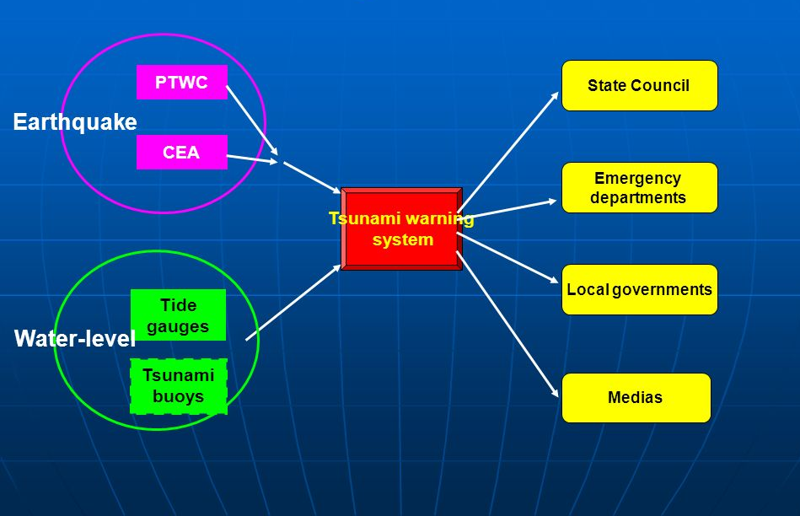
Figure 1: A typical tsunami warning system
Credits: Zhao Lianda, National Marine Environmental Forecasting Center (NMEFC), SOA
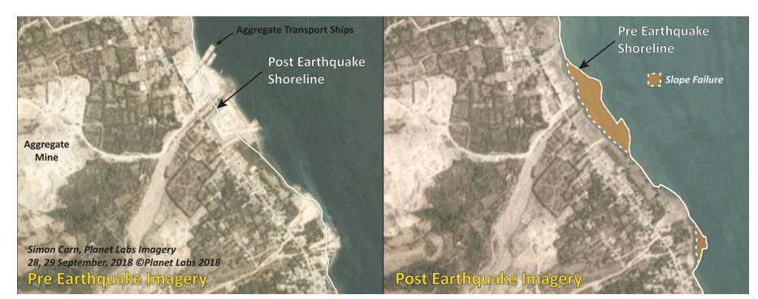
Figure 2: Pre-and post-earthquake satellite imagery comparison showing slope failures along the coastline of western Palu Bay, west of the mouth of Palu River, Sulawesi, Indonesia (Planet Labs, 2017). Credits: EERI.

