Can barrier islands survive sea-level rise? Quantifying the relative role of tidal inlets and overwash deposition
Jaap H. Nienhuis1,* and Jorge Lorenzo-Trueba2
1 School of Geosciences, Utrecht University, Utrecht, NL
2 Department of Earth and Environmental Studies, Montclair State University, Montclair, New Jersey, USA
* Corresponding author address: Princetonlaan 8a, Utrecht, NL 3584CB, j.h.nienhuis@uu.nl

Key points
- Flood-tidal deltas built by ephemeral and rapidly migrating tidal inlets contribute significantly to barrier landward movement in response to sea-level rise
- Additional landward sediment flux from tidal inlets can help barrier islands keep pace with sea-level rise
- Barrier stratigraphy is not always a good indicator of formative landward sediment fluxes

Abstract
Barrier island response to sea-level rise depends on their ability to transgress and move sediment onto and behind the barrier, either through flood-tidal delta deposition, or via overwash. Our understanding of these processes over decadal or longer timescales, however, is limited. Here we use a recently developed barrier island model (BRIE) to better understand the interplay between tidal dynamics, overwash fluxes, and sea-level rise on barrier coasts and barrier island stratigraphy. Model results suggest that in micro-tidal environments with large alongshore sediment transport fluxes, tidal inlets are ephemeral and migrate rapidly. These conditions lead to effective deposition of flood-tidal deltas and allow inlets to constitute most of the landward sediment flux. Whether barrier islands can survive sea-level rise depends on the combined landward sediment flux from overwash and flood-tidal delta deposition, likely making barrier islands with artificially stabilized inlets (via jetty construction or maintenance dredging) more vulnerable to sea-level rise.

Introduction
Low-lying coastal barriers face an uncertain future in coming decades as sea levels are projected to rise (IPCC, 2014). In order to keep pace with sea-level rise (SLR), barrier islands in their natural state migrate towards land in two ways: overwash and flood-tidal delta deposition (McGee, 1890; Leatherman, 1983). However, if the landward flux of overwash and flood-tidal deltas is insufficient, as it often is the case for developed barrier islands (Rogers et al., 2015), barrier islands do not migrate fast enough and can drown (Gilbert, 1885; Storms et al., 2002; Lorenzo-Trueba & Ashton, 2014; Mellett & Plater, 2018).
Given the socio-economic and ecological importance of barrier islands and their associated back-barrier environments, a number of models have been developed to better understand their response to SLR (Storms, 2003; Stolper et al., 2005; Masetti et al., 2008; Moore et al., 2010; Lorenzo-Trueba & Ashton, 2014; Lorenzo-Trueba & Mariotti, 2017). These models, however, do not explicitly include tidal inlets even though, tidal inlets and flood-tidal delta deposition can represent a significant fraction of the landward-directed sediment flux (Pierce, 1969; Armon & McCann, 1979; Simms et al., 2006). Rather, most barrier island models either only consider overwash processes, or consider barrier island transgression very generally without an explicit treatment of different processes that transport sediment landwards.
Here we apply a new morphodynamic barrier island model that includes both overwash and tidal inlets explicitly (BRIE, see Nienhuis & Lorenzo-Trueba, 2019) to explore barrier island dynamics and their response to SLR on decadal to millennial timescales. Specifically, we aim to quantify the relative role of overwash and tidal inlets on barrier island response to SLR. We investigate the importance of flood-tidal delta deposition in enhancing landward barrier migration, and therefore reducing the likelihood of barrier drowning occurrence. Additionally, we use the model to produce synthetic stratigraphy and investigate the relationship between barrier facies and landward-directed sediment fluxes. This allows us to compare observed barrier facies (e.g., Mallinson et al., 2010a) to centennial timescale overwash and flood-tidal delta deposition.

Background
Storms can set up water flow and sediment transport across a barrier island, which can result in overwash deposition, and the formation of tidal inlets and their associated flood-tidal deltas. When flows into the lagoon are depositional, they lead to the formation of washover fans that extend the subaerial portion of the barrier towards land (i.e., increase barrier width). If flows are erosional, they lead to barrier breaching and inlet formation (Pierce, 1970). Despite the importance of these processes in determining the longer-term geomorphic change of barrier islands, we lack a quantitative understanding that would allow us to predict inlet and washover fan size or location (Donnelly et al., 2006; McCall et al., 2010; Wesselman et al., 2019). In general, however, overwash events are typically larger and more frequent on narrow and low lying barriers (Leatherman, 1979). Tidal inlets also preferentially form in narrow barriers (Johnson, 1919). Tidal inlets can form flood-tidal deltas from littoral sediments and produce a landward-directed sediment flux (Leatherman, 1979), particularly when they migrate along the barrier and continually expose new parts of the basin to flood-tidal deposition (Nienhuis & Ashton, 2016). Inlets can close if tidal flows are insufficient to sustain a breach (Escoffier, 1940).
Subject to SLR and in the absence of external sediment sources, the width of a barrier island decreases, making it more susceptible to overwash and barrier breaching. Based on observations at Assateague Island, Virginia, Leatherman (1979) developed the concept of a critical barrier width. This concept states that when the barrier width is below a certain critical width, overwash deposition can reach the back of the barrier and maintain barrier transgression (i.e., barrier “rollover”). Jiménez and Sánchez-Arcilla (2004) later expanded this concept in their modelling study of the Ebro Delta and postulated that the volume of overwash is linearly related to the deviation of the barrier width from the critical width, such that narrower barriers overwash more sediment. More recently, Lorenzo-Trueba and Ashton (2014) assumed the existence of a maximum overwash flux, potentially a function of storm characteristics and sediment properties. Barrier drowning is likely to occur either when the rate of shoreface adjustment is slow or when the maximum overwash flux is insufficient for a given SLR rate (Lorenzo-Trueba & Ashton, 2014).
Even though the impact of inlets on barrier coasts is widely appreciated (Pons et al., 1963; Pierce, 1969; Inman & Dolan, 1989; Beets & van der Spek, 2000; Fitzgerald et al., 2001; Ridderinkhof et al., 2014; Mallinson et al., 2018), long-term dynamics of inlets and feedbacks with barrier morphology are largely unexplored.

BRIE model
The BRIE model combines existing overwash and shoreface formulations (Lorenzo-Trueba & Ashton, 2014) with alongshore sediment transport (Ashton & Murray, 2006), inlet stability (Escoffier, 1940), inlet migration, and flood-tidal delta deposition (Nienhuis & Ashton, 2016). These formulations depend on barrier geometry, thus allowing for feedbacks between overwash, inlets, and shoreface dynamics. For example, flood-tidal delta deposition increases barrier width, thereby limiting barrier overwash. Inlets on the other hand can act as a littoral sediment trap and starve the downdrift barrier of sediment, locally increasing overwash fluxes (Leatherman, 1979). Here we provide a brief description of the model and refer to Nienhuis and Lorenzo-Trueba (2019) for the source code and additional documentation.

Cross-shore component
Following Lorenzo-Trueba and Ashton (2014), we use an idealized cross-shore geometry that allows us to describe barrier island response to SLR as a function of barrier height and three boundaries: the shoreface toe, the ocean shoreline, and the backbarrier shoreline. The shoreface toe is located at a depth below sea level where sediment exchange between the shoreface and the shelf is negligible (Ortiz and Ashton, 2016) . Changes in the shoreface toe and the ocean shoreline position describe the cross-shore dynamics of the shoreface, which dynamically adjusts toward an equilibrium profile. That is, the shoreface sediment flux is directed offshore when the shoreface steepens beyond its equilibrium configuration as a result of SLR (e.g., Bruun, 1954) or convergence of alongshore sediment transport. In contrast, the shoreface flux is directed onshore when the shoreface profile flattens beyond its equilibrium configuration, which occurs during barrier overwash, or if there is a net sediment loss resulting from alongshore transport divergence.
Overwash ﬂuxes connect the barrier shoreface with the backbarrier environment, and are computed as a function of a critical barrier width and height, beyond which overwash ﬂux to the back and the top of the barrier shuts down. Overwash fluxes also depend on the lagoon depth, which depends on the rate of fine sediment accumulation. Fine sediments contribute to the total barrier volume as the barrier migrates landwards, but do not recycle back in the form of overwash as the shoreface erodes. We estimate the parameters associated with the cross-shore dynamics using the formulations described by Houston (1995), Lorenzo-Trueba and Ashton (2014), Ortiz and Ashton (2016), and Nienhuis and Lorenzo-Trueba (2019).

Along-shore component
The barrier island profiles and their dynamics are described at a regular interval (typically 100 m) along a barrier island chain. We connect these cross-shore profiles via alongshore sediment transport. Convergence or divergence of alongshore sediment transport sets the rate of shoreline erosion and progradation, as well as the degree of shoreface steepening or flattening. We calculate shoreline change in a periodic alongshore domain of typically 100 km based on a non-linear diffusion equation defined at the toe of the shoreface (Ashton & Murray, 2006). We compute the diffusivity parameter as a function of wave climate, which is in turn characterized by its wave height, wave period, and the distribution of incoming wave directions.

Inlet opening and closing
An inlet can form subject to two conditions: (1) it has to be sufficiently far away from existing inlets (> 10 km, see Roos et al., 2013), and (2) it breaches where the barrier cross-sectional volume is smallest. Inlet width and depth is based on Escoffier’s principle (Escoffier, 1940) and quantified using the formulations presented by Swart and Zimmerman (2009). An inlet closes if its tidal velocity amplitude is smaller than a critical velocity (here 1 m s-1). Inlets can close at any timestep and can therefore also have very short lifespans (up to one timestep, usually 0.05 years). The tidal prism is a function of the tidal drainage basin area, which in turn depends on (1) the distance to neighboring inlets, (2) the backbarrier marsh percentage, and (3) the distance between the back barrier and the passively flooded mainland. We do not solve for multi-inlet tidal hydrodynamics (e.g., Roos et al., 2013; Reef et al., 2019), but assume back-barrier water drains to the nearest tidal inlet. When a section of the barrier chain drowns (i.e., width < 0 or height < 0), we convert it to an inlet, such that it steals tidal prism from neighboring inlets and acts as a sink of alongshore sediment transport.

Inlet migration and flood delta deposition
For each inlet, we use the parameterizations from Nienhuis and Ashton (2016) to calculate inlet migration rates and changes in the volume of the flood tidal-delta. At each time step (usually 0.05 years), a wave direction is drawn from a probability distribution based on the wave climate asymmetry and highness. With this wave direction, we calculate the alongshore sediment flux directed to each inlet (Ashton & Murray, 2006; Nienhuis et al., 2015). Next, sediment transported towards the inlet is (i) deposited in the updrift barrier, which results in downdrift extension and inlet migration, (ii) deposited as flood-tidal delta, or (iii) bypassed to the downdrift barrier. Sediment released from the eroded bank of a migrating inlet is distributed similarly. Sediment flux distribution is based on the relative momentum fluxes of the inlet jet and the alongshore radiation stress, which depend on the tidal prism and the wave climate. Inlet migration rates are highest for a mixed tidal and wave energy environment (Nienhuis & Ashton, 2016). New barrier and flood-tidal delta deposits are assumed to be right at sea level. BRIE does not explicitly include ebb-tidal deltas but instead accounts for the morphodynamic effects of ebb-tidal deltas implicitly through its tidal inlet parameterizations (Nienhuis & Ashton, 2016).

Model analyses
First, we run the model for different wave climates, tidal conditions, and SLR rates. Using these simulations, we investigate the relative contribution of overwash and flood tidal deposition on the total landward flux, which we quantify by the ratio F,
.
where Qinlet (m3/yr) is the annually deposited flood-tidal delta volume in all inlets along the barrier complex. Qoverwash (m3/yr) is the overwash flux component associated with the landward extension of the barrier width. Second, we extract synthetic inlet and flood-tidal delta facies from model simulations to investigate how these facies relate to the inlet fraction of the landward flux F. Third, we investigate the potential for barrier drowning under a wide range of scenarios. We identify barrier drowning when more than 50% of the barrier chain has experienced either width or height drowning (i.e., width < 0 or height < 0).

Feedbacks between inlets and barrier morphodynamics
Barrier and inlet migration rates can be highly variable even under constant forcing. In Fig. 1, we present an example model run under constant SLR rate and constant boundary conditions in which inlets open, close, merge, and saturate the barrier system (e.g., Roos et al., 2013). Differential inlet migration and inlet merger can increase the potential tidal prism locally and allow for the formation of new inlets (i.e., Escoffier, 1940). Inlet migration rates are a function of a number of factors and can therefore undergo cycles over a wide range of timescales, from years to millennia (Fig. 1e). Because inlet migration is a function of the tidal prism, the proximity to other inlets can affect inlet migration rates (Fig. 1c, 1e). In general, we find that periods of rapid inlet migration coincide with relatively high flood-tidal delta deposition (Fig. 1e, 1f).
Although inlets tend to migrate faster along narrow barriers (Nienhuis & Ashton, 2016), the relationship between inlet migration rate and barrier width is not straightforward (Fig. 1d, 1e). As we increase the rate of inlet migration, flood-tidal delta deposition increases, which in turn increases barrier width. Additionally, higher rates of inlet migration increase the possibility of inlets merging between them. The combination of wider barriers with a decrease in the number of inlets leads to reduction in the average inlet migration rate (Fig. 1e). This feedback between inlets and barrier morphology becomes important over longer timescales than the ones in which tidal inlets are typically assessed (i.e., centennial to millennial time scales).
Notably, even though in this example the long-term contribution of inlets to barrier landward migration (described by parameter F) is 10%, barrier morphology differs markedly from a similar simulation without inlets. For example, alongshore-averaged barrier width in the no-inlet simulation is constant in time (“dynamic equilibrium retreat”, see Lorenzo-Trueba & Ashton, 2014). Accounting for inlet morphodynamics we obtain significantly wider barrier islands and observe millennial timescale fluctuations in barrier width (Fig. 1d).

The contribution of inlets to barrier transgression
We compare the contribution of inlets to barrier landward migration for different tide and wave regimes as a function of the F parameter. We fix the SLR rate and basement slope, both assumed to be constant, such that the landward migration distance required to keep pace with sea-level is the same between model runs. We find that the fraction F varies from less than 0.1 to more than 0.9 (Fig. 2a). F varies as a function of tide and wave regime, with the highest contribution of inlets for mixed energy environments (Hayes, 1979). In these environments, the average inlet lifetime is short and (with large littoral sediment fluxes) inlet migration rates are high, continuously exposing new lagoon to flood tidal delta deposition and ensuring their capacity as littoral sediment sinks. F increases with increasing wave height because flood-tidal delta deposition is linearly related to alongshore sediment transport, whereas, in BRIE, barrier overwash is not explicitly related to wave height. Note however that a dependency between overwash and wave height could be added in the future.
In the next set of model experiments (Fig. 2b-e), we find that overwash becomes more important for barrier landward movement as the rate of SLR increases (Fig. 2b). Under a higher SLR rate, larger landward sediment fluxes are required, which in turn results in thinner barrier islands given that both overwash and flood-tidal delta deposition are inversely related to barrier width. However, overwash fluxes increase linearly with decreasing barrier width (e.g., Jiménez & Sánchez-Arcilla, 2004), whereas flood-tidal delta deposition is sub-linearly related to barrier width (e.g., Nienhuis & Ashton, 2016), resulting in lower F for higher SLR rates. Higher maximum potential overwash fluxes vary linearly with actual overwash fluxes and therefore result in higher proportions of overwash deposition compared to flood-tidal delta deposition in a retreating barrier system (Fig. 2c).
The sensitivity of tidal inlet morphodynamics to changes in tidal prism is demonstrated by the marsh cover in the lagoon (Fig. 2d). The tidal prism is low in lagoons that are filled with marsh vegetation, which in turn increases the likelihood of inlet closing (i.e., Escoffier, 1940). Low marsh coverage (large tidal prism) enhances inlet stability and limits inlet migration rates. Low migration rates, in turn, reduce the potential of inlets to fill the lagoon with flood-tidal deltas.
We also explore how the inlet fraction F varies for different wave directions, expressed by the proportion of wave energy approaching from the left relative to the regional shoreline trend (Fig. 2e). Asymmetric wave climate increases net alongshore sediment transport along the barrier coast. This increases inlet migration rates and, consequently, flood-tidal delta deposition. However, the relation with net alongshore transport is not linear. Inlets still contribute to barrier landward migration for a symmetric wave climate because of flood-tidal delta deposition after inlet formation.
Given that inlets contribute to the landward-directed sediment flux of a barrier system, can they prevent barriers from drowning for high SLR rates? We compared model experiments with inlets to experiments without inlets (which behave similar to simulations by Lorenzo-Trueba & Ashton, 2014). For barriers without tidal inlets that would disintegrate because of SLR, we find that barrier coasts with inlets can withstand higher sea level rise rates (Fig. 3). The additional landward sediment flux from flood-tidal delta deposition can lead to transgression rates that are sufficient to withstand faster SLR. We also find a relation with offshore wave height; larger net alongshore transport increases flood-tidal delta deposition, which adds to the maximum potential landward flux of overwash deposition alone and makes barrier islands able to remain subaerial under higher SLR rates.

The stratigraphic record of inlets
The importance of inlets has been suggested by several studies (e.g., Pierce, 1969; Wilkinson, 1975; Fitzgerald et al., 2001; Mallinson et al., 2010a), based on the widespread occurrence of inlets and inlet-related facies along modern barrier islands. We investigate how the distribution of these facies compares to the long-term landward-directed sediment flux. From the experiments shown in Figures 2 and 3 we extracted synthetic facies and compared the area of inlet related facies to storm overwash facies (Fig. 4a). We formed these synthetic facies by tracking the thickness and responsible processes (e.g. flood-tidal delta or overwash deposition) of sediment deposition along the barrier chain through time. We also track the depth and width of processes eroding the barrier island (e.g. inlet formation, inlet migration).
We find, in general, a non-linear but monotonic relationship between F and the fraction of barrier stratigraphy composed of inlet related facies. Although there is considerable scatter, a higher inlet related fraction in the composition of a barrier island is indicative of inlets being more important for barrier landward migration (higher F). Under low inlet activity (Fig 4b, c) inlet deposits are underrepresented in barrier island facies, whereas high inlet activity (Fig. 4d) results in inlets being overrepresented. Overrepresentation can be attributed to inlet migration, which leads to a high inlet fraction in barrier island facies but does not directly add to barrier island landward migration. Lower volumes of preserved tidal deposition on the other hand are caused by flood-tidal delta deposition, which is punctuated alongshore and frequently eroded by inlets. The relation between landward sediment fluxes and barrier facies is highly sensitive around F = 0.5, which we attribute to the necessity of inlet migration (and consequently the reworking of overwash deposits) to achieve F > 0.5.

Discussion and conclusion
In this study, we present a morphodynamic model for barrier island evolution (BRIE), in which inlets can form and contribute to barrier island landward migration. Compared to previous modeling efforts that do not explicitly include inlets (Stolper et al., 2005; Masetti et al., 2008; Lorenzo-Trueba & Ashton, 2014; Ashton & Lorenzo-Trueba, 2018), we find that inlets can play a significant role on the response of barrier island chains to SLR (Fig. 3). Although the BRIE model is based on a simplified representation of the processes that affect inlets, overwash, and the shoreface, it reproduces the existing qualitative observation that inlets that are short-lived and migrating are important for barrier transgression (Leatherman, 1979).
In general, the BRIE model can help to understand the key drivers of barrier island migration, and aid in predicting future barrier response to accelerated rates of SLR. We find that the relative role of inlets is reduced as the rate of SLR increases (Fig. 2b). Observations of the importance of inlets in the historical record (under low SLR rates) might therefore not be representative of their future (high SLR rates) influence on barrier landward migration. Compared to earlier models of long-term barrier evolution (e.g., Masetti et al., 2008; Lorenzo-Trueba & Ashton, 2014), our more explicit treatment of the various landward-directed sediment fluxes can help with field validation and future predictions. For example, our simulations in BRIE suggest that the maximum potential landward flux of barrier islands with inlets depends on wave heights (Fig. 3). Previous models lumped different landward moving sediment fluxes and therefore had to assume (the existence of) potential landward sediment fluxes (e.g., Lorenzo-Trueba & Ashton, 2014).
Despite an improved representation of coastal processes such as inlet dynamics, BRIE does not yet aim to simulate the dynamics of any particular barrier system. To do that, we would need to incorporate additional factors such as variations in the coastal lithology and topography (Schwab et al., 2000; Cooper et al., 2012; Swanson et al., 2018; Shawler et al., 2019), human influence (Oost et al., 2012), and/or the extent of the marsh platform (Lorenzo-Trueba & Mariotti, 2017), which can potentially lead to complex dynamics in the barrier system. For example, paleovalleys can constrain inlet migration rates, and even anchor inlets in place over geological time scales (Beets & van der Spek, 2000; Mallinson et al., 2010b). Site-specific application and model validation of long-term barrier evolution is also hindered by the limited preservation of their sedimentological record (Ciarletta et al., 2019).
We assume that barrier systems can be characterized by long-term average statistics, even though episodic storms can significantly impact their morphology. Overwash fluxes are computed as a function of barrier geometry, including its critical width and height, and the maximum potential overwash flux. These parameters have poor empirical constraints and are likely dependent on the considered timescale (Lazarus, 2016). Consequently, future work will include a process-based overwash formulation. Additionally, the model implementation of barrier drowning is limited. In many cases a drowning barrier would dissect the shoreface, and any remaining barrier islands would be flanked by free spits (e.g., Ashton et al., 2016). BRIE is not able to simulate these dynamics. We refer to free-form coastline models such as CEM (Ashton et al., 2016) and ShorelineS (www.shorelines.nl), or reduced complexity 2DH models (e.g., Mariotti & Murshid, 2018) where such behavior is easier to simulate.
In conclusion, we find a rich set of tidal inlet, overwash, and barrier island dynamics over decadal to millennial timescales. Flood-tidal deltas can contribute significantly to barrier landward migration in cases where rapidly migrating inlets expose new back-barrier basin to flood delta deposition. Given the increased anthropogenic pressures on barrier islands and the anticipated acceleration of sea level rise rates, inlets might help keep barrier islands above sea level. Conversely, inlet stabilization therefore might reduce barrier island resilience.

Acknowledgements
This research was supported by National Science Foundation grant EAR-1810855 and Netherlands Organisation for Scientific Research grant VI.Veni.192.123 to JHN. JLT was supported by National Science Foundation grant CNH-1518503 and the American Chemical Society grant PRF #58817-DNI8. Model code and description are in Nienhuis and Lorenzo-Trueba (2019). Model data to reproduce all findings and figures can be found in the supplementary material, available at: https://osf.io/u4tcf/. The authors appreciate helpful discussions with Andrew Ashton and constructive feedback from Brad Murray and an anonymous reviewer.

References
Armon, J. W., & McCann, S. B. (1979). Morphology and landward sediment transfer in a transgressive barrier island system, southern Gulf of St. Lawrence, Canada. Marine Geology, 31(3–4), 333–344. https://doi.org/10.1016/0025-3227(79)90041-0
Ashton, A. D., Nienhuis, J. H., & Ells, K. (2016). On a neck, on a spit: controls on the shape of free spits. Earth Surface Dynamics, 4(1), 515–560. https://doi.org/10.5194/esurf-4-193-2016
Ashton, A. D., & Lorenzo-Trueba, J. (2018). Morphodynamics of Barrier Response to Sea-Level Rise. In Barrier Dynamics and Response to Changing Climate (pp. 277–304). Cham: Springer International Publishing. https://doi.org/10.1007/978-3-319-68086-6_9
Ashton, A. D., & Murray, A. B. (2006). High-angle wave instability and emergent shoreline shapes: 2. Wave climate analysis and comparisons to nature. Journal of Geophysical Research, 111(F4), F04012. https://doi.org/10.1029/2005JF000423
Beets, D. J., & van der Spek, A. J. F. (2000). The Holocene evolution of the barrier and the back-barrier basins of Belgium and the Netherlands as a function of late Weichselian morphology, relative sea-level rise and sediment supply. Netherlands Journal of Geosciences, 79(01), 3–16. https://doi.org/10.1017/S0016774600021533
Bruun, P. (1954). Coastal erosion and development of beach profiles. US Army beach erosion board technical memorandum No. 44. Washington DC, USA.
Ciarletta, D. J., Lorenzo-Trueba, J., & Ashton, A. D. (2019). Mechanism for retreating barriers to autogenically form periodic deposits on continental shelves. Geology, 47(3), 239–242. https://doi.org/10.1130/G45519.1
Cooper, J. A. G., Jackson, D. W. T., Dawson, A. G., Dawson, S., Bates, C. R., & Ritchie, W. (2012). Barrier islands on bedrock: A new landform type demonstrating the role of antecedent topography on barrier form and evolution. Geology, 40(10), 923–926. https://doi.org/10.1130/G33296.1
Donnelly, C., Kraus, N., & Larson, M. (2006). State of Knowledge on Measurement and Modeling of Coastal Overwash. Journal of Coastal Research, 22(4), 965–991. https://doi.org/10.2112/04-0431.1
Escoffier, F. F. (1940). The Stability of Tidal Inlets. Shore and Beach, 8(4), 114–115.
Fitzgerald, D. M., Buynevich, I. V., & Rosen, P. S. (2001). Geological evidence of former tidal inlets along a retrograding barrier Duxbury Beach. Journal of Coastal Research, SI 34(January), 1–13.
Gilbert, G. K. (1885). The topographic features of lake shores. In Papers accompanying the annual report of the director of the U.S. Geological Survey (pp. 69–123). Washington DC, USA.
Hayes, M. O. (1979). Barrier island morphology as a function of tidal and wave regime. In S. P. Leatherman (Ed.), Barrier Islands (pp. 1–27). New York, USA: Academic Press.
Heron, S. D., Moslow, T. F., Berelson, W. M., Herbert, J. R., Steele, G. A., & Susman, K. R. (1984). Holocene sedimentation of a wave-dominated barrierisland shoreline: Cape Lookout, North Carolina. Marine Geology, 60(1–4), 413–434. https://doi.org/10.1016/0025-3227(84)90160-9
Houston, J. R. (1995). Beach-fill volume required to produce specified dry beach width, Coastal Engineering Technical Note 11-32. Vicksburg, MS, USA.
Inman, D. L., & Dolan, R. (1989). The Outer Banks of North Carolina: Budget of sediment and inlet dynamics along a migrating barrier system. Journal of Coastal Research, 5(2), 193–237. Retrieved from http://www.jstor.org/stable/10.2307/4297525
IPCC. (2014). Climate Change 2014: Synthesis Report. Contribution of Working Groups I, II and III to the Fifth Assessment Report of the Intergovernmental Panel on Climate Change. IPCC. Geneva, Switzerland.
Jiménez, J. A., & Sánchez-Arcilla, A. (2004). A long-term (decadal scale) evolution model for microtidal barrier systems. Coastal Engineering, 51(8–9), 749–764. https://doi.org/10.1016/j.coastaleng.2004.07.007
Johnson, D. W. (1919). Shore Processes and Shoreline Development (1st ed.). New York, USA: John Wiley & Sons, Inc.
Lazarus, E. D. (2016). Scaling laws for coastal overwash morphology. Geophysical Research Letters, 43(23), 12,113-12,119. https://doi.org/10.1002/2016GL071213
Leatherman, S. P. (1979). Migration of Assateague Island, Maryland, by inlet and overwash processes. Geology, 7(2), 104–107. https://doi.org/10.1130/0091-7613(1979)7<104:MOAIMB>2.0.CO;2
Leatherman, S. P. (1983). Barrier dynamics and landward migration with Holocene sea-level rise. Nature, 301(5899), 415–417. https://doi.org/10.1038/301415a0
Lorenzo-Trueba, J., & Ashton, A. D. (2014). Rollover, drowning, and discontinuous retreat: Distinct modes of barrier response to sea-level rise arising from a simple morphodynamic model. Journal of Geophysical Research: Earth Surface, 119(4), 779–801. https://doi.org/10.1002/2013JF002941
Lorenzo-Trueba, J., & Mariotti, G. (2017). Chasing boundaries and cascade effects in a coupled barrier-marsh-lagoon system. Geomorphology, 290, 153–163. https://doi.org/10.1016/j.geomorph.2017.04.019
Mallinson, D. J., Smith, C. W., Culver, S. J., Riggs, S. R., & Ames, D. (2010a). Geological characteristics and spatial distribution of paleo-inlet channels beneath the outer banks barrier islands, North Carolina, USA. Estuarine, Coastal and Shelf Science, 88(2), 175–189. https://doi.org/10.1016/j.ecss.2010.03.024
Mallinson, D. J., Culver, S. J., Riggs, S. R., Thieler, E. R., Foster, D., Wehmiller, J., … Pierson, J. (2010b). Regional seismic stratigraphy and controls on the Quaternary evolution of the Cape Hatteras region of the Atlantic passive margin, USA. Marine Geology, 268(1–4), 16–33. https://doi.org/10.1016/j.margeo.2009.10.007
Mallinson, D. J., Culver, S., Leorri, E., Mitra, S., Mulligan, R., & Riggs, S. (2018). Barrier Island and Estuary Co-evolution in Response to Holocene Climate and Sea-Level Change: Pamlico Sound and the Outer Banks Barrier Islands, North Carolina, USA. In Barrier Dynamics and Response to Changing Climate (pp. 91–120). Cham: Springer International Publishing. https://doi.org/10.1007/978-3-319-68086-6_3
Mariotti, G., & Murshid, S. (2018). A 2D Tide-Averaged Model for the Long-Term Evolution of an Idealized Tidal Basin-Inlet-Delta System. Journal of Marine Science and Engineering, 6(4), 154. https://doi.org/10.3390/jmse6040154
Masetti, R., Fagherazzi, S., & Montanari, A. (2008). Application of a barrier island translation model to the millennial-scale evolution of Sand Key, Florida. Continental Shelf Research, 28(9), 1116–1126. https://doi.org/10.1016/j.csr.2008.02.021
McCall, R. T., Van Thiel de Vries, J. S. M., Plant, N. G., Van Dongeren, A. R., Roelvink, J. A., Thompson, D. M., & Reniers, A. J. H. M. (2010). Two-dimensional time dependent hurricane overwash and erosion modeling at Santa Rosa Island. Coastal Engineering, 57(7), 668–683. https://doi.org/10.1016/j.coastaleng.2010.02.006
McGee, W. J. (1890). Encroachments of the sea. New York, USA: Forum Publishing Company.
Mellett, C. L., & Plater, A. J. (2018). Drowned Barriers as Archives of Coastal-Response to Sea-Level Rise. In Barrier Dynamics and Response to Changing Climate (pp. 57–89). Cham: Springer International Publishing. https://doi.org/10.1007/978-3-319-68086-6_2
Moore, L. J., List, J. H., Williams, S. J., & Stolper, D. (2010). Complexities in barrier island response to sea level rise: Insights from numerical model experiments, North Carolina Outer Banks. Journal of Geophysical Research, 115(F3), F03004. https://doi.org/10.1029/2009JF001299
Nienhuis, J. H., & Ashton, A. D. (2016). Mechanics and rates of tidal inlet migration: Modeling and application to natural examples. Journal of Geophysical Research: Earth Surface, 121(11), 2118–2139. https://doi.org/10.1002/2016JF004035
Nienhuis, J. H., Ashton, A. D., & Giosan, L. (2015). What makes a delta wave-dominated? Geology, 43(6), 511–514. https://doi.org/10.1130/G36518.1
Nienhuis, J. H., & Lorenzo-Trueba, J. (2019). Simulating barrier island response to sea level rise with the barrier island and inlet environment (BRIE) model v1.0. Geoscientific Model Development, 12(9), 4013–4030. https://doi.org/10.5194/gmd-12-4013-2019
Oost, A. P., Hoekstra, P., Wiersma, A., Flemming, B., Lammerts, E. J., Pejrup, M., … Wang, Z. B. (2012). Barrier island management: Lessons from the past and directions for the future. Ocean & Coastal Management, 68, 18–38. https://doi.org/10.1016/j.ocecoaman.2012.07.010
Ortiz, A. C., & Ashton, A. D. (2016). Exploring shoreface dynamics and a mechanistic explanation for a morphodynamic depth of closure. Journal of Geophysical Research: Earth Surface, 121(2), 442–464. https://doi.org/10.1002/2015JF003699
Pierce, J. W. (1969). Sediment budget along a barrier island chain. Sedimentary Geology, 3(1), 5–16. https://doi.org/10.1016/0037-0738(69)90012-8
Pierce, J. W. (1970). Tidal Inlets and Washover Fans. The Journal of Geology, 78(2), 230–234.
Pons, L. J., Jelgersma, S., Wiggers, A. J., & Jong, A. J. de. (1963). Evolution of the Netherlands coastal area during the Holocene. Verhandelingen van Het Koningklijk Nederlands Geologisch Mijnbouwkundig Genootschap, Geologische Serie, 21(2), 197–208.
Reef, K., Roos, P., Schuttelaars, H., & Hulscher, S. (2019). The influence on basin geometry on the long-term morphological evolution of barrier coasts. In L. Brakenhoff & M. van der Vegt (Eds.), NCK-days (p. 76). Enkhuizen: NCK.
Ridderinkhof, W., de Swart, H. E., van der Vegt, M., Alebregtse, N. C., & Hoekstra, P. (2014). Geometry of tidal inlet systems: A key factor for the net sediment transport in tidal inlets. Journal of Geophysical Research: Oceans, 119(10), 6988–7006. https://doi.org/10.1002/2014JC010226
Rogers, L. J., Moore, L. J., Goldstein, E. B., Hein, C. J., Lorenzo-Trueba, J., & Ashton, A. D. (2015). Anthropogenic controls on overwash deposition: Evidence and consequences. Journal of Geophysical Research: Earth Surface, 120(12), 2609–2624. https://doi.org/10.1002/2015JF003634
Roos, P. C., Schuttelaars, H. M., & Brouwer, R. L. (2013). Observations of barrier island length explained using an exploratory morphodynamic model. Geophysical Research Letters, 40(16), 4338–4343. https://doi.org/10.1002/grl.50843
Schwab, W., Thielert, E. R., Allen, J. R., Foster, D. S., Swift, B. A., & Denny, J. F. (2000). Influence of Inner-Continental Shelf Geologic Framework on the Evolution and Behavior of the Barrier-Island System Between Fire Island Inlet and Shinnecock Inlet, Long Island, New York. Journal of Coastal Research, 16(2), 408–422.
Shawler, J. L., Ciarletta, D. J., Lorenzo-Trueba, J., & Hein, C. J. (2019). Drowned Foredune Ridges as Evidence of Pre-Historical Barrier-Island State Changes Between Migration and Progradation. In P. Wang, J. D. Rosati, & M. Vallee (Eds.), Coastal Sediments 2019 (pp. 158–171). St Petersburg, FL: World Scientific Pub Co Inc. https://doi.org/10.1142/9789811204487_0015
Simms, A. R., Anderson, J. B., & Blum, M. D. (2006). Barrier-island aggradation via inlet migration: Mustang Island, Texas. Sedimentary Geology, 187(1–2), 105–125. https://doi.org/10.1016/j.sedgeo.2005.12.023
Stolper, D., List, J. H., & Thieler, E. R. (2005). Simulating the evolution of coastal morphology and stratigraphy with a new morphological-behaviour model (GEOMBEST). Marine Geology, 218(1–4), 17–36. https://doi.org/10.1016/j.margeo.2005.02.019
Storms, J. E. A. (2003). Event-based stratigraphic simulation of wave-dominated shallow-marine environments. Marine Geology, 199(1–2), 83–100. https://doi.org/10.1016/S0025-3227(03)00144-0
Storms, J. E. A., Weltje, G. J., van Dijke, J. J., Geel, C. R., & Kroonenberg, S. B. (2002). Process-Response Modeling of Wave-Dominated Coastal Systems: Simulating Evolution and Stratigraphy on Geological Timescales. Journal of Sedimentary Research, 72(2), 226–239. https://doi.org/10.1306/052501720226
Swanson, T., Palermo, R., Anderson, J. B., & Nittrouer, J. A. (2018). Exploring the influence of bay morphology during coastal barrier retreat. In American Geophysical Union, Fall Meeting (p. #EP23C-2304). New Orleans, LA: American Geophysical Union.
de Swart, H. E., & Zimmerman, J. T. F. (2009). Morphodynamics of Tidal Inlet Systems. Annual Review of Fluid Mechanics, 41, 203–229. https://doi.org/10.1146/annurev.fluid.010908.165159
Wesselman, D., de Winter, R., Oost, A., Hoekstra, P., & van der Vegt, M. (2019). The effect of washover geometry on sediment transport during inundation events. Geomorphology, 327, 28–47. https://doi.org/10.1016/j.geomorph.2018.10.014
Wilkinson, B. H. (1975). Matagorda Island, Texas: The Evolution of a Gulf Coast Barrier Complex. Geological Society of America Bulletin, 86(7), 959. https://doi.org/10.1130/0016-7606(1975)86<959:MITTEO>2.0.CO;2

Figures
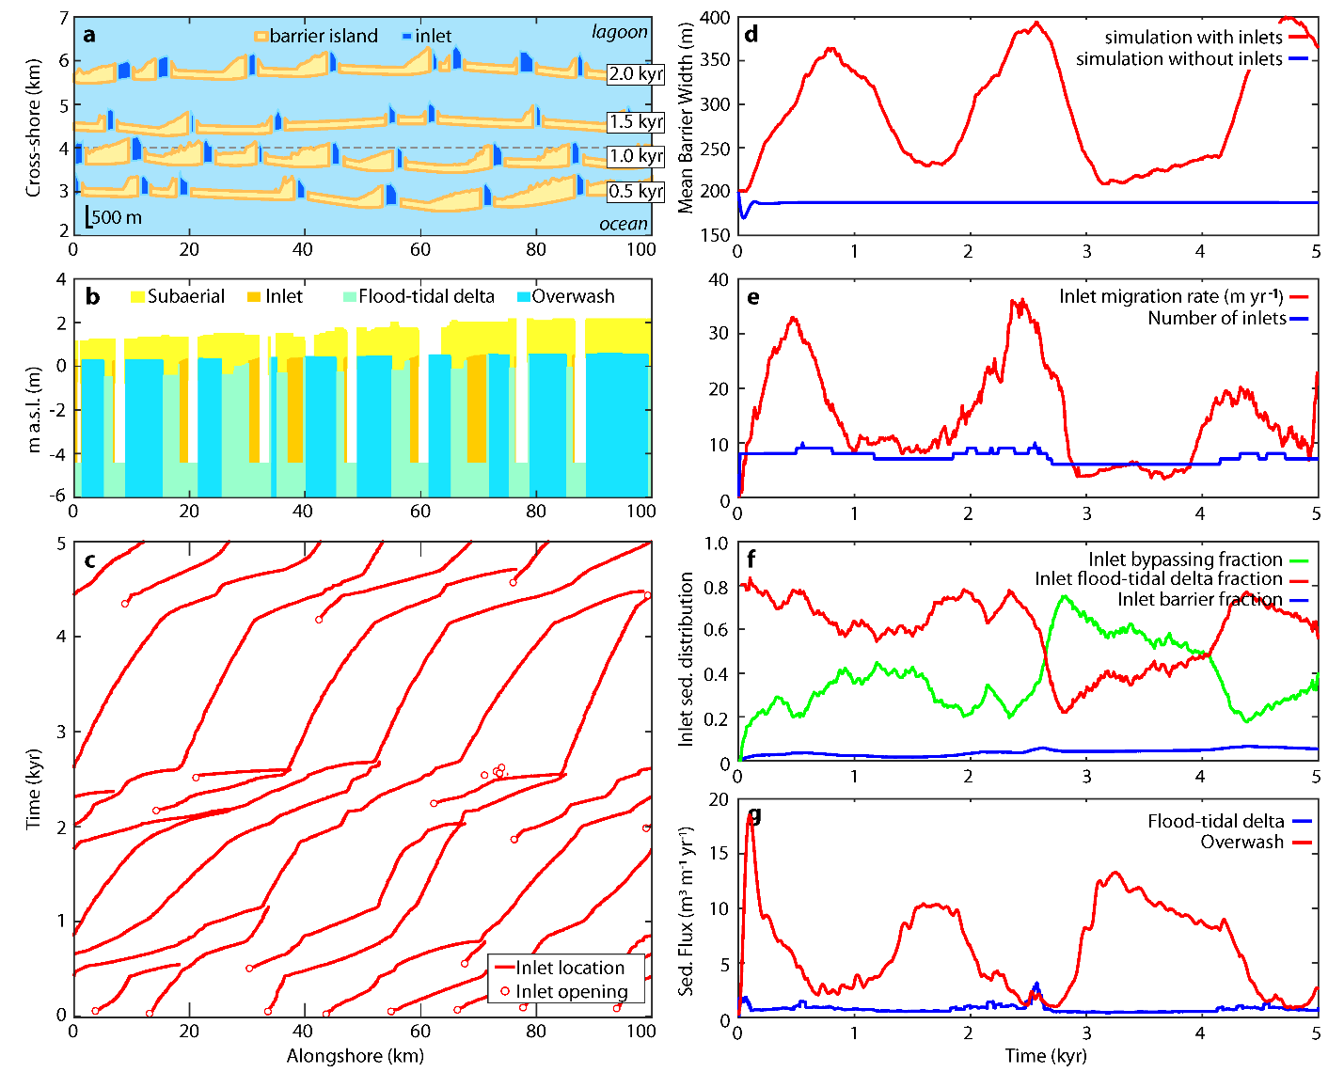
Figure 1: Example model experiment (F = 10%) showing (a) barrier plan-view morphology after 0.5, 1, 1.5, and 2 kyr. (b) Synthetic facies of the barrier as it transgressed across the 4 km cross-shore transect (shown in panel A), in meters above sea level (m.a.s.l.). Deposit ages range from 0.9 to 1.2 kyr. (c) Inlet location, (d) mean barrier width, including a 1D model simulation without inlets for comparison, (e) mean inlet migration rate and the number of inlets, (f) average inlet sediment distribution (see Nienhuis & Ashton, 2016), and (g) the barrier landward-directed sediment flux through time. See supplementary animation S1, supplementary table S1, and supplementary data S1.
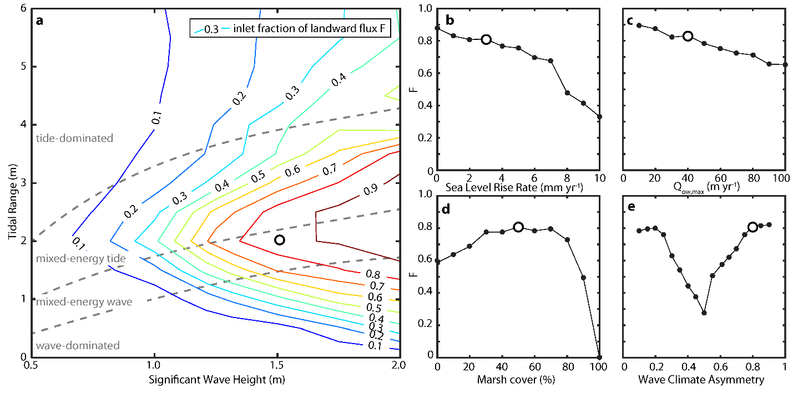
Figure 2: The inlet fraction of the total landward-directed sediment flux F, (a) contoured in a space defined by the significant wave height and the tidal range, and for varying (b) sea level rise rates, (c) maximum potential overwash fluxes, (d) fraction of the lagoon covered by marsh, and (e) fraction of the waves approaching from the left, looking offshore. The white filled circle included in all panels specifies a model experiment with the same model parameters. See supplementary data S2.
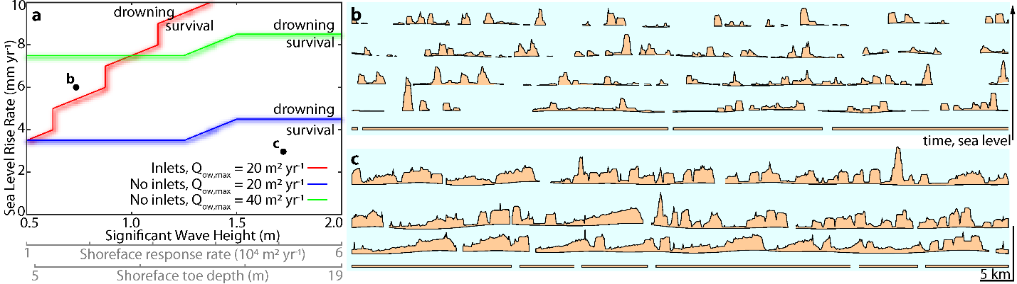
Figure 3: (a) Regime diagram depicting barrier island drowning versus survival under different SLR rates and wave heights. We define drowning as more than 50% of the barrier complex losing its subaerial portion. (b) and (c) are time stacks of the barrier island simulations (including inlets) indicated in panel A, showing respectively drowning and survival. See supplementary data S3.
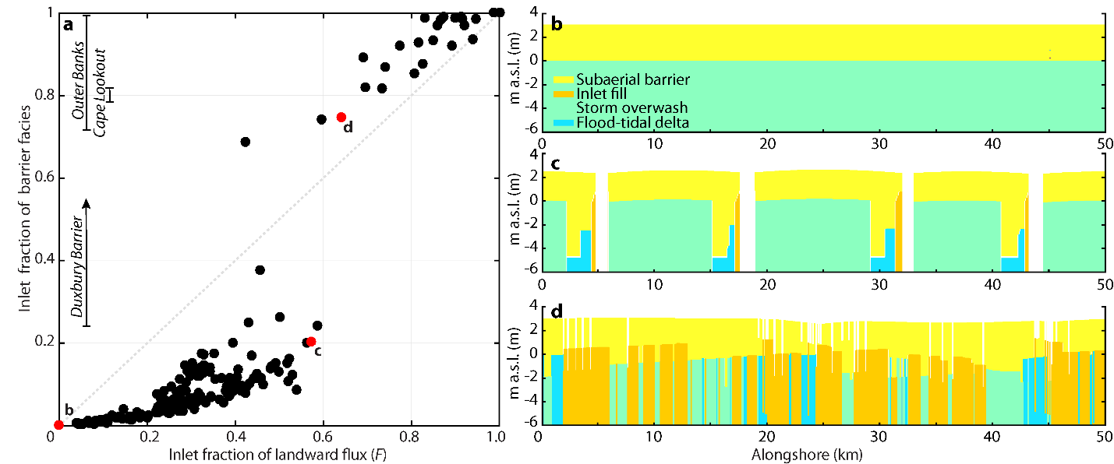
Figure 4: (a) The relationship between barrier island transgression and its representation in barrier island stratigraphy, obtained from model simulations shown in Fig. 1-3. Three field studies with quantified inlet fraction of barrier facies are indicated, the Duxbury barrier (Fitzgerald et al., 2001), the Outer Banks (Mallinson et al., 2010a), and Cape Lookout (Heron et al., 1984). (b-d) Three examples of synthetic facies obtained from model experiments.

