Can barrier islands survive sea-level rise? Quantifying the relative role of tidal deltas and overwash deposition
Jaap H. Nienhuis1,* and Jorge Lorenzo-Trueba2
1 School of Geosciences, Utrecht University, Utrecht, NL
2 Department of Earth and Environmental Studies, Montclair State University, Montclair, New Jersey, USA
* Corresponding author address: Princetonlaan 8a, Utrecht, NL 3584CB, j.h.nienhuis@uu.nl

Key points (140 characters max)
- Barrier transgression results from both overwash and flood-tidal delta deposition
- Flood-tidal deltas built by ephemeral and rapidly migrating tidal inlets can contribute significantly to barrier transgression
- Additional transgressive flux from tidal inlets can help barrier islands keep pace with sea-level rise

Abstract (150 words)
Barrier island response to sea-level rise depends on their ability to transgress and move sediment onto and behind the barrier, either through flood-tidal delta deposition, or via overwash. Our understanding of these processes over decadal or longer timescales, however, is limited and poorly constrained. Here we use a recently developed barrier island model (BRIE) to better understand the interplay between tidal dynamics, overwash fluxes, and sea-level rise on barrier coasts and barrier island stratigraphy. Model results suggest that in micro-tidal environments with large alongshore sediment transport fluxes, tidal inlets are ephemeral and migrate rapidly. These conditions lead to effective deposition of flood-tidal deltas and allow inlets to constitute most of the landward sediment flux. Flood-tidal delta deposition can also prevent barrier systems from drowning, likely making barrier islands with artificially stabilized inlets that cannot migrate (via jetty construction or maintenance dredging) more vulnerable to sea-level rise.

Introduction
Low-lying coastal barriers face an uncertain future over the next decades as sea levels are projected to rise (IPCC, 2014). In order to keep pace with sea-level rise (SLR), barrier islands in their natural state migrate towards land via overwash and flood-tidal delta deposition (McGee, 1890; Leatherman, 1983). However, if the transgressive flux of overwash and tidal inlets in response to SLR is insufficient, as it often is the case for developed barrier islands (Rogers et al., 2015), barrier islands can drown (Gilbert, 1885; Mellett & Plater, 2018).
Given the socio-economic and ecological importance of barrier islands and their associated back-barrier environments, a number of models have been developed to better understand their response to SLR (e.g., Storms et al., 2002; Stolper et al., 2005; Masetti et al., 2008; Lorenzo-Trueba & Ashton, 2014; Lorenzo-Trueba & Mariotti, 2017). These models, however, only include overwash processes even though field studies have shown that flood-tidal delta deposition can represent a significant fraction of the transgressive flux (Pierce, 1969; Armon & McCann, 1979; Simms et al., 2006).
Here we apply a new morphodynamic barrier island model that includes both overwash and tidal inlets (BRIE, see Nienhuis & Lorenzo-Trueba, 2019) to explore barrier island dynamics and their response to SLR on decadal to millennial timescales. Specifically, we aim to quantify the relative role of overwash and tidal inlets on barrier island response to SLR. Based on the role of tidal inlets, we investigate if the transgressive flux of inlets can reduce the risk of barrier drowning. Lastly, because the importance of inlets for barrier transgression has been concluded mainly based on their dominance within barrier facies (e.g., Mallinson et al., 2010), we use synthetic stratigraphy from the model to investigate the relationship between barrier facies and transgressive sediment fluxes.

Background
Overwash and tidal inlets have much in common. Both tend to develop during storms, when waves and water-level differential lead to flow and sediment transport across the barrier. Sediment transport into the lagoon can be depositional, and lead to the formation of overwash fans that widen the barrier, or erosional, leading to barrier breaching and inlet formation (Pierce, 1970). Despite their importance in determining the geomorphic change of barrier islands, we lack the quantitative understanding that would allow us to predict the size and location of overwash fans and inlets (Donnelly et al., 2006; Wesselman et al., 2019). Generally, however, the magnitude and likelihood of occurrence of overwash events is greater for narrow and low lying barriers (Leatherman, 1979). Tidal inlets also preferentially form in narrow barriers (Johnson, 1919). Despite initially being erosional, tidal inlets can form flood-tidal deltas from littoral sediments and produce a transgressive sediment flux (Leatherman, 1979), particularly when they migrate along the barrier and continually expose new parts of the basin to flood-tidal deposition (Nienhuis & Ashton, 2016). Inlets can close if there is not enough potential for tidal flows to sustain a breach (Escoffier, 1940).
Subject to SLR, a barrier system gradually narrows and becomes more susceptible to overwash and barrier breaching. Based on observations at Assateague Island, Virginia, Leatherman (1979) developed the concept of a critical barrier width: overwash can widen a barrier up to a certain (critical) width after which overwash can only aggrade a barrier. Jiménez and Sánchez-Arcilla (2004) later expanded this concept in their modelling study of the Ebro Delta and postulated that the volume of overwash is linearly related to the deviation of the barrier width from the critical width, such that narrower barriers overwash more sediment. More recently, Lorenzo-Trueba and Ashton (2014) assumed the existence of a maximum overwash flux, potentially a function of storm characteristics and sediment properties. Barrier drowning is likely to occur either when the rate of shoreface adjustment is slow or when the maximum overwash flux is insufficient for a given sea level rise rate (Lorenzo-Trueba & Ashton, 2014).
Even though the impact of inlets on barrier coasts is widely appreciated (Pons et al., 1963; Pierce, 1969; Inman & Dolan, 1989; Beets & van der Spek, 2000; Ridderinkhof et al., 2014; Mallinson et al., 2018), long-term dynamics of inlets and feedbacks with barrier morphology are largely unexplored.

BRIE model
The BRIE model combines existing overwash and shoreface formulations (Lorenzo-Trueba & Ashton, 2014) with alongshore sediment transport (Ashton & Murray, 2006), inlet stability (Escoffier, 1940), inlet migration, and flood-tidal delta deposition (Nienhuis & Ashton, 2016). These formulations show dependence on barrier geometry, thus allowing for feedbacks between overwash, inlets, and shoreface dynamics. For example, flood-tidal delta deposition increases barrier width, thereby limiting barrier overwash. Inlets on the other hand can act as a littoral sediment trap and starve the downdrift barrier of sediment, increasing overwash fluxes (Leatherman, 1979). Here we provide a brief description of the model and refer to Nienhuis and Lorenzo-Trueba (2019) for the source code and additional documentation.

Cross-shore component
Following Lorenzo-Trueba and Ashton (2014), we describe barrier evolution in the cross-shore by the barrier height and three moving boundaries: the shoreface toe, the ocean shoreline, and the backbarrier shoreline. The shoreface toe is located at a depth below sea level where sediment exchange between the shoreface and the shelf is negligible (Ortiz and Ashton, 2016), and both the ocean and backbarrier shoreline are located at sea level. Changes in the shoreface toe and the ocean shoreline position describe the dynamics of the shoreface, which dynamically adjusts toward an equilibrium profile. That is, shoreface sediment flux is directed offshore when the shoreface steepens beyond its equilibrium configuration as a result of SLR (e.g., Bruun, 1954) or alongshore sediment input. In contrast, shoreface flux is directed onshore when the shoreface profile flattens beyond its equilibrium configuration, which occurs when overwash fluxes activate or there is a net sediment loss in the alongshore direction. Overwash ﬂuxes connect the barrier shoreface with the backbarrier environment, and are computed as a function of a critical barrier width and height, beyond which overwash ﬂux to the back and the top of the barrier shuts down, as well as the lagoon depth, which depends on the rate of fine sediment accumulation. Fine sediments contribute to the total barrier volume as the barrier migrates landwards, but do not recycle back in the form of overwash as the shoreface erodes. We estimate the parameters associated with the cross-shore dynamics using the formulations described by Lorenzo-Trueba and Ashton (2014), Ortiz and Ashton (2016), and Houston (1995).

Along-shore component
We connect a series of cross-shore profiles via alongshore sediment transport. Plan view gradients determine the rates of shoreline erosion and progradation, as well as the degree of shoreface steepening or flattening. In particular, we calculate shoreline change in a periodic alongshore domain of typically 100 km based on a non-linear diffusion equation defined at the toe of the shoreface (Ashton & Murray, 2006). We compute the diffusivity parameter as a function of wave climate, which is in turn characterized by its wave height, wave period, wave climate asymmetry (the fraction of waves approaching from the left looking offshore), and highness (the fraction of waves approaching at angles greater than 45˚ from shore normal).

Inlet opening and closing
An inlet can form subject to two conditions: (1) it has to be sufficiently far away from existing inlets (~10 km, see Roos et al., 2013), and (2) it breaches where the barrier cross-sectional volume is smallest. Inlet width and depth is based on Escoffier’s principle (Escoffier, 1940) and quantified using the formulations presented by Swart and Zimmerman (2009). An inlet closes if its tidal velocity amplitude is smaller than a critical velocity (here 1 m/s). Inlets can close at any timestep and can therefore also be ephemeral. The area of a tidal drainage basin is a function of the tidal prism, which in turn depends on (1) the distance to neighboring inlets, (2) the backbarrier marsh percentage, and (3) the basin length (the distance between the back barrier and the passively flooded mainland). We do not solve for multi-inlet tidal hydrodynamics (e.g., Roos et al., 2013; Reef et al., 2019), but assume back-barrier water drains to the nearest tidal inlet. When a section of the barrier chain drowns (i.e., width < 0 or height < 0), we convert it to an inlet, such that it steals tidal prism from neighboring inlets and acts as a sink of alongshore sediment transport.

Inlet migration and flood delta deposition
For each inlet, we use the parameterizations from Nienhuis and Ashton (2016) to calculate inlet migration rates and changes in the volume of the flood tidal-delta. At each time step (usually 0.05 years), a wave direction is drawn from a probability distribution based on the wave climate asymmetry and highness. With this wave direction, we calculate the alongshore sediment flux directed to each inlet (Ashton & Murray, 2006; Nienhuis et al., 2015). Next, sediment transported towards the inlet is then (i) deposited in the updrift barrier, which results in downdrift extension and inlet migration, (ii) deposited as flood-tidal delta, or (iii) bypassed to the downdrift barrier. Sediment released from the eroded bank of a migrating inlet is distributed similarly. Sediment flux distribution is based on the relative momentum fluxes of the inlet jet and the alongshore radiation stress, which depend on the tidal prism and the wave climate. Inlet migration rates are maximized for a mixed tidal and wave energy environment (Nienhuis & Ashton, 2016). New barrier and flood-tidal delta is deposited at sea level.

Model analyses
First, we run the model for different wave climates, tidal conditions, and SLR rates. Using these simulations, we investigate the relative contribution of overwash and flood tidal deposition on the total landwards flux, which we quantify by the ratio F,
$F=\frac{Q_{\text{inlet}}}{Q_{\text{inlet}}+Q_{\text{overwash}}}$.
where Qinlet (m3/yr) is the annually deposited flood-tidal delta volume in all inlets along the barrier complex, both from the alongshore transport directly and from the fraction of the eroded, downdrift barrier incorporated into the flood tidal delta. Qoverwash (m3/yr) is the overwash flux component associated with the landward extension of the barrier width during barrier migration. Second, we extract synthetic inlet and flood-tidal delta facies from model simulations to investigate how these facies relate to the inlet fraction of the transgressive flux F. Third, we investigate the potential for barrier drowning under a wide range of scenarios. We identify barrier drowning when more than 50% of the barrier chain has experienced either width or height drowning (i.e., width < 0 or height < 0).

Results
In an example model experiment of barrier response to SLR we find high dynamism despite involving constant boundary conditions (Fig. 1). The barrier quickly saturates with inlets, such that there is no more space for additional inlets (e.g., Roos et al., 2013) until differential inlet migration creates space. Inlet migration rates can vary over a wide range of timescales. Because inlet migration is a function of the tidal prism, the proximity to other inlets can affect inlet migration rates (Fig. 1D, 1E). Periods of rapid inlet migration coincide with narrow barrier width and relatively high flood-tidal delta deposition (Fig. 1G) (Nienhuis & Ashton, 2016). Even though in this example the long-term contribution of inlets to barrier transgression (described by parameter F) is 10%, barrier morphology differs markedly from a similar simulation without inlets. For example, alongshore-averaged barrier width in the no-inlet simulation is constant in time (“dynamic equilibrium retreat”, see Lorenzo-Trueba & Ashton, 2014). Including inlets and flood-tidal delta deposition in the model increases alongshore-averaged barrier width and induces millennial timescale fluctuations (Fig. 1D).
Comparing the contribution of inlets between different environments under a fixed SLR rate (and therefore a fixed total transgressed volume), we find that the fraction F varies from less than 10% to more than 90% (Fig. 2A). F varies systematically as a function of tidal and wave regime, with the highest contribution of inlets for mixed energy environments (Hayes, 1979). In these environments, the average inlet lifetime is short and (with an asymmetric wave climate) inlet migration rates are high, thereby creating new accommodation space for flood tidal deltas and ensuring their capacity as sediment sinks. F increases with increasing wave height because flood-tidal delta deposition is linearly related to alongshore sediment transport whereas, in BRIE, barrier overwash is not related to wave height or tidal range.
In model experiments where we vary other factors (Fig. 2B-E) we find that overwash becomes more important as the rate of SLR increases (Fig. 2B). High rates of SLR result in thinner barrier islands. Overwash fluxes increase linearly with decreasing barrier width, whereas flood-tidal delta deposition is sub-linearly related to barrier width (Nienhuis & Ashton, 2016). Higher maximum potential overwash fluxes vary linearly with actual overwash fluxes and therefore also result in higher proportions of overwash in a transgressing barrier system (Fig. 2C). The sensitivity of tidal inlet morphodynamics to changes in tidal prism is demonstrated by the marsh cover in the lagoon. If the marsh coverage is high, the potential for inlets to form is reduced. Low marsh coverage enhances inlet stability but limits inlet migration rates. Finally, we explored the effect of the wave climate asymmetry, or net alongshore sediment transport along the coast (Fig. 2E). As expected, a symmetric wave climate reduces inlet migration rates and results in a small ratio F.
Given that inlets contribute to the transgressive flux of a barrier system, can they prevent barriers from drowning for high SLR rates? We compared model experiments with inlets to experiments without inlets (which behave similar to simulations by Lorenzo-Trueba & Ashton, 2014). For barriers without inlets that undergo width drowning, we find that barrier coasts with inlets can withstand higher sea level rise rates (Fig. 3). The additional transgressive flux from flood-tidal delta deposition can lead to transgression rates that are sufficient to withstand faster SLR. Our simulations in BRIE also suggest that the maximum potential transgressive flux of barrier islands depends on (offshore) wave heights.
The importance of inlets has been suggested by several studies (e.g., Pierce, 1969; Fitzgerald et al., 2001; Mallinson et al., 2010), based on the widespread occurrence of inlets and inlet-related facies along modern barrier islands. We investigate how the distribution of these facies compares to the long-term transgressive flux. From the experiments shown in Figures 2 and 3 we extracted synthetic facies and compared the area of inlet related facies to storm overwash facies (Fig. 4A). We find that, in general, the transgressive inlet fraction was non-linearly but positively represented in the fraction of barrier stratigraphy. Although there is considerable scatter, a higher inlet related fraction in the composition of a barrier island is indicative of inlets being more important in barrier transgression. Interestingly, for low inlet activity (Fig 4b, c) inlets are underrepresented in the barrier island facies, whereas for high inlet activity (Fig. 4c) inlets are overrepresented. Overrepresentation can be attributed to inlet migration, which leads to a high inlet fraction in barrier island facies but does not directly add to barrier island transgression. Underrepresentation on the other hand is caused by flood-tidal delta deposition, which is punctuated alongshore and frequently eroded by inlets. The relation between transgressive fluxes and barrier facies is highly sensitive around F = 50%, which we attribute to the necessity of inlet migration (and therefore reworking of overwash deposits) to achieve F fractions above 50%.

Discussion and conclusion
In this study, we present a morphodynamic model for barrier island evolution (BRIE), in which inlets can form and contribute to barrier island transgression. Compared to previous modeling efforts that do not explicitly include inlets (Stolper et al., 2005; Masetti et al., 2008; Lorenzo-Trueba & Ashton, 2014; Ashton & Lorenzo-Trueba, 2018), we find that inlets can play a significant role on the response of barrier island chains to SLR (Fig. 3). Although the BRIE model is based on a simplified representation of the processes that affect inlets, overwash, and the shoreface, it reproduces the existing qualitative observation that inlets that are short-lived and migrating are important for barrier transgression (Leatherman, 1979). We also find that the relative role of inlets is reduced as the rate of SLR increases (Fig. 2B). Historic observations of the importance of inlets might therefore not be representative of their future influence on barrier transgression. In general, the BRIE model can help to understand the transgressive drivers of modern barrier islands, and aid in predicting future barrier response to accelerated rates of SLR.
The BRIE model is not aimed to simulate the dynamics of any particular barrier system, which often requires the incorporation of additional factors into the model such as lithologic and ecologic heterogeneities. Site-specific application and model validation of long-term barrier evolution is also hindered by the scarce sedimentological evidence of past behavior (Ciarletta et al., 2019). We also assume that barrier systems can be characterized by long-term average statistics, even though episodic storms can significantly impact their morphology. Overwash fluxes are computed as a function of barrier geometry, including its critical width and height, and the maximum potential overwash flux. These parameters have poor empirical constraints and are likely dependent on the considered timescale (Lazarus, 2016). Consequently, future work will extend the overwash formulation to incorporate additional hydrodynamic characteristics from single storm events. Additionally, the model implementation of barrier drowning is limited. In many cases a drowning barrier would dissect the shoreface, and any remaining barrier islands would be flanked by free spits (e.g., Ashton et al., 2016). BRIE is not able to simulate these dynamics. We refer to free-form coastline models such as CEM (Ashton et al., 2016) and ShorelineS (www.shorelines.nl), or reduced complexity 2DH models (Mariotti & Murshid, 2018) where such behavior is easier to implement.
In conclusion, we find a rich set of dynamics between tidal inlets, overwash, and barrier islands over decadal to millennial timescales. Flood-tidal deltas can contribute significantly to barrier transgression in cases where rapidly migrating inlets expose new back-barrier basin to flood delta deposition. Given the increased anthropogenic pressures on barrier islands and the anticipated acceleration of sea level rise rates, inlets might help keep barrier islands above sea level. Conversely, inlet stabilization therefore might reduce barrier island resilience.

Acknowledgements
This research was supported by National Science Foundation grant EAR-1810855 to JHN and CNH-1518503 to JLT. JLT also received support from the American Chemical Society (PRF #58817-DNI8). Model output is available in the supplementary data. Model code and description are in Nienhuis and Lorenzo-Trueba (2019). Data and model code to reproduce all findings and figures can be found in the supplementary material. The authors appreciate helpful discussions with Andrew Ashton.

References
Armon, J. W., & McCann, S. B. (1979). Morphology and landward sediment transfer in a transgressive barrier island system, southern Gulf of St. Lawrence, Canada. Marine Geology, 31(3–4), 333–344. https://doi.org/10.1016/0025-3227(79)90041-0
Ashton, A. D., Nienhuis, J. H., & Ells, K. (2016). On a neck, on a spit: controls on the shape of free spits. Earth Surface Dynamics, 4(1), 515–560. https://doi.org/10.5194/esurf-4-193-2016
Ashton, A. D., & Lorenzo-Trueba, J. (2018). Morphodynamics of Barrier Response to Sea-Level Rise. In Barrier Dynamics and Response to Changing Climate (pp. 277–304). Cham: Springer International Publishing. https://doi.org/10.1007/978-3-319-68086-6_9
Ashton, A. D., & Murray, A. B. (2006). High-angle wave instability and emergent shoreline shapes: 2. Wave climate analysis and comparisons to nature. Journal of Geophysical Research, 111(F4), F04012. https://doi.org/10.1029/2005JF000423
Beets, D. J., & van der Spek, A. J. F. (2000). The Holocene evolution of the barrier and the back-barrier basins of Belgium and the Netherlands as a function of late Weichselian morphology, relative sea-level rise and sediment supply. Netherlands Journal of Geosciences, 79(01), 3–16. https://doi.org/10.1017/S0016774600021533
Bruun, P. (1954). Coastal erosion and development of beach profiles. US Army Beach Erosion Board Technical Memorandum, 589–604.
Ciarletta, D. J., Lorenzo-Trueba, J., & Ashton, A. D. (2019). Mechanism for retreating barriers to autogenically form periodic deposits on continental shelves. Geology, 47(3), 239–242. https://doi.org/10.1130/G45519.1
Donnelly, C., Kraus, N., & Larson, M. (2006). State of Knowledge on Measurement and Modeling of Coastal Overwash. Journal of Coastal Research, 22(4), 965–991. https://doi.org/10.2112/04-0431.1
Escoffier, F. F. (1940). The Stability of Tidal Inlets. Shore and Beach, 8(4), 114–115.
Fitzgerald, D. M., Buynevich, I. V., & Rosen, P. S. (2001). Geological evidence of former tidal inlets along a retrograding barrier Duxbury Beach. Journal of Coastal Research, SI 34(January), 1–13.
Gilbert, G. K. (1885). The topographic features of lake shores. Papers accompanying the annual report of the director of the U.S. Geological Survey. Washington DC, USA.
Hayes, M. O. (1979). Barrier island morphology as a function of tidal and wave regime. In S. P. Leatherman (Ed.), Barrier Islands (pp. 1–27). New York, USA: Academic Press.
Heron, S. D., Moslow, T. F., Berelson, W. M., Herbert, J. R., Steele, G. A., & Susman, K. R. (1984). Holocene sedimentation of a wave-dominated barrierisland shoreline: Cape Lookout, North Carolina. Marine Geology, 60(1–4), 413–434. https://doi.org/10.1016/0025-3227(84)90160-9
Houston, J. R. (1995). Beach-fill volume required to produce specified dry beach width, Coastal Engineering Technical Note 11-32. Vicksburg, MS, MS.
Inman, D. L., & Dolan, R. (1989). The Outer Banks of North Carolina: Budget of sediment and inlet dynamics along a migrating barrier system. Journal of Coastal Research, 5(2), 193–237. Retrieved from http://www.jstor.org/stable/10.2307/4297525
IPCC. (2014). Climate Change 2014: Synthesis Report. Contribution of Working Groups I, II and III to the Fifth Assessment Report of the Intergovernmental Panel on Climate Change. IPCC. Geneva, Switzerland.
Jiménez, J. A., & Sánchez-Arcilla, A. (2004). A long-term (decadal scale) evolution model for microtidal barrier systems. Coastal Engineering, 51(8–9), 749–764. https://doi.org/10.1016/j.coastaleng.2004.07.007
Johnson, D. W. (1919). Shore Processes and Shoreline Development (1st ed.). New York, USA: John Wiley & Sons, Inc.
Lazarus, E. D. (2016). Scaling laws for coastal overwash morphology. Geophysical Research Letters, 43(23), 12,113-12,119. https://doi.org/10.1002/2016GL071213
Leatherman, S. P. (1979). Migration of Assateague Island, Maryland, by inlet and overwash processes. Geology, 7(2), 104–107. https://doi.org/10.1130/0091-7613(1979)7<104:MOAIMB>2.0.CO;2
Leatherman, S. P. (1983). Barrier dynamics and landward migration with Holocene sea-level rise. Nature, 301(5899), 415–417. https://doi.org/10.1038/301415a0
Lorenzo-Trueba, J., & Ashton, A. D. (2014). Rollover, drowning, and discontinuous retreat: Distinct modes of barrier response to sea-level rise arising from a simple morphodynamic model. Journal of Geophysical Research: Earth Surface, 119(4), 779–801. https://doi.org/10.1002/2013JF002941
Lorenzo-Trueba, J., & Mariotti, G. (2017). Chasing boundaries and cascade effects in a coupled barrier-marsh-lagoon system. Geomorphology. https://doi.org/10.1016/j.geomorph.2017.04.019
Mallinson, D. J., Smith, C. W., Culver, S. J., Riggs, S. R., & Ames, D. (2010). Geological characteristics and spatial distribution of paleo-inlet channels beneath the outer banks barrier islands, North Carolina, USA. Estuarine, Coastal and Shelf Science, 88(2), 175–189. https://doi.org/10.1016/j.ecss.2010.03.024
Mallinson, D., Culver, S., Leorri, E., Mitra, S., Mulligan, R., & Riggs, S. (2018). Barrier Island and Estuary Co-evolution in Response to Holocene Climate and Sea-Level Change: Pamlico Sound and the Outer Banks Barrier Islands, North Carolina, USA. In Barrier Dynamics and Response to Changing Climate (pp. 91–120). Cham: Springer International Publishing. https://doi.org/10.1007/978-3-319-68086-6_3
Mariotti, G., & Murshid, S. (2018). A 2D Tide-Averaged Model for the Long-Term Evolution of an Idealized Tidal Basin-Inlet-Delta System. Journal of Marine Science and Engineering, 6(4), 154. https://doi.org/10.3390/jmse6040154
Masetti, R., Fagherazzi, S., & Montanari, A. (2008). Application of a barrier island translation model to the millennial-scale evolution of Sand Key, Florida. Continental Shelf Research, 28(9), 1116–1126. https://doi.org/10.1016/j.csr.2008.02.021
McGee, W. J. (1890). Encroachments of the sea. New York, USA: Forum Publishing Company.
Mellett, C. L., & Plater, A. J. (2018). Drowned Barriers as Archives of Coastal-Response to Sea-Level Rise. In Barrier Dynamics and Response to Changing Climate (pp. 57–89). Cham: Springer International Publishing. https://doi.org/10.1007/978-3-319-68086-6_2
Nienhuis, J. H., & Ashton, A. D. (2016). Mechanics and rates of tidal inlet migration: Modeling and application to natural examples. Journal of Geophysical Research: Earth Surface, 121(11), 2118–2139. https://doi.org/10.1002/2016JF004035
Nienhuis, J. H., Ashton, A. D., & Giosan, L. (2015). What makes a delta wave-dominated? Geology, 43(6), 511–514. https://doi.org/10.1130/G36518.1
Nienhuis, J. H., & Lorenzo-Trueba, J. (2019). Simulating barrier island response to sea-level rise with the barrier island and inlet environment (BRIE) model v1.0. Geoscientific Model Development Discussions, 1–33. https://doi.org/10.5194/gmd-2019-10
Ortiz, A. C., & Ashton, A. D. (2016). Exploring shoreface dynamics and a mechanistic explanation for a morphodynamic depth of closure. Journal of Geophysical Research: Earth Surface, 121(2), 442–464. https://doi.org/10.1002/2015JF003699
Pierce, J. W. (1969). Sediment budget along a barrier island chain. Sedimentary Geology, 3(1), 5–16. https://doi.org/10.1016/0037-0738(69)90012-8
Pierce, J. W. (1970). Tidal Inlets and Washover Fans. The Journal of Geology, 78(2), 230–234.
Pons, L. J., Jelgersma, S., Wiggers, A. J., & Jong, A. J. de. (1963). Evolution of the Netherlands coastal area during the Holocene. Verhandelingen van Het Koningklijk Nederlands Geologisch Mijnbouwkundig Genootschap, Geologische Serie, 21(2), 197–208.
Reef, K., Roos, P., Schuttelaars, H., & Hulscher, S. (2019). The influence on basin geometry on the long-term morphological evolution of barrier coasts. In L. Brakenhoff & M. van der Vegt (Eds.), NCK-days (p. 76). Enkhuizen: NCK.
Ridderinkhof, W., de Swart, H. E., van der Vegt, M., Alebregtse, N. C., & Hoekstra, P. (2014). Geometry of tidal inlet systems: A key factor for the net sediment transport in tidal inlets. Journal of Geophysical Research: Oceans, 119(10), 6988–7006. https://doi.org/10.1002/2014JC010226
Rogers, L. J., Moore, L. J., Goldstein, E. B., Hein, C. J., Lorenzo-Trueba, J., & Ashton, A. D. (2015). Anthropogenic controls on overwash deposition: Evidence and consequences. Journal of Geophysical Research: Earth Surface. https://doi.org/10.1002/2015JF003634
Roos, P. C., Schuttelaars, H. M., & Brouwer, R. L. (2013). Observations of barrier island length explained using an exploratory morphodynamic model. Geophysical Research Letters, 40(16), 4338–4343. https://doi.org/10.1002/grl.50843
Simms, A. R., Anderson, J. B., & Blum, M. D. (2006). Barrier-island aggradation via inlet migration: Mustang Island, Texas. Sedimentary Geology, 187(1–2), 105–125. https://doi.org/10.1016/j.sedgeo.2005.12.023
Stolper, D., List, J. H., & Thieler, E. R. (2005). Simulating the evolution of coastal morphology and stratigraphy with a new morphological-behaviour model (GEOMBEST). Marine Geology, 218(1–4), 17–36. https://doi.org/10.1016/j.margeo.2005.02.019
Storms, J. E. A., Weltje, G. J., van Dijke, J. J., Geel, C. R., & Kroonenberg, S. B. (2002). Process-Response Modeling of Wave-Dominated Coastal Systems: Simulating Evolution and Stratigraphy on Geological Timescales. Journal of Sedimentary Research, 72(2), 226–239. https://doi.org/10.1306/052501720226
de Swart, H. E., & Zimmerman, J. T. F. (2009). Morphodynamics of Tidal Inlet Systems. Annual Review of Fluid Mechanics, 41, 203–229. https://doi.org/10.1146/annurev.fluid.010908.165159
Wesselman, D., de Winter, R., Oost, A., Hoekstra, P., & van der Vegt, M. (2019). The effect of washover geometry on sediment transport during inundation events. Geomorphology, 327, 28–47. https://doi.org/10.1016/j.geomorph.2018.10.014

Figures
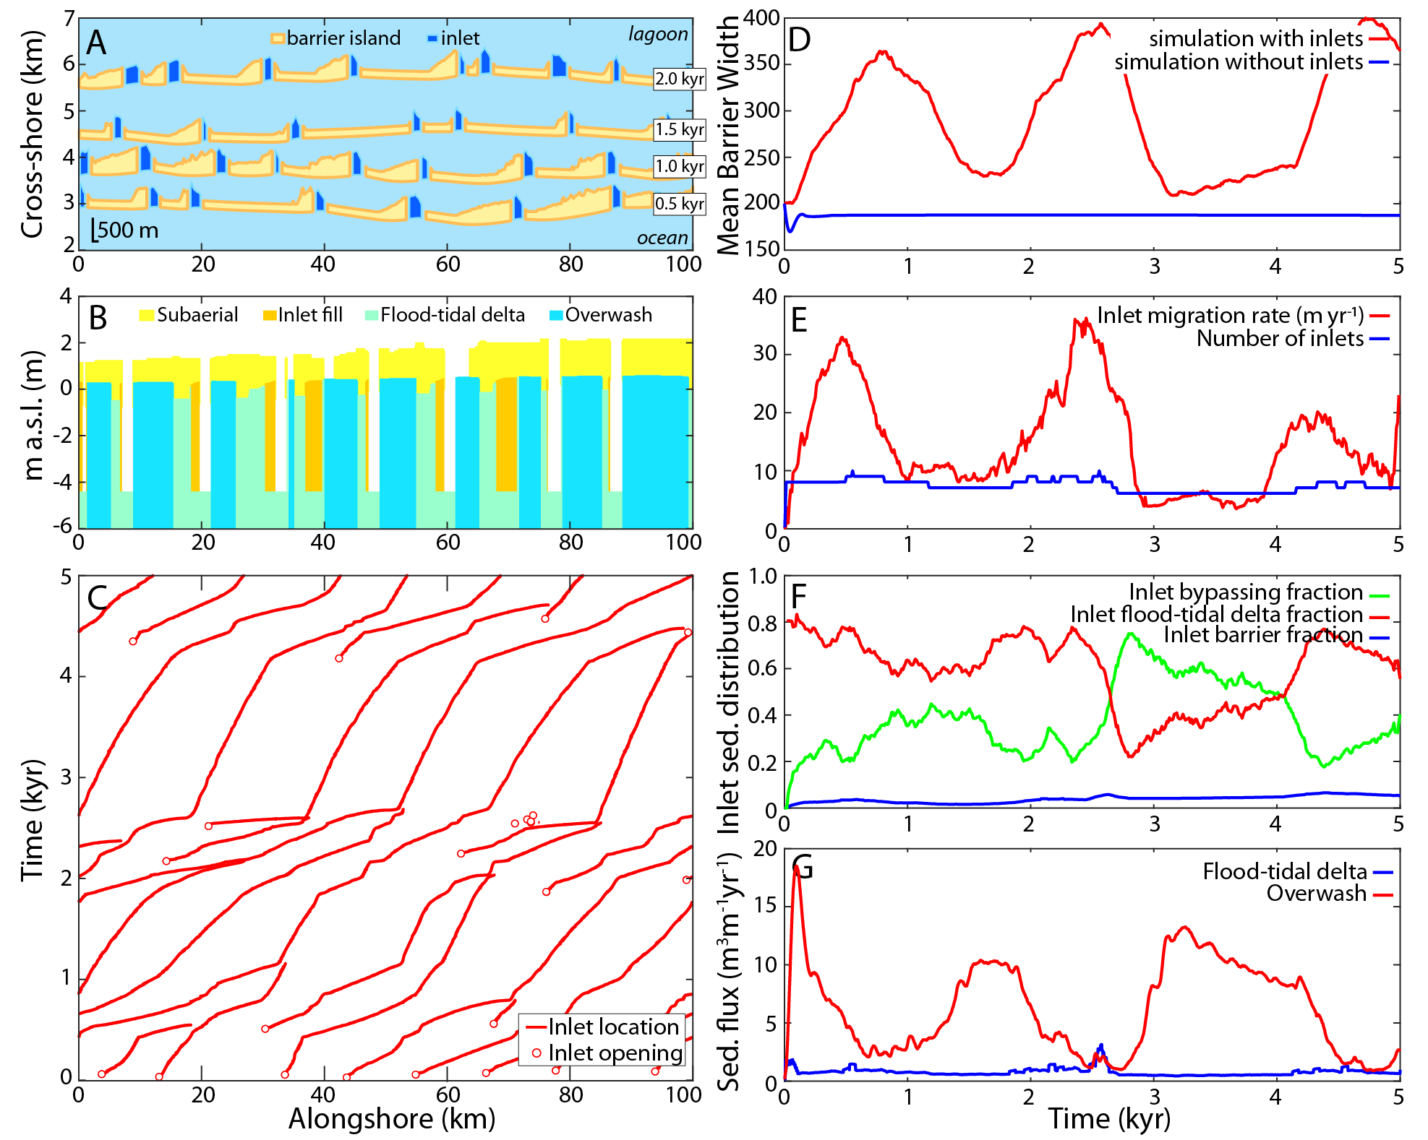Figure 1: Example model experiment (F = 10%) showing (A) barrier plan-view morphology after 0.5, 1, 1.5, and 2 kyr. (B) Synthetic facies of the barrier as it transgressed across the 4 km cross-shore transect, in meters above sea level (m.a.s.l.), deposit ages range from 0.9 to 1.2 kyr. (C) Inlet location, (D) mean barrier width, including a 1D model simulation without inlets for comparison, (D) mean inlet migration rate and the number of inlets, (E) average inlet sediment distribution (e.g., Nienhuis & Ashton, 2016), and (F) the barrier transgressive sediment flux through time. See supplementary animation S1, supplementary table S1, and supplementary data S1.
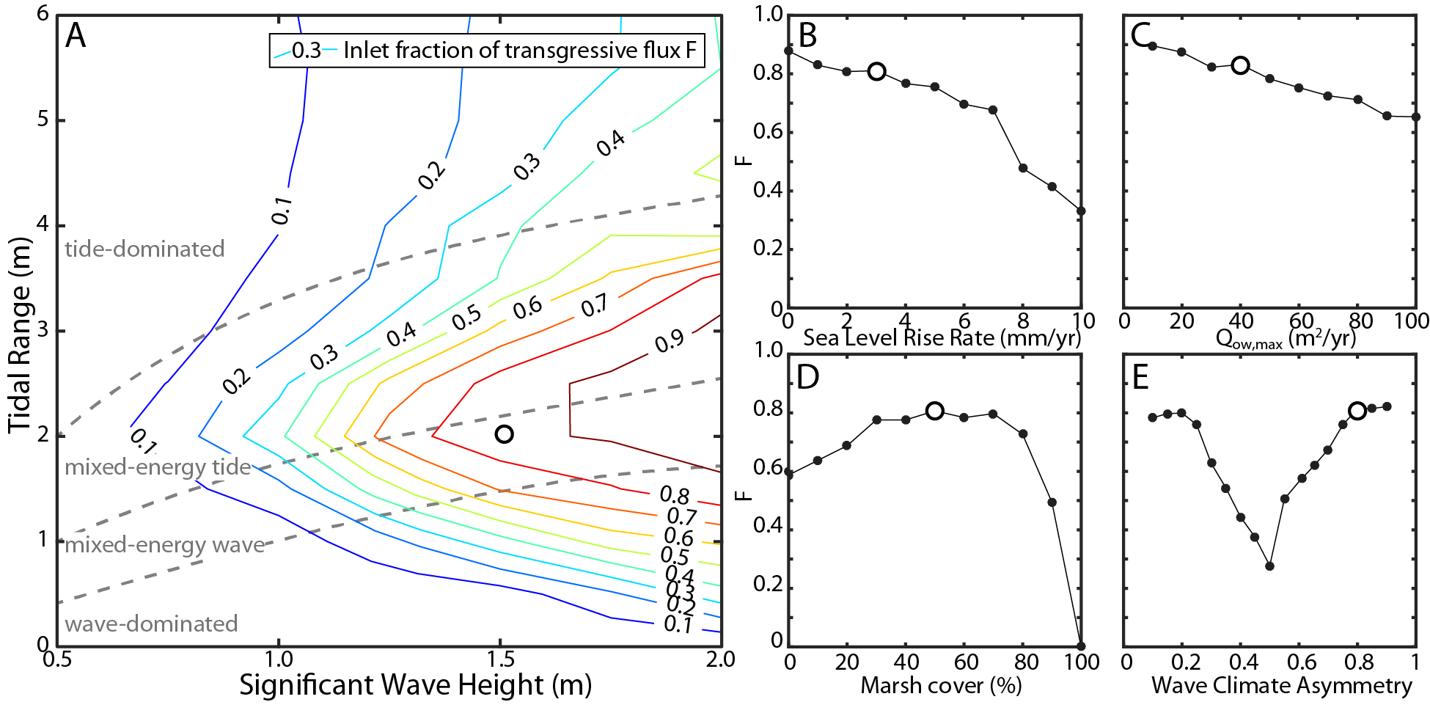
Figure 2: The inlet fraction of the total transgressive sediment flux F, (A) contoured in a space defined by the significant wave height and the tidal range, and for varying (B) sea level rise rates, (C) maximum potential overwash fluxes, (D) fraction of the lagoon covered by marsh, and (E) fraction of the waves approaching from the left, looking offshore. The white filled circle included in all panels specifies a model experiment with the same model parameters. See supplementary data S2.
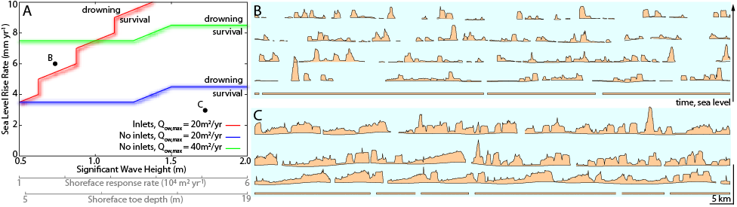
Figure 3: (A) Regime diagram depicting barrier island drowning versus survival under different SLR rates and wave heights. We define drowning as more than 50% of the barrier complex losing its subaerial portion. (B) and (C) are time stacks of the barrier island simulations (including inlets) indicated in panel A, showing respectively drowning and survival. See supplementary data S3.
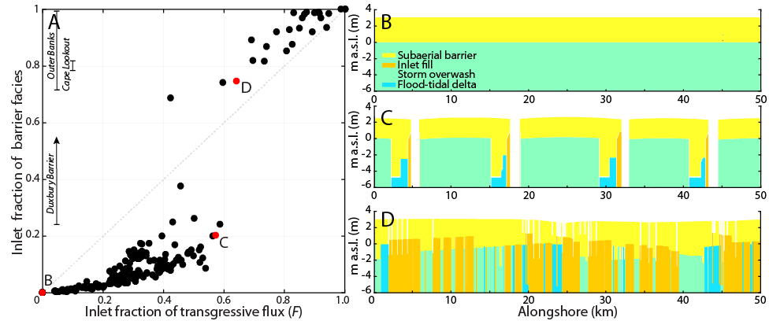
Figure 4: (A) The relationship between barrier island transgression and its representation in barrier island stratigraphy, obtained from model simulations shown in Fig. 1-3. Three field studies with quantified inlet fraction of barrier facies are indicated, the Duxbury barrier (Fitzgerald et al., 2001), the Outer Banks (Mallinson et al., 2010), and Cape Lookout (Heron et al., 1984). (B-D) Three examples of synthetic facies obtained from model experiments.

