Relationships between soil chemical properties and rare earth element concentrations in the aboveground biomass of a tropical herbaceous plant

Olivier Pourret^{1*}, Bastien Lange¹, Raul E. Martinez², Oliver Wiche³, Michel-Pierre Faucon¹

¹UniLaSalle, AGHYLE, Beauvais, France
²Max Plank Institute for Biogeochemistry, Jena, Germany
³Institute for Biosciences, Biology/Ecology Unit, TU Bergakademie Freiberg, Freiberg, Germany

*Corresponding author: olivier.pourret@unilasalle.fr, tel. +33 3 44 06 89 79, fax. + 33 3 44 06 25 26
Abstract
The geochemical behavior of rare earth elements (REE) has been mainly investigated in geological systems where they represent the best proxies for processes occurring at the interface between different media. REE concentrations, normalized with respect to the upper continental crust, were used to assess their behavior. In this study, REE geochemical behavior was investigated in plant shoots of a facultative metallophyte naturally growing in Katanga (Democratic Republic of Congo). Anisopappus chinensis and rooting zone soil samples (n=80) were collected in four natural sites with contrasting pedogeological environments (e.g., parent rock type, pH, organic matter content) and highly variable REE contents. Soil and plant REE concentrations and chemical soil factors were was analyzed by ICP-MS, to examine relationships between soil factor and REE accumulation in plants. REE uptake by plants was primarily correlated with their concentrations and/or their speciation in the soil as previously shown in the literature. Results of this study show that REE patterns in shoots are relatively flat whereas soils are enriched in middle REE. The geochemical behavior of REE illustrates that metals accumulation in aerial parts of A. chinensis is most probably driven by mechanisms involving REE complexation processes in the rhizosphere.

Keywords: lanthanide; A. chinensis; Democratic Republic of Congo; Katanga; metallophytes; critical zone.

- Introduction
Rare earth elements (REE) represent a group of fifteen elements, with similar physiochemical properties and often considered and treated together (McLennan and Taylor, 2012; Davranche et al., 2017). In aquatic systems, REE concentrations are lower compared to those in host-rocks (e.g., Noack et al., 2014). Over the past few decades, the REE became highly important due to their use in many high-tech products and medical applications, therefore acquiring a great economic interest (e.g., Guyonnet et al., 2015). The increment in the industrial demand of REE has led to an increase of their release into the environment, particularly into natural waters and surrounding soils (Kulaksiz and Bau, 2013; Mihajlovic et al., 2014; Davranche et al., 2015). Although their toxicological effects and the potential environmental implications are still not fully understood (González et al., 2015; Herrmann et al., 2016; Martinez et al., 2018), it is important to assess REE biogeochemical behavior in order to better understand their occurrence and fate particularly in ecosystems. In agriculture, REE-doped food is used for pig and poultry fattening (He et al., 2001, 2003, 2010). In China REE-containing phosphate fertilizers have been applied for several years on a massive scale for growing crops, such as maize, rice, wheat, potato and cabbage (Liang et al., 2005; Pang et al., 2002; Liu et al., 2006). The recent growth in the demand for REE has led to an exponential increase of their global mining production from about 50 kt/year in 1990 to 170 kt/year in 2018 (Chen, 2011; Haxel et al., 2002; USGS, 2019). This has led to a significant presence of REE in the environment, and they are therefore being considered as emerging pollutants (Kulaksiz and Bau, 2011; Yang et al., 2009). Elevated REE concentrations have been shown particularly in China, in soils adjacent to REE mines and refining plants (Wang et al., 1997; Wei et al., 2001; Zhu et al., 1997), and in agricultural areas with intensive use of REE-enriched fertilizers (França et al., 2002). No human intoxication due to REE intake has been yet reported, nevertheless there is a growing concern about the continuous exposure to low levels of REE in foods, since it is well known that plants can accumulate REE (Xu et al., 2002; Zhang and Shan, 2001). REE have previously been considered to be nontoxic and to be readily excreted by animals and humans after ingestion (Schwabe et al., 2012). However, recent publications have reported toxic effects of REE in bacteria (Wilde et al., 2002), plants (Babula et al., 2008; Martinez et al. 2018) and animals (Briner et al., 2000; Che et al., 2010; Feng et al., 2006).
A better understanding of the behavior of the REE within the critical zone and more specifically in the biosphere is needed. The present study is therefore focused on understanding the role of main soil factors (i.e. organic matter, iron and manganese content, pH, other potentially toxic metals) in controlling the transfer of REE at the soil plant interface. Information on the influence and toxicity of REEs on plant development remain contradictory and not fully understood. For example, studies have shown positive Eu anomalies suggesting that Eu³⁺ can form stable organic complexes in place of Ca²⁺ in several biological processes in xylem fluids (Censi et al., 2014). However, the vast majority of dose-response studies have been conducted under hydroponic conditions. These types of research works have shown stronger effects on plant growth by REE and are not necessarily representative of natural conditions (Thomas et al., 2014). In contrast, we have not chosen a laboratory (e.g., Ding et al., 2006; Han et al., 2005; Sun et al., 1997; Semhi et al., 2009; Shtangeeva and Ayrault, 2007) or greenhouse experiment in pots enriched with anthropogenic REE (Ding et al., 2006; Liang et al., 2005; Xu et al., 2002, 2003), but an in situ approach under undisturbed natural conditions, to allow for the investigation of the REE interaction with plants from a pristine pedo-geochemical background, as done previously by Brioschi et al. (2013). The bioavailability of man-made inorganic or organic compounds to plants is one of the most important issues for environmental studies. In fact, the influence of soil properties and plant absorption capabilities are two of the main drivers that govern the bioavailability of the REE in natural settings (Thomas et al., 2014).
In this study, the geochemical behavior of REE was investigated in the broad-niched Anisopappus chinensis (Asteraceae) that grows on a high variability of chemically contrasted soils. Four sites with subtropical humid climates and contrasting pedogeological conditions were selected in order to assess the environmental variability. At each site, REE transfer from soil to shoots was studied in A. chinensis. The objectives of this study were to (i) examine intraspecific variability of REE shoot concentrations and (ii) assess the influence of soil chemical factors on the REE transfer rates at the soil-plant interface in order to contribute to a better characterization of REE bioavailability to plants, as well as flow and storage in soils and plant biomass.

2 Materials and methods
2.1. Plant populations
One model plant species has been selected in the study: Anisopappus chinensis (L.) Hook.f. & Arn. (Asteraceae) which is a facultative metallophyte (Lange et al., 2017). It is a short-lived perennial plant occurring on both the natural Cu-Co hills of the Katangan Copperbelt of Central Africa and the surrounding the Miombo woodlands (Séleck et al., 2013; Faucon et al., 2016). Large variations of Cu and Co concentrations in the shoots of this species have already been highlighted (Faucon et al., 2007). Four populations of this plant were selected from different sites in the Katanga region (Dem. Rep. of Congo), as illustrated in Figure 1 and shown in Table 1. Two populations have been sampled on natural Cu-Co undisturbed hills from the Tenke-Fungurume region: Fungurume 5 (F5) and Goma 2 (G2), and two populations have been sampled in the woodland: Kiswishi (Ki) and Mikembo (Mi). Details and description of the sites can be found in Pourret et al. (2016).

2.2. Sampling and samples preparation
A total of 80 plant and 80 soil samples were considered in this study. At each site, 20 plants (whole shoots) and 20 soil samples from the rooting zone of each plant (0-15 cm) were collected. Study populations were carefully delimited and sampling was carried out systematically across sites, covering edaphic heterogeneities for each site. Plants were collected at the same development stage. Anisopappus chinensis specimens were sampled in April 2012 and June 2013. After collection, plant shoots were carefully brushed, washed with Alconox® 1% in demineralized water, dried at 60°C for 48 h (Faucon et al., 2007; Lange et al., 2014) and weighted. Soil samples were dried at room temperature, sieved (2 mm) and milled (RETSCH RM 200).

2.3. Plant and soil analysis
To determine metal concentration in shoots of A. chinensis 0.25g (accurately weighed) of samples were digested using a mixture of 8 mL HNO₃ and 2 mL HCl and a microwave system (Mars 5 Microwave Accelerated Reaction System – CEM corporation, USA) according to the procedure reported by Avula et al. (2010). Rare earth element concentrations in the digest samples were determined by Inductively Coupled Plasma Mass Spectrometry (ICP-MS) (Thermo Scientific XSERIES2). Quantification was carried out by external calibration (REE multi elemental standard solution from Accu Trace Reference, USA) and indium (2.5 μg/L) as an internal standard in order to correct for instrumental drift and matrix effects. Isobaric interferences due to the formation and ionization of oxides and/or hydroxides in the ICP-MS can modify the determination especially of Eu concentrations with Ba. The REE concentrations where corrected from this potential source of error as suggested earlier (Davranche et al., 2017). The instrumental accuracy was assessed by analyzing the SPS-SW2 certified reference material (CRM) for measurement of elements in surface water (SpectraPur standards, Oslo, Norway). The analyses of real samples were carried out provided that the bias of the measured standard concentrations was <5% compared to the certified values. The method for plant analyses was validated by the analysis of a tomato leaves standard (SRM 1573a, NIST, Gaithersburg, USA). Statistical agreement with the “determined but not certified data” for La, Ce, Sm and Gd was obtained as well. Soil analyses were performed by Acme Analytical Laboratories Ltd. (Vancouver Canada). For this purpose, 0.25 g of soil samples were digested by using a mixture of HNO₃- HClO₄-HF; the samples were heated to fuming and taken to dryness. The residue was further dissolved in HCl and the solutions were analyzed using ICP-MS. The precision and accuracy of the analyses of elemental concentrations were determined using standard material (SO-18). Analyses agreed with standard values to within 5%. The soil samples pH was determined on a saturated soil-water paste and the total carbon content was measured by Leco Analysis (Lange et al., 2014).

2.4. Statistical analysis
Descriptive statistics were performed on total soil analyses and normality of data and homogeneity of variances were verified. One way ANOVA (Analysis of Variance) and Tukey HSD were used to test for differences in REE concentrations in shoots among populations and differences in metals fractionation among sites. Significance was defined and represented as follows: ***: p<0.001, **: p<0.01, *: p<0.05, NS=non-significant. The relationships between element concentration in plants and edaphic factors (elemental concentration, total carbon content (%), pH) were characterized using Pearson’s correlations.

2.5. Elemental ratios and anomalies
REE data are presented as distribution patterns, with the individual REE listed in the order of their atomic number, normalized to the upper continental crust (thereafter called REE patterns).
The change of the shape of the REE patterns between 2 successive reservoirs (i.e. in our study soil and plant) is called “fractionation of the REE”, e.g. an enrichment or a depletion in light, or heavy REE. For that, (La/Sm)_{UCC,} (Gd/Yb)_{UCC} and (La/Yb)_{UCC} ratios are calculated. More specific fractionations are positive or negative peaks in the REE distribution patterns, which are most common for Ce and Eu, and referred to as positive or negative Ce and Eu anomalies. The magnitude of these anomalies is quantified by Ce/Ce* and Eu/Eu* ratios:

Ce/Ce* = (2 x Ce_{UCC})/(La_{UCC} + Pr_{UCC}) (1)
and
Eu/Eu*=(2 x Eu_{UCC})/(Sm_{UCC} + Gd_{UCC}) (2)

The subscript “UCC” stands for normalized values. Anomalies with Ce/Ce* and Eu/Eu* ratios >1 appear as positive peaks in a REE pattern and are therefore referred to as “positive anomalies”. Anomalies with Ce/Ce* and Eu/Eu* ratios <1 yield negative peaks and are called “negative anomalies”. The occurrence of positive or negative Ce anomalies is typical for oxidizing conditions where Ce is present as Ce⁴⁺ and therefore less soluble than the other REE (Marsac et al., 2017). By contrast, on the Earth’s surface Eu anomalies are, in most cases, related to the presence of feldspar or feldspar-derived alteration products such as clay minerals (Davranche et al., 2017).

3. Results
3.1. Rare earth element signature in soils

Soil samples (organic layer) were collected at four sites: two from natural Cu-Co (~8000 mg/kg of Cu and 500-3000 mg/kg of Co) undisturbed hills (Ca poor, 0.14 wt %< Ca <0.27 wt %) from the Tenke-Fungurume region: Fungurume 5 and Goma 2; and two from the Miombo woodlands, both Cu-Co poor (< 65 mg/kg for Cu and <117 mg/kg for Co), Ca very poor (<0.04 wt %) and Fe rich (up to 17 wt% Fe₂O₃) for Mikembo and alkaline rich for Kiswishi (Table 2). It must be noted that Mikembo and Kiswishi soils have acidic pH (i.e., mean pH values of 4.4 and 4.5 respectively; Table 2) whereas Goma 2 and Fungurume 5 soils have near neutral pH (i.e., mean pH values of 6.1 and 6.2; Table 2). Goma 2 and Fungurume 5 soils have higher total C content (mean TOT C% from 2.7 to 5.4; Table 2) compared to Mikembo and Kiswishi soils (mean TOT C% from 1.6 to 1.7; Table 2). Mean La concentrations varied from 13.10 mg/kg at Mikembo, 18.94 mg/kg at Goma 2, 34.22 mg/kg at Fungurume 5. These values range from 30.00 mg/kg (UCC values; McLennan 2001) to levels up to 623.72 mg/kg at Kiswishi. Mean Eu concentrations vary from 0.59 mg/kg at Mikembo, 0.99 mg/kg at Goma 2, 1.08 mg/kg at Fungurume 5. These values range from 0.88 mg/kg (UCC values; McLennan 2001) to concentrations of 6.33 mg/kg at Kiswishi. Mean Lu concentrations vary from 0.28 mg/kg at Fungurume 5, 0.29 mg/kg at Mikembo, 0.32 mg/kg at Goma 2, and 0.56 mg/kg at Kiswishi, values that are in the range of UCC (0.32 mg/kg; McLennan 2001).
Soil REE patterns for Fungurume 5 and Goma 2 are relatively flat, suggesting middle REE (MREE) enrichment (Figure 2a, b). Indeed, (La/Sm)_{UCC} is <1 for most samples (except 4 samples in Fungurume 5), and (Gd/Yb)_{UCC} >1. There is no cerium anomaly, nor an europium anomaly. Mikembo samples display heavy REE (HREE) enrichment with (La/Sm)_{UCC} <1 and (Gd/Yb)_{UCC} <1 and (La/Yb)_{UCC} <1. No Eu anomaly was found, however, considerable positive Ce anomalies were present (from 1.6 to 4.8) (Figure 2c).
Eventually, as highlighted by REE patterns (Figure 2), the four sampled sites (i.e. Goma 2, Fungurume V, Kiswishi and Mikembo) display different signatures due to different controlling parameters (organic matter, Mn/Fe oxides, host rock, pH; see Table2).

3.2. Rare earth element signature in plants
Mean La concentrations in shoots of A. chinensis vary from 0.886 mg/kg at Mikembo, 0.335 mg/kg at Goma 2, 0.215 mg/kg at Fungurume 5, to values of up to 6.039 mg/kg at Kiswishi (Table 3). Mean Eu concentrations vary from 0.013 mg/kg at Mikembo, 0.013 mg/kg at Goma 2, 0.007 mg/kg at Fungurume 5, to 0.052 mg/kg at Kiswishi (Table 3). Mean Lu concentrations were found at 0.001 mg/kg at Fungurume 5, 0.014 mg/kg at Mikembo, 0.002 mg/kg at Goma 2, and 0.025 mg/kg at Kiswishi (Table 3).
Plant REE patterns display MREE enrichment relative to the LREE (Figure 3). Indeed, Fungurume 5 samples display LREE to MREE enriched patterns with (La/Sm)_{UCC} <1 and (Gd/Yb)_{UCC} >1 and (La/Yb)_{UCC} >1, without Eu and Ce anomalies (Figure 3a). Goma 2 samples were LREE to MREE enriched, with (La/Sm)_{UCC} <1 and (Gd/Yb)_{UCC} >1 and (La/Yb)_{UCC} >1, without Eu and Ce anomaly (Figure 3b). Mikembo samples display LREE enriched patterns with (La/Sm)_{UCC} >1, (Gd/Yb)_{UCC} >1 and (La/Yb)_{UCC} >1, and positive Ce anomalies (mean value of 1.7 and up to 2.3) (Figure 3c) and no Eu anomaly. Kiswishi samples display LREE enriched patterns with (La/Sm)_{UCC} >1, (Gd/Yb)_{UCC} >1 and (La/Yb)_{UCC} >1, negative Ce anomalies (mean value of 0.54; ranging from 0.20 to 0.67) and negative Eu anomalies (mean value of 0.67; ranging from 0.48 to 0.86) (Figure 3d). Thus, shoot REE patterns are consistent with those found in soils (Figures 2, 3).

3.3. Rare earth element transfer at soil/plant interface
The transfer factor (TF) values for the REE evidence different behavior between sites (Table 4). The mean values of the TF for La, Eu and Lu were in good agreement: ranging from 0.006 to 0.018 for La with the exception of 0.068 for Mikembo samples; from 0.004 to 0.008 for Eu with the exception of 0.035 for Mikembo samples; and from 0.004 to 0.005 for Lu with the exceptions of 0.044 and 0.048 for Kiswishi and Mikembo, respectively. Total concentrations of La, Eu and Lu in the soil samples were correlated with total La, Eu and Lu levels in plants (r_{Pearson} = 0.54, 0.46 and 0.54 with p < 0.001, respectively; see Figure 4 for La).

While REE concentrations increase, a LREE enrichment can be observed as expressed by (La/Yb)_{UCC} ratio (Figure 5a; r_{Pearson} = 0.73 with p < 0.001); this highlights a preferential uptake of LREE at higher REE levels. This LREE fractionation is more evident for the Mikembo site (increase of La/Sm ratio in the shoots for the same La/Sm ratio in the soils) whereas no significant fractionation occurs for the Kiswishi site (Figure 5b; positive correlation with r_{Pearson} = 0.41; p value < 0.1) Moreover, a strong HREE fractionation for Mikembo site is observed (increase of Gd/Yb ratio in the shoots for the same Gd/Yb ratio in the soils) whereas no fractionation could be observed for the other sites (Figure 5c; positive correlation with r_{Pearson} = 0.82; p value < 0.001).

4. Discussion
4.1. Rare earth element fractionation in soils
Soils, derived from Fe and Mn laterite, typically show REE patterns at acidic pH dependent on Fe oxides which control the development of the positive Ce anomaly and Tetrad effect (e.g., Bau, 1999). A detailed study by Braun et al. (1990), highlighted the Ce distribution within the lateritic soil profile in Cameroon. It showed that the highest Ce contents and anomalies are present in non-ferruginous seams and are associated with the porosity of white seams, where halloysite needles precipitate. However, for some New Zealand soils positive Ce anomalies were related to the presence of Fe-Mn concretions, as observed by Rankin and Childs (1976). This was further illustrated by the modeling studies of Pourret and Davranche (2013) and highlighted for heterogenite (CoOOH) from the studied area (Decrée et al., 2015). In the present study, Kiswishi samples display LREE enrichment (with (La/Sm)_{UCC} >1 and (Gd/Yb)_{UCC} >1 and (La/Yb)_{UCC} >1 with both negative Ce and Eu anomalies ranging from 0.5 to 0.7 and 0.8 to 0.9, respectively; Figure 2d). The large negative Eu anomalies at Kiswishi are similar to that observed at Luiswishi (5 km East from Kiswishi) and may be inherited from the sources, generated during brine transport or through remobilization during the second mineralization stage (Debruyne et al., 2013). The association of these negative Eu anomalies with high total REE contents favors the latter interpretation. Under the reducing conditions found at the sites of mineralization, Eu is likely reduced to fluid-mobile, divalent Eu and therefore preferentially lost to the fluid during subsequent remobilization. The presence of both Ce and Eu anomalies at Kiswishi can be explained by changing redox conditions during fluid migration, mineral precipitation and later recrystallization and inheritance in the soil derived from this host rock (Laveuf and Cornu, 2009). Cerium anomaly variations are likely due to pH change (Braun et al., 1990). Indeed, soils from Kiswishi and Mikembo with Ce anomalies show a significantly lower pH compared to the Goma 2 and Fungurume 5 sites (4.4 and 4.5 compared to 6.0 and 6.2).

4.2. Soil factors influencing REE accumulation in A. chinensis
It is generally assumed that, as for any other element, availability of REEs to plants result from various soil associated factors as well as plant associated factors controlling mobilization, speciation and uptake of elements at the soil-root interface (rhizosphere). Among others, soil associated factors include total concentrations, initial distribution among mineral and organic soil phases as well as soil physicochemical properties such as pH and redox conditions. The results of this study indicate a strong influence of REE concentrations and speciation in soils on REE availability to plants as A. chinensis displays relatively the same REE patterns as the soil REE pattern is (Figures 2 and 3). As an exception, differences in REE concentrations in plants compared to soil were observed at Mikembo site which might be influenced by REE concentrations in soil. According to the literature, typical REE concentrations in soils are a few tens of mg/kg for Nd and a few hundreds of mg/kg for the sum of the REE (Laveuf and Cornu, 2009; Loell et al., 2011; Tyler, 2004). REE levels in soils are primarily controlled by pedogenetic parameters and the mineralogy of the REE carrier phases in the bedrock and in the soil rather than by the REE concentrations of the bedrock. REE concentrations in soils vary according to parental soil materials and history (Laveuf and Cornu, 2009). At the soil surface, REE levels reach up to 100–200 mg/kg (Liang et al., 2005; Tyler, 2004; Wyttenbach et al., 1998; Xu et al., 2002; Zhang and Shan, 2001). These concentrations are in good agreement to the soil REE levels at sites investigated in this study, except for Kiswishi soils that were characterized by REE concentrations of roughly one order of magnitude higher. Accordingly, compared to the other sites shoot concentrations of REEs in A. chinensis were highest in populations growing at Kiswishi without significant differences between other sites, Mikembo, Fungurume and Goma. It is under these conditions that we expect toxicity to plants to be more pronounced, as explained also in previous studies (Zhang and Shan, 2001). However, transfer factors calculated based on total soil and plant concentrations (Table 4) were much higher at Goma 2 and Mikembo (La: 0.018 –0.068) compared to Kiswishi (La: 0.01). This indicates that other factors than total soil concentrations seem to control the soil-plant transfer of REEs among the investigated sites. Indeed many studies evidenced that soil REE concentration could not totally predict plant REE uptake and that the concentrations of individual REEs found in plants were not a simple function of the total content of these elements in soils (Laveuf and Cornu, 2009; Li et al., 1998; Tyler, 2004; Wyttenbach et al., 1998). Eventually, soil concentrations have an impact only at high levels (i.e., for Kiswishi site; Figure 4) or at specific soil conditions that favor their presence in shoot plant growing in the site. Soil pH and REEs associated to SOM and Fe-oxyhydroxides fractions are the most important soil factors controlling availability of REEs to plants (Wiche et al. 2017; Wiche and Heilemeier 2016). Soils at Kiswishi and Mikembo were characterized by low pH, and SOM which favors release of REEs from REE-containing soil phases such as Fe-oxyhydroxides and other secondary minerals forming the labile and potentially plant-available element pool in soils. Concomitantly, soils at Mikembo where characterized by high contents of Fe-oxyhydroxides what might explain the high soil-plant transfer of REEs at Mikembo, though total REE contents of soils where not significantly different between Mikembo, Fungurume 5 and Goma 2, respectively. However, there was no significant difference in shoot REE concentrations between Mikembo, Fungurume 5 and Goma 2, though there were significant differences between their soil functional properties. This may suggest that other factors than soil properties are needed to explain REEs accumulation by the plants and processes in the rhizosphere as well as species specific uptake and exclusion mechanisms must be taken into account which, however, remains field for further research.

4.3 Fractionation of REEs in plants
The environmental behavior of REE in soil is dominated by their low solubility (Davranche et al., 2017). Fluorides, carbonates, phosphates may form complexes with low solubility REEs, resulting in low dissolved REE concentrations in the aqueous phase. In soil solution, REEs may be complexed with inorganic (e.g., carbonate, sulfate) and organic ligands (e.g., humic and fulvic acids), and at a high pH, with hydroxyl ions. The adsorption capacity of REE depends on the soil organic matter and the count of amorphous iron and manganese oxides, the latter having the highest sorption ability (Pourret and Davranche, 2013; Liu et al., 2017). The fractionation of the REEs can be related to preferential scavenging of the HREE by pedogenic minerals, most probably Fe-oxyhydroxides. LREE are consequently more mobile and preferentially exported by surface and sub-surface runoff. This also implies that LREE are more available for root absorption than HREE. Indeed, LREE enrichment of plant roots may be related to two different factors: (i) the soil water pool from where plant roots absorb REE is enriched in LREE because pedogenic Fe-oxyhydroxides include preferentially HREE in their mineral structure; (ii) the resulting LREE enrichment of plant roots is amplified by the preferential uptake of free LREE compared to HREE essentially present as complexed ions. In our study, while soil total REE concentrations increase, a LREE enrichment is observed in the plants; this highlights a preferential uptake of LREE when more REEs are abundant in soils. This LREE enrichment is more evident for Mikembo site whereas no changing in the REE pattern occurs for Kiswishi site (Figures 2 and 3). Moreover, HREE enrichment for Mikembo site is observed whereas no fractionation occurs for other sites (Figures 2 and 3).This can be largely explained by differences in soil pH, organic matter and Fe-oxyhydroxide contents among the investigated sites. At acidic pH, and lower organic matter content, the case at Mikembo and Kiswishi, REE are more mobile (e.g.,Pourret et al., 2007; Davranche et al., 2015) and thus more available to plants. However, Mikembo soils were characterized by significantly higher contents of Fe which suggest LREE enrichment relative to REEs through preferential immobilization of HREEs onto surfaces of Fe-oxyhydroxides. Possibly, such phenomena is exacerbated at higher REE content, as observed for the Kiswishi site. In contrast, at sites with near neutral pH, with high organic carbon content, like for Goma 2 and Fungurume 5, REEs are most probably mainly bound to organic material. Besides the fractionation between LREE and HREE and the anomalies of some individual REE, a Tetrad effect of the REE distribution pattern has been found in some ferns, sea- weeds, and other plants (Liang et al., 2008). The distribution curve of the REE can be divided into four similar parts: La-Nd, Nd-Gd, Gd-Ho, Ho-Lu. There exist two types of Tetrad effects in nature, the concave “W” and the convex “M”. The former exists in solution and the latter is generally present in the solid phase. Though the “W” type Tetrad effect has been found to be present in the aerial parts of plants, the mechanisms by which it arises remain unclear. However, an assessment of the geochemical behavior of REE according to the theory of the Tetrad Effect confirms that REE coming from soil are scavenged onto root tissues or mineral surfaces whereas their behavior in aerial parts of Vitis vinifera (Censi et al., 2014) or Taxodium japonicum and Thea sinensis (Fu et al., 2001) is driven by dissolved complexation. Wyttenbach et al. (1998) suggested that the types and concentrations of organic ligands in the rhizosphere may be the main factors causing the distribution patterns and levels of REE fractionation in various plants. Additions of DTPA, EDTA, citric acid, humic acid, or fulvic acid caused the decreased REE concentrations in plants, together with the decreased level of MREE enrichment in roots and HREE enrichment in leaves (Wyttenbach et al., 1998). Heavy REE enrichment in the aerial parts of plants has been observed owing to the stronger combination of most ligands with HREE than that with LREE and thus a higher mobility of HREE within the plant tissues. However, Wiche et al. (2017) demonstrated that presence of naturally occurring chelates like citric acid and the microbial siderophore DFO-B significantly decreased REE-accumulation in Phalaris arundinacea plants suggesting preferential uptake of REEs in their ionic form. These results suggest that processes in the rhizosphere, especially presence of organic ligands may lead to a discrimination of HREEs relative to LREEs during plant uptake, while complexation within the plants favors transfer of HREEs from roots to shoots. Furthermore, the fractionations of REE can be influenced by the pH value, Eh, and inorganic ions in the rhizosphere of plants. Owing to the fact that plants at our study sites generally show LREE enrichment our results suggest that processes in the rhizosphere of A. chinensis, most probably complexation with organic ligands caused REE fractionation during soil-plant-transfer. However, the extent to which the above-mentioned sub-processes influence the pattern of REEs in shoots of soil-grown plants may vary strongly between different plant species or even among populations within species.

4.3. Intra-specific variations of REE concentrations in plant shoots
Anisopappus chinensis is a facultative metallophyte occupying non-metalliferous soils (Kiswishi, Mikembo) as well as highly Cu and Co enriched soils (Fungurume 5, Goma 2) in southeastern D.R. Congo (Table 2). Lange et al. (2018) demonstrated that Cu-Co accumulation and tolerance is not constitutive at the species level by highlighting populations was Co tolerant compared to their relatives originating from normal soils (non metalliferous soils, e.g. Kiswishi and Mikembo). Here, we expected differences in REE shoot concentrations and soil-plant transfer factors between populations, originating from contrasting environments, including high REE soil variability. Our results highlight that REE uptake by plants was primarily correlated with soil concentrations and/or speciation as it was previously shown (e.g., Brioschi et al., 2013; Censi et al., 2014). In all investigated populations, REE patterns in shoots are relatively LREE enriched whatever soils are (Figures 2 and 3). In particular, total REE, Cu and Co concentrations, pH, SOM as well as Fe-oxyhydroxide co-varied among populations (Tables 2 and 3) make it substantially difficult to judge whether differences in shoot concentrations and soil-plant transfer factors originate from soil-associated factors or plant-associated factors. Generally, plant-associated factors affecting availability of REEs to plants involve species-specific mechanisms for mobilization and uptake in the rhizosphere during mineral nutrient (Wiche and Heilmeier, 2016; Wiche et al., 2016; 2017). Based on results from greenhouse studies, it seems that REE accumulation in plants is negatively correlated with carboxylate exudation (Wiche and Heilmeier, 2016), and with the acidification of the rhizosphere (Wiche and Heilmeier, 2016; Wiche et al. 2017; Martinez et al., 2018) and the release of siderophores (Kraemer et al., 2017). Moreover, mutualistic relationships between plant roots and rhizosphere bacteria and fungi may strongly influence speciation of REEs and consequently availability to plants (Tyler 2004; Martinez et al., 2014; Kraemer et al., 2017). These plant-associated processes may show distinct variability among different genotypes as previously demonstrated for plant nutrients (Krasilnikoff et al., 2003). Therefore, high phenotypic variation in transfer factors between sites (Table 4) as well as high variation of shoot REEs concentration within populations (Table 3) could be explained by differences in REE availability in soils, impacted by root-induced chemical changes in the rhizosphere or even by intraspecific root interactions of neighboring plants growing at the sites (Wiche et al., 2016). The hypothesis of a genetic variability of REE accumulation in plant shoots could also explain this high phenotypic variation as demonstrated for several metals (Maestri et al., 2013; Meyer et al., 2015). For example, Lange et al. (2018) observed lowest concentrations of Cu in plants from Kiswishi site that were in contact with extraordinarily high levels of REEs. It is generally accepted that organic acid anions, particularly citrate and malate, play a central role in metal resistance (Delhaize and Ryan, 1995). There are some remarkable similarities in the toxicity of REEs and Al to roots (Ishikawa et al., 1996). Aluminum and REEs both activate the efflux of malate from wheat roots (Kataoka et al., 2002). Unfortunately our data obtained in this field study do not allow further interpretation. Eventually, REE shoot concentration should be investigated growing the four populations under controlled conditions on homogeneous substrates with defined REE concentrations and properties to highlight and quantify the genetic variability.
Mechanisms that explain REE accumulation in plants remain poorly understood and remain field for further research. Perspective is to examine this variation in several plant species and populations in contrasted soil in situ and in controlled conditions ex situ.

5. Conclusion
In the present study, REE geochemical behavior was investigated in plant shoots of A. chinensis growing on soils from Katanga (Democratic Republic of Congo). The four natural sites with contrasting pedogeological environments and highly variable REE contents allowed us to highlight that REE uptake by plants was primarily correlated with their concentrations and/or their speciation in the soil as it was previously shown in literature. Results from this study show that REE patterns in shoots are relatively flat whereas soils are enriched in MREE. The geochemical behavior of REE illustrates that metals accumulation in aerial parts of A. chinensis is mainly driven by mechanisms involving REE complexation processes.
Further investigations are needed to understand better REE availability to plants. Our results on the intraspecific variability of REE shoot concentration and transfer factor in Anisopappus chinensis remains unclear. We can hypothesise that, in addition to soil-plant-associated factors, population-specific plant responses to REE may account for the high phenotypic variations observed in our study. In particular, root REE absorption capacity, transport mechanisms, translocation and/or plant nutritional needs. Genetic variability of REE accumulation by facultative metallophytes from Cu and Co enriched soils should be explored growing under controlled conditions a broad sample of populations from contrasted environment, under controlled conditions, on soil artificially enriched with several REE element/dose combinations to test and quantify it.

Acknowledgments
The authors thank UniLaSalle, Beauvais, France, for funding BL MSc project. The Belgian Fund for Scientific Research (FRS-FNRS) is acknowledged for financial support to BL. Tenke Fungurume Mining s.a.r.l. permitted us the plants and soils collection. We are grateful to Petru Jitaru for his help in the ICP-MS analysis.

References
Avula B, Wang Y-H, Smillie TJ, Duzgoren-Aydin NS and Khan IA (2010). Quantitative Determination of Multiple Elements in Botanicals and Dietary Supplements Using ICP-MS. Journal of Agricultural and Food Chemistry 58: 8887-8894.
Babula P, Adam V, Opatrilova R, Zehnalek J, Havel L and Kizek R (2008). Uncommon heavy metals, metalloids and their plant toxicity: A review. Environmental Chemistry Letters 6: 189-213.

Briner W, Rycek RF, Moellenberndt A and Dannull K (2000). Neurodevelopmental effects of lanthanum in mice. Neurotoxicology and Teratology 22: 573-581.

Bau M (1999). Scavenging of dissolved yttrium and rare earths by precipitating iron oxyhydroxide: Experimental evidence for Ce oxidation, Y-Ho fractionation, and lanthanide tetrad effect. Geochim. Cosmochim. Acta 63: 67-77.
Braun JJ, Pagel M, Muller JP, Bilong P, Michard A and Guillet B (1990). Cerium anomalies in lateritic profiles. Geochim. Cosmochim. Acta 54: 781-795.
Brioschi L, Steinmann M, Lucot E, Pierret M, Stille P, Prunier J and Badot P (2013). Transfer of rare earth elements (REE) from natural soil to plant systems: implications for the environmental availability of anthropogenic REE. Plant Soil 366: 143-163.
Cao X, Wang X and Zhao G (2000). Assessment of the bioavailability of rare earth elements in soils by chemical fractionation and multiple regression analysis. Chemosphere 40: 23-28.
Censi P, Saiano F, Pisciotta A and Tuzzolino N (2014). Geochemical behaviour of rare earths in Vitis vinifera grafted onto different rootstocks and growing on several soils. Sci. Total Environ. 473–474: 597-608.

Che Y, Xing R, Zhu Y, Cui Y and Jiang X (2010). Effects of lanthanum chloride administration on detouring learning in chicks. Biol Trace Elem Res: 1-7.

Chen Z (2011). Global rare earth resources and scenarios of future rare earth industry. Journal of Rare Earths 29: 1-6.

Davranche M, Gruau G, Dia A, Marsac R, Pédrot M and Pourret O (2015). Biogeochemical Factors Affecting Rare Earth Element Distribution in Shallow Wetland Groundwater. Aquat. Geochem. 21: 197-215.

Davranche M., Gruau G., Dia A., Le Coz-Bouhnik M., Marsac R., Pédrot M., Pourret O. (2017). Chapter 7. Rare Earth Elements in Wetlands. In Trace Elements in Waterlogged Soils and Sediments. Eds Rinklebe J., Knox A.S., Paller M.,Taylor & Francis Group/CRC Press, 135-162.

Debruyne D, Balcaen L, Vanhaecke F and Muchez P (2013). Rare earth element and yttrium characteristics of carbonate within the sediment-hosted Luiswishi and Kamoto Cu-Co, Katanga Copperbelt (Democratic Republic of Congo - DRC). Geologica Belgica 16: 76-83.
Decrée S, Pourret O and Baele J-M (2015). Rare earth element fractionation in heterogenite (CoOOH): implication for cobalt oxidized ore in the Katanga Copperbelt (Democratic Republic of Congo). Journal of Geochemical Exploration 159: 290-301.
Delhaize E, Ryan PR (1995) Aluminum Toxicity and Tolerance in Plants. Plant Physiology, 107: 315-321.
Ding SM, Liang T, Zhang CS, Huang Z, Xie Y and Chen T (2006). Fractionation mechanisms of Rare Earth Elements (REEs) in hydroponic wheat: an application for metal by plants. Environ. Sci. Technol. 40: 2686-2691.
Evans JR (1983). Nitrogen and Photosynthesis in the Flag Leaf of Wheat (Triticum aestivum L.). Plant Physiology 72: 297-302.
Faucon MP, Shutcha MN and Meerts P (2007). Revisiting copper and cobalt concentrations in supposed hyperaccumulators from SC Africa: Influence of washing and metal concentrations in soil. Plant Soil 301: 29-36.
Faucon, M.-P., Le Stradic, S., Boisson, S., wa Ilunga, E.I., Séleck, M., Lange, B., Guillaume, D., Shutcha, M.N., Pourret, O., Meerts, P., Mahy, G. (2016). Implication of plant-soil relationships for conservation and restoration of copper-cobalt ecosystems. Plant and Soil, 403(1): 153-165.
Feng L, Xiao H, He X, Li Z, Li F, Liu N, Zhao Y, Huang Y, Zhang Z and Chai Z (2006). Neurotoxicological consequence of long-term exposure to lanthanum. Toxicology Letters 165: 112-120.

França EJ, De Nadai Fernandes EA, Bacchi MA and Tagliaferro FS (2002). Pathway of rare-earth elements in a Brazilian forestry fragment. J. Alloy. Compd. 344: 21-26.

Fu F, Akagi T, Yabuki S and Iwaki M (2001). The variation of REE (rare earth elements) patterns in soil-grown plants: a new proxy for the source of rare earth elements and silicon in plants. Plant Soil 235: 53-64.

Gao Y, Zeng F, Yi A, Ping S and Jing L (2003). Research of the entry of rare earth elements Eu3+ and La3+ into plant cell. Biol Trace Elem Res 91: 253-265.
González V, Vignati DAL, Pons M-N, Montarges-Pelletier E, Bojic C and Giamberini L (2015). Lanthanide ecotoxicity: First attempt to measure environmental risk for aquatic organisms. Environmental Pollution 199: 139-147.

Guyonnet D, Planchon M, Rollat A, Escalon V, Tuduri J, Charles N, Vaxelaire S, Dubois D and Fargier H Material flow analysis applied to rare earth elements in Europe. Journal of Cleaner Production 107: 215-228
Han F, Shan XQ, Zhang J, Xie YN, Pei ZG, Zhang SZ, Zhu YG and Wen B (2005). Organic acids promote the uptake of lanthanum by barley roots. New Phytologist 165: 481-492.

Haxel GB, Hedrick JB and Orris GJ (2002). Rare Earth Elements - Critical Resources for High Technology.

He ML, Ranz D and Rambeck WA (2001). Study on the performance enhancing effect of rare earth elements in growing and fattening pigs. Journal of Animal Physiology and Animal Nutrition 85: 263-270.

He ML, Wang YZ, Xu ZR, Chen ML and Rambeck WA (2003). Effect of dietary rare earth elements on growth performance and blood parameters of rats. Journal of Animal Physiology and Animal Nutrition 87: 229-235.

He ML, Wehr U and Rambeck WA (2010). Effect of low doses of dietary rare earth elements on growth performance of broilers. Journal of Animal Physiology and Animal Nutrition 94: 86-92.

Herrmann H, Nolde J, Berger S and Heise S (2016). Aquatic ecotoxicity of lanthanum – A review and an attempt to derive water and sediment quality criteria. Ecotoxicology and Environmental Safety 124: 213-238.
Ishikawa S, Wagatsuma T, Ikarashi T (1996) Comparative toxicity of Al3+, Yb3+, and La3+ to root-tip cells differing in tolerance to high Al3+ in terms of ionic potentials of dehydrated trivalent cations. Soil Science and Plant Nutrition, 42: 613-625.
Kataoka T, Stekelenburg A, Nakanishi TM, Delhaize E, Ryan PR (2002) Several lanthanides activate malate efflux from roots of aluminium-tolerant wheat. Plant, Cell & Environment, 25: 453-460.
Kraemer D, Tepe N, Pourret O and Bau M (2017). Negative cerium anomalies in manganese (hydr)oxide precipitates due to cerium oxidation in the presence of dissolved siderophores. Geochim. Cosmochim. Acta 196: 197-208.
Krasilnikoff G, Gahoonia T, Nielsen NE (2003) Variation in phosphorus uptake efficiency by genotypes of cowpea (Vigna unguiculata) due to differences in root and root hair length and induced rhizosphere processes. Plant and Soil 251: 83-91.
Kulaksiz S and Bau M (2011). Anthropogenic gadolinium as a microcontaminant in tap water used as drinking water in urban areas and megacities. Appl. Geochem. 26: 1877-1885.

Kulaksız S and Bau M (2013). Anthropogenic dissolved and colloid/nanoparticle-bound samarium, lanthanum and gadolinium in the Rhine River and the impending destruction of the natural rare earth element distribution in rivers. Earth Planet. Sci. Lett. 362: 43-50.

Lange B, Faucon M-P, Meerts P, Shutcha M, Mahy G and Pourret O (2014). Prediction of the edaphic factors influence upon the copper and cobalt accumulation in two metallophytes using copper and cobalt speciation in soils. Plant Soil 379: 275-287.
Lange B, van der Ent A., Baker A.J.M., Echevarria G., Mahy G., Malaisse F., Meerts P., Pourret O., Verbruggen N., Faucon M.-P. (2017) Copper and cobalt accumulation in plants: a critical assessment of the current state of knowledge. New Phytologist, 213(2): 537-551.
Lange B, Delhaye G, Boisson S, Verbruggen N, Meerts P, Faucon M-P (2018) Variation in copper and cobalt tolerance and accumulation among six populations of the facultative metallophyte Anisopappus chinensis (Asteraceae). Environmental and Experimental Botany 153: 1-9.
Laveuf C and Cornu S (2009). A review on the potentiality of Rare Earth Elements to trace pedogenetic processes. Geoderma 154: 1-12.
Li F, Shan X, Zhang T and Zhang S (1998). Evaluation of plant availability of rare earth elements in soils by chemical fractionation and multiple regression analysis. Environmental Pollution 102: 269-277.
Liang T, Zhang S, Wang L, Kung H-T, Wang Y, Hu A and Ding S (2005). Environmental biogeochemical behaviors of rare earth elements in soil–plant systems. Environmental Geochemistry and Health 27: 301-311.
Liang T, Ding S, Song W, Chong Z, Zhang C and Li H (2008). A review of fractionations of rare earth elements in plants. Journal of Rare Earths 26: 7-15.
Liu X, Wang J, Yang J, Fan Y, Wu Y and Zhang H (2006). Application of Rare Earth Phosphate Fertilizer in Western Area of China. Journal of Rare Earths 24: 423-426.
Loell M, Albrecht C and Felix-Henningsen P (2011). Rare earth elements and relation between their potential bioavailability and soil properties, Nidda catchment (Central Germany). Plant Soil 349: 303-317.
Maestri E, Pirondini A, Visioli G and Marmiroli N (2013). Trade-off between genetic variation and ecological adaptation of metallicolous and non-metallicolous Noccaea and Thlaspi species. Environmental and Experimental Botany, 96, 1-10.
Martinez RE, Pourret O and Takahashi Y (2014). Modeling of rare earth element sorption to the Gram positive Bacillus subtilis bacteria surface. J. Colloid Interface Sci. 413: 106-111.
Martinez, R.E., Pourret, O., Faucon, M.-P., Dian, C. (2018) Effect of rare earth elements on rice plant growth. Chemical Geology, 489: 28-37.
Marsac, R., Real, F., Banik, N.L., Pedrot, M., Pourret, O., Vallet, V. (2017) Aqueous chemistry of Ce(IV): estimations using actinide analogues. Dalton Transactions, 46(39): 13553-13561.
Meyer C-L, Juraniec M, Huguet S, Chaves-Rodriguez E, Salis P, Isaure M-P, Goormaghtigh E and and Verbruggen N (2015). Intraspecific variability of cadmium tolerance and accumulation, and cadmium-induced cell wall modifications in the metal hyperaccumulator Arabidopsis halleri. Journal of Experimental Botany.

Mihajlovic J, Stärk H-J and Rinklebe J (2014). Geochemical fractions of rare earth elements in two floodplain soil profiles at the Wupper River, Germany. Geoderma 228–229: 160-172.

McLennan SM (2001). Relationships between the trace element composition of sedimentary rocks and upper continental crust. Geochemistry Geophysics Geosystems 2: 109.
McLennan SM and Taylor SR (2012). Geology, Geochemistry and Natural Abundances of the Rare Earth Elements. In: Atwood DA, ed. The Rare Earth Elements. Fundamentals and Applications. Wiley: Chichester, pp. 1-19.

Noack CW, Dzombak DA and Karamalidis AK (2014). Rare earth element distributions and trends in natural waters with a focus on groundwater. Environ. Sci. Technol. 48: 4317-4326.

Pang X, Li D and Peng A (2002). Application of rare-earth elements in the agriculture of China and its environmental behavior in soil. Environ Sci Pollut Res 9: 143-148.

Pourret O and Davranche M (2013). Rare earth element sorption onto hydrous manganese oxide A modeling study. J. Colloid Interface Sci. 395: 18-23.
Pourret O, Davranche M, Gruau G and Dia A (2007). Rare Earth Elements complexation with humic acid. Chem. Geol. 243: 128-141.
Pourret O, Gruau G, Dia A, Davranche M and Molénat J (2010). Colloidal control on the distribution of rare earth elements in shallow groundwaters. Aquat. Geochem. 16: 31-59.
Pourret O, Lange B, Bonhoure J, Colinet G, Decrée S, Mahy G, Séleck M, Shutcha M and Faucon M-P (2016). Assessment of soil metal distribution and environmental impact of mining in Katanga (Democratic Republic of Congo). Appl. Geochem. 64: 43-55.
Rankin PC and Childs CW (1976). Rare-earth elements in iron-manganese concretions from some New Zealand soils. Chem. Geol. 18: 55-64.
Schwabe A, Meyer U, Grün M, Voigt KD, Flachowsky G and Dänicke S (2012). Effect of rare earth elements (REE) supplementation to diets on the carry-over into different organs and tissues of fattening bulls. Livestock Science 143: 5-14.
Séleck M, Bizoux J-P, Colinet G, Faucon M-P, Guillaume A, Meerts P, Piqueray J and Mahy G (2013). Chemical soil factors influencing plant assemblages along copper-cobalt gradients: implications for conservation and restoration. Plant Soil 373: 455-469.
Semhi K, Chaudhuri S and Clauer N (2009). Fractionation of rare-earth elements in plants during experimental growth in varied clay substrates. Appl. Geochem. 24: 447-453.
Shannon RD (1976). Revised effective ionic radii and systematic studies of interatomic distances in halides and chalcogenides. Acta Crystallogr. A32: 751-767.
Shtangeeva I and Ayrault S (2007). Effects of Eu and Ca on yield and mineral nutrition of wheat (Triticum aestivum) seedlings. Environmental and Experimental Botany 59: 49-58.
Stille P, Steinmann M, Pierret M-C, Gauthier-Lafaye F, Chabaux F, Viville D, Pourcelot L, Matera V, Aouad G and Aubert D (2006). The impact of vegetation on REE fractionation in stream waters of a small forested catchment (the Strengbach case). Geochim. Cosmochim. Acta 70: 3217-3230.
Sun H, Wang X, Wang Q, Wang H, Wang L, Chen Y and Dai Lemei C (1997). The effects of chemical species on bioaccumulation of Rare Earth Elements in wheat grown in nutrient solution. Chemosphere 35: 1699-1707.
Thomas PJ, Carpenter D, Boutin C and Allison JE (2014). Rare earth elements (REEs): Effects on germination and growth of selected crop and native plant species. Chemosphere 96: 57-66.
Tyler G (2004). Rare earth elements in soil and plant systems - A review. Plant Soil 267: 191-206.
USGS (2019). Mineral Commodity Summaries 2018. USGS: 204.
Wang YQ, Sun JX, Chen HM and Guo FQ (1997). Determination of the contents and distribution characteristics of REE in natural plants by NAA. J. Radioan. Nucl. Ch. 219: 99-103.
Wei Z, Yin M, Zhang X, Hong F, Li B, Tao Y, Zhao G and Yan C (2001). Rare earth elements in naturally grown fern Dicranopteris linearis in relation to their variation in soils in South-Jiangxi region (Southern China). Environmental Pollution 114: 345-355.
Wiche O, Kummer N-A and Heilmeier H (2016). Interspecific root interactions between white lupin and barley enhance the uptake of rare earth elements (REEs) and nutrients in shoots of barley. Plant and Soil 402: 235-245.
Wiche O, Heilmeier H (2016) Germanium (Ge) and rare earth element (REE) accumulation in selected energy crops cultivated on two different soils. Minerals Engineering, 92: 208-215.
Wiche O, Zertani V, Hentschel W, Achtziger R, Midula P (2017) Germanium and rare earth elements in topsoil and soil-grown plants on different land use types in the mining area of Freiberg (Germany). Journal of Geochemical Exploration 175: 120-129.
Wilde EW, Berry CJ and Goli MB (2002). Toxicity of gadolinium to some aquatic microbes. Bull Environ Contam Toxicol 68: 420-427.
Wyttenbach A, Furrer V, Schleppi P and Tobler L (1998). Rare earth elements in soil and in soil-grown plants. Plant Soil 199: 267-273.
Xu X, Zhu W, Wang Z and Witkamp GJ (2002). Distributions of rare earths and heavy metals in field-grown maize after application of rare earth-containing fertilizer. Sci. Total Environ. 293: 97-105.
Xu X, Zhu W, Wang Z and Witkamp GJ (2003). Accumulation of rare earth elements in maize plants (Zea mays L.) after application of mixtures of rare earth elements and lanthanum. Plant Soil 252: 267-277.
Yang J, Liu Q, Zhang L, Wu S, Qi M, Lu S, Xi Q and Cai Y (2009). Lanthanum chloride impairs memory, decreases pCaMK IV, pMAPK and pCREB expression of hippocampus in rats. Toxicology Letters 190: 208-214.
Zeng F, Tian H, Wang Z, An Y, Gao F, Zhang L, Li F and Shan L (2003). Effect of rare earth element europium on amaranthin synthesis in Amarathus caudatus seedlings. Biol Trace Elem Res 93: 271-282.
Zhang S and Shan X-Q (2001). Speciation of rare earth elements in soil and accumulation by wheat with rare earth fertilizer application. Environmental Pollution 112: 395-405.
Zhu W, Xu S, Shao P, Zhang H, Wu D, Yang W and Feng J (1997). Bioelectrical activity of the central nervous system among populations in a rare earth element area. Biol Trace Elem Res 57: 71-77.

Figure and table captions

Table 1 Location and description of study sites. All sites are in Katanga (Democratic Republic of Congo). Coordinates are in GCS WGS84 (DD).
Table 2 Major elements (Si, Al, Fe, Ca, Cu, Co) and selected REE concentrations (La, Eu and Lu) of soil samples from Fungurume 5, Goma 2, Kiswishi and Mikembo sites. Means are compared by One way ANOVA and Tukey (HSD); the means with the same letters are not significant.
Table 3 Selected shoot REE concentrations (La, Eu and Lu) in A. chinensis populations of Fungurume 5, Goma 2, Kiswishi and Mikembo sites. Means are compared by One way ANOVA and Tukey (HSD); the means with the same letters are not significant.
Table 4. Transfer factor (TF) values (ratio of plant concentration on soil concentration).

Figure 1 Geological sketch map (modified from Cailteux et al. 2005 and Decrée et al. 2015) and sampling point locations.
Figure 2 Upper continental crust (UCC)-normalized rare earth element patterns in soils sampled at (a) Fungurume 5, (b) Goma 2, (c) Mikembo and (d) Kiswishi. UCC values are from McLennan (2001).
Figure 3 Upper continental crust (UCC)-normalized rare earth element patterns in A. chinensis leaves sampled at (a) Fungurume 5, (b) Goma 2, (c) Mikembo and (d) Kiswishi. UCC values are from McLennan (2001).
Figure 4 (a) Lanthanum concentrations (mg/kg) in A. chinensis as a function of La concentrations (mg/kg) in soil samples from Fungurume 5, Goma 2, Kiswishi and Mikembo sites (r pearson = 0.54, p < 0.001), and (b) Ce/Ce* in A. chinensis as a function of Ce/Ce* in soil samples from Fungurume 5, Goma 2, Kiswishi and Mikembo sites (r pearson = 0.79, p < 0.001).
Figure 5 (a) (La/Yb)_{UCC} ratio for A. chinensis as a function of ΣREE (mg/kg) for A. chinensis from Fungurume 5, Goma 2, Kiswishi and Mikembo sites (r pearson = 0.73, p < 0.001), (b) (La/Sm)_{UCC} ratio for A. chinensis as a function of (La/Sm)_{UCC} ratio for soil samples from Fungurume 5, Goma 2, Kiswishi and Mikembo sites (r pearson = 0.24, p < 0.1), and (c) (Gd/Yb)_{UCC} ratio for A. chinensis as a function of (Gd/Yb)_{UCC} ratio for soil samples from Fungurume 5, Goma 2, Kiswishi and Mikembo sites (r pearson = 0.82, p < 0.001).

Table 1
Sites | Soil description | Elevation m | Coordinates
Fungurume 5 (F5) | Natural Cu-Co hill not disturbed by mining. Sampled on grassland. | 1300 | S10.61644° E026.28907°
Goma 2 (G2) | Natural Cu-Co hill not disturbed by mining. Sampled on grassland. | 1300 | S10.59981° E026.13888°
Kiswishi (Kis) | Sampled on woodlands | 1310 | S11.53160° E027.46668°
Mikembo (Mi) | Sampled on woodlands | 1185 | S11.47799° E027.66216°

Table 2
 | Fungurume 5 |  | Goma 2 |  | Kiswishi |  | Mikembo
 | mean | sd | mean | sd | mean | sd | mean | sd | One way ANOVA
SiO₂ (%) | 61.9_{a} | 9.5 | 62.0_{a} | 4.4 | 74.0_{b} | 2.3 | 64.1_{ac} | 4.3 | F_{3,76} = 85.2; P < 0.001
Al₂O₃ (%) | 7.7 | 3.4 | 8.5 | 2.3 | 8.8 | 1.0 | 8.4 | 0.7 | NS
Fe₂O₃ (%) | 3.8_{a} | 2.1 | 4.0_{a} | 0.9 | 6.5_{b} | 0.6 | 17.0_{c} | 3.6 | F_{3,76} = 167; P < 0.001
CaO (%) | 0.27_{a} | 0.26 | 0.07_{b} | 0.02 | 0.04_{bc} | 0.01 | 0.03_{bc} | 0.01 | F_{3,76} = 15.4; P < 0.001
TOT Cu (mg/kg) | 8654.5_{a} | 2260.9 | 9678.2_{a} | 1190.9 | 64.6_{b} | 14.4 | 15.2_{b} | 2.7 | F_{3,76} = 342; P < 0.001
TOT Co (mg/kg) | 3550.7_{a} | 2550.2 | 672.2_{b} | 242.6 | 117.4_{bc} | 38.0 | 16.6_{bc} | 5.0 | F_{3,76} = 33.8; P < 0.001
TOT C (%) | 5.4_{b} | 2.5 | 3.5_{a} | 1.4 | 1.7_{c} | 0.7 | 1.6_{c} | 0.3 | F_{3,76} = 29; P < 0.001
pH_{H2O} | 6.2_{a} | 0.6 | 6.0_{a} | 0.2 | 4.4_{b} | 0.2 | 4.5_{b} | 0.2 | F_{3,76} = 173; P < 0.001
La (mg/kg) | 34.22_{a} | 30.46 | 18.94_{a} | 7.74 | 623.72_{b} | 289.36 | 13.08_{a} | 1.63 | F_{3,76} = 85.2; P < 0.001
Eu (mg/kg) | 1.078_{a} | 0.210 | 0.989_{a} | 0.350 | 6.331_{b} | 2.009 | 0.588_{a} | 0.067 | F_{3,76} = 139.8; P < 0.001
Lu (mg/kg) | 0.275_{a} | 0.091 | 0.319_{a} | 0.141 | 0.563_{b} | 0.054 | 0.290_{a} | 0.031 | F_{3,76} = 81.6; P < 0.001
Total REE (mg/kg) | 140.91_{a} | 90.91 | 121.98_{a} | 39.14 | 1898.3_{b} | 835.15 | 120.59_{a} | 27.01 | F_{3,76} = 88.2; P < 0.001

Table 3
 | Fungurume 5 |  | Goma 2 |  | Kiswishi |  | Mikembo |  | One way ANOVA
mg/kg | mean | sd | mean | sd | mean | sd | mean | sd | One way ANOVA
La | 0.215_{a} | 0.117 | 0.335_{a} | 0.280 | 6.039_{b} | 4.834 | 0.886_{a} | 0.706 | F_{3,73} = 24.7; p < 0.001
Eu | 0.004_{a} | 0.001 | 0.005_{a} | 0.003 | 0.053_{b} | 0.046 | 0.021_{a} | 0.012 | F_{3,73} = 17.4; p < 0.001
Lu | 0.001_{a} | 0.001 | 0.002_{a} | 0.002 | 0.025_{b} | 0.016 | 0.014_{bc} | 0.009 | F_{3,73} = 17.4; p < 0.0001
(n=20 for each site)

Table 4 Transfer factor (TF) values.
 | La | Eu | Lu
Fungurume 5 | 0.006 | 0.004 | 0.004
Goma 2 | 0.018 | 0.005 | 0.006
Kiswishi | 0.010 | 0.008 | 0.044
Mikembo | 0.068 | 0.035 | 0.048

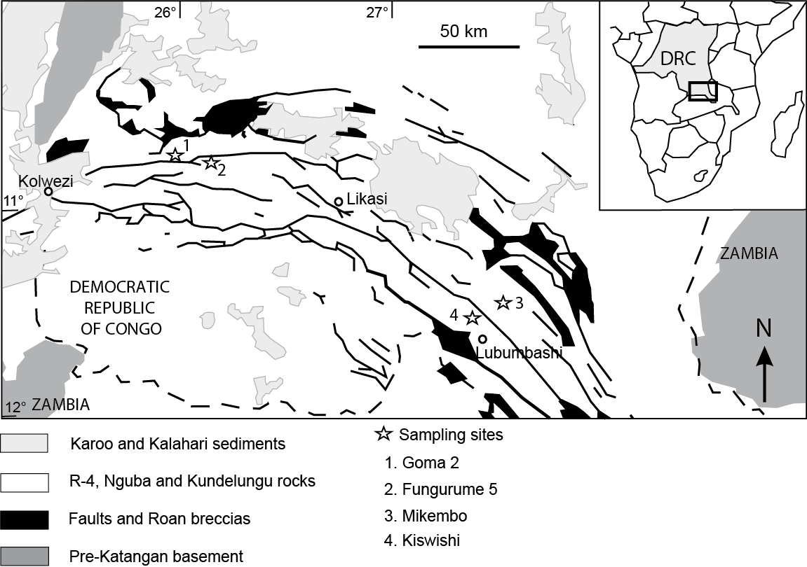
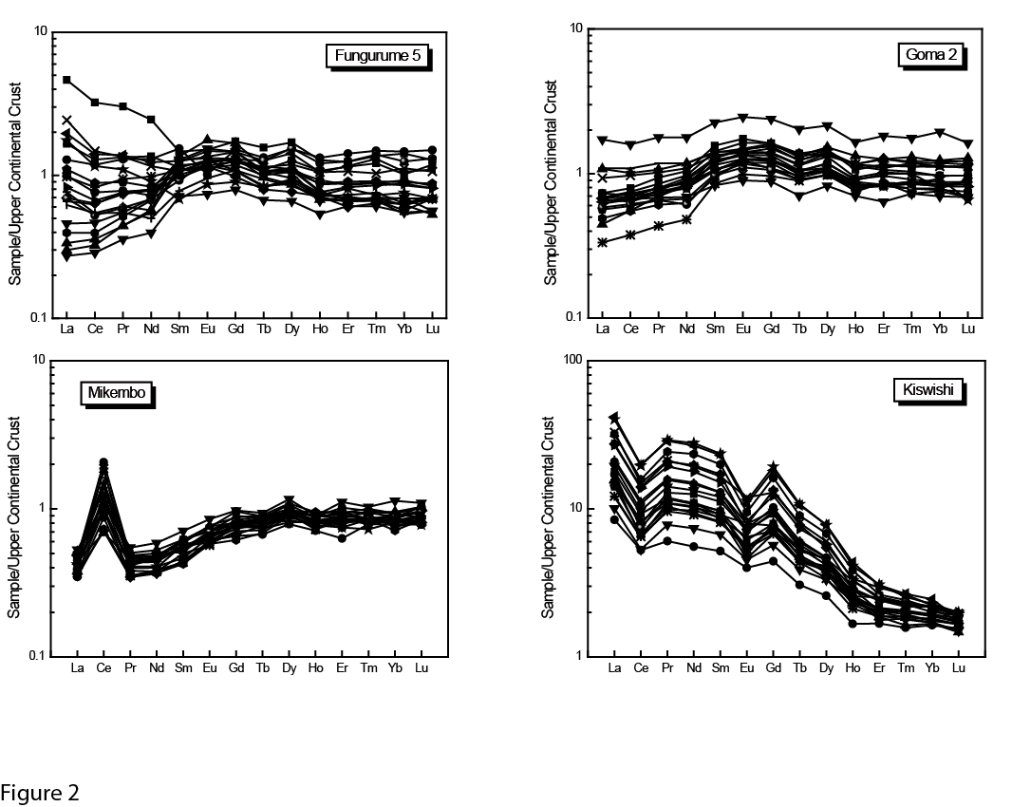
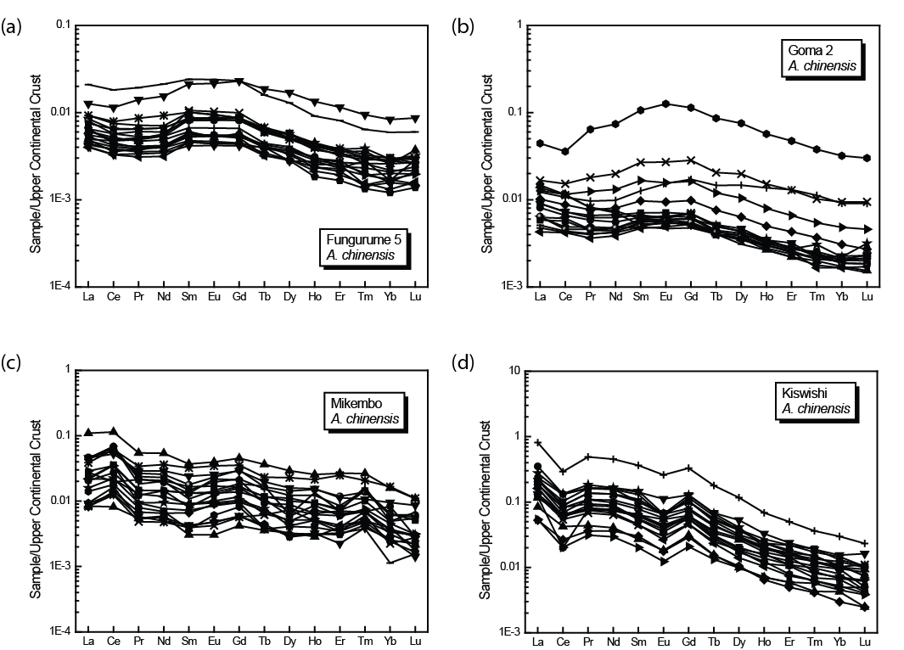
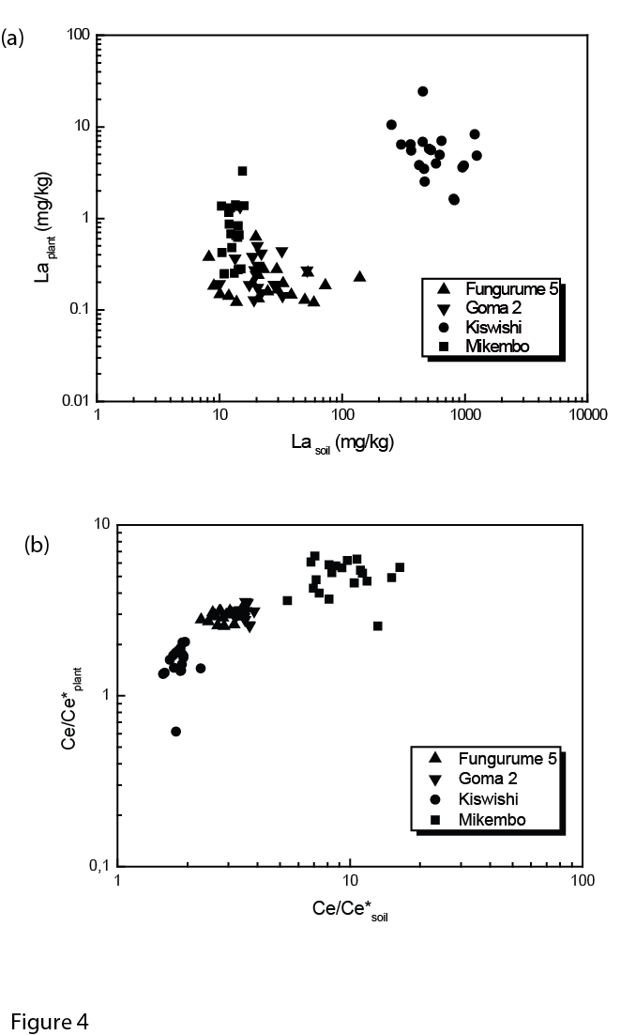
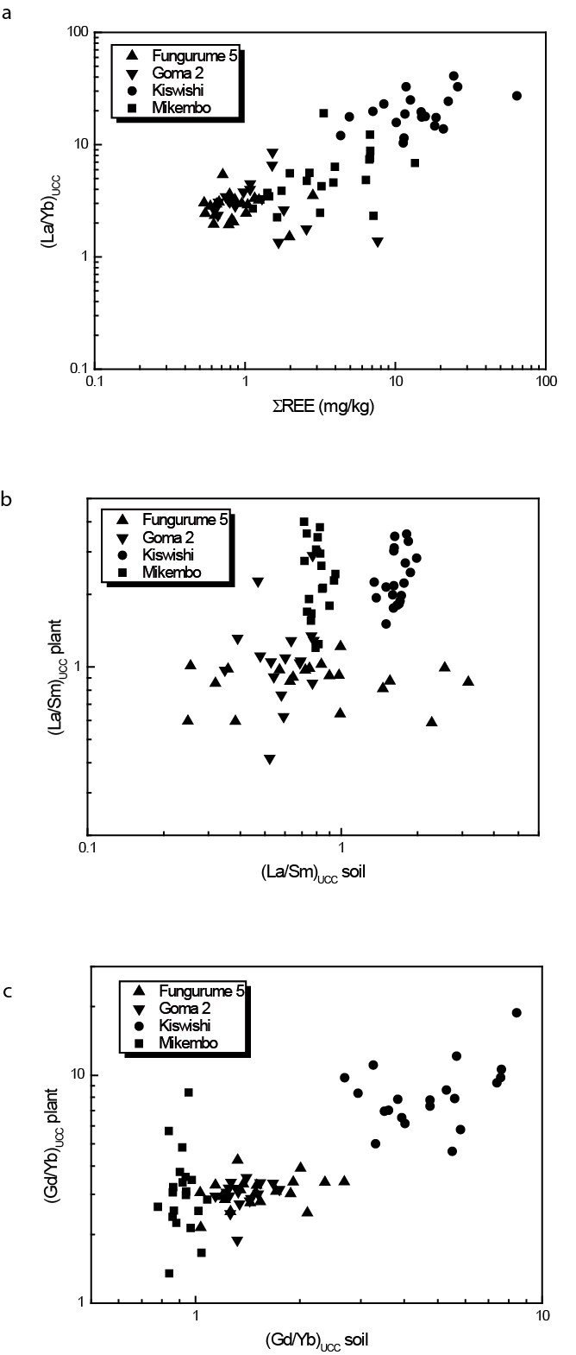
Figure 5
Figure 5

