Nature Communications

Global resource potential of seasonal pumped-storage
for energy and water storage
Julian D. Hunt*, Edward Byers¹, Yoshihide Wada¹, Simon Parkinson^{1,4},
David E.H.J. Gernaat^{2,3}, Simon Langan¹, Detlef P. van Vuuren^{2,3}, Keywan Riahi¹

The risk of seasonal mismatches between electricity supply and demand is increasing due to expanded use of wind, solar and hydropower resources. Power system planners are thus in search of low-cost seasonal energy storage options. Seasonal Pumped-Storage (SPS) can provide short, medium and long-term energy storage at a relatively low-cost and provides co-benefits in the form of freshwater storage capacity. Here, we present the first global assessment of SPS potential, using a novel plant-siting methodology and high-resolution topographical and hydrological data. Our results show that SPS costs vary from 0.007 to 0.2 $/m³ of water stored, 1.8 to 50 $/MWh of energy stored and 0.37 to 0.6 $/GW of installed power generation capacity. The estimated world energy storage capacity below a cost of 50 $/MWh is 17.3 PWh, approximately 79% of the world electricity consumption in 2017.
Whilst a number of energy storage technologies are being developed to manage electricity grids, most technologies only fulfil short term cycles (daily or shorter) (Fig. 1). Pumped-storage systems are currently the most mature and widespread method for large-scale electricity storage¹. Global installed pumped-storage electricity generation capacity is approximately 165 GW, of which 25 GW have been identified as mixed plants that are also conventional reservoir based hydropower dams^{2,3}. Often, pumped-storage is seen as a technology capable of storing energy for daily or weekly cycles^{4–9}; however, the technology can also operate over monthly, annually and pluri-annual cycles¹⁰. Given the current costs reduction in other technologies offering daily energy storage (particularly batteries), pumped-storage is anticipated to gain importance as a seasonal energy and water storage alternative.
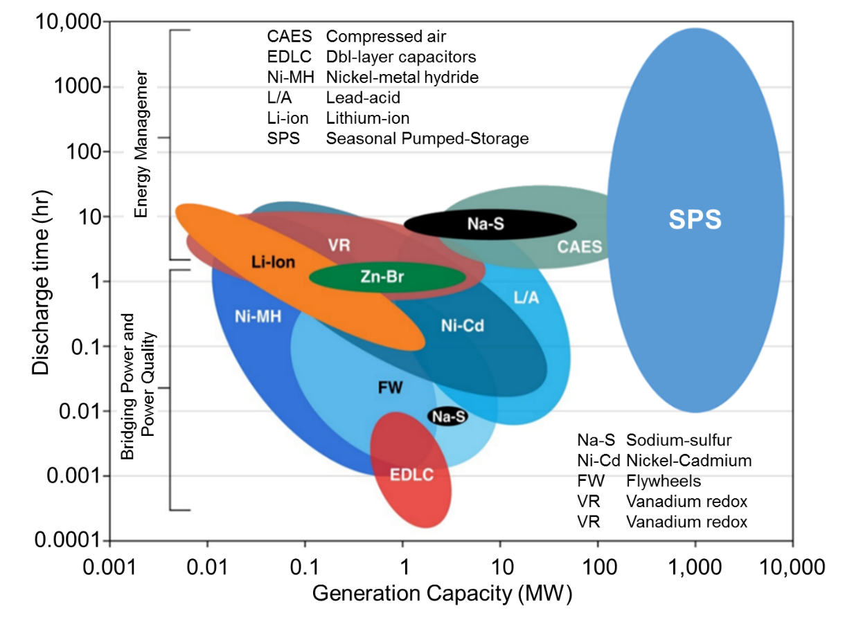
Fig. 1 | Energy storage technologies and demand. SPS compared with other energy storage applications and technologies. The graph shows that a single SPS project can provide grid scale energy storage in seconds to years long cycles.
A Seasonal Pumped-Storage (SPS) plant consists of a high-head storage reservoir built parallel to a major river. During periods of low energy demand or high water availability, water is pumped into the reservoir. Stored water is released from the reservoir generating electricity when additional electricity generation capacity is required or water is scarce. SPS plants have lower land requirements than conventional hydropower dams, for a comparable energy and water storage potential, because the off-river reservoir design permits higher hydraulic heads. Seasonal pumped-storage can be attractive to deal with the load problems emerging from electricity consumption and supply seasonal variations and increasing use of intermittent sources of generation. The storage of water can also help to overcome water shortage problems. Because storage is also not near the main river, possible negative impacts of hydropower can be better managed (further details in Supplementary Table 1).
To understand the potential that SPS can fulfil in future energy storage requirements, in this paper, we present the first comprehensive and globally consistent assessment of SPS potential. This paper presents the results from the SPS world potential model, which is an upgrade of the methods that have been used for estimating global hydropower potential^{11–16}. The only current study looking at the global potential for SPS assumes the construction of two large reservoirs, which might not practical or viable, and does not include cost analysis^{17,18}. Other studies have been developed to find the potential for SPS projects in Europe^{19,20}, and Iran²¹, however, these are regional models and do not include costs. In this paper we scan the landscape alongside rivers for attractive sites to build artificial reservoirs for water and energy storage purposes with SPS plants. Here, we evaluate all land grid points for project suitability at a 15” resolution (approx. 450 m resolution), using a detailed siting assessment methodology for developing and costing SPS projects with high-resolution topography, river network and hydrological data.
To assess the global potential of SPS, our methodology integrates five critical components, which are: topographical, river network and hydrology data, infrastructure cost estimation and project design optimization. SPS project suitability is highly sensitive to the topography, distance to a river and water availability, which together determine the technical potential. Additional contextual factors, such as distance from energy demand and associated transmission infrastructure losses and associated costs, determine the economic feasibility. Whilst previous studies have used similarly high resolution topography for reservoir estimation ¹¹, the possibility of storing water and energy by pumping water to a reservoir parallel to a major river has not been globally assessed. Since storage potential and infrastructure costs are highly dependent on the topography, our new spatially-explicit approach identifies numerous technically feasible candidate sites and provides improved estimates of costs.
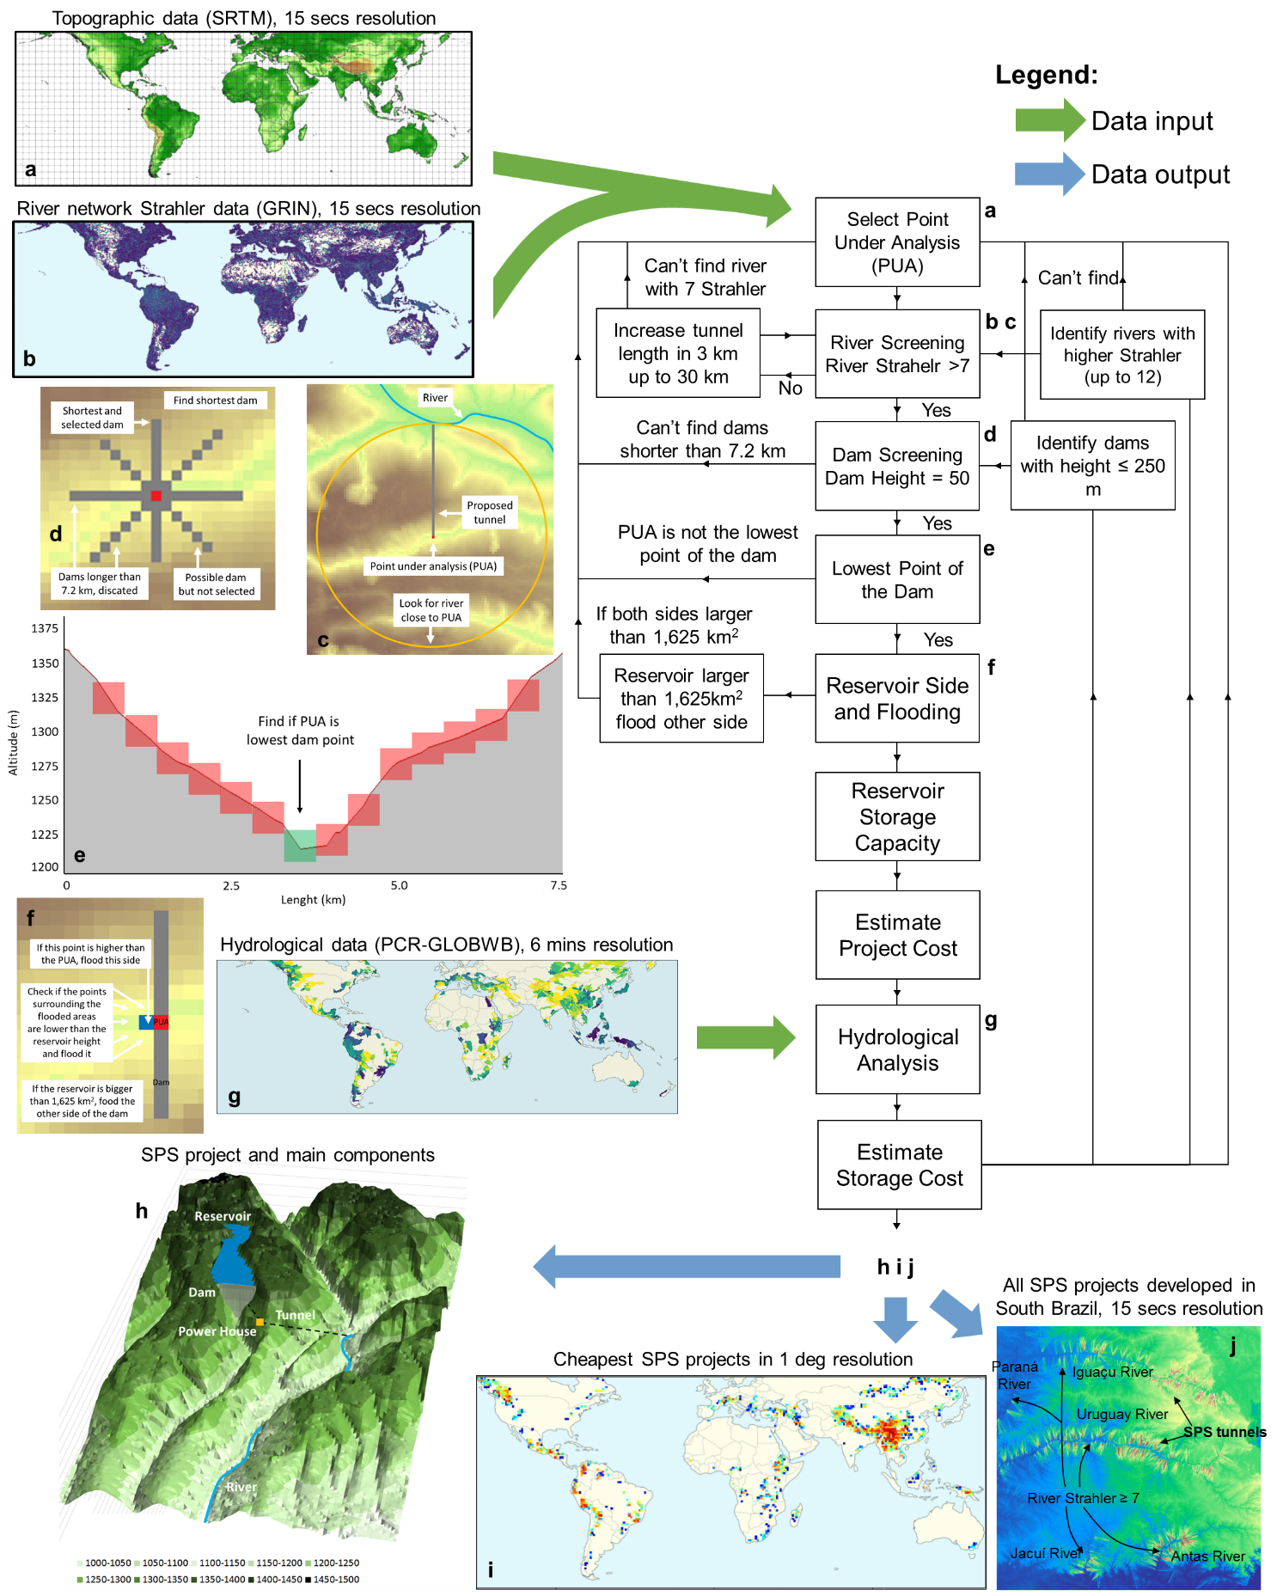
Fig. 2 | SPS world potential model framework. a, Topographical data input²². b, River network Strahler data input²³. c, Finding rivers close to the SPS site. d, Looking for possible dams. e, Limiting the number of proposed SPS projects. f, Creating and finding reservoirs. g, Hydrological data input²⁴. h, Representation of a possible SPS project in the Zambezi river basin. i, Cheapest SPS projects in 1 degree resolution. j, Location with several SPS projects proposed.
Details of the SPS world potential model framework, are explained step-by-step in Fig. 2 and Supplementary Tables 2, 3 and 7. The model goes through each grid cell location delineated at a 15” resolution, implementing a detailed siting assessment that accounts for topography and hydrology in the calculation of project-level costs. The model performs the stages as follows: i) looks for a river with reasonable flowrate up to 30 km away from a reservoir (Fig. 2c), ii) check if a dam up to 250 m high can be built within the grid square (Fig. 2d), iii) remove projects with competing dams (Fig. 2e), iv) find the side of the reservoir and create the reservoir (Fig. 2f), v) calculate the volume and flooded areas, vi) estimate the costs of the dam, tunnel, turbine, generator, excavation and land, vii) check the water availability of the river for storage (Fig. 2g), viii) estimate water and energy storage costs (Fig. 2i). The hydrological data were used to restrict the size of the storage reservoirs, according to water availability. This guarantees that there will be water available to fill up the storage reservoir without having a considerable impact on the overall river flow.
SPS reservoirs in this study are operated to reduce the seasonality and inter annual river flow variations, to regulate the flow of the river. If the river flow is already constant, then the water available for storage in the SPS reservoir will be zero, as it would deregulate the flow of the river. Additionally, conservative storage values are assumed to reduce the impact on the SPS plant in the river flow. The maximum volume of the reservoir equals to 11% of the annual river flow, from which the need for storage is divided by seasonal storage needs and inter-annual storage needs. This value was selected with the intent of reducing the environmental impact of storage in the overall river flow. On average, the water available for storage in SPS reservoirs in this model equals to 7.7% of the annual river flow (Supplementary Fig. 2).

Costs Analysis and Land Requirement
The SPS world potential model identified more than 5.1 million potential projects, all of which have a fixed generation/pumping capacity of 1 GW (Supplementary Figs. 3 and 4). With the intention of eliminating competing projects and focusing on the best projects per region, the projects with the lowest costs for water storage ($/m³), long ($/MWh) and short (B $/GW) term energy storage, within a 1 arc degree resolution of the globe are presented. This consists of 1,457 water storage projects and 1,092 energy storage projects.
Critical components of the SPS project costs are the dam and tunnel (Fig. 3a). Tunnel costs increase proportionally with length and reduce with generation head. Dam costs increase proportionally with width and exponentially with height. A high land-value of 41,000 $/ha was assumed in this paper, and represents typically 5% of the total project costs. It is important to emphasize the relatively low land requirement of SPS in comparison to conventional hydropower dams that have smaller variations of reservoir levels and thus flood more area for the same water storage capacity. The average level variation of SPS projects is 151.7 meters (Supplementary Table 4).
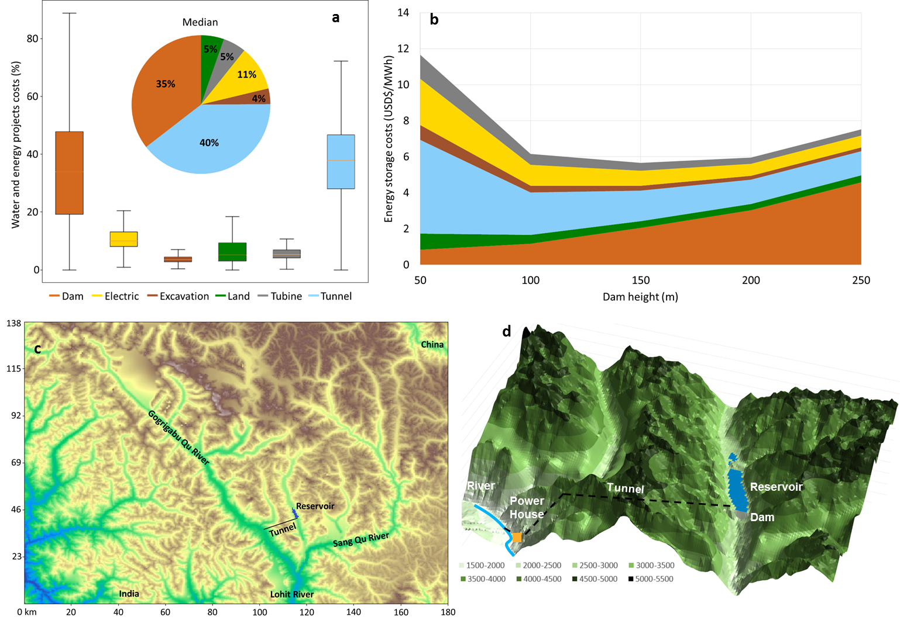
Fig. 3 | SPS costs and description. a, SPS project cost distribution (1,092 projects) shows that the most expensive components tend to be the tunnel and dam. b, Example of cost variation according to different heights for the example project in Fig. 3c. The energy storage cost reduces with the increase in dam height due to economies of gains, however, it then increases because the reservoir becomes larger than the amount of water available to be sustainably stored. c, Presentation of selected project in Tibet, China, on a topographic map, presenting its tunnel in black and reservoir in purple. d, Zoom in the selected project.

We use a site in Tibet, China to illustrate the calculations (Fig. 3b and c). With a 50 m dam height, the energy storage costs are the highest at $ 11.7/MWh. Most of the costs are related to the tunnel costs (45%), which is 18 km long. The land cost is high (8%) compared to the dam costs (7%) because the amount of water stored per km² is low. Energy storage cost is the lowest for a 150 m dam height. In this case, the tunnel cost is 30% and dam costs 36% and land cost is low (6%) (Supplementary Tables 5 and 6). A further increase in head increases energy storage costs, mostly because the required water to fill up the reservoir according to equation (3) exceeds the maximum flow extraction from the river.
The water storage cost with seasonal pumped-storage varies from 0.007 to 0.2 $/m³ of water stored (Fig. 4a). This large cost difference is due to the variation in topography and water availability. The energy storage cost varies from 4.6 to 50 $/MWh without including dams in cascade and 1.8 to 50 $/MWh including dams in cascade (Figs. 4b and 4c, respectively). The water stored in a SPS plant also stores water for the dams downstream (in cascade). The higher the altitude of the SPS system the more energy it stores for the whole basin. Given that the SPS projects proposed in this paper intend to regulate the flow of the river, the capacity of the dams in cascade would be enough to generate electricity with the extra flow from the SPS plant. Assuming a cost for natural gas storage of 1 $/mcf²⁵ and an electricity generation efficiency of 50%, the cost of energy storage is approximately 6.8 $/MWh. This value is higher than the energy storage with SPS in mountainous regions around the world. The world storage capacity curves are shaded because they include the cheapest projects and a combination of cheap and large storage capacity projects.
The cost of 1 GW pumped-storage capacity varies from 0.37 to 0.6 billion $/GW (Fig. 4d). This excludes dam and land costs. The costs are segmented in different steps due to the variation in length of the tunnel, which starts at 3 km with additional increments of 3 km. A cost comparison of other short term energy storage technologies can be found at ²⁶.

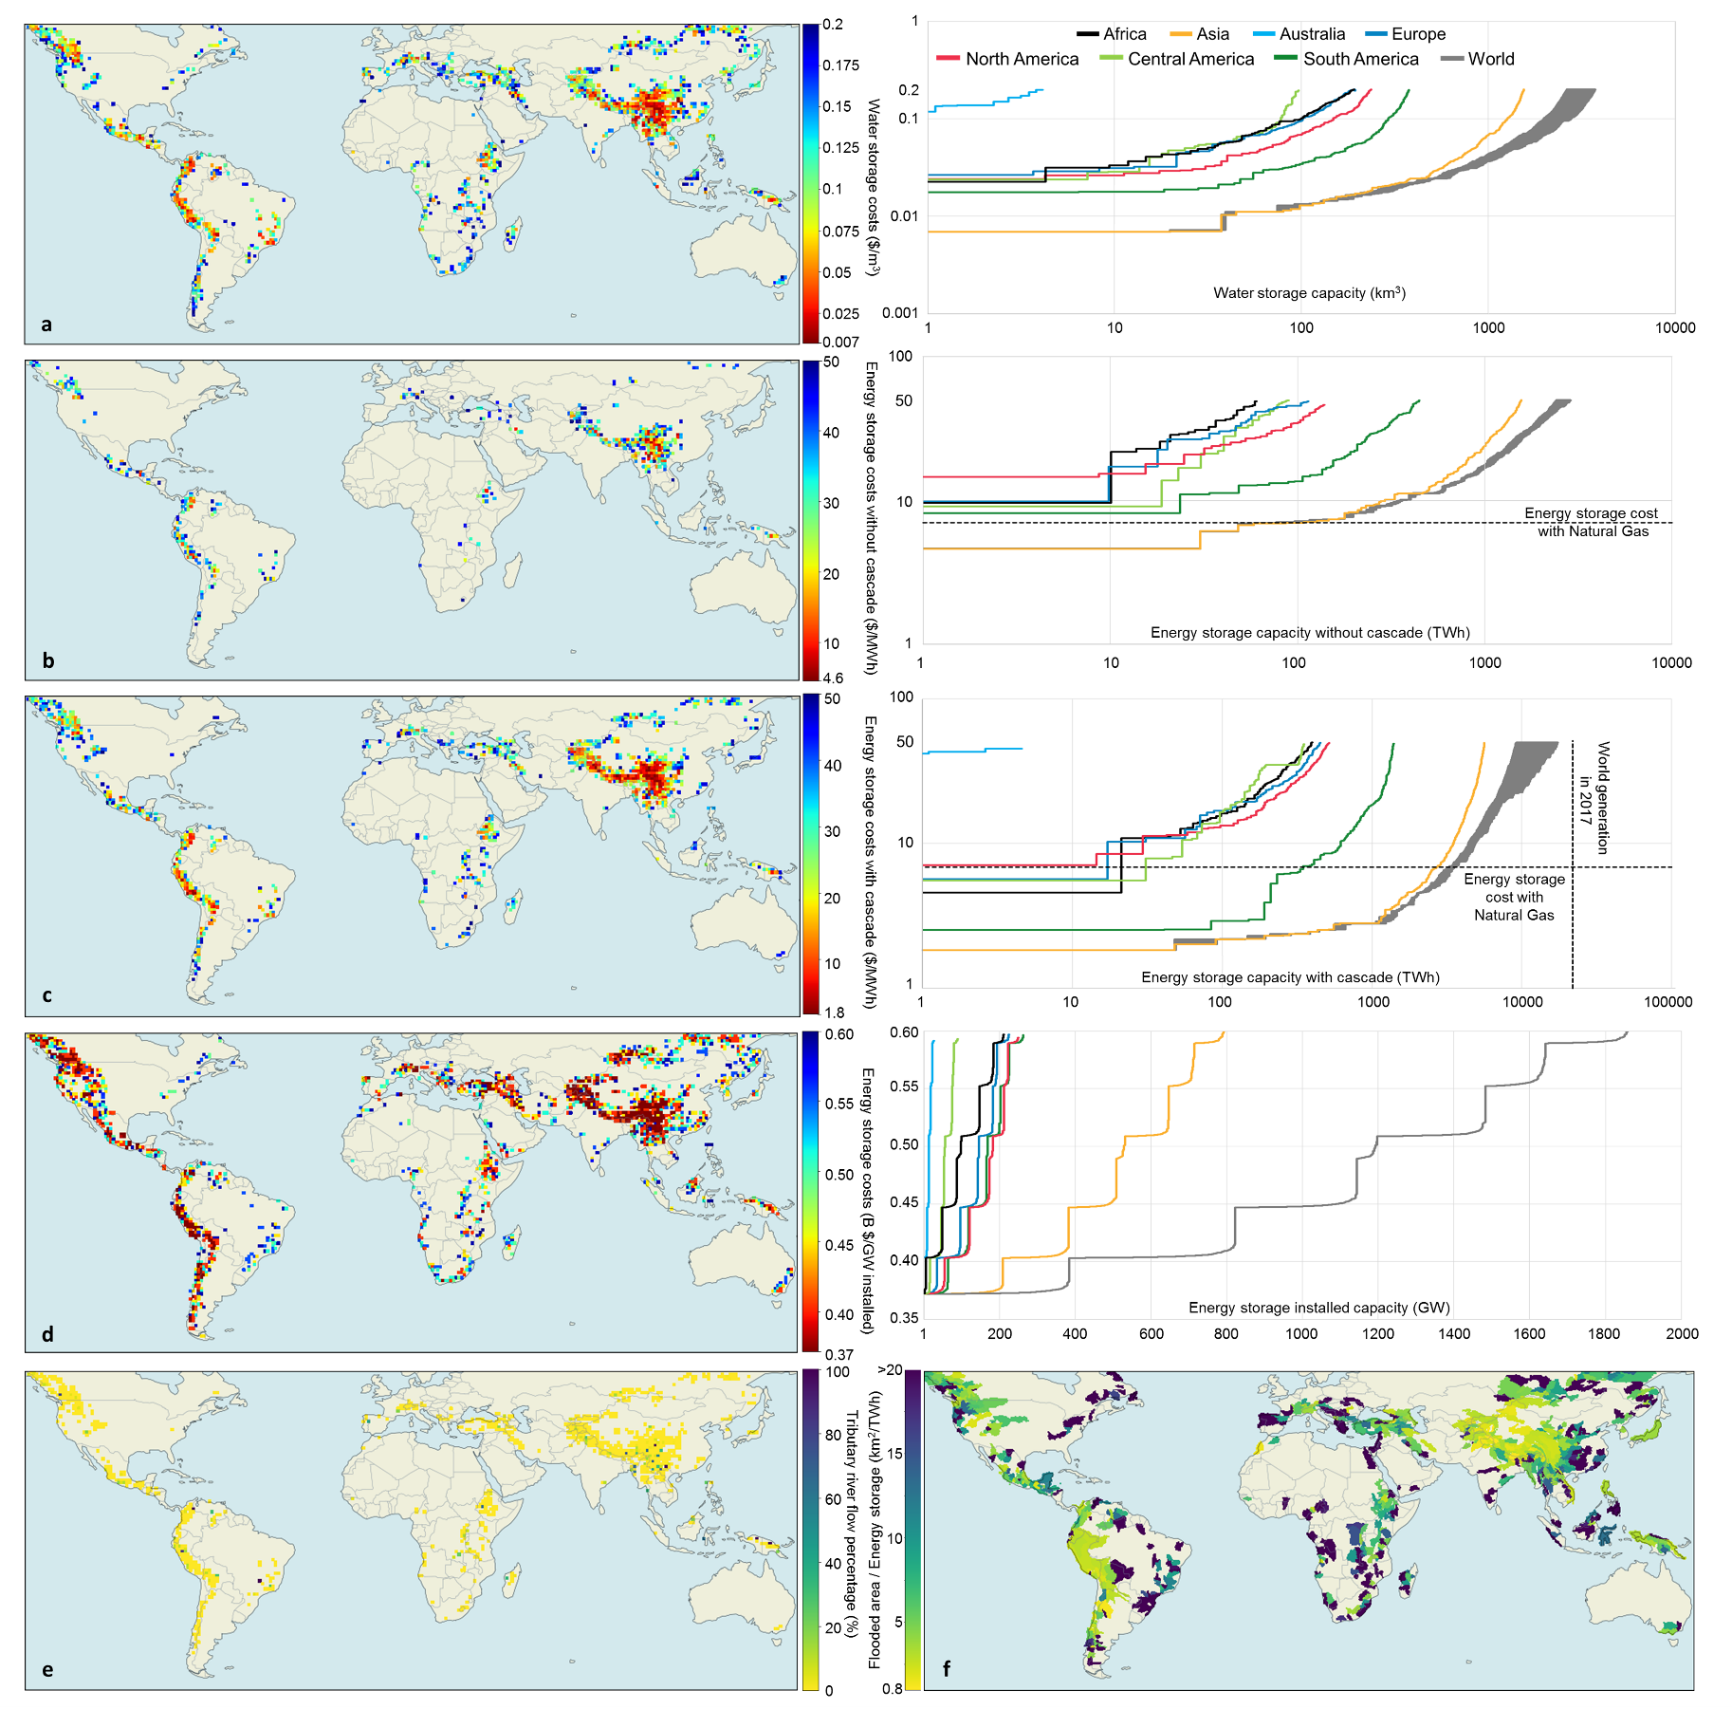
Fig. 4 | SPS world cost and flooded area maps. a, Water storage costs and capacity curve in km³. b, Energy storage without considering hydropower plants in cascade costs and capacity curve in $/MWh. c, Energy storage considering hydropower plants in cascade costs and capacity curve in $/MWh. d, Additional generation capacity costs and capacity curve in B $/GW. e, Percentage of the reservoir that is filled with the river inflow into the SPS reservoir. f, Average land requirement for energy storage in different basins.
The percentage of inflow to fill up the reservoir varies considerably from each project (Fig. 4e). The remaining percentage consists of the water that requires to be pumped into the SPS reservoir from the river below. Three of the proposed projects have 100% of the inflow coming from the river. In these cases, a reversible turbine would be interesting only to allow the project to store energy in daily and weekly cycles, given that the seasonal cycle is already accomplished with the river flow.
The land requirement for energy storage vary from 1.2 to 20 km²/TWh (Fig. 4f). This is a result of the high water level variation in SPS reservoirs (141 meters for water storage and 152 meters for energy storage (Supplementary Table 4)). For comparison, the average land requirement for energy storage in Brazil is around 150 km²/TWh²⁷. The low land requirement of SPS projects makes it a more social and environmentally friendly storage alternative when compared with conventional dams. Large reservoirs usually have lower storage costs than small ones and might have longer storage cycles. The storage cycle will depend on the needs for storage and the storage potential of the reservoir.

Discussion
Conventional hydropower dams have been built in main river channels with the intention of managing water resources and generating low-cost, low-carbon electricity, but often they fragment flow and flood upstream areas. SPS plants built adjacent to the main river can provide similar water management and energy storage services while avoiding the large land footprint associated with conventional hydropower dams. This paper has identified where SPS plants could be built and the associated unit costs for energy and water storage services. The estimated potential is restricted to mountainous regions with reasonable water availability and high hydraulic heads supporting cost-efficient SPS system design. Significant potential exists in the lower part of the Himalayas, Andes, Alps, Rocky Mountains, Northern part of the Middle East, Ethiopian Highlands, Brazilian Highlands, Central America, East Asia, Papua New Guinea, the Sayan, Yablonoi and Stanovoy mountain ranges in Russia, and other locations with smaller potential, with energy storage costs varying from 1.8 to 15 $/MWh.
SPS are shown to provide multiple income generating services, for example, a single SPS project provides water storage at $ 0.1/m³, long-term energy storage at $ 30/MWh and short-term energy storage at B $ 0.6/GW. Considering that the need for three storage services are complementary in the SPS projects, the costs of these services are substantially reduced. The change in cost for each storage service will vary with the need for storage and the operation of the SPS plant. Compared with natural gas storage, this work has shown that there is considerable potential for SPS to provide competitive storage, noting that the gas comparison does not even consider the cost of the gas power plant so as not to confuse storage with generation.
Our estimates show that the global technical and economical potential for water and energy storage with SPS is vast because sites are not restricted to rivers but can be built wherever in the landscape. Considering all the energy storage projects with the cascade, in Fig. 4c, the total storage capacity is equivalent to 17,325 TWh. This is equivalent to approximately 79% of the world electricity consumption in 2017. Whilst we have considered a maximum of one SPS per 1 degree grid square (100x100km), in some locations a series of SPS plants in cascade could further increase the energy storage potential.
Given that this is the first global assessment for SPS, the model was developed with the intent of focusing on its technical potential. Other restrictions that impact socio-economic feasibility, such as population, land use, biodiversity, transmission, etc. were not included in this work with the intent of presenting the existing potential and not the viability. The addition of these restrictions is proposed for future work and regional studies.
With the needs for reducing CO₂ emissions to mitigate the impacts of climate change, SPS provides short and long-term energy storage services allowing the development of 100% renewable energy grids. SPS also increases water security in regions with unsuitable topography for conventional dams, high evaporation and sedimentation rates. It is, thus, a prominent alternative for sustainable development on a worldwide scale.

Methods

Data collection, engineering design and costs
The SPS World Potential Model provides a near-global scale potential (60º S to 60º N). The excluded area is due to unavailable Shuttle Radar Topography Mission (SRTM) topographic data. The topographic data applied is SRTM²² and has 3” resolution. The resolution is reduced to 15”, assuming the center point, to reduce modelling time and to combine with the river network data. The river network data assumed the Strahler methodology in Global-scale river network (GRIN)²³, which is derived from the SRTM data and has 15” resolution. This is used to give a better estimate of the tunnel length connecting the river and the reservoir. The topographic and river Strahler data are then combined with the hydrological data taken from PCR-GLOBWB²⁴, which is derived into annual discharge, seasonality and inter-annual variations. To design and cost the SPS projects, we use detailed design methods²⁸ and cost-estimation²⁹ procedures which include the optimization of the tunnels’ diameter and number of tunnels and are further explained in Supplementary Table 2.

Site selection model

The site selection model is divided into nine main stages (Supplementary Table 3). Initially, the topographic data are combined with the river Strahler data at the same resolution with the intention of finding the location of the rivers in the topographic data, which is a numerical measure of its branching complexity and was derived from the same topographic data. The higher the value the more tributary rivers (branches) deliver water to the given part of the river²³. The two are compared at the same resolution to identify rivers within the topographic data and to estimate the length of the tunnels connecting the upper reservoir and the lower reservoir in the river. The river Strahler data are also used to reduce the amount of SPS projects developed within a given area and reduce the modelling time. Rivers with small river Strahler have low river flows, which results in unviable SPS projects with small generation capacities. A minimum river Strahler of 7 is selected because the river has a considerable number of tributary rivers connected to it, which results in a relatively large and constant river flow.
For each land grid cell at a latitude between 60º N and 60º S (point under analysis (PUA)), the model searches for rivers with sufficient discharge (river Strahler >= 7) within 1 to 30 km of distance, which consist of the tunnel length. If a large river is found, the model attempts to build dams of 50, 100, 150, 200 and 250 meters height, along 4 axes (N-S, W-E, NW-SE, NE-SW) and with a maximum length of 7.2 km in the PUA. If the topography allows the construction of such dams, it verifies whether the PUA is the lowest point of the dam (if it is not, the process stops with the intention of not repeating the same project). Using the surrounding topography and observing limits to the maximum flooded area of the reservoir, the model identifies the side with the largest storage volume. Subsequently, the reservoir water level is varied to determine the flooded area vs. level and storage volume vs. level curves. This is done by subtracting the volume of land and water with the reservoir at a given level by the volume of land and water with the reservoir at its minimum level.
Project costs are subsequently estimated, divided between dam, tunnel, powerhouse excavation, pump-turbine, electro-technical equipment and land costs^{28,30}. In the analysis, the water storage capacity of the SPS projects is limited according to the water availability of the main river. The maximum water storage capacity is limited to 11% of the annual river flow, which is a small portion of the river flow total river flow and result in a small impact to the river. If the storage capacity is much higher than the amount of water available, the estimated cost of storage tends to zero, as the reservoir will never fill up. The project costs are then compared with the hydrology of the river to find the water and energy storage costs with equations (4,5).

Hydrology
The seasonal and inter annual variability of river discharge used in the Hydrological Analysis Stage is calculated with the equations (1,2). They intend to show the seasonal and inter annual variations of the river flow. They are important to calculate the water available for storage in the SPS reservoir, with the objective of producing a constant river flow. If the river has no seasonal variation, then the water available for storage would be equal to zero. This is because, if the SPS deregulate the flow of the river, the hydropower potential of the dams in cascade or the water supply downstream could be negatively affected.
$$S_{V}= \frac{\sqrt{\frac{\sum_{m∈M}{{({\overline{q}}_{m}-{\overline{q}}_{s})}^{2}}}{N_{M}}}}{{\overline{q}}_{s}} \left\{ if S_{V}>1→S_{V}=1\right.$$ | (1)
$$I_{V}= \frac{\sqrt{\frac{\sum_{y∈Y}{{({\overline{q}}_{y}-{\overline{q}}_{s})}^{2}}}{N_{Y}}}}{{\overline{q}}_{s}} \left\{ if I_{V}>1→I_{V}=1\right.$$ | (2)
where, $S_{V}$ is the seasonal variation, $I_{V}$ is the inter annual variation, ${\overline{q}}_{m}$ is the river flow of a given month, ${\overline{q}}_{y}$ is the river flow of a given year, ${\overline{q}}_{s}$ is the average river flow over Y years, M is the number of months, Y is the number of years.
They are used in calculating the water available for storage in the SPS reservoir with the objective of producing a constant river flow. If a river has no seasonal variation, then the water available for storage would be equal to zero because the SPS would deregulate the flow of the river and the hydropower potential of the dams in cascade or the water supply downstream could be negatively affected.
The costs of water and energy storage service calculated in the Estimate Storage Cost stage vary according to the annual river flow, the seasonal and inter annual variation. These hydrological parameters have three main purposes. Firstly, they intend to guarantee that there will be sufficient water in the river to be stored in the upper reservoir. Secondly, the need for water and energy storage should not have a substantial detrimental impact on the river flow. Thirdly, the water storage potential intends to regulate the flow of the river and produce a constant flow of water, reducing its seasonality and inter annual variations.
Using the values calculated for $S_{V}$ and $I_{V}$ (Supplementary Fig. 1) and the percentage of river annual discharge available for storage (Supplementary Fig. 2), the water available for storage $Q_{A}$ (equation (3)) is calculated by:
$$Q_{A}=Q ×{(S}_{V}×0.1)×(1+(I_{V}×0.1))$$ | (3)
where, $Q_{A}$ is the water available for storage in km³,$Q$ is the river annual discharge in km³/y.
The variation of the water and long-term energy storage costs with the water available for storage is presented in equation (4). The costs for additional short-term energy storage costs is presented in equation (5).
$$C_{W}= \frac{C_{P}}{W_{S}} ; C_{Ewc}= \frac{C_{P}}{E_{Rwc}\frac{W_{R}}{W_{S}}} ; C_{Ewoc}= \frac{C_{P}}{E_{Rwoc}\frac{W_{R}}{W_{S}}} \left\{\begin{aligned}if W_{R}<Q_{A} → W_{S}=W_{R} \\ if Q_{A}<W_{R}< {2Q}_{A}→ {W_{S}=Q}_{A}+{0.5W}_{R } \\ if W_{R}> {2Q}_{A} → W_{S}={1.5Q}_{A} \end{aligned}\right.$$ | (4)

where, $C_{W}$ is the cost of water storage in $/km³, $C_{P}$ is the cost of the project (i.e. dam, tunnel, turbine, electrical equipment, excavation and land) in $ $W_{S}$ is the water storage capacity adjusted by the water availability in km³, $C_{Ewoc}$ is the cost of long-term energy storage excluding the cascade in $/MWh, $W_{R}$ is the water storage capacity of the reservoir developed in the model in km³, $E_{Rwoc}$ and $E_{Rwoc}$ are the energy storage capacity of the reservoir developed in the model with and without cascade in MWh, respectively, $C_{Ewc}$ is the cost of long-term energy storage including the cascade in $/MWh.
$$C_{GW}= \frac{C_{PGW}}{G}$$ | (5)
where, $C_{GW}$ is the cost of additional generation capacity in billion $/GW, $C_{PGW}$ is the cost of additional generation capacity (i.e. tunnel, turbine, electrical equipment, excavation) in billion $, $G$ is the generation capacity in GW (fixed to be 1 GW for all SPS plants proposed).

Authors Contribution

JH conceived the idea, developed the modelling techniques and led the manuscript writing, EB contributed to modelling and to the concept, YW and DG developed the hydrological datasets used in the paper, SP contributed to the model and references, SL contributed to the water availability restriction to the model and references, DV and KR perfected the idea with valuable inputs. All authors contributed to the manuscript.

Competing Interests
The authors declare no competing interests.

Acknowledgements
We would like to thank CAPES/BRAZIL for the research grant as part of the CAPES/IIASA Postdoctoral Program.

References
1. International Energy Agency. Technology Roadmap: Energy Storage. (2014).
2. International Renewable Energy Agency (IRENA). Renewable power generation costs in 2014. Renewable power generation costs (2014). doi:10.1007/SpringerReference_7300
3. Mouli-Castillo, J. et al. Inter-seasonal compressed-air energy storage using saline aquifers. Nat. Energy (2019).
4. International Electrotechnical Comission. Electrical Energy Storage: White Paper. (2011).
5. Renewable Energy Association. Energy storage in the UK: An Overview. (2016).
6. Akhil, A. et al. DOE/EPRI 2013 Electricity Storage Handbook in Collaboration with NRECA. (2013).
7. World Energy Council. World Energy Resources: E-Storage. (2016).
8. Luo, X., Wang, J., Dooner, M. & Clarke, J. Overview of current development in electrical energy storage technologies and the application potential in power system operation. Appl. Energy 137, 511–536 (2015).
9. International Energy Agency. Technology Roadmap: Hydrogen and Fuel Cells. (2015).
10. Hunt, J., Byers, E., Riahi, K. & Langan, S. Comparison between seasonal pumped-storage and conventional reservoir dams from the water, energy and land nexus perspective. Energy Convers. Manag. 166, 385–401 (2018).
11. Gernaat, D. E. H. J., Bogaart, P. W., Vuuren, D. P. van, Biemans, H. & Niessink, R. High-resolution assessment of global technical and economic hydropower potential. Nat. Energy 2, 821–828 (2017).
12. Zhou, Y. et al. A comprehensive view of global potential for hydro-generated electricity. Energy Environ. Sci. 8, 2622–2633 (2015).
13. Hoes, O. A. C., Meijer, L. J. J., Van Der Ent, R. J. & Van De Giesen, N. C. Systematic high-resolution assessment of global hydropower potential. PLoS One 12, (2017).
14. Petheram, C., Gallant, J. & Read, A. An automated and rapid method for identifying dam wall locations and estimating reservoir yield over large areas. Environ. Model. Softw. 92, 189–201 (2017).
15. van Vliet, M. T. H. et al. Multi-model assessment of global hydropower and cooling water discharge potential under climate change. Glob. Environ. Chang. 40, 156–170 (2016).
16. Rogeau, A., Girard, R. & Kariniotakis, G. A generic GIS-based method for small Pumped Hydro Energy Storage (PHES) potential evaluation at large scale. Appl. Energy 197, 241–253 (2017).
17. Lu, B., Stocks, M., Blakers, A. & Anderson, K. Geographic information system algorithms to locate prospective sites for pumped hydro energy storage. Appl. Energy 222, 300–312 (2018).
18. Stocks, M. AREMI is a spatial data platform for the Australian energy industry. (2019). Available at: https://nationalmap.gov.au/renewables/#share=s-oDPMo1jDBBtwBNhD.
19. Gimeno-Gutiérrez, M. & Lacal-Arántegui, R. Assessment of the European potential for pumped hydropower energy storage. (2013).
20. Lacal-Arántegui, R. & Leahy, N. Pumped-hydro energy storage: potential for transformation from single dams. (2012).
21. Ghorbani, N., Makian, H. & Breyer, C. A GIS-based method to identify potential sites for pumped hydro energy storage - Case of Iran. Energy 169, 854–867 (2019).
22. Jarvis A., H.I. Reuter, A. Nelson, E. G. Hole-filled seamless SRTM data V4. International Centre for Tropical Agriculture (CIAT) (2008). Available at: http://srtm.csi.cgiar.org.
23. Schneider, A., Jost, A., Coulon, C., Silvestre, M., Théry, A. Ducharne, A. Global scale river network extraction based on high-resolution topography and constrained by lithology, climate, slope, and observed drainage density. Geophys. Res. Lett. 44, 2773–2781 (2017).
24. Wada, Y., Graaf, I. & van Beek, L. High-resolution modeling of human and climate impacts on global water resources. J. Adv. Model. Earth Syst. 8, 735–763 (2016).
25. Federal Energy Regulatory Commission. Current State of and Issues Concerning Underground Natural Gas Storage. (2004).
26. Zakeri, B. & Syri, S. Electrical energy storage systems: A comparative life cycle cost analysis. Renew. Sustain. Energy Rev. 42, 569–596 (2015).
27. Hunt, J. D., Freitas, M. A. V. D. & Pereira Junior, A. O. A review of seasonal pumped-storage combined with dams in cascade in Brazil. Renew. Sustain. Energy Rev. 70, (2017).
28. Rognlien, L. Pumped Storage Development in Ovre. (2012).
29. Slapgard, J. Cost base for hydropower plants: with a generating capacity of more than 10,000 kW. (2012).
30. Slapgard, J. Cost base for hydropower plants. (2012).
31. Hunt, J. D., Freitas, M. A. V. & Pereira Junior, A. O. Enhanced-Pumped-Storage: Combining pumped-storage in a yearly storage cycle with dams in cascade in Brazil. Energy 78, (2014).
32. Olauson, J. et al. Net load variability in Nordic countries with a highly or fully renewable power system. Nat. Energy 1, (2016).
33. Shin-Ichi, I. Prospects for Large-Scale Energy Storage in Decarbonised Power Grids. (2009).
34. Converse, A. Seasonal Energy Storage in a Renewable Energy System. Proc. IEEE 100, 401–409 (2011).
35. Pehl, M. et al. Understanding future emissions from low-carbon power systems by integration of life-cycle assessment and integrated energy modelling. Nat. Energy 2, 939–945 (2017).
36. ITACA. Part 2: Solar Energy Reaching The Earth’s Surface. The Sun As A Source Of Energy (2017). Available at: http://www.itacanet.org/the-sun-as-a-source-of-energy/part-2-solar-energy-reaching-the-earths-surface/.
37. International Energy Angency. Energy Technology Perspectives: scenarious & Strategies to 2050. (2008).
38. Conway, D., Dalin, C., Landman, W. A. & Osborn, T. J. Hydropower plans in eastern and southern Africa increase risk of concurrent climate-related electricity supply disruption. Nat. Energy 2, 946–953 (2017).
39. Kling, H. Climate variability risks for electricity supply. Nat. Energy 2, 916–917 (2017).
40. Bueno, C. & Carta, J. A. Wind powered pumped hydro storage systems, a means of increasing the penetration of renewable energy in the Canary Islands. Renew. Sustain. Energy Rev. 10, 312–340 (2006).
41. Portero, U., Velázquez, S. & Carta, J. A. Sizing of a wind-hydro system using a reversible hydraulic facility with seawater. A case study in the Canary Islands. Energy Convers. Manag. 106, 1251–1263 (2015).
42. Winemiller, K. O. et al. Balancing hydropower and biodiversity in the Amazon, Congo, and Mekong. Science (80-. ). 351, 128–129 (2016).

International Institute of Applied Systems Analysis (IIASA), Laxenburg, Austria. ² PBL – Netherlands Environmental Assessment Agency, Bezuidenhoutseweg 30, 2594 AV Den Haag, The Netherlands. ³ Copernicus Institute of Sustainable Development, Utrecht University, Heidelberglaan 2, 3584 CS Utrecht, The Netherlands, ⁴ Institute for Integrated Energy Systems, University of Victoria, PO Box 3055 STN CSC. *email: hunt@iiasa.ac.at.

