Limitations on the use of space borne differential SAR interferometry for systematic monitoring and failure forecast of alpine landslides

Andrea Manconi

Swiss Federal Institute of Technology, Department of Earth Sciences, Sonneggstrasse 5, Zurich 8092, Switzerland, Email: andrea.manconi@erdw.ethz.ch

Keywords: landslides, monitoring, DInSAR, early warning, failure forecast

ORCID: https://orcid.org/0000-0003-2930-4422

Abstract

Recent advances on satellite geodesy have boosted our capabilities to map and monitor landslides globally with unprecedented resolutions. In this scenario, differential interferometry of space borne synthetic aperture radar imagery (DInSAR) plays a major role in identifying surface displacements associated to slope instabilities and in monitoring their spatial and temporal evolution. However, this technique involves a number of constraints to consider when approaching systematic and/or operational monitoring of landslides. The main focus of this technical note is on the effects of DInSAR temporal phase aliasing when analyzing accelerating slope deformation in alpine scenarios. First, a general framework considering the currently available satellites for DInSAR investigations is postulated. Secondly, a specific example of a recently accelerating slope deformation is discussed. The goal of this work is to provide insights to scientists and practitioners on the application of multitemporal space borne DInSAR in systematic and/or automatic monitoring frameworks, potentially involving early warning applications both at local slopes and/or regional scales.

- Introduction
Space borne Differential Synthetic Aperture Radar Interferometry (DInSAR) is nowadays a well-established remote sensing technique used to detect, map, and monitor displacements of the Earth’s surface (Bürgmann et al. 2000; Rosen et al. 2000). Numerous authors have shown how the combination of multitemporal SAR acquisitions with advanced algorithms allows generating ground velocity maps and displacement time series with relatively high spatial and temporal resolutions, as well as sub-centimetric accuracies (Ferretti et al. 2001, 2011; Berardino et al. 2002; Casu et al. 2006; Lanari et al. 2007; Hooper 2008). These methods have been extensively applied in different geohazard scenarios, including landslides (e.g., Wasowski and Bovenga, 2014 and reference therein). The use of space based DInSAR to study landslide displacements is becoming a common practice due to the increase of the available data and of its quality (Manconi et al. 2014; Schlögel et al. 2015; Novellino et al. 2017; Frattini et al. 2018). The reasons of this success stem from the main advantages provided by DInSAR compared to other monitoring approaches, as for example the possibility to retrieve quantitative information on surface displacements at regional scales (Meisina et al. 2008), and also in areas of difficult access (Dini et al. 2019). Currently, a variety of space borne SAR sensors is available, offering a wide range of monitoring opportunities that are related to their spatial and temporal resolution, as well as to their nominal frequency bands (Wasowski and Bovenga, 2014).

The launch of the Sentinel-1 twin satellites in 2014 and 2016, in the framework of the European Space Agency (ESA) Copernicus program (Torres et al. 2012), has enhanced the use of DInSAR in the framework of landslide research. This is mainly related to the open data policy applied from ESA, to the increased temporal sampling (6-days revisit time in Europe and other key areas, generally 12-days elsewhere), and to the advances attained in SAR capabilities both in terms of hardware and software implementations. As in the near future the family of space borne SAR sensors will further increase, the offer in terms of monitoring options will also rise (Filippazzo and Dinand 2017). Recently, an increasing number of authors have shown the potential for regional and country scale monitoring by exploiting different approaches exploiting Sentinel-1 dataset (Barra et al. 2017; Haghighi and Motagh 2017; Zinno et al. 2018; Delgado Blasco et al. 2019). These advances shifted the traditional application of DInSAR for back analyses to systematic monitoring of ground displacements.

The application of DInSAR has evolved considerably, and is now aimed at the possibility to detect criticalities (anomalies) as for example the initiation of displacement in areas previously considered stable, as well as accelerations of active areas identified and mapped in the past (Raspini et al. 2018). Despite the mentioned advances, however, its use in landslide investigations retains a number of problems that should be carefully considered, especially while aiming at operational activities. Limitations associated with multitemporal DInSAR in monitoring have been extensively discussed (Bovenga et al. 2018), thus this work is specifically focused on the potential effects of temporal phase aliasing (named also velocity of ambiguity) on the analysis and interpretation of alpine slope deformation. Phase aliasing is an intrinsic limitation affecting DInSAR measurements when the displacement of the target under investigation (i.e., a slope instability in this specific case) exceeds the threshold of λ/4 between two subsequent satellite acquisitions and/or two adjacent pixels, where λ is the nominal wavelength of the SAR sensor. Moretto et al. 2017, have recently performed a back analysis on specific slope failure events to evaluate the performance of failure forecast approaches based on Sentinel-1 data analysis. Here a more general scenario of surface displacement evolution of large alpine slopes is discussed, and a recent exemplary case of a landslide located in the Swiss Alps is shown.

- Slope displacement accelerations towards failure in alpine scenarios
Landslides in alpine scenarios are associated to slope processes acting at different spatial and temporal scales. The geological and geomorphological histories have an important role as predisposing factors of instability, i.e. determining favorable conditions to ground movements and sporadically leading to slope failures (Stead and Wolter 2015). In this long-term process, ground shaking due to earthquakes and pore pressure changes due to groundwater table variations can accelerate the evolution towards catastrophic failure events (Stead and Eberhardt 2013). Particular attention is given to large rock slides and deep seated gravitational slope deformations (DSGSD), which are abundant in high mountain ranges (Hermanns et al. 2006; Crosta et al. 2013; Coe et al. 2017; Ambrosi et al. 2018). The main reason is that, despite the majority of large slope instabilities are usually affected by minor surface displacements (in the order of few cm/year or less), their sudden acceleration towards failure may involve large volumes and pose relevant hazards (Agliardi et al. 2009; Crosta et al. 2014; Fey et al. 2017).

A conventional hypothesis for the investigation and interpretation of the evolution of slope displacements towards ultimate failure is based on the creep theory (i.e., Fukuzono-Voigth relationship, Voight 1988; Federico et al. 2012). This assumption has been extensively explored to perform back analyses on slope failure events (Rose and Hungr 2007; Sättele et al. 2016), to determine best-practice procedures to manage monitoring systems and early warning system (Crosta and Agliardi 2002; Crosta et al. 2017; Carlà et al. 2017), as well as in operational scenarios to determine the time of slope failure for civil protection purposes (Manconi and Giordan 2015; Loew et al. 2017b; Carlà et al. 2019). The Fukuzono-Voigth relationship is based on the observation that linear dependency between inverse velocity of surface displacements and time occurs during the ultimate stages before failure, i.e. the accelerating or tertiary creep stage (Petley et al. 2002; Rose and Hungr 2007). Depending on the landslide type (Hungr et al. 2013) and on the scale of observation, the total duration of the accelerating creep phase may vary considerably and can be fully described only after failure occurrence. For example, large, deep seated landslide processes affecting entire slopes may displace for decades before reaching critical stages and occasionally fail (Agliardi et al. 2009; Stead and Eberhardt 2013). During these periods, accelerated displacement are often reported without reaching ultimate failure. These phases are related to transient processes such as groundwater recharge due to snow melt in spring and/or strong rainfalls in late summer and fall (Hansmann et al. 2012; Loew et al. 2017b), and are extremely important to consider to understand the complexities of progressive failure in slope processes.

- Measuring accelerated slope displacement with satellite DInSAR
By assuming accelerating creep, it is possible to write the dependency between inverse velocity and time as:
$V^{-1}={\left[A\left(α-1\right)\right]}^{\frac{1}{α-1}} {\left(t_{f}-t\right)}^{\frac{1}{α-1}}$ (1)

where V is the surface velocity, t is time, A and α are two constants, and t_{f} is the time-of-failure. As common practice (derived from empirical observations) α=2 , and the inverse velocity function assumes a linear trend while approaching t_{f} (Rose and Hungr 2007). Equation (1) is used here to simulate the evolution of surface velocities by assuming specific temporal ranges prior to failure (see Figure 1). Moreover, a sinusoidal signal with period of one year and maximum amplitudes up to 1 mm/day was added, to simulate seasonal effects of ground water recharge due to snow melt. This cyclic signal is assumed here to have the same maximum amplitudes in the middle of the year and is completely reversible, although timing and amplitudes might vary depending on the start of snow melt periods and on the amount of snow fall during winter (Loew et al. 2015). Moreover, during these periods additional irreversible deformation might also occur.

Temporal phase aliasing thresholds associated to the currently available SAR satellites were computed according to their nominal wavelengths and revisit times (Wasowski and Bovenga 2014; Moretto et al. 2017). In Figure 1, when the surface velocities exceed the threshold defined for a given satellite (or a combination of satellites), the surface displacements retrieved with DInSAR are intrinsically biased (i.,e, underestimated) due to aliasing affecting the phase unwrapping step (Rabus and Pichierri 2018). When acceleration towards failure occurs relatively rapidly (e.g., the 2 years case scenario in Figure 1), only few satellites may provide the theoretical capability to follow the surface displacement evolution, and they would deliver in any case biased values when landslide velocities are larger than 3 mm/day. On the other hand, if the tertiary creep stage is lasting for many years, the range of possible satellites available for long term operational monitoring increases; however, due to superimposed displacement accelerations occurring every year, a progressive underestimation of the evolution of surface velocities might occur. This means that models based on the estimation of the inverse velocity measured from systematic DInSAR and aiming to predict the landslide time-of-failure would be also affected.

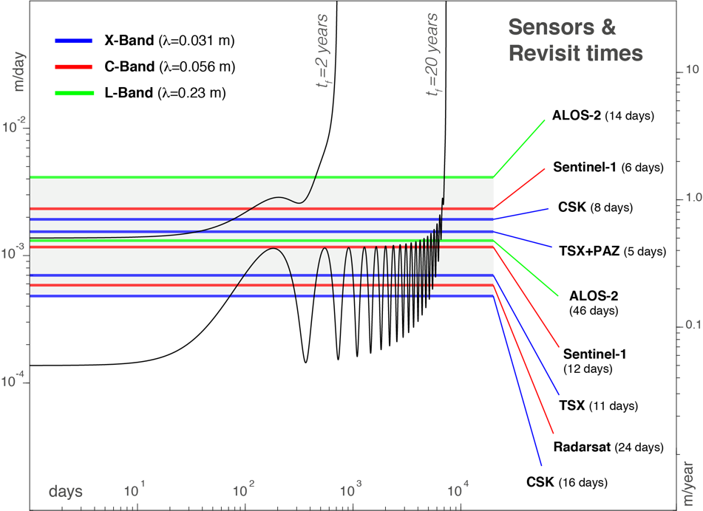

Figure 1: Simulation of two scenarios (black lines) considering accelerating creep towards ultimate failure of an alpine slope according to equation (1). Seasonal velocities with maximum amplitude of 1 mm/day are superimposed. Horizontal lines (colors refer to the SAR signal bands) show the temporal phase aliasing thresholds for available SAR satellites which are commonly used for surface deformation monitoring. We refer the reader to (Wasowski and Bovenga 2014) for more details on satellite parameters.

- The Moosfluh rock slope instability, Swiss Alps
The Moosfluh rock slope is one of the largest active deep-seated instabilities of the European Alps (see Figure 2). It is located in the vicinity of the Great Aletsch glacier, an area that has undergone to several cycles of glacial advancement and retreat deeply affecting the evolution of the surrounding landscape (Grämiger et al. 2017; Glueer et al. 2019). The moving mass associated to Moosfluh affects an area of about 2 km² and a total volume of 75-100 Mm³ (Glueer et al. 2019). Slope displacement was initially identified by exploiting the information provided by satellite DInSAR, optical imagery, GNSS, as well as terrestrial radar and laser scanning (Strozzi et al., 2010; Kos et al., 2016). In the late summer 2016, a further acceleration of the Moosfluh rockslide was observed, with surface velocities reaching locally values larger than 1 m/day early in October. Such a critical evolution resulted in substantial internal deformation composed of toppling, formation of new tensile scarps, basal sliding, as well as of an increased number of rock failures in the form of single block falls and/or rock mass collapses of moderate size (Manconi et al. 2018a).
Since 2014, the Moosfluh slope is monitored through a network of different in-situ sensors, including a robotized total station (RTS) measuring displacements at specific point targets (monitoring network details can be found in (Loew et al. 2017a; Glueer et al. 2019)).

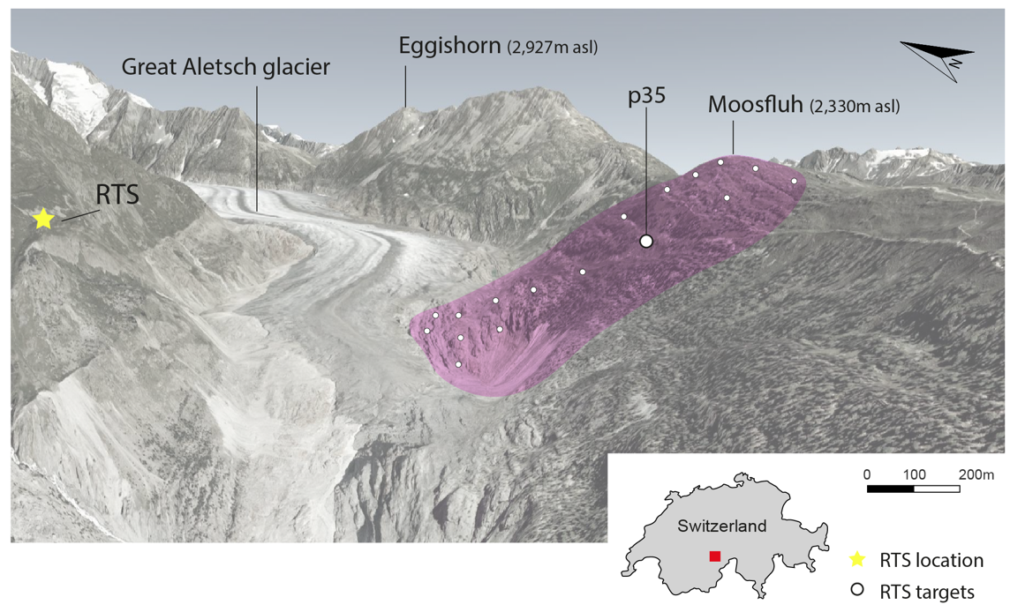

Figure 2: Overview of the Great Aletsch glacier terminus (from Google Earth imagery) and of the unstable area affecting the Moosfluh slope (pink shading). Relevant RTS monitoring targets located on the slope (white circles) are shown. More information on the historical evolution and on the complete RTS monitoring network can be found in (Glueer et al. 2019).
Figure 3a shows the evolution of the surface displacements measured at the point 35 (see location in Figure 2) between October 1st, 2014 and October 5th, 2016. Displacements are converted towards the line-of-sight (LOS) of Sentinel-1 (descending track, relative orbit 66). This monitoring point was selected here because is the longest continuous RTS measurement record, and also because is representative of the evolution of the whole deep-seated slope instability during the last five years and not only of very localized processes. The time series evidences a power-law evolution (as described for accelerating creep phases, (Crosta et al. 2017)) reaching asymptotic trend towards the end of September, 2016. Seasonal velocity changes are clearly visible in the displacement time series (see also zoom in Figure 3b), and well correlated with snow melt periods (see Figure 3e-f).

Figure 3c-d shows only DInSAR pairs that would respect the phase aliasing threshold of Sentinel-1 (i.e. displacement <1.4 cm between pairs) among all possible combinations. The shortest revisit time considered here was 12 days, as the 6 days revisit time started to be available only towards the end of 2016. The results show that during winter periods, when the velocity of Moosfluh is relatively small, Sentinel-1 pairs up to 36 days can be theoretically exploited to retrieve unbiased information on surface displacements. However, during alpine winters snow cover deeply affects the quality of DInSAR measurements (Wasowski and Bovenga 2014). As soon as the landslide velocity increases in spring due to the effect of snow melt (see detail on Figure 3b and 3d for spring 2015), all the Sentinel-1 pairs would be affected by phase aliasing. This means that, despite the resulting time series obtained from multitemporal DInSAR processing might look reasonable, the sensor has intrinsically lost its capability to measure the full amount of displacement occurred between two acquisitions. This effect would be only partially mitigated by the use of the current temporal resolution of the Sentinel-1 constellation over Europe (i.e., 6 days, see Figure S1, Supplementary Information). In addition, for the specific case of Moosfluh we observe that starting from spring 2016, i.e. the critical phase when the landslide is severely accelerating towards a potentially catastrophic evolution, all the Sentinel-1 pairs would underestimate the displacement, and thus affect any attempt of time-of-failure forecast. On the other hand, we remind that despite the dramatic evolution experienced by the Moosfluh slope in 2016, a catastrophic slope failure has not occurred (Manconi et al. 2018b).

- Discussion and conclusions
In this study, the effect of DInSAR temporal phase aliasing on the investigation of accelerating creep of alpine slopes was analyzed. Moreover, a representative case scenario of alpine rock slope instability was presented. The results show that the accelerating creep stage might mislay accurate satellite DInSAR measurement of surface displacements many months before the occurrence of ultimate failure due to the overcome of phase aliasing thresholds. Moreover, the velocity of ambiguity can be reached also during relatively short periods of slope accelerations, e.g. also when displacements are triggered by pore pressure changes associated to groundwater recharge. For example, seasonal ground accelerations in the Alps start during snow melt periods (e.g., as soon as temperatures increase between end of March and beginning of May). During this time, major portions of the slopes are still covered by snow, which is unfavorable to SAR coherence and thus hinders quality of the multitemporal DInSAR results (Ferretti et al. 2011; Bovenga et al. 2018). Additionally, further landslide accelerations might occur in relatively short time due to intense rainfall events in summer and/or fall (Loew et al. 2017b). Since surface acceleration due to rainfall trigger is a common observation not only in alpine slopes but also in other geological and geomorphological settings (Bayer et al. 2018), phase aliasing thresholds should be taken into account also there for a correct interpretation of DInSAR results. The use of L-Band SAR sensors, such as the ALOS-2, assuming the nominal revisit time of 14 days could provide a better solution to increase the possibility to follow the displacements during critical phases before failure below surface velocities of 3 mm/day. However, the availability of systematic ALOS-2 acquisitions every 14 days for ALOS-2 is very limited. In future, satellite implementations as the NISAR mission (L-Band and revisit time of 12 days at global scale) will further help in these analyses (Rosen et al. 2017). However, a revisit time of 12 days is still too coarse for early warning tasks.

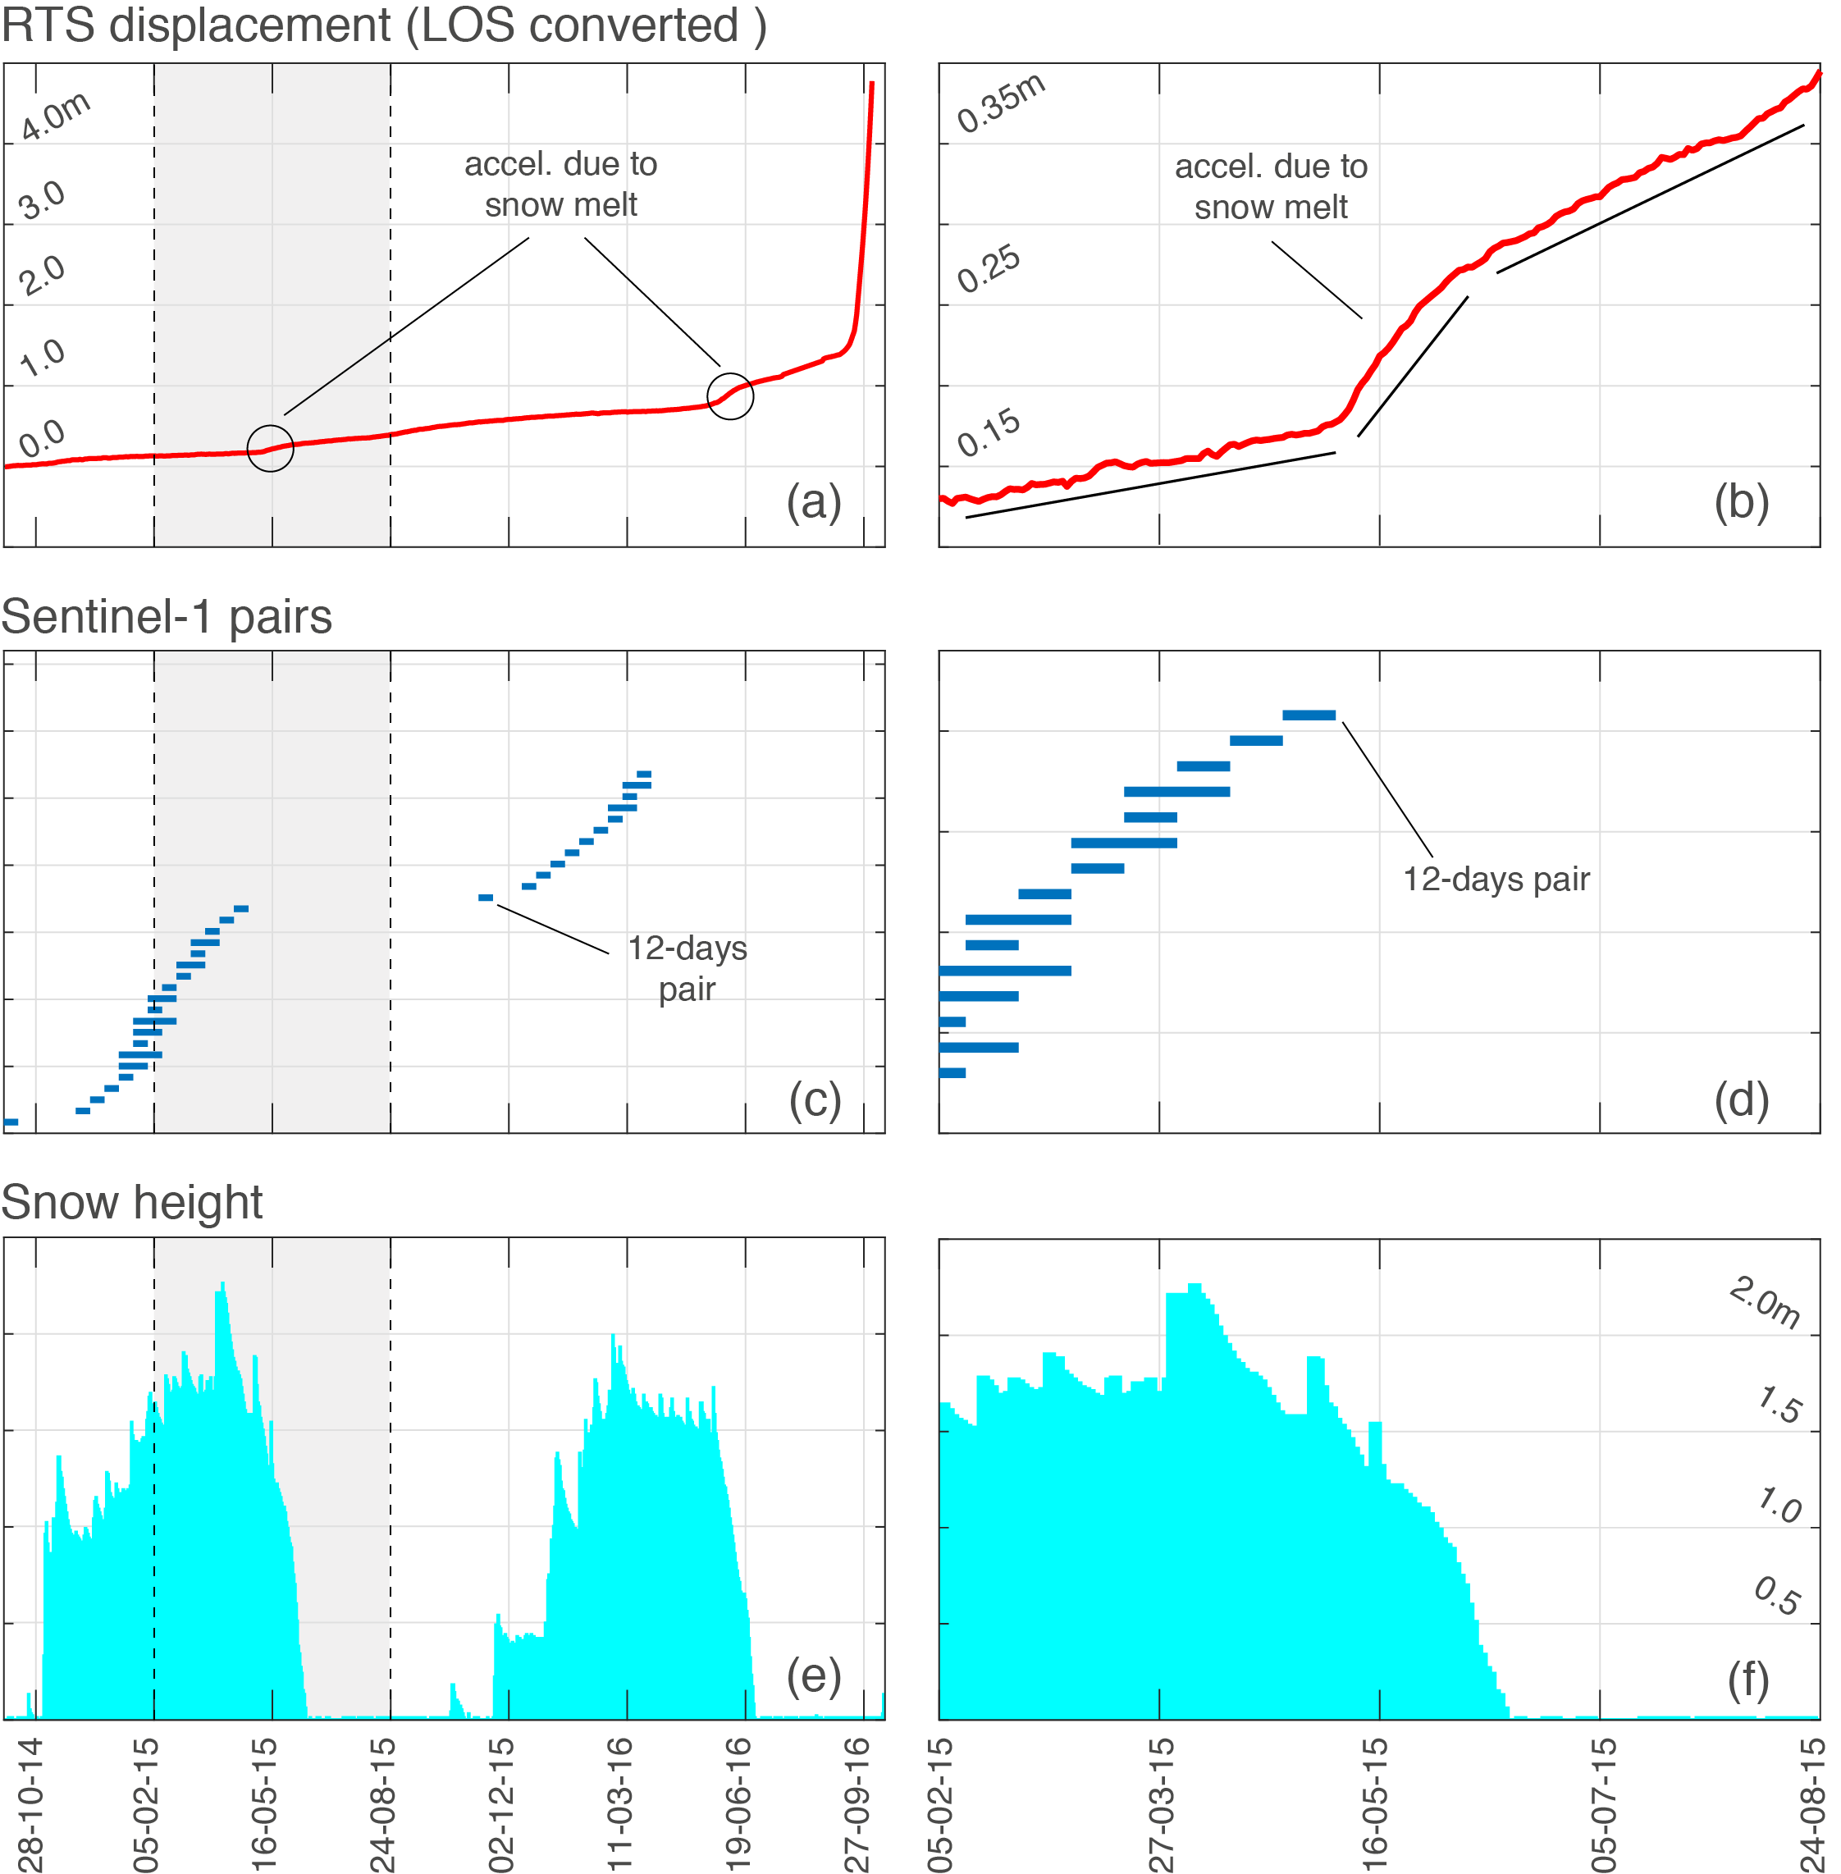

Figure 3: Evolution of the Moosfluh rock slope instability during a period of about 2 years, i.e., between October 1st, 2014 (shortly after the installation of the RTS at the location Driest) and October 5th, 2016 (peak of the displacements during the crisis). Left panels show the full time series, while right panels are zooms of the period February 5th, 2015 – August 24th, 2015. (a) Surface displacement time series recorded with RTS at the point 35. The displacements have been converted towards the LOS of the Sentinel-1 descending orbit n. 66. The zoom on the panel (b) shows a typical example of seasonal acceleration affecting alpine slopes during snow melt periods. (c-d) DInSAR pairs that would be not affected by temporal phase aliasing, i.e. displacement between pairs is lower than 1.4 cm. (e-f) Snow height time series as recorded at the weather station Eggishorn (see location in Figure 2). See text for more details.

Because slope accelerations occasionally lead to slope failure, the possibility to forecast landslide evolution from space over wide regions and eventually predict the time-of-failure is an appealing goal. However, systematic misdetection of surface displacements due to DInSAR phase aliasing would result in a progressive underestimation of the landslide temporal evolution, and potentially to misleading evaluation of displacement anomalies. In very specific cases, a-posteriori investigations might show successful failure predictions based on the analysis of DInSAR time series with the Fukuzono-Voigth relationship (Intrieri et al. 2017). These examples cannot be generalized, however, to support the conclusion that DInSAR is currently an efficient monitoring approach for systematic and/or operational management of early warning contexts in alpine settings. Indeed, (Moretto et al. 2017) has shown how the chances of prediction based on multitemporal DInSAR decrease when considering a large number of past failure events of different volumes and in different environments. The use of classical in-situ monitoring and/or ground based radar systems appears currently to be a more (if not the sole) reliable solution for early warning and/or failure forecast attempts based on the Fukuzono-Voight equation (Carlà et al. 2019, 2018; Crosta et al. 2017; Loew et al. 2017b; Manconi et al. 2018b). Nevertheless, while in back analyses forecast model fit can be calibrated efficiently as the failure time is known, experiences of failure predictions in near-real time by exploiting accurate in-situ monitoring systems has shown that slopes might not fail catastrophically despite clear accelerating creep behavior (e.g., Manconi and Giordan 2015). This suggests that the range of validity of the accelerating creep theory might be limited, and cannot be generalized in all landslide monitoring scenarios.

Additional constraints imposed by the use of space borne SAR in mountain areas have to be also carefully considered, especially when applied for operational monitoring and anomaly detection over regional scales as recently proposed (Raspini et al. 2018; Solari et al. 2019). Atmospheric phase delay may seriously affect the accuracy of DInSAR measurements if not properly corrected (Ding et al. 2008; Crosetto et al. 2018). Moreover, due to satellite acquisition geometries and local topography, the areas affected by layover and shadowing effects cannot be monitored at all (Cigna et al., 2014). For example, the recent Piz Cengalo rock avalanche occurred in August 2017, one of the largest catastrophic failures occurred in the Alps over the last 20 years causing 8 fatalities and consistent damage in the Val Bondasca, Swiss Alps, occurred in an area mostly affected by layover and its evolution could be not mapped nor monitored in advance with space borne DInSAR. Several unknown unstable slopes are potentially located in areas not visible from satellites, or have displacements that already overcome phase aliasing thresholds. Thus, satellite DInSAR applications aimed at systematic and/or automatic early warning at regional scales should always provide a statistical assessment of potential false and missed alarms expected in the specific region of interest, otherwise evaluations could be misleading. In conclusion, satellite DInSAR is surely an invaluable source of information on landslide displacements, however, the intrinsic limitations have to be always carefully presented to avoid extreme generalization and overrating of this monitoring technique.

References
Agliardi F, Crosta GB, Zanchi A, Ravazzi C (2009) Onset and timing of deep-seated gravitational slope deformations in the eastern Alps, Italy. Geomorphology 103:113–129. doi: 10.1016/j.geomorph.2007.09.015
Ambrosi C, Strozzi T, Scapozza C, Wegmüller U (2018) Landslide hazard assessment in the Himalayas (Nepal and Bhutan) based on Earth-Observation data. Eng Geol. doi: 10.1016/j.enggeo.2018.02.020
Barra A, Monserrat O, Crosetto M, et al (2017) Sentinel-1 Data Analysis for Landslide Detection and Mapping: First Experiences in Italy and Spain. In: Advancing Culture of Living with Landslides. Springer, Cham, pp 201–208
Bayer B, Simoni A, Mulas M, et al (2018) Deformation responses of slow moving landslides to seasonal rainfall in the Northern Apennines, measured by InSAR. Geomorphology 308:293–306. doi: 10.1016/j.geomorph.2018.02.020
Berardino P, Fornaro G, Lanari R, Sansosti E (2002) A new algorithm for surface deformation monitoring based on small baseline differential SAR interferograms. IEEE Trans Geosci Remote Sens 40:2375–2383. doi: 10.1109/TGRS.2002.803792
Bovenga F, Belmonte A, Refice A, et al (2018) Performance Analysis of Satellite Missions for Multi-Temporal SAR Interferometry. Sensors 18:. doi: 10.3390/s18051359
Bürgmann R, Rosen PA, Fielding EJ (2000) Synthetic aperture radar interferometry to measure Earth’s surface topography and its deformation. Annu Rev Earth Planet Sci 28:169–209
Carlà T, Farina P, Intrieri E, et al (2018) Integration of ground-based radar and satellite InSAR data for the analysis of an unexpected slope failure in an open-pit mine. Eng Geol 235:39–52. doi: 10.1016/j.enggeo.2018.01.021
Carlà T, Intrieri E, Traglia FD, et al (2017) Guidelines on the use of inverse velocity method as a tool for setting alarm thresholds and forecasting landslides and structure collapses. Landslides 14:517–534. doi: 10.1007/s10346-016-0731-5
Carlà T, Nolesini T, Solari L, et al (2019) Rockfall forecasting and risk management along a major transportation corridor in the Alps through ground-based radar interferometry. Landslides. doi: 10.1007/s10346-019-01190-y
Casu F, Manzo M, Lanari R (2006) A quantitative assessment of the SBAS algorithm performance for surface deformation retrieval from DInSAR data. Remote Sens Environ 102:195–210. doi: 10.1016/j.rse.2006.01.023
Cigna F, Bateson LB, Jordan CJ, Dashwood C (2014) Simulating SAR geometric distortions and predicting Persistent Scatterer densities for ERS-1/2 and ENVISAT C-band SAR and InSAR applications: Nationwide feasibility assessment to monitor the landmass of Great Britain with SAR imagery. Remote Sens Environ 152:441–466. doi: 10.1016/j.rse.2014.06.025
Coe JA, Bessette-Kirton EK, Geertsema M (2017) Increasing rock-avalanche size and mobility in Glacier Bay National Park and Preserve, Alaska detected from 1984 to 2016 Landsat imagery. Landslides 1–15. doi: 10.1007/s10346-017-0879-7
Crosetto M, Devanthéry N, Monserrat O, et al (2018) A Persistent Scatterer Interferometry Procedure Based on Stable Areas to Filter the Atmospheric Component. Remote Sens 10:1780. doi: 10.3390/rs10111780
Crosta GB, Agliardi F (2002) How to obtain alert velocity thresholds for large rockslides. Phys Chem Earth Parts ABC 27:1557–1565
Crosta GB, Agliardi F, Rivolta C, et al (2017) Long-term evolution and early warning strategies for complex rockslides by real-time monitoring. Landslides 1–18. doi: 10.1007/s10346-017-0817-8
Crosta GB, di Prisco C, Frattini P, et al (2014) Chasing a complete understanding of the triggering mechanisms of a large rapidly evolving rockslide. Landslides 11:747–764. doi: 10.1007/s10346-013-0433-1
Crosta GB, Frattini P, Agliardi F (2013) Deep seated gravitational slope deformations in the European Alps. Tectonophysics 605:13–33. doi: 10.1016/j.tecto.2013.04.028
Delgado Blasco JM, Foumelis M, Stewart C, Hooper A (2019) Measuring Urban Subsidence in the Rome Metropolitan Area (Italy) with Sentinel-1 SNAP-StaMPS Persistent Scatterer Interferometry. Remote Sens 11:129. doi: 10.3390/rs11020129
Ding X, Li Z, Zhu J, et al (2008) Atmospheric Effects on InSAR Measurements and Their Mitigation. Sensors 8:5426–5448. doi: 10.3390/s8095426
Dini B, Manconi A, Loew S (2019) Investigation of slope instabilities in NW Bhutan as derived from systematic DInSAR analyses. Eng Geol. doi: 10.1016/j.enggeo.2019.04.008
Federico A, Popescu M, Elia G, et al (2012) Prediction of time to slope failure: a general framework. Environ Earth Sci 66:245–256. doi: 10.1007/s12665-011-1231-5
Ferretti A, Fumagalli A, Novali F, et al (2011) A New Algorithm for Processing Interferometric Data-Stacks: SqueeSAR. IEEE Trans Geosci Remote Sens 49:3460–3470. doi: 10.1109/TGRS.2011.2124465
Ferretti A, Prati C, Rocca F (2001) Permanent scatterers in SAR interferometry. IEEE Trans Geosci Remote Sens 39:8–20. doi: 10.1109/36.898661
Fey C, Wichmann V, Zangerl C (2017) Reconstructing the evolution of a deep seated rockslide (Marzell) and its response to glacial retreat based on historic and remote sensing data. Geomorphology. doi: 10.1016/j.geomorph.2017.09.025
Filippazzo G, Dinand S (2017) The Potential Impact Of Small Satellite Radar Constellations On Traditional Space Systems. 12
Frattini P, Crosta GB, Rossini M, Allievi J (2018) Activity and kinematic behaviour of deep-seated landslides from PS-InSAR displacement rate measurements. Landslides 15:1053–1070. doi: 10.1007/s10346-017-0940-6
Glueer F, Loew S, Manconi A (2019) Paraglacial history and structure of the Moosfluh Landslide (1850–2016), Switzerland. Geomorphology. doi: 10.1016/j.geomorph.2019.02.021
Grämiger LM, Moore JR, Gischig VS, et al (2017) Beyond debuttressing: Mechanics of paraglacial rock slope damage during repeat glacial cycles. J Geophys Res Earth Surf 122:1004–1036. doi: 10.1002/2016JF003967
Haghshenas Haghighi M, Motagh M (2017) Sentinel-1 InSAR over Germany: Large-Scale Interferometry, Atmospheric Effects, and Ground Deformation Mapping. Zfv – Z Für Geodäsie Geoinformation Landmanagement 245–256. doi: 10.12902/zfv-0174-2017
Hansmann J, Loew S, Evans KF (2012) Reversible rock-slope deformations caused by cyclic water-table fluctuations in mountain slopes of the Central Alps, Switzerland. Hydrogeol J 20:73–91. doi: 10.1007/s10040-011-0801-7
Hermanns RL, Folguera A, Gonzáles Diaz FE, Fauque L (2006) Landslide dams in the Central Andes of Argentina–showing the need of revising the established landslide dam classification. Ital J Eng Geol Env 1:55–60
Hooper A (2008) A multi-temporal InSAR method incorporating both persistent scatterer and small baseline approaches. Geophys Res Lett 35:L16302. doi: 10.1029/2008GL034654
Hungr O, Leroueil S, Picarelli L (2013) The Varnes classification of landslide types, an update. Landslides 11:167–194. doi: 10.1007/s10346-013-0436-y
Intrieri E, Raspini F, Fumagalli A, et al (2017) The Maoxian landslide as seen from space: detecting precursors of failure with Sentinel-1 data. Landslides 1–11. doi: 10.1007/s10346-017-0915-7
Kos A, Amann F, Strozzi T, et al (2016) Contemporary glacier retreat triggers a rapid landslide response, Great Aletsch Glacier, Switzerland. Geophys Res Lett 43:12,466-12,474. doi: 10.1002/2016GL071708
Lanari R, Casu F, Manzo M, et al (2007) An Overview of the Small BAseline Subset Algorithm: a DInSAR Technique for Surface Deformation Analysis. Pure Appl Geophys 164:637–661. doi: 10.1007/s00024-007-0192-9
Loew S, Gischig V, Glueer F, et al (2017a) Multidisciplinary monitoring of progressive failure processes in brittle rock slopes. In: Rock Mechanics and Engineering Volume 4: Excavation, Support and Monitoring, Xia-Ting Feng. CRC Press, London, pp 629–662
Loew S, Gschwind S, Gischig V, et al (2017b) Monitoring and early warning of the 2012 Preonzo catastrophic rockslope failure. Landslides 14:141–154. doi: 10.1007/s10346-016-0701-y
Loew S, Lützenkirchen V, Hansmann J, et al (2015) Transient surface deformations caused by the Gotthard Base Tunnel. Int J Rock Mech Min Sci 75:82–101. doi: 10.1016/j.ijrmms.2014.12.009
Manconi A, Casu F, Ardizzone F, et al (2014) Brief communication: Rapid mapping of event landslides: the 3 December 2013 Montescaglioso landslide (Italy). Nat Hazards Earth Syst Sci Discuss 2:1465–1479
Manconi A, Coviello V, Galletti M, Seifert R (2018a) Short Communication: Monitoring rockfalls with the Raspberry Shake. Earth Surf Dyn 6:1219–1227. doi: https://doi.org/10.5194/esurf-6-1219-2018
Manconi A, Giordan D (2015) Landslide early warning based on failure forecast models: the example of the Mt. de La Saxe rockslide, northern Italy. Nat Hazards Earth Syst Sci 15:1639–1644. doi: 10.5194/nhess-15-1639-2015
Manconi A, Kourkouli P, Caduff R, et al (2018b) Monitoring Surface Deformation over a Failing Rock Slope with the ESA Sentinels: Insights from Moosfluh Instability, Swiss Alps. Remote Sens 10:672. doi: 10.3390/rs10050672
Meisina C, Zucca F, Notti D, et al (2008) Geological interpretation of PSInSAR Data at regional scale. Sensors 8:7469–7492. doi: 10.3390/s8117469
Moretto S, Bozzano F, Esposito C, et al (2017) Assessment of Landslide Pre-Failure Monitoring and Forecasting Using Satellite SAR Interferometry. Geosciences 7:36. doi: 10.3390/geosciences7020036
Novellino A, Cigna F, Sowter A, et al (2017) Exploitation of the Intermittent SBAS (ISBAS) algorithm with COSMO-SkyMed data for landslide inventory mapping in north-western Sicily, Italy. Geomorphology 280:153–166. doi: 10.1016/j.geomorph.2016.12.009
Petley DN, Bulmer MH, Murphy W (2002) Patterns of movement in rotational and translational landslides. Geology 30:719–722. doi: 10.1130/0091-7613(2002)030<0719:POMIRA>2.0.CO;2
Rabus B, Pichierri M (2018) A New InSAR Phase Demodulation Technique Developed for a Typical Example of a Complex, Multi-Lobed Landslide Displacement Field, Fels Glacier Slide, Alaska. Remote Sens 10:995. doi: 10.3390/rs10070995
Raspini F, Bianchini S, Ciampalini A, et al (2018) Continuous, semi-automatic monitoring of ground deformation using Sentinel-1 satellites. Sci Rep 8:7253. doi: 10.1038/s41598-018-25369-w
Rose ND, Hungr O (2007) Forecasting potential rock slope failure in open pit mines using the inverse-velocity method. Int J Rock Mech Min Sci 44:308–320. doi: 10.1016/j.ijrmms.2006.07.014
Rosen P, Hensley S, Joughin IR, et al (2000) Synthetic aperture radar interferometry. Proc IEEE 88:333–382
Rosen P, Hensley S, Shaffer S, et al (2017) The NASA-ISRO SAR (NISAR) mission dual-band radar instrument preliminary design. In: 2017 IEEE International Geoscience and Remote Sensing Symposium (IGARSS). pp 3832–3835
Sättele M, Krautblatter M, Bründl M, Straub D (2016) Forecasting rock slope failure: how reliable and effective are warning systems? Landslides 13:737–750. doi: 10.1007/s10346-015-0605-2
Schlögel R, Malet J-P, Doubre C, Lebourg T (2015) Structural control on the kinematics of the deep-seated La Clapière landslide revealed by L-band InSAR observations. Landslides. doi: 10.1007/s10346-015-0623-0
Solari L, Soldato MD, Montalti R, et al (2019) A Sentinel-1 based hot-spot analysis: landslide mapping in north-western Italy. Int J Remote Sens 0:1–24. doi: 10.1080/01431161.2019.1607612
Stead D, Eberhardt E (2013) Understanding the Mechanics of Large Landslides. Ital J Eng Geol Environ 85–112. doi: 10.4408/IJEGE.2013-06.B-07
Stead D, Wolter A (2015) A critical review of rock slope failure mechanisms: The importance of structural geology. J Struct Geol 74:1–23. doi: 10.1016/j.jsg.2015.02.002
Strozzi T, Delaloye R, Kääb A, et al (2010) Combined observations of rock mass movements using satellite SAR interferometry, differential GPS, airborne digital photogrammetry, and airborne photography interpretation. J Geophys Res Earth Surf 115:. doi: 10.1029/2009JF001311
Torres R, Snoeij P, Geudtner D, et al (2012) GMES Sentinel-1 mission. Remote Sens Environ 120:9–24. doi: 10.1016/j.rse.2011.05.028
Voight B (1988) A method for prediction of volcanic eruptions. Nature 332:125–130. doi: 10.1038/332125a0
Wasowski J, Bovenga F (2014) Investigating landslides and unstable slopes with satellite Multi Temporal Interferometry: Current issues and future perspectives. Eng Geol 174:103–138. doi: 10.1016/j.enggeo.2014.03.003
Zinno I, Bonano M, Buonanno S, et al (2018) National Scale Surface Deformation Time Series Generation through Advanced DInSAR Processing of Sentinel-1 Data within a Cloud Computing Environment. IEEE Trans Big Data 1–1. doi: 10.1109/TBDATA.2018.2863558

Supplementary Information

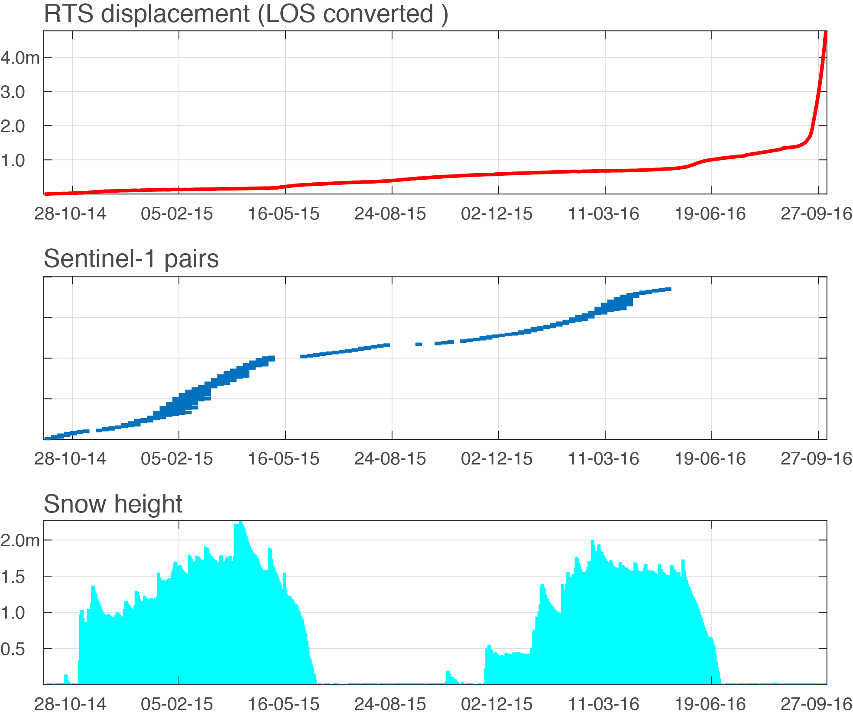
Figure S1: Same as Figure 3 but considering the minimum revisit time of 6-days for Sentinel pairs. Despite increased temporal resolution, periods of rapid acceleration as during snow melt are also affected by phase aliasing and thus underestimation of surface displacements.

