Understanding Low Cloud Mesoscale Morphology with an Information Maximizing Generative Adversarial Network
Tianle Yuan^{1,2,3}
¹Earth Sciences Directorate, NASA Goddard Space Flight Center
²Joint Center for Earth Systems Technology, University of Maryland, Baltimore County
³Benyuan Tech, Rockville, Maryland

Abstract

Generative adversarial networks (GANs) are a class of machine learning algorithms with two neural networks, one generator and one discriminator, playing adversarial games with each other. Information maximizing GANs (InfoGANs) is a particular GAN type that tries to maximize mutual information between a subset of latent variables and generated samples, thereby establishing a mapping between the latent variables and generated images. Here we demonstrate the feasibility of classifying low clouds mesoscale morphology with no human supervision by training an InfoGAN. We take a set of latent variables as mesoscale cloud morphology categories and successfully train a generator to map each category variable to realistic images that belong to a corresponding mesoscale morphology. The trained generator generates visually realistic cloud scenes. Furthermore, the model learns ten physically meaningful categories each corresponding to a particular morphology. We also show that by perturbing other latent variables while keeping the cloud category variable the same, the model can generate images that have the same morphology but with substantial variations. The trained discriminator can be used to classify real cloud scenes with limited training samples in the future.

1. Introduction
Low clouds display rich mesoscale morphologies such as open and closed cellular stratocumulus, stratus, scattered trade cumulus, aggregated trade cumulus (Atkinson & Zhang, 1996; Wood & Hartmann, 2006), which can be visually identified using satellite images. The radiative effect of low clouds can sensitively depend on their mesoscale morphology because the cloud fraction and cloud optical properties are related to mesoscale morphology. For example, scattered trade cumulus scenes have low overall cloud fraction and low values of cloud liquid water path while open cellular convection scenes have higher cloud fraction and usually much higher liquid water path. Furthermore, mesoscale morphology types are manifestations of distinct physical processes within the cloud fields. For example, relatively homogeneous stratocumulus cloud fields are products of strong radiative cooling at the cloud top within a relatively homogeneous environment ( Wood, 2012); open cellular structure can develop as a result of drizzle related mesoscale circulation (Feingold et al., 2010).

Significant progress has been made to understand mesoscale morphology of low clouds. Large-eddy simulations (LESs) have been deployed and their results suggest both large-scale environmental conditions and internal cloud processes play important role in determining the mesoscale morphology type(Feingold et al., 2010; Wang & Feingold, 2009a). Despite the progress, many open questions remain open. In particular, observational analyses of mesoscale morphology are relatively rare(Muhlbauer et al., 2014; Wood & Hartmann, 2006). In particular, current morphology classifications often focus on the stratocumulus regime while ignoring the vast areas covered by trade cumulus clouds. High cost of manual classification of satellite data and the challenge of automatic classification algorithm are contributing factors to the lack of adequate observational studies. Improved observational capability would help to better understand the low cloud mesoscale morphology and its relationship with environmental conditions.

Here we introduce an algorithm that can generate realistic images that belong to different maritime low cloud regimes without human supervision and can be used to classify natural satellite images of both low cloud scenes into different morphological categories. Section 2 introduces the data and method used in this paper. Section 3 presents results and discussion. Finally, we conclude in section 4.

2. Model and data

2.1 data
The MODerate resolution Imaging Spectroradiometer (MODIS) onboard both the Terra and the Aqua satellites has 36 spectral channels from deep blue to thermal infrared. Its measurements have been used for a wide range of applications and one of them is to observe and retrieve cloud properties(Platnick et al., 2016). We use single channel reflectance data at 0.55 µm as our training data. We use the 1km resolution data and apply a few simple filters to get only marine low cloud scenes. First, we remove pixels that have viewing zenith angles greater than 45 degrees to avoid edge pixels. We then use cloud phase and cloud height retrievals from the MOD06 products to keep scenes that are at least 5% covered by low clouds and whose high clouds fraction is less than 10%. Each scene is a 128x128 image and low clouds are defined as cloudy pixels whose cloud top does not exceed 3500m. We use Aqua data from January, April, July, and October of 2010 and the training data are randomly selected from a pool of 600,000 filtered scenes that come from the Northeast and Southeast Pacific. The data include both stratocumulus and trade cumulus clouds. We normalize the MODIS reflectance data so they have unit variance and zero mean.

2.2 model
We adopt the generative adversarial networks (GANs) approach(Goodfellow et al., 2014). GANs usually have two components: a generator and a discriminator, both of which are multilayer neural nets. The generator G(z) is used to generate samples from a noise vector z and the discriminator D(x) is used to tell if the input is from actual data or generated samples. The generator tries to generate realistic samples and fool the discriminator and discriminator tries to do the opposite and when the model reaches an equilibrium G(z) will generate realistic samples that are inseparable from data and D(x) will output a probability of 0.5. The training is achieved through playing a minimax game with the function V(G,D):
$\min_{G}{\max_{D}{V\left(D,G\right)= E_{x\sim p_{data}(x)}\left[logD(x)\right]+E_{z\sim p_{z}(z)}\left[log⁡(1-D\left(G\left(x\right)\right)\right]}}$.
In this paper, we use the information maximizing GAN (InfoGAN) (Chen et al., 2016) by adding a regularizing term to the minimax game:
$\min_{G}{\max_{D}{V_{I}\left(D,G\right)= V(D,G)}}-λI(c;G\left(z,c\right))$,
where $λ$ is a constant, c is a code vector, and $I(c;G)$ is the mutual information function that measures how much information can be learned about c from the knowledge of G. By adding the mutual information term, InfoGAN learns to couple the code vector c with generated samples. Our goal is to be able to generate samples that both are realistic and belong to 10 categories that are not predefined and learned by the model itself. In other words, the model will learn to generate samples that belong to 10 different categories without supervision. The learned D(x) can be minimally modified to classify observation data into different categories because it has already learned enough features of images during InfoGAN training.

We use a deep convolutional neural network that takes a noise vector z and code vector c as input for the generator. The generator has two densely connected layers and four convolutional layers that together produce a 128x128 image. Following the best practices proposed in the literature (Radford et al., 2015), we use a transposed convolutional layer followed by a convolutional layer. We use rectified linear unit as activation functions and add a batch normalization layer after each convolutional layer. The discriminator is also a deep convolutional neural network and it takes a 128x128 image as input and outputs a true or false to separate input into data and generated samples. It also outputs a code vector to represent what category the input most likely belongs to, based on mutual information function $I(c;G)$. For simplicity, we set $λ$ as 1. The discriminator is made of 5 layers of convolutional layers with each followed by a batch normalization layer. The final layers are a dense layer and softmax layer that computes the likelihood of binary flag.

During training, we alternate between training the generator and the discriminator by fixing the weights of one when training the other. We use a constant batch size of 64 and the Adam optimizer (Kingma & Ba, 2014). We train the model with a total of 60 epochs.

3. Results

3.1 Data and generated samples
Figure 1 shows a random selection of 100 MODIS images from our training data. Low clouds display a rich set of morphologies that can be categorized based on their visual features. We can relate these morphologies to cloud internal processes such as dynamics and microphysics. There are scenes of mostly overcast stratocumulus clouds such as G8, I3, G2 and A9. They often occur close to the coast of upwelling regions and result from relatively homogeneous longwave cooling at the cloud top (Wood, 2012). D2 and B5 are open cellular stratocumulus scenes although their cell forms are not classic hexagonal shapes. Significant precipitation within cloud fields is necessary for them to occur (Feingold et al., 2010). C7 and C8 and F8 are scenes that typically occur when closed cellular stratocumulus clouds move to waters of warmer sea surface temperatures than those of upwelling regions (Wang & Feingold, 2009b). They appear to have overall lower optical depth, but there are a few pixels with high optical depth scattered in the scene. These scenes would eventually transition into organized or scattered cumulus cloud fields. There are scenes of aggregated but non-cellular convective scenes such as I4 and I8. They occur often in the tropics where trade cumulus clouds dominate. Then there are many examples of scattered convective clouds that are either very low in cloud fraction such as A1, D1, G1, C2, or relatively high in cloud fraction such as B10 and E10. They are often characterized by cloud tops not higher than 3km and no significant clustering of convection. There are additional organization types that are not present in this set of examples. Therefore, it is not trivial to classify cloud scenes with such rich spatial structure information without human supervision.

Figure 2 shows a random selection of generated samples by the generator after 60 epochs of training on a 600,000-sample training set. This is a diverse set of samples with many different visual patterns and they appear quite similar to many real MODIS images in Figure 1. For example, G4, A10 and E10 appear to be the typical closed cellular stratocumulus clouds. A2, D3, and F1 are scattered cumulus clouds typically occur in the trade wind regions. D6 and H8 belong to the aggregated/clustered cumulus clouds that are also quite common in the real data. The open cellular convection scenes are not represented in this batch, but they do appear in the generated samples as will be discussed later. This batch of samples are dominated by scenes with low cloud fraction, consistent with what occurs in nature where the low cloud fraction trade cumulus regime dominates in terms of areal coverage (Medeiros & Stevens, 2011). These realistic generated images suggest that the generator learns a mapping function that is close to reality.

Figure 3 shows juxtapositions of randomly selected samples (top two rows) from the generator and equal number of real MODIS images (bottom two rows). It demonstrates that the generator can generate realistic and versatile MODIS samples. To distinguish the generated samples from real MODIS images is hard if they are randomly mixed. A good example is the pair of J2 and J3 that happen to be next to each other and they are so visually inseparable that it appears that they may be taken from the same cloud field. A1 and G4 belong to the same cloud regime and the generator captures the characteristics of this cloud regime quite well. J1 looks like an open cellular scene with rather large cell sizes. G3 is a real MODIS scene with closed cellular stratocumulus regime dominating. I1 is generated and it captures well the same type of regime. D2 is a stratus regime with no clear structure and it looks rather realistic from the visual context. Similarly, E2 is generated to have the characteristics of an aggregated shallow convection regime where shallow convective elements are clumped together to form larger clusters (Yuan, 2011). C1 and E1 do the same for scattered cumulus clouds.

3.2 Capture cloud morphology without supervision

In Figure 4, we show generated samples that belong to each of 10 categories that the model learns without supervision. Each row represents one category and shows six samples that are generated with a fixed category and different noise vectors. The ten cloud categories are well separated in cloud morphology, a proxy for cloud organization. More importantly, to the extent that we can determine cloud regimes based on the morphology, the model learns meaningful cloud categories that correspond well to our physical understanding. For example, row 6 represents stratus/stratocumulus cloud regimes with no clear cellular structures. Row 4 corresponds to typical closed cellular stratocumulus. Row 10 corresponds to clouds that are organized in irregular mixture of convective lines and cells. Row 5 represents more open cellular like convection. Rows 2, 3 and 9 correspond to cumulus clouds that have different overall cloud fraction and organizations. Row 2 corresponds to low cloud fraction conditions while rows 3 and 9 may represent suppressed convection with different spatial organizations. For each category, the generator can also generate diverse samples while maintaining the spatial structure of this particular category as shown in each row, which further testifies that the model learns meaningful mutual information between category and the corresponding cloud scene.

3.3 Discussions

Here we explore InfoGAN’s capability to find categorical information in the data. Continuous variables that represent other important physical meanings such as the cloud fraction and cloud brightness may also be disentangled from the noise vector. We are currently working to train the model to find representations in terms of continuous variables. This paper is a first step towards fully utilizing the power of InfoGANs to obtain interpretable and disentangled representations of cloud fields.

We test training the model with less and more categories. It appears that the model can manage to find meaningful categories. In the case of less categories, the model simply groups a few categories discussed here together because they appear more closely related. Further increasing the categories can make the resulting interpretation harder. We pick ten categories because this choice seems to offer clear interpretable categories and include a diverse set of categories.

In training the InfoGAN, we not only obtain the generator model to generate realistic samples, but also train a discriminator that are good at tell apart real data from generated samples and which category variable a sample should have. This usually means that the discriminator has learned good representations of the data distribution, which provides an excellent start for developing a classification model. It would only need limited labeled data to be trained in a supervised fashion into a good classification model, which saves time in preparing labeled data and training from scratch. We are preparing labeled data for this purpose. We will present the technique and results in a separate study.

4. Conclusions

In this paper, we train an InfoGAN to be able to generate realistic samples and learn mesoscale morphology of low clouds, from stratus to trade cumulus. The generator can generate samples that are hard to separate from real data because it captures the cloud morphology very well. The learnt categorical variables provide a physically sound scheme to categorize low cloud morphology that is consistent with our current understanding. With a fixed category, the generator can generate diverse samples that are morphologically consistent. Future work can take advantage of the learned discriminator to classify real low cloud scenes into different morphologies.

5. Reference

Atkinson, B. W., & Zhang, W. J. (1996). Mesoscale shallow convection in the atmosphere. Reviews Of Geophysics, 34(4), 403–431. https://doi.org/10.1029/96RG02623
Chen, X., Duan, Y., Houthooft, R., Schulman, J., Sutskever, I., & Abbeel, P. (2016). InfoGAN: Interpretable Representation Learning by Information Maximizing Generative Adversarial Nets. Retrieved from https://arxiv.org/abs/1606.03657v1
Feingold, G., Koren, I., Wang, H., Xue, H., & Brewer, W. A. (2010). Precipitation-generated oscillations in open cellular cloud fields. Nature, 466(7308), 849–852. https://doi.org/10.1038/nature09314
Goodfellow, I. J., Pouget-Abadie, J., Mirza, M., Xu, B., Warde-Farley, D., Ozair, S., et al. (2014). Generative Adversarial Networks. Retrieved from https://arxiv.org/abs/1406.2661v1
Kingma, D. P., & Ba, J. (2014). Adam: A Method for Stochastic Optimization. Retrieved from https://arxiv.org/abs/1412.6980v9
Medeiros, B., & Stevens, B. (2011). Revealing differences in GCM representations of low clouds. Climate Dynamics, 36(1–2), 385–399. https://doi.org/10.1007/s00382-009-0694-5
Muhlbauer, A., McCoy, I. L., & Wood, R. (2014). Climatology of stratocumulus cloud morphologies: microphysical properties and radiative effects. Atmospheric Chemistry And Physics, 14(13), 6695–6716. https://doi.org/10.5194/acp-14-6695-2014
Platnick, S., Meyer, K. G., King, M. D., & Wind, G. (2016). The MODIS Cloud Optical and Microphysical Products: Collection 6 Updates and Examples From Terra and Aqua. \ldots on Geoscience and \ldots. Retrieved from http://ieeexplore.ieee.org/abstract/document/7707459/
Radford, A., Metz, L., & Chintala, S. (2015). Unsupervised Representation Learning with Deep Convolutional Generative Adversarial Networks. ArXiv.Org. Retrieved from http://arxiv.org/abs/1511.06434v2
Wang, H., & Feingold, G. (2009a). Modeling mesoscale cellular structures and drizzle in marine stratocumulus. Part I: Impact of drizzle on the formation and evolution of open cells. Journal Of The Atmospheric Sciences, 66(11), 3237–3256. https://doi.org/10.1175/2009JAS3022.1
Wang, H., & Feingold, G. (2009b). Modeling Mesoscale Cellular Structures and Drizzle in Marine Stratocumulus. Part II: The Microphysics and Dynamics of the Boundary Region between Open and Closed Cells. Journal Of The Atmospheric Sciences, 66(11), 3257–3275. https://doi.org/10.1175/2009JAS3120.1
Wood, R. (2012). Stratocumulus Clouds. Monthly Weather Review, 140(8), 2373–2423. https://doi.org/10.1175/MWR-D-11-00121.1
Wood, R., & Hartmann, D. L. (2006). Spatial variability of liquid water path in marine low cloud: The importance of mesoscale cellular convection. Journal Of Climate, 19(9), 1748–1764.
Yuan, T. (2011). Cloud macroscopic organization: order emerging from randomness. Atmospheric Chemistry And Physics, 11(15), 7483–7490. https://doi.org/10.5194/acp-11-7483-2011

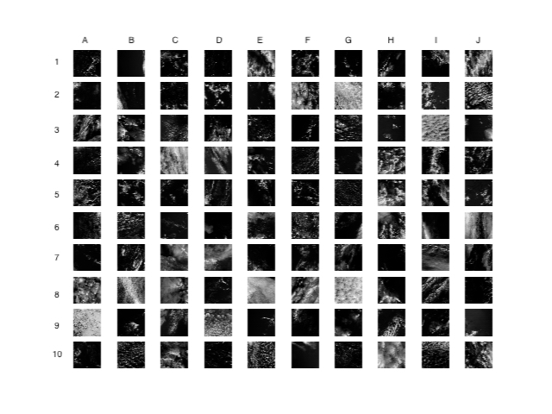
Figure 1: 100 random real MODIS images showing different low cloud morphologies. Each morphology category is often associated with a set of particular physical processes as explained in the text.
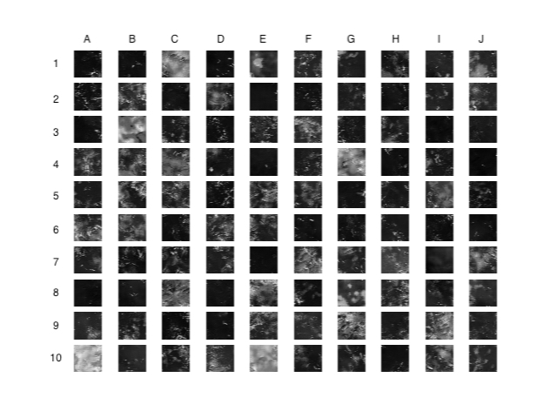
Figure 2: 100 random generated samples. The generator generates realistic samples that have different spatial structures. A few typical cloud morphologies are present in this set such as closed cellular and scattered cumulus scenes.

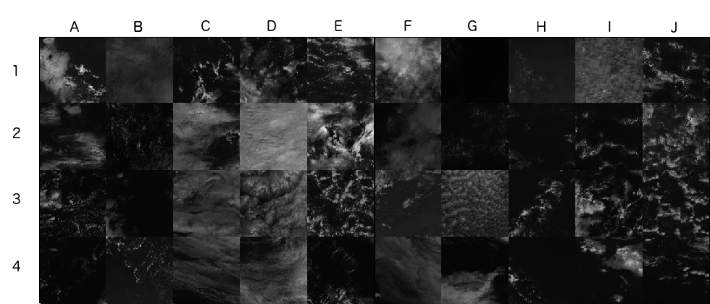
Figure 3: 20 real MODIS images (bottom two rows) and 20 generated samples (top two rows). The generator generates very realistic images that sometimes are hard to be separated from real data. This suggests the generator learns good approximation of the real data distribution.

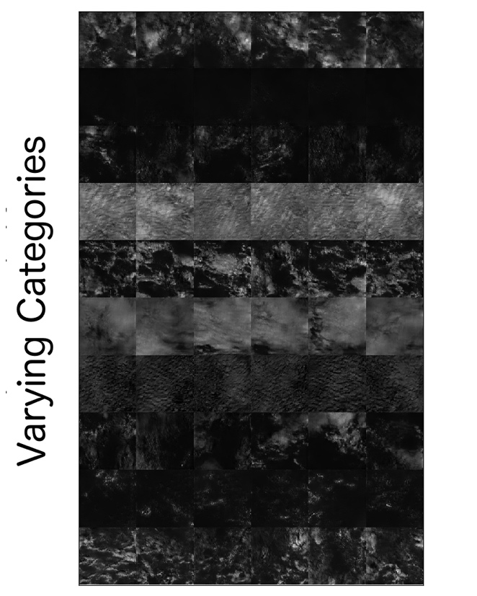
Figure 4: sixty images of generated samples with each of the 10 categories having six samples. Within a specific category, the generated scenes have consistent spatial structure while changing categories substantially change the spatial structure.

