The influence of basin settings and flow properties on the dimensions of submarine lobe elements

Spychala, Y.T.¹*, Eggenhuisen, J.T.¹, Tilston, M.¹, Pohl, F.¹

¹EuroSEDS, Department of Earth Sciences, Utrecht University, 3584 CB Utrecht, NL
*Corresponding author: yts@gmx.de

ABSTRACT
Submarine lobes have been identified within various deep-water settings, including the basin-floor, the base of slope and the continental slope. Their dimensions and geometries are postulated to be controlled by the topographical configuration of the seabed, sediment supply system and slope maturity. While confinement has been suggested as a main control factor for lobe dimensions, it does not explain the spread of lobe dimensions within individual systems.
Ten experiments were conducted in a 3D-flume to study the depositional characteristics of lobe associated with 1) different basin floor dipping angles (0-4°), 2) different sediment concentration of the parent turbidity current (11-19 % Vol), and 3) varying discharge (25 - 40 m³/h). Most runs produced lobate deposits that onlapped onto the lower slope independent of basin floor-dip and concentration. We determined that the deposits best describe the hierarchical level of lobe elements. Lobe element length is proportional to basin-floor angle and sediment volume concentration. A higher amount of bypass is observed in the proximal area as the basin-floor angles get steeper and concentrations higher. Deposits of runs with lower discharge could be traced higher upslope while runs with higher discharge produced an area of low deposition behind the channel mouth, i.e. discharge controls whether lobe deposits are attached or detached from their channel-levee systems. Integration of measured lobe element dimensions and particle advection length-scale analysis shows that latter can be used as a first order estimation of lobe element length. However, the estimations are strongly depended on the used average grain size (e.g. silt is still actively transported after all sand has been deposited) and the method cannot be used to locate the main depocentre. Furthermore, attempted reconstruction of turbidity current velocities from natural systems suggest that the method is not appropriate for use on more complex composite bodies as lobes.

Keywords: submarine lobes, experimental study. dimensions, advection length, sand vs. silt

INTRODUCTION

Submarine lobes are high aspect-ratio, sand-rich deposits fed by sediment gravity flows via channels. They are a major component of submarine fans, the largest depositional bodies on the planet, and therefore represent an important archive of palaeo-environmental change. Submarine lobe deposits are also of economic interest because of their potential as hydrocarbon reservoirs. Thus, lobe characteristics such as dimensions, geometries, volumes and depositional sand quality are of high interest (e.g. Mulder and Alexander, 2001; Portén et al., 2016).
Traditionally, submarine lobe deposits were described as simple radial bodies that thin and become progressively finer-grained away from an apex (e.g. Normark, 1970; Mutti, 1977; Normark, 1978; Luthi, 1981; Lowe, 1982; Bouma, 2000). However, it has recently been recognized that the geometry of lobe deposits is more complicated (e.g. Nelson et al., 1992; Twichell et al., 1992; Gervais, 2006; Hodgson et al., 2006; Deptuck et al., 2008; Prélat et al., 2009; Etienne et al., 2012; Burgreen & Graham, 2014, Grundvåg et al., 2014, Spychala et al., 2017a). It has also been observed that lobe dimensions and aspect-ratios do vary significantly within individual submarine fans (Deptuck et al., 2008; Jegou et al., 2008; Saller et al., 2008; Prélat et al., 2009; Bourget et al., 2010; Morris et al, 2014; see Fig. 1). The cause of this variation in lobe dimensions has not been studied yet, and will be the focus of this paper. Prélat et al. (2010) proposed that, while lobe volumes have a narrow range, which is independent of the size of the overall deepwater system they are deposited in, lobe geometries and dimensions show strong influence from the local topography and the up-dip supply system. Confinement is seen as a main controlling factor, dividing systems in unconfined and confined lobes (Prélat et al., 2010), whereas Hamilton et al. (2017) debate that supercritical vs. subcritical behaviour connected to slope angles is the main control on lobe dimensions.
Outcrops and seismic datasets allow the in-depth study of lobe facies, internal architecture and plan-view geometries. They do, however, not allow for the direct study of the influence of controlling parameters of flow discharge, sand:mud ratio and basin set-up that led to the deposits (Posamentier and Kolla, 2003; Prélat et al. 2010). Laboratory experiments allow the manipulation of specific boundary conditions, and therefore their influence on the deposits can be directly quantified. In addition, instrumental documentation of changes to the flow can be conducted systematically (e.g. Baas et al., 2004; Hamilton et al., 2017). While flume experiments traditionally focus on the behaviour of the flow itself, increasing effort has been invested to also model the development of prominent morphologies of submarine fans (e.g. Luthi, 1981; Ouchi et al., 1995; Parsons et al., 2002; Baas et al., 2004; Pyles et al., 2013; Fernandez et al., 2014; Hamilton et al., 2017, de Leeuw et al., 2018). Break in slope, channel dimensions, channel hydraulics and grain-size distribution have been suggested to have an important influence on the architecture of lobes (Baas et al., 2004; Prélat et al., 2010, Cantelli et al., 2011, Fernandez et al., 2014; Hamilton et al., 2017, De Leeuw et al., 2018).
It is generally assumed that length of turbidity current deposits is primarily determined by the velocity of the flow, settling velocity of the particles and flow thickness (e.g. Mulder and Alexander, 2001; Lamb et al., 2010; Ganti et al., 2014). Ganti et al. (2014) suggested a simple mathematical approximation to determine the advection length (l_{a}) of a variety of sedimentary features, including submarine fans built up by turbidity currents. Advection length is defined as the horizontal length over which a characteristic particle is transported in the flow before it settles to the ground. This approach deals with three simple parameters: flow velocity (u), average settling height (h_{s}) and settling velocity of the characteristic particle size (w_{s}). Whether this advection length method can be used as a first order estimation tool for deposit length from turbidity currents, or if other parameters like basin angle and turbulence intensity need to be incorporated, is untested. Using different grain sizes as characteristic particle will potentially lead to very different estimated length scales, especially in mixed systems that are built by flows that comprise sand and silt grains.
Here, we systematically investigate the influence of basin morphology, volume concentration and discharge of the parent flow on lobe dimensions and geometries, while we keep grain-size distribution and channel morphology constant. Specific aims for the presented study are 1) to study the range of dimensions and geometries observed from changing boundary conditions; 2) to investigate if observed depositional patterns can be related to flow properties; 3) to discuss which factors are controlling the differences in observed deposit shapes; 4) to debate if it is possible to predict dimensions and geometries from velocity (u) and settling velocity (w_{s}) alone, and, if yes, what are the caveats of this method? and, 5) to compare the discrepancy of predicted advection length using sand or silt particles as characteristic parameter.

METHODS
Set-up and procedure

The experiments are conducted in the Eurotank Flume Laboratory at Utrecht University. The Eurotank is 6 m wide and 11 m long. The tank was filled up with water to a level of 1.2 m (Fig. 2A). The bathymetry created in the tank consisted of a 11° slope, a variable dipping (0-4°) basin floor, and a horizontal termination at the end of the set-up that was used for setting up the measurement equipment (Fig. 2A). A channel (0.8 m wide and 0.05 m deep) with levees was built on the slope and restored to the same dimensions after each run. The channel dimensions are chosen to conform with the equilibrium channel regime presented by Heijnen et al. (in prep.). The entire set-up is covered by unconsolidated substrate allowing for erosion by the incoming turbidity currents. Shields scaling (de Leeuw et al., 2016, Pohl et al., in prep) was applied to create turbidity currents that allow for investigation of depositional processes.
The experimental series consist of ten runs in total; Runs 1-4 and 6 investigate the influence of the basin-floor dip (Series I), Runs 5-8 focus on the influence volume concentration of the sediment (Series II) and Runs 6,9 and 10 on different discharge (Series III). The values for each parameter in the individual runs are shown in Table 1. A mixture of sand and water (0.9 m³) with varying volume concentrations (Series II) was prepared in a separate mixing tank. The used sediment is a mixture of 75% quartz grains (density: 2650 kg/m³) and 25% ground glass (2500 kg/m³) and has a median grain size (d50) of 133 μm. The mixture is pumped into the Eurotank using a radial flow pump. The discharge rate was set to 30 m³/h for most of the runs except for the discharge series Run 9 and 10 (Table 1). The discharge was monitored with a discharge meter (Krohne Optiflux 2300). The mixture then enters the experimental set-up through an inlet box which has a 1 m section of non-erodible material attached to its front and gradually expanding side-walls. A small scour is generated where the flow passes onto the erodible section of the slope. As this erosion is an experimental artifact, it will be neglected in the evaluation of depositional and erosional patterns.

Data acquisition and processing
UVP
Velocity profiles of the turbidity currents were collected in four different locations (Fig.2B) using Ultrasonic Velocity Profiler probes (UVPs). The probes were set up 18 cm above the bed to prevent obstruction of the flow. They were oriented in a 60° angle to the local preformed bed. As the bed is the datum for the UVP data, and its position varies throughout the run due to erosion and deposition, the first step of the data processing phase involves identifying the temporal changes in bed position. Velocity profiles and flow thickness were averaged for individual runs for the body of the current. For time-averaged velocity profiles the start and end of the incoming current was picked with the first 5 seconds (current head) and last 10 seconds (current tail) omitted from the dataset. Bed-parallel velocity is calculated through trigonometry with the assumption that there is no average bed-perpendicular velocity and that the mean flow direction is in the vertical plane of the angled UVP beam.

DEM
Before and after each experiment a laser scan of the topography within the tank is conducted. These are used to create digital elevation models (DEMs) with a horizontal resolution of 2x2 mm and maps of the deposition and erosion that occurred during the runs. Changes in elevation less than 5 mm were omitted in the erosion/deposition maps to avoid interference of bed reworking (migration ripples) with depositional trends. After each experiment the dimensions (width, length, and thickness) of the lobe body and its relation to the base of slope (detached or attached) were documented (Fig. 3), as well as the channel length and its dip. Width and length were measured with a tape measure in the tank, whereas thickness was established by looking at the longitudinal cross-sections created from the DEMs. Strike-Cross-sectional areas, which are a proxy for the depocentre, were determined by subtracting the DEMs of the initial topography from those of the post experimental topography.
Deposits are interpreted as attached if their onset on deposition is on the slope, whereas deposits that show distinctive thickening on the basin floor are interpreted as detached.

RESULTS
Morphology of lobe deposits

In this section, we present the dimensions and geometries of the deposits in detail in association of the series they have been conducted in. A summary of the dimensions can be found in Table 2.

Series I: basin-floor slope
Run 1-4 and 6 (Series I) study the influence of the dipping angle of the basin floor on lobe dimensions and morphology. As the basin-floor angle increases from 0° to 4°, the length of the lobe increases from 310 cm to 383 cm, whereas the width of the lobe decreases from 186 cm to 139 cm (Table 2 and Fig.4). This means that aspect ratios (L/W) vary from 1.7 to 3.2 (Table 2). While the maximum thickness only shows slight variations from 8.8 to 6.2 cm, the location of the thickest part of the deposit is situated distinctly farther from the break-of-slope as the basin-floor becomes steeper (Fig. 5). As the point of maximum thickness is located further downstream, more of the sediment volume also becomes progressively accumulated farther downstream, in effect relocating the depocentre out onto the basin floor (Fig. 6A). All deposits have prominent lobate cross-sections. The exception is Run 6 which shows a small indent (1 cm) to the generally convex top of the deposit in the proximal area (Fig. 6A), for the first 50 cm, after the break-of-slope. All deposits, except the one formed by Run 1, onlap onto the slope (Fig. 5).

Series II: sediment volume concentration
Run 5-8 (Series II) investigate the effect of varying sediment concentration. It can be observed that deposit length is proportional to concentration (Figs. 5C and 8), i.e. the run with the highest sediment concentration (Run 5; 19% Vol) is the longest (465 cm), whereas the run with the lowest concentration (Run 8; 13% Vol) is the shortest (340 cm). Deposits of Run 6 (17% Vol) and Run 7 (15% Vol) are 444 cm and 390 cm long, respectively (Fig. 9). Width dimensions do not show much variability (Table 2) ranging from 143 cm to 139 cm. It is worth noting that Run 8 has a narrower width of 123 cm, though. Aspect ratios (L/W) range from 2.7 to 3.4 (Table 2) which means that these deposits are highly elongated. Maximum thickness values show a clear decrease with lower sediment concentrations of the flow (Fig. 5). While a flow with 19% Vol has a deposit with the maximum thickness of 7.8 cm, a flow of 13% Vol has a deposit with a maximum thickness of 5.6 cm. In Series II, two distributions of sediment volume can be observed (Fig. 6B). The runs with the higher concentration (Run 5 and 6) have most of their sediment volume deposited in the intermediate to distal part of the lobe, while the runs with lower sediment concentration (Run 7 and 8) have most of their volume deposited in the proximal area. Cross-sections show small indents to the convex tops of the deposit for Run 5 and 6 (between 0.5 and 1 cm; up to 1.5 m from the break-of-slope), while Run 7 and 8 show prominent convex lobe geometries throughout the deposit (Fig. 8B). All runs of Series II show onlap onto the slope. Deposition in the channel becomes more prominent with decreasing sediment concentration of the flow.

Series III: Discharge
Finally, Runs 6, 9 and 10 (Series III) were conducted to examine the consequence of changing discharge to the dimensions of the resulting deposits. There is no observable trend in the length of the deposits associated with higher or lower discharge, in fact a discharge of 30m³/h (Run 6) produces a slightly longer lobe (444 cm) than a discharge of 40m³/h (Run 10; 430 m). The same is true for the width of the deposits (Table 2), that vary between 143 and 118 cm, and maximum thickness that show a range from 5.6 to 6.9 cm (Fig. 5), but no correlation to discharge changes. Aspect ratios (L/W) range from 3.1 to 3.4 (Table 2). The main depocentres for the resulting deposits are located in an intermediate to distal position, with the exception of Run 9 (lowest discharge; 25m³/h) that has more longitudinal uniformity in its depositional thickness (Fig. 6C). The main difference between the three runs is the point of onset of lobe deposition (Fig. 9). This point is located further down-dip with higher discharges. While the deposit of Run 9 onlaps high up on the slope (after 190 cm of slope length) shortening the total slope length, the deposit of Run 6 onlaps at 210 cm at the base of the slope, and the deposit of Run 10 is detached from the slope (250 cm from the inlet). An area of low deposition is located between the break-of-slope and the lobe for Run 10 (Fig. 9). It shows irregular geometries for 2 m after the break of slope before the deposit thickens and shows a convex geometry in cross-section. Deposits of Run 9 fill the channel form upslope, while deposition from Run 6 and 10 drape the channel form while keeping it with the same dimensions although slightly shallower (4.5 cm instead of 5 cm depth).
All of the experimental deposits show a ripple-field to the margins of the main sand body that is best developed to the frontal margin of the deposit (Fig. 9).

Flow properties
Flow velocities
At the break of slope the average velocity for the runs of Series I (Runs 1,2,3,4 and 6) varies from 0.64 m/s to 0.53 m/s with no observable trends in association with change in the downstream basin floor angle (Fig.10A). However, at the position of UVP 7 a pattern starts to develop: Run 6 which corresponds with the steepest basin floor (4°) maintains velocities of 0.34 m/s, whereas the maximum velocity decreases more abruptly with shallower basin-floor gradients and most with a horizontal basin floor (0.2 m/s).
For runs with changing concentration (Series II; Fig. 10B) it can be stated that runs with higher sediment volume concentration (Run 5 and 6) show slightly higher channel exit velocities (0.62 m/s and 0.63 m/s) than those with lower sediment volume concentrations (Run 7: 0.61 m/s; Run 8: 0.54 m/s). The trend becomes more prominent downstream, and velocities correlate positively with sediment concentration at the locations of UVP probes 6 and7. A similar trend can be observed in Series III (Fig. 10C), where runs with higher discharge show higher initial maximum velocities at the break of slope where the flow experiences the loss of confinement and a lower velocity decay rate.

Flow thickness
Flow thickness doesn’t show any clear trends for Series I and III (Fig. 10). In Series II it could be observed that runs with lower sediment volume concentrations (Run 7 and 8) have lower initial flow thicknesses and may thicken downstream (Run 8), while runs with higher sediment volume concentration (Run 5 and 6) are thicker on the break of slope and gradually thinner downstream.

DISCUSSION

Controlling factors of lobe length and geometries
The runs of Series I show that lobe element deposits get subsequently longer, narrower and thinner when the basin-floor angle is increased. This is due to slower loss of streamwise velocity as gravity forces acting on the current counteract its deceleration through loss of excessive density as the flow deposits sediment. There is a lag time until the current adjusts to the new conditions on the basin floor (Mulder and Alexander, 2001) therefore the correlation in flow deceleration with basin-floor angle can best be observed in UVP 7 (Fig. 10A). The deposit of Run 1 detached from the slope as sediment suspension is enhanced as energy from downslope travel needs to be dissipated at this abrupt break in slope (11°), depositing the grains according to flow velocity and settling velocity, i.e. the faster the flow the further detached the lobe deposit (e.g. Mulder and Alexander, 2001; Gray et al., 2005). Successively the current loses its capacity to carry the bulk of sediment and becomes strongly depletive (Cantero et al., 2014; Eggenhuisen et al., 2017). In contrast to this scenario, basin floor angles that are more inclined enable sediment to be bypassed more efficiently throughout the basin, eventually relocating the depocentre of the lobe element (Run 6; Fig. 6A).
The outcome of Series II shows that changing volume concentration primarily controls lobe element length and the position of the depocentre, while lobe width does not seem to be much influenced. Higher concentration runs have higher initial velocities compared to low concentration runs due to more excess density (Run 8 vs. Run 5; Fig. 10B), i.e. their driving force is bigger. This conforms with observations made on enhanced flow efficiency associated with higher initial densities (Laval et al., 1988; Gladstone et al., 1998; Al Ja’Aidi et al., 2004). Additionally, higher concentration runs show slower velocity-loss downstream as the overall sediment concentration of the current throughout remains higher compared to low concentration runs. The geometry of the deposit and volume distribution of higher concentration flows suggest that the sediment concentration has reached a limit where hindered settling (Richardson and Zaki, 1954) has at least a partial influence (Kneller and Branney, 1995). Also, indents in the convex tops of the lobate deposits (Run 5 and Run 6; Fig. 8A) point to an increased bypass rate in the proximal axial area of the deposits which explains the relocation of the lobe element depocenter farther downstream. These indent morphologies may be (a precursor of) distributary lobe-top channels (see Jegou et al., 2008). It remains to be tested if they represent long-term conduits (Mutti and Normark, 1987) or if they will be filled in by the next incoming event.
Series III shows that changing discharge does not affect the length of the lobe elements significantly, but steers whether the deposits are attached or detached from the slope. As higher discharge runs have higher velocities (Fig. 10) they have a higher capacity to transport sediment past the break of slope. Run 10 with the highest discharge transports the sediment farthest out into the basin producing the most elongated lobe element deposit (L/W: 3.4).
In summary, sediment suspension is maintained further into the basin by higher basin-floor slope, higher flow discharge, and higher sediment concentrations. The effect on the dimensions of the lobe differ, though: increased slope changes the planform dimensions, increased sediment volume concentration moves the depocenter further into the basin, and increased discharge controls the point of deposition onset while leaving the lobe dimensions more or less the same.
Level of hierarchy
When comparing experimental data to field data the proper level of hierarchy has to be established (cf. Hamilton et al., 2017) to make useful statements. We recognise that a lobe is a composite body comprised of predominantly compensational stacked lobe elements, that are themselves built of several beds (Deptuck et al., 2008; Prélat et al., 2009; Mulder & Etienne, 2010; Prélat et al., 2010; Bernhard et al., 2012; Etienne et al., 2012; Grundvåg et al., 2014; Marini et al., 2015; Picot et al., 2016; Zhang et al., 2016; Spychala et al., 2017a,b; see Fig. 11). This complexity cannot be modelled by single flow event experiments. However, it is documented that strength of compensation decreases with lower hierarchical levels (Straub et al., 2012), as bed-scale stacking is laterally constrained by the genetically related channel resulting in more or less aggradationally stacked beds that form lobe elements (Fig. 11). Therefore, we suggest that observations made during our experiments can be used to compare against lobe element bodies.

Lobe dimensions in natural systems
Prélat et al. (2010) suggested that confinement is the main force behind the division of thick and areally small, and thin, but areally extensive, lobe deposits. This was already debated by Hamilton et al. (2017) stating that higher slope angles can produce thicker lobes relative to their area without the need of confinement. Our experiments confirm this finding somewhat for lobe elements, although we show that the basin-floor angle does play as important a role as the slope angle. This suggests that lobe element deposited in relative steep dipping intraslope basins (e.g. Prather et al., 1998; Adeogba et al., 2005; Gamberi and Rovere, 2011; Barton et al., 2012; Pirmez et al., 2012) have different geometries from lobe elements deposited on the relative gentle dipping basin floor. However, lobes are composite bodies formed by several lobe elements creating significantly larger deposits. It is to be expected that confinement has an influence on lobe element stacking patterns (aggradational vs. compensational stacking), which will determine if the lobe body itself is thick and areally small, or thin and areally wide. Therefore, confinement cannot be dismissed as an important factor on the composite lobe bodies.
Increased sediment supply (sediment volume concentration and/or sediment discharge) to the basin, whether as a response to relative sea-level fall and/or progressive confinement and increase of turbidity current efficiency (Mutti, 1992; Gardner et al., 2003; Kneller, 2003; Hodgson et al., 2016), is thought to steer progradation of the turbidite system into the basin. Our experiments conform to this model such as runs with the highest sediment volume concentration and highest discharge (Run 5 and Run 10) are able to bypass more sediment basinwards. Increased bypass is marked either by an indent in the lobe element top or an area of relative low sedimentation rate that effectively detaches the lobe element deposit from the slope. In contrast, runs with low sediment concentration and discharge (Runs 8 and 9) may represent lobe elements formed during waning sediment supply to the basin through raising relative sea-level and/or channel system aggradation and widening.
This suggests that lobe deposits formed during low vs. high sediment supply may show distinctive different geometries in their morphology as well as their relation with the channelized slope, raising the question if the erosive channel-lobe transition zone (e.g. Palanques et al., 1995; Wynn et al, 2002; Hofstra et al., 2015) is a transient feature and therefore rarely observed in ancient outcrops (cf. Brooks et al., 2018).

Can we estimate lobe element dimensions with simple mathematical assumptions?
Advection length, which is defined as the horizontal length of over which a characteristic particle is transported in the flow before it is deposited, has been proposed as a simple method to establish length scales of turbidity current deposits (Mulder and Alexander, 2001; Lamb et al., 2010; Ganti et al., 2014). It deals with three parameters only: flow velocity (u), average settling height (h_{s}) and settling velocity (w_{s}). Advection length (l_{a}) is defined as:
l_{a}= uh_{s}/w_{s} (1)
To test if the advection length approach leads to good estimations on lobe element length scales, we compare measured results from our experimental runs with estimated length values. To this end we use the average velocities reported from UVP 4 at the break of slope where the currents enter the unconfined basin floor and start spreading and depositing. As turbidity currents are density stratified (Kneller and Branney, 1995; Sohn, 1997; Amy et al., 2005, Cartigny et al., 2013; Cantero et al., 2014; Tilston et al., 2015), we cannot assume a homogeneous sediment concentration profile. Thus, we corrected the settling height for the currents’ near-bed concentration:
h_{s}= h/r_{o} (2)
with r_{o}= near bed concentration (%)/ initial concentration (%) (Ganti et al.,2014). Near-bed concentration data were taken from separate 2D experiments (Pohl et al., in review) for 17% sediment volume concentrations. Finally, we used the d₅₀ of the initial suspension (d₅₀= 133μm) as the characteristic grain size. All calculated advection lengths and measured lobe element lengths as well as used parameters can be found in Table 3.
Generally, predicted lengths are more than 50 % accurate. This means that advection length can be used as a first order estimation of lobe element length, although length values are consistently under predicted (Fig.12). We propose that this under prediction is due to the fact that the equation does not account for the effect of turbulence in turbidity currents (Middleton and Hampton, 1973; Southard and Mackintosh, 1981; Kneller and Buckee, 2000; Shringapure et al., 2012). Settling is counteracted by turbulent mixing, and grains will remain in suspension longer before they settle to the bed. This effect does not rely on an-isotropy of turbulent statistics (cf. Ganti et al. 2014), but on correlation between velocity and concentration fluctuations: upwards moving patches of fluid advect higher sediment concentrations upwards, while downwards moving patches of fluid advect lower sediment concentrations downwards. These correlated fluctuations average out to an upwards positive flux of sediment that works against the settling of sediment. In a steady flow that bypasses all of its sediment (sensu Stevenson et al., 2015), the settling flux is entirely balanced by the turbulent advection flux. In a depletive, but still turbulent turbidity current, the turbulent advection flux partially counteracts settling, and it is thus expected to delay deposition and carry sediment beyond the distances predicted by the advection length. The advection length resulted in the most accurate prediction for Run 1 and Run 5 (70 % accurate; Fig. 12). The turbidity current in this experiment travelled onto a horizontal basin-floor, and became highly depletive after passing the break of slope. It worked worst for Run 8 (48% accurate; Fig. 12), probably because near-bed concentrations are estimated too high and therefore the corrected settling height is too low. In general, factors that disturb the patterns of high depletive sedimentation, such as steeper basin floor-angles, and higher sediment concentration and discharge, lead to less accurate length predictions.
Length estimations with advection length approach have to be carried out keeping in mind that the final result is strongly linked to the used characteristic grain size (Fig. 13A). For example, in this case we have used a d₅₀ of 133 μm (fine sand) biasing our result to the sand grains in our currents. The effect on estimated lobe element dimensions by omitting silt particles is discussed below. In addition, although advection length is useful to predict dimensions for specific grain sizes, it is still important to have a firm understanding of the overall deposit geometry to pinpoint the main depocentre and its relation to the slope (attached vs. detached.) The principles behind advection length (a simple settling from a stratified flow, with lowest and coarsest grains settling fastest) suggests a simple tapering wedge shape for the created deposit with the main depocentre located proximal to the break of slope. However, basin-floor slope, high concentration, and high discharge shift the depocentre farther basinwards. Figure 13B illustrates how the calculated length of the deposit of Run 10 does not only underestimate the dimensions, but also poorly characterises the depocentre position of the lobe element.

Can we use advection length to reconstruct turbidity current velocities from natural systems?
Advection length is a simple method to estimate first order length scale for the deposits resulting from our experiments. The question that arises is if we could also use this method to give us an idea of the turbidity current velocities that have deposited natural systems. The data chosen to test this encompass four systems whose lobe dimensions, grain sizes and channel depth close to the channel-lobe transition zone were reported. Care was taken to ensure used lobe dimensions conform to the same hierarchical level. The datasets chosen include the Amazon Fan (Jegou et al., 2008), Fan 3, Tanqua depocentre, Karoo Basin (Prélat et al., 2009, Kane et al., 2017), the Golo Fan offshore Corsica (Deptuck et al., 2008; Hamilton et al., 2017) and the Pleistocene Fan, Kutai Basin, Indonesia (Saller et al., 2004, 2008). Table 4 shows all calculated velocities for these four systems.
With the exception of the reconstructed velocities from the Pleistocene Fan of the Kutai Basin (1.75 – 9.1 m/s) all the calculated values reconstructed from lobe measurements are deemed far too high (> 10 m/s) to be sensible in respect to other measured (0.4- 3.5 m/s depth-average flow velocity; Khripounoff et al., 2004; Cooper et al., 2012; Liu et al., 2012; Xu et al., 2014) and estimated ( 3.8 m/s depth-average flow velocity; Stevenson et al., 2018) turbidity current velocities from natural systems that are not caused by major earthquakes (up to 20 m/s; see Talling et al., 2013). However, using lobe element dimension from Fan 3 of the Karoo Basin a much more reasonable value of 4.2 m/s for the current velocity is estimated, although this is still somewhat high (Table 4). This outcome underlines anew the composite nature of lobe deposits that is a sum of their lobe element dimensions and stacking patterns which are in turn affected by the properties of incoming turbidity currents, their modification through the channel fairways and underlying topography. A lobe formed by progradational stacked lobe elements would for example result in overestimated flow velocities with this approach due to the successive basinward change of the transition from channel to lobe element as sediment is bypassed through the development of distributive channels that extend farther into the basin (see Ferguson et al. in review). On the other hand, lobe elements that are aggradationally stacked to form a lobe will give more reasonable estimations of current velocities. In addition, the maintenance of suspension into the basin through basin setting and sediment concentration of the turbidity current are other important factors that need to be taken into account as they can cause hindered settling and/or progradation into the basin. Our experiments taught us, that advection length is in average about 50% accurate. With that in mind calculated velocities are likely to be two times to high even on the lobe element scale. For the Karoo in particular this would result in velocities of 2.1 m/s, which are reasonable numbers for a system that has been continuously built up.

Depositional trends sand vs. silt

Silt-grained sediment is dominantly deposited in lobe fringe and distal lobe fringe environments (Prélat et al., 2009; Etienne et al., 2012; Grundvåg et al., 2014; Marini et al., 2015; Spychala et al., 2017a,b) and was suggested to form a wide halo around the sandy lobe proportion as silt will still be transported basinwards and deposits long after the sand-sized grains have settled out. Lack of exposure, insufficient seismic resolution, and bias towards sand-prone lobe deposits have impeded the estimation of length scales of these silt-prone deposits to be established, although they can create features of 100 meters thickness when lobe deposition experiences lateral confinement (cf. aggradational lobe fringes, Spychala et al., 2017b). Our experiments enable us to give first quantitative predictions on the distance silty material is transported and deposited after all sand has been deposited from the flow.
For Run 8 UVP 7 captures the transition from sand-prone deposits to silt-prone deposits. Average velocities at this point are still at 0.24 m /s. Settling velocities of silt sized grains are much smaller that for the sand (0.0014 m/s vs. 0.014 m/s). If we use the simple advection length method we can show that silt will be deposited for another 9.2 m (see Table 3) in a longitudinal direction, effectively changing lobe element length from 3.4 m to 12.6 m.
Consequently, we have to start thinking of lobes in a different way than before. The sand-prone part (lobe axis and off-axis environments) of a lobe only covers a small proximal portion of the whole deposit (Fig. 14) and transitions laterally into heterolithic packages that form the lobe fringes. The dimensions of the lobe fringes are governed by the variations in dimensions and the manner of stacking between beds and lobe elements. Finally, silt-prone distal fringes are the most areally widespread parts of lobes (Fig. 14). This results further strengthens the argument that several metres-thick siltstone intervals named “lobe fringe complexes” or “interlobes” (Prélat and Hodsgon, 2013; Spychala et al., 2017a) separating lobe complexes are formed by autogenic processes (Prélat et al., 2009; Spychala et al., 2017a) instead of genetical unrelated sedimentation (Satur et al., 2000; Johnson et al., 2001; Van der Werff and Johnson, 2003; Hodgson et al., 2006; Mulder and Etienne, 2010; McArthur et al., 2017), and may be traced laterally into sand-prone lobe complexes that are located up to several kilometers away.

CONCLUSIONS
Ten experimental runs where performed to test the influence of basin geometry, sediment volume concentration and discharge on lobe element dimensions and the architecture of their depositional bodies. We show that lobe element length is proportional to basin-floor angle and sediment volume concentration, whereas discharge is the main control factor on the onset of lobe element deposition. Higher amounts of bypass behind the break of slope are observed with steeper basin-floor angles, higher concentration and higher discharge. Future research should aim to cover multiple successive runs to test how these initially formed depositional bodies develop over time. Flow properties show only subtle differences.
Our results suggest that lobe element deposits formed during different stages of the sediment supply cycle have pertinent different geometries. We tested the option to estimate lobe element dimensions with the simple mathematical approach of advection length calculations. On a first order this method gives a good prediction of the length of lobe element deposits created in our experiments. However, a consistent under prediction of length scales is observed, because maintenance of sediment suspension into the basin through either turbulence production (basin floor slope and flow discharge), and hindered settling (sediment concentration) is neglected. Attempts to reconstruct turbidity current velocities that have deposited natural systems additionally show, that this approach is hierarchy dependent and cannot be expected to yield reasonable results for higher order composite sedimentary bodies, such as lobes and lobe complexes, that are built by a multitude of turbidity currents over an extended period of time.
Finally, we established that reconstructions of lobe geometries are biased towards their sandy parts, even though silt-prone deposits are still deposited long after all the sand grains have been depleted. This is partly due to missing outcrop exposures, seismic resolution, and partly due to a general bias to sand-prone lobe deposits. This outcome strengthens the interpretation of silt-prone intervals (termed distal lobe fringes or intralobes) to be formed by autogenic process of lobe deposition rather than representing background sedimentation.

ACKNOWLEDGEMENTS
This project was funded by NWO, ExxonMobil, Shell and Statoil for which we are thankful.

REFERENCES
Adeogba, A.A., McHargue, T.R. and Graham, S.A. (2005). Transient fan architecture and depositional controls from near-surface 3-D seismic data, Niger Delta continental slope. AAPG Bulletin 89, 627-643.

Al Ja’aidi, O.S., McCaffrey, W.D. and Kneller, B.C. (2004). Factors influencing the deposit geometry of experimental turbidity currents: implications for sand-body architecture in confined basins. In: Confined Turbidite Systems (Eds S.A. Lomas and P. Joseph). Geological Society, London, Spec. Publ., 222, 45-58.

Amy, L.A., Hogg, A.J., Peakall, J. and Talling, P.J. (2005). Abrupt transitions in gravity currents. J.Geophys. Res. 110, F03001.

Baas, J.H., Van Kesteren, W. and Postma, G. (2004). Deposits of depletive high-density turbidity currents: a flume analogue of bed geometry, structure and texture. Sedimentology 51, 1053-1088.

Barton, M.D. (2012). Evolution of an Intra-Slope Apron, Offshore Niger Delta Slope: Impact of step geometry on apron architecture. In: Application of the principles of seismic geomorphology to continental -slope and base-of-slope systems: Case studies from seafloor and near-seafloor analogues (Eds. B.E. Prather, M.E. Deptuck, D. Mohrig, B. van Hoorn and R.B. Wynn), SEPM Spec. Publ., 99, 181- 197.

Bouma, A.H. (2000). Fine-grained, mud-rich turbidite systems: Model and comparison with coarse-grained, sand-rich systems. In: Fine-grained Turbidite Systems (Eds. A.H. Bouma and C.G. Stone) AAPG Memoir 72/SEPM Spec. Publ., 68, 9-19.

Brooks, H.L., Hodgson, D.M., Brunt, R.L., Peakall, J., Hofstra, M. and Flint, S.S. (2018). Deep-water channel-lobe transition zone dynamics: Processes and depositional architecture, an example from the Karoo Basin, South Africa. Geol. Soc. Am. Bull., 130, 1723-1746.

Burgreen, B. and Graham, S. (2014). Evolution of a deep-water lobe system in the Neogene trench-slope setting of the East Coast Basin, New Zealand: Lobe stratigraphy and architecture in a weakly confined basin configuration. Mar. Petrol. Geol., 54, 1-22.

Bourget, J., Zaragosi, S., Mulder, T., Schneider, J.-L., Garlan, T., Van Toer, A., Mas, V. and Ellouz-Zimmermann, N. (2010). Hyperpycnal-fed turbidite lobe architecture and recent sedimentary processes: Acase study from the Al Batha turbidite system, Oman margin. Sed. Geol., 229, 144-159.

Cantelli, A., Pirmez, C., Johnson, S. and Parker, G. (2011). Morphodynamic and Stratigraphic Evolution of Self-Channelized Subaqueous Fans Emplaced by Turbidity Currents. J. Sed. Res., 81, 233-247.

Cantero, M., Balachandar, S., Cantelli, A. and Parker, G. (2014). A simplified approach to address turbulence modulation in turbidity currents as a response to slope breaks and loss of lateral confinement. Environment Fluid Mechanics, 14, 371-385.

Cartigny, M., J.B., Eggenhuisen, J.T., Hansen, E.W.M. and Postma, G. (2013). Concentration-Dependent Flow Stratification In Experimental High-Density Turbidity Currents and Their Relevance To Turbidite Facies Models. J. Sed. Res., 83, 1047-1065.

Cooper, C., Wood, J. and Andrieux, A. (2013). Turbidity current measurements in the Congo Canyon, OTC Abstract 23992. Offshore Technology Conference, 6–9 May, Houston, Texas 12 pp.

de Leeuw, J., Eggenhuisen, J.T. and Cartigny, M.J.B. (2016). Morphodynamics of submarine channel inception revealed by new experimental approach. Nature Comm., 7, Article number: 10886.

de Leeuw, J., Eggenhuisen, J.T., Spychala., Y.T., Heijnen, M.S., Pohl, F. and Cartigny, M.J.B. (2018). Sediment Volume and Grain-Size Partitioning between Submarine Channel-Levee Systems and Lobes: An Experimental Study. J. Sed. Res., 88, 1-18.

Deptuck, M.E., Piper, D.J.W., Savoye, B. and Gervais, A. (2008). Dimensions and architecture of late Pleistocene submarine lobes off the northern margin of East Corsica. Sedimentology, 55, 869-898.

Etienne, S., Mulder, T., Bez, M., Desaubliaux, G., Kwasniewski, A., Parize, O., Dujoncquoy, E. and Salles, T. (2012). Multiple scale characterization of sand-rich distal lobe deposit variability: Examples from the Annot Sandstones Formation, Eocene–Oligocene, SE France. Sed. Geol., 273, 274, 1-18.

Ferguson, R.A., Kane, I.A., Eggehuisen, J.T., Pohl, F., Tilston, M., Spychala, Y.T. and Brunt, R.L. (in review). Disentangling external and internal controls on submarine fan evolution.

Fernandez, R.L., Cantelli, A., Pirmez, C., Sequeiros, O. and Parker, G. (2014). Growth patterns of subaqueous depositional channel lobe systems developed over a basement with a downdip break in slope: Laboratory experiments. J. Sed. Res., 84, 168-182.

Gamberi, F. and Rovere, M. (2011). Architecture of a modern transient slope fan (Villafranca fan, Gioia basin–Southeastern Tyrrhenian Sea). Sed Geol., 236, 211-225.

Ganti, V., Lamb, M.P. and McElroy, B. (2014). Quantitative bounds on morphodynamics and implications for reading the sedimentary record. Nature Comm., 5, Article number: 3298

Gervais, A., Savoye, B., Mulder, T. and Gonthier, E. (2006). Sandy modern turbidite lobes: A new insight from high resolution seismic data. Mar. Petrol. Geol., 23, 485-502.

Gladstone, C., Phillips, J.C. and Sparks, R.S. (1998). Experiments on bidisperse, constant-volume gravity currents: propagation and sediment deposition. Sedimentology, 45, 833-843.

Gray, T.E., Alexander, J. and Leeder, M.R. (2005). Quantifying velocity and turbulence structure in depositing sustained turbidity currents across breaks in slope. Sedimentology, 52, 467-488.

Grundvåg, S.A., Johannessen, E.P., Helland-Hansen, W. and Plink-Björklund, P. (2014). Depositional architecture and evolution of progradationally stacked lobe complexes in the Eocene Central Basin of Spitsbergen. Sedimentology, 61, 535-569.

Hamilton, P., Gaillot, G., Strom, K., Fedele, J. and Hoyal., D. (2017). Linking hydraulic properties in supercritical submarine distributary channels to depositional-lobe geometry. J. Sed. Res., 87, 935-950.

Hodgson, D.M., Flint, S.S., Hodgetts, D., Drinkwater, N.J., Johannessen, E.P. and Luthi, S. (2006). Stratigraphic evolution of fine-grained submarine fan systems, Tanqua depocentre, Karoo Basin, South Africa. J. Sed. Res., 76, 20– 40.

Hodgson, D.M., Kane, I.A., Flint, S.S., Brunt, R.L. and Ortiz-Karpf, A. (2016). Time-transgressive confinement on the slope and the progradation of basin-floor fans: Implications for the sequence stratigraphy of deep-water deposits. J. Sed. Res., 86, 73-86.

Jegou, I., Savoye, B., Pirmez, C. and Droz, L. (2008). Channel-mouth lobe complex of the recent Amazon fan: The missing piece. Mar. Geol., 252, 62–77.

Johnson, S.D., Flint, S.S., Hinds, D. and Wickens, H.d.V. (2001). Anatomy of basin floor to slope turbidite systems, Tanqua Karoo, South Africa: sedimentology, sequence stratigraphy and implications for subsurface prediction. Sedimentology, 48, 987–1023.

Kane, I.A., Pontén, A.S.M., Vangdal, B., Eggenhuisen, J.T., Hodgson, D.M. and Spychala, Y.T. (2017). The stratigraphic record and processes of turbidity current transformation across deep-marine lobes. Sedimentology, 64, 1236–1273

Kneller, B.C. and Branney, M.J. (1995). Sustained high-density turbidity currents and the deposition of thick massive sands. Sedimentology, 42, 607-616.

Kneller, B. and Buckee, C. (2000). The structure and fluid mechnics of turbidity currents: some recent studies and their geological implications. Sedimentology, 47, 62-94.

Kneller, B. (2003). The influence of flow parameters on turbidite slope channel architecture. Mar. Petrol. Geol., 20, 901-910.

Khripounoff, A., Vangriesheim, A., Babonneau, N., Crassous, P., Dennielou, B. and Savoye, B. (2003). Direct observation of intense turbidity current activity in the Zaire submarine valley at 4000 m water depth. Mar. Geol., 194, 151–158. 2003

Lamb, M.P., McElroy, B., Kopriva, B., Shaw, J. and Mohrig, D. (2010). Linking river-flood dynamics to hyperpycnal-plume deposits: Experiments, theory, and geological implications. Geol. Soc. Am. Bull., 122, 1389-1400.

Laval, A., Cremer, M., Beghin, P. and Ravenne, C. (1988). Density surges: two-dimensional experiment. Sedimentology, 35, 73-84.

Liu, J.T., Wang, Y.-H., Yang, R.T., Hsu, R.T., Kao, S.-J., Lin, H.-L. and Kuo, F.H. (2012). Cyclone induced hyperpycnal turbidity currents in a submarine canyon. J. Geophys. Res., 117, C04033.

Lowe, D.R. (1982). Sediment gravity flows: II. Depositional models with special reference to the deposits of high-density turbidity currents. J. Sed. Petrol., 52, 279-297.

Luthi, S. (1981). Experiments on non-channelized turbidity currents and their deposits. Mar. Geol., 40, M59-M68.

Marini, M., Salvatore, M., Ravnås, R. and Moscatelli, M. (2015). A comparative study of confined vs. semi-confined turbidite lobes from the Lower Messinian Laga Basin (Central Apennines, Italy): Implications for assessment of reservoir architecture. Mar. Petrol. Geol., 63, 142-165.

McArthur, A.D., Gamberi, F., Kneller, B.C., Wakefield, M.I., Souza, P.A. and Kuchle, J. (2017). Palynofacies classification of submarine fan depositional environments: Outcrop examples from the Marnoso-Arenacea Formation, Italy. Mar. Petrol. Geol., 88, 181-199.

Middleton, G.V. and Hampton, M.A. (1973). Part I. Sediment gravity flows: Mechanics of flow and deposition. Pacific Section SEPM, 1-38.

Morris, E.A., Hodgson, D.M., Flint, S.S., Brunt, R.L., Butterworth, P.L. and Verhaeghe, J. (2014). Sedimentology, stratigraphic architecture and depositional context of submarine frontal lobe complexes. J. Sed. Res., 84, 763-780.

Mulder, T. and Alexander, J. (2001). Abrupt change in slope causes variation in the deposit thickness of concentrated particle-driven density currents. Mar. Geol., 175, 221-235.

Mulder, T. and Etienne, S. (2010). Lobes in deep-sea turbidite systems: State of the art. Sed. Geol., 229, 75-80.

Mutti, E. (1977). Distinctive thin-bedded turbidite facies and related depositional environments in the Eocene Hecho Group (South-central Pyrenees, Spain). Sedimentology, 24, 107-131.

Mutti, E. (1992). Turbidite Sandstones, Agip -Instituto di Geologia, Università di Parma, Italy, 275p.

Mutti, E. and Normark, W.R. (1987). Comparing examples of modern and ancient turbidite systems: Problems and concepts. In: Marine Clastic Sedimentology: Concepts and Case Studies (Eds. J.K. Leggett and C.G. Zuffa) Graham & Trotman, London, 1-38.

Nelson, C.H., Twichell, D.C., Schwab, W.C., Lee, H.J. and Kenyon, N.H. (1992). Upper Pleistocene turbidite sand beds and chaotic silt beds in the channelized, distal, outer-fan lobes of the Mississippi fan. Geology, 20, 693–696.

Normark, W.R. (1970). Channel piracy on Monterey Deep-Sea Fan. Deep-Sea. Deep-Sea Research and Oceanographic Abstracts 17, 837-846.

Normark, W.R. (1978). Fan valleys, channels, and depositional lobes on modern submarine fans: Characters for recognition of sandy turbidite environments. AAPG Bull., 62, 912-931.

Ouchi, S., Ethridge, F.G., James, E.W. and Schumm, S.A. (1995). Experimental study of subaueous fan development. In: Hartley, A.J., Prosser, D.J. (Eds.), Characterization of Deep Marine Clastic Systems. Geol. Soc. Spec. Publ., 4, 13-29.

Palanques, A., Kenyon, N.H., Aloso, B. and Limonov, A. (1995). Erosional and depositional patterns in the Valencia Channel mouth: An example of a modern channel-lobe transition zone. Mar. Geophys. Res., 17, 503-517.

Parsons, J.D., Schweller, W.J., Stelting, C.W., Southard, J.B., Lyons, W.J. and Grotzinger, J.P. (2002). A preliminary experimental study of turbidite fan deposits. J. Sed. Res., 72, 619-628.

Pirmez, C., Prather, B.E., Mallarino, G., O'Hayer, W.W., Droxler, A.W. and Winker, C.D. (2012). Chronostratigraphy of the Brazos-Trinity depositional system, Western Gulf of Mexico: Implications for deepwater depositional models. In: Application of the Principles of Seismic Geomorphology to Continental -Slope and Base-of-Slope Systems: Case Studies from Seafloor and Near-Seafloor Analogues (Eds. B.E. Prather, M.E. Deptuck, D. Mohrig, B. van Hoorn and R.B. Wynn). SEPM Spec. Publ., 99, 112- 143.

Porten, K.W., Kane, I.A., Warchoł, M.J. and Southern, S.J. (2017). A sedimentological process-based approach to depositional reservoir quality of deep-marine sandstones: an example from the Springar Formation, north-western Vøring Basin, Norwegian Sea. J. Sed. Res., 86, 1269-1286.

Posamentier, H.W. and Kolla, V. (2003). Seismic geomorphology and stratigaphy of depositional elements in deep-water settings. J. Sed. Res., 73, 367-388.

Pohl, F., Eggenhuisen, J.T., Cartigny, M., Tilston, M. and Hermidas, N. (in review). The influence of a slope break on turbidite deposits: an experimental investigation.

Prather, B.E., Booth, J.R., Steffens, G.S. and Craig, P.A. (1998). Classification, lithologic calibration, and stratigraphic succession of seismic facies of intraslope basins, Deep-Water Gulf of Mexico. AAPG Bull., 82, 701-728.

Prélat, A., Hodgson, D.M. and Flint, S.S. (2009). Evolution, architecture and hierarchy of distributary deep-water deposits: a high-resolution outcrop investigation from the Permian Karoo Basin, South Africa. Sedimentology, 56, 2132-2154.

Prélat, A., Covault, J.A., Hodgson, D.M., Fildani, A. and Flint, S. S. (2010). Intrinsic controls on the range of volumes, morphologies, and dimensions of submarine lobes. Sed. Geol., 232, 66-76.

Prélat, A. and Hodgson, D.M. (2013). The full range of turbidite bed thickness patterns in submarine lobes: controls and implications. J. Geol. Soc. London, 170, 1-6.

Pyles, D.R., Straub, K.M. and Stammer, J.G. (2013). Spatial variations in the composition of turbidites due to hydrodynamic fractionation. Geophys. Res. Lett., 40, 3919-3923.

Richardson, J.F. and Zaki, W.N. (1954). The sedimentation of a suspension of uniform spheres under conditions of viscous flow. Chem. Eng. Sci., 3, 65-73.

Saller, A.H., Noah, J.T., Prama Ruzuar, A. and Schneider, R. (2004). Linked lowstand delta to basin-floor fan deposition, offshore Indonesia: An analog for deep-water reservoir systems. AAPG Bull., 88, 21-46.

Saller, A., Werner, K., Sugiaman, F., Cebastiant, A., May, R., Glenn, D. and Barker, C. (2008). Characteristics of Pleistocene deep-water fan lobes and their application to an upper Miocene reservoir model, offshore East Kalimantan, Indonesia. AAPG Bull., 92, 919–949.

Satur, N., Hurst, A., Cronin, B.T., Kelling, G. and Gürbüz, K. (2000). Sand body geometry in a sand-rich, deep-water clastic system, Miocene Cingöz Formation of southern Turkey. Mar. Petrol. Geol., 17, 239-252.

Sohn, Y.K. (1997). On traction-carpet sedimentation. J. Sed. Geol., 67, 502-509.

Southard, J.B. and Mackintosh, M.E. (1981). Experimental test of autosuspension. Earth Surf. Proc. Land., 6, 103-111.

Spychala, Y.T., Hodgson, D.M., Prélat, A., Kane, I.A., Flint, S.S. and Mountney, N.P. (2017a). Frontal and Lateral Submarine Lobe Fringes: Comparing Sedimentary Facies, Architecture and Flow Processes. J. Sed. Res., 87, 75-96.

Spychala, Y.T., Hodgson, D.M., Stevenson, C.J. and Flint, S.S. (2017b). Aggradational lobe fringes: The influence of subtle intrabasinal seabed topography on sediment gravity flow processes and lobe stacking patterns. Sedimentology, 64, 582–608.

Stevenson, C.J., Jackson, C.A-L., Hodgson, D.M., Hubbard, S.M. and Eggenhuisen, J.T. (2015) Sediment bypass in deep-water systems from modern seafloor, outcrop, subsurface and experimental data. J. Sed. Res., 85, 1058-1081.

Stevenson, C.J., Feldens, P., Georgiopoulou, A., Schönke, M., Krastel., S., Piper, D.J.W., Lidhorst, K. and Mosher, D. (2018). Reconstructing the sediment concentration of a giant submarine gravity flow. Nature Comm., 9, Article number: 2616.

Talling, P.J., Paill, C.K. and Piper, D.J.W. (2013). How are subaqueous sediment density flows triggered, what is their internal structure and how does it evolve? Direct observations from monitoring of active flows. Earth-Sci. Rev., 125, 244-287.

Tilston, M., Arnott, R.W.C., Rennie, C.D. and Long, B. (2015). The influence of grain size on the velocity and sediment concentration profiles and depositional record of turbidity currents. Geology, 43, 839-842.

Twichell, D.C., Schwab, W.C., Nelson, C.H., Kenyon, N.H. and Lee, H.J. (1992). Characteristics of a sandy depositional lobe on the outer Mississippi fan from DeaMARC IA sidescan sonar images. Geology, 20, 689–692.

van der Werff, W. and Johnson, S. (2003). High resolution stratigraphic analysis of a turbidite system, Tanqua Karoo Basin, South Africa: Mar. Petrol. Geol., 20, 45-69.

Wynn, R.B., Weaver, P.E., Masson, D.G. and Stow, D.A.V. (2002). Turbidite depositional architecture across three interconnected deep-water basins on the north-west African margin. Sedimentology, 49, 669-695.

Xu, J.P., Sequeiros, O.E. and Noble, M.A. (2014). Sediment concentrations, flow conditions, and downstream evolution of two turbidity currents, Monterey Canyon, USA. Deep-Sea Research I 89, 11-34.

FIGURE CAPTIONS

Figure 1: Width vs length values for lobes deposited in the Karoo Basin (Prélat et al., 2009), the Amazon Fan (Jegou et al., 2008), the Golo Fan (Deptuck et al., 2008), the Kutai Basin (Saller et al., 2008), the Giza Field (Morris et al., 2014) and the Al Batha Turbidite System (Bourget et al., 2010) and their length:width aspect ratios.

Figure 2: A) The experimental set-up consists of three areas: 1) slope dipping at 11° with a pre-formed channel, 2) basin floor with varying dip (0-4°), and 3) horizontal plain which is used to install the UVP probes. B) Set-up of UVP probes in relation to the pre-formed channel. Four UVPs probes are located longitudinal to the channel form.

Figure 3: Schematic of an experimental deposit and the measured parameters.

Figure 4: Erosion/deposition maps of Series I (basin floor angle). Blue colours represent deposition, red colours erosion. As the basin floor becomes steeper (A to E) the deposit becomes more elongated and the depocenter is relocated further basinwards. Erosional patterns in front of the inlet are an experimental artefact.

Figure 5: Topographic profiles showing the longitudinal geometry of the deposits. A: Run 1 shows the highest thickness of 8.8 cm 1m from the break of slope. The deposit thins subsequently as the basin floor angle increases and the point of maximum thickness shifts farther into the basin. Run 6 for example has a thickness of 6.2 cm 2.7 m from the break of slope. B: Runs with varying concentrations produce two types of geometries. The higher concentration runs (Run 5 and 6) have deposits that reach far into the basin and show their maximum thickness at 3.0 and 2.7 m from the break of slope, respectively, whereas lower concentration runs (Run 7 and 8) have wedge-shaped longitudinal geometries with their maximum thickness directly after the break of slope. C: Runs with different discharges produce similar geometries. However, the onlap of the deposit produced by Run 9 (lowest discharge) is significantly upstream of the break of slope (also see Fig. 10), while Run 10 (highest discharge) produces an area of low sedimentation behind the break of slope. The deposit starts thickening 1.0 m into the basin.

Figure 6: Surface area over distance from the break of slope a proxy of volume distribution. A: Distributions for Series I imply that steeper basin-floor angles are more efficient in transporting sediment resulting in a basinward relocation of the depocentre. B: Distributions for Series II show that higher concentration currents will deposit the bulk volume of sediment farther in the basin, while lower concentration currents aggrade deposits in front of the break of slope and taper downstream. C: Distributions for Series III display that higher discharges will result in more basinward located depocentres, wheres lower discharges will shift the depocentre upstream.

Figure 7: Erosion/deposition maps of Series II by (changing sediment volume concentration). Currents Deposits withfrom experiments with lower sediment concentration become shorter.

Figure 8: Cross-section view for different distances behind the break of slope. A: Run 6 shows an indent into its convex up shape near the break of slope indicating increased bypass of the current. B: Convex up shaped geometry of Run 7.

Figure 9: Digital elevation models (DEMs) of the deposits created by changing discharge. A: The deposit of Run 9 (lowest discharge) onlaps high onto the slope. B: The deposits of Run 6 (medium discharge) onlaps at the base of slope. C: The deposit of Run 10 (highest discharge) is detached from the slope by an area of low deposition.

Figure 10: Maximum velocity and flow height graphs for Series I (A), Series II (B) and Series III (C).

Figure 11: A: Diagram of lobe hierarchy dependent compensation; B:Planview relationship between lobe elements forming a lobe. Yellow colours mark sand-prone deposits, grey colours silt-prone deposits (modified from Straub et al., 2012).

Figure 12: Measured lobe element length versus calculated advection lobe element length. Generally, calculated lengths are more than 50 % accurate in general. This means that advection length can be used as a first order estimation of lobe element length, although length values are consistently under predicted.

Figure 13: Limitations of the advection length scale approach. A: The method is highly dependent on the input of average grain size. All grain sizes below the d50 are omitted from the length estimation. B: In runs with high concentration and high discharge the depocentre is shifted farther basinwards. The calculated length of the deposit of Run 10 does not only underestimate the length dimensions, but would also omit the main depocentre of the depositional body.

Figure 14: Simplified lobe model showing sand-prone, heterolithic and silt-prone dominated environments. The sandy lobe only represents a small part of the full lobe. A: In planview the silt-prone deposits surround the sandy lobe like a halo. B: Longitudinal cross-section shows that siltstone deposits form a extensive thin layer into the basin.

Table 1: Overview of the experimental parameters for the ten conducted runs.

Table 2: Summary of maximum dimensions and aspect-ratios for the deposits of all conducted runs.

Table 3: Reconstructed turbidity current velocities from include the Amazon Fan (Jegou et al., 2008), Fan 3, Tanqua depocentre, Karoo Basin (Prélat et al., 2009, Kane et al., 2017), the Golo Fan offshore Corsica (Deptuck et al., 2008, Hamilton et al., 2017) and the Pleistocene Fan, Kutai Basin, Indonesia (Saller et al., 2004, 2008).
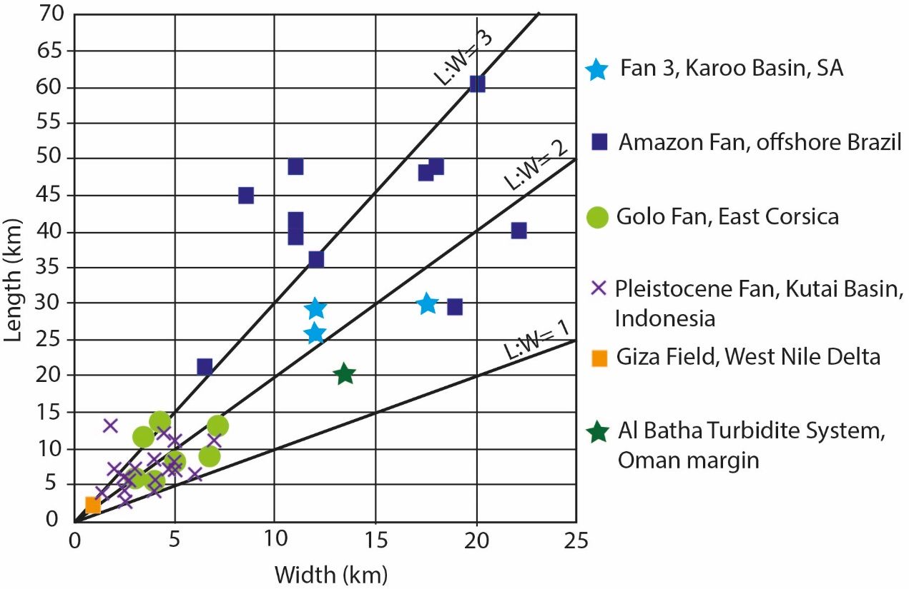
Figure 1

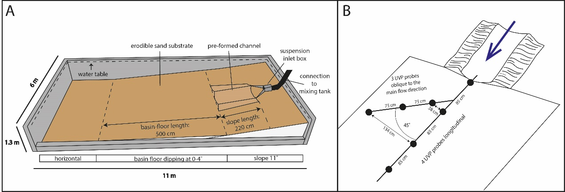
Figure 2

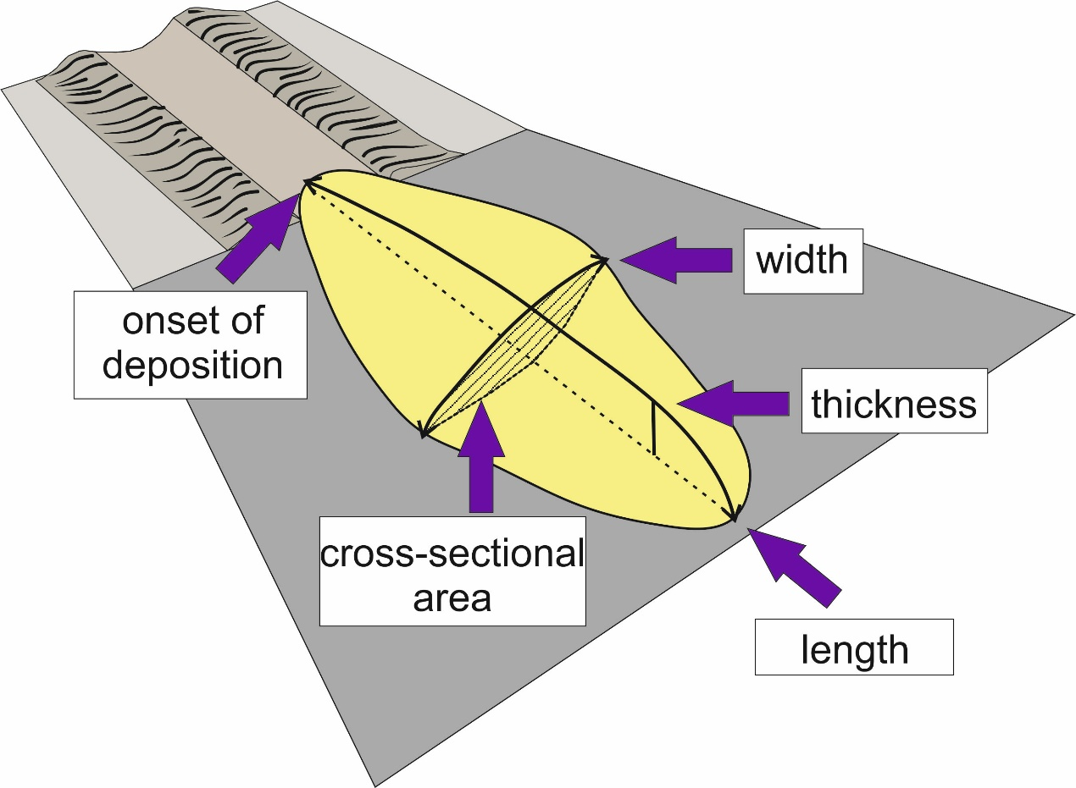
Figure 3

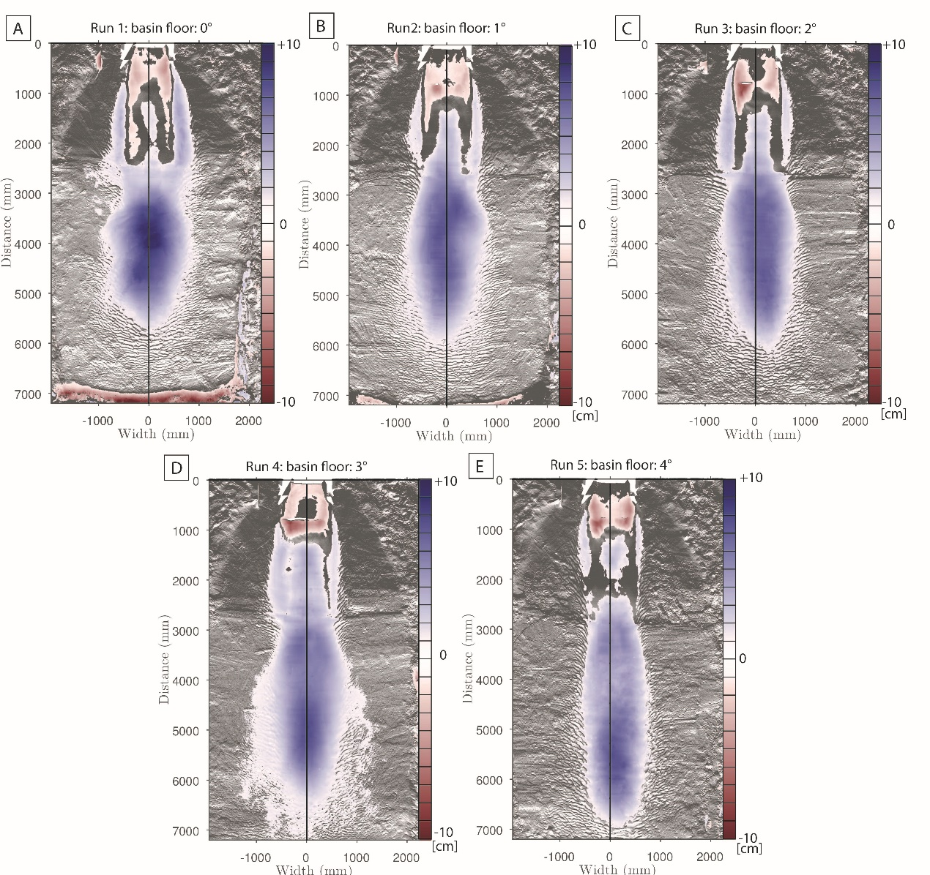
Figure 4

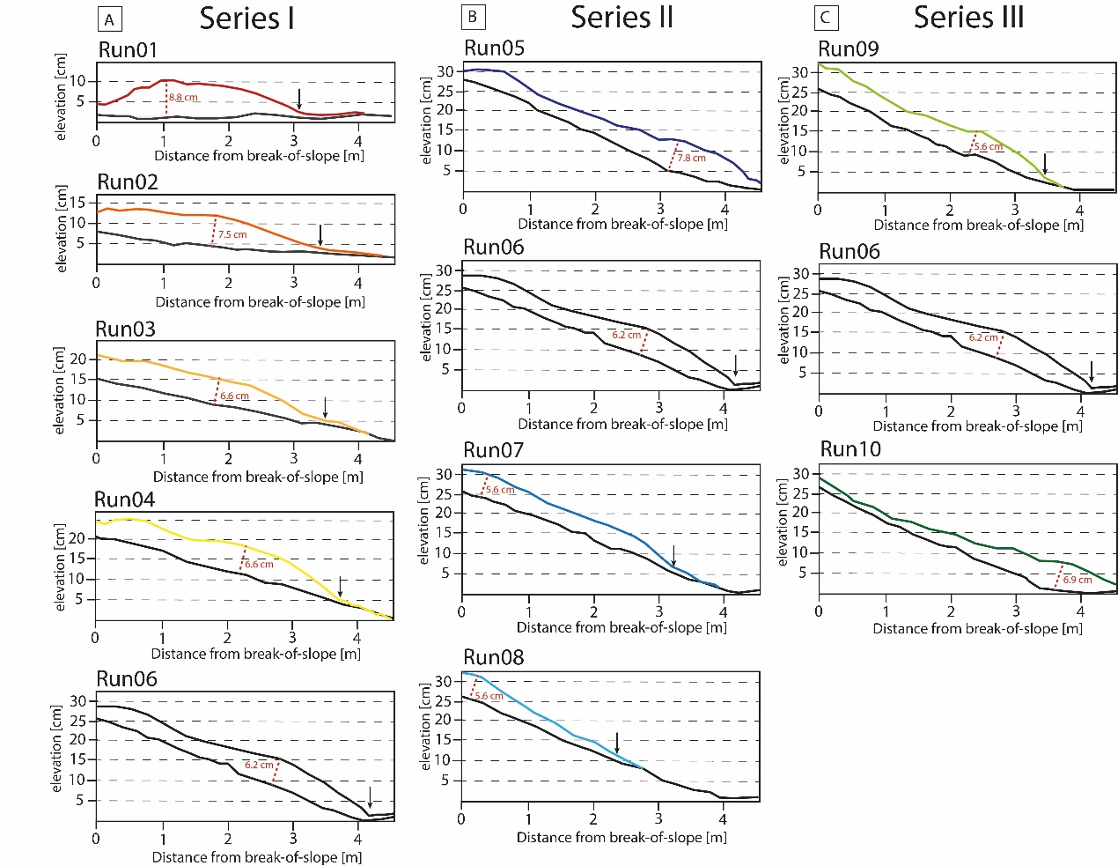
Figure 5

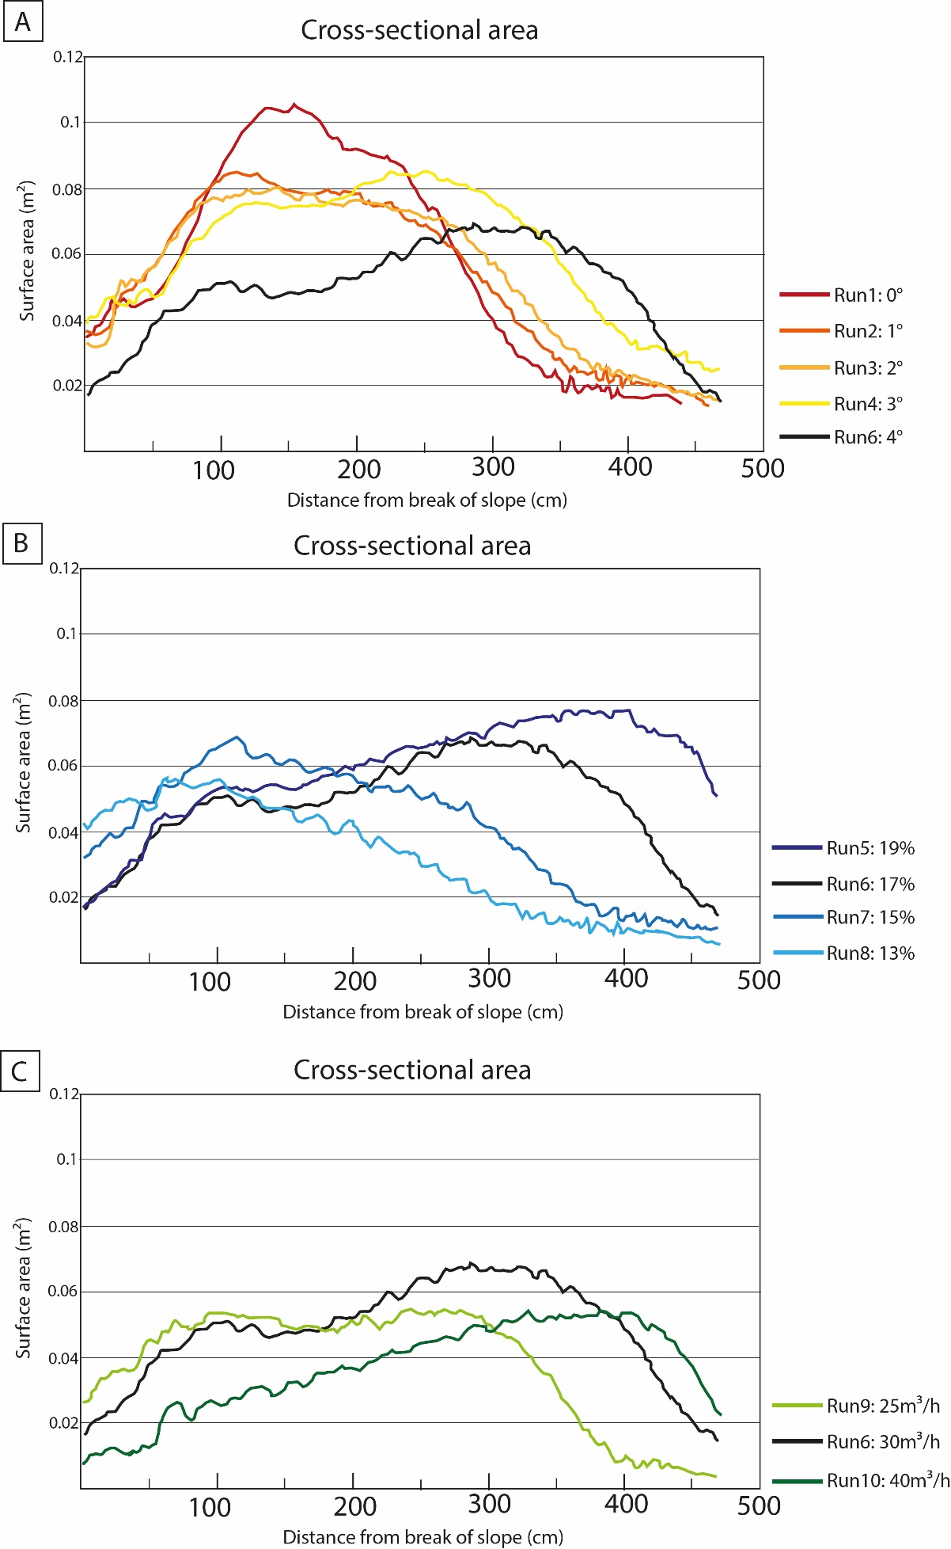
Figure 6

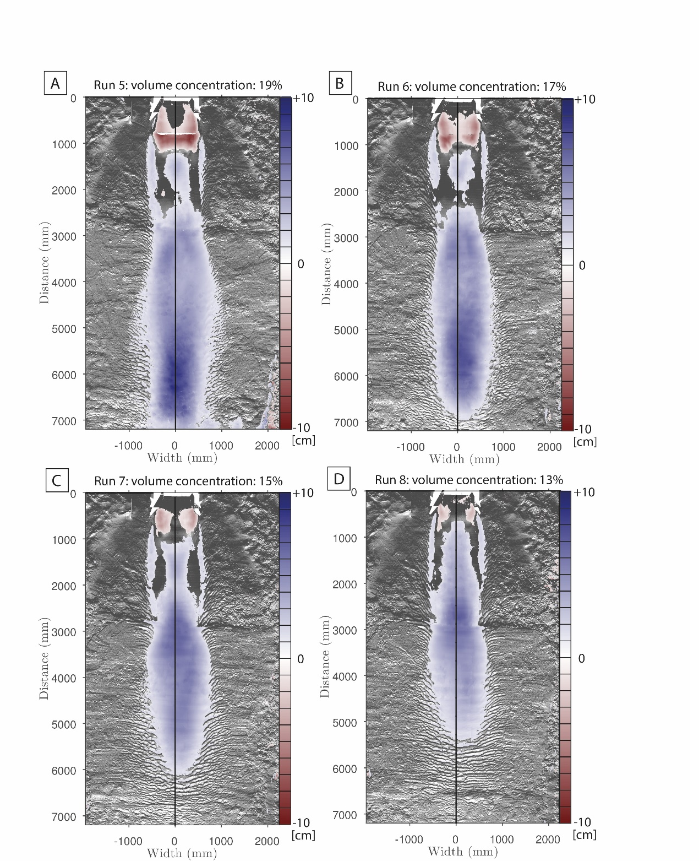
Figure 7

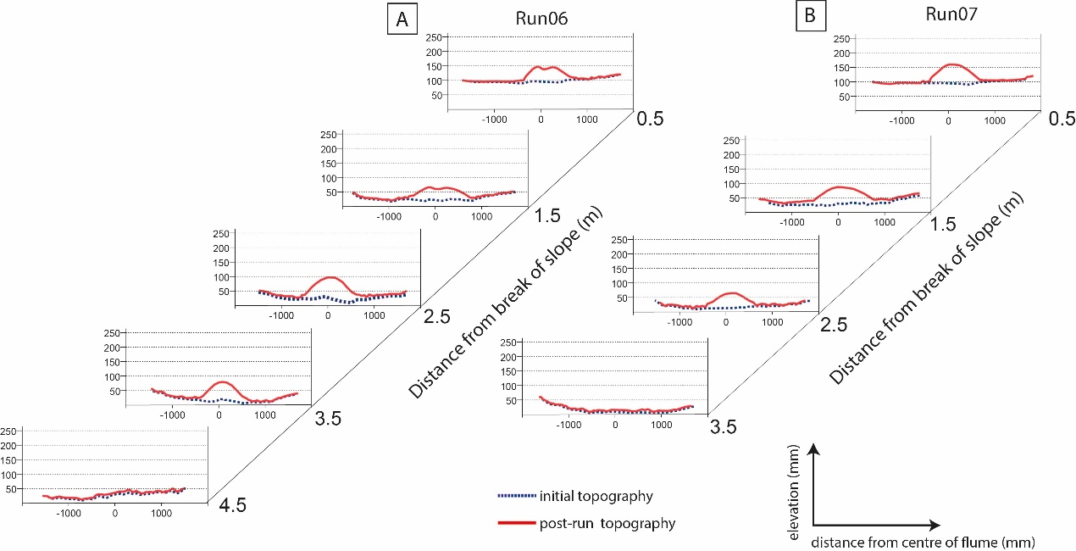
Figure 8

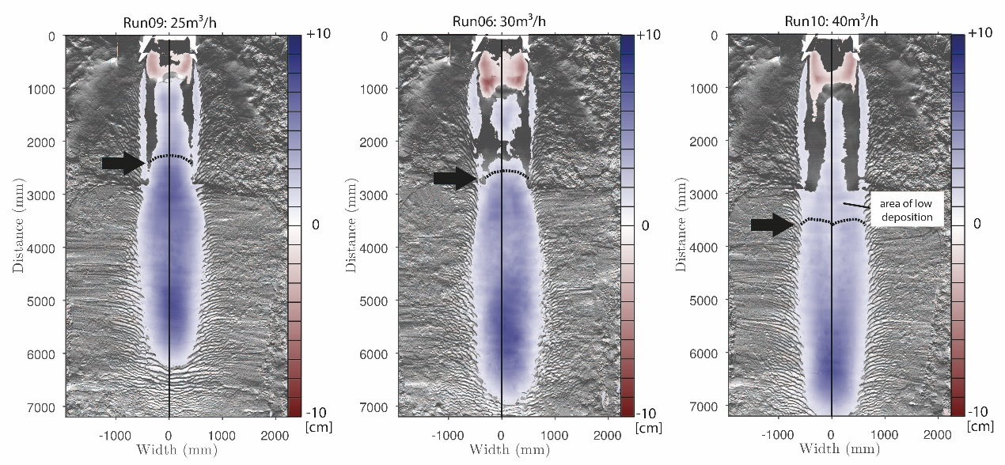
Figure 9

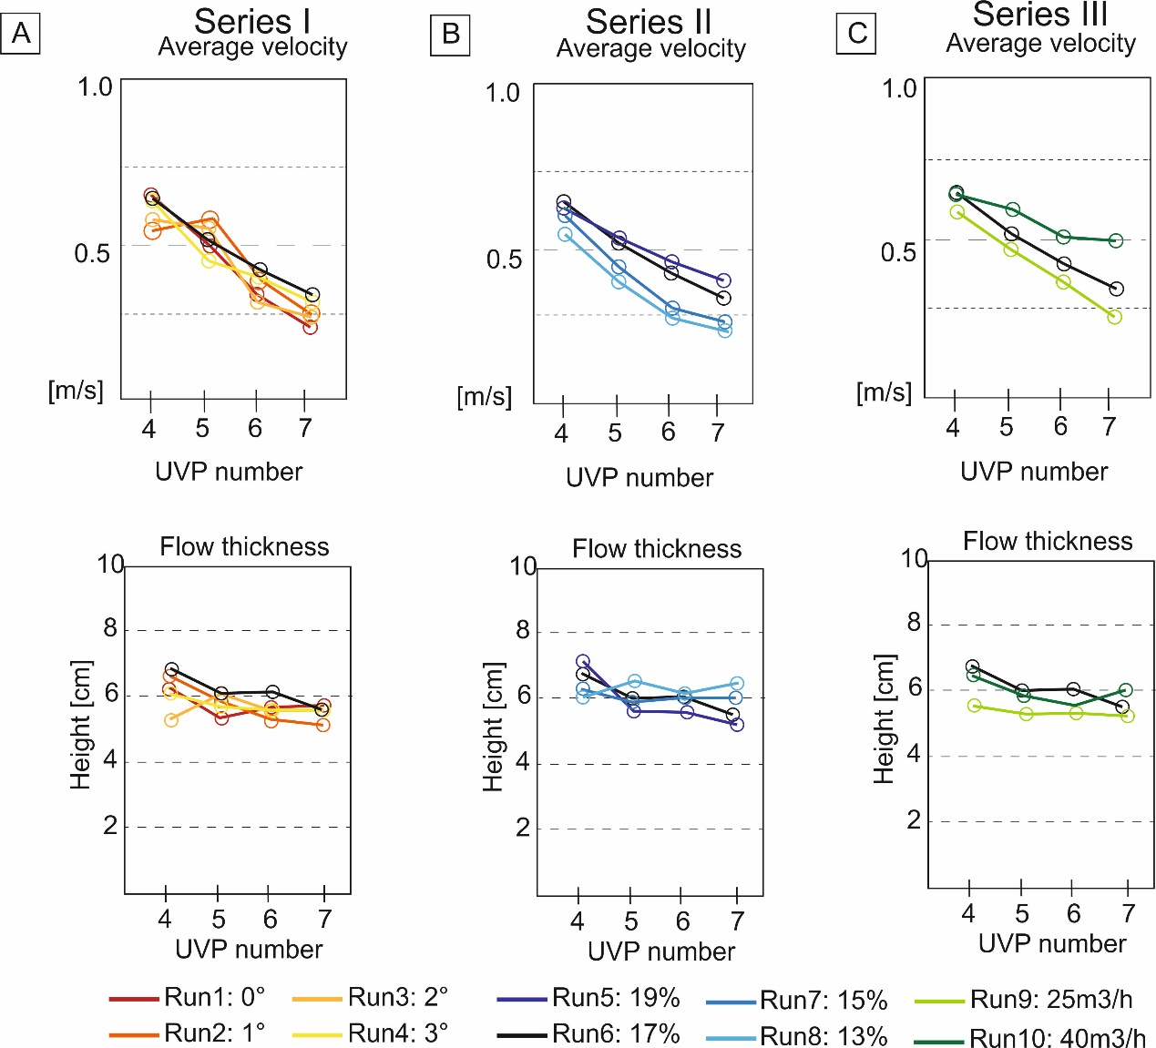
Figure 10

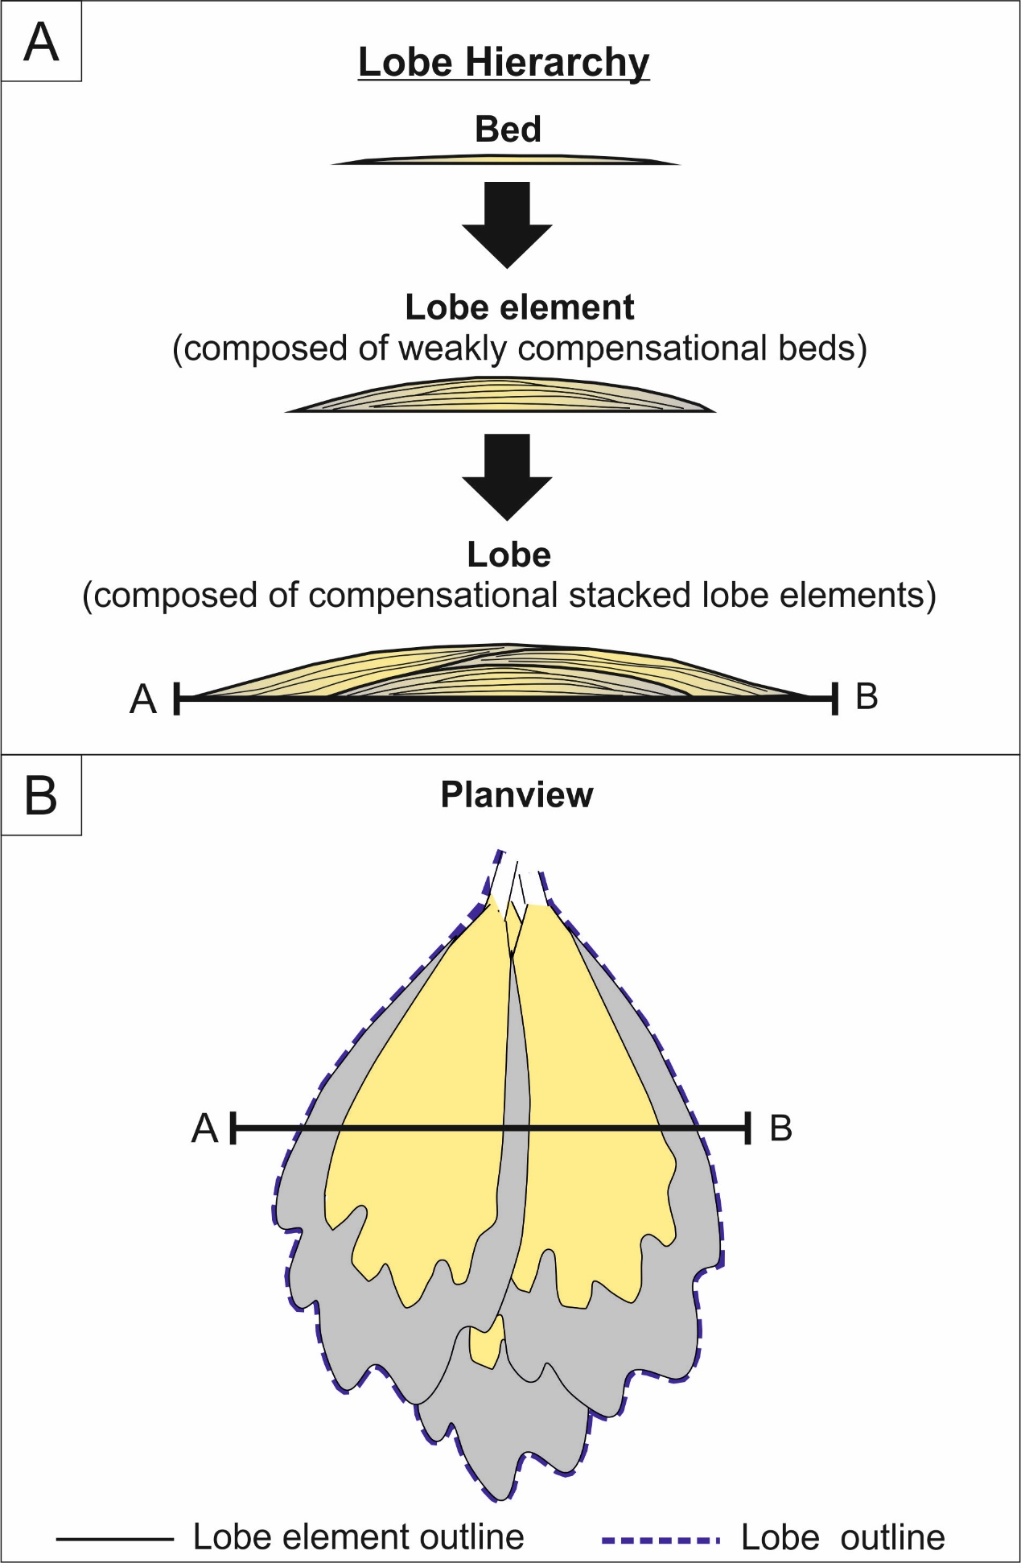
Figure 11

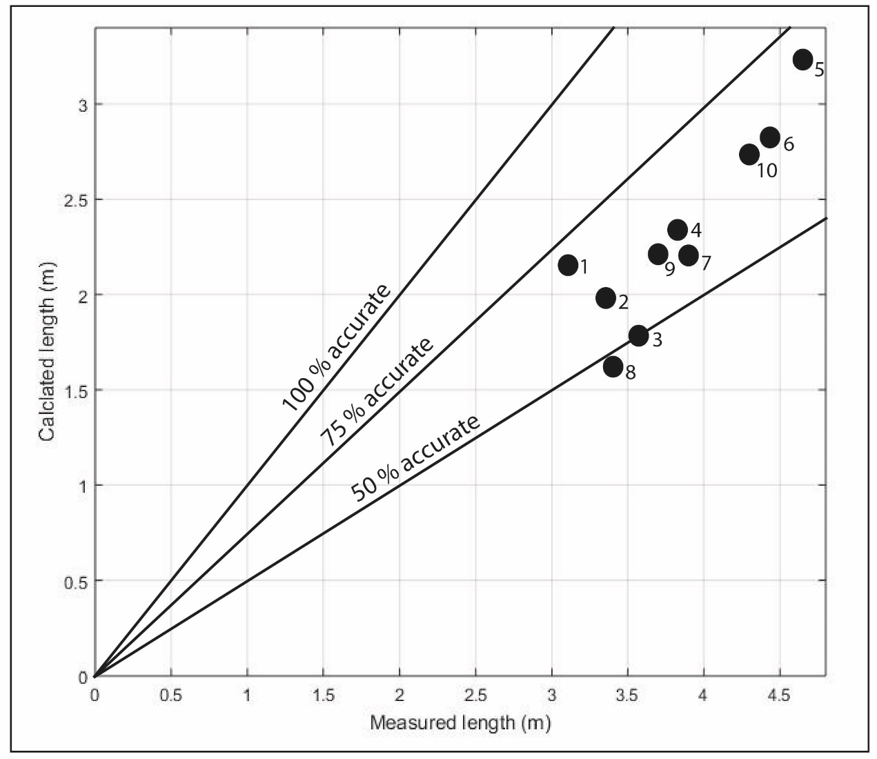
Figure 12

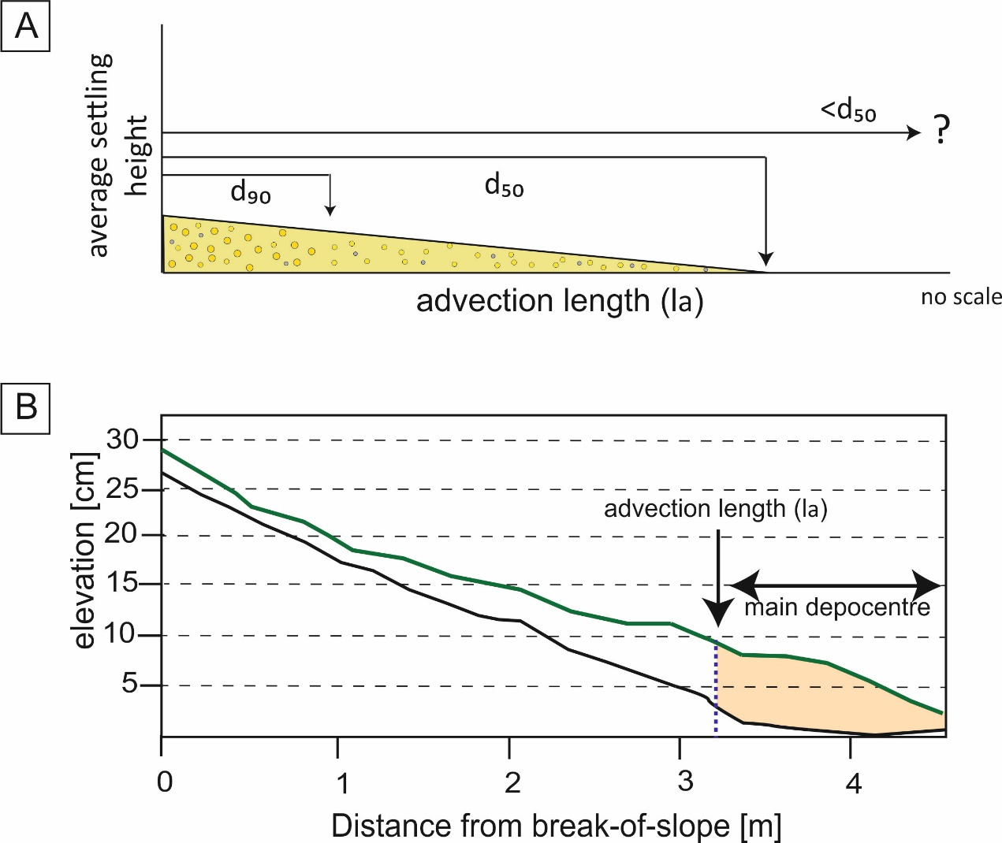
Figure 13

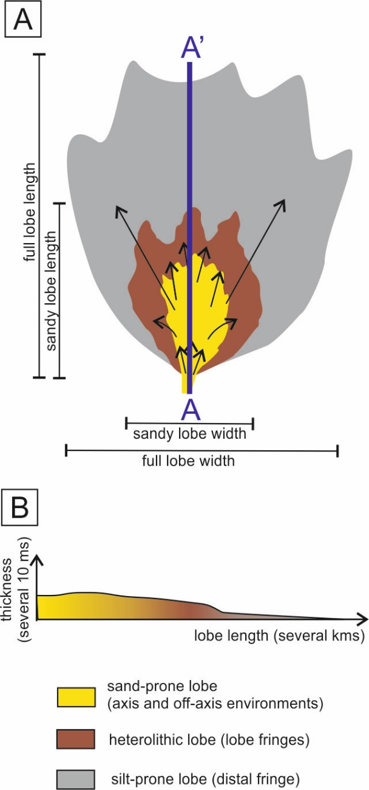
Figure 14

Table1

Table 2

Table 3

