Distorted Olivine Crystals: An unexploited record of magma storage at Kīlauea Volcano, Hawaiʻi
Penny E. Wieser^{*1}, Marie Edmonds¹, John Maclennan¹ and John Wheeler²
¹ Department of Earth Sciences, University of Cambridge, Downing Street, Cambridge, UK, CB2 3EQ.
² Department of Earth, Ocean and Ecological Sciences, University of Liverpool.
* Corresponding author: pew26@cam.ac.uk

Abstract
Distorted olivines of enigmatic origin occur in basaltic lavas erupted in a wide range of volcanic settings (e.g. Hawaiʻi, Iceland, Reunion, Chile). At Kīlauea Volcano, they have been attributed to various processes: creep within rift zone dunites, grain collisions, or an early phase of dendritic growth. We assess these competing hypotheses using electron backscatter diffraction. Distorted olivines display crystallographic signatures distinct from those of dendritic growth, but consistent with deformation at high temperatures. The spatial distribution of eruptions containing distorted grains, along with the absence of adcumulate textures (e.g. internal melt films), is inconsistent with derivation from rift zone dunites. We suggest that distortions are generated by gravitational loading within melt-rich olivine cumulates with thicknesses of a few hundred metres accumulating within the summit reservoir. This mechanism invalidates petrological arguments for deep rift zone magma transport at Kīlauea, and accounts for the presence of deformed grains in many basaltic volcanoes.
Prior investigations of the textural and geochemical characteristics of olivine crystals have revealed significant complexity in basaltic volcanic plumbing systems, including the timescales of eruptive triggering from diffusion profiles¹, storage times from crystal chemistry², and depths of magma storage from melt inclusion geochemistry³. Olivines with prominent lattice distortions occur in a diverse range of olivine-rich basalts globally^{2,4,5}, and may provide an unexploited source of information. However, the magmatic processes producing distorted olivines remain poorly understood. Previously, these features have been described as subgrains and kink bands; we initially favour the descriptive term “distorted” to avoid any genetic connotations.
At Kīlauea, distorted olivines are commonly attributed to ductile creep within dunitic bodies located in the deep rift zones (~5-9 km depth)^{6,7} or around the central conduit⁸. However, a recent suggestion that lattice distortions are produced by an early phase of branching dendritic growth, followed by textural ripening and the merging of misorientated crystal buds is gaining considerable traction^{5,9}. Lattice distortions have also been attributed to collisions between crystals during magma flow through constricted or irregular conduits^{10,11}.
Establishing the magmatic processes producing distorted olivines is crucial to further our understanding of basaltic plumbing systems. Extracting the information held within these features is particularly vital at Kīlauea, where olivine is the only silicate phase at >6.8 wt% MgO^{[12]}, so provides the main record of pre-eruptive storage. Furthermore, Kīlauean primary melts have ∼15-17 wt% MgO¹³, yet erupted lavas contain 5-10 wt% MgO, and few crystals (1-3 vol%)¹⁴. This disparity in MgO contents requires fractionation and storage of considerable volumes of olivine within the Kīlauean edifice¹⁵.
High-velocity materials (interpreted as dunitic bodies) have been imaged seismically within the summit region and deep rift zones of Kīlauea Volcano¹⁶. Large earthquakes, slow slip events and landslides have been attributed to the presence of these weak dunitic bodies separating the south flank of Kīlauea from the rest of the island^{15,17}. Yet, the relationship between distorted olivines in erupted products and seismically-imaged dunites remains unresolved. If lattice distortions form within dunitic bodies, microstructural interrogation may provide insights into south flank instability. However, Welsch et al.⁵ suggest that if distortions are in fact growth features, the role that dunitic bodies play in causing edifice instability at ocean islands such as Hawaiʻi and Reunion may have been overestimated from petrological observations of distorted grains. Finally, the hypothesis that distorted olivines originate from dunitic bodies has fuelled suggestions that Kīlauea’s deep rift zones provide a pathway by which magma bypasses the summit reservoir⁷. Re-assessing the petrological evidence for summit bypass is vital for accurate estimates of magma supply rates (and thus CO₂ flux) at Kīlauea¹⁸.
In this paper, we examine lattice distortions in olivine crystals within basaltic spatter and scoria from eruptions temporally associated with activity at Mauna Ulu (May 1969 - December 1974). This five year period is distinct in Kīlauea’s history; eruptions occurred almost simultaneously on the East and South West rift zones (ERZ; SWRZ), and at discrete sites within and around the summit caldera (Fig. 1)¹⁹. This provides a unique opportunity to decipher the spatial distribution of distorted olivines within a single eruptive period at Kīlauea. We also investigate two further SWRZ eruptions; the circumferential lava flow on the seismic SWRZ (~1700 AD)²⁰ and the Mauna Iki eruption on the volcanic SWRZ (1919-1920 AD)²¹. Finally, to evaluate the suggestion that lattice distortion results from dendritic growth, we examine olivines with dendritic crystal morphologies from West Greenland Picrites²².
Until now, most assessments of lattice distortion in volcanic olivines have used optical microscopy^{7,8,23}. However, this method is qualitative, and optical evidence for distortion is often ambiguous in small grains, or across subgrain boundaries with small misorientations²⁴. Previous studies employing more quantitative methods at Kīlauea have been restricted to visual examination of dislocation structures and densities following oxidation-decoration of dislocations^{25,26}, and examination of lattice strain using in situ X-ray diffraction²⁴. In this study, we classify the occurrence and character of lattice distortions using Electron Backscatter Diffraction (EBSD). This offers significant improvements in spatial and angular resolution compared to optical observations²⁷, and permits quantitative comparisons of lattice distortions to the growth signatures of olivine dendrites, and to deformation fabrics observed within mantle peridotites. This provides a conceptual framework, with broad applicability in other volcanic systems, in which to evaluate the magmatic processes producing distorted olivines.

Incidence of Lattice distortions
Distorted olivines were thought to be reasonably rare in subaerial eruptions compared to submarine eruptions at Kīlauea Volcano^{8,15,28}. Yet, we find abundant distorted grains in subaerially erupted products from all ERZ eruptions (Pau’ahi crater, Episode 1 and 12 of Mauna Ulu) and seismic SWRZ eruptions (1974; ~1700 AD; Fig. 1). Spatter from Mauna Iki on the volcanic SWRZ also contains a significant number of distorted grains. In contrast, erupted products from four intra-caldera summit eruptions and the 1971 volcanic SWRZ eruption contain very few distorted grains. In almost all eruption products, distorted grains are more abundant in sieved size fractions >1mm^{[25]} (Fig. 1). The 1971 Northern SWRZ spatter contain very few grains >1 mm (4 in ~150 g), but all are distorted, whereas no grains <1 mm show distortion. Intracaldera summit eruptions contain no grains >1 mm, but all distorted grains are >840 µm.

Evaluating the Dendritic Growth Hypothesis
First, we test the hypothesis that lattice distortions are produced during an early phase of branching dendritic growth, followed by textural re-equilibration during periods of reduced undercooling⁵. During diffusion-limited dendritic growth, high concentrations of incompatible elements (e.g. P) accumulate within the boundary layer of a growing crystal, resulting in their incorporation into the crystal structure²⁹. While the external morphology of dendritic crystals evolves during textural re-equilibrium to obscure this early growth phase, slow diffusion rates preserve internal P enrichments³⁰. The presence of P-rich zones passing across extinction discontinuities is one of the main lines of evidence supporting the dendritic growth hypothesis^{5,9}. However, wavelength-dispersive spectroscopy (WDS) maps collected by electron microprobe reveal homogenous cores within almost all distorted grains, and notable internal P enrichments within undistorted grains (Fig. 2). Similar findings have been reported for Kīlauea Iki²³. In one case, we observe the truncation of P enrichments at a subgrain boundary, indicating that rapid growth preceded distortion of the crystal lattice (Fig. 2d). Thus, while some olivines at Kīlauea may have experienced early dendritic growth, this process seems unrelated to the production of the lattice distortions.
Furthermore, if distorted olivines represent texturally matured dendrites, the crystallographic signatures of dendritic growth and lattice distortion should be identical. Low angle subgrain boundaries were examined in 137 distorted olivine crystals from Kīlauea, and compared with 61 olivine dendrites from West Greenland²². We assess the crystallographic signature of each boundary type using two metrics; the misorientation across the boundary, and the Weighted Burgers Vector Direction (WBVD). The misorientation describes the axis-angle pair (corresponding to the minimum misorientation angle³¹) of the coordinate transform from the crystallographic orientation on one side of the boundary to that across the boundary. The Weighted Burgers Vector (WBV) gives the weighted mean of the Burgers vectors of all types of geometrically necessary dislocation in a local region, assessed using 2D orientation gradients in EBSD maps³². It depends on the dislocation density for each type, and is weighted towards dislocation lines at a high angle to the map. For discrete boundaries, the apparent dislocation density and hence WBV magnitude depends on pixel spacing, but the WBV direction (WBVD) does not, and provides crystallographic information sufficient for our aim here. Specifically, the WBVD samples the Burgers vectors of dislocations in low angle boundaries and cannot introduce any “illusory” directions not present in the actual microstructure.
Most dendrite buds show identical crystallographic orientations to the primary crystal; merging of such buds cannot produce lattice distortions. The 125 crystal buds which are misorientated with respect to their host crystal (Fig. 3a) show a bimodal distribution of misorientation axes, with a strong maximum around [010]³³ and a weaker maximum around [100] (Fig. 3c). Misorientation angles are predominantly <20˚, but extend up to 90.5˚(Fig. 3d). In contrast, lattice distortions in Kīlauean olivines show misorientation axes predominantly between [010] and [100] (Fig. 4c), and small (<5˚) misorientation angles. Finally, while dendritic growth is dominated by [010] and [001] WBVDs (Fig. 3b), lattice distortions show predominantly [100] WBVDs, with some [001] vectors (Fig. 4b).
These crystallographic differences demonstrate that lattice distortions are not produced by textural maturation of olivine dendrites. Instead, the misorientation axes and WBVDs in distorted olivines are similar to fabrics produced in olivine deformation experiments at conditions resembling Kīlauea’s plumbing system (>1000˚C)³⁴. Thus, we propose that lattice distortions represent true deformation of the crystal lattice, rather than growth features.

Crystal-Crystal Collisions?
The indistinguishable major element chemistry of deformed and undeformed grains^{8,28}, along with euhedral grain outlines, has led to suggestions that lattice distortions are produced by grain collisions during magma flow through constricted conduits^{10,11}. However, we find that deformed grains have higher forsterite contents than undeformed grains (Fig. 5a-b), with statistically significant differences for individual eruptions (p<0.01, Kolmogorov-Smirnov test, Fig. 5c-f). Differences in minor element compositions have also been reported for deformed and undeformed grains erupted at Kīlauea Iki²³. Finally, deformed olivines in different eruptions have similar forsterite contents, which are significantly out of equilibrium with their matrix glasses. In contrast, undeformed olivines show more chemical variability, and plot closer to the equilibrium composition (Fig. 5a-b). These observations cannot be reconciled with late stage crystal-crystal collisions, which would result in deformed and undeformed grains having indistinguishable chemistry²³, and the same degree of disequilibrium with their matrix glasses.

Alternative Settings for Plastic Deformation
The majority of deformed olivines at the Earth’s surface are derived from mantle peridotites. However, deformed Kīlauean olivines are unlikely to be mantle xenocrysts for several reasons. Firstly, almost all deformed olivines have high CaO contents (>0.2 wt%), while mantle peridotites and plutonic rocks typically have <0.1 wt% CaO^{15,35} (Fig. 6a). Secondly, many deformed olivines have inclusions of melt and euhedral spinels, which are indicative of growth within volcanic systems^{7,25}. These observations suggest that these olivines grew, and were subsequently deformed within Kīlauea’s plumbing system.
To generate lattice distortions, crystals must be subject to non-hydrostatic stress⁸. Previously, deformation has been attributed to differential stresses exerted within Kīlauea’s deep rift zone dunites, during the downward flow of olivine from the summit area to the rift zones, or the rapid extension of the rift zones during south flank earthquakes¹⁵. However, mechanisms involving deep rift zone processes requires specific magma transport paths to bring deformed crystals to the surface. For example, the presence of deformed grains in lavas from the Mauna Ulu eruption have been used to invoke magma transport along the basal decollement, followed by vertical transport to the eruption site⁷. Yet, significant magma transport through the deep rift zones is at odds with geophysical evidence, which demonstrates no measurable changes in rift zone opening rates during magma supply surges or rift zone eruptions¹⁸. Given the wide spatial and temporal distribution of deformed grains identified in this study, it seems untenable that every eruption received a significant contribution to its olivine crystal cargo from deep rift zone transport paths.
The textural features of deformed olivines are also inconsistent with an origin from low melt fraction dunites (<5 % melt)¹⁵. Olivines derived from such bodies would be expected to show adcumulate textures similar to those found in xenoliths erupted at Kīlauea Iki⁸ and post-shield Hawaiian lavas³⁶. Instead, most distorted grains have subhedral-euhedral outlines with no internal melt films and high angle grain boundaries (Fig. 4). While corrosion followed by overgrowth can produce euhedral crystals from disaggregated dunites³⁷, this process would preserve internal melt films.
Deformed olivines similar to those found at Kīlauea have been noted in a variety of basaltic systems, including Iceland², Piton de la Fournaise Volcano⁵ and the Andean Southern Volcanic Zone⁴. However, unlike Kīlauea, these localities do not contain deep rift zone dunites. Instead, plastic deformation must be generated by a near ubiquitous process in volcanic plumbing systems. We suggest that a plausible mechanism is gravitational loading within melt-rich cumulate piles produced by crystal settling² (with ~40% porosity³⁸). This can account for the global distribution of deformed grains, and the absence of adcumulate textures at Kīlauea. To investigate this hypothesis further, we quantify the conditions under which deformation proceeded.

Conditions of Deformation
Extensive study of naturally- and experimentally-deformed mantle peridotites has led to the identification of five olivine fabrics (A to E-types), and an understanding of the role that pressure, temperature, differential stress and hydration exert on the occurrence of these fabrics^{39–41}. However, until now, deformation microstructures within volcanic olivines have not been evaluated under the conceptual framework developed for mantle peridotites²⁴. We suggest that as many deformation experiments were conducted at conditions similar to those found within igneous plumbing systems (e.g. 300 MPa, 1250˚C)⁴², such comparisons are justified.
In mantle peridotites, deformation conditions are commonly deduced from known relationships between fabric types and crystallographic preferred orientations (CPOs)⁴³. However, in tephra and spatter deposits, the orientations of olivine grains have been randomised relative to one another upon eruption, and again during sample collection and preparation. Instead, we identify the dominant slip systems from EBSD maps of individual olivine grains building on known geometric relationships for subgrain walls⁴⁴. Previous work has shown how slip systems influence fabric types and how fabric types relate to deformation conditions, thus establishing a link between dominant slip systems and deformation conditions. We propose that the proportions of different types of dislocation preserved in low angle boundaries reflect the relative activities of the different slip systems.
We identify the dominant slip system in low angle boundaries by quantifying the direction of misorientation axes, the weighted Burgers vector direction (WBVD), and the geometry of the boundary wall. This resolves the ambiguities involved when using misorientation axes alone to determine slip systems⁴³. For example, tilt walls consisting of (100)[001] or (001)[100] dislocations (described in terms of (slip plane)[Burgers Vector]) and twist walls consisting of (010)[100] and (010)[001] dislocations all produce misorientation axes about [010]. However, WBVDs can distinguish between these three boundary types; (100)[001] tilt walls would show [001] WBVDs (red), (001)[100] tilt walls would show [100] WBVDs (green), while twist walls would show mixes of [100] and [001] WBVDs (green via yellow to red). The geometry of the subgrain boundary provides further discriminatory power. Tilt walls contain the rotation axis within the boundary plane, while twist wall boundary planes are perpendicular to the direction of the rotation axis (Fig. 7a-b). For simplicity, it was assumed that subgrain boundaries showed pure tilt or twist character.
Subgrain boundaries within individual EBSD map were classified using new code built in MTEX 5.0.4⁴⁵, incorporating WBVD calculations from CrystalScape³². Firstly, misorientation axes were calculated for boundary segments with misorientation angles between 0.5-10˚. Boundaries were classified as twist walls if they met the following criteria: a) angle between the misorientation axis and the z direction in specimen coordinates >15˚ and b) angle between the misorientation axis and the grain boundary trace in specimen coordinates >75˚. Condition a) accounts for the fact that boundaries with low dips are unlikely to be observed³². Crucially, this rules out misidentification of a tilt boundary orientated such that the misorientation axis is near vertical as a twist wall. The second condition accounts for the theoretical geometry of a twist wall (Fig. 7b), where the misorientation axis is perpendicular to the boundary trace (allowing for 15˚ leniency). Boundaries were classified as tilt walls if: c) the boundary was not classified as a twist wall and d) the normal to the plane containing the grain boundary trace and rotation axis (i.e. the normal to the tilt boundary plane) in specimen coordinates was >15˚ from the z direction (discarding boundaries with low dips). For example, boundary pixels within the pink rectangle (Fig. 7c) meet condition b) but not a), as the misorientation axes are nearly vertical (blue dots; Fig. 7d). Thus, boundary pixels were classified as a tilt walls, as they met condition c) and condition d). This tilt wall is orientated with a near vertical boundary plane and misorientation axis.
This method classifies only 17% of boundaries as twist walls. This is consistent with literature observations that olivine subgrain walls with [100] WBVDs tend to have edge character³⁴, and the fact that the majority of WBVDs are [100] or [001] (Fig. 4,7c), rather than mixed directions (e.g. a WBVD parallel to [101] would appear yellow). We proceeded by classifying the dislocation geometries in the more prevalent tilt walls.
Within a single grain, tilt boundaries with a given WBVD display a narrow range of boundary traces (Fig. 7c), allowing isolation of tilt boundaries with [100] and [001] WBVD. For boundaries displaying each WBVD, the direction of the misorientation axis for each boundary segment was compared to the misorientation axis (in crystal coordinates) expected for each slip system (Fig. 7e). Slip system proportions were calculated in two ways; by summing the total length of each boundary type, and by calculating the proportion of each boundary type in a single grain, and averaging these values (N=62 grains, Fig. 8a). This reveals that boundaries related to (010)[100], {0kl}[100] and (001)[100] slip comprise ~30%, ~44% and ~16% of the total length of tilt boundaries respectively (Fig. 8a). The mosaicity of crystallographic orientation in some olivine grains (Fig. 4) results from secondary (100)[001] and (010)[001] slip (~3 and ~6% of boundaries respectively; Fig. 8a). Subgrain boundaries related to [001] slip systems are only observed in grains with a dominant set of boundaries with [100] Burgers vectors (Fig. 7c), suggesting that secondary [001] slip plays a role in relaxing the strain compatibility problem in olivine⁴⁶.
Experimental work shows that (010)[100] slip dominates in hot, dry, low stress environments (e.g. 300 MPa, 1500 K, ~300 H/10⁶Si_{molar})⁴¹. Slip on (001)[100] occurs at similar pressure, temperature and stress conditions, but is favoured by increasing water content⁴⁰. The strengths of these two slip systems are comparable at pressures of 300 MPa, and olivine water contents of ~200 H/10⁶Si ^{[40]}. The conditions producing {0kl}[100] slip are less certain: they may involve high stresses, low temperatures and low water contents^{39,47}. Here we deduce {0kl}[100] slip from misorientation axes lying between [001] and [010]. However, this axis distribution may also result from the presence of (010)[100] and (001)[100] dislocations within a single subgrain boundary (as suggested for mantle peridotites⁴⁸). Slip on (010)[001] dominates at high stress and/or moderate-high water contents, while (100)[001] slip dominates at high water contents and low stress⁴⁹ (Fig. 8c). Thus, the prevalence of [100] slip in Kīlauean olivines is indicative of deformation at moderate-high temperatures and low-moderate water contents. To further constrain the deformation conditions, we place independent estimates on differential stresses and olivine water contents.
Differential stress was estimated using subgrain and dislocation density piezometry; as both methods apply to “steady state” microstructures, they likely give minimum stress estimates. Subgrain piezometry utilizes the empirical relationship between subgrain size (d) and differential stress (σ)⁵⁰:
σ =$\frac{45µb}{d}$ (1)
where $µ$is the shear modulus (65x10⁹ Pa), b is the magnitude of the Burgers vector (5 x 10⁻¹⁰ m) and d is the distance between subgrains in m^{[50].} Subgrain sizes were quantified using an adapted linear intercept method suitable for EBSD maps of individual olivines. The distances between boundaries with [100] WBVD and misorientations >0.5˚ were measured perpendicular to the mean boundary trace, rather than along predefined directions in specimen coordinates⁴² (Supplementary Information). Distances were multiplied by 0.65 to account for different cuts of subgrain boundaries (assuming a random distribution of boundary dips), and converted into estimates of differential stress using equation 1. This gives a distribution of stresses between 1-22 MPa, with a peak at ~3-12 MPa (Fig. 8b).
Similarly, dislocation density piezometry utilizes the relationship between dislocation densities (ρ) and differential stress (σ)⁵¹.
σ =$\sqrt[s]{\frac{ρb^{2}}{B} }* µ$ (2)
Where B=1.74x10⁻³ and s=1.37. Sakyi et al.²⁵ report dislocation densities measured using the oxidative decoration technique⁵² in a variety of picritic basalts from Kīlauea and Mauna Loa (including some from Mauna Ulu). While they do not report dislocation densities for specific eruptions, the textural descriptions of their “blocky olivines” are very similar to our observations of distorted grains. Blocky olivines have dislocation densities of 1-5 x 10¹⁰ m⁻², yielding differential stress estimates of ~3.5-11.4 MPa. Despite estimates pertaining to different samples, and the large uncertainties associated with each method, stress estimates from subgrain piezometry and dislocation densities are in close agreement (Fig. 8b).
Olivine water contents were estimated using water concentrations in olivine-hosted melt inclusions from multiple Kīlauean eruptions⁵² and olivine-melt partition coefficients (K_{D} = 0.031-0.0021)⁵³. This yields H/10⁶ Si=20-320 (orange bar; Fig. 8c). The apparent presence of {0kl}[100] slip is at odds with our differential stress and water content estimates (Fig. 8c), supporting our earlier suggestion that subgrain walls apparently relating to {0kl}[100] slip are in fact made from mixtures of (010)[100] and (001)[100] type dislocations. Our estimates for water contents and differential stress, which indicate conditions where the strengths of (010)[100] and (001)[100] slip are comparable⁴⁰, are then entirely consistent with our microstructural analysis of slip system proportions.

Insights into Mush Pile Storage
These differential stress estimates allow us to assess whether gravitational loading within melt-rich olivine cumulate piles is a plausible mechanism by which to deform olivines. In cumulate piles, differential stresses scale as a function of the density difference between crystals and host melts ($Δρ)$, and the thickness of the mush pile (H):
H =$\frac{σ_{Differential}}{{g*(Δρ}_{olivine-liquid})}$ (3)
Where g=9.8 m/s², and $Δρ$=567 kg/m³ (using ρ=3282 kg/m³ for Fo₈₆ olivine at 1230˚C^{[54]}, and ρ=2715 kg/m³ for the interstitial basaltic liquid^{52,55}). Measured stresses of ~3-12 MPa can be generated at the bottom of mush piles ~540-2160 m thick. However, extensive work on granular materials has demonstrated that solid particles arrange themselves into force chains, resulting in unequal transmission of force⁵⁶. Highly stressed chains of primary members transmit most of the force, while a larger group of secondary members experience less than the mean force, and a few spectator particles experience no force (Fig. 9b)⁵⁷. Simulations of crystal mush piles show that the proportion of particles experiencing more than the mean force has an exponential distribution, with forces on certain grains exceeding 6x the mean force⁵⁸. Dynamical processes within magma chambers (e.g. magma injection) drive the migration of force chains, resulting in a large proportion of olivines experiencing greater than the mean force⁵⁸. This process could reduce the required mush pile thickness by a third, to ~180-720m.
We use a simple box model to explore the parameter space required to generate mush piles of these thicknesses at Kīlauea. Primary melts with 16.5 wt% MgO enter a cylindrical sill at a rate of 0.1km³/yr ^{[59]} (Fig. 10a). Within the sill, olivine crystals form and settle into cumulate piles (~40% porosity), causing the remaining liquid to evolve to lower MgO contents. This liquid leaves the reservoir, and is either erupted, or stored within the deep rift zones⁵⁹. Fractionation from primary liquids to the average whole rock MgO contents of erupted lavas (~10 wt% MgO) requires removal of ~14% olivine cumulate¹⁵. The thickness of the cumulate pile produced in the sill is a play off between the reservoir radius, and the accumulation time (Fig. 10b). Geodetic observations of surface displacements provide constraints on the reservoir radius; InSAR displacements centred on the south caldera area can be modelled as penny shaped cracks with radii of ~2-4 km⁶⁰. This geometry permits accumulation of ~200-700 m of olivine cumulate in just a few centuries. This is consistent with the diverse range of trace element ratios within melt inclusions in any given eruption, which require mush pile residence times of a few centuries or more (Wieser et al., in prep). Thus, generation of deformed crystals within several hundred metres of crystal mush is highly plausible at Kīlauea based on available geophysical constraints.
More precise constraints on mush pile thicknesses will now require several conceptual advances. Numerical simulations of granular mush piles are computationally expensive, despite only considering spherical particles in 2D^{[58].} In reality, the force applied at contacts between angular crystals will be amplified into very high stresses by small contact areas⁶¹. Such highly heterogenous stress distributions within individual grains^{61,62} will likely complicate piezometric estimates. An increased understanding of how heterogenous stresses within individual grains are translated into subgrain sizes and dislocation densities is clearly needed, alongside discrete-element models accounting for force chain geometry in three dimensions, using realistic crystal shapes. Finally, transitions between a predominantly frictional regime (with force chains) to a lubricating regime may occur within mush piles, affecting the amount of stress amplification⁵⁸. An alternative research direction would be to perform EBSD on olivines at the base of mush piles of known thickness (e.g. exposed sills) to produce a calibration between deformation intensity and mush pile thickness.
Location of Mush Piles
The spatial distribution of deformation grains across the Kīlauean edifice can be used to investigate the location of gravitationally loaded mush piles. Geophysical and geochemical observations at Kīlauea have led to a model in which magma is stored at two distinct depths^{63–65}. We find the largest proportion of deformed olivines in eruptions thought to derive a significant proportion of their magma supply from the deeper (South Caldera) reservoir based on Pb isotopes^{64,65}. In contrast, there are few deformed grains in intracaldera and volcanic SWRZ eruptions thought to tap the upper, more evolved (Halema’uma’u) reservoir. The different source of these eruptions is also evident in the Mg# of the co-erupted glasses (Fig. 5a-b); eruptions containing abundant deformed grains have more primitive glass compositions glasses (consistent with the storage of higher MgO melts in the deeper reservoir)^{64,66}. Interestingly, unlike the 1971 SWRZ eruption, the 1919-1920 Mauna Iki eruption contains abundant deformed grains (both eruptions occurred on the volcanic SWRZ). This may reflect that fact that the Mauna Iki eruption is thought to have tapped magma from multiple reservoirs²¹.
The commonality between eruptions containing deformed grains is that a significant proportion of their magma supply (and thus crystal cargo) was derived from the deeper reservoir. An origin for deformed grains within mush piles at the base of the deeper reservoir is a simpler explanation for their abundance in a wide variety of subaerial eruptions than invoking magma transport paths along the basal decollement⁷. The narrow range of forsterite contents in deformed grains (~Fo₈₇; Fig. 5) may result from diffusive re-equilibration of Mg and Fe during prolonged mush pile storage². The scavenging of deformed grains from mush piles just before eruption also explains the high degree of olivine-liquid disequilibrium between deformed grains and their host melts. As the upper reservoir is thought to be recharged from the deeper reservoir⁶⁴, entrainment of a small number of deformed grains during recharge events can account for their occasional occurrence in intracaldera eruptions, and the more extreme difference in forsterite contents between deformed and undeformed grains in these eruptions than in rift zone and extracaldera eruptions (Fig. 5e).
The temporal evolution of mush piles at the base of the deeper reservoir is uncertain. To resolve space problems, migration of olivine downslope to form the seismically imaged dunitic bodies is likely required¹⁵ (Fig. 9a). We suggest that during this evolution, the amount of interstitial melt gradually reduces, leading to the generation of true adcumulate textures, with internal melt films and high angle grain boundaries. Additional stress imposed during downslope flow accounts for the higher differential stresses estimated from subgrain piezometry in dunitic xenoliths from Hualalai (40±20 MPa)³⁶ than those estimated in this study (~3-12 MPa). Deformed olivines from the ~1700 AD eruption may record the first stages of this process; they show prominent subgrains, and high angle grain boundaries (misorientations >10˚; Fig 6b-c). The latter are decorated with thin films of melt (Fig. 6b), indicating derivation from low melt fraction bodies. These olivines also show trails of secondary vapor bubbles, similar to those observed in Hawaiian xenoliths¹⁵. Finally, these olivines have substantially lower forsterite contents than other deformed olivines (~Fo₈₂₋₈₃ vs. ~Fo₈₆₋₈₈; Fig. 5a-b), and several have Ca contents overlapping with values measured in Hualalai dunites (Fig. 6a)³⁶. These chemical differences may reflect cooling during transport away from the main magma storage region at Kīlauea. Texturally similar olivines have also been identified in the Kīlauea Iki eruption⁸. Eruptions sampling these more consolidated dunitic bodies are clearly uncommon, and may be restricted to those ascending along infrequently utilized pathways to the surface⁸.

Conclusions
A quantitative examination of the crystallographic signatures of lattice distortions within olivine crystals erupted at Kīlauea Volcano by Electron Backscatter Diffraction reveals striking similarities to the microstructures observed in deformed mantle peridotites. In contrast, lattice distortions show different crystallographic signatures to dendritic olivines (in West Greenland picrites), indicating that these features did not form during rapid crystal growth. Previous petrological work has suggest that deformed olivines are sourced from deep rift zone dunitic bodies. Crucially, this has fuelled suggestions that significant quantities of magma bypass the summit reservoir and travel along the deep rift zones, despite the paucity of geophysical evidence for deep rift zone magma transport.
Instead, we suggest that deformed olivines are produced by gravitational loading in mush piles at the base of the deeper (South Caldera) reservoir. This explains their abundance in subaerial rift and extracaldera eruptions, and their paucity in intracaldera summit eruptions. This mechanism can account for the occurrence of deformed olivines in basaltic systems worldwide which, unlike Kīlauea, have no deep rift zone dunites (e.g. Iceland, Chile, Reunion). Application of piezometers developed for mantle peridotites reveals that deformed grains have experienced differential stresses of ~3-12 MPa. The amplification of loading within granular mush piles by the formation of force chains can generate the observed dislocation microstructures in mush piles with thicknesses of only a few hundred metres. Within this conceptual framework, deformed olivines do not provide an archive of processes occurring within Kīlauea’s deep rift zones. However, the absence of petrological evidence for dunitic bodies does not imply their absence (c.f. ⁵). Many deep processes within igneous systems are not manifested in erupted products⁶⁷, but still play a crucial role in the evolution of the volcanic system.

Figure 1
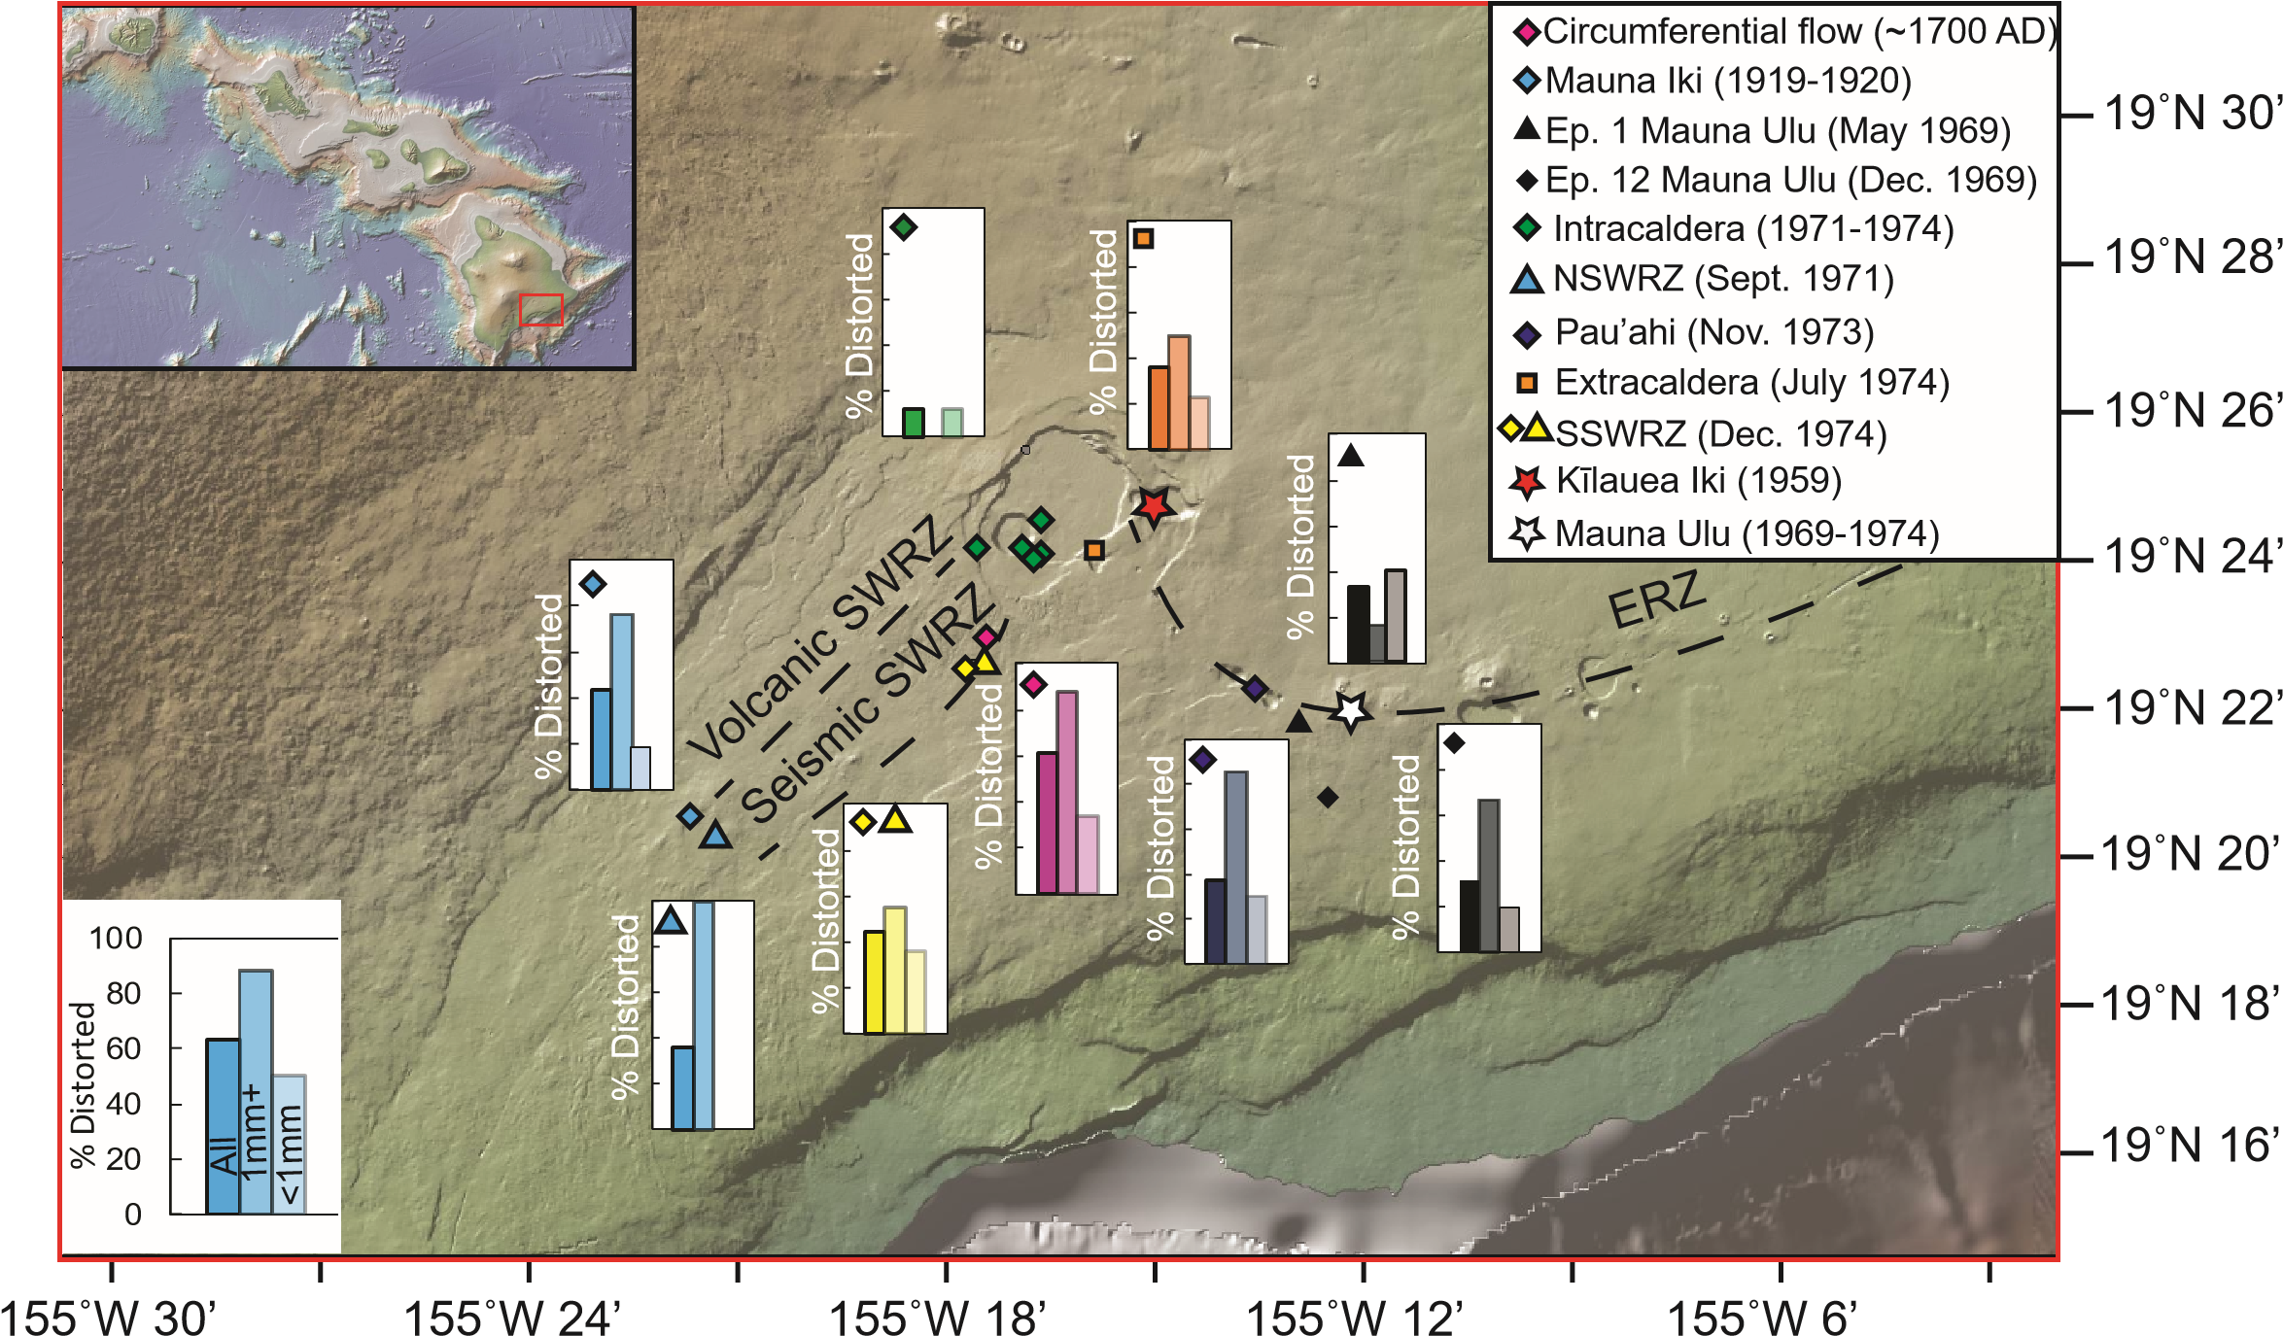
Fig. 1 – Spatial distribution of distorted grains across the Kīlauean edifice. Bar charts show the proportion of distorted grains across all sizes, and subdivided into grains >1mm and <1mm (based on sieved size fractions). Basemap from GEOMAPP APP.

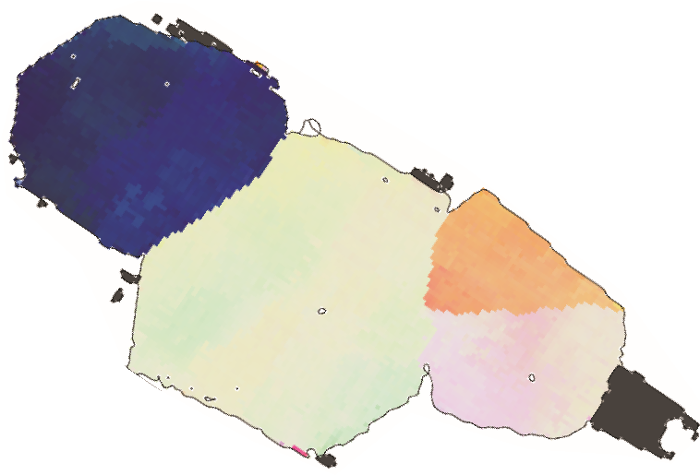

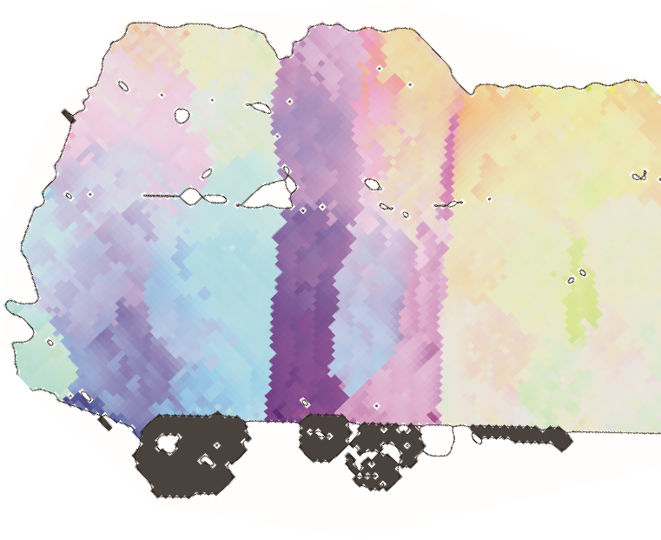
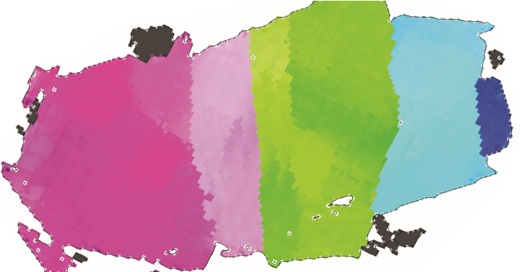
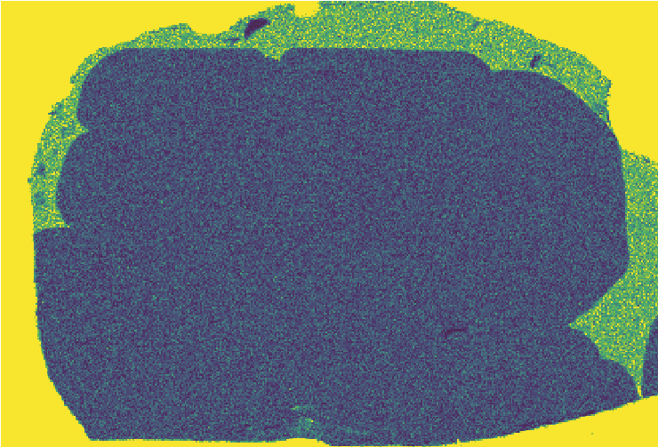
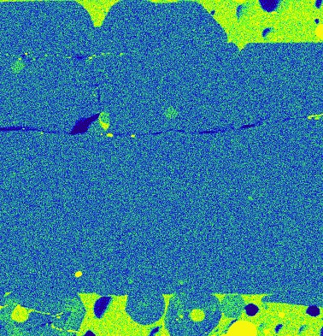
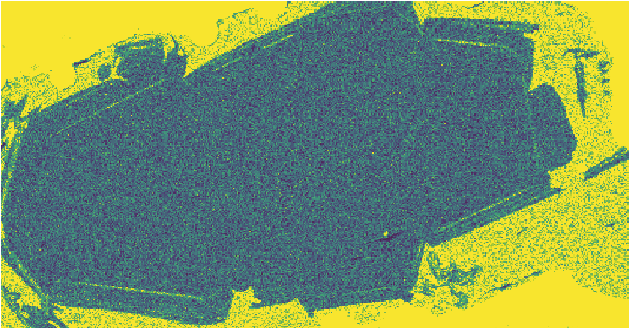
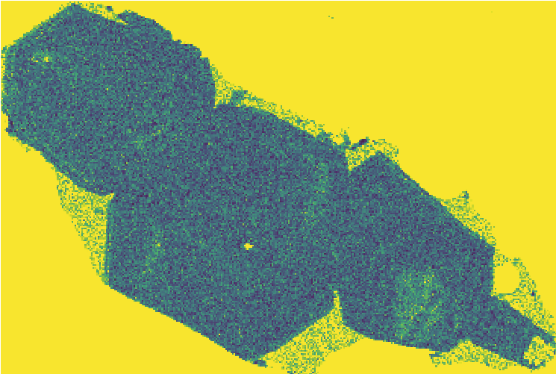

Figure 2
a)
b)
c)
d)
Low P
High P
[010]
[100]
[001]
500
µm
Truncation

Fig. 2 – Minor element chemistry of distorted grains. Wavelength Dispersive Spectrometry (WDS) maps of P enrichment (LHS) compared to EBSD maps (right). WDS elemental maps are colored by the number of counts per pixel (in ImageJ). EBSD maps are colored using the inverse pole figure (IPF) key. A sample reference direction is chosen such that the mean orientation of the central grain is coloured white. The color scale (top right) shows how pixels with crystallographic directions deviating from the mean are colored. Once the deviation angle is greater than >3˚, the pixel is colored black. Most distorted grains show no P enrichments in their cores (a, b, c). Observed phosphorus enrichments occur in the rims of some grains, likely marking a period of rapid growth upon eruption (c). In some cases, internal P enrichments are clearly truncated by subgrain boundaries (d).

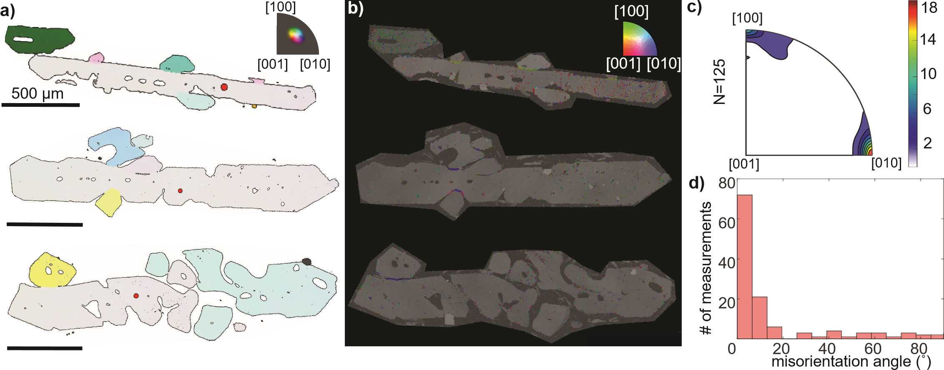
Figure 3
Fig. 3 – Crystallographic signatures of dendritic branching in West Greenland picrites²². a) EBSD maps colored using the IPF key, with the mean orientation of the grain containing the red dot set to white. Pixels with deviation angles >20˚ are colored black. b) Weighted Burgers Vector directions (WBVD) overlain on band contrast maps ([100]=green, [010]=blue, [001]=red]). c) Misorientation axes for 125 misorientated buds (misorientation angle >1˚). d) Histogram of misorientation angles between adjacent dendrite buds. Many buds are misorientated from the host crystal by >>5 ˚.

Figure 4
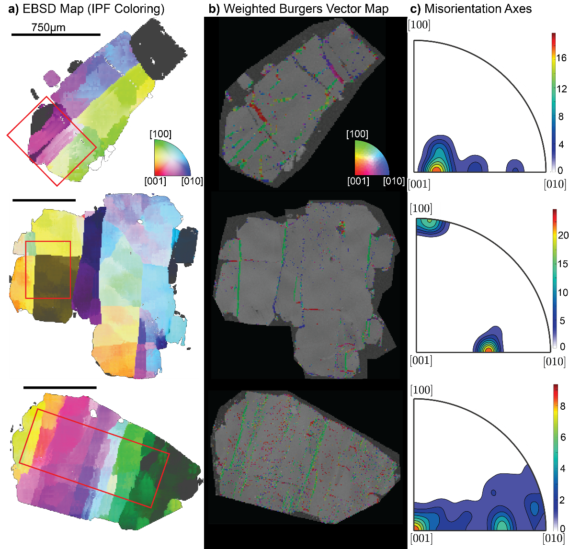
Fig. 4 – Crystallographic signatures of lattice distortions within Kīlauean olivines. a) EBSD maps colored using the IPF key as in Fig. 2. b) WBV directions overlain on band contrast maps ([100]=green, [010]=blue, [001]=red]). c) Misorientation axes across subgrain boundaries located within the red box indicated in column a). Subgrain boundaries with [100] WBVDs (green) show misorientation axes between [001] and [010]. Subgrain boundaries with [001] WBVDs (red) show misorientation axes about [100] or [010].

Figure 5
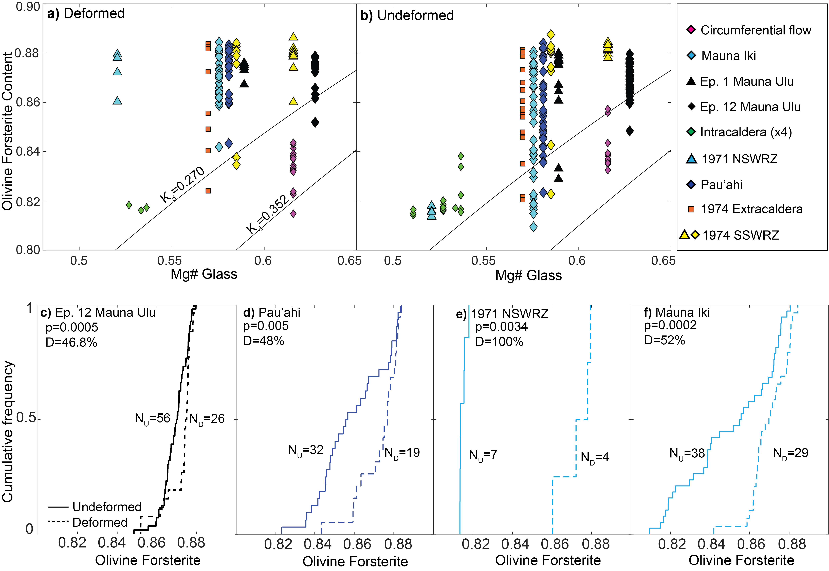Fig. 5 – Chemical differences between deformed and undeformed olivine grains. a-b) Olivine forsterite contents versus matrix glass Mg# (Fe³⁺/Fe_{T}=0.15; ~QFM)⁶⁸. Olivine-liquid equilibrium lines are shown for Kd=0.270-0.352^{69,70}. Both deformed and undeformed grains have higher forsterite contents than the equilibrium olivine composition of their matrix glasses. However, deformed grains show a narrower range of forsterite contents, which lie further from the equilibrium field than undeformed grains. c-f) Cumulative distribution functions comparing undeformed (solid lines) and deformed (dashed lines) olivines for 4 eruptions. Deformed grains are more primitive at a statistically significant level (p<0.01) using the two sample Kolmogorov-Smirnov test. The test statistic D is also shown.

Figure 6

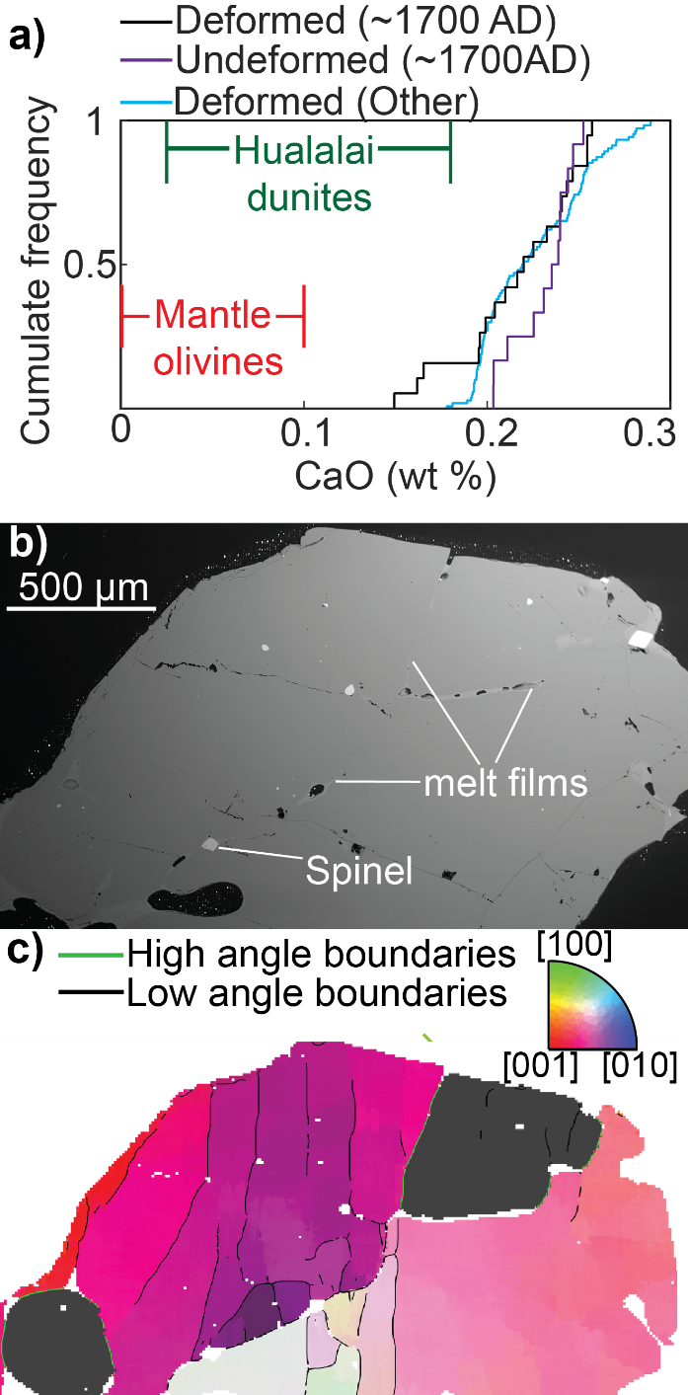
Fig. 6 –Textural and chemical evolution during downslope flow. a) CaO contents of deformed Kīlauean olivines (excluding the ~1700 AD lava flow) plot well outside the field for mantle olivines³⁵, and have substantially higher CaO contents than olivines from Hualalai dunites¹⁵. Some deformed olivines from ~1700 AD have lower CaO contents than undeformed olivines in this sample. In fact, three deformed olivines fall within the field of Hualalai dunites. b) BSE image showing prominent melt films along high angle boundaries in the interior of a deformed crystal from the ~1700 AD eruption. c) EBSD map colored with the IPF colour key scaled to 10˚ about the mean orientation of the central grain. High angle boundaries (misorientation angle >10˚) are shown in green, with low angle boundaries (misorientation angle <10˚) in black.

Figure 7
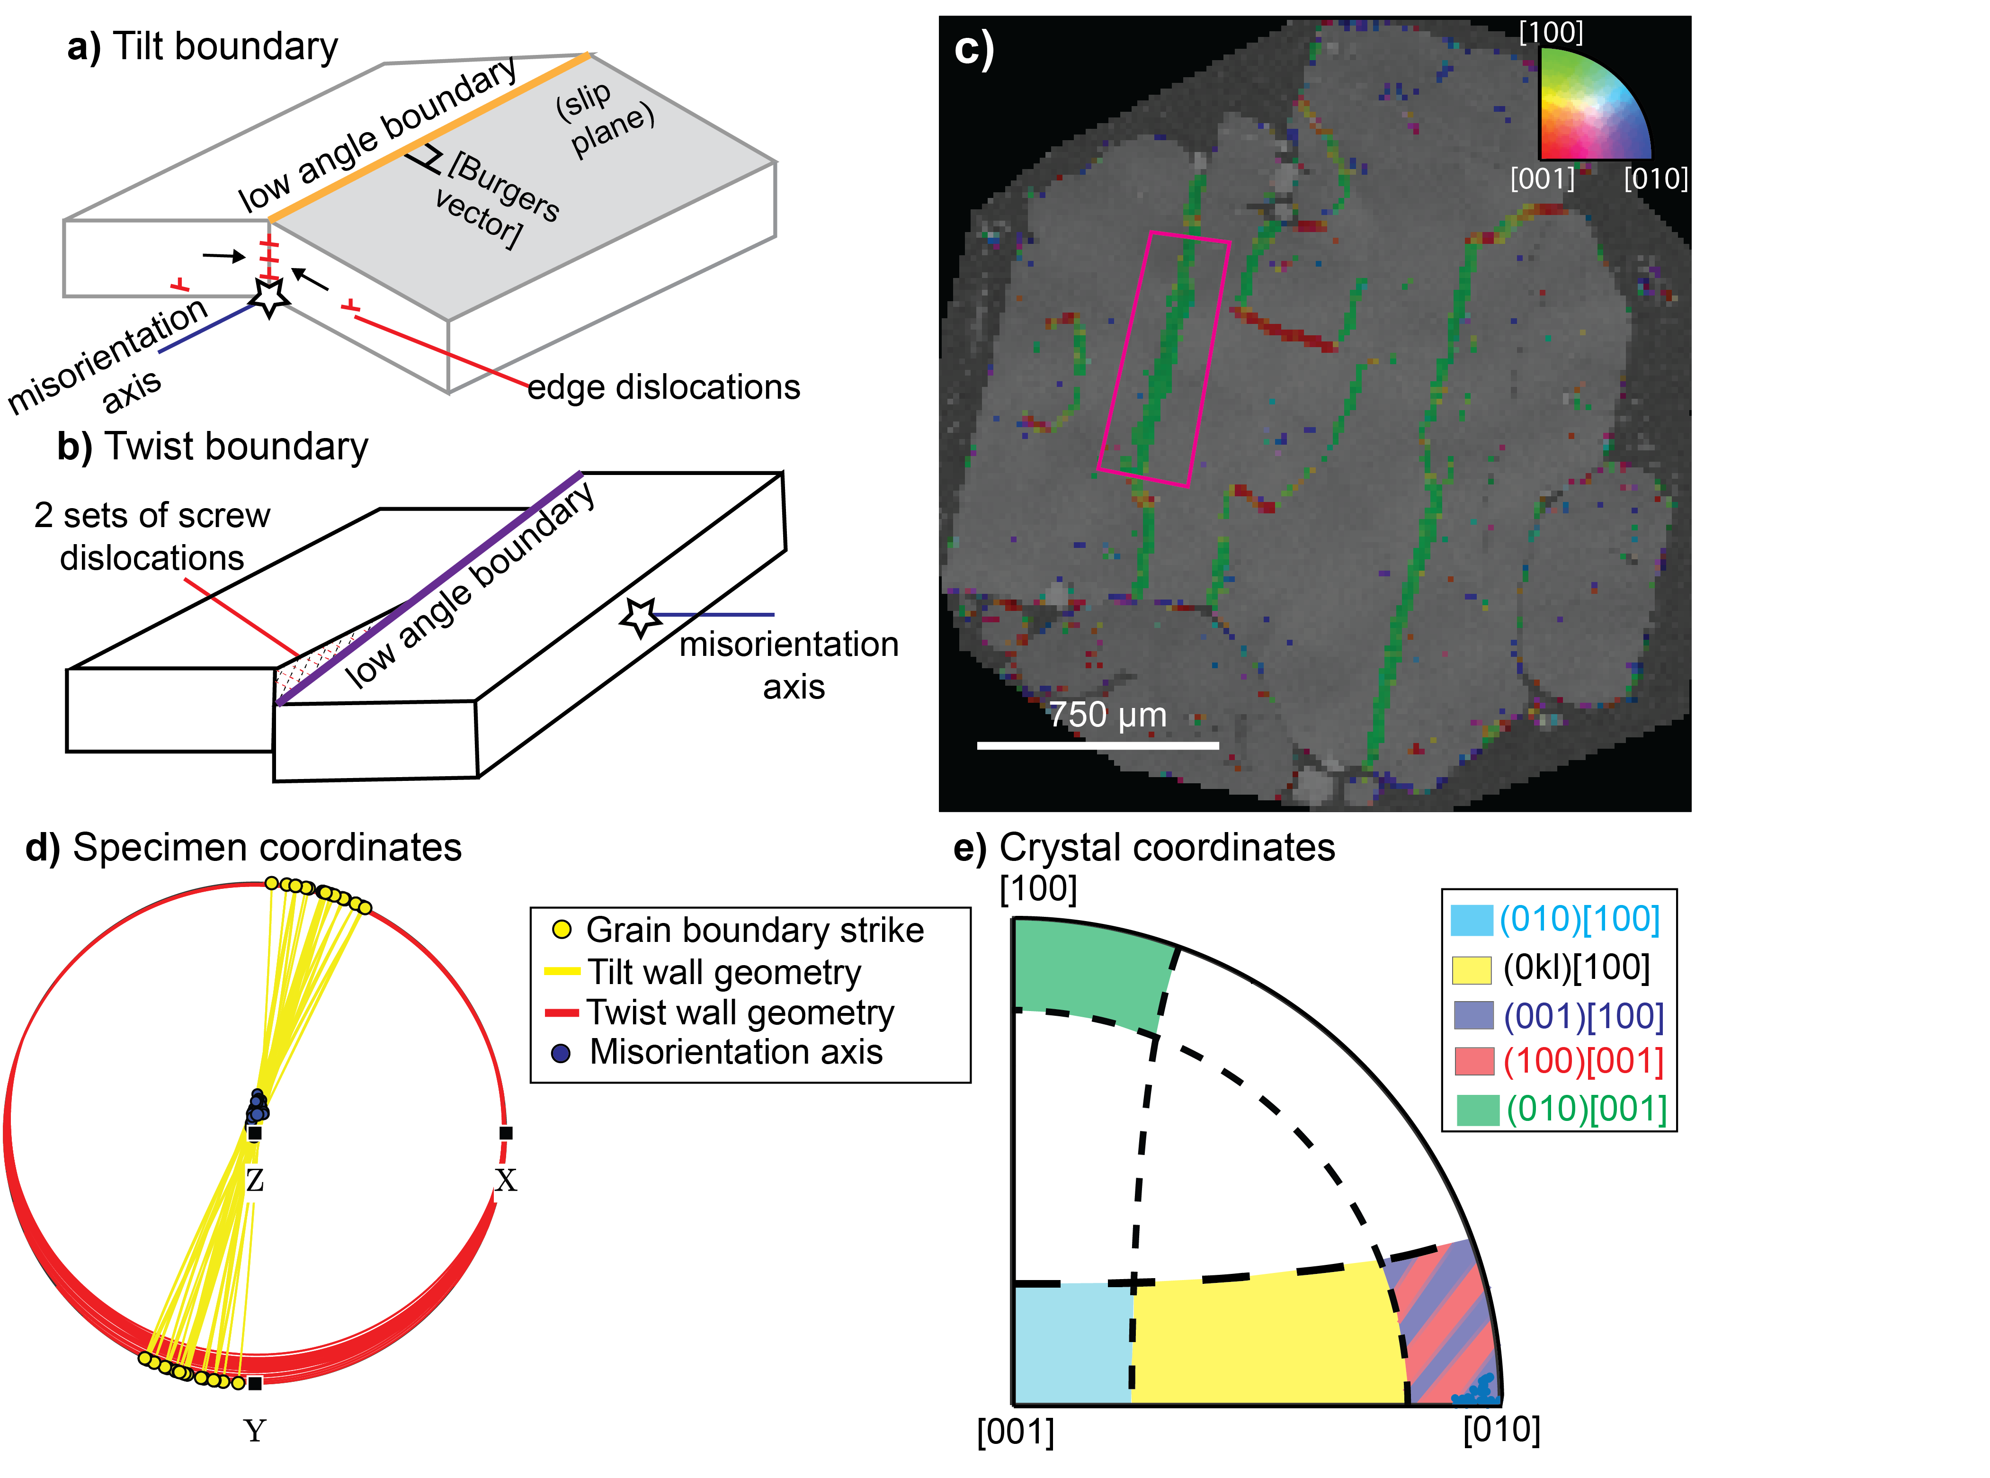
Fig. 7 –Slip system identification method developed for this study. a) An ideal tilt boundary contains the rotation axis within the plane of the low angle boundary. b) An ideal twist boundary is perpendicular to the rotation axis. Two sets of screw dislocations are shown within the twist wall for illustrative purposes; this is just one possible geometry. c) Map of WBVDs in a deformed olivine. Boundaries with [100] WBVDs strike ~N-S, while those with [001] WBVDs strike ~E-W. A small section of a [100] WBVD boundary is selected for further discussion (pink rectangle). d) Ideal tilt (yellow) and twist (red) boundaries calculated for each boundary segment in the pink rectangle based on the trace of the subgrain boundary and direction of the misorientation axis. As the calculated twist wall planes show extremely low dips, the MTEX code classifies all segments along this boundary as tilt walls. e) Schematic diagram showing the misorientation axes in crystal coordinates for tilt boundaries built from dislocations types associated with each of the 5 olivine slip systems (written as (slip plane)[burgers vector]), allowing 20˚ leniency. Misorientation axes of the boundary pixels within the pink rectangle plot near [010]. Alongside the [100] WBVD, this indicates that this tilt wall consists of (001)[100] dislocations.

Figure 8
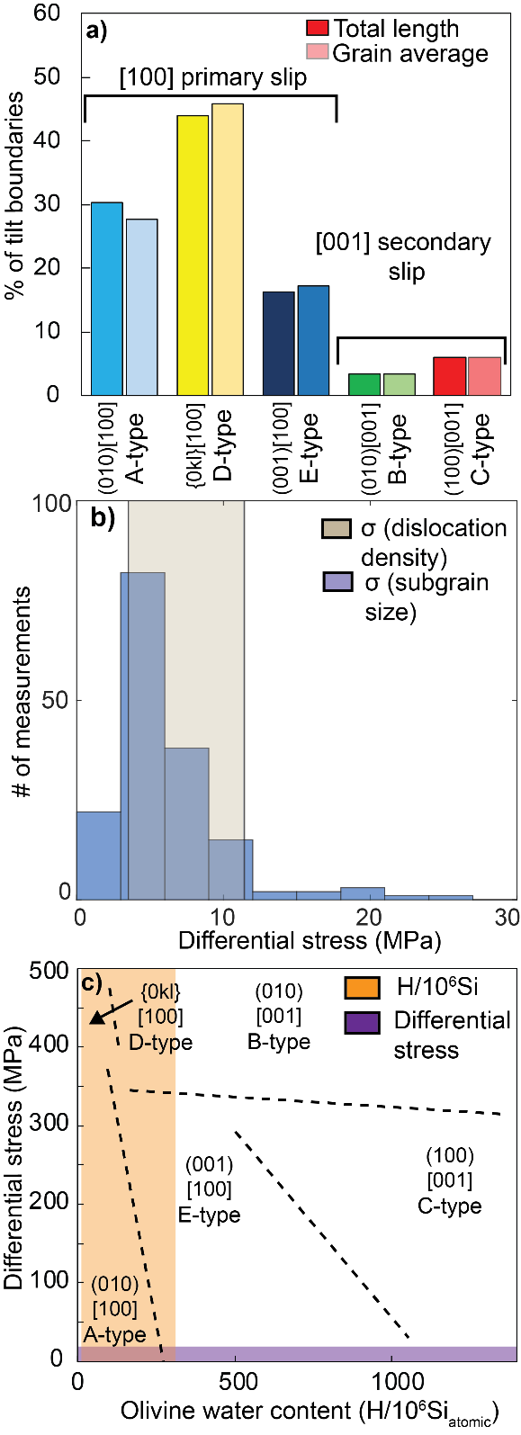
Fig. 8 –Quantifying the conditions of deformation. a) Proportions calculated by summing the total length of each boundary type in 62 deformed grains (LHS), and by averaging the proportion of each slip system per grain (RHS; giving equal weight to all grains regardless of their size). b) Differential stresses calculated using subgrain piezometery⁵⁰ applied to linear intercept distances clearly overlap with those estimated from dislocation density piezometery⁵¹ on published dislocation densities²⁵. d) Olivine regime diagram⁴⁹ for T=1470-1570K with subgrain stress estimates (purple bar) and olivine water contents (orange bar) superimposed.

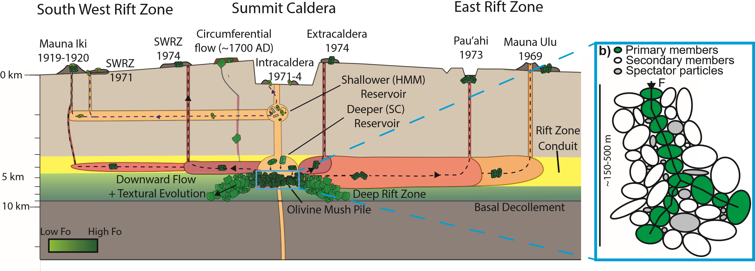
Figure 9
Fig. 9 – Schematic diagram showing the formation of deformed grains at Kīlauea. a) Olivine crystals in intracaldera eruptions thought to tap the shallower reservoir based on Pb isotope compositions^{64,65} are largely undeformed. These crystals have evolved forsterite contents, close to the equilibrium composition of their matrix glasses. Extracaldera and rift eruptions, thought to tap the deeper reservoir based on Pb isotopes^{64,65}, entrain deformed crystals from melt-rich olivine mush piles at the base of the deeper reservoir just prior to eruption. The Mauna Iki eruption taps a mixed crystal cargo, from the upper and lower reservoir²¹. The ~1700 AD eruption and the Kīlauea Iki eruption⁸ may tap olivine bodies that have begun their descent into the deep rift zones. b) Schematic diagram of force chains within granular olivine mush piles. Primary members can experience forces ~6x the mean force, secondary members experience less than the mean force, while spectator particles experience no force.

Figure 10
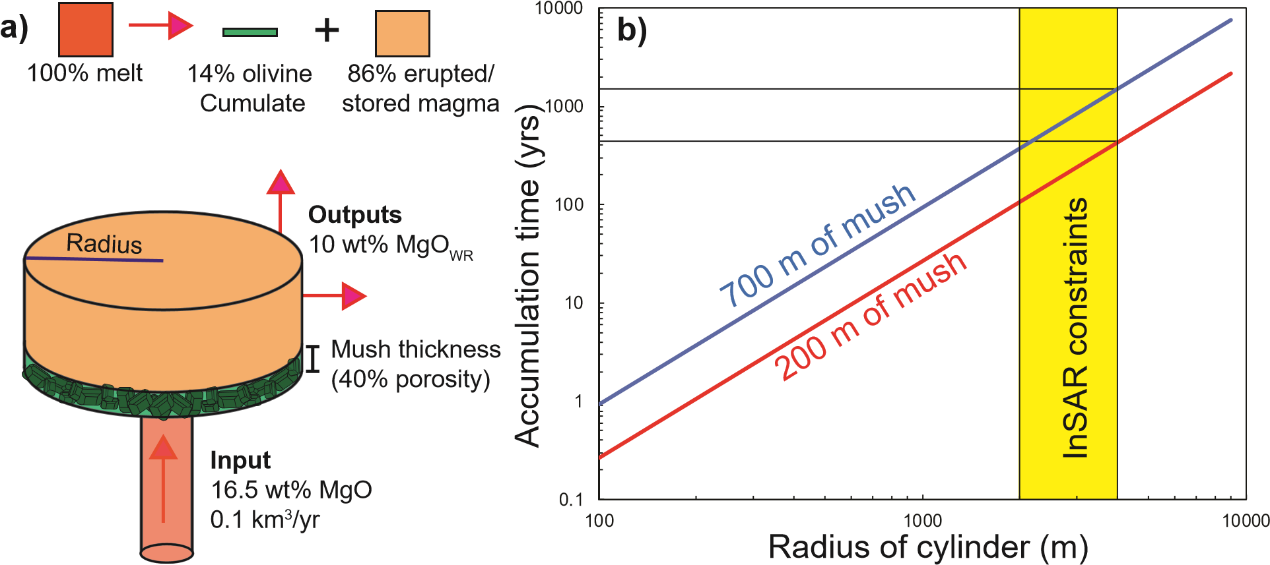
Fig. 10 –Estimating mush pile accumulation rates using a simple model. a) A cylinder is supplied with primary melt (16.5 wt% MgO) at a rate of 0.1km³/yr ^{[59]}. Fractionation of this melt to the output composition (taken as the average whole rock MgO content of erupted lavas; ~10 wt% MgO) requires fractionation of 14 vol % olivine crystals¹⁵. b) The play off between cylinder radius and accumulation time is shown for mush piles with thicknesses of 200m and 700m (assuming 40% porosity). Available constraints on reservoir radius from InSAR are overlain⁶⁰.

Methods

Sample Preparation and Data Collection.
Tephra and lava samples were jaw crushed and sieved into three size fractions (>1 mm, 840-250 µm and <250 µm). Olivine crystals were picked and mounted in epoxy stubs. West Greenland picrites, and one Kīlauean epoxy grain mount were made into thin sections. Epoxy mounts and thin sections were polished with progressively finer silicon pastes, then colloidal silica using a VibroMet 2 Buehler Vibratory Polisher. EBSD data was collected on a FEI Quanta 650FEG SEM equipped with a Bruker e- Flash HR EBSD detector. Spot analysis and element maps were performed on a Cameca SX100 EPMA in the Department of Earth Sciences, University of Cambridge. For detailed analytical methodologies, see the Supplementary Information.

Data Processing
Data clean up and post-processing was performed in MTEX V5.0.4⁴⁵, an open-source toolset for MATLAB. Single misindexed pixels were removed. Data was denoised using a 5 neighbour Kuwahara filter²⁷. Subgrain boundaries were identified using the calcGrains function, with a threshold angle of 0.5˚ (combining inner and outer boundaries).

Distinguishing lattice distortions
Classifying a grain as distorted or undistorted is somewhat arbitrary, particularly based on optical observations^{24,25}. Here, the presence of distortion was quantitatively assessed from EBSD maps. Grains were classified as distorted if at least 1 low angle boundary was identified by the MTEX calcGrains function. The same detector resolution was used for all EBSD acquisitions, and pixel spacings were significantly smaller than the microstructure features of interest (3-10µm vs. ~100µm), resulting in a consistent definition of a distorted crystal. The shape of the boundary and relation to external morphological features in BSE images were visually assessed to ensure that grains containing low angle boundaries resulting from grain aggregation were not considered further.
To allow comparison with previous studies at Kīlauea, EBSD maps for ~20 grains within a ~40µm thick section were compared to optical observations. Low angle boundaries with misorientations <1˚ were almost always invisible optically. Additionally, the ability to optically resolve subgrain boundaries depended on the sharpness of the misorientation contrast, and the orientation of the crystal within the thin section. In some instances, subgrain boundaries with misorientations up to 2.5˚ were invisible. Based on the small subset of grains examined here, previous optical studies may have significantly underestimated the proportion of distorted grains²⁵ (by up to 45%).

Code Availability
The Matlab scripts used to classify olivine slip systems (MTEX 5.0.4) have been uploaded into the supplementary information with an example .ctf file.

Data Availability
Olivine and glass compositions can be found in Supplementary Data Table A.

Acknowledgments
We acknowledge Zoja Vukmanovic and Chris Gregson for very helpful discussions about identifying slip systems. Isobel Walker collected the samples used in this study. Giulio Lampronti and Iris Buisman for help collecting EBSD and EPMA data. PW is funded by NERC DTP studentship NE/L002507/1.

Author Contributions
PW conceived the project with help from ME and JM. PW collected and processed the EBSD and EPMA data and wrote the MTEX code. JW provided the WBVD scripts, and guidance in interpreting the EBSD data. PW wrote the manuscript with help from ME, JM and JW.

References
1. Rae, A. S. P. et al. Time scales of magma transport and mixing at Kīlauea Volcano, Hawai’i. Geology 44, 463–466 (2016).
2. Thomson, A. & Maclennan, J. The Distribution of Olivine Compositions in Icelandic Basalts and Picrites. Journal of Petrology 54, 745–768 (2013).
3. Tuohy, R. M., Wallace, P. J., Loewen, M. W., Swanson, D. A. & Kent, A. J. R. Magma transport and olivine crystallization depths in Kīlauea’s east rift zone inferred from experimentally rehomogenized melt inclusions. Geochimica et Cosmochimica Acta 185, 232–250 (2016).
4. Vinet, N., Molina, P. & Flemming, R. Quantification and origin of intracrystalline deformation of olivine from basalts of the Andean Southern Volcanic Zone: A multidisplinary study. Congreso Geologica Chileno (2015).
5. Welsch, B., Faure, F., Famin, V., Baronnet, A. & Bachèlery, P. Dendritic Crystallization: A Single Process for all the Textures of Olivine in Basalts? Journal of Petrology 54, 539–574 (2013).
6. Clague, D. A., Moore, J. G., Dixon, J. E. & Friesen, W. B. Petrology of Submarine Lavas from Kilauea’s Puna Ridge, Hawaii. Journal of Petrology 36, 299–349 (1995).
7. Vinet, N. & Higgins, M. D. Magma Solidification Processes beneath Kilauea Volcano, Hawaii: a Quantitative Textural and Geochemical Study of the 1969-1974 Mauna Ulu Lavas. Journal of Petrology 51, 1297–1332 (2010).
8. Helz, R. Diverse olivine types in lava of the 1959 eruption of Kilauea volcano and their bearing on eruption dynamics. Volcanism In Hawaii 1 691–722 (1987).
9. Welsch, B., Hammer, J. & Hellebrand, E. Phosphorus zoning reveals dendritic architecture of olivine. Geology 42, 867–870 (2014).
10. Natland, J. H. Capture of Helium and Other Volatiles during the Growth of Olivine Phenocrysts in Picritic Basalts from the Juan Fernandez Islands. Journal of Petrology 44, 421–456 (2003).
11. Wilkinson, J. F. G. & Hensel, H. D. The petrology of some picrites from Mauna Loa and Kilauea volcanoes, Hawaii. Contributions to Mineralogy and Petrology 98, 326–345 (1988).
12. Wright, T. L. & Fiske, R. S. Origin of the Differentiated and Hybrid Lavas of Kilauea Volcano, Hawaii. Journal of Petrology 12, 1–65 (1971).
13. Clague, D. A., Weber, W. & Dixon, J. Picritic Glasses from Hawaii. Nature 353, 6344 (1991).
14. Garcia, M. O. A Petrologic Perspective of Kilauea Volcano’s Summit Magma Reservoir. Journal of Petrology 44, 2313–2339 (2003).
15. Clague, D. A. & Denlinger, R. P. Role of olivine cumulates in destabilizing the flanks of Hawaiian volcanoes. Bulletin of Volcanology 56, 425–434 (1994).
16. Park, J. et al. Comparative velocity structure of active Hawaiian volcanoes from 3-D onshore–offshore seismic tomography. Earth and Planetary Science Letters 259, 500–516 (2007).
17. Denlinger, R. P. & Morgan, J. K. Instability of Hawaiian Volcanoes. in Characteristics of Hawaiian Volcanoes 1801, 149–176 (2014).
18. Poland, M. P., Miklius, A. & Emily, M.-B. Magma Supply, Storage, and Transport at Shield-Stage Hawaiian Volcanoes. in Characteristics of Hawaiian Volcanoes 1081, 179–234 (2014).
19. Lockwood, J. P. et al. Magma Migration and Resupply During the 1974 Summit Eruptions of Kllauea Volcano, Hawai’i. in USGS Geological Survey Professional Paper 1613, 47 (1999).
20. Lynn, K. J., Garcia, M. O., Shea, T., Costa, F. & Swanson, D. A. Timescales of mixing and storage for Keanakāko‘i Tephra magmas (1500–1820 C.E.), Kīlauea Volcano, Hawai‘i. Contributions to Mineralogy and Petrology 172, (2017).
21. Rowland, S. K. & Munro, D. C. The 1919-1920 eruption of Mauna Iki, Kilauea: chronology, geologic mapping, and magma transport mechanisms. Bulletin of Volcanology 55, 190–203 (1993).
22. Larsen, L. M. & Pedersen, A. K. Processes in High-Mg, High-T Magmas: Evidence from Olivine, Chromite and Glass in Palaeogene Picrites from West Greenland. Journal of Petrology 41, 1071–1098 (2000).
23. Bradshaw, R. W., Kent, A. J. R. & Tepley, F. J. Chemical fingerprints and residence times of olivine in the 1959 Kilauea Iki eruption, Hawaii: Insights into picrite formation. American Mineralogist 103, 1812–1826 (2018).
24. Vinet, N., Flemming, R. L. & Higgins, M. D. Crystal structure, mosaicity, and strain analysis of Hawaiian olivines using in situ X-ray diffraction. American Mineralogist 96, 486–497 (2011).
25. Sakyi, P. A., Tanaka, R., Kobayashi, K. & Nakamura, E. Inherited Pb isotopic records in olivine antecryst-hosted melt inclusions from Hawaiian lavas. Geochimica et Cosmochimica Acta 95, 169–195 (2012).
26. Kohlstedt, D. L., Goetze, C. & vander Sande, J. New Technique for Decorating Dislocations in Olivine. Science 191, 1045–1046 (1976).
27. Humphreys, F. J. Review Grain and subgrain characterisation by electron backscatter diffraction. Journal of materials science 36(16), 3833–3854
28. Garcia, M. O., Rhodes, J. M., Trusdell, F. A. & Pietruszka, A. J. Petrology of lavas from the Puu Oo eruption of Kilauea Volcano: III. The Kupaianaha episode (1986-1992). Bulletin of Volcanology 58, 359–379 (1996).
29. Milman-Barris, M. S. et al. Zoning of phosphorus in igneous olivine. Contributions to Mineralogy and Petrology 155, 739–765 (2008).
30. Spandler, C., O’Neill, H. S. C. & Kamenetsky, V. S. Survival times of anomalous melt inclusions from element diffusion in olivine and chromite. Nature 447, 303–306 (2007).
31. Wheeler, J., Prior, D., Jiang, Z., Spiess, R. & Trimby, P. The petrological significance of misorientations between grains. Contributions to Mineralogy and Petrology 141, 109–124 (2001).
32. Wheeler, J. et al. The weighted Burgers vector: a new quantity for constraining dislocation densities and types using electron backscatter diffraction on 2D sections through crystalline materials. Journal of Microscopy 233, 482–494 (2009).
33. Donaldson, C. H. An experimental investigation of olivine morphology. Contributions to Mineralogy and Petrology 57, 187–213 (1976).
34. Boioli, F., Carrez, P., Cordier, P., Devincre, B. & Marquille, M. Modeling the creep properties of olivine by 2.5-dimensional dislocation dynamics simulations. Physical Review B 92, (2015).
35. Thompson, R. N. & Gibson, S. A. Transient high temperatures in mantle plume heads inferred from magnesian olivines in Phanerozoic picrites. Nature 407, 502–506 (2000).
36. Kirby, S. & Green, H. Dunite Xenoliths from Hualalai Volcano: evidence for mantle diapiric flow beneath the island of Hawaii. American Journal of Science 280, 550–575 (1980).
37. Boudier, F. Olivine xenocrysts in picritic magmas: An experimental and microstructural study. Contributions to Mineralogy and Petrology 109, 114–123 (1991).
38. Hughes, C. Igneous Petrology. 7, (Elsevier, 2013).
39. Ave’Lallemant, H. G. & Carter, N. L. Syntectonic Recrystallization of Olivine and Modes of Flow in the Upper Mantle. Geological Society of America Bulletin 81, 2203 (1970).
40. Katayama, I., Jung, H. & Karato, S. New type of olivine fabric from deformation experiments at modest water content and low stress. Geology 32, 1045 (2004).
41. Zhang, S. & Karato, S. lattice preferred orientation of olivine aggregates deformed in simple shear. Nature 375(6534), 774 (1995).
42. Hansen, L. N. & Warren, J. M. Quantifying the effect of pyroxene on deformation of peridotite in a natural shear zone: Pyroxene and peridotite deformation. Journal of Geophysical Research: Solid Earth 120, 2717–2738 (2015).
43. Cao, Y. et al. Plastic Deformation and Seismic Properties in Fore-arc Mantles: A Petrofabric Analysis of the Yushigou Harzburgites, North Qilian Suture Zone, NW China. Journal of Petrology 56, 1897–1944 (2015).
44. Prior, D. J. et al. The application of electron backscatter diffraction and orientation contrast imaging in the SEM to textural problems in rocks. American Mineralogist 84, 1741–1759 (1999).
45. Bachmann, F., Hielscher, R. & Schaeben, H. Texture Analysis with MTEX – Free and Open Source Software Toolbox. Solid State Phenomena 160, 63–68 (2010).
46. Zhang, S., Karato, S., Fitz Gerald, J., Faul, U. H. & Zhou, Y. Simple shear deformation of olivine aggregates. Tectonophysics 316, 133–152 (2000).
47. Jung, H. & Karato, S. Water-Induced Fabric Transitions in Olivine. Science 293, 1460–1463 (2001).
48. Hansen, L. N., Zhao, Y.-H., Zimmerman, M. E. & Kohlstedt, D. L. Protracted fabric evolution in olivine: Implications for the relationship among strain, crystallographic fabric, and seismic anisotropy. Earth and Planetary Science Letters 387, 157–168 (2014).
49. Jung, H., Katayama, I., Jiang, Z., Hiraga, T. & Karato, S. Effect of water and stress on the lattice-preferred orientation of olivine. Tectonophysics 421, 1–22 (2006).
50. Toriumi, M. Relation between dislocation density and subgrain size of naturally deformed olivine in peridotites. Contributions to Mineralogy and Petrology 68, 181–186 (1979).
51. Bai, Q. & Kohlstedt, D. L. High-temperature creep of olivine single crystals, 2. Dislocation structures. Tectonophysics 206(1–2), 1–29 (1992).
52. Sides, I. R., Edmonds, M., Maclennan, J., Swanson, D. A. & Houghton, B. F. Eruption style at Kīlauea Volcano in Hawai‘i linked to primary melt composition. Nature Geoscience 7, 464–469 (2014).
53. Hauri, E., Gaetani, G. & Green, T. Partitioning of water during melting of the Earth’s upper mantle at H2O-undersaturated conditions. Earth and Planetary Science Letters 248, 715–734 (2006).
54. Neave, D. A., Maclennan, J., Hartley, M. E., Edmonds, M. & Thordarson, T. Crystal Storage and Transfer in Basaltic Systems: the Skuggafjöll Eruption, Iceland. Journal of Petrology 55, 2311–2346 (2014).
55. Lange, R. A. & Carmichael, I. S. E. Densities of Na2O-K2O-CaO-MgO-FeO-Fe2O3-Al2O3-TiO2-SiO2 liquids: New measurements and derived partial molar properties. Geochimica et Cosmochimica Acta 51, 2931–2946 (1987).
56. Antony, S. . Link between single-particle properties and macroscopic properties in particulate assemblies: role of structures within structures. Philosophical Transactions of the Royal Society A: Mathematical, Physical and Engineering Sciences 365, 2879–2891 (2007).
57. Estep, J. & Dufek, J. Substrate effects from force chain dynamics in dense granular flows. Journal of Geophysical Research: Earth Surface 117(F1), (2012).
58. Bergantz, G. W., Schleicher, J. M. & Burgisser, A. On the kinematics and dynamics of crystal-rich systems: Hydrogranular Dynamics. Journal of Geophysical Research: Solid Earth 122, 6131–6159 (2017).
59. Anderson, K. R. & Poland, M. P. Bayesian estimation of magma supply, storage, and eruption rates using a multiphysical volcano model: Kīlauea Volcano, 2000–2012. Earth and Planetary Science Letters 447, 161–171 (2016).
60. Baker, S. & Amelung, F. Top-down inflation and deflation at the summit of Kīlauea Volcano, Hawai‘i observed with InSAR. Journal of Geophysical Research: Solid Earth 117, (2012).
61. Gallagher, J., Friedman, M., Handin, J. & Sowers, G. Experimental Studies Relating to Microfracture in Sandstone. Tectonophysics 21(3), 203–247 (1974).
62. Wheeler, J. The effects of stress on reactions in the Earth: Sometimes rather mean, usually normal, always important. Journal of Metamorphic Geology 36, 439–461 (2018).
63. Cervelli, P. F. & Miklius, A. The Shallow Magmatic System of Kïlauea Volcano. in USGS professional paper 1676, 149–163 (2003).
64. Pietruszka, A. J., Marske, J. P., Heaton, D. E., Garcia, M. O. & Rhodes, J. M. An Isotopic Perspective into the Magmatic Evolution and Architecture of the Rift Zones of Kīlauea Volcano. Journal of Petrology (2018). doi:10.1093/petrology/egy098
65. Pietruszka, A. J., Heaton, D. E., Marske, J. P. & Garcia, M. O. Two magma bodies beneath the summit of Kīlauea Volcano unveiled by isotopically distinct melt deliveries from the mantle. Earth and Planetary Science Letters 413, 90–100 (2015).
66. Helz, R. T., Clague, D. A., Mastin, L. G. & Rose, T. R. Evidence for Large Compositional Ranges in Coeval Melts Erupted from Kilauea’s Summit Reservoir. in Hawaiian Volcanoes: from source to surface 125–145 (2015).
67. Davidson, J., Turner, S., Handley, H., Macpherson, C. & Dosseto, A. Amphibole “sponge” in arc crust? Geology 35, 787 (2007).
68. Moussallam, Y. et al. The impact of degassing on the oxidation state of basaltic magmas: A case study of Kīlauea volcano. Earth and Planetary Science Letters 450, 317–325 (2016).
69. Roeder, P. L. & Emslie, R. F. Olivine-liquid equilibrium. Contributions to Mineralogy and Petrology 29, 275–289 (1970).
70. Matzen, A. K., Baker, M. B., Beckett, J. R. & Stolper, E. M. Fe–Mg Partitioning between Olivine and High-magnesian Melts and the Nature of Hawaiian Parental Liquids. Journal of Petrology 52, 1243–1263 (2011).

