EarthArXiv coversheet for:

Dataset of global extreme climatic indices due to an acceleration of ice sheet melting during the 21st century
Dimitri Defrance

Dimitri Defrance
*corresponding author :
E-mail: dimitri.defrance@inra.fr
RG : https://www.researchgate.net/profile/Dimitri_Defrance

SYSTEM, Univ Montpellier, INRA, Montpellier SupAgro, CIRAD, CIHEAM, 2 Place Pierre Viala, Bâtiment 27, 34060 Montpellier, France

This article is a non-peer reviewed preprint version. This preprint is submitted to Data in Brief since 21th of March 2019 for peer review.
Looking forward to the publication of the paper in the journal Applied Geography, the citation of this article should use the EarthArXiv DOI:
Defrance, D. (n.d.). Dataset of global extreme climatic indices due to an acceleration of ice sheet melting during the 21st century. <EarthArXiv DOI>
Dataset of global extreme climatic indices due to an acceleration of ice sheet melting during the 21st century
Authors: Dimitri Defrance
Affiliations: SYSTEM, Univ Montpellier, INRA, Montpellier SupAgro, CIRAD, CIHEAM, Montpellier, France
Contact email: Dimitri.defrance@inra.fr

Abstract
This article describes extreme indices maps (Data Cube, raster X Time) for different scenarios with a more important contribution to the sea level rise from Greenland and/or Antarctica during the 21st century under the Representative Concentration Pathway (RCP) 8.5 emission scenario. The indices are produced annually and globally with a resolution of 0.5°X0.5° from 1951 to 2099. The data were generated by simulating daily maximum and minimum temperature and precipitation from the IPSL-CM5A-LR model from Coupled Model Intercomparison Project Phase 5 (CMIP5). These climatic data are unbiased and downscaled to the 0.5°x0.5 scale with the the Cumulative Distribution Function transform (CDFt) and EWEMBI dataset compiled to support the bias correction of climate input data for ISIMIP. Finally, each extreme indice is compute on the unbiased data on each grid cell on all continents. These data are available at http://dx.doi.org/10.17632/fbsdj87gjg.1 .

Keywords: ice sheet contribution; climate change; extreme events ; temperature; precipitation; global climate model

Specifications Table

Subject area | Climate change and extreme events
More specific subject area | Evolution of extreme events due to a high contribution of freshwater from ice sheets.
Type of data | Data Cube (Raster X Time)
How data was acquired | Climatic simulation with Global Circulation Model using current and projected gasses emissions
Data format | Netcdf file
Experimental factors | Geographic Coordinate System WGS1984 with 0.5X0.5 spatial resolution
Experimental features | Unbiased Temperature and Precipitation data from IPSL-CM5A-LR climate model to compute 17 extreme climatic indices
Data source location | Global scale
Data accessibility | On data.mendeley: http://dx.doi.org/10.17632/fbsdj87gjg.1
Related research article | Sillmann, J., Kharin, V. V., Zhang, X., Zwiers, F. W., & Bronaugh, D. (2013). Climate extremes indices in the CMIP5 multimodel ensemble: Part 1. Model evaluation in the present climate. Journal of Geophysical Research: Atmospheres, 118(4), 1716-1733.

Value of the Data
- Annual 19 extreme climatic indices at global scale between 1951 and 2099.
- Alternative scenarios with an acceleration of the ice sheets contribution to sea level rise.
- Data can be used in impacts studies around the world on several thematics: economy, agronomy, hydrology
- Data can be compared with other climate simulations obtained with other GCMs.
Data
The data consist of 16 annual extreme indices on the entire world and given in a geo-tiff raster datasets. These indices depend on daily precipitation or daily temperature simulated by the Global Circulation Model (GCM) IPSL-CM5A-LR used in the Coupled Model Intercomparison Project Phase 5 (CMIP5). A historical run and seven different climatic scenarios are simulated between 1951 and 2006 (historical) and between 2006 and 2099 (climatic scenarios). The first climatic scenario is the RCP8.5 baseline scenario from The Intergovernmental Panel on Climate Change (IPCC) corresponds to a global temperature increase of ~5°C with respect to the pre-industrial level. The six other scenarios are superimposed on the RCP8.5 scenarios with an input of freshwater from Greenland and/or West-Antarctica added in the ocean. The amount of added freshwater corresponds to 1, 1.5 or 3m of sea level rise.
The results are seven annual time series of the 16 indices across the world with a 0.5°X0.5° resolution (~50x50 km at the equator) and an historical run from 1951 to 2005. The different climate indices characterize the extreme events related to temperature and precipitation and have been determined by Expert Team on Climate Change Detection and Indices (ETCCDI). For each grid cell, we have seven different annual evolutions of each index by the end of 21st century (Fig 1.). It can be accessed via http://dx.doi.org/10.17632/fbsdj87gjg.1.

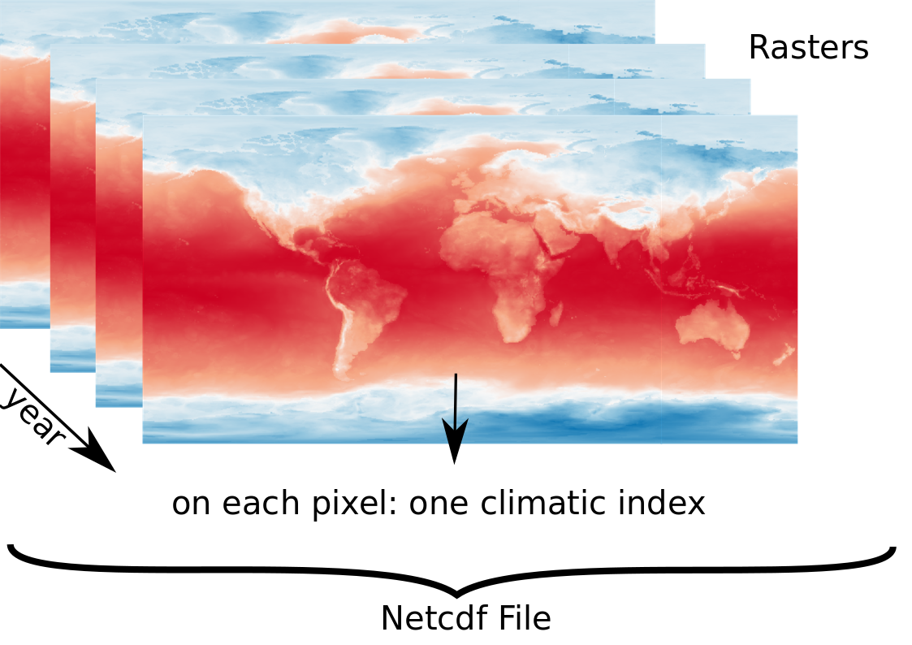
Figure 1 - Structure of climatic index (raster map X year)
Experimental Design, Materials, and Methods
To calculate the different extreme climatic indices under an acceleration of ice-sheet melting, three steps are necessary:
- Climatic simulation (precipitation and temperature) obtained by a GCM,
- Unbiased temperature and precipitation time series,
- Calculation of 16 climatic indices.
Climatic simulation

All the experiments are carried out with the coupled atmosphere-ocean model IPSL-CM5A-LR (Dufresne et al., 2013) used in international intercomparison projects of climate models (CMIP5) whose results are reported by the IPCC. The atmospheric component (LMDZ) has a spatial resolution of 3.75 ° over 1.875 ° in longitude and latitude respectively with 39 vertical levels; the oceanic component (NEMO) uses an irregular grid with a nominal resolution of 2 ° and a finer resolution in the latitude of 0.5 ° in the equatorial ocean and on 31 vertical levels (For details see Dufresne et al., 2013)
The climate scenario that is considered in our dataset and which serves as a baseline scenario is the RCP8.5 for the period 2006 to 2100. It corresponds to the most pessimistic evolution of the climate by the IPCC and leading to an average increase of temperature of about 5 ° compared to that of the pre-industrial era. In this scenario, we add a flow of freshwater corresponding to a sea level rise of 1 m, 1.5 m and 3 m (0.11 Sv, 0.22 Sv, 0.34 Sv and 0.68 Sv, 1Sv = 10⁶ m³/s) from 2020 to 2070. This freshwater flow can come from either Greenland only (GrIS scenario) or West Antarctic only (WAIS scenario) either of the two ice sheets (GrWAIS scenario).

Locations of freshwater addition are chosen to produce a rapid model response. Freshwater discharges are therefore placed in deep-water formations in the North Atlantic for the GrIS and GrWAIS scenarios and in the western part of the Southern Ocean for the WAIS and GrWAIS scenarios. For GrWAIS scenario the contribution of each ice sheet is identical. The choice of high volumes of fresh water (0.11 Sv to 0.68 Sv) is justified by the fact that current climate models do not seem sufficiently sensitive to freshwater inputs (Swingedouw et al., 2013). These high values ​​make it possible to better evaluate the potential impacts on the thermohaline circulation in the Atlantic.

Unbiased temperature and precipitation time series

Several studies have shown that climate models, despite improvements over the years, are subject to significant biases for precipitation and current temperature. The study by Dufresne et al. (2013) shows that the IPSL-CM5A-LR has for example a cold bias in West Africa and a warm bias on the Gulf of Guinea which prevents a good estimate of monsoon rains. All of the global temperature and precipitation biases are described in this article for more detail.

To circumvent this disadvantage, we applied a statistical method to improve the precipitation and temperatures simulated by the IPSL-CM5A-LR in the world. This method, called "Cumulative Distribution Function transform" (CDF-t) was originally developed by (Michelangeli, Vrac, & Loukos, 2009) and has been successfully applied in many climate studies (eg, Colette, Vautard, & Bulk, 2012). This is a variant of the "Quantile Mapping Approach" (eg, Déqué, 2007), which is detailed in the article by Famien et al. (2018). The Quantile Mapping Approach technique involves associating with a modeled precipitation value (or other climatic variables) a precipitation value in the control distribution (ie, the observations or the reanalysis dataset), so that cumulative distributions (modeled and reference values) are equivalent (Panofsky & Brier, 1958).
The CDF-t method goes even further and takes into account the climate change signal in the corrected dataset. This is made possible by the assumption that there is a mathematical transformation to translate the cumulative distribution function of the modeled variables to be corrected into the cumulative distribution function representing climate variables from the reference dataset (for the period history or calibration) or corrected values ​​(for the future).

Our climate simulations have been corrected with respect to the interpolated EWEMBI climate reanalysis at a spatial resolution of 0.5°x0.5° (Frieler et al., 2017), used as a reference. Here, the so-called "calibration" period covers the 34-year period from 1979 to 2013, while the "projection" period covers the 94-year period from 2006 to 2099. The evaluation of the method was carried out across Africa (Famien et al., 2018) and shows that the bias on temperature and precipitation is greatly reduced.

Calculation of 16 climatic indices

In order to better characterize global changes related to the melting of Greenland and Antarctica, climate indices other than precipitation totals and mean annual temperatures are computed. These indicators are based on daily surface data: minimum temperature (TN), maximum temperature (TX) and precipitation (PR). The 16 climatic indices come from a set of indicators defined by the ETCCDI supported by the CLIVAR project (http://www.clivar.org/) and are well described on the ETCCDI website as well as in for example (Alexander et al., 2006, Sillmann, Kharin, Zhang, Zwiers, & Bronaugh, 2013). The different indices are calculated year by year on each grid cell (0.5°X0.5°) around the world by CDO and Climate indices of daily temperature and precipitation extremes library.

Temperature indices
Label | Index name | Index definition | Units
TNmin | Annual minimum temperature | Let TNmin be the daily minimum temperature in period j. The minimum daily minimum temperature is then: TNminj = min(TNj) | °C
TXmax | Annual maximum temperature | Let TXmax be the daily minimum temperature in period j. The minimum daily minimum temperature is then: TXmaxj = max(TXj) | °C
FD | Number of frost days | Let TN be the daily minimum temperature on day i in period j. Count the number of days where TNij < 0°C | days
ID | Number of icing days | Let TX be the daily maximum temperature on day i in period j. Count the number of days where TXij < 0°C | days
TR | Number of tropical nights | Let TN be the daily minimum temperature on day i in period j. Count the number of days where TNij > 20°C | days
SU | Number of summer days | Let TX be the daily maximum temperature on day i in period j. Count the number of days where TXij > 25°C | days
WSDI | Warm speel duration index | Let TXij be the daily maximum temperature on day i in period j and let TXin90 be the calendar day 90th percentile centered on a 5 day window for the base period 1976–2005. Then the number of days per period is summed where, in intervals of at least 6 consecutive days: TXij > TXin90 | days
CWDI | Cold wave duration index | Let TNij be the daily minimum temperature on day i in period j and let TNin10 be the calendar day 10th percentile centered on a 5 day window for the base period 1976–2005. Then the number of days per period is summed where, in intervals of at least 6 consecutive days: TNij < TNin10 | days
Precipitation indices
Label | Index name | Index definition | Units
PRCPTOT | Total wet‐day precipitation | Let PRij be the daily precipitation amount on day i in period j. If I represents the number of days in j, then: PRCPTOTj = PRij | mm
R1mm | Annual count of wet days | Let PRij be the daily precipitation amount on day i in period j. Count the number of days where PRij > 1 mm | days
R10mm | Annual count of days when PRCP≥ 10mm | Let PRij be the daily precipitation amount on day i in period j. Count the number of days where PRij > 10 mm | days
R20mm | Annual count of days when PRCP≥ 20mm | Let PRij be the daily precipitation amount on day i in period j. Count the number of days where PRij > 20 mm | days
SDII | Simple pricipitation intensity index | Let PRwj be the daily precipitation amount on wet days, PR > = 1 mm in period j. If W represents number of wet days in j, then: SDIIj = ( PRwj) / W | mm
RX5day | maximum consecutive 5-day precipitation | Let PRkj be the precipitation amount for the 5 day interval ending k, period j. Then maximum 5 day values for period j are: RX5dayj = max (PRkj) | mm
CDD | Maximum length of dry spell, maximum number of consecutive days with RR < 1mm | Let PRij be the daily precipitation amount on day i in period j. Count the largest number of consecutive days where PRij < 1 mm | days
CWD | Maximum length of wet spell, maximum number of consecutive days with RR ≥ 1mm | Let PRij be the daily precipitation amount on day i in period j. Count the largest number of consecutive days where PRij > 1 mm | days

Acknowledgments
The author thanks Thomas Noël and the climate data factory to apply the bias correction on the climatic simulations. This study benefited also from the high performance computing (HPC) resources made available by Grand Equipement National de Calcul Intensif, CEA, and Centre National de la Recherche Scientifique.

References

Alexander, L. V., Zhang, X., Peterson, T. C., Caesar, J., Gleason, B., Tank, A. K., ... & Tagipour, A. (2006). Global observed changes in daily climate extremes of temperature and precipitation. Journal of Geophysical Research: Atmospheres, 111(D5).
Colette, A., Vautard, R., & Vrac, M. (2012). Regional climate downscaling with prior statistical correction of the global climate forcing. Geophysical Research Letters, 39(13).
Déqué, M. (2007). Frequency of precipitation and temperature extremes over France in an anthropogenic scenario: Model results and statistical correction according to observed values. Global and Planetary Change, 57(1-2), 16-26.
Dufresne, J. L., Foujols, M. A., Denvil, S., Caubel, A., Marti, O., Aumont, O., ... & Bony, S. (2013). Climate change projections using the IPSL-CM5 Earth System Model: from CMIP3 to CMIP5. Climate Dynamics, 40(9-10), 2123-2165.
Famien, A. M., Janicot, S., Ochou, A. D., Vrac, M., Defrance, D., Sultan, B., & Noel, T. (2018). A bias-corrected CMIP5 dataset for Africa using the CDF-t method: a contribution to agricultural impact studies. Earth System Dynamics, 9(1), 313-338.
Frieler, K., Lange, S., Piontek, F., Reyer, C. P., Schewe, J., Warszawski, L., ... & Geiger, T. (2017). Assessing the impacts of 1.5 C global warming–simulation protocol of the Inter-Sectoral Impact Model Intercomparison Project (ISIMIP2b). Geoscientific Model Development, 10(12), 4321-4345.
Michelangeli, P. A., Vrac, M., & Loukos, H. (2009). Probabilistic downscaling approaches: Application to wind cumulative distribution functions. Geophysical Research Letters, 36(11).

Panofsky, H. A., & Brier, G. W. (1958). Some applications of statistics to meteorology. Mineral Industries Extension Services, College of Mineral Industries, Pennsylvania State University.

Sillmann, J., Kharin, V. V., Zhang, X., Zwiers, F. W., & Bronaugh, D. (2013). Climate extremes indices in the CMIP5 multimodel ensemble: Part 1. Model evaluation in the present climate. Journal of Geophysical Research: Atmospheres, 118(4), 1716-1733.

Swingedouw, D., Rodehacke, C. B., Behrens, E., Menary, M., Olsen, S. M., Gao, Y., Mikolajewicz, U., Mignot, J. and Biastoch, A. (2013). Decadal fingerprints of freshwater discharge around Greenland in a multi-model ensemble, Clim. Dyn., 41(3–4), 695–720.

