*This manuscript is a preprint and has not been peer-reviewed. When (if) the manuscript is accepted for publication, the definitive version will be available via the ‘Peer-reviewed publication DOI’ link on the right-hand side of this webpage.*

**Average daily flow of microplastics through a tertiary wastewater treatment plant over a ten-month period**

Reina M. Blair1*, Susan Waldron1, Caroline Gauchotte-Lindsay2

1 School of Geographical and Earth Sciences, University of Glasgow, G12 8QQ

2 School of Engineering, University of Glasgow, G12 8LT

*Corresponding author: [r.blair.1@research.gla.ac.uk](mailto:r.blair.1@research.gla.ac.uk)

**Abstract**

Microplastics (MPs, <5 mm in size) are classified as emerging contaminants but currently treatment processes are not designed to remove these small particles. Wastewater treatment systems have been proposed as pathways for MPs pollution to receiving waters but quantitative and qualitative data on MP occurrence and transport in these systems remains limited, hindering risk assessment and regulation of these materials. Here, for the first time, the stepwise abundance and loading of MPs in a tertiary wastewater treatment plant in the UK was assessed by sampling from May 2017 to February 2018. Microplastics were present during all sampling campaigns, with an average inflow of 8.1 x 108 (95% CI, 3.8 x 108 to 1.2 x 109) items day-1, but their prevalence decreased from influent to final effluent. Overall abundances decreased on average by 2%, 54-70%, 92%, and 97% after the pre-treatment, primary, secondary, and tertiary treatment stages respectively, although considerable variability was exhibited throughout the year. Sufficient particles remained in the treated effluent to generate an average discharge of 2.2 x 107 (95% CI, 1.2 x 107 to 3.2 x 107]) particles day-1 to the recipient river. Secondary MPs were predominant, while abundances of primary MPs were minimal. Fibres comprised 67% of all items, followed by films (18%) and fragments (15%). Chemical characterisation confirmed the presence of different types of polymers, with polypropylene fibres and fragments most abundant (23%). This research informs understanding of how wastewater effluent may channel MPs to the natural environment and their composition, and helps understand control points for optimising advanced treatment processes.

# Introduction

Microplastics (MPs; <5 mm) are ubiquitous in the environment and may pose a threat to biota and humans (Anbumani & Kakkar 2018), thus are classed as contaminants of emerging concern (Hartl et al. 2015) but remain not regulated by water quality standards or criteria. This may be largely because they have not been fully assessed due to their heterogeneous nature and high spatio-temporal variations, even within localized environmental compartments. Furthermore, a lack of standardized protocols leads to limited comparability across available surveys and a lack of guidelines to monitor MPs in aquatic systems. Current empirical data is still too limited to fully understand the extent of their pollution and the severity of their threat, making it difficult for regulators to determine what types of MPs need to be prioritised in monitoring programmes and where controls should be implemented. Nevertheless, similar to other anthropogenic contaminants, 80% of MPs are considered to originate from land-based sources (Rochman et al. 2015), therefore the role of wastewater treatment plants (WWTPs) as potential barriers of MP pollution should be considered, as they are important links between the anthropogenic and natural environments (Ou & Zeng 2018).

Wastewater treatment systems are designed to remove contaminants from household and trade effluent, so their role in MPs removal has been generating increasing attention from the research community, yet they remain largely unexplored (**Table 1**). The majority of available studies quantify MPs in secondary WWTPs in Europe (Magnusson and Noren 2014; Dris et al. 2015; Bayo et al. 2016; Murphy et al. 2016; Leslie et al. 2017; Mintenig et al. 2017; Lares et al. 2018; Simon et al. 2018) and North America (Carr et al. 2016; Mason et al. 2016; Sutton et al. 2016; Dyachenko et al. 2017; Gies et al. 2018), with single studies available from Australia (Ziahjaromi et al. 2017) and China (Li et al. 2018). Data for advanced WWTPs remain comparably limited, and, available surveys come from similar geographical locations in Europe (Leslie et al. 2017; Mintenig et al. 2017; Talvitie et al. 2017a,b; Simon et al. 2018; Magni et al. 2019), the USA (Carr et al. 2016; Mason et al. 2016; Sutton et al. 2016), and Australia (Browne et al. 2011; Ziahjaromi et al. 2017). Only one study is available for primary WWTPs and was conducted in Australia (Ziahjaromi et al. 2017).

**Table 1** Summarised research from 2011 and 2019 on MPs in WWTPs



*Discharges were normalised on a daily basis. Effluent concentration in particles L-1 was provided where discharge day-1 was not available; **PE**, population equivalent

While the WWTP literature has grown moderately quickly in the past two years, each study differs in methodologies, plant capacity, and type of treatment technologies and stages examined, often limiting comparability of findings and comprehensive understanding of the occurrence and fate of MPs in these systems. Current evidence broadly suggests that a mixture of primary and secondary MPs may be entering the treatment facilities daily, at varying levels of pollution (Sun et al. 2019). Microplastic concentrations in raw wastewater are reported so far to range from <1 particle L-1 as observed by multiple studies (Sun et al. 2019), to 18,285 particles L-1 reported in a secondary treatment site in Denmark (Simon et al. 2018). Conversely, effluent concentrations between 0.0008 (Magnusson and Noren. 2014) and 447 (Simon et al. 2018) particles L-1 have been observed in secondary WWTPs, and between 0 (Carr et al. 2016) and 51 particles L-1 (membrane bioreactor, MBR; Leslie et al. 2017) after advanced treatment (Sun et al. 2019), with larger facilities likely discharging higher loads (Mason et al. 2018). Comparison of influent vs effluent concentrations is a common approach to estimate removal efficiencies, and these range between 40% and 99.9%, but not all studies report this (**Table 1**). Despite high retention efficiencies, low concentrations in final or treated effluent may represent a continuous and considerable MP source when scaled up for the volume of water discharged (Mason et al. 2016; Murphy et al. 2016). For instance, concentrations of 0.25 and 0.004 particles L-1 in final effluent, equated to discharges of 65 x 106 and 5 x 104 MPs day-1, respectively in secondary treatment plants in Scotland (Murphy et al. 2016) and San Francisco, USA (Mason et al. 2016). However, MPs concentrations and discharges from WWTPs are highly variable, and treatment procedure employed at the facility is presumed to play a crucial role in their retention.

The role of different treatment processes in removing contaminants from these systems can be assessed by a stage-wise inspection of MPs abundances during their passage through a single facility. Nevertheless, owing to challenges of sample collection and processing times, only a few studies have done this (Dris et al. 2015; Michielssen et al. 2016; Murphy et al. 2016; Ziahjaromi et al. 2017; Gies et al. 2018; Talvitie et al. 2017b; Magni et al. 2019), and specific stages sampled vary across studies. Findings so far propose that between ~63-98% of the removal can occur by the primary stage (Sun et al. 2019), while secondary treatment may aid in reducing an additional 7 to 20% of MPs that are not captured by preliminary and primary treatment (Talvitie et al. 2017b; Ziahjaromi et al. 2017; Gies et al. 2018). Evidence from studies observing MPs concentrations in different types of biosolids suggest that the removal of these materials during earlier stages is due to their capture in various sludge fractions including grit and grease skimmings (Murphy et al. 2016), sewage sludge (Bayo et al. 2016; Murphy et al. 2016; Leslie et al. 2017; Mintenig et al. 2017; Li et al. 2018), and returned activated or excess sludge (Carr et al., 2016; Talvitie et al. 2017a; Lares et al. 2018).

While the nature of primary and secondary treatment is mostly consistent across studies, a wide array of advanced treatment techniques have been observed. Studies comparing MPs in tertiary vs. secondary effluent found that different advanced treatment technologies can further decrease MPs before discharge (Michielssen et al. 2016; Mintenig et al. 2017; Talvitie et al. 2017a,b; Ziahjaromi et al. 2017; Lares et al. 2018; Magni et al. 2019). Overall, MBR (Lares et al. 2018; Talvitie et al. 2017a) and advanced filtration technologies (Michielssen et al. 2016; Mintenig et al. 2017; Talvitie et al. 2017 a,b; Ziahjaromi et al. 2017; Magni et al. 2019) are often reported as effective means in reducing MPs from final effluent. Dissolved air flotation in Finland (Talvitie et al. 2017a) and reverse osmosis and decarbonation in Australia (Ziahjaromi et al. 2017) also showed high performance. However, contrasting findings were found in other experiments where advanced treatment by gravity sand filtration (Carr et al. 2016; Mason et al. 2016; Sutton et al. 2017) and MBR (Leslie et al. 2017) did not promote further reduction of particles. The different findings in advanced WWTP studies support the need for further research to take into account a broad range of treatment technologies and produce a representative assessment of their role in removing MPs from wastewater. This information can contribute to identification of control points within these systems, and to the development or modification of operational procedures that decrease discharge of MPs to the recipient waters.

Further research for WWTPs is crucial in MPs research because wastewater is a complex and heterogeneous matrix, and pollution levels and removal efficiencies reported thus far exhibit high inter- and intra-site variability due to differing site parameters and methodologies (Mason et al. 2017). Especially, more empirical data are needed for multiple stages other than final effluent and for long-term sampling campaigns to explore factors driving spatio-temporal variabilities. Moreover, future research should explore methods to capture small MP fractions since most of the current knowledge comes from particles sized between 20 µm and 5 mm, with very few studies evaluating smaller dimensions (Gies et al. 2018; Simon et al. 2018). Here, a study was conducted in a WWTP in Scotland to: (1) understand the inflow and outflow loading of MPs (quantity and composition) in a tertiary treatment plant, accommodating temporal variability, and (2) assess the stepwise effect of treatment stage on the distribution and fate of MPs sized between 2.8 mm - 1.2 µm. To our knowledge, this is the first study to evaluate MPs in advanced treatment systems in the UK and the first to conduct long-term (i.e. 10 months) spatial sampling from a single facility.

# Materials and methods

## Study site and sampling

The study site was a tertiary wastewater treatment plant in Scotland, UK, with 184,500 population equivalents (PE) and receiving a mix of trade and domestic sewage. The plant consists of preliminary treatment of wastewater by coarse screening (12 mm) and grit removal, primary settling tanks (phases 1 and 2), activated sludge treatment and clarification in final settling tanks (phases 1 and 2), and nitrification on plastic media trickling filters (**Fig 1**), with final discharge of treated effluent into a freshwater river. Phases 1 and 2 were created due to an expansion of the treatment plant, but there is no difference in treatment between the two.

Sampling was conducted between May 2017 and February 2018 for a total of five sampling events: 19 May 2017 (SE1), 13 July 2017 (SE2), 20 October 2017 (SE3), 11 January 2018 (SE4), and 16 February 2018 (SE5). The flow range covered by the sampling events was 111,496 to 184,703 m3/day, representing low to medium flow conditions for the period of study (Qmean = 166,422 m3/day; **Fig 2, Fig S1**). During each sampling event, a 5-L sample was collected from each of eight sample collection points: influent before screens (P1), preliminary effluent after coarse screening and grit removal (P2), primary effluent phase 1 (P3a) and phase 2 (P3b), secondary effluent phase 1 (P4a) and phase 2 (P4b), secondary effluent mixed liquor (P5), and final effluent after tertiary treatment (P6) (**Fig 1**). Samples were collected in the morning for all events, with two additional samples collected in the afternoon on the same day during SE5 from the influent (P1, pm) and effluent (P6, pm), to explore daily fluctuations. A bulk sample, taken by lowering a metal bucket into the stream to collect wastewater, was filtered through a 2.8 mm metal sieve, and collected in plastic bottles for transport to the laboratory. A field blank, to control for background contamination from the sampling process, was prepared for each sampling event using DI water and the same sampling approach. Samples and blanks were kept in black plastic bags at 3°C until processing within a maximum of 8 weeks after collection.

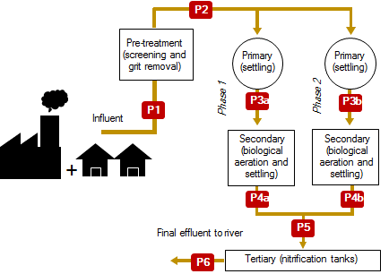

**Fig 1** Conceptual diagram of the tertiary sewage treatment process in the selected study site, illustrating eight sample collection points (P1-P6)



**Fig 2** Flow duration curve for the tertiary wastewater treatment plant based on daily inlet flows during the period of study from May 2017 to February 2018

## Microplastic extraction and characterisation

The methods used for extraction and characterisation are broadly adapted from wet peroxide oxidation (WPO) protocols (Eaton et al. 1998; Nuelle et al. 2014). As sewage can contain harmful microorganisms, such as bacteria, viruses and parasites, all samples were processed in a Category 2 biological safety cabinet (Cat 2 BSC) and room, which also helped minimise potential background contamination of samples. Samples were transferred to glass Erlenmeyer flasks and spiked with 50 polyethylene (PE) beads each (0.71-0.85 mm diameter, ρ=0.96 g cm-3; Cospheric LLC, Santa Barbara, California), to determine recovery rates. The spiked samples were treated with 30% hydrogen peroxide (H2O2; 1:1, v/v) for digestion of labile organics, heated in a water bath to 75°C for 30 minutes to speed up the reaction, then stirred in a magnetic stirrer for 10 minutes, and digested in the Cat 2 BSC at room temperature for three days. After the digestion period, samples were treated with UV light for 30 minutes to ensure samples were sterile enough to be removed from the Cat 2 BSC and room for filtration under vacuum through Whatman 1.2-µm glass fibre filters. Processing and filtration of the entire sample through a 1.2-µm pore size was selected to minimise the potential loss of smaller MPs by on-site filtration during sampling as this approach sets the lower cut off at a larger size in previous studies (Sun et al. 2019). Laboratory blanks to check for background contamination were created by placing DI water in open glass containers in lab benches during the extraction process, and filtering in parallel with each run of field samples.

All filters were examined under light microscopy using a Leica MX75 microscope with magnification ranging between 10x and 32x, for identification and enumeration of MPs based on physical appearance (i.e. shape and colour). Suspected MP pieces were classified into four categories: pellets, fibres, fragments, and films; and, two subcategories: pale (clear and white pieces) and coloured (non-clear/white pieces). We describe these samples are suspected as chemical analysis is needed to confirm composition (Blair et al. 2019). A subsample consisting of 70 pieces, equivalent to 5% of total items identified during visual inspection, was selected for chemical characterisation by Fourier-transform infrared-attenuated total reflectance spectroscopy (FTIR-ATR), using a Shimadzu IRAffinity-1S FTIR with diamond crystal and 20 scans. Materials were identified by comparison to the ATR spectral libraries equipped in the Shimadzu LabSolutions IR software. The percentage of pieces analysed chemically in this study is comparable to those of other wastewater surveys (Leslie et al. 2017; Gies et al. 2018). The subsample consisted of fibres (n=19), fragments (n=10) and films (n=41). Pellets could not be analysed as they were too small (<300 micron) to be manually transferred to the equipment.

Microplastic counts were used to estimate abundances in items L-1 at each stage during each sampling campaign. Daily flow data for the WWTP were used to estimate incoming and outgoing MP loads in items day-1 for normalised results.

## Fragmentation tests

Fragmentation tests using MP-spiked DI water were carried out to assess if the extraction process could generate secondary MPs at various stages. To achieve this, 12 spiked samples were created by placing 500 mL of DI water and 10 PE beads (0.71-0.85 mm diameter, ρ=0.96 g cm-3; Cospheric LLC, Santa Barbara, California) each in glass Erlenmeyer flasks. Nine of the spiked samples were then treated with 30% H2O2 (1:1, v/v) and three were left as blank controls (no treatment). Three samples were extracted under vacuum filtration as described above, before and after each step of the WPO treatment: (1) no treatment, (2) after H2O2 addition, (3) after heating, (4) after stirring. The filters were examined under light microscopy for quantification of full beads and fragmented pieces recovered.

# Results and discussion

## Blanks

Suspected MP fibres were observed in field and lab blanks in concentrations of 1-3 and 2-3 fibres L-1, respectively, indicating that background contamination during sampling or processing occurred. Blanks in field samples indicated contamination of wastewater may also occur from atmospheric fallout into the open wastewater channel, at any stage of the treatment process. Blanks in the lab show background contamination is difficult to avoid even when care is taken to minimise contamination from the lab environment. The deposition of airborne fibres as a source of analytical bias even under sterile conditions has been noted before (Dris et al., 2015; Wesch et al., 2017). More recently, fibres have been reported in potable water supplies (Kosuth et al. 2018), which may suggest an alternate pathway for their deposition if they are not being removed by purification processes, and these supplies are then used to create blanks. It was not possible to analyse fibres in the blanks chemically, as manual transfer was difficult due to their elongated shape and small diameters, and their light weights that made them easily airborne when handling. Therefore, blanks were initially treated as separate categories and corrected for chemical proportions similar to wastewater samples, to allow use to blank-correct field data.

Fibres in blanks were not always visually similar to those observed in wastewater samples (**Fig 3**), especially for lab blanks where fibres were often darker and shorter. Therefore, after FTIR correction, only field blanks were used to correct the wastewater data. Automated chemical methods are often cited as an urgent gap in MPs research, to avoid the bias of visual inspection (Hidalgo-Ruz et al. 2012; Blair et al. 2017; Sun et al. 2019). However, here the visual comparison helped refine results, thus a combined visual and chemical characterisation may still be better to improve accuracy of findings.

No other type of MPs were observed in blanks, providing confidence that the plastic funnel and bottle used in the sampling process, did not contribute MP fragments to the samples. Abundances and MPs loads are thus presented as FTIR- and field blank-corrected data, which avoids over-estimation of loading.

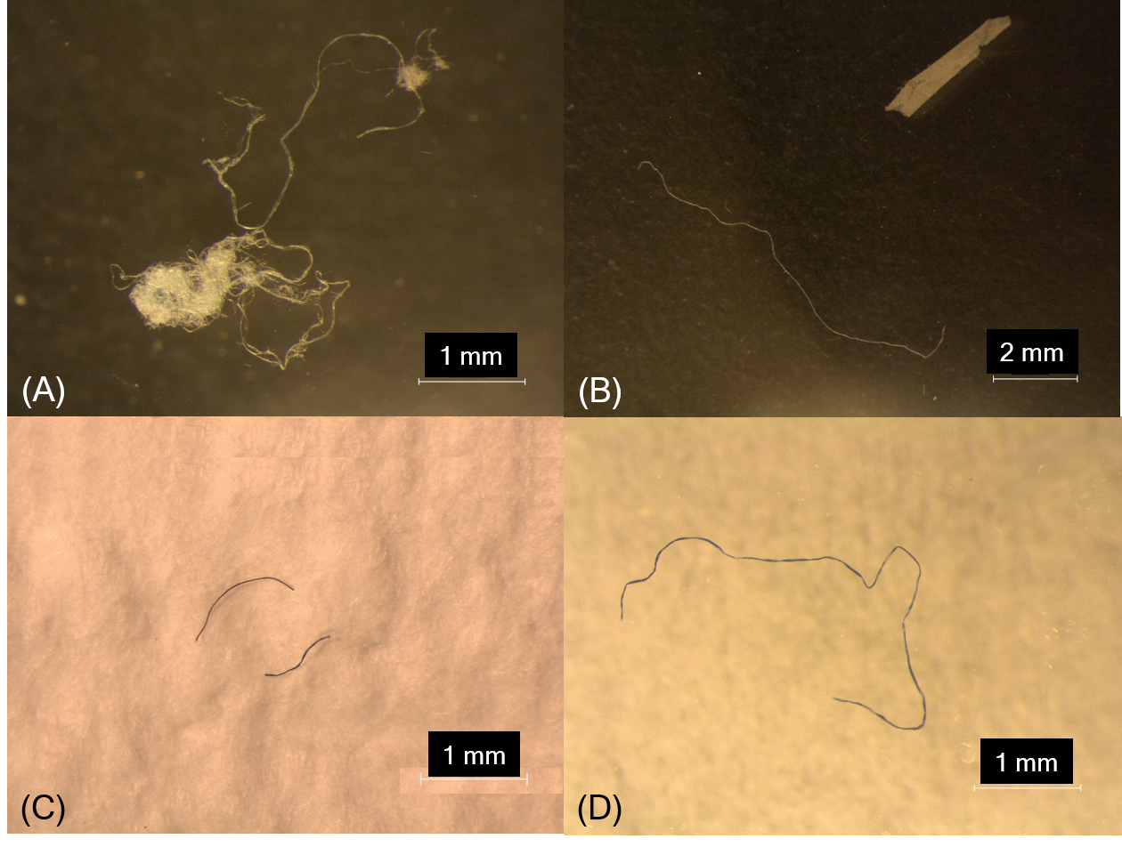

**Fig 3** Representative fibres observed in wastewater samples (A-B), lab blanks (C), and field blanks (D)

## Fragmentation tests

Bead recovery from spiked wastewater samples (n=3) ranged from 27-48 out of 50 beads (mean 42, median 43, standard deviation 5), and 1-18 bead fragments (mean 6, median 4, 6) were observed in 50% of spiked samples, with no fragments present in the remaining half. Percent recovery in fragmentation tests using DI standards were comparable, with recoveries of 6-10 out of 10 beads (mean 9, median 9, standard deviation 1) **(Table S1)**. During fragmentation tests, production of fragments was observed after heating (1 fragment in one replicate only) and after stirring (6 and 21 fragments in two replicates), indicating that the combination of treatments employed during the extraction protocol may contribute to the breakdown of MP pieces already present in the samples, but not always **(Table S1)**. Nevertheless, if this fragmentation occurs it could result in higher counts of MP fragments and a misleading interpretation of their abundance. Controlled recovery and method validation tests are needed as part of routine testing, but seem rarely reported in the literature. This is currently a pressing research need for validation of results, particularly as research progresses towards method standardisation, and is crucial for adequate risk assessment of MPs.

## MPs characterisation

During visual characterisation, a total of 1308 items across all samples were considered potential MPs, and classified based on morphology as either fibres (n=871), fragments (n=191), films (n=239), or pellets (n=7) (**Fig 4**). Visual inspection alone has been used by previous studies for identification of MPs in wastewaters (Dris et al. 2015; Mason et al. 2016; Sutton et al. 2016) but the majority of studies follow this step with polymer identification by chemical analysis (Sun et al. 2016), as done here, too.

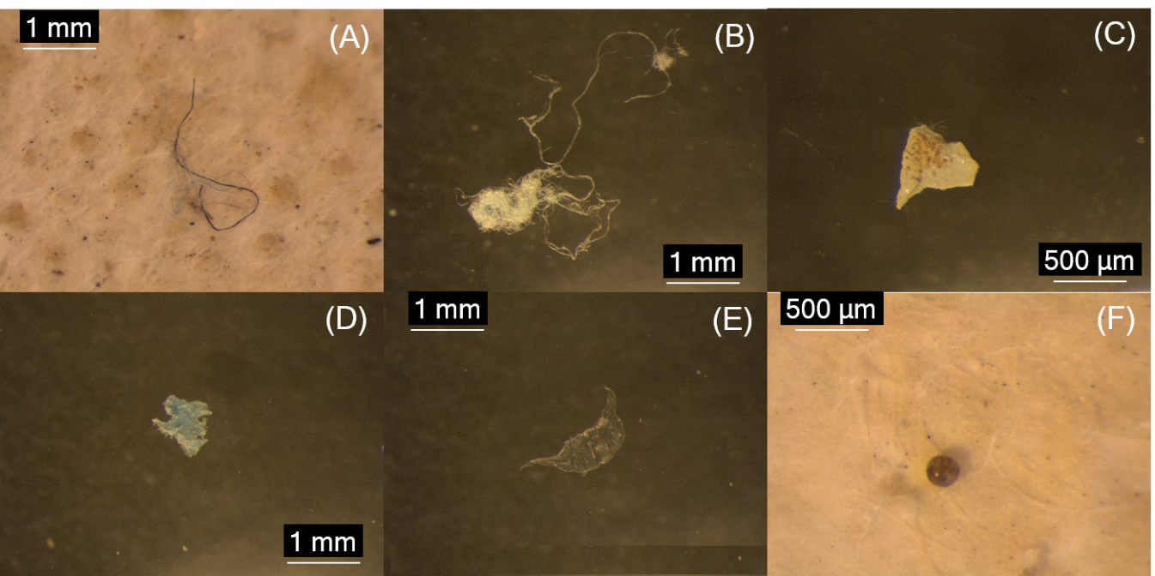

**Figure 4** Examples of secondary and primary types of MPs extracted from wastewater samples and identified visually: fibres (A-B), fragments (C-D), film (E), and pellet (F)

Chemical characterisation of a subsample confirmed that MPs were present: 39% of pieces measured by FTIR-ATR were determined to be plastic, but other materials with similar appearance and size were also present (**Fig 5**). The second most abundant material was cellulose (36%), as fibres and films, followed by a material of unknown origin labelled as reshicin (13%) in the reference libraries and present as films. Similarly, a study of a secondary treatment plant in Vancouver using FTIR-ATR analysis of 4.8% of 770 suspected MPs identified visually, observed 32.4% were plastics and cellulose was also comparably abundant to their plastic measurements (Gies et al. 2018). These percentages of FTIR-confirmed MPs are higher than observed in a primary treatment plant in Australia (~10%), but than those in secondary and tertiary WWTPs (~70-80% and ~60-80%, respectively) in the same study (Ziajahromi et al. 2017). The presence of non-plastic micromaterials in comparably high abundances in this and other studies reinforces the importance of chemical analysis of MPs during characterisation, particularly when future management decisions are predicated on these research findings as this can provide information on sources of origin.

Different types of polymers were identified (**Fig 5A**), including commonly-used plastics like polypropylene (PP, 23%) and PE (4%), and some less common, such as poly(vinyl) stearate (PVS, 7%) and polyoxymethylene (POM, 1%). The remaining MPs identified here were grouped as copolymers and included an ethylene-ethylacrylate film and a PE-PP fragment. Both PP and PE observed here are often reported in relatively high abundances across available surveys (Sun et al. 2019), as they are used in a wide number of applications including personal care and consumer products. The second-most detected polymer was PVS, but this material has not been reported in other studies to date, and it is of limited use in the plastics industry (Gooch 2011). This polymer is usually co-polymerised with PVC (Gooch 2011) so may indicate delivery via industrial rather than domestic waste streams and may reflect the inflow sources of the WWTP. The POM particles also may not be common, only reported to date from a secondary WWTP in Denmark. The same study found PE-PP copolymers in raw and treated wastewater (Simon et al. 2018), but in higher abundance than this study.

The remaining pieces classed as “Other” were particles that were not identified by the reference libraries. These included 5 fibres, 2 fragments, and 1 film, all likely too small in surface area to be analysed by single-point FTIR spectroscopy. Ongoing research to optimise and automate FTIR-based methods (Primpke et al. 2017, Simon et al. 2018) could facilitate analysis of these smaller pieces in future studies, but these techniques are still being investigated and are not widely-available at present.



**Fig 5** (A) Pie chart showing the chemical distribution in percentages of different types of materials identified in a subsample of suspected secondary MPs (n=70); (B) Bar graph showing the repartition by count for the chemical and categorical data combined.

While MPs from all three secondary categories were analysed, micropellets could not be assessed chemically due to their small sizes (< 0.3 mm) and as their smooth surfaces made them easily flicked during transfer. An alternative solution for chemical characterisation of this category may involve the use of scanning electron microscopy couple with electron dispersive spectroscopy (SEM-EDS). The SEM-EDS technique allows for elemental analysis of smaller pieces and has been used successfully in a previous study to correct misidentification of non-plastic spheres such as coal ash in the Laurentian Great Lakes (Eriksen et al. 2013), although it does not allow for determination of polymer type. For this research, in absence of chemical confirmation and thus based on physical appearance, all micropellets recovered from wastewater samples were considered primary MPs, noting their presence was minimal.

The chemical data refined the initial count of estimated plastics for each category (**Fig 5B**). Thus, based on FTIR-corrected data, a total of 749 MPs were observed across all wastewater samples, consisting of 549 fibres, 153 fragments, 41 films, and 7 pellets. Fibres were predominantly plastics (58% PP and 5% PE), with the rest of analysed fibres identified as cellulose (11%) or of unknown origin. Fragments were also predominantly MPs, with PP comprising 50% of analysed specimens, and PVS, POM and PE-PP each comprising 10%. Most films were composed of cellulose (56%) and the unknown material reshicin (22%), while only 17% of these were confirmed plastics.

## MPs types

Secondary MPs were predominant in the wastewater samples, comprising 99.5% of total pieces. Fibres were the most common type of MPs, followed by fragments and films. The predominance of fibres here is consistent with previous wastewater surveys (Magnusson and Noren, 2014; Dris et al. 2015; Sutton et al. 2016; Leslie et al. 2017; Talvitie et al. 2017a,b; Ziajahromi et al. 2017; Gies et al. 2018; Lares et al. 2018). Their abundance is expected to be higher in densely-populated areas and those receiving sewage as they can be released during clothes washing (Browne et al. 2011; Magnusson and Noren 2014). For example, washing machine effluent was observed to contain over 1900 fibres per wash (Browne et al 2011), although this may vary by textile type (Almroth et al. 2018). Furthermore, fibres were present throughout the entire system. Their abundance was highly-variable across sampling events, but generally this decreased by count after each treatment stage (**Fig 6**) although a few persisted through the process and were observed in final effluent. Their removal may be partially influenced by the tendency of fibres to cluster together or become entrapped in settling solids (Sun et al. 2019).

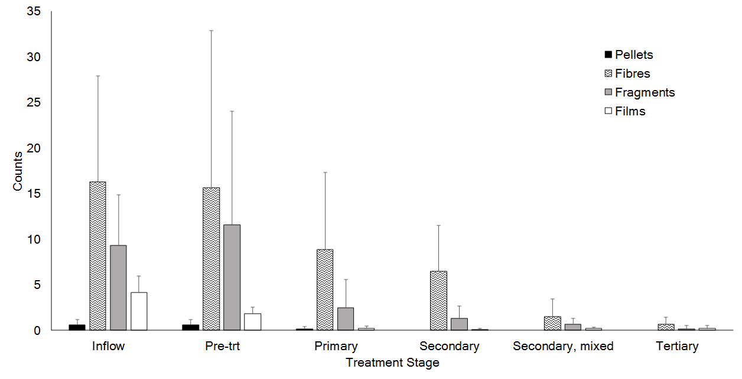

**Figure 6** Mean counts of MPs at different stages using FTIR- and blank-corrected data calculated averaging all sampling campaigns. Error bars represent standard deviation.

Fragments were also present throughout all stages of the treatment process, with at least one particle observed in final effluent during the sampling period (**Fig 6**). Most fragment removal seemed to occur after the primary stage (when settling of solids takes place) and again after tertiary treatment. Films were mostly removed during pre-treatment, which may indicate the higher buoyancy of these materials allows them to be captured in the grit and grease biosolids (Murphy et al. 2016). Different types of fragmented pieces have also been observed across multiple WWTPs (Sun et al. 2019) and generally refer to uneven or irregular pieces. Here, fragmented pieces were categorised as either films or fragments to distinguish between two-dimensional thin particles and three-dimensional pieces with broken edges, respectively. However, the terms used to categorise these particles may vary across surveys (Hidalgo-Ruz et al. 2012). Thus for purposes of inter-study comparability, non-fibre and non-primary particles are discussed jointly as fragments. As observed here, fragments were the second most-abundant type of MPs after fibres in a secondary WWTP in Sweden (Magnusson and Noren 2014), in secondary and tertiary WWTPs in the USA (Mason et al. 2016; Sutton et al. 2016), and in a tertiary treatment plant in northern Italy (Magni et al. 2019). While fragments can be produced from a wide variety of sources and enter the wastewater stream via household and industrial effluent, the potential for generation of fragments during the treatment process cannot be excluded. For example, WWTPs may employ a variety of plastic equipment throughout the system that may degrade and release plastics during use. Besides the present study, only one survey reported the use of plastic materials during tertiary treatment in the form of tightly-packed polystyrene beads used in biological active filters, and while this technology did not decrease MPs concentration, additional production of MPs was not reported either (Talvitie et al. 2017b). Nevertheless, the wastewater treatment can be turbulent and lead to further mechanical breakdown of incoming MPs, perhaps in sizes that may be evading detection. This hypothesis may be supported by evidence from fragmentation tests from the present study and thus presents an important research gap in these systems that warrants further investigation as without it we cannot fully understand WWTP loading and MP redistribution.

Primary MPs (i.e. microbeads) that can be introduced in household sewage from use of cosmetics and cleaning products, have been observed in varying concentrations in a few WWTPs (Mason et al. 2016; Murphy et al. 2016). Micropellet counts here were comparable to those of a secondary treatment plant in urban Paris, where only one sphere was observed across all samples collected from pre-treatment, primary, and final effluent (Dris et al. 2015). Microbeads in this study were only observed before secondary treatment, suggesting that if they are present in sewage, they are likely to be removed in the early treatment stages (**Fig 6**). This is consistent with previous observations in secondary WWTPs in Sweden where 95-99% of microbeads were observed to settle out in sludge (Magnusson and Noren, 2014), and in the UK where microbeads were only found in grease fractions removed during pre-treatment (Murphy et al. 2016). The categorical data for this study indicates that primary MPs represent only a small portion of the plastic load in this catchment. This is relevant to current conversations on control measures of MPs, especially as current actions such as regulatory bans are mainly aimed at reducing primary MPs inputs, but few focus on secondary sources. However, these findings may vary by site-specific characteristics. For example, studies in two USA studies were contrasting to findings in this and other European studies. In San Francisco, although beads were not the most common type of MPs, it was estimated that ~1.4 x 106 microbeads were discharged per facility per day across 17 WWTPs, and between 3 and 23 x 109 microbeads could be released from US municipal wastewater treatment facilities daily (Mason et al. 2016). Similarly, primary MPs resembling those used in toothpaste were abundant across seven secondary and tertiary wastewater sites in Los Angeles, indicating that inputs from personal care products are important sources of MPs to WWTPs in these specific catchments (Carr et al. 2016).

## MP abundances

The FTIR-corrected counts were used to estimate abundances at each stage for each sampling event. Microplastics were present throughout the system and concentrations ranged from ~1 to 13 MPs L-1, with the highest abundances observed in pre-treatment effluent during SE1 in the spring (**Fig 7**). Total concentrations of MPs in wastewater were highly-variable across sampling dates and time, which is consistent with the general findings from the current literature where wide ranges in concentrations are often reported (Sun et al. 2019). Influent concentrations were between 3 and 10 MPs L-1, which are at the lower end of ranges reported in the literature and comparable to those observed for secondary treatment plants in Sweden (Magnusson and Noren 2014) and in Scotland (Murphy et al. 2016). The lowest concentrations were mostly observed after tertiary treatment (final effluent), except during SE2 in the summer, when concentrations reached their minimum after the mixed secondary liquor phase. However, as no replicates were collected during each sampling campaign, it is not possible to determine whether these seasonal representations are the norm or outliers.

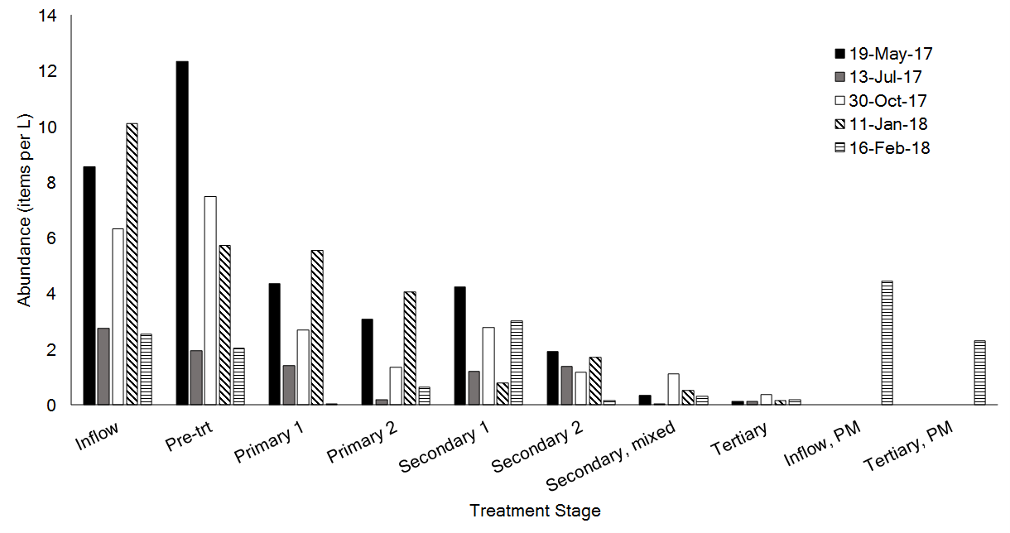

**Fig 7** FTIR-corrected MP abundances across all treatment stages and events in a tertiary sewage treatment plant. **P1**, influent; **P2**, preliminary effluent; **P3a**, primary effluent phase 1; **P3b**, primary effluent phase 2; **P4a**, secondary effluent phase 1; **P4b**, secondary effluent phase 2; **P5**, secondary effluent mixed liquor; **P6**, final effluent; **P1**, influent afternoon sample; **P6**, final effluent afternoon sample.

Some inter-seasonal variations were observed with lower abundances in raw wastewater at the influent in July compared to May, October, and January. These may be associated with seasonal flows. July is a summer month with fewer rainfall events and so there may be less storm run-off, and holidays reducing household effluent. Abundances in the last sampling campaign in February were also low and comparable to those in July despite higher flow conditions, which could suggest that drivers of incoming MP loads may scale with volume. However, the May sample does not support this and therefore a stronger driver of variation may be relative changes in household, industrial and storm run-off.

Short-term variations were not explored in detail in this study, but abundances were higher in two afternoon samples compared to their morning counterparts collected on the same day. This may reflect daily variations in domestic and industrial activities on inflow concentrations, but further research is needed to be conclusive. Seasonality of incoming small anthropogenic litter was explored from pre-treatment effluent across three seasons in a WWTP in Michigan, USA where microlitre concentrations were twofold in spring compared to fall and winter (Michielssen et al. 2016). No other similar long-term studies are available, thus more information is needed to further assess temporal controls. While daily replicates were not possible for this study due to the long processing times for samples, sampling campaigns were considered collectively to understand treatment effect on MPs concentrations and estimate variability.

## Treatment stage effect and MPs loads

Average inflow of MPs to the treatment plant over one year was 8.1 x 108, 95% CI [3.8 x 108, 1.2 x 109] particles day-1. Influent loads based on incoming concentrations and plant flows are only reported by a few studies (Magnusson and Noren 2014; Murphy et al. 2016; Lares et al. 2018), but their findings suggest these loads may be dependent on the size of population served. For example, a larger secondary treatment plant with size of 650,000 PE in the same catchment in Scotland received an average of 4 x109 MPs day-1. In Sweden, a smaller secondary sewage treatment plant with 14,000 PE was observed to receive loadings of 78 x 106 day-1 (Magnusson and Noren 2014). Concentrations in this study were comparable to those of a secondary treatment plant (PE not specified) in Finland with a reported inflow of 6.2 x 108 MPs (Lares et al. 2018).

An overall decrease of incoming particles was observed from influent to outflow with each treatment stage removing different proportions of MPs (**Fig 8**). Mean concentrations decreased by ~2% after pre-treatment, and while preliminary treatment has only been assessed by two previous studies, removal efficiencies in the present study are lower than those reported previously, ~35-58% (Michielssen et al. 2016; Murphy et al. 2016). Primary treatment removed between 54-70% of overall MP counts and is consistent with other surveys (63-81%, Dris et al. 2016; 84-88%, Michielssen et al. 2016; 78%, Murphy et al. 2016; 97.4-98.4%, Talvitie et al. 2017b; ~68%, Ziahjaromi et al. 2017). There was indication of further removal after secondary treatment, but this was only evident at the secondary mixed liquor stage after the channels are joined back together (P5). Thus, while no additional treatment is employed, this decrease may suggest some settling or removal of MPs taking place as the water flows from the final settling tanks to a distribution chamber for the nitrifying tanks, where the sample is collected. After secondary treatment, removal reached 92%, comparable to efficiencies observed by other secondary treatment studies that report between 7 and 20% of additional MPs can be removed by activated sludge treatment (Talvitie et al. 2017b).

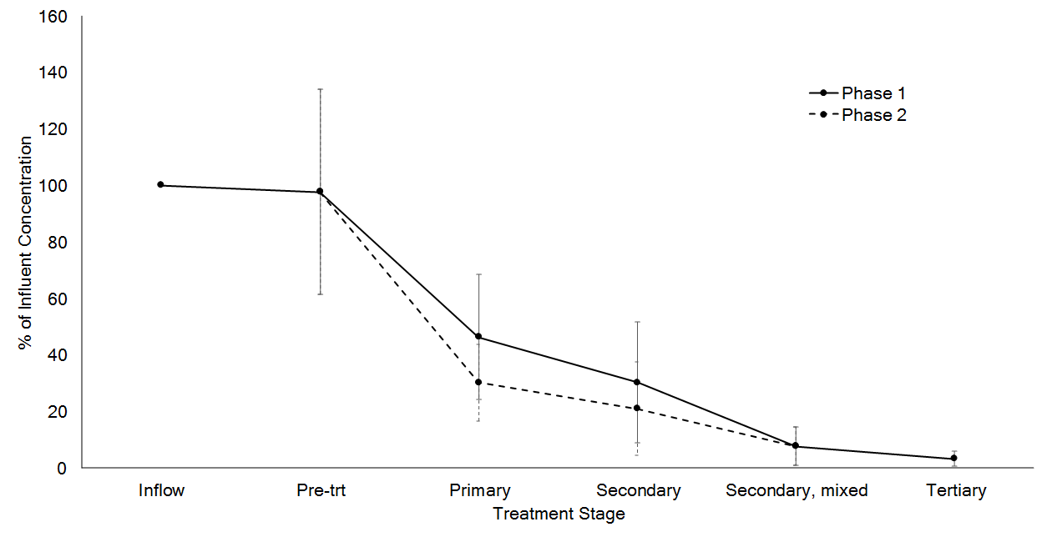

**Fig 8** Percent change relative to influent microplastic concentrations after each treatment stage, averaged across five sampling campaigns. Concentrations are FTIR- and field blank-corrected, then averaged across the five sampling events.

Tertiary treatment produced an average decrease of 5% of MPs in secondary effluent, bringing the total retention efficiency to 97% (**Fig 8**). The plant discharges on average 2.2 x 107, 95% CI [1.2 x 107, 3.2 x 107] MPs day-1 under low to medium flow conditions. The removal ranges and discharges observed here are within values reported in the literature (**Table 1**). A larger secondary treatment plant in Scotland had a retention efficiency of 98.41% and discharged 65 x 106 particles day-1 (Murphy et al. 2016). Although the data come from different WWTPs, both studies are located in the same catchment, serve a similar population demographic, and observed a similar profile of MP types, thus the comparable removal percentages could indicate that tertiary treatment may not result in higher MPs retention than secondary treatment processes. Previous studies have observed variable removal of MPs, with efficacy seemingly dependent on type of process and technology used. For example, advanced treatment including ultrafiltration, reverse osmosis and decarbonation improved retention of MPs in a WWTP in Australia, with 100% removal of particles larger than 190 micron (Ziahjaromi et al. 2017). The use of discfilters for advanced filtration in a WWTP in Finland was also effective for removing MPs from secondary effluent, but efficiency was dependent on pore size, with removal of 40% and ~98% using 10 µm and 20 µm, respectively (Talvitie et al. 2017a). The same study observed that rapid sand filtration and dissolved air flotation also improved MP removal from secondary effluent by 97% and 95%, respectively, while the highest removal was observed with the use of MBR (99.9%; Talvitie et al. 2017a). In Michigan, MBR exhibited higher removal of small anthropogenic litter including MPs, when compared to effluent from a secondary WWTP and a tertiary plant with sand filtration (Michielssen et al. 2019). Similarly, a study in Finland observed higher removal efficiencies in MBR permeate compared to conventional activated sludge effluents (Lares et al. 2018). In contrast, the use of MBR in a WWTP in the Netherlands did not reduce MP concentrations, although this was attributed to a decrease of performance of this technology over time (Leslie et al. 2017). Sand filtration and disinfection were also found not to be effective in removing MPs across comparable studies in Los Angeles (Carr et al. 2016) and San Francisco (Mason et al. 2016; Sutton et al. 2016). In the present study, the process can be generally categorised as post-filtration for purposes of comparison, but no other sites of the same type of treatment considered here (i.e. use of plastic media in nitrifying trickling filters), have been documented so further analysis is not possible. Overall, findings for primary and secondary treatment processes seem comparably consistent across studies, but the diversity of advanced technologies and the contrasting results reported for these, mean more research in WWTPs is needed to help identify treatment processes that further reduce MPs pollution in and from these systems.

Reductions in MP concentrations during the treatment process are generally attributed to biosolid entrapment (e.g. grit and grease, sewage sludge, returned activated sludge, MBR sludge). It was not possible to test this hypothesis here as solid fractions were not sampled, low to high MPs concentrations have been found in sludge fractions elsewhere (Magnusson and Noren 2014; Bayo et al. 2016; Carr et al. 2016; Murphy et al. 2016; Leslie et al. 2017; Mintenig et al. 2017; Lares et al. 2018; Li et al. 2018). While some 20% of these biosolids may be recycled back into the system (Talvitie et al. 2017b), most of this material will be removed (Lares et al. 2018). In Netherlands, sewage sludge is usually incinerated and thus retention of MPs in this fraction would be an end-point for these materials (Leslie et al. 2017). However, in other regions, sludge can be sent to landfills or prepared for land-application, could allow release to the environment. Research pursuing this should be accompanied by exploration of whether mechanical breakdown of pieces, as evidenced here in the fragmentation tests, renders particles beyond detection and so they are still in the effluent. The sporadic increases in MPs concentration observed between treatment stages during sampling events (**Fig 7**) may reflect this.

# Conclusions

Here, the occurrence, distribution, and fate of MPs in an advanced WWTP were assessed. A continuous input of MPs and other microdebris to the treatment site was observed over the course of one year. Single-point FTIR-ATR analysis confirmed the presence of different types of MPs, with PP being the most abundant type and present as fibres and fragments. Microplastics were mainly observed as secondary types, and while a few pellets were present, their chemical composition could not be determined due to size limitations of the FTIR-ATR approach employed here. Fibres were dominant and their high abundance is expected as they are often associated with washing machine effluent, but their presence in blanks suggests that some may be entering the system via atmospheric deposition at any point of the process as the wastewater is treated in open channels. The system investigated here had removal efficiencies at the higher end reported so far, but MPs were not entirely removed and at least 1-2 million particles day-1 can be discharged from this site even during low flow. Similar to other studies, the largest change in concentration was observed in the early treatment stages. Generally, this is linked to retention of microplastics in the sludge and so the concentration and fate of MPs in sludge is an area that needs further attention because rather than providing a solution, it may be displacing the pathway for delivery of MPs to the environment. This study contributes new information for understanding of MPs in WWTPs by considering multiple stages, lowering the cut off size to consider smaller MPs, and employing a longer sampling period in a single facility to explore seasonal variations. Further research is recommended to replicate this study using larger sample volumes and additional replicates for validation of the results.

Wastewater treatment plants are expected to play an increasingly important role in regulating the delivery of MPs coming from land-based sources, thus warrant further attention, but challenges exist in assessing MPs pollution in such systems. For example, wastewater treatment processes and technologies may differ according to regional legislations and conditions, and are likely to vary in types and levels of MPs pollution across sites. Therefore further research is needed to more confidently extrapolate results from this or similar studies. Additionally, future work should aim to explore the factors driving spatio-temporal variations across sites and to explore the changes at multiple treatment stages for a broader range of treatment systems. However, often studies will not be able to collect everything needed to conduct a thorough examination of the system or will not have the available technologies to effectively measure the broad range of MPs types and sizes. Improved collaboration across researchers is crucial to addressing these challenges and build a comprehensive understanding and risk assessment of the severity of MPs pollution and their regulation in WWTPs. This and similar studies can help to inform regulators about what needs to be prioritized in monitoring programmes and where controls should be implemented, thus guiding fundamental action.

**Acknowledgements**

The authors are grateful to Professor Vernon Phoenix (University of Strathclyde) who contributed to the experimental planning of this project, and for his constructive comments on this manuscript. The authors thank Kenny Roberts at the University of Glasgow and the operations staff at the WWTP for their assistance during sample collection. This project is funded by the Scottish Government’s Hydronation Scholars Programme and is in conjunction with Scottish Water and SEPA.

**References**

Almroth BMC, Astrom L, Roslund S, Petersson H, Johansson M, Persson N-K (2018) Quantifying shedding of synthetic fibers from textiles; a source of microplastics released into the environment. Environ Sci Pollut Res 25: 1191-1199

Anbumani S, Kakkar P. 2018. Ecotoxicological effects of microplastics on biota: a review. Environ Sci Pollut Res 25: 14373-14396

Bayo J, Olmos S, López-Castellanos J, Alcolea A (2016) Microplastics and microfibers in the sludge of a municipal wastewater treatment plant. Int J Sus Dev Plann 11: 812-821

Blair RM, Waldron S, Phoenix V, Gauchotte-Lindsay C (2017) Micro- and nanoplastic pollution of freshwater and wastewater treatment systems. Springer Sci Rev 5: 19-30

Blair RM, Waldron S, Phoenix VR, Gauchotte-Lindsay C (2019). Microscopy and elemental analysis characterisation of microplastics in sediment of a freshwater urban river in Scotland, UK. Environ Sci Pollut Res

Browne MA, Crump P, Niven SJ, Teuten E, Tonkin A, Galloway T, Thompson R. 2011. Accumulation of microplastic on shorelines worldwide: sources and sinks. Environ Sci Technol 45: 9175-9179

Carr SA, Liu J, Tesoro AG (2016) Transport and fate of microplastic particles in wastewater treatment plants. Water Res 91: 174-182

Dris R, Gasperi J, Rocher V, Saad M, Renault N, Tassin B (2015) Microplastic contamination in an urban area: a case study in Greater Paris. Environ Chem 12: 592-599

Dyachenko A, Mitchell J, Arsem N (2017) Extraction and identification of microplastic particles from secondary wastewater treatment plant (WWTP) effluent. Anal Methods 9: 1412-1481

Eaton AD, Clesceri LS, Greenberg AE, Franson MA (1998). Standard methods for the examination of water and wastewater. American Public Health Association., American Water Works Association., & Water Environment Federation. Washington, DC: American Public Health Association

Eriksen M, Mason S, Wilson S, Box C, Zellers A, Edwards W, Amato S (2013) Microplastic pollution in the surface waters of the Laurentian Great Lakes. Mar Pollut Bull 77:177-182

Gies EA, LeNoble JL, Noel M, Etemadifar A, Bishay F, Hall ER, Ross PS (2018) Retention of microplastics in a major secondary wastewater treatment plant in Vancouver, Canada. Mar Pollut Bull 133: 553-561

Gooch JW (2011) Polyvinyl Stearate. In: Gooch J.W. (eds) Encyclopedic Dictionary of Polymers. Springer, New York, NY

Hartl MGJ, Gubbins E, Gutierrez T, Fernandes TF (2015) Review of existing knowledge – emerging contaminant: Focus on nanomaterials and microplastics in the aquatic environment. CREW - Centre of Expertise for Waters

Hidalgo-Ruz V, Gutow L, Thompson RC, Thiel M (2012) Microplastics in the marine environment: a review of the methods used for identification and quantification. Environ Sci Technol 46: 3060-3075

Kosuth M, Mason SA, Wattenberg EV (2018) Anthropogenic contamination of tap water, beer, and sea salt. PLoS ONE 13: e0194970

Lares M, Ncibi MC, Sillanpaa M, Sillanpaa M (2018) Occurrence, identification and removal of microplastic particles and fibers in conventional activated sludge process and advanced MBR technology. Water Res 133: 236-246

Leslie HA, Brandsma SH, van Velzen MJM, Vethaak AD (2017) Microplastics en route: Field measurements in the Dutch river delta and Amsterdam canals, wastewater treatment plants, North Sea sediments and biota. Environ Int 101: 133-142

Li X, Chen L, Mei Q, Dong B, Dai X, Ding G (2018) Microplastics in sewage sludge from the wastewater treatment plants in China. Water Res 142: 75-85

Long M, Moriceau B, Gallinari M, Lambert C, Huvet A, Raffray J, Soudant P (2015) Interactions between microplastics and phytoplankton aggregates: Impact on their respective fates. Mar Chem 175: 39-46

Magni S, Binelli A, Pittura L, Avio CG, della Torre C, Parenti CC, Gorbi S, Regoli F (2019) The fate of microplastics in an italian wastewater treatment plant. Sci Total Environ 652: 602-610

Magnusson K, Norén F (2014) Screening of Microplastic Particles in and down-Stream a Wastewater Treatment Plant, Report C55. Swedish Environmental Research Institute: Stockholm

Mason SA, Garneau D, Sutton R, Chu Y, Ehmann K, Barnes J, Fink P, Papazissimos D, Rogers DL (2016) Microplastic pollution is widely detected in US municipal wastewater treatment plant effluent. Environ Pollut 218: 1045-1054

Michielssen MR, Michielssen ER, Ni J, Duhaime MB (2016) Fate of microplastics and other small anthropogenic litter (SAL) in wastewater treatment plants depends on unit processes employed. Environ Sci Water Res Technol 2: 1064-1073

Mintenig SM, Int-Veen I, Loder MGJ, Primpke S, Gerdts G (2017) Identification of micriokastic in effluents of waste water treatment plants using focal plane array-based micro-Fourier-transform infrared imaging. Water Res 108: 365-372

Murphy F, Ewins C, Carbonnier F, Quinn B (2016) Wastewater treatment works (WwTW) as a source of microplastics in the aquatic environment. Environ Sci Technol 50: 5800-5808

Nuelle MT, Dekiff JH, Remy D, Fries E (2014) A new analytical approach for monitoring microplastics in marine sediments. Environ Pollut 184:161-169

Ou H, Zeng EY (2018) Occurrence and fate of microplastics in wastewater treatment plants. In: Zeng EY (eds) Microplastic Contamination in Aquatic Environments: An Emerging Matter of Environmental Urgency. Elsevier, pp 317-338

Primpke S, Lorenz C, Rascher-Friesenhausen R, Gerdts G (2017) An automated approach for microplastics analysis using focal plane array (FPA) FTIR microscopy and image analysis. Anal Methods 9: 1499-1511

Rochman CM, Kross SM, Armstrong JB, Bogan MT, Darling ES, Green SJ, Smyth AR, Veríssimo D (2015) Scientific evidence supports a ban on microbeads. Env Sci Technol 49: 10759-10761

Simon M, van Alst N, Vollertsen J (2018) Quantification of microplastic mass and removal rates at wastewater treatment plants applying Focal Plane Array (FPA)-based Fourier Transform Infrared (FT-IR) imaging. Water Res 142: 1-9

Sun J, Dai X, Wang Q, van Loosdrecht MCM, Ni B-J (2019) Microplastics in wastewater treatment plants: Detection, occurrence and removal. Water Res 152: 21-37

Sutton R, Mason SA, Stanek SK, Willis-Norton E, Wren IF, Box C (2016) Microplastic contamination in the San Francisco Bay, California, USA. Mar Pollut Bull 109: 230-235

Talvitie, J, Mikola A, Koistinen A, Setala O (2017a) Solutions to microplastic pollution – removal of microplastics from wastewater effluent with advanced wastewater treatment technologies. Water Res 123: 401-407

Talvitie J, Mikola A, Setala O, Heinonen M, Koistinen A (2017b) How well is microliter purified from wastewater? – A detailed study on the stepwise removal of microliter in a tertiary level wastewater treatment plant. Water Res 109: 164-172

Viršek MK, Lovšin MN, Koren S, Krzan A, Peterlin M (2017) Microplastics as a vector for the transport of the bacterial fish pathogen species Aeromonas salmonicida. Mar Pollut Bull 125: 301-309

Wesch C, Barthel AK, Braun U, Klein R, Paulus M (2016) No microplastics in benthic eelpout (Zoarces viviparus): an urgent need for spectroscopic analyses in microplastic detection. Environ Res 148: 36-38

Ziajahromi S, Neale PA, Rintoul L, Leusch FDL (2017) Wastewater treatment plants as pathways for microplastics: development of a new approach to sample wastewater-based microplastics. Water Research: 112: 93-99